BEFORE THE FLORIDA PUBLIC SERVICE COMMISSION

In re: Petition for designation as an eligible telecommunications carrier, by TAG Mobility, LLC d/b/a TAG Mobile. | DOCKET NO. 20240162-TP  ORDER NO. PSC-2025-0040-PAA-TP  ISSUED: February 6, 2025

The following Commissioners participated in the disposition of this matter:

MIKE LA ROSA, Chairman
ART GRAHAM
GARY F. CLARK
ANDREW GILES FAY
GABRIELLA PASSIDOMO SMITH

NOTICE OF PROPOSED AGENCY ACTION
ORDER GRANTING DESIGNATION AS AN ELIGIBLE
TELECOMMUNICATIONS CARRIER TO
TAG MOBILITY, LLC

BY THE COMMISSION:

NOTICE is hereby given by the Florida Public Service Commission that the action discussed herein is preliminary in nature and will become final unless a person whose interests are substantially affected files a petition for a formal proceeding, pursuant to Rule 25-22.029, Florida Administrative Code (F.A.C.).

Background
On December 12, 2024, TAG Mobility, LLC d/b/a TAG Mobile (TAG Mobility or Company) filed a petition with the Florida Public Service Commission (Commission) seeking designation as an eligible telecommunications carrier (ETC) for the sole purpose of providing Lifeline service to qualifying consumers throughout Florida. TAG Mobility is a Mobile Virtual Network Operator (MVNO) and offers prepaid wireless telecommunications services to consumers as a wireless reseller. Specifically, TAG Mobility uses the network infrastructure and wireless transmission facilities of AT&T to operate as a MVNO. TAG Mobility is currently designated as an ETC providing Lifeline service in 19 other states.

As a MVNO, TAG Mobility is regulated as a common carrier pursuant to 47 U.S.C. § 153(11). TAG Mobility is a Limited Liability Company that was organized in the State of Texas in January of 2024, in connection with the bankruptcy reorganization of its predecessor entity, TAG Mobile, LLC. As part of that reorganization, TAG Mobile, LLC’s assets were divided between two newly created entities, both of which were acquired indirectly by Mr. Henry Hung Do.

TAG Mobility asserts that it meets all applicable federal requirements for designation as a Lifeline only ETC in Florida pursuant to 47 U.S.C. 214(e) and 47 C.F.R. 54.201. TAG Mobility acknowledges and asserts that, if approved, it will comply with Section 364.10 and 364.105, Florida Statutes (F.S.) and Rule 25-4.0665, Florida Administrative Code (F.A.C.), which govern Lifeline service and provide for a transitional discount for customers who no longer qualify for Lifeline.

We are vested with jurisdiction in this matter pursuant to Section 214(e)(2) of the Telecommunications Act of 1996 (the Act) and Section 364.10, Florida Statutes.

Decision and Analysis
ETC designation is necessary for telecommunications companies to participate in the federal Lifeline program. Section 364.10, F.S., allows this Commission to approve wireless Lifeline ETC petitions by requesting carriers. Specifically, Section 364.10(1)(a) and (3)(a) F.S., provide that the Commission has the authority to designate a commercial mobile radio service provider as an ETC for the limited purpose of providing Lifeline service.

Federal rules outline the requirements for ETC designation. To obtain ETC designation to provide Lifeline services, federal rules require that carriers:
- Be a common carrier;
- Offer the services that are supported by the federal universal support mechanisms either using its own facilities or a combination of its own facilities and resale of another carrier’s services;
- Advertise the availability of its Lifeline service through a media of general distribution;
- Provide voice grade access to the public switch network or its functional equivalent;
- Offer minutes of use for local service at no additional charge to end users;
- Provide access to the emergency services available by local government or other public safety organizations;
- Provide Broadband Internet Access Service;
- Demonstrate financial and technical capability to of provide Lifeline service; and
- Not charge Lifeline customers a monthly number-portability charge.
In addition, Florida law requires ETCs to:

- Offer a discounted transitional basic telecommunications service; and
- Participate in the Lifeline Promotion Process.
Forbearance of Facilities Requirements
TAG Mobility plans to offer all of the supported services enumerated under Section 254(c) of the Act through its wireless resale agreements with AT&T. Therefore, it sought forbearance of the facilities requirement from the FCC. On September 21, 2022, the FCC approved TAG Mobility’s amended compliance plan as a condition of obtaining forbearance from the facilities requirement for the provision of Lifeline service. As part of its compliance plan TAG Mobility committed to the following:
- Provide the supported services throughout the carriers designated areas;
- Remain functional in emergency situations;
- Comply with the Cellular Telecommunications and Internet Association's Consumer Code for Wireless Service;
- Demonstrate that it is financially and technically capable of providing the Lifeline service in compliance with federal rules; and
- Describe the terms and conditions of the broadband Internet access service plans offered to Lifeline subscribers.
Because TAG Mobility will offer the supported services and is compliant with the FCC requirements pursuant to 47 U.S.C. 214(e) and 47 C.F.R. 54.201, as well as the Florida specific requirements, TAG Mobility is eligible for designation as a Lifeline only ETC in Florida.

Financial, Managerial, and Technical Capabilities
As noted in its petition, TAG Mobility has offered service since 2024 and has not filed for any form of bankruptcy relief. The company has operated as an ETC in 19 states and has not been subject to any ETC revocation proceedings in any state. The company has many years of technical and managerial experience, and it does not rely exclusively on Lifeline reimbursements for its operating revenues. As TAG Mobility will be providing resold wireless service, it will also rely upon the managerial and technical expertise of its underlying carriers.

Public Interest
State commissions are required to find that ETC designation is in the public interest. TAG Mobility asserts granting its ETC designation will bring Lifeline eligible consumers more choice in providers without creating additional burden on the federal high-cost programs. Our most recent Lifeline report notes that three wireless companies represent 98 percent of the Lifeline market in Florida. However, the FPSC’s estimated Lifeline participation rate for last year was 12.8 percent. While we have designated additional Lifeline ETCs, the increase in carriers servicing this market may increase participation through additional marketing and would serve the public interest.

Conclusion
We have reviewed TAG Mobility’s petition for ETC designation in Florida. TAG Mobility meets all the requirements for designation as an ETC. Additionally, the company has demonstrated sufficient financial, managerial and technical capabilities. Therefore, we find TAG Mobility shall be granted ETC designation throughout the State of Florida as identified in Attachment A of this Order. Further we find that if there is a future change of Company ownership, the new owners shall be required to file a petition with us to demonstrate that it is in the public interest to maintain the Company’s ETC designation.
Based on the foregoing, it is

ORDERED by the Florida Public Service Commission that TAG Mobility shall be granted ETC designation to provide Lifeline service throughout the State of Florida. It is further

ORDERED that if there is a future change of Company ownership, the new owners shall be required to file a petition us to demonstrate that it is in the public interest to maintain the Company’s ETC designation. It is further

ORDERED that if no person whose substantial interests are affected by the proposed agency action files a protest within 21 days of the issuance of the Proposed Agency Action Order, this docket shall be closed upon the issuance of a consummating order.

By ORDER of the Florida Public Service Commission this 6th day of February, 2025.

/s/ Adam J. Teitzman
ADAM J. TEITZMAN
Commission Clerk
Florida Public Service Commission
2540 Shumard Oak Boulevard
Tallahassee, Florida 32399
(850) 413-6770
www.floridapsc.com

Copies furnished: A copy of this document is provided to the parties of record at the time of issuance and, if applicable, interested persons.

JDI

NOTICE OF FURTHER PROCEEDINGS OR JUDICIAL REVIEW

The Florida Public Service Commission is required by Section 120.569(1), Florida Statutes, to notify parties of any administrative hearing that is available under Section 120.57, Florida Statutes, as well as the procedures and time limits that apply. This notice should not be construed to mean all requests for an administrative hearing will be granted or result in the relief sought.

Mediation may be available on a case-by-case basis. If mediation is conducted, it does not affect a substantially interested person's right to a hearing.

The action proposed herein is preliminary in nature. Any person whose substantial interests are affected by the action proposed by this order may file a petition for a formal proceeding, in the form provided by Rule 28-106.201, Florida Administrative Code. This petition must be received by the Office of Commission Clerk, 2540 Shumard Oak Boulevard, Tallahassee, Florida 32399-0850, by the close of business on February 27, 2025.

In the absence of such a petition, this order shall become final and effective upon the issuance of a Consummating Order.

Any objection or protest filed in this/these docket(s) before the issuance date of this order is considered abandoned unless it satisfies the foregoing conditions and is renewed within the specified protest period.

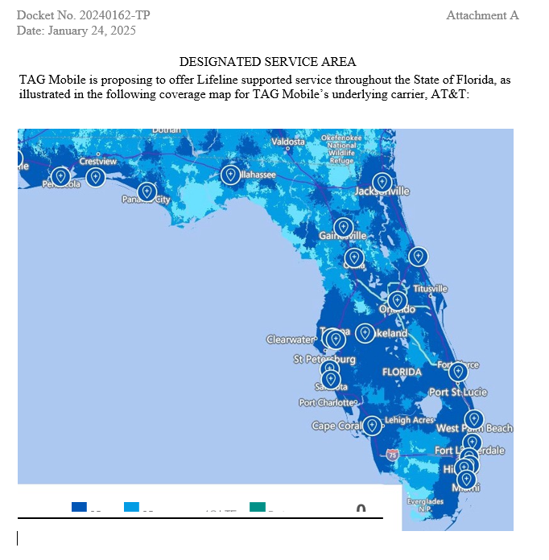

47 U.S.C. § 153(11) (defining a common carrier as “any person engaged as a common carrier for hire, in interstate or foreign communications by wire or radio . . . .”; 47 U.S.C. §332(c)(1)(A) (treating commercial mobile service providers as common carriers).
47 C.F.R. § 54.201(a).
47 C.F.R. § 214(e)(1), 47 U.S.C. 54.101, 47 U.S.C. 54.201, and 47 U.S.C. 54.401; While Section 54.101(a) also includes requirements addressing toll limitation services to qualifying low-income consumers, the FCC in its 2012 Lifeline and Link Up Reform Order (FCC 12-11) stated that: “ETCs are not required to offer toll limitation service to low-income consumers if the Lifeline offering provides a set amount of minutes that do not distinguish between toll and non-toll calls.”
Broadband Internet Access Service (BIAS) is defined as a mass-market retail service that provides the capability to transmit and receive data, but excluding dial-up service.
Section 364.105, F.S states that each ETC shall offer a residential basic local telecommunications service at 70 percent of the residential local telecommunications service rate for any Lifeline subscriber who no longer qualifies for Lifeline for a period of 1 year after the date the subscriber ceases to qualify for Lifeline .
Rule 25-4.0665(3), Florida Administrative Code (F.A.C.); The Lifeline Promotion Process is an electronic system developed in collaboration with the Florida Department of Children and Families, ETCs and the FPSC. This system helps assist ETCs and the FPSC in providing information on how to apply for Lifeline assistance to eligible customers.
47 C.F.R. § 54.202(a)
47 U.S.C. 214(e)(2)
2024 Florida Lifeline Assistance Report, December 2024, Appendix C, p 24.
Ibid, p 18.

