State of Florida   |  | Public Service Commission  Capital Circle Office Center ● 2540 Shumard Oak Boulevard  Tallahassee, Florida 32399-0850  -M-E-M-O-R-A-N-D-U-M-
DATE: | August 22, 2025
TO: | Office of Commission Clerk (Teitzman)
FROM: | Division of Economics (Pope)  Office of the General Counsel (Bloom)
RE: | Docket No. 20250089-EU – Joint petition for approval of amended and restated territorial agreement in Polk County, by Tampa Electric Company and City of Lakeland.
AGENDA: | 9/4/25 – Regular Agenda – Proposed Agency Action – Interested Persons May Participate
COMMISSIONERS ASSIGNED: |  |  | All Commissioners
PREHEARING OFFICER: |  |  | Fay
CRITICAL DATES: |  |  | None
SPECIAL INSTRUCTIONS: |  |  | None

Case Background
On June 30, 2025, Lakeland Electric (Lakeland) and Tampa Electric Company (TECO) (collectively, the joint petitioners or utilities) filed a joint petition seeking Commission approval of an Amended and Restated Territorial Agreement (Amended Agreement) in Polk County. The Amended Agreement was filed pursuant to Section 4.1 of the joint petitioners’ existing territorial agreement, executed in 1991 (Original Agreement) and previously amended twice. Most recently, the joint petitioners obtained Commission approval to provide temporary retail electric service in designated areas outside their existing territorial boundaries.
The temporary service petition (Docket No. 20240171-EU) was filed on December 23, 2024, and sought authority for TECO to provide temporary retail electric service to 34 lots within Phase 2 of the Cadence Crossing development (located in Lakeland’s territory), and Lakeland to similarly serve 39 lots in the Schaller Preserve subdivision (located in TECO’s territory). In Order No. PSC-2025-0089-PAA-EU, these temporary assignments were granted to accommodate developer timelines and avoid delays associated with constructing new infrastructure.
With the instant filing, the joint petitioners seek to convert the temporary service arrangements that were previously approved by the Commission by Order No. PSC-2025-0089-PAA-EU into permanent territory exchanges. During the review process, staff issued a data request to the joint petitioners and responses were received on July 18, 2025.
The Amended Agreement and its Composite Exhibit A, featuring the legal descriptions for the territorial boundary between TECO and Lakeland, including a noted exception and maps pertaining specifically to the Schaller Preserve and Cadence Crossing subdivisions, is attached to this recommendation (Attachment A). On August 5, 2025 the Joint Petitioners filed a supplement to the maps previously filed in Composite Exhibit A correcting a color-coding error that appeared in the original maps on pages 8–13 (Attachment B).
The Commission has jurisdiction over this matter pursuant to Section 366.04, Florida Statutes (F.S.).

Discussion of Issues

Issue 1:
Should the Commission approve the Amended Agreement between TECO and Lakeland in Polk County, dated June 30, 2025?

Recommendation:
Yes, the Commission should approve the proposed Amended Agreement between TECO and Lakeland in Polk County, as reflected in Attachments A and B. The agreement satisfies the standards for approval set forth in Rule 25-6.0440(2), Florida Administrative Code, and would allow the joint petitioners to gain further operational efficiencies, support near-term development activity, and improve service delivery in their respective retail service areas. (Pope)

Staff Analysis:

Pursuant to Section 366.04(2)(d), F.S., and Rule 25-6.0440(2), Florida Administrative Code (F.A.C.), the Commission has jurisdiction to approve territorial agreements between and among rural electric cooperatives, municipal electric utilities, and other electric utilities. Unless the Commission determines that such an agreement is detrimental to the public interest, it should be approved.

Rule 25-6.0440(2), F.A.C., outlines the standards the Commission may consider in evaluating territorial agreements, including:
(a) The reasonableness of the purchase price of any facilities being transferred;
(b) The reasonable likelihood that the agreement, in and of itself, will not cause a decrease in the reliability of electrical service to the existing or future ratepayers of any utility party to the agreement;
(c) The reasonable likelihood that the agreement will eliminate existing or potential uneconomic duplication of facilities; and
(d) Any other factor the Commission finds relevant in reaching a determination that the territorial agreement is in the public interest.

Proposed 2025 Amended Agreement

TECO and Lakeland executed the proposed Amended Agreement on June 30, 2025, to modify their existing 1991 agreement and formalize permanent service assignments for two subdivisions located in Polk County. Through the Amended Agreement, the joint petitioners seek to:

(1) Replace the temporary service arrangements previously authorized in Order No. PSC-2025-0089-PAA-EU with permanent boundary adjustments;

(2) Avoid the uneconomic duplication of facilities by assigning service responsibility to the utility with nearby infrastructure already in place; and

(3) Clarify territorial boundaries in the affected area to support long-term service planning and operational efficiency.

These combined objectives are expected to improve customer service, support ongoing development activity, and reduce the need for redundant infrastructure.
The Amended Agreement includes all terms and conditions, along with written boundary descriptions, parcel-specific maps reflecting the proposed territorial changes, and documentation of the lots affected by the proposed reassignment. Under the proposed Amended Agreement, the joint petitioners request that the same parcels for which the utilities sought and received the authority to offer temporary retail electric service be reassigned permanently. The utilities assert that in the prior docket as well as in the instant one, the utility seeking reassignment has distribution facilities in closer proximity and maintains sufficient capacity to serve the respective developments, which minimizes costs and avoids uneconomic duplication of facilities.

Pursuant to Section 5.1 of the Amended Agreement, if approved, the agreement would remain in effect for 15 years from the date the Commission issues its final order and the order is no longer subject to judicial review. Thereafter, the agreement would automatically renew for successive one year periods, unless terminated by either party with at least 12 months’ written notice in accordance with Section 7.3.

Proposed Boundary Changes

The Amended Agreement formalizes the reassignment of parcels within two developments, Cadence Crossing Phase 2 and Schaller Preserve, that were the subject of temporary service arrangements previously approved by the Commission by Order No. PSC-2025-0089-PAA-EU. No customer transfers are proposed under the agreement. The proposed service reassignments under the Amended Agreement result from negotiations between TECO and Lakeland and are intended to avoid duplication of electric infrastructure and unnecessary costs.
Cadence Crossing Phase 2 includes 34 lots located within Lakeland’s territory, which were temporarily assigned to TECO in late 2024 to allow for timely construction and service activation. TECO has since completed approximately 40 percent of the required infrastructure and anticipates full energization by the end of 2025. Schaller Preserve includes 39 lots located within TECO’s territory, which were temporarily assigned to Lakeland. As of July 2025, no construction has commenced at Schaller Preserve, and service is not expected before February 2027.
In their petition, the joint petitioners stated that the maps in Composite Exhibit A reflect only those changes necessary to address the Schaller Preserve and Cadence Crossing subdivisions, and clarified that the maps control in the event of any conflict with the legal descriptions. No other parcel-level or boundary-wide adjustments were proposed in this filing.
The joint petitioners assert that each utility is better positioned to serve the respective developments due to the proximity of existing facilities and the absence of system capacity constraints. The Amended Agreement does not involve any transfer of existing customer accounts, as the affected parcels are either currently unserved or were temporarily authorized for service by the utility now seeking permanent designation. As such, the proposed Amended Agreement avoids disruption to existing customers and minimizes administrative complexity.
In response to staff’s July 2025 data request, the petitioners confirmed that no additional parcel-level modifications are included in this agreement. The petitioners also indicated that no new cost estimates, system studies, or engineering analyses were performed in support of the petition, citing the minimal load impact and previously approved service arrangement as sufficient justification.

Staff Review

As noted previously, Rule 25-6.0440(2), F.A.C. provides guidance for the Commission regarding standards for approving territorial agreements for electric utilities. Rule 25-6.0440(2)(a), F.A.C., addresses the reasonableness of the purchase price for facilities that may be subject to transfer between utilities. For the instant matter, the joint petitioners state the rule is inapplicable in this instance, since there are no facilities that TECO and Lakeland are transferring to one another. Staff agrees.

Rule 25-6.0440(2)(b), F.A.C., sets forth that the Commission should consider the reasonable likelihood that the proposed territorial agreement, in and of itself, will not cause a decrease in the reliability of electrical service to the existing or future ratepayers of either utility. According to the joint petitioners, each utility’s system planning team reviewed the proposed service area changes and determined that the agreement will not negatively impact the reliability of service to current or future customers. The utilities explained that their respective system planning teams reviewed the proposed service areas subject to transfer, and determined the expected load would be minimal and would not impact reliability for either utility. Staff believes the utilities’ assertions are reasonable.

Rule 25-6.0440(2)(c), F.A.C., requires the Commission to consider the reasonable likelihood that the agreement will eliminate existing or potential uneconomic duplication of facilities. The joint petitioners state that each utility is better positioned to serve the assigned parcels based on the proximity of existing facilities and the absence of capacity constraints; the parcels are either unserved or were temporarily authorized for service by the utility now seeking permanent designation. In staff’s review of utility facilities provided by the joint petitioners in Docket No. 20240171-EU, the proposed permanent boundary assignments align service with the nearest adequately sized facilities and avoid duplicative extensions. No new engineering or cost analyses were prepared for this filing. Based on the foregoing, staff finds a reasonable likelihood that the agreement eliminates existing or potential uneconomic duplication under Rule 25-6.0440(2)(c), F.A.C.

The final rule providing guidance for approving territorial agreements is Rule 25-6.0440(2)(d), F.A.C., which allows the Commission to consider other relevant factors on a case-by-case basis. Staff notes there are no specific factors that are evident under this consideration. Because no active customers are being transferred, the original petition did not include comparative billing information which would have been required pursuant to Rule 25-6.0440(1)(d), F.A.C.. Therefore, staff did not consider or perform any rate impact analysis. The petitioners state that they do not anticipate any future customer objections related to the reassignment of service rights.

Conclusion
Based on the above analysis, staff believes the Commission should approve the proposed Amended Agreement between TECO and Lakeland, as reflected in Attachments A and B. The agreement satisfies the Standards for Approval set forth in Rule 25-6.0440(2), F.A.C., and would allow the joint petitioners to gain further operational efficiencies, support near-term development activity, and improve service delivery in their respective retail service areas.

Issue 2:
Should this docket be closed?

Recommendation:
If no protest is filed by a person whose substantial interests are affected within 21 days of the issuance of the Order, this docket should be closed upon the issuance of a Consummating Order. (Bloom)

Staff Analysis:
If no protest is filed by a person whose substantial interests are affected within 21 days of the issuance of the Order, this docket should be closed upon the issuance of a Consummating Order.

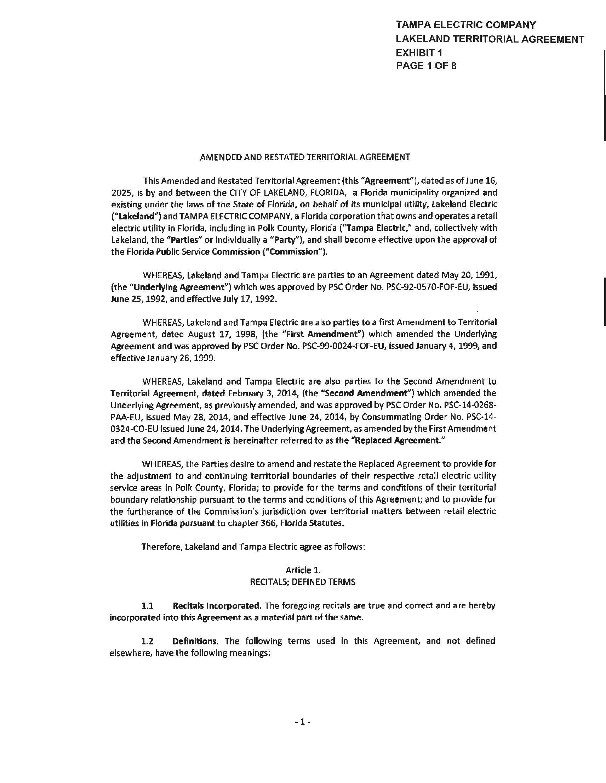
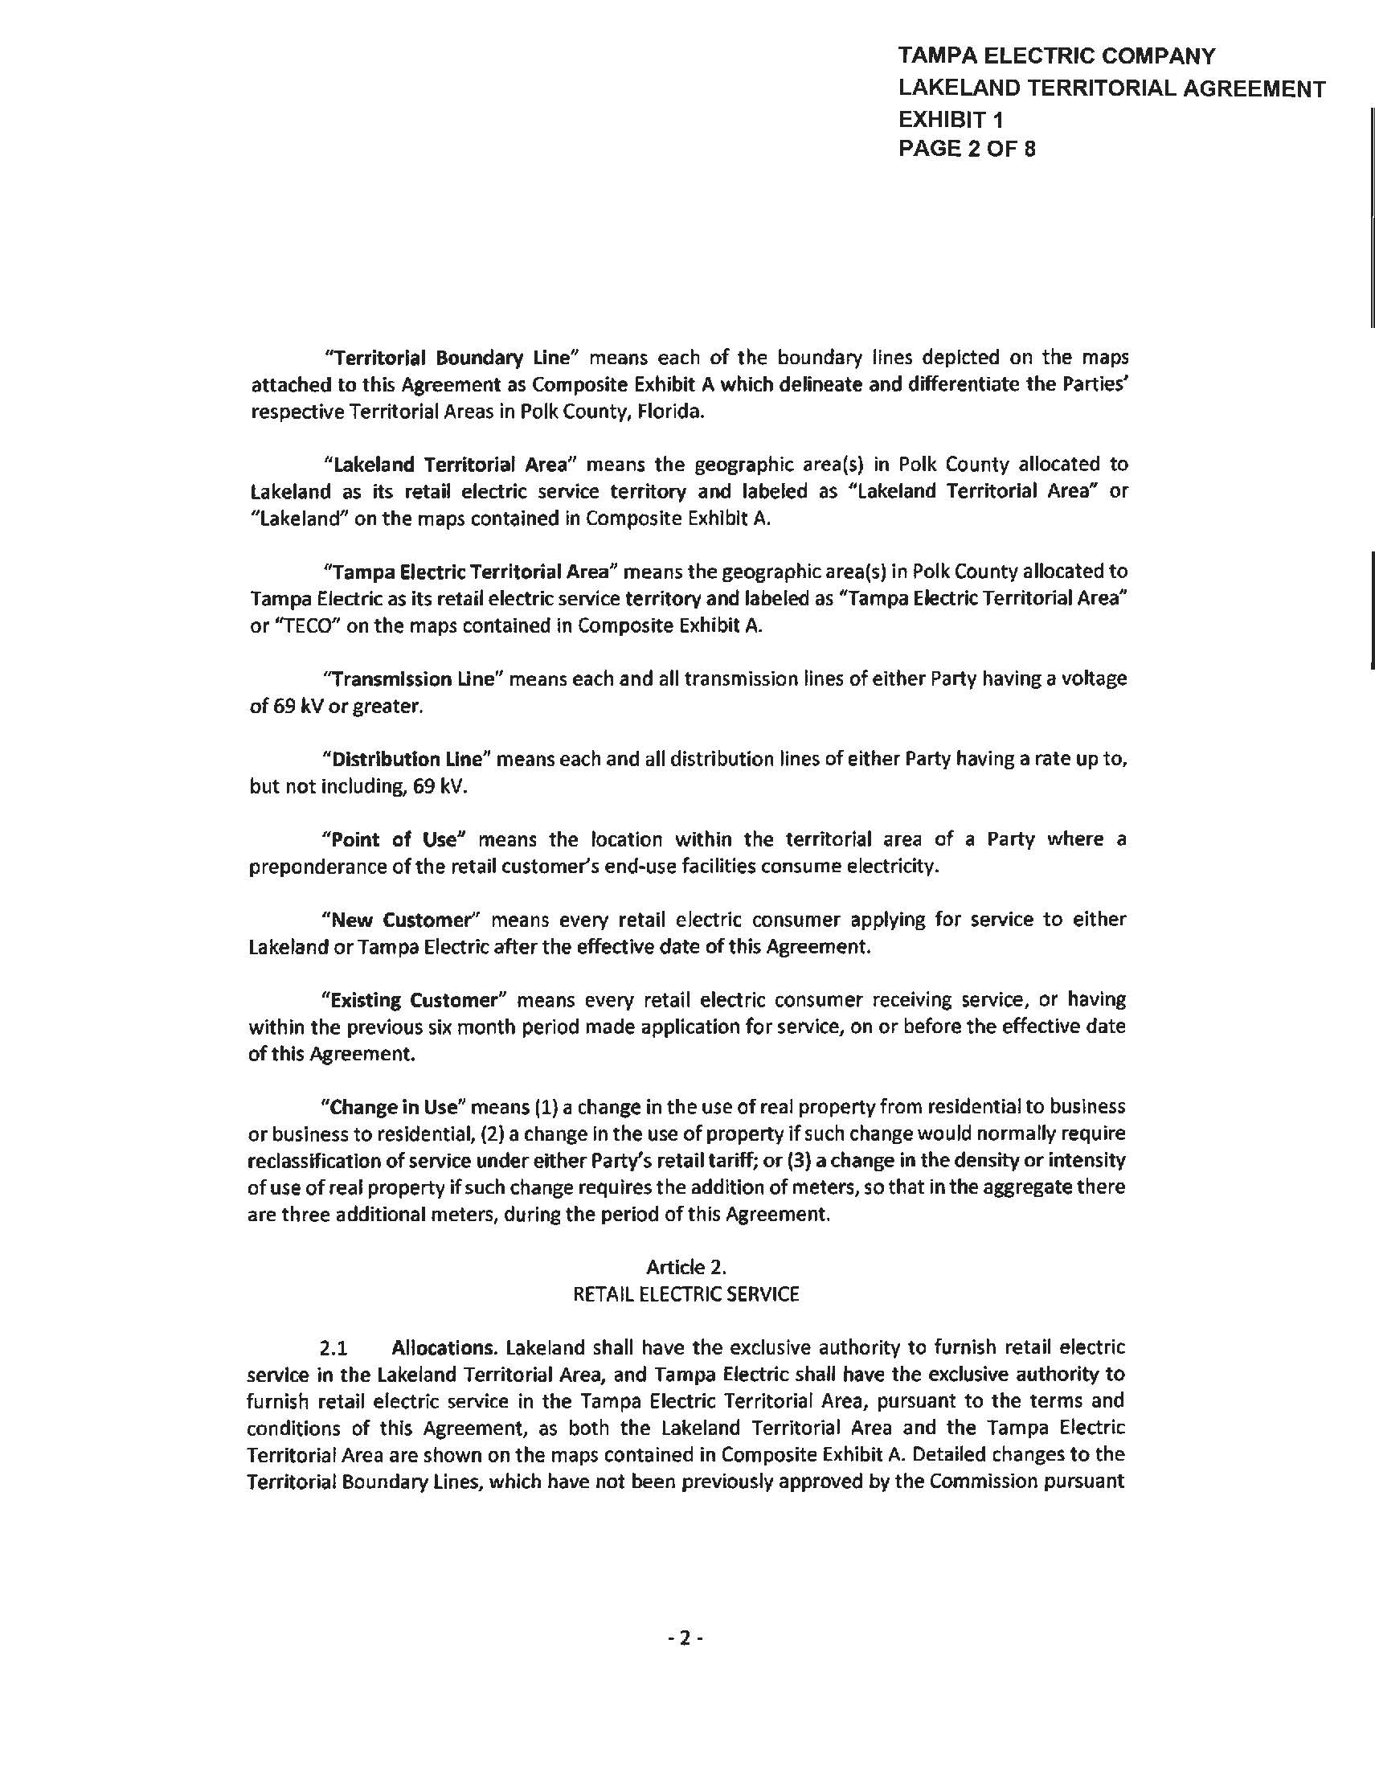

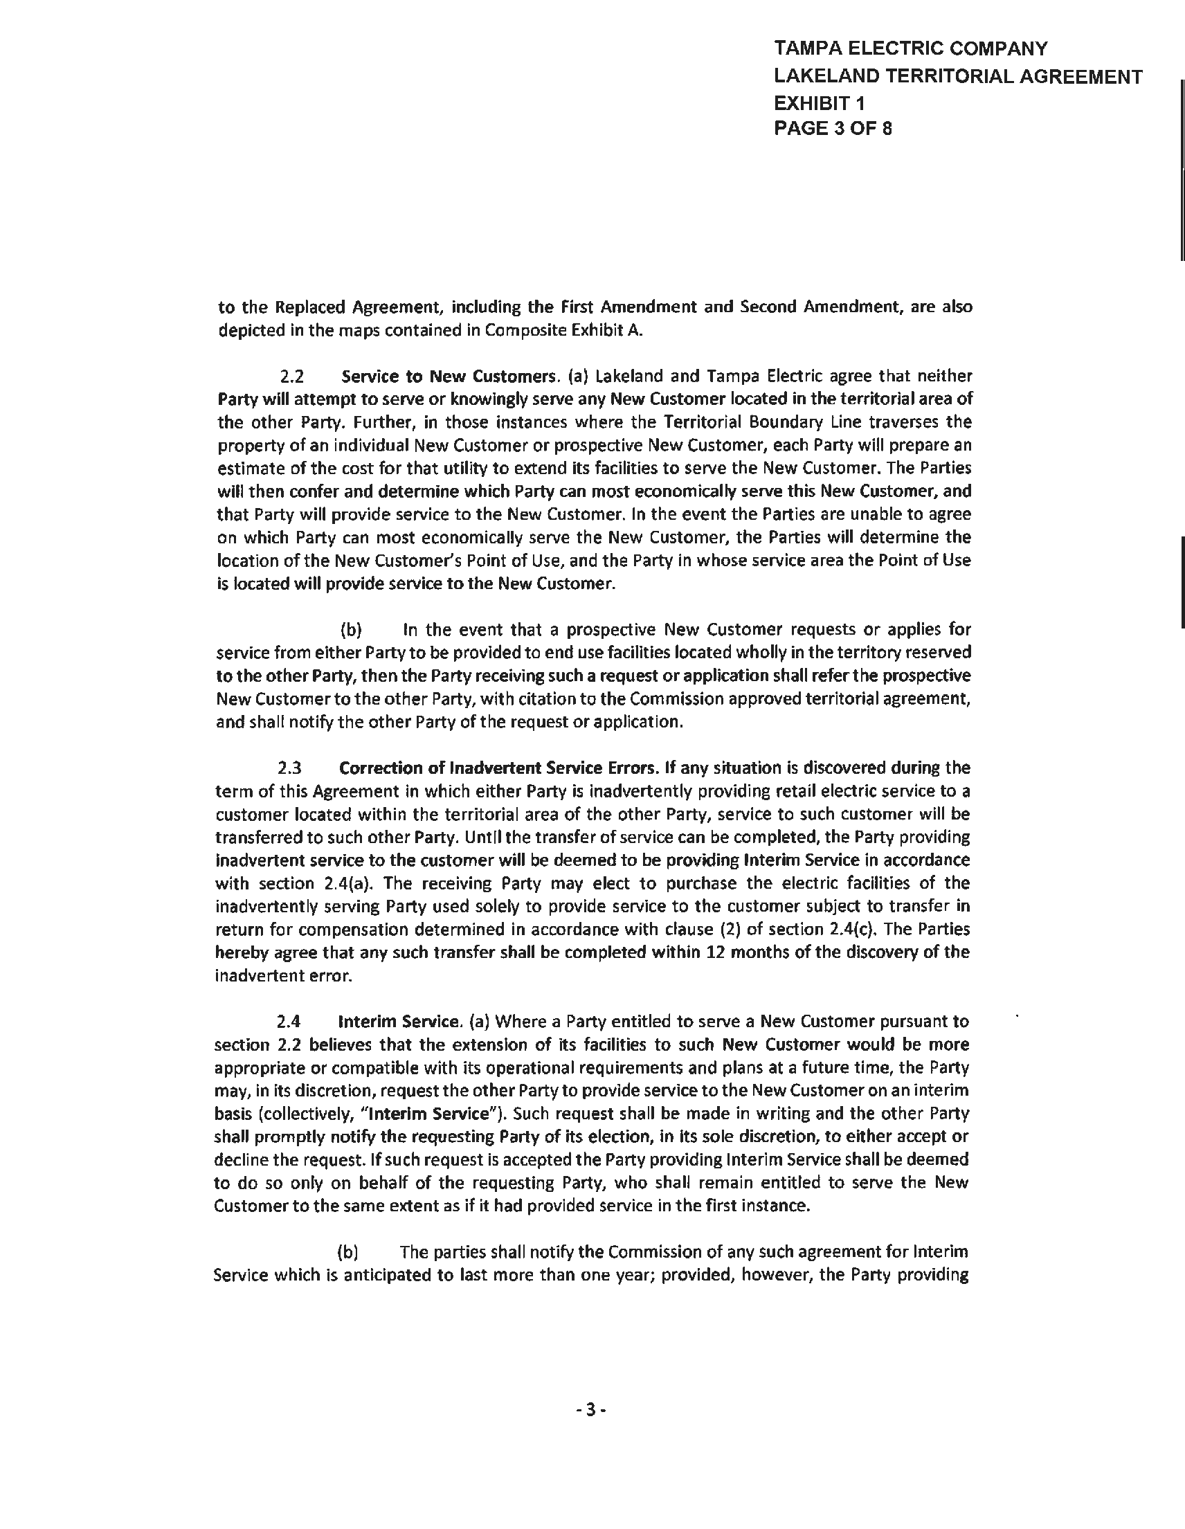

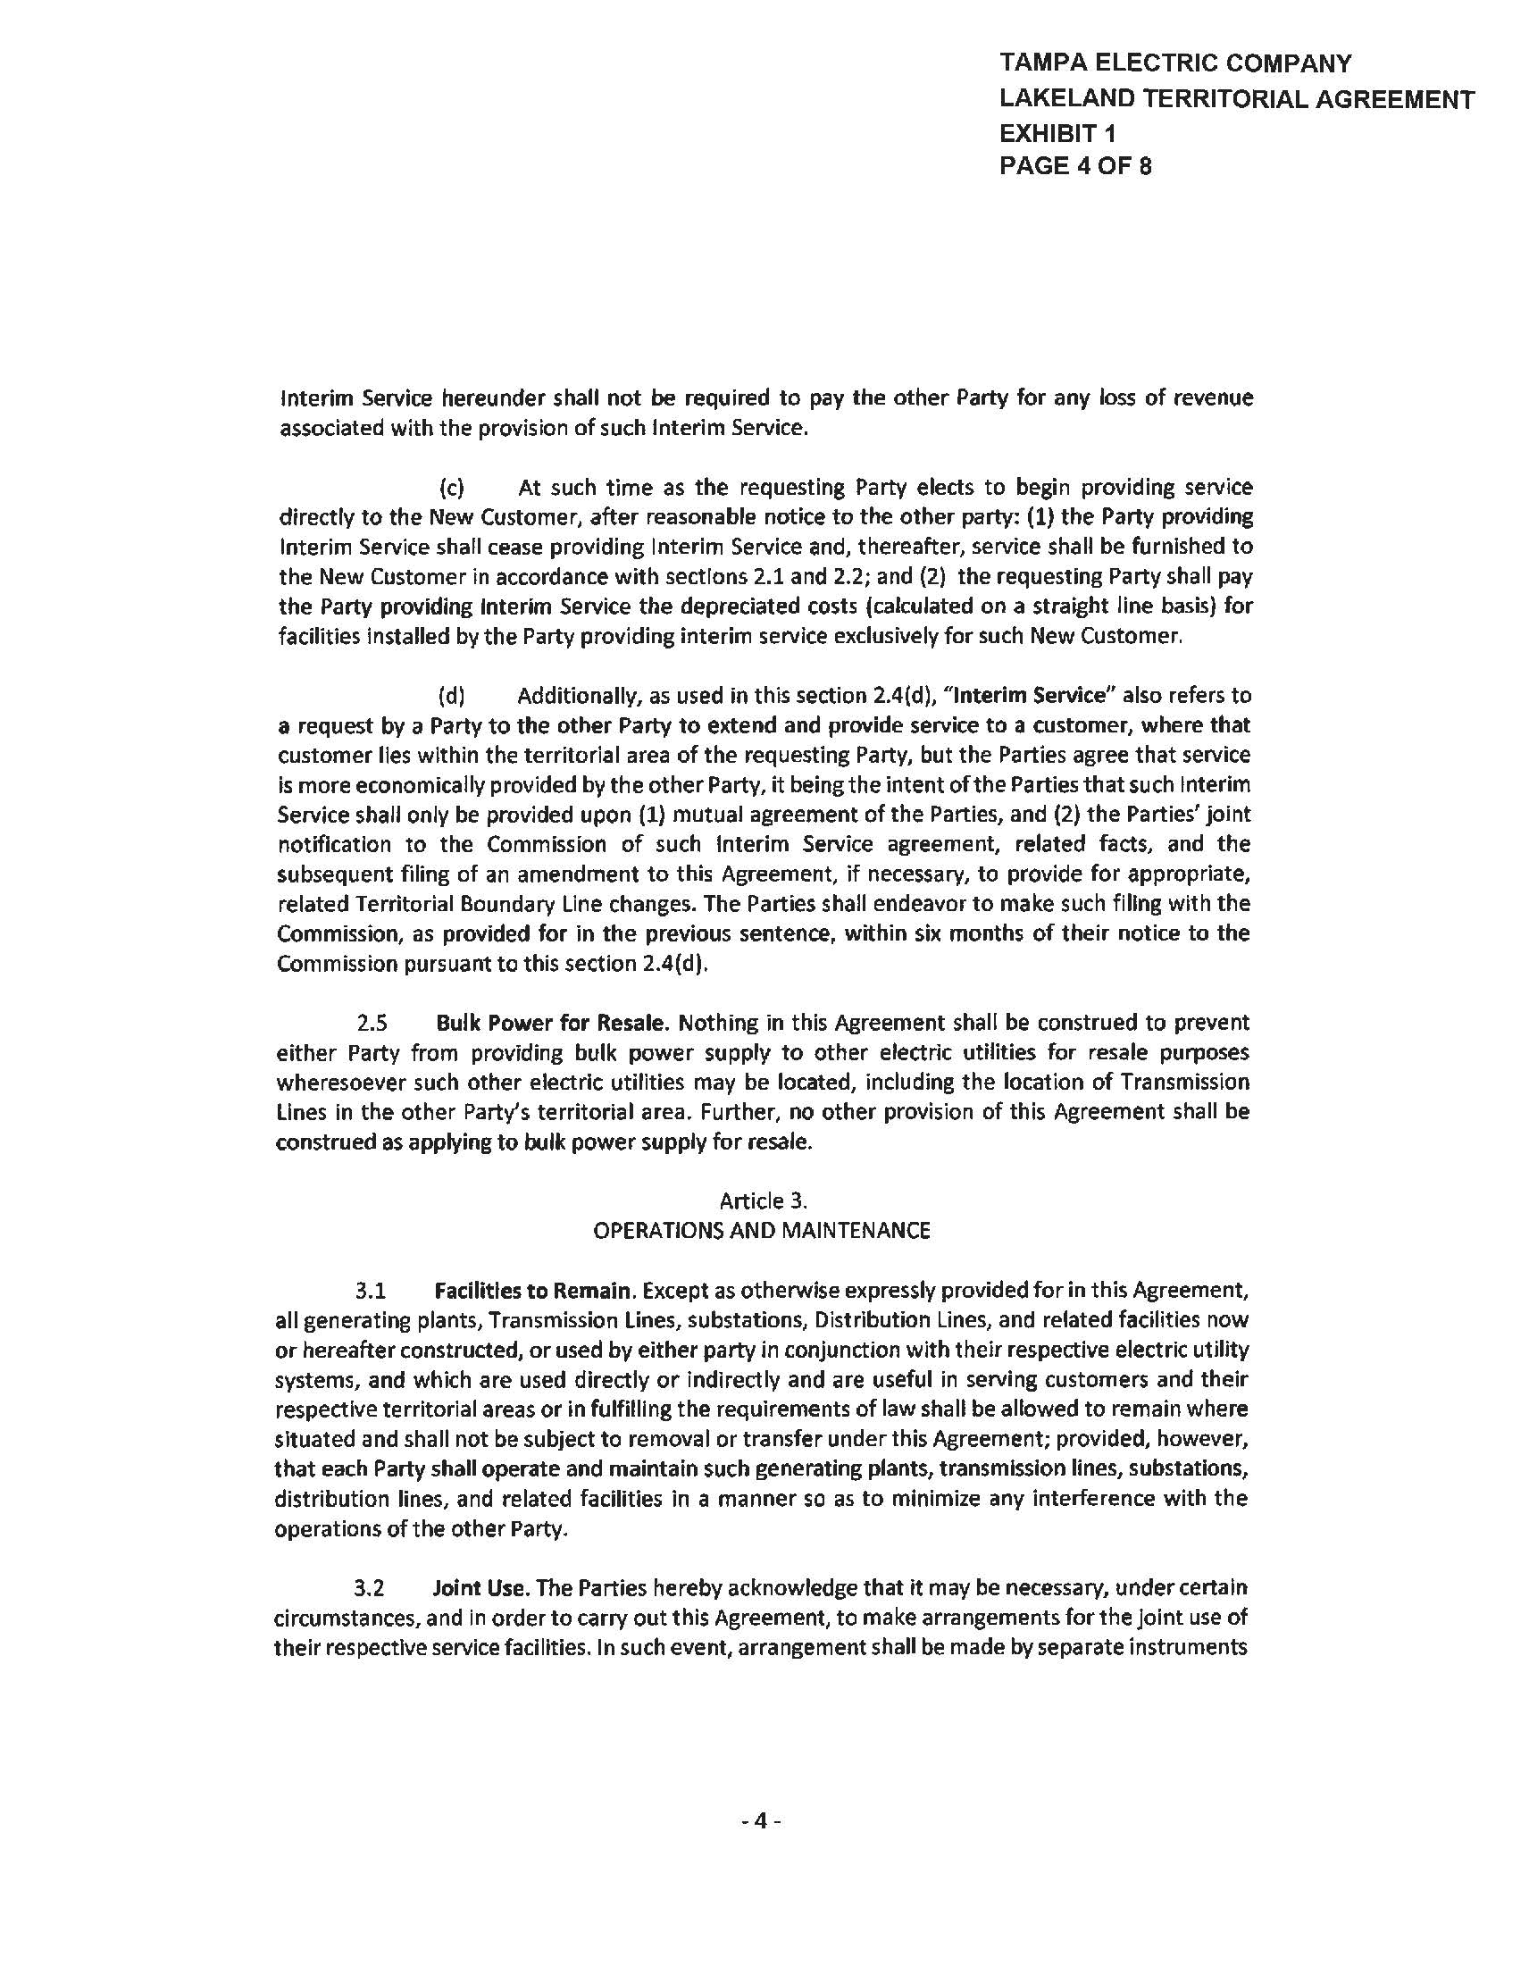

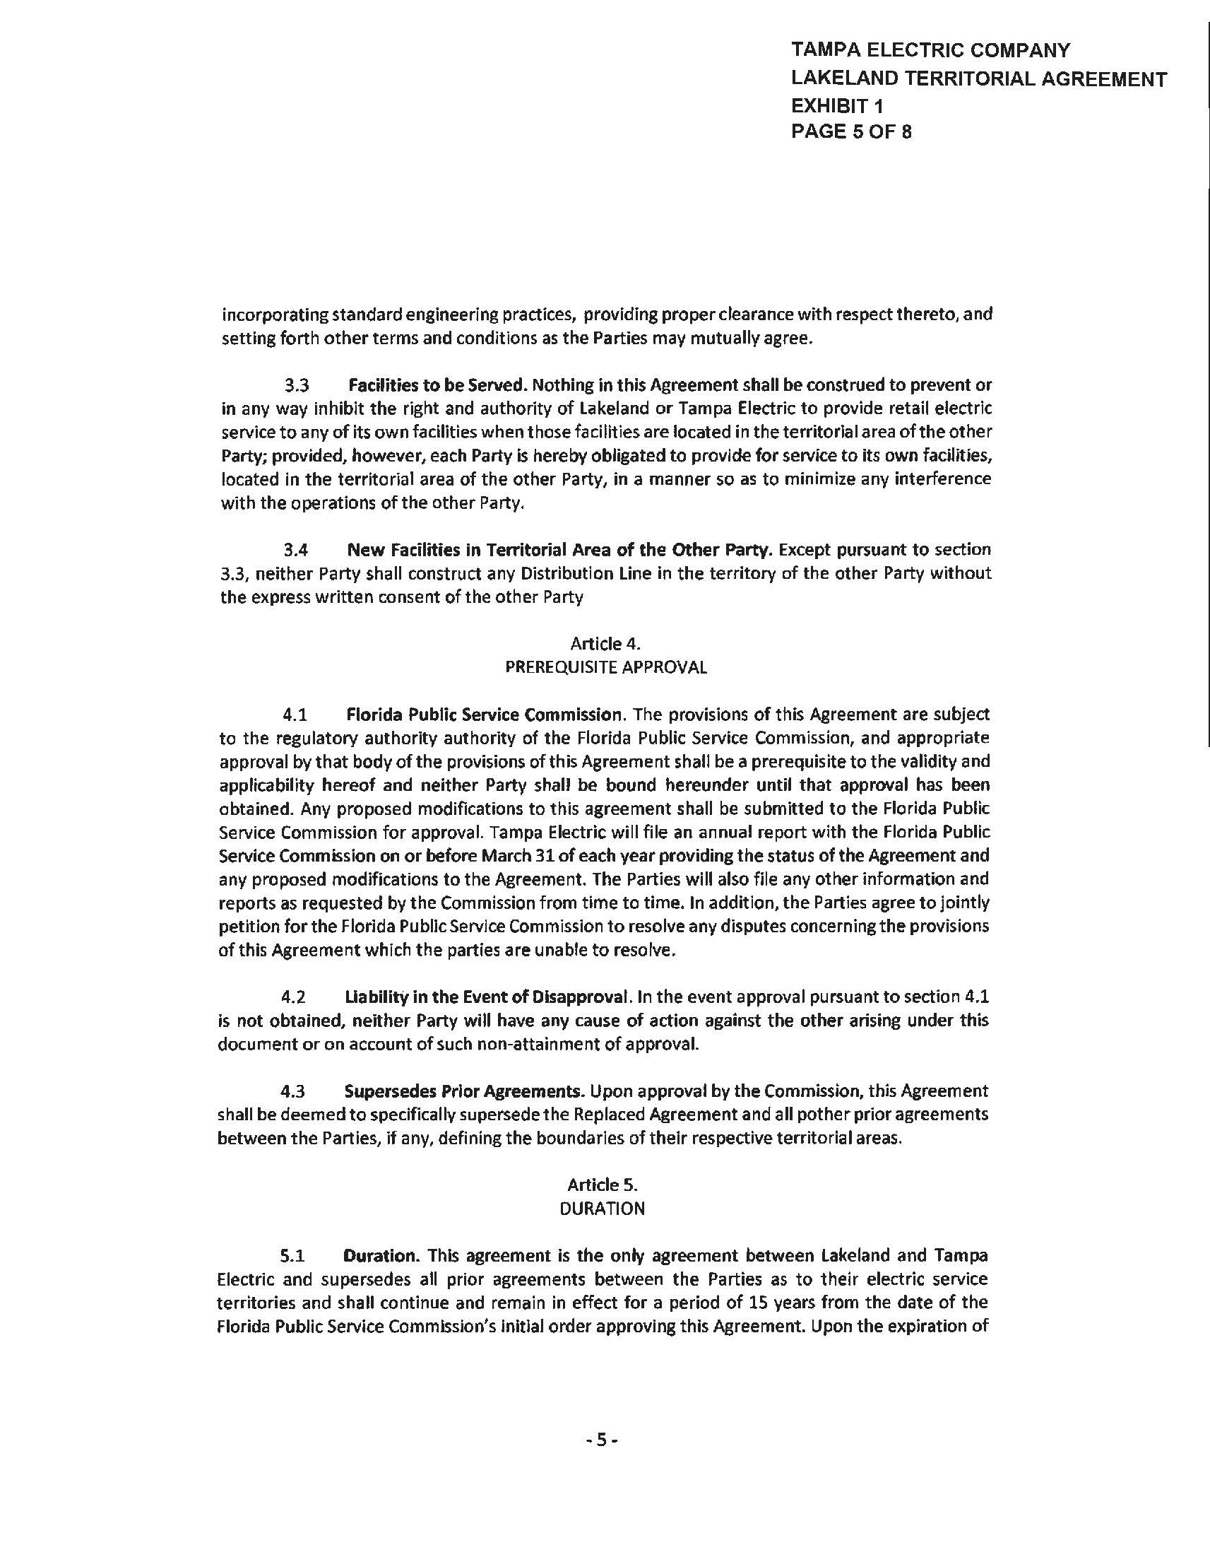

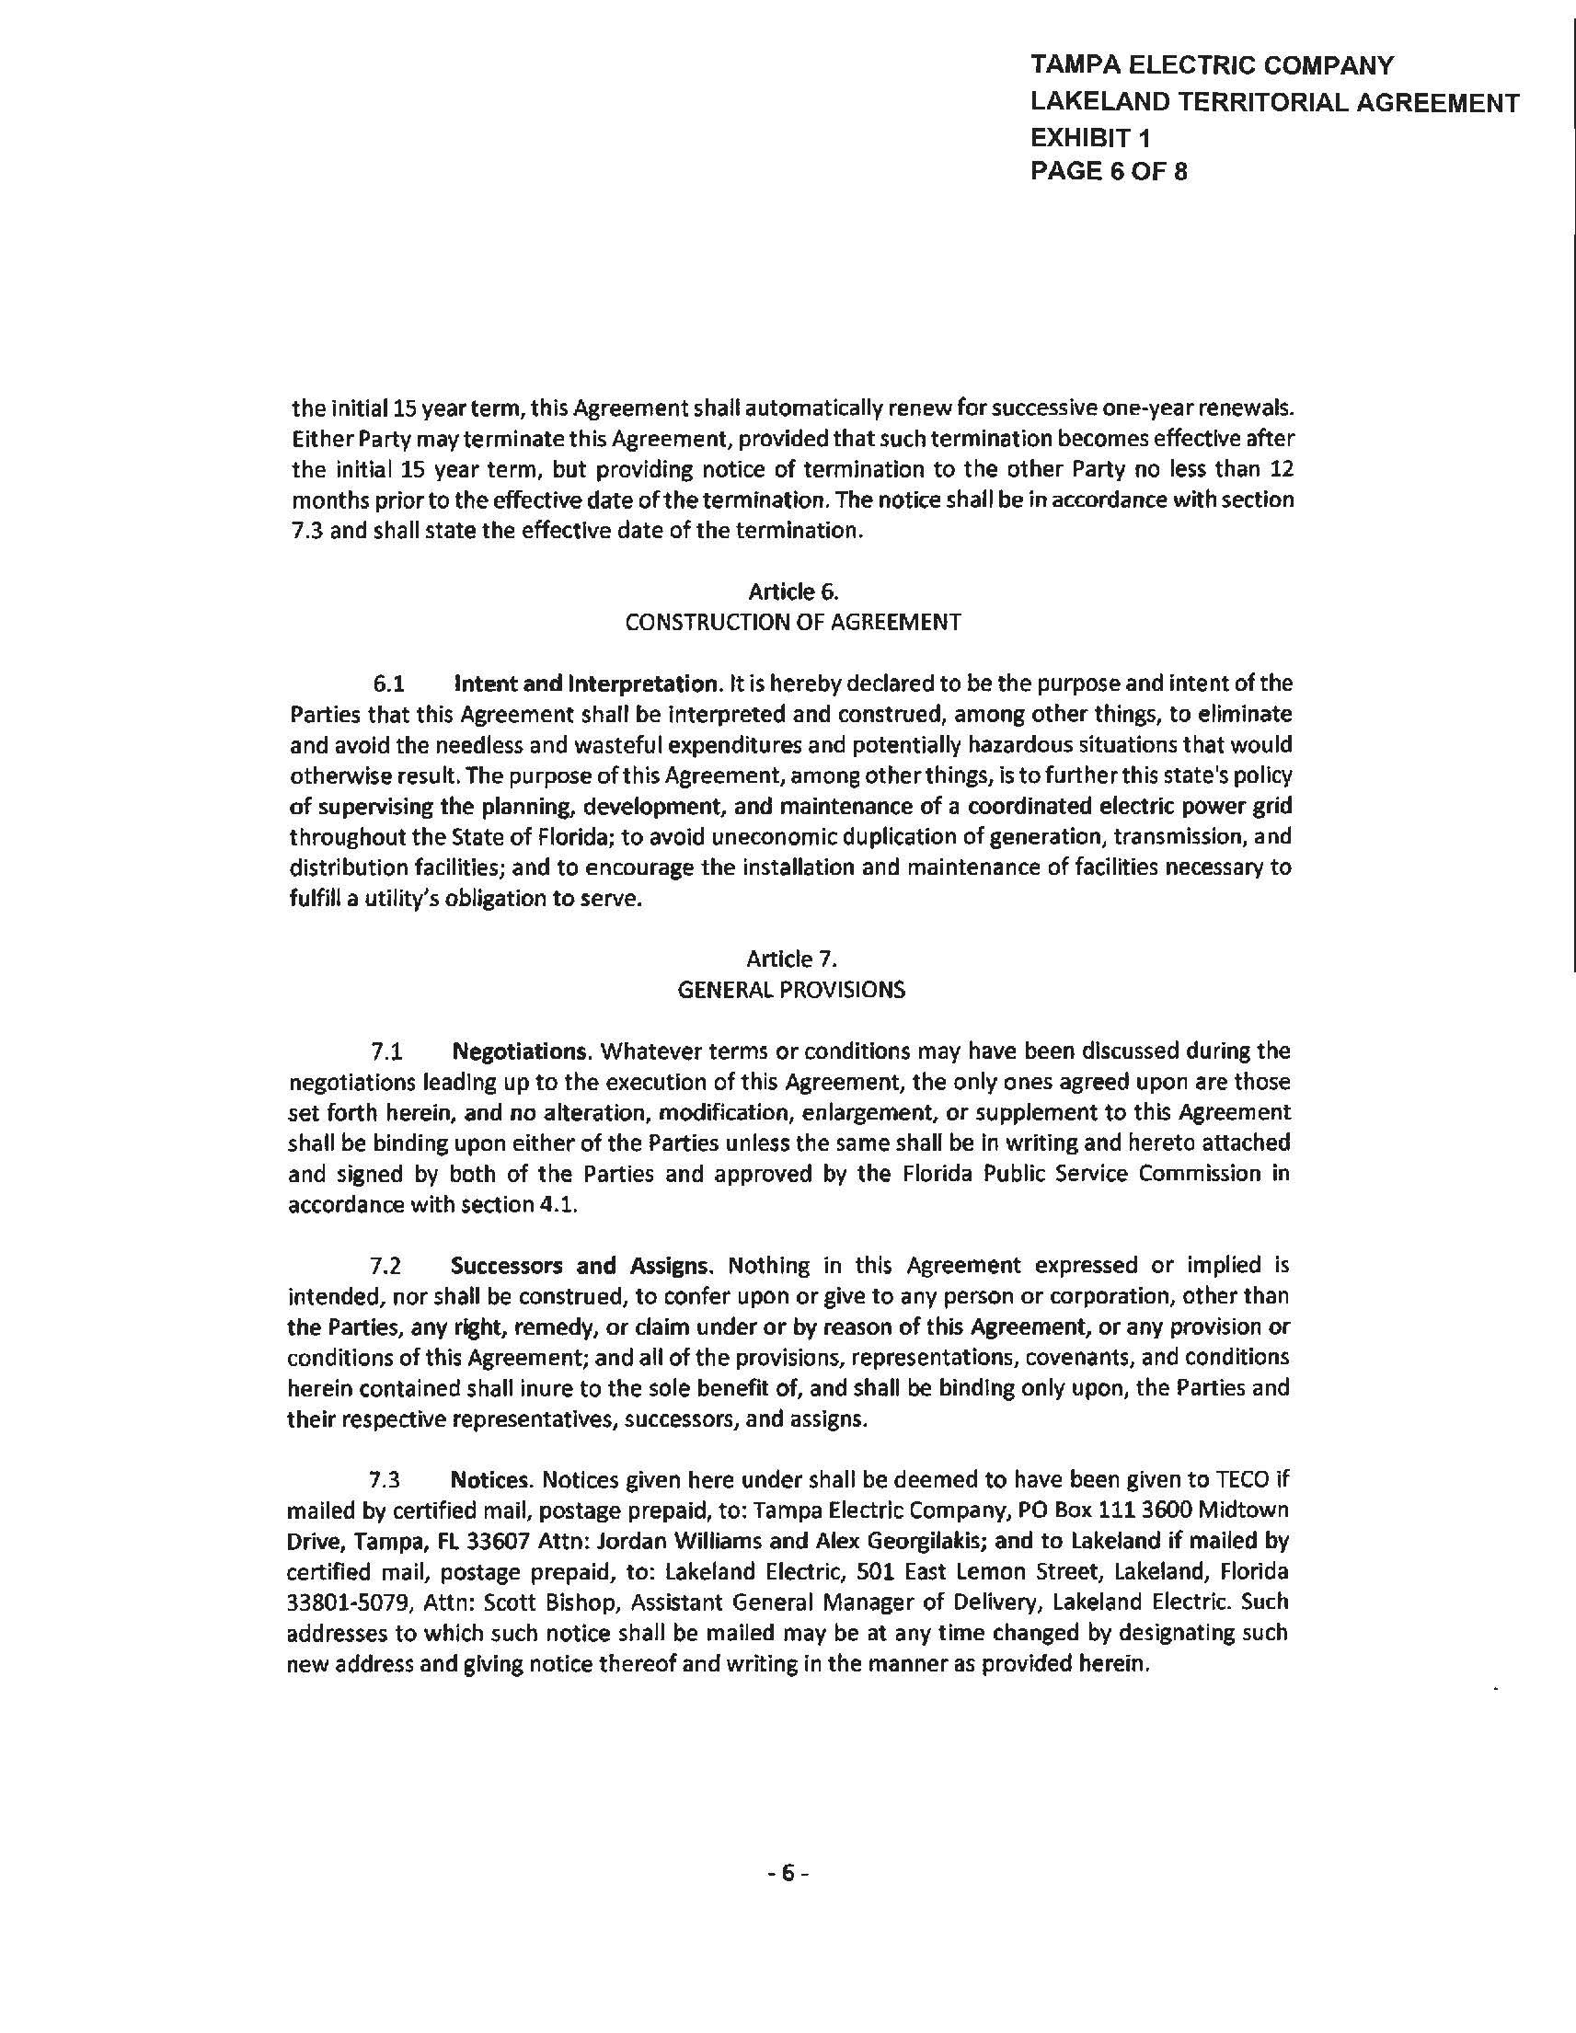

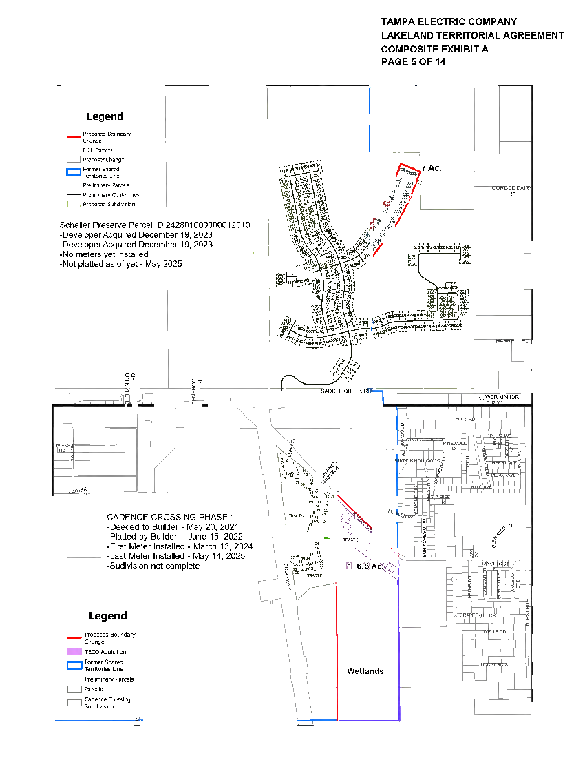

TAMPA ELECTRIC COMPANY LAKELAND TERRITORIAL AGREEMENT COMPOSITE EXHIBIT A SUPPLEMENTAL PAGE 8 OF 14
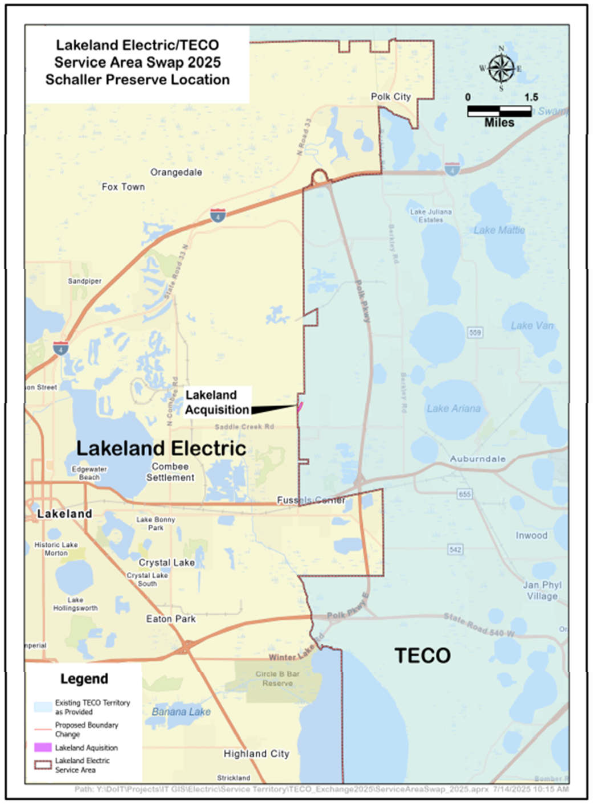

TAMPA ELECTRIC COMPANY LAKELAND TERRITORIAL AGREEMENT COMPOSITE EXHIBIT A SUPPLEMENTAL PAGE 9 OF 14
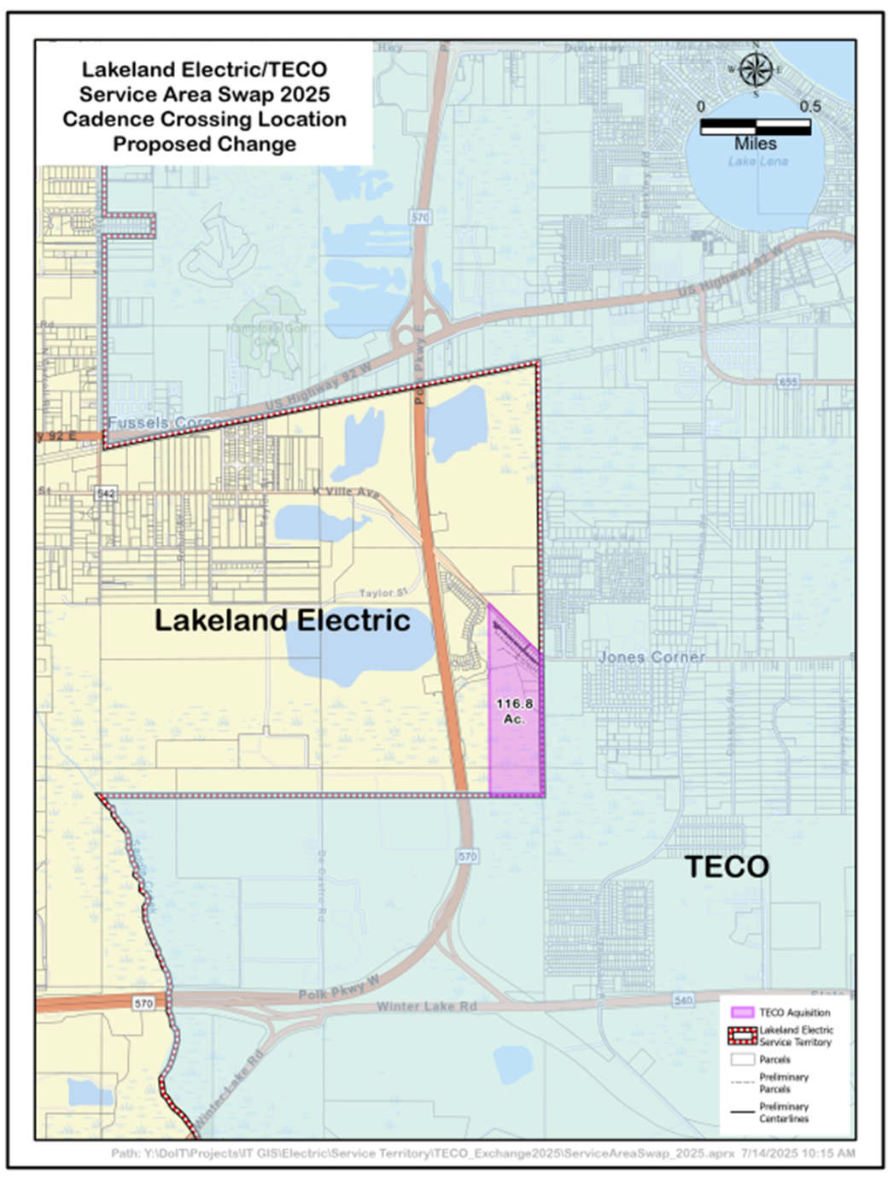

TAMPA ELECTRIC COMPANY LAKELAND TERRITORIAL AGREEMENT COMPOSITE EXHIBIT A SUPPLEMENTAL PAGE 10 OF 14
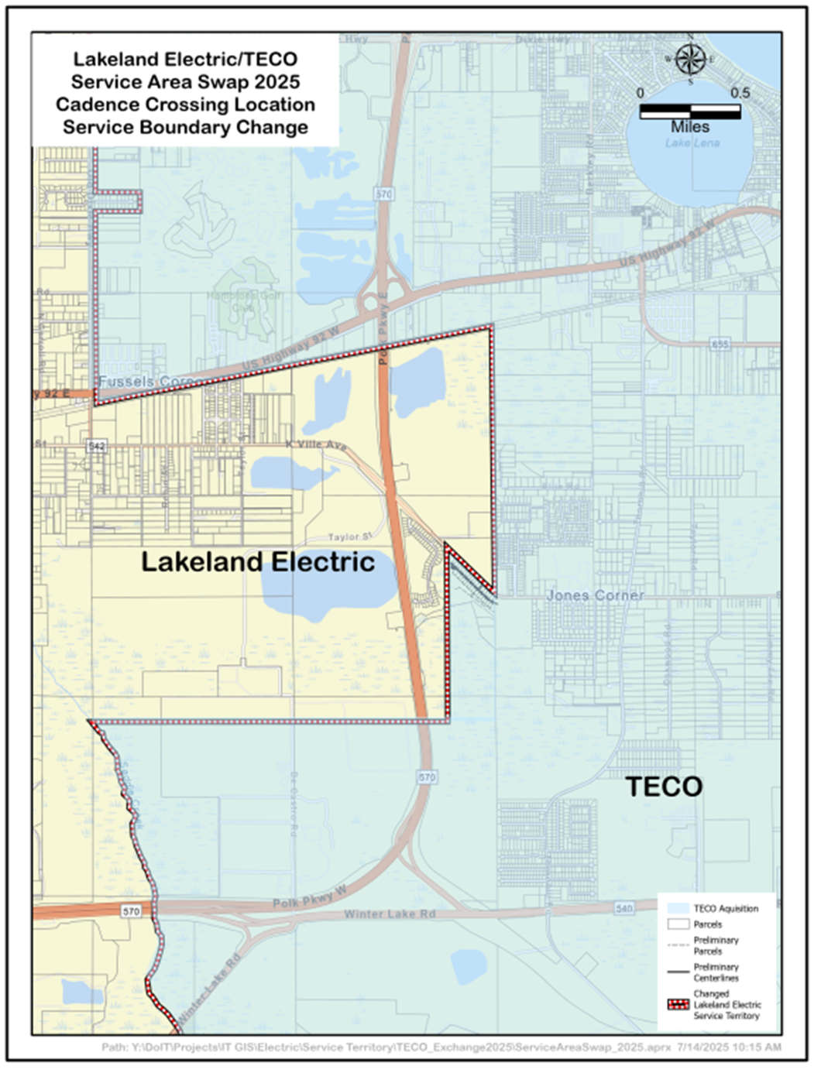

TAMPA ELECTRIC COMPANY LAKELAND TERRITORIAL AGREEMENT COMPOSITE EXHIBIT A SUPPLEMENTAL PAGE 11 OF 14
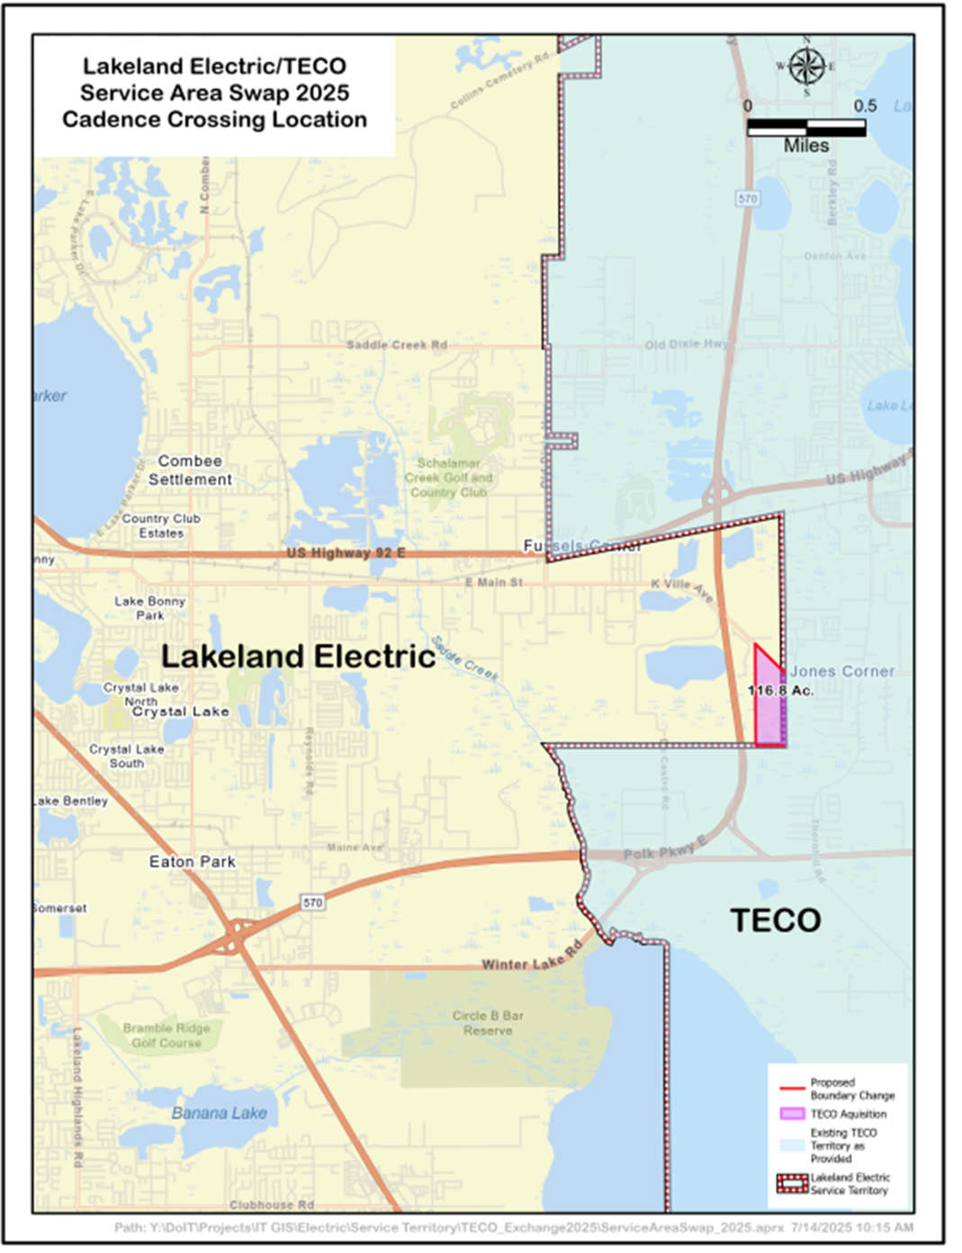

TAMPA ELECTRIC COMPANY LAKELAND TERRITORIAL AGREEMENT COMPOSITE EXHIBIT A SUPPLEMENTAL PAGE 12 OF 14
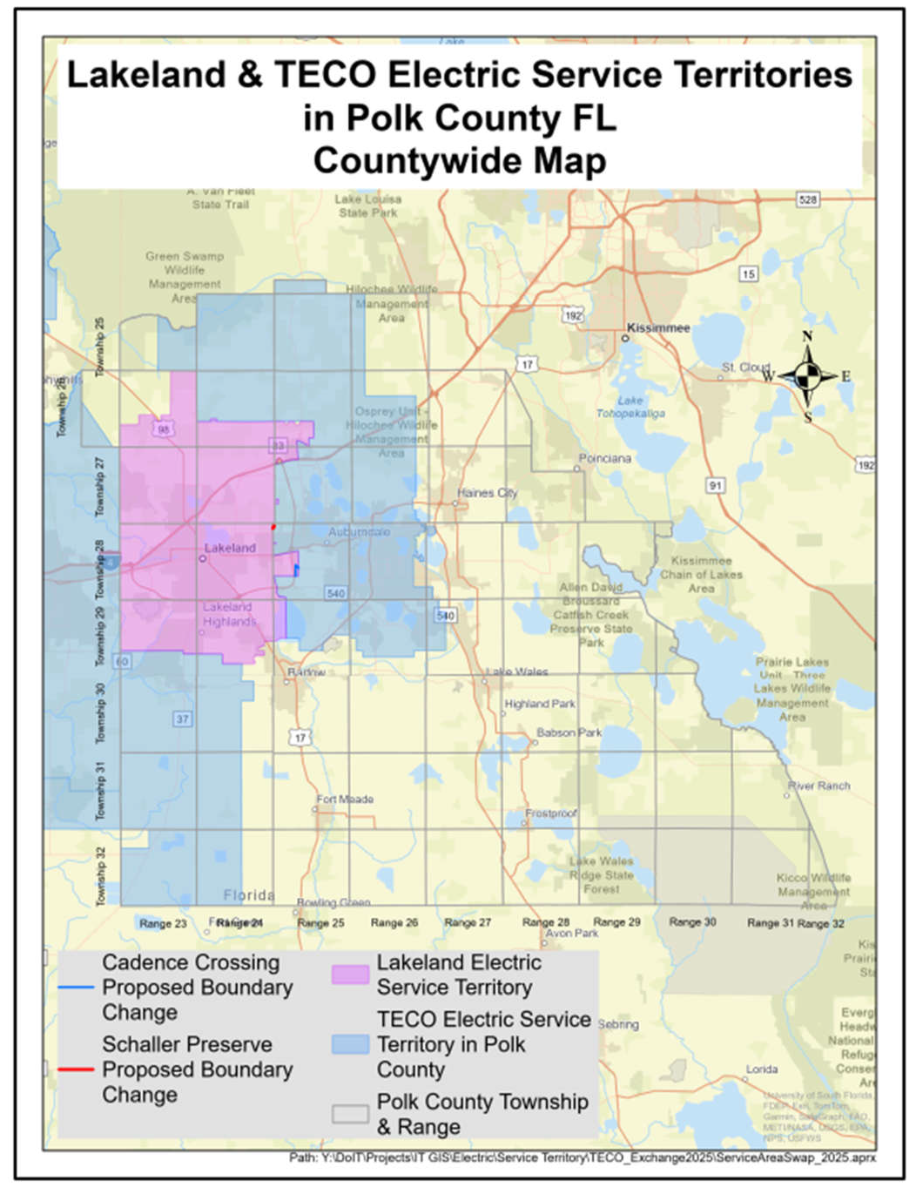

TAMPA ELECTRIC COMPANY LAKELAND TERRITORIAL AGREEMENT COMPOSITE EXHIBIT A SUPPLEMENTAL PAGE 13 OF 14
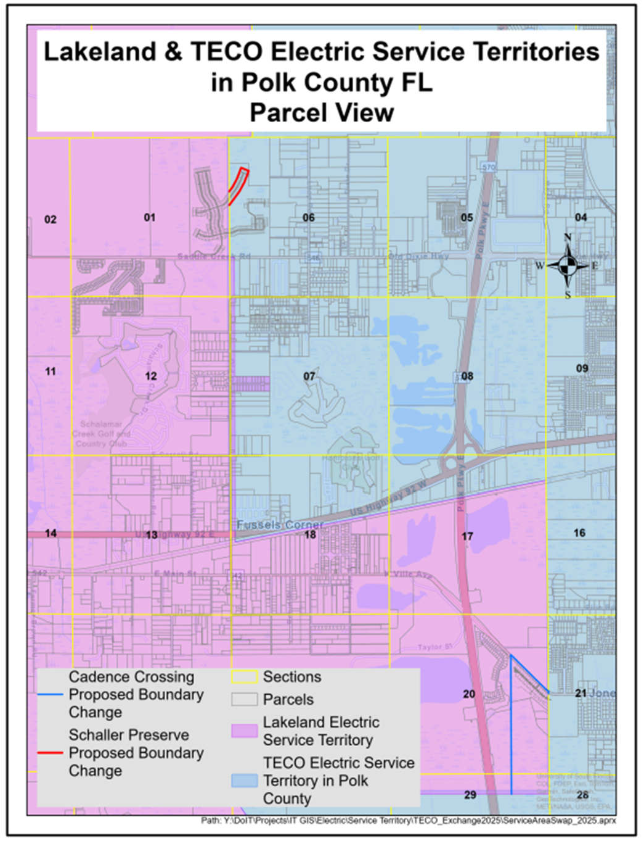

Order No. PSC-92-0570-FOF-EU, issued June 25, 1992, in Docket No. 920251-EU, In re: Joint Petition of Tampa Electric Company and the City of Lakeland for Approval of Territorial Agreement.
Order No. PSC-99-0024-FOF-EU, issued January 4, 1999, in Docket No. 981263-EU, In re: Joint Petition of Tampa Electric Company and the City of Lakeland for Approval of Amendment to Territorial Agreement; Order No. PSC-14-0268-PAA-EU, issued May 28, 2014, in Docket No. 140054-EU, In re: Joint Petition of Tampa Electric Company and City of Lakeland For Approval of Second Amendment to Territorial Agreement.
Order No. PSC-2025-0089-PAA-EU, issued March 24, 2025, in Docket No. 20240171-EU, In re: Joint Petition for Approval of Temporary Services by Tampa Electric Company and the City of Lakeland.
Utilities Commission of the City of New Smyrna Beach v. Florida Public Service Commission, 469 So. 2d 731 (Fla.1985).
Document No. 06532-2025, Joint Petitioners’ response to Staff’s First Data Request, No. 2.a.
Document No. 05324-2025, Joint Petition, paragraph 17.d–g.
Document No. 06532-2025, joint petitioners’ response to Staff’s First Data Request, Nos 6.c, 6.d., and 6.e.
Ibid, No. 2.a.
Ibid, No. 1.a.
Ibid.

