State of Florida   |  | Public Service Commission  Capital Circle Office Center ● 2540 Shumard Oak Boulevard  Tallahassee, Florida 32399-0850  -M-E-M-O-R-A-N-D-U-M-
DATE: | October 23, 2025
TO: | Office of Commission Clerk (Teitzman)
FROM: | Division of Economics (P. Kelley, Hampson)  Division of Accounting and Finance (Gatlin, Mason)  Division of Engineering (P. Buys, Davis)  Office of the General Counsel (Marquez, Stiller)
RE: | Docket No. 20250112-EI – Petition for approval of 2026 subsequent year adjustment, by Tampa Electric Company.
AGENDA: | 11/04/25 – Regular Agenda – Tariff Filing – Interested Persons May Participate
COMMISSIONERS ASSIGNED: |  |  | All Commissioners
PREHEARING OFFICER: |  |  | Administrative
CRITICAL DATES: |  |  | 11/04/25 (60-Day Suspension Waived until 11/04/25)
SPECIAL INSTRUCTIONS: |  |  | None

Case Background
On September 4, 2025, Tampa Electric Company (TECO) filed a petition seeking approval to implement its 2026 subsequent year adjustment (SYA). The Florida Public Service Commission (Commission) approved the 2026 SYA in its final order addressing TECO’s request for base rate increase, Order No. PSC-2025-0038-FOF-EI (Rate Case Order). Pages 151–169 of the Rate Case Order discuss the 2026 SYA, including the specific projects and their associated incremental operating and maintenance (O&M) expense, depreciation expense, and investment tax credit amortization. Based on Commission-approved adjustments to each of the projects, the total approved 2026 SYA revenue requirement was $86,627,795.
The Rate Case Order further required TECO to file its proposed 2026 SYA rates for approval in September 2025, with rates effective the first billing cycle of January 2026. In addition, the Rate Case Order required TECO to verify the in-service dates of all projects and use the then-current billing determinates.
On June 11, 2025, the Commission granted in part and denied in part the Office of Public Counsel’s Motions for Reconsideration and Clarification of the Rate Case Order by Order No. PSC-2025-0203-FOF-EI (Reconsideration Order). There the Commission agreed that inadvertent errors in the underlying calculations of the revenue requirement should be corrected, resulting in a revenue requirement increase of $1.1 million. After accounting for the original balance from the Rate Case Order, this meant that the total 2026 SYA revenue requirement was now $87,727,795.
Pursuant to Section 366.06(3), Florida Statutes (F.S.), the Commission may withhold consent to any portion of new rate schedules for good cause shown provided such notice is given within 60 days. On September 15, 2025, TECO waived the 60-day suspension deadline until the November 4, 2025 Agenda Conference. Staff issued one data request during the evaluation of the petition, with responses filed by TECO on October 3, 2025. Attachment A to the recommendation contains the proposed legislative tariff sheets that would implement the 2026 SYA. The Commission has jurisdiction over this matter pursuant to Sections 366.05(1)(e), 366.06 and 366.076, F.S.

Discussion of Issues

Issue 1:
Should the Commission approve TECO’s proposed rates and associated tariffs to implement its 2026 subsequent year adjustment?

Recommendation:
Yes. The Commission should approve TECO’s proposed rates and associated tariffs to implement its 2026 SYA, because the project timelines, rates, and associated tariffs are consistent with the Commission’s prior decision in the Rate Case Order. The rates have been calculated to recover a total 2026 SYA revenue requirement of $87,727,795 as previously approved by the Commission and as presented in Exhibit 1 of TECO’s petition. Consistent with the Rate Case Order, the associated tariffs, included as Attachment A to this recommendation, should become effective with the first billing cycle of January 2026. (P. Kelley)

Staff Analysis:
The Polk 1 Flexibility, Energy Storage, Corporate Headquarters, Bearss Operations Center, South Tampa Resilience, GRR (PLTE Spectrum), and Cottonmouth and Long Branch Solar Projects went into service in 2025 or are expected to be in-service by the end of 2025. Two Polk Fuel Diversity Project unit upgrades are expected to be in-service in 2026. TECO submitted sworn affidavits in support thereof. Additionally, staff conducted discovery on the in-service dates estimated for the projects. TECO provided additional detail regarding the original in-service dates, the Commission-ordered in-service dates, most recent anticipated in-service dates, clarification, and an explanation for any adjustments to the projects. All relevant projects appear on track to meet the timeframes contained in the Rate Case Order.
TECO’s petition included the proposed tariff sheets, the allocation of the revenue increase to the various rate classes, and calculations showing the revenue from the sale of electricity by rate schedule under current and proposed rates. Staff conducted discovery on the underlying rate calculations. Consistent with the Rate Case Order and the Reconsideration Order, the total amount to be collected through the 2026 SYA is $87,727,795. Exhibit 1 of TECO’s petition presents a calculation of this amount. Also, consistent with the Rate Case Order, TECO used the most recent billing determinants, which were also used for TECO’s cost recovery clause projection filings, to calculate the 2026 SYA base rates.
The base rate portion of a monthly residential electric bill for 1,000 kilowatt-hours would increase from the current $97.47 to $102.98, which is an increase of $5.51. TECO stated it would provide notice of the proposed rate increase with its December bills.

Conclusion

The Commission should approve TECO’s proposed rates and associated tariffs to implement the 2026 SYA because the project timelines, rates, and associated tariffs are consistent the Commission’s prior decision in the Rate Case Order. The rates have been calculated to recover a total 2026 SYA revenue requirement of $87,727,795 as previously approved by the Commission and as presented in Exhibit 1 of TECO’s petition. Consistent with the Rate Case Order, the associated tariffs, included as Attachment A to this recommendation, should become effective with the first billing cycle of January 2026.
Issue 2:
Should this docket be closed?

Recommendation:
If Issue 1 is approved and a protest is filed within 21 days of the issuance of the Order by a person whose substantial interests are affected, the tariff should remain in effect, with any incremental revenues held subject to refund, pending resolution of the protest. If no timely protest is filed, this docket should be closed upon the issuance of a Consummating Order. (Marquez, Stiller)

Staff Analysis:
If Issue 1 is approved and a protest is filed within 21 days of the issuance of the Order by a person whose substantial interests are affected, the tariff should remain in effect, with any incremental revenues held subject to refund, pending resolution of the protest. If no timely protest is filed, this docket should be closed upon the issuance of a Consummating Order.

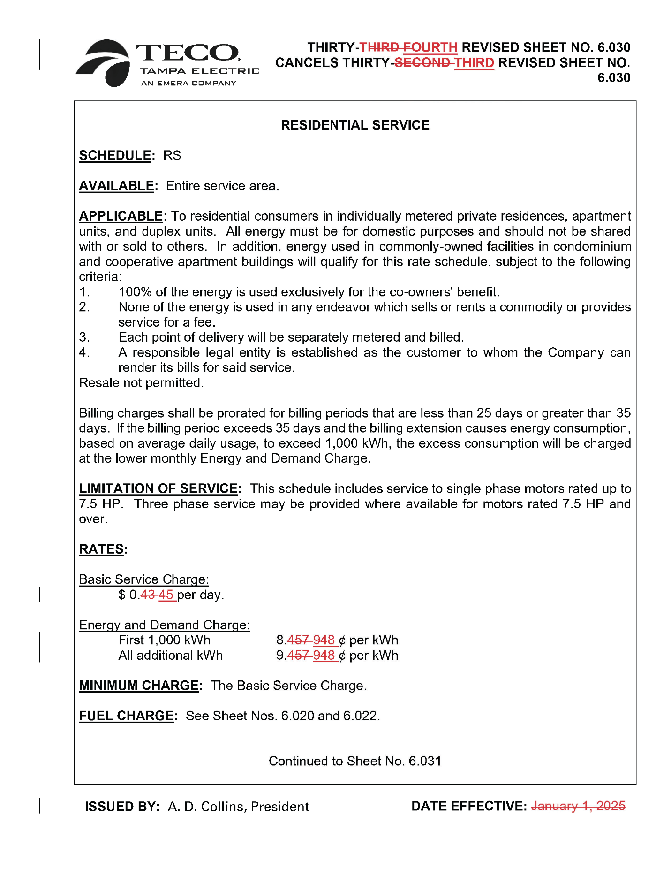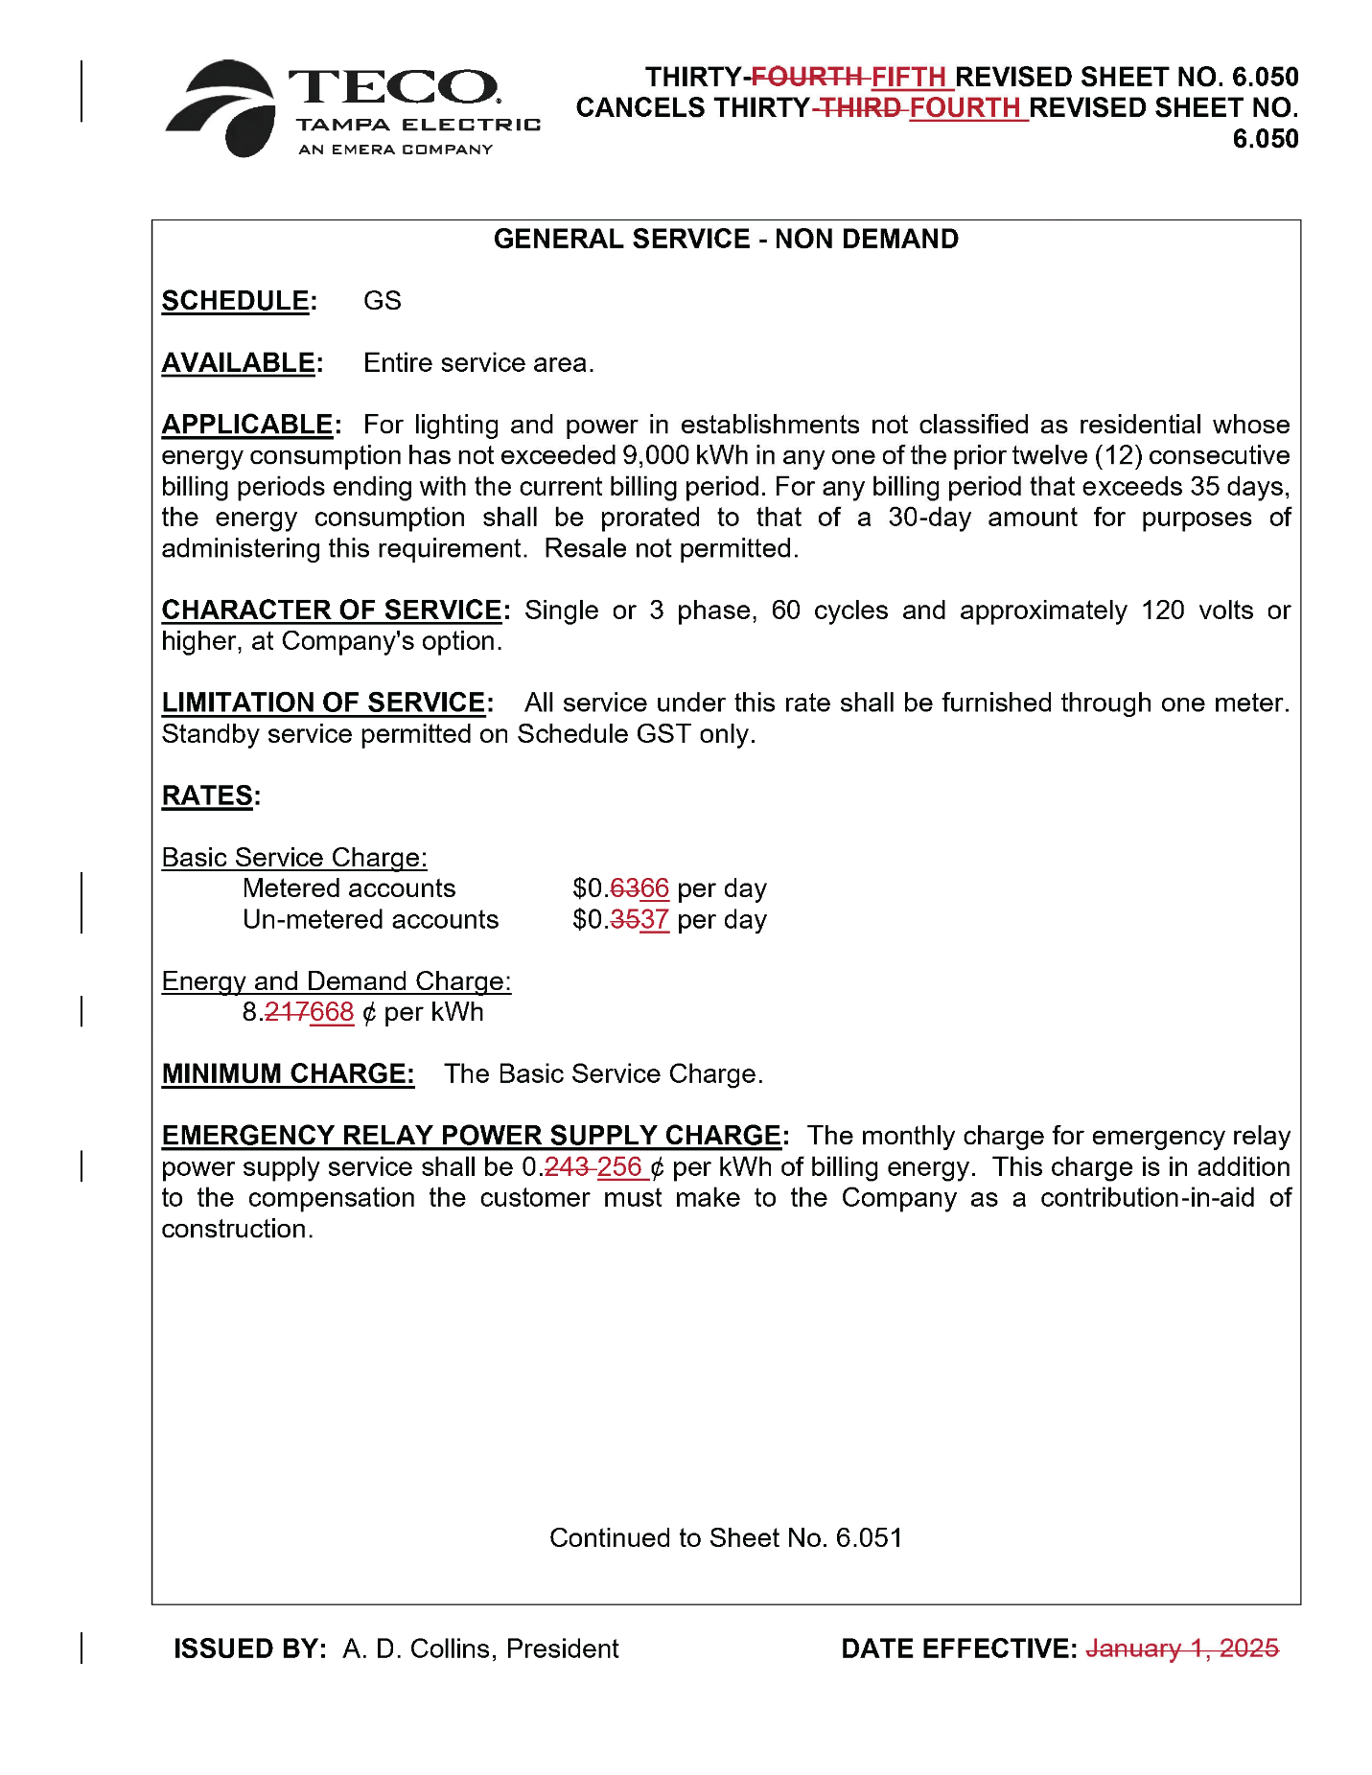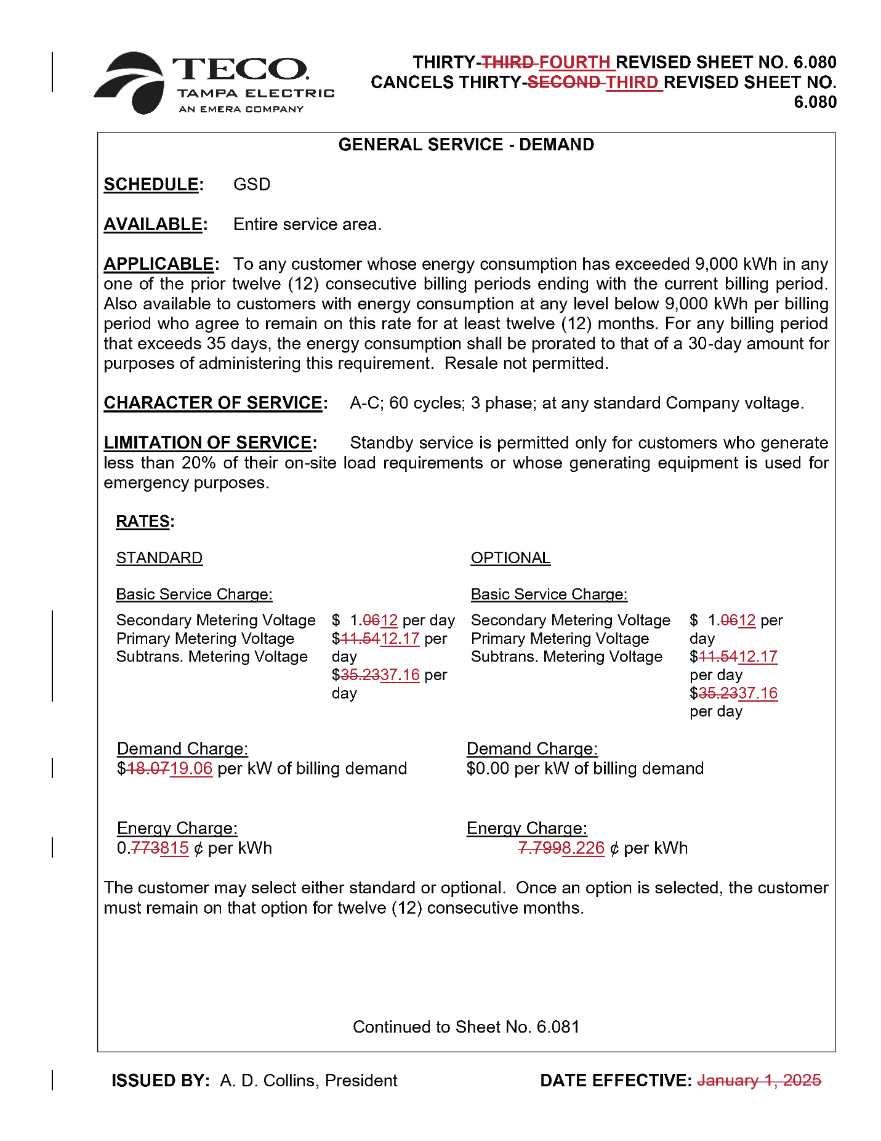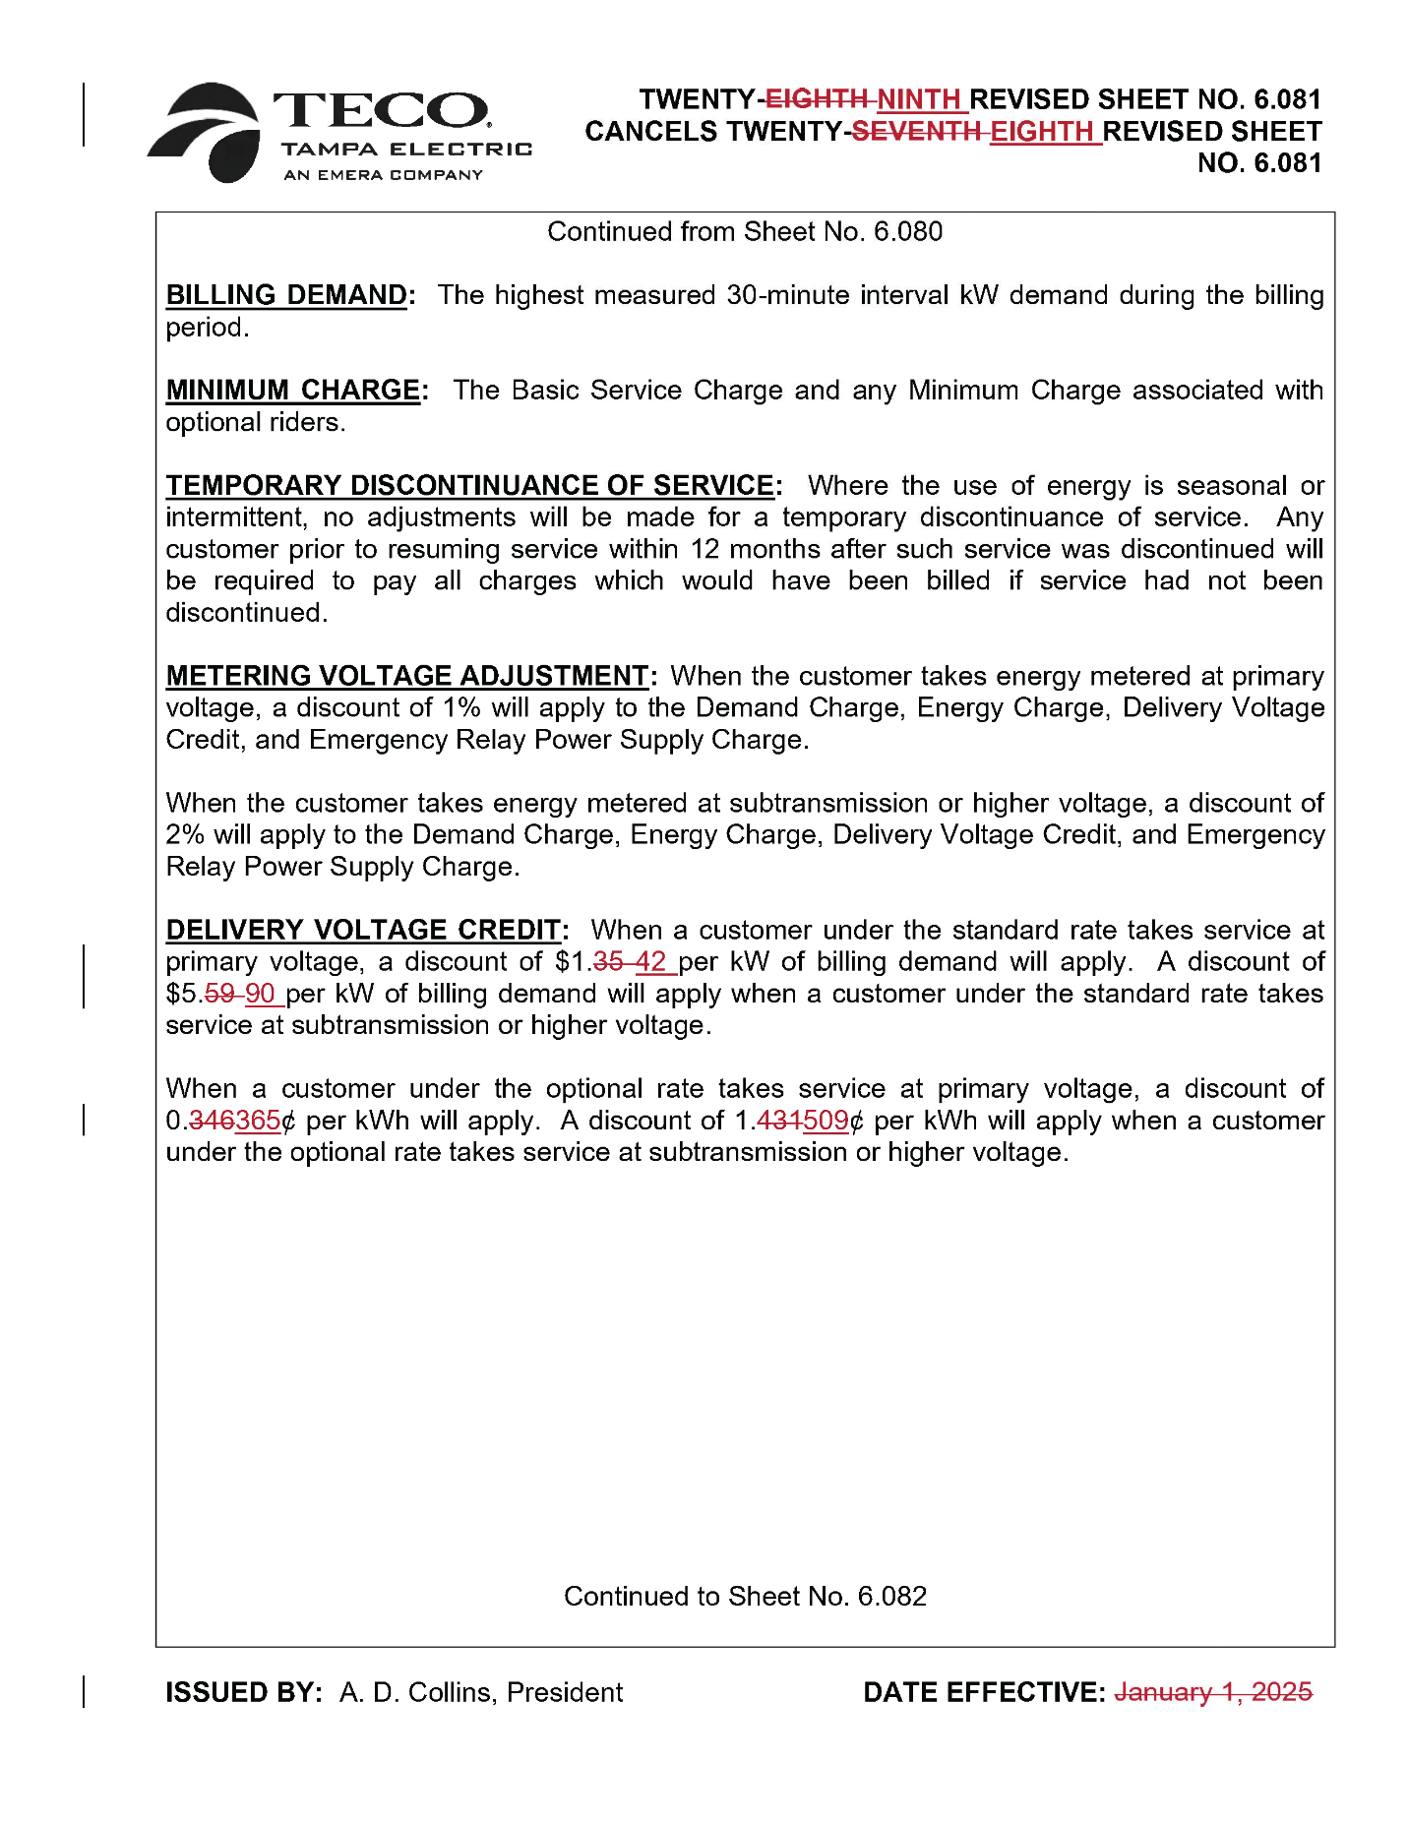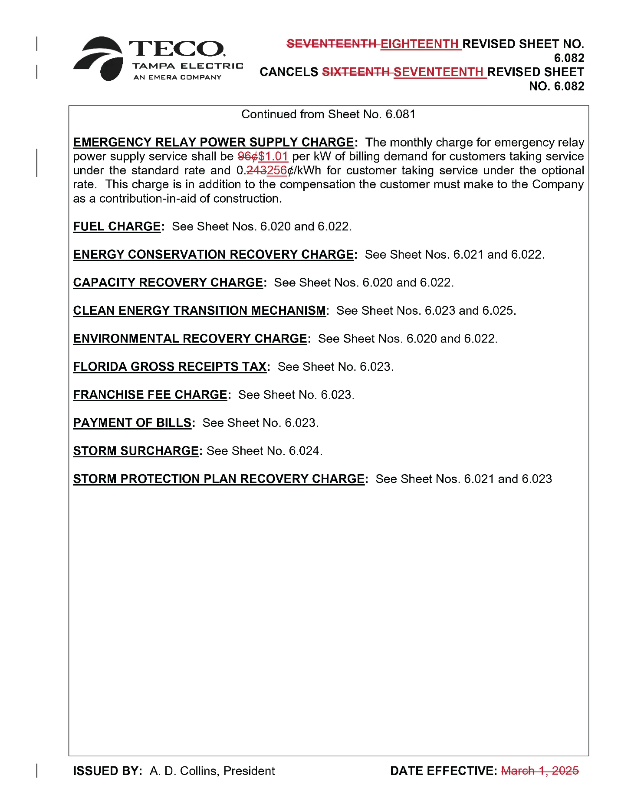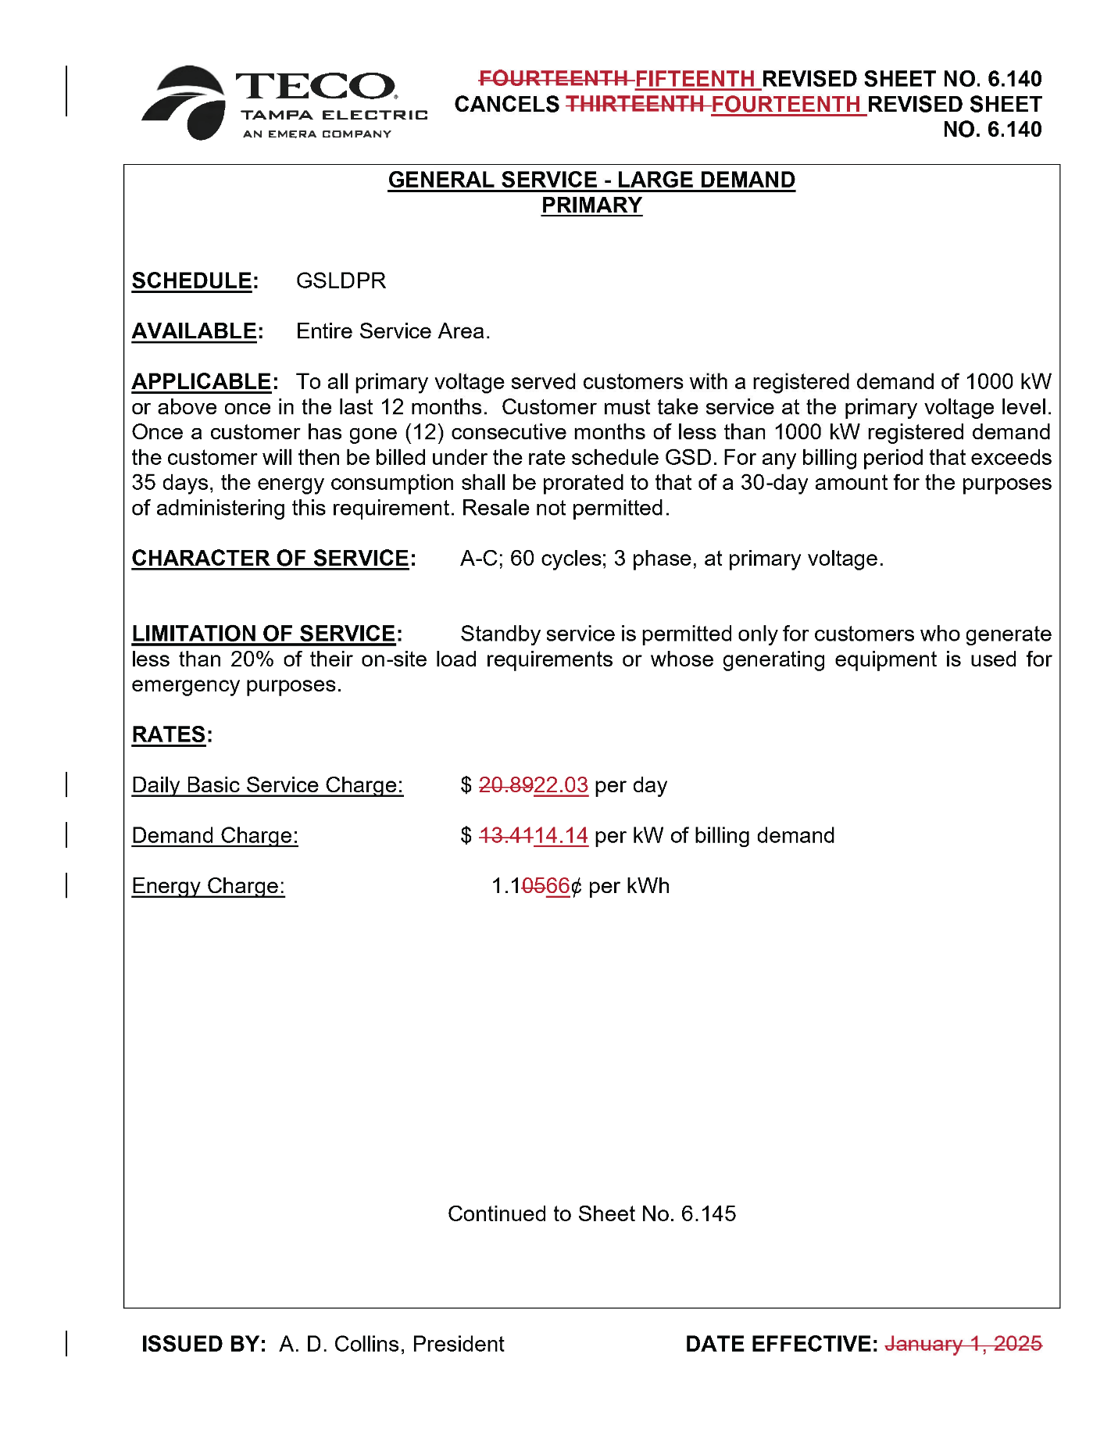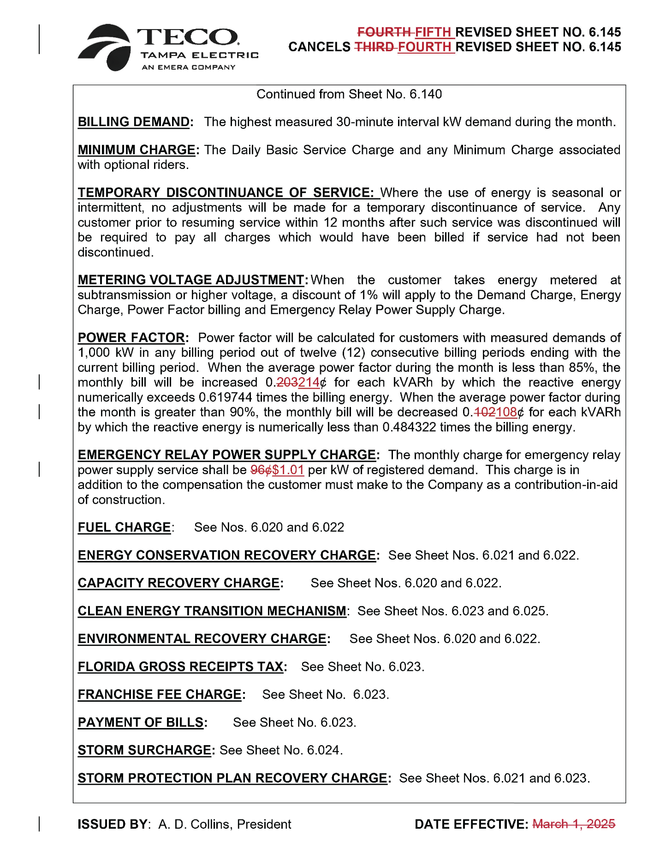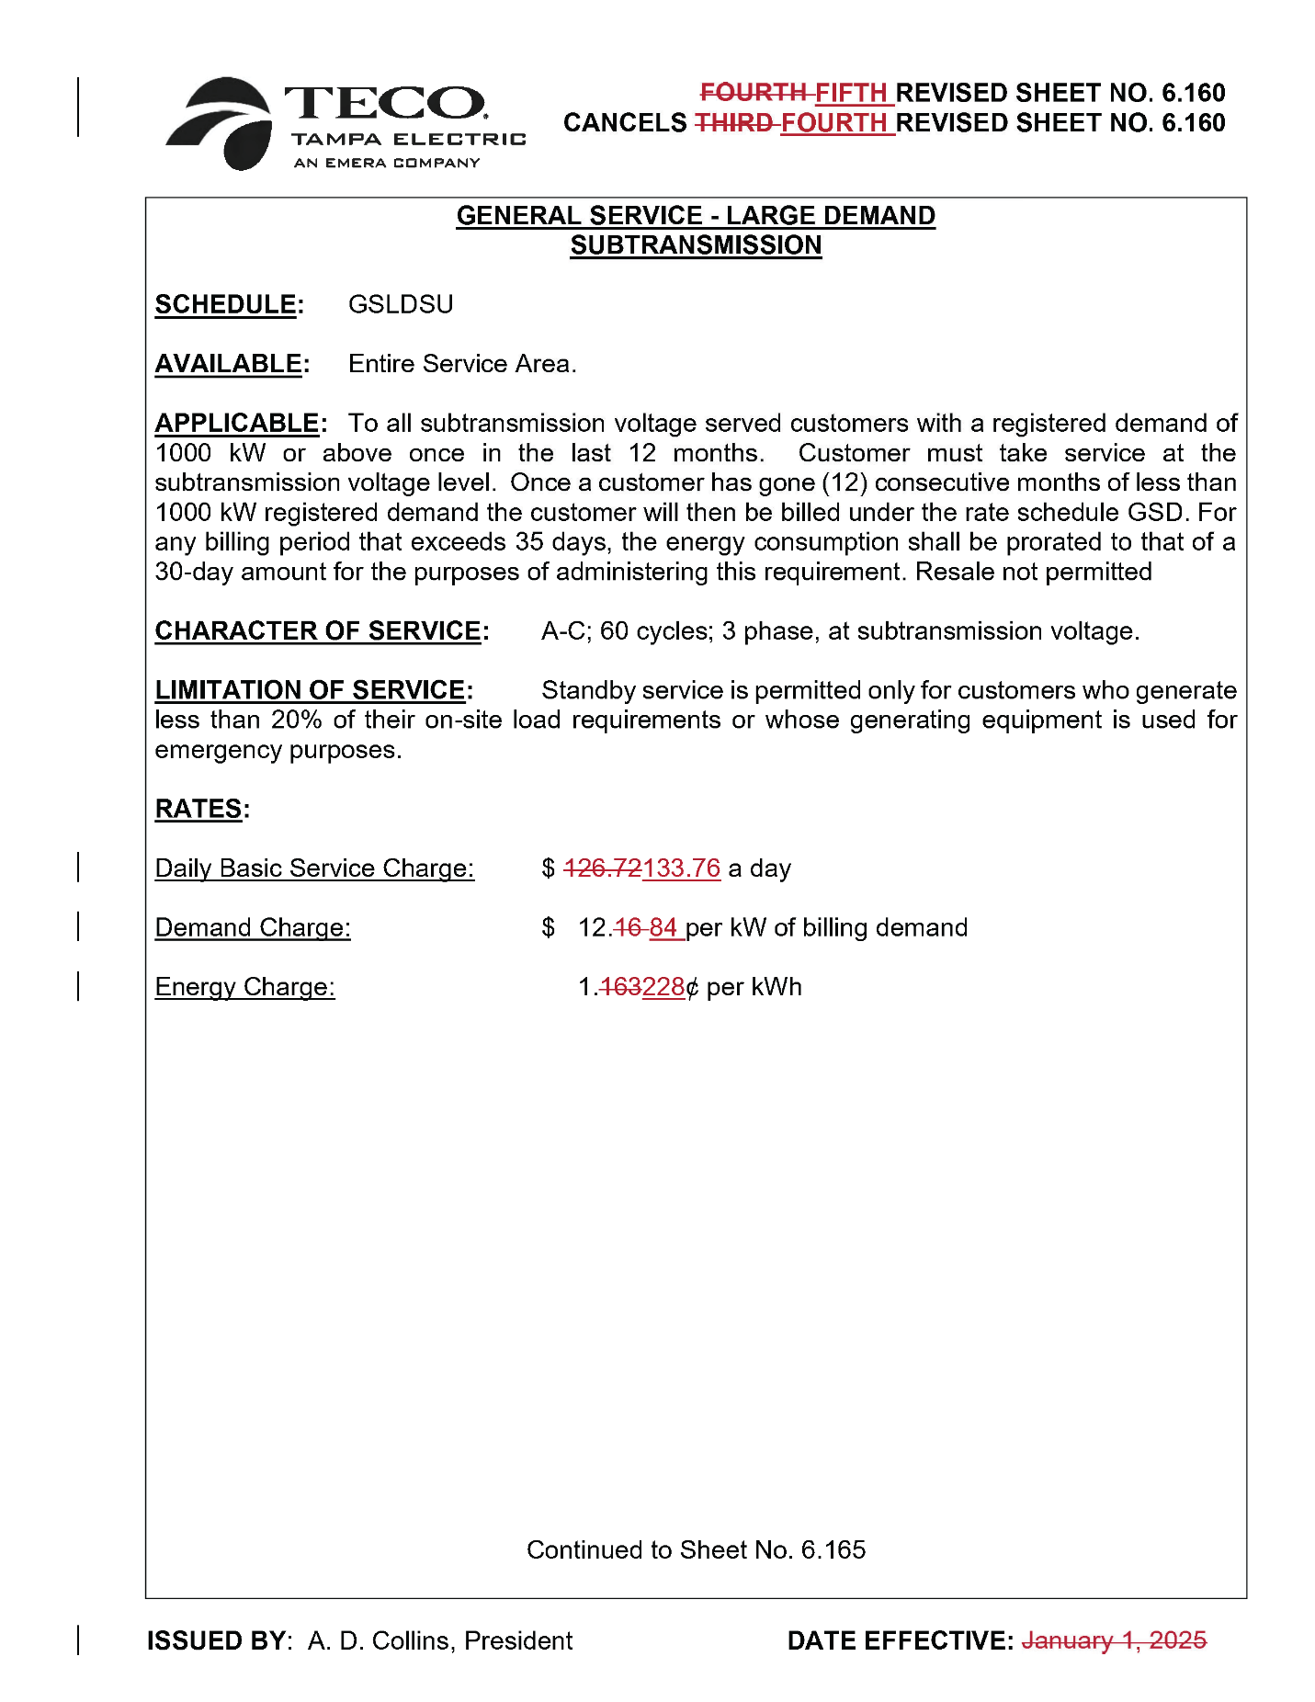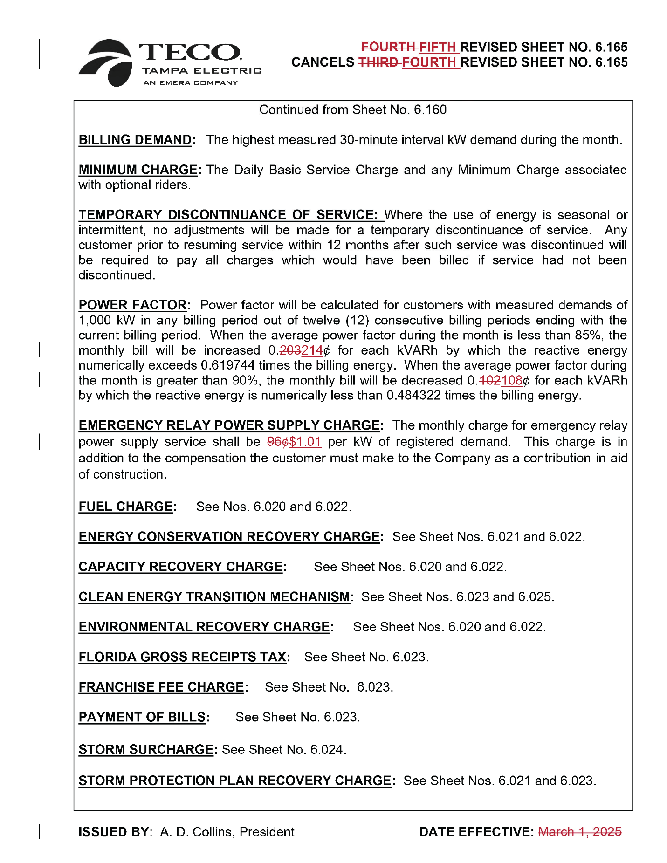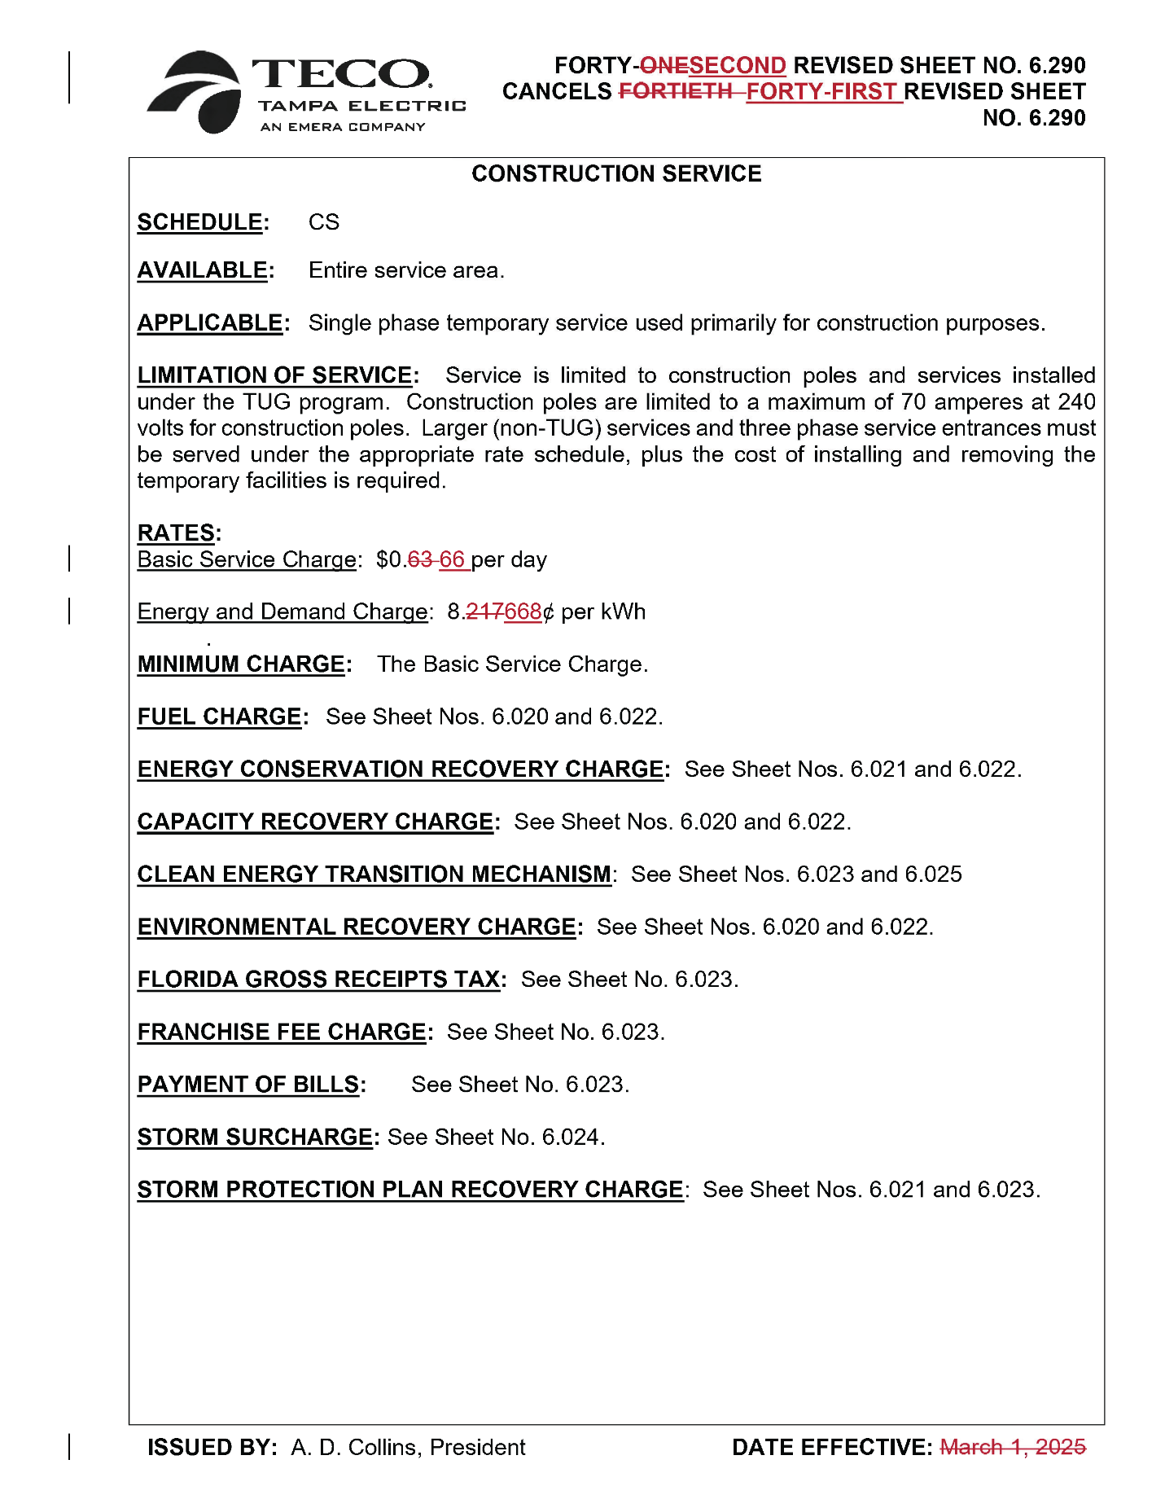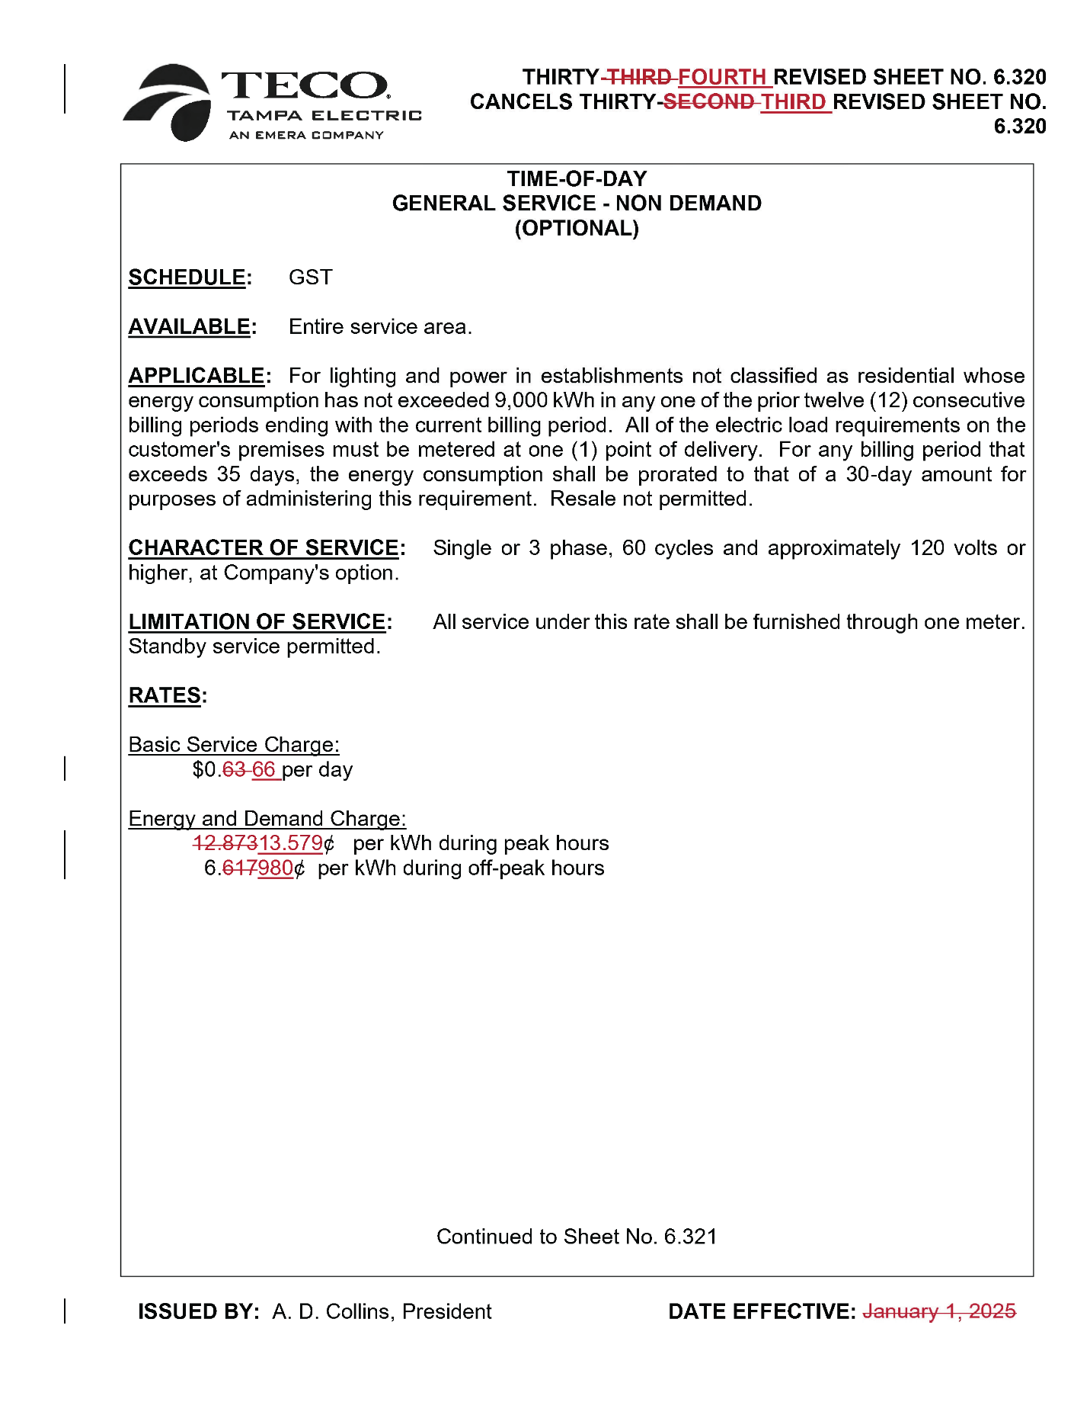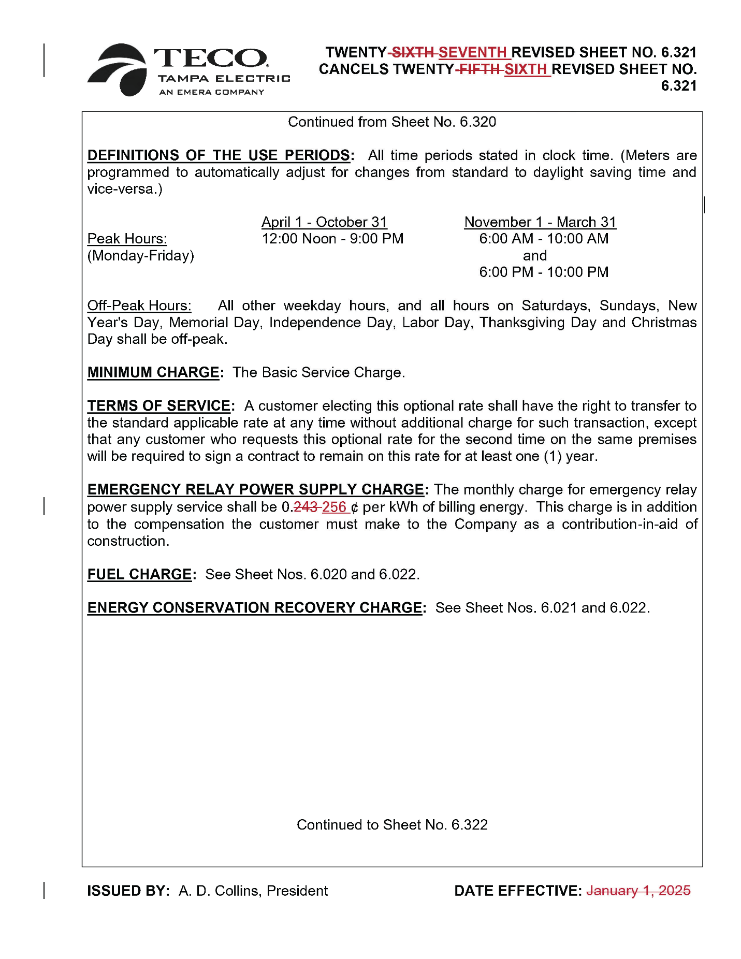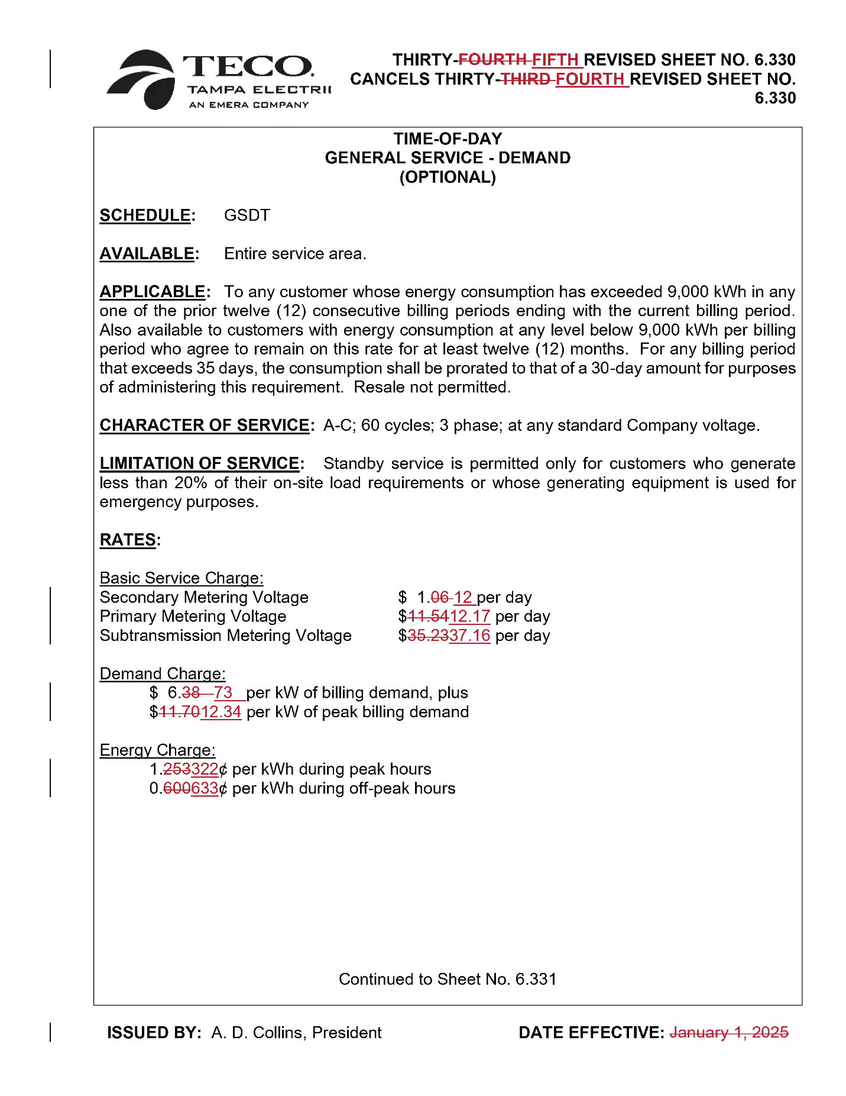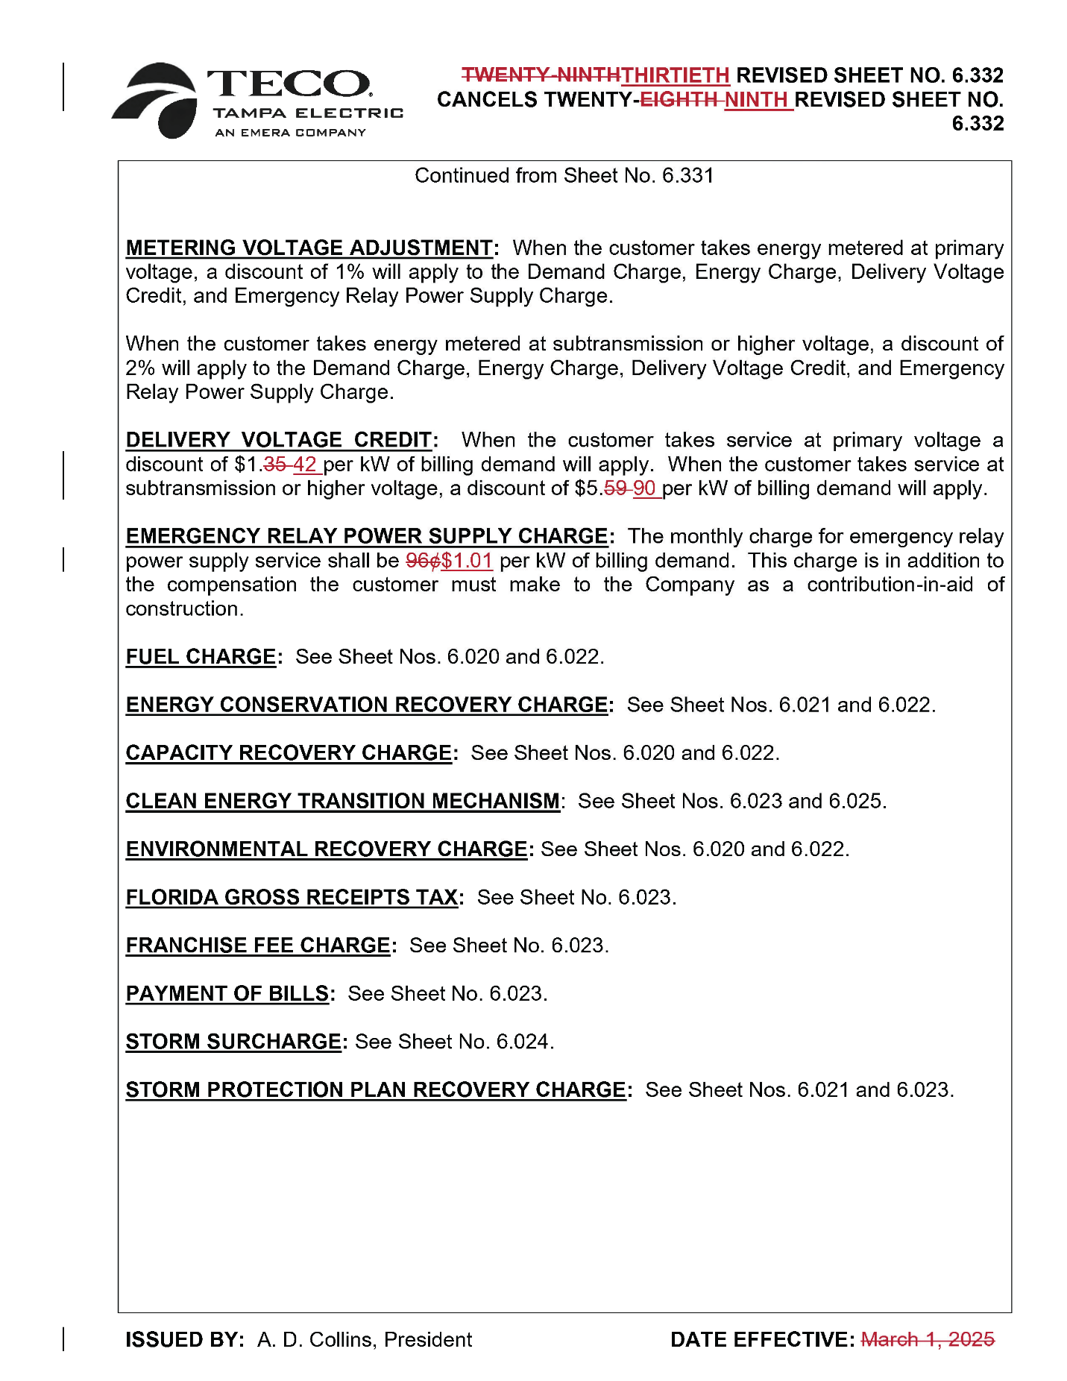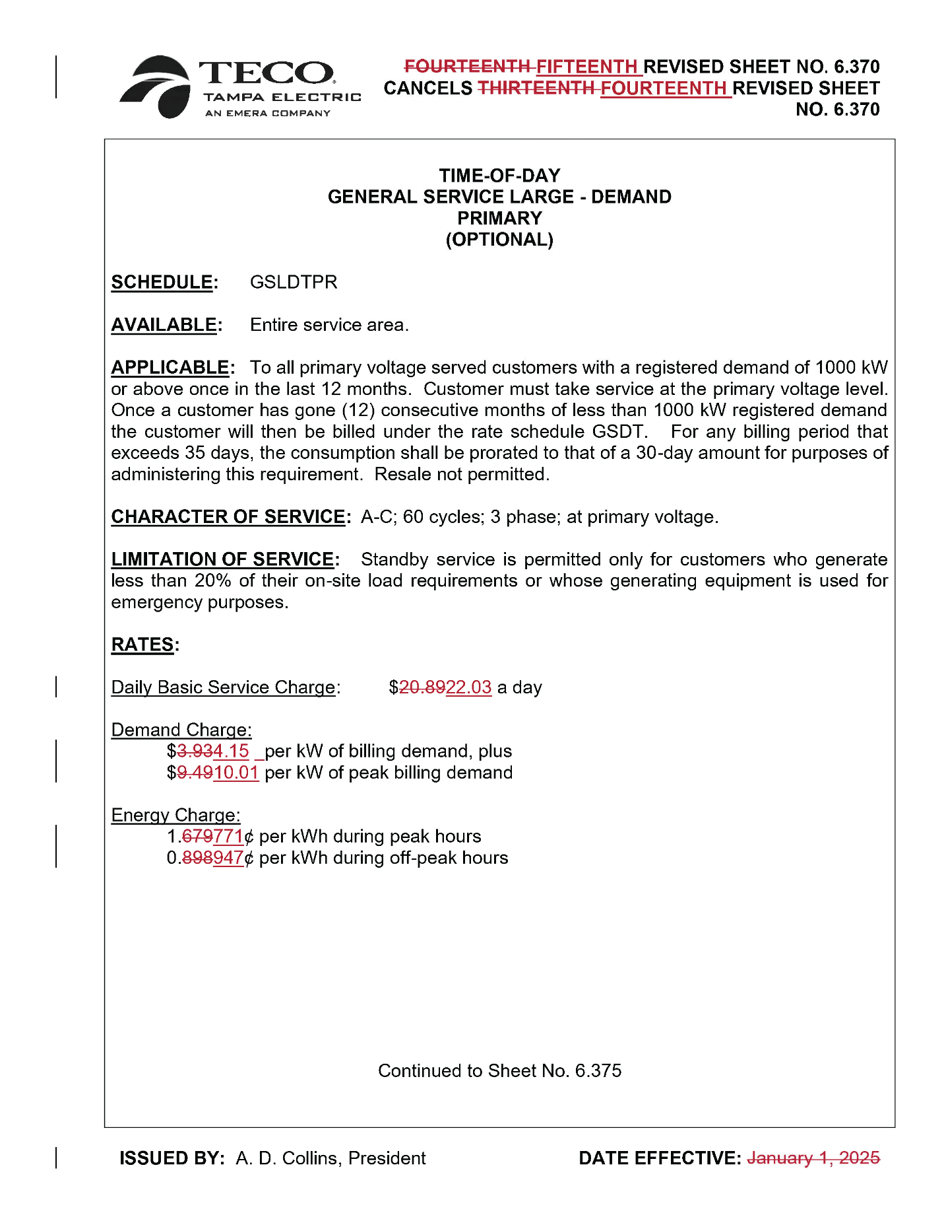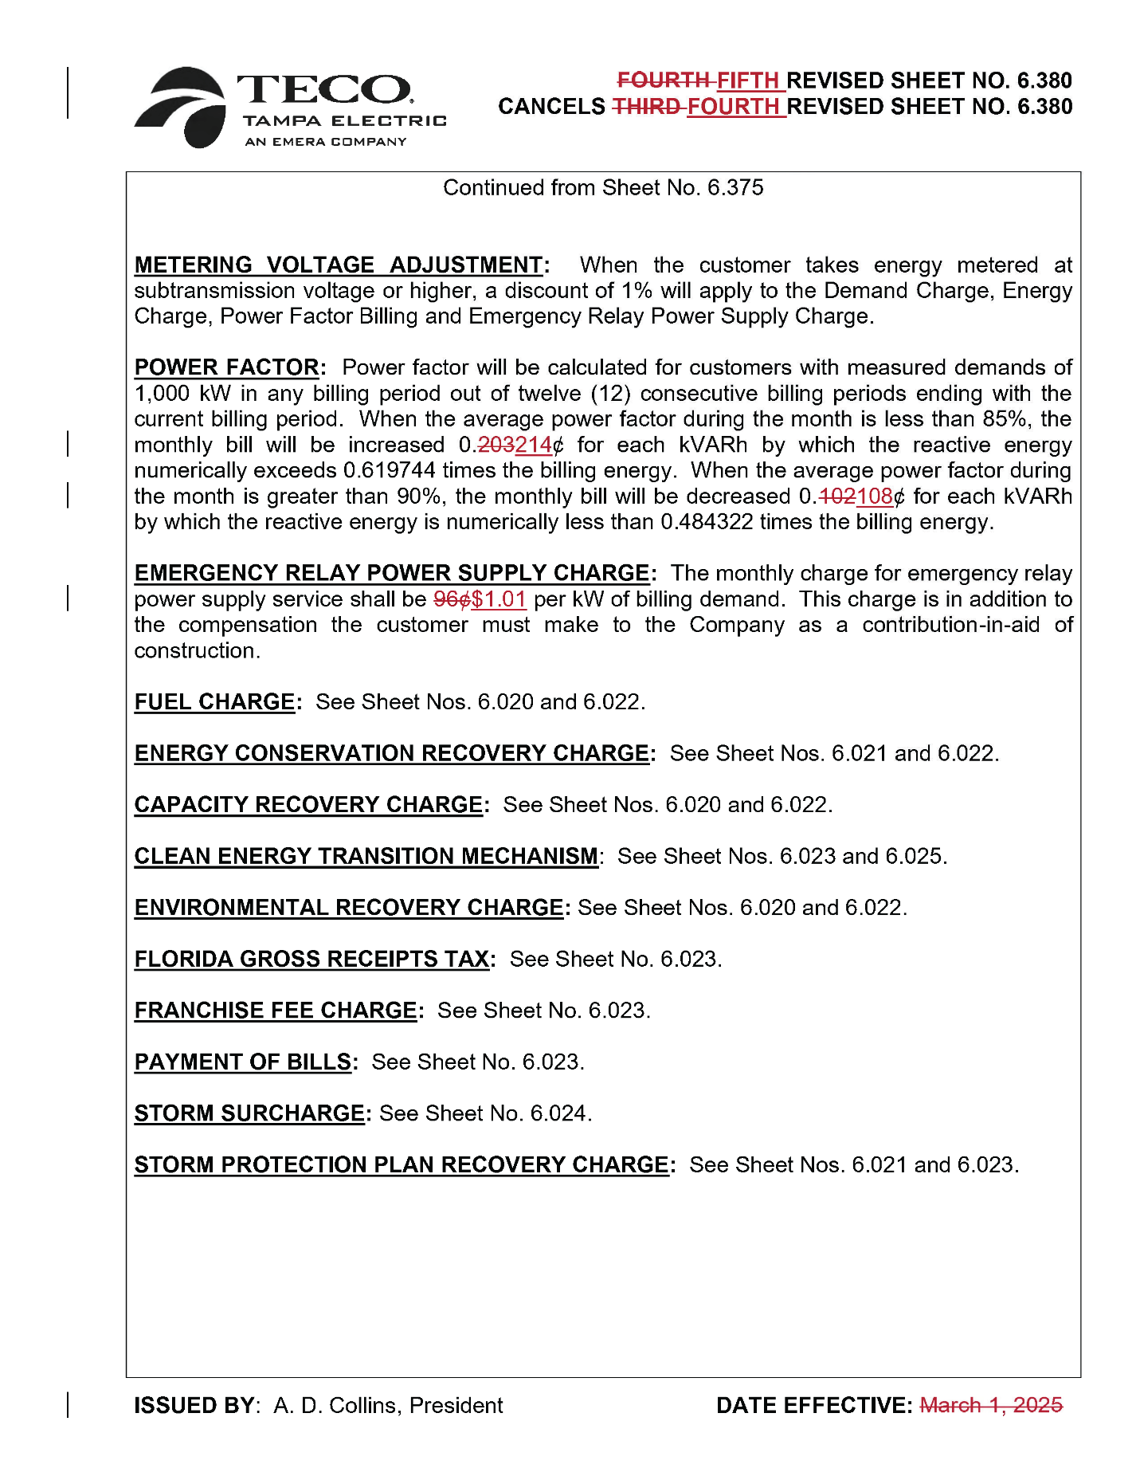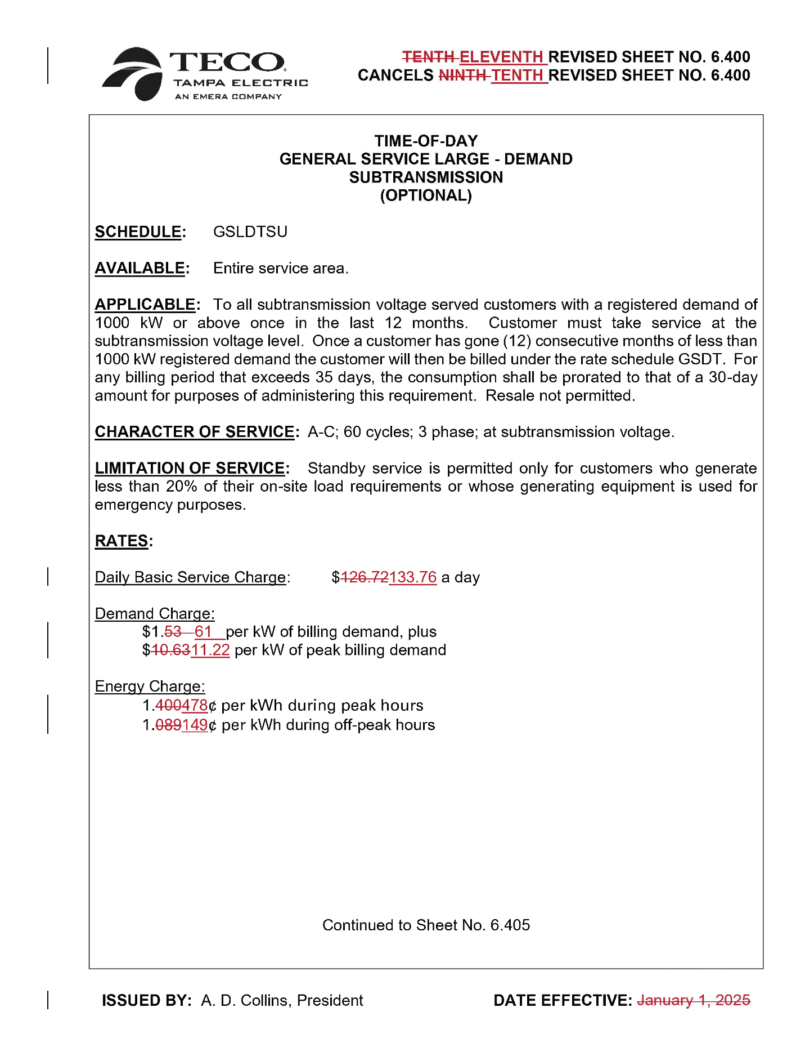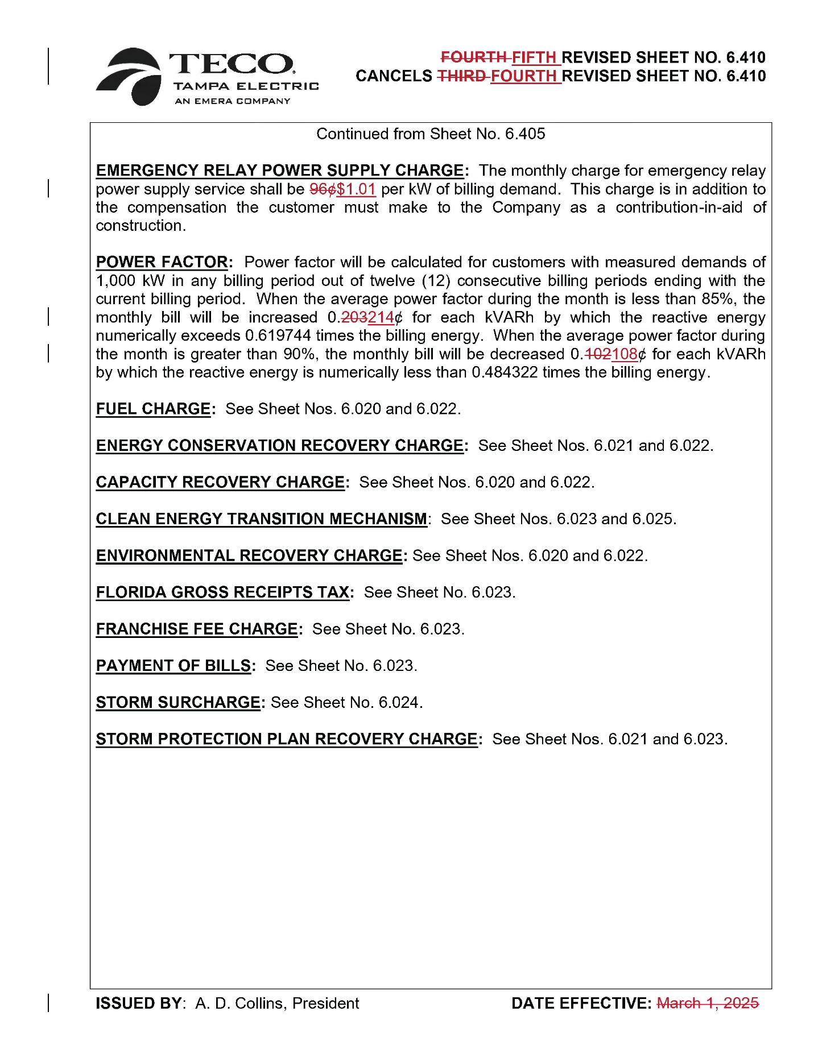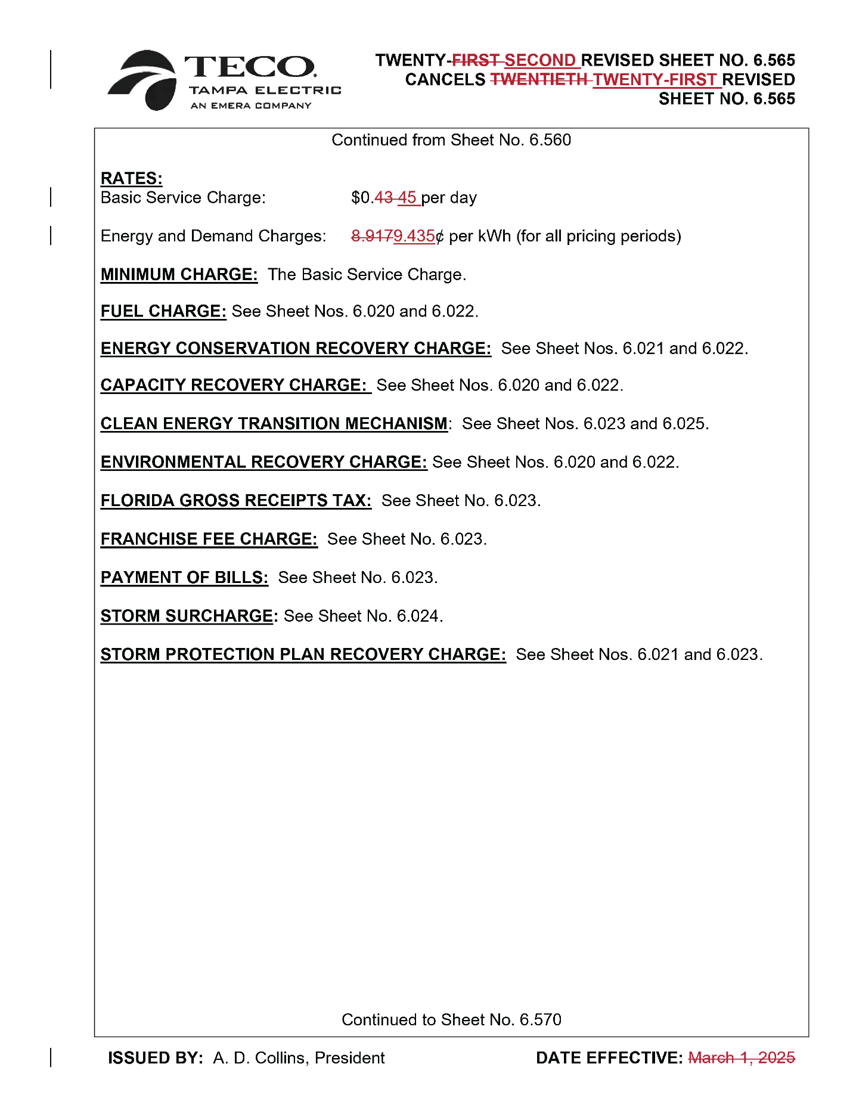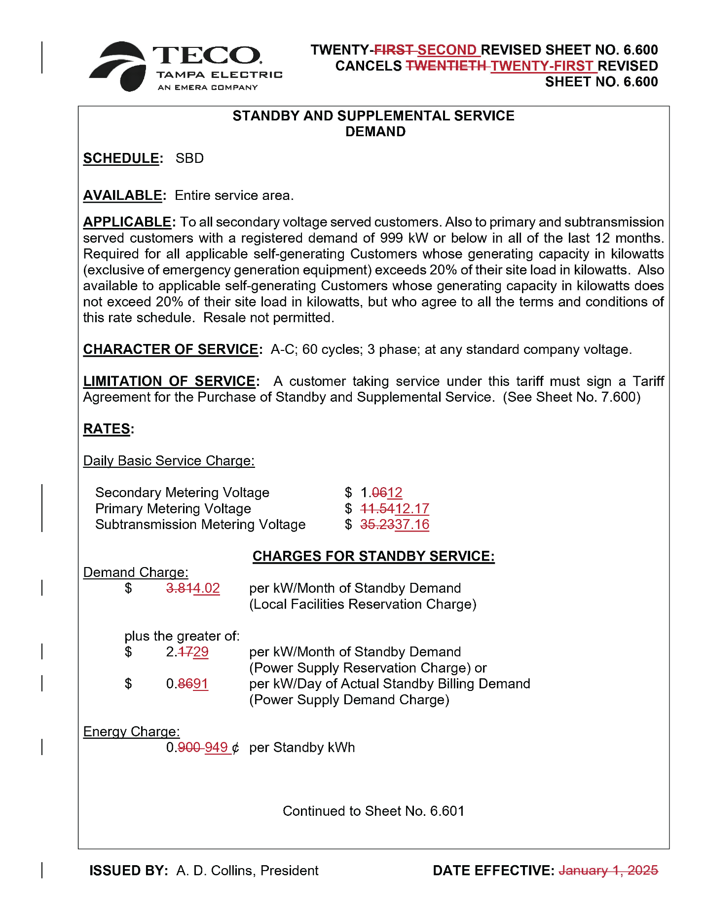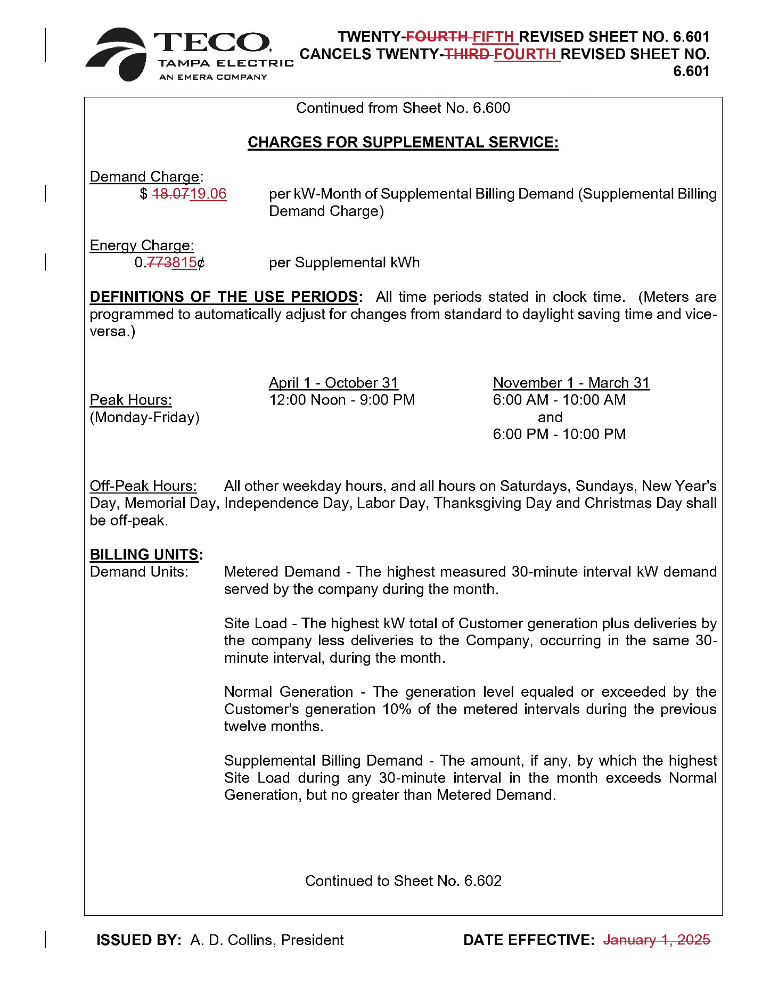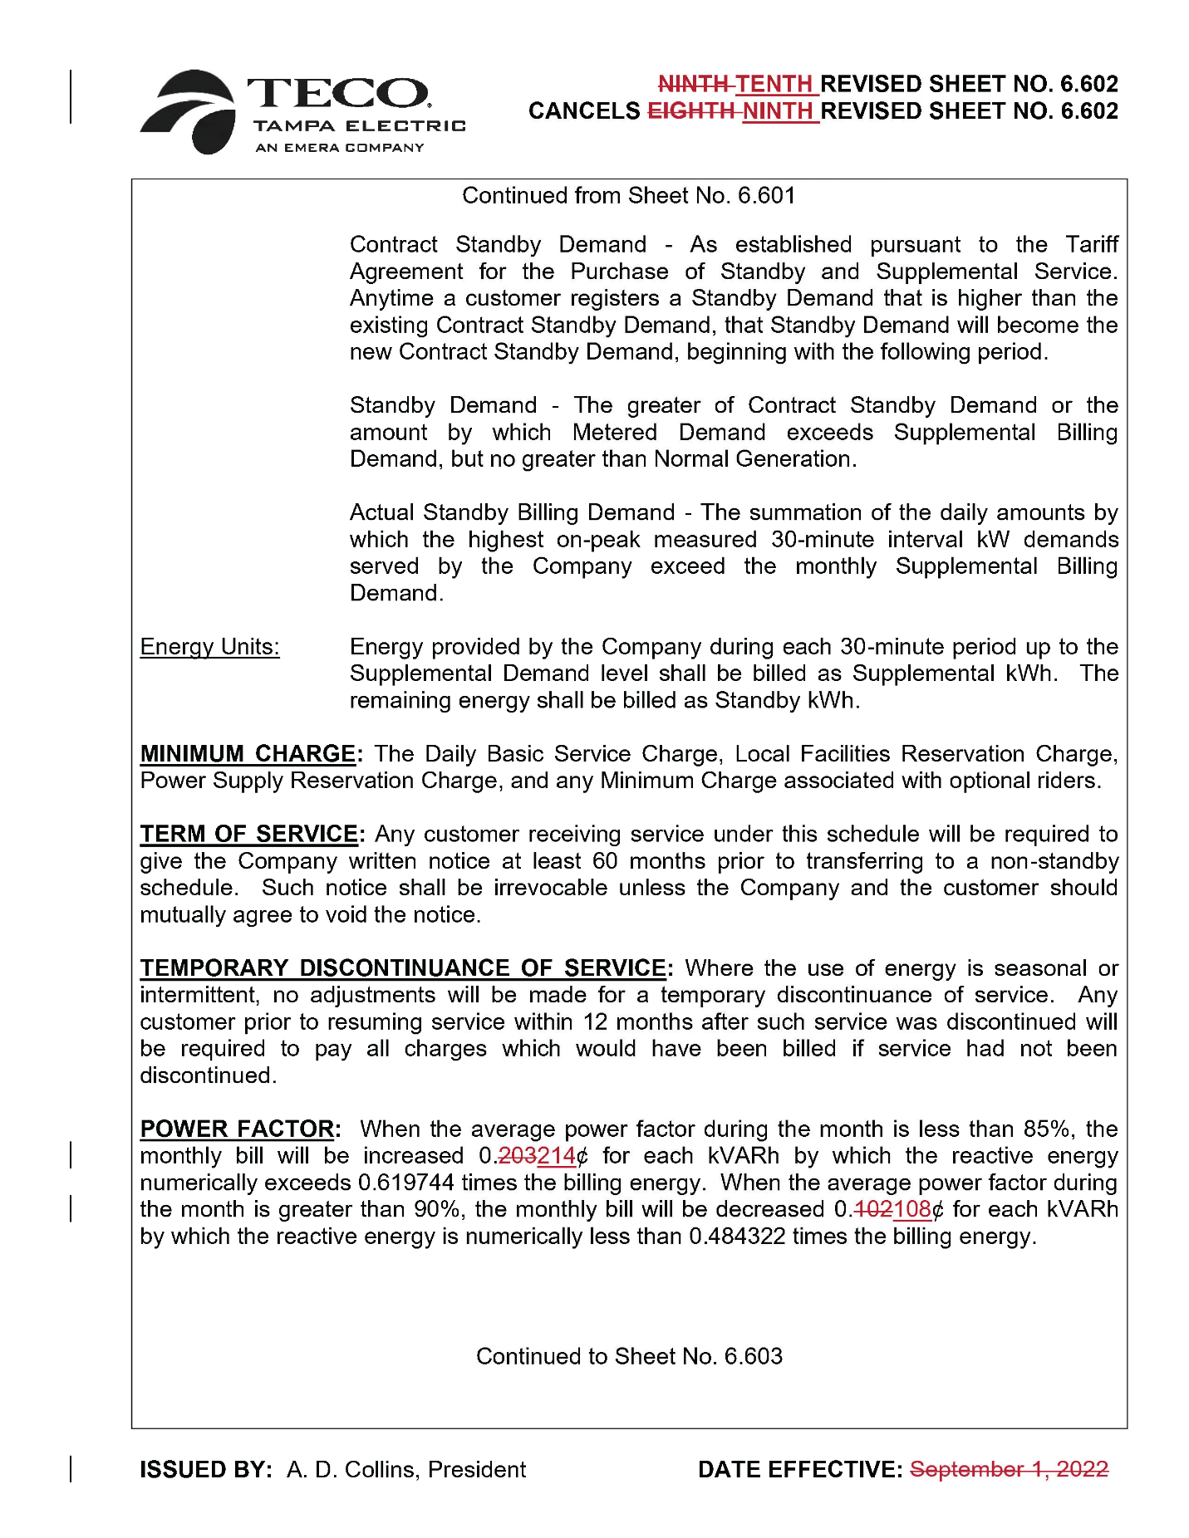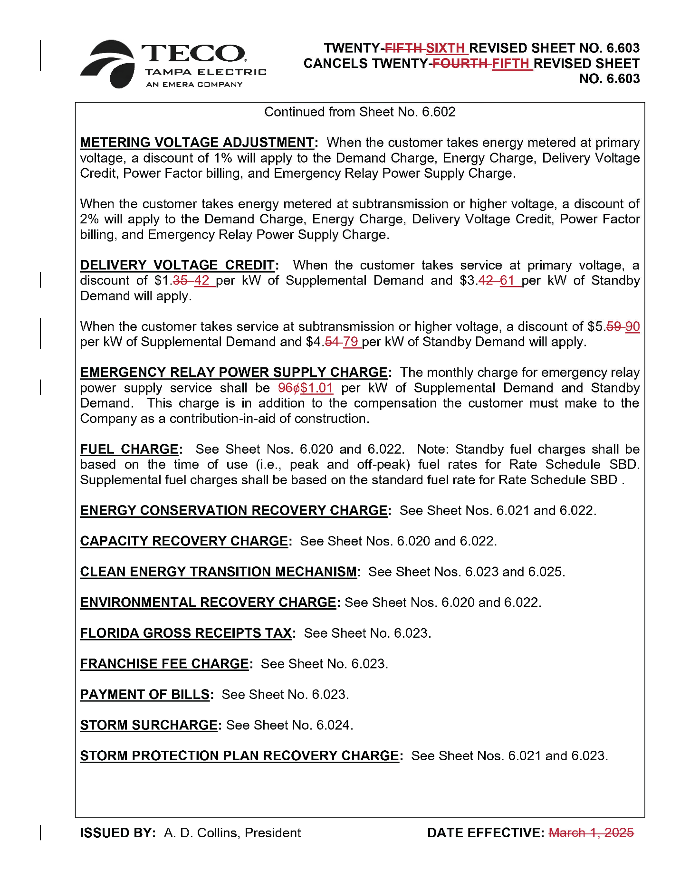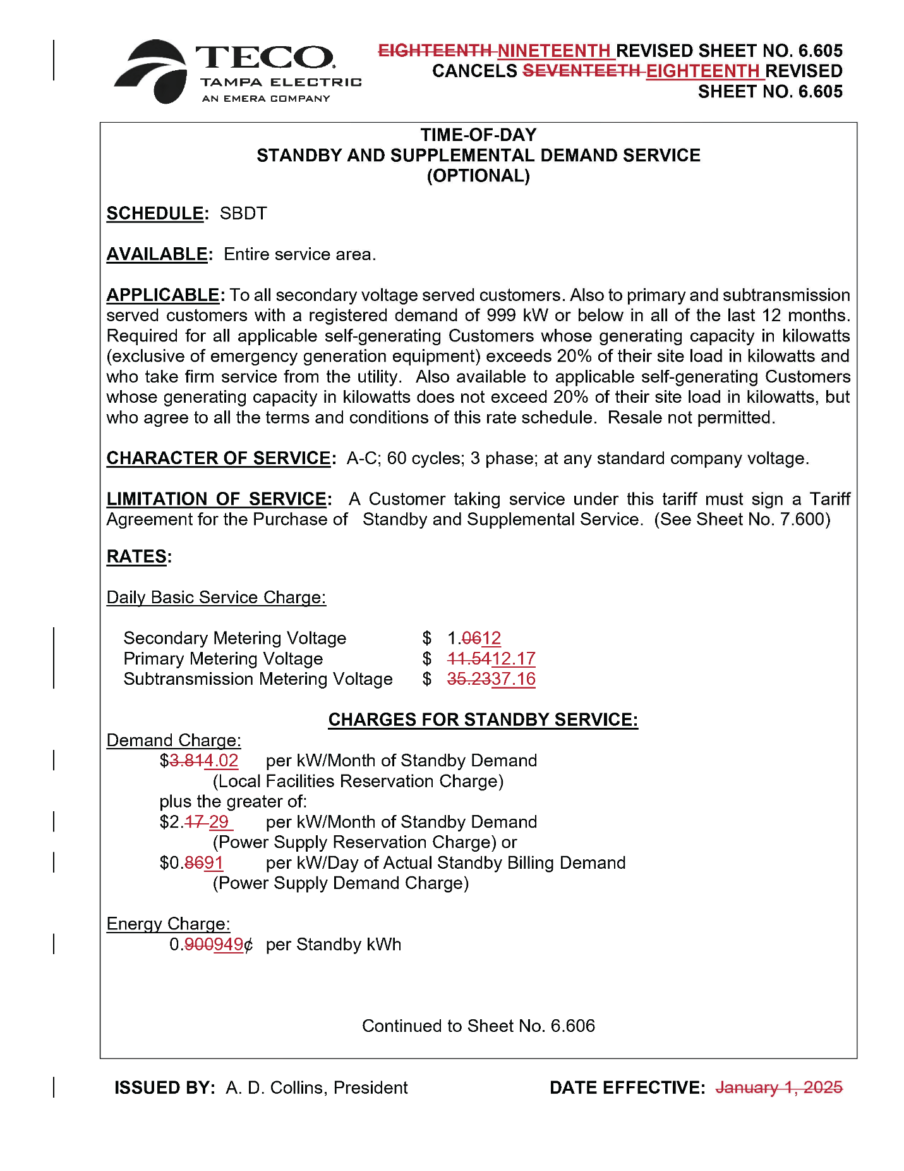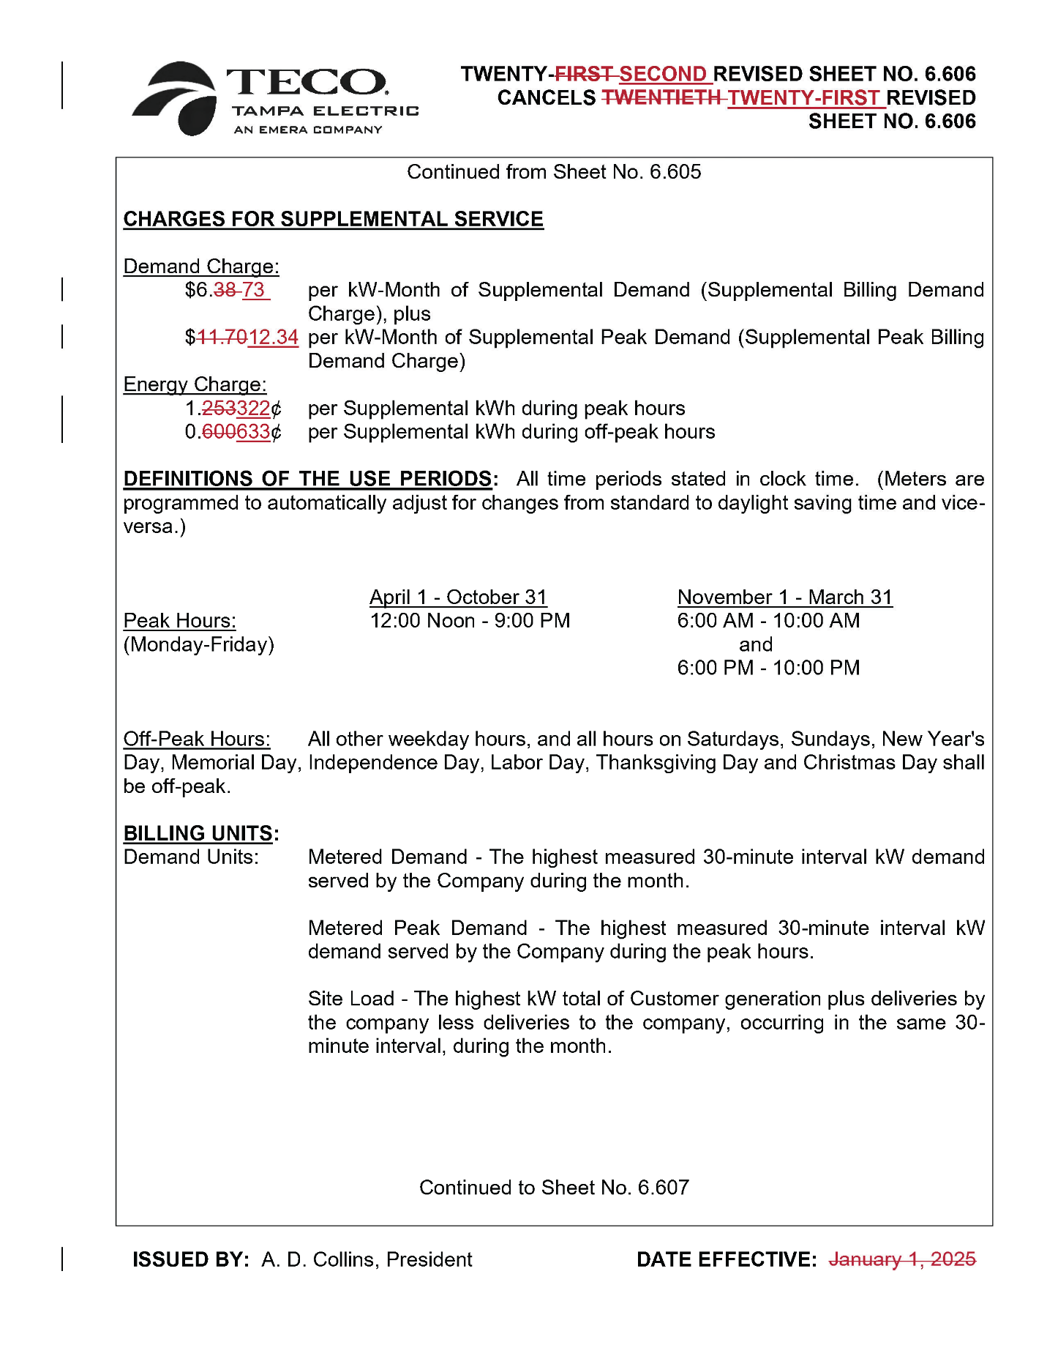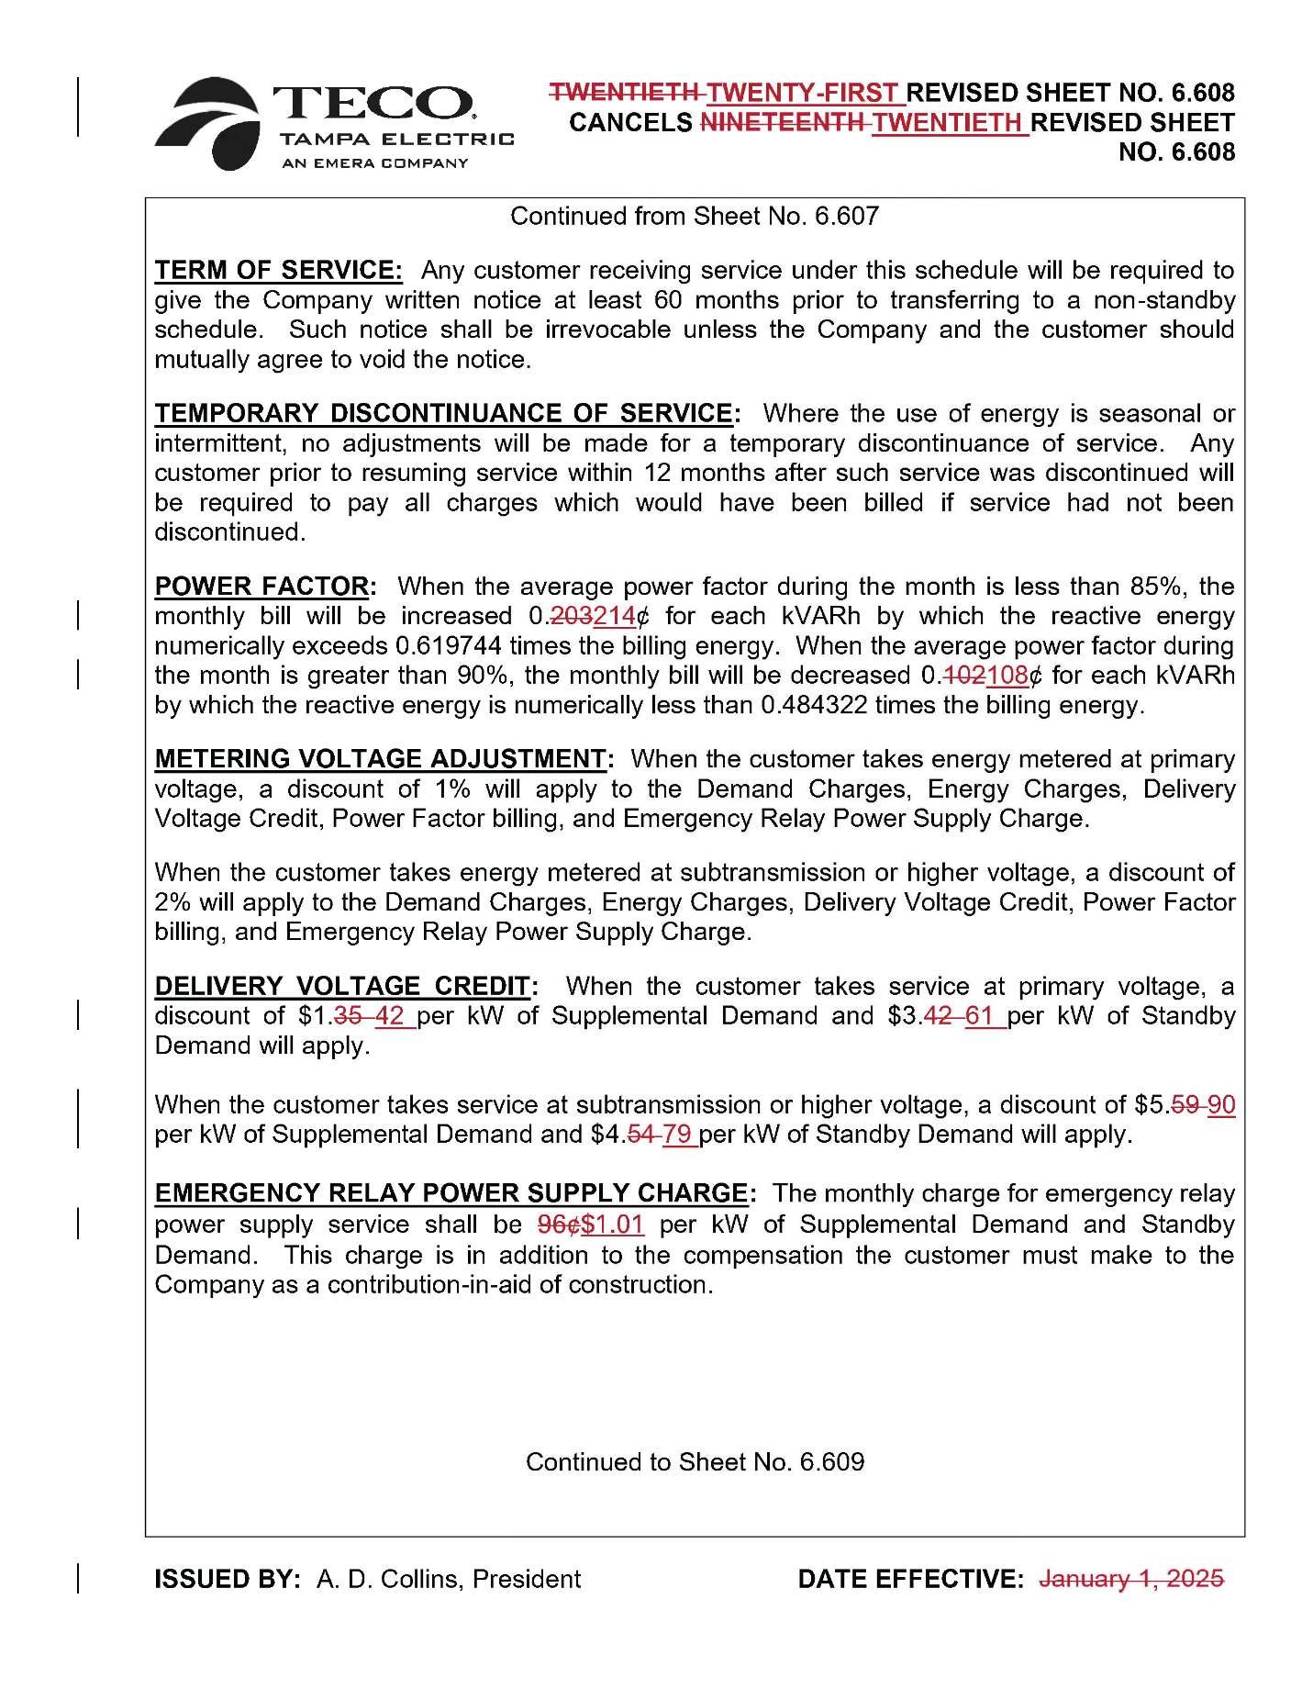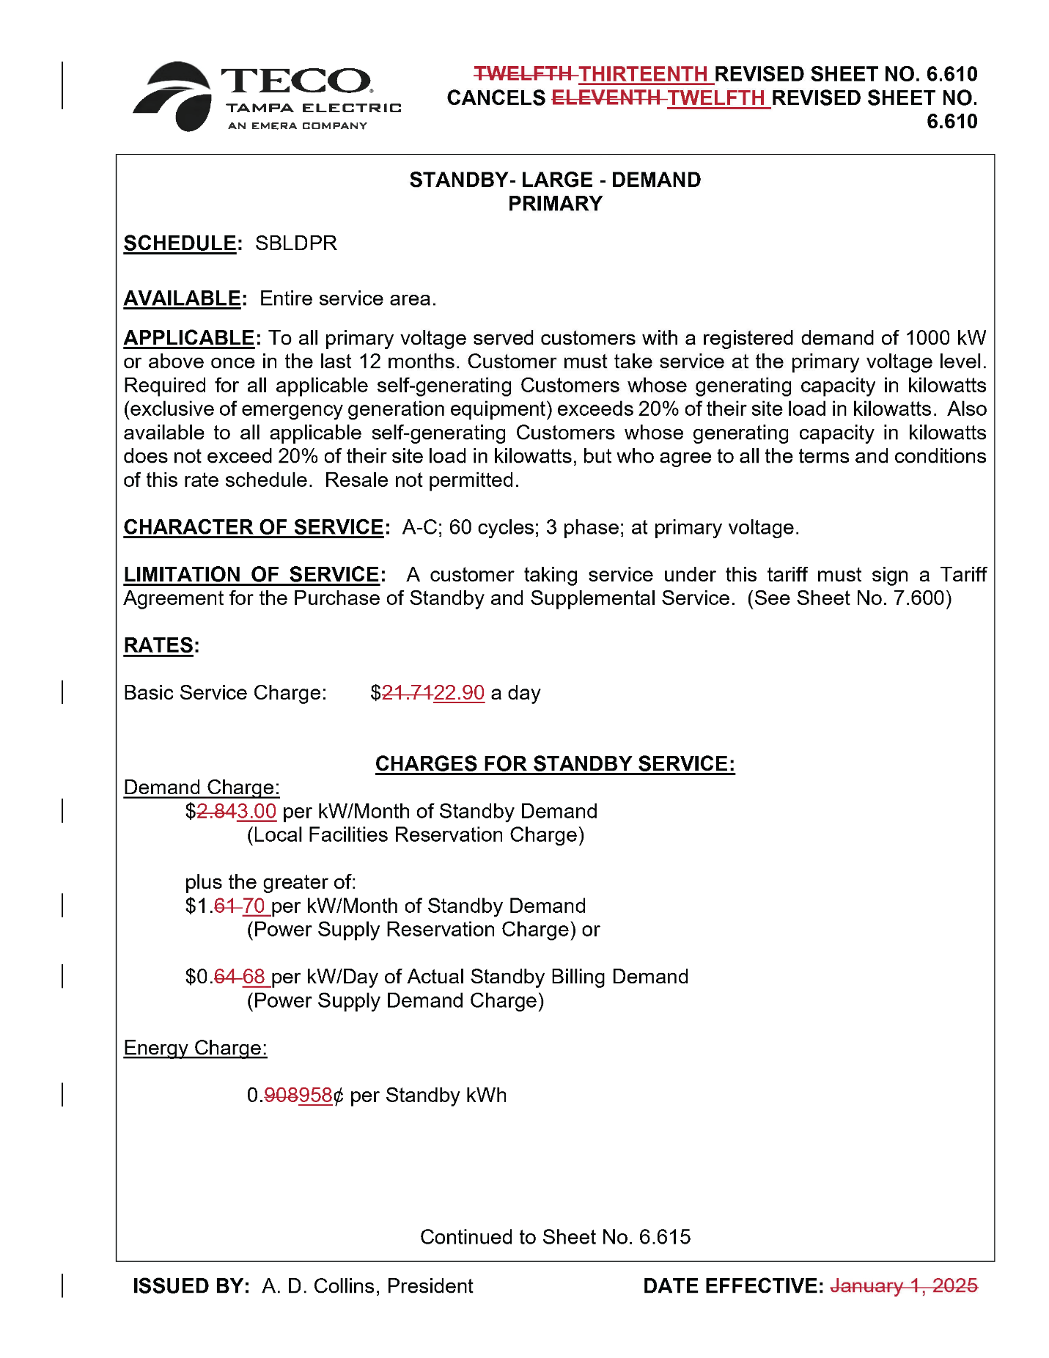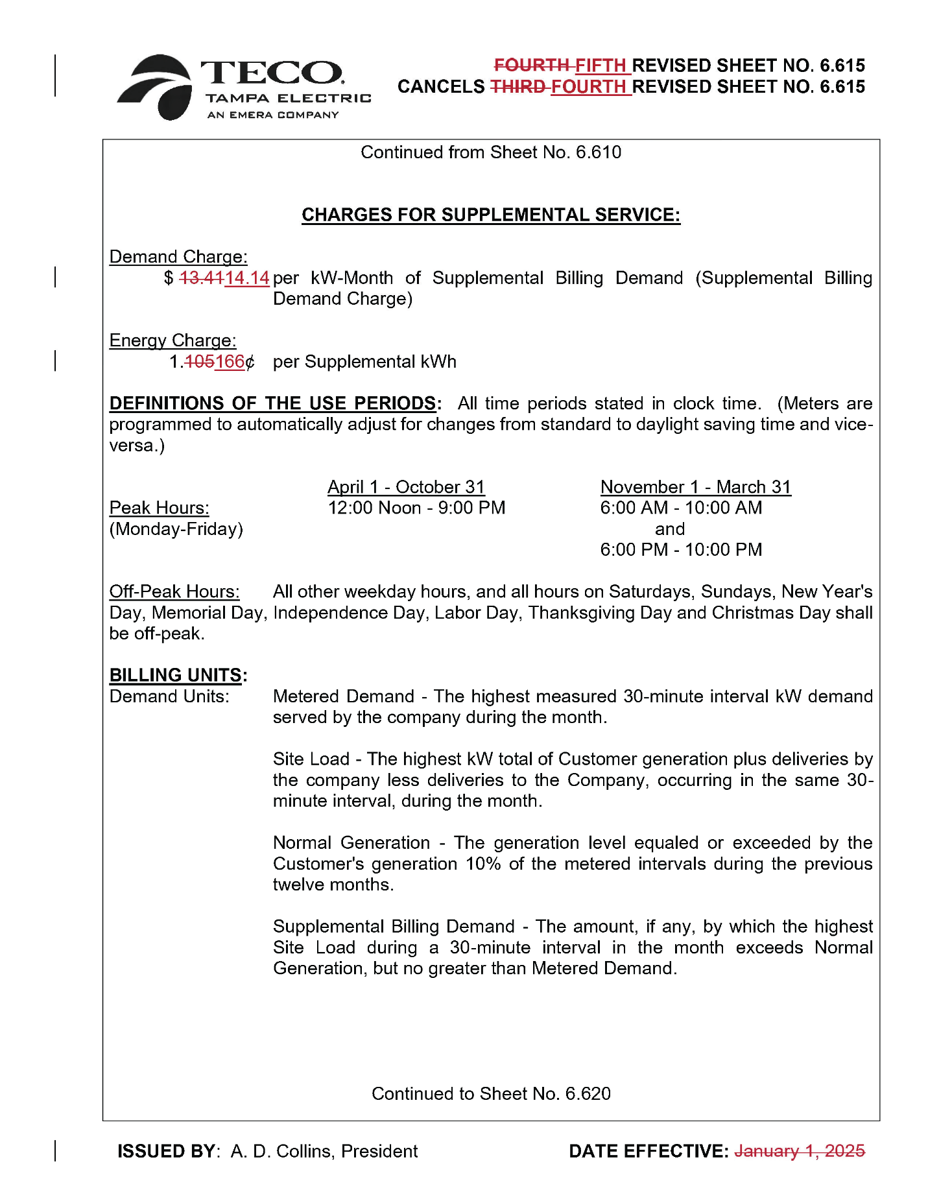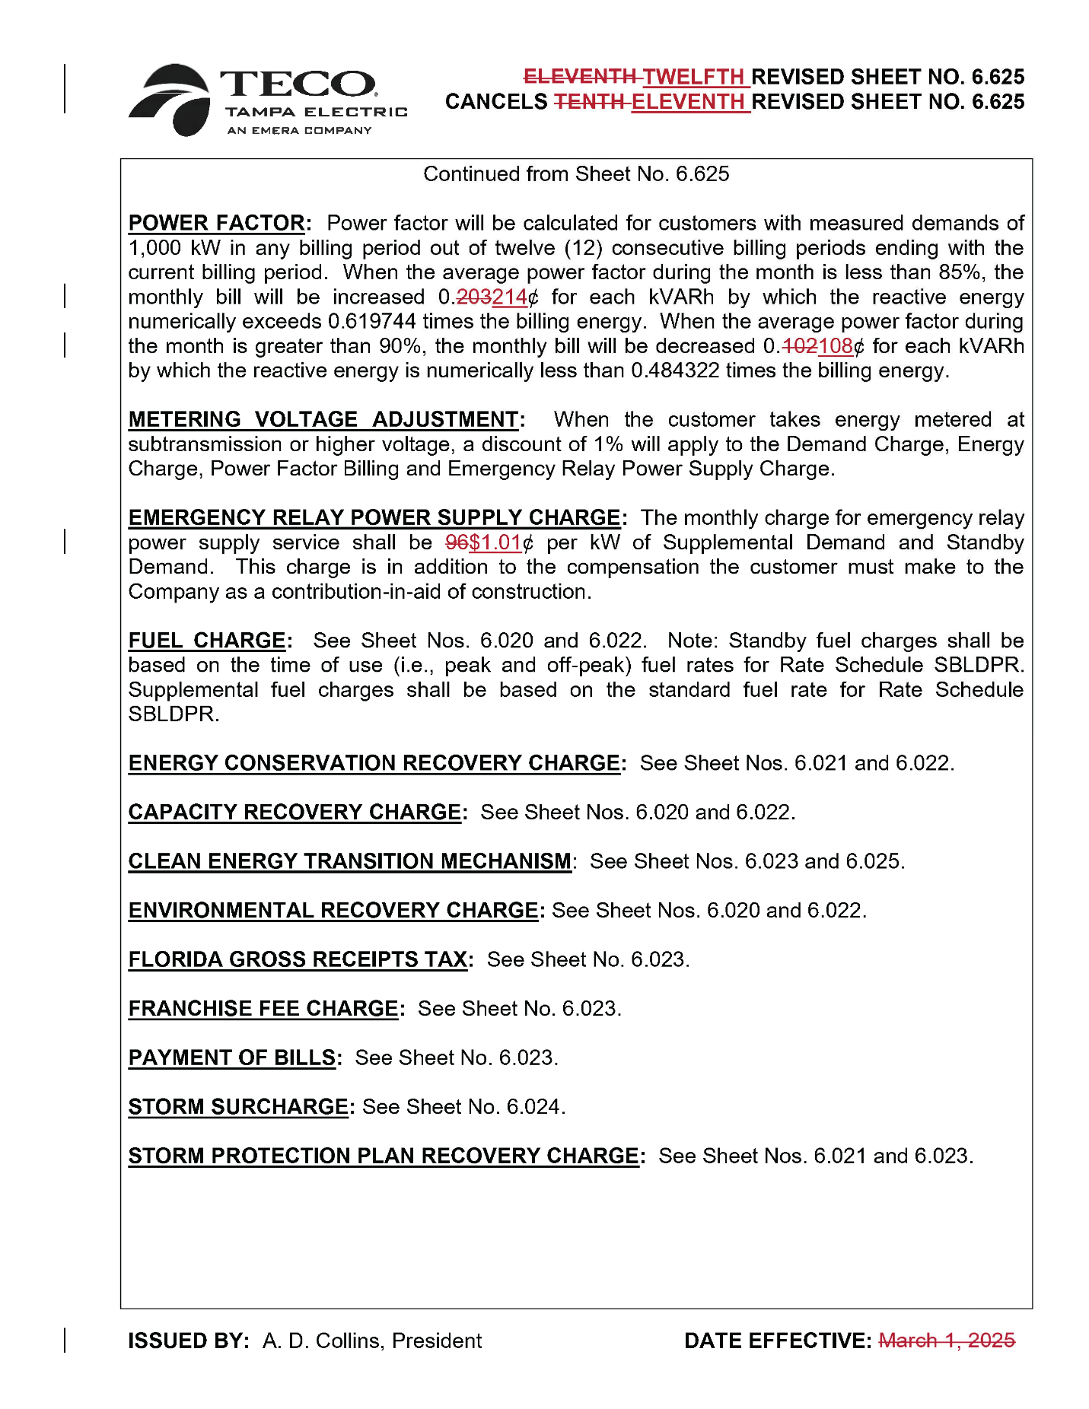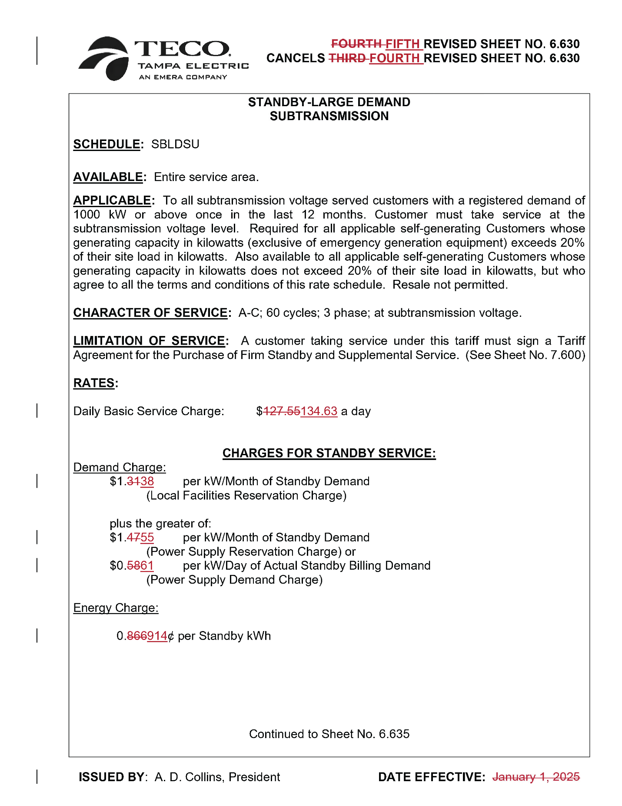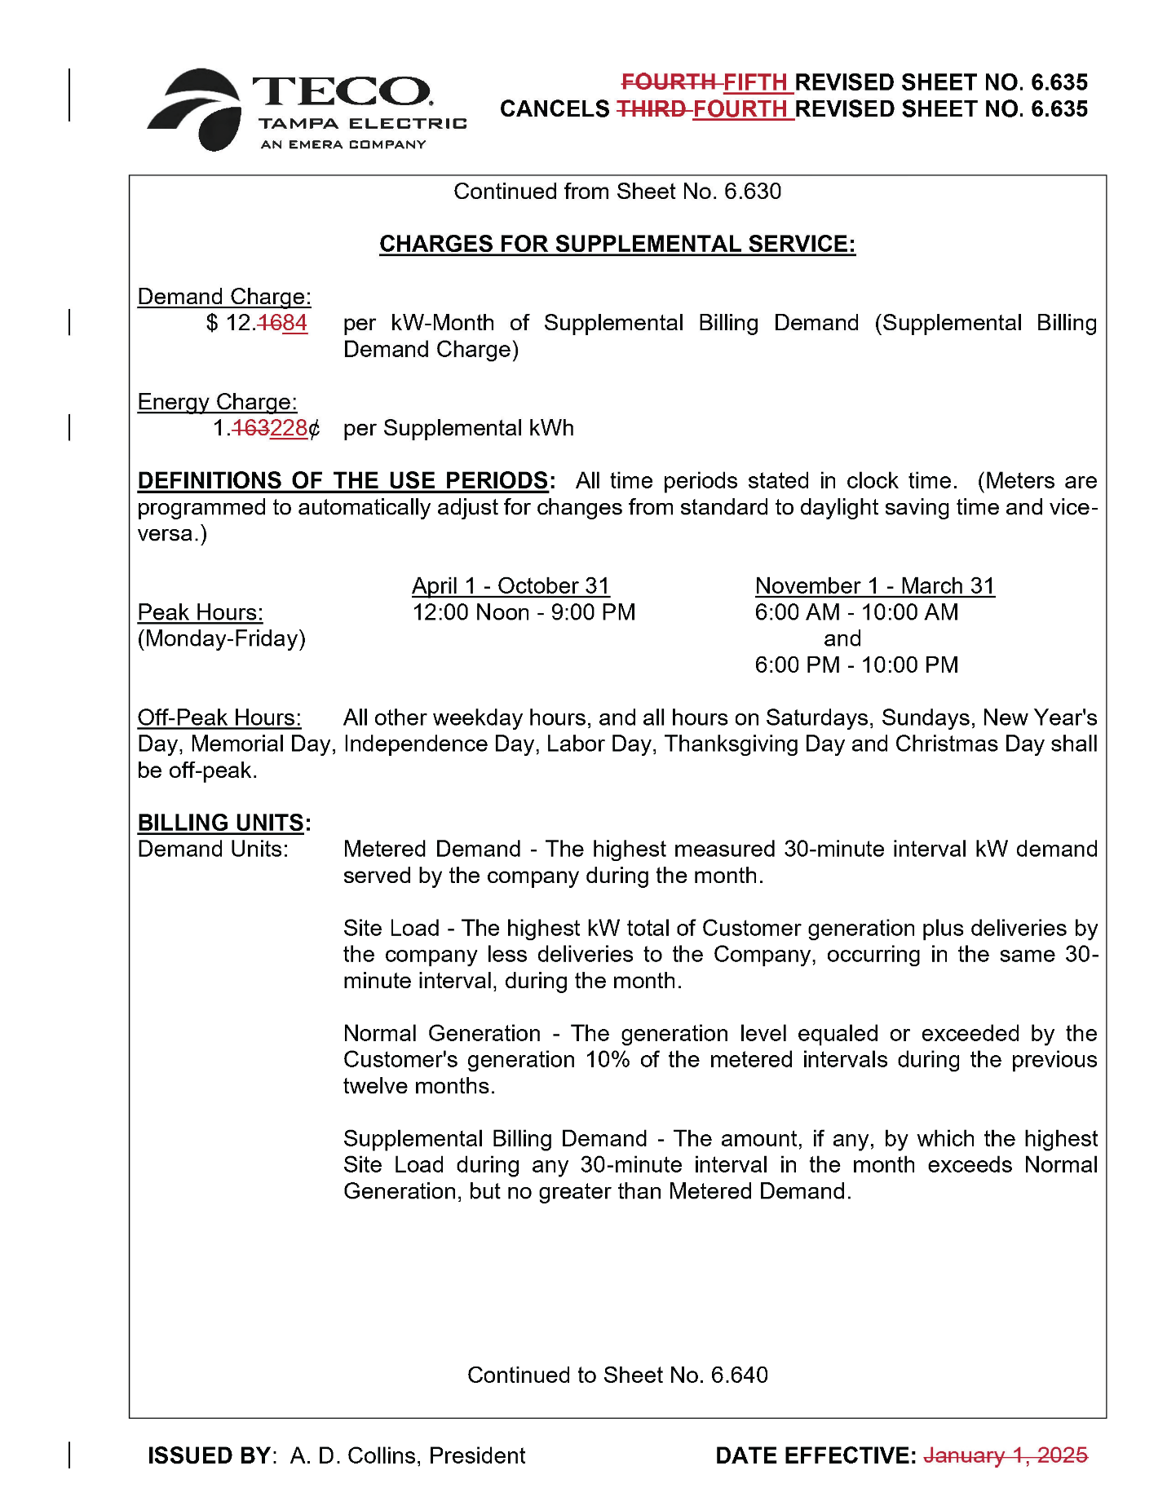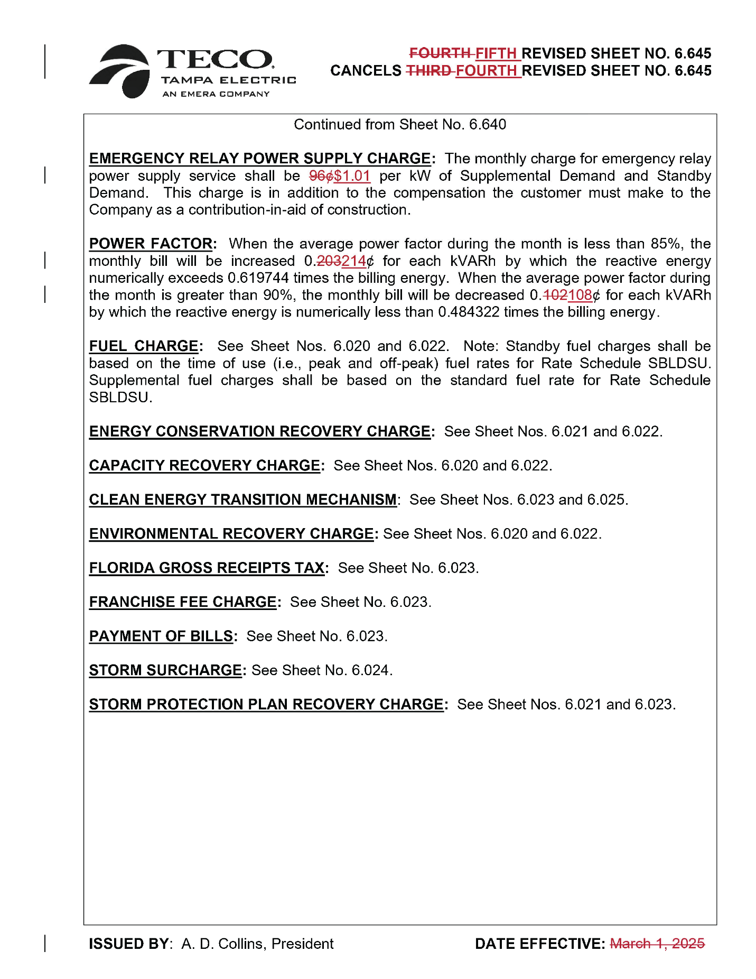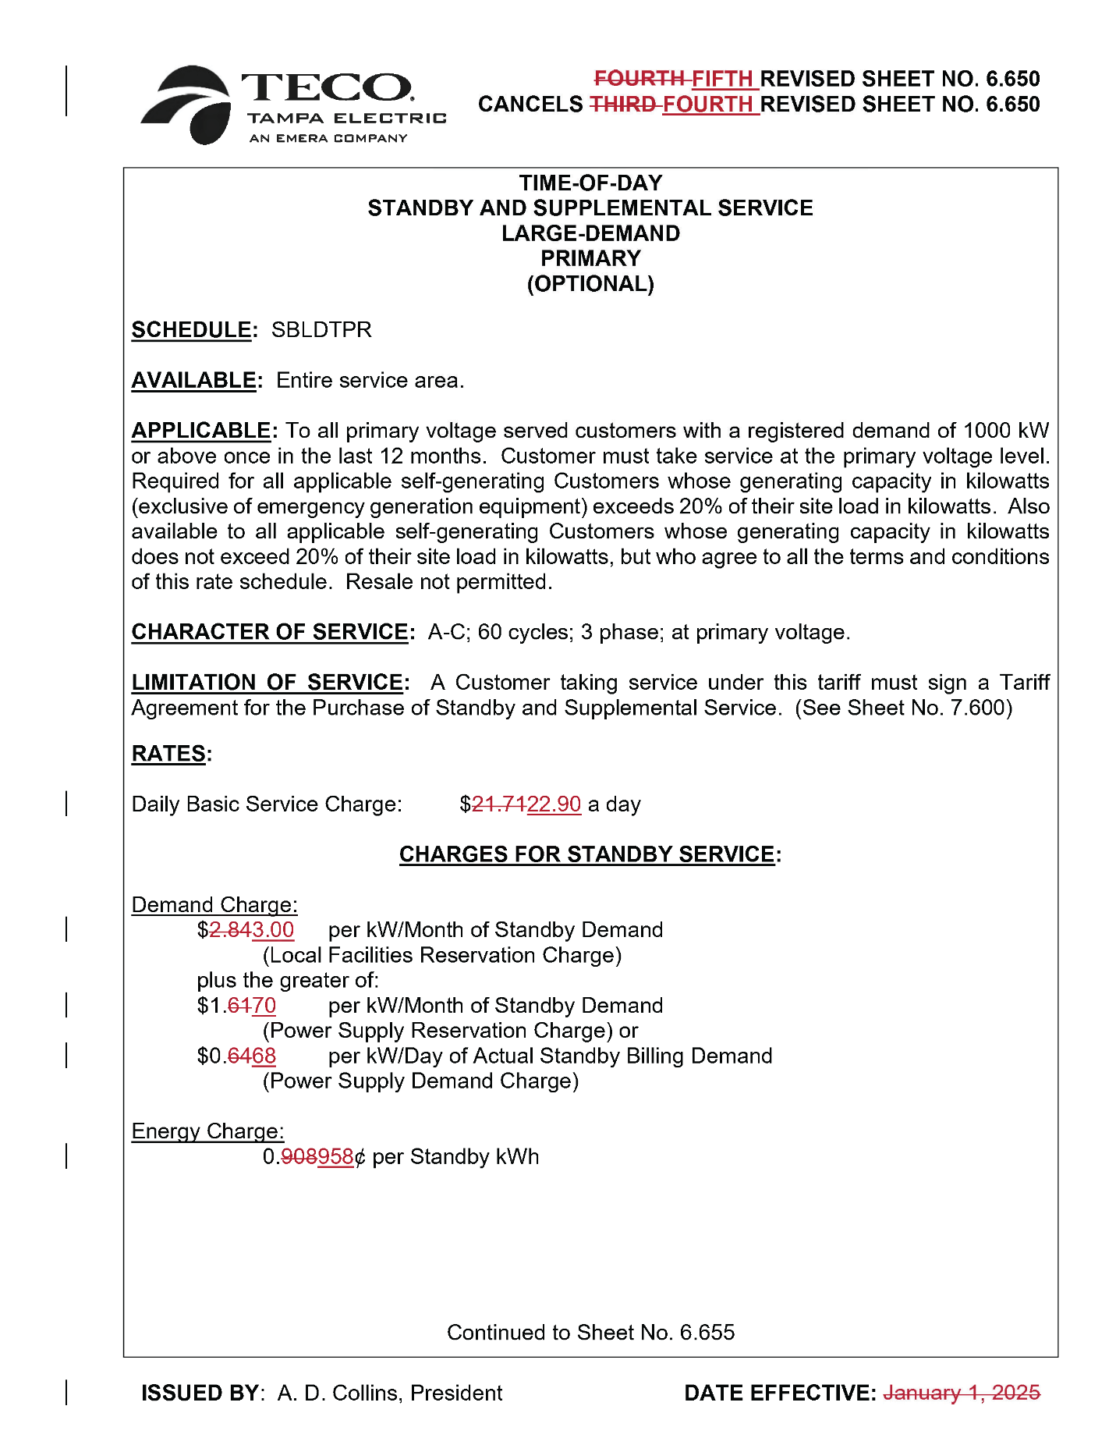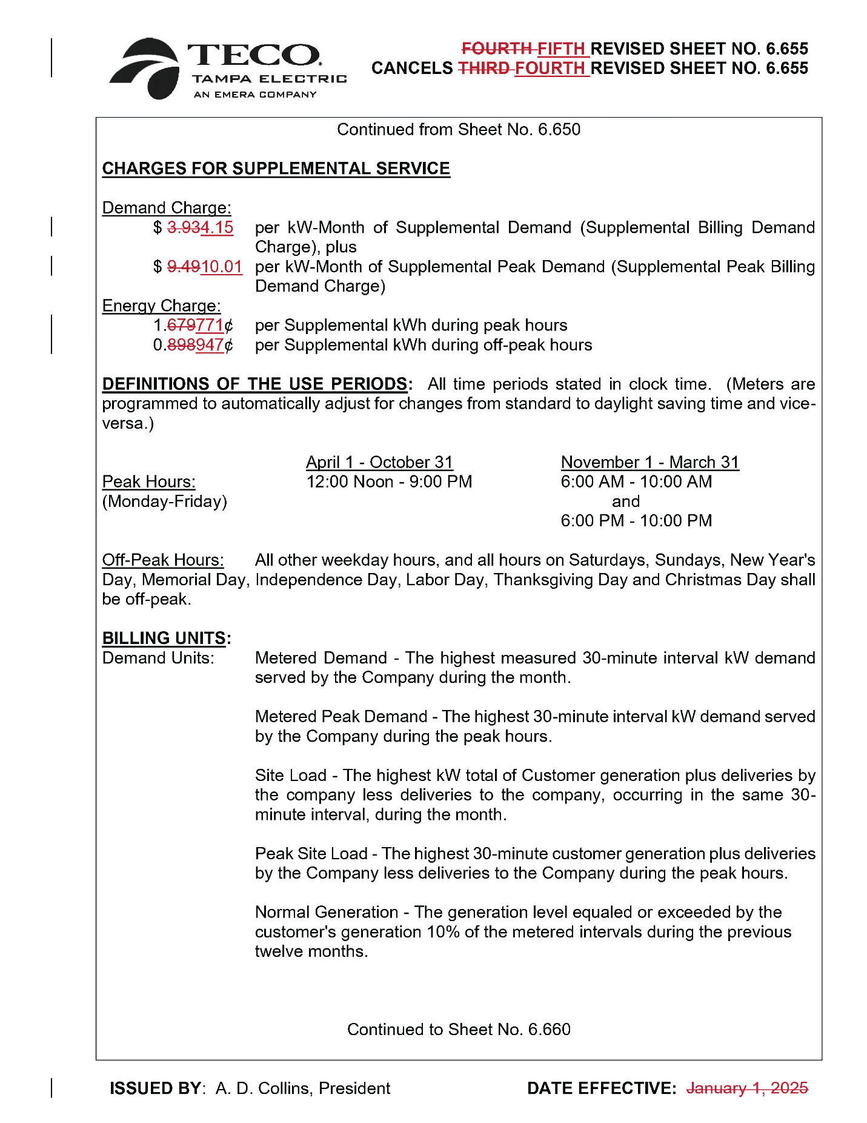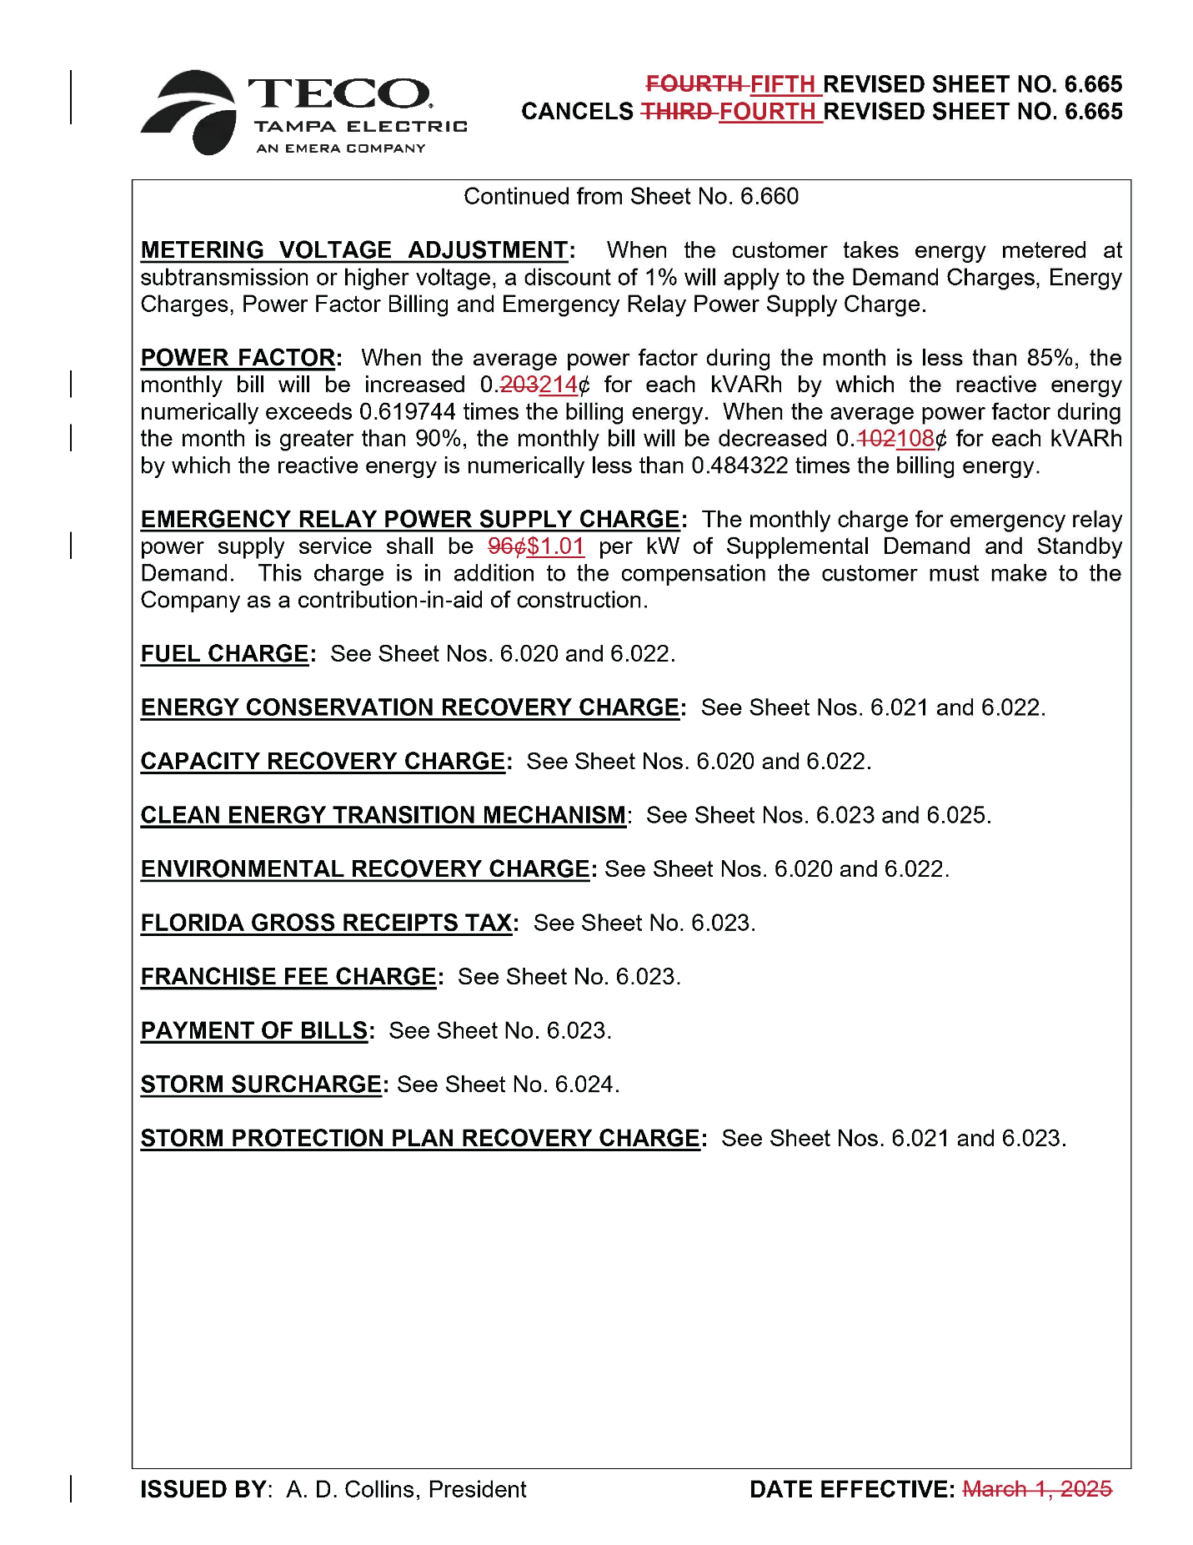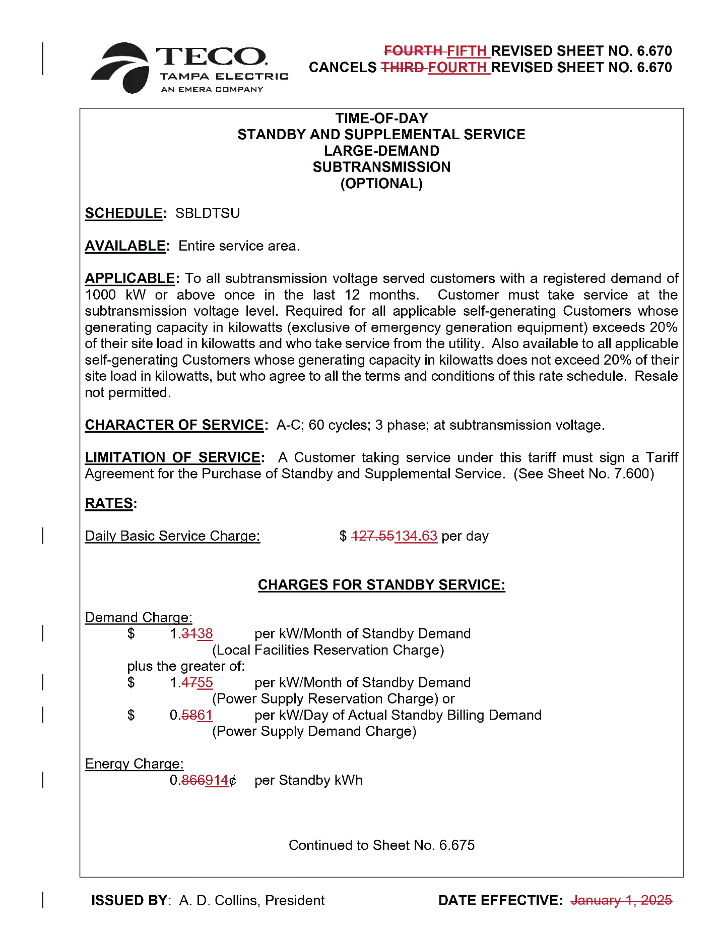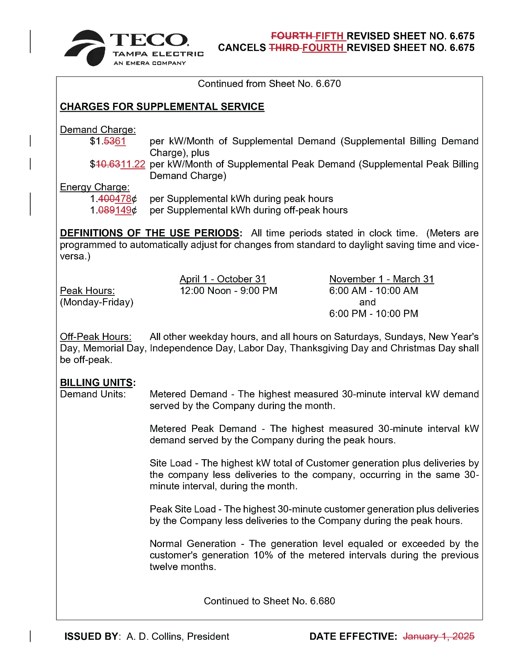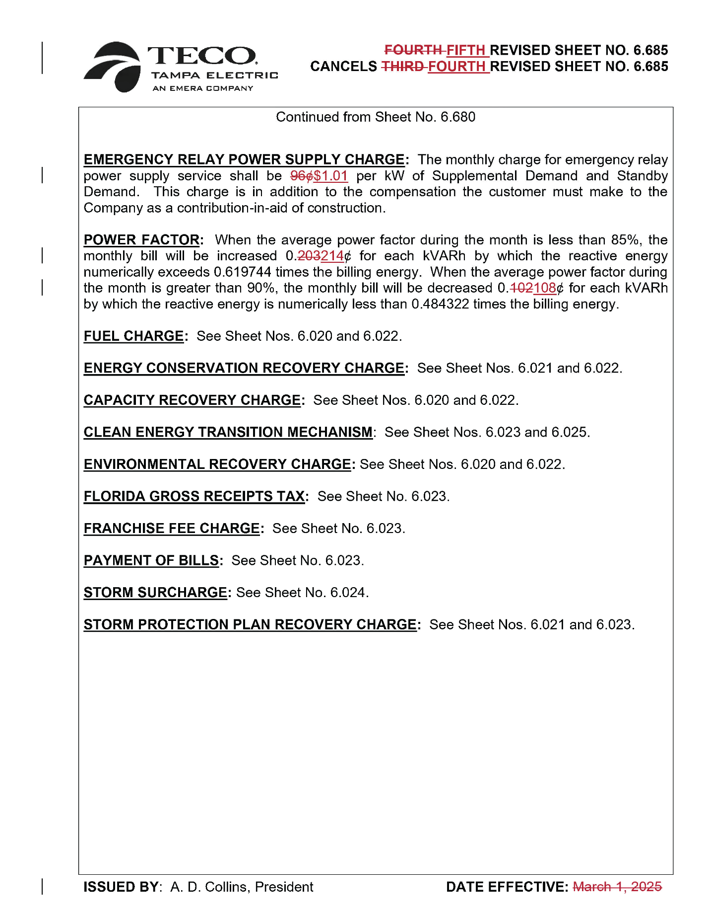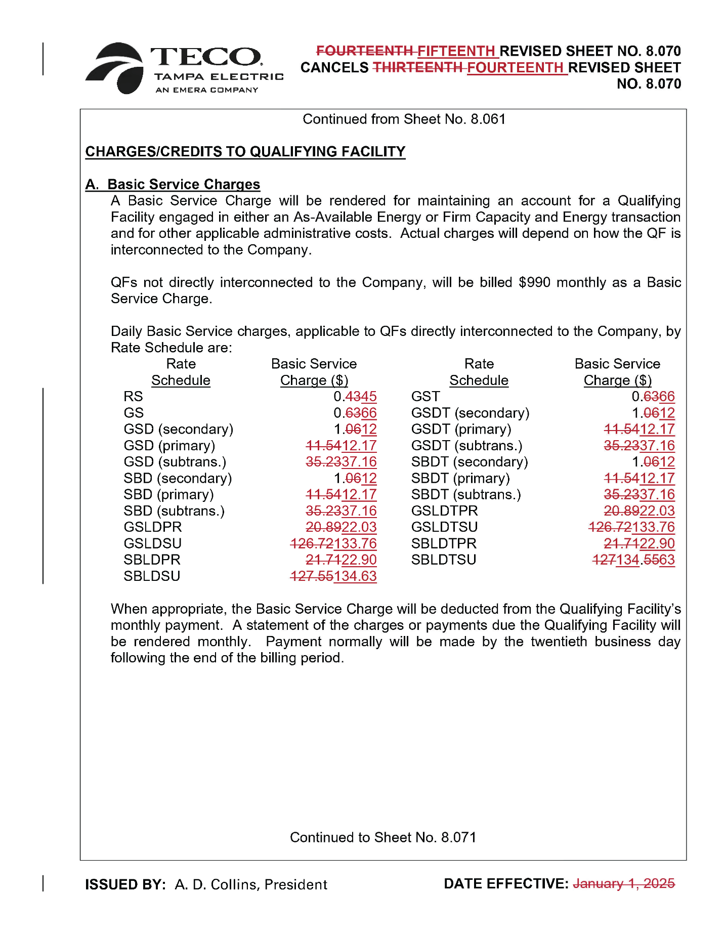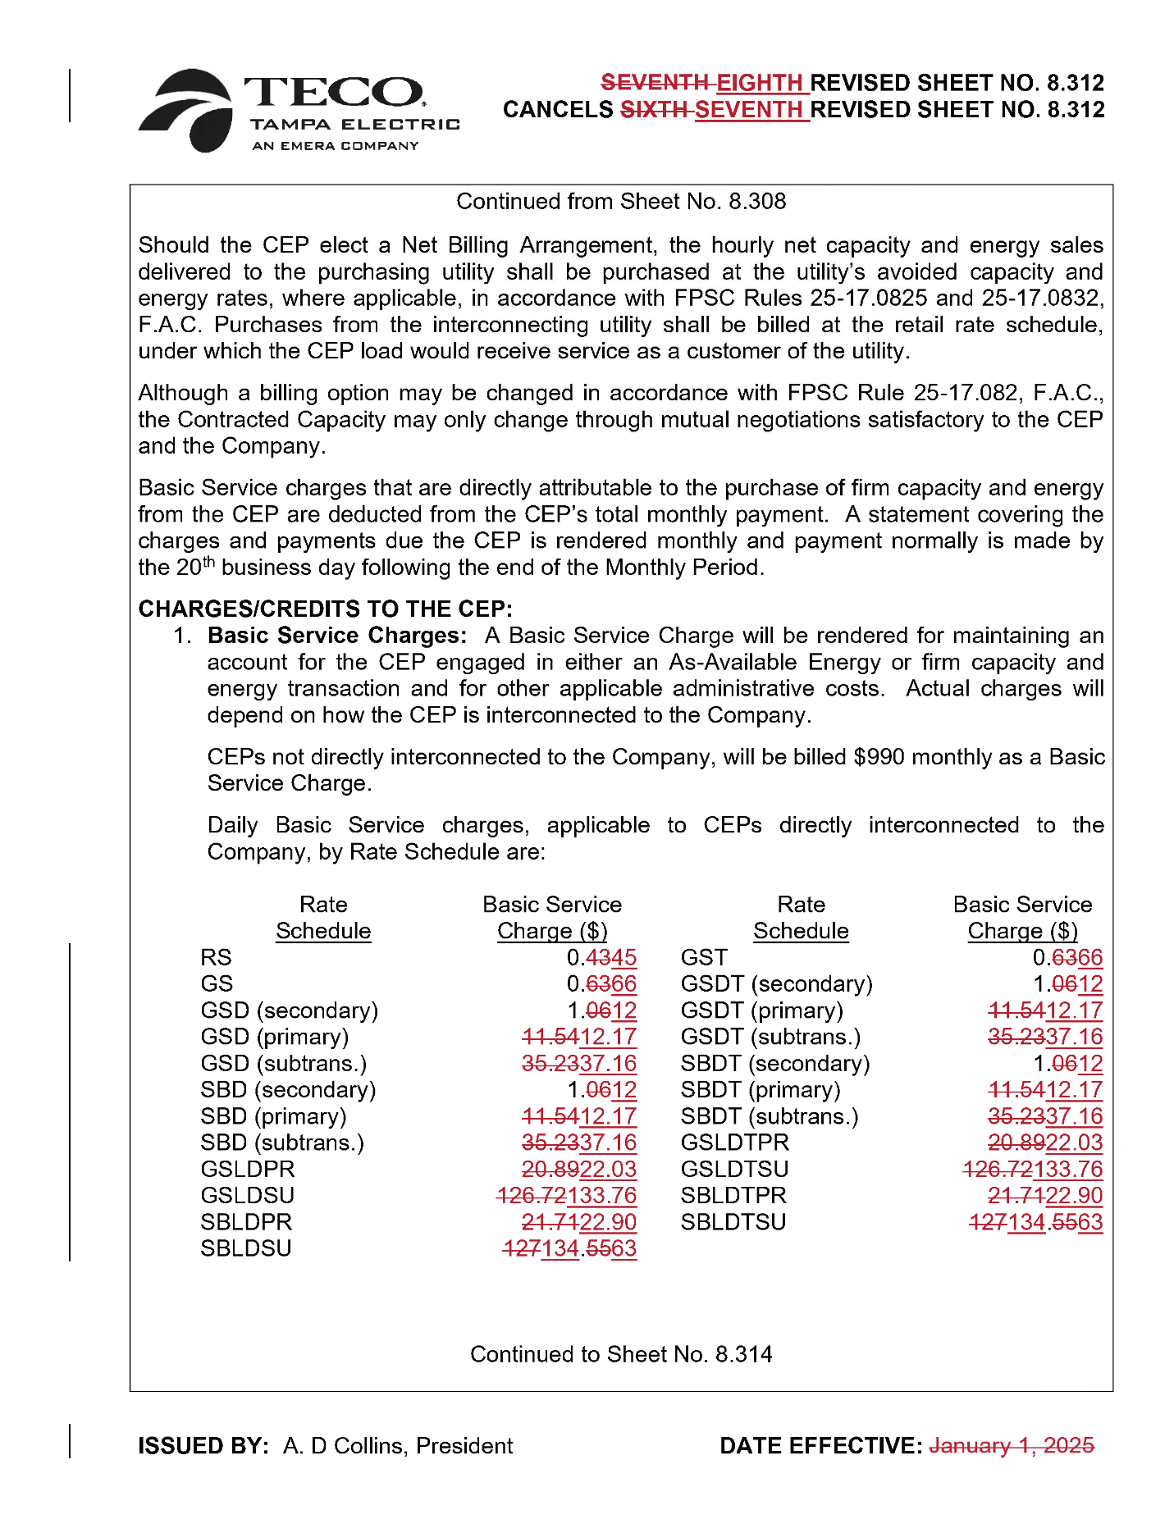

Order No. PSC-2025-0038-FOF-EI, issued February 3, 2025, in Docket No. 20240026-EI, In re: Petition for rate increase by Tampa Electric Company.
Ibid. at 167.
Order No. PSC-2025-0203-FOF-EI, issued June 11, 2025, in Docket No. 20240026-EI, In re: Petition for rate increase by Tampa Electric Company.
Ibid. at 15–17.

