BEFORE THE PUBLIC SERVICE COMMISSION

In re: Joint petition of Tampa Electric Company and Withlacoochee River Electric Cooperative, Inc. for expedited interim approval of customer transfers pending consideration of joint application for permanent relocation of territorial boundaries. | DOCKET NO. 041408-EU  ORDER NO. PSC-06-0128-PAA-EU  ISSUED: February 16, 2006

The following Commissioners participated in the disposition of this matter:

LISA POLAK EDGAR, Chairman
J. TERRY DEASON
ISILIO ARRIAGA
MATTHEW M. CARTER II
KATRINA J. TEW

NOTICE OF PROPOSED AGENCY ACTION ORDER APPROVING AMENDMENT TO TERRITORIAL AGREEMENT BETWEEN TAMPA ELECTRIC COMPANY AND WITHLACOOCHEE RIVER ELECTRIC COOPERATIVE, INC.

BY THE COMMISSION:

NOTICE is hereby given by the Florida Public Service Commission that the action discussed herein is preliminary in nature and will become final unless a person whose interests are substantially affected files a petition for a formal proceeding, pursuant to Rule 25-22.029, Florida Administrative Code.

The retail electric service boundary between Tampa Electric Company (TECO) and Withlacoochee River Electric Cooperative, Inc. (WREC) was established by Order No. 23905, issued December 20, 1990, in Docket No. 900752-EU, In Re: Joint Petition for approval of 1990 amendment to Territorial Agreement by Tampa Electric Company and Withlacoochee River Electric Cooperative, Inc.
On December 17, 2004, TECO and WREC filed a joint petition for expedited interim approval of customer transfers pending our consideration of an application for permanent relocation of territorial boundaries. The petition requested that TECO be permitted to provide interim electric service to those portions of the Belle Chase subdivision located in WREC’s territory so that service could be provided to all of the Belle Chase lots in January 2005. WREC did not have adequate facilities within the area to serve the Bell Chase subdivision. The joint petition also stated that TECO and WREC agreed to file a joint application for an amendment to their existing territorial boundary in a subsequent filing. The request for interim service was approved by Order No. PSC-05-0102-PCO-EU, issued January 25, 2005. This docket was held open to address the subsequent joint application for modification of territorial boundaries.
TECO and WREC completed a review of their boundaries in Pasco and Polk Counties and jointly filed a proposed amendment to their retail territorial service boundary on September 8, 2005. The proposed amendment to the existing service territory boundary between TECO and WREC is limited to two geographic areas in addition to the interim service concerns at the Belle Chase subdivision. All three boundary changes are within Pasco County.
We have jurisdiction pursuant to Sections 366.04 and 366.05, Florida Statutes.
The 1990 boundaries approved by Order No. 23905 were established prior to the various subdivision projects that have resulted in the proposed amendment. Joint responses by TECO and WREC to staff’s data requests indicate that the utilities have assessed the long-term load, locations of future facilities, and reliability requirements for each of the three areas. In each of the three areas, the least cost approach addressing load growth and system reliability resulted in a retail electric territorial boundary that substantially follows natural boundaries set by the respective development plans. Customers with the same service provider will tend to be grouped together within a development. Thus, the proposed amendment is expected to avoid future uneconomic duplication of facilities because of the coordinated planning and review by TECO and WREC. Drawings of relevant areas showing the new amendment’s boundary lines are contained in Attachment A to this order.
The amendment is in compliance with Rule 25-6.0440, Florida Administrative Code, and Section 366.04(2), Florida Statutes, the laws governing territorial agreements. No current customers are affected by the proposed boundary changes. No uneconomic duplication of facilities is expected. Based on the foregoing, the territorial agreement amendment is in the public interest and is approved.

Based on the foregoing, it is

ORDERED by the Florida Public Service Commission that that the joint petition for approval of amended territorial agreement in Pasco County by Tampa Electric Company and Withlacoochee River Cooperative, Inc. is approved, to become effective when this Order becomes final. It is further
ORDERED that Attachment A to this Order is incorporated herein by reference. It is further
ORDERED that the provisions of this Order, issued as proposed agency action, shall become final and effective upon the issuance of a Consummating Order unless an appropriate petition, in the form provided by Rule 28-106.201, Florida Administrative Code, is received by the Director, Division of the Commission Clerk and Administrative Services, 2540 Shumard Oak Boulevard, Tallahassee, Florida 32399-0850, by the close of business on the date set forth in the "Notice of Further Proceedings" attached hereto. It is further

ORDERED that in the event this Order becomes final, this docket shall be closed.

By ORDER of the Florida Public Service Commission this 16th day of February, 2006.

BLANCA S. BAYÓ, Director
Division of the Commission Clerk
and Administrative Services

By: | /s/ Kay Flynn
Kay Flynn, Chief
Bureau of Records

This is a facsimile copy. Go to the Commission's Web site, http://www.floridapsc.com or fax a request to 1-850-413-7118, for a copy of the order with signature.

( S E A L )

JAR

NOTICE OF FURTHER PROCEEDINGS OR JUDICIAL REVIEW

The Florida Public Service Commission is required by Section 120.569(1), Florida Statutes, to notify parties of any administrative hearing that is available under Section 120.57, Florida Statutes, as well as the procedures and time limits that apply. This notice should not be construed to mean all requests for an administrative hearing will be granted or result in the relief sought.

Mediation may be available on a case-by-case basis. If mediation is conducted, it does not affect a substantially interested person's right to a hearing.

The action proposed herein is preliminary in nature. Any person whose substantial interests are affected by the action proposed by this order may file a petition for a formal proceeding, in the form provided by Rule 28-106.201, Florida Administrative Code. This

petition must be received by the Director, Division of the Commission Clerk and Administrative Services, 2540 Shumard Oak Boulevard, Tallahassee, Florida 32399-0850, by the close of business on March 9, 2006.

In the absence of such a petition, this order shall become final and effective upon the issuance of a Consummating Order.

Any objection or protest filed in this/these docket(s) before the issuance date of this order is considered abandoned unless it satisfies the foregoing conditions and is renewed within the specified protest period.
TECO’s Service Area
Additions to TECO’s Service Area
WREC’s Service Area
Additions to WREC’s Service Area
TECO/WREC Service Area within the
Meadow Pointe Subdivision
Additions to WREC’s Service Area
WREC/TECO Service Area within the
Belle Chase Subdivision

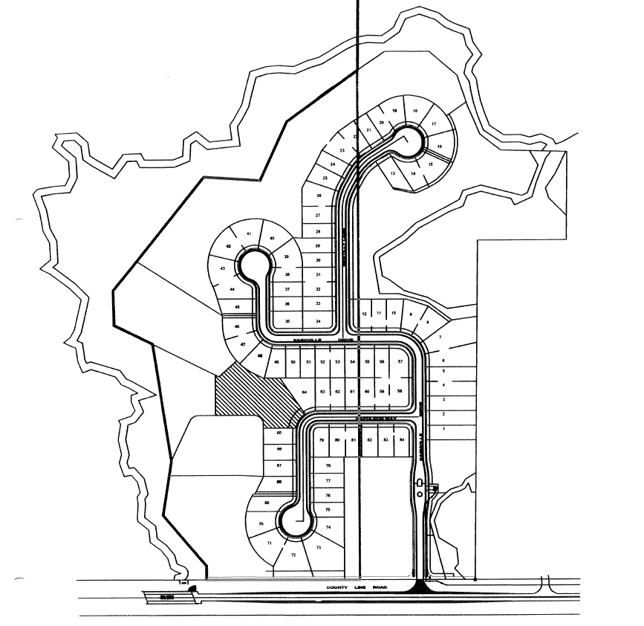
TECO’s Service Area
WREC’s Service Area
Additions to TECO’s Service Area
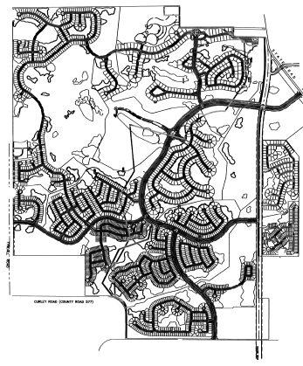
WREC’s Service Area
TECO’s Service Area

Additions to WREC’s
Service Area

Additions to TECO’s
Service Area

WREC/TECO Service Area within the
Cannon ranch Subdivision

