BEFORE THE PUBLIC SERVICE COMMISSION

In re: Application for certificates to provide water and wastewater service in Polk County by Four Points Utility Corporation. | DOCKET NO. 050595-WS  ORDER NO. PSC-07-0280-PAA-WS  ISSUED: April 2, 2007

The following Commissioners participated in the disposition of this matter:

LISA POLAK EDGAR, Chairman
MATTHEW M. CARTER II
KATRINA J. McMURRIAN

ORDER APPROVING SETTLEMENT AGREEMENT, DECLINING TO INITIATE SHOW CAUSE PROCEEDINGS, AND GRANTING WATER AND WASTEWATER CERTIFICATES NOS. 634-W AND 544-S TO FOUR POINTS UTILITY CORPORATION EFFECTIVE MARCH 13, 2007

AND

NOTICE OF PROPOSED AGENCY ACTION
ORDER APPROVING RATES AND CHARGES AND CLOSING ESCROW ACCOUNT

BY THE COMMISSION:

NOTICE is hereby given by the Florida Public Service Commission that our actions discussed herein approving rates and charges and closing the escrow account established by Order No. PSC-06-0753-SC-WS are preliminary in nature and will become final unless a person whose interests are substantially affected filed a petition for a formal proceeding, pursuant to Rule 25-22.029, Florida Administrative Code.

Background
On September 8, 2005, Island Club West Development Inc. (Island Club) filed an application for certificates of authorization for an existing utility currently charging for water and wastewater service in Polk County (County). In January 2006, Island Club chose to place the utility operations under a sister corporation, Four Points Utility Corporation. On June 15, 2006, the utility officially notified the Commission that the utility corporate entity would be Four Points Utility Corporation (Four Points or utility). The utility is located in a water use caution area of the Southwest Florida Water Management District. The utility has been in existence since 2001, and serves approximately 255 residential connections and two general service connections.

Although Polk County came under Commission jurisdiction on May 14, 1996, this utility was not brought to our attention until a customer of the utility filed a complaint. Four Points filed an application for water and wastewater certificates on September 8, 2005, after our staff contacted the utility about inquiries from customers about the veracity of charges imposed by the utility.

By Order PSC-06-0753-SC-WS, issued September 6, 2006, in this docket, we required the utility to show cause why it should not be fined in the amount of $5,000 for its failure to obtain certificates of authorization and approval of rates and charges prior to providing service to customers. The utility paid the fine in lieu of filing a response to the show cause order. Moreover, by that same Order, we temporarily authorized the utility to charge rates, with revenues held subject to refund, pending approval of final rates in this docket. Additionally, the utility was ordered not to discontinue service for failure of a customer to pay contested bills for utility services subject to Commission jurisdiction during the pendency of this Commission’s water and wastewater, electric, and telephone service investigations.

Sixteen customers took the time to write letters to the Commission complaining about utility billings, service, and objecting to the utility’s application for certificate. Other customers sent e-mails concerning billing issues. One customer, Mr. Jim Brett, Chairman of the Island Club West Homeowners Association (Association), filed a request for hearing, after which time the utility and customers (parties) engaged in mediation conducted by a Commission-sponsored mediator. Through the mediation process, the parties arrived at a Settlement Agreement to resolve all of the issues between them. A copy of the Settlement Agreement is attached to this Order as Attachment A. On November 17, 2006, with the express consent of the Association, Four Points filed a Consented Motion Seeking Commission Approval of Settlement Agreement and Cancellation of Hearing.

Sometime thereafter, we became aware that Four Points erroneously increased its temporarily authorized rates from November 2006 to January 2007, to match an increase of the County’s residential rates. The utility corrected this error and refunded the overcharges to customers by applying a credit to customer bills in February 2007.

This Order addresses the Settlement Agreement, whether the utility should be required to show cause as to why it should not be fined for charging unauthorized rates from November 2006 to January 2007, the application for original water and wastewater certificates, initial rates and charges, and the monies in escrow held subject to refund. We have jurisdiction pursuant to Sections 367.031, 367.045, 367.081, and 367.161, Florida Statutes.
Settlement Agreement
After Mr. Brett filed a formal objection to the utility’s application on behalf of customers, the utility and the customers (parties) engaged in mediation conducted by a Commission-sponsored mediator. Through the mediation process, the parties arrived at a Settlement Agreement to resolve all of the issues between them. On November 17, 2006, with the express consent of the Association, Four Points filed a Consented Motion Seeking Commission Approval of Settlement Agreement and Cancellation of Hearing (Motion).

In the Motion, the parties state that they believe the Settlement Agreement serves the public interest and is consistent with the Commission’s long-standing policy and practice of encouraging parties in protested proceedings to settle issues wherever possible. Accordingly, the parties request that this Commission accept and approve it without modification. The parties further requested cancellation of the hearing which was scheduled for March 1, 2007, in this docket. Upon that request and the Prehearing Officer’s recommendation, the Chairman’s Office cancelled the hearing.

In the Settlement Agreement, the utility agrees to utilize meters that conform to Commission rules; read meters in accordance with the established protocol attached as Exhibit A to the Settlement Agreement; and perform meter testing in accordance with Commission rule and with a customer representative to monitor the test if the Association so desires. The Settlement Agreement requires the utility to conduct a customer meeting within 30 days of Commission approval, to instruct customers how to read and review their own meters, and to discuss how to alleviate problems arising from abnormally high usage levels. The utility informed our staff that it would conduct this customer meeting on March 21, 2007. The Settlement Agreement also provides that the utility shall establish a 24-hour telephone number for utility service emergencies and redesign the format of its bills to include the meter serial number and actual usage. A copy of the new bill format is attached to the Settlement Agreement as Exhibit B. The Settlement Agreement also requires the utility to provide a specified system map to Mr. Brett within a specified time, which the utility has done.

Moreover, in the Settlement Agreement, the utility represents and warrants that it is financially able to provide a safe, continuous and reliable service to the customers. The Settlement Agreement requires the utility to provide Mr. Brett with a written history of payments made to the County for bulk water and wastewater service within a specified time, which the utility has done. The utility has placed a deposit with the County in the amount of $4,200 in order to secure bulk service, agrees to maintain the deposit at all times, and agrees to provide the Association with a monthly copy of the County invoice for bulk service along with a copy of the check to the County for payment for the service. The Settlement Agreement requires that two weeks prior to this Commission’s final decision in this docket, the utility will submit a current financial statement and balance sheet for proof of financial responsibility at that time, which the utility has done. Finally, the parties agree that if the Commission accepts the Settlement Agreement and issues a final order with respect to the certificate application, the protest shall be deemed withdrawn and all issues concerning the application among and between the parties shall be deemed resolved. If the Settlement Agreement is not accepted and approved without modification by Commission Order, it shall be considered null and void and neither party may use the attempted agreement in this or in any other proceeding.

We find that it is in the public interest to approve the Settlement Agreement without modification as a reasonable resolution of Mr. Brett’s protest. The Settlement Agreement benefits all participants in this proceeding by alleviating customer concerns about the certificate application and by avoiding the time and expense of a hearing in this matter. Therefore, the Motion is hereby granted and we accept and approve the Settlement Agreement without modification.
Show Cause Proceedings Not Initiated
0
Four Points erroneously increased its temporarily authorized rates from November 2006 to January 2007, to match an increase of the County’s residential rates. The utility provided a breakdown of the overcharges, which amounted to a total of $545.41. Four Points corrected this error by charging its Commission authorized rates for its February 2007 billing. In addition, the utility provided a spreadsheet showing the total amount of credit to be applied to each customer bill. The credit was applied to the customers’ accounts on February 27, 2007.
Section 367.081(1), Florida Statutes, provides that a utility may only charge rates and charges that have been approved by the Commission. Section 367.091(3), Florida Statutes, requires that each utility’s rates, charges, and customer service policies be contained in a tariff approved by and on file with the Commission. Rule 25-30.135(1) and (2), Florida Administrative Code, requires utilities to file tariffs and prohibits utilities from modifying or revising their rules, regulations, or schedules of rates and charges until they file and receive approval from the Commission for any such modification or revision. By increasing its temporarily authorized rates from November 2006 to January 2007 without Commission approval, Four Points is in apparent violation of the above-identified provisions of Chapter 367, Florida Statutes, and Commission rule.
Section 367.161(1), Florida Statutes, authorizes this Commission to assess a penalty of not more than $5,000 for each offense, if a utility is found to have knowingly refused to comply with, or to have willfully violated any provision of Chapter 367, Florida Statutes. By increasing its temporarily authorized rates from November 2006 to January 2007 without Commission approval, the utility’s act was “willful” in the sense intended by Section 367.161, Florida Statutes. In Order No. 24306, issued April 1, 1991, in Docket No. 890216-TL, In Re: Investigation Into The Proper Application of Rule 25-14.003, Florida Administrative Code, Relating to Tax Savings Refund For 1988 and 1989 For GTE Florida, Inc., having found that the company had not intended to violate the rule, the Commission nevertheless found it appropriate to order the utility to show cause why it should not be fined, stating that “[i]n our view, ‘willful’ implies an intent to do an act, and this is distinct from an intent to violate a statute or rule.”
Although Four Points’ failure to obtain Commission approval prior to increasing its temporarily authorized rates from November 2006 to January 2007 is an apparent violation of Sections 367.081(1) and 367.091(3), Florida Statutes, and Rule 25-30.135, Florida Administrative Code, there are circumstances which appear to mitigate the utility’s apparent violation. The utility mistakenly believed that because this Commission had authorized it to continue collecting its existing rates, which were the same as the County’s residential rates, that when the County increased its rates the utility could also increase its rates. When the utility became aware of this error, it took immediate steps to correct it by issuing credits on all customer bills in the amount of the overcharges. The vast majority of customers were overcharged in an amount of less than $5.00, for a total of $545.41 of overcharges on a system-wide basis that have been credited to customer bills. Therefore, we do not believe that the apparent violation of Sections 367.081(1) and 367.091(3), Florida Statutes, and Rule 25-30.135, Florida Administrative Code, rises in these circumstances to the level which warrants the initiation of a show cause proceeding. However, the utility shall file a status report verifying the amount credited to each customer account. The report shall be filed within 30 days of the issuance date of this Order.
For the foregoing reasons, we decline to initiate show cause proceedings against Four Points for charging unauthorized rates from November 2006 to January 2007. However, because this is the second time that Four Points has charged unauthorized rates, we admonish the utility that it must charge its Commission-approved rates and charges until authorized to change by this Commission, and that such apparent statutory and rule violations will not be tolerated in the future.
Water and Wastewater Certificate Application

Four Points filed an application for original water and wastewater certificates to provide service in Polk County on September 8, 2005. The application is in compliance with the governing statute, Section 367.045, Florida Statutes, and other pertinent statutes and administrative rules concerning an application for original certificates.
The application contains proof of compliance with the noticing provisions set forth in Rule 25-30.030, Florida Administrative Code. The notice of application for an initial certificate of authorization for water and wastewater certificates was mailed to the customers on December 20, 2005. As mentioned earlier, many customers and the homeowners association objected to the utility’s application. The utility and the customers have resolved their issues and reached a Settlement Agreement, which we have approved by this Order and which is attached as Attachment A. There have been no other objections to the notice of application and the time for filing such has expired.
Adequate service territory and system maps and a territory description have been provided as prescribed by Rule 25-30.033(1) (l), (m) and (n), Florida Administrative Code. A description of the service territory approved by this Order totaling 40 acres is attached to this Order as Attachment B. This is less territory than was requested by the applicant, as the notice was for 70 acres. We hereby grant water and wastewater certificates for the territory already being served, which is a subdivision called Island Club. An additional 30 acres south of the Island Club development was noticed, but no need for service to that area has been shown and no indication has been given as to how service would be provided. The additional 30 acres is across Sand Mine Road from the current Island Club development. The utility may file an amendment application when plans for development of any additional area are more concrete.
The applicant appears to have the financial and technical ability to provide service to the service area. The applicant is affiliated with the developer of the service area which is providing the funding to cover the operations of the utility. The owner has agreed to provide financial support to the utility and has provided a copy of his personal financial statement. We have reviewed the financial statement of the owner and it appears that there are adequate resources to support the utility. Also, measures have been taken as a result of the Settlement Agreement to secure the confidence of the customers of the utility’s financial stability.
Regarding the applicant's technical ability, the owner indicated that he will make the financial and operating commitment necessary for Four Points to be successful in providing water and wastewater service to the residents in the service territory. The applicant has retained licensed professionals for the management and operation of the utility systems. In addition, the applicant has set up its books and records for the utility in compliance with the National Association of Regulatory Utility Commissioners Uniform System of Accounts (NARUC USOA) and has indicated an understanding that the utility may not change its rates and charges, serve outside of its authorized territory, or sell the utility without obtaining prior Commission approval. Also, as a regulated utility, the utility owner understands the requirements to file an annual report and remit regulatory assessment fees.
The Island Club West development consists of 255 residential connections and 2 general service connections. The applicant stated that the only other utility nearby that could provide service is the County. The County provides both water and wastewater service to the utility at a bulk rate. The applicant states that the provision of service in the service territory, as outlined in the application, is consistent with the water and wastewater sections of the local comprehensive plan for the County, as approved by the Department of Community Affairs (DCA).
According to our records, the utility's 2005 annual report has been filed and a fine for filing the annual report late has been paid. Also, the 2005 RAFs, penalties, and interest for late payment of the RAFs have been paid. The utility is hereby put on notice that the 2006 annual report and RAFs are due March 31, 2007.
Based on the above information, we find that it is in the public interest to grant the application for original water and wastewater certificates, limited to the 40 acres described above and as more fully described in Attachment B. Accordingly, Four Points is hereby granted Certificate Nos. 634-W and 544-S to serve the territory described in Attachment B, to be effective March 13, 2007, the date of our vote on the matter. This Order will serve as the utility’s water and wastewater certificates and shall be retained by the utility.
Initial Rates and Charges

Four Points’ proposed rates are based on its current rate base, cost of capital, customer demand, and operating and maintenance expenses. In reviewing the utility’s proposed rates and charges, we find that the utility’s calculations are reasonable and consistent with those normally used by this Commission in setting initial rates and charges for a utility in existence. The analysis below describes the utility’s proposed and our approved initial rates and charges and return on investment for water and wastewater service.

Rate Base
The utility’s proposed rate bases are $27,887 for water and $28,522 for wastewater, as shown on Schedule Nos. 1 and 2. The rate base schedules are for informational purposes to establish initial rates and charges, and are not intended to formally establish rate base. This is consistent with Commission practice in original certificate applications.
Utility Plant-in-Service (UPIS)
The utility proposed UPIS of $210,654 for water and $213,533 for wastewater. The utility’s proposed UPIS includes $20,000 in organization costs for each system. The remaining UPIS of $190,654 for water and $193,533 for wastewater reflects the developer’s investment in transmission and distribution lines, services, meters, hydrants, backflow devices, and collection sewers. Four Points constructed and donated to the County a lift station, receiving wells and supply mains to connect to the County. The donated plant is not included in the rate base balances. The facilities are designed to serve a total build-out of 255 residential ERCs and two general service ERCs.
We have reviewed the utility’s UPIS costs and, based on the supporting documentation provided, we find the amounts to be reasonable. Therefore, the utility’s proposed balances of $210,654 for water and $213,533 for wastewater shall be included in the UPIS accounts.
Accumulated Depreciation
The utility proposed accumulated depreciation balances of $16,284 for water and $13,299 for wastewater. The accumulated depreciation was calculated using the guideline rates for average service lives as set forth in Rule 25-30.140, Florida Administrative Code. Therefore, the utility’s proposed accumulated depreciation balances of $16,284 for water and $13,299 for wastewater are appropriate and shall be included in rate base.
Contributions-In-Aid-of-Construction (CIAC) and Accumulated Amortization
The utility did not provide evidence to show that the investments in water and wastewater facilities, with the exception of organization costs, were not written off to the cost of goods sold on the developer’s tax returns. Pursuant to Rule 25-30.570, Florida Administrative Code,

[i]f the amount of CIAC has not been recorded on the utility’s books and the utility does not submit competent substantial evidence as to the amount of CIAC, the amount of CIAC shall be imputed to be the amount of plant costs charged to the cost of land sales for tax purposes if available, or the proportion of the cost of the facilities and plant attributable to the water transmission and distribution system and the sewage collection system.

Because all of the utility’s investment in plant is transmission, distribution, and collection lines, other than the recent organization costs, we find that the value of these lines, $190,654 for water and $193,533 for wastewater, are the appropriate CIAC balances to include in rate base. The associated accumulated amortization balances are $15,784 for water and $12,799 for wastewater.

Working Capital

Working capital allowances of $8,387 and $9,022, for water and wastewater respectively, are included in the proposed rate base calculations based on one-eighth of operating and maintenance expenses for each system. We find the amounts to be reasonable, and working capital allowances of $8,387 and $9,022 shall be included in rate base.
Summary of Rate Base
For purposes of setting initial rates and charges, the utility’s proposed rate base balances of $27,887 for water and $28,522 for wastewater shall be used. The schedules of rate base are for informational purposes to establish initial rates and charges and are not intended to formally establish rate base.
Cost of Capital
The proposed capital structure for Four Points is shown on Schedule No. 3. The pro forma capital structure consists of 100% equity. The utility proposed an overall cost of capital of 8.97% based on the current leverage formula authorized in Order No. PSC-06-0476-PAA-WS, issued June 5, 2006, in Docket No. 060006-WS, In re: Water and wastewater industry annual reestablishment of authorized range of return on common equity for water and wastewater utilities pursuant to Section 367.081 (4) (f), F.S., which was consummated by Order No. PSC-06-0554-CO-WS, issued June 27, 2006.
We agree with the utility’s cost of capital proposal. Therefore, an overall cost of capital of 8.97% for Four Points shall be used to set the initial rates.
Return on Investment
The utility’s proposed return on investment, based on a cost of capital of 8.97%, is $2,501 for water and $2,558 for wastewater which is shown on Schedule Nos. 4 and 5. Based on the rate base approved herein and overall return on investment for Four Points, a return on investment of $2,501 for water and $2,558 for wastewater shall be included in the utility’s revenue requirements for setting initial rates.
Revenue Requirement
Four Points’ proposed revenue requirements are $73,410 and $78,782 for water and wastewater, respectively. The utility’s proposed revenue requirements and rates are based on its proposed rate base, the cost of capital, operating and maintenance expenses, depreciation expense and regulatory assessment fees. The following analysis describes the utility’s proposed and our approved revenue requirements.
Operations and Maintenance (O&M) Expenses
The utility’s proposed O&M expenses of $67,096 for water and $72,179 for wastewater are based on current costs for purchased water and treated wastewater, salaries, materials and supplies, bad debt, miscellaneous expenses, and contractual services. We find that the amounts are reasonable. Therefore, $67,096 for water and $72,179 for wastewater shall be included in the revenue requirements for O&M expense.
Depreciation Expense and Amortization Expense
The utility’s proposed depreciation expense of $9,382 for water and $8,949 for wastewater is based on the depreciation rates reflected in Rule 25-30.140, Florida Administrative Code. The utility’s proposed CIAC amortization expense is $8,882 for water and $8,449 for wastewater. The utility’s proposed net depreciation and amortization expense of $500 for water and $500 for wastewater shall be included in the revenue requirement.
Taxes Other Than Income and Income Taxes
The proposed balances for taxes other than income of $3,313 for water and $3,545 for wastewater are for regulatory assessment fees (RAFs) of 4.5% of gross revenues for the systems. The utility operation does not incur an income tax liability. Therefore, no income tax expense was included in the proposed revenue requirement. Taxes other than income of $3,313 for water and $3,545 for wastewater shall be included in the revenue requirement.
Summary of Revenue Requirement
Based on our analysis of the utility’s proposed O&M expenses, depreciation and amortization of CIAC, taxes other than income, and return on investment, the utility’s proposed revenue requirements of $73,410 and $78,782 for water and wastewater, respectively, shall be used in setting initial rates for Four Points.
Rates and Charges
The utility proposed rates which are designed to produce revenues of $73,410 and $78,782 for water and wastewater. The customer base includes 255 residential customers with 5/8” x 3/4” meters.
The utility proposed two rate structures for water. One includes a base facility charge (BFC) of $11.68 and a single gallonage charge of $2.94. The other includes a BFC of $11.68 and a two tiered gallonage charge of $2.75 for the first 10,000 gallons and $3.37 for usage in excess of 10,000 gallons.
The two tiered gallonage charge will induce conservation of water by sending a price signal to residential customers that the cost of consumption will increase as consumption increases. This will encourage high consumption customers to reduce their consumption or to upgrade plumbing fixtures to achieve more efficiency.

Currently, the utility’s rate for water includes an inclining block rate structure with four tiers as shown on Schedule No. 6. Because customers are currently charged for water based on an inclining block rate structure, the approved rates shall also be based on an inclining block rate structure. However, because approximately 90% of the water demand is 10,000 gallons per month or less, more than two tiers are not needed. Therefore, we find that a water rate structure with a BFC and a two tiered gallonage charge is appropriate because it encourages conservation.

The requested wastewater rates include a BFC of $13.39 and a gallonage charge of $3.33 capped at 10,000 gallons for residential customers. We hereby approve a wastewater rate structure to include a BFC of $13.39 and a gallonage charge of $3.33 capped at 10,000 gallons for residential customers.

The utility’s proposed monthly water and wastewater rates, along with a comparison of typical monthly bills, as shown on Schedule No. 6, are hereby approved. The utility shall notice all customers of the approved rates prior to billing for monthly water and wastewater service. The utility shall also file a proposed customer notice reflecting the Commission-approved rates within ten days of the date of the consummating order issued in this docket. The approved rates shall be effective for service rendered on or after the stamped approval date on the tariff sheet, pursuant to Rule 25-30.475(1), Florida Administrative Code. Four Points shall charge the approved rates until authorized to change them by this Commission in a subsequent proceeding. A return on equity of 8.97% plus or minus 100 basis points is hereby approved.
Miscellaneous Service Charges and Late Payment Charge
The applicant has requested this Commission’s standard miscellaneous water and wastewater service charges and a $5.00 late payment charge to discourage delinquent payments. We find this request to be reasonable and the amount is consistent with recent Commission decisions. In addition, since the utility is at build-out and all of the existing facilities were donated as CIAC, there is no need to establish service availability charges and the utility is not authorized to charge service availability charges. If the utility expands its territory, the need for service availability charges can be addressed at that time.
This Commission’s standard miscellaneous water and wastewater service charges and a $5.00 late payment charge as shown on Schedule No. 6 are reasonable and are approved for Four Points. These charges shall become effective on or after the stamped approval date on the tariff sheets, pursuant to Rule 25-30.475, Florida Administrative Code, and shall be included in the notice to the customers.
Escrow Account

Pursuant to Order No. PSC-06-0753-SC-WS, issued September 6, 2006, the utility was required to deposit 44% of the revenues collected into an escrow account during the pendency of this proceeding as security in the event a refund was required. The utility filed monthly reports as required showing the monthly deposits. As of January 31, 2007, the balance in the escrow account was $42,020.48, based on revenues collected of $95,501.12. According to the bank statement, the actual amount in the account is $42,230.78.
Although a specific revenue requirement was not authorized, the utility was authorized to continue collecting the rates that it had been charging its customers, which were the same as the County’s residential rates for water and wastewater service. We have estimated that the utility’s historical revenues did not appear to exceed the revenues approved herein. Therefore, the balance in the escrow account shall be returned to the utility and the escrow account shall be closed administratively upon verification by our staff that the utility has credited each customer account for unauthorized rates charged from November 2006 to January 2007, as discussed above.

Based on the foregoing, it is

ORDERED by the Florida Public Service Commission that the Settlement Agreement between Four Points Utility Corporation and customers filed November 17, 2006, is hereby approved without modification. It is further

ORDERED that Four Points Utility Corporation shall not be required to show cause for charging unauthorized rates from November 2006 to January 2007. Four Points Utility Corporation is hereby admonished that it must charge its Commission-approved rates and charges until authorized to change by this Commission, and that such apparent violations will not be tolerated in the future. It is further

ORDERED that Four Points Utility Corporation shall file a status report verifying the amount credited to each customer account for unauthorized rates charged from November 2006 to January 2007. The report shall be filed within 30 days of the issuance date of this Order. It is further

ORDERED that the Attachments appended hereto are incorporated herein by reference. It is further

ORDERED that Four Points Utility Corporation is hereby granted Certificate Nos. 634-W and 544-S to serve the territory described in Attachment B, to be effective March 13, 2007. This Order serves as the utility’s water and wastewater certificates and shall be retained by the utility. Four Points Utility Corporation is hereby put on notice that the 2006 annual report and regulatory assessment fees are due March 31, 2007. It is further

ORDERED that Four Points Utility Corporation’s proposed monthly water and wastewater rates, along with a comparison of typical monthly bills, as shown on Schedule No. 6, are hereby approved. Four Points Utility Corporation shall notice all customers of the approved rates prior to billing for monthly water and wastewater service. The utility shall also file a proposed customer notice reflecting the Commission-approved rates and charges within ten days of the date of the consummating order issued in this docket. The approved rates and charges shall be effective for service rendered on or after the stamped approval date on the tariff sheet, pursuant to Rule 25-30.475(1), Florida Administrative Code. Four Points Utility Corporation shall charge the approved rates and charges until authorized to change them by this Commission in a subsequent proceeding. It is further

ORDERED that the balance in the escrow account established by Order No. PSC-06-0753-SC-WS shall be returned to Four Points Utility Corporation and the escrow account shall be closed administratively upon verification by our staff that the utility has credited each customer account for unauthorized rates charged from November 2006 to January 2007. It is further

ORDERED that if no timely protest is filed by a substantially affected person to the proposed agency actions taken herein in accordance with the “Notice of Further Proceedings or Judicial Review” set forth below, a consummating order shall be issued and the docket shall be closed administratively upon verification by our staff that the utility has credited each customer account for unauthorized rates charged from November 2006 to January 2007.

By ORDER of the Florida Public Service Commission this 2nd day of April, 2007.

/s/ Ann Cole
ANN COLE
Commission Clerk

This is a facsimile copy. Go to the Commission's Web site, http://www.floridapsc.com or fax a request to 1-850-413-7118, for a copy of the order with signature.

( S E A L )

RG

NOTICE OF FURTHER PROCEEDINGS OR JUDICIAL REVIEW

The Florida Public Service Commission is required by Section 120.569(1), Florida Statutes, to notify parties of any administrative hearing or judicial review of Commission orders that is available under Sections 120.57 or 120.68, Florida Statutes, as well as the procedures and time limits that apply. This notice should not be construed to mean all requests for an administrative hearing or judicial review will be granted or result in the relief sought.

As identified in the body of this order, our action approving rates and charges and closing the escrow account established by Order No. PSC-06-0753-SC-WS is preliminary in nature. Any person whose substantial interests are affected by the action proposed by this order may file a petition for a formal proceeding, in the form provided by Rule 28-106.201, Florida Administrative Code. This petition must be received by the Director, Division of the Commission Clerk and Administrative Services, at 2540 Shumard Oak Boulevard, Tallahassee, Florida 32399-0850, by the close of business on April 23, 2007. If such a petition is filed, mediation may be available on a case-by-case basis. If mediation is conducted, it does not affect a substantially interested person's right to a hearing. In the absence of such a petition, this order shall become effective and final upon the issuance of a Consummating Order.

Any objection or protest filed in this docket before the issuance date of this order is considered abandoned unless it satisfies the foregoing conditions and is renewed within the specified protest period.

Any party adversely affected by the Commission's final action in this matter may request: (1) reconsideration of the decision by filing a motion for reconsideration with the Director, Division of the Commission Clerk and Administrative Services within fifteen (15) days of the issuance of this order in the form prescribed by Rule 25-22.060, Florida Administrative Code; or (2) judicial review by the Florida Supreme Court in the case of an electric, gas or telephone utility or the First District Court of Appeal in the case of a water or wastewater utility by filing a notice of appeal with the Director, Division of the Commission Clerk and Administrative Services and filing a copy of the notice of appeal and the filing fee with the appropriate court. This filing must be completed within thirty (30) days after the issuance of this order, pursuant to Rule 9.110, Florida Rules of Appellate Procedure. The notice of appeal must be in the form specified in Rule 9.900(a), Florida Rules of Appellate Procedure.

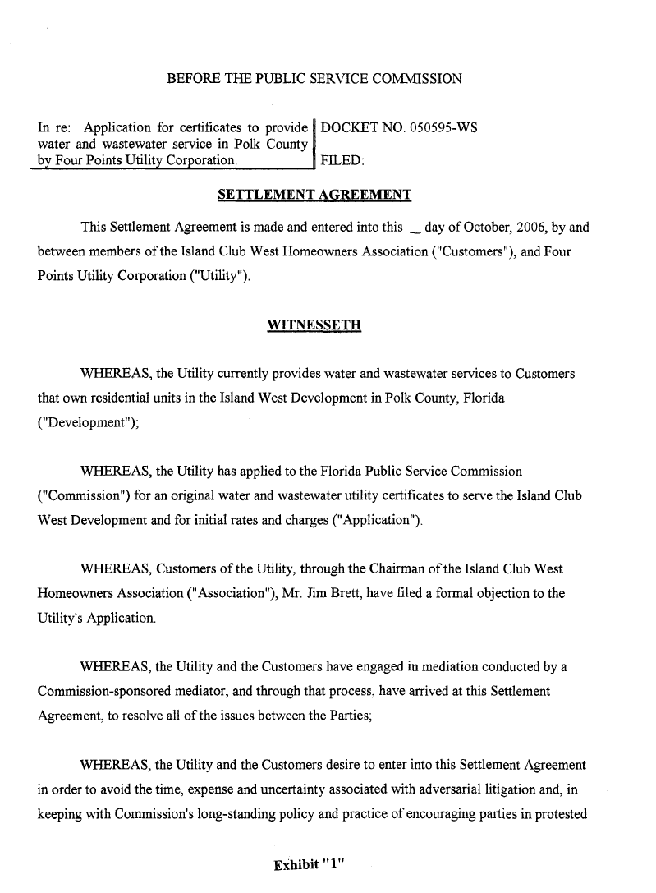
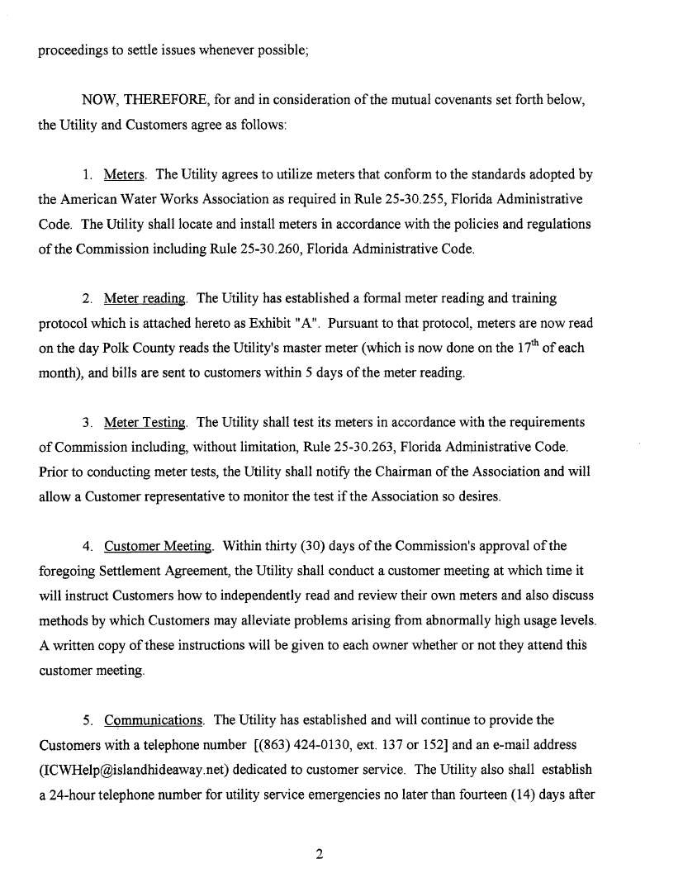
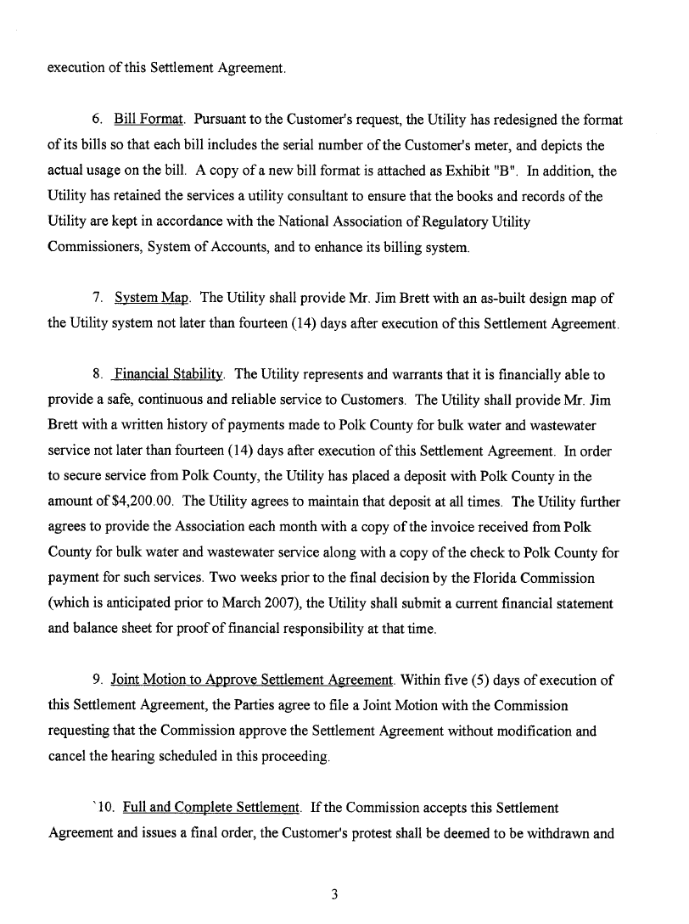
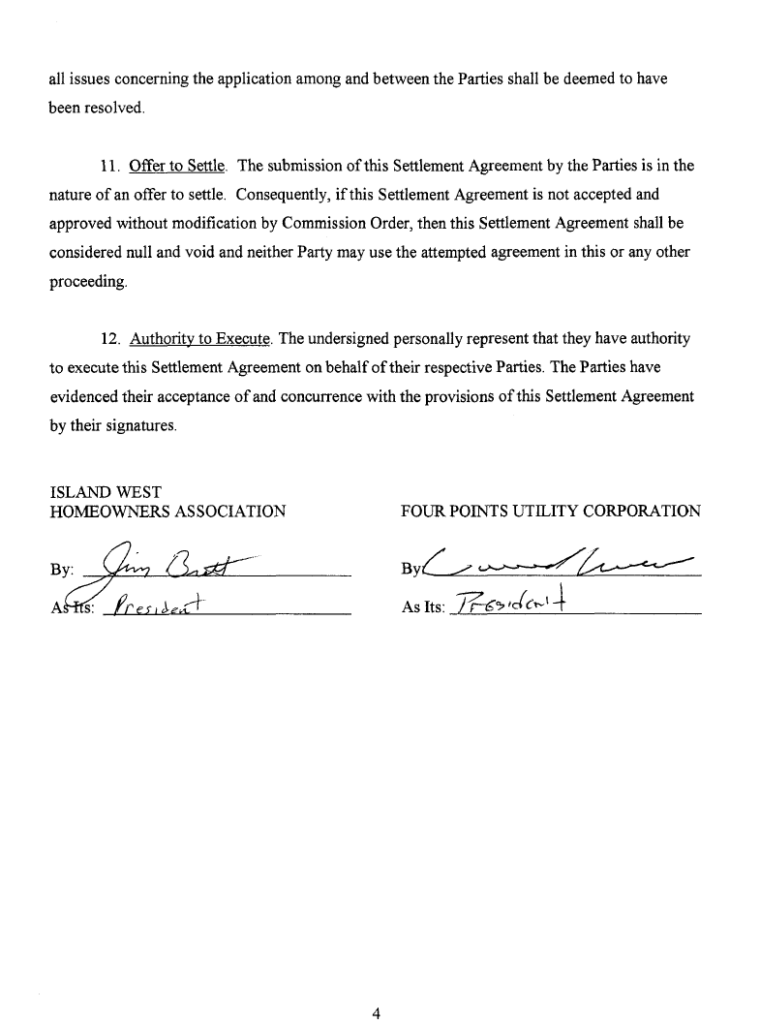
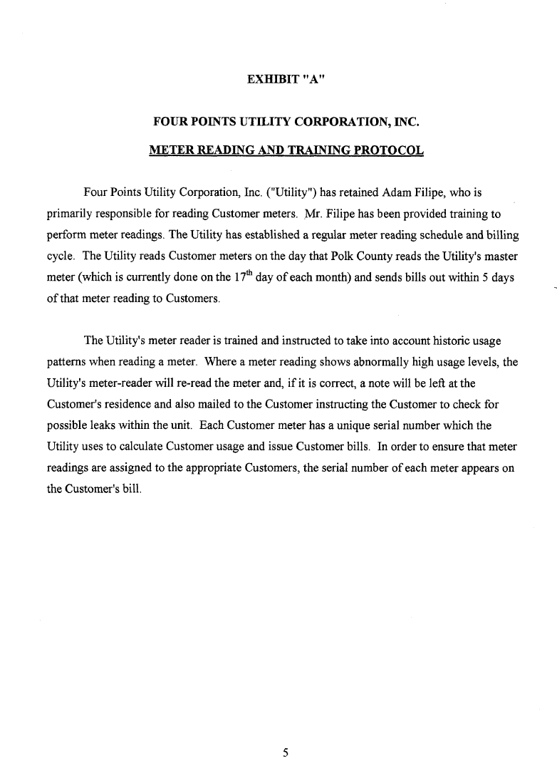
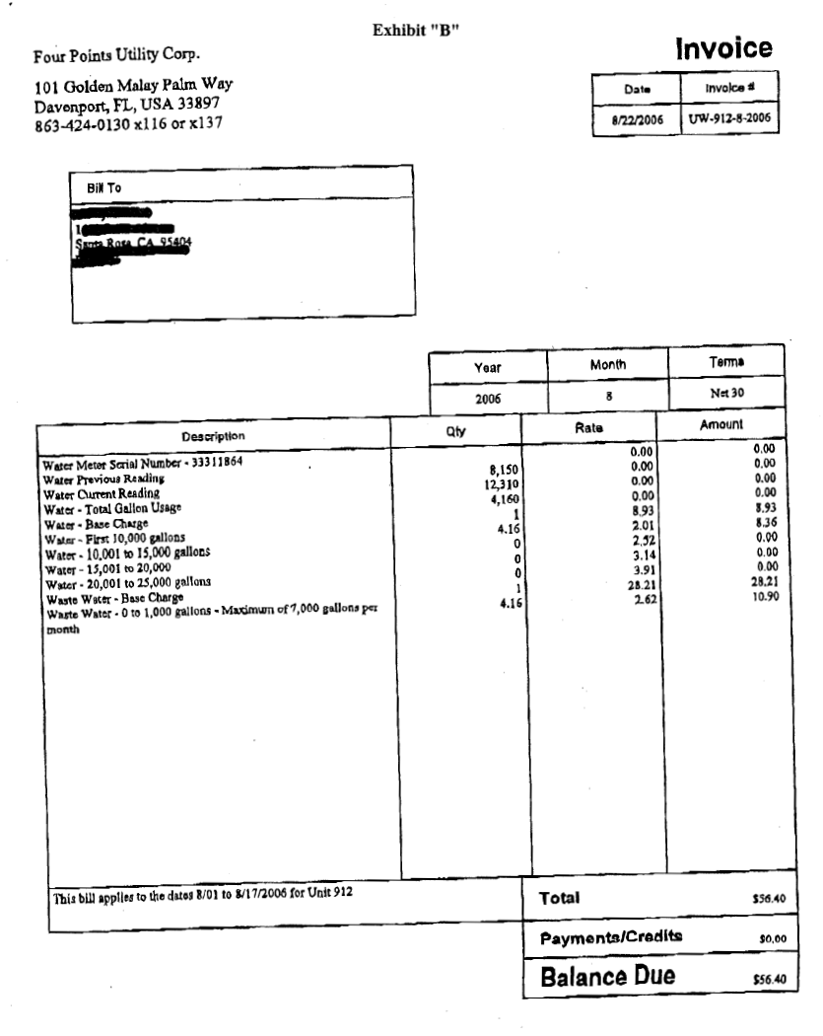
FOUR POINTS UTILITY CORPORATION

DESCRIPTION OF TERRITORY SERVED

ISLAND CLUB SUBDIVISION

In Township 25 South, Range 26 East, Section 14, Polk County, Florida:

The Southwest ¼ of the Northeast ¼

FLORIDA PUBLIC SERVICE COMMISSION
Authorizes

Four Points Utility Corporation
pursuant to
Certificate Number 634-W

to provide water service in Polk County in accordance with the provisions of Chapter 367, Florida Statutes, and the Rules, Regulations, and Orders of this Commission in the territory described by the Orders of this Commission. This authorization shall remain in force and effect until superseded, suspended, cancelled or revoked by Order of this Commission.
Order Number Date Issued Docket Number Filing Type
PSC-07-0280-PAA-WS 4/02/2007 050595-WS Original Certificate

FLORIDA PUBLIC SERVICE COMMISSION
Authorizes

Four Points Utility Corporation
pursuant to
Certificate Number 544-S

to provide wastewater service in Polk County in accordance with the provisions of Chapter 367, Florida Statutes, and the Rules, Regulations, and Orders of this Commission in the territory described by the Orders of this Commission. This authorization shall remain in force and effect until superseded, suspended, cancelled or revoked by Order of this Commission.
Order Number Date Issued Docket Number Filing Type
PSC-07-0280-PAA-WS 4/02/2007 050595-WS Original Certificate

FOUR POINTS UTILITY CORPORATION |  | SCHEDULE NO. 1
SCHEDULE OF WATER RATE BASE |  | DOCKET NO. 050595-WS
 |  | UTILITY REQUESTED
DESCRIPTION |  | COMMISSION APPROVED
UTILITY PLANT IN SERVICE |  | $210,654
ACCUMULATED DEPRECIATION |  | (16,284)
CIAC |  | (190,654)
AMORTIZATION OF CIAC |  | 15,784
WORKING CAPITAL ALLOWANCE |  | 8,387
WASTEWATER RATE BASE |  | $27,887

FOUR POINTS UTILITY CORPORATION |  | SCHEDULE NO. 2
SCHEDULE OF WASTEWATER RATEBASE |  | DOCKET NO. 050595-WS
 |  | UTILITY REQUESTED
DESCRIPTION |  | COMMISSION APPROVED
UTILITY PLANT IN SERVICE |  | $213,533
ACCUMULATED DEPRECIATION |  | (13,299)
CIAC |  | (193,533)
AMORTIZATION OF CIAC |  | 12,799
WORKING CAPITAL ALLOWANCE |  | 9,022
WASTEWATER RATE BASE |  | $28,522

FOUR POINTS UTILITY CORPORATION Schedule No. 3
SCHEDULE OF COST OF CAPITAL

DESCRIPTION | BALANCE  PER  UTILITY | WEIGHT | COST  RATE | WEIGHTED  COST
Common Equity | $ 56,409 | 100.% | 8.97% | 8.97%
Long and Short-Term Debt |  | 0.0% | 0.0% | 0.00%
Customer Deposits |  | 0.0% | 0.0% | 0.00%
 |  | 100.0% | 8.97% | 8.97%
Range of Reasonableness | High | Low
Common Equity | 9.97% | 7.97%

FOUR POINTS UTILITY CORPORATION
Statement of Water Operations
Schedule No. 4
DESCRIPTION |  | UTILITY  REQUESTED AND COMMISSION APPROVED
Operating Revenues |  | $ 73,410
Operating and Maintenance |  | 67,096
Depreciation Expense |  | 500
Taxes Other Than Income |  | 3,313
Income Taxes |  | 0
Total Operating Expense |  | 70,909
Net Operating Income(Loss) |  | $2,501
Rate Base |  | $ 27,887
Rate of Return |  | 8.97%

FOUR POINTS UTILITY CORPORATION
Statement of Wastewater Operations
Schedule No. 5

UTILITY
REQUESTED AND COMMISSION APPROVED
Operating Revenues |  | $ 78,782
Operating and Maintenance |  | 72,179
Depreciation Expense |  | 500
Taxes Other Than Income |  | 3,545
Income Taxes |  | 0
Total Operating Expense |  | 76,224
Net Operating Income(Loss) |  | $2,558
Rate Base |  | $ 28,522
Rate of Return |  | 8.97%

FOUR POINTS UTILITY CORPORATION
Schedule No. 6
Monthly Service Rates

 | Water |  | Wastewater
 | Existing Rates | Approved Rates | Existing Rates | Approved Rates
Base Facility Charge

5/8” x 3/4 | $8.93 | $11.68 | $28.21 | $13.39
First 10,000 gallons | $2.01 | $2.75
Next 5,000 gallons | $2.52
Next 5,000 gallons | $3.14
Next 5,000 gallons | $3.91
Excess over 10,000 gallons |  | $3.37
Charge per 1,000 gallons |  |  | $2.62* | $3.33**
*Cap of 7,000 gallons for residential wastewater
**Cap of 10,000 gallons for residential wastewater

Typical Residential Bills
 |  | Water |  |  | Wastewater
 | Existing Rates |  | Approved Rates | Existing Rates |  | Approved Rates
5/8” x 3/4” meter
5,000 gallons | $18.98 |  | $25.43 | $41.31 |  | $30.04
10,000 gallons | $29.03 |  | $39.18 | $46.55 |  | $46.69
15,000 gallons | $41.63 |  | $56.03 | $46.55 |  | $46.69

Miscellaneous Service Charges

 | Water | Wastewater
Initial Connection | $20.00 | $20.00
Normal Reconnection | 20.00 | 20.00
Premise Visit | 20.00 | 20.00
Violation Reconnection | 20.00 | Actual
Late fee | 5.00 | 5.00

See Order No. PSC-06-0170A-PAA-WS, issued March 9, 2006, in Docket No. 050281-WS, In Re: Application for increase in water and wastewater rates in Volusia County by Plantation Bay Utility Company.

