BEFORE THE PUBLIC SERVICE COMMISSION

In re: Joint petition to implement practices and procedures with Department of Children and Families to automatically enroll eligible customers in Lifeline telephone program, by Citizens of Florida and AARP. | DOCKET NO. 060677-TL  ORDER NO. PSC-07-0417-PAA-TL  ISSUED: May 11, 2007

The following Commissioners participated in the disposition of this matter:

LISA POLAK EDGAR, Chairman
MATTHEW M. CARTER II
KATRINA J. McMURRIAN

NOTICE OF PROPOSED AGENCY ACTION
ORDER ON LIFELINE AUTOMATIC ENROLLMENT PROCESS

BY THE COMMISSION:

NOTICE is hereby given by the Florida Public Service Commission that the action discussed herein is preliminary in nature and will become final unless a person whose interests are substantially affected files a petition for a formal proceeding, pursuant to Rule 25-22.029, Florida Administrative Code.

I. Case Background

On October 11, 2006, the Office of Public Counsel (OPC) and AARP jointly filed a petition with this Commission requesting that it order local exchange telecommunications companies in Florida to implement practices and procedures with the Department of Children and Families (DCF) to automatically enroll eligible customers in the Lifeline telephone program.

On October 20, 2006, Charles J. Crist, as Florida Attorney General, petitioned this Commission to enter an Order granting leave to the Attorney General to intervene in this docket. According to the Attorney General, “[o]ne million households in Florida who are intended beneficiaries of the Lifeline program are failing to realize its benefits.” Furthermore, the Attorney General expressed his support of the Joint Petition filed by the Office of Public Counsel and AARP to implement automatic enrollment for Lifeline. By Order No. PSC-06-0897-PCO-TL, issued October 26, 2006, we granted the Attorney General’s request to intervene in this docket.

On October 30, 2006, and October 31, 2006, respectively, Windstream Florida, Inc. and TracFone Wireless, Inc. filed Petitions to Intervene in this docket. By Order No. PSC-06-0940-PCO-TL, issued November 7, 2006, we granted Windstream Florida, Inc.’s request to intervene in this docket noting that Windstream’s substantial interests may be affected because it provides incumbent local exchange service in Florida. By Order No. PSC-06-0959-PCO-TL, issued November 17, 2006, we granted TracFone Wireless, Inc.’s request to intervene in this docket since it provides commercial mobile radio services in Florida, and has a Petition for Designation as an Eligible Telecommunications Carrier (ETC) in the State of Florida currently pending before the Federal Communications Commission.

On November 28, 2006, BellSouth Telecommunications, Inc. filed a “Motion For Abeyance” requesting that this docket be held in abeyance for a minimum of six months pending the results of our newly initiated On-Line Automated Lifeline and Link-Up Application Process. On December 12, 2006, Embarq Florida, Inc. filed a “Request For Abeyance” asking that the we hold this docket in abeyance for at least six months pending results of our On-Line Automated Lifeline and Link-Up Application Process and the rule development workshop which was conducted February 6, 2007 to address Lifeline issues.

By Order No. PSC-07-0064-PCO-Tl, issued January 24, 2007, BellSouth’s Motion for Abeyance and Embarq’s Request for Abeyance were denied noting that the FPSC and DCF have been working together on an automatic enrollment process in some fashion for a period of time. An informal meeting was held with the parties on February 5, 2007 to identify areas of agreement and disagreement regarding the Joint Petitioner’s automatic enrollment proposal.

II. Analysis

We have been proactive regarding Lifeline enrollment in Florida. A number of different enrollment methods have been developed, and are continuing to be developed, to make it easier for consumers to enroll in Florida’s Lifeline program. A brief historical summary of the various Lifeline enrollment processes is provided below.

Lifeline Enrollment Processes

Simplified-Certification Form --- By Order No. PSC-05-0153-AS-TL, issued February 8, 2005, in Docket No. 040604-TL, we approved a proposal which allows Lifeline eligible customers to simply sign a document certifying “under penalty of perjury” that the customer participates in one of the Florida Lifeline eligible programs and identifying the qualifying program. This process replaced the previous procedure whereby Lifeline applicants had to provide proof that they are enrolled in one of the qualifying programs. Once completed, the simplified-certification form is submitted via mail or fax to the appropriate ETC to be enrolled in Lifeline. On August 7, 2006, we ordered all ETCs to adopt the simplified-certification enrollment process.

The simplified-certification form is available on our web site at http://www.psc.state.fl.us/utilities/telecomm/lifeline/lifelinePDFs/ApplicationEnglish.pdf and through various outreach programs. A copy of the simplified-certification form is attached to this Order as Attachment A.

Automated Online Application Process — In October 2006, in an effort to further simplify Lifeline enrollment, we created a direct link to a Lifeline application located on our Web site. The electronic application process allows consumers the opportunity to complete a Lifeline application online and submit it by hitting one button. Once submitted, the system forwards an automatic e-mail informing the appropriate ETC that a Lifeline application is available for retrieval through our secure database. The ETC retrieves the application and enrolls the consumer in Lifeline. All ten incumbent local exchange companies, six competitive local exchange companies and three wireless carriers which have been granted ETC status in Florida are participating in the automated enrollment process. As of April 10, 2007, over 1,300 consumers were enrolled in Lifeline through the Automated Online Application Process.

The automated online Lifeline application is available on our web site at https://secure.floridapsc.com/(S(o1ts3zqjezhlay2mzlhiem45))/public/lifeline/lifelineapplication.aspx. A copy of the automated application form is also attached to this Order as Attachment B.

Automatic Enrollment Process — In April 2006, DCF and our staff renewed their efforts to develop a process whereby potential Lifeline customers, once certified through a DCF program, could automatically receive Lifeline discounts. From the perspective of the client, the automatic enrollment process should be seamless from filling out the DCF web application to receiving Lifeline discounts.

The automatic enrollment process entails the DCF client checking a “yes” or “no” box on the DCF web application stating an interest in receiving the Lifeline discounts on his or her telephone service. The “no” box provides an option to the applicant not to subscribe to Lifeline discounts if he or she chooses. If the client answers in the affirmative, the applicant identifies a telephone service provider from a drop-down box on the application and answers several questions. The DCF forwards to this Commission the names of the clients approved by DCF for benefits making them eligible for Lifeline and have chosen to receive the Lifeline discounts. In addition, the relevant information needed for the client to be enrolled in Lifeline is also transferred. We electronically sort the information by ETC and place the names on the same secure web site established for our automated enrollment process for the ETCs to process their customers for Lifeline discounts.

OPC and the AARP Petition

The Petition filed by the Office of Public Counsel requests that we order local exchange telecommunications companies in Florida to “implement practices and procedures with the Department of Children and Families to automatically enroll eligible customers in the Lifeline telephone program.” As mentioned above, our staff and DCF have been working on an automatic Lifeline enrollment process for DCF clients since April 2006. DCF’s assistance in developing a Lifeline automatic enrollment process has been invaluable.

The process that has been developed by this Commission differs in some areas from that proposed by OPC and AARP. However, we believe that the intent and goals of the petition have been met. The automatic enrollment process implemented allows for all 19 Florida ETCs to participate in the automatic enrollment process and provides a choice for DCF applicants to enroll in the Lifeline program to receive discounts. Like any new process, monitoring is needed to determine areas where improvements may need to be made. Based upon the results and any issues that arise, input and observations from all parties concerned--OPC, AARP, the Attorney General, DCF, the ETCs, and consumers--should be heard to determine how the process can be improved. Accordingly, our staff shall submit a status report on the automatic enrollment process in six months.

In order to obtain more experience with the developed automatic enrollment system, receive feedback from the parties, and evaluate any relevant statute modifications, this docket shall be placed in abeyance at this time. Therefore, this docket shall remain open pending analysis of the results of the Lifeline automatic enrollment process being implemented by this Commission and the Department of Children and Families.

Based on the foregoing, it is

ORDERED by the Florida Public Service Commission that pending analysis of the results of the newly instituted Lifeline automatic enrollment process, we shall not order the local exchange telecommunications companies in Florida to implement practices and procedures with the Department of Children and Families to automatically enroll eligible customers in the Lifeline telephone program. It is further

ORDERED that the Commission staff shall submit a status report on the automatic enrollment process in six months. It is further

ORDERED that the provisions of this Order, issued as proposed agency action, shall become final and effective upon the issuance of a Consummating Order unless an appropriate petition, in the form provided by Rule 28-106.201, Florida Administrative Code, is received by the Office of Commission Clerk, 2540 Shumard Oak Boulevard, Tallahassee, Florida 32399-0850, by the close of business on the date set forth in the "Notice of Further Proceedings" attached hereto. It is further

ORDERED that in the event this Order becomes final, this docket shall remain open.

By ORDER of the Florida Public Service Commission this 11th day of May, 2007.

/s/ Ann Cole
ANN COLE
Commission Clerk

This is an electronic transmission. A copy of the original signature is available from the Commission's website, www.floridapsc.com, or by faxing a request to the Office of Commission Clerk at 1-850-413-7118.

( S E A L )

AJT

NOTICE OF FURTHER PROCEEDINGS OR JUDICIAL REVIEW

The Florida Public Service Commission is required by Section 120.569(1), Florida Statutes, to notify parties of any administrative hearing that is available under Section 120.57, Florida Statutes, as well as the procedures and time limits that apply. This notice should not be construed to mean all requests for an administrative hearing will be granted or result in the relief sought.

Mediation may be available on a case-by-case basis. If mediation is conducted, it does not affect a substantially interested person's right to a hearing.

The action proposed herein is preliminary in nature. Any person whose substantial interests are affected by the action proposed by this order may file a petition for a formal proceeding, in the form provided by Rule 28-106.201, Florida Administrative Code. This petition must be received by the Office of Commission Clerk, 2540 Shumard Oak Boulevard, Tallahassee, Florida 32399-0850, by the close of business on June 1, 2007.

In the absence of such a petition, this order shall become final and effective upon the issuance of a Consummating Order.

Any objection or protest filed in this/these docket(s) before the issuance date of this order is considered abandoned unless it satisfies the foregoing conditions and is renewed within the specified protest period.

ATTACHMENT A
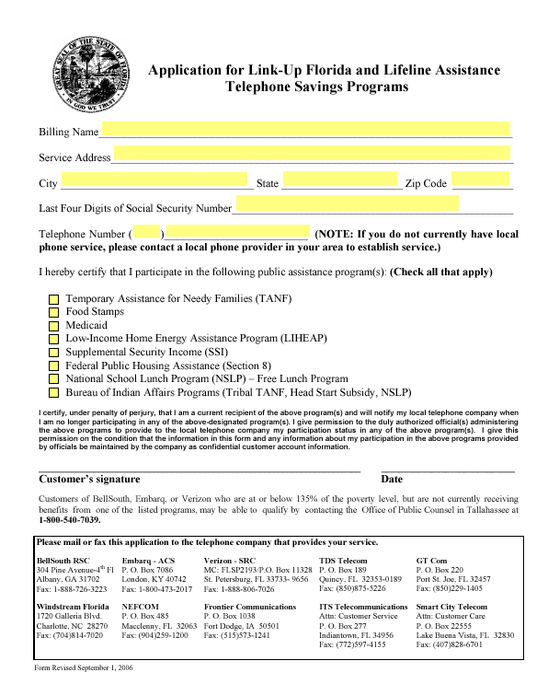
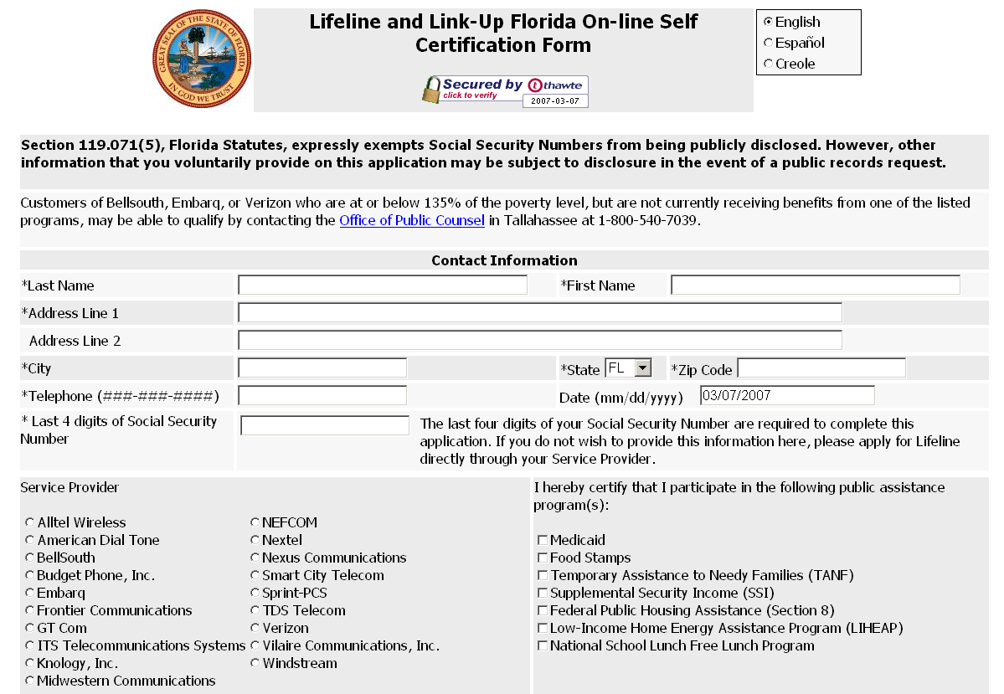
ATTACHMENT B

The Lifeline and Link-Up assistance programs help low-income consumers obtain and maintain basic telecommunications service at just, reasonable, and affordable rates by providing a minimum $13.50 monthly credit to eligible consumers.
Section 254(e) of the Communications Act of 1934, as amended (the Act), provides that “only an eligible telecommunications carrier designated under section 214(e) shall be eligible to receive specific Federal universal service support.” Pursuant to section 214(e)(l), a common carrier designated as an ETC must offer the services supported by the federal universal service mechanisms throughout the designated service area either by using its own facilities or by using a combination of its own facilities and resale of another carrier’s services (including the services offered by another ETC), and must advertise these services throughout the designated service area.
Order No. PSC-06-0680-PAA-TL, issued August 7, 2006.
BellSouth d/b/a AT&T Florida, Verizon, Embarq, GTC, Windstream, TDS Telecom, NEFCOM, Frontier, ITS Telecom, Smart City, Nextel Partners, ALLTEL Wireless, Sprint PCS, Knology, Budget Phone, American Dial Tone, Nexus, Vilaire, and Midwestern.

