BEFORE THE PUBLIC SERVICE COMMISSION

In re: Petition for permanent approval of a performance guaranty agreement, including approval of first revised Tariff Sheet No. 9.946 by Florida Power & Light Company. | DOCKET NO. 070291-EI  ORDER NO. PSC-07-0536-TRF-EI  ISSUED: June 26, 2007

The following Commissioners participated in the disposition of this matter:

LISA POLAK EDGAR, Chairman
MATTHEW M. CARTER II
KATRINA J. McMURRIAN
NANCY ARGENZIANO
NATHAN A. SKOP

ORDER APPROVING PERFORMANCE GUARANTY AGREEMENT

BY THE COMMISSION:

BACKGROUND
By Order No. PSC-04-0406-TRF-EI, we approved a new Performance Guaranty Agreement (PGA) for Florida Power & Light Company (FPL). The PGA tariff applies to customers who request electric facilities that would not likely be required by other customers within five years following the date of the requested system expansion. The agreement requires a customer requesting specialized equipment to post a deposit to cover the cost of the facilities, either in cash or by letter of credit. If the projected usage materializes, the deposit is returned after three years. We approved the program as a three-year pilot program in 2004 so that we could monitor the application of the performance guaranty. The initial period has now expired and FPL is requesting that the Agreement be made permanent. We have jurisdiction pursuant to Sections 366.03, 366.04, 366.06, 366.07, and 366.075, Florida Statutes.
APPROVING PERFORMANCE GUARANTY AGREEMENT
FPL’s PGA is essentially another form of a deposit. However, it only applies to customers who request specialized electric facilities that would not likely be used by other customers within five years following the date of the requested system expansion, should the initial customer cease operations. This includes non-standard voltages or configurations, or service to facilities located in areas not considered attractive for other development in the near future. Rule 25-6.064, Florida Administrative Code, allows a utility to require upfront payment (Contribution in Aid of Construction or CIAC) for facilities necessary to provide service to a specific customer where those facilities exceed standard design. The projected costs are reduced by four times the expected annual revenue generated by the customer to determine the nonrefundable payment.
Expected revenues, however, are heavily dependent on the customer’s projection of load, especially if the business involves a new technology or product about which the utility has little or no historical knowledge. The customer has an incentive to maximize load projections to minimize the CIAC. The estimated CIAC may not cover the actual cost of the facilities installed if the projected load does not materialize. The purpose of the PGA is to protect the general body of ratepayers from stranded investment by requiring a three year deposit which is netted against actual revenues over that period. Unlike the traditional CIAC, the PGA allows the applicant for service to receive a full or partial refund of the performance guaranty if the projected load and revenues are realized.
PGA Requirements. Under the PGA, an applicant is required to post a three year performance guaranty in the form of cash, a surety bond, or a bank letter of credit. FPL determines the amount of the performance guaranty by estimating the cost of the requested system expansion less any CIAC paid by the customer. That amount is multiplied by a carrying cost factor of 1.51. The carrying cost factor represents the carrying cost (return, depreciation, property taxes, and insurance) to FPL over the 30-year life of the investment.
During the three-year term of the agreement, FPL compares the base revenues received from the customer to the performance guaranty amount. Base revenues include the applicable demand and non-fuel energy charges, and facilities rental charges, if applicable. If, during the three-year period, the total base revenues received equal or exceed the performance guaranty amount posted, and the customer has posted a surety bond or letter of credit, the bond or letter of credit will be released or canceled. If the customer pays the performance guaranty in cash, FPL will reduce the cash balance on a monthly basis by the amount of the previous month’s base revenue charges and credit the same amount to the applicant’s previous monthly bill.
Under either a cash or non-cash deposit, if at the end of the three-year period the base revenues received are less than the performance guaranty amount posted, then an adjustment will be made. Customers who provided a letter of credit or surety bond will be required to pay FPL an amount equal to the difference between the performance guaranty and base revenues paid during the three-year period. If a customer posted a cash guaranty, FPL will retain the remaining balance of the performance guaranty.
Approval of Pilot. In Order No. PSC 04-0406-EI-TRF-EI, we found that the PGA tariff is appropriate because it provides protection for FPL and its general body of ratepayers in the event that the projected revenues of customers requiring specialized facilities do not materialize. However, we limited the availability of the PGA to three years because of concerns that application could result in discriminatory treatment or that the guaranty would be required where revenues were not really at risk, since there was no precise mechanism for determining when a performance guaranty would be required. We ordered FPL to file annual status reports that include an explanation of why the agreement was requested, the amount of the performance guaranty requested, whether the applicant agreed to sign the agreement, and the total achieved base rate revenues.
FPL stated in its initial petition that it expected to use the new PGA tariff only in rare and unusual circumstances. This has proven to be the case. FPL requested no PGAs in 2004 or 2005, and only one in 2006. The description of the 2006 project appears to fit squarely in the description of at risk projects anticipated when the tariff was approved (see Attachment A, attached hereto and incorporated herein by reference). Further, a customer disputing the need for a PGA may file a complaint with this Commission for review. Therefore, based on the original finding that the PGA is a tool to protect the general body of ratepayers from stranded investment installed to serve at risk load, and the demonstration that FPL has appropriately and judiciously applied the tariff, we find it appropriate to approve the PGA as a permanent offering, as requested by FPL, and that the annual reporting requirement be eliminated. The tariff shall be effective June 5, 2007.
Based on the foregoing, it is
ORDERED by the Florida Public Service Commission that the pilot Performance Guaranty Agreement (PGA) is approved as set forth herein as a permanent offering, and the annual reporting requirements specified in Order No. PSC 04-0406-EI-TRF-EI shall be discontinued. It is further

ORDERED that the revised tariff shall become effective June 5, 2007. It is further
ORDERED that if a protest is filed within 21 days of the issuance of the order, the revised tariff shall remain in effect, with any revenues held subject to refund, pending resolution of the protest. It is further
ORDERED that if no timely protest is filed, this docket shall be closed upon the issuance of a Consummating Order.

By ORDER of the Florida Public Service Commission this 26th day of June, 2007.

/s/ Ann Cole
ANN COLE
Commission Clerk

This is an electronic transmission. A copy of the original signature is available from the Commission's website, www.floridapsc.com, or by faxing a request to the Office of Commission Clerk at 1-850-413-7118.

( S E A L )

JSB

NOTICE OF FURTHER PROCEEDINGS

The Florida Public Service Commission is required by Section 120.569(1), Florida Statutes, to notify parties of any administrative hearing or judicial review of Commission orders that is available under Sections 120.57 or 120.68, Florida Statutes, as well as the procedures and time limits that apply. This notice should not be construed to mean all requests for an administrative hearing or judicial review will be granted or result in the relief sought.

Mediation may be available on a case-by-case basis. If mediation is conducted, it does not affect a substantially interested person's right to a hearing.

The Commission's decision on this tariff is interim in nature and will become final, unless a person whose substantial interests are affected by the proposed action files a petition for a formal proceeding, in the form provided by Rule 28-106.201, Florida Administrative Code. This petition must be received by the Office of Commission Clerk, 2540 Shumard Oak Boulevard, Tallahassee, Florida 32399-0850, by the close of business on July 17, 2007.

In the absence of such a petition, this Order shall become final and effective upon the issuance of a Consummating Order.

Any objection or protest filed in this docket before the issuance date of this order is considered abandoned unless it satisfies the foregoing conditions and is renewed within the specified protest period.

ATTACHMENT A
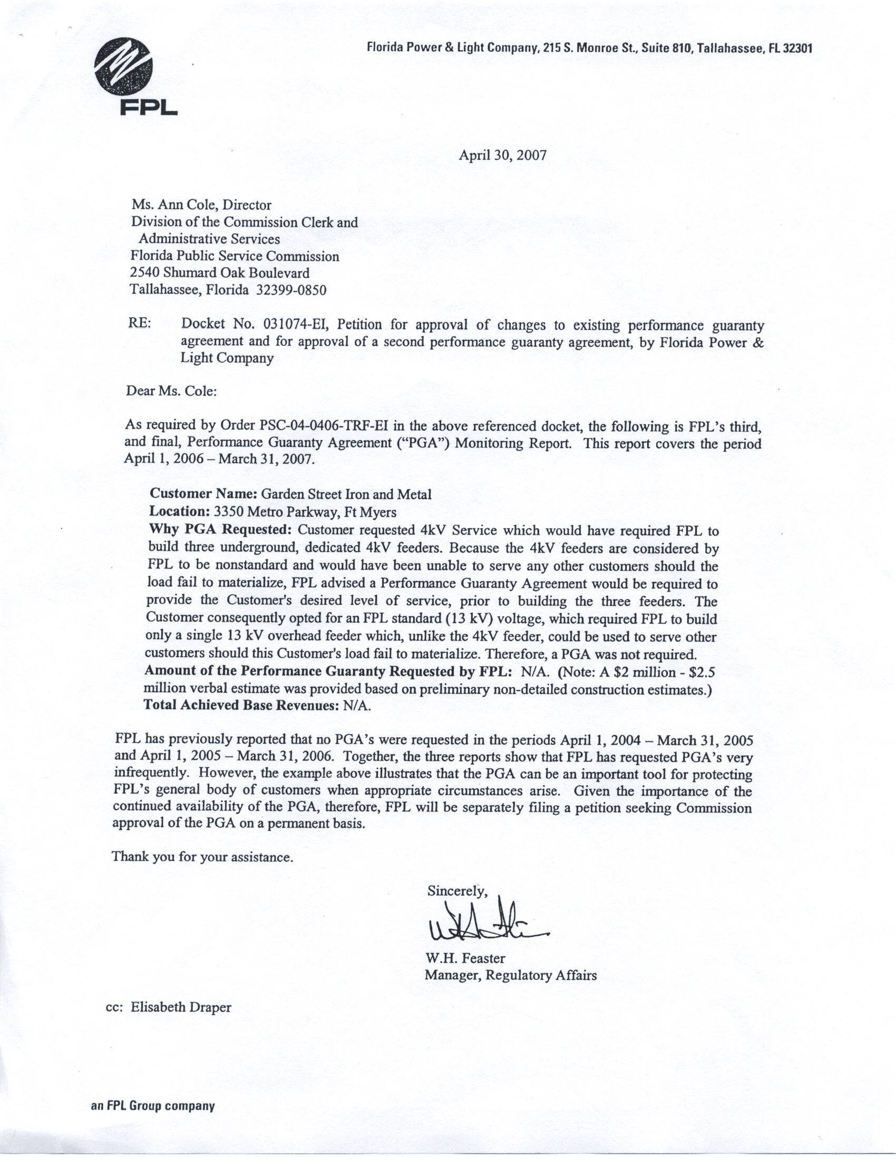

Issued April 19, 2004, in Docket No. 031074-EI, In re: Petition for approval of changes to existing performance guaranty agreement and for approval of a second performance guaranty agreement, by Florida Power & Light

