BEFORE THE PUBLIC SERVICE COMMISSION

In re: Application for amendment of Certificates Nos. 340-W and 297-S to add territory in Pasco County by Mad Hatter Utility, Inc. | DOCKET NO. 021215-WS
In re: Application for amendment of Certificate No. 340-W to add territory in Pasco County by Mad Hatter Utility, Inc. | DOCKET NO. 041342-WU  ORDER NO. PSC-07-0669-SC-WS  ISSUED: August 20, 2007

The following Commissioners participated in the disposition of this matter:

LISA POLAK EDGAR, Chairman
MATTHEW M. CARTER II
KATRINA J. McMURRIAN
NANCY ARGENZIANO
NATHAN A. SKOP

ORDER INITIATING SHOW CAUSE PROCEEDINGS,
AND APPROVING SETTLEMENT AGREEMENT
AND AMENDMENT OF CERTIFICATE NOS. 340-W AND 297-S

BY THE COMMISSION:

BACKGROUND
Mad Hatter is a Class A utility in south central Pasco County holding Certificate Nos. 340-W and 297-S, serving 3,041 water connections and 2,726 wastewater connections. The utility received revenues in 2004 of $1,791,961, with net operating income of $149,591. The 2005 annual report was not filed until June 27, 2007, and the 2006 annual report is currently delinquent.
The application in Docket No. 021215-WS was filed December 6, 2002. The application requested the addition of about twenty residential lots in the Oak Grove subdivision that the utility was already serving and commercial area fronting the subdivision along State Road 54. A timely objection was filed by Pasco County. A quick-take application was filed on November 24, 2004, for additional territory in Docket No. 041342-WU, pursuant to Section 25-30.036(2), Florida Administrative Code. The quick-take application stated that the amendment would allow Mad Hatter to serve two property owners who were having problems with existing wells. Pasco County also timely filed an objection to the quick-take amendment. These two dockets were consolidated for the purposes of hearing in Order No. PSC-05-0395-PCO-WS, issued April 15, 2005.
Although a hearing was scheduled in these dockets, a number of continuances were granted to permit the parties to seek clarification of a federal court order which interpreted Pasco County’s obligations under a 1992 bulk wastewater treatment agreement. By Order No. PSC-05-0942-PCO-WS, issued September 26, 2005, both dockets were held in abeyance pending resolution of the utility and County’s dispute in federal court.
In January 2007, the utility notified our staff that it was working with Pasco County to finalize a Settlement Agreement involving the resolution of numerous issues, including all of the issues related to Docket Nos. 021215-WS and 041342-WU. One provision in the Settlement is that Mad Hatter will withdraw its pending appeal of the federal court matter as well as pending actions in Florida Circuit Court. The Settlement was executed on or around January 8, 2007, a copy of which is attached hereto as Attachment A, and incorporated herein by reference.
As part of the Settlement, Mad Hatter provided a revised notice of the areas affected by its amendment requests. Due to a concern over the legal description, Pasco County timely filed an objection to the notice, but later withdrew its objection upon correction of a minor surveyor error.
We have jurisdiction pursuant to Sections 367.045 and 367.161, Florida Statutes.
APPROVING SETTLEMENT AND
AMENDMENT OF CERTIFICATE NOS. 340-W AND 297-S

Mad Hatter Utility, Inc. filed an amendment application in Docket No. 021215-WS on December 6, 2002, to add some commercial property on the south side of State Road 54 adjacent to the Oak Grove subdivision and to include approximately twenty residential lots in Oak Grove to its territory. Mad Hatter also filed a quick-take application in Docket No. 041432-WU on November 24, 2004. The purpose of this application was to add two new customers to its water territory. One of the properties is a single family residence and the other is an 8400 square foot building now used as a child care center. Pasco County protested the utility’s notice in both dockets, stating that the county has an existing water system nearby and asserted that Mad Hatter’s system would duplicate the existing water service of the county. The county further stated that it could provide service to the prospective customers.
There are three areas at issue in these dockets:
Oak Grove Subdivision – The utility has been engaged in litigation with Pasco County for a number of years concerning a 1992 Bulk Wastewater Agreement between the utility and the County, and Mad Hatter’s service of customers in the Oak Grove Subdivision. In the course of the litigation, the utility determined that a portion of Oak Grove, part of which is commercial and part of which is residential, was outside the utility’s Commission-approved territory.

Leonard Road Residences – Mad Hatter is currently serving a mobile home residence on the south side of Leonard Road, which is outside of its certificated service area. A neighboring mobile home residence received service at one time through an unauthorized connection to Mad Hatter’s system, but that service was disconnected. That residence is currently unoccupied, and no service is currently provided to that connection. Under the Settlement, the County and Mad Hatter agree that the utility shall not permanently include these two mobile home residences on the south side of Leonard Road in the utility’s service territory. However, Mad Hatter has agreed to continue providing service for the time being to the residence where service is currently provided. That service is being provided to an elderly couple in a mobile home whose well went bad. In a letter dated April 10, 2007, Mad Hatter stated that it was inappropriate for the utility to discontinue that service, once it began providing service, under those circumstances. Furthermore, the County has no ability to serve those customers at this time.

Livingston Road - There are also four parcels east of Livingston Road where the utility is proposing to provide service, and has service readily available to them from stubbed out lines owned and operated by Mad Hatter. However, none of these parcels are currently receiving service from Mad Hatter. Pursuant to the Settlement, Mad Hatter would be permitted, with the Commission’s approval, to amend its service territory to include these properties. The County has no lines near these parcels.

Proposed Settlement Agreement
The Settlement between Mad Hatter and Pasco County provides that, with our approval, and in settlement of Docket Nos. 021215-WS and 041342-WU, Mad Hatter should be permitted to provide water and wastewater service to the residential customers in Oak Grove, but not the commercial property along SR 54, and Mad Hatter should be permitted to provide water and wastewater service to four properties east of Livingston Road, including the child care center and three other residential parcels. These parcels along Livingston Road have septic tanks. The Settlement also provides for Mad Hatter to provide service, on a temporary basis, to the home on Leonard Road currently served by Mad Hatter, as well as the adjacent but currently unoccupied residence. The parties agree that Mad Hatter’s service of these two residences should continue until the County extends service to the properties located south of these residences.
The parties request that Mad Hatter be allowed to temporarily serve these two residences, in the context of the Settlement, and in recognition that well service is no longer available to these customers and that only Mad Hatter is currently in a position to provide service. We agree that it is reasonable to permit Mad Hatter to include these customers in its service area, until such time as Pasco County is ready, willing, and able to serve. At such time, Mad Hatter agrees to relinquish service of these customers. Until such time, we find that Mad Hatter shall include the Leonard Road residences in its territory description, and account for service to these residences in its annual reports and regulatory assessment fees. In order to monitor the status of this matter, Mad Hatter shall additionally file a report on an annual basis, from the date of this order, updating the status of the two Leonard Road customers. Upon notice by Pasco County that it is willing, ready and able to serve these customers, our staff shall have administrative authority to acknowledge the removal of these customers from Mad Hatter’s service territory and amend the utility’s territory description accordingly.
The amendment applications are in compliance with the governing statute, Section 367.045, Florida Statutes, and administrative rules concerning an amendment of certificate. Proof of compliance with the noticing provisions set forth in Rule 25-30.030, Florida Administrative Code, has been provided. The utility renoticed on February 5 and 15, 2007. As discussed previously, the only objection filed to the notice was by Pasco County, which was subsequently withdrawn.
Adequate service territory maps and territory descriptions have been provided as prescribed by Rule 25-30.036(3)(e) and (i), Florida Administrative Code, for the Oak Grove, Livingston Road, and Leonard Road properties.
The utility has adequate water capacity to meet the needs of the properties involved. Pasco County provides bulk wastewater treatment to Mad Hatter and does not object to the addition of these properties for wastewater service and the demand those properties will place on the wastewater system. There are no outstanding issues or violations with the Department of Environmental Protection.
The utility owner has demonstrated that the utility is sufficiently experienced and has the financial and technical ability to provide service to the territory requested. There are no pending complaints in the Division of Regulatory Compliance and Consumer Assistance.
Based upon the above, we find that the Settlement filed by the parties provides a reasonable resolution of the parties’ dispute in these dockets and it is therefore approved. Certificate Nos. 340-W and 297-S held by Mad Hatter Utility, Inc. shall be amended to include the territory shown on Attachment B, attached hereto and incorporated herein by reference. The resultant Order shall serve as Mad Hatter’s water and wastewater certificates and shall be retained by the utility. Mad Hatter shall charge these new customers the same rates and charges contained in the utility’s tariff until authorized to change by this Commission in a subsequent proceeding. Mad Hatter shall additionally file a report on an annual basis, from the date of the order, updating the status of the two Leonard Road customers. Upon notice by Pasco County that it is willing, ready and able to serve these customers, our staff shall have administrative authority to acknowledge the removal of these customers from Mad Hatter’s service territory and amend the utility’s territory description accordingly.
DECISION TO INITIATE SHOW CAUSE PROCEEDINGS
In the process of reviewing Mad Hatter’s amendment application, it became apparent to our staff that the utility is currently providing service to areas which are not included in its current certificated territory. Staff requested that the utility provide information detailing when and under what circumstances the utility began serving these customers. By letter dated April 10, 2007, the utility responded with respect to service it is providing to the Oak Grove subdivision and Leonard Road.
Oak Grove Subdivision - According to the utility, it has been engaged in litigation with Pasco County for a number of years concerning a 1992 Bulk Wastewater Agreement between the utility and the County. As a result of that litigation, Mad Hatter states that it determined that a portion of the Oak Grove subdivision that it was serving was outside of the utility’s existing territory, and that the utility had mistakenly believed the residential portion of that area to be within its service area. When it discovered otherwise, Mad Hatter filed its application for amendment in Docket 021215-WS. At the time the application was filed, approximately 5 residences in Oak Grove were receiving service from Mad Hatter. However, due to development in that area, that number has since grown to twenty residences currently receiving service that are outside Mad Hatter’s territory, but who will now be within the utility’s territory, pursuant to our approval of the Settlement and amendment of Mad Hatter’s certificates, as discussed previously.
Leonard Road Residences – As discussed previously, Mad Hatter is currently serving a mobile home residence on the south side of Leonard Road outside of the certificated service area. A neighboring mobile home residence received service at one time through an unauthorized connection to Mad Hatter’s system, but that service was disconnected. That residence is currently unoccupied, and no service is currently provided to that connection. Under the Settlement, the County and Mad Hatter agree that the utility shall not permanently include the two mobile home residences on the south side of Leonard Road in the utility’s service territory. However, Mad Hatter has agreed to continue providing service to the residence where service is currently provided, until such time as Pasco County is able to serve those customers. The service is being provided to an elderly couple in a mobile home whose well went bad. In its April 10th letter, Mad Hatter stated that it was inappropriate for the utility to discontinue that service, once it began providing service under those circumstances. Furthermore, the County has no ability to serve those customers at this time.
Findings and Conclusion

Mad Hatter has been serving customers outside of its certificated territory, in apparent violation of Section 367.045(2), Florida Statutes. That section states that a utility may not extend its service outside the area described in its certificate of authorization until it has obtained an amended certificate of authorization from this Commission. As noted above, Mad Hatter explains that it had mistakenly believed certain areas to be already within its service area, and it provided service to a customer with a bad well, when the County was otherwise unable to serve the affected customer.
Section 367.161(1), Florida Statutes, authorizes us to assess a penalty of not more than $5,000 for each offense, if a utility is found to have knowingly refused to comply with, or to have willfully violated any provision of Chapter 367, Florida Statutes. In serving outside of its certificated territory without obtaining an amended certificate of authorization, the utility’s act was “willful” in the sense intended by Section 367.161, Florida Statutes. In Order No. 24306, issued April 1, 1991, in Docket No. 890216-TL, In Re: Investigation Into The Proper Application of Rule 25-14.003, Florida Administrative Code, Relating to Tax Savings Refund For 1988 and 1989 For GTE Florida, Inc., having found that the company had not intended to violate the rule, this Commission nevertheless found it appropriate to order the utility to show cause why it should not be fined, stating that “[i]n our view, ‘willful’ implies an intent to do an act, and this is distinct from an intent to violate a statute or rule.”
Mad Hatter’s failure to obtain our approval prior to serving outside of its certificated service area is an apparent violation of Section 367.045(2), Florida Statutes. Mad Hatter is a relatively large system, with several thousand water and wastewater customers, and, as such, should be more cognizant of our rules than the smaller water and wastewater companies. Further, it has been involved in a territorial dispute with Pasco County for a number of years, and we would expect the utility to be especially aware of the location and limits of its Commission-approved service area. Under the circumstances, we find that more than just a warning is warranted.
We find that the utility has not provided circumstances or justification which satisfactorily mitigate the utility’s apparent violation. Based on the above, we find that Mad Hatter shall show cause in writing, within 21 days, why it should not be fined a total of $500 for its apparent violation noted above. Our decision herein incorporates the following conditions:
- The utility’s response to the show cause order shall contain specific allegations of fact and law;
- Should Mad Hatter file a timely written response that raises material questions of fact and makes a request for a hearing pursuant to Sections 120.569 and 120.57(1), F.S., a further proceeding will be scheduled before a final determination of this matter is made;
- A failure to file a timely written response to the show cause order shall constitute an admission of the facts herein alleged and a waiver of the right to a hearing on this issue;
- In the event that Mad Hatter fails to file a timely response to the show cause order, the fine shall be deemed assessed with no further action required by this Commission;
- If the utility responds timely but does not request a hearing, a recommendation shall be presented to this Commission regarding the disposition of the show cause order; and
- If the utility responds to the show cause order by remitting the fine, this show cause matter shall be considered resolved.
Further, the utility is hereby put on notice that failure to comply with our orders, rules, or statutes will again subject the utility to show cause proceedings and fines of up to $5,000 per day per violation for each day the violation continues as set forth in Section 367.161, F.S.
In the course of these dockets, the utility identified a number of customers it has been serving outside of its certificated service area. In an effort to reconcile the utility’s certificated territory with the customers served by the utility, we further find that Mad Hatter shall provide, within 90 days of this order, a map showing the utility’s entire water and wastewater service area, as set forth in the legal description for that certificated area approved in this order and all prior Commission orders. The map shall further clearly show each and every existing customer served by the utility, whether that customer is within or without the utility’s approved service area.
Based on the foregoing, it is

ORDERED by the Florida Public Service Commission that the Settlement and applications for amendment of Certificates Nos. 340-W and 297-S by Mad Hatter Utility, Inc., are approved as set forth in the body of this Order, and that Mad Hatter Utility, Inc.’s service area shall be amended to include the territory shown on Attachment B. It is further
ORDERED that the attachments to this Order are incorporated by reference herein. It is further
ORDERED that this Order shall serve as Mad Hatter’s water and wastewater certificates and shall be retained by the utility. It is further
ORDERED that Mad Hatter shall charge these customers the same rates and charges contained in the utility’s tariff until authorized to change by this Commission in a subsequent proceeding. It is further
ORDERED that Mad Hatter shall file a report on an annual basis, from the date of the order, updating the status of the Leonard Road customers. It is further
ORDERED that, upon notice by Pasco County that it is willing, ready and able to serve the Leonard Road customers, our staff shall have the administrative authority to acknowledge the removal of these customers from Mad Hatter’s service territory and amend the utility’s territory description accordingly. It is further
ORDERED that Mad Hatter shall provide, within 90 days of this order, a map showing the utility’s entire water and wastewater service area, as set forth in the legal description for that certificated area approved in this order and all prior Commission orders. The map shall further clearly show each and every existing customer served by the utility, whether that customer is within or without the utility’s approved service area. It is further
ORDERED that Mad Hatter shall show cause in writing, within 21 days, why it should not be fined a total of $500 for its apparent violation of Section 367.045(2), Florida Statutes. The order to show cause should incorporate the conditions stated below in the staff analysis. It is further
ORDERED that any response shall comply with the conditions set forth in the body of this Order and shall be filed with the Office of the Commission Clerk, within 21 days of the date of issuance of this Order. It is further
ORDERED that if Mad Hatter pays the $500 in fines, these dockets shall be closed administratively. If the utility timely responds in writing to the Order to show cause, the dockets shall remain open to allow for the appropriate processing of the response.
By ORDER of the Florida Public Service Commission this 20th day of August, 2007.

/s/ Ann Cole
ANN COLE
Commission Clerk

This is an electronic transmission. A copy of the original signature is available from the Commission's website, www.floridapsc.com, or by faxing a request to the Office of Commission Clerk at 1-850-413-7118.

( S E A L )

JSB

NOTICE OF FURTHER PROCEEDINGS OR JUDICIAL REVIEW

The Florida Public Service Commission is required by Section 120.569(1), Florida Statutes, to notify parties of any administrative hearing or judicial review of Commission orders that is available under Sections 120.57 or 120.68, Florida Statutes, as well as the procedures and time limits that apply. This notice should not be construed to mean all requests for an administrative hearing or judicial review will be granted or result in the relief sought.

Any party adversely affected by the Commission's final action in this matter may request: 1) reconsideration of the decision by filing a motion for reconsideration with the Office of Commission Clerk, 2540 Shumard Oak Boulevard, Tallahassee, Florida 32399-0850, within fifteen (15) days of the issuance of this order in the form prescribed by Rule 25-22.060, Florida Administrative Code; or 2) judicial review by the Florida Supreme Court in the case of an electric, gas or telephone utility or the First District Court of Appeal in the case of a water and/or wastewater utility by filing a notice of appeal with the Office of Commission Clerk, and filing a copy of the notice of appeal and the filing fee with the appropriate court. This filing must be

completed within thirty (30) days after the issuance of this order, pursuant to Rule 9.110, Florida Rules of Appellate Procedure. The notice of appeal must be in the form specified in Rule 9.900(a), Florida Rules of Appellate Procedure.

The show cause portion of this Order is preliminary, procedural or intermediate in nature. Any person whose substantial interests are affected by this Show Cause Order may file a response within 21 days of issuance of the Show Cause Order as set forth herein. This response must be received by the Office of Commission Clerk, 2540 Shumard Oak Boulevard, Tallahassee, Florida 32399-0850, by the close of business on September 10, 2007.

Failure to respond within the time set forth above shall constitute an admission of all facts and a waiver of the right to a hearing and a default pursuant to Rule 28-106.111(4), Florida Administrative Code. Such default shall be effective on the day subsequent to the above date.

If an adversely affected person fails to respond to the show cause portion of this Order within the time prescribed above, that party may request judicial review by the Florida Supreme Court in the case of an electric, gas or telephone utility or by the First District Court of Appeal in the case of a water or wastewater utility by filing a notice of appeal with the Office of Commission Clerk, and filing a copy of the notice of appeal and the filing fee with the appropriate court. This filing must be completed within thirty (30) days of the effective date of this Order, pursuant to Rule 9.110, Florida Rules of Appellate Procedure.

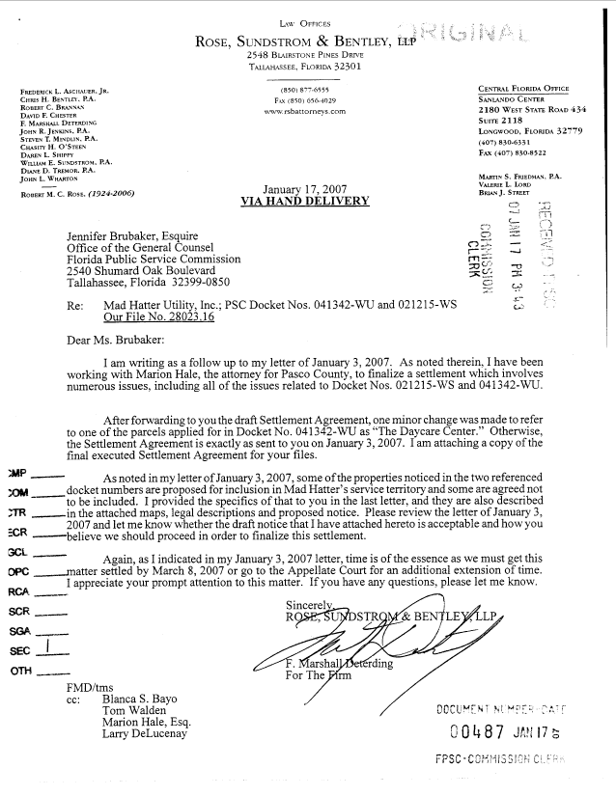
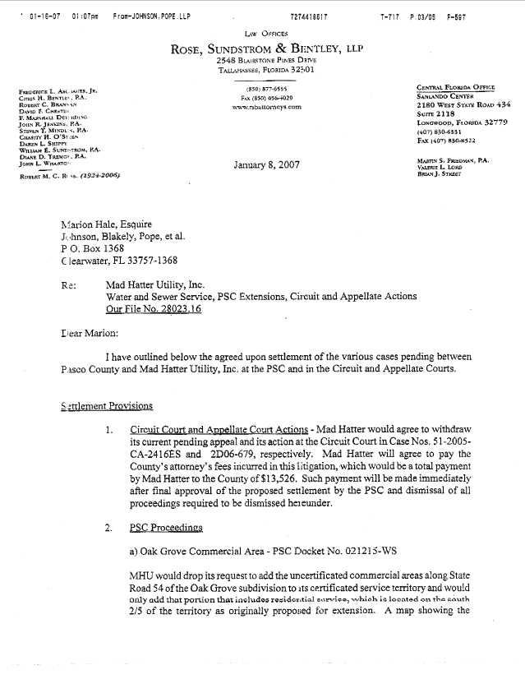
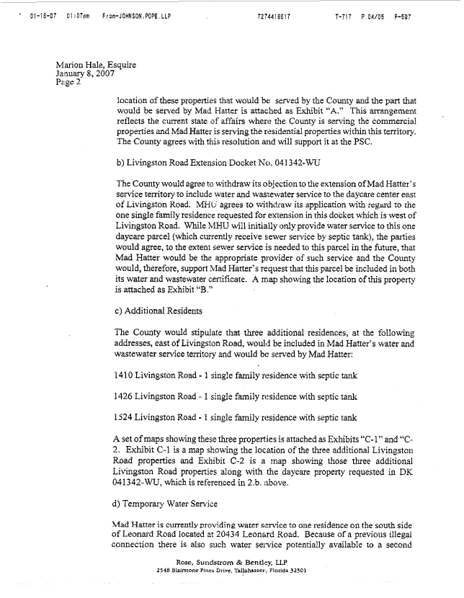
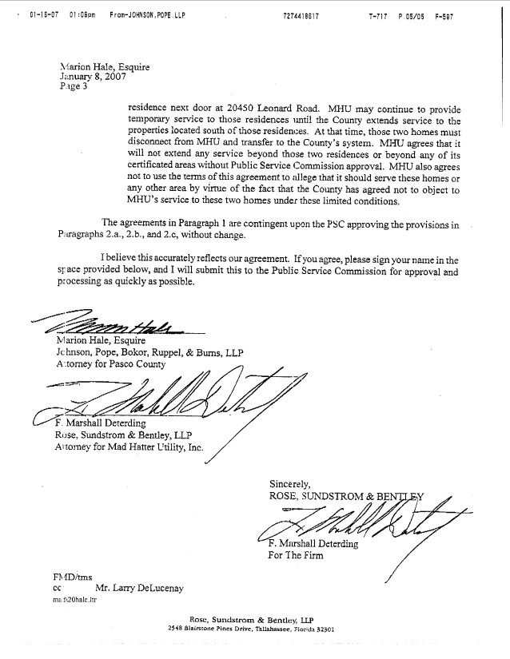

MAD HATTER UTILITY, INC.
Additional Water territory
In Section 35, Township 26 South, Range 18 East, Pasco County, two properties on Leonard Road:

20434 Leonard Road, being further described as follows:
In the NE ¼ of the NE ¼ of the NW ¼ of said Section 35. Commence at the NE corner of the NE ¼ of the NE ¼ of the NW ¼ of said Section 35; thence west 155 feet; thence south 20 feet to the Point of Beginning; thence south 100 feet; thence west 88.3 feet; thence north 100 feet; thence east 88.3 feet to the Point of Beginning. OR 6389 PG 1478 OR 6854 PG 1093.
20450 Leonard Road, being further described as follows:
In the NE ¼ of the NE ¼ of the NW ¼ of said Section 35. Commence at the NE corner of the NE ¼ of the NE ¼ of the NW ¼ of said Section 35; thence S 0° 27’ W 20 feet to the Point of Beginning; thence S 0° 27’ W 100 feet; thence west 103.88 feet; thence north 100 feet; thence east 104.84 feet to the Point of Beginning. Less and except the north 5 feet thereof for Leonard Road right of way. OR 7317 PG 20
MAD HATTER UTILITY, INC.
Additional Water and Wastewater territory
Parcel 1 – Livingston Road property
A portion of the North 696 feet of the West 437.5 feet of the Northwest ¼ of the Northeast ¼ of Section 32, Township 26 South, Range 19 East, Pasco County, Florida, abounded and described as follows:
Commence at the Northeast corner of said tract and run South 396 feet for a Point of Beginning. Thence from said point, the following six courses:
S 01º 01’ 43” W, 300 feet; thence N 88º 58’ 21” W, 437.29 feet; thence N 01º 01’ 43” E, 272.31 feet; thence S 88º 14’18” E, 242.50 feet; thence N 01º 01’ 43” E, 27.96 feet; thence S 88º 58’ 21” E, 194.81 feet to the aforementioned Point of Beginning.
LESS AND EXCEPT THE FOLLOWING:
A portion of the Northeast ¼ of the Northwest ¼ and a portion of the Northwest ¼ of the Northeast ¼ of Section 32, Township 26 South, Range 19 East, Pasco County, Florida, described as follows:
Commence at the North ¼ corner of Section 32, Township 26 South, Range 19 East, and run S 01º 01’ 43” W, a distance of 423.59 feet along the west boundary of the Northwest ¼ of the Northeast ¼ of Section 32 to the Point of Beginning. Thence from said Point of Beginning the following seven courses:
S 88º 14’ 18” E, 16.33 feet; thence S 00º 43’ 23” W, 272.11 feet; thence N 88º 58’ 21” W, 17.78 feet; thence N 00º 01’ 43” E, 228.90 feet; thence N 88º 46’ 48” W, 8.23 feet; thence N 00º 51’ 52” E, 43.49 feet; thence S 88º 14’ 18” E, 8.36 feet to the aforementioned Point of Beginning.
Parcel 2 – Livingston Road property
The N ½ of the SW ¼ of the NW ¼ of the NW ¼ of the SE ¼ of Section 32, Township 26 South, Range 19 East, less the west 30 feet for the road right-of-way for Livingston Road. OR 5819 PG 1993
MAD HATTER UTILITY, INC.
Additional Water and Wastewater territory
Parcel 3
The S ½ of the NW ¼ of the NW ¼ of the NW ¼ of the SE ¼ of Section 32, Township 26 South, Range 19 East, less the west 30 feet for the road right-of-way for Livingston Road. OR 5706 PG 1981
Parcel 4
The E ½ of the NW ¼ of the NW ¼ of the SE ¼ of Section 32, Township 26 South, Range 19 East. OR 1266 PG 1843 OR 3829 PG 969 OR 6346 PG 619
Oak Grove
A southern portion of the NE ¼ of the NW ¼ of Section 33, Township 26 South, Range 19 East, Pasco County, Florida, being more particularly described as follows:
Beginning at the SW corner of the NE ¼ of the NW ¼ of said Section 33, thence N 00°01’16” E, along the west boundary of the NE ¼ of the NW ¼ of said Section 33, a distance of 595.04 feet to the south boundary line of parcel described in Official Record Book 6120, Page 1703; thence S 89°58’48” E, along said south boundary line, a distance of 676.93 feet to the west right of way line of Oak Grove Boulevard (60’ right of way); thence along said right of way, the three following courses: (1) Southeasterly, 11.673 feet along the arc of a curve to the left having a radius of 660 feet and a chord bearing and distance of S 19°45’55” E, 11.63 feet to a point of tangency; thence (2) S 20°17’53” E, a distance of 141.83 feet to a point of curvature; thence (3) Southwesterly, 464.15 feet along the arc of a curve to the right, having a radius of 600 feet and chord bearing and distance of S 01°51’29” W, 452.66 feet to the south boundary of the NE ¼ of the SW ¼ of said Section 33; thence N 89°52’18” W, along said south boundary, a distance of 715.62 feet to the Point of Beginning.
And
Beginning at the SE corner of the NE ¼ of the NW ¼ of said Section 33, thence N 89°52’18” W, along the south boundary of the NE ¼ of the NW ¼ of said Section 33 a distance of 539.69 feet to the east right of way line of Oak Grove Boulevard (60’ right of way); thence along said right of way, the two following courses: (1) Northerly, 484.21 feet along the arc of a curve to the left, having a radius of 660 feet and chord bearing and distance of N 00°42’51” E, 473.42 feet to a point of tangency; (2) thence N 20°17’52” W, a distance of 131.29 feet to the north boundary of Oak Grove Phase 1B as recorded in Plat Book 35, Page 18, Public Records of Pasco County, Florida; thence S 89°59’34” E along said north boundary, a distance of 580.19 feet to the east boundary of the NE ¼ of the NW ¼ of said Section 33; thence S 00°04’55” W, along said east boundary, a distance of 597.66 feet to the Point of Beginning.
(Oak Grove area described above contains 17.23 acres, more or less)
FLORIDA PUBLIC SERVICE COMMISSION

authorizes

Mad Hatter Utility, Inc.
pursuant to
Certificate Number 340-W

to provide water service in Pasco County in accordance with the provisions of Chapter 367, Florida Statutes, and the Rules, Regulations, and Orders of this Commission in the territory described by the Orders of this Commission. This authorization shall remain in force and effect until superseded, suspended, cancelled or revoked by Order of this Commission.

Order Number Date Issued Docket Number Filing Type

10325 10/7/81 800530-WS Transfer
13552 07/31/84 840199-WS Amendment
14058 02/05/85 840171-WS Transfer
15693 02/18/86 860016-WS Amendment
16976 12/18/86 860859-WS Amendment
20143 10/10/88 880737-WS Transfer
PSC-97-0378-FOF-WS 04/07/97 960576-WS Amendment
PSC-97-1173-FOF-WS 10/01/97 960576-WS Amendment
PSC-98-0447-FOF-WS 03/30/98 971362-WU Amendment
PSC-97-1173A-FOF-WS 05/07/98 960576-WS Correction
PSC-03-0243-FOF-WS 02/20/03 020982-WS Amendment/deletion
PSC-07-0669-SC-WS 08/20/07 021215-WS Amendment
PSC-07-0669-SC-WS 08/20/07 041342-WU Amendment

FLORIDA PUBLIC SERVICE COMMISSION

authorizes

Mad Hatter Utility, Inc.
pursuant to
Certificate Number 297-S

to provide wastewater service in Pasco County in accordance with the provisions of Chapter 367, Florida Statutes, and the Rules, Regulations, and Orders of this Commission in the territory described by the Orders of this Commission. This authorization shall remain in force and effect until superseded, suspended, cancelled or revoked by Order of this Commission.

Order Number Date Issued Docket Number Filing Type

10325 10/7/81 800530-WS Transfer
13552 07/31/84 840199-WS Amendment
14058 02/05/85 840171-WS Transfer
15693 02/18/86 860016-WS Amendment
16976 12/18/86 860859-WS Amendment
18814 02/08/88 870618-SU Amendment
20143 10/10/88 880737-WS Transfer
PSC-97-0378-FOF-WS 04/07/97 960576-WS Amendment
PSC-97-1173-FOF-WS 10/01/97 960576-WS Amendment
PSC-97-1173A-FOF-WS 05/07/98 960576-WS Correction
PSC-03-0243-FOF-WS 02/20/03 020982-WS Amendment/deletion
PSC-07-0669-SC-WS 08/20/07 021215-WS Amendment

We note that the utility was delinquent in filing its 2005 annual report, which was not filed until June 27, 2007, and is currently delinquent in filing its 2006 annual report, in apparent violation of Rule 25-30.110, Florida Administrative Code. If enforcement proceedings are to occur pursuant to Section 367.161, Florida Statutes, we will address the annual reports in a separate docket.
Mad Hatter Utility, Inc. v. Pasco County, United States District Court, Middle District of Florida, Case No. 94-1473-Civ-T-25E

