BEFORE THE PUBLIC SERVICE COMMISSION

In re: Application for amendment of Certificates 592-W and 509-S to extend water and wastewater service area to include certain land in Polk County by Cypress Lakes Utilities, Inc. | DOCKET NO. 070275-WS  ORDER NO. PSC-07-0718-PAA-WS  ISSUED: September 4, 2007

The following Commissioners participated in the disposition of this matter:

LISA POLAK EDGAR, Chairman
MATTHEW M. CARTER II
KATRINA J. McMURRIAN
NANCY ARGENZIANO
NATHAN A. SKOP

FINAL ORDER AMENDING CERTIFICATE NOS. 592-W AND 509-S
TO INCLUDE ADDITIONAL TERRITORY IN POLK COUNTY
AND
PROPOSED AGENCY ACTION ORDER APPROVING SPECIAL DEVELOPER AGREEMENT

BY THE COMMISSION:

NOTICE is hereby given by the Florida Public Service Commission that the action discussed herein regarding the special developer agreement is preliminary in nature and will become final unless a person whose interests are substantially affected files a petition for a formal proceeding, pursuant to Rule 25-22.029, Florida Administrative Code.

Background

On April 17, 2007, Cypress Lakes Utilities, Inc. (Cypress Lakes or utility) filed an application to amend Certificate Nos. 592-W and 509-S to add water and wastewater territory to its service area in Polk County, pursuant to section 367.045, Florida Statutes. Cypress Lakes is a Class B utility which provides water and wastewater service in Polk County to approximately 1,218 water customers and 1,123 wastewater customers. The utility’s 2006 annual report shows combined water and wastewater annual operating revenues of $745,699, and a net income of $35,352. The proposed area is in the Southwest Florida Water Management District. Cypress Lakes proposes to serve 120 potential water and wastewater residential customers. The area consists of approximately 50 acres which is the site of a new development (Phase 12) located inside Cypress Lakes Golf and Country Club. We have jurisdiction pursuant to section 367.045, Florida Statutes.
Amendment

The application is in compliance with the governing statute, section 367.045, Florida Statutes, and Rule 25-30.036, Florida Administrative Code. The application contains proof of compliance with the noticing provisions set forth in Rule 25-30.030, Florida Administrative Code.

The utility has demonstrated its ability to serve the proposed extended areas and that it has the necessary financial and technical expertise to do so. The Department of Community Affairs has indicated that the utility’s application is consistent with the Polk County Comprehensive Plan. The utility operates a .448 MGD water treatment facility, which consists of pumping and chlorine disinfection, with no storage capability. For wastewater, there is a .175 MGD extended aeration wastewater treatment facility with effluent disposal by means of reuse to two golf courses inside the Cypress Lakes community. To accommodate the additional flows from the proposed area, the utility indicated in its application that its water treatment plant has sufficient capacity. However, expansion will be needed for the wastewater treatment plant. Pursuant to an agreement between the utility and the developer of the property, the developer has agreed to share in funding the $250,000 estimated cost of the improvements to the wastewater treatment plant. The agreement also indicates that the water distribution and sewer collection lines will be contributed.

The utility also provided verification of a deed to the water and wastewater treatment plant sites. Adequate service territory maps and a territory description have also been provided. No objections to the application have been received and the time for filing such has expired.

Based on the foregoing, we find that it is in the public interest to approve the application filed by Cypress Lakes to amend its territory to reflect the area described in Attachment A. The resultant order shall serve as Cypress Lakes’ amended certificates and shall be retained by the utility. The utility shall charge the customers in the territory added herein the rates and charges contained in its current tariff until authorized to change by this Commission.

Special Developer Agreement

The utility’s amendment application included an agreement for water and wastewater service for the new 120 connection, Phase 12, development located inside Cypress Lakes Golf and Country Club. Pursuant to Rule 25-30.550(2), Florida Administrative Code, each special service availability contract shall be approved by this Commission prior to becoming effective. Contained within the agreement, the developer agrees to construct and install the complete distribution, collection and interconnection facilities needed to serve Phase 12. Ownership of this property will be conveyed to the utility. The water treatment plant has sufficient capacity. However, expansion of the utility’s wastewater treatment plant will be necessary to accommodate additional flows from the proposed amended area. In the proposed agreement, the developer agrees to pay the utility half of the $250,000 estimated cost for necessary improvements to the utility’s wastewater treatment plant. The utility will in turn provide water and wastewater service to all customers within the proposed area. Existing monthly service rates approved by this Commission shall apply.

Currently, the utility’s service availability fees and charges do not include plant capacity charges for water or wastewater. Pursuant to Order No. PSC-07-0199-PAA-WS, issued March 5, 2007, in Docket No. 060257-WS, we proposed to authorize plant capacity charges of $1,500 each for water and wastewater service for new connections. However, the order was protested by the developer. A hearing has been set for September 2007. Negotiations are ongoing among the parties to address the appropriateness of plant capacity charges for the proposed new development as well as the remaining undeveloped lots in Cypress Lakes. The appropriateness of service availability charges will be addressed in the pending rate case in Docket No. 060257-WS.

Pursuant to Rule 25-30.550(3), Florida Administrative Code, each special service availability contract and developer’s agreement shall be accompanied by a statement from the utility affirming the current treatment plant connected load, the current treatment plant capacity, and the amount of capacity reserved under the agreement or contract. This information shows that the utility has the capacity to serve the customers in the proposed area with the wastewater expansion.

We recognize that developers’ agreements are negotiated transactions. If they are not approved and the utility declines to amend its service territory, the developers might have to provide their own water and wastewater service by building small water and wastewater plants, or installing individual wells and septic tanks, which are not the best environmental option.

Based on the above, we find that the special developer agreement in Attachment B between Cypress Lakes Associates, Ltd. and Cypress Lakes Utilities, Inc. is hereby approved. The appropriateness of service availability charges will be addressed in the pending rate case in Docket No. 060257-WS.

Based on the foregoing, it is

ORDERED by the Florida Public Service Commission that Cypress Lakes Utilities, Inc.’s application for amendment of Certificate Nos. 592-W and 509-S is hereby approved as set forth herein. It is further

ORDERED that all attachments attached hereto are incorporated herein by reference. It is further

ORDERED that Cypress Lakes Utilities, Inc. shall charge the customers in the territory added herein the rates and charges approved in its tariff until authorized to change by this Commission in a subsequent proceeding. It is further
ORDERED that the special developer agreement between Cypress Lakes Associates, Ltd. and Cypress Lakes Utilities, Inc. is hereby approved. It is further

ORDERED that if no protest is filed to the special developer agreement within 21 days of the issuance of this Order, this docket shall be closed upon the issuance of a Consummating Order.

By ORDER of the Florida Public Service Commission this 4th day of September, 2007.

/s/ Ann Cole
ANN COLE
Commission Clerk

This is an electronic transmission. A copy of the original signature is available from the Commission's website, www.floridapsc.com, or by faxing a request to the Office of Commission Clerk at 1-850-413-7118.

( S E A L )

KEF

NOTICE OF FURTHER PROCEEDINGS OR JUDICIAL REVIEW

The Florida Public Service Commission is required by Section 120.569(1), Florida Statutes, to notify parties of any administrative hearing or judicial review of Commission orders that is available under Sections 120.57 or 120.68, Florida Statutes, as well as the procedures and time limits that apply. This notice should not be construed to mean all requests for an administrative hearing or judicial review will be granted or result in the relief sought.

As identified in the body of this order, our action regarding the special developer agreement is preliminary in nature. Any person whose substantial interests are affected by the action proposed by this order may file a petition for a formal proceeding, in the form provided by Rule 28-106.201, Florida Administrative Code. This petition must be received by the Office of Commission Clerk, at 2540 Shumard Oak Boulevard, Tallahassee, Florida 32399-0850, by the close of business on September 25, 2007. If such a petition is filed, mediation may be available on a case-by-case basis. If mediation is conducted, it does not affect a substantially interested person's right to a hearing. In the absence of such a petition, this order shall become effective and final upon the issuance of a Consummating Order.

Any objection or protest filed in this docket before the issuance date of this order is considered abandoned unless it satisfies the foregoing conditions and is renewed within the specified protest period.

Any party adversely affected by the Commission's final action in this matter may request: (1) reconsideration of the decision by filing a motion for reconsideration with the Office of Commission Clerk, within fifteen (15) days of the issuance of this order in the form prescribed by Rule 25-22.060, Florida Administrative Code; or (2) judicial review by the Florida Supreme Court in the case of an electric, gas or telephone utility or the First District Court of Appeal in the case of a water or wastewater utility by filing a notice of appeal with the Office of Commission Clerk and filing a copy of the notice of appeal and the filing fee with the appropriate court. This filing must be completed within thirty (30) days after the issuance of this order, pursuant to Rule 9.110, Florida Rules of Appellate Procedure. The notice of appeal must be in the form specified in Rule 9.900(a), Florida Rules of Appellate Procedure.

CYPRESS LAKES UTILITIES, INC.
EXTENSION OF SERVICE TERRITORY

TO BE ADDED TO WATER AND WASTEWATER CERTIFICATES:

The East 2 of the Northwest 3 of the Northwest 3 of Section 3, Township27 South, Range 23 East, all lying and being in Polk County, Florida, LESS AND EXCEPT the East 132.0 feet of the South 330.0 feet thereof:

TOGETHER WITH
The West 2 of the Northeast 3 of the Northwest 3 of Section 3, Township 27 South, Range 23 East, Polk County, Florida; LESS AND EXCEPT the East 330.0 feet thereof an LESS AND EXCEPT the South 330.0 feet thereof.

TOGETHER WITH
The East 330.0 feet of the West 2 of the Northeast 3 of the Northwest 3 of Section 3, Township 27 South, Range 23 East, Polk County, Florida; LESS AND EXCEPT the South 330.0 feet thereof. Excepting therefrom any portion of the above described land lying within the maintained right-of-way known as Max Cash Road as depicted on Polk County Maintained Right-of-Way Map recorded May 16, 1990, in Map Book 11, Page 55, of the Public Records of Polk County, Florida.

TOGETHER WITH
The West 2 of the Northwest 3 of the Northwest 3 of Section 3, Township 27 South, Range 23 East, all lying and being in Polk County, Florida

TOGETHER WITH
The South 30.0 feet of the West 2 of the Northeast 3 of the Northwest 3 of Section 3, Township 27 South, Range 23 East, all lying and being in Polk County, Florida.

FLORIDA PUBLIC SERVICE COMMISSION

Authorizes

Cypress Lakes Utilities, Inc.
Pursuant to
Certificate Number 592-W

to provide wastewater service in Polk County in accordance with the provisions of Chapter 367, Florida Statutes, the Rules, Regulations and Orders of this Commission in the territory described by the Orders of this Commission. This authorization shall remain in force and effect until superseded, suspended, cancelled or revoked by Order of this Commission.

Order Number Date Issued Docket Number Filing Type

PSC-00-0264-FOF-WS 02-08-2000 971220-WS Transfer

PSC-07-0718-PAA-WS 09-04-2007 070275-WS Amendment

FLORIDA PUBLIC SERVICE COMMISSION

Authorizes

Cypress Lakes Utilities, Inc.
Pursuant to
Certificate Number 509-S

to provide wastewater service in Polk County in accordance with the provisions of Chapter 367, Florida Statutes, the Rules, Regulations and Orders of this Commission in the territory described by the Orders of this Commission. This authorization shall remain in force and effect until superseded, suspended, cancelled or revoked by Order of this Commission.

Order Number Date Issued Docket Number Filing Type

PSC-00-0264-FOF-WS 02-08-2000 971220-WS Transfer

PSC-07-0718-PAA-WS 09-04-2007 070275-WS Amendment

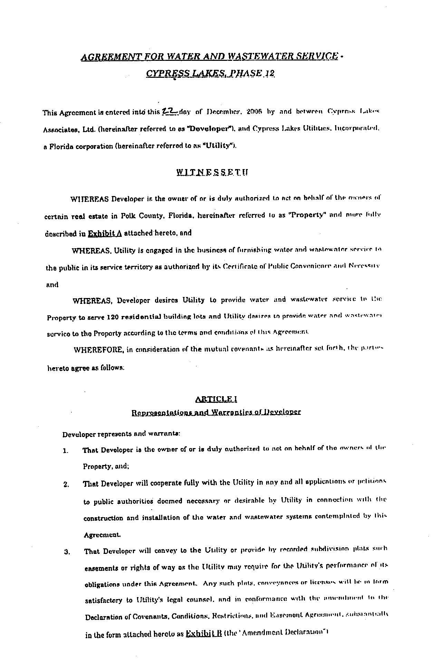
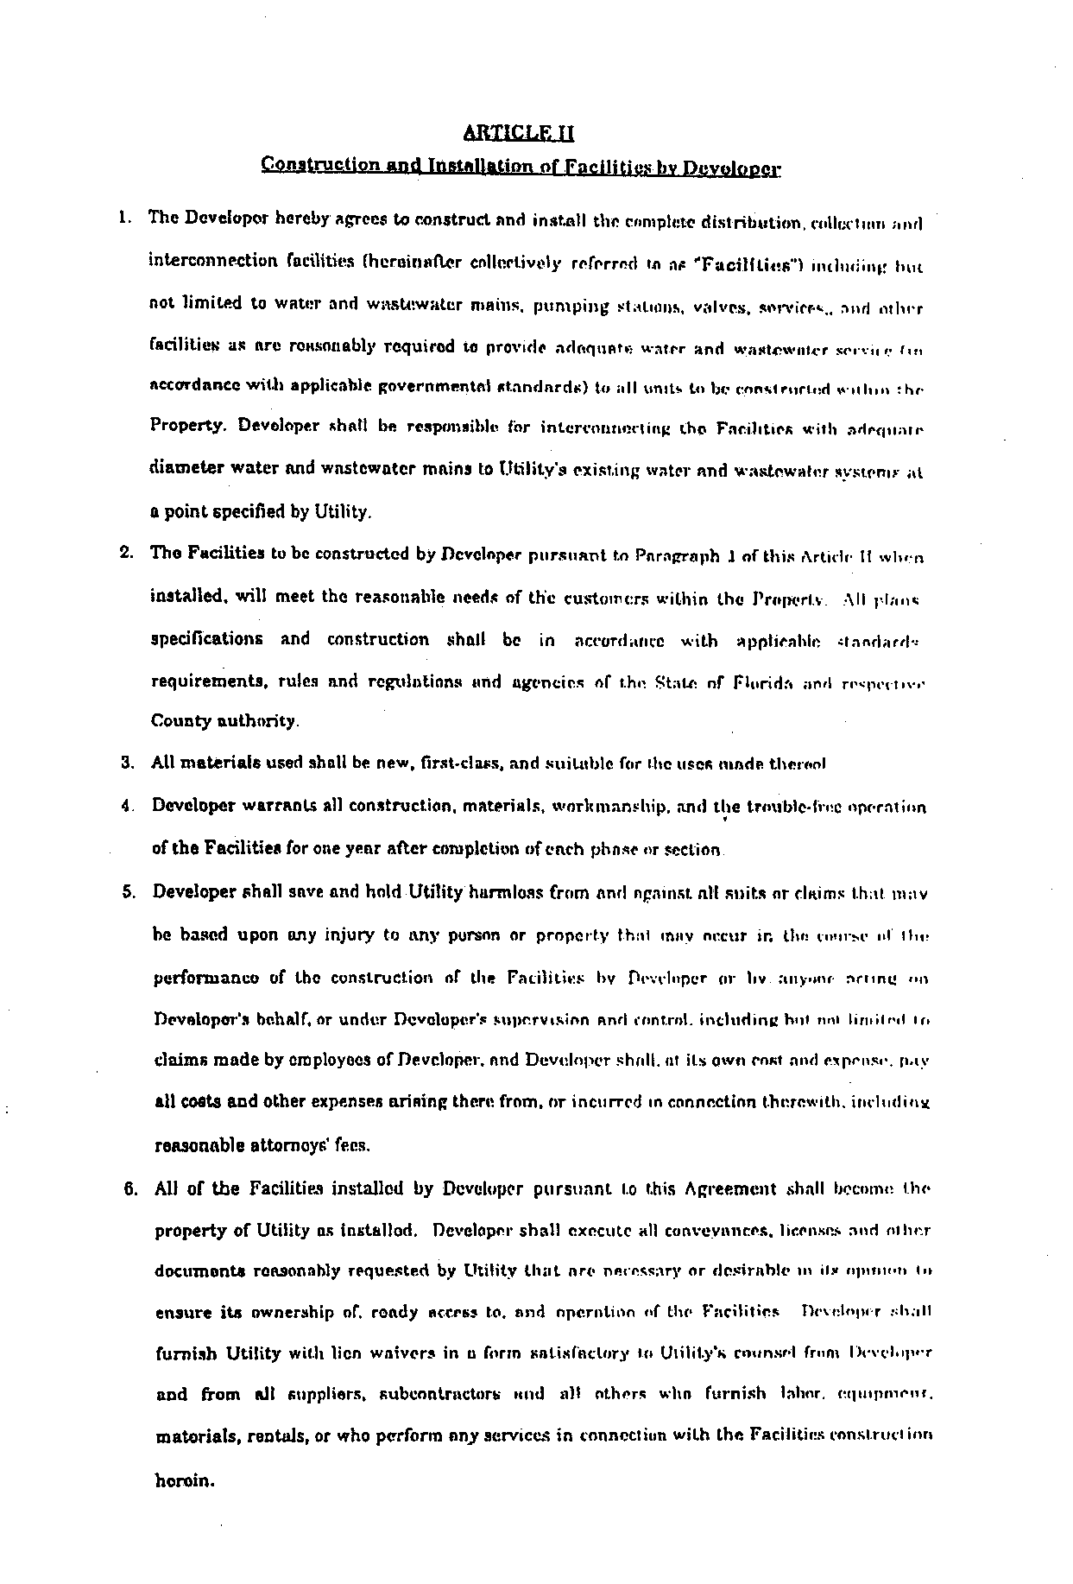
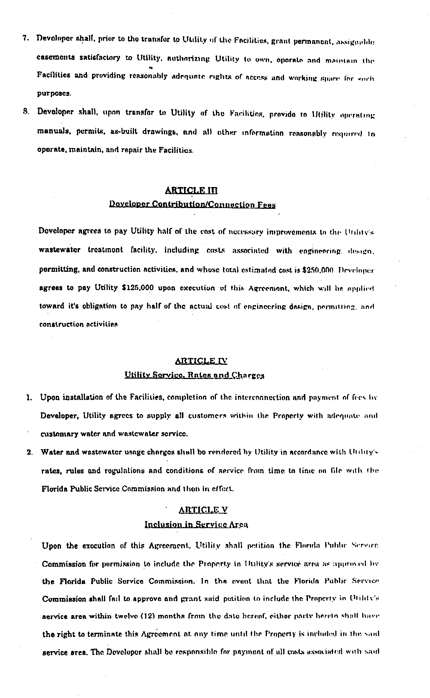
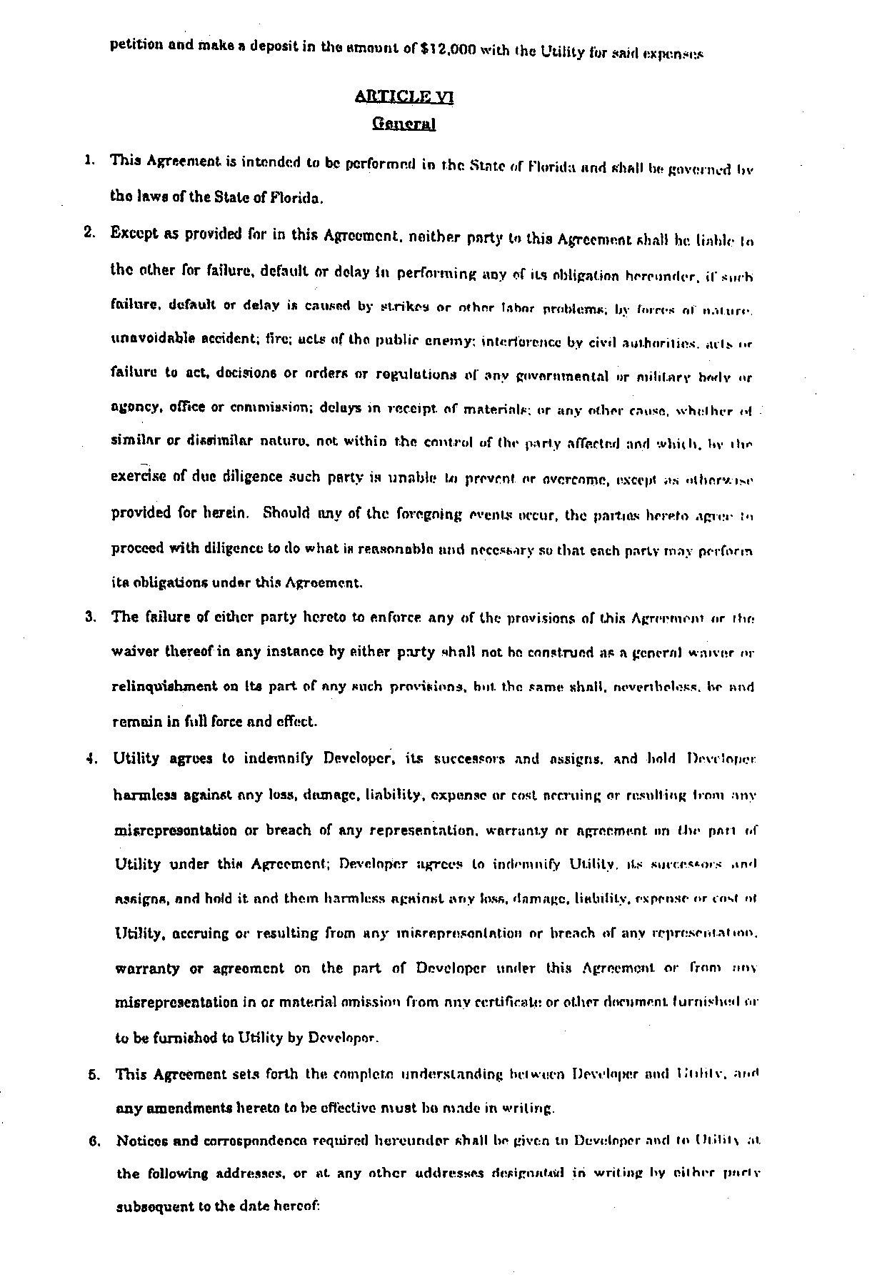
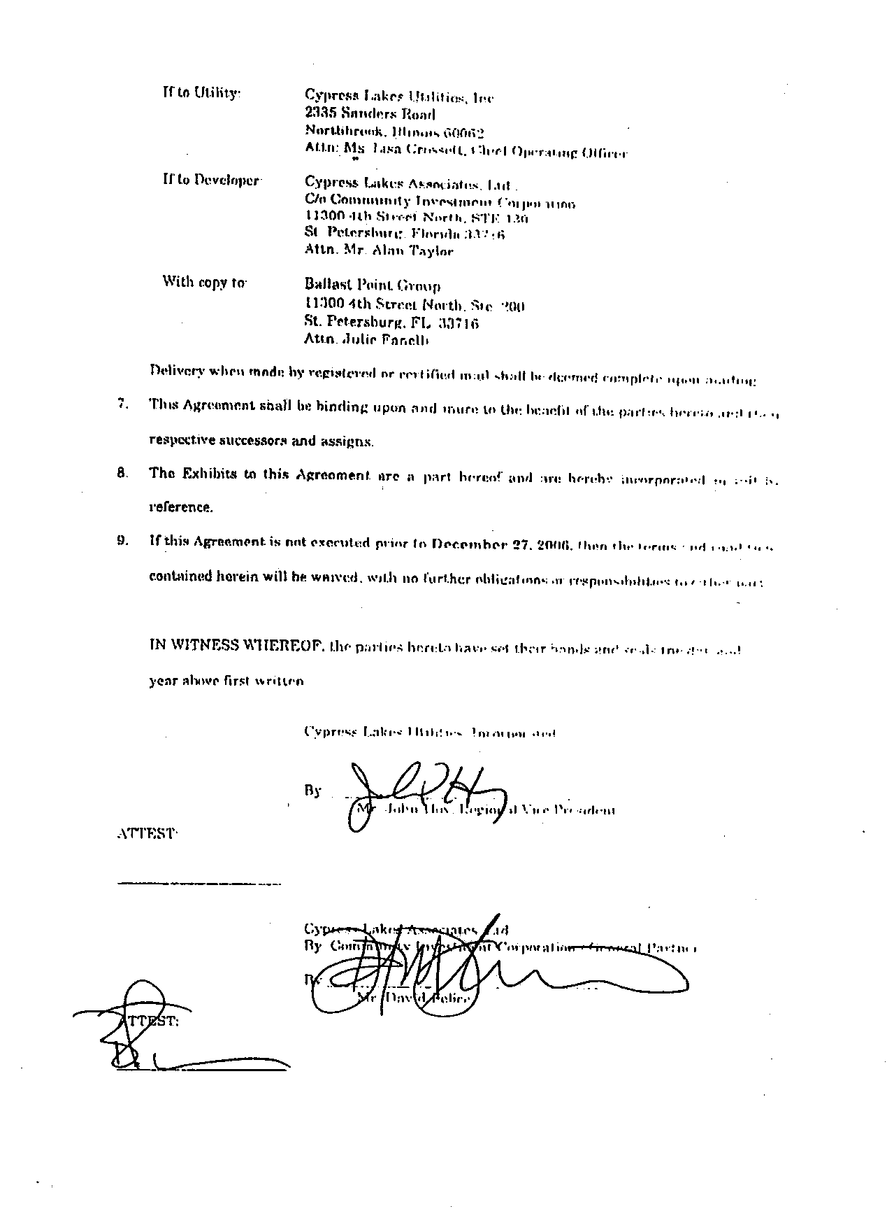
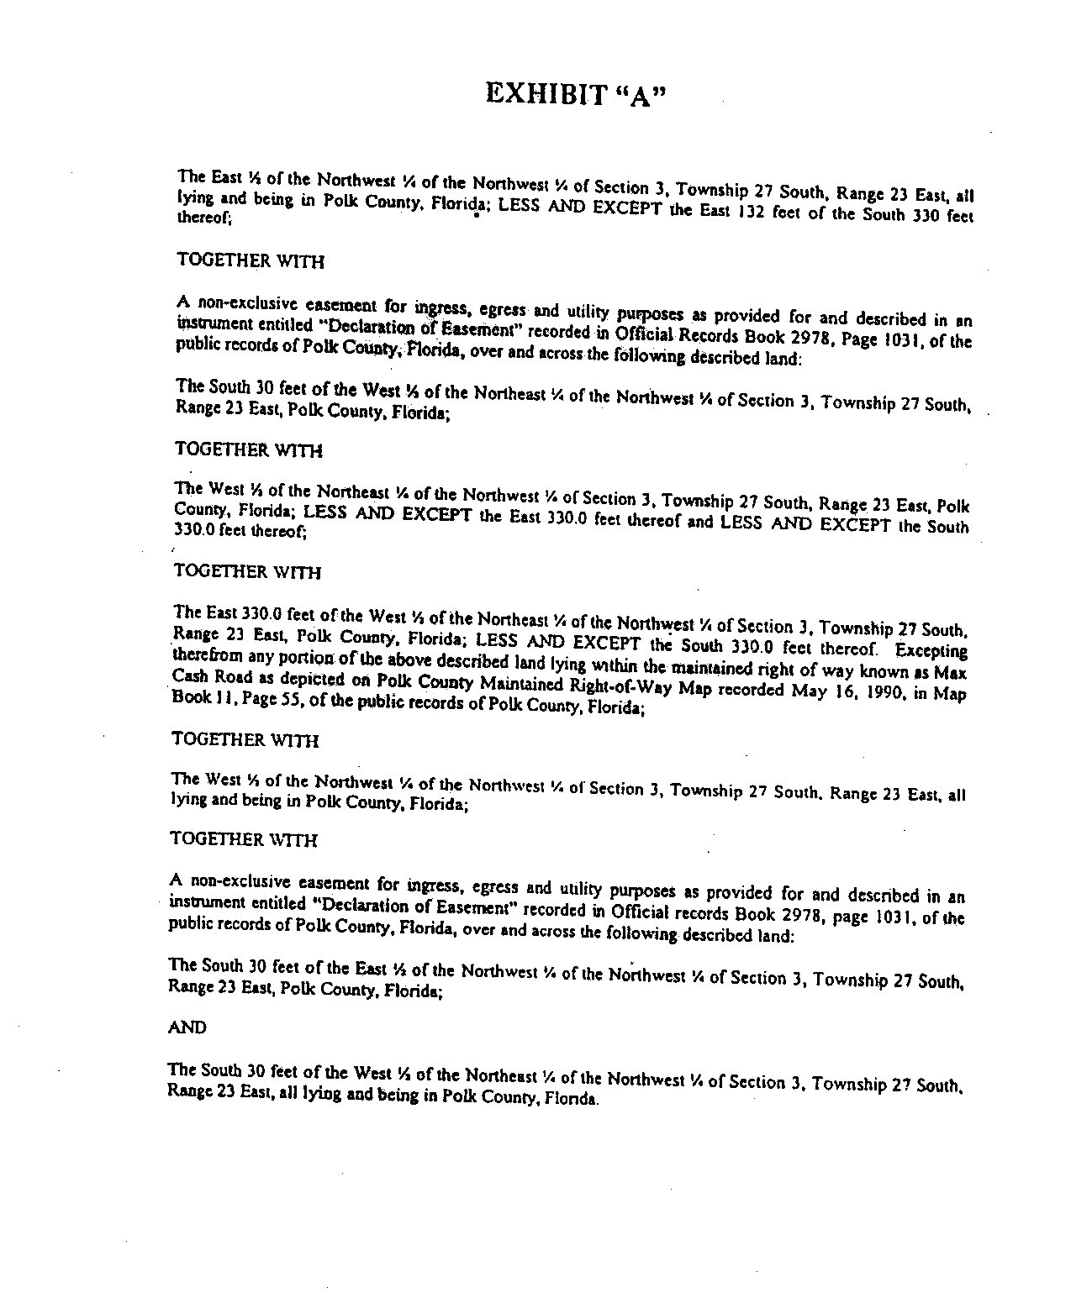

In re: Application for increase in water and wastewater rates in Polk County by Cypress Lakes Utilities, Inc.

