BEFORE THE FLORIDA PUBLIC SERVICE COMMISSION

In re: Petition for rate increase by St. Joe Natural Gas Company, Inc. | DOCKET NO. 070592-GU  ORDER NO. PSC-08-0436-PAA-GU  ISSUED: July 8, 2008

The following Commissioners participated in the disposition of this matter:

MATTHEW M. CARTER II, Chairman
LISA POLAK EDGAR
KATRINA J. McMURRIAN
NANCY ARGENZIANO
NATHAN A. SKOP

ORDER GRANTING RATE INCREASE

BY THE COMMISSION:

NOTICE is hereby given by the Florida Public Service Commission that the action discussed herein is preliminary in nature and will become final unless a person whose interests are substantially affected files a petition for a formal proceeding, pursuant to Rule 25-22.029, Florida Administrative Code (F.A.C.).

BACKGROUND
On December 21, 2007, St. Joe Natural Gas Company, Inc. (SJNG or Company) filed a petition for a permanent rate increase. SJNG requested an increase in its retail rates and charges to generate $624,166 in additional gross annual revenues. SJNG’s requested increase would allow the Company to earn an overall rate of return of 6.14 percent or an 11.50 percent return on equity (range 10.50 percent to 12.50 percent). Per Rule 25-7.140(1)(d), F.A.C., SJNG elected to use the five month Proposed Agency Action process authorized in Section 366.06(4), Florida Statutes (F.S.). By letter dated April 30, 2008, SJNG waived the five month deadline and extended it to June 17, 2008.

By Order No. PSC-08-0135-PCO-GU, issued March 3, 2008, we suspended SJNG’s proposed permanent rate increase and authorized an interim increase of $157,775. As required by Section 366.071(5)(b)3, F.S., the applicable return on equity (ROE) for purposes of an interim increase is the minimum of the range of return as authorized in the Company’s last rate proceeding. We granted the $157,775 interim increase on the appropriate ROE and overall cost of capital of 10.50 percent and 5.60 percent, respectively.

Customer meetings were held in Port St. Joe, Florida, on April 21, 2008 and May 19, 2008. No customers attended either of the customer meetings.

Our decision below addresses SJNG’s requested permanent rate increase. We have jurisdiction pursuant to Sections 366.06(2) and (4), and 366.071, F.S

DECISION
As we will explain in detail below, we find SJNG's rate base to be $3,024,656. We find the average cost of capital to be 5.44 percent and the return on common equity to be 11.00 percent with a range of 10.00 percent to 12.00 percent. We grant SJNG an annual revenue increase of $543,868.

TEST PERIOD
The Company based its request on a projected test year ending December 31, 2008. The Company stated that this test year is the appropriate period because it represents the conditions to be faced by the Company, and is representative of the customer base, investment requirements, throughput levels, and overall cost of service to be realized under the new rates. The Company’s proposed test period is appropriate.
QUALITY OF SERVICE
No customers attended the customer meetings held in Port St. Joe, Florida, on April 21, 2008 and May 19, 2008, and quality of service is not at issue in this proceeding.
RATE BASE
Plant Additions
Based on its past purchasing experience, SJNG included $8,700 in its 2008 projected plant additions for six pressure temperature units. SJNG purchased these units in 2008 at an actual cost of $10,889. We have increased Account 387, Other Equipment, by $2,189 ($10,889-$8,700) to account for the increase in cost. We have also increased the related depreciation expense and accumulated depreciation each by $231.
Also, the Company projected $16,000 in its 2008 plant additions for a new billing insert machine. SJNG received a price quote from Pitney Bowes of $14,361. We have reduced Account 391.2, Office Equipment, $4,317 ($16,000-$14,361) to correct the overstatement. We have also reduced the associated accumulated depreciation and depreciation expense each by $685.
The effect of these adjustments are shown in the following chart:
2008 Projected Plant Additions-Adjustments
Account Number | Description | Reason | Plant | Accumulated Depreciation | Depreciation  Expense
387.0 | Other Equipment | Audit Finding 2 | $2,189 | $231 | $231
391.2 | Office Equipment | Audit Finding 3 | (4,317) | (685) | (685)
Total |  |  | ($2,128) | ($454) | ($454)

Equipment no Longer in Service

Our staff’s audit review shows that the Company retired and sold three trucks without recording any salvage to Account 392.0, Transportation. On MFR Schedule G-1, page 176, the projected retirements for this account included the following: (1) a 1999 Chevrolet Pickup sold on January 16, 2008, for $1,870, (2) a 2002 Silverado Chevrolet truck sold on January 29, 2008, for $8,000, and (3) a 2002 Chevrolet 2500 truck expected to be retired in 2008 with an expected salvage value of $5,000. The company should have recorded total salvage of $14,870.

Also, SJNG purchased a 2001 Silverado Chevrolet truck for $22,629 and placed it in service on August 31, 2001. The truck was retired on December 31, 2003, and was given to the General Manager as a retirement gift. At that time, the truck was 2.3 years of age, and had accumulated $5,807 in depreciation expense. The average service life of this plant account is 8 years with an average remaining life rate of 10.3 percent. Also, the early retirement of the truck left an unrecovered investment of $16,822. The Company should have recorded the amount to accumulated depreciation as salvage. This salvage amount equates to a remaining life of 7.2 years for the plant investment.

We find that accumulated depreciation shall be increased by $31,692 for the retirement of the four trucks, which includes $14,870 and $16,822 for salvage that should be booked to Account 392, Transportation.

Account Number | Description | Audit  Finding | Accumulated  Depreciation
392 | Transportation | 4 | $14,870
 |  | 5 | 16,822
Total |  |  | $31,692

Accumulated Depreciation
We find that the appropriate adjustment to accumulated depreciation to reflect our recently approved depreciation rates for the Company is a reduction of $6,658.
This calculation is based upon the decision we made Order No. PSC-08-0259-PAA-GU, issued April 25, 2008, in Docket No. 070737-GU, In re: Application for approval of new depreciation rates, effective January 1, 2008, by St Joe Natural Gas Company, Inc.
Plant in Service0
Based on our decision above, we find that the appropriate 13-month average amount of Gas Plant in Service for the December 2008 projected test year is $6,435,378 (see Schedule 1).
Accumulated Depreciation for Plant in Service
Based on our decisions made above, we find that the appropriate 13-month average amount of Accumulated Depreciation of Gas Plant in Service for the December 2008 projected test year is $3,280,359 (see Schedule 1).
0
Working Capital

The Company did not remove non-utility activity in Miscellaneous Current Liabilities and Taxes Accrued-General when calculating working capital for the year ended December 31, 2008. The thirteen-month average balances of $29,165 and $16,944 consisted of the co-mingled utility and non-utility activity. In calculating the working capital allowance, adjustments for non-utility activity should be consistent throughout the applicable general ledger accounts.

The Company estimates that the amount of non-utility Miscellaneous Current Liabilities is $11,795 and the amount of non-utility Accrued Taxes is $1,670. Based on this information, we find that that working capital shall be increased by $13,465 ($11,795 + $1,670) for the year ended December 31, 2008, to remove non-utility activities.

Operation and Maintenance Expense

As discussed in our staff’s Audit Finding No. 10, the Company recorded $1,411 in Account 886, Maintenance of Structures and Improvements. This amount represents the cost of a service agreement with Pitney Bowes for a folding machine maintenance contract for the period August 1, 2006, through July 31, 2007. This machine is used in the preparation of bills. The Company misclassified the cost of the service agreement in Account 886, Maintenance of Structures and Improvements. Also, only a portion of the amount was applicable to 2006. The Company agrees with this audit finding.

While the audit addressed the amount paid in 2006, the amounts paid in other years were not discussed. The Company paid $1,265.22 in 2005 and $1,468.04 in 2007. No expense was included in 2008. Consistent treatment for those years would be to include a portion of the 2005 payment for 2006, and a portion of 2007 for 2008, with corresponding adjustments to the working capital 13-month average.

We find that Operation and Maintenance Expense Account 886 for 2006 shall be $1,326, resulting in a reduction of $85. The trended reduction for 2008 is $90. For 2008, expense shall be increased by $856, resulting in a net increase of $766. In addition, working capital shall be increased by $263 for 2008.

Working Capital Allowance

Based upon our adjustments to Working Capital and Operations and Maintenance Expense described above, we find that the appropriate level of projected test year Working Capital Allowance is ($130,363) (see Schedule 1).
Total Rate Base
Based on the adjustments to rate base we made above, we find that the appropriate amount of rate base for the projected test year is $3,024,656 (see Schedule 1).
COST OF CAPITAL
Return on Common Equity
SJNG’s currently authorized ROE of 11.50 percent was last established in 2001 by Order No. PSC-01-1274-PAA-GU. In its petition, SJNG asks that we maintain this same return for purposes of this proceeding.

Citing the high cost of retaining an expert cost of capital witness, SJNG did not file traditional cost of capital testimony with its petition in this case. The Company did offer pre-filed testimony on what it believes is the appropriate cost rate for common equity. In his testimony, Mr. Stuart Shoaf, President of SJNG, stated that SJNG shares many of the same operating characteristics and overall financial risks as Indiantown Gas Company, Sebring Gas System, and Chesapeake Utilities Corporation Florida Division. Mr. Shoaf recommended that we set SJNG’s ROE based on his assessment of the Company’s business risk, financial risk, and comparability with other similarly-situated natural gas utilities.

Mr. Shoaf provided a general assessment of the Company’s business risk factors. He noted that SJNG is highly sensitive to loss of customers, and that there has been a slow-down in the economy, increased operating expenses, and declining gas consumption. SJNG is heavily dependent on one large volume industrial customer, Arizona Chemical Company (Arizona), for a significant percentage of its throughput. As discussed subsequently in this order, Arizona provides approximately 20 percent of SJNG’s total revenues at present rates. However, Arizona has been reducing its annual volume usage. Between 2002 and 2006, Arizona reduced its usage by 33 percent. Moreover, Mr. Shoaf stated that Arizona was acquired by a private equity firm in 2007, and its future as a customer of SJNG is uncertain. Finally, he explained that SJNG is an extremely small company relative to other regulated natural gas distribution companies. Based on these factors, Mr. Shoaf contended that SJNG is exposed to greater business risk than the average natural gas distribution company.

Mr. Andy Shoaf, Manager of Corporate Services, noted in his pre-filed testimony, however, that although SJNG faces certain business risks, the market also provides various opportunities for the Company. He identified a housing development that should lead to new customer growth. SJNG has the potential to add 1,500 new residential accounts and numerous new commercial accounts during the ten year time frame the Windmark development is projected to be built.

Regarding financial risk, the Company has an equity ratio as a percentage of investor supplied capital of 84.4 percent. This level of equity capitalization is much greater than the relative level of equity capital maintained by the other natural gas distribution companies. A high equity ratio indicates SJNG is exposed to less financial risk than the average natural gas distribution company.

We agree with the Company that SJNG and the other small Florida natural gas distribution companies share similar business risks and opportunities. Historically, the returns authorized for natural gas distribution companies and transmission and distribution electric utilities have been very similar. The following table shows the returns authorized by the Commission for Florida natural gas distribution companies and the Electric Division of Florida Public Utilities Company (FPUC) since 2000. As this table shows, the level of returns has remained relatively stable over the past 8 years.

Company | Order No. | Issued | ROE
FPUC Electric | PSC-08-0327-FOF-EI | May 19, 2008 | 11.00%
Sebring Gas | PSC-04-1260-PAA-GU | December 20, 2004 | 11.50%
FPUC Gas | PSC-04-1110-PAA-GU | November 8, 2004 | 11.25%
Indiantown Gas | PSC-04-0565-PAA-GU | June 2, 2004 | 11.50%
FPUC Electric | PSC-04-0369-AS-EI | April 6, 2004 | 11.50%
Florida City Gas | PSC-04-0128-PAA-GU | February 9, 2004 | 11.25%
Peoples Gas | PSC-03-0038-FOF-GU | January 6, 2003 | 11.25%
Indiantown Gas | PSC-02-1666-PAA-GU | November 26, 2002 | 11.50%
St. Joe Gas | PSC-01-1274-PAA-GU | June 8, 2001 | 11.50%
Florida City Gas | PSC-01-0316-PAA-GU | February 5, 2001 | 11.50%
Chesapeake Gas | PSC-00-2263-FOF-GU | November 28, 2000 | 11.50%

The most recent case where we heard testimony on the appropriate rate of return on equity was in the proceeding for the Electric Division of FPUC. In that case, we approved an ROE of 11.00 percent.

Since the time of our decision in SJNG’s last rate case in May 2001, the Federal Reserve has lowered short-term interest rates by 250 basis points. In addition, the long-term BBB corporate bond yield has declined 176 basis points. Over this same period, the thirty-year Treasury bond yield has declined 120 basis points. These changes in interest rates influence the required rate of return a company would need to attract capital under reasonable terms.

Based on the analysis outlined above, we authorize a ROE of 11.00 percent for SJNG, with a range of plus or minus 100 basis points.

Capital Structure

In its MFRs, SJNG filed a projected capital structure with an equity ratio of 84.4 percent as a percentage of investor supplied capital. We have previously found, however, that an appropriate capital structure for ratemaking purposes for this Company should consist of no more than 60 percent equity as a percentage of investor sources of capital.

Normally, a company with a high equity ratio is considered to have less financial risk than a comparable company with a lower equity ratio. The higher equity ratio reduces the company’s risk of default on its bond payments and thus reduces its overall financial risk. Because equity capital is more expensive than debt, however, a company must reach a balance between equity and debt to minimize its overall cost of capital. To the extent a utility is able to use lower cost debt to leverage its operations, it can lower its overall cost of capital.

We believe that by approving an ROE of 11.00 percent with an equity ratio of no greater than 60 percent as a percentage of investor capital, we are sending the proper signal that the Company has the responsibility to minimize its overall cost of capital. Allowing SJNG an equity ratio that is greater than the average equity ratio maintained by other natural gas distribution companies offsets the business risks facing a small, privately-held utility that is exposed to the financial and business risks discussed above. This adjustment is consistent with our previous orders and with our decision in SJNG’s last rate case.

Therefore, we find that the appropriate capital structure for SJNG’s projected test year ending December 31, 2008, shall consist of no more than 60 percent equity as a percentage of investor capital.
Weighted Average Cost of Capital
Based upon the decisions made above, and the proper components, amounts, and cost rates associated with the capital structure for the test year ending December 31, 2008, we find that the weighted average cost of capital shall be 5.44 percent (see Schedule 2).

The 13-month average per book amounts is taken directly from the Company's MFR filing. We agree with the respective cost rates provided by SJNG in its MFR filing, with one exception. As discussed above, we have authorized a return on common equity of 11.00 percent, and we have adjusted SJNG’s capital structure to reflect a 60 percent equity ratio as a percentage of investor capital. After these specific adjustments, we made a pro rata adjustment over investors’ sources of capital to reconcile rate base and capital structure.

The net effect of these adjustments is a reduction in the overall cost of capital from the 6.14 percent return requested by the Company to a return of 5.44 percent. Schedule 2 shows the components, amounts, cost rates, and weighted average cost of capital associated with the test year capital structure.
NET OPERATING INCOME
Purchased Gas Adjustment Revenues and Expenses

In its filing, SJNG included the revenues and expenses related to the Purchased Gas Adjustment clause (PGA) in the 2008 projected income statement. For ratemaking purposes, the amounts related to the PGA are excluded from the income statement because they are not included in base rates. Therefore, an adjustment shall be made to remove any amounts related to the PGA for the 2008 projected test year. We shall reduce operating revenues by $1,055,904, O&M Expense – Cost of Gas by $1,050,619, and taxes other than income by $5,285. The net effect on net operating income is zero for the 2008 projected test year.
Interest Income

The Company included interest income of $7,202 in operating revenues in the Minimum Filing Requirements (MFRs) for the year ended December 31, 2008. This amount represents interest earned on the cash recorded in Account 131.4, Cash. As noted in our staff’s Audit Finding No. 7, this account consists of both utility and non-utility activities. The Company stated that 48 percent of this amount is attributable to non-utility activities. The Company agrees with the Audit Finding.

We find, therefore, that $3,457 of interest income attributable to non-utility activities shall be removed from Operating Revenues for 2008.

Total Operating Revenue
Based on the determinations we have made in this proceeding, we find that $1,072,946 is the appropriate projected level of Total Operating Revenues for the December 2008 projected test year (see Schedule 3).
Rental Expense

For the 2008 projected test year, SJNG included lease rental expense of $25,000 for a metal warehouse. The warehouse is to be used by SJNG to store equipment, fittings, plastic pipe and other utility-related items. In response to a data request, the Company explained that it originally planned to lease a 4,200 square foot building at $6 per square foot for a total expense of $25,200. After the MFRs were filed, the property owner found out that the maximum size building suitable for use on the property was 3,200 square feet due to government regulations. Based on the reduced square footage of the building, SJNG entered into a 3-year lease agreement on March 25, 2008, at $1,400 per month, or an annual expense of $16,800.
In the MFRs, the Company recorded warehouse rental lease expense under Distribution Expense, in Account 880, Other Expenses. The Uniform System of Accounts defines Account 880 as Other Expenses that should include expenses associated with systems operations not provided elsewhere in the utility’s accounting system. Account 881, Rents, should include rents for property of others used, occupied or operated in connection with the operation of the distribution system. The rental lease expense should be recorded in Account 881, Rents.
Based on the above, we find that Account 881, Rent Expense, shall be increased by $16,800 to reflect the monthly lease rental expense of $1,400. In addition, Account 880, Other Expenses, shall be reduced by $25,000 to remove the misclassified lease rental expense. The net effect is an $8,200 reduction to expenses for the test year.
Uncollectible Expense
In Audit Finding No. 11, our staff noted that the Company reported $11,429 in write-offs for the year ended December 31, 2006. The $11,429 represents the write-off of uncollectible accounts for the year ended December 31, 2005. Audit Finding No. 11 determined that the actual write-off of uncollectible accounts was $7,314 for the year ended December 31, 2006. The Company agrees that the actual expense is $7,314 for 2006. Based on the above, we find that the 2008 Uncollectible Accounts Expense, Account 904, shall be reduced by the 2008 trended amount of $4,357.
Advertising Expense
In the 2006 historical test year, SJNG included a donation of $10 to the Gulf County Schools Gold Card Club and $80 for a lunch with a donation to the Habitat for Humanity. Charitable contributions and miscellaneous expenses associated with the contribution should not be recovered through base rates. The Uniform System of Accounts states that all payments or donations for charitable, social, or community welfare purposes should be recorded in Account 426.1, Donations, which is not an operating expense account. Account 426.1 is classified as a “below-the-line” expense account and is not included in the determination of net operating income for ratemaking purposes. We find that Account 913, Advertising Expense, shall be reduced by $90 for 2006 and by the trended amount of $95 for 2008 to remove donation expenses and an associated miscellaneous expense.

Outside Services Employed

Our staff’s Audit Finding No. 12 states that 2006 Outside Services Employed, Account 923, should be reduced by $2,000 for services that were rendered on February 9, 2006, to prepare the 2005 Financial Audit. In response to Audit Finding No. 12, the Company agreed that the $2,000 for services was to prepare the 2005 Financial Audit. Also, SJNG stated that the auditors missed a payment of $14,985 on May 18, 2006, for the 2005 audit work. Therefore, we find that a total reduction of $16,985 shall be made to Account 923, Outside Services Employed, for 2006.
In addition, the Company explained that it inadvertently omitted its actual 2006 outside service expenses of $19,240 for its outside auditing and financial report expenses. The 2006 outside auditing and financial expenses were paid on March 9, 2007, ($5,000) and May 25, 2007 ($14,240). The Company explained that it uses the accrual method of accounting to account for its expenses. However, some expenses for a particular year may not be known until the following year. Once the actual expense amount is known, the Company records the expense in the appropriate year. The Company provided the supporting documentation, in a letter dated May 15, 2008, for the 2006 actual expense of $19,240. The 2006 net increase of $2,255 shall be trended up for the inflation factors of 3.48 percent for 2007 and 2.30 percent for a 2008 net increase of $2,388.
Based on the above, we find that the 2006 Outside Services Employed, Account 923, shall be decreased by $16,985 for the 2005 expenses. In addition, the actual 2006 expenses of $19,240 shall be included, resulting in a net increase of $2,255, for 2006 and a trended net increase of $2,388 for 2008.
Rate Case Expense
In its MFRs, SJNG requested $78,000 in rate case expense, to be amortized over four years. The four year amortization period is consistent with the Company’s previous rate case. In response to discovery, the Company provided documentation to support its rate case expense. SJNG explained that the $78,000 was based on the following: $42,500 for the consultant; $25,000 based on the legal fees incurred by Indiantown Gas Company in its 2003 rate case, and the attorney’s $150 hourly fee included in the 2004 Sebring Gas System, Inc. rate case; $2,000 estimated expenses for the accountant; and $8,500 for estimated miscellaneous expenses and overtime labor.
We find that the following adjustments to SJNG’s requested rate case expense are appropriate:
1. According to the discovery, SJNG’s actual rate case expense to date is $51,894. We have reduced the Company’s requested rate case expense by $26,106 to reflect the actual amount expended.
2. The final payment to the rate case consultant in the amount of $5,000 was not included in the current rate case expense total because the payment is not due until the permanent rates have been approved and implemented. The Professional Services Agreement dated August 3, 2007, states that the maximum owed under this agreement is $42,500. The current amount expensed to the consultant is $37,500.
3. The Company included an expense of $106.49 for a Star customer notice for a customer meeting on April 11, 2008. SJNG did not include the customer notice expense for April 17, 2008, and May 1, 2008, because the Company had not received the bill. Therefore, we have increased rate case expense by $213.
4. We have removed $5,104 in overtime expense for Stuart Shoaf, President of St. Joe Natural Gas Company, because overtime hours are covered by management’s annual compensation as discussed in Order No. PSC-08-0327-FOF-EI.
5. In order to complete the case, SJNG will incur additional expenses for attorney’s fees, noticing requirements, and other miscellaneous expenses. We find that an additional $3,000 in rate case expense shall be sufficient to cover these additional costs.
Based on the above, we find that the appropriate amount of test year rate case expense is $55,003. The appropriate amortization period is four years. Therefore, the requested annual amortization of $19,500 shall be reduced by $5,749 to $13,751.
Total Operations and Maintenance Expense - Other
Based on the adjustments we have made above, the projected 2008 O&M Expense – Other of $913,680 shall be reduced by $15,247 to an adjusted amount of $898,433 (see Schedule 3).
Depreciation Expense
We recalculated SJNG’s projected test year depreciation expense using the new depreciation rates we approved in Order No. PSC-08-0259-PAA-GU. The impact of the new depreciation rates on the test year is a $13,440 reduction in depreciation expense for 2008.
Based on the adjustments we have made in this proceeding, the projected
2008 Depreciation and Amortization Expense of $260,105 should be reduced by $13,894 to an adjusted amount of $246,211 (see Schedule 3).

Investment Tax Credits and Excess Deferred Income Taxes
In Order No. PSC-08-0259-PAA-GU, we approved the Company's proposed remaining lives, to be effective January 1, 2008. Revising a utility's book depreciation lives generally results in a change in its rate of Investment Tax Credits (ITC) amortization and flowback of Excess Deferred Income Taxes (EDIT), in order to comply with the normalization requirements of the Internal Revenue Code (IRC) and its underlying Regulations. We find that the current amortization of ITCs and the flowback of EDIT shall be revised to match the actual recovery periods for the related property. On an annual basis, SJNG shall include detailed calculations of the revised ITC amortization and the flowback of EDIT in its December earnings surveillance reports beginning with the annual period ending December 31, 2008.
Taxes Other Than Income
Based on the adjustments we have made in this proceeding, we find that the projected 2008 Taxes Other Than Income of $63,387 shall be reduced by $5,302 to an adjusted amount of $58,085 (see Schedule 3).
Income Tax Expense
Based on the adjustments we have made in this proceeding we find that the projected 2008 income taxes of $45,351 shall be reduced by $2,163 to an adjusted amount of $43,188 (see Schedule 3). The $2,163 reduction is the net of a $9,671 income tax increase due to the revenue and expense adjustments we have made and an $11,834 income tax reduction due to the interest synchronization adjustment (Schedule 2) related to the capital structure adjustments.
Projected Net Operating Income
Based on the adjustments we have made in this proceeding, the appropriate Net Operating Income for the December 2008 projected test year is ($172,972) (see Schedule 3).
REVENUE REQUIREMENTS
Net operating Income Multiplier
SJNG provided the calculation of its 1.6114 net operating income multiplier on MFR Schedule G-4. We have reviewed the calculation and determined that it is appropriate, and we approve it.
Operating Revenue Increase
Based on the adjustments we have made in this proceeding, the appropriate Net Operating Income for the December 2008 projected test year is $543,868. The following schedule shows the calculation of the revenue requirements.

Calculation of Revenue Requirements
December 31, 2008 Test Year
 | SJNG | STAFF
Rate Base  Rate of Return | $3,037,636  x 6.14% | $3,024,656  x 5.44%
Required NOI  Adjusted Achieved NOI (Loss) | $186,511  (200,835) | $164,541  (172,972)
NOI Deficiency  Revenue Expansion Factor | $387,346  x 1.6114 | $337,513  x 1.6114
Total Revenue Increase | $624,166 | $543,868

COST OF SERVICE AND RATE DESIGN
Cost of Service Methodology
As explained below, we find that the appropriate methodology to be used in allocating costs to the rate classes is contained in Schedule 4, and reflects the adjustments we have made to rate base, expenses, rate of return, and net operating income.

The purpose of a cost of service study is to allocate the total base rate costs of the utility system among the various rate classes. The results of the cost of service study are used to determine how any revenue increase we grant will be allocated to the rate classes. Once this determination is made, base rates are designed for each rate class that recover the total revenue requirement attributable to that class. Base rates for SJNG include the monthly fixed customer charge and the variable per-therm charge, which we will address below. The Company’s proposed cost of service study is contained in MFR Schedule H.

Witness Householder stated that he used the standard methodology traditionally used in natural gas rate cases as the basis for SJNG’s cost of service study. However, SJNG proposed specific adjustments to the initial cost allocations. The main adjustment to the cost of service study was done to the cost to serve the proposed FTS-5 rate class, which serves Arizona Chemical Company (Arizona). As shown in SJNG’s Response No. 4 to Staff’s discovery, Exhibit A, the cost to serve Arizona is $820,095. Current revenues attributable to Arizona are $219,065. SJNG’s proposed target revenue for the FTS-5 rate class is $285,509. This represents a $66,444 increase from Arizona’s revenues at present rates.

Arizona is SJNG’s largest customer. For 2008, SJNG projects that Arizona will consume 4.9 billion therms, which represents 77 percent of SJNG’s gas throughput. Arizona provides approximately 20 percent of SJNG’s total revenues at present rates for the test period. Witness Shoaf expressed concerns about SJNG’s heavy dependence on Arizona’s revenues, and about Arizona’s future as a customer of SJNG. Arizona’s therm consumption has decreased in recent years, and Arizona is located less than 1,000 feet from a Florida Gas Transmission (FGT) pipeline lateral. Arizona could potentially by-pass SJNG’s distribution facilities and directly connect to FGT. FGT already provides direct connect service to an industrial customer near the Arizona plant.

On May 12, 2008, Arizona met with SJNG and our staff and expressed concern about the proposed $66,444 increase in its revenue requirement, and about SJNG’s proposed significant increase in the customer charge while decreasing the therm charge. Arizona explain that it currently produces and sells biofuel as byproduct of its main process, the manufacture of pine resin. Arizona has the option of using a portion of the biofuel to burn at its plant and generate up to 20 percent of its energy instead of selling the biofuel.

Witness Householder based Arizona’s proposed revenue requirement on Arizona’s cost to bypass SJNG. In response to discovery, SJNG showed that the approximate cost for Arizona to by-pass SJNG and directly interconnect with the FGT pipeline would be $435,000 with an additional $5,000 to $10,000 annual O&M cost. The $435,000 includes an FGT pipeline tap, a gate station, 1,000 feet of main, and engineering and permitting costs. Witness Householder stated that in his experience most industrial customers look for a payback on capital expenditures of 24 months or less. Therefore, SJNG first adjusted Arizona’s revenue requirement to $227,500 ($435,000/2 + $10,000). Witness Householder believes that if Arizona were to by-pass, Arizona would incur higher capacity rates payable to FGT, resulting in approximately $58,000 per year in incremental capacity costs. Thus, SJNG’s proposed target revenue for Arizona is $285,500 ($227,500 + $58,000). Arizona believes that its by-pass cost could be lower. We do know, however, that if we were to approve a lower target revenue for Arizona, the remaining rate classes would see an increase in their base rates.

We recognize that the loss of Arizona could result in rate increases to the remaining customers. We find that Arizona’s target revenues shall be set at $285,011, based on the by-pass analysis done by SJNG. We notes that in 1999, SJNG lost its then-largest customer, Florida Coast Paper Company, which was a major factor contributing to SJNG’s 2001 rate case. SJNG’s proposed target revenue for the FTS-5 rate class enables SJNG to retain Arizona as a customer, which, even at reduced rates, makes contributions to the recovery of fixed costs.

It is fairly common in the gas industry for large volume industrial customers who have alternative fuel options to receive a rate or special contract that is designed to retain the customer. In SJNG’s last rate case, we granted Arizona’s rate class a 6.3 percent revenue decrease, recognizing the need to offer competitive rates to Arizona. The 6.3 percent decrease included the effect of separately billing the Gross Receipts Tax of 2.5 percent, which previously had been included in base rates.

Based on the above we approve the cost of service study as shown in Schedule 4, as reflective of the adjustments to rate base, expenses, rate of return, and net operating income that we have made in this proceeding.
Customer Charges

The customer charge is a fixed charge that applies to each customer’s bill, no matter the quantity of gas used for the month. The customer charge is typically designed to recover costs such as metering and billing that are incurred whether any gas is consumed or not. For any given revenue requirement, any customer related costs that are not recovered through the customer charge are recovered through the therm charge. Therefore, a higher customer charge results in a lower therm base charge. This shift in cost recovery may benefit larger users who can offset the overall bill increase due to the higher customer charge with lower per therm charges. Small users, however, cannot benefit to the same extent from the lower therm charge. Small customers may see larger increases overall from shifting cost recovery from the variable therm charge to the fixed customer charge than larger customers. The shift to a higher fixed charge also reduces the small customer’s ability to affect his overall bill. We have evaluated the Company’s proposed customer charges in light of these trade-offs for different usage levels.

We approve the customer charges contained in the table below. The table also shows the present customer charges and the company-proposed charges.

Proposed  Rate Class Titles | Current  Customer  Charge | Company  Proposed  Customer  Charge | Commission  Approved  Customer  Charge
RS-1  (presently in GS-1) | $9.00 | $16.50 | $13.00
RS-2  (presently in GS-1) | $9.00 | $20.25 | $16.00
RS-3  (presently in GS-1) | $9.00 | $24.00 | $20.00
GS-1/FTS-1  (presently GS-2/TS-2) | $9.00 | $25.00 | $20.00
GS-2/FTS-2  (presently GS-3/TS-3) | $40.00 | $70.00 | $70.00
GS-3/FTS-3  (presently GS-4/TS-4) | $360.00 | $925.00 | $500.00
GS-4/FTS-4  (presently GS-5/TS-5) | $1,000.00 | $5,000.00 | $2,000.00
GS-5/FTS-5  (presently GS-6/TS-6) | $1,000.00 | $6,000.00 | $3,000.00

As shown in the table, we have approved lower charges than the Company proposed for most rate classes, due to our concern that large increases in the customer charges may result in large percentage increases in some bills, particularly for low-use residential and small commercial customers. We note that the Company currently does not have any customers taking service under the proposed GS-3, GS-4, GS-5, FTS-1, FTS-2, and FTS-3 rate classes.

We have considered witness Householder’s arguments on behalf of shifting costs under the Straight Fixed Variable (SFV) basis from the variable per therm charge to the fixed monthly customer charge. There is some merit in his argument that a local distribution company (LDC) experiences very little variable cost for building and maintaining infrastructure. SFV cost allocations are consistent with the pricing schemes approved by the Federal Energy Regulatory Commission for interstate pipelines. The customer still experiences variability due to fluctuations in the cost of gas itself, but purchased gas costs are addressed in the annual PGA proceedings. This proceeding only addresses the base rate portion of the Company’s costs that recovers the infrastructure and daily operating expenses of the utility.

Section 366.06(1), F.S., states that we shall “to the extent practicable, consider the cost of providing service to the class, as well as the rate history, value of service and experience of the public utility...” The term “rate history” has been interpreted to be consideration of rate shock or abnormally large increases to customers’ bills. As noted by witness Householder, a complete shift to a SFV rate structure is not practical at this time. A shift of most of the Company’s base rate costs from the variable per therm charge to a large fixed customer charge would unduly penalize small-use customers who may not benefit from the correspondingly lower therm charge resulting from such a shift. It also sends a price signal that could discourage growth of the customer base on SJNG’s system, which witness Stuart Shoaf has identified as vital to the Company’s long term success.

We believe a fairer approach is to set the customer charge to minimize the impact on very low users and let the therm charge capture the balance of the class revenue requirement, because that is what the customer can control. The rates we approve will recover a greater proportion of the base rate costs through the customer charge than current rate design as a step towards recognizing the operating characteristics of LDCs while providing some stability to customer rates and minimizing impacts on low users.

A similar approach was taken for the commercial classes. We have set the level of the customer charge to more equally allocate the increase across all customer usage levels, as opposed to very high increases for small users and much smaller increases for very large users in each class. We find that the Company’s proposed customer charge for the GS-2 class is appropriate, as it results in impacts similar to the impacts on the other classes. Lowering the GS-2 customer charge would result in larger customers receiving a larger percentage increase than smaller customers, which is contrary to the goal of attracting and retaining larger commercial customers. Customer charges for the Firm Transportation rates mirror the charges for the comparable non-transportation only classes.

Gas Delivery Service Rates

SJNG has proposed that the the Non-Fuel Charge be renamed Gas Delivery Service Rate. The Gas Delivery Service Rate (therm charge) is the variable per-therm charge, and recovers SJNG’s cost of providing distribution service. The therm charge does not include the actual gas commodity, as that is shown separately on the bill and determined in the annual Purchased Gas Adjustment (PGA) Proceedings. The therm charges are calculated to recover the revenues that remain after subtracting the revenues generated by the customer charges we have approved.

Residential customers take sales service, while non-residential customers elect either sales or transportation service. Sales customers receive their gas supply directly from SJNG and take service under the GS rate schedules. Transportation customers take service under the FTS rate schedules. Transportation customers arrange for the purchase of their gas through a gas marketer for delivery to SJNG’s system, and SJNG provides only the transportation of the gas to the customer. At present, only Gulf Correctional Institute and Arizona take transportation service.

SJNG’s tariff provides separate rate schedules for sales and transportation customers to reflect that sales customers, in addition to base rates, are responsible for the PGA charge. The PGA charge does not apply to transportation customers because they purchase their own gas. The customer and therm charges that are at issue in this proceeding are the same for sales and transportation service, i.e., a GS-1 customer pays the same customer and therm charge as a FTS-1 customer.

The table below shows the therm charges that were in effect prior to the interim increase, the interim charges (effective March 13, 2008), the SJNG proposed charges, and our approved charges. All charges are shown in cents per therm. No customers take service under the proposed rate schedules that are marked with an asterisk.

Current rate schedule | Proposed rate schedule | Prior to interim | Interim | SJNG proposed | Staff recommended
GS-1 | RS-1 | 38.086 | 50.218 | 46.972 | 70.441
GS-1 | RS-2 | 38.086 | 50.218 | 46.880 | 56.729
GS-1 | RS-3 | 38.086 | 50.218 | 46.903 | 50.381
GS-2/TS-2 | GS-1/FTS-1* | 38.086 | 47.569 | 38.488 | 43.981
GS-3/TS-3 | GS-2/FTS-2* | 20.665 | 25.068 | 33.790 | 31.801
GS-4/TS-4 | GS-3*/FTS-3* | 4.210 | n/a | 6.610 | 6.610
GS-5/TS-5 | GS-4*/FTS-4 | 8.091 | 9.735 | 3.748 | 11.749
GS-6/TS-6 | GS-5*/FTS-5 | 3.676 | 4.313 | 1.406 | 3.554

The therm charges we have approved are higher than most of SJNG’s proposed charges, because we have approved lower customer charges than SJNG proposed. For any given revenue requirement for a rate class, lowering the customer charge increases the per therm charge. For example, for the RS-1 class, we have approved a $13 customer charge, resulting in a 70.441 cents per therm charge. Increasing the customer charge to $14 would reduce the therm charge to 56.247 cents per therm.
Schedule 5 contains a comparison of monthly bills for various levels of consumption for all rate schedules with customers SJNG is currently serving. As shown on page 2 of 7 of Schedule 5, a residential customer using 22 therms per month currently pays $36.71 (including PGA costs). Under the proposed RS-2 rates, the customer would see a $11.10 increase.
Miscellaneous Service Charges

Miscellaneous service charges are fixed charges that are paid when a specified activity occurs, such as the initial connection of a residence or business, a change of account, or a late payment. The miscellaneous service charges are designed to recover the billing, personnel, and other overhead costs associated with the specific charge.

The miscellaneous service charges we approve for this proceeding are contained in the table below. The table also shows the present miscellaneous service charges and the Company-proposed charges.

Miscellaneous  Service Charge | Present  Miscellaneous  Service Charge | Company  Proposed Miscellaneous  Service Charge | Commission  Approved  Miscellaneous  Service Charge
Residential Connect and Reconnect | $30.00 | $40.00 | $40.00
Non-residential Connect and Reconnect | $60.00 | $60.00 | $60.00
Change of Account | $20.00 | $30.00 | $26.00
Collection in Lieu of Disconnect | $15.00 | $0.00 | $0.00
Returned Check Charge | Greater of $25.00  or 5% | Greater of $25.00  or 5% | Greater of $25.00  or 5%
Late Payment Charge | Greater of $3.00  Or 1 ½% | Greater of $3.00  or 1 ½% | Greater of $3.00  or 1 ½%

As shown in the table, we have approved the same miscellaneous service charges as the Company has proposed except for the Change of Account charge. During discovery, our staff determined that the calculations of the cost to provide the Change of Account contained an error that caused the proposed amount to be overstated by $4.00. We have therefore adjusted the proposed Change of Account charge to $26.00.

The Collection in Lieu of Disconnect charge is being eliminated. In discussions with SJNG, it was determined that the charge had never been collected due to security and liability concerns about Company personnel accepting cash and monetary payments in the field. Annual reconnects for SJNG from 2005-2007 were between 1.09 percent and 1.15 percent of billed customers, which encompasses both reconnects for nonpayment of bills and reconnects for customers leaving their premises for a vacation or other residence. A customer seeking to avoid disconnection for nonpayment of bills can contact SJNG via phone or email and pay the arrears at a Company office. Given the liability concerns, modest amount of reconnects, and the customers’ ability to contact the Company and resolve billing arrears, we find that elimination of the Collection in Lieu of Disconnect charge is appropriate.

Residential Service Class Stratification

Currently, residential customers are served under rate schedule GS-1. SJNG has proposed to rename and stratify its current single residential class into three individual classes depending on annual therm usage: RS-1, RS-2, and RS-3. The customer and therm charge would vary among the proposed three residential classes.

The RS-1 class will be available to residential customers whose annual usage is less than 150 therms. The RS-2 class will be available to residential customers who use 150-299 therms annually. The RS-3 class will be available to residential customers who use over 300 therms annually. Based on 2007 data, witness Householder states that approximately 38 percent of customers would be assigned to the RS-1 class, 33 percent to the RS-2 class, and 29 percent to the RS-3 class. SJNG projects to serve 2,820 residential customers in 2008.

Witness Householder states that SJNG is proposing to restructure its existing residential class to achieve greater stratification within the class and to group customers based on common usage characteristics. Witness Householder states that it is typical to find a wide volumetric therm range within a company’s single residential class, with the class exhibiting significant subsidization within the class. A RS-1 customer typically has a single appliance, usually cooking, or is a seasonal resident. RS-1 consumers generally are not heating their homes with gas. A RS-2 customer typically operates multiple gas appliances such as a water heater and cooking or clothes drying appliances and may be using gas to heat their homes. A RS-3 customer’s residence would include gas heating equipment and all of the above appliances. High-use RS-3 customers may also have pool heating, grills, etc.

One important goal of rate design is to more closely align rates with the actual cost to serve them. The costs of providing gas service are typically divided into customer, commodity, and capacity (or demand) costs. Based on the cost of service filed by SJNG, customer costs do not vary much among low-use and high-use residential customers. Commodity costs are variable and relate to volume of gas sold. Those costs are minor, since SJNG experiences very little variable costs in providing distribution service. Both the customer and commodity costs therefore do not form a reasonable basis to stratify the residential rate class.

However, capacity costs do vary between low-use and high-use residential customers. Capacity costs are fixed costs that the gas company incurs to ensure that the system is ready to serve customers at peak requirement levels. SJNG has allocated capacity costs on the basis of peak and average monthly sales, which is the traditional method of allocating capacity costs for gas utilities. That method essentially allocates capacity costs based on monthly therms consumed. Customers with multiple gas appliances, or who use gas to heat their homes, use more therms, thus are allocated a larger percentage of the gas pipelines. As shown in Schedule H-2, page 1 of 5, the capacity allocation factors vary among the three proposed residential rate classes, being lowest for the proposed RS-1 class, and highest for the proposed RS-3 class, and therefore form a reasonable basis to stratify the current single residential class into three rate classes.

We have approved similar rate restructuring for other gas utilities. In the 2003 City Gas rate case, we approved five volumetric rate classes for residential customers, depending on how many therms they use annually. City Gas’s GS-1 rate serves customers using between 0 and 99 therms per year, the GS-100 rate serves customers using between 100 and 219 therms per year, etc. The Florida Division of Chesapeake Utilities Corporation (Chesapeake) serves customers using 0 to 500 therms per year under three rate schedules.

We believe that the proposed replacement of the existing residential rate class with three rate classes yields a more equitable distribution of the costs of serving various residential customers. The proposed residential classes more accurately reflect similar use patterns or assignment of capacity costs. For these reasons, we find that the proposed residential rate classes are appropriate, and we approve them.

Closing RS-1 and RS-2 Rate Classes to New Customers

SJNG has asked to restrict the availability of the proposed RS-1 and RS-2 residential rates to premises that currently take service under those rate schedules. New customers who move into existing premises that were billed under the RS-1 or RS-2 rates could continue to receive service under those rates. However, once a customer’s usage at a specific premises exceeds 300 therms per year, the customer residing at that premises would be permanently reclassified as an RS-3 customer. Any customers using between 0 and 300 therms per year who move into newly constructed premises would be classified as RS-3 customers.

In support of its proposal, SJNG states that historically the rates of return for small volume residential customers have been set at levels that do not recover the Company’s cost to serve. SJNG further states that the subsidization affects the Company’s competitive position since rates for larger customers are higher to support the subsidy, and closing the RS-1 and RS-2 rate class would take a step toward ensuring that all future residential customer additions provide an appropriate recovery of costs.

SJNG further asserts that the proposed change is virtually identical to the Chesapeake tariff we approved. In Docket No. 040956-GU, Chesapeake received approval to close the existing FTS-A (0-130 therms) and FTS-B (131-250 therms) rate schedules to new premises and to serve any new customers using between 0 and 500 therms under the FTS-1 rate. Chesapeake’s rate schedules are based on annual therm usage, rather than end-use, i.e., residential or commercial.

Schedule H-3, page 2 of 5, of the MFRs filed by SJNG shows that the forecast rate of return at present rates is negative for all rate classes, including the residential rate classes, indicating the current rates for all classes are too low to recover SJNG’s cost to serve. However, since all rate classes, including the RS-1 and RS-2 classes, receive an increase in this proceeding, the RS-1 and RS-2 class will pay their fair share of the cost to serve and are no longer being subsidized. Chesapeake’s petition involved a revenue-neutral restructuring, not a base rate increase.

For the reasons discussed above, we deny SJNG’s request to close the proposed RS-1 and RS-2 classes to new customers.
Area Extension Program
SJNG’s current tariff does not offer an Area Extension Program (AEP). The AEP is a method of collecting a contribution in aid of construction (CIAC) that can be assessed when the cost to serve a customer requires an extension of facilities exceeding the Maximum Allowable Construction Cost (MACC), which is four times the estimated gas revenues expected from the facilities needed to connect a customer, less the cost of gas. The AEP is usually applied to condominiums, multi-family residences and single family subdivisions, as commercial and industrial customers are required to pay up front the CIAC required. The AEP is applied at the Company’s discretion.
The current tariff states that when the extension costs are greater than the MACC, the person requesting the extension must pay a CIAC equal to the difference between the estimated costs and the MACC. The person paying the CIAC is entitled to a refund of any excess MACC used to determine the CIAC if the MACC turns out to be higher than initially calculated. The person paying the CIAC is also entitled to a refund of any excess MACC that exceeds the connection cost for each additional customer on an extension within 5 years from the date of construction.
The current policy can place inordinate financial burdens on the first customers who move into the subdivision, since they are responsible for paying for the costs of extending gas service to the entire subdivision. The mains, regulators, and other equipment required to extend gas service to a subdivision are substantially more expensive than what is required to serve a single residence. While additional customers moving into a subdivision can provide for a refund of some of the CIAC, the initial cost to the first customers moving in can be substantial. Should the Company assume the risk and not charge the customers a CIAC, then the Company has placed all of its customers at financial risk if the subdivision or development does not build out as planned.
SJNG proposes to create a new Area Extension Policy that would divide the difference between the construction costs and the MACC by the number of premises projected to be served at the end of the fifth year from the in-service date of the extension. The cost would be a fixed per premises charge and be assessed over an amortization period not to exceed 120 months. If a premises became inactive or vacant during that period, the AEP charge would be suspended until the premises was reoccupied and gas service reactivated. SJNG would true up the AEP charge at the end of the fifth year following the in-service date of the extension. The Company would calculate the cost difference between the original MACC based on estimated costs and revenues, and a recalculated MACC, using the Company’s actual capital investment costs and the actual gas delivery service revenues. The amount remaining to be credited or collected would be charged to the actual number of customer premises for which gas service had been activated by the end of year 5 for the remainder of the 120 month amortization period.
The cost of the expansion is known when a subdivision or development is placed into service. Under a per therm charge, which other gas utilities in Florida have used to recover extension costs, a unit with four appliances would potentially pay four times the amount of a unit with only one appliance when the cost of installing the facilities does not vary with usage. SJNG’s proposed AEP surcharge is designed to recover the fixed cost of extending facilities which provide equal benefits in terms of access to all units, no matter how much gas they actually use. This is consistent with the treatment we have approved for Peoples Gas System and the Florida Division of Chesapeake Utilities Corporation.
SJNG’s proposed AEP charge will equitably distribute the fixed costs of extending facilities to a development or subdivision customer on a per premises basis. By equitably allocating the costs of extending service and eliminating from those costs variables such as usage and weather, the proposed AEP charge diminishes the potential for default and eliminates having a variable charge that would unevenly collect fixed costs. We therefore approve the charge.
Conversion Installation Costs
SJNG has included a provision in its tariff that would allow the Company to enter into an agreement with a customer who chooses to contract with SJNG to convert the premises to natural gas use. That is an optional service. Customers have the choice of financing the conversion through SJNG or hiring and paying a licensed contractor (plumber, gas fitter, A/C contractor, etc). SJNG states that typically commercial customers choose to convert to natural gas by re-doing the piping. For example, a restaurant that currently uses propane to cook and heat water might want to switch to natural gas due to the high prices of propane. SJNG does not expect residential customers to switch their premises to natural gas.

SJNG proposed to adjust the therm charge to reflect the costs incurred by SJNG in providing the conversion to natural gas. At such time as SJNG has recovered its costs, bills rendered shall return to the therm charge stated in the tariff. We believe the better approach is to show the conversion costs as a separate line item on the gas bill, as opposed to rolling the costs into the therm charge. Showing the conversion costs as a separate line item will clearly show the customer the conversion costs, and thus avoid customer confusion.

SJNG’s proposed tariff provision is identical to language in Florida City Gas’ and Chesapeake Utilities Corporation’s current tariffs. While both Florida City Gas and Chesapeake’s approved tariffs allow the conversion costs to be reflected as an adjustment to the variable therm charge, we find it is more appropriate to show the conversion costs as a separate line item on the gas bill to clearly show the customer the conversion costs.
OTHER ISSUES
Revised Tariffs
SJNG shall file revised tariffs to reflect our approved final rates and charges for administrative approval within five (5) business days of the issuance of this PAA order. Pursuant to Rule 25-22.0406(8), F.A.C., customers shall be notified of the revised rates in their first bill containing the new rates. A copy of the notice shall be submitted to staff for approval prior to its use.

Interim Rates

By Order No. PSC-08-0135-PCO-GU, issued March 3, 2008, we authorized the collection of interim rates, subject to refund, pursuant to Section 366.071, F.S. The approved interim revenue requirement was $1,265,568, which represents an increase of $157,775 or 14.24 percent. The interim collection period is March 2008 through July 2008.
According to Section 366.071, F.S., any refund shall be calculated to reduce the rate of return of the utility during the pendency of the proceeding to the same level within the range of the newly authorized rate of return. Adjustments made in the rate case test period that do not relate to the period interim rates are in effect shall be removed. Rate case expense is an example of an adjustment which is recovered only after final rates are established.

In this proceeding, the test period for establishment of interim and final rates is the 12-month period ending December 31, 2006. SJNG’s approved interim rates did not include any provisions for pro forma or projected operating expenses or plant. The interim increase was designed to allow recovery of actual interest costs, and the lower limit of the last authorized range for return on equity.

To establish the proper refund amount, we calculated a revised interim revenue requirement utilizing the same data used to establish final rates for the 2008 projected test year. Rate case expense was excluded because this item is prospective in nature and did not occur during the interim collection period. Using the principles discussed above, because the $1,265,568 revenue requirement granted in Order No. PSC-08-0135-PCO-GU, for the 2006 interim test year is less than the revenue requirement for the 2008 interim collection period of $1,616,814, we find that no refund is required. Further, upon issuance of the Consummating Order in this docket, the corporate undertaking shall be released.

Based on the foregoing, it is

ORDERED that St. Joe Natural Gas Company’s Petition for Rate Increase is granted in part and denied in part as described in the body of this Order. It is further

ORDERED that each of the findings made in the body of this Order are hereby approved in every respect. It is further

ORDERED that all matters contained in the attachments and schedules appended hereto are incorporated herein by reference. It is further

ORDERED that within five business days of the issuance of this Order, St. Joe Natural Gas Company shall file revised tariffs to reflect our approved final rates and charges for administrative approval by our staff. It is further

ORDERED that the approved rates and charges for St. Joe Natural Gas Company shall be effective for meter readings on or after July 17, 2008. Pursuant to the requirements of Rule 25-22.0406(8), F.A.C., customers shall be notified of the revised rates in their first bill containing the new rates. It is further

ORDERED that St. Joe Natural Gas Company shall
file, within 90 days after the date of the Final Order in this docket, a description of all entries or adjustments to its annual report, earnings surveillance reports, and books and records that will be required as a result of the decision’s made in this docket. It is further
ORDERED that the provisions of this Order, issued as proposed agency action, shall become final and effective upon the issuance of a Consummating Order unless an appropriate petition, in the form provided by Rule 28-106.201, Florida Administrative Code, is received by the Commission Clerk, 2540 Shumard Oak Boulevard, Tallahassee, Florida 32399-0850, by the close of business on the date set forth in the "Notice of Further Proceedings" attached hereto. It is further

ORDERED that in the event this Order becomes final, this docket shall be closed.

By ORDER of the Florida Public Service Commission this 8th day of July, 2008.

/s/ Ann Cole
ANN COLE
Commission Clerk

This is an electronic transmission. A copy of the original signature is available from the Commission's website, www.floridapsc.com, or by faxing a request to the Office of Commission Clerk at 1-850-413-7118.

( S E A L )

MCB

NOTICE OF FURTHER PROCEEDINGS OR JUDICIAL REVIEW

The Florida Public Service Commission is required by Section 120.569(1), Florida Statutes, to notify parties of any administrative hearing that is available under Section 120.57, Florida Statutes, as well as the procedures and time limits that apply. This notice should not be construed to mean all requests for an administrative hearing will be granted or result in the relief sought.

Mediation may be available on a case-by-case basis. If mediation is conducted, it does not affect a substantially interested person's right to a hearing.

The action proposed herein is preliminary in nature. Any person whose substantial interests are affected by the action proposed by this order may file a petition for a formal proceeding, in the form provided by Rule 28-106.201, Florida Administrative Code. This petition must be received by the Office of Commission Clerk, 2540 Shumard Oak Boulevard, Tallahassee, Florida 32399-0850, by the close of business on July 29, 2008.

In the absence of such a petition, this order shall become final and effective upon the issuance of a Consummating Order.

Any objection or protest filed in this/these docket(s) before the issuance date of this order is considered abandoned unless it satisfies the foregoing conditions and is renewed within the specified protest period.

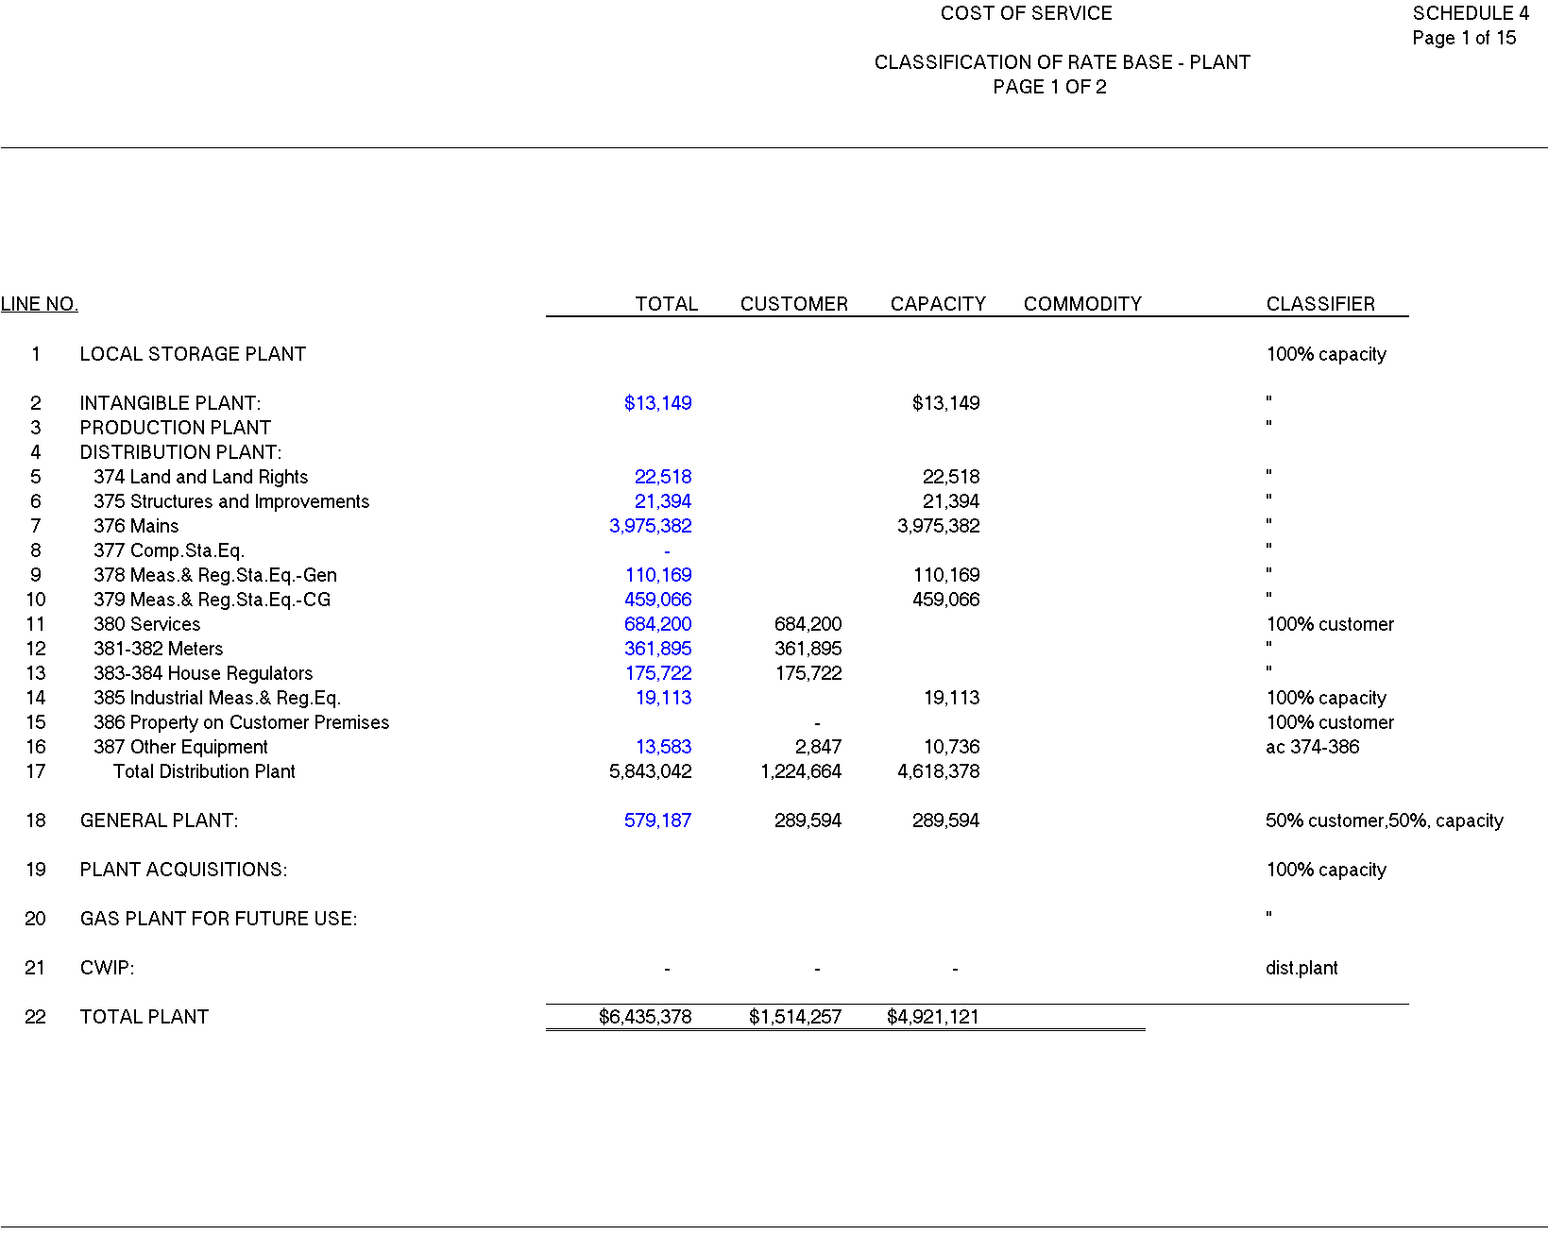
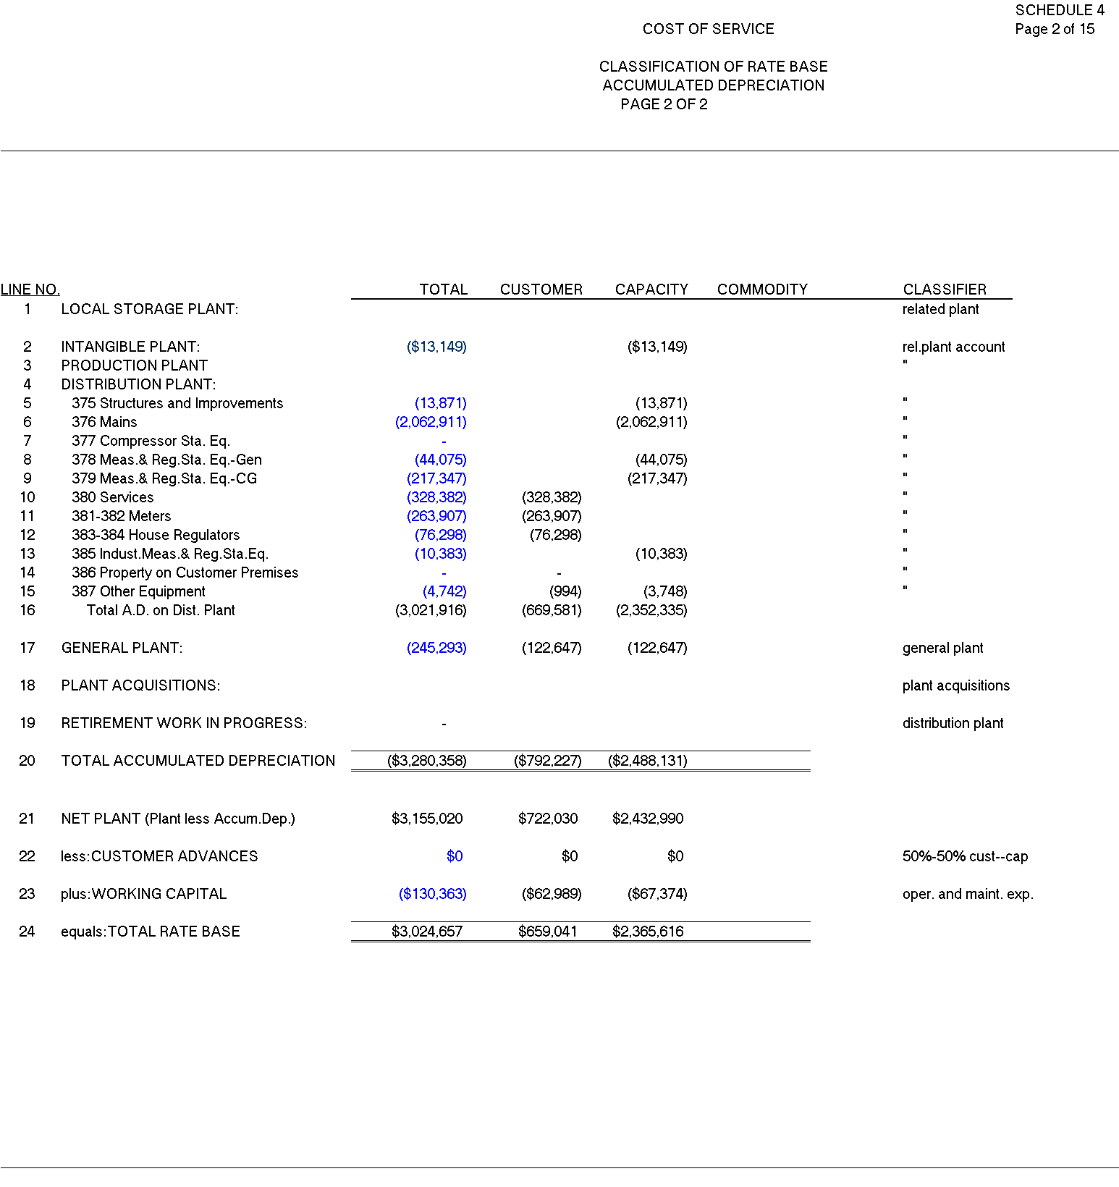
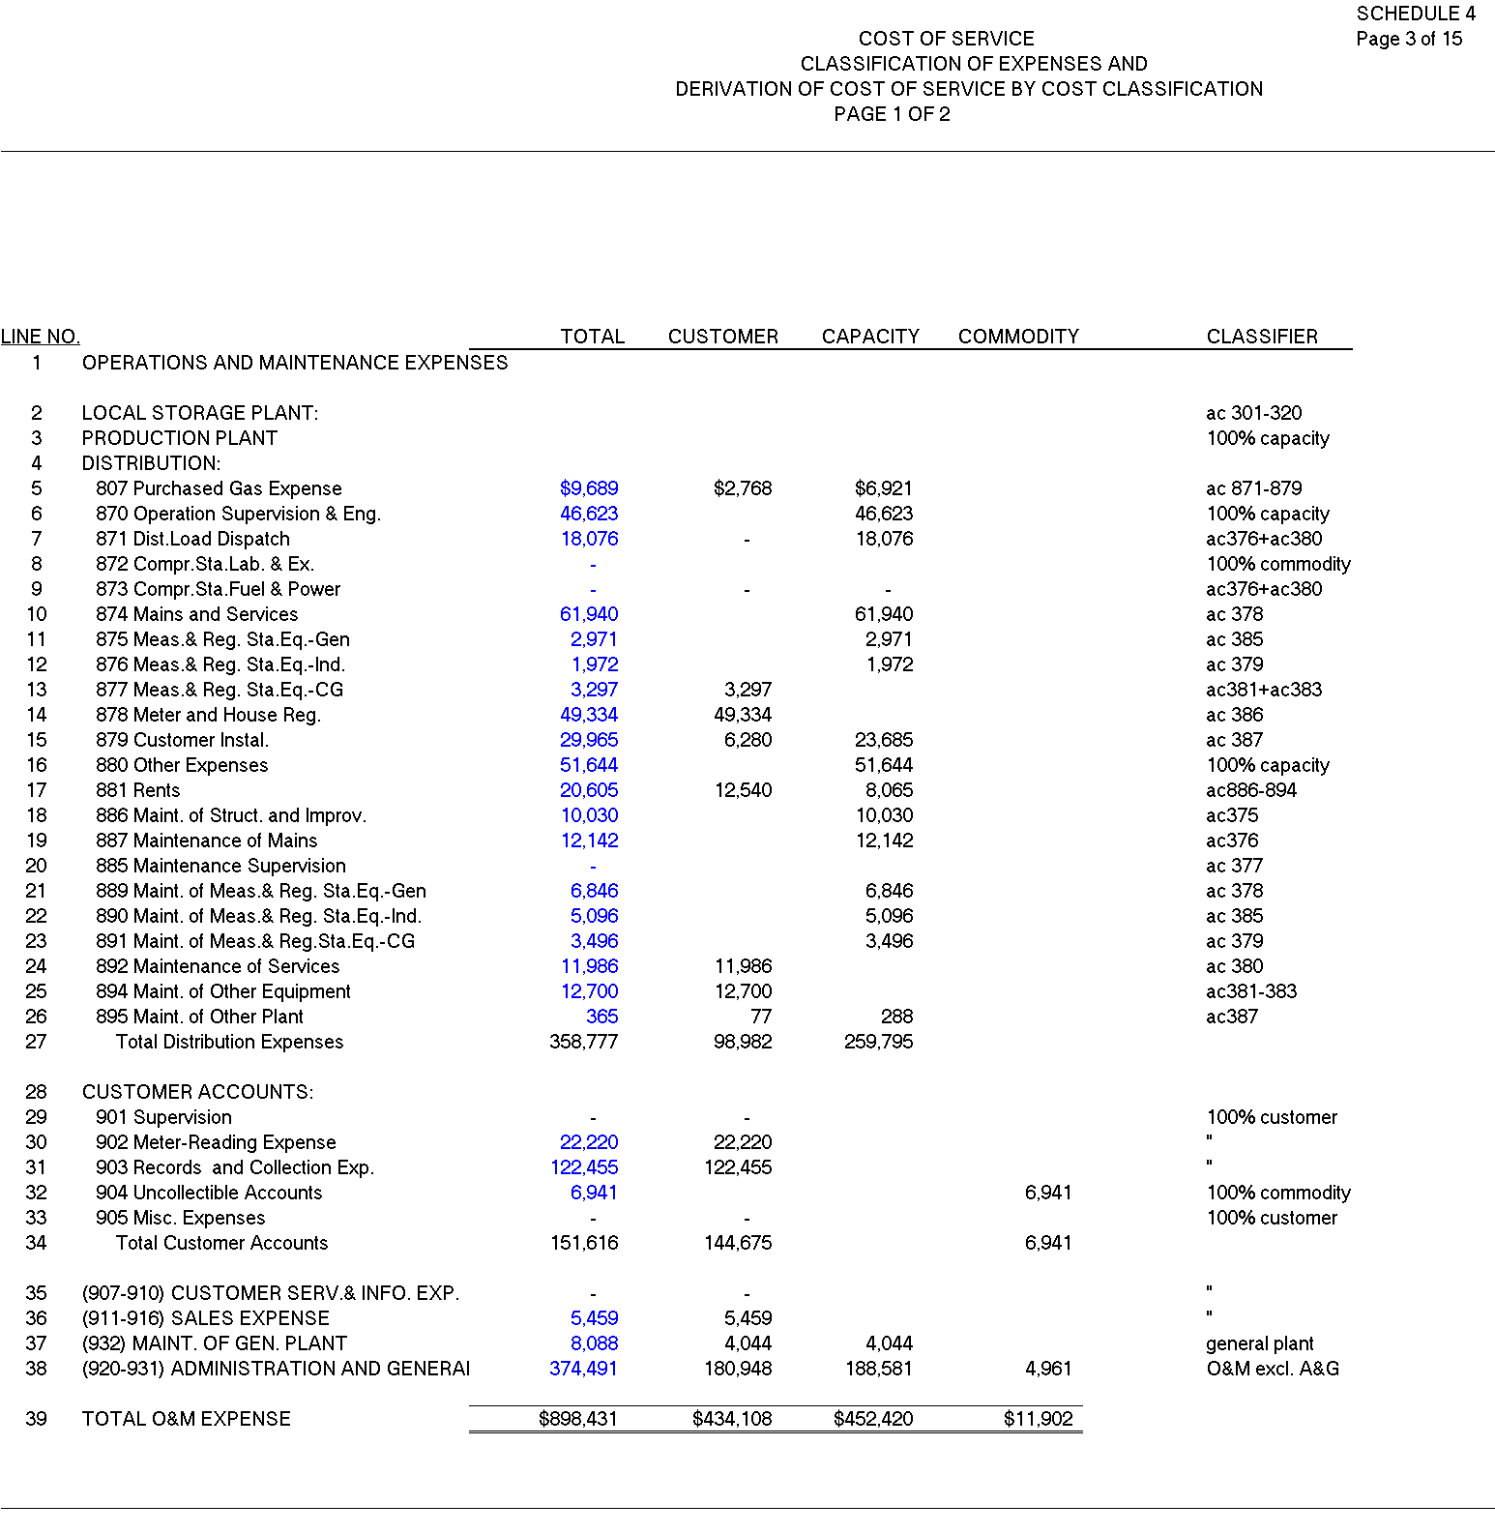
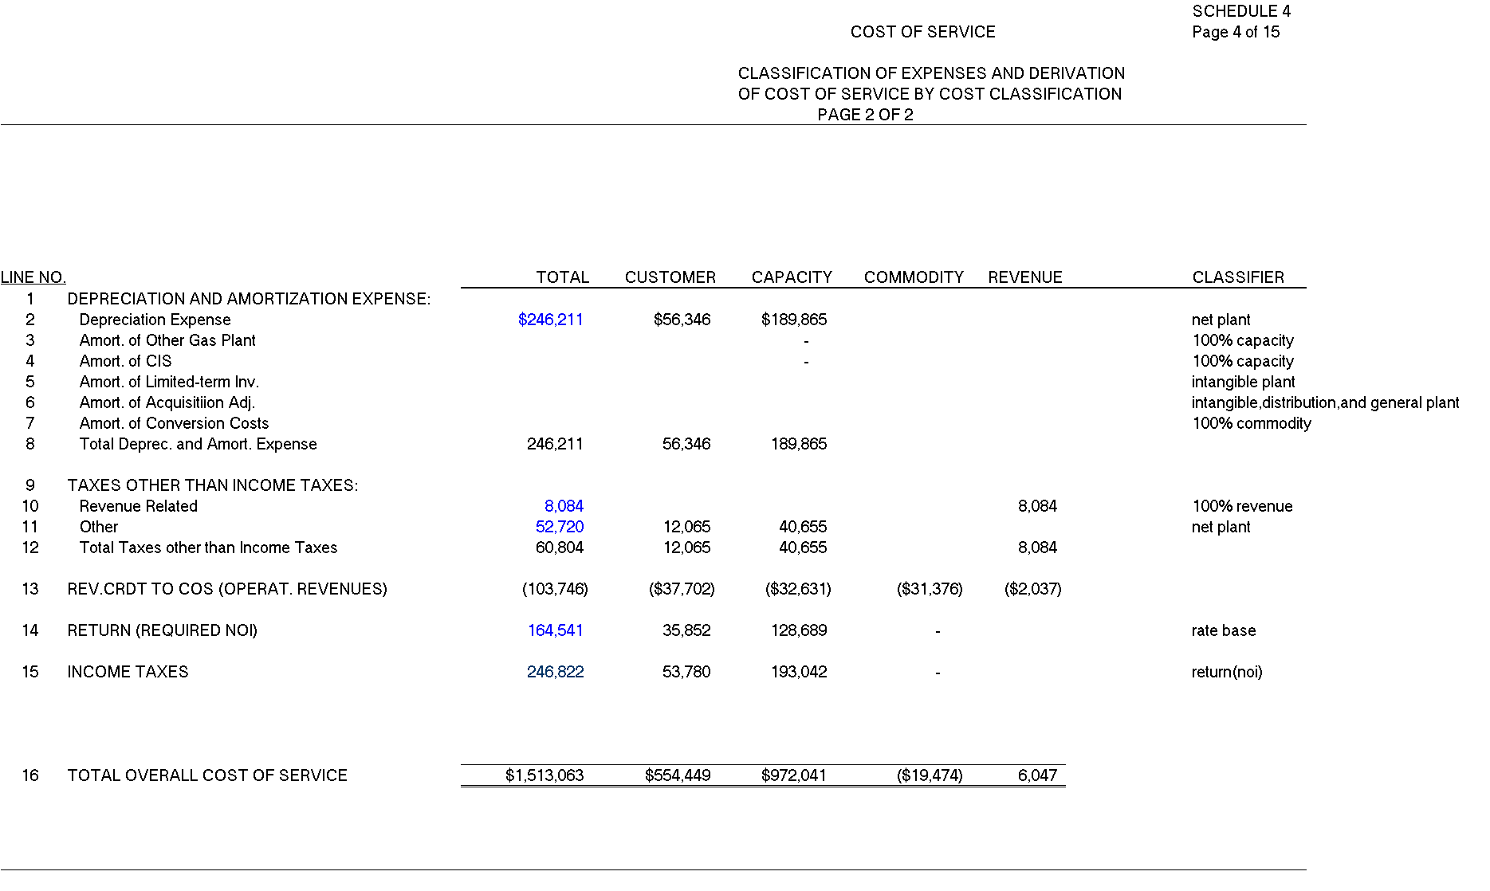
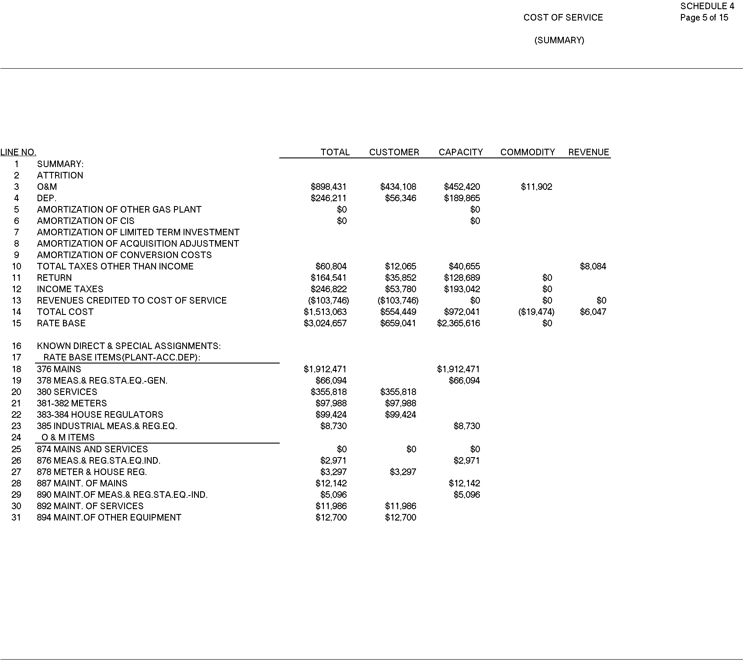
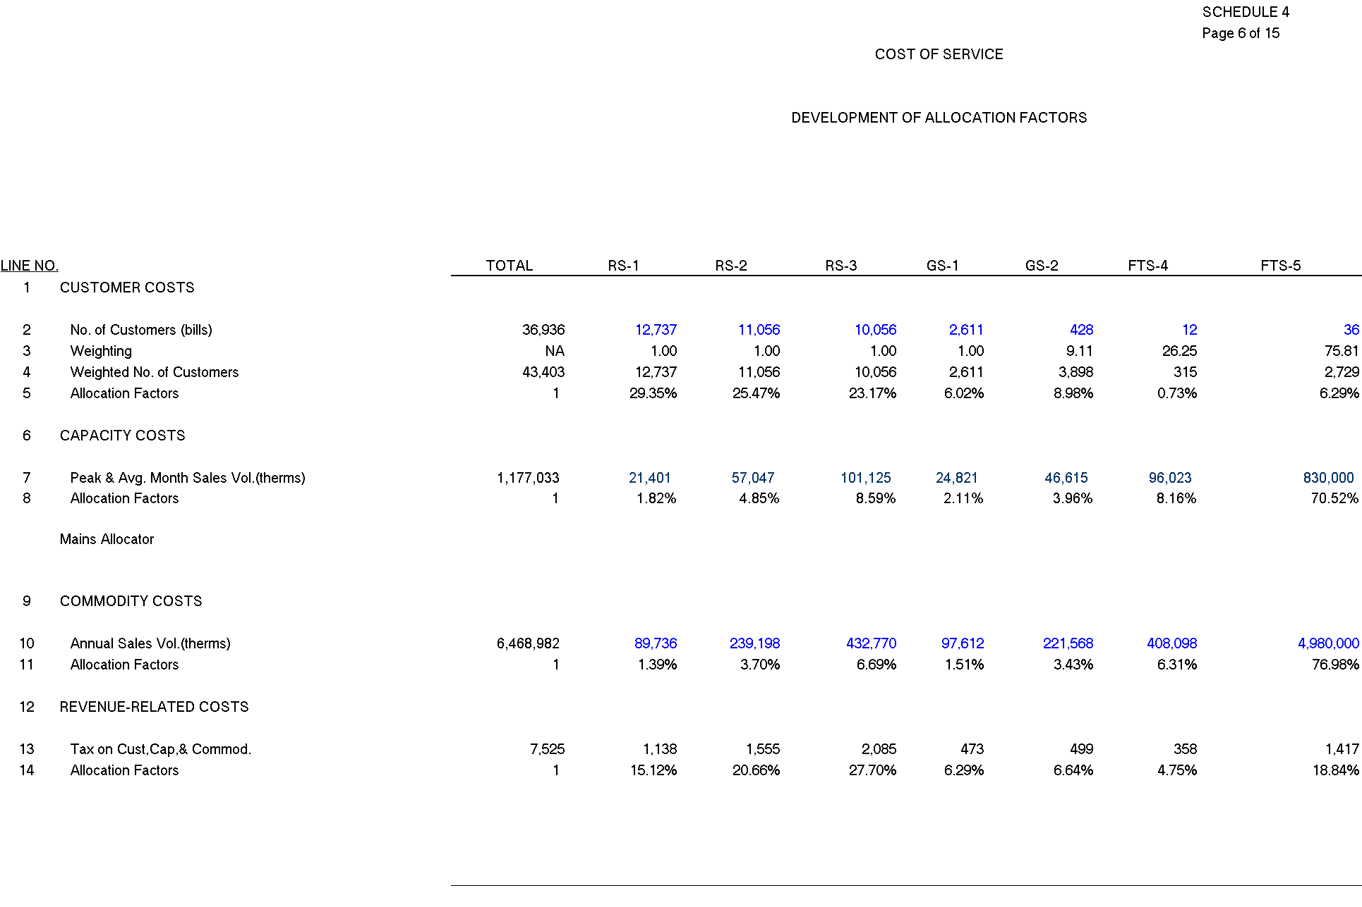
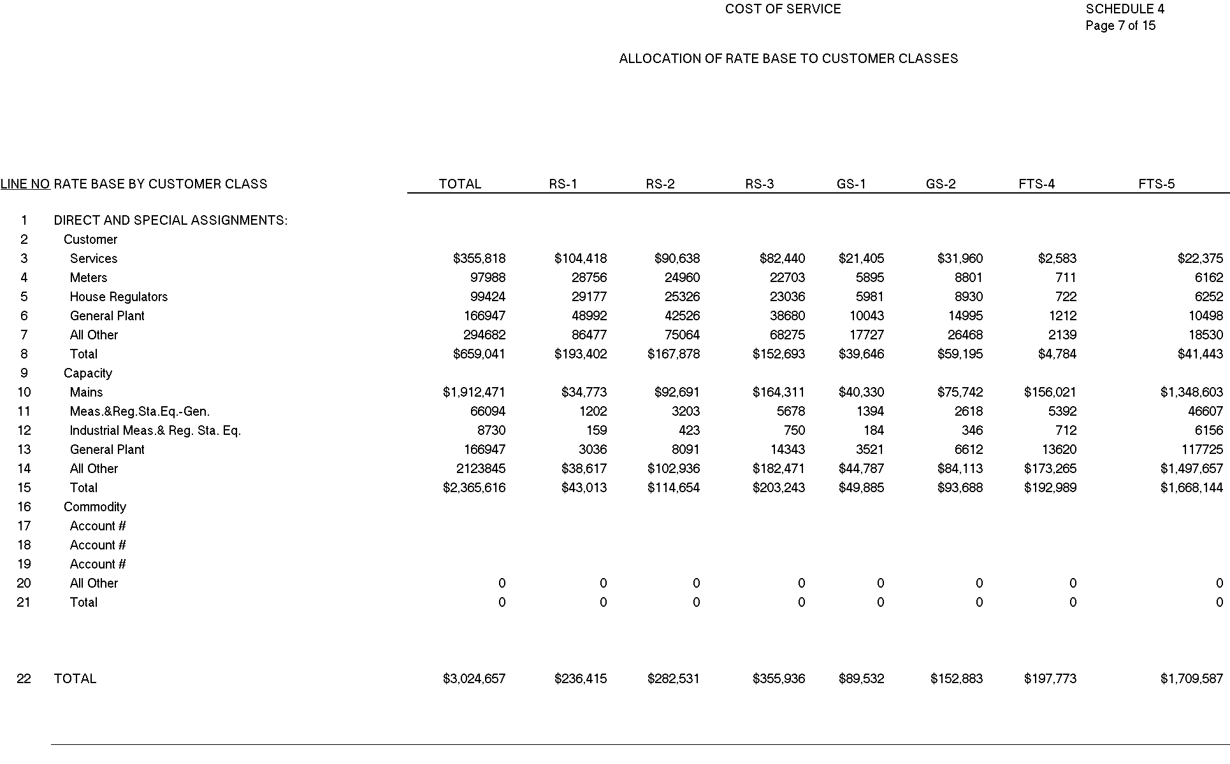

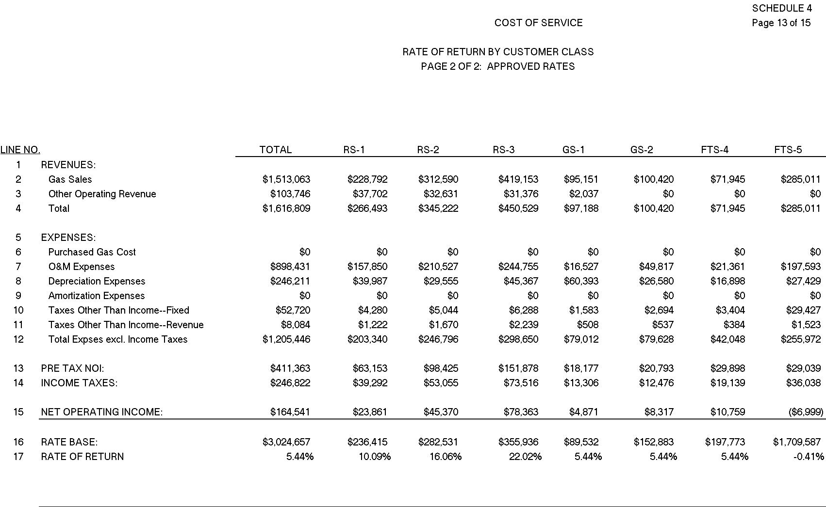

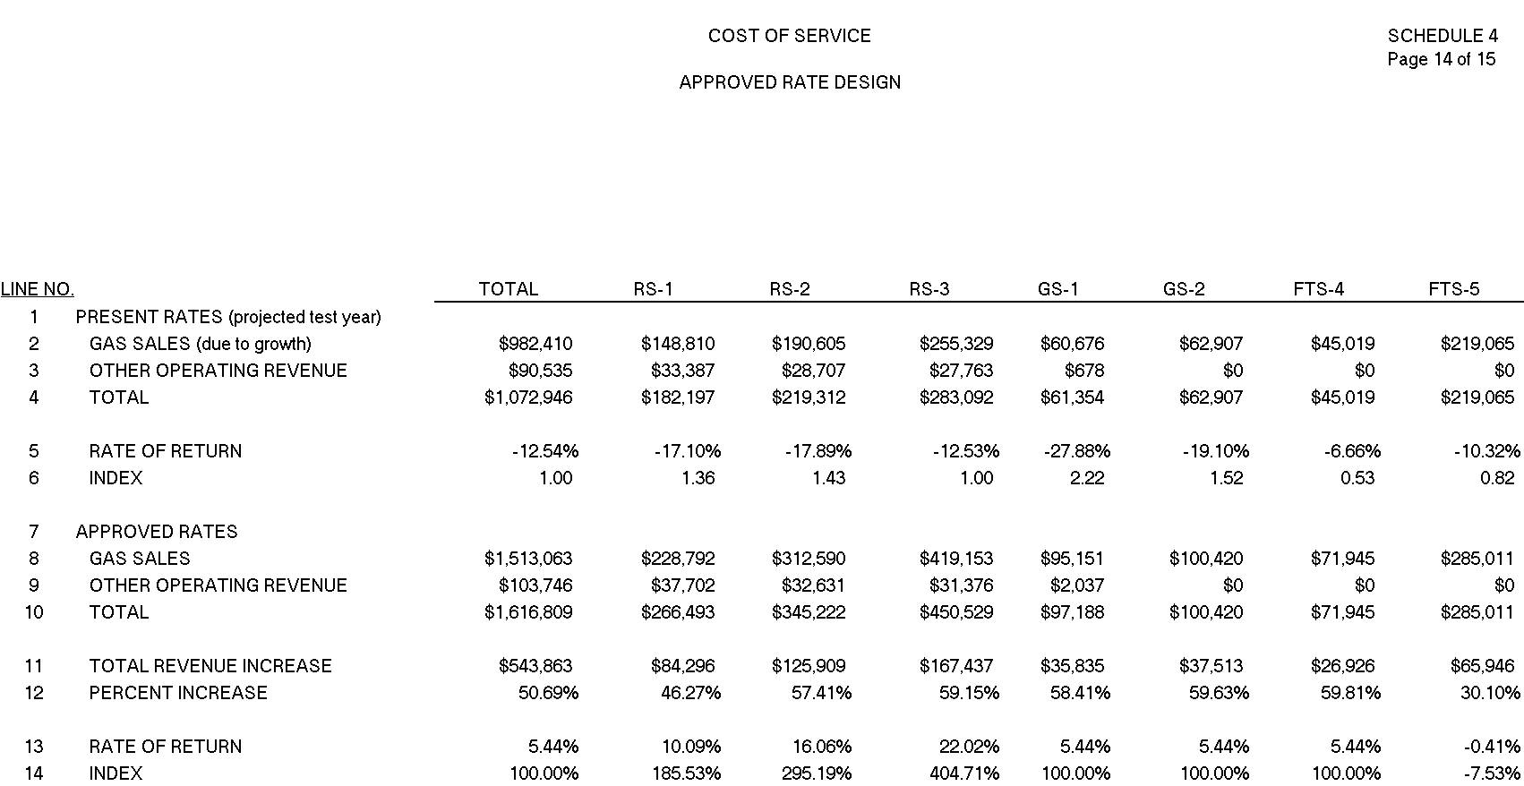
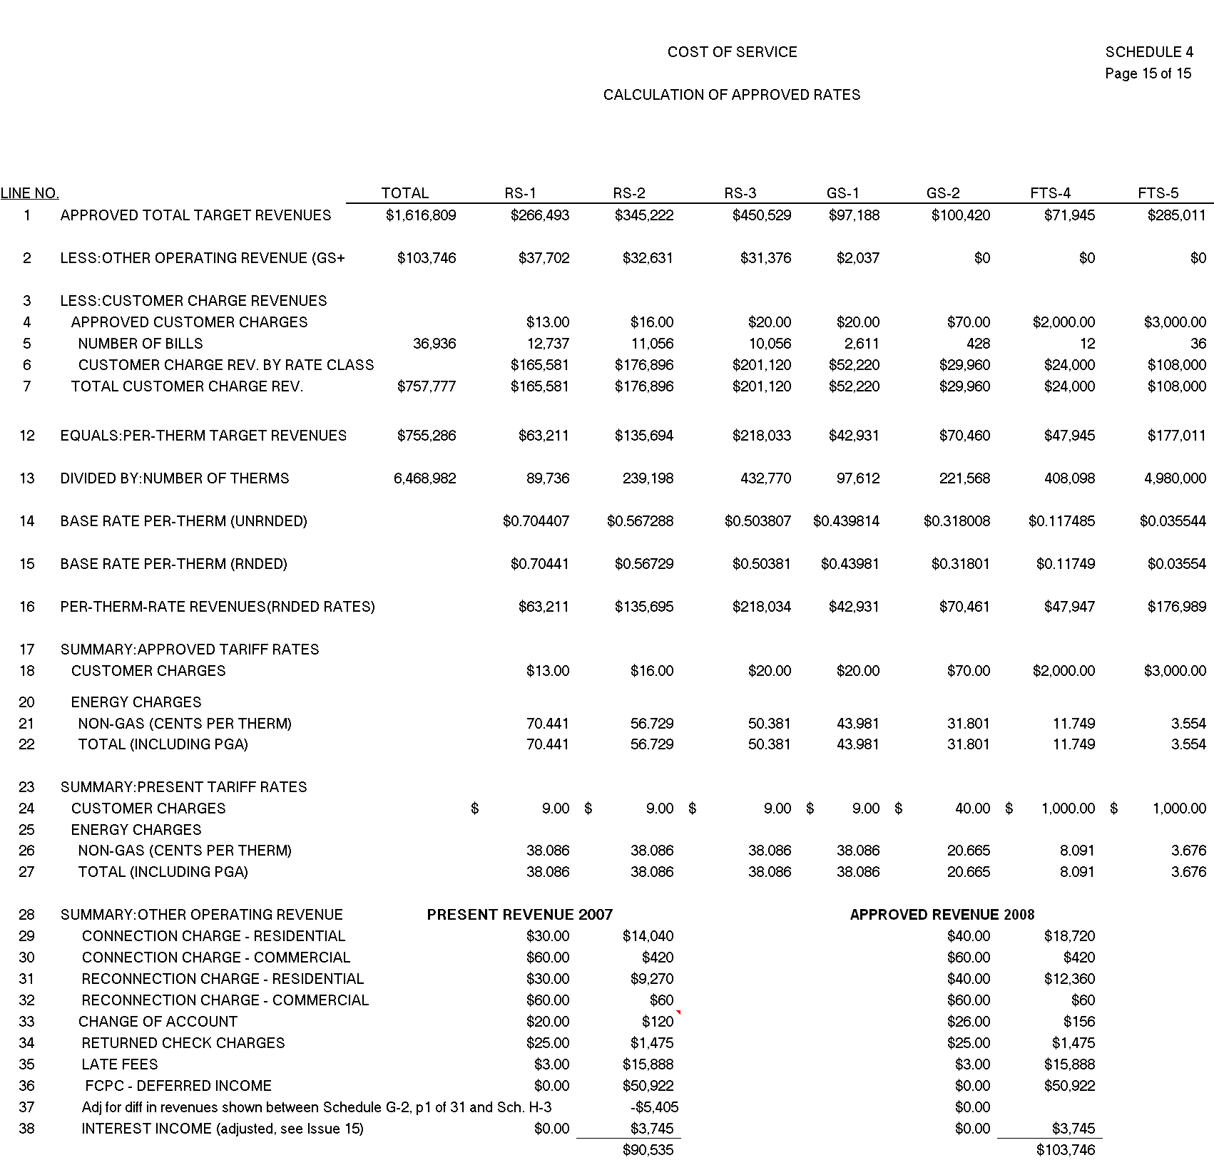

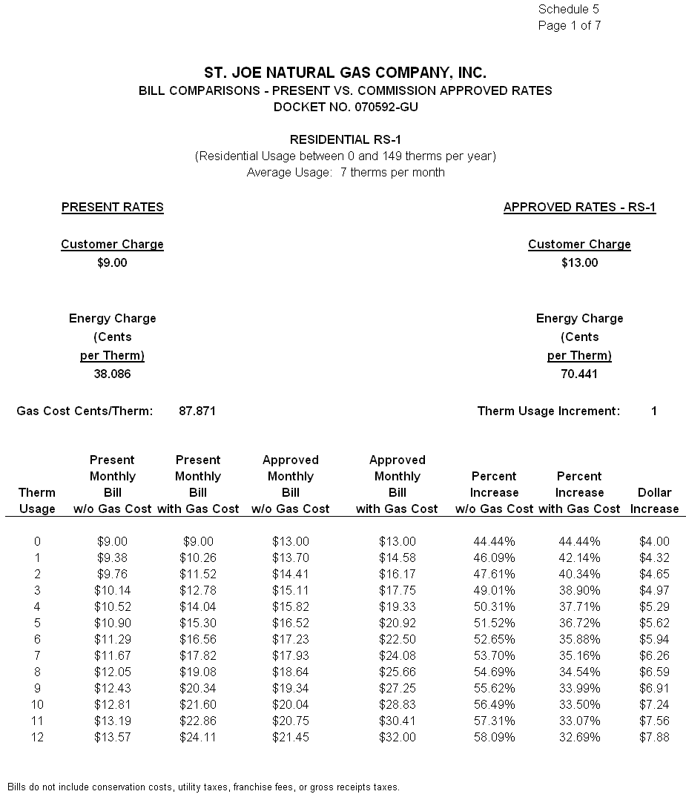
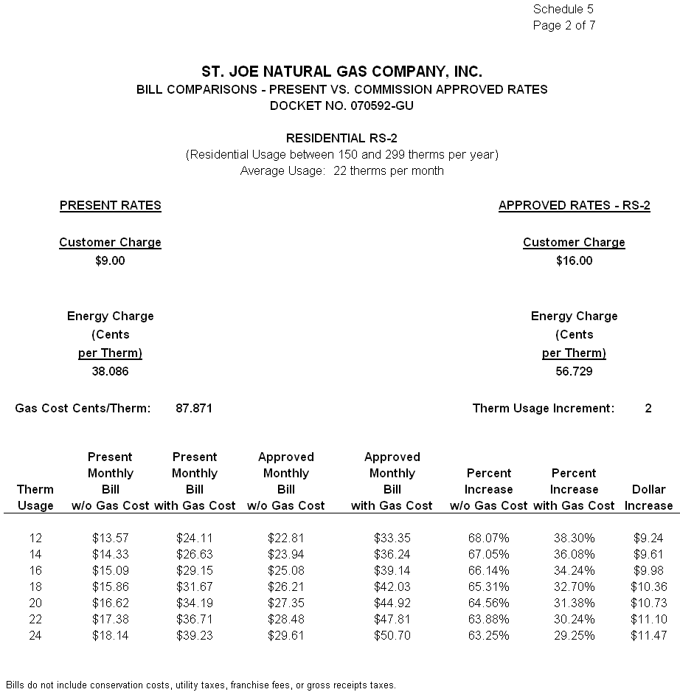
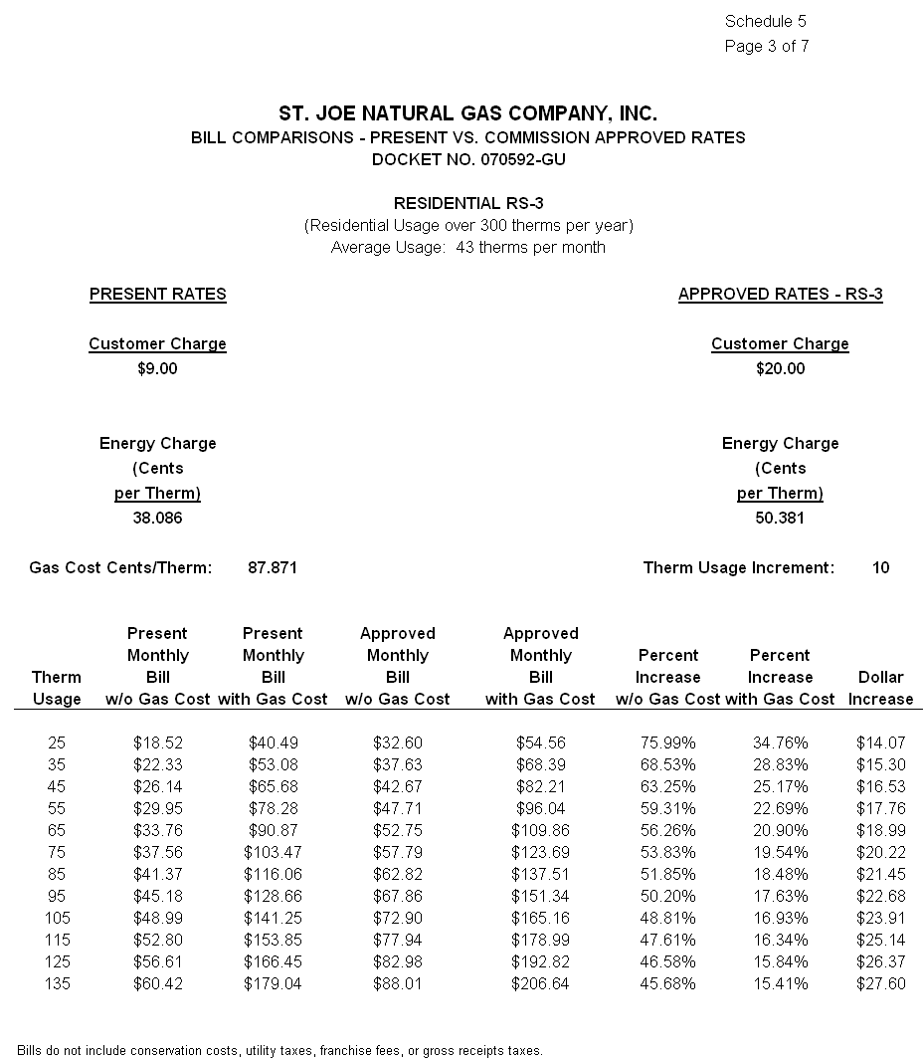

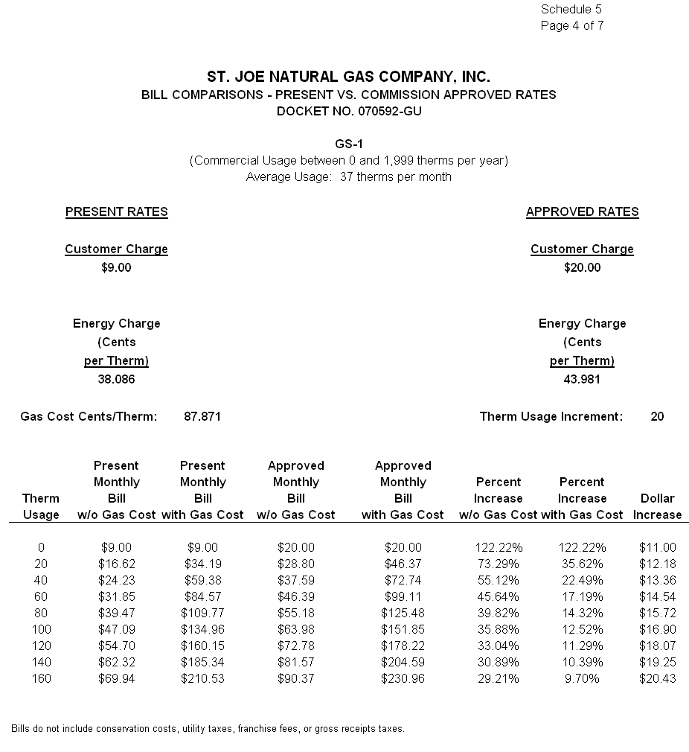
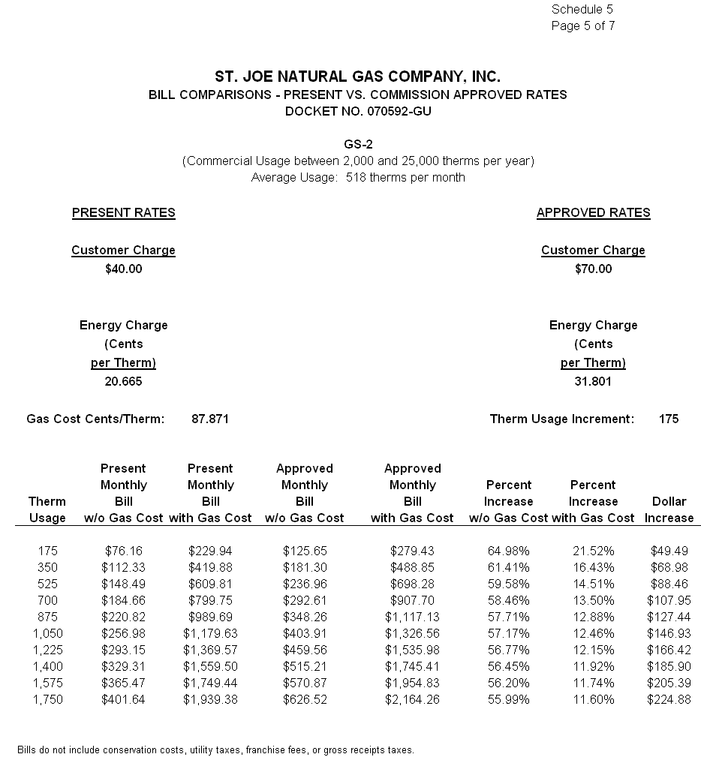
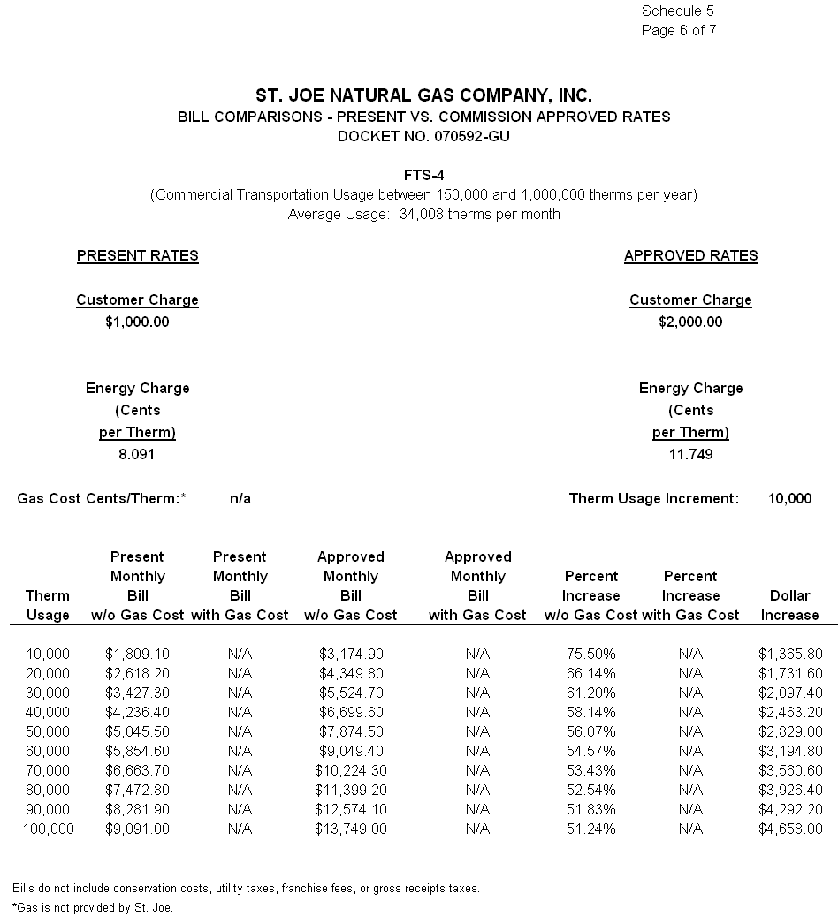

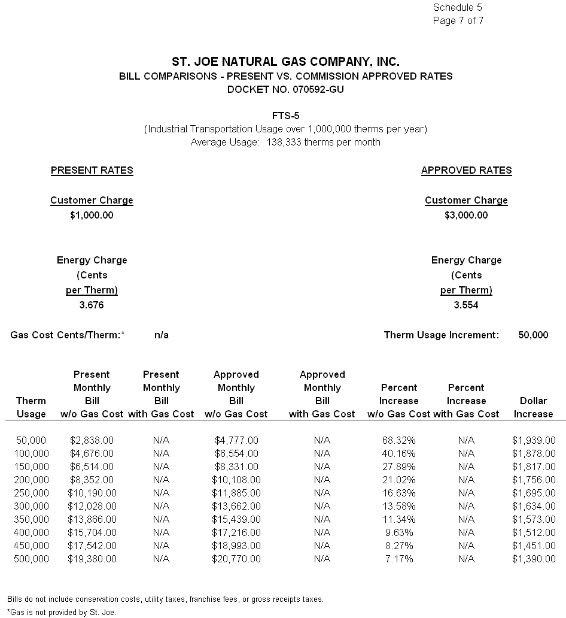

By Order No. PSC-01-1274-PAA-GU, issued June 8, 2001, in Docket No. 001447-GU, In re: Request for rate increase by St. Joe Natural Gas Company, Inc., we granted SJNG a $327,149 rate increase. We found the Company’s jurisdictional rate base to be $4,061,937 for the projected test year ended December 31, 2001. The allowed overall rate of return was 5.96 percent for the test year using an 11.50 percent return on equity.
Order No. PSC-08-0327-FOF-EI, issued May 19, 2008, in Docket No. 070300-EI, In re: Petition for rate increase by Florida Public Utilities Company.
Order No. PSC-01-1274-PAA-GU, issued June 8, 2001, in Docket No. 001447-GU, In re: Request for rate increase by St. Joe Natural Gas Company, Inc.
Order No. PSC-01-1274-PAA-GU, issued June 8, 2001, in Docket No. 001447-GU, In re: Request for rate increase by St. Joe Natural Gas Company, Inc.
Order No. PSC-04-0565-PAA-GU, issued June 2, 2004, in Docket No. 030954-GU, In re: Petition for rate increase by Indiantown Gas Company; and Order No. PSC-04-1260-PAA-GU, issued December 20, 2004, in Docket No. 040270-GU, In re: Application for rate increase by Sebring Gas System, Inc.
Order No. PSC-08-0327-FOF-EI, issued May 19, 2008, in Docket No. 070304-EI, In re: Petition for rate increase by Florida Public Utilities Company.
See Order No. PSC-01-1274-PAA-GU, at p. 27.
See Order No. PSC-04-0128-PAA-GU, issued February 9, 2004, in Docket No. 030569-GU, In re: Application for rate increase by City Gas Company of Florida.
Order No. PSC-05-0208-PAA-GU, issued February 22, 2005, in Docket No. 040956-GU, In re: Petition for authorization to establish new customer classifications and restructure rates, and for approval of proposed revised tariff sheets by Florida Division of Chesapeake Utilities Corporation.
Order No.PSC-08-0103-TRF-GU, issued February 18, 2008, in Docket No. 070688-GU, In Re: Petition for approval of tariff modifications relating to main and service extension amortization surcharge, by Peoples Gas System., p. 1-3.
Order No. PSC-07-0427-TRF-GU, issued May 15, 2007, in Docket No. 060675-GU, In Re: Petition for authority to implement phase two of experimental transitional transportation service pilot program and for approval of new tariff to reflect transportation service environment, by Florida Division of Chesapeake Utilities Corporation., p. 6-7.

