BEFORE THE FLORIDA PUBLIC SERVICE COMMISSION

In re: Investigation into the establishment of operations support systems permanent performance measures for incumbent local exchange telecommunications companies. (AT&T FLORIDA TRACK) | DOCKET NO. 000121A-TP  ORDER NO. PSC-08-0618-PAA-TP  ISSUED: September 23, 2008

The following Commissioners participated in the disposition of this matter:

MATTHEW M. CARTER II, Chairman
LISA POLAK EDGAR
KATRINA J. McMURRIAN
NANCY ARGENZIANO
NATHAN A. SKOP

NOTICE OF PROPOSED AGENCY ACTION
ORDER ACCEPTING STIPULATION

BY THE COMMISSION:

NOTICE is hereby given by the Florida Public Service Commission that the action discussed herein is preliminary in nature and will become final unless a person whose interests are substantially affected files a petition for a formal proceeding, pursuant to Rule 25-22.029, Florida Administrative Code.

I. Case Background
By Order No. PSC-01-1819-FOF-TP, issued September 10, 2001, in Docket No. 000121A-TP, this Commission adopted a Performance Assessment Plan for the purpose of monitoring performance levels of Operations Support Systems (OSS) provided to CLECs. The performance measurement plan provides a standard against which CLECs and the Commission can measure performance over time to detect and correct any degradation of service provided to CLECs. AT&T’s performance measurement plan also includes a Self-Effectuating Enforcement Mechanism (SEEM) remedy plan. The Order also recognizes our vested authority, per section 364.01(3), Florida Statutes, to provide regulatory oversight necessary to ensure effective competition in the telecommunications industry. This docket has remained open since that time to address issues and concerns arising from OSS performance.

Following the BellSouth and AT&T merger, AT&T began plans to consolidate the operations support systems (OSS) of the two companies. AT&T started the process of providing official notification to CLECs of its OSS consolidation plans (known as the 22-State OSS Release) over a year ago. The 22-State OSS Release plan involves a phased-in approach. The first phase commenced with the April 19, 2008 release (“April Release”).

On May 12, 2008, Cbeyond Communications, LLC (Cbeyond), Time Warner Telecom, LP (TWTC), and DeltaCom, Inc. (Deltacom), jointly referred to as the petitioners, filed a petition with the Commission requesting an audit of the April Release. The petition also requested a stay of CLEC-impacting OSS Releases and that we issue a Show Cause Order requiring AT&T to explain in detail the circumstances surrounding the April Release and explain why AT&T should not be penalized for its failure to appropriately implement the April Release.

On May 15, 2008, our staff held two informal workshops with AT&T, the petitioners, and other participating CLECs to discuss issues surrounding the current and future OSS releases. During the meetings, AT&T acknowledged that a variety of CLEC-impacting issues arose in connection with the April Release. Furthermore, AT&T made several commitments to address and resolve the issues and to prevent similar occurrences in future OSS releases. AT&T memorialized the list of commitments in a filing with this Commission on May 27, 2008.

On June 2, 2008, AT&T filed a response to the CLECs’ May 12, 2008 Complaint. In the response, AT&T attached the list of commitments to resolve the remaining issues associated with the April Release. Included in the list is the temporary suspension of future 22-State OSS releases, expanded customer support and communications, expanded testing for future OSS releases, and provision of proactive billing adjustments related to the April Release. AT&T stated that it has used, and continues to use, best efforts to resolve such issues, and it expects to resolve any known, remaining April Release issues by the end of June 2008. AT&T requested that we issue an order dismissing the CLECs’ petition.

On June 5, 2008, the petitioners filed a response requesting that we deny AT&T’s request to dismiss.

II. Jurisdiction

We are vested with jurisdiction over this matter pursuant to Sections 364.01(3) and (4)(g), Florida Statutes. Pursuant to Section 364.01(3), Florida Statutes, the Florida legislature has found that regulatory oversight is necessary for the development of fair and effective competition in the telecommunications industry. To that end, Section 364.01(4) (g), Florida Statutes, provides, in part, that this Commission shall exercise its exclusive jurisdiction in order to ensure that all providers of telecommunications service are treated fairly by preventing anticompetitive behavior. Furthermore, the FCC has encouraged the states to implement performance metrics and oversight for purposes of evaluating the status of competition under the Telecommunications Act of 1996.

III. Analysis

Stipulation

On April 19, 2008, AT&T implemented a software release titled Release 27.1 (April Release) in the nine state former BellSouth region as part of AT&T’s 22-State OSS consolidation plan. Since April 19, 2008 the petitioners and numerous other CLECs, have experienced a severe impact in their ability to interface with AT&T’s OSS. Specifically, the CLECs reported that they had not received order confirmations, requests for order clarifications, disconnection notices, rejection notices, and communications related to meetings at the customer premises for installations for a period of time following the release. CLEC orders submitted to AT&T during this timeframe were adversely affected by this release.

At a May 7, 2008, AT&T Change Control Process meeting between AT&T and participating CLECs, AT&T admitted that problems occurred with the April Release. At the meeting, AT&T provided a detailed chronology of events that occurred the first two weeks after the April release. AT&T acknowledged that outgoing transactions, clarifications and rejections were not being delivered to CLECs. AT&T also acknowledged that a backlog of orders in the manual processing center occurred due to outages and instability of the system used by the AT&T representatives in the company’s manual processing center. In subsequent Change Control Process meetings, AT&T identified additional issues associated with the release. Most notably over 200,000 billing completion notices and 12,000 completion notices had not been properly delivered to CLECs in the region.

On May 15, 2008, AT&T participated in two informal workshops with our staff to discuss issues surrounding the April Release and AT&T’s plans for future OSS Releases in the Southeast region. At the workshop, and in response to the petition, AT&T acknowledges that a variety of CLEC-impacting issues arose in connection with the April Release in the Southeast region and that such issues primarily impacted CLECs’ ability to timely receive outbound transmissions from AT&T in certain situations. AT&T asserts that it has used, and continues to use best efforts to resolve such issues, and expected to resolve any known, remaining April Release issues in June. AT&T also asserted that it would continue to communicate the status of such issues to all CLECs in a timely and informative manner.

At the workshops, AT&T estimated that 71,000 orders in the nine state region were negatively affected by the April Release. Of these orders, AT&T stated that 59,000 were electronic orders, and 11,000 were backlogged manual orders. The CLEC petitioners describe this April Release as the most significant competitively damaging OSS failure in the State of Florida since enactment of the Telecommunication Act of 1996.

In a June 30, 2008 response to a staff data request, AT&T reported that there have been 229 identified software defects open from the April Release, 125 of which have had a direct impact on CLECs. Below is a chart detailing the severity of the April Release defects.
April Release Defect Status As of June 30, 2008
 | 1-Critical | 2-Major | 3-Average | Total
CLEC Impacting Defects | 58 | 41 | 26 | 125
Non-CLEC Impacting Defects | 31 | 53 | 20 | 104
Total CLEC/Non-CLEC Impacting Defects | 89 | 94 | 46 | 229

In response to the May 15, 2008 workshop, AT&T provided a list of commitments to resolve the open issues associated with the April Release. At our staff’s request, AT&T memorialized the commitments made during the May 15th meeting. AT&T states that the disruption to the normal processing of CLEC ordering was the result of a series of unexpected events including hardware, software, and network issues. AT&T contends that there was no total breakdown of AT&T’s OSS. AT&T intends to address and resolve the April Release issues and implement process improvements that should reduce the likelihood of issues of this magnitude arising in connection with future 22-State OSS Releases in the Southeast. AT&T also committed to keeping the our staff and interested CLECs informed of its efforts.

In the current petition, the CLECs requested an independent audit be conducted that focuses on the cause of the OSS failures. In its June 2, 2008 Response, AT&T denies that an independent audit of the April Release is necessary. AT&T states that it has provided, and will continue to provide, information and explanations regarding the April Release, and has fully supported CLEC requests for status, escalation, and assistance. AT&T also states that it will continue to respond to CLEC inquiries through individual customer support and weekly conference calls opened to all CLECs. AT&T asserts that its internal review and expanded test plan will include any necessary root cause analysis of the April Release issues.

A conference call was held between our staff and the parties on July 31, 2008 exploring the possibility that the audit be conducted by Commission staff. After further discussions, on August 5, 2008, the parties agreed to the audit being conducted by our staff and entered into the attached stipulation (Attachment 1). The scope of the audit would be to:

- Document and assess AT&T’s root cause analysis of the April Release.
- Document and assess AT&T’s defect resolution associated with the April Release.
- Document and assess pre-release and post-release communications.
The stipulation also states the petitioners will file a Motion to Dismiss the request for an independent audit and request that we hold the remaining portions of the complaint in abeyance pending a vote on our staff’s recommendation addressing the final audit report. Following the filing of this Motion, AT&T agrees to refrain from implementing future 22-State OSS releases until the earlier of our vote on the final audit report and our staff’s recommendation or a mutually agreeable timeframe.

IV. Decision

Upon review of the parties’ stipulation, we accept the stipulation regarding the audit of AT&T Florida’s April OSS Release as set forth in Attachment 1. This Order will become final upon issuance of a Consummating Order if no person whose substantial interests are affected timely files a protest within 21 days of the issuance of this Order. This docket shall remain open pending the conclusion of the audit and for purpose of future performance measure monitoring.

Based on the foregoing, it is

ORDERED by the Florida Public Service Commission that the stipulation between Cbeyond Communications, LLC, Time Warner Telecom, LP, DeltaCom, Inc. and BellSouth Telecommunications, Inc. d/b/a AT&T Florida regarding the audit of AT&T Florida’s April OSS Release as set forth in Attachment 1 is hereby accepted. It is further

ORDERED that the provisions of this Order, issued as proposed agency action, shall become final and effective upon the issuance of a Consummating Order unless an appropriate petition, in the form provided by Rule 28-106.201, Florida Administrative Code, is received by the Office of Commission Clerk, 2540 Shumard Oak Boulevard, Tallahassee, Florida 32399-0850, by the close of business on the date set forth in the "Notice of Further Proceedings" attached hereto.
By ORDER of the Florida Public Service Commission this 23rd day of September, 2008.

/s/ Ann Cole
ANN COLE
Commission Clerk

This is an electronic transmission. A copy of the original signature is available from the Commission's website, www.floridapsc.com, or by faxing a request to the Office of Commission Clerk at 1-850-413-7118.

( S E A L )

AJT

NOTICE OF FURTHER PROCEEDINGS OR JUDICIAL REVIEW

The Florida Public Service Commission is required by Section 120.569(1), Florida Statutes, to notify parties of any administrative hearing that is available under Section 120.57, Florida Statutes, as well as the procedures and time limits that apply. This notice should not be construed to mean all requests for an administrative hearing will be granted or result in the relief sought.

Mediation may be available on a case-by-case basis. If mediation is conducted, it does not affect a substantially interested person's right to a hearing.

The action proposed herein is preliminary in nature. Any person whose substantial interests are affected by the action proposed by this order may file a petition for a formal proceeding, in the form provided by Rule 28-106.201, Florida Administrative Code. This petition must be received by the Office of Commission Clerk, 2540 Shumard Oak Boulevard, Tallahassee, Florida 32399-0850, by the close of business on October 14, 2008.

In the absence of such a petition, this order shall become final and effective upon the issuance of a Consummating Order.

Any objection or protest filed in this/these docket(s) before the issuance date of this order is considered abandoned unless it satisfies the foregoing conditions and is renewed within the specified protest period.

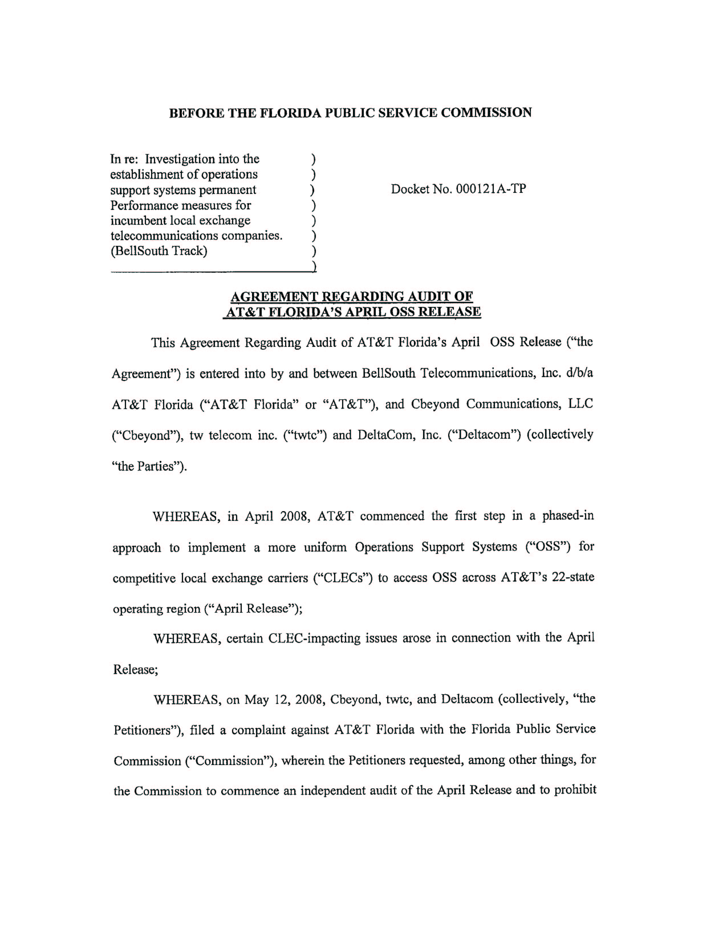
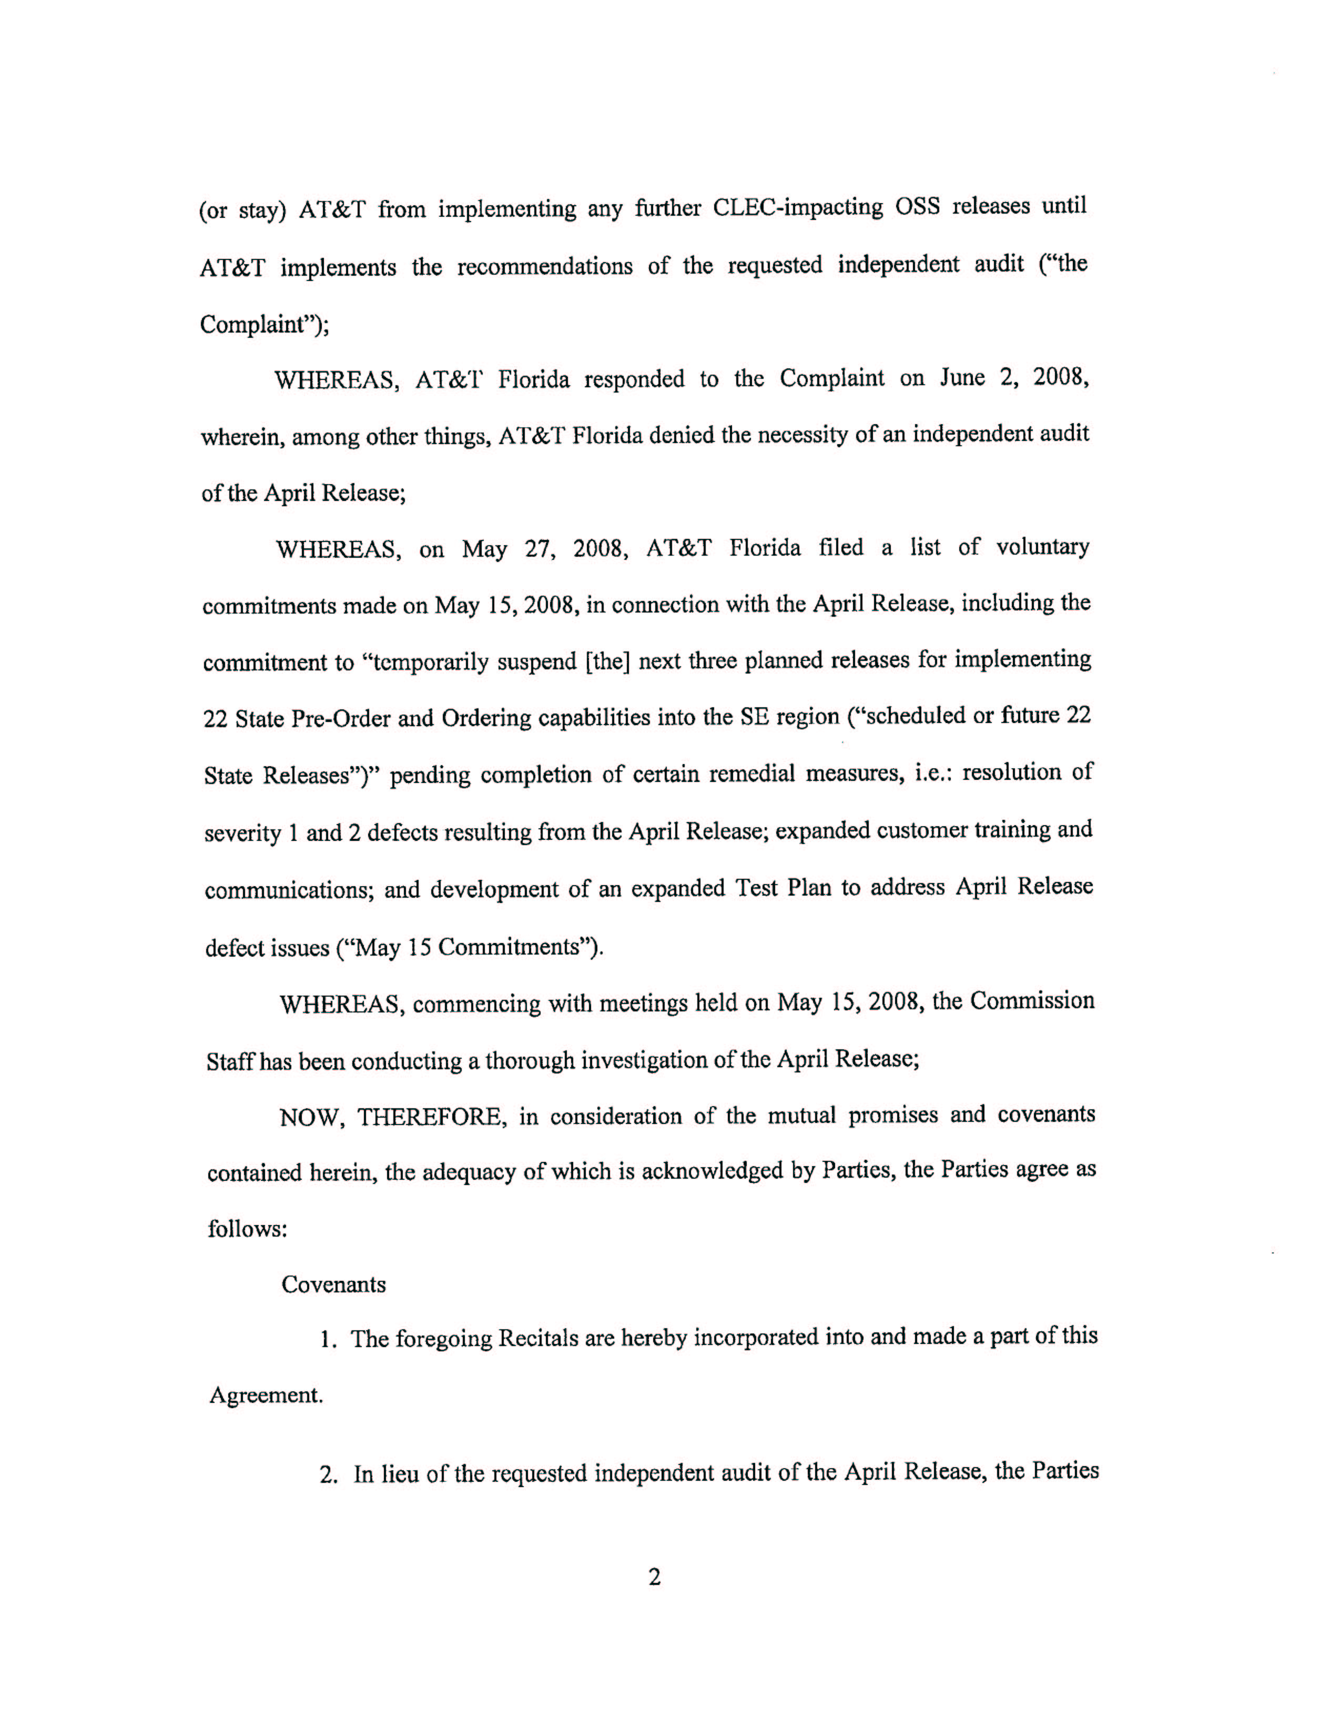
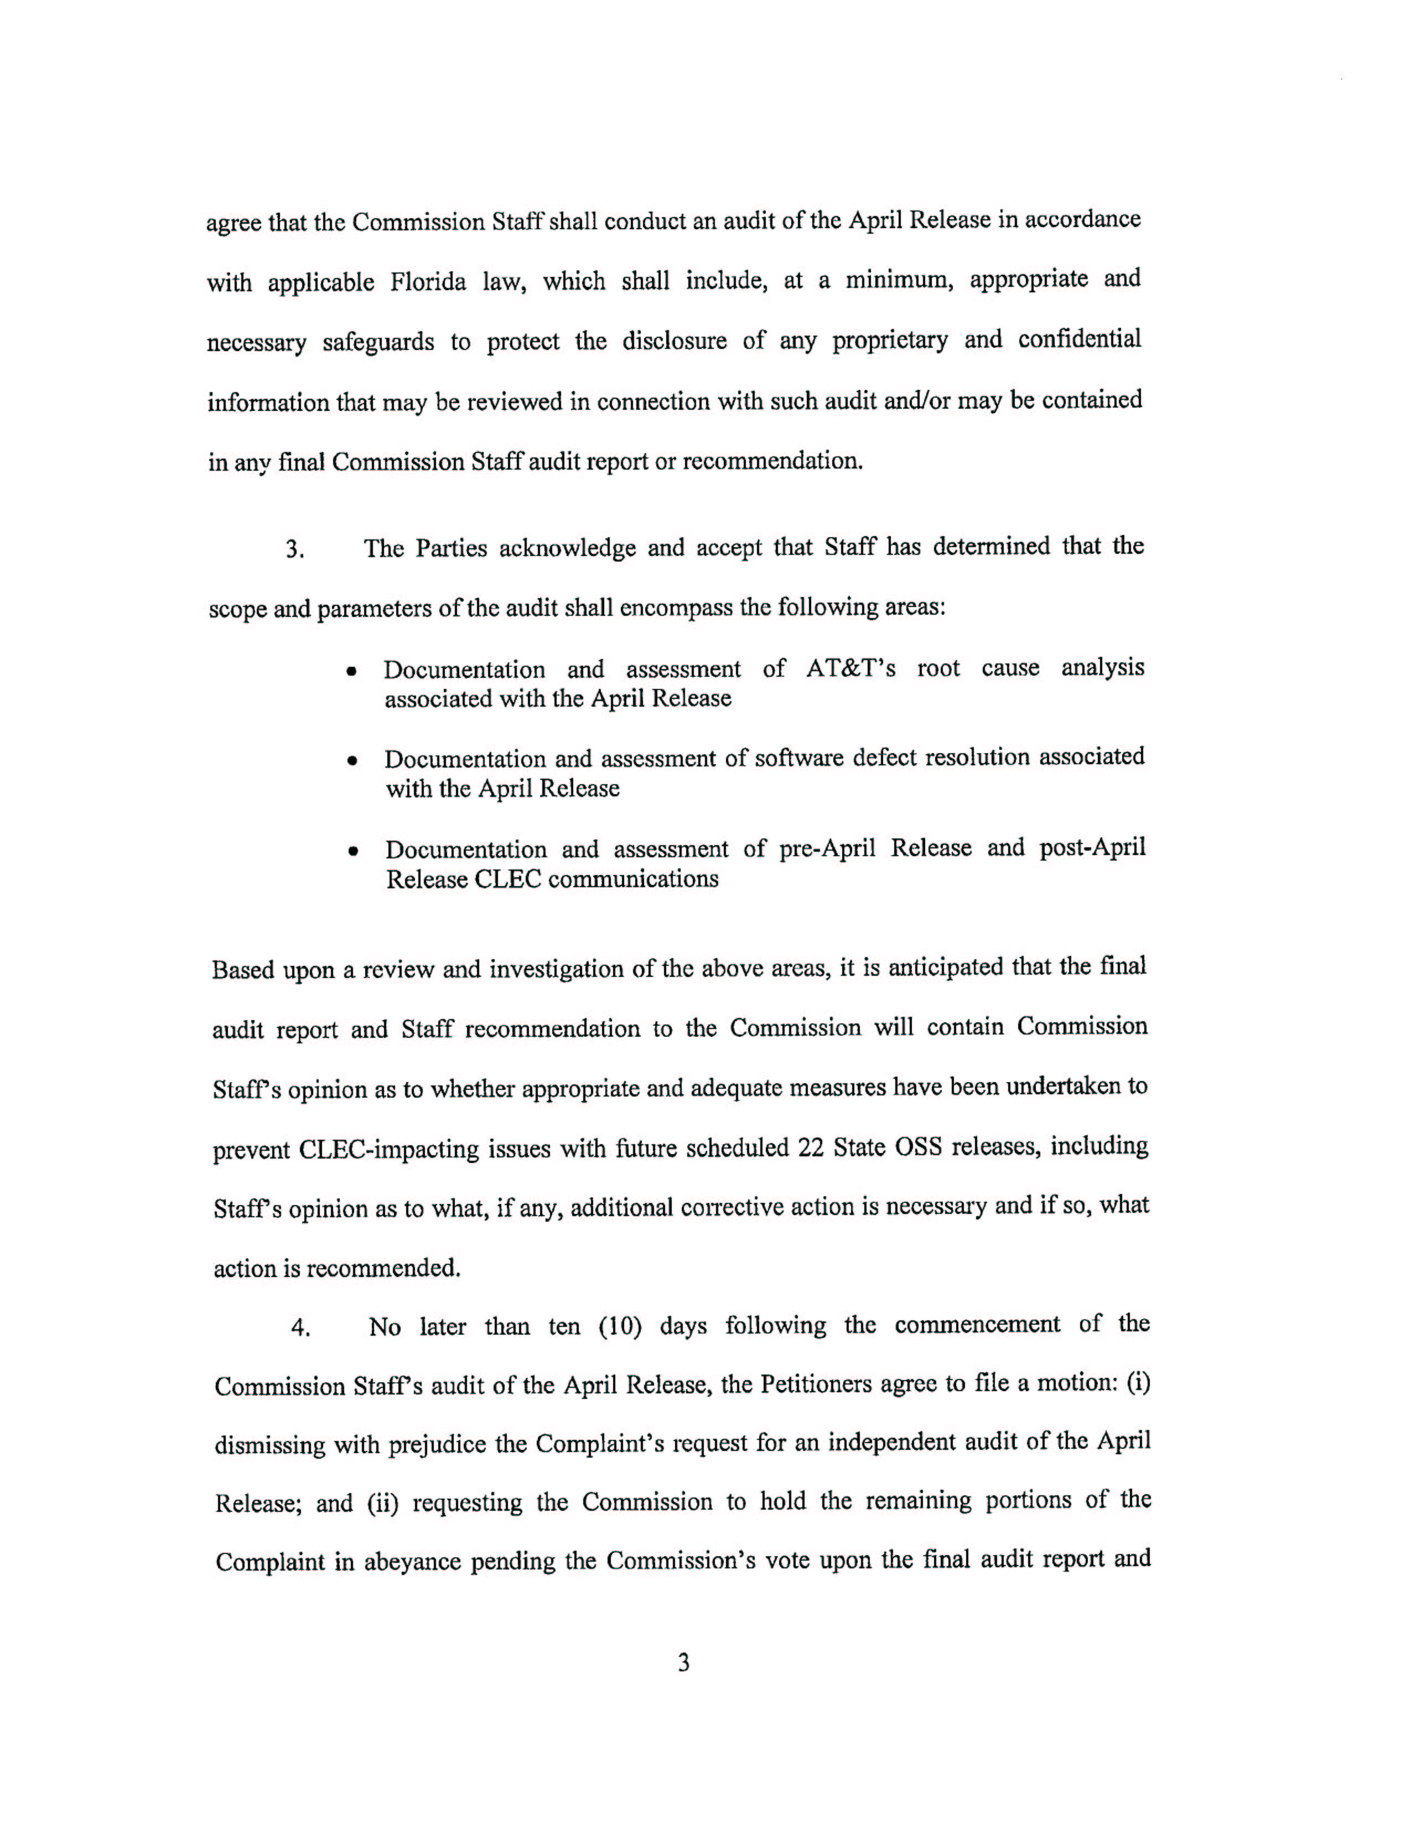
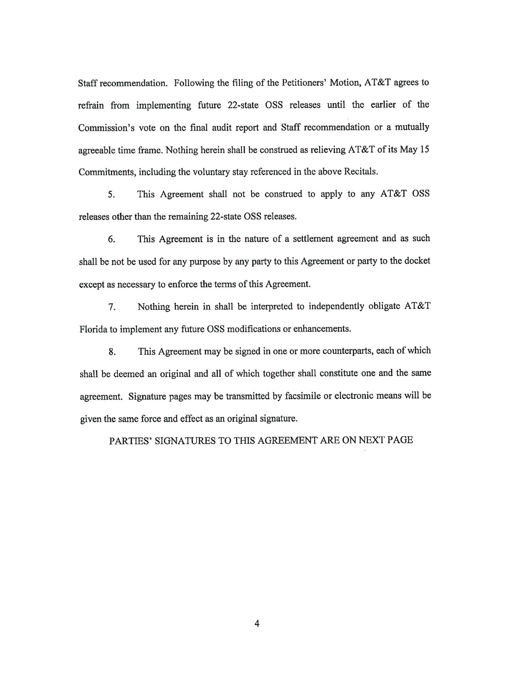
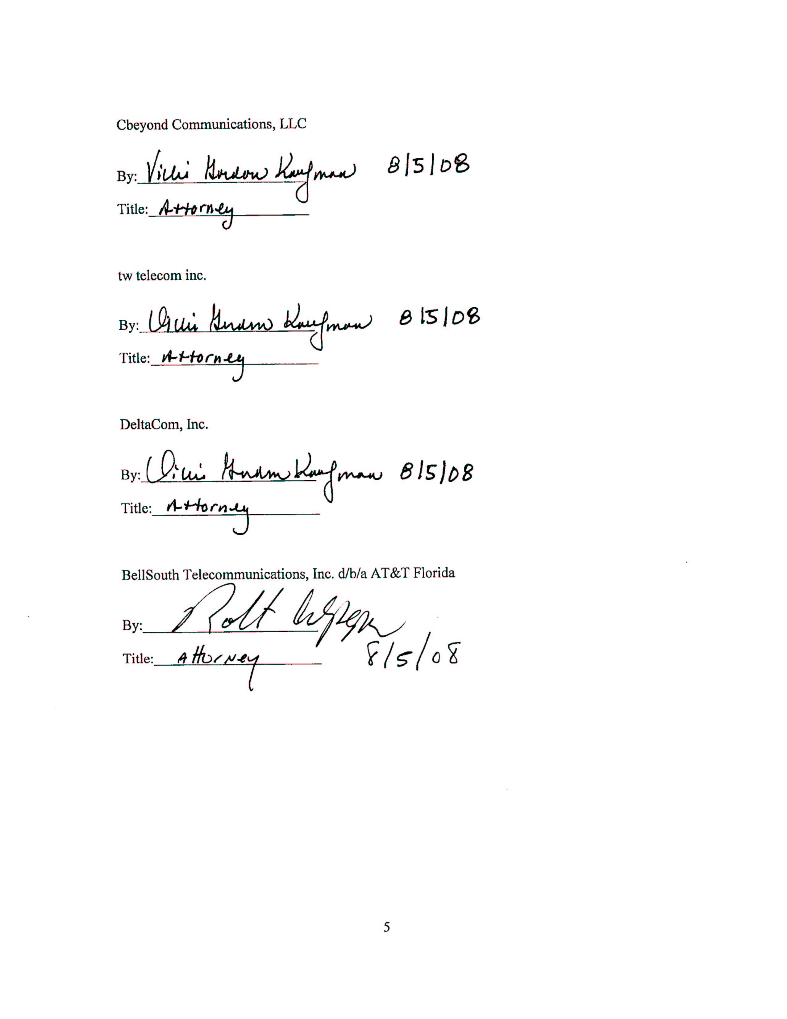

AT&T did not file a Motion to Dismiss but rather a response to the CLECs’ petition requesting an order dismissing the petition.
Weekly conference calls began May 12, 2008 and ended July 15, 2008.
The remaining portions of the complaint include delaying future 22-State OSS releases and requesting a show cause proceeding of why AT&T should not be penalized for its failure to appropriately implement the April Release.
To the extent the parties disagree with staff’s audit recommendations or further guidance is needed, a vote from the Commission may be necessary.

