BEFORE THE FLORIDA PUBLIC SERVICE COMMISSION

In re: Petition for approval to modify renewable energy program by Tampa Electric Company. | DOCKET NO. 080367-EG  ORDER NO. PSC-08-0647-TRF-EG  ISSUED: October 6, 2008

The following Commissioners participated in the disposition of this matter:

MATTHEW M. CARTER II, Chairman
LISA POLAK EDGAR
KATRINA J. McMURRIAN
NANCY ARGENZIANO
NATHAN A. SKOP

ORDER APPROVING MODIFICATION TO TAMPA ELECTRIC COMPANY’S
RENEWABLE ENERGY PROGRAM

BY THE COMMISSION:

Background
Tampa Electric Company’s (TECO or Company) renewable energy program gained our approval for permanent status in December 2006. TECO’s renewable energy program is a voluntary program which allows its customers the option to purchase an unlimited amount of renewable energy consisting of 200 kilowatt-hour (kWh) blocks for $5.00 per block. Pursuant to Order No. PSC-06-1063-TRF-EG, revenues and expenses of the renewable energy program are recorded in accounts associated with TECO’s Energy Conservation Cost Recovery (ECCR) clause. Any excess revenues are placed in Account 253, Other Deferred Credits, an account established as a revenue tracking account. TECO states that during 2007, revenues were approximately $18,000 short of making the program self-sustaining. The Company notes, however, that by June 2008, revenues were able to make the program self-sustaining and TECO’s Renewable Energy Plan began to experience a positive balance in Account 253. As of June 2008, the account had a positive balance of $22,000, and TECO estimates that by year end, the balance is projected to be approximately $93,000.
Under the current program, customers are required to participate in the program for a minimum term of one year. TECO does not outsource its renewable energy program. All renewable energy for TECO’s program is produced in its local area or within the State of Florida. The renewable energy sources consist of photovoltaic arrays, biomass fuel, and landfill gas.
On June 23, 2008, TECO filed a petition to modify its Renewable Energy Program. TECO requests our approval to eliminate the one year term of service required under the current program.
We have jurisdiction under Section 366.04, 366.05. 366.06, 366.80, 366.81 and 366.82, Florida Statutes.
Decision

TECO’s permanent Renewable Energy Program became effective in January 2007. All of the Company’s renewable energy for its program is produced locally or within Florida and is derived from photovoltaic arrays, biomass fuel, or landfill gas. TECO currently requires participation in its Renewable Energy Program for a period of one year. After the initial twelve months, the customer can terminate participation after giving a two months’ termination notice. TECO’s customers are allowed to purchase increments of 200 kWh blocks of renewable generation for $5.00 per block per month. The program is available to residential, commercial, and industrial customers. As of May 2008, 3,143 customers were currently participating in the program. In addition, a total of 4,169 blocks of renewable energy have been purchased. Revenues from January 2007 through June 2008 are $260,593 and expenses are $176,720.
TECO proposes to modify its Renewable Energy Program to remove the twelve month participation requirement. The Company believes doing so will result in additional participation from residential and commercial customers who wish to not be tied to the mandatory one year participation requirement. In support of its request to modify the program, TECO states that it has received several inquiries from residential and commercial customers regarding the possibility of making one time purchases of renewable energy on a periodic basis rather than the one year minimum term of service. Those commercial customers include convention centers, hotels with large scale conference facilities, and sporting event venues that regularly host clients that want to promote the use of renewable energy during their events.
Upon consideration, we approve TECO’s petition to modify its Renewable Energy Program. The proposed tariff shall state that participation in the program is based on a first-come, first-serve basis for a minimum term of one billing period and subject to availability of renewable energy. We find that removing the one year participation requirement will allow residential customers who might not be able to participate in the program on an annual basis, to be able to make a one-time purchase of a 200 kWh block of renewable energy for $5.00 per block when feasible. In addition, customers shall not be required to give a two-months’ termination notice regarding participation in the program. Also, organizations conducting conventions, meetings, and other events shall be able to make one-time purchases of renewable energy for their events as well. We find that removing the one year participation requirement could also allow for increased participation in the program and increased production of renewable energy in the state of Florida.
All other conditions and provisions approved by Order No. PSC-06-1063-TRF-EG shall remain in place. TECO shall continue to provide reports on the program’s progress every six months, which shall include the participation levels achieved, energy produced, and cost and revenue estimates. Excess revenues shall continue to be placed in Account 253, Other Deferred Credits. In addition, revenues and expenses for the Renewable Energy Program shall continue to be recorded separately in TECO’s ECCR clause. Moreover, TECO shall continue to provide a summary of the program’s progress in its testimony, which is submitted during the true-up proceedings in the ECCR docket. TECO shall continue to use excess revenues from the program toward investigating the potential of new renewable resources, efforts to increase program participation, reduction of monthly fees to participants, program administration, marketing, and continued education of customers on the attributes of renewable energy.
The customer’s costs and guidelines of the modified Renewable Energy program shall be established by tariff titled the Renewable Energy Program Fourth Revised Tariff Sheet No. 6400. This tariff sheet is attached to this Order as Attachment A.
This tariff shall become effective on October 30, 2008. If a protest is filed within 21 days of the issuance of the order, this tariff shall remain in effect with any increase held subject to refund pending resolution of the protest. If no timely protest is filed, this docket shall be closed upon the issuance of a consummating order.
Based on the foregoing, it is

ORDERED by the Florida Public Service Commission that Tampa Electric Company’s petition to modify its Renewable Energy Program by eliminating the mandatory one year term of participation is hereby approved as set forth herein. It is further

ORDERED that Order No. PSC-06-1063-TRF-EG is affirmed in all other respects. It is further

ORDERED that the tariff titled Renewable Energy Program Fourth Revised Tariff Sheet No. 6400, and attached to this order as Attachment A, is hereby approved effective October 30, 2008. It is further

ORDERED that if a protest is filed within 21 days of the issuance of the Order, the tariff shall remain in effect with any charges held subject to refund pending the resolution of the protest. It is further

ORDERED that if no timely protest is filed, this docket shall be closed upon the issuance of a Consummating Order.

ORDERED that all attachments attached hereto are incorporated herein by reference. It is further

By ORDER of the Florida Public Service Commission this 6th day of October, 2008.

ANN COLE
Commission Clerk

By: | /s/ Hong Wang
Hong Wang
Office of Commission Clerk

This is an electronic transmission. A copy of the original signature is available from the Commission's website, www.floridapsc.com, or by faxing a request to the Office of Commission Clerk at 1-850-413-7118.

( S E A L )

JEH

NOTICE OF FURTHER PROCEEDINGS

The Florida Public Service Commission is required by Section 120.569(1), Florida Statutes, to notify parties of any administrative hearing or judicial review of Commission orders that is available under Sections 120.57 or 120.68, Florida Statutes, as well as the procedures and time limits that apply. This notice should not be construed to mean all requests for an administrative hearing or judicial review will be granted or result in the relief sought.

Mediation may be available on a case-by-case basis. If mediation is conducted, it does not affect a substantially interested person's right to a hearing.

The Commission's decision on this tariff is interim in nature and will become final, unless a person whose substantial interests are affected by the proposed action files a petition for a formal proceeding, in the form provided by Rule 28-106.201, Florida Administrative Code. This petition must be received by the Office of Commission Clerk, 2540 Shumard Oak Boulevard, Tallahassee, Florida 32399-0850, by the close of business on October 27, 2008.

In the absence of such a petition, this Order shall become final and effective upon the issuance of a Consummating Order.

Any objection or protest filed in this docket before the issuance date of this order is considered abandoned unless it satisfies the foregoing conditions and is renewed within the specified protest period.

ATTACHMENT A
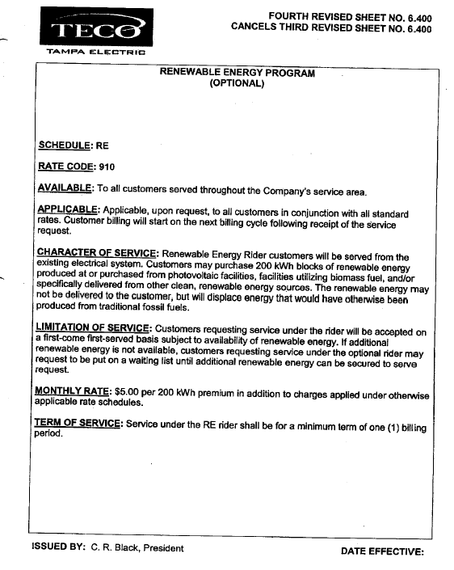

Order No. PSC-06-1063-TRF-EG, issued December 26, 2006, in Docket No. 060678-EG, In Re: Petition for approval to make renewable energy pilot program (f/k/a green energy rate rider) permanent, by Tampa Electric Company.

