BEFORE THE FLORIDA PUBLIC SERVICE COMMISSION

In re: Petition for rate increase by Peoples Gas System. | DOCKET NO. 080318-GU  ORDER NO. PSC-08-0696-PCO-GU  ISSUED: October 20, 2008

The following Commissioners participated in the disposition of this matter:

MATTHEW M. CARTER II, Chairman
LISA POLAK EDGAR
KATRINA J. McMURRIAN
NANCY ARGENZIANO
NATHAN A. SKOP

ORDER SUSPENDING PROPOSED PERMANENT RATE INCREASE
AND APPROVING INTERIM RATE INCREASE

BY THE COMMISSION:

BACKGROUND
This proceeding commenced on August 11, 2008, with the filing of a petition for a permanent rate increase by Peoples Gas System (Peoples or Company). Peoples requested an increase in its retail rates and charges to generate $26,488,091 in additional gross annual revenues. This increase would allow the Company to earn an overall rate of return of 8.88 percent or an 11.50 percent return on equity (range 10.50 percent to 12.50 percent). The Company based its request on a projected test year ending December 31, 2009. Peoples stated that this test year is the appropriate period to be utilized because it represents the conditions to be faced by the Company, and is representative of the customer base, investment requirements, throughput levels, and overall cost of service to be realized for the period when the new rates will be in effect.

Peoples has also requested an interim rate increase in its retail rates and charges to generate $3,748,000 in additional gross annual revenues. This increase would allow the Company to earn an overall rate of return of 8.31 percent or a 10.25 percent return on equity which is the minimum of the currently authorized range of 10.25 percent to 12.25 percent. The Company based its interim request on a historical test year ended April 30, 2008.

We last granted Peoples a $12,050,000 rate increase by Order No. PSC-03-0038-FOF-GU. In that order, we found the Company’s jurisdictional rate base to be $505,441,206 for the projected test year ended December 31, 2003. The allowed rate of return was found to be 8.83 percent for the test year using an 11.25 percent return on equity.

Pursuant to Section 366.06(4), Florida Statutes (F.S.), Peoples requested to proceed under the rules governing changes in rates and charges. Under Section 366.06(4), F.S., we must enter our vote within eight months of the date on which a complete set of minimum filing requirements (MFRs) were filed with the Commission. The eight-month effective date would be April 11, 2009. However, Peoples has agreed to an extension of the effective date up to and including May 19, 2009. We have jurisdiction over this request for a rate increase and interim rate increase under Sections 366.06(2) and 366.071, F.S.

DECISION

Suspension of Permanent Base Rate Increase

Peoples filed its petition, testimony, and MFRs on August 11, 2008. The Company has requested a total permanent base rate increase of $26,488,091 based on a projected test year ending December 31, 2009.

Historically, especially when a projected test year has been involved, we have suspended the requested permanent rate schedules in order to adequately and thoroughly examine the basis for the new rates. The suspension of the rate increase is authorized by Section 366.06(3), F.S., which provides:

Pending a final order by the commission in any rate proceeding under this section, the commission may withhold consent to the operation of all or any portion of the new rate schedules, delivering to the utility requesting such increase, within 60 days, a reason or written statement of good cause for withholding its consent.

Therefore, we suspend the requested permanent rate schedules to allow staff and any intervenors sufficient time to adequately investigate whether the request for permanent rate relief is appropriate.

Interim Test Year Rate Base

In its filing, the Company proposed an interim test year 13-month average rate base of $515,212,000 for the period ended April 30, 2008.

The MFR Schedule F-3 rate base adjustments made in the current filing have been reviewed for consistency with the findings made in the Company’s last rate case Order No. PSC-03-0038-FOF-GU. Based on our preliminary review, it appears that Peoples has made the applicable and appropriate adjustments that are consistent with the previous rate case. Therefore, $515,212,000 is the appropriate amount of rate base for the 2008 interim test year. The calculation is contained within Attachment A.

It should be noted that 2007 is the historical base year that was utilized in part to develop the 2009 projected test year for the requested permanent base rate increase. The 2007 historical test year data is currently being audited as part of the normal ratemaking review process in this docket.

Return On Equity

Pursuant to Section 366.071(2)(a), F.S., the appropriate return on equity (ROE) for purposes of determining an interim rate increase is the minimum of the Company’s currently authorized ROE range. As established in Order No. PSC-03-0038-FOF-GU, Peoples’ authorized ROE is 11.25 percent with a range of plus or minus 100 basis points. For its interim request, Peoples used an ROE of 10.25 percent. We find that the resulting overall cost of capital of 8.31 percent is appropriate for calculating interim rates. Attachment B details the calculation of the Company’s overall cost of capital.

Net Operating Income

The proposed interim test year net operating income of $40,534,000 is the 12-month amount for the year ended April 30, 2008. We have reviewed the net operating income adjustments made in the current interim filing for consistency with the findings made in the Company’s last rate case.

Section 366.071(5)(b)1, F.S., requires that the achieved rate of return for interim rates be calculated by applying appropriate adjustments consistent with those which were used in the most recent individual rate proceeding of the public utility. In Peoples’ most recent rate proceeding, a parent debt adjustment was made to income tax expense, pursuant to Rule 25-14.004, Florida Administrative Code (F.A.C.). However, Peoples failed to make a parent debt adjustment in the MFRs supporting its interim request.

The interim MFRs filed by Peoples are based on a test year ended April 30, 2008, and do not include the data needed to calculate the parent debt adjustment. However, the Company did include three of the four required elements for calculating the parent debt adjustment in its MFRs for final rates: a parent debt ratio of 19 percent, a parent debt cost rate of 7.3 percent, and a consolidated income tax rate of 38.575 percent. To approximate the final element (equity dollars for Peoples excluding retained earnings) for interim purposes, we reviewed the Company’s Annual Report for the year ended December 31, 2007. The amount of paid-in capital reported by Peoples in its Annual Report was $155,550,000. Based upon the best information available and consistent with the methodology prescribed by Rule 25-14.004(4), F.A.C., we calculated a parent debt adjustment of $832,000. Accordingly, we find that an adjustment shall be made to reduce income tax expense by $832,000 in determining Peoples’ achieved rate of return for interim rate purposes.

Therefore, we find that the appropriate interim test year net operating income is $41,366,000 after making the parent debt adjustment. The calculation of net operating income is shown on Attachment A.
Net Operating Income Multiplier

On MFR Schedule F-6, the Company calculated a net operating income multiplier of 1.6436 using a 35 percent federal income tax rate and a 5.5 percent state income tax rate. Additionally, the Company applied a .5 percent factor for regulatory assessment fees. We have reviewed the Company’s calculation of the net operating income multiplier and we are not proposing any adjustments. Therefore, we find that 1.6436 is the appropriate net operating income multiplier. The calculation is shown below.

Line | Description
1 | Revenue Requirement | 100.0000%
2 | Gross Receipts Tax | 0.0000%
3 | Regulatory Assessment Fee | (0.5000)%
4 | Bad Debt Rate | (0.4511)%
5 | Net Before Income Taxes | 99.0489%
6  7  8 | Combined State/Federal Income Tax @ 38.575%  Revenue Expansion Factor  Net Operating Income Multiplier | (38.2081)%  60.8408%  1.6436
Interim Revenue Increase

Peoples requested interim rate relief of $3,748,000 for the test year that ended April 30, 2008. This would allow the Company to earn an overall rate of return of 8.31 percent and the minimum of the range on return on equity of 10.25 percent.

As discussed above, we have made a parent debt adjustment to Peoples’ net operating income. This adjustment affects the calculation of the interim increase to be granted in this docket. The calculation of the approved $2,380,000 interim rate relief and the 1.54 percent increase factor is shown below. This would allow the Company to earn an overall rate of return of 8.31 percent and a 10.25 percent ROE, the minimum of the range. After a determination of the permanent rate increase has been made, the interim rate increase will be reviewed to determine if any portion should be refunded to the ratepayers.

Therefore, the interim revenue increase for Peoples shall be $2,380,000, for a percentage increase of 1.54 percent.

Jurisdictional Adjusted Rate Base $515,212,000
Adjusted Overall Rate of Return x 8.31%
Jurisdictional Adjusted Revenue Requirement $42,814,000
Jurisdictional Adjusted Net Operating Income (41,366,000)
Income Deficiency/(Excess) $1,448,000
Net Operating Income Multiplier x 1.6436
Interim Revenue Increase/(Decrease) $2,380,000
Base Rate Revenues -:- 154,709,414
Percentage Increase Factor 1.54%

Distribution Among Rate Classes

As shown on Attachments C and D, we have determined the cents-per-therm increases to be applied to each rate class based on an interim increase of $2,380,000. The increases were calculated using the methodology contained in Rule 25-7.040, F.A.C., which requires that any increase be applied evenly across the board to all rate classes based on their base rate revenues. A residential customer using 20 therms will see the bill increase from $42.94 to $43.21 or by $0.27. The bill includes purchased gas costs of 127.033 cents per therm.

The interim rates shall be effective for all meter readings made on or after 30 days from the date of our vote approving the interim increase. Peoples shall give appropriate notice to customers commencing with the first bill for service that reflects the approved interim increase that explains the nature, purpose, and effect of the increase. A copy of the notice shall be submitted to the Division of Economic Regulation for administrative approval prior to its use.
Security to Guarantee Funds

Peoples has requested that all funds collected subject to refund be secured by a corporate undertaking. The criteria for a corporate undertaking include sufficient liquidity, ownership equity, profitability, and interest coverage to guarantee any potential refund. We reviewed Peoples’ financial statements to determine if the Company can support a corporate undertaking for the amount of $2.4 million. Peoples’ 2007, 2006, and 2005 financial statements were used to determine the financial condition of the Company. This analysis shows Peoples has experienced a decline in liquidity that has remained at insufficient levels throughout the three-year review period. In addition, Peoples has maintained an adequate but declining interest coverage ratio during this period. However, Peoples’ average equity ratio over the three-year period has been stable at approximately 56 percent, which is sufficient in this instance based on Peoples’ overall financial condition. Finally, net income has been on average ten times greater than the requested corporate undertaking amount. Peoples’ financial performance has demonstrated adequate levels of profitability, interest coverage, and equity capitalization to offset the decline in liquidity.

We believe that Peoples has adequate resources to support a corporate undertaking in the amount requested. Based on this analysis, we find that a corporate undertaking of $2.4 million is acceptable. The brief financial analysis contained herein is only appropriate for deciding if the Company can support a corporate undertaking in the amount proposed, and shall not be considered a finding regarding other issues in this proceeding.

Based on the foregoing, it is

ORDERED by the Florida Public Service Commission that the $26,488,091 permanent base rate increase and its associated tariff revisions requested by Peoples Gas System shall be suspended as set forth herein. It is further

ORDERED that Attachments A, B, C, and D are herein incorporated by reference. It is further

ORDERED that the appropriate interim test year rate base for People Gas System is $515,212,000. It is further

ORDERED that the appropriate interim test year net operating income shall be $41,366,000. It is further

ORDERED that 1.6436 is the appropriate net operating income multiplier as set forth herein. It is further

ORDERED that the interim revenue increase for People Gas System shall be $2,380,000, for a percentage increase of 1.54 percent. It is further

ORDERED that Peoples Gas System shall give appropriate notice to customers, commencing with the first bill for service which reflects the increase authorized by this Order, explaining the nature, purpose, and effect of the increase. A copy of the notice shall be submitted to the Division of Economic Regulation for administrative approval prior to its use. It is further

ORDERED that Peoples Gas System shall provide a corporate undertaking in the amount of $2.4 million as security for the potential refund of the interim rate increase granted in this Order. It is further

ORDERED that this docket shall remain open pending our final resolution of the Company’s requested rate increase.

By ORDER of the Florida Public Service Commission this 20th day of October, 2008.

/s/ Ann Cole
ANN COLE
Commission Clerk

This is an electronic transmission. A copy of the original signature is available from the Commission's website, www.floridapsc.com, or by faxing a request to the Office of Commission Clerk at 1-850-413-7118.

( S E A L )

CMK

NOTICE OF FURTHER PROCEEDINGS OR JUDICIAL REVIEW

The Florida Public Service Commission is required by Section 120.569(1), Florida Statutes, to notify parties of any administrative hearing or judicial review of Commission orders that is available under Sections 120.57 or 120.68, Florida Statutes, as well as the procedures and time limits that apply. This notice should not be construed to mean all requests for an administrative hearing or judicial review will be granted or result in the relief sought.

Any party adversely affected by this order, which is non-final in nature, may request (1) reconsideration within 15 days pursuant to Rule 25-22.060, Florida Administrative Code, or (2) judicial review by the Florida Supreme Court, in the case of an electric, gas or telephone utility, or the First District Court of Appeal, in the case of a water or wastewater utility. A motion for reconsideration shall be filed with the Office of Commission Clerk, in the form prescribed by Rule 25-22.060, Florida Administrative Code. Citizens of the State of Florida v. Mayo, 316 So.2d 262 (Fla. 1975), states that an order on interim rates is not final or reviewable until a final order is issued. Such review may be requested from the appropriate court, as described above, pursuant to Rule 9.100, Florida Rules of Appellate Procedure.

Peoples Gas System |  |  |  |  |  |  |  |  | Attachment B
FPSC Adjusted Capital Structure
Interim Test Year 4/30/2008
Docket No. 080318-GU
 | CAPITAL STRUCTURE
 | COMPANY ADJUSTMENTS |  |  |  | COMMISSION ADJUSTMENTS
 |  |  |  | ADJUSTED
 | PER |  | PRO | PER |  | PRO | COMM. |  | COST | WEIGHTED
 | BOOKS | SPECIFIC | RATA | BOOKS | SPECIFIC | RATA | ADJUSTED | RATIO | RATE | COST
Common Equity | $268,072 | ($1,257) | ($8,283) | $258,532 | $0 | $0 | $258,532 | 50.18% | 10.25% | 5.14%
Long-term Debt | $195,536 | ($3,637) | ($5,958) | $185,941 | 0 | 0 | $185,941 | 36.09% | 7.23% | 2.61%
Short-term Debt | $12,863 | 0 | ($399) | $12,464 | 0 | 0 | $12,464 | 2.42% | 4.65% | 0.11%
Customer Deposits (Residential) | $9,448 | 0 | 0 | $9,448 | 0 | 0 | $9,448 | 1.83% | 6.00% | 0.11%
Customer Deposits (Commercial) | $25,309 | 0 | 0 | $25,309 | 0 | 0 | $25,309 | 4.91% | 7.00% | 0.34%
Inactive Deposits | $319 |  |  | $319 | 0 | 0 | $319 | 0.06% | 0.00% | 0.00%
Deferred Income Taxes | $25,113 | ($1,992) |  | $23,121 | 0 | 0 | $23,121 | 4.49% | 0.00% | 0.00%
Tax Credits - Zero Cost | $0 | $79 | 0 | $79 | 0 | 0 | $79 | 0.02% | 0.00% | 0.00%
 | $536,660 | ($6,807) | ($14,640)0) | $515,213 | $0 | $0 | $515,213 | 100.00% |  | 8.31%

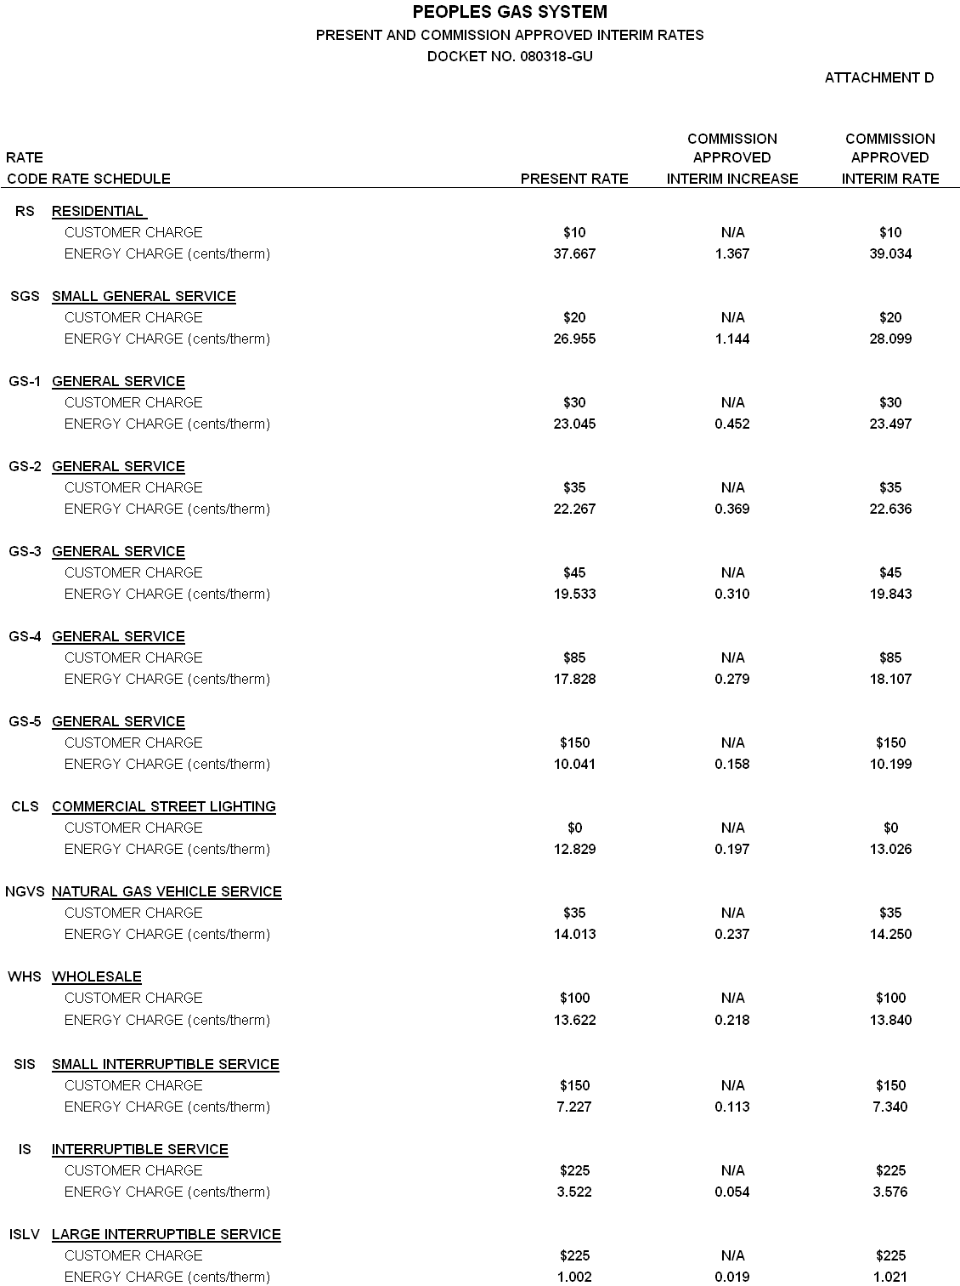

Order No. PSC-03-0038-FOF-GU, issued January 6, 2003, in Docket No. 020384-GU, In re: Petition for rate increase by Peoples Gas System.
Letter dated August 25, 2008, Document No. 07723-08.

