BEFORE THE FLORIDA PUBLIC SERVICE COMMISSION

In re: Petition for expedited Commission approval of base rate increase for costs associated with MUR phase of CR3 uprate project, pursuant to Section 366.93(4), F.S., and Rule 25-6.0423(7), F.A.C., by Progress Energy Florida, Inc. | DOCKET NO. 080603-EI  ORDER NO. PSC-08-0779-TRF-EI  ISSUED: November 26, 2008

The following Commissioners participated in the disposition of this matter:

MATTHEW M. CARTER II, Chairman
LISA POLAK EDGAR
KATRINA J. McMURRIAN
NANCY ARGENZIANO
NATHAN A. SKOP

ORDER APPROVING INCREASE IN BASE RATES, PROPOSED TARIFFS
AND ASSOCIATED CHARGES

BY THE COMMISSION:

BACKGROUND
In 2006, the Florida Legislature enacted legislation, Section 366.93, Florida Statutes (F.S.), encouraging the development of nuclear energy in the state. In that section, the Legislature directed us to adopt rules providing for alternate cost recovery mechanisms that would encourage investor-owned electric utilities to invest in nuclear power plants. We adopted Rule 25-6.0423, Florida Administrative Code (F.A.C.), which provides for an annual clause recovery proceeding to consider investor-owned electric utilities’ requests for cost recovery for nuclear plants.
We granted Progress Energy Florida, Inc.’s (PEF’s) need determination for the Crystal River 3 (CR3) Uprate on February 8, 2007. Once completed, the CR3 Uprate will provide an additional 180 MW of nuclear generation. The CR3 Uprate will be accomplished in three phases. The reasonableness and prudence of the construction expenditures related to each phase of the CR3 Uprate project are subject to review in Docket No. 080009-EI.
Phase 1, the Measurement Uncertainty Recapture (MUR) phase, was completed during the 2007 refueling outage and went online on January 31, 2008. It resulted in the addition of approximately 12 megawatts of nuclear generation to PEF’s system. On September 19, 2008, PEF filed a petition to increase its base rates by the $1,297,979 revenue requirements associated with the MUR phase of the CR3 Uprate project pursuant to Rule 25-6.0423(7), F.A.C. PEF has requested expedited approval of its petition so that the new base rates can become effective with the first billing cycle for January 2009.
We have jurisdiction over this subject matter pursuant to the provisions of Section 366.93, F.S., and other provisions of Chapter 366, F.S.
DISCUSSION AND DECISION

As noted above, PEF has requested approval to increase its base rates by $1,297,979 for the MUR phase of the CR3 Uprate project. The MUR phase went into commercial service on January 31, 2008.
In compliance with Rule 25-6.0423(7), F.A.C., PEF submitted its calculation of the annualized base revenue requirements for the MUR phase for the first 12 months of operations. This calculation is appended to this order as Attachment A. We have reviewed the calculation of the $1,297,979 jurisdictional annual revenue requirement. We find that the annual revenue requirement calculation has been calculated in compliance with Rule 25-6.0423(7), F.A.C., and therefore we approve the $1,297,979 base rate increase.
At the October 14, 2008, Agenda Conference, we found that the 2007 expenditures for the MUR phase of the CR3 Uprate project were reasonable and prudent in Docket No. 080009-EI. However, the 2008 construction expenditures related to the MUR phase are still under review in Docket No. 080009-EI. A final determination of the reasonableness and prudence of the 2008 construction expenditures will not be made until 2009. Per Attachment A, the increase in Electric Plant in Service included in the calculation is $8,565,344 ($8,030,267 jurisdictional), net of joint owners. If the $8,565,344 amount is revised based on a final audit and review of the 2008 construction expenditures, the annual revenue requirement will have to be recalculated. This would require a true-up of the revenues already collected and a revision of the related tariffs. Thus, the approval of the $1,297,979 base rate increase shall be made subject to true-up and revision based on the final review of the 2008 MUR phase construction expenditures in the 2009 Nuclear Cost Recovery Clause proceeding.
As discussed above, PEF has proposed to increase its base rate energy charges by $1,297,979. PEF allocated this amount to the various rate classes based on the 12 Coincident Peak (CP) and 1/13 Average Demand methodology, which is our current methodology to allocate production demand costs to rate classes. This methodology essentially allocates costs to the rate classes based on the average of their monthly contribution to the system peak. The allocation of the $1,297,979 to the rate classes is appended to this order as Attachment B.
As shown in Attachment B, the residential base rate energy charge will increase by 0.004 cents per kilo-watt hour, adding 4 cents to the base rate component of the 1,000 kWh residential bill. PEF has proposed increases to its various cost recovery factors, including the fuel and purchased power cost recovery factor (Docket No. 080001-EI), which may have additional impacts on bills beginning in 2009. However, because of Docket No. 080001-EI and other proposed changes, the current 1,000 kWh residential bill of $110.59 is projected to increase to $137.88 in January 2009.
PEF has requested that the proposed tariffs go into effect with the first billing cycle in January 2009. We have reviewed the proposed tariffs and calculation of the revised base rate energy charges and they are hereby approved to go into effect with the first billing cycle in January 2009.
Based on the foregoing, it is

ORDERED by the Florida Public Service Commission that PEF’s request to increase its base rates by $1,297,979 for the MUR phase of the CR3 Uprate project is hereby approved. It is further

ORDERED that this approval is subject to true-up and revision based on the final review of the 2008 MUR phase construction expenditures in the 2009 Nuclear Cost Recovery Clause proceeding. It is further
ORDERED that PEF’s proposed tariffs and associated charges shall go into effect with the first billing cycle in January 2009. It is further
ORDERED that if a protest is filed within 21 days of the issuance of the order, this tariff shall remain in effect, with any revenues held subject to refund, pending resolution of the protest. It is further
ORDERED that if no timely protest is filed, this docket shall be closed upon the issuance of a consummating order.
By ORDER of the Florida Public Service Commission this 26th day of November, 2008.

/s/ Ann Cole
ANN COLE
Commission Clerk

This is an electronic transmission. A copy of the original signature is available from the Commission's website, www.floridapsc.com, or by faxing a request to the Office of Commission Clerk at 1-850-413-7118.

( S E A L )

ELS
NOTICE OF FURTHER PROCEEDINGS

The Florida Public Service Commission is required by Section 120.569(1), Florida Statutes, to notify parties of any administrative hearing or judicial review of Commission orders that is available under Sections 120.57 or 120.68, Florida Statutes, as well as the procedures and time limits that apply. This notice should not be construed to mean all requests for an administrative hearing or judicial review will be granted or result in the relief sought.

Mediation may be available on a case-by-case basis. If mediation is conducted, it does not affect a substantially interested person's right to a hearing.

The Commission's decision on this tariff is interim in nature and will become final, unless a person whose substantial interests are affected by the proposed action files a petition for a formal proceeding, in the form provided by Rule 28-106.201, Florida Administrative Code. This petition must be received by the Office of Commission Clerk, 2540 Shumard Oak Boulevard, Tallahassee, Florida 32399-0850, by the close of business on December 17, 2008.

In the absence of such a petition, this Order shall become final and effective upon the issuance of a Consummating Order.

Any objection or protest filed in this docket before the issuance date of this order is considered abandoned unless it satisfies the foregoing conditions and is renewed within the specified protest period.

ATTACHMENT A

Attachment B
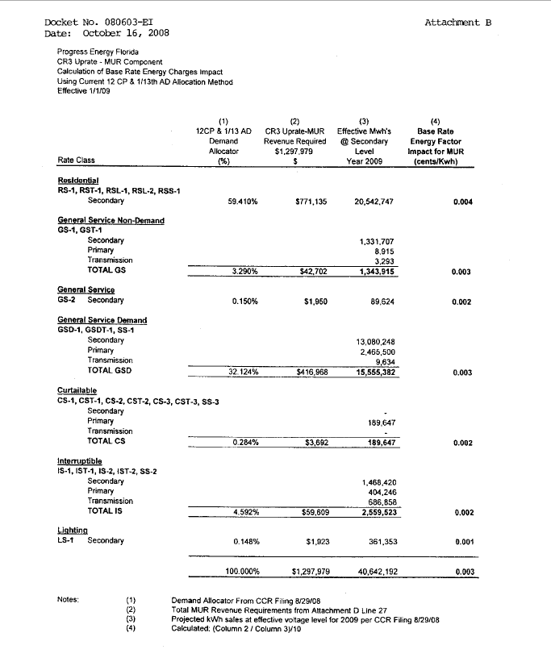

Order No. PSC-07-0119-FOF-EI, issued February 8, 2007, in Docket No. 060642-EI, In re: Petition for determination of need for expansion of Crystal River 3 nuclear power plant, for exemption from Bid Rule 25-22.082, F.A.C., and for cost recovery through fuel clause, by Progress Energy Florida, Inc.
Phase 1 – Measurement Uncertainty Recapture; Phase 2 – Balance of Plant; and Phase 3 – Extended Power Uprate.
Docket No. 080009-EI, In re: Nuclear cost recovery clause.

