BEFORE THE FLORIDA PUBLIC SERVICE COMMISSION

In re: State certification of rural telecommunications carriers pursuant to 47 C.F.R. 54.314, High Cost Universal Service. | DOCKET NO. 090168-TL  ORDER NO. PSC-09-0514-FOF-TL  ISSUED: July 21, 2009

The following Commissioners participated in the disposition of this matter:

MATTHEW M. CARTER II, Chairman
LISA POLAK EDGAR
KATRINA J. McMURRIAN
NANCY ARGENZIANO
NATHAN A. SKOP

ORDER GRANTING ANNUAL CERTIFICATION

BY THE COMMISSION:

I. Case Background
Section 254(e) of the Telecommunications Act of 1996 provides that a carrier that receives universal service support “…shall use that support only for the provision, maintenance, and upgrading of facilities and services for which the support is intended.” In its Fourteenth Report and Order, Twenty-Second Order on Reconsideration, and Further Notice of Proposed Rulemaking in CC Docket No. 00-256 (the Rural Task Force Order; hereafter, the RTF Order), the Federal Communications Commission (FCC) modified its rules pertaining to the provision of high-cost support for rural telephone companies. The FCC adopted a rule requiring that states who wish for rural carriers within their jurisdiction to receive federal high-cost support must file a certification annually with the FCC and with the Universal Service Administrative Company (USAC). This certification is to affirm that the federal high-cost funds flowing to rural carriers in the state, or to any competitive eligible telecommunications carriers seeking support for serving customers within a rural carrier’s service area, will be used in a manner that comports with Section 254(e). 47 C.F.R. §54.314 provides the following:
State certification of support for rural carriers.

(a) State certification. States that desire rural incumbent local exchange carriers and/or eligible telecommunications carriers serving lines in the service area of a rural incumbent local exchange carrier within their jurisdiction to receive support pursuant to §§54.30 (local switching support), 54.305 (sale or transfer of exchanges), and/or 54.307 (support to competitive ETC) of this part and/or part 36, subpart F of this chapter must file an annual certification with the Administrator and the Commission stating that all federal high-cost support provided to such carriers within that State will be used only for the provision, maintenance, and upgrading of facilities and services for which the support is intended...

(c) Certification format. A certification pursuant to this section may be filed in the form of a letter from the appropriate regulatory authority for the State, and shall be filed with both the Office of the Secretary of the Commission clearly referencing CC Docket No. 96-45, and with the Administrator of the high-cost universal service support mechanism, on or before the deadlines set forth below in subsection (d). . . .

The FCC requires that certifications for the next calendar funding year must be submitted by the preceding October 1; thus, in order for a rural carrier to be eligible for high-cost universal service support for all of calendar year 2010, certification must be submitted by October 1, 2009.

On March 17, 2005, the FCC released Order No. FCC 05-46 establishing new annual certification and reporting requirements to comply with the conditions of Eligible Telecommunication Carrier (ETC) designation and to ensure universal service funds are used for their intended purposes. In making its decision, the FCC believed that the new reporting requirements were reasonable and consistent with the public interest and the Act, and will further the FCC’s goal of ensuring that ETCs satisfy their obligation under Section 214(e) of the Act to provide supported services throughout their designated service areas. The FCC also believed that the administrative burden placed on carriers would be outweighed by strengthening the requirements and certification guidelines to help ensure that high-cost support is used in the manner that it was intended, and would help prevent carriers from seeking ETC status for purposes unrelated to providing rural and high-cost consumers with the access to affordable telecommunications and information services.

By Order No. PSC-05-0824-FOF-TL, issued August 15, 2005, and Order No. PSC-05-0824A-FOF-TL, issued August 17, 2005, we approved the establishment of the annual certification and reporting requirements.

Each of the rural carriers which are seeking state certification for 2010 have complied with our new reporting requirements. This Order pertains to certification of Florida’s rural LECs for 2010.

II. Analysis

Unless this Commission submits certifications to the FCC and to the USAC by October 1, 2009, Florida’s rural carriers will receive no interstate high-cost universal service funds during the first quarter of 2010, and would forego all federal support for that quarter. Certifications filed after October 1, 2009, would cause rural carriers to be eligible for high-cost funds for only partial quarters of 2010. For example, certifications filed by January 1, 2010, would allow rural carriers to be eligible for high-cost funds in the second, third, and fourth quarters of 2010. Certifications filed by April 1, 2010, would only allow rural carriers to be eligible for high-cost funds in the third and fourth quarters of 2010. All of these rural ETCs are now under intrastate price-cap regulation. However, the FCC anticipated that certain state commissions may have limited economic regulatory authority:

In the case of non-rural carriers, we concluded that states nonetheless may certify to the FCC that a non-rural carrier in the state had accounted to the state commission for its receipt of federal support, and that such support will be ‘used only for the provision, maintenance and upgrading of facilities and services for which the support is intended.’ We determined that, in states in which the state commission has limited jurisdiction over such carriers, the state need not initiate the certification process itself. . . .We conclude that this approach is equally appropriate here with regard to rural carriers and competitive eligible telecommunications carriers serving lines in the service area of a rural local exchange carrier. (RTF Order, ¶188)

On February 27, 2004, the Federal-State Joint Board on Universal Service (Joint Board) recommended that the FCC encourage states to use the annual ETC certification process to ensure that federal universal service support is used to provide the supported services and for associated infrastructure costs. Annual review affords states the opportunity for a periodic review of ETC fund use. The Joint Board asserted that states should examine compliance with any build-out plans. Where an ETC fails to comply with the requirements in Section 214(e) and any additional requirements proposed by the state commission, the Joint Board noted that the state commission may decline to grant an annual certification or may rescind a certification granted previously. To date, there have been no indications that the rural ETCs are in violation of any of the provisions of Section 214(e).
The FCC has noted that it may institute an inquiry on its own motion for companies for which it, rather than state commissions, has granted ETC status. Such an inquiry could include an examination of the ETC’s records and documentation to ensure that the high-cost support it receives is being used “only for the provision, maintenance, and upgrading of facilities and services.” The FCC stated that failure to fulfill the requirements of the statute, its rules, and the terms of its designation order could result in the loss of the carrier’s ETC designation.
As has been done in prior years, each of the seven Florida rural ETCs has provided this Commission with an affidavit (see Attachments A through G) in which they have certified that their use of interstate high-cost universal service support received during 2010 will comport with Section 254(e) of the Act and applicable FCC rules. Given these ETCs’ certifications, we hereby certify to the FCC and to the USAC that for the year 2010 Windstream Florida, Inc., Frontier Communications of the South, LLC, GTC, Inc. d/b/a FairPoint Communications, ITS Telecommunications Systems, Inc., Northeast Florida Telephone Company d/b/a NEFCOM, Quincy Telephone Company d/b/a TDS Telecom/Quincy Telephone, and Smart City Telecommunications, LLC, d/b/a Smart City Telecom will only use the federal high-cost support they receive for the provision, maintenance and upgrading of facilities and services for which the support is intended.

This docket shall be closed and subsequent annual certifications of rural telephone companies shall be addressed in a new docket.

Based on the foregoing, it is

ORDERED by the Florida Public Service Commission that we hereby certify to the FCC and to the USAC that for the year 2010 Windstream Florida, Inc., Frontier Communications of the South, LLC, GTC, Inc. d/b/a FairPoint Communications, ITS Telecommunications Systems, Inc., Northeast Florida Telephone Company d/b/a NEFCOM, Quincy Telephone Company d/b/a TDS Telecom/Quincy Telephone, and Smart City Telecommunications, LLC, d/b/a Smart City Telecom will only use the federal high-cost support they receive for the provision, maintenance and upgrading of facilities and services for which the support is intended. It is further

ORDERED that this Docket shall be closed.

By ORDER of the Florida Public Service Commission this 21st day of July, 2009.

ANN COLE
Commission Clerk

By: | /s/ Dorothy E. Menasco
Dorothy E. Menasco
Chief Deputy Commission Clerk

This is an electronic transmission. A copy of the original signature is available from the Commission's website, www.floridapsc.com, or by faxing a request to the Office of Commission Clerk at 1-850-413-7118.

( S E A L )

AJT

NOTICE OF FURTHER PROCEEDINGS OR JUDICIAL REVIEW

The Florida Public Service Commission is required by Section 120.569(1), Florida Statutes, to notify parties of any administrative hearing or judicial review of Commission orders that is available under Sections 120.57 or 120.68, Florida Statutes, as well as the procedures and time limits that apply. This notice should not be construed to mean all requests for an administrative hearing or judicial review will be granted or result in the relief sought.

Any party adversely affected by the Commission's final action in this matter may request: 1) reconsideration of the decision by filing a motion for reconsideration with the Office of Commission Clerk, 2540 Shumard Oak Boulevard, Tallahassee, Florida 32399-0850, within fifteen (15) days of the issuance of this order in the form prescribed by Rule 25-22.060, Florida Administrative Code; or 2) judicial review by the Florida Supreme Court in the case of an electric, gas or telephone utility or the First District Court of Appeal in the case of a water and/or wastewater utility by filing a notice of appeal with the Office of Commission Clerk, and filing a copy of the notice of appeal and the filing fee with the appropriate court. This filing must be completed within thirty (30) days after the issuance of this order, pursuant to Rule 9.110, Florida Rules of Appellate Procedure. The notice of appeal must be in the form specified in Rule 9.900(a), Florida Rules of Appellate Procedure.
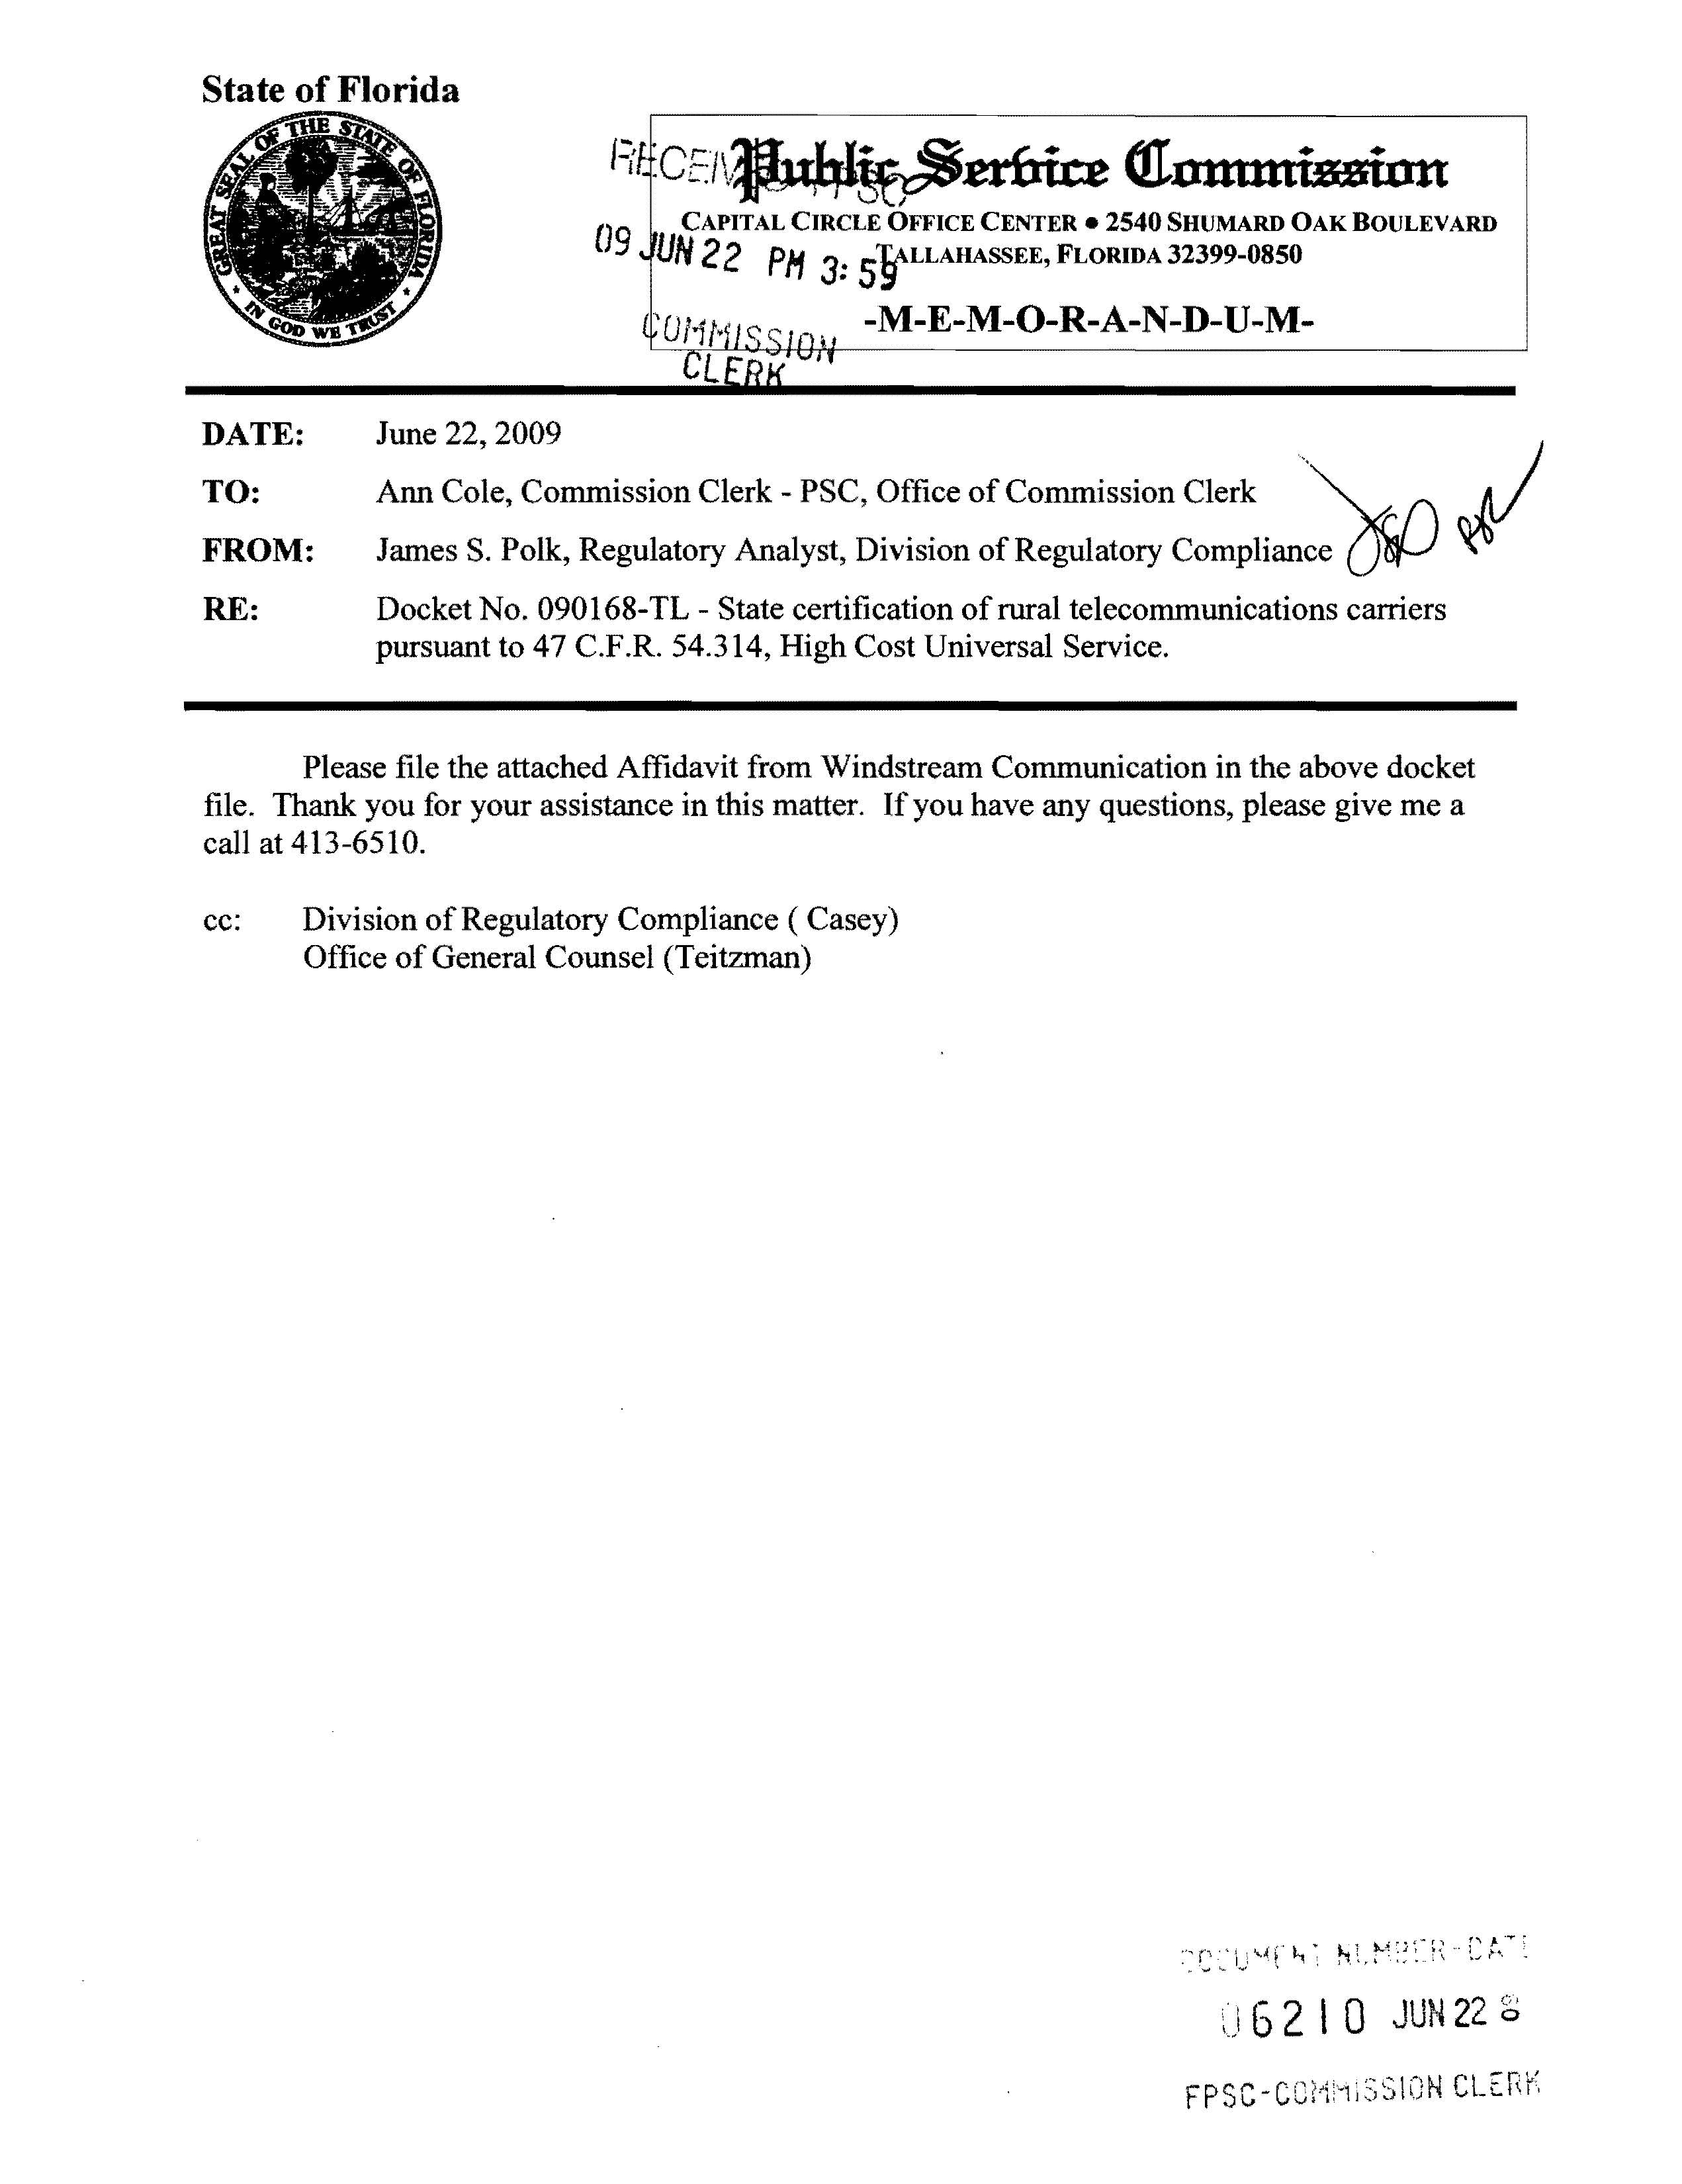
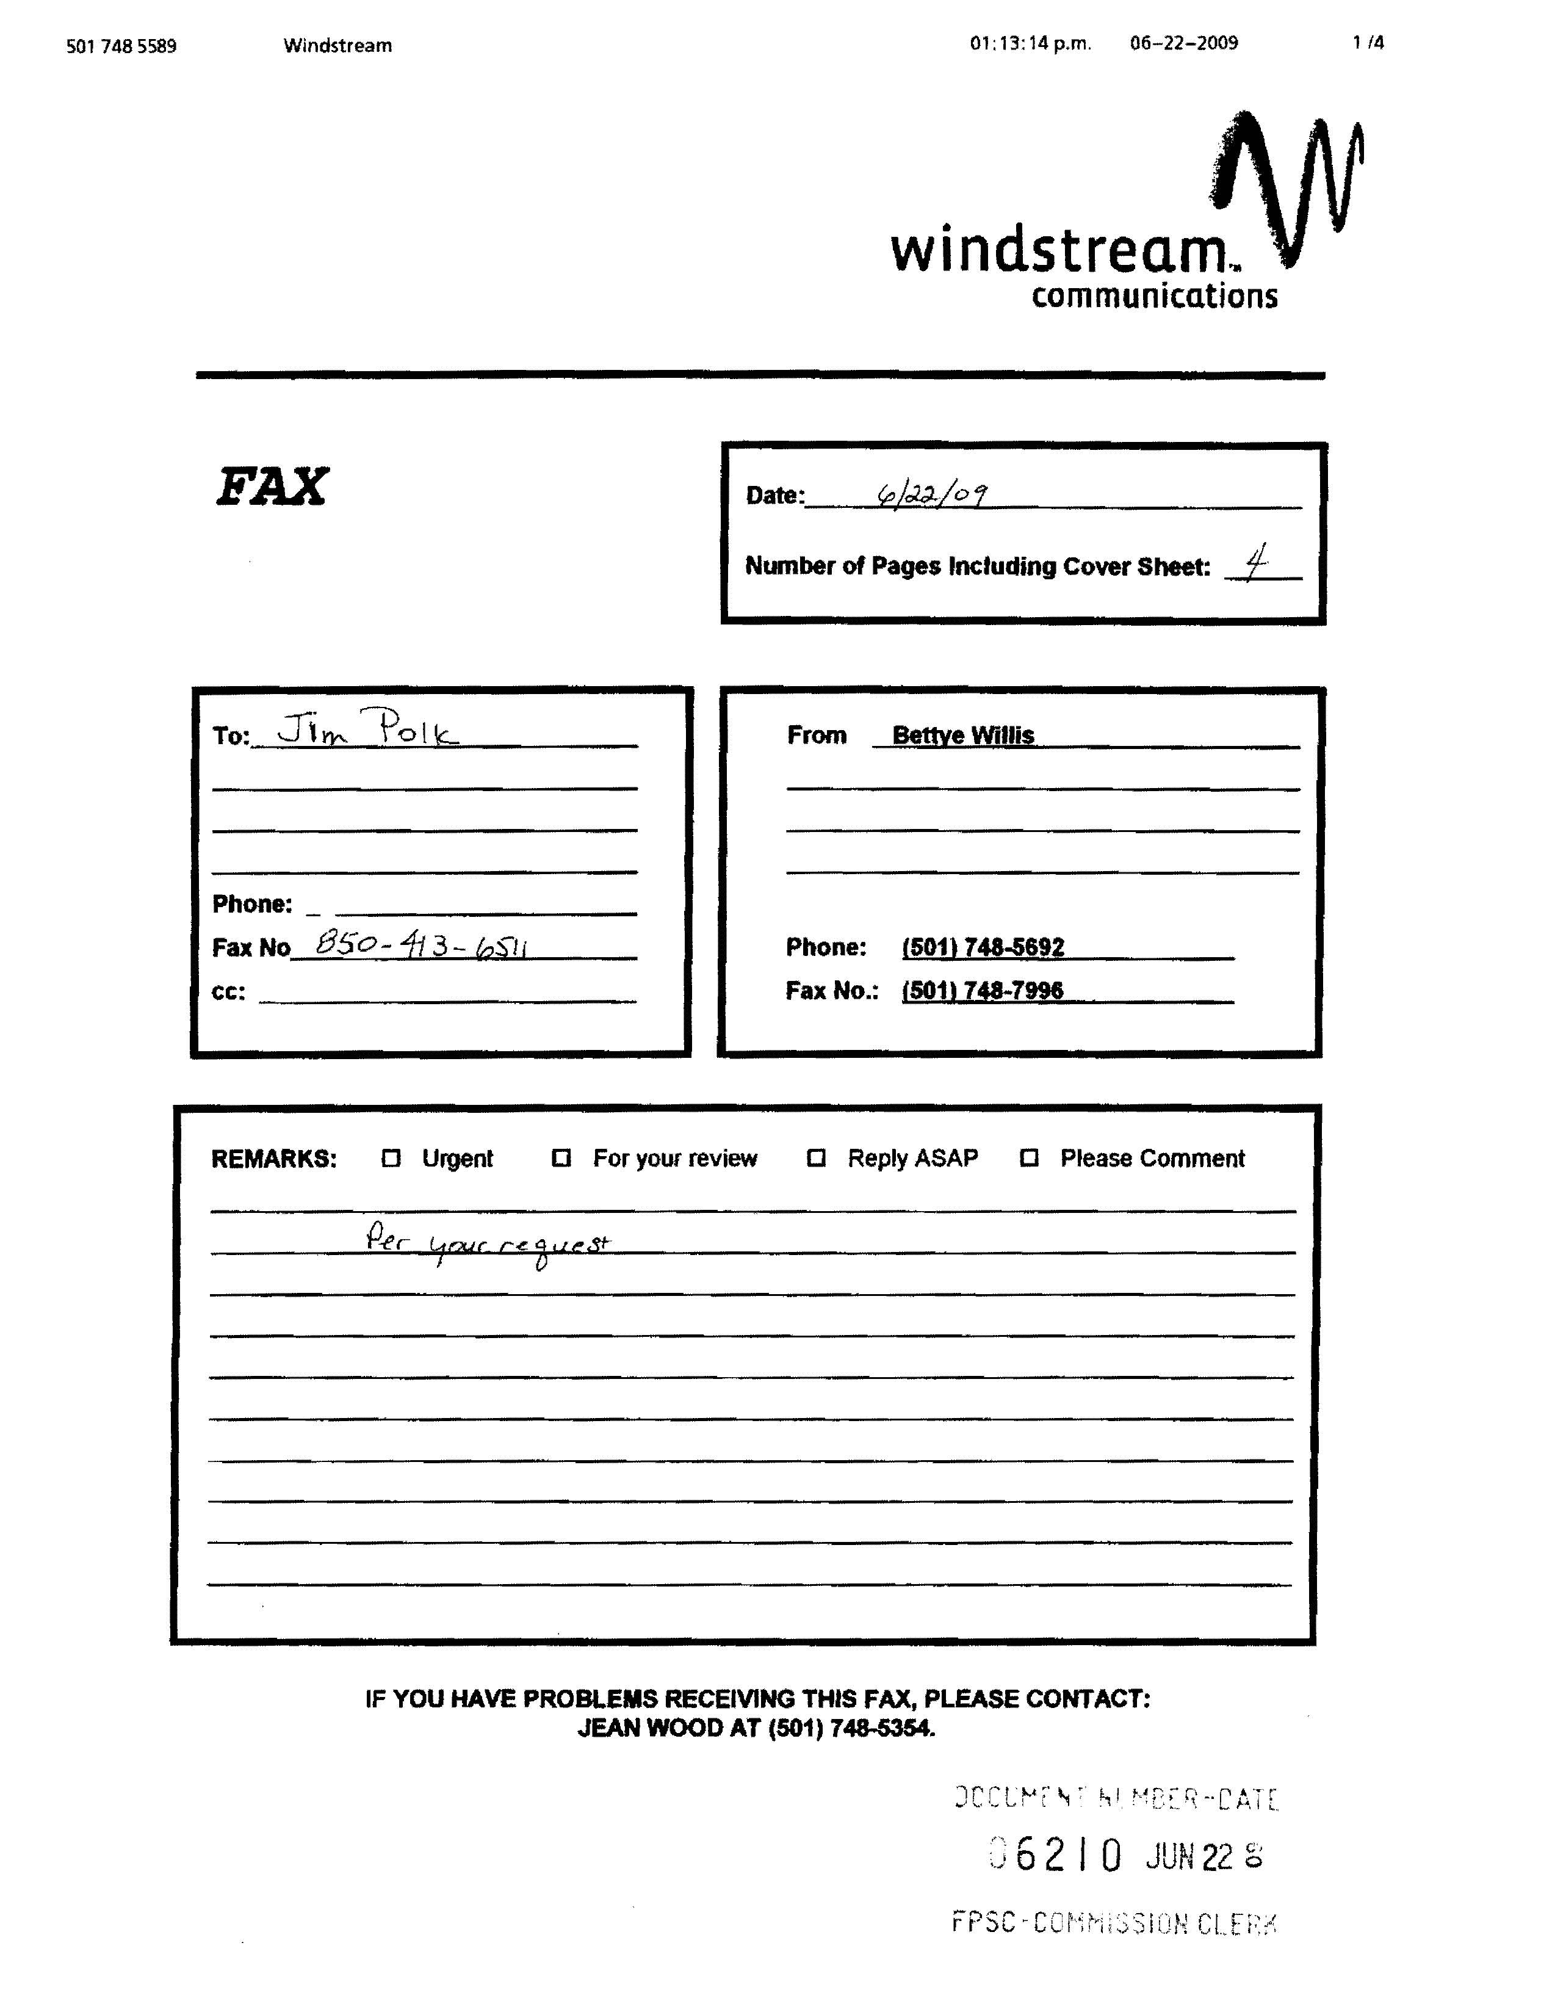
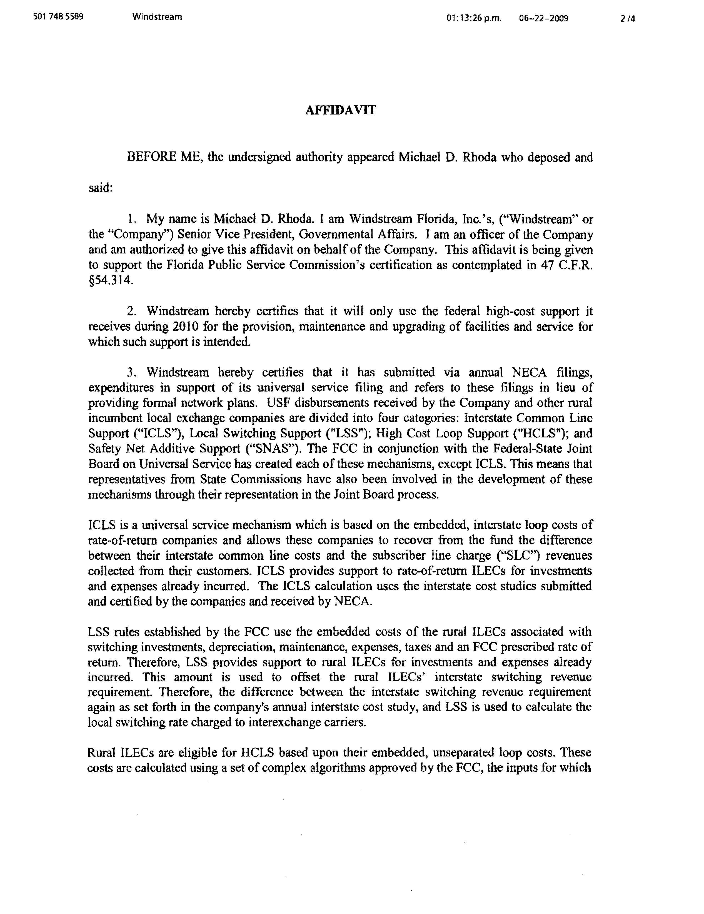
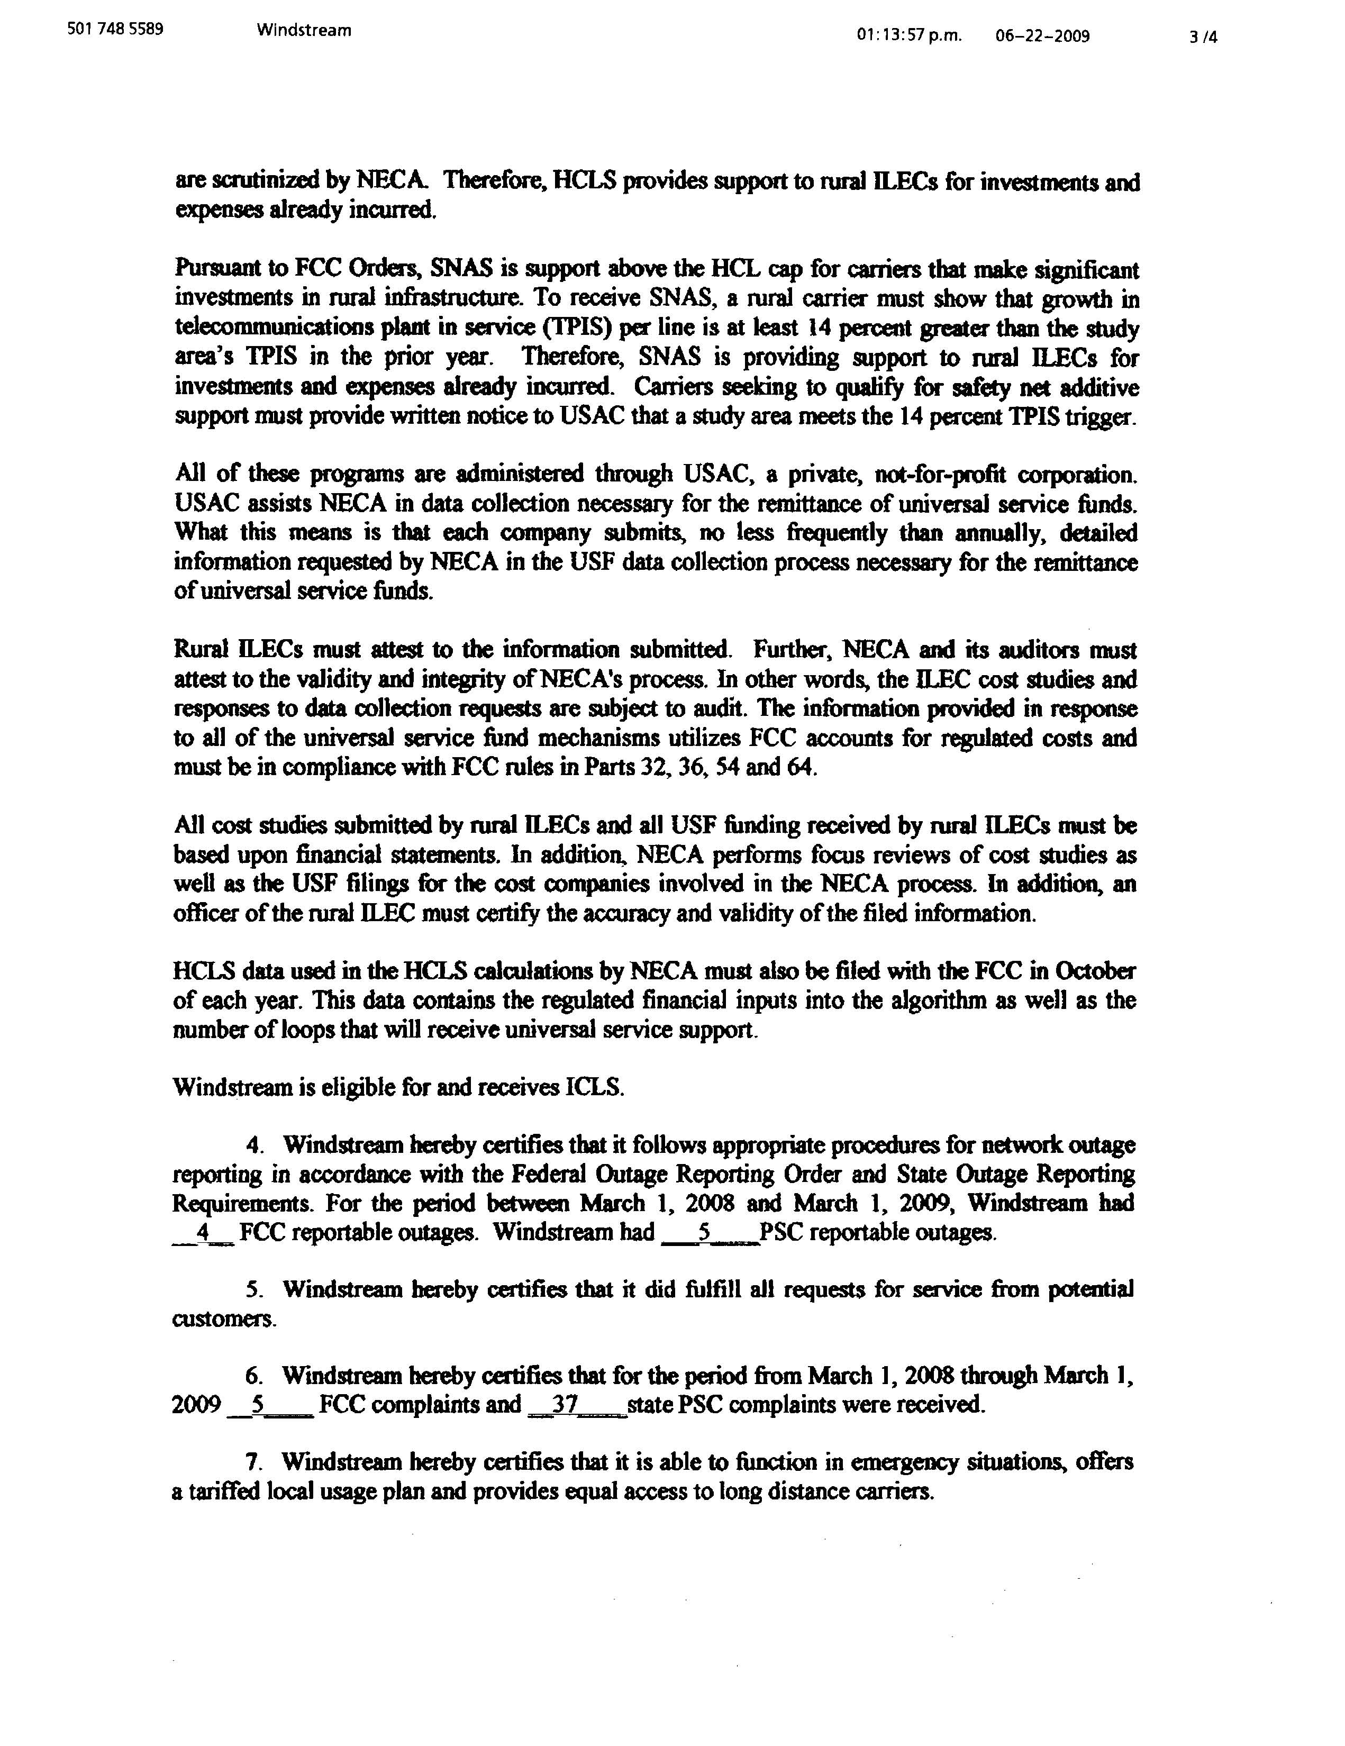
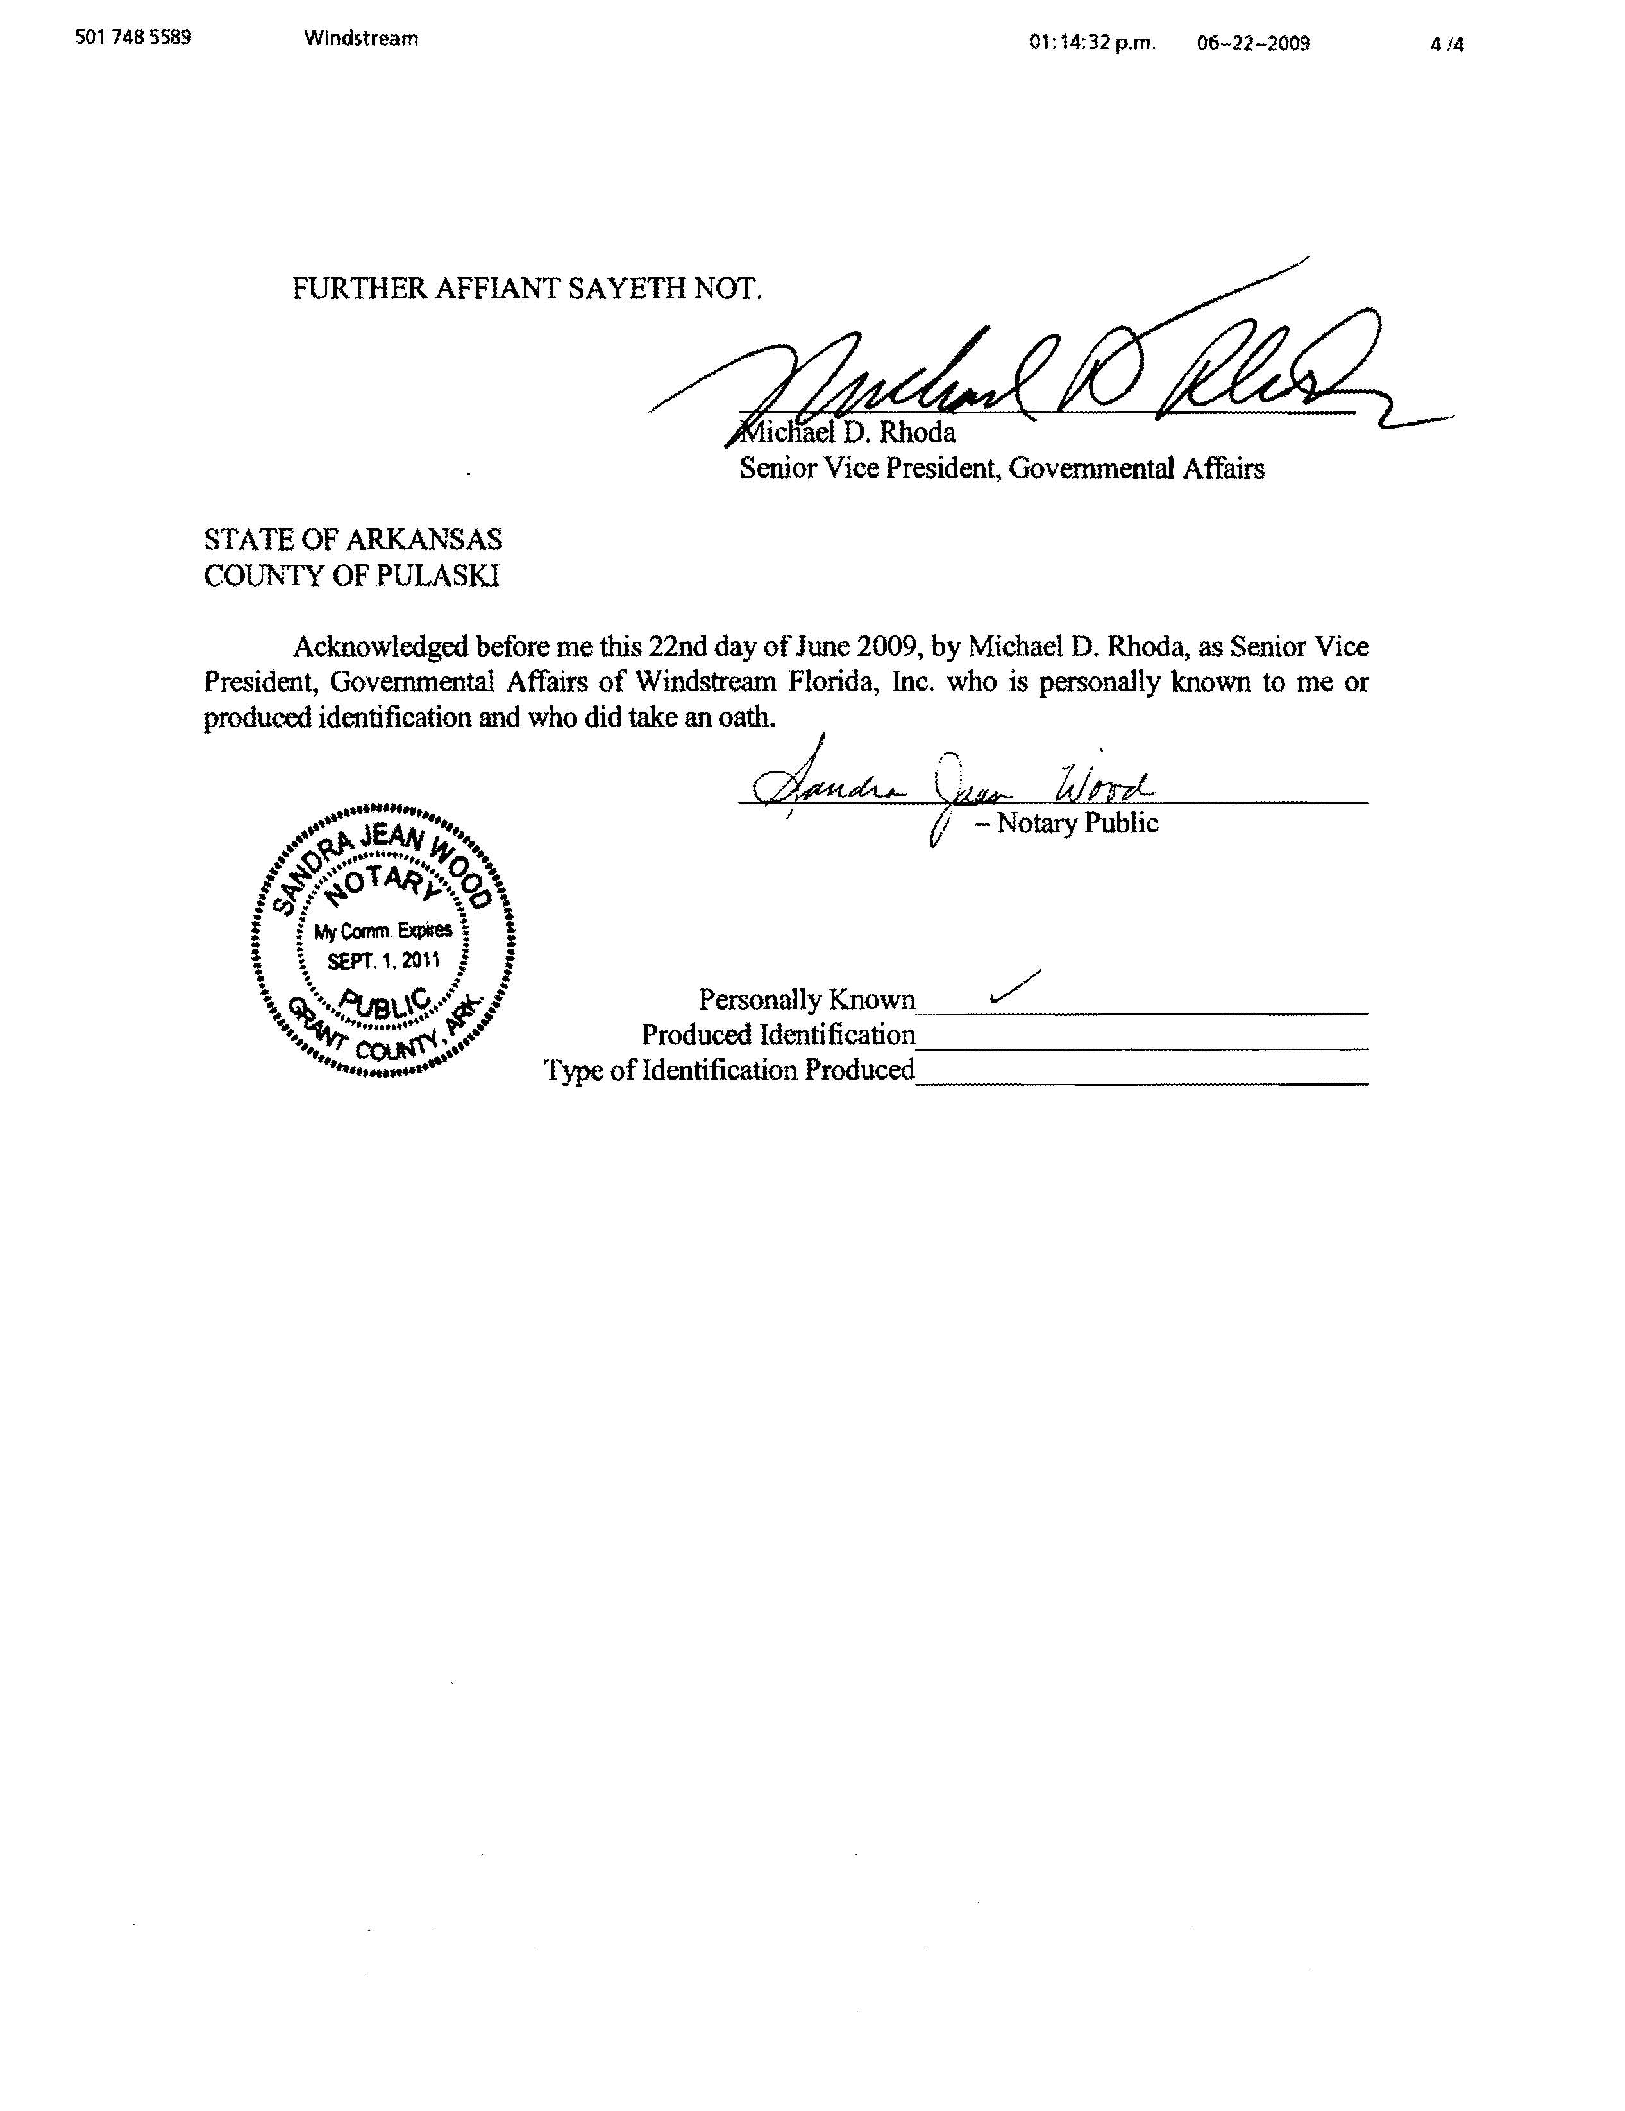

See Federal-State Joint Board on Universal Service, Recommended Decision, CC Docket No. 96-45, FCC 04J-1, pars. 46-48 (2004).
See Federal-State Joint Board on Universal Service, Ninth Report and Order and Eighteenth Order on Reconsideration, CC Docket No. 96-45, FCC 99-306, par. 95 (1999) (Ninth Report and Order) (stating that accountability for the use of federal funds in the state ratemaking process is an appropriate mechanism to ensure that non-rural carriers use high-cost support for the provision, maintenance and upgrading of facilities and services for which the support is intended); see also Rural Task Force Order, CC Docket 96-45, FCC 01-157, par. 187 (2001) (anticipating that states would take the appropriate steps to account for the receipt of high-cost support and ensure that federal support is being applied in a manner consistent with Section 254).
Federal-State Joint Board on Universal Service; Western Wireless Corporation Petition for Preemption of an Order of the South Dakota Public Utilities Commission, Declaratory Ruling, CC Docket No. 96-45, (2000), recon. pending (Section 214(e) Declaratory Ruling), par. 15.
See Federal-State Joint Board on Universal Service, Memorandum Opinion and Order, CC Docket No. 96-45, FCC 04-37, par. 43, (2004).

