BEFORE THE FLORIDA PUBLIC SERVICE COMMISSION

In re: Petition for approval of revised lighting tariff by Tampa Electric Company. | DOCKET NO. 140232-EI  ORDER NO. PSC-15-0094-TRF-EI  ISSUED: February 5, 2015

The following Commissioners participated in the disposition of this matter:

ART GRAHAM, Chairman
LISA POLAK EDGAR
RONALD A. BRISÉ
JULIE I. BROWN
JIMMY PATRONIS

ORDER APPROVING REVISIONS TO TAMPA ELECTRIC
COMPANY’S LIGHTING TARIFF

BY THE COMMISSION:

On December 3, 2014, Tampa Electric Company (TECO or company) filed a petition requesting our approval to close to new customers all of the existing High Pressure Sodium (HPS) and Metal Halide (MH) outdoor lighting offerings. The proposed closing would result in TECO offering only light emitting diode (LED) technology to new outdoor lighting customers. In addition, TECO proposed adding nine new LED fixtures to the current LED tariff. The proposed tariff revisions are included as Attachment 1. We first approved TECO’s LED lighting tariff in Order No. PSC-13-0138-FOF-EI. We have jurisdiction over this matter pursuant to Section 366.06(1), Florida Statutes (F.S.).
In its petition, TECO has requested approval to close the existing HPS and MH fixtures tariff to new customers and to add nine new LED fixtures to its current tariff. TECO explained in its petition that in the few short years since the company began studying LED outdoor lighting, the technology and its pricing have evolved to the point that LED lighting is now the preferred solution for roadway and outdoor area applications. The company also stated that LED technology is superior to the HPS and MH technologies in several ways. LED lighting is significantly more energy-efficient and more reliable than HPS and MH technology and provides for more uniform illumination. In addition, unlike the bulbs used for HPS and MH lighting, LED fixtures and components are environmentally friendly involving no special disposal practices or costs.

TECO reported that market demand for LED outdoor lighting has seen a rapid rise in recent years, even with the higher cost of the early generation products. Several municipal customers within TECO's service area are currently subscribing to the company's LED tariff for street lighting. Those customers are also demanding additional LED street lighting options and are beginning to request conversion to LED fixtures of some of their existing HPS fixtures that are in service but have reached the end of their contract commitment.
In addition to the efficiency benefits, TECO listed four additional reasons customers are requesting to change to LED lighting:
- Obtaining certifications relating to security, environment, or energy efficiency;
- Better reliability resulting in fewer business disruptions for lighting repairs or replacements;
- Favorable color rendition and aiming characteristics; and
- LED lighting is viewed as a "green" choice.
TECO also reported that lighting manufacturing industry representatives have informed the company that over the next few years, many plants currently manufacturing HPS and MH lighting fixtures for utility use will close or be retooled to produce comparable LED products. As the HPS and MH products are phased out, the costs of such fixtures and components are expected to increase substantially and future availability is uncertain due to this reduction in production capacity. The proposed closure of the HPS and MH fixtures is shown on tariff sheets 6.805 and 6.806 (Attachment 1, pages 1 and 2).
While proposing to close the HPS and MH tariffs to new customers, TECO also proposed to add nine new LED fixtures: two floodlight, two decorative post-top, one area-lighter, two mongoose, and two roadway fixtures. The charges for the new LED lighting fixtures are comprised of three components: a fixture charge, a maintenance charge, and a non-fuel energy charge, consistent with TECO’s current other lighting options. The new LED fixtures and associated charges are shown on tariff Sheet 6.808 (Attachment 1, page 3). In conjunction with its petition, TECO submitted supporting cost information that included a presentation of the following: individual tariff calculations; installation, maintenance, labor and vehicle costs; overhead cost factors; and monthly energy consumption charges. We have reviewed the cost information submitted with TECO’s petition and find that the charges are reasonable and appropriate.
TECO’s observations about the desirability of LED lighting is confirmed by the U.S. Energy Information Agency (EIA) in its November 4, 2014 report, in which EIA stated:
Improvements in lighting technology for light-emitting diode (LED) bulbs have increased lighting efficiency, or efficacy, as well as color quality. In September of this year, several manufacturers released ENERGY STAR®-qualified bulbs surpassing 100 lumens per watt. For comparison, traditional incandescent bulbs, which do not meet current light bulb efficiency standards and are no longer sold, provide 13 to 18 lumens per watt.
When first introduced, LED bulbs were far more expensive than other bulbs, but their costs have since come down dramatically. Even now, however, they are often the most expensive bulbs on the shelf, but their much longer lifetimes and lower power draw can economically justify the higher initial cost.
Given the information discussed above, we find that the proposed changes to TECO’s lighting tariff are reasonable and are hereby approved.
Based on the foregoing, it is
ORDERED by the Florida Public Service Commission that Tampa Electric Company’s proposed changes to its lighting tariff as discussed in the body of this Order are hereby approved. It is further
ORDERED that the effective date of Tampa Electric Company’s revised lighting tariff shall be February 3, 2015. It is further
ORDERED that if a protest is filed within 21 days of the issuance of this order, the tariff shall remain in effect with any revenues held subject to refund pending resolution of the protest. It is further
ORDERED that if no timely protest is filed, this docket shall be closed upon the issuance of a Consummating Order.
By ORDER of the Florida Public Service Commission this 5th day of February, 2015.

s | /s/ Carlotta S. Stauffer
CARLOTTA S. STAUFFER
Commission Clerk
Florida Public Service Commission
2540 Shumard Oak Boulevard
Tallahassee, Florida 32399
(850) 413-6770
www.floridapsc.com

Copies furnished: A copy of this document is provided to the parties of record at the time of issuance and, if applicable, interested persons.

SBr

NOTICE OF FURTHER PROCEEDINGS

The Florida Public Service Commission is required by Section 120.569(1), Florida Statutes, to notify parties of any administrative hearing or judicial review of Commission orders that is available under Sections 120.57 or 120.68, Florida Statutes, as well as the procedures and time limits that apply. This notice should not be construed to mean all requests for an administrative hearing or judicial review will be granted or result in the relief sought.

Mediation may be available on a case-by-case basis. If mediation is conducted, it does not affect a substantially interested person's right to a hearing.

The Commission's decision on this tariff is interim in nature and will become final, unless a person whose substantial interests are affected by the proposed action files a petition for a formal proceeding, in the form provided by Rule 28-106.201, Florida Administrative Code. This petition must be received by the Office of Commission Clerk, 2540 Shumard Oak Boulevard, Tallahassee, Florida 32399-0850, by the close of business on February 26, 2015.

In the absence of such a petition, this Order shall become final and effective upon the issuance of a Consummating Order.

Any objection or protest filed in this docket before the issuance date of this order is considered abandoned unless it satisfies the foregoing conditions and is renewed within the specified protest period.

Attachment 1
Page 1 of 3

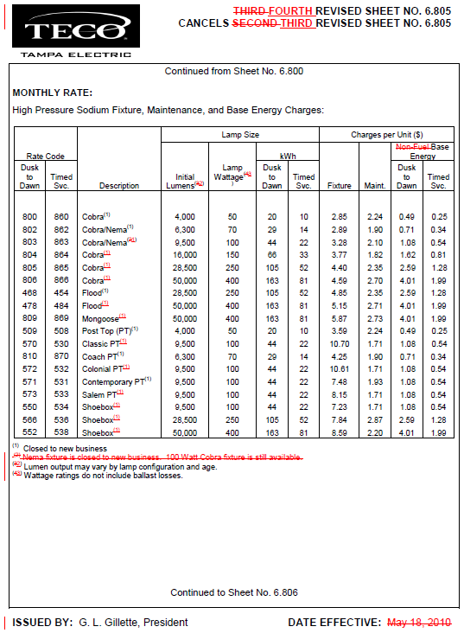

Attachment 1
Page 2 of 3

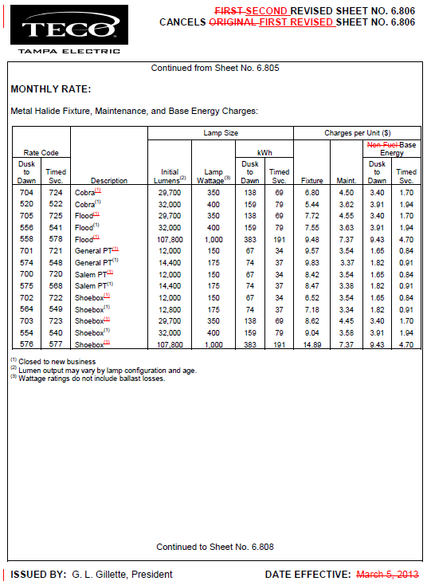

Attachment 1
Page 3 of 3

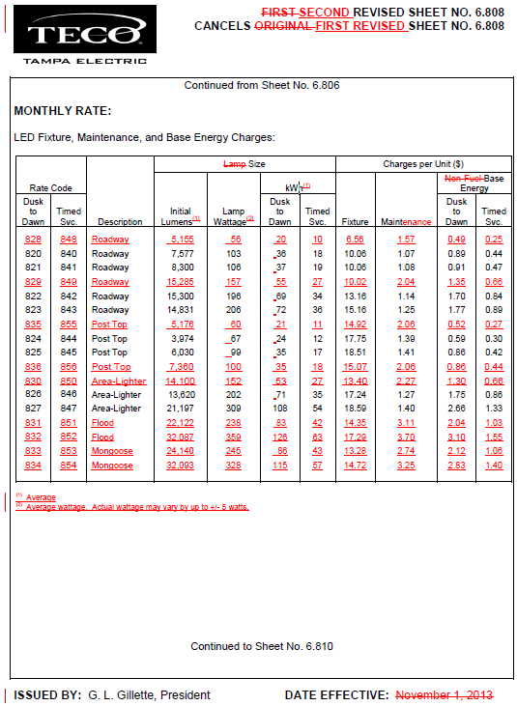

Order No. PSC-13-0138-FOF-EI, issued March 25, 2013, in Docket No. 130019-EI, In re: Petition for approval of revised lighting tariffs by Tampa Electric Company.
U.S. Energy Information Administration website report, “LED light bulbs keep improving in efficiency and quality”, November 4, 2014, http://www.eia.gov/todayinenergy/detail.cfm?id=18671&src=email.

