BEFORE THE FLORIDA PUBLIC SERVICE COMMISSION

|  |  |
| --- | --- |
| In re: Petition to extend economic development rider on a permanent basis, by Tampa Electric Company. | DOCKET NO. 160059-EI  ORDER NO. PSC-16-0210-TRF-EI  ISSUED: May 25, 2016 |

The following Commissioners participated in the disposition of this matter:

JULIE I. BROWN, Chairman

LISA POLAK EDGAR

ART GRAHAM

RONALD A. BRISÉ

JIMMY PATRONIS

ORDER EXTENDING ECONOMIC DEVELOPMENT RIDER ON PERMANENT BASIS

BY THE COMMISSION:

Background

On March 14, 2016, Tampa Electric Company (Tampa Electric or company) filed a petition to extend its Economic Development Rider program (rider or program) on a permanent basis. The rider was introduced as a three-year pilot in the stipulation and settlement agreement (settlement) this Commission approved in Tampa Electric’s 2013 base rate proceeding.[1] The program became effective on the implementation date of the settlement (November 1, 2013) and ends on December 31, 2016. The rider, which requires a five-year contract, provides base rate discounts for new businesses that meet certain requirements such as minimum size, job creation, and verification that the availability of the rider is a significant factor in the customer’s location or expansion decision.

Commission staff issued one data request to Tampa Electric, to which the company responded on April 1, 2016. On April 19, 2016, Tampa Electric filed a letter in the docket file clarifying paragraph 7 of the petition. The proposed tariff pages are contained in Attachment 1 of this Order. We have jurisdiction over this matter pursuant to Sections 288.035 and 366.06, Florida Statutes.

Decision

The economic development rider is designed to attract new business to Tampa Electric’s service territory. The rider is available for load associated with initial permanent service to new establishments or the expansion of existing establishments and requires a five-year customer contract. Under the rider, the new load must be a minimum of 350 kilowatt (kW) at a single delivery point and the customer must employ an additional work force of at least 25 full-time equivalent employees (FTEs). Each customer taking service under the rider must sign an attestation letter stating that the customer will employ at least 25 FTEs. The percentage discount applicable to the base demand and energy charges of the customer’s otherwise applicable rate schedule begin at 20 percent in the first year, and declines by five percentage points every year (e.g., 15 percent discount in year 2) until the fifth year when the discount is zero.

The first customer took service under the rider in June 2014. Since that time, Tampa Electric stated that the program has attracted new load resulting in approximately $760,000 in incremental base revenue and the addition of 405 FTEs in Tampa Electric’s service territory. The discount amount associated with the new load is approximately $130,000, which represents the difference between the rider rates and the otherwise applicable tariffed rates for the period June 2014 through February 2016. Currently, there are two commercial customers taking service under the rider.

The proposed permanent rider tariff deletes the pilot program’s beginning and end dates and adds additional language to specify that the discount will begin once the customer has achieved minimum load and job requirements and that the agreement will terminate automatically if the minimum load and job requirements have not been achieved within 120 days of the effective date of the service agreement. Tampa Electric is developing an annual attestation letter that customers will have to sign and return which states that the customers are maintaining the minimum 25 FTEs required to remain on the program. The rider contains provisions for early termination and requires a customer to reimburse Tampa Electric for any discounts received under the rider if the agreement is terminated prior to the end of the five-year contract.

Pursuant to Rule 25-6.0426(5), Florida Administrative Code (F.A.C.), Tampa Electric currently reports any economic development expenses associated with the rider (e.g., marketing) on its earnings surveillance reports filed with this Commission. In response to Commission staff’s data request and the letter filed on April 19, 2016, Tampa Electric explained that in the next rate case the company will request recovery of any base rate reductions, i.e., difference between tariffed base rates and discounted base rates pursuant to the rider, as a cost of the rider. Only discounts provided in the test year will be eligible for cost recovery. Pursuant to Rule 25-6.0426(4), F.A.C., this Commission will determine the level of sharing of prudent economic development costs in the company’s next rate case.

Any direct impact on the general body of ratepayers will depend on the amount of discounts, if any, in the test year and the level of sharing determined by this Commission. We note that economic development provides indirect positive impacts to ratepayers including economic and job growth. Furthermore, any increased load as a result of the rider benefits the general body of ratepayers by spreading fixed cost among a larger customer base.

The company averred it is working on additional customer projects that would not have been viable without the rider incentive. According to Tampa Electric, economic development contacts and negotiations are often conducted a substantial amount of time before a prospective customer would begin to take service from the company. The company asserted that being able to assure that the rider will be available when the customer is ready to make a decision is very important to continue the success of the program. Therefore, the company requested approval to make the rider permanent several months before the pilot program expires at the end of this year. Tampa Electric believes that a permanent program will encourage business growth in its territory.

The rider appears to be successful in attracting new load and incremental base revenues to Tampa Electric’s service territory, which benefits the general body of ratepayers. Therefore, this Commission finds that Tampa Electric’s petition to extend its economic development rider and associated tariffs on a permanent basis shall be approved, effective May 5, 2016.

Based on the foregoing, it is

ORDERED by the Florida Public Service Commission that Tampa Electric Company’s economic development rider and associated tariffs are hereby extended on a permanent basis, effective May 5, 2016.

ORDERED that if a protest is filed within 21 days of issuance of the Order, the tariff shall remain in effect pending resolution of the protest. It is further

ORDERED that if no timely protest is filed, this docket shall be closed upon the issuance of a Consummating Order.

By ORDER of the Florida Public Service Commission this 25th day of May, 2016.

|  |  |
| --- | --- |
|  | /s/ Carlotta S. Stauffer |
|  | CARLOTTA S. STAUFFER  Commission Clerk |

Florida Public Service Commission

2540 Shumard Oak Boulevard

Tallahassee, Florida 32399

(850) 413‑6770

www.floridapsc.com

Copies furnished: A copy of this document is provided to the parties of record at the time of issuance and, if applicable, interested persons.

MAL

NOTICE OF FURTHER PROCEEDINGS

The Florida Public Service Commission is required by Section 120.569(1), Florida Statutes, to notify parties of any administrative hearing or judicial review of Commission orders that is available under Sections 120.57 or 120.68, Florida Statutes, as well as the procedures and time limits that apply. This notice should not be construed to mean all requests for an administrative hearing or judicial review will be granted or result in the relief sought.

Mediation may be available on a case-by-case basis. If mediation is conducted, it does not affect a substantially interested person's right to a hearing.

The Commission's decision on this tariff is interim in nature and will become final, unless a person whose substantial interests are affected by the proposed action files a petition for a formal proceeding, in the form provided by Rule 28-106.201, Florida Administrative Code. This petition must be received by the Office of Commission Clerk, 2540 Shumard Oak Boulevard, Tallahassee, Florida 32399-0850, by the close of business on June 15, 2016.

In the absence of such a petition, this Order shall become final and effective upon the issuance of a Consummating Order.

Any objection or protest filed in this docket before the issuance date of this order is considered abandoned unless it satisfies the foregoing conditions and is renewed within the specified protest period.

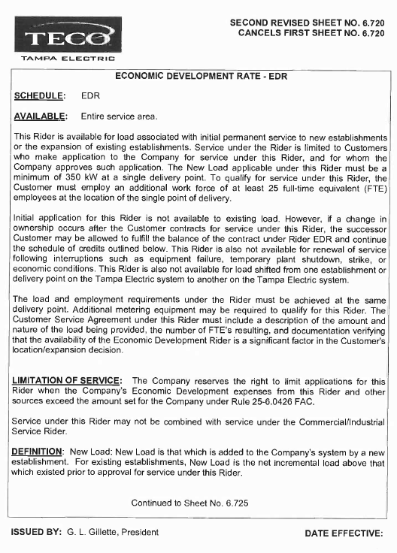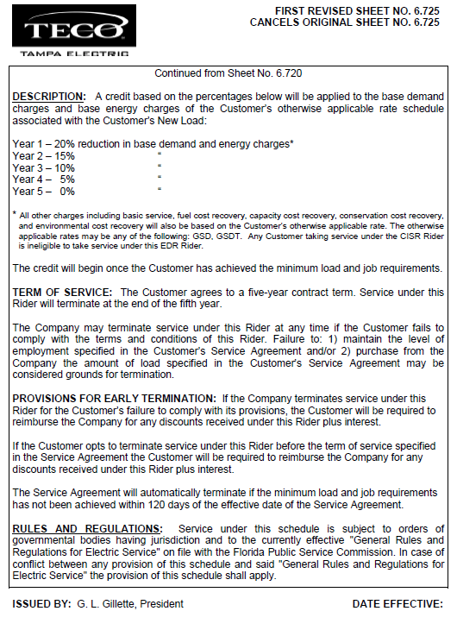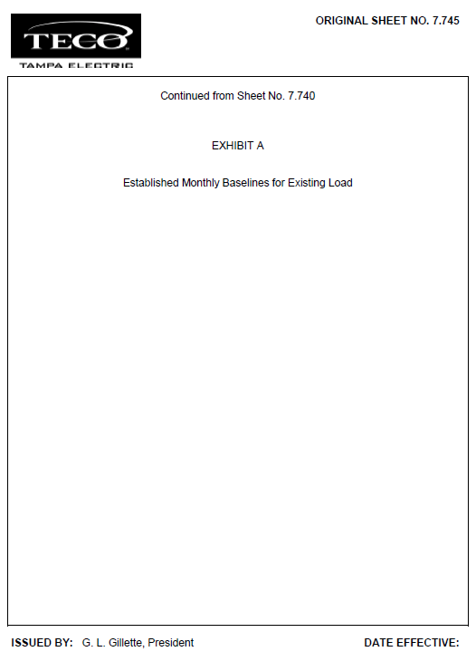

1. Order No. PSC-13-0443-FOF-EI, issued September 30, 2013, in Docket No. 130040-EI, In re: Petition for rate increase by Tampa Electric Company.