BEFORE THE FLORIDA PUBLIC SERVICE COMMISSION

In re: Joint petition to approve territorial agreement in Columbia, Lafayette, Suwannee, and Hamilton Counties by Suwannee Valley Electric Cooperative and Duke Energy Florida, LLC. | DOCKET NO. 160211-EU  ORDER NO. PSC-17-0039-PAA-EU  ISSUED: January 31, 2017

The following Commissioners participated in the disposition of this matter:

JULIE I. BROWN, Chairman
LISA POLAK EDGAR
ART GRAHAM
RONALD A. BRISÉ
DONALD J. POLMANN

NOTICE OF PROPOSED AGENCY ACTION
ORDER APPROVING TERRITORIAL AGREEMENT IN COLUMBIA, LAFAYETTE, SUWANNEE, AND HAMILTON COUNTIES BY SUWANNEE VALLEY ELECTRIC COOPERATIVE AND DUKE ENERGY FLORIDA, LLC.

BY THE COMMISSION:

NOTICE is hereby given by the Florida Public Service Commission that the action discussed herein is preliminary in nature and will become final unless a person whose interests are substantially affected files a petition for a formal proceeding, pursuant to Rule 25-22.029, Florida Administrative Code (F.A.C.).

Background

On September 14, 2016, Suwannee Valley Electric Cooperative (SVEC) and Duke Energy Florida, LLC (DEF) filed a joint petition for approval of an amended territorial agreement (proposed agreement) in Columbia, Lafayette, Suwannee, and Hamilton Counties. The proposed agreement is Attachment 1 to the petition, and incorporated as Attachment A to this order, while the maps and written descriptions delineating the area to be served by the proposed agreement are provided in the petition as Exhibits A and D, respectively. Due to the volume of those exhibits, only page 25 of the petition, the map of Columbia County’s service area, is included as Attachment B. At Commission staff’s request, DEF submitted a composite exhibit that contains the data from all 98 map sheets involved in this transfer into a single, easy to read exhibit attached to this order as Attachment C.

This Commission approved the existing territorial agreement between SVEC and DEF in 1995. The existing agreement was for a term of 20 years and ended March 14, 2015. Since then there have been two Commission-approved extensions to allow the joint petitioners time to finalize negotiations. The first extension expired March 14, 2016, and the second extended the agreement until September 14, 2016. The joint petitioners have negotiated the proposed agreement, which delineates their respective service boundaries in Columbia, Lafayette, Suwannee, and Hamilton Counties, for a 20-year term. This agreement also consolidates an expired territorial agreement in Hamilton County which was issued August 1990 and expired in August 2010. This agreement transfers 29 commercial customers and 102 residential customers from DEF to SVEC, and 11 commercial customers and 57 residential customers from SVEC to DEF. The transfers will be implemented as soon as it is operationally feasible for both parties to serve the total 199 impacted customers, but no later than 36 months after this order.
We have jurisdiction over this matter pursuant to Section 366.04, Florida Statutes (F.S.).
Decision
This agreement is an extension of an earlier one set to expire in 2016, and consolidates the previously expired agreement for Hamilton County. It is in the public interest and will enable SVEC and DEF to better serve their current and future customers.
Pursuant to Section 366.04(2)(d), F.S. and Rule 25-6.0440(2), F.A.C., we have jurisdiction to approve territorial agreements between, and among, rural electric cooperatives, municipal electric utilities, and investor-owned utilities. Unless we determine that the agreement will cause a detriment to the public interest, the agreement should be approved.
The two utilities desire to continue and consolidate two existing agreements and clarify the territorial boundaries within Columbia, Lafayette, Suwannee, and Hamilton Counties. This agreement enables the petitioners to more reliably and economically serve customers. This agreement modifies the territorial boundaries to eliminate split parcels, and results in the transfer of 199 customers between the utilities. Madison County has been removed from this proposed agreement due to the fact that DEF does not share any territorial boundaries with SVEC in the county.
This agreement is in effect for a 20-year term, and contains the condition that after the expiration date, the agreement will remain in effect until and unless either party provides a written notice at least 12 months prior to termination. Pursuant to Section 1.9 of the agreement, the effective date of the agreement will be the date that we issue the final order, provided no timely protests are filed.
In accordance with Rule 25-6.0440(1)(d), F.A.C., the 199 customers impacted by this agreement have been notified by mail of the transfer and each were provided with a description of the difference in rates between DEF and SVEC. As of August 2016, the rate comparison for a non-demand commercial customer, using 1,500 kilowatt-hours, was $171.22 for DEF and $180.00 for SVEC. As of August 2016, the rate comparison for a residential customer, using 1,000 kilowatt-hours, was $108.48 for DEF and $121.00 for SVEC. Both parties will apply any deposits of the impacted customers to their last electric bill and will directly refund any surplus. The joint petitioners expect that the customer transfers will be completed within 36 months of the agreement’s effective date and will notify the Commission in writing if additional time is needed.
With regard to this proposed agreement, the petitioners have asserted that SVEC has not received any feedback, questions, or concerns from the customers and DEF has received feedback from three customers. All three customers desired to remain with DEF and raised concerns about reliability of service, higher rates, vegetation management, and comparative restoration times with SVEC during Hurricane Hermine. DEF has personally contacted all three customers and provided information on how to submit comments to the Public Service Commission. This Commission received correspondence from one customer on November 8, 2016. This customer also cited reliability of service and higher rates as concerns with the proposed agreement.
Section 3.4 (Compensation for Transferred Customers) of the proposed agreement allows for the compensation of lost revenue due to the transfer of customers. Compensation only applies to the number of customers affected by modifications to the territorial boundaries, and the party losing the customers will be compensated for the loss of revenue by the receiving party. In total SVEC is estimated to pay DEF approximately $260,412 in lost revenue and DEF is estimated to pay SVEC approximately $111,535. These estimates are reasonable in light of current rates. However, the final compensation amounts will depend on the approval date of this agreement. Compensation is intended to be provided within 60 days of the provided invoice.
In accordance with section 3.5 (Compensation for Transferred Facilities) of the proposed agreement, SVEC may elect to purchase electric distribution facilities used exclusively for providing electric service to the transferred customers. To determine the facilities’ value, DEF will use a common engineering cost estimation methodology such as the Handy-Whitman index. In response to Commission staff’s data request, joint petitioners believe that the net purchase of facilities to be transferred will not exceed $100,000. The actual amount will depend on approval of this agreement.
This agreement should avoid the likelihood of the duplication of services and wasteful expenditures by DEF and SVEC. This agreement should also improve the ability of each utility to take actions to protect the public health and safety of its customers from potentially hazardous conditions. This Commission’s approval of this agreement is therefore in the public interest.
By merging the two prior agreements, this Commission has clarified boundary lines, and reduced the likelihood of uneconomic duplication of facilities. This action should promote the responsiveness to customer needs without a decrease in the reliability of electric service. After considering the concerns of cost and service issues raised by individual customers, we have determined that the transfer of 199 customers will benefit the customer base as a whole by avoiding the duplication of services, maintaining lower rates, enhancing safety and reliability, and reducing restoration times. Accordingly, the territorial agreement between SVEC and DEF is hereby approved.
Based on the foregoing, it is

ORDERED by the Florida Public Service Commission that the territorial agreement between Suwannee Valley Electric Cooperative and Duke Energy Florida, LLC shall be approved.

ORDERED that the provisions of this Order, issued as proposed agency action, shall become final and effective upon the issuance of a Consummating Order unless an appropriate petition, in the form provided by Rule 28-106.201, Florida Administrative Code, is received by the Commission Clerk, 2540 Shumard Oak Boulevard, Tallahassee, Florida 32399-0850, by the close of business on the date set forth in the “Notice of Further Proceedings” attached hereto. It is further

ORDERED that in the event this Order becomes final, this docket shall be closed.

By ORDER of the Florida Public Service Commission this 31st day of January, 2017.

/s/ Carlotta S. Stauffer
CARLOTTA S. STAUFFER
Commission Clerk
Florida Public Service Commission
2540 Shumard Oak Boulevard
Tallahassee, Florida 32399
(850) 413-6770
www.floridapsc.com

Copies furnished: A copy of this document is provided to the parties of record at the time of issuance and, if applicable, interested persons.

WLT

NOTICE OF FURTHER PROCEEDINGS OR JUDICIAL REVIEW

The Florida Public Service Commission is required by Section 120.569(1), Florida Statutes, to notify parties of any administrative hearing that is available under Section 120.57, Florida Statutes, as well as the procedures and time limits that apply. This notice should not be construed to mean all requests for an administrative hearing will be granted or result in the relief sought.

Mediation may be available on a case-by-case basis. If mediation is conducted, it does not affect a substantially interested person's right to a hearing.

The action proposed herein is preliminary in nature. Any person whose substantial interests are affected by the action proposed by this order may file a petition for a formal proceeding, in the form provided by Rule 28-106.201, Florida Administrative Code. This petition must be received by the Office of Commission Clerk, 2540 Shumard Oak Boulevard, Tallahassee, Florida 32399-0850, by the close of business on February 21, 2017.

In the absence of such a petition, this order shall become final and effective upon the issuance of a Consummating Order.

Any objection or protest filed in this/these docket(s) before the issuance date of this order is considered abandoned unless it satisfies the foregoing conditions and is renewed within the specified protest period.

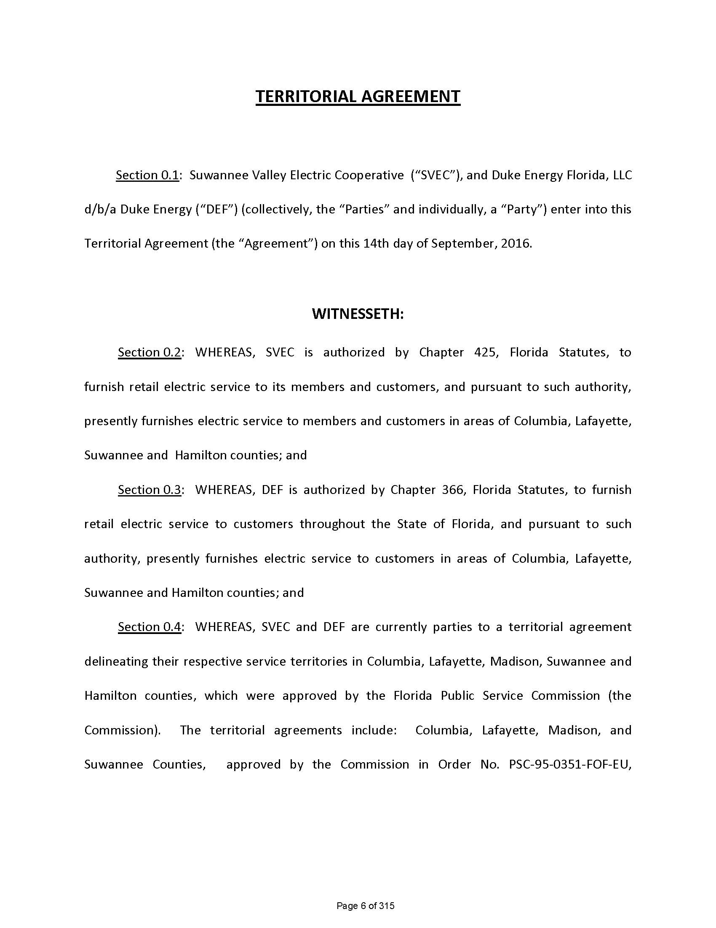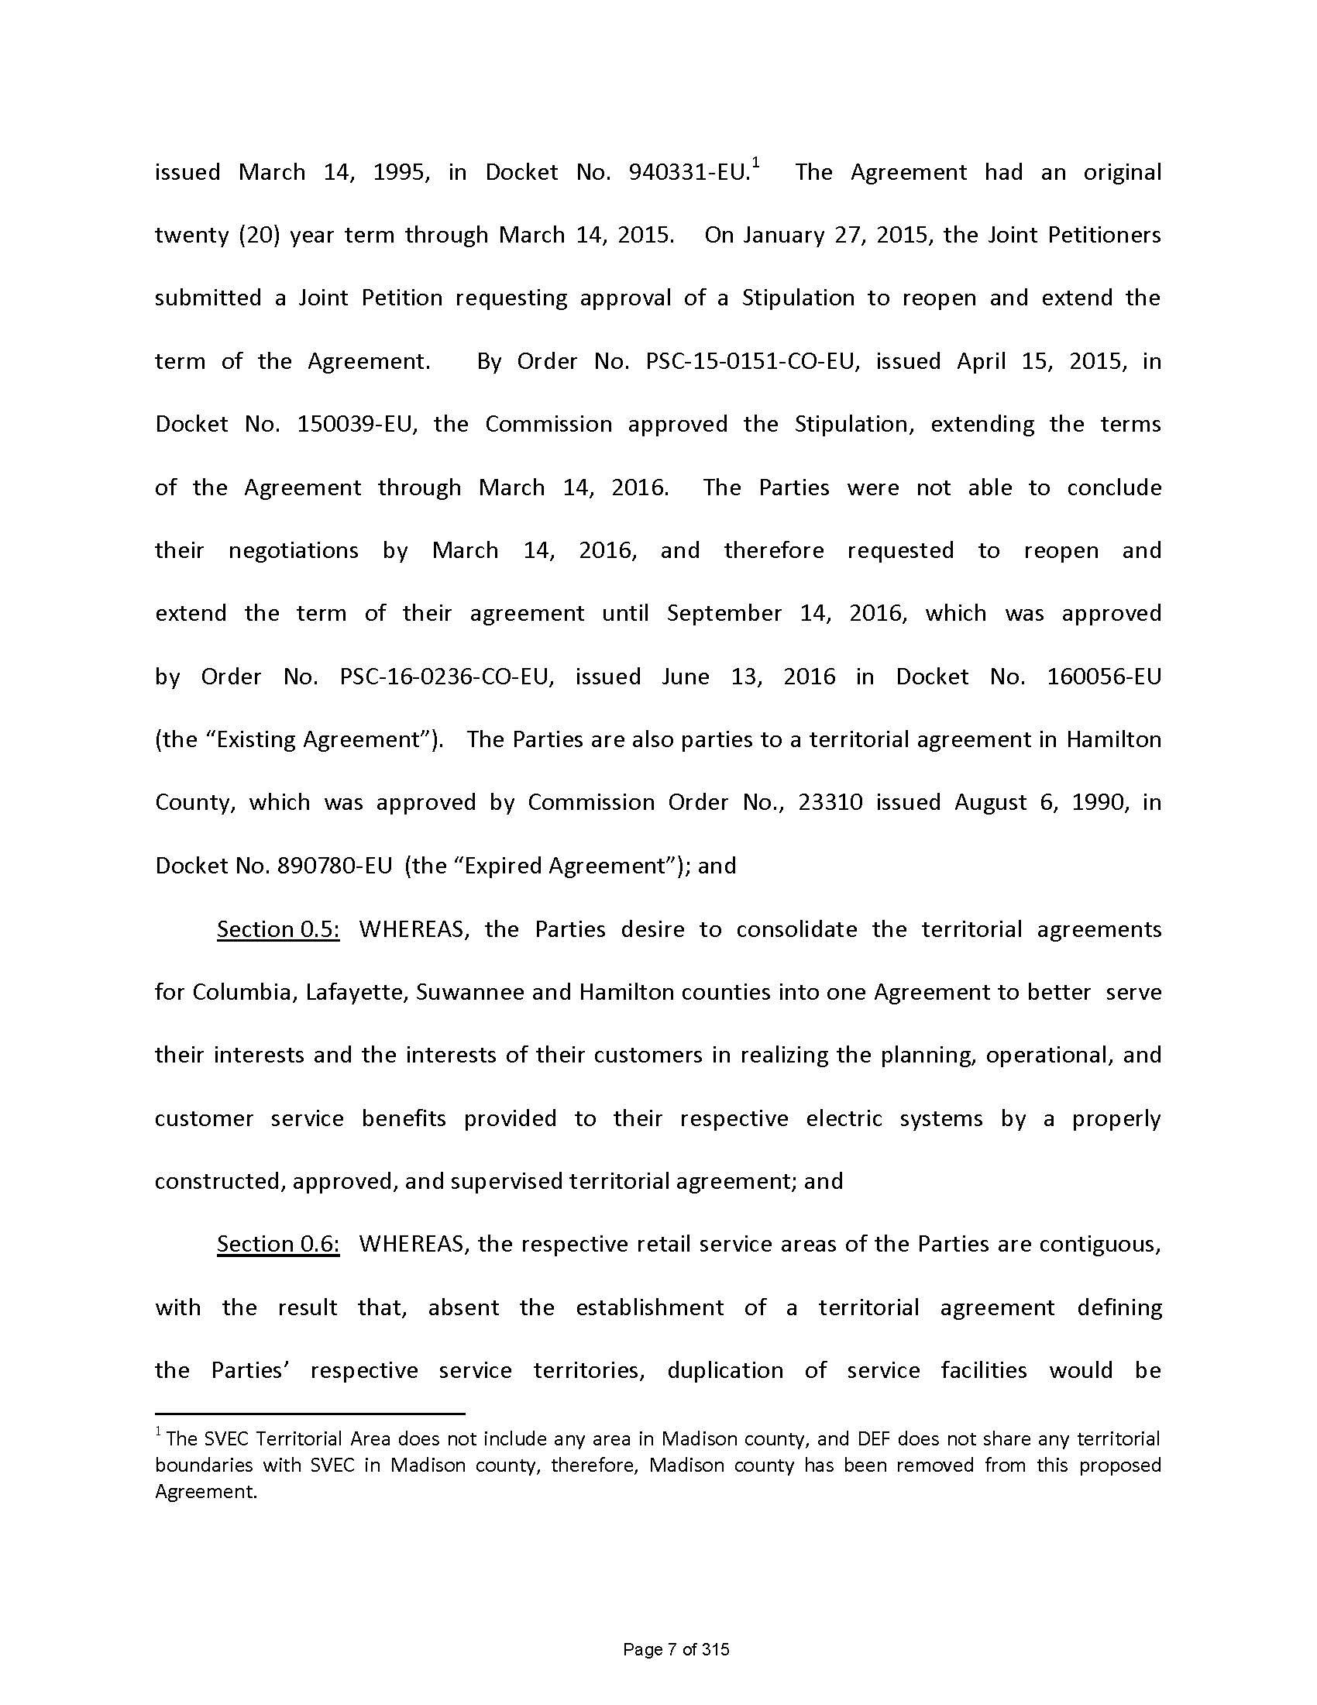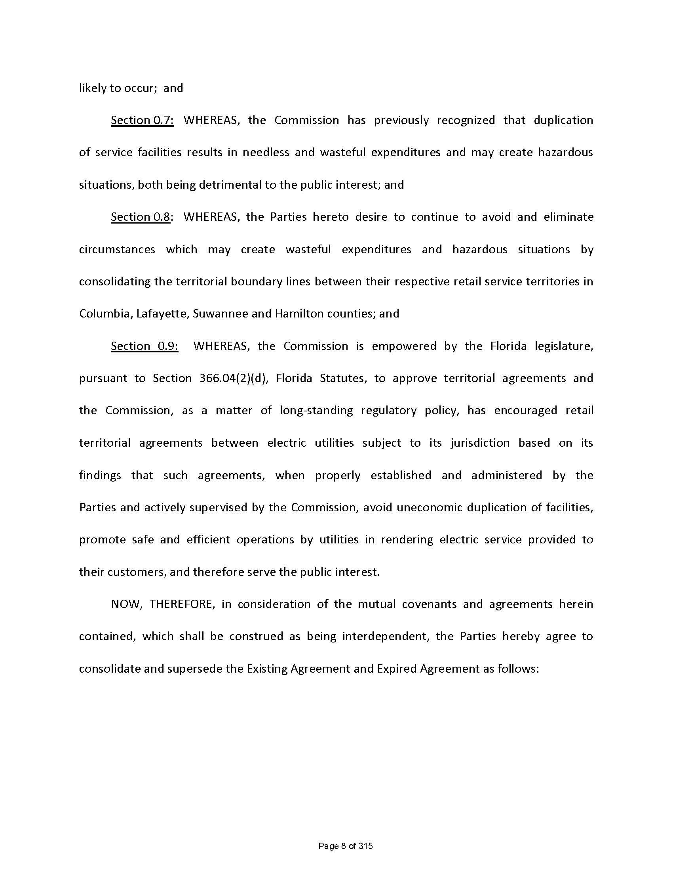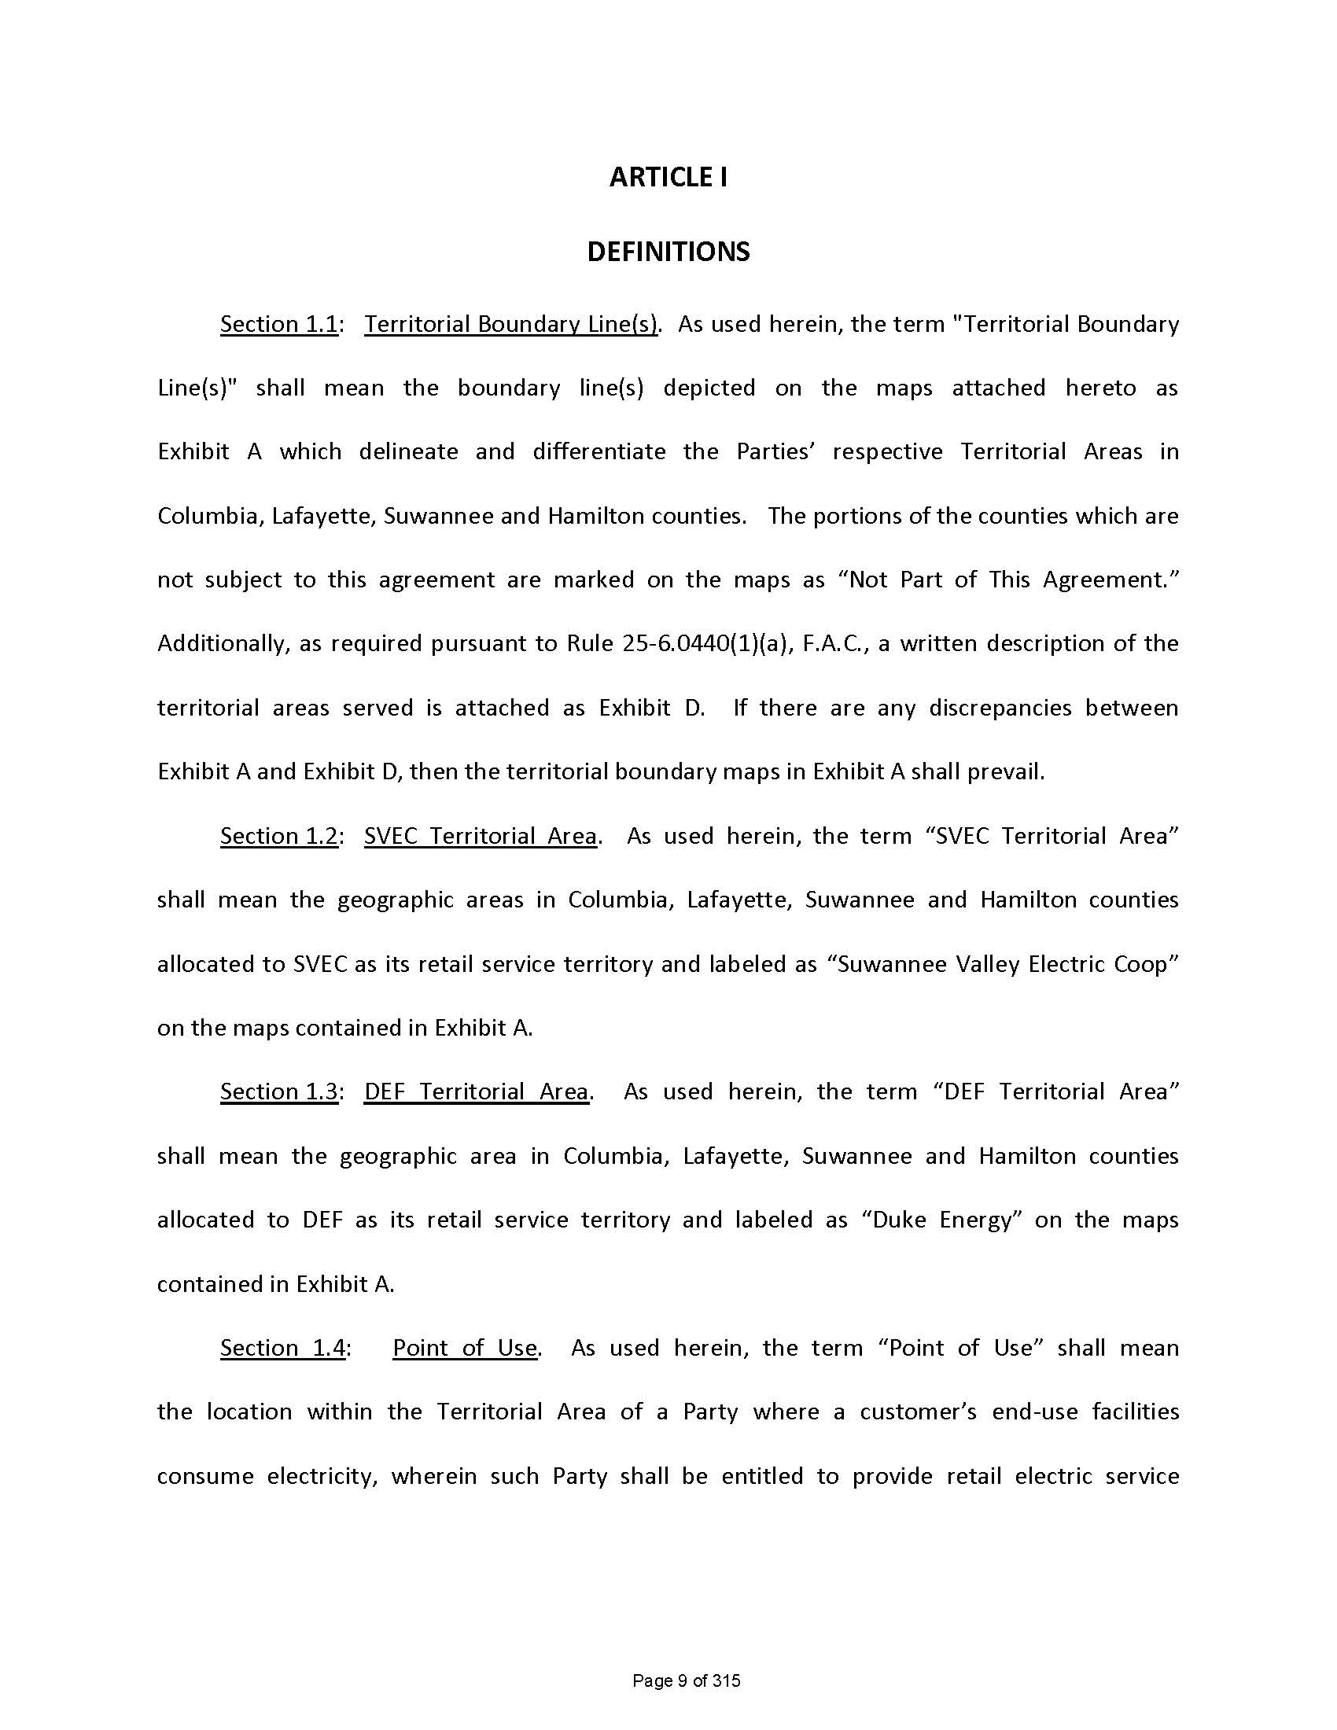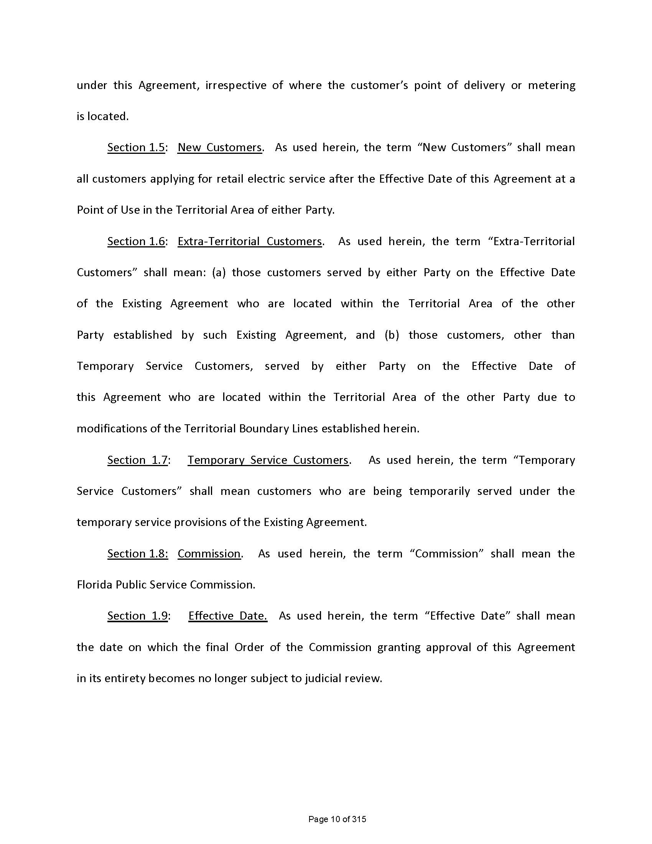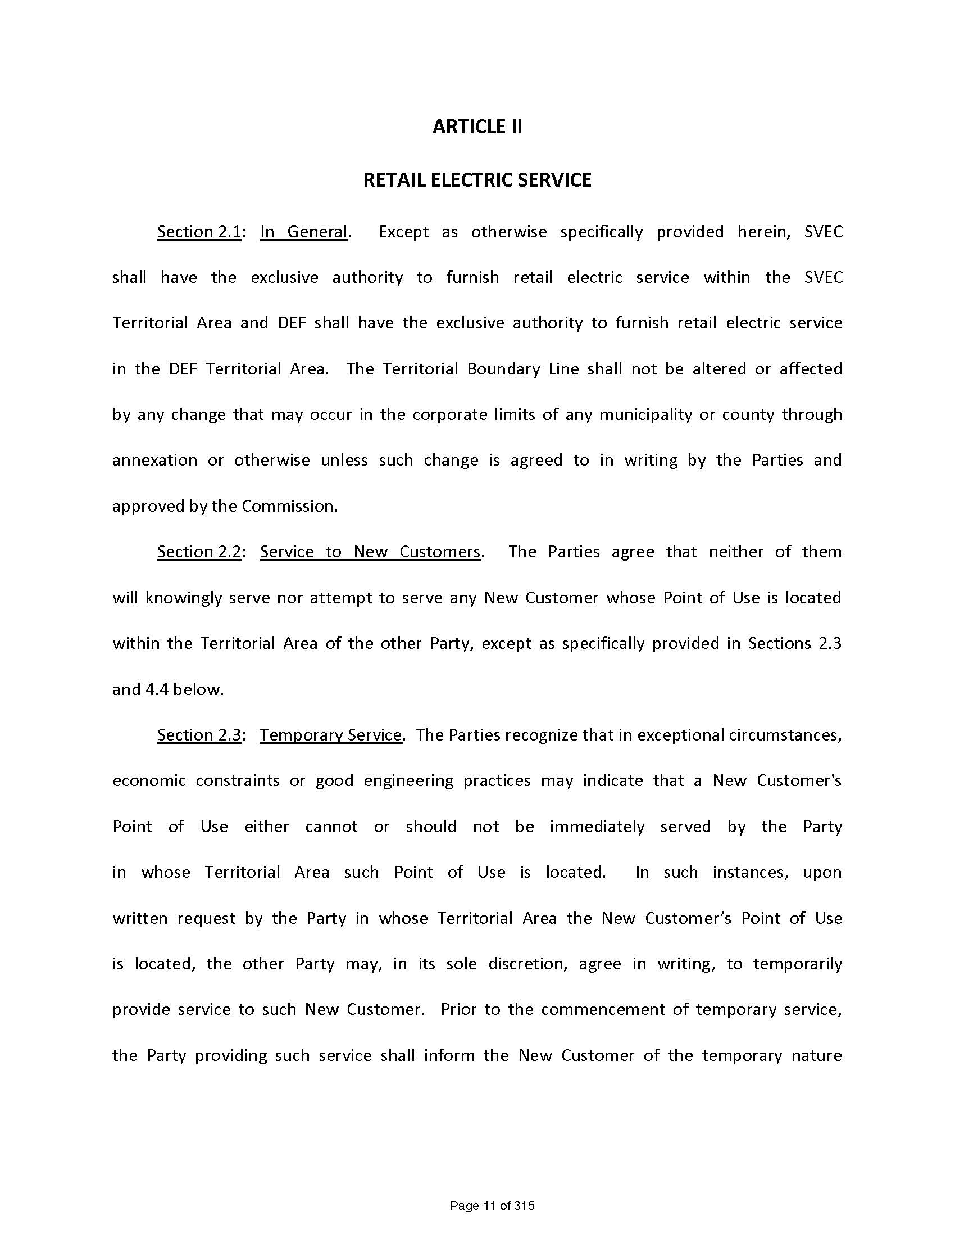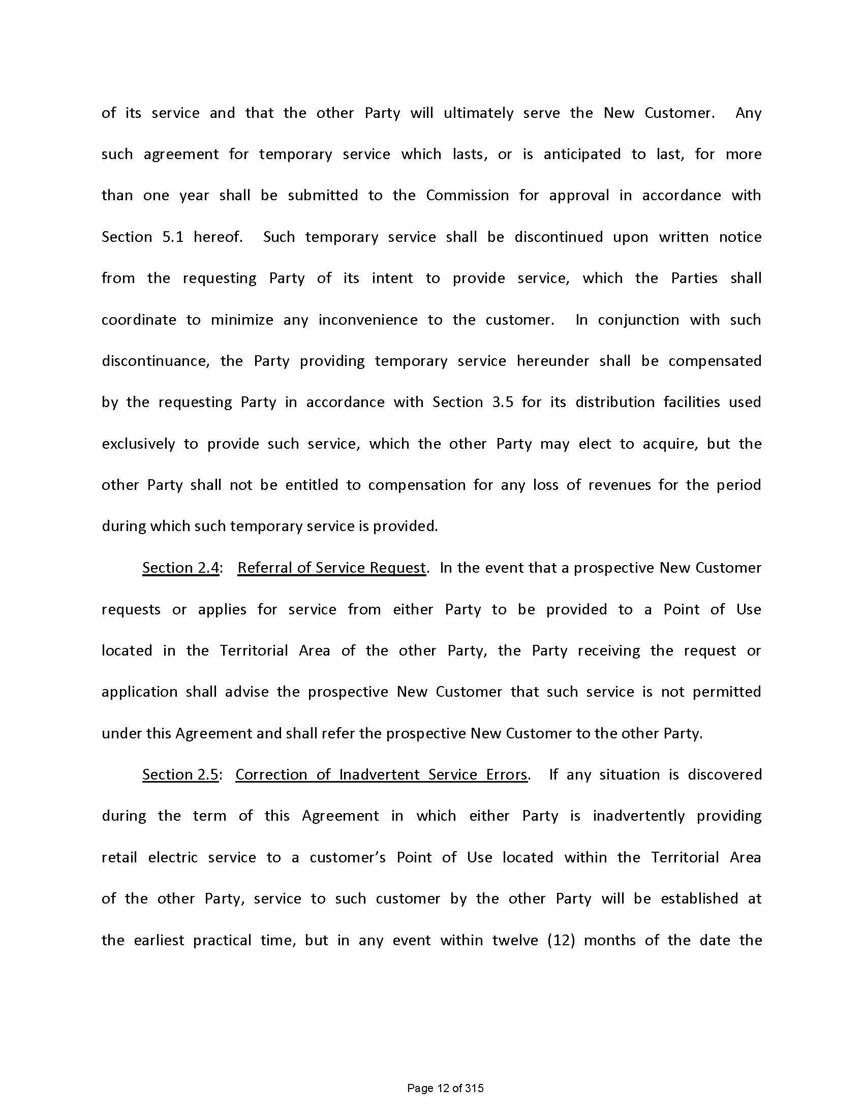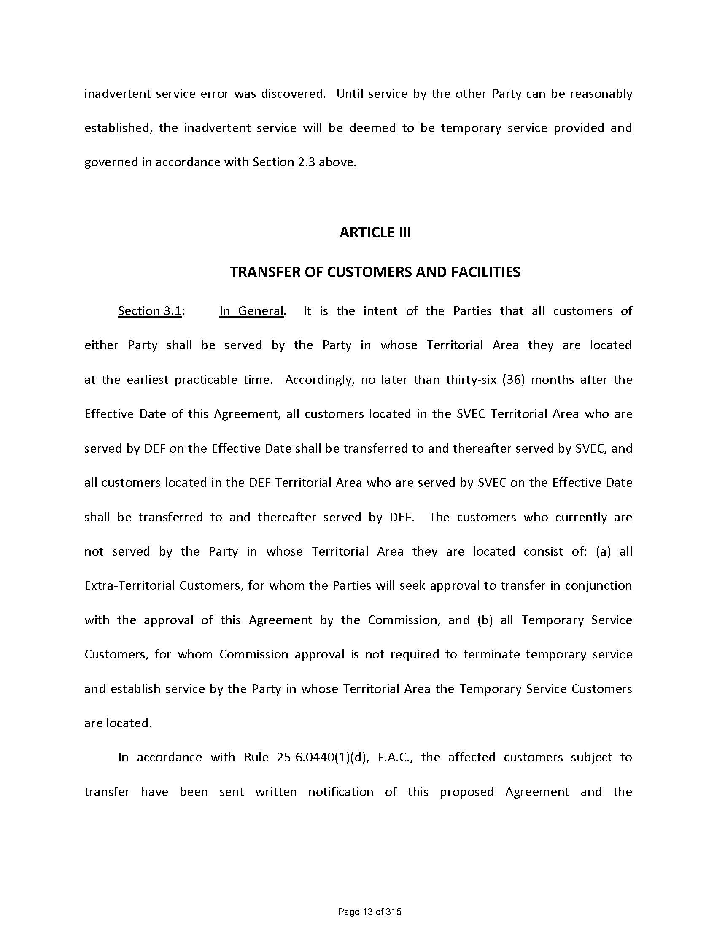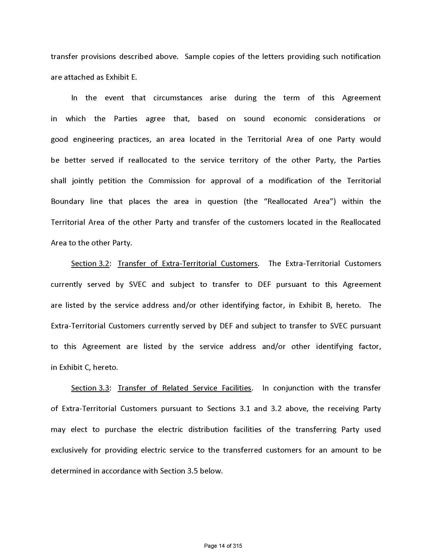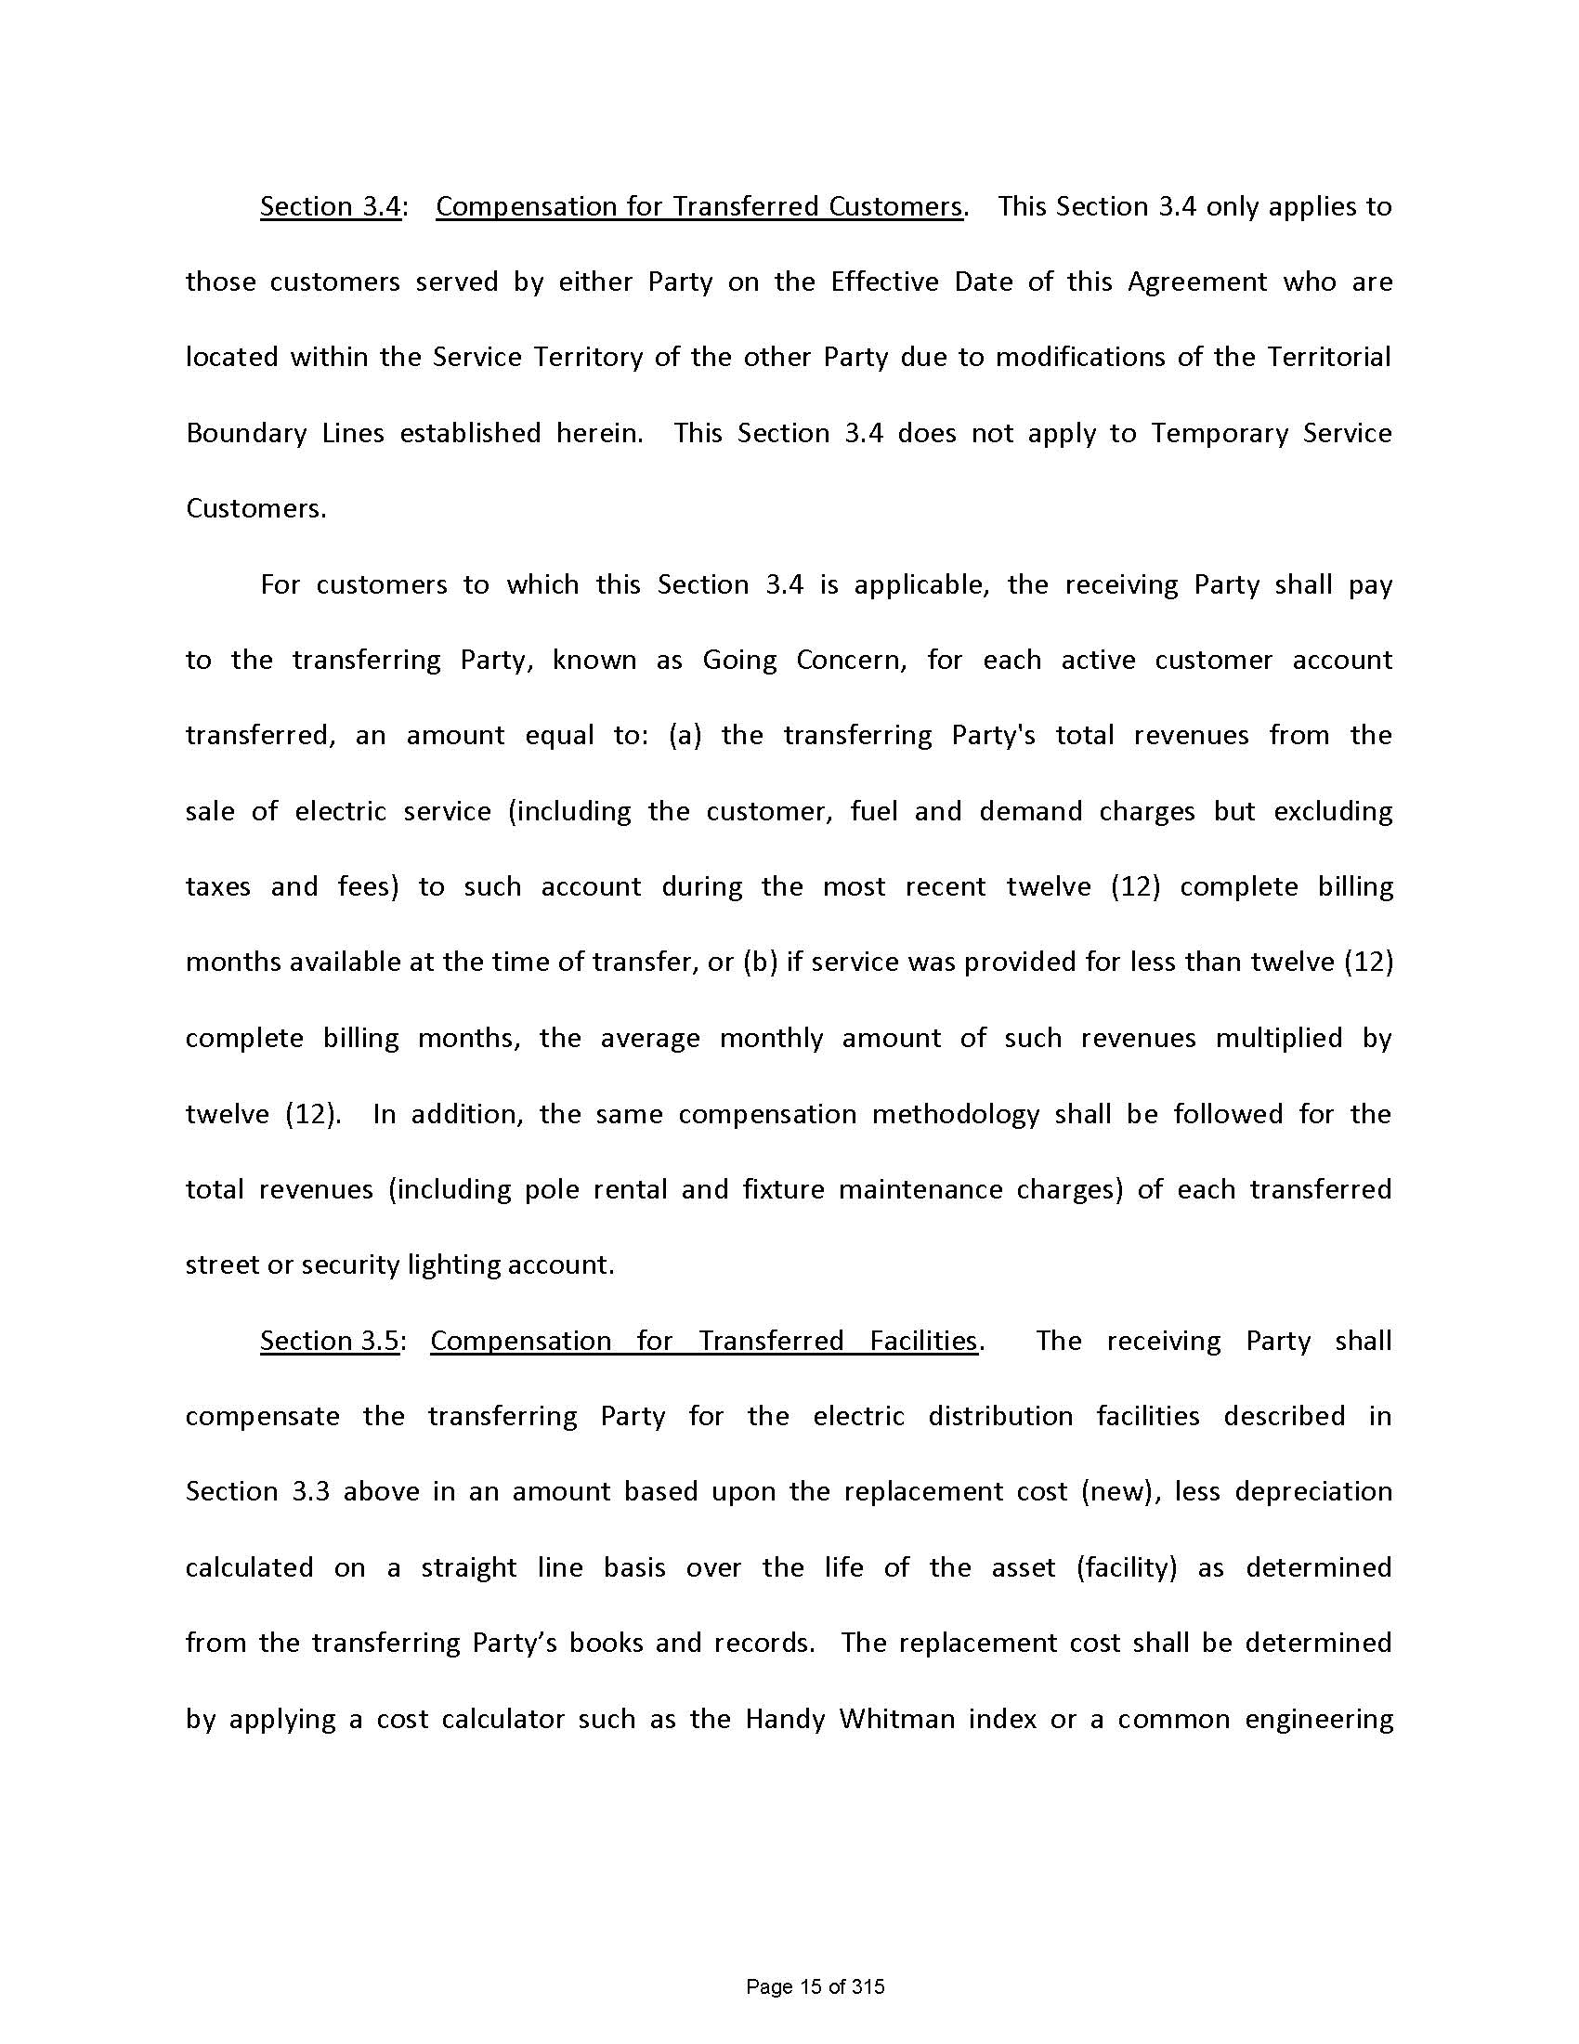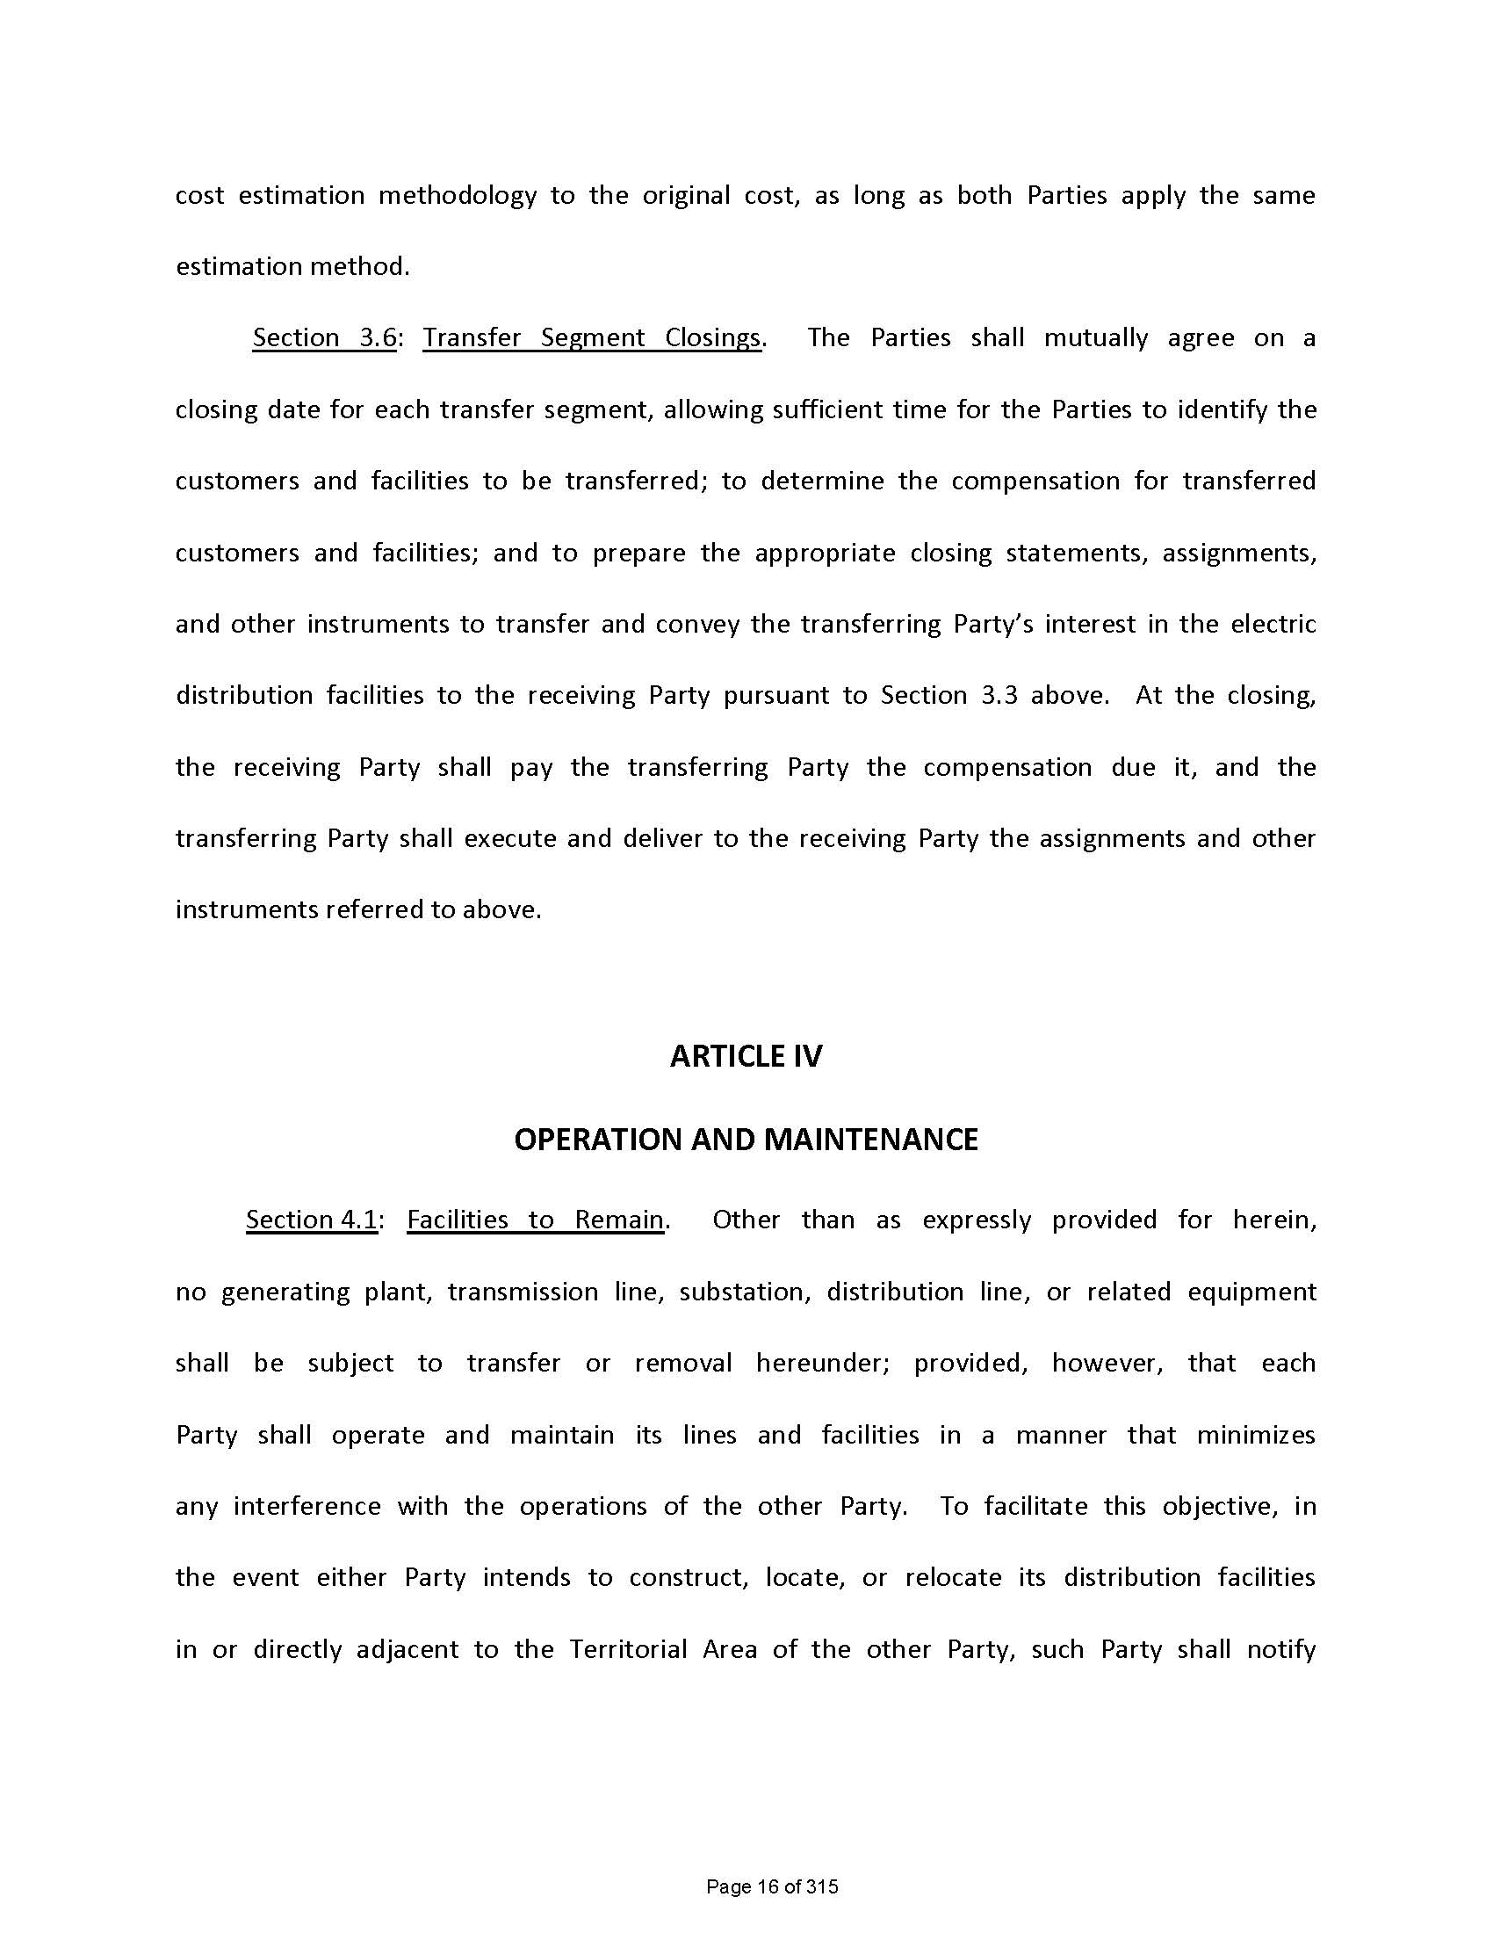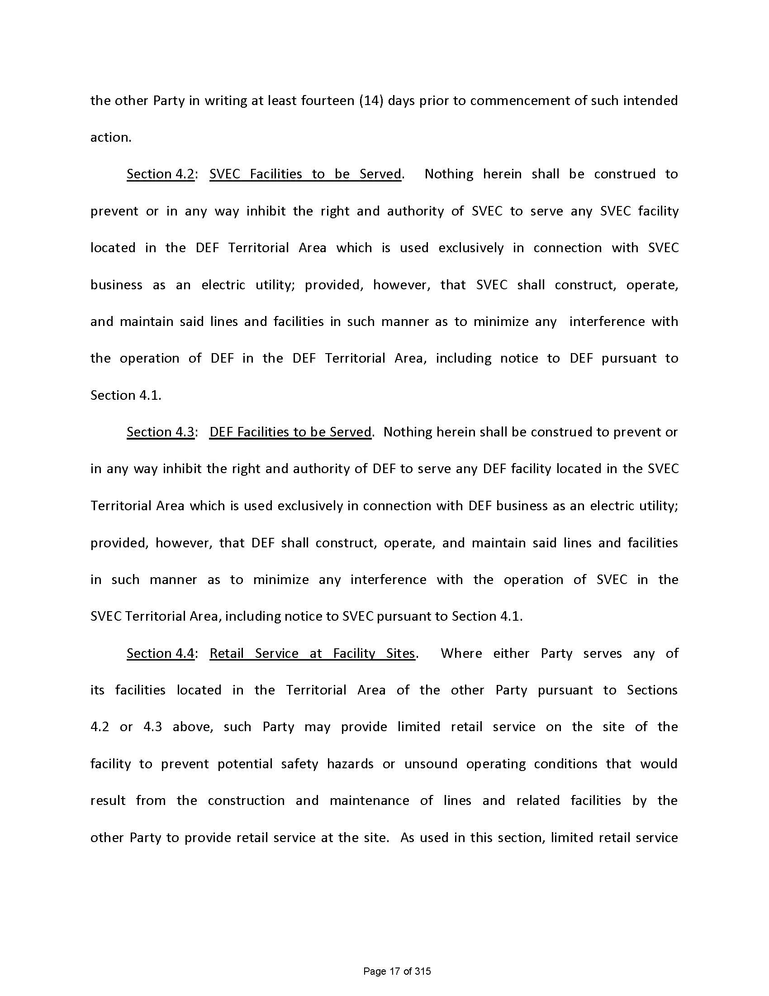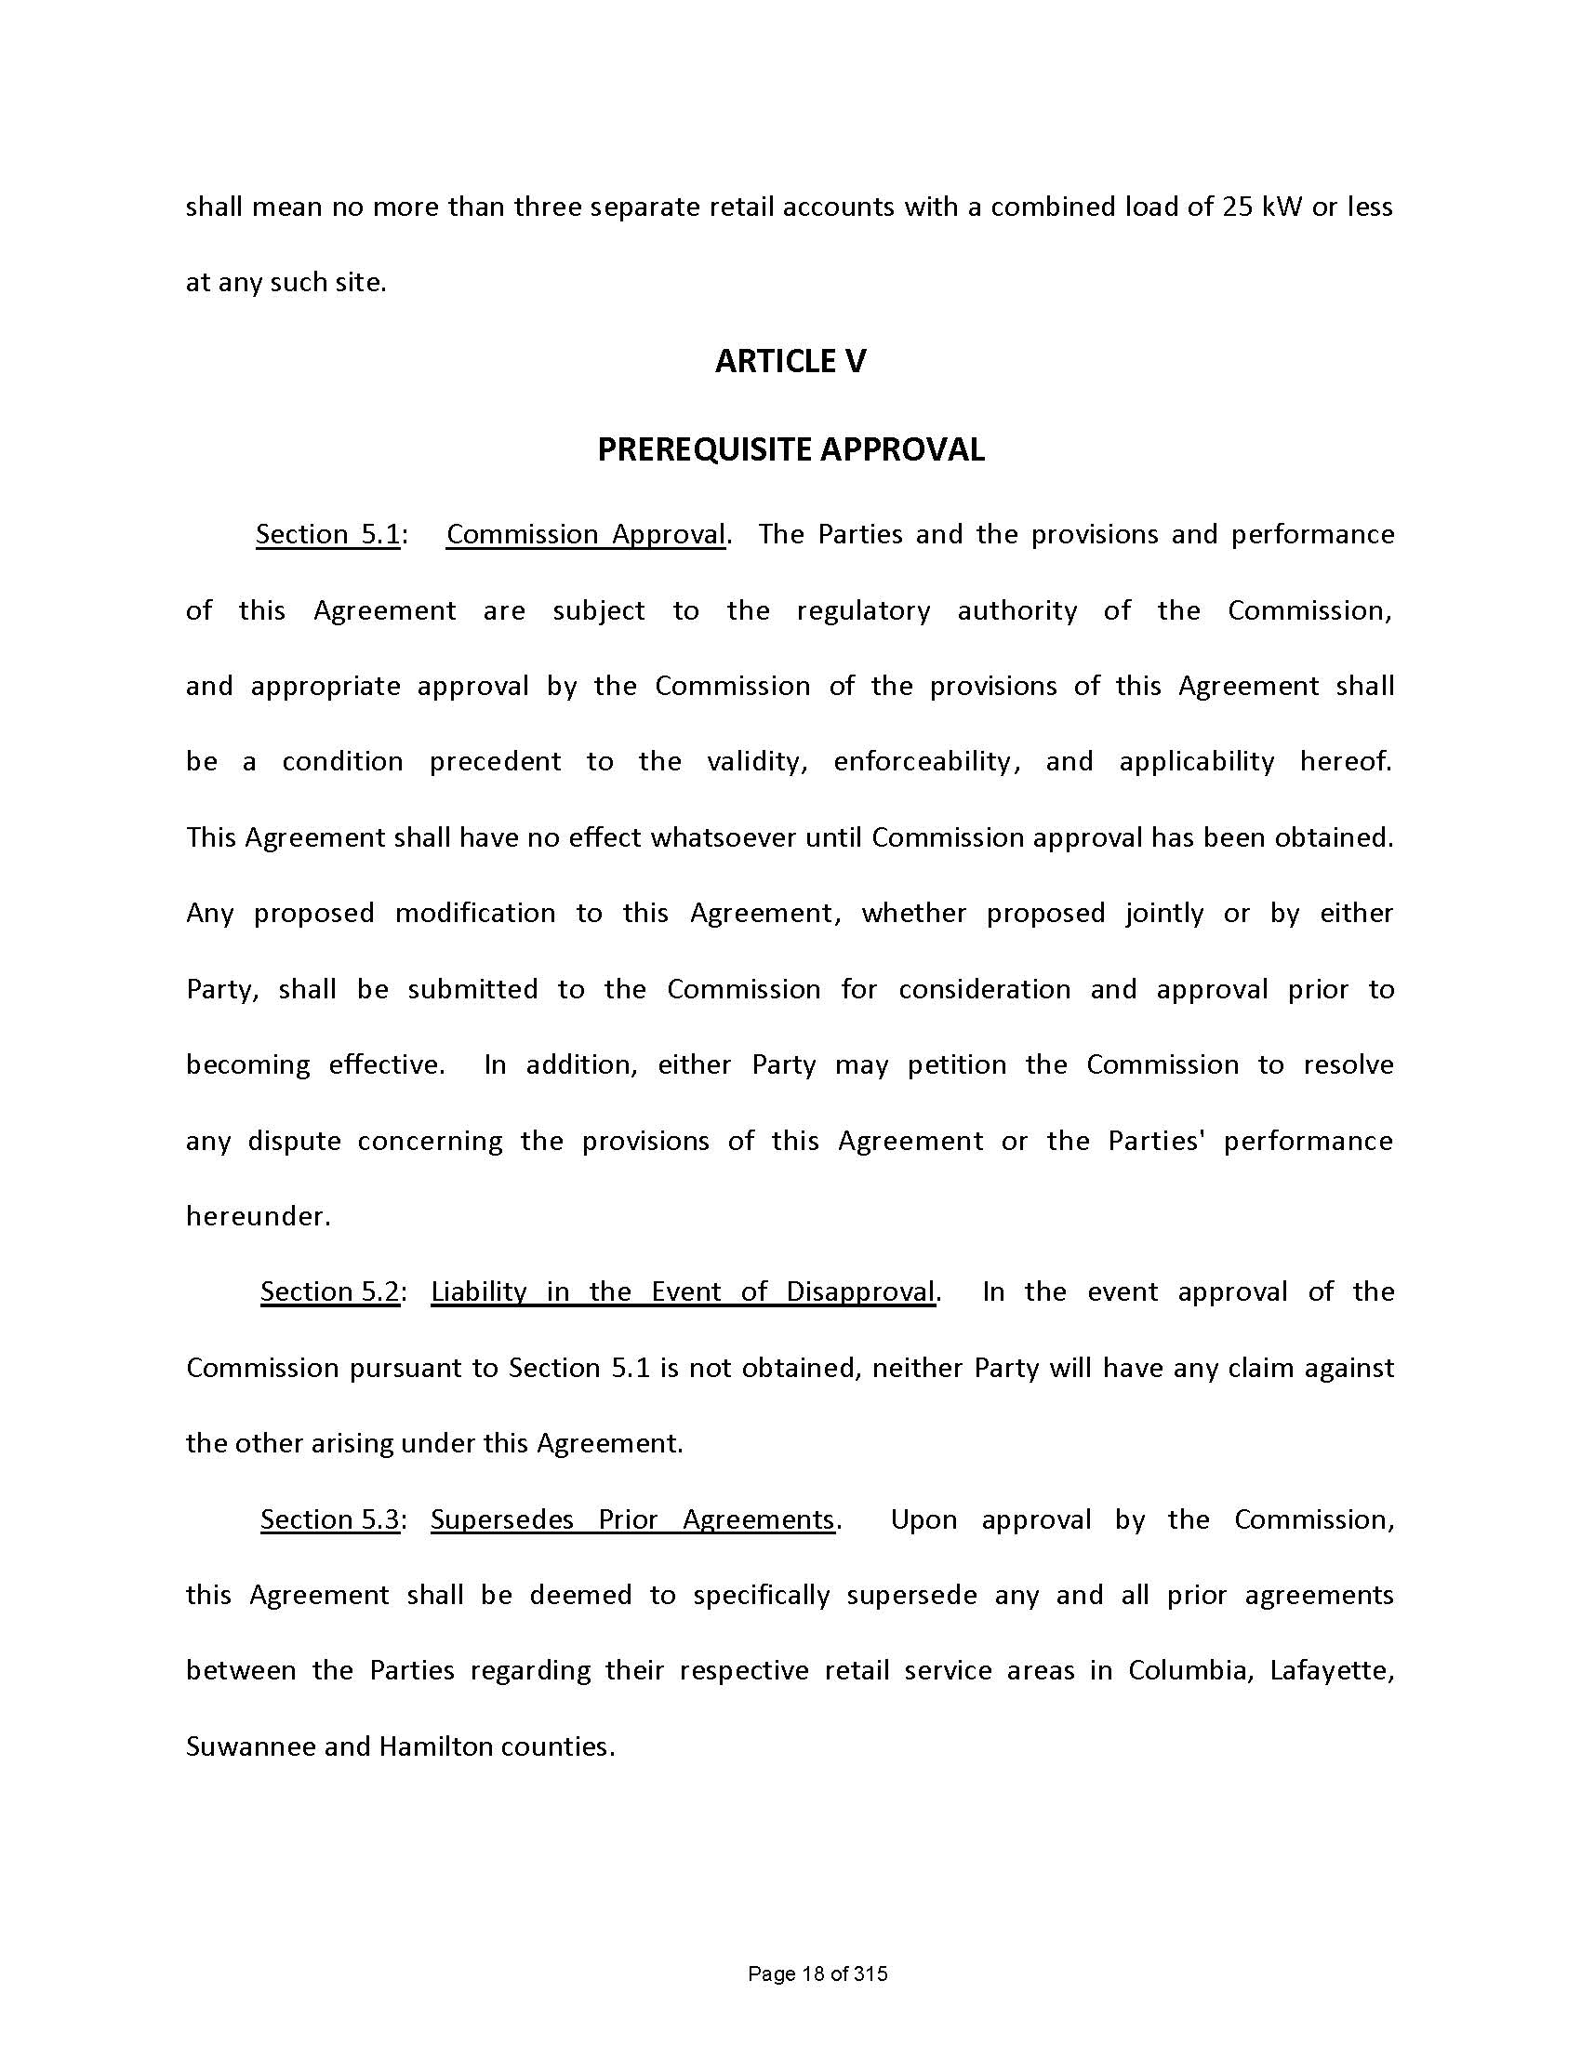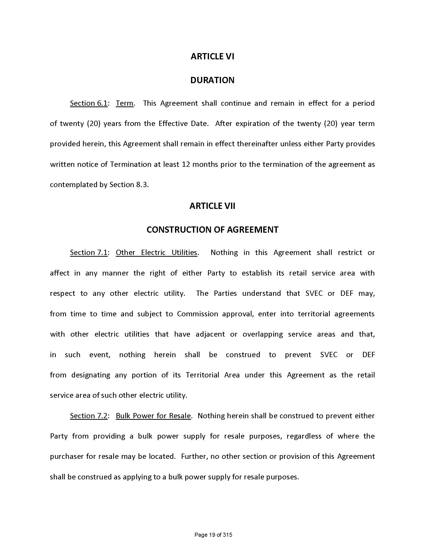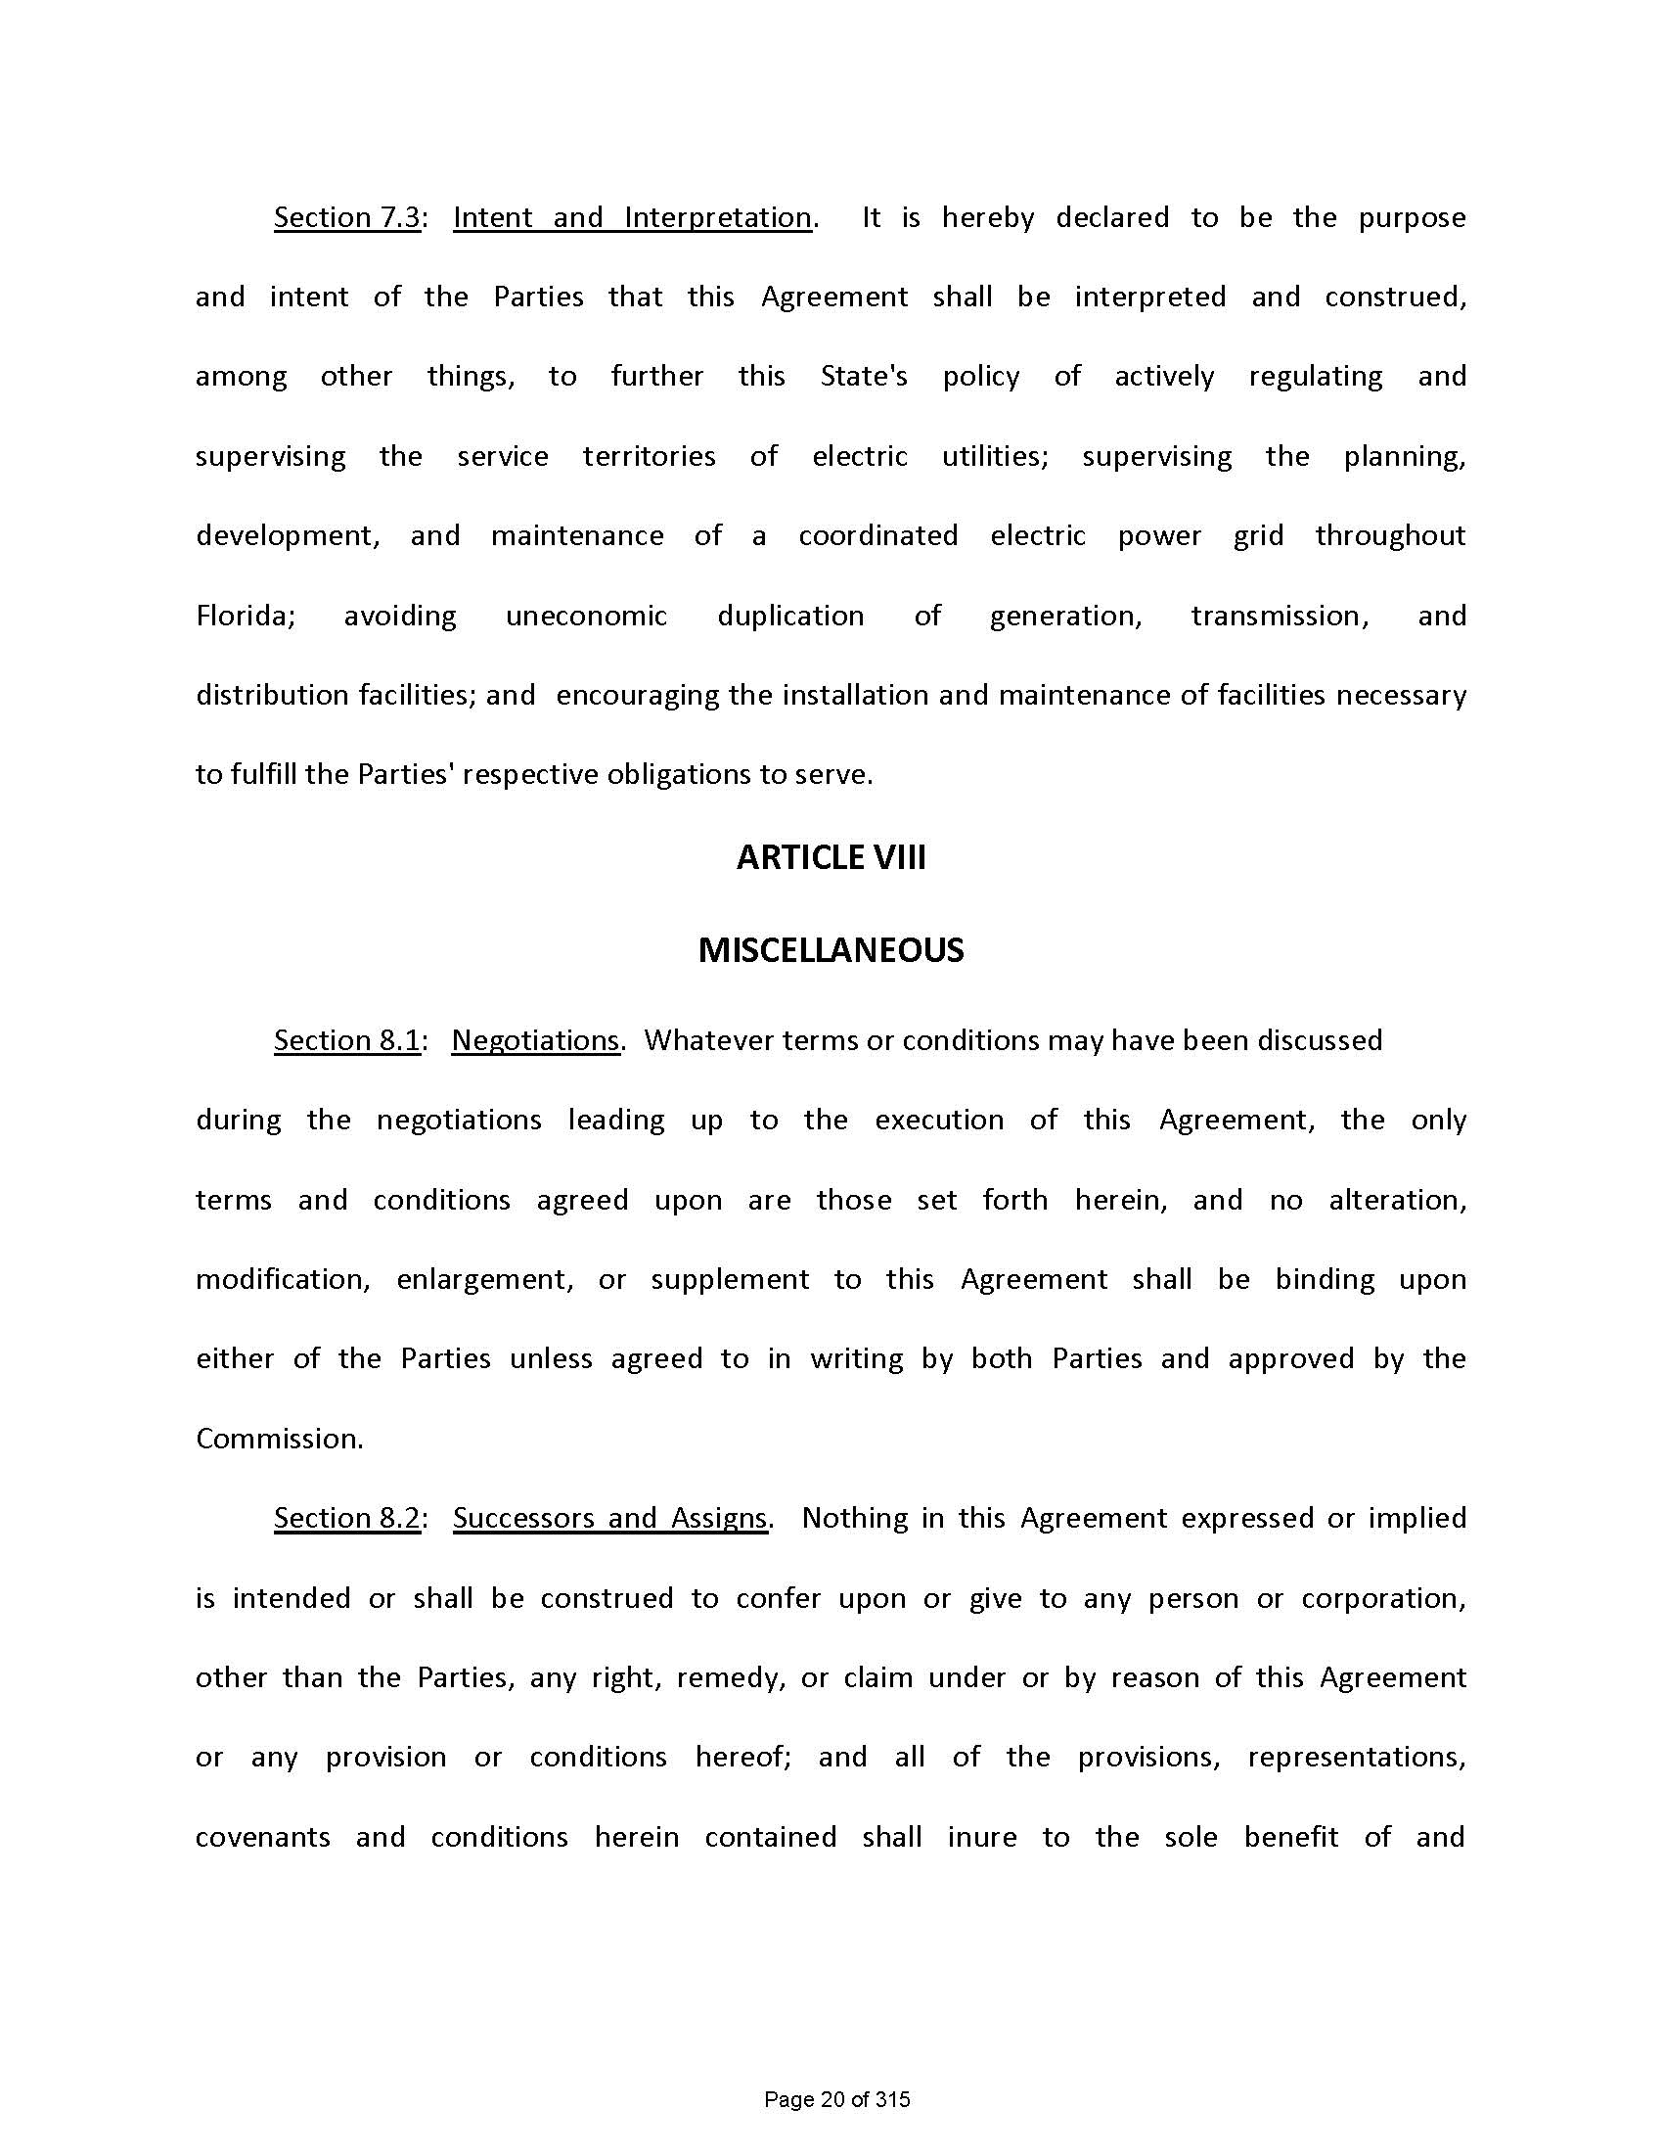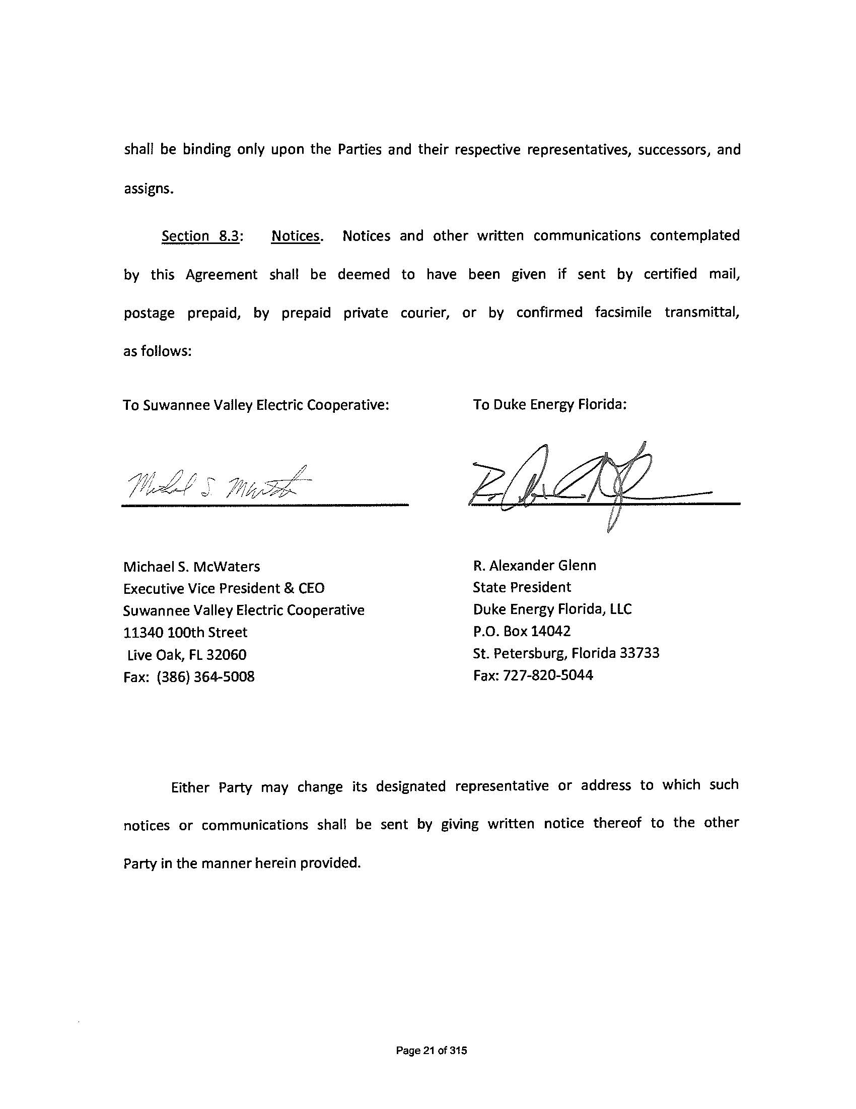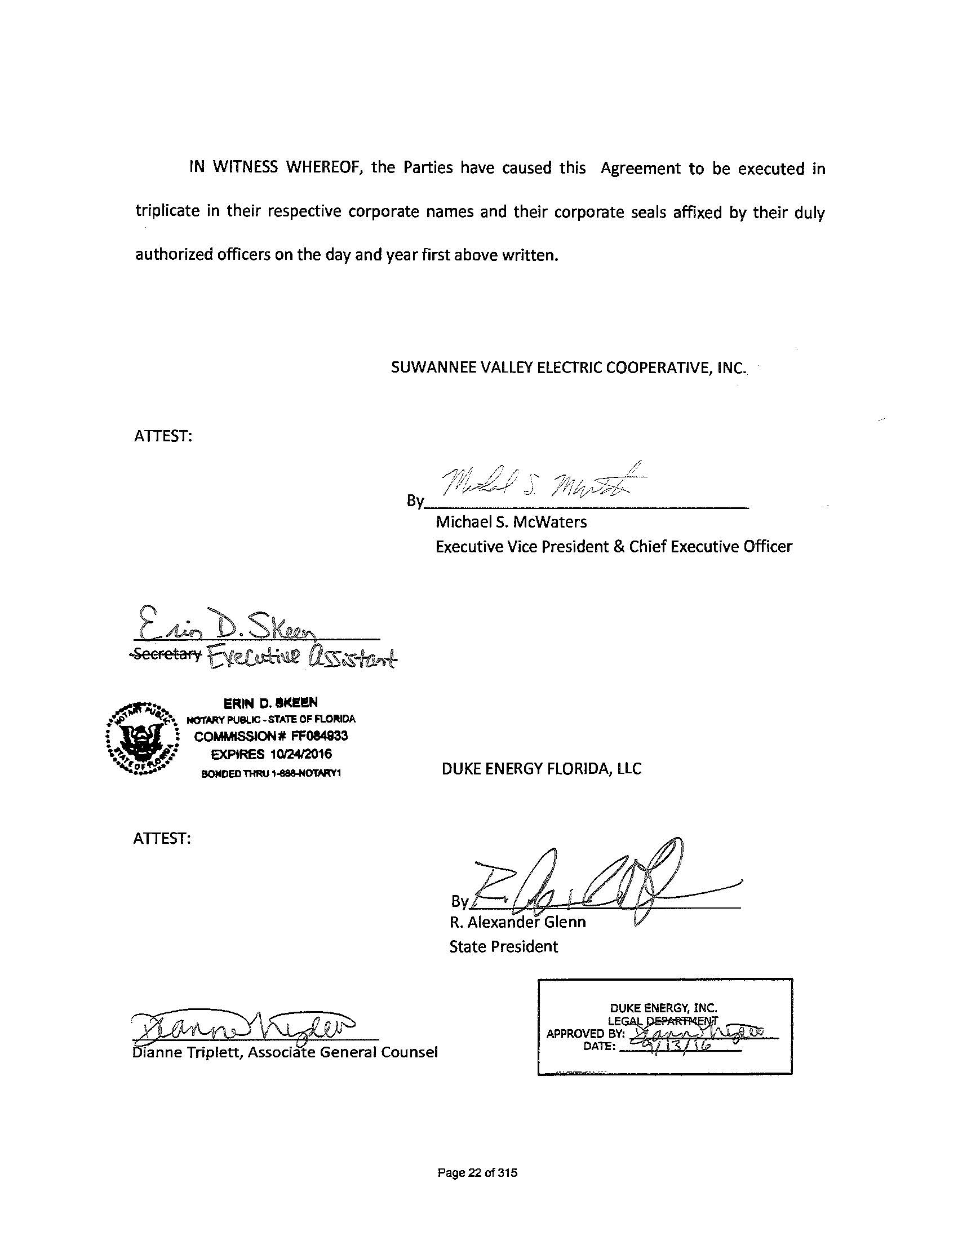
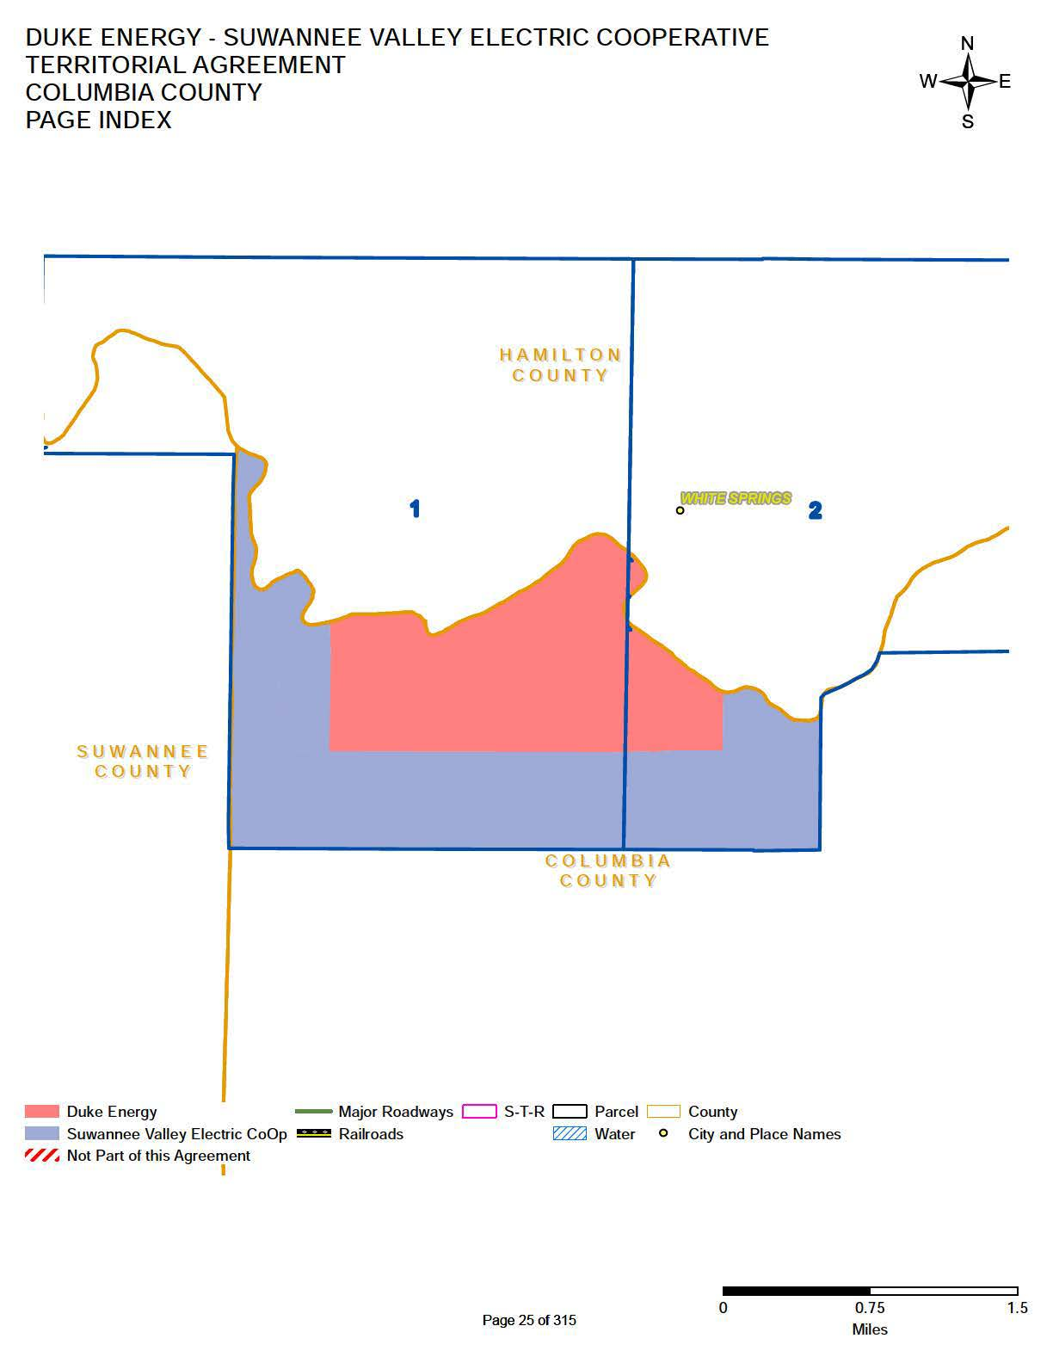
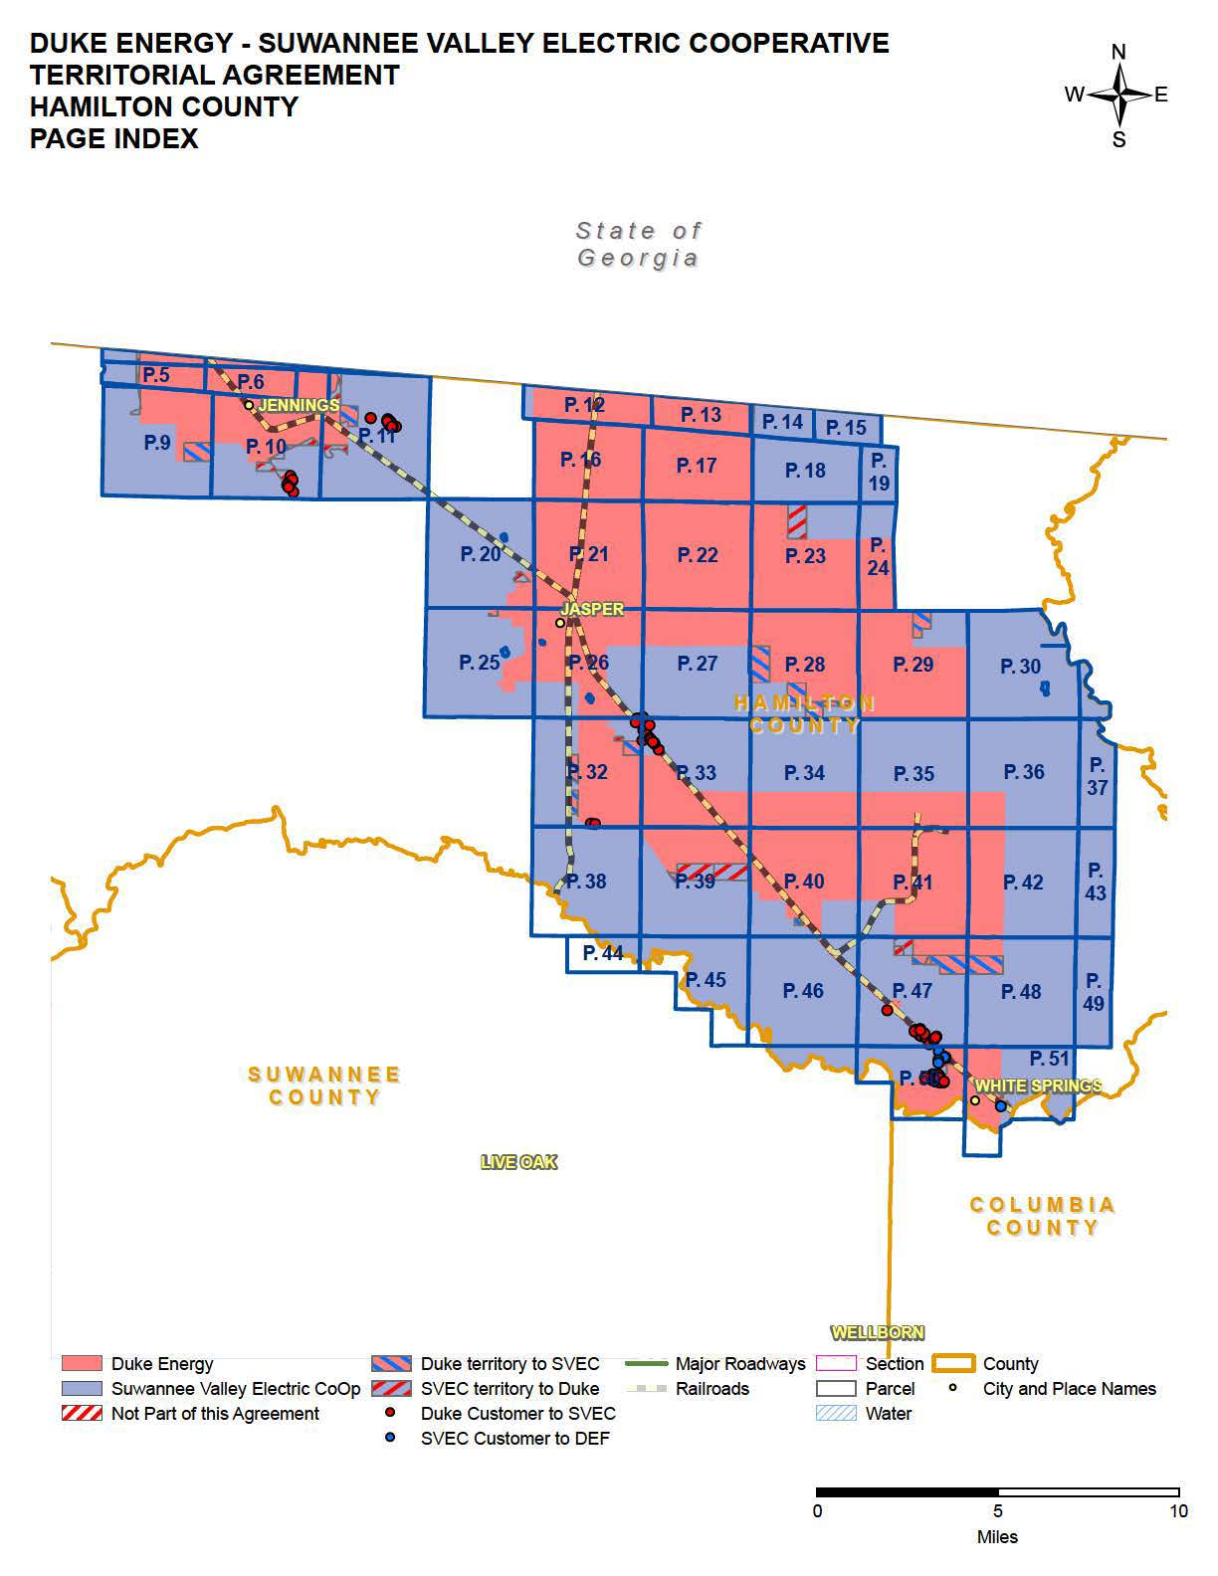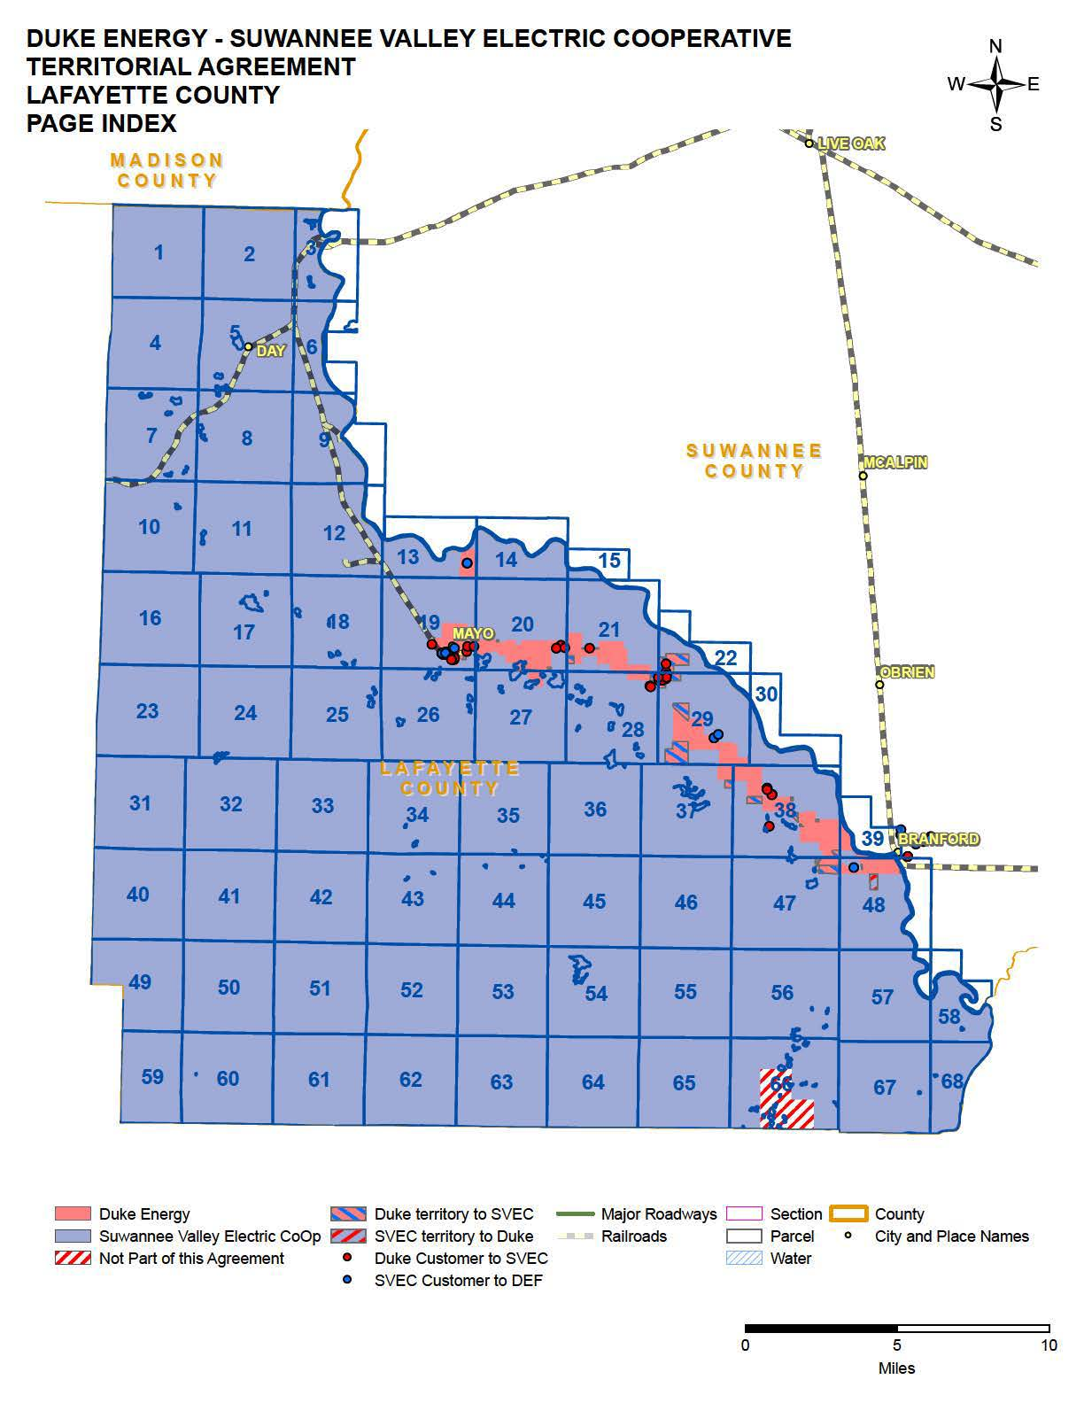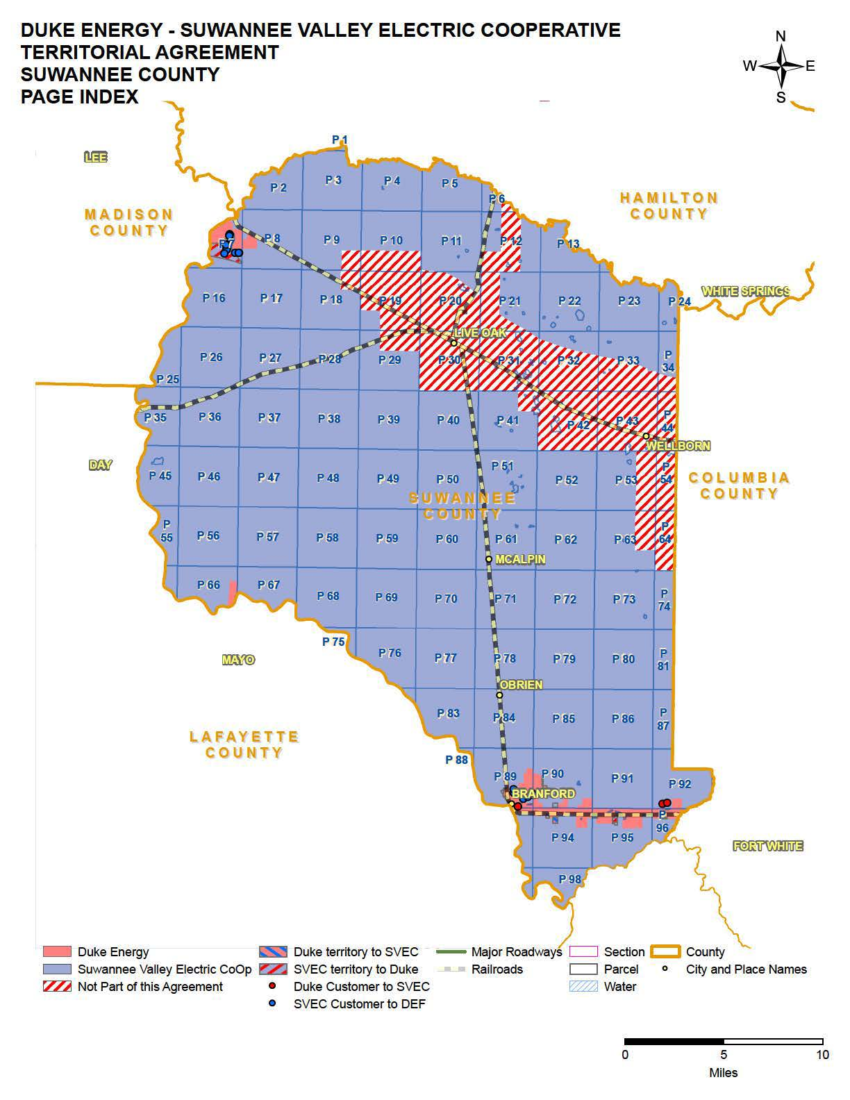

Order No. PSC-95-0351-FOF-EU, issued March 14, 1995, in Docket No. 940331-EU, In re: Petition to resolve territorial dispute with Florida Power Corporation.
Order No. PSC-15-0128-PAA-EU, issued March 20, 2015, in Docket No. 150039-EU, In re: Joint petition to reopen and extend the term of existing territorial agreement in Columbia, Lafayette, Madison, and Suwannee Counties.
Order No. PSC-16-0193-PAA-EU, issued May 17, 2016, in Docket No. 160056-EU, In re: Joint petition to reopen and extend the term of existing territorial agreement in Columbia, Lafayette, Madison, and Suwannee Counties.
Order No. 23310, issued August 6, 1990, in Docket No. 890780-EU, In re: Petition of Suwannee Valley Electric Cooperative, Inc. to resolve territorial disputes with Florida Power Corporation in Hamilton County.
Utilities Commission of the City of New Smyrna Beach v. Florida Public Service Commission, 469 So. 2d 731 (Fla. 1985).
Petition Exhibit E.
Document No. 08730-16, filed November 8, 2016, in Docket 160211-EU, In re: Joint petition to approve territorial agreement in Columbia, Lafayette, Suwannee, and Hamilton Counties.

