BEFORE THE FLORIDA PUBLIC SERVICE COMMISSION

In re: Petition for approval of settlement agreement pertaining to Peoples Gas System's 2016 depreciation study, environmental reserve account, problematic plastic pipe replacement, and authorized ROE. | DOCKET NO. 160159-GU  ORDER NO. PSC-17-0066-AS-GU  ISSUED: February 28, 2017

The following Commissioners participated in the disposition of this matter:

JULIE I. BROWN, Chairman
ART GRAHAM
RONALD A. BRISÉ
JIMMY PATRONIS
DONALD J. POLMANN

ORDER APPROVING SETTLEMENT AGREEMENT

BY THE COMMISSION:

Background

On June 28, 2016, Peoples Gas System (PGS), pursuant to Rule 25-7.045, Florida Administrative Code (F.A.C.), filed a petition for approval of the company’s 2016 depreciation study. Intervention by the Office of Public Counsel (OPC) was acknowledged by Order No. PSC-16-0324-PCO-GU, issued August 11, 2016. PGS amended its depreciation study on October 14, 2016, and again on October 25, 2016. On November 4, 2016, OPC filed a preliminary report regarding PGS’s October 25, 2016 updated depreciation study. On December 15, 2016, PGS and OPC (the signatories) filed a joint motion seeking Commission approval of a Settlement Agreement (SA) as being in the public interest, proposing resolution of all matters with respect to the company’s 2016 depreciation study. In addition, the SA addresses cost recovery associated with PGS’s manufactured gas plant-related environmental liability, the replacement of problematic plastic pipe installed in PGS’s distribution system, and the reduction of the bottom of PGS’s authorized earning range. Commission staff issued multiple sets of data requests and staff reports to PGS, and held 2 noticed meetings with respect to the docket.

In 1986, PGS was permitted to recover costs associated with its assessment, monitoring, and remediation/cleanup of environmental contaminants produced by old manufactured gas plants (MGPs). In 1998, a reserve accounting treatment was approved for the company with an annual accrual of $0.64 million which has not been revisited since that time. The MGP-related costs have now increased since PGS’s responsibilities have evolved from assessment and monitoring to cleanup and monitoring. The estimated total cost is nearly $55 million, which would require approximately 85 years to achieve full cost recovery with the existing authorized accrual rate.

PGS’s has approximately 550 miles of installed “problematic plastic pipe” (PPP). The PPP, manufactured before 1983, has significant safety concerns. In certain areas, this PPP is interspersed with, or connected to, the cast iron and bare steel pipe that is currently being replaced under PGS’s Rider CI/BSR (cast iron / bare steel replacement).

In response to a Commission staff data request and pursuant to discussions with the parties held in noticed meetings, PGS clarified that obtaining a final decision approving the SA by February 7, 2017, would enable PGS to utilize the proposed new depreciation rates in its Securities Exchange Commission 10-K filing due February 10, 2017. Otherwise, PGS would be required to recompute the depreciation expense data appearing in its 10-K filing using the current depreciation rates, which would reflect higher depreciation expense than proposed without the benefit of the offsets negotiated in the proposed SA.

In order to effectuate a final decision by this Commission on the proposed settlement so PGS can meet its February 10, 2017, filing date, the signatories agreed to waive: (a) all notice requirements for a hearing as set forth in Section 120.569(2)(b), Florida Statutes (F.S.), or other applicable provisions of law; (b) their right to require a hearing on the merits; (c) their respective rights to seek reconsideration pursuant to Rule 25-22.060, F.A.C., of any final order that approves the SA in its entirety and without change; and (d) their respective rights to judicial review of any such final agency action approving the SA afforded by Section 120.68, F.S.

By Order No. PSC-17-0018-PCO-GU, issued January 11, 2017, this matter was scheduled for an administrative hearing on February 7, 2017. At the hearing, we heard arguments from the parties and admitted evidence into the record supporting the public interest. We have jurisdiction to consider this matter pursuant to Sections 366.04, 366.041, 366.05, 366.06, and 120.57, F.S.

The Settlement Agreement

The SA is expected to result in a reduction in PGS’s 2016 depreciation expense of approximately $16.1 million, and a reduction in depreciation expense included in Rider CI/BSR (Rider) surcharges. The Commission-approved 2017 surcharges associated with the Rider will not be revised under this approved SA. Through the annual true-up mechanism of the Rider, the depreciation expense reduction beginning January 1, 2016, under the SA would be reflected in the 2018 surcharges that are subject to Commission approval.

The SA includes several measures addressing MGP-related cost recovery. First, the SA requires the amortization of $21 million current environmental reserve account balance deficiency over 2 years beginning in 2016 and amortization of at least $32 million of the reasonably and prudently incurred current/future MGP environmental liability over the period 2016 – 2020 (inclusive of the portion amortized in 2016 and 2017). The SA also allows for the accrual of additional reasonably and prudently incurred MGP environmental expense over the years 2016 - 2020, wherein amounts above $55 M are subject to being contested by OPC. The SA also indicates that accrual/amortization of MGP expense would not be used by PGS to drive its achieved return on equity (ROE) below the bottom of its authorized range.

As discussed above, the SA addresses cost recovery associated with PGS’s replacement of PPP installed in PGS’s distribution system, PGS’s definition of “Eligible Replacements” for cost recovery under Rider CI/BSR (PGS’s Natural Gas Tariff, Sheet No. 7.806, Revised Volume 3) would be revised per the SA to specifically include PPP (“specific polyethylene / plastic facilities”) replacements. The SA allows for the recovery of PPP replacement beginning in 2017 where feasible to benefit ratepayers, with CI/BSR still being the priority until 2022, and recovery for PPP replacement continuing until 2028. The SA also proposes to revise the tariff such that new materials identified as obsolete and potential safety threats can be considered “Eligible Replacements.” PGS has assured this Commission that it will discuss any such proposed replacements with Commission staff and OPC before including the replacements in PGS’s annual Rider CI/BSR filing.

PGS’s current authorized ROE is 10.75% with an earnings range of 9.75% to 11.75%. Under the SA, the bottom of the authorized range is reduced to 9.25%. This shall remain in effect until the earlier of either the effective date of new base rates in a rate case resulting from PGS’s earnings falling below 9.25% prior to December 31, 2020, or, December 31, 2020, after which time the bottom of PGS’s authorized ROE range will return to 9.75%. According to the SA, PGS will not file a request for a general base rate proceeding before December 31, 2020, unless its earnings fall below 9.25%.

The signatories to the SA propose that the effective date of the SA to be the day after it is approved.

Decision

The standard for approval of a settlement agreement is whether it is in the public interest. A determination of public interest requires a case-specific analysis based on consideration of the proposed settlement taken as a whole. The weight of the evidence presented to this Commission through an extensive series of data requests by Commission staff, and the detailed responses by the SA’s signatories fully supports the conclusion that this agreement is in the public interest. The SA will allow PGS to maintain the financial integrity necessary to properly address the company’s environmental remediation liabilities as well as initiate the replacement of problematic plastic pipe while maintaining current base rates. PGS’s agreement to lower the floor of its earnings range and to not seek to raise its authorized ROE for four years, unless the company’s earnings fall below its revised floor of 9.25 percent, protects consumers. The SA promotes safety and efficiency while enabling PGS to sustain its current level of service which provides a certain degree of rate stability and predictability for the company’s ratepayers. Having carefully reviewed all the evidence presented, we find that, when taken as a whole, the SA provides a reasonable resolution of all the issues raised. We find, therefore, that the terms and conditions included in the SA are in the public interest, and they are hereby approved.

Based on the foregoing, it is

ORDERED by the Florida Public Service Commission that the Joint Motion for Approval of Settlement Agreement is hereby granted and that the Settlement Agreement filed on December 15, 2016, attached hereto as Attachment A, and incorporated herein by reference, is approved. It is further

ORDERED that this docket shall be closed.

By ORDER of the Florida Public Service Commission this 28th day of February, 2017.

/s/ Carlotta S. Stauffer
CARLOTTA S. STAUFFER
Commission Clerk
Florida Public Service Commission
2540 Shumard Oak Boulevard
Tallahassee, Florida 32399
(850) 413-6770
www.floridapsc.com

Copies furnished: A copy of this document is provided to the parties of record at the time of issuance and, if applicable, interested persons.

WLT

NOTICE OF FURTHER PROCEEDINGS OR JUDICIAL REVIEW

The Florida Public Service Commission is required by Section 120.569(1), Florida Statutes, to notify parties of any administrative hearing or judicial review of Commission orders that is available under Sections 120.57 or 120.68, Florida Statutes, as well as the procedures and time limits that apply. This notice should not be construed to mean all requests for an administrative hearing or judicial review will be granted or result in the relief sought.

Any party adversely affected by the Commission's final action in this matter may request: 1) reconsideration of the decision by filing a motion for reconsideration with the Office of Commission Clerk, 2540 Shumard Oak Boulevard, Tallahassee, Florida 32399-0850, within fifteen (15) days of the issuance of this order in the form prescribed by Rule 25-22.060, Florida Administrative Code; or 2) judicial review by the Florida Supreme Court in the case of an electric, gas or telephone utility or the First District Court of Appeal in the case of a water and/or wastewater utility by filing a notice of appeal with the Office of Commission Clerk, and filing a copy of the notice of appeal and the filing fee with the appropriate court. This filing must be completed within thirty (30) days after the issuance of this order, pursuant to Rule 9.110, Florida Rules of Appellate Procedure. The notice of appeal must be in the form specified in Rule 9.900(a), Florida Rules of Appellate Procedure.

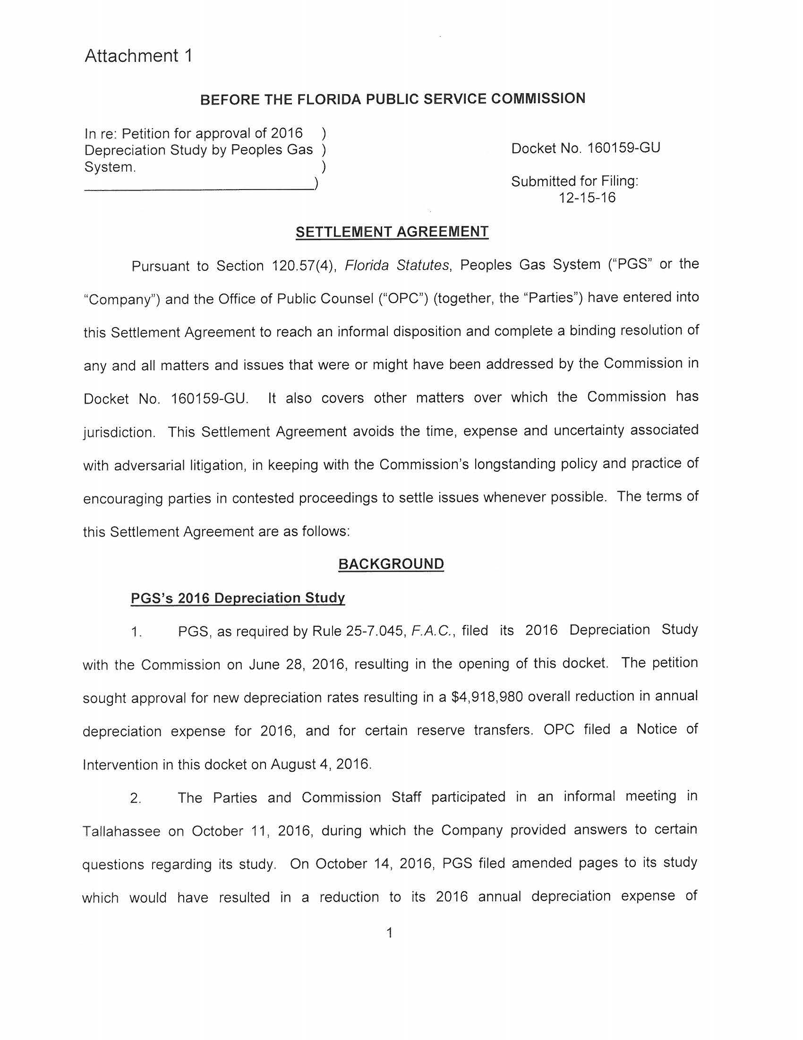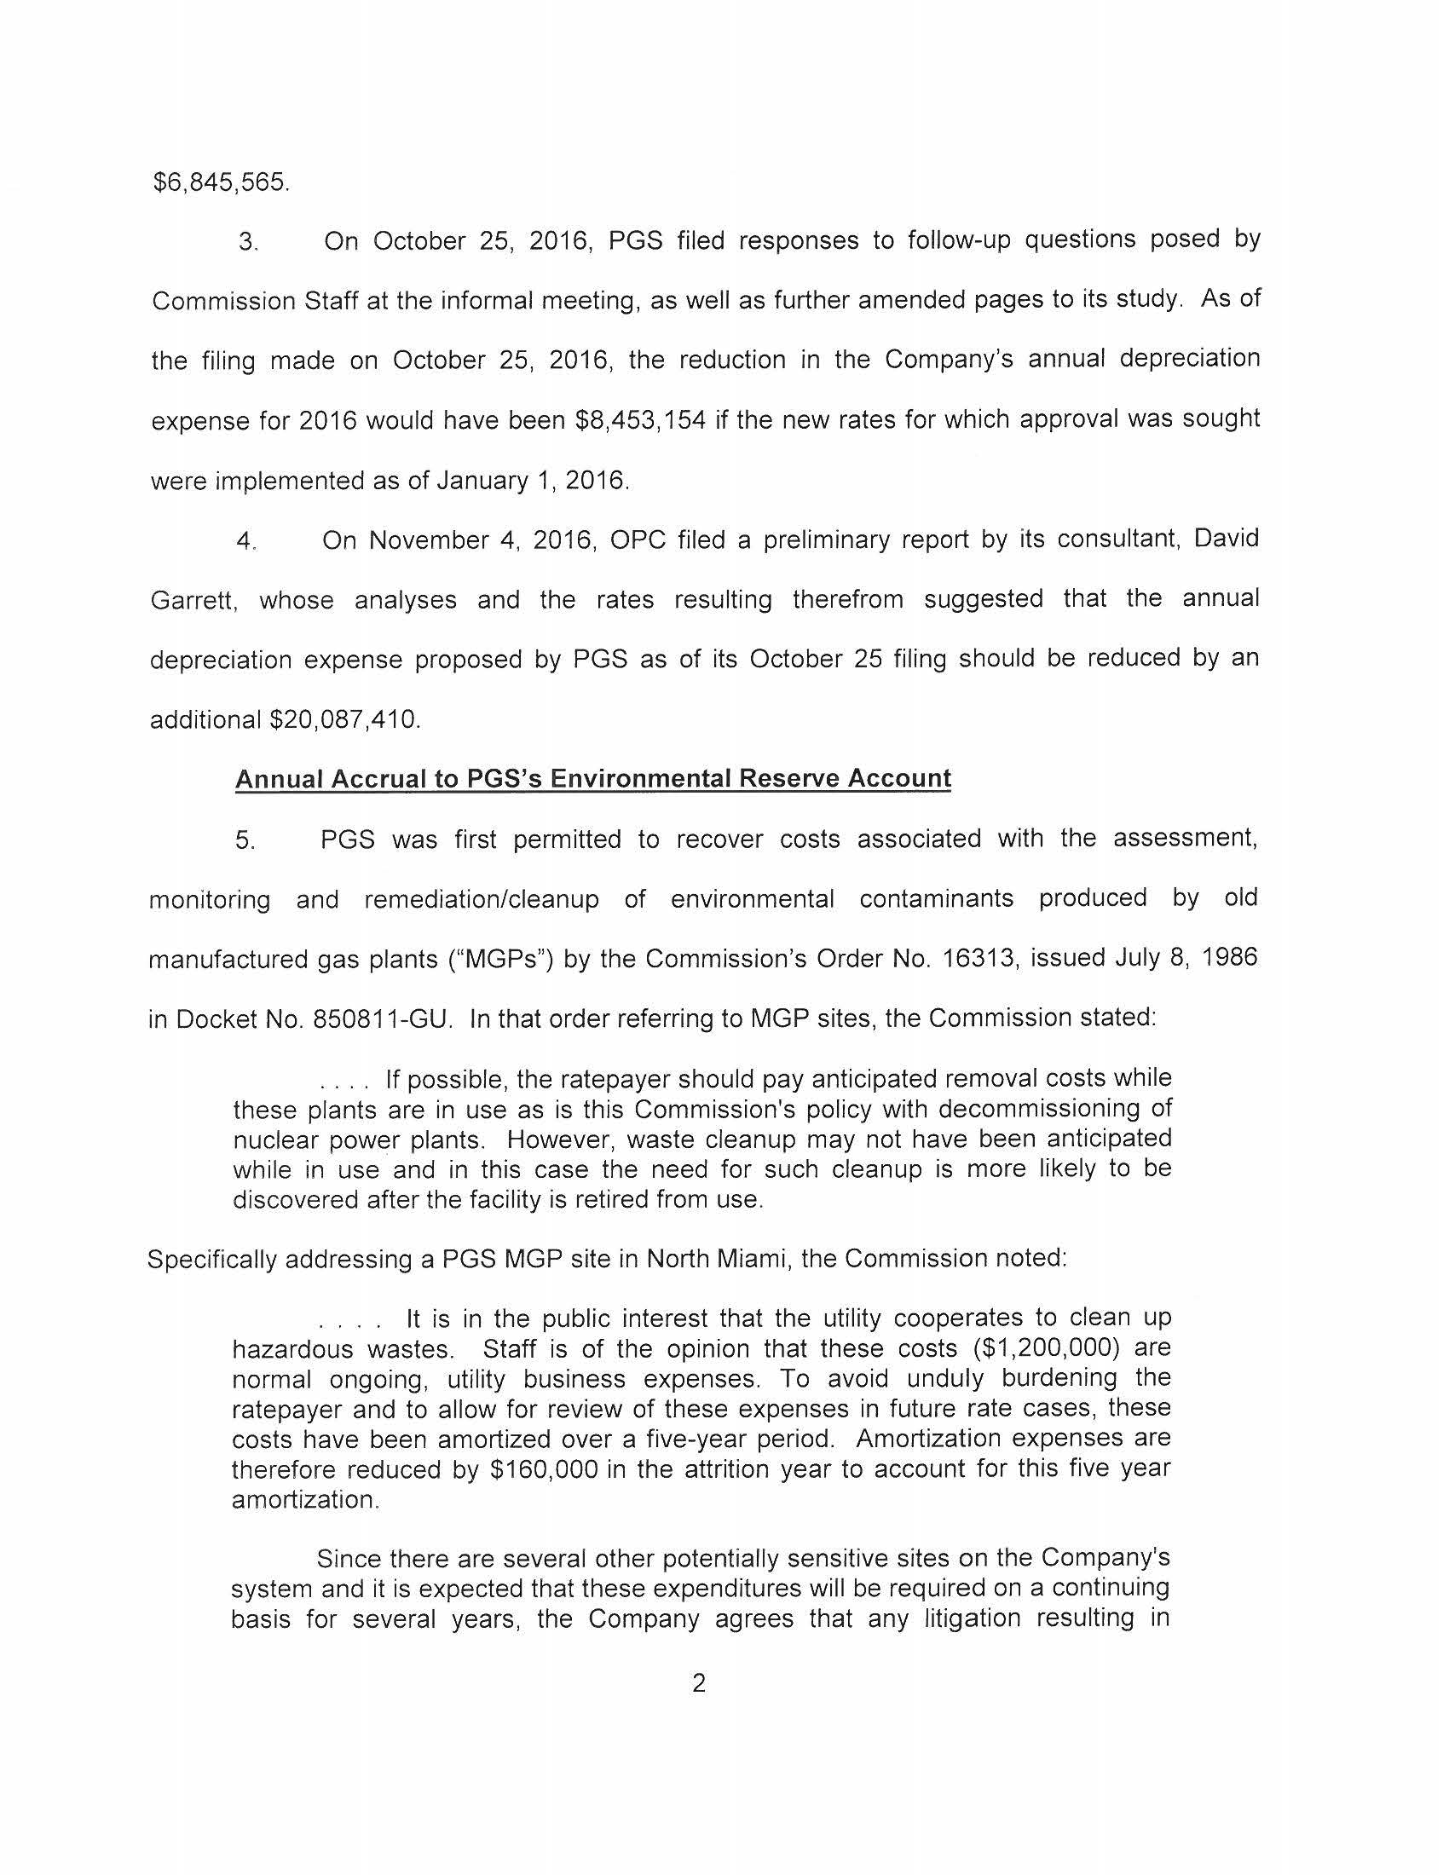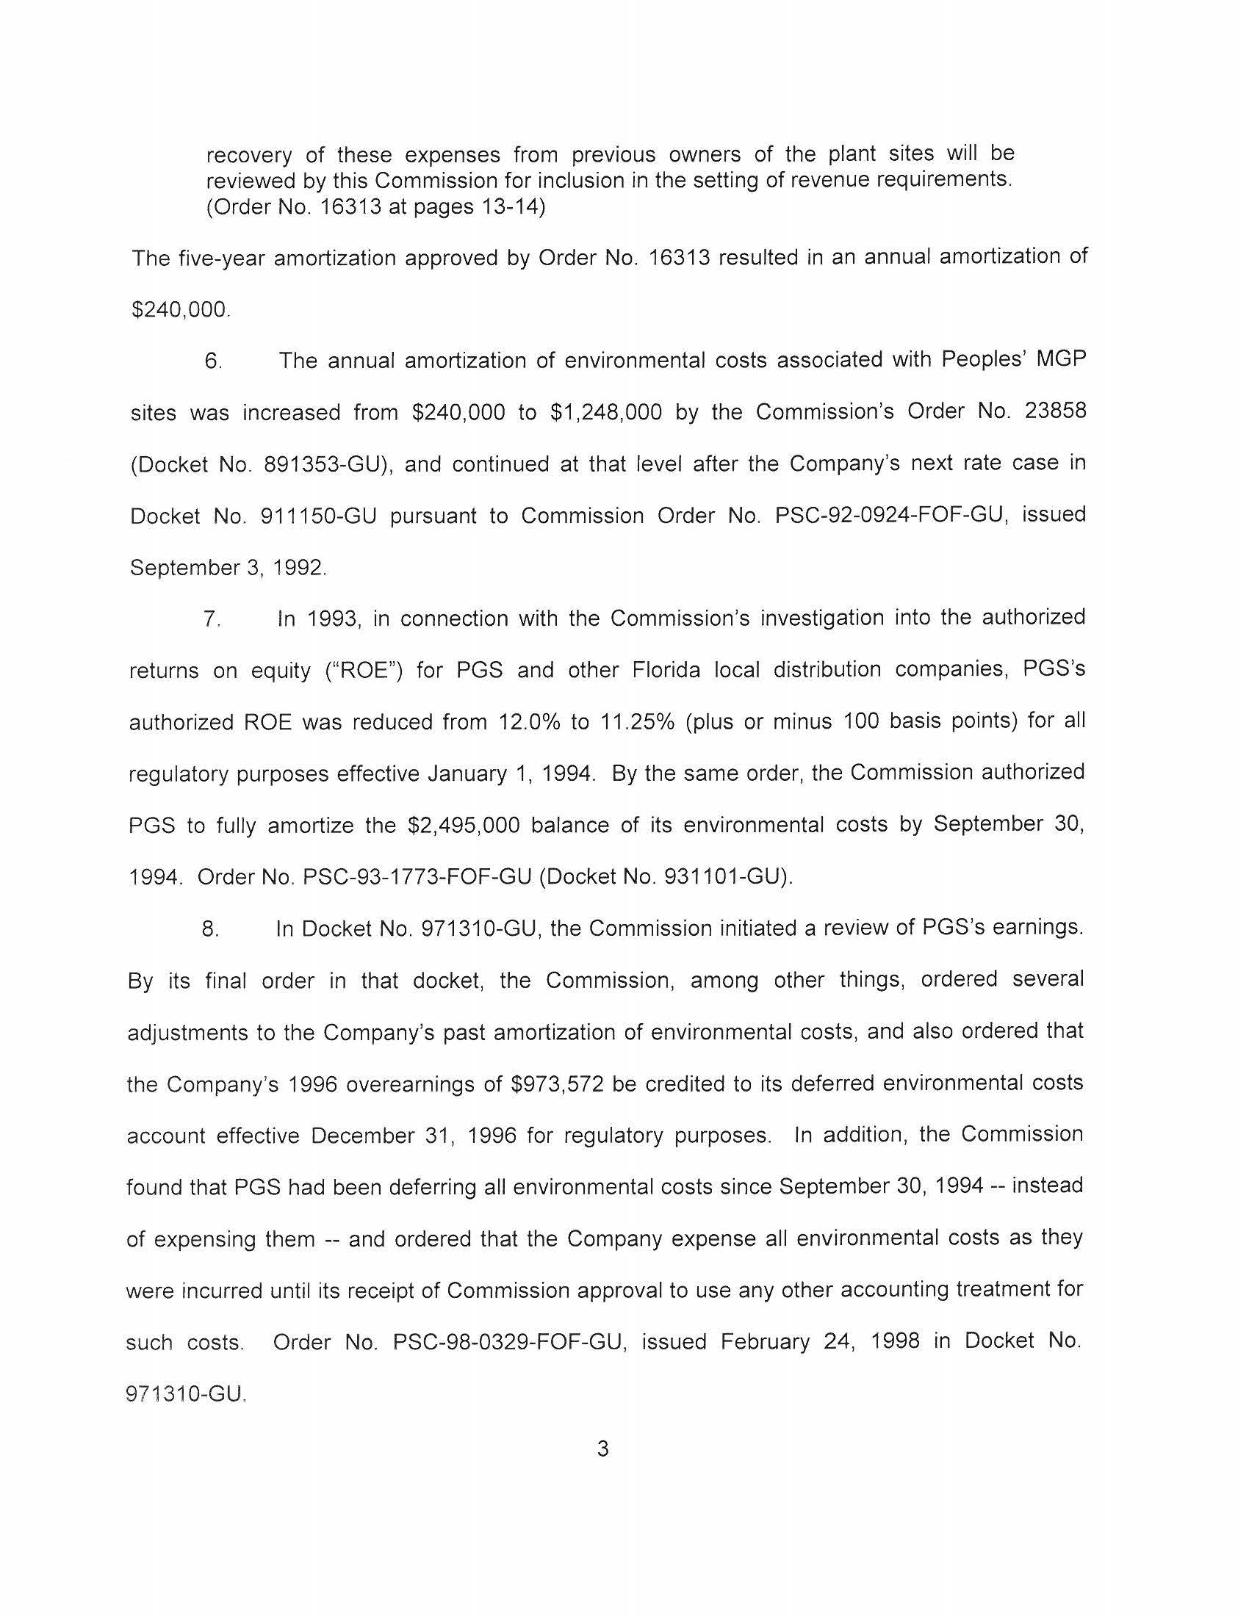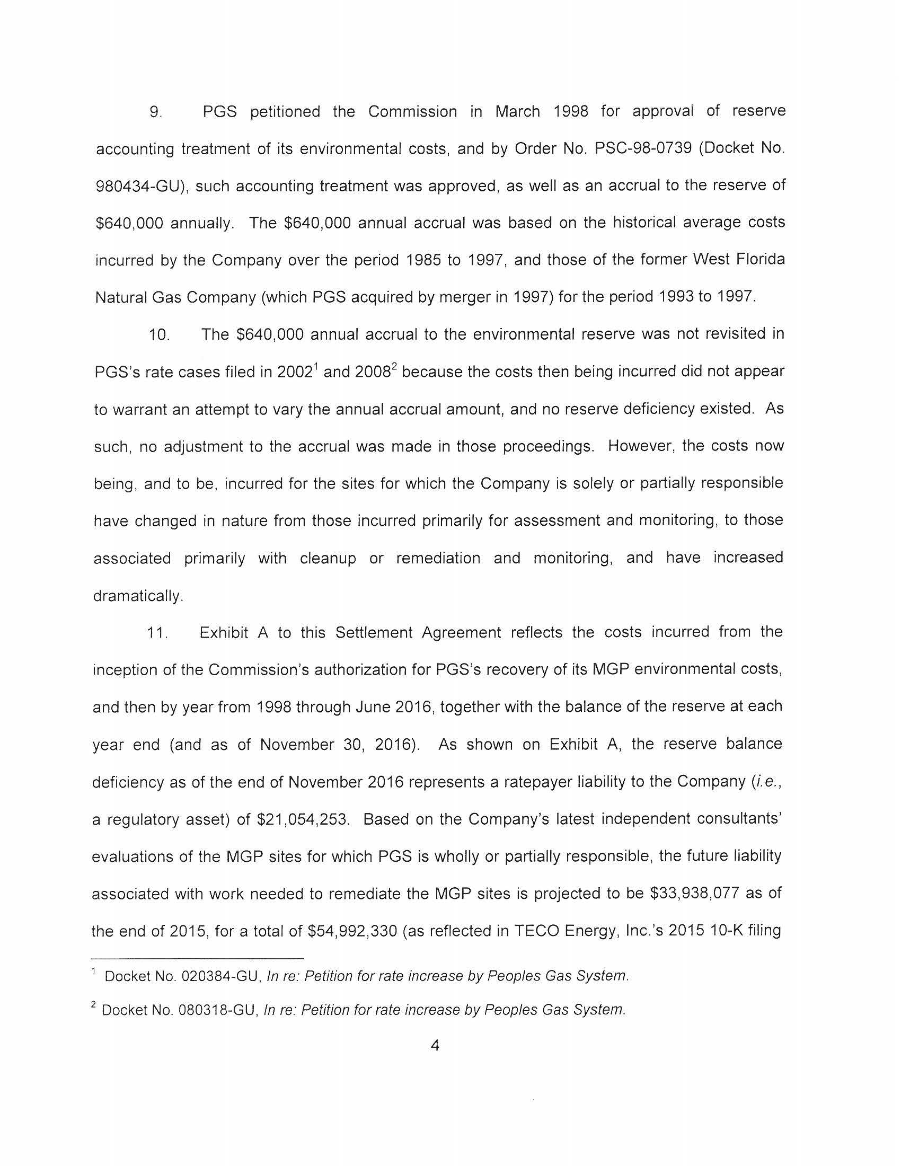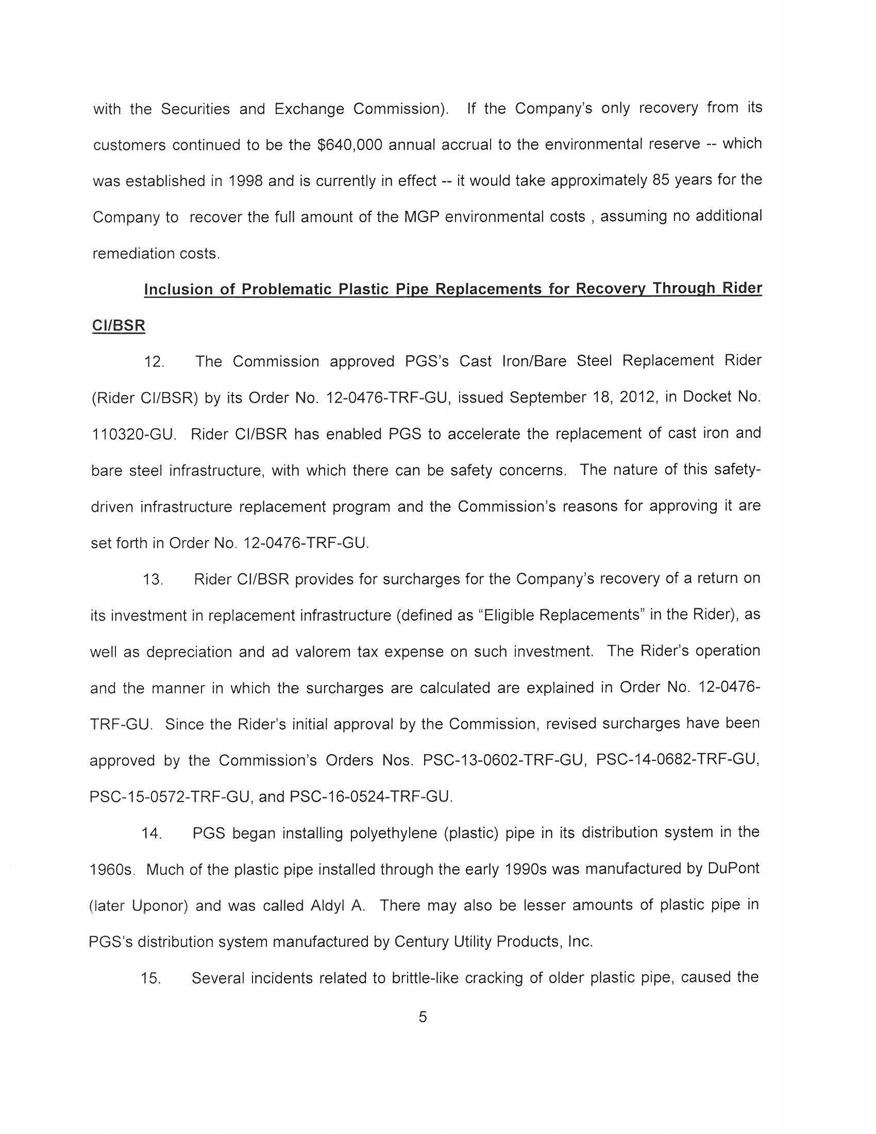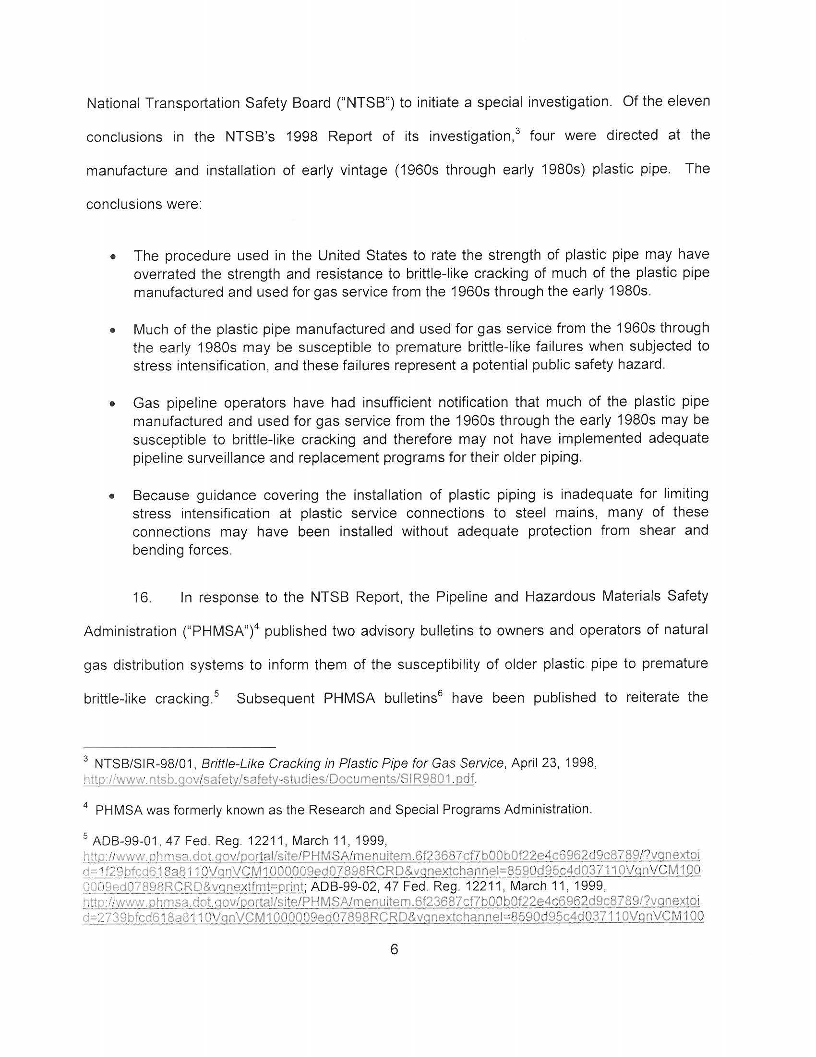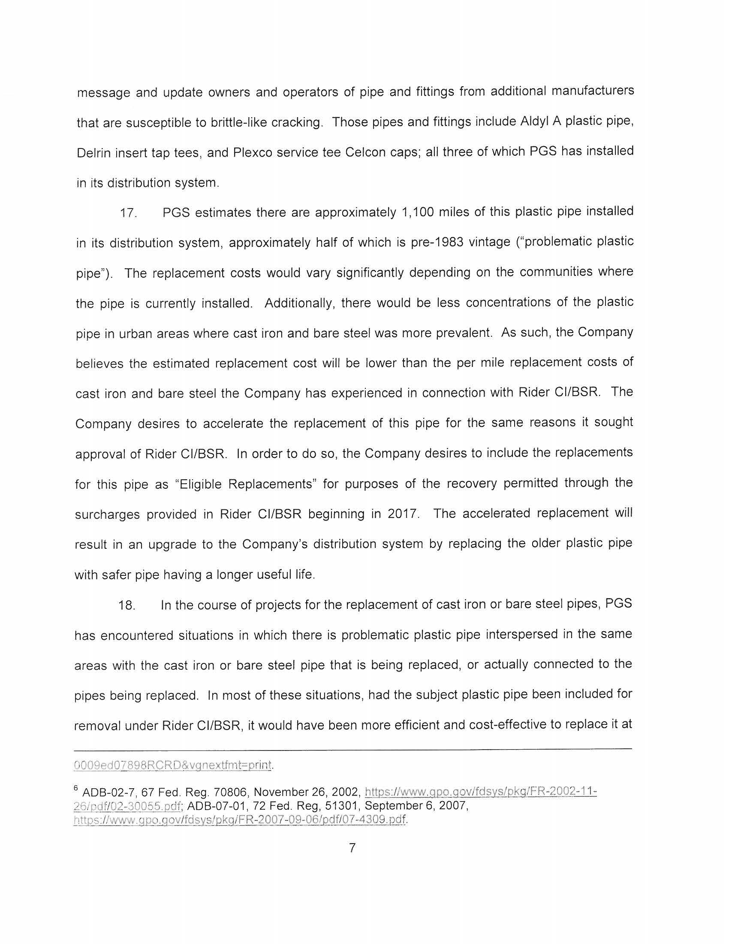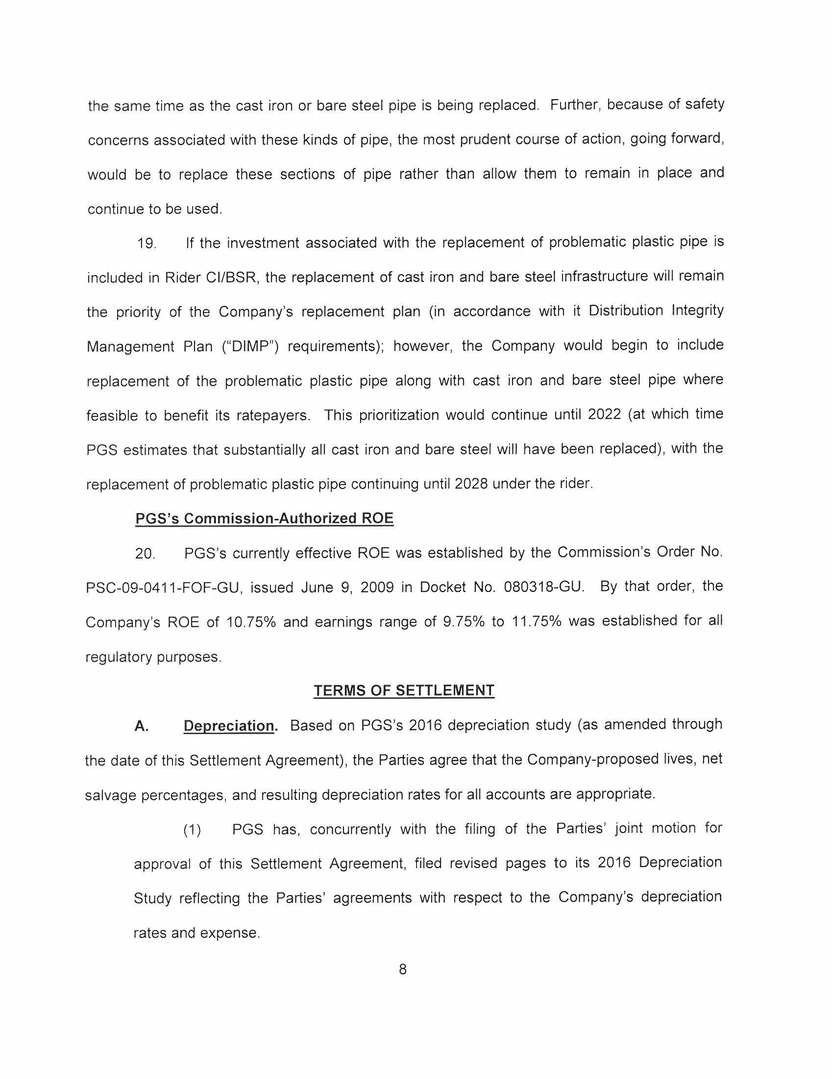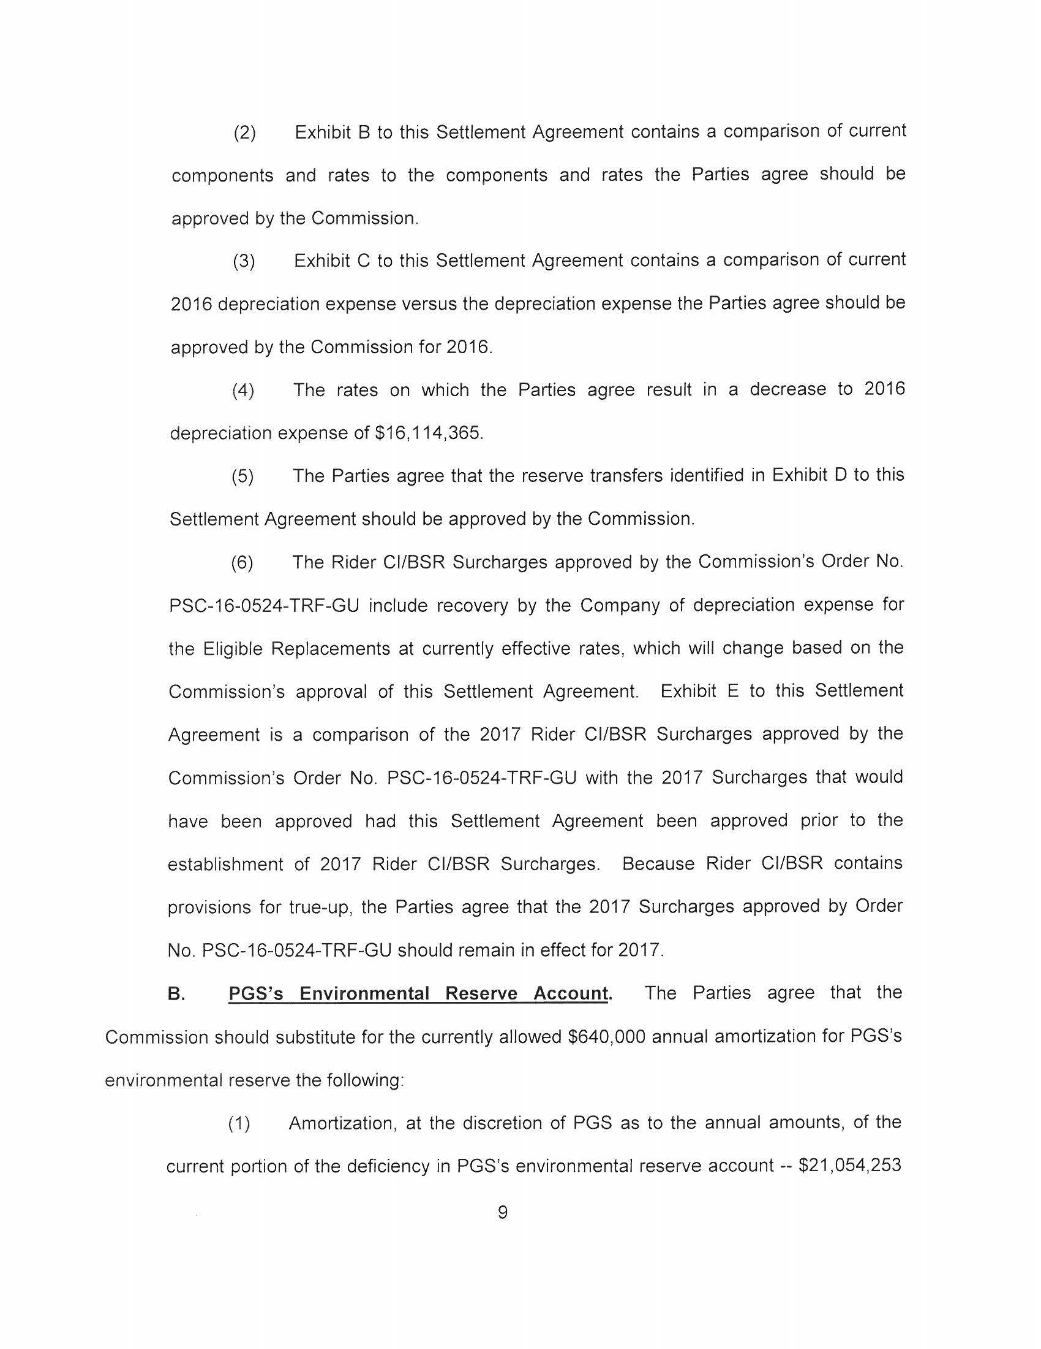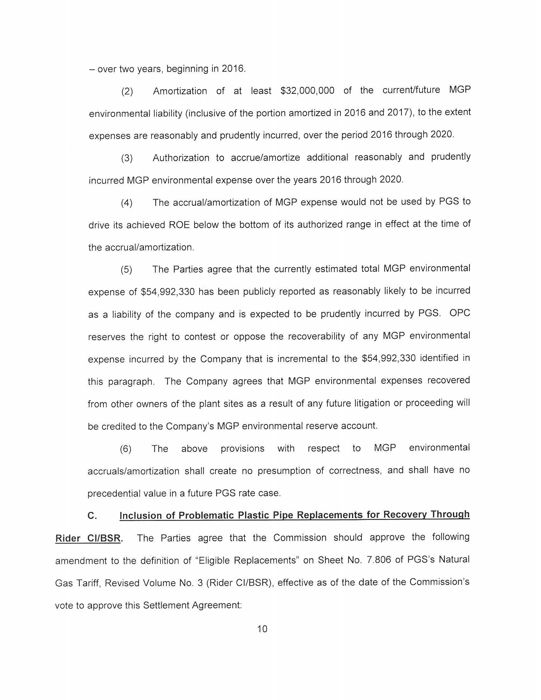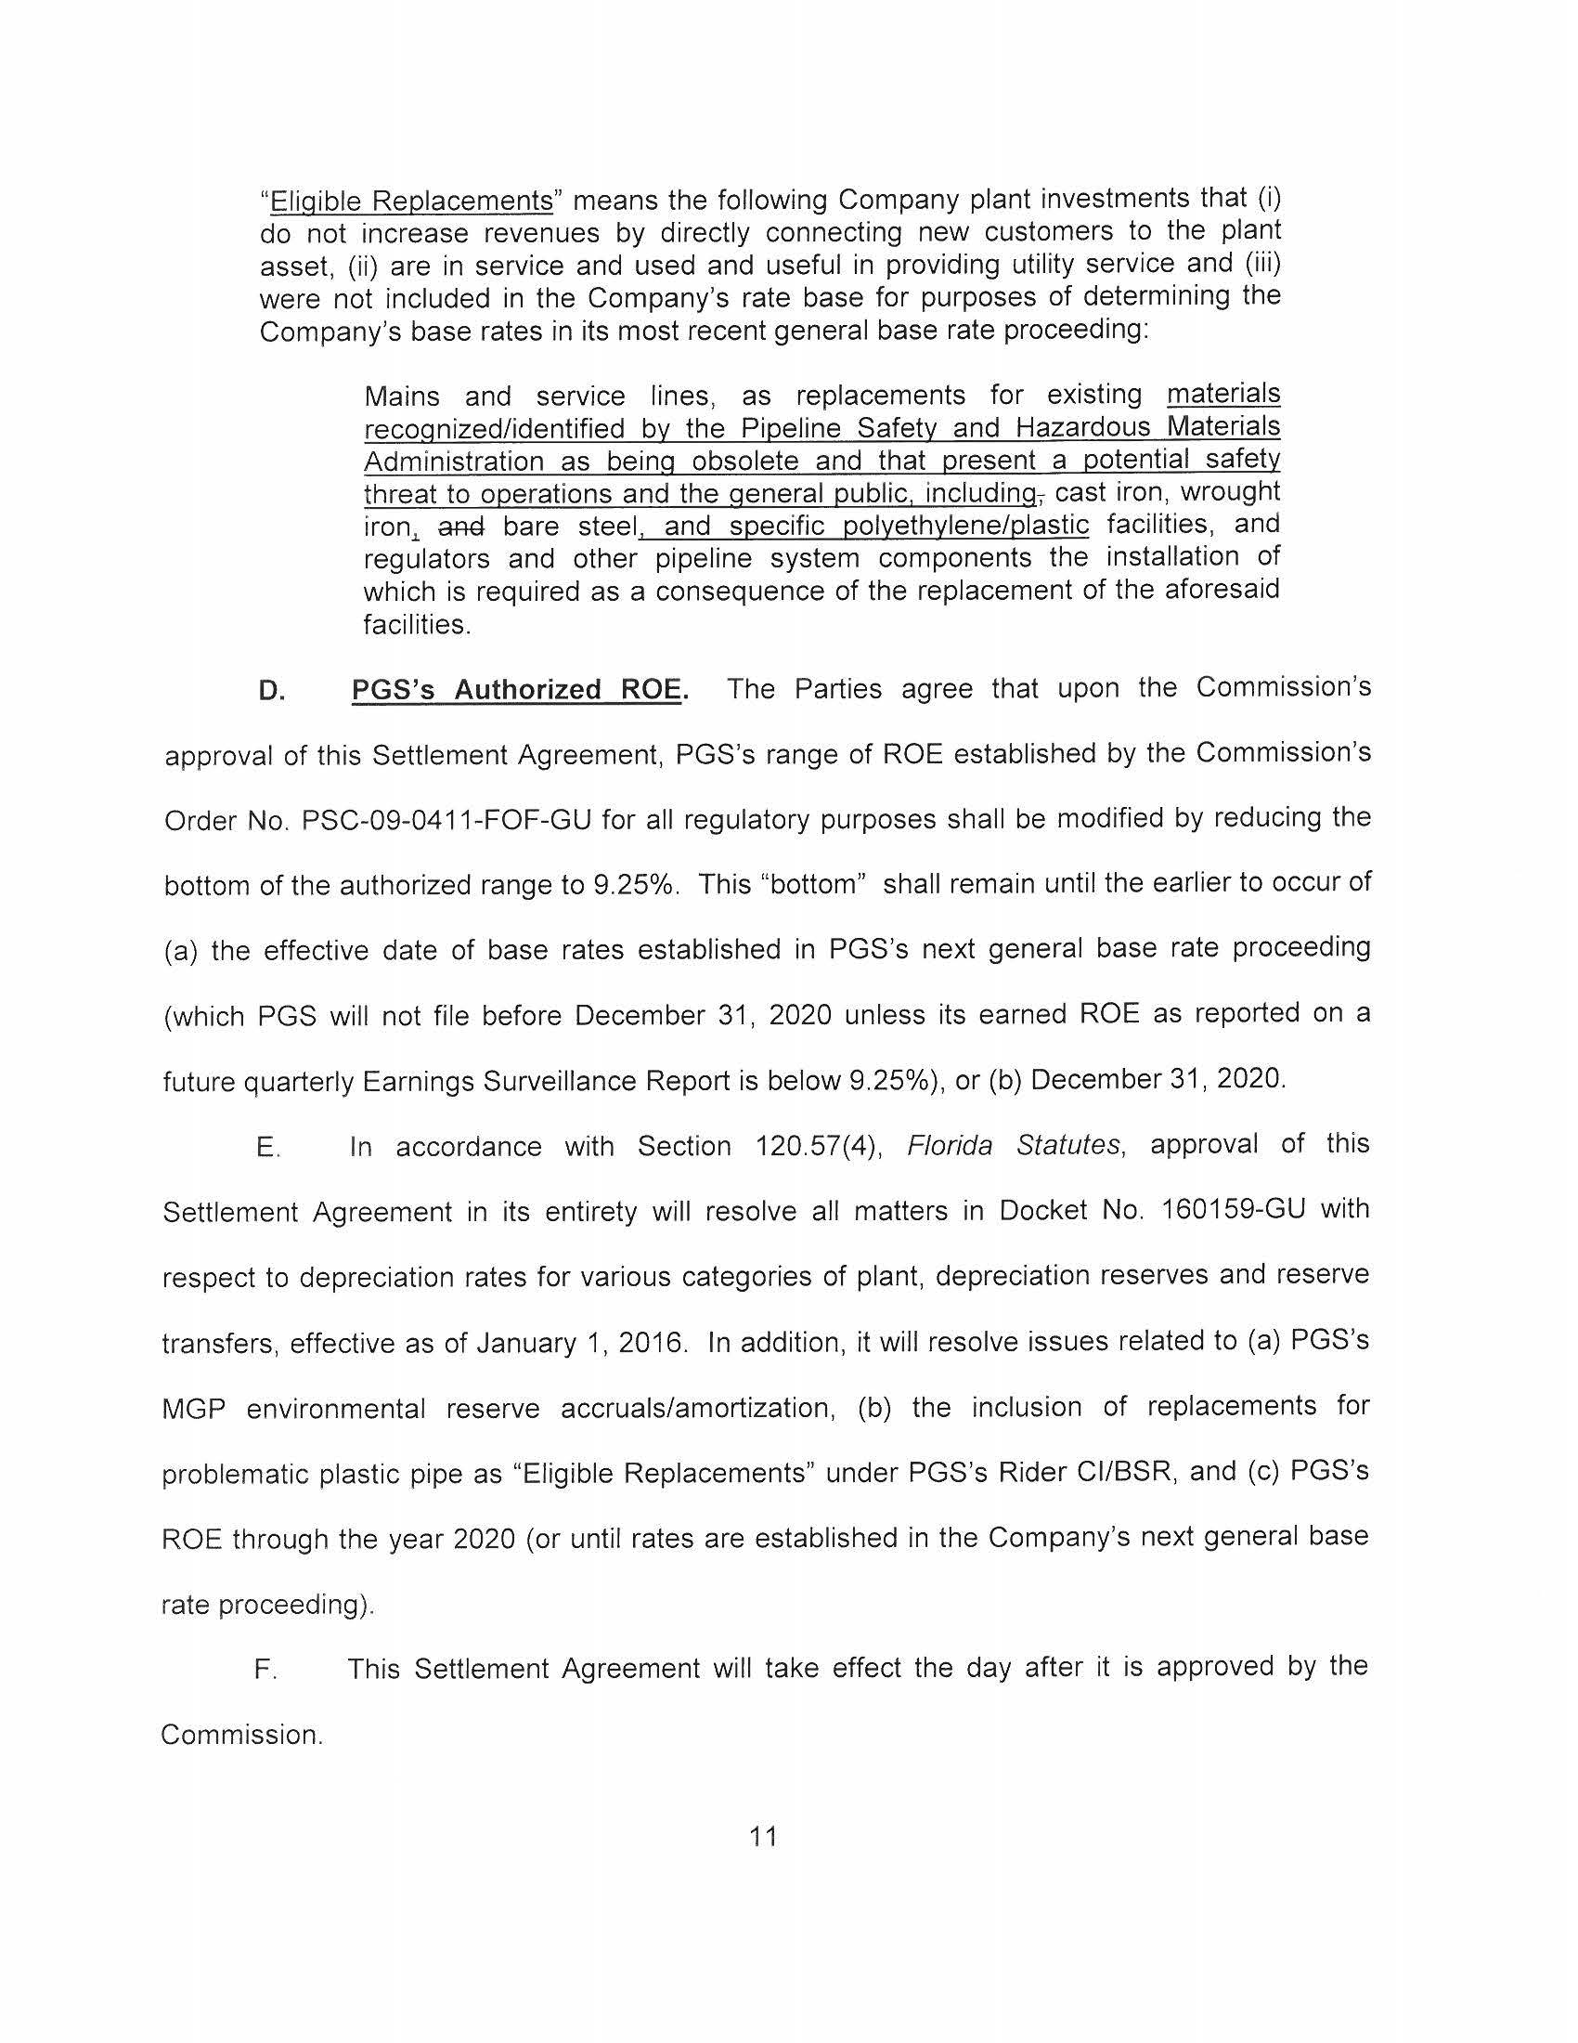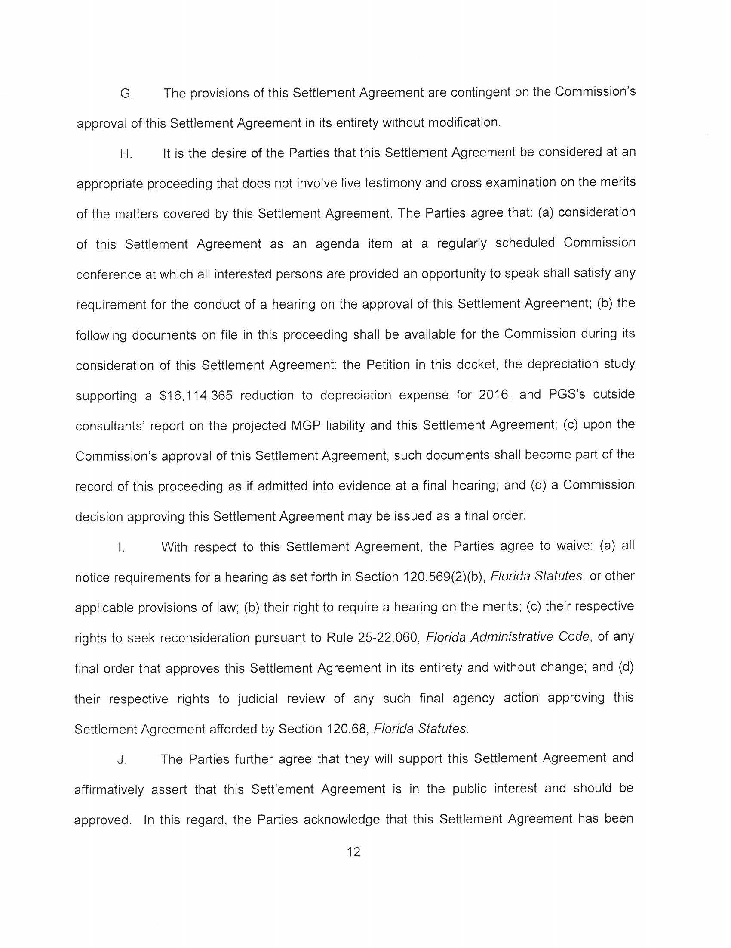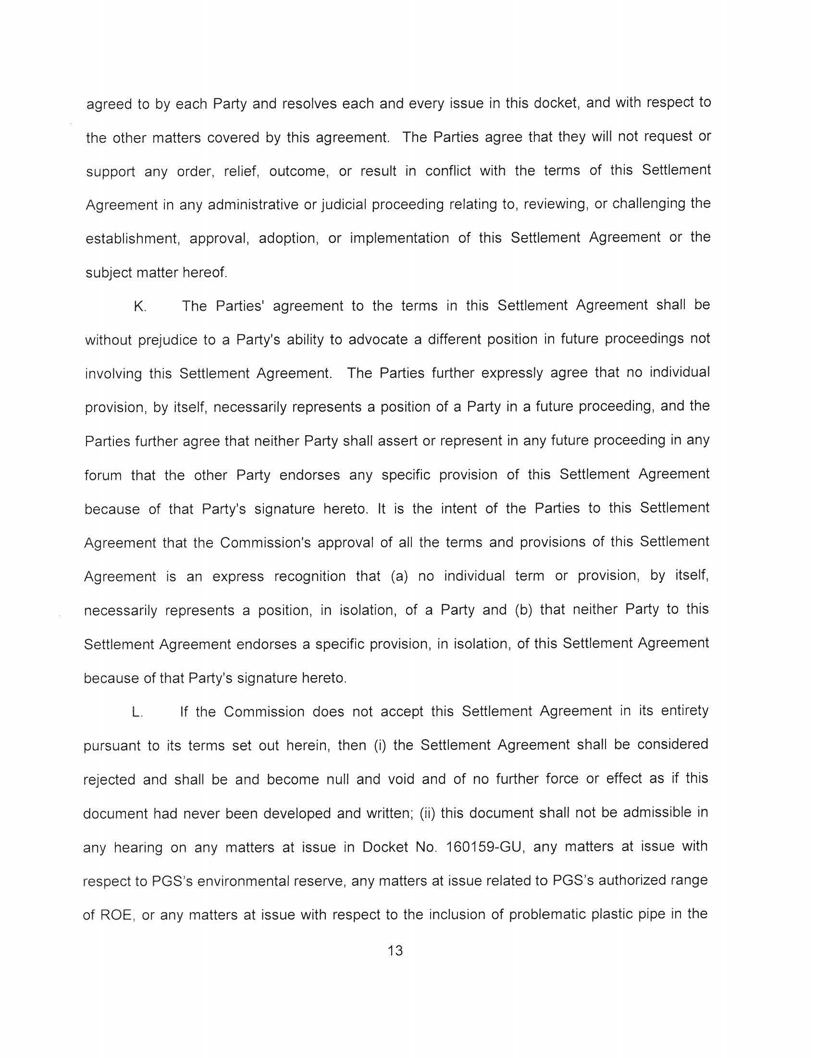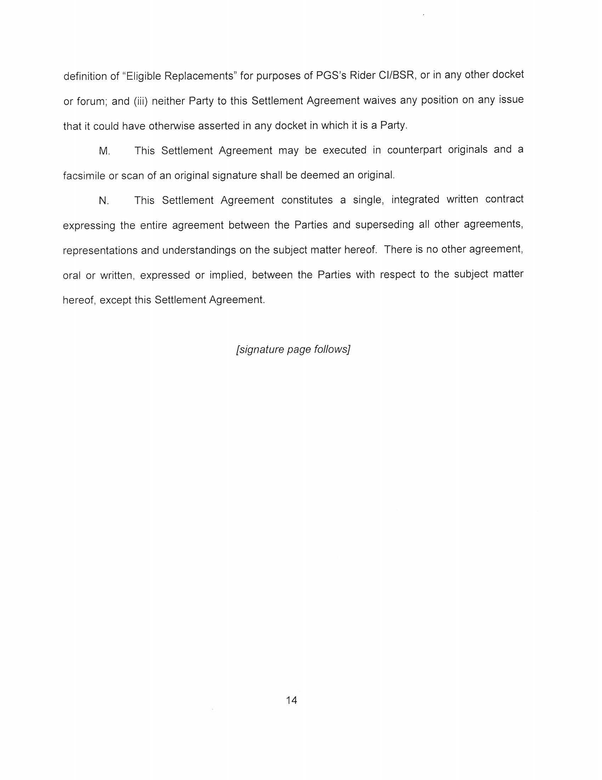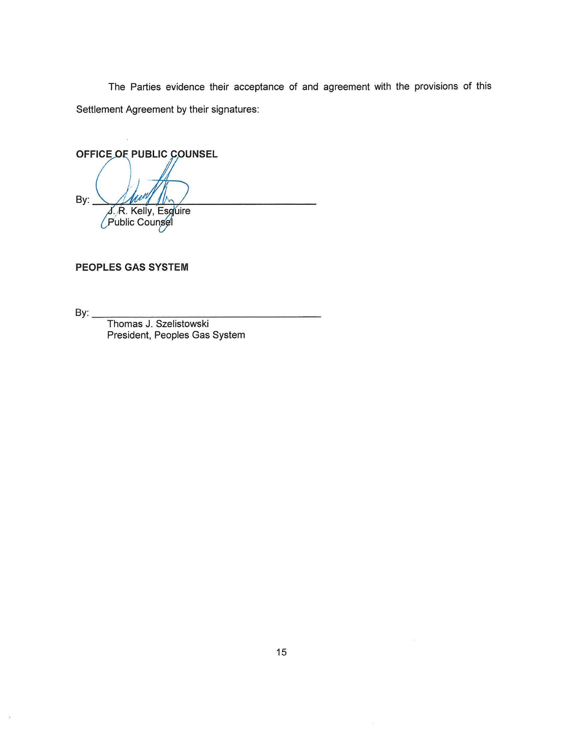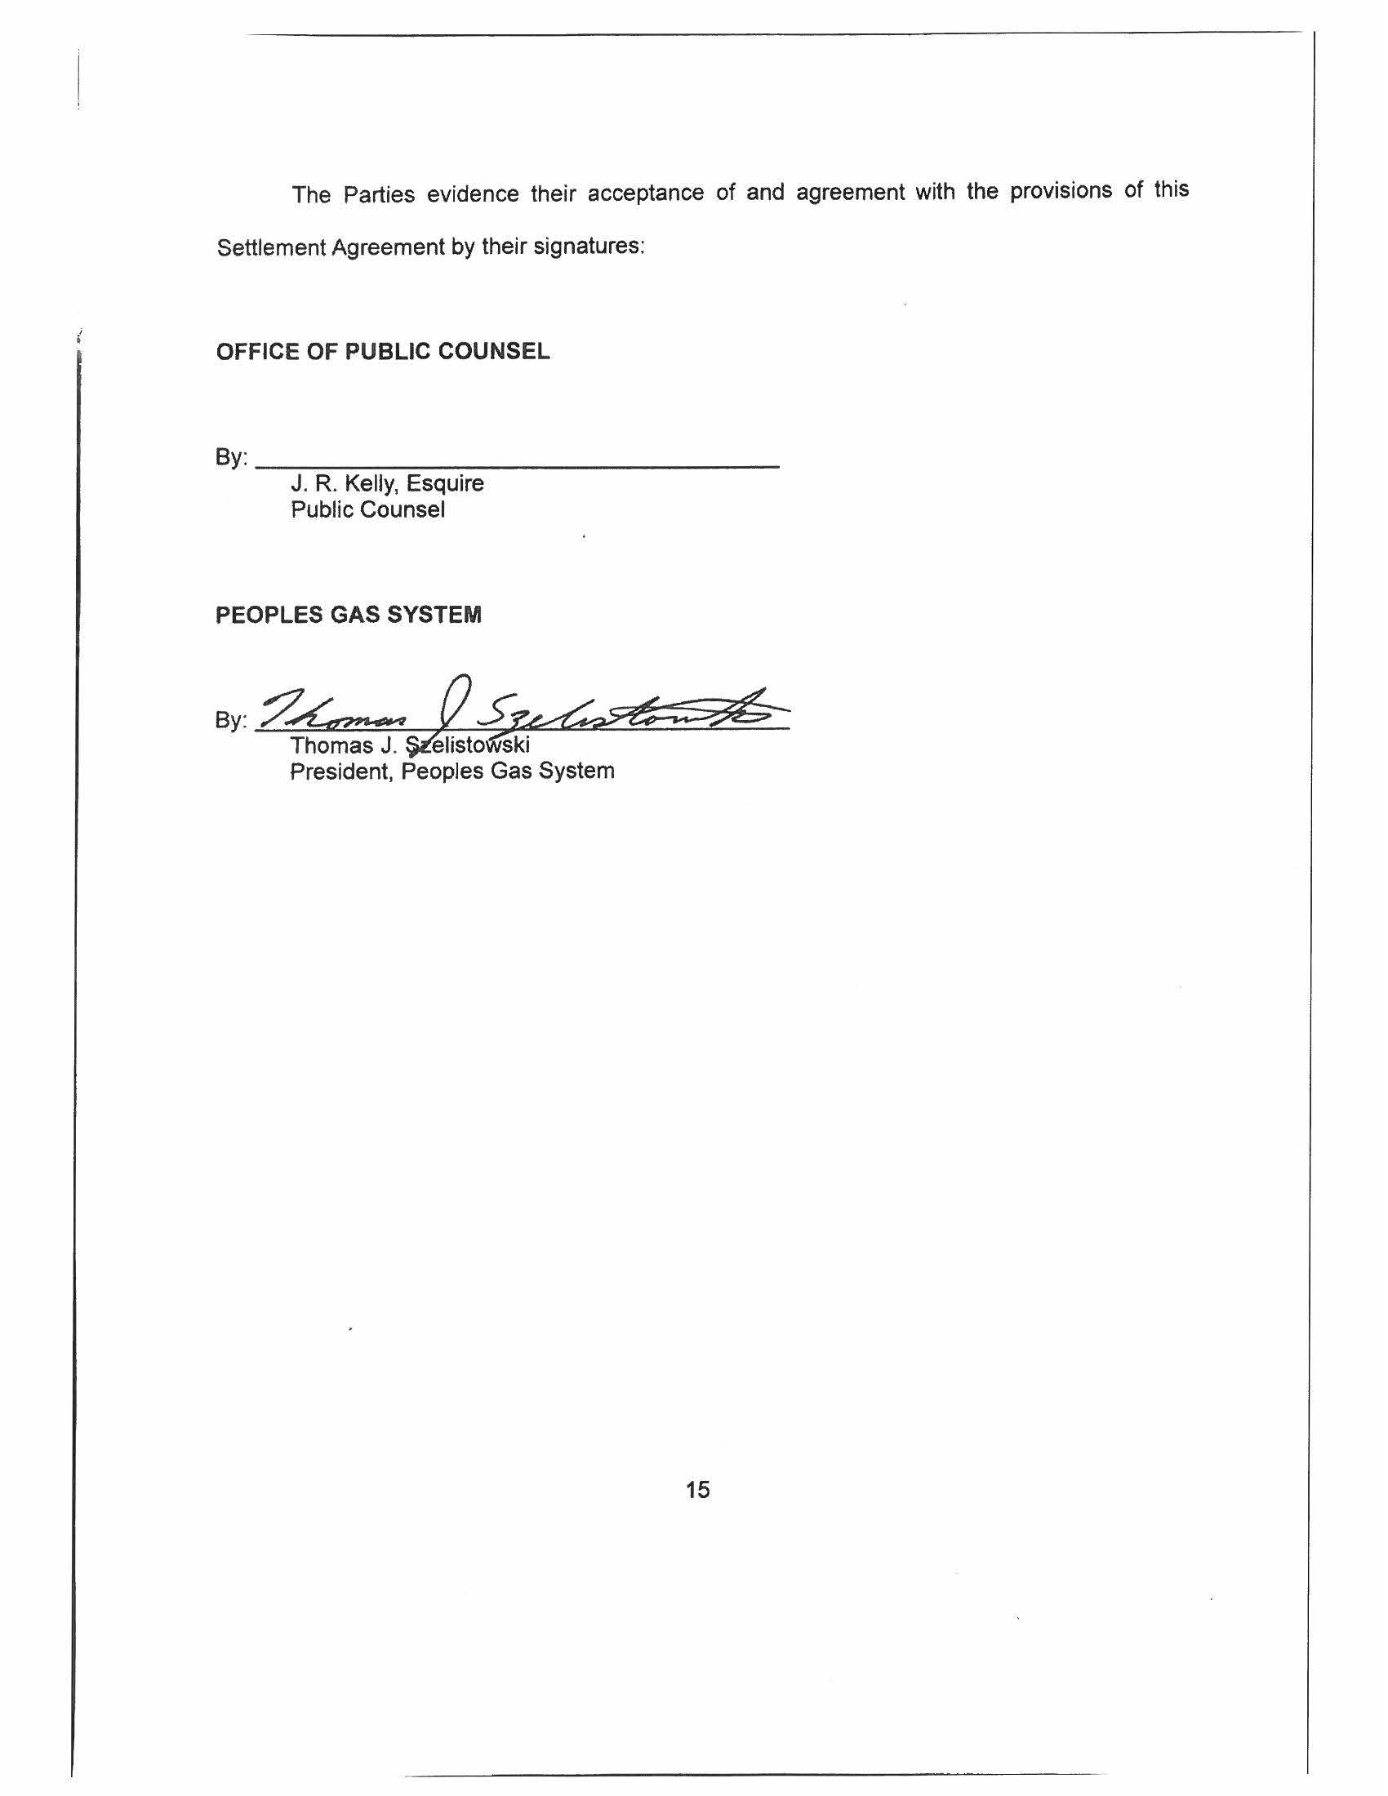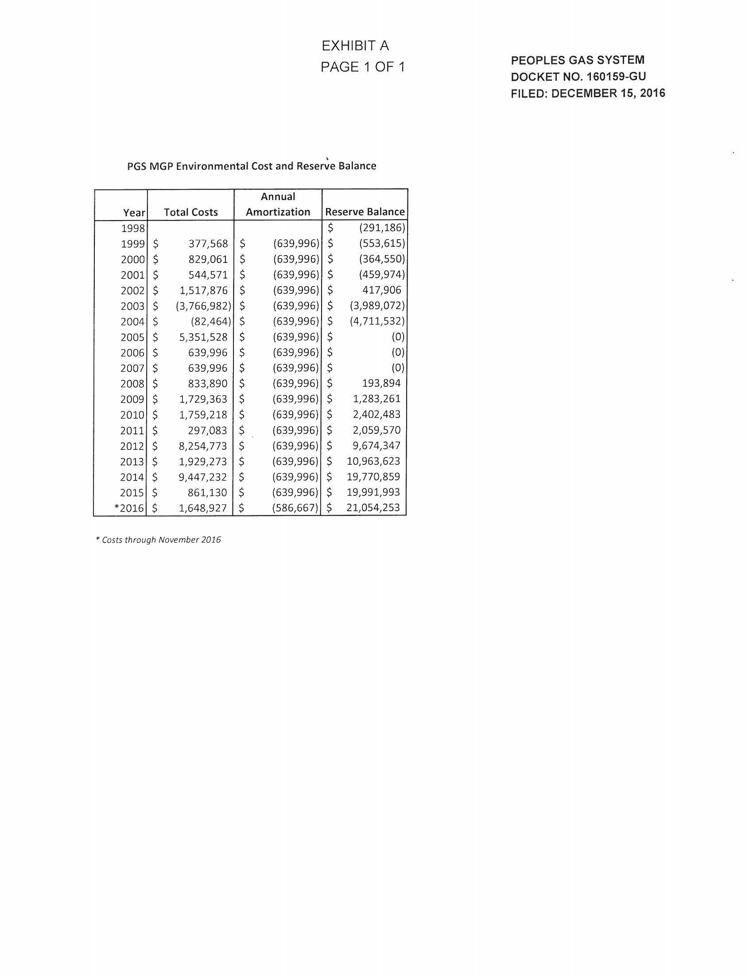
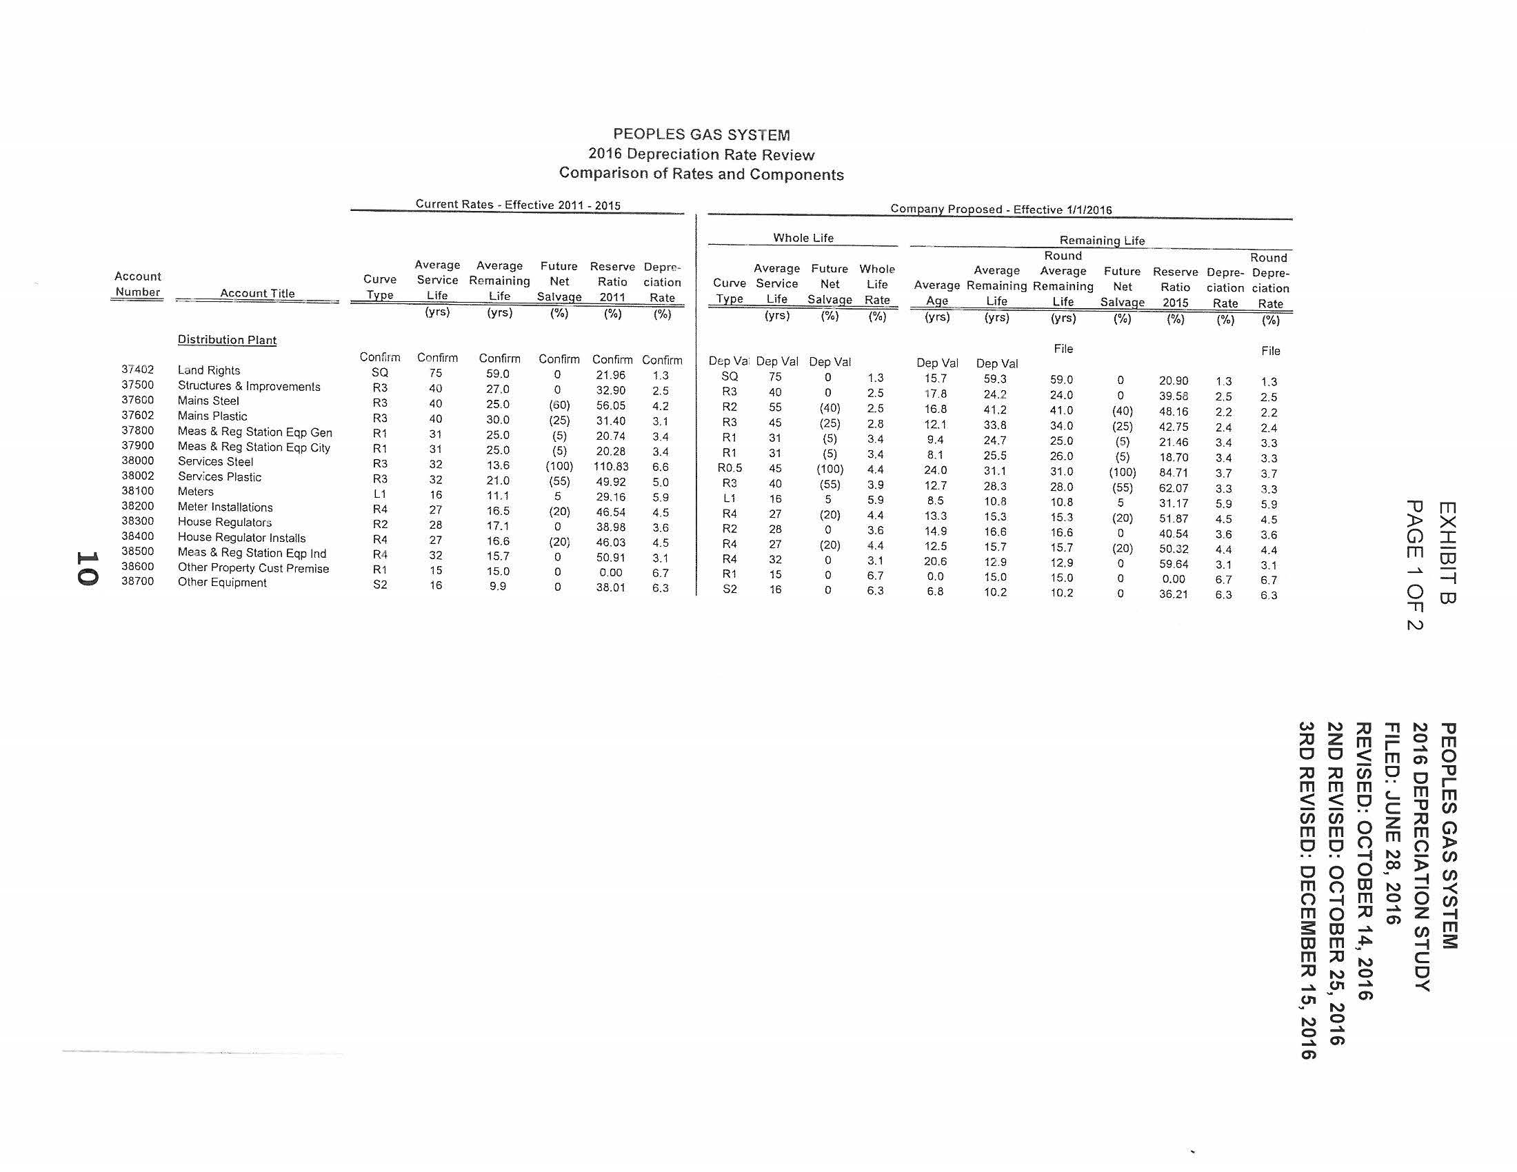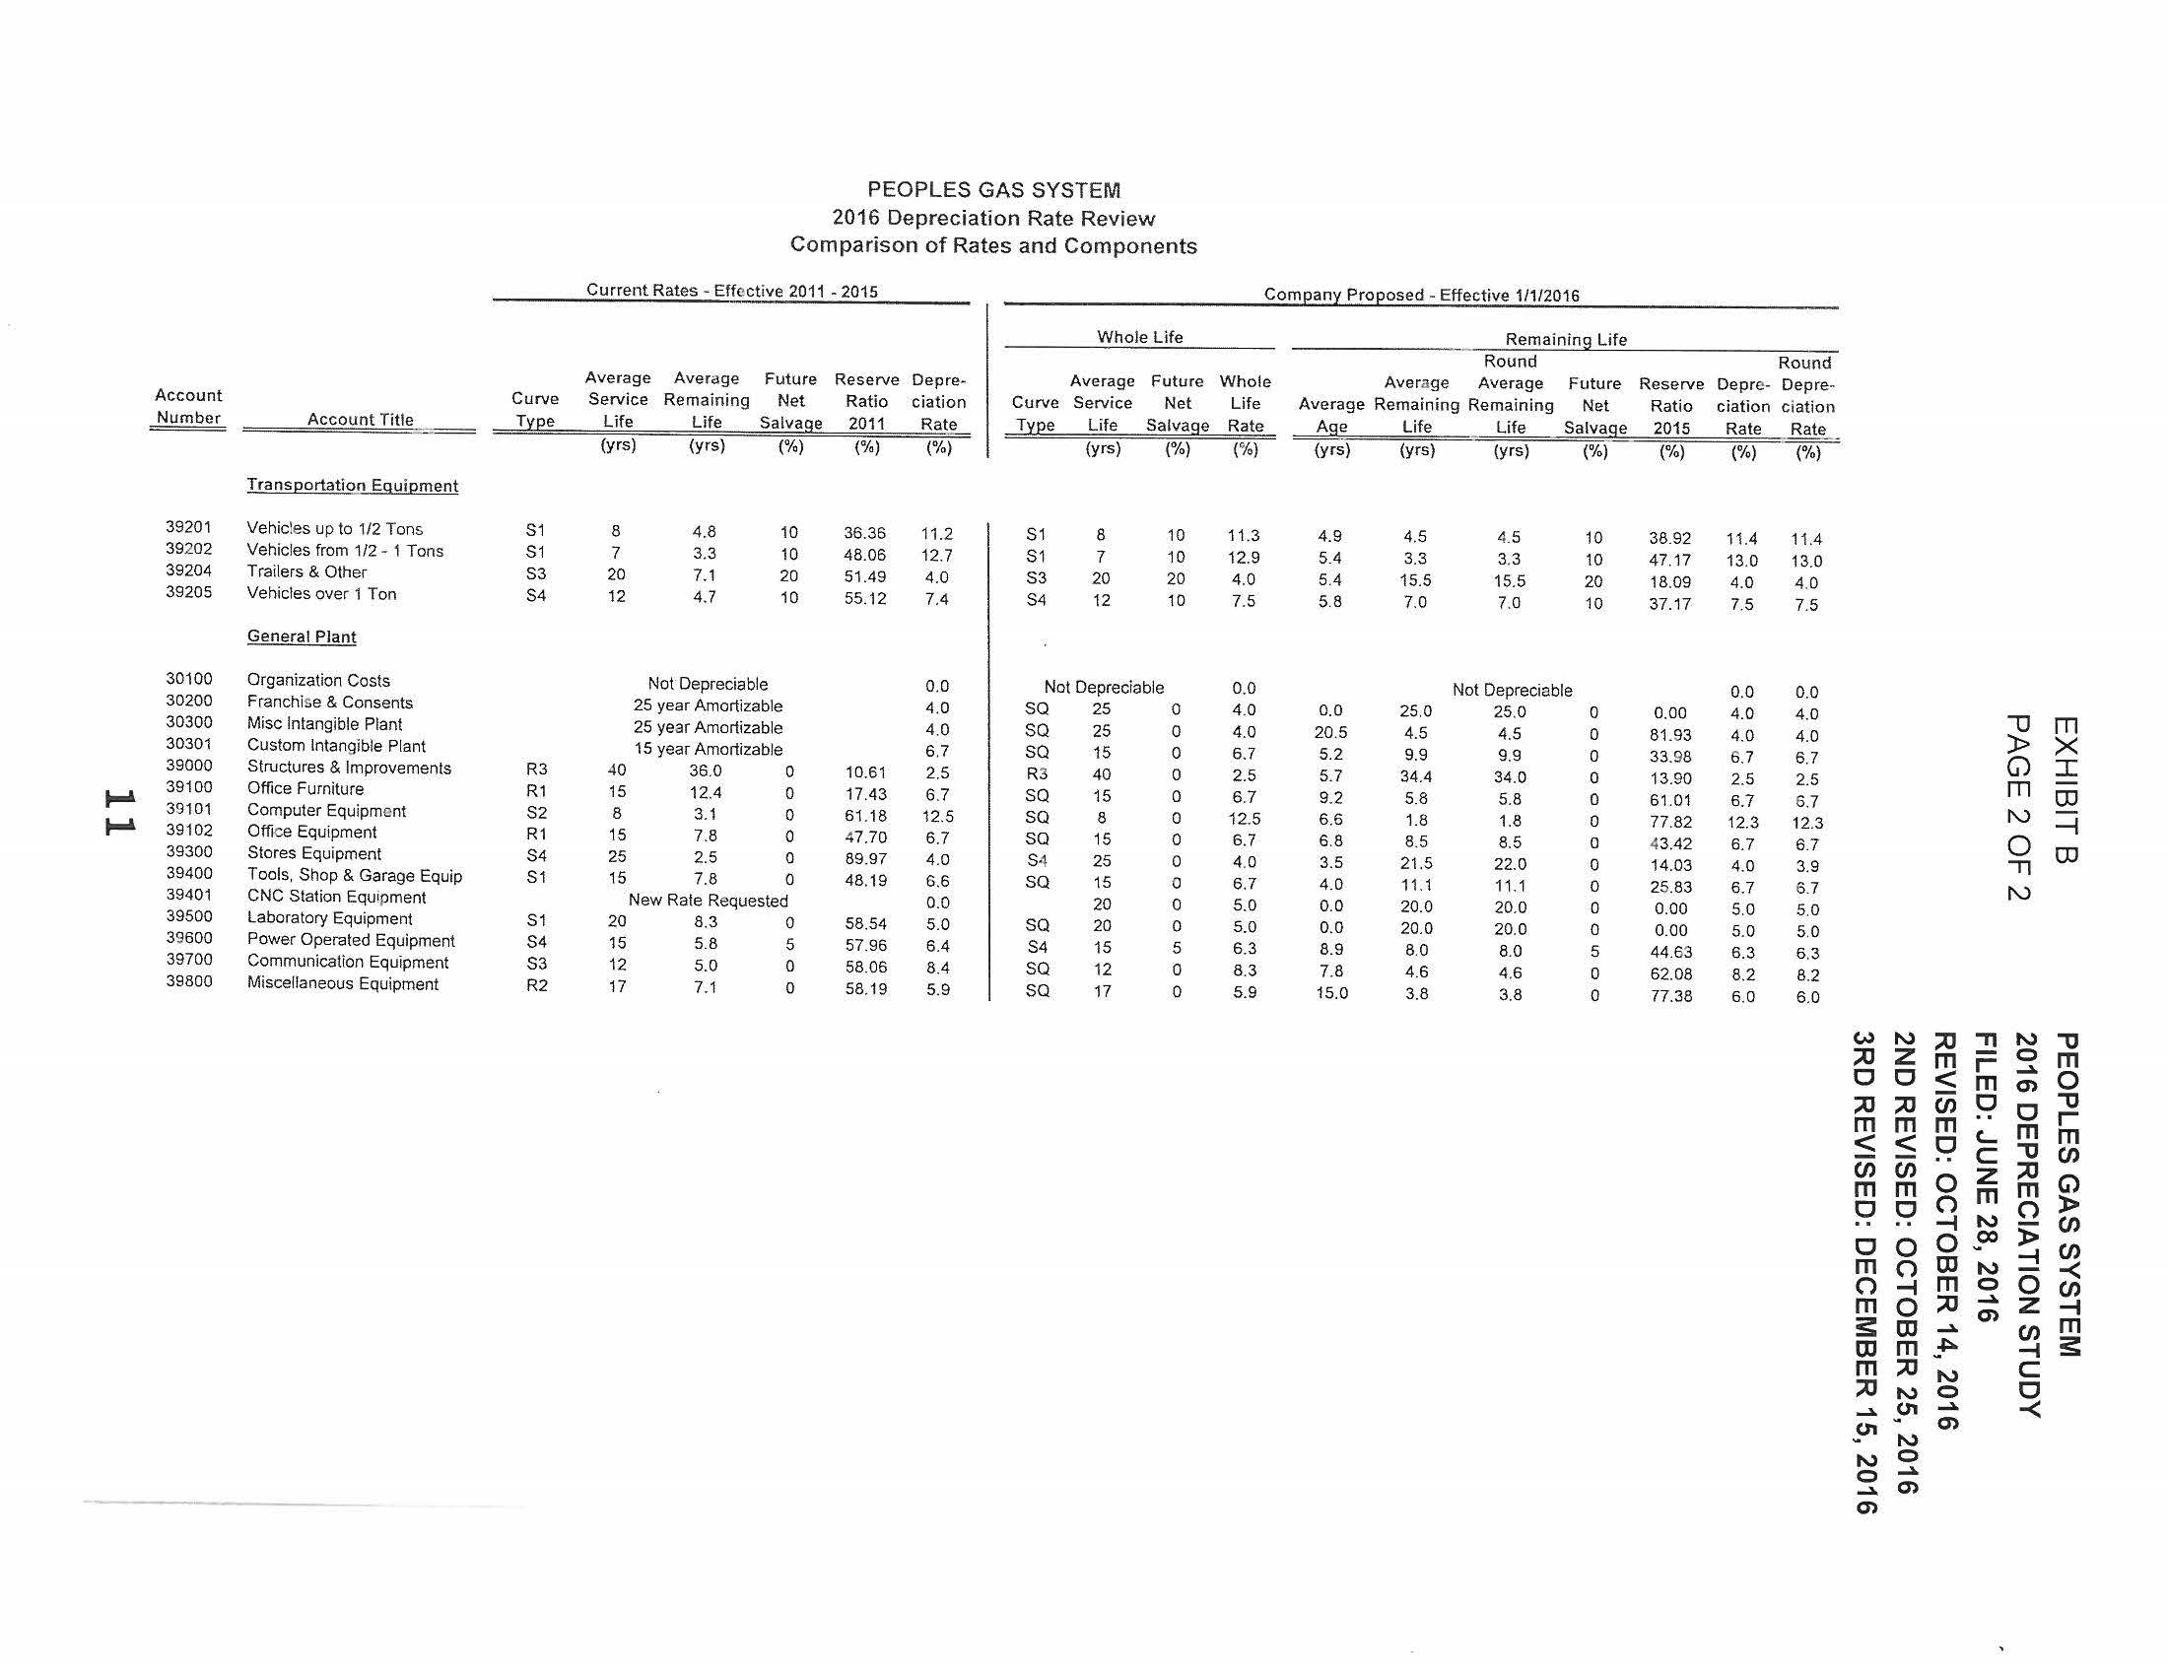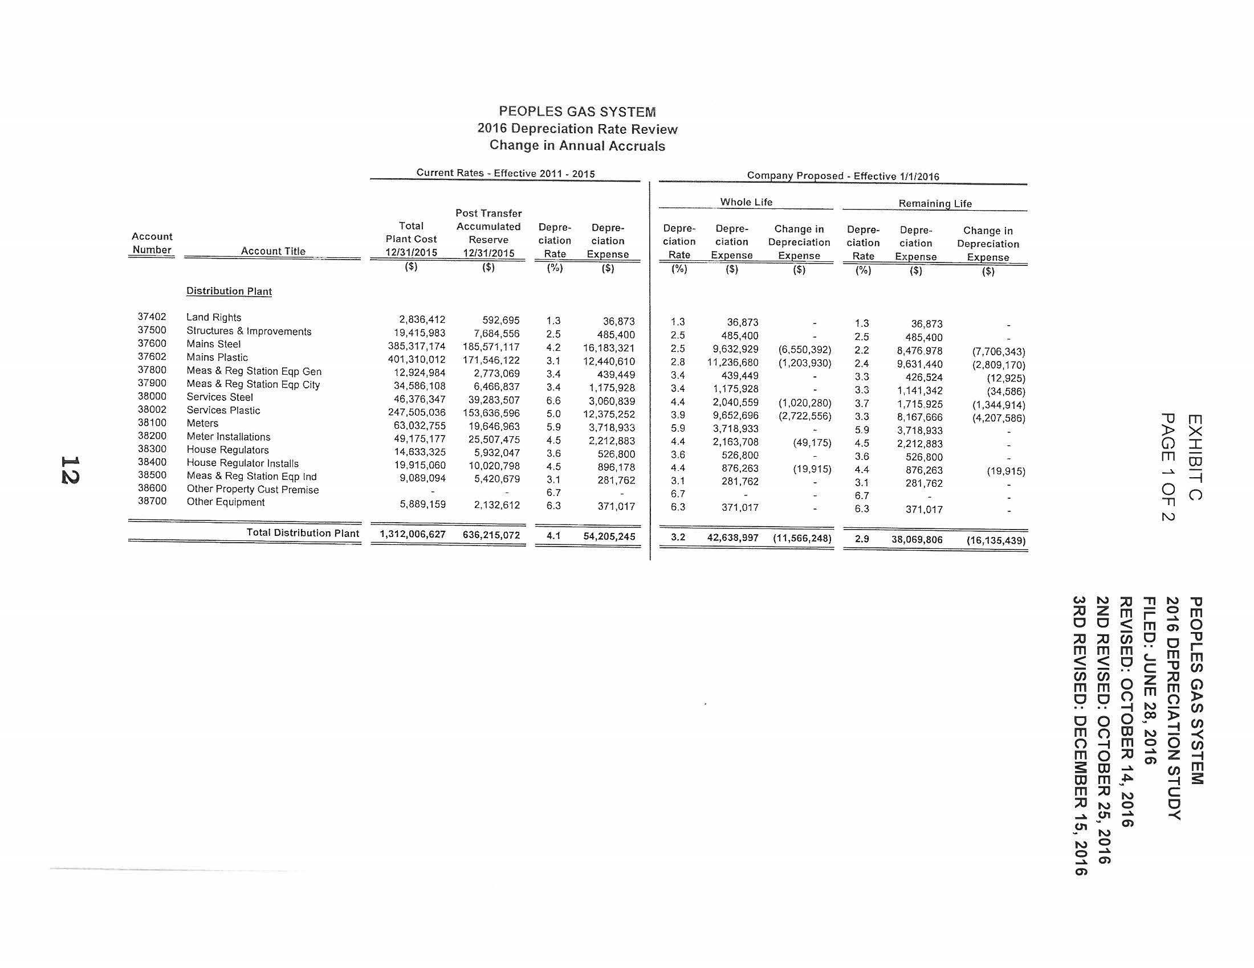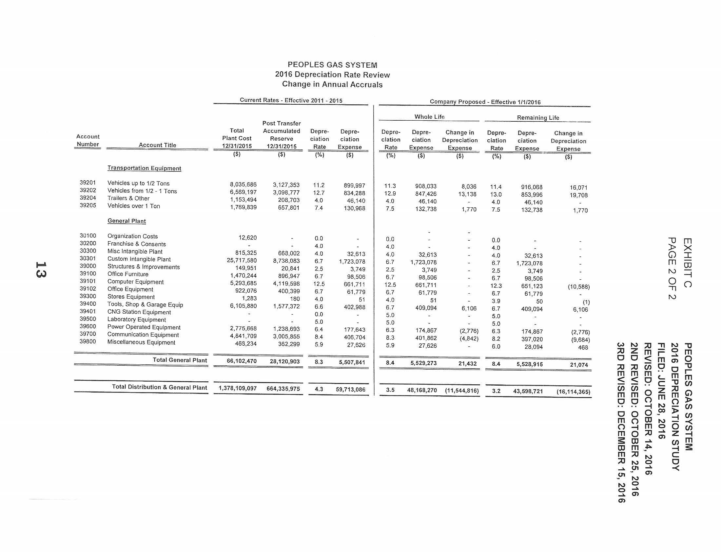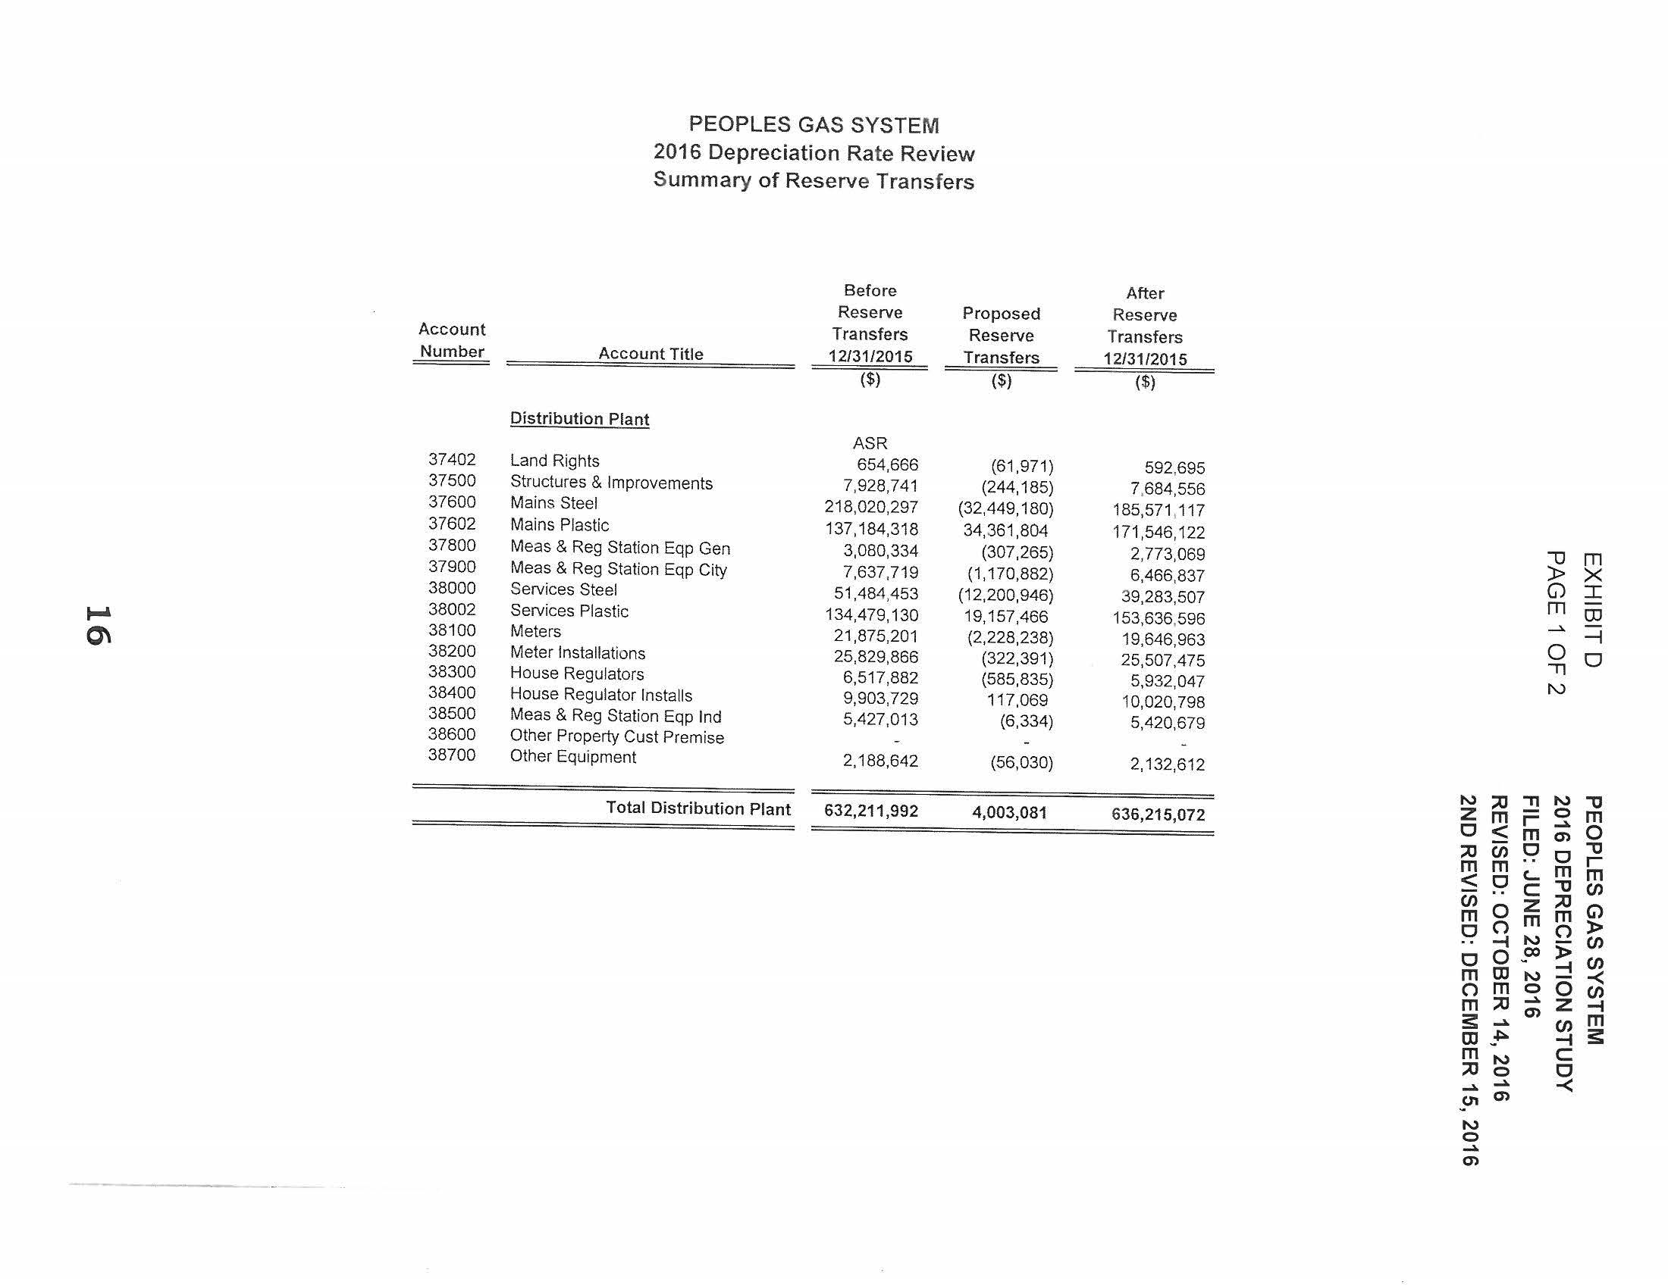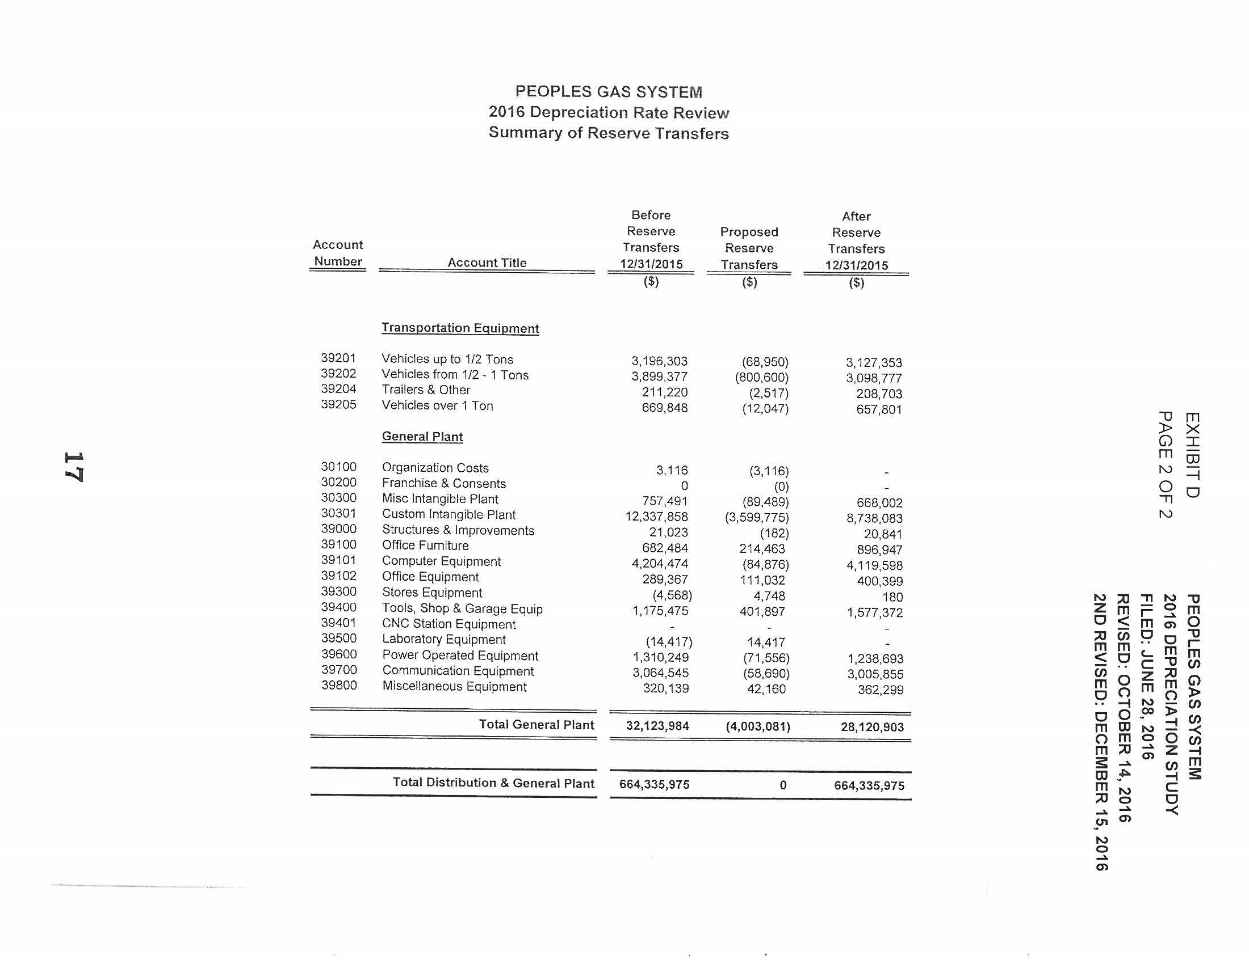
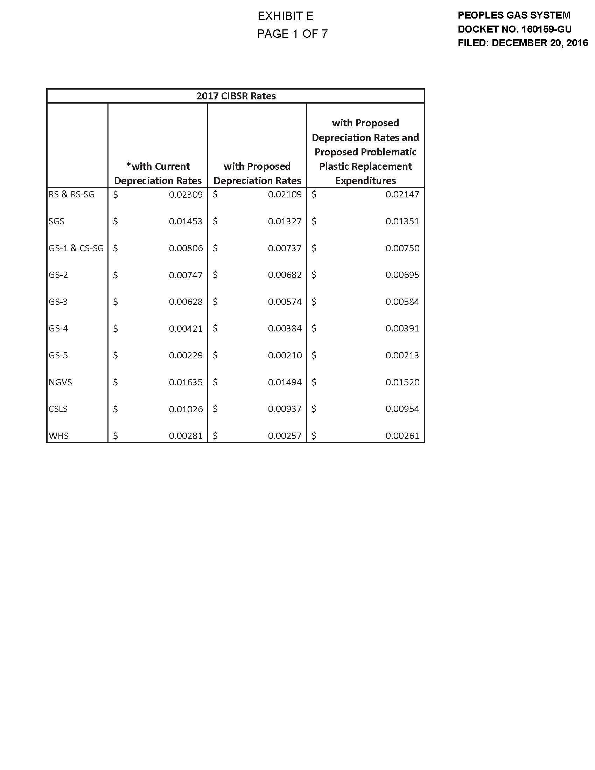
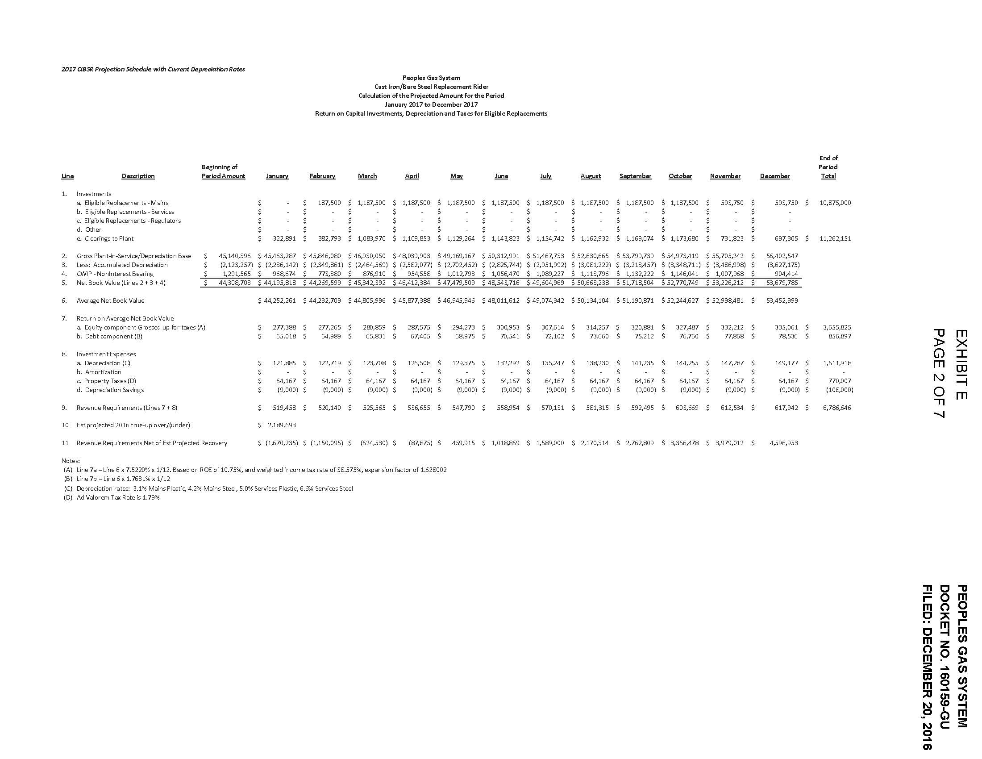
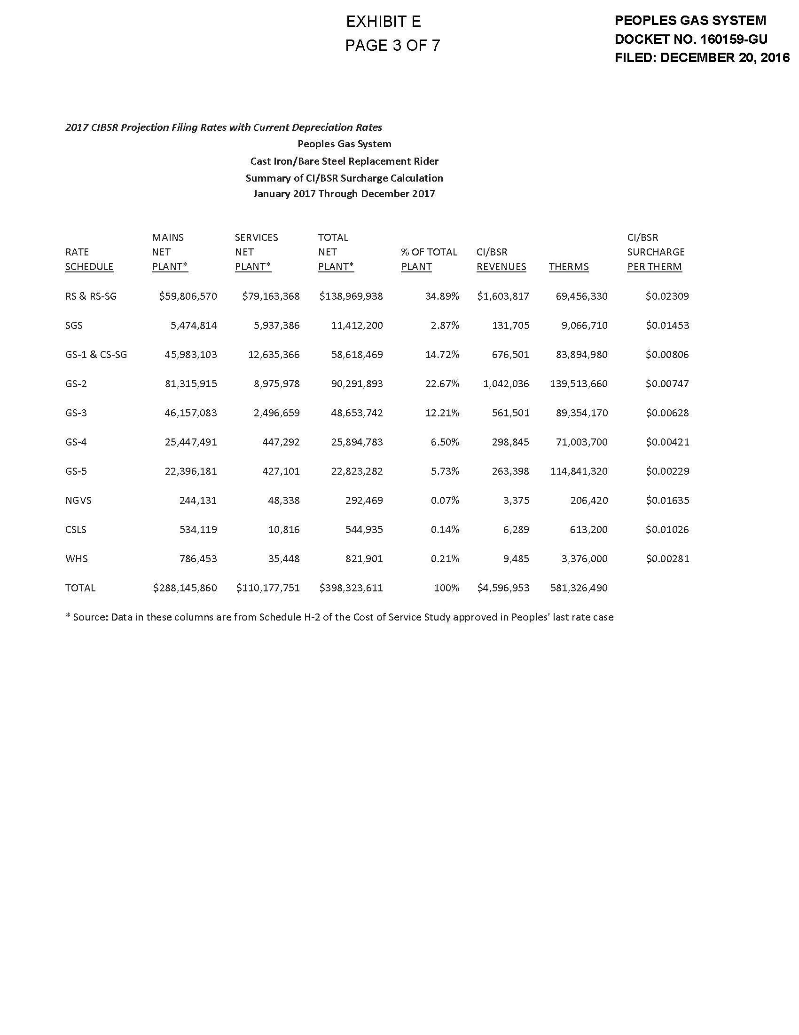
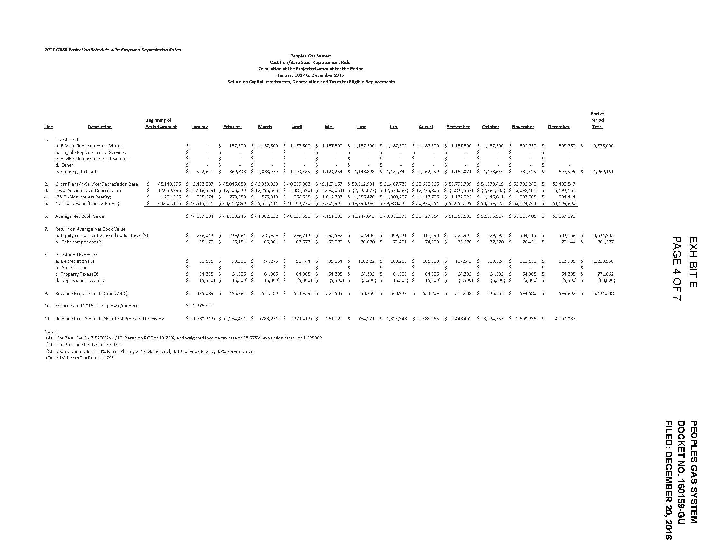
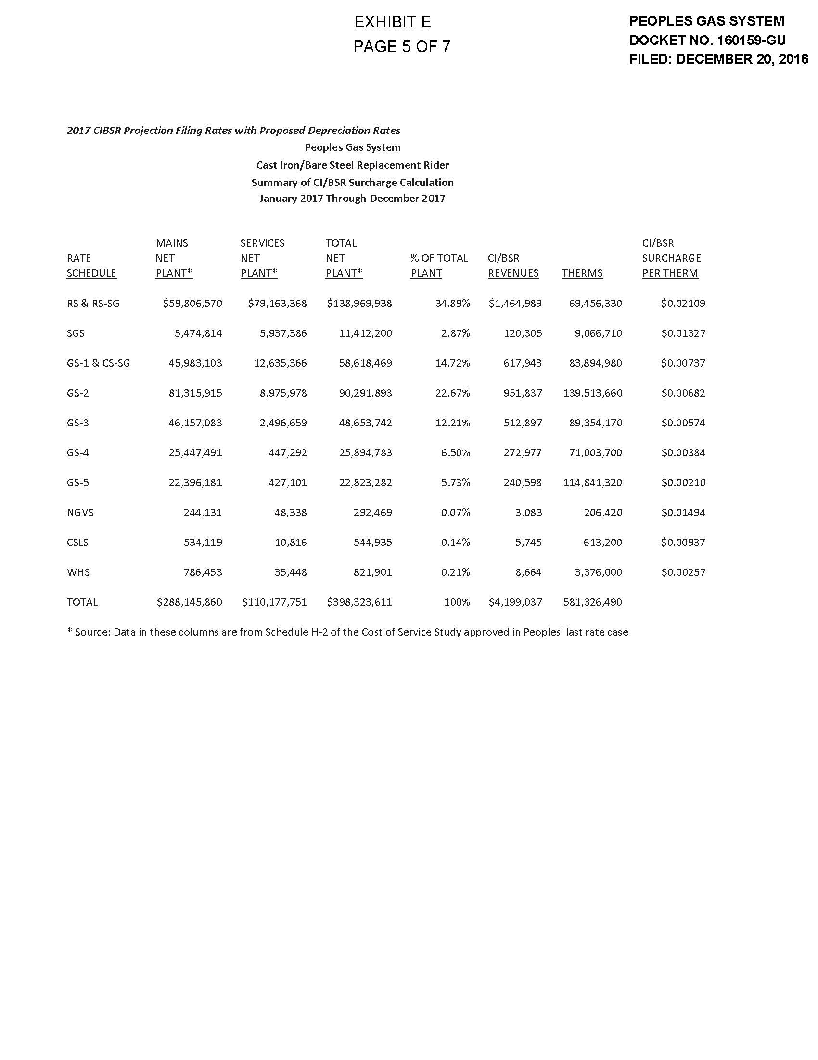
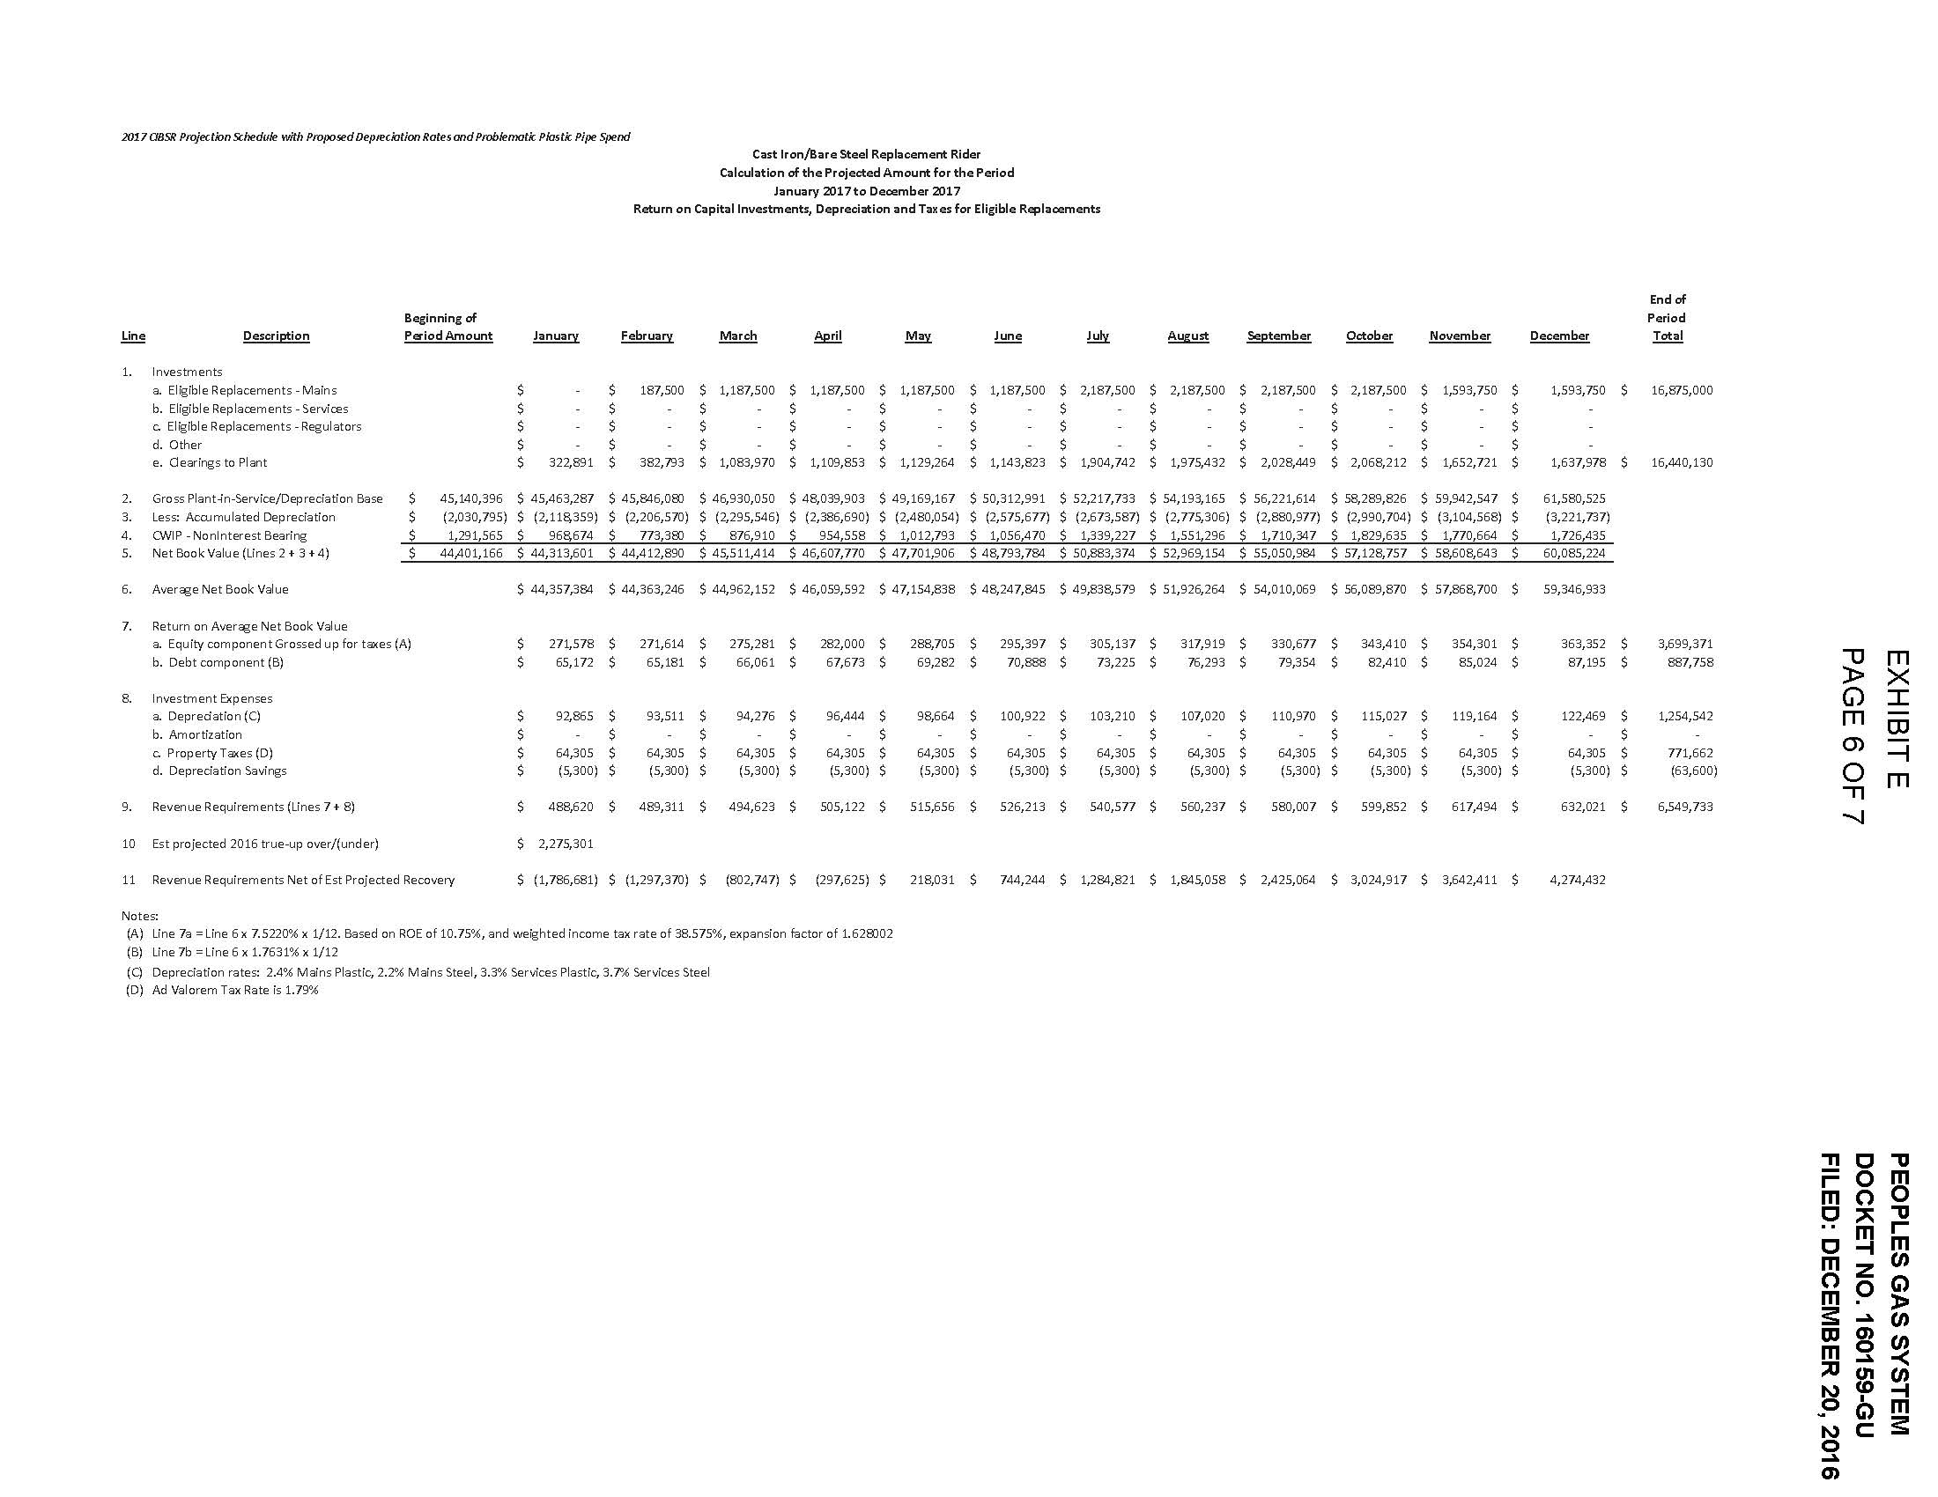
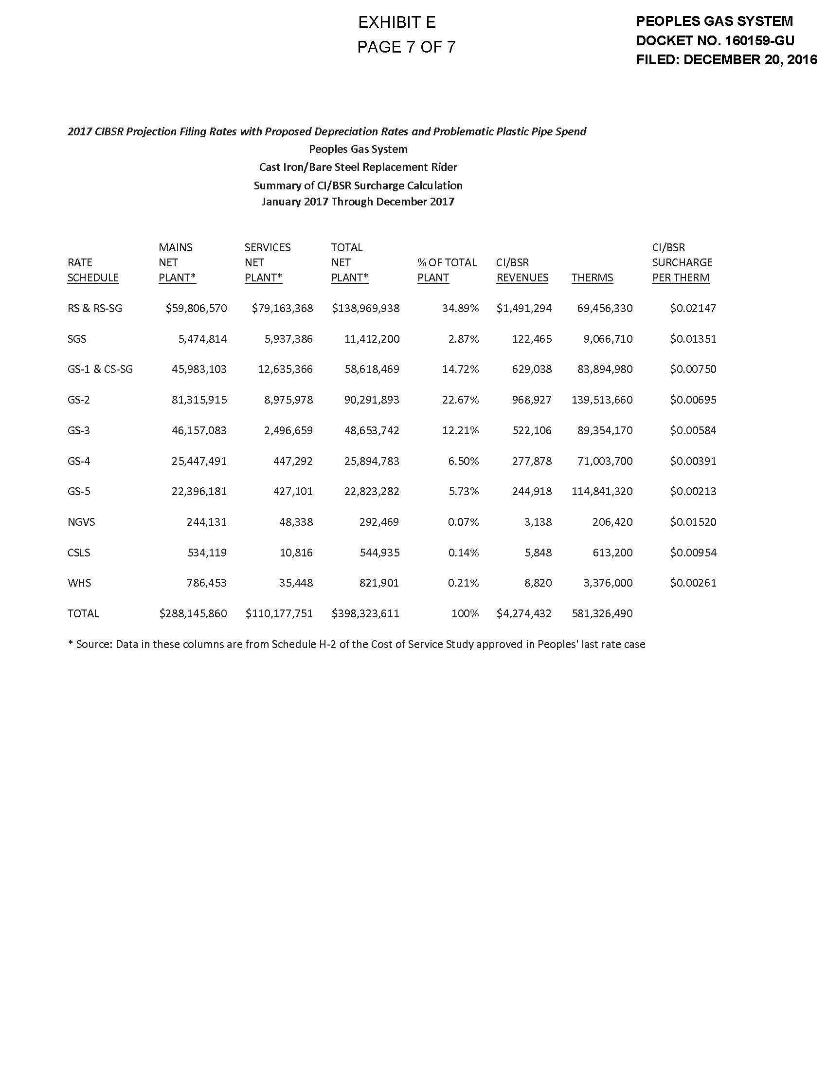

Order No. PSC-13-0023-S-EI, issued on January 14, 2013, in Docket No. 120015-EI, In re: Petition for increase in rates by Florida Power & Light Company; Order No. PSC-11-0089-S-EI, issued February 1, 2011, in Docket Nos. 080677 and 090130, In re: Petition for increase in rates by Florida Power & Light Company and In re: 2009 depreciation and dismantlement study by Florida Power & Light Company; Order No. PSC-13-0023-S-EIPSC-10-0398-S-EI, issued June 18, 2010, in Docket Nos. 090079-EI, 090144-EI, 090145-EI, 100136-EI, In re: Petition for increase in rates by Progress Energy Florida, Inc., In re: Petition for limited proceeding to include Bartow repowering project in base rates, by Progress Energy Florida, Inc., In re: Petition for expedited approval of the deferral of pension expenses, authorization to charge storm hardening expenses to the storm damage reserve, and variance from or waiver of Rule 25-6.0143(1)(c), (d), and (f), F.A.C., by Progress Energy Florida, Inc., and In re: Petition for approval of an accounting order to record a depreciation expense credit, by Progress Energy Florida, Inc.; Order No. PSC-05-0945-S-EI, issued September 28, 2005, in Docket No. 050078-EI, In re: Petition for rate increase by Progress Energy Florida, Inc.
Order No. PSC-13-0023-S-EI, at p. 7.

