BEFORE THE FLORIDA PUBLIC SERVICE COMMISSION

In re: Request for approval of tariff modifications related to natural gas vehicles and fueling facilities by Peoples Gas System. | DOCKET NO. 170038-GU  ORDER NO. PSC-17-0195-TRF-GU  ISSUED: May 19, 2017

The following Commissioners participated in the disposition of this matter:

JULIE I. BROWN, Chairman
ART GRAHAM
RONALD A. BRISÉ
JIMMY PATRONIS
DONALD J. POLMANN

ORDER APPROVING TARIFF MODIFICATIONS

BY THE COMMISSION:

Background

On February 20, 2017, Peoples Gas System (Peoples or the company) filed a petition seeking approval of modifications to its Natural Gas Vehicle Service (NGVS) tariffs. Specifically, Peoples proposed modifications to its current NGVS-2 rate schedule and proposed new rate schedule NGVS-3. Rates and charges for NGVS customers are not changing. The proposed tariff changes are designed to provide more clarity regarding optional services offered by Peoples to customers buying natural gas for compression and delivery into compressed natural gas (CNG) vehicles.
In Order No. 25626, we approved Peoples’ original program for the use of CNG in motor vehicles. The program was designed to assist fleet operators and filling station operators in obtaining compressor units to encourage the development of a CNG infrastructure. In 2013, we approved Peoples’ currently available NGVS-2 tariff, which provides three options for Peoples to install and maintain private or public fueling stations for CNG customers.
Section 334.044(33)(a)4., Florida Statutes (F.S.), encourages the increased use of natural gas to reduce transportation costs for businesses and residents within the state. Peoples waived the 60-day file and suspend provision of Section 366.06(3), F.S. We have jurisdiction over this matter pursuant to Section 366.04, F.S.
Decision

The NGVS-2 rate schedule applies to customers wishing to buy gas for the purpose of compression and delivery into CNG vehicles. The NGVS-2 rate schedule was designed to provide customers with three options with respect to the facilities and equipment required for the compression and dispensing of CNG while allowing Peoples to recover its cost to provide these options.
Peoples explained that based on three years of experience with the NGVS-2 rate schedule, Peoples has determined that the three options can be confusing to customers and the company. Therefore, Peoples filed the instant petition to keep Option 1 as the only service provided under the NGVS-2 rate schedule, eliminate Option 2, and offer Option 3 under the new rate schedule NGVS-3. Peoples currently has no customers taking service under Options 2 and 3.
The current NGVS-2 rate schedule is included as Attachment A to this order. The proposed modified NGVS-2 and proposed new NGVS-3 rate schedules are included as Attachment B. The three existing options contained in the NGVS-2 rate schedule and Peoples’ proposed modifications with respect to each option are discussed below.
Under Option 1, Company-provided Facilities on Customer’s Premises, Peoples incurs the capital cost to construct the CNG station and the ongoing costs associated with the maintenance of the CNG station. Customers are billed under the otherwise applicable residential or commercial rate schedules based on annual consumption. In addition, customers are assessed a monthly facilities charge to allow Peoples to recover the cost associated with the facilities provided. The company currently has three customers: the City of Orlando’s Solid Waste Division, NoPetro in Orlando serving CNG buses, and St. Johns County serving its CNG fleet. These customers have CNG fueling facilities on their premises, such as at a public works parking lot or fleet vehicles yard. This option would remain available to customers and will be the only service covered under the NGVS-2 rate schedule.
Under Option 2, Limited Access Facilities Located on Company Premises, one or more customers can contract with the company to provide and maintain, on company premises, an NGV compression and fueling station. Similar to Option 1, customers pay a monthly facilities charge. Peoples explained that this tariff option, as written, would have been difficult to administer as facilities cost would vary based on the number of customers taking this option. The company stated that it does not anticipate future customers taking service under this limited service option on company premises as there are more fueling stations that are open to the public now; therefore, Peoples is proposing to eliminate NGVS-2 rate schedule’s Option 2.
Current Option 3, Publicly Accessible Facilities Located on Company Premises, contained in the NGVS-2 tariff is designed for Peoples to operate a publicly accessible facility located on its premises. Customers under this option are not billed the otherwise applicable rate. Customers instead pay $0.50 per therm for distribution and dispensing, in addition to the cost of gas. The $0.50 per therm fee was developed to recover the estimated cost of providing the CNG to a vehicle in a public station.
Peoples is proposing to move Option 3 to a new rate schedule NGVS-3. Although, currently, there are no customers taking service under Option 3, it is proposed as a placeholder to be used when the opportunity arises for Peoples to build publicly accessible CNG fueling stations.
Peoples’ proposed NGVS programs and tariffs are reasonable and will allow Peoples to recover its cost of providing CNG service. We hereby approve Peoples’ petition to modify the NGVS-2 rate schedule and approve the new NGVS-3 rate schedule effective May 4, 2017.
Based on the foregoing, it is

ORDERED by the Florida Public Service Commission that Peoples Gas System’s proposed petition to modify Natural Gas Vehicle Service (NGVS) tariffs are hereby approved effective May 4, 2017, as set forth in the body of this order. It is further

ORDERED that if a protest is filed within 21 days of issuance of the Order, the tariff shall remain in effect with any charges held subject to refund pending resolution of the protest. It is further

ORDERED that if no timely protest is filed, this docket shall be closed upon the issuance of a Consummating Order.

By ORDER of the Florida Public Service Commission this 19th day of May, 2017.

/s/ Hong Wang
HONG WANG
Chief Deputy Commission Clerk
Florida Public Service Commission
2540 Shumard Oak Boulevard
Tallahassee, Florida 32399
(850) 413-6770
www.floridapsc.com

Copies furnished: A copy of this document is provided to the parties of record at the time of issuance and, if applicable, interested persons.

DJ

NOTICE OF FURTHER PROCEEDINGS

The Florida Public Service Commission is required by Section 120.569(1), Florida Statutes, to notify parties of any administrative hearing or judicial review of Commission orders that is available under Sections 120.57 or 120.68, Florida Statutes, as well as the procedures and time limits that apply. This notice should not be construed to mean all requests for an administrative hearing or judicial review will be granted or result in the relief sought.

Mediation may be available on a case-by-case basis. If mediation is conducted, it does not affect a substantially interested person's right to a hearing.

The Commission's decision on this tariff is interim in nature and will become final, unless a person whose substantial interests are affected by the proposed action files a petition for a formal proceeding, in the form provided by Rule 28-106.201, Florida Administrative Code. This petition must be received by the Office of Commission Clerk, 2540 Shumard Oak Boulevard, Tallahassee, Florida 32399-0850, by the close of business on June 9, 2017.

In the absence of such a petition, this Order shall become final and effective upon the issuance of a Consummating Order.

Any objection or protest filed in this docket before the issuance date of this order is considered abandoned unless it satisfies the foregoing conditions and is renewed within the specified protest period.

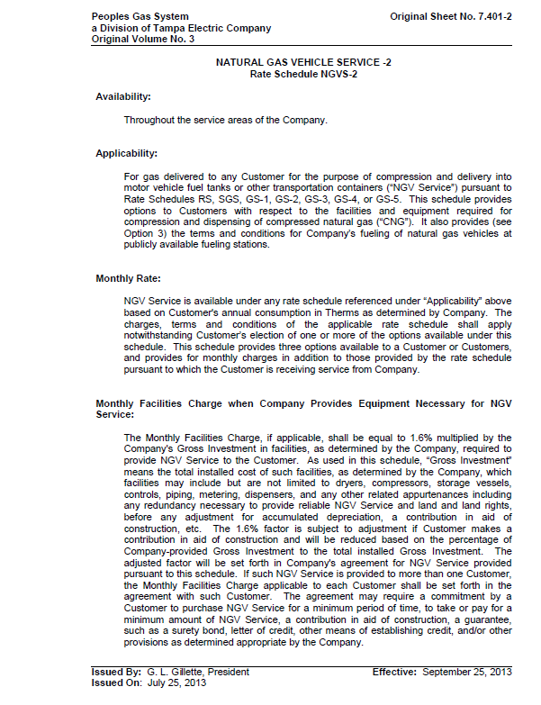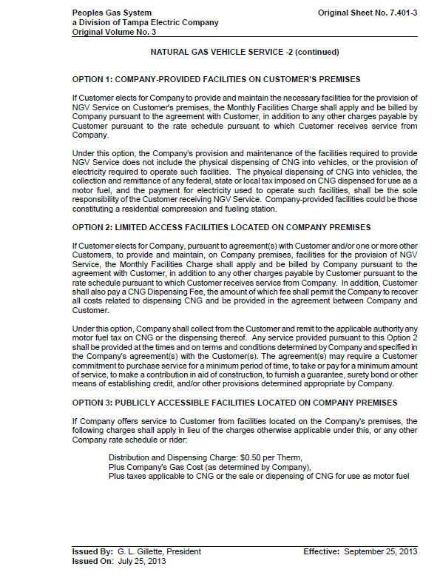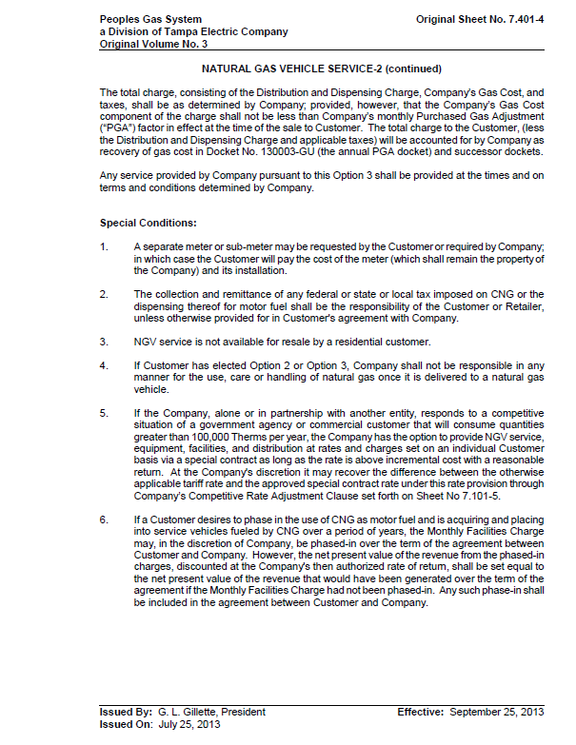
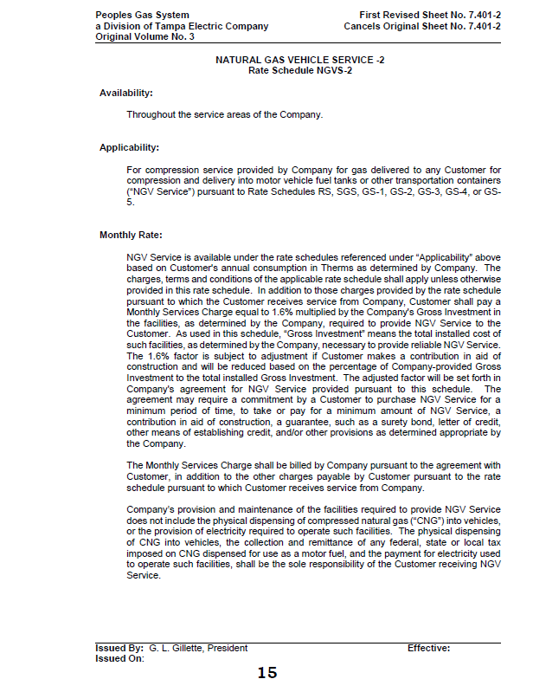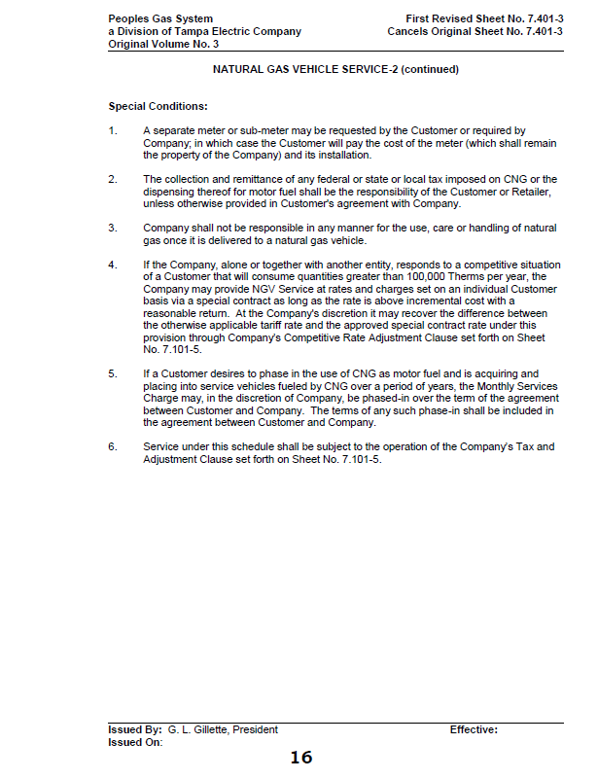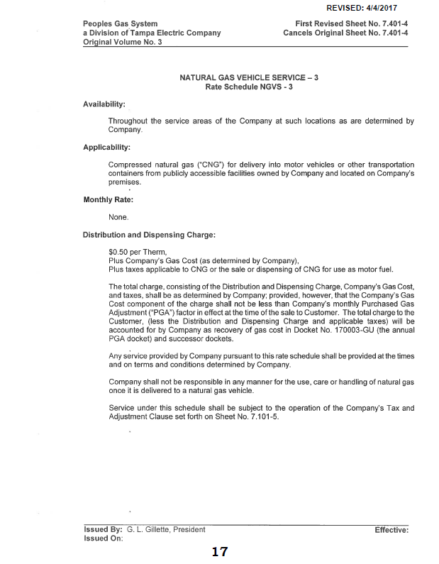

Order No. 25626, issued January 22, 1992, in Docket No. 910942-EG, In re: Petition for approval of its natural gas vehicle program for peoples Gas system, Inc.
Order No. PSC-13-0446-PAA-GU, issued October 1, 2013, in Docket No. 130197-GU, In re: Request for approval of tariff modifications related to natural gas vehicles and fueling facilities by People’s Gas System.

