BEFORE THE FLORIDA PUBLIC SERVICE COMMISSION

In re: Petition for approval of revised standard offer for energy purchase from cogenerators and renewable generating facilities and standard offer contract for purchases of firm capacity and energy, by Florida Public Utilities Company. | DOCKET NO. 20170070-EQ  ORDER NO. PSC-2017-0279-PAA-EQ  ISSUED: July 18, 2017

The following Commissioners participated in the disposition of this matter:

JULIE I. BROWN, Chairman
ART GRAHAM
RONALD A. BRISÉ
DONALD J. POLMANN

NOTICE OF PROPOSED AGENCY ACTION ORDER APPROVING
STANDARD OFFER RATE SCHEDULES AND STANDARD OFFER CONTRACT

BY THE COMMISSION:

NOTICE is hereby given by the Florida Public Service Commission (Commission) that the action discussed herein is preliminary in nature and will become final unless a person whose interests are substantially affected files a petition for a formal proceeding, pursuant to Rule 25-22.029, Florida Administrative Code (F.A.C.).

CASE Background

On March 30, 2017, Florida Public Utilities Company (FPUC) filed a petition for approval of its revised standard offer rate schedule and standard offer contract, in accordance with Rules 25-9.003, 25-17.200 through 17.310, 25-17.0825, and 25-17.0832, Florida Administrative Code (F.A.C.) Section 366.91(3), Florida Statutes (F.S.) requires that each investor-owned utility (IOU) continuously offers to purchase capacity and energy from renewable energy generators and small qualifying facilities. Commission Rules 25-17.200 through 25-17.310, F.A.C., implement the statute and require each IOU to file a standard offer contract, based on the next avoidable fossil fueled generating unit of each technology type identified in the utility’s current Ten-Year Site Plan, with us by April 1 of each year.

Although it is an IOU, FPUC does not own or operate any electric generating units, thus it does not have any avoidable units on which to base its standard offer contract. Under such circumstances, Rule 25-17.250(1), F.A.C., requires that the standard offer contract be based on avoiding or deferring a planned purchase. FPUC currently purchases all of its electric power through purchased power agreements in its Northeast Division from Jacksonville Electric Authority (JEA), and in its Northwest Division from Gulf Power Company (Gulf). FPUC is currently in negotiations with Florida Power & Light (FPL) to become the full requirements supplier for the Northeast Division once the contract with JEA expires on December 31, 2017.

We have jurisdiction pursuant to Sections 366.04 through 366.06, and 366.91, F.S.

DECISION

Rule 25-17.250, F.A.C., requires that FPUC, an IOU, continuously make available a standard offer contract for the purchase of firm capacity and energy from renewable generating facilities (RF) and small qualifying facilities (QF) with a design capacity of 100 kilowatt (kW) or less. FPUC does not own or operate any of its own electric generating facilities, and thus does not file a Ten-Year Site Plan with this Commission. Instead, FPUC purchases all of its electric energy under long-term, full requirements contracts with wholesale providers.

FPUC’s standard offer rate schedule consists of three components: (1) the Standard Offer-As Available schedule (SOA); (2) the Standard Offer- Firm Schedule (SOF); and (3) the Standard Offer Contract. The SOA and SOF consolidate FPUC's previous REN and COG tariffs, as approved by us in Order No. PSC-16-0531-PAA-EQ, issued November 22, 2016. Revisions to FPUC’s standard offer contract and rate schedule, in type-and-strike format, are included as Attachment A to this Order. The capacity and energy payments under FPUC’s proposed rate schedule depend on the terms of FPUC’s wholesale contracts with suppliers for its Northeast Division and Northwest Division.

FPUC Northeast Division

At present, JEA is the full requirements supplier for FPUC's Northeast Division, which consists of Fernandina Beach and Amelia Island. However, FPUC is currently in negotiations with FPL for FPL to become the full requirements supplier for FPUC’s Northeast Division when its contract with JEA expires on December 31, 2017. FPUC provided estimates of the annual payments to an operator with a 10 MW facility, operating at a capacity factor of 80 percent, for a RF/QF operator located inside the service territory with FPL as the full requirements supplier, in response to our Staff’s First Data Request.

FPUC Northwest Division

At present, Gulf is the full requirements supplier for FPUC's Northwest Division, which consists of portions of Jackson, Calhoun, and Liberty Counties. In response to our Staff’s First Data Request, FPUC provided estimates of the annual payments to an operator with a 10 MW facility, operating at a capacity factor of 80 percent, for a RF/QF operator located inside the service territory.

Conclusion

We find that FPUC’s revised standard offer contract and related rate schedules conform to all the requirements of Rule 25-17.0825, and 25-17.200 through 25-17.310, F.A.C., and reflect the avoidable costs associated with FPUC’s purchased power agreements. Therefore, we approve the FPUC’s revised standard offer contract and related rate schedules as filed on March 30, 2017, and incorporated herein as Attachment A. Potential signatories should be aware that, if a timely protest is filed, FPUC’s standard offer contract may subsequently be revised.

Based on the foregoing, it is

ORDERED by the Florida Public Service Commission that Florida Public Utilities Company’s revised standard offer contract and related rate schedules are approved as filed. It is further

ORDERED that the provisions of this Order, issued as proposed agency action, shall become final and effective upon the issuance of a Consummating Order unless an appropriate petition, in the form provided by Rule 28-106.201, Florida Administrative Code, is received by the Commission Clerk, 2540 Shumard Oak Boulevard, Tallahassee, Florida 32399-0850, by the close of business on the date set forth in the “Notice of Further Proceedings” attached hereto. It is further

ORDERED that potential signatories should be aware that, if a timely protest is filed, Florida Public Utilities Company’s standard offer contract and related rate schedules may subsequently be revised. It is further

ORDERED that in the event this Order becomes final, this docket shall be closed.

By ORDER of the Florida Public Service Commission this 18th day of July, 2017.

/s/ Carlotta S. Stauffer
CARLOTTA S. STAUFFER
Commission Clerk
Florida Public Service Commission
2540 Shumard Oak Boulevard
Tallahassee, Florida 32399
(850) 413-6770
www.floridapsc.com

Copies furnished: A copy of this document is provided to the parties of record at the time of issuance and, if applicable, interested persons.

KFC

NOTICE OF FURTHER PROCEEDINGS OR JUDICIAL REVIEW

The Florida Public Service Commission is required by Section 120.569(1), Florida Statutes, to notify parties of any administrative hearing that is available under Section 120.57, Florida Statutes, as well as the procedures and time limits that apply. This notice should not be construed to mean all requests for an administrative hearing will be granted or result in the relief sought.

Mediation may be available on a case-by-case basis. If mediation is conducted, it does not affect a substantially interested person's right to a hearing.

The action proposed herein is preliminary in nature. Any person whose substantial interests are affected by the action proposed by this order may file a petition for a formal proceeding, in the form provided by Rule 28-106.201, Florida Administrative Code. This petition must be received by the Office of Commission Clerk, 2540 Shumard Oak Boulevard, Tallahassee, Florida 32399-0850, by the close of business on August 8, 2017.

In the absence of such a petition, this order shall become final and effective upon the issuance of a Consummating Order.

Any objection or protest filed in this/these docket(s) before the issuance date of this order is considered abandoned unless it satisfies the foregoing conditions and is renewed within the specified protest period.

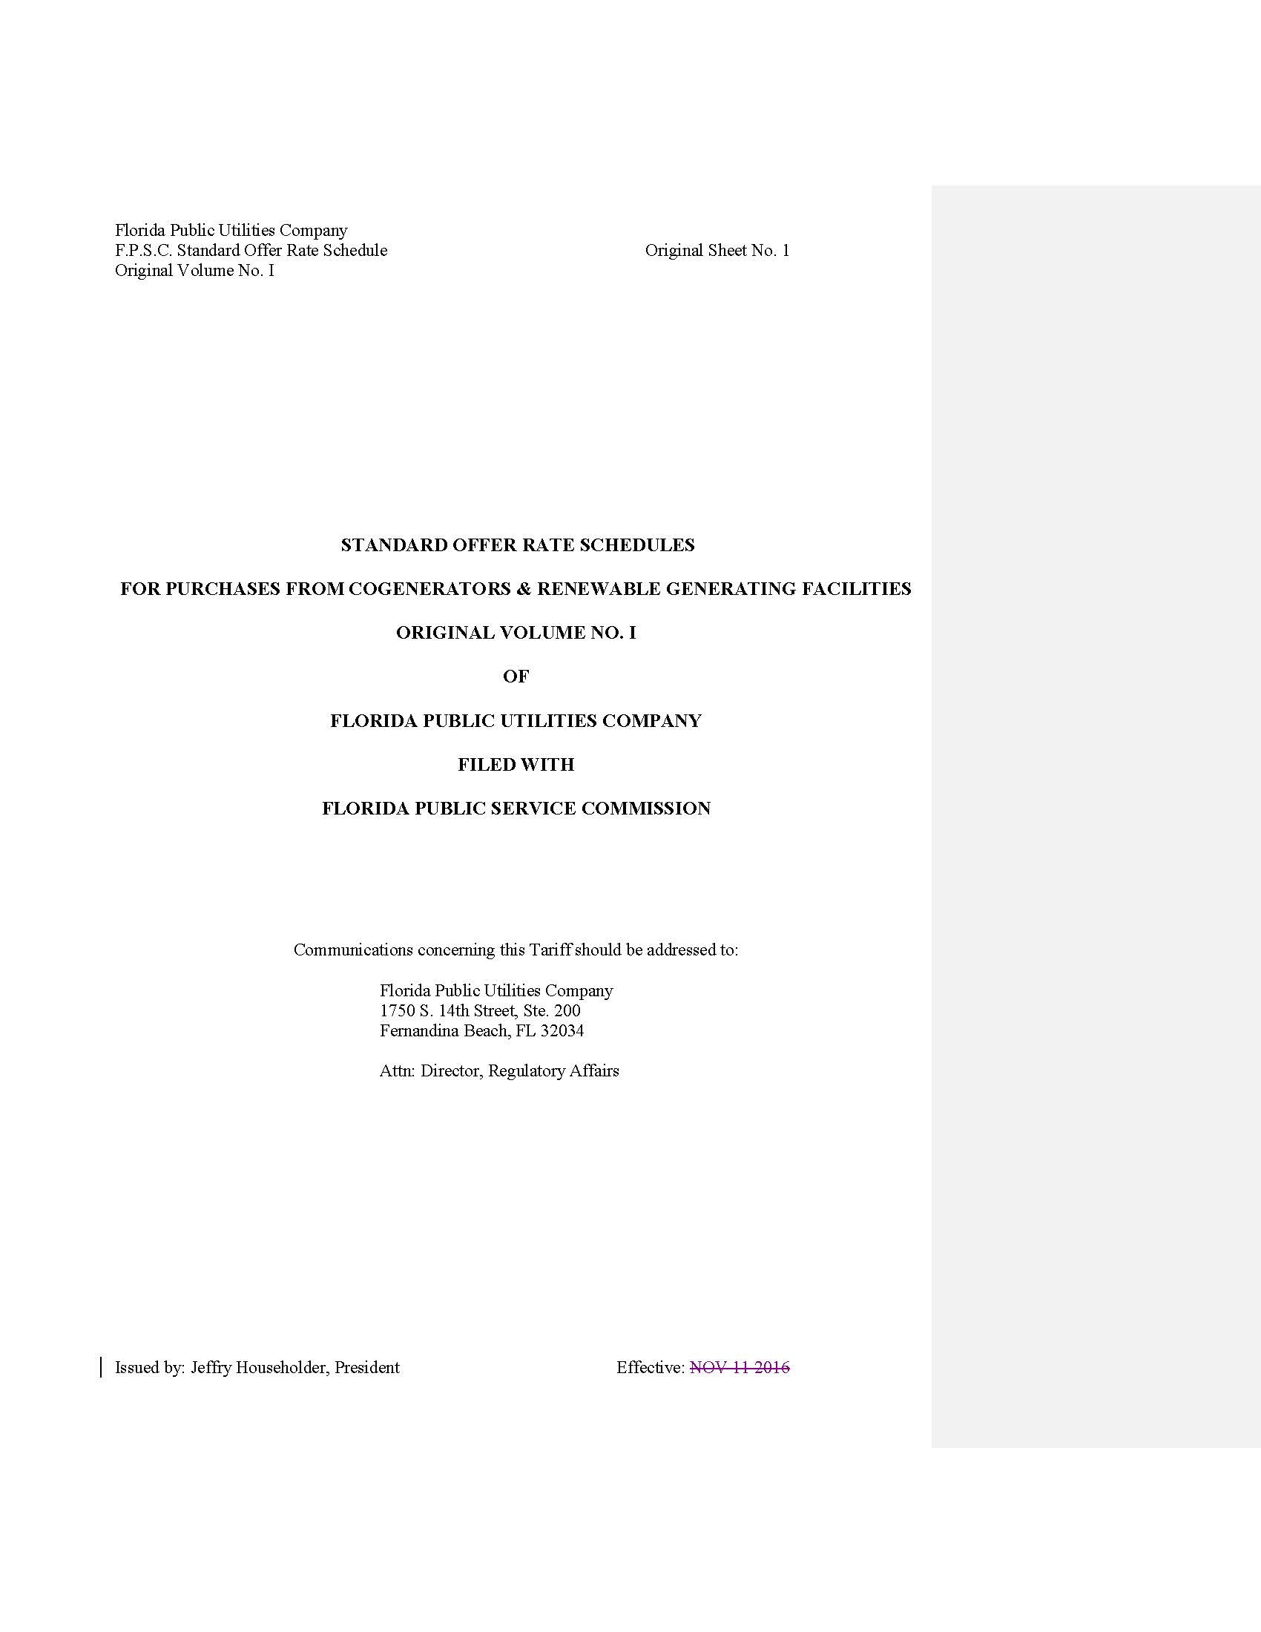

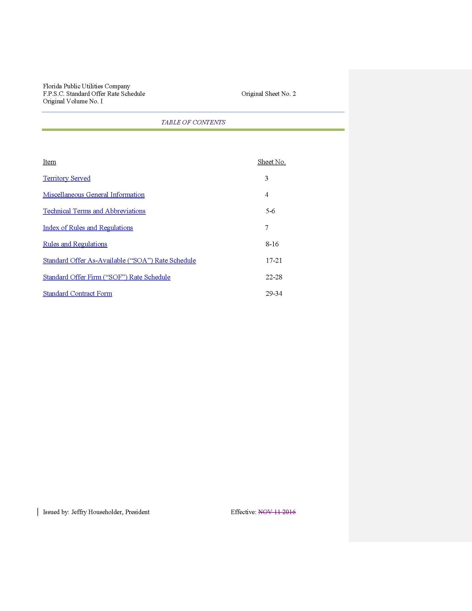

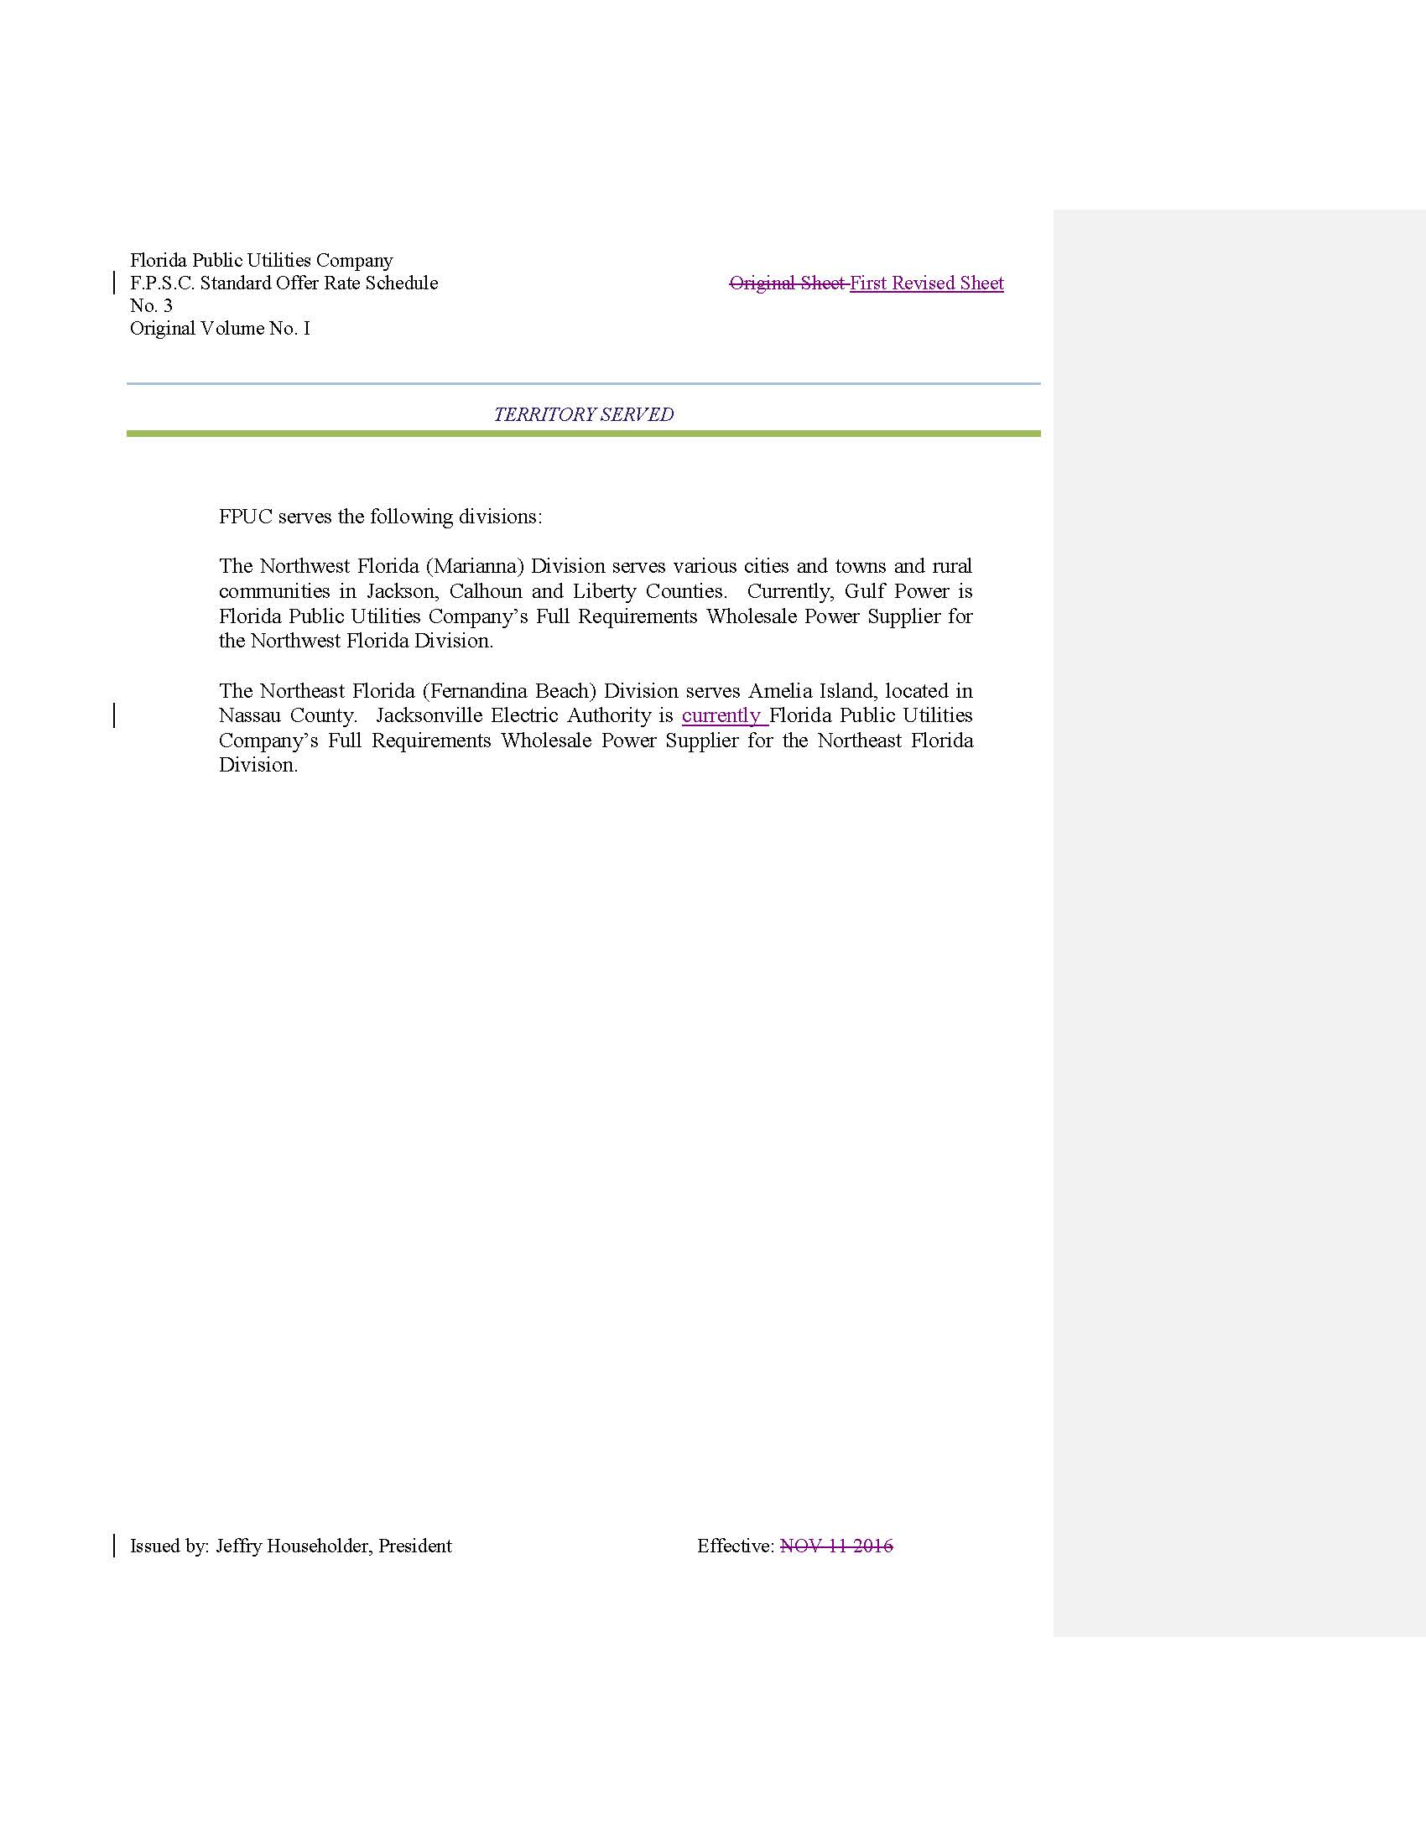

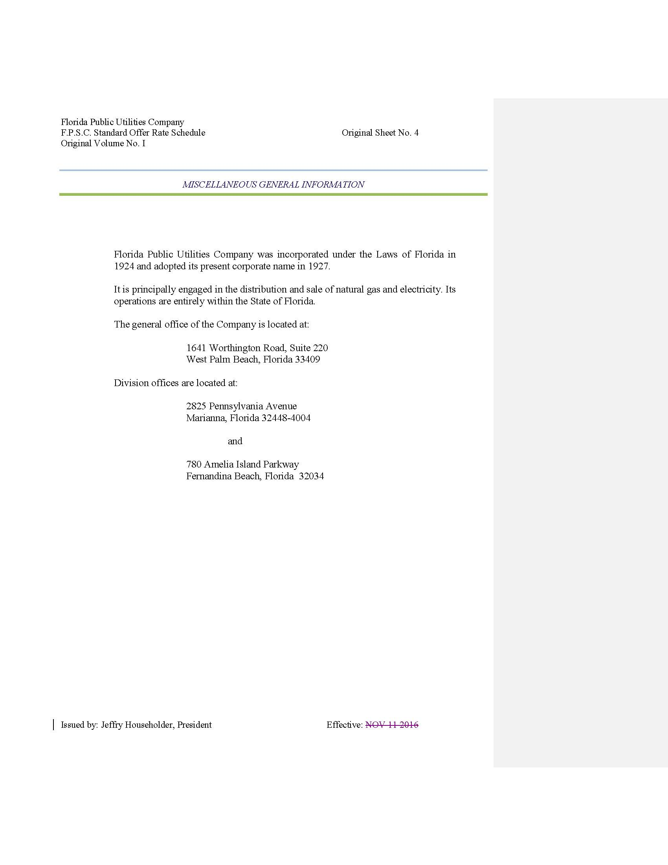

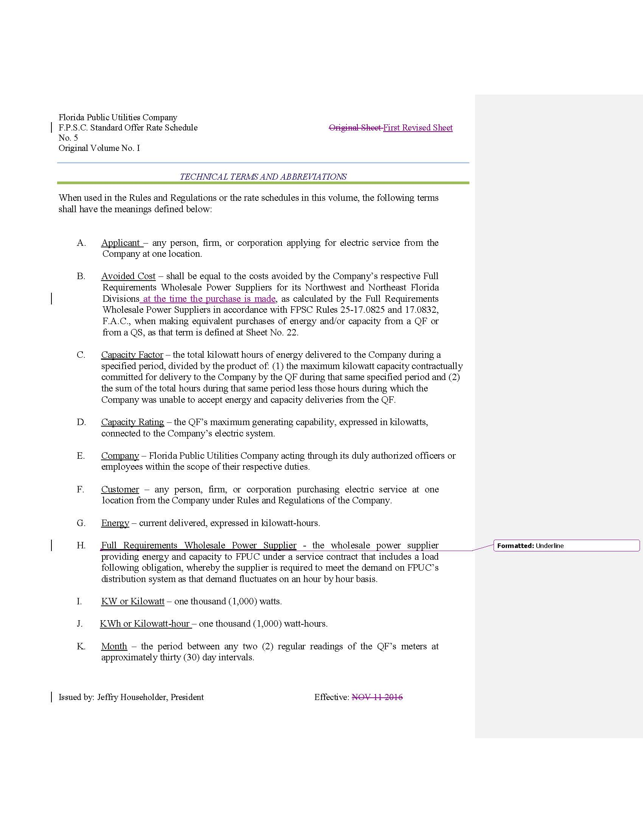

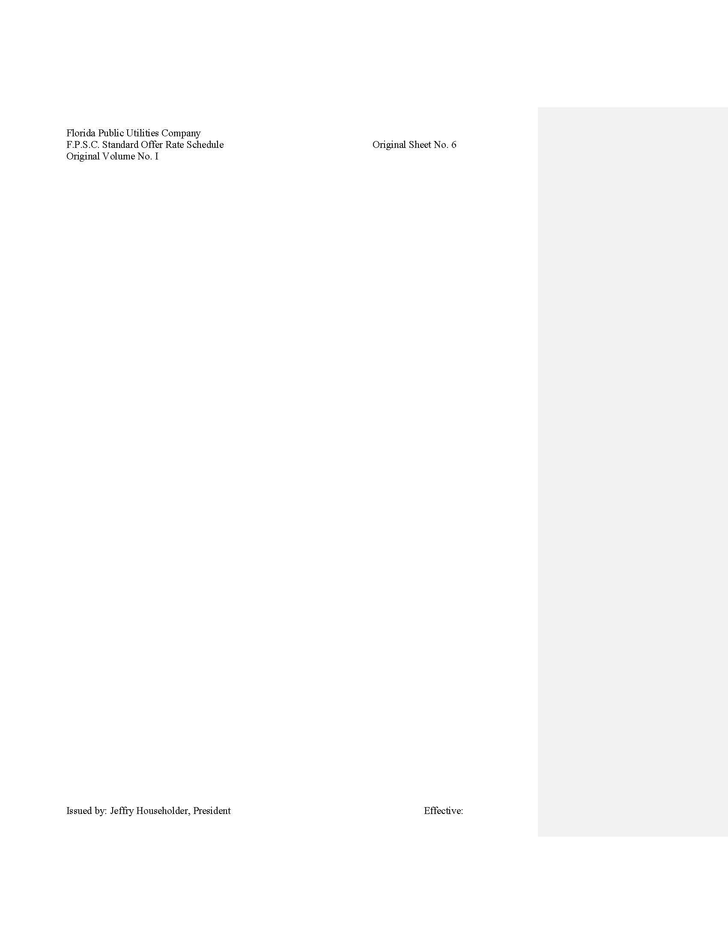

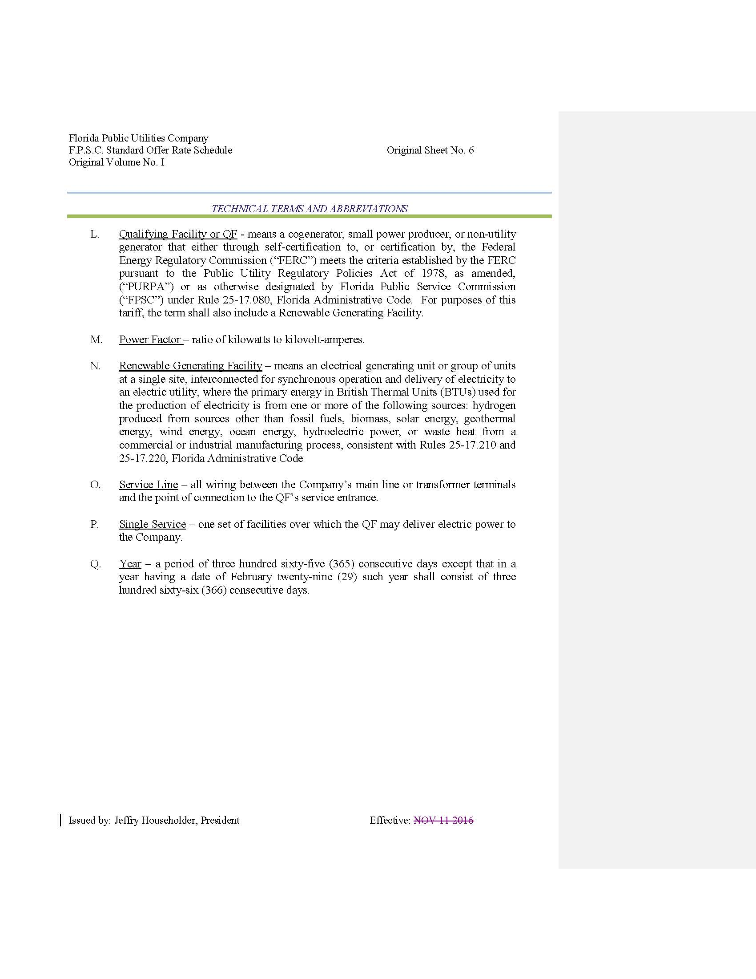

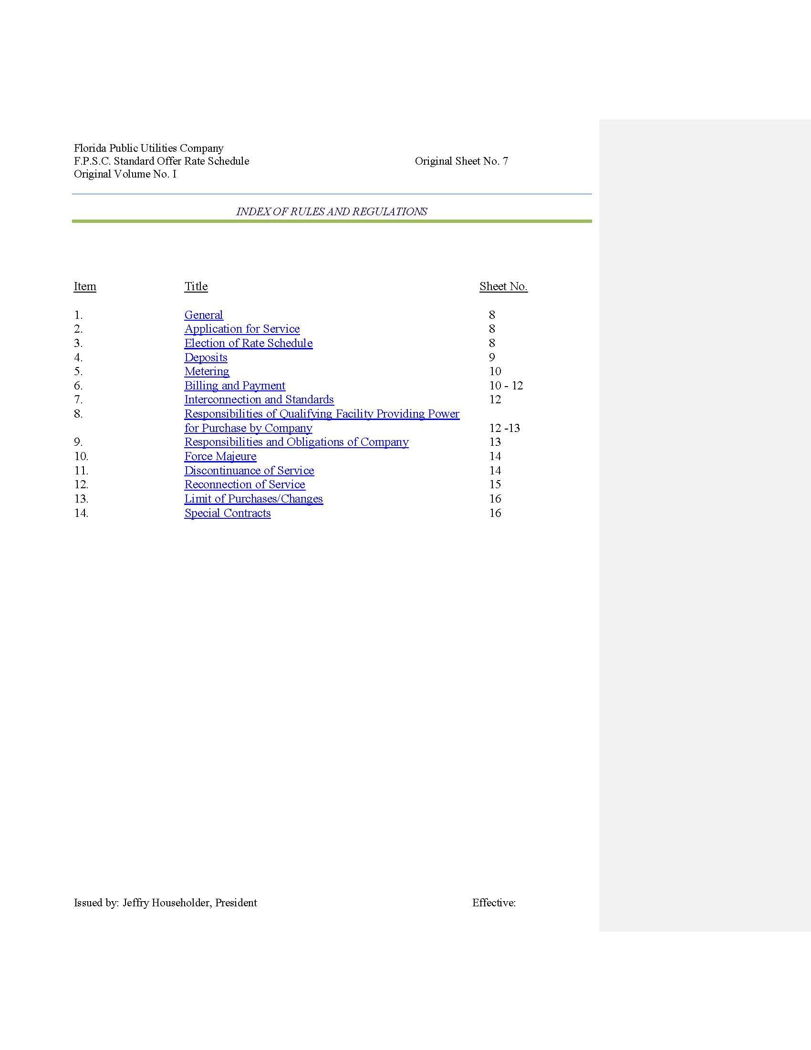

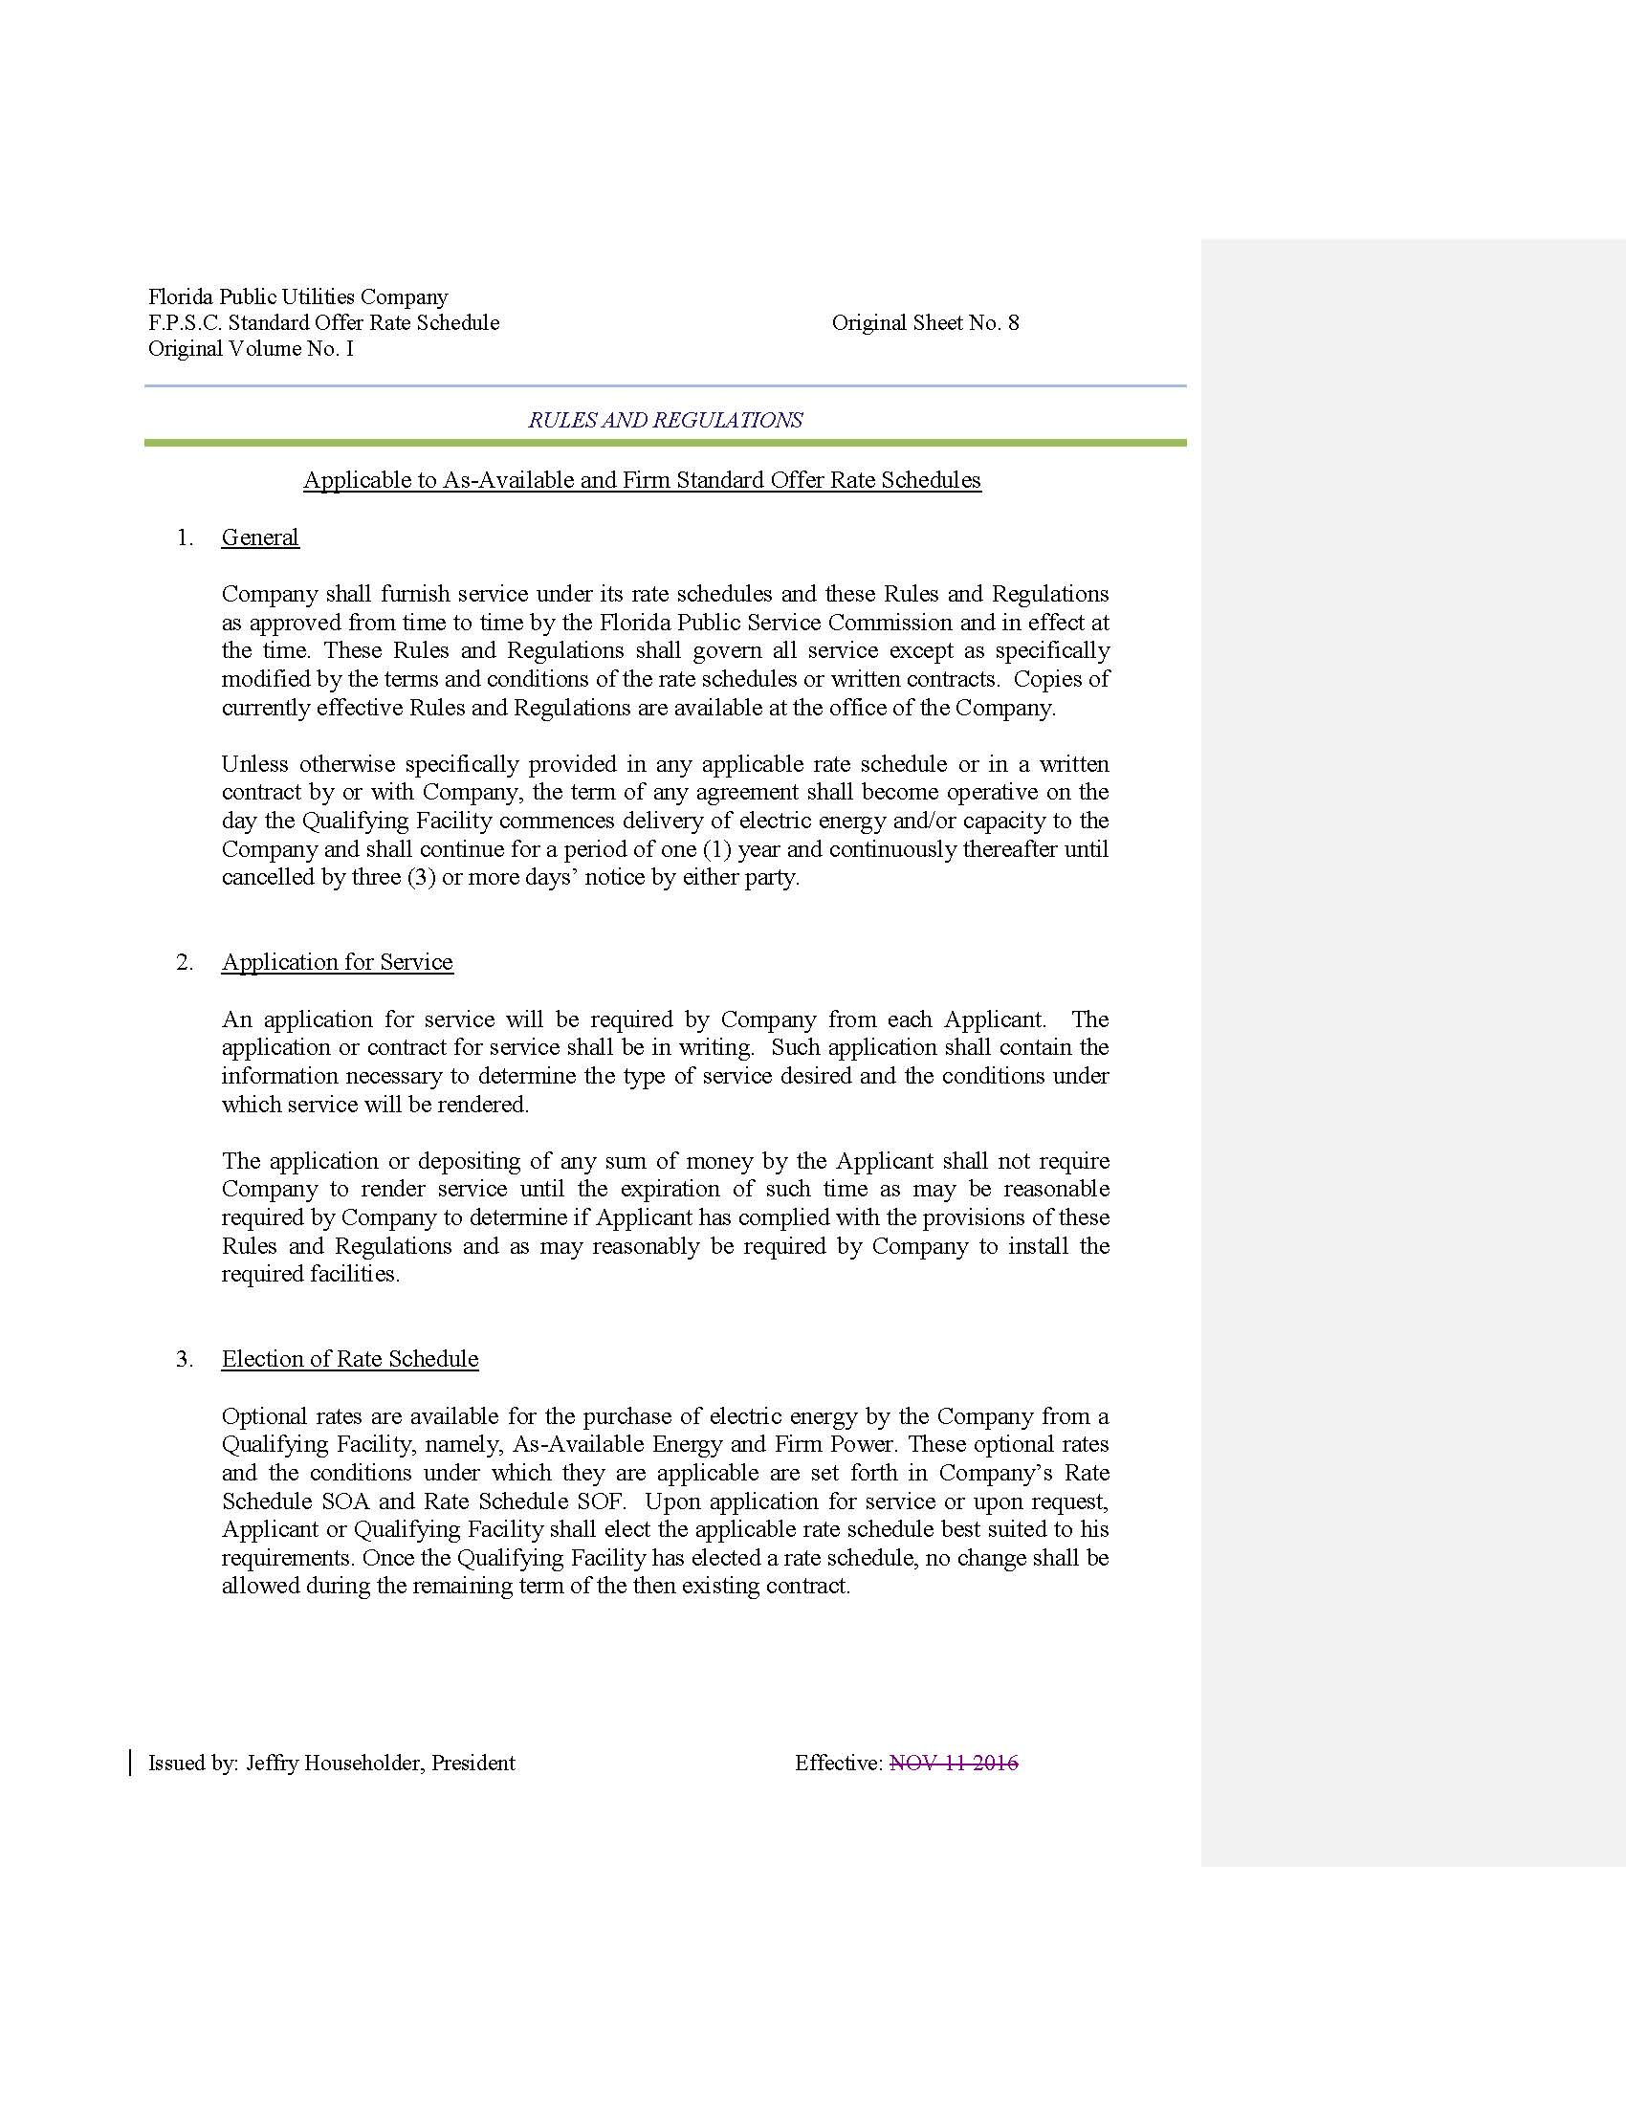

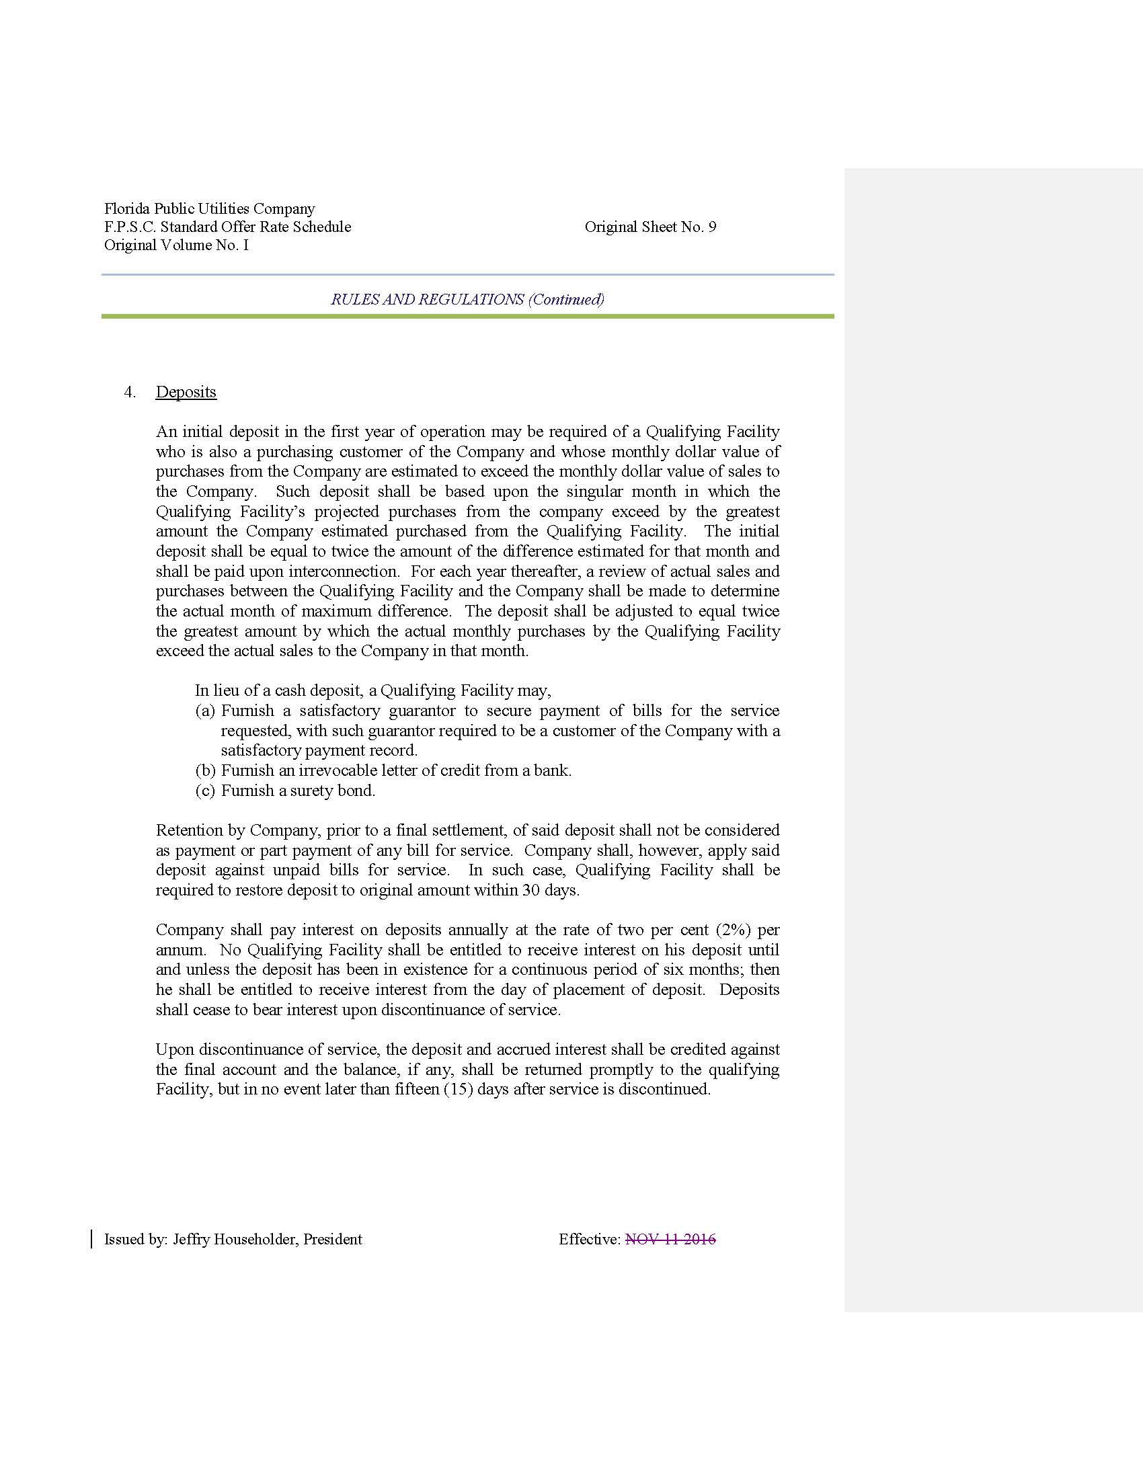

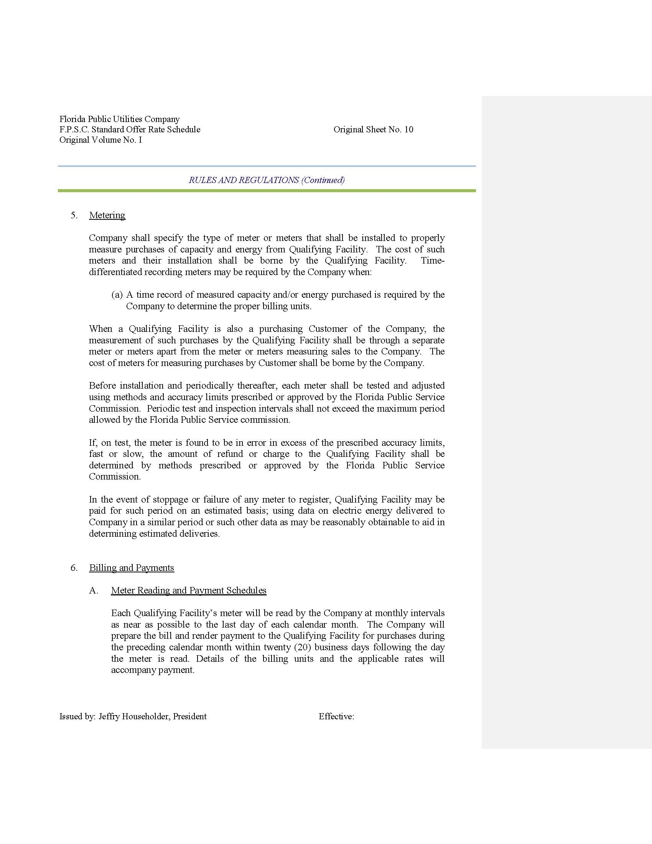

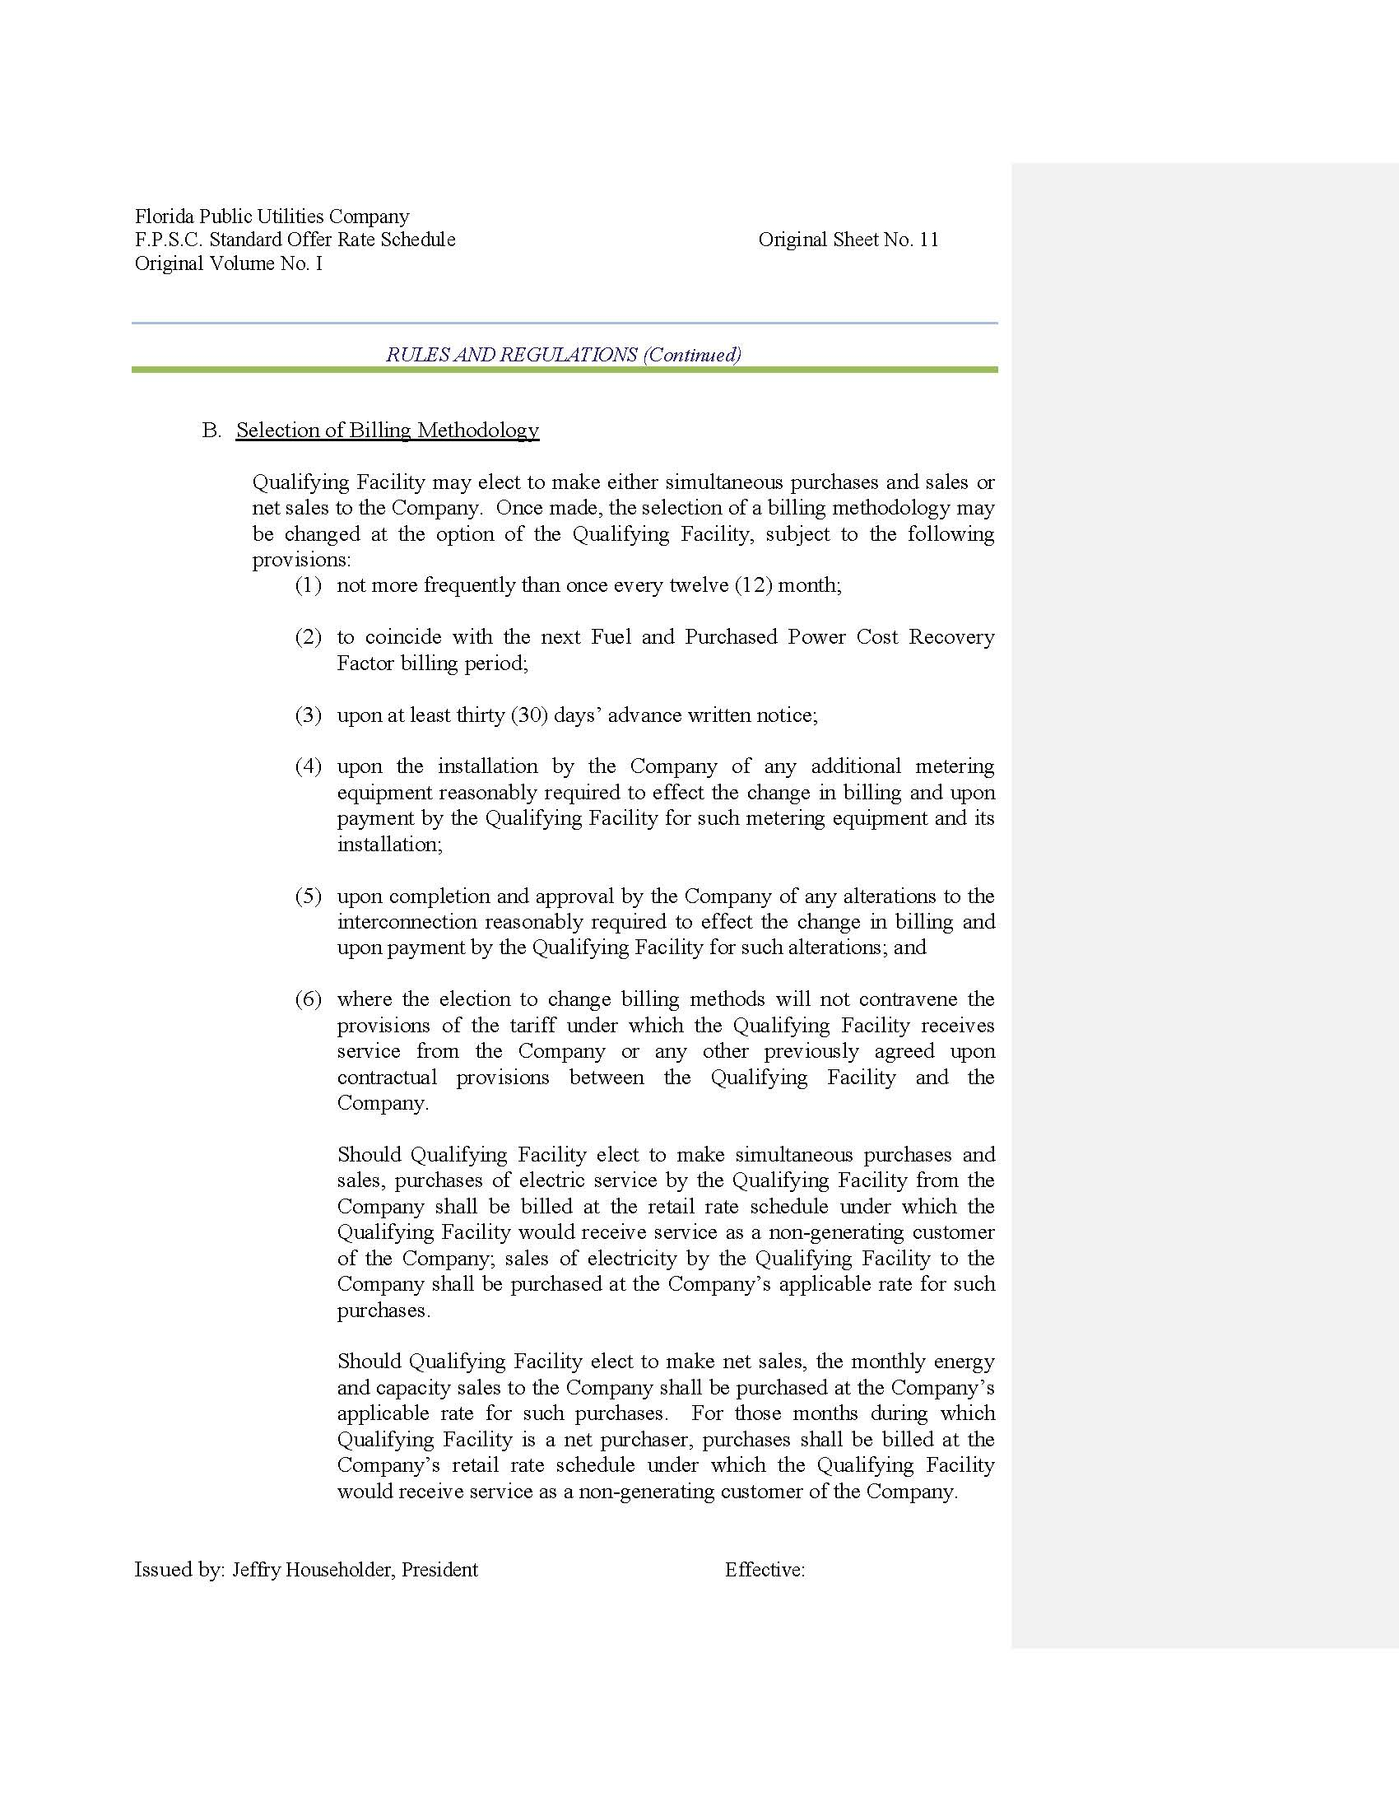

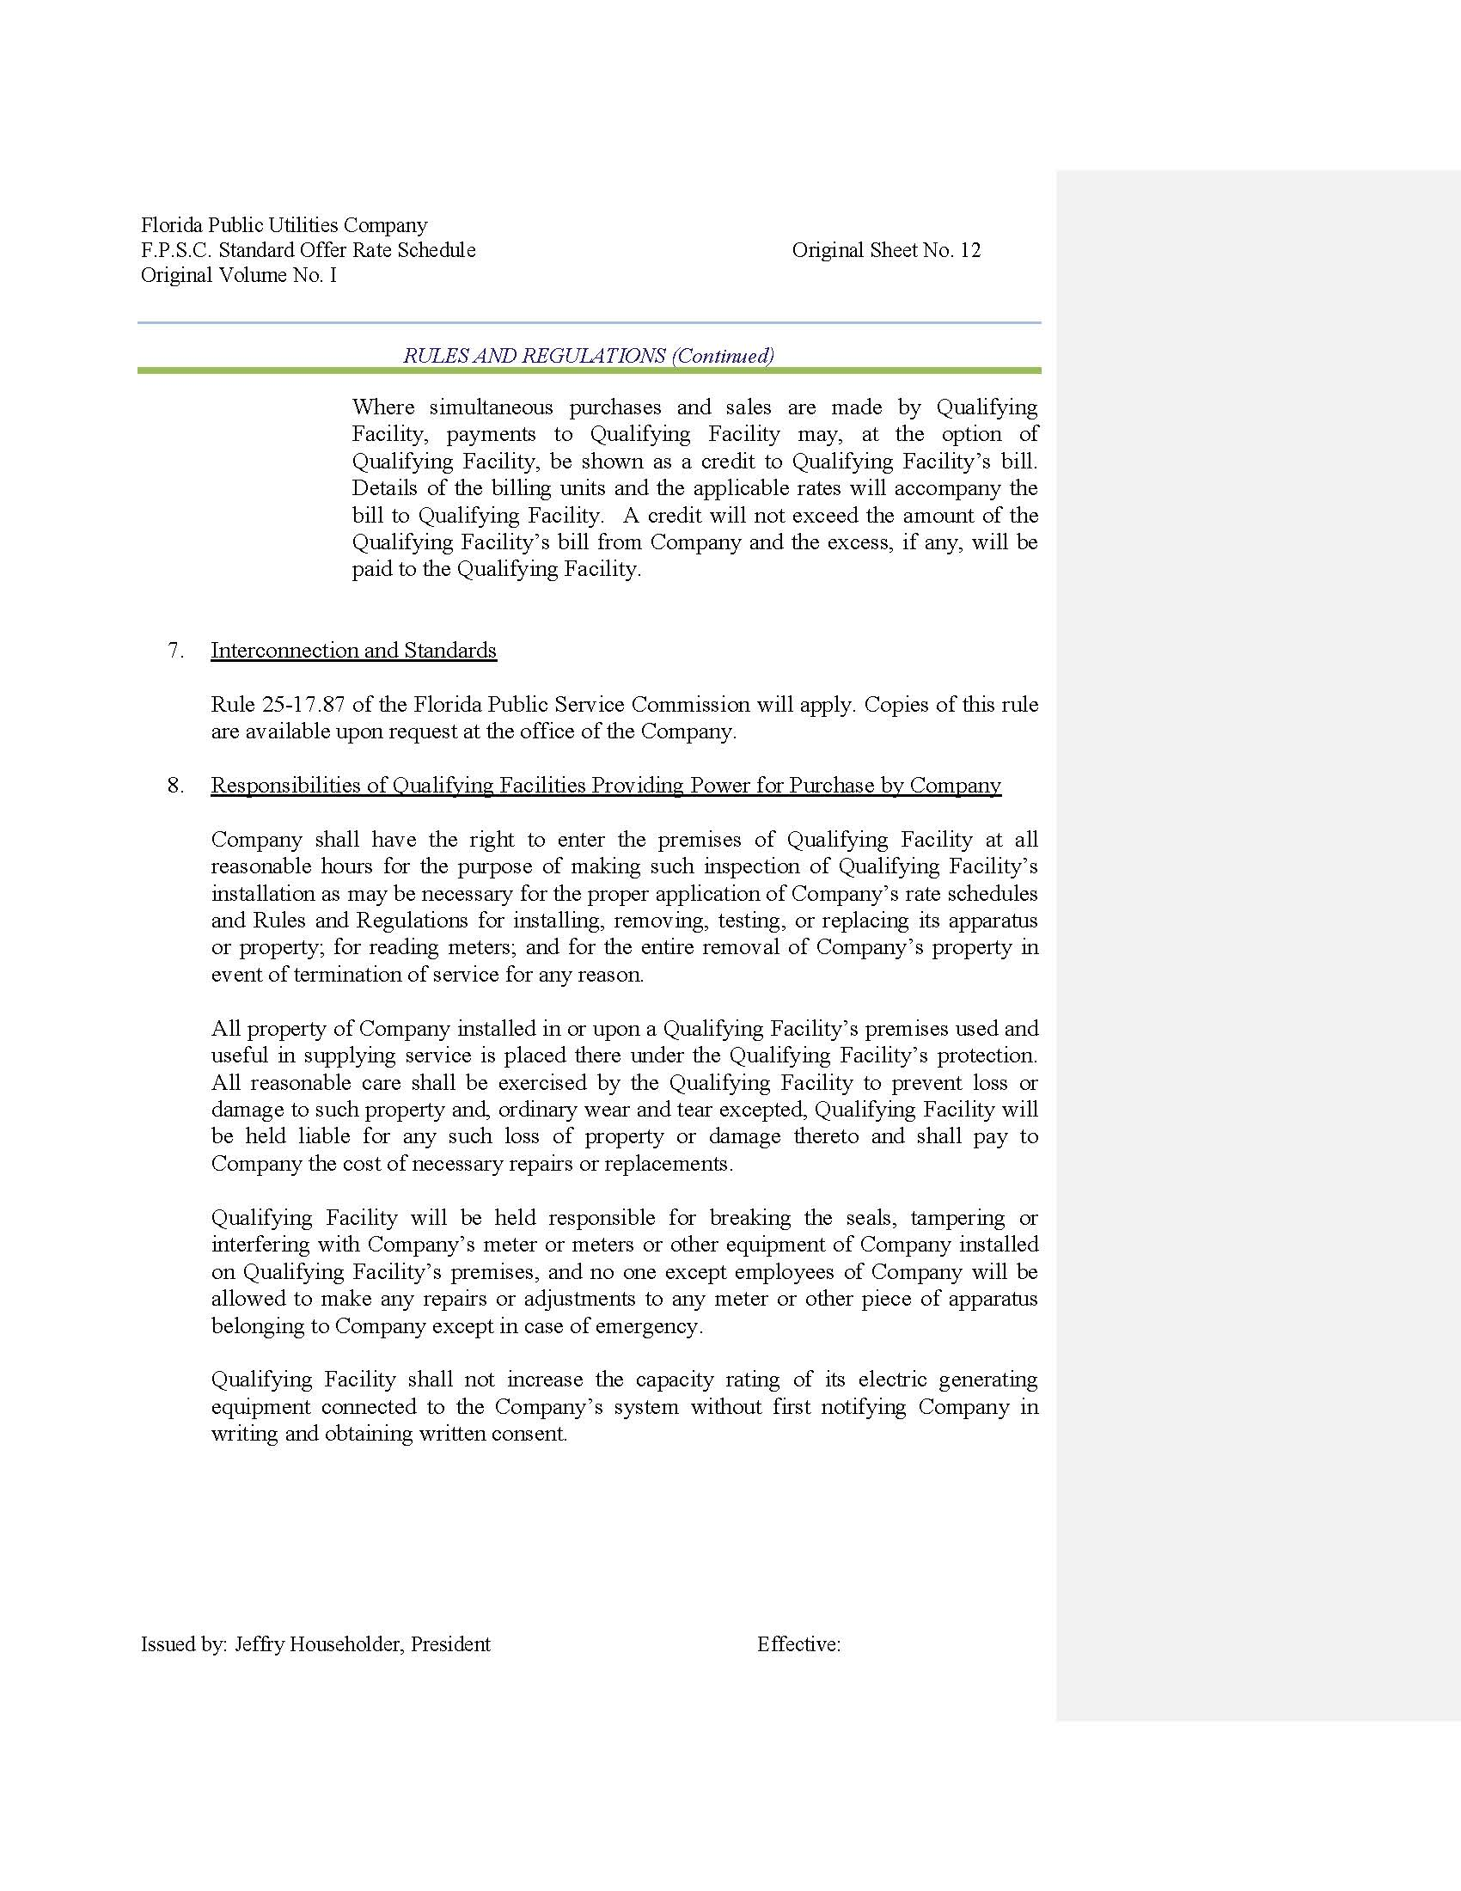

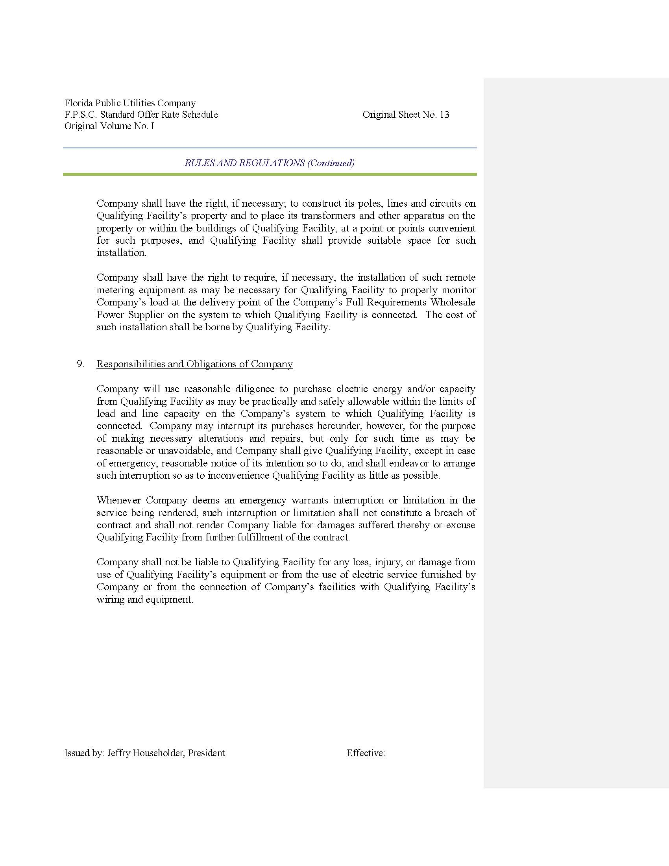

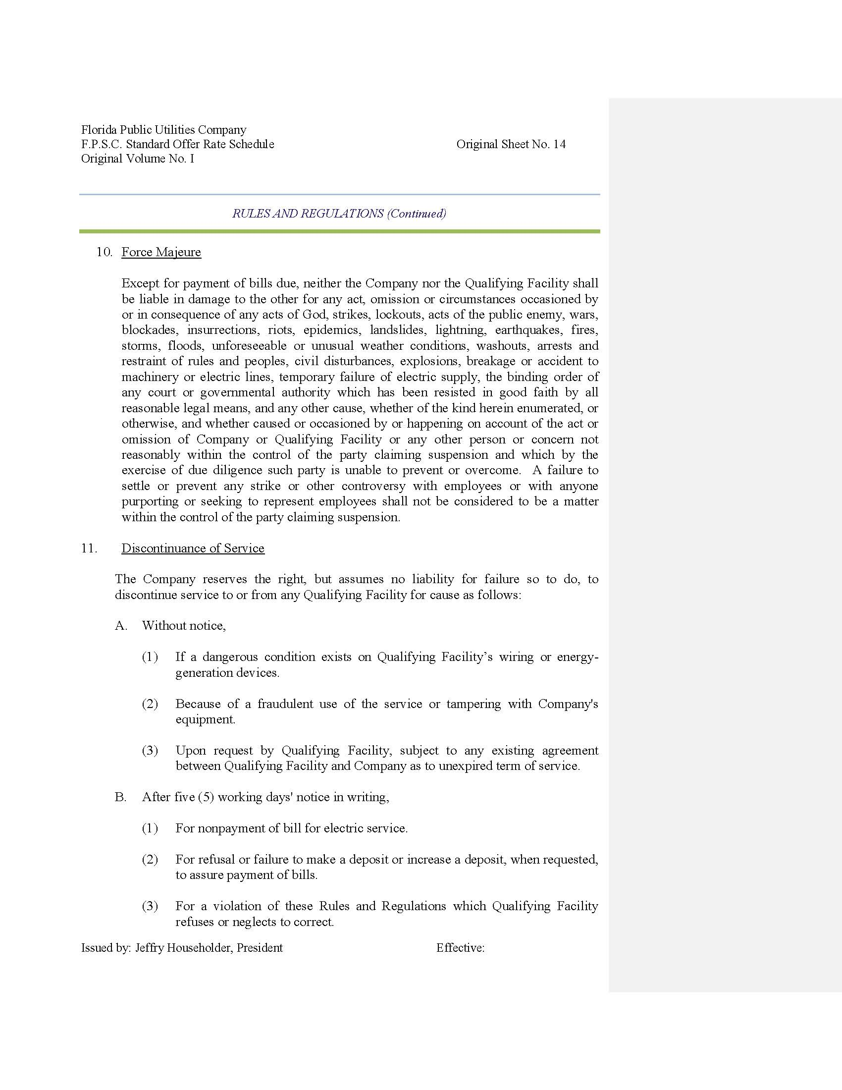

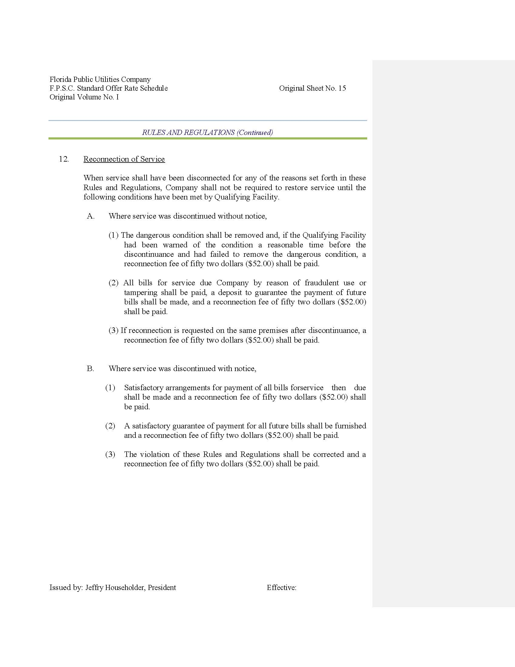

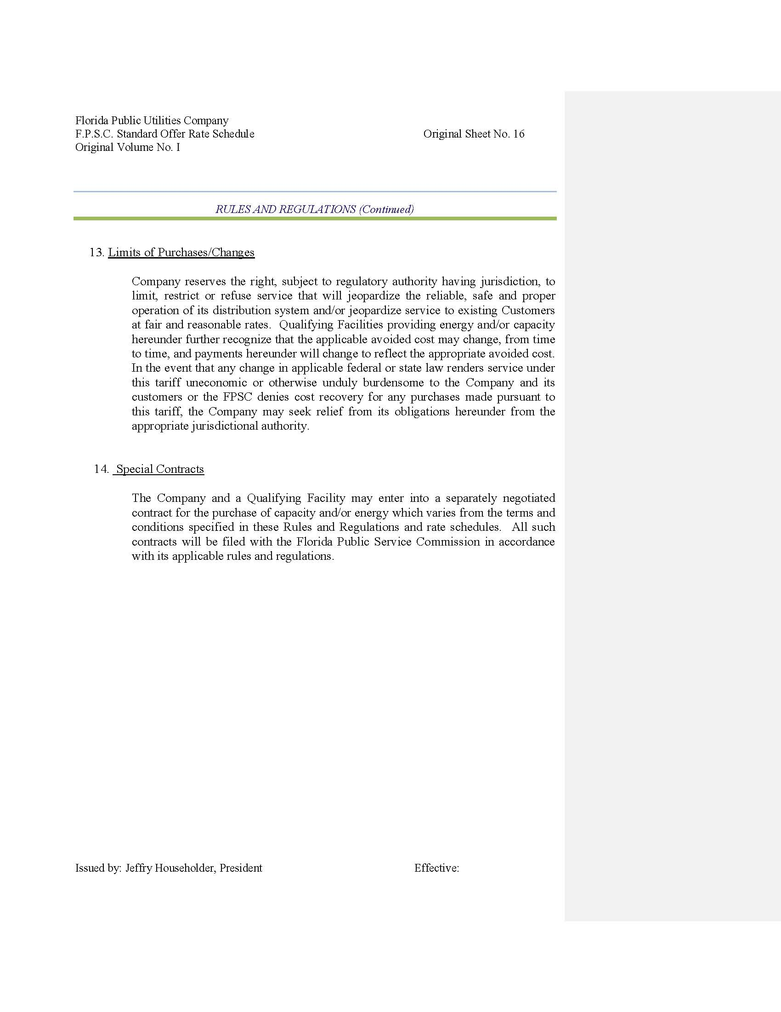

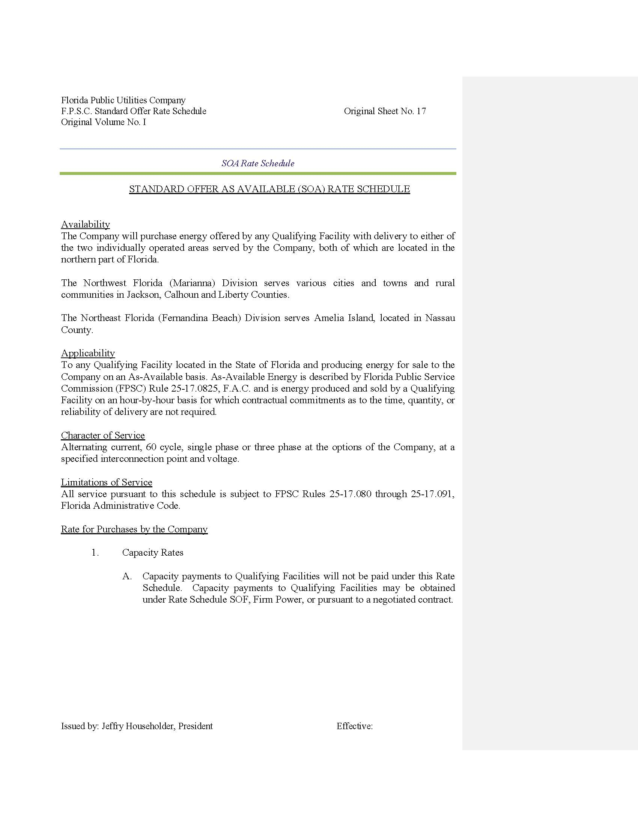

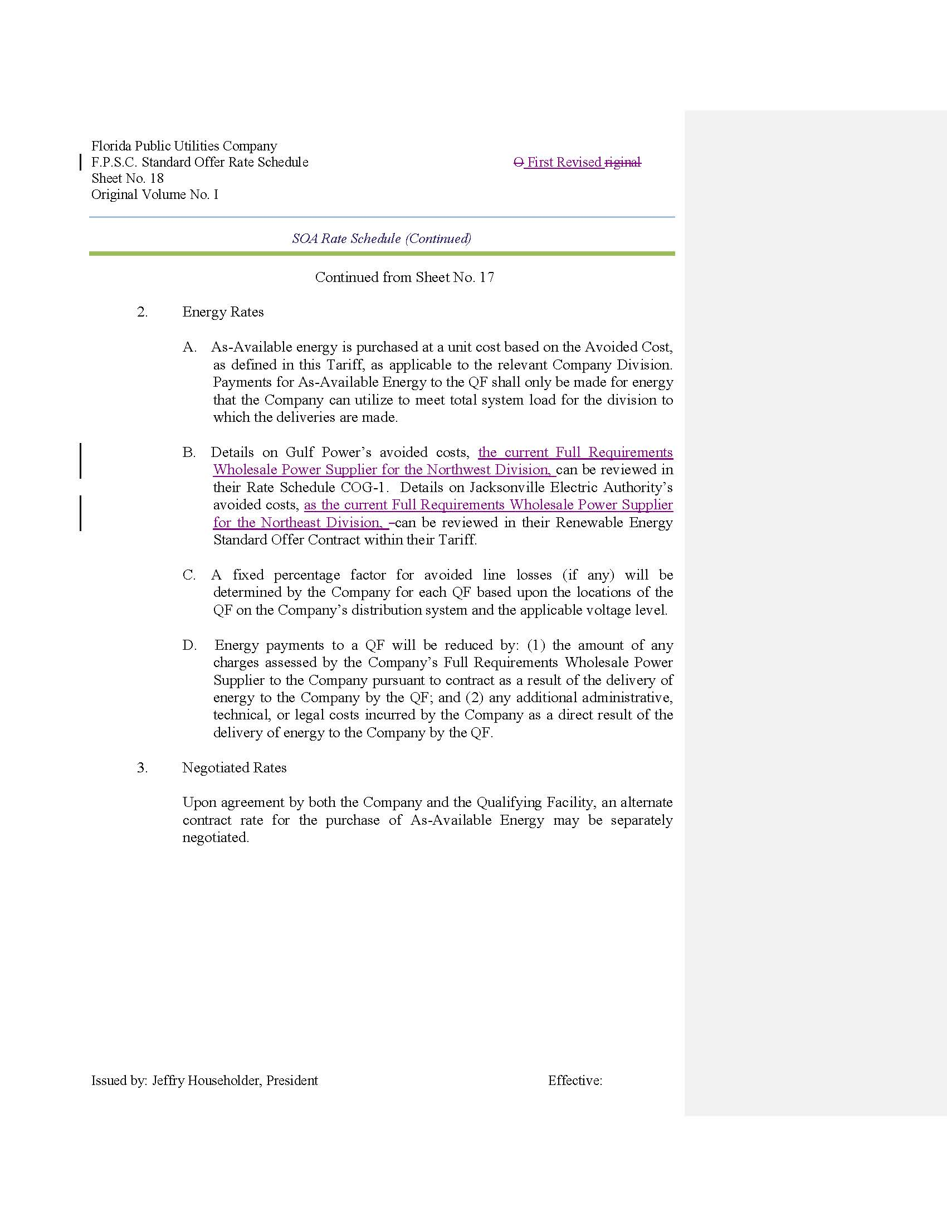

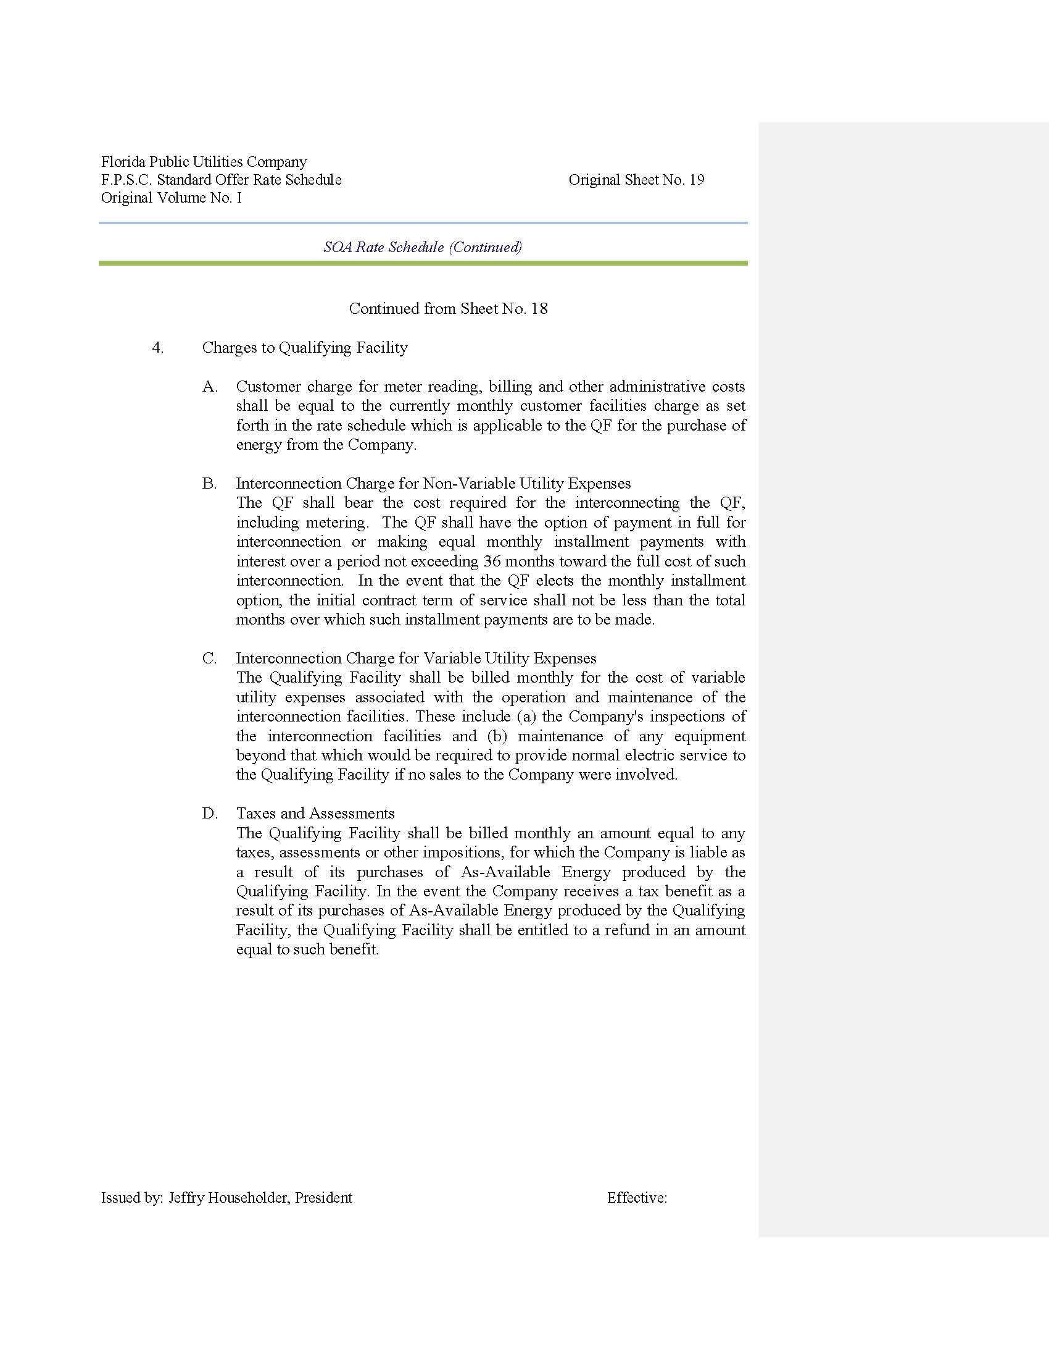

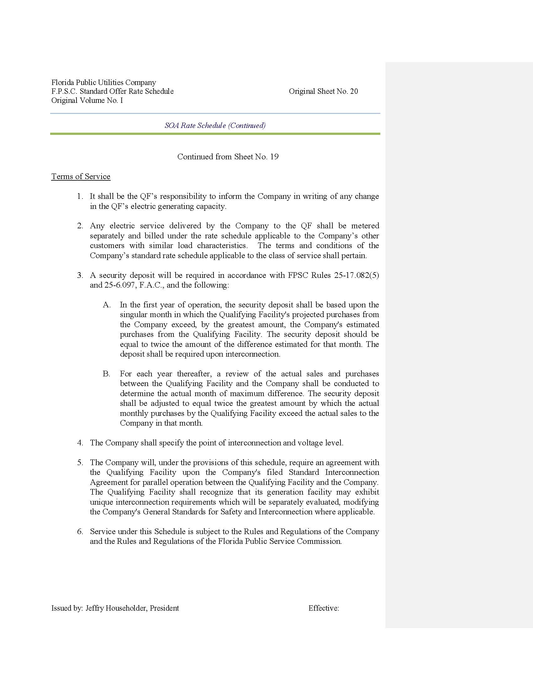

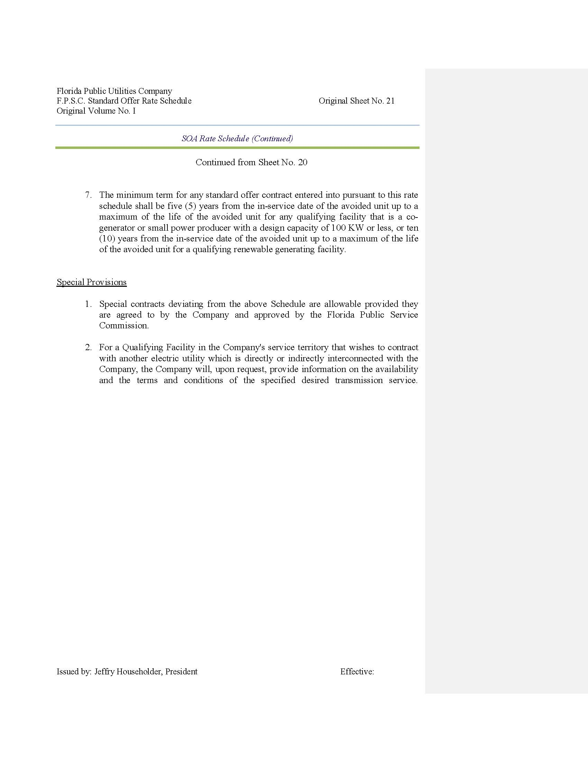

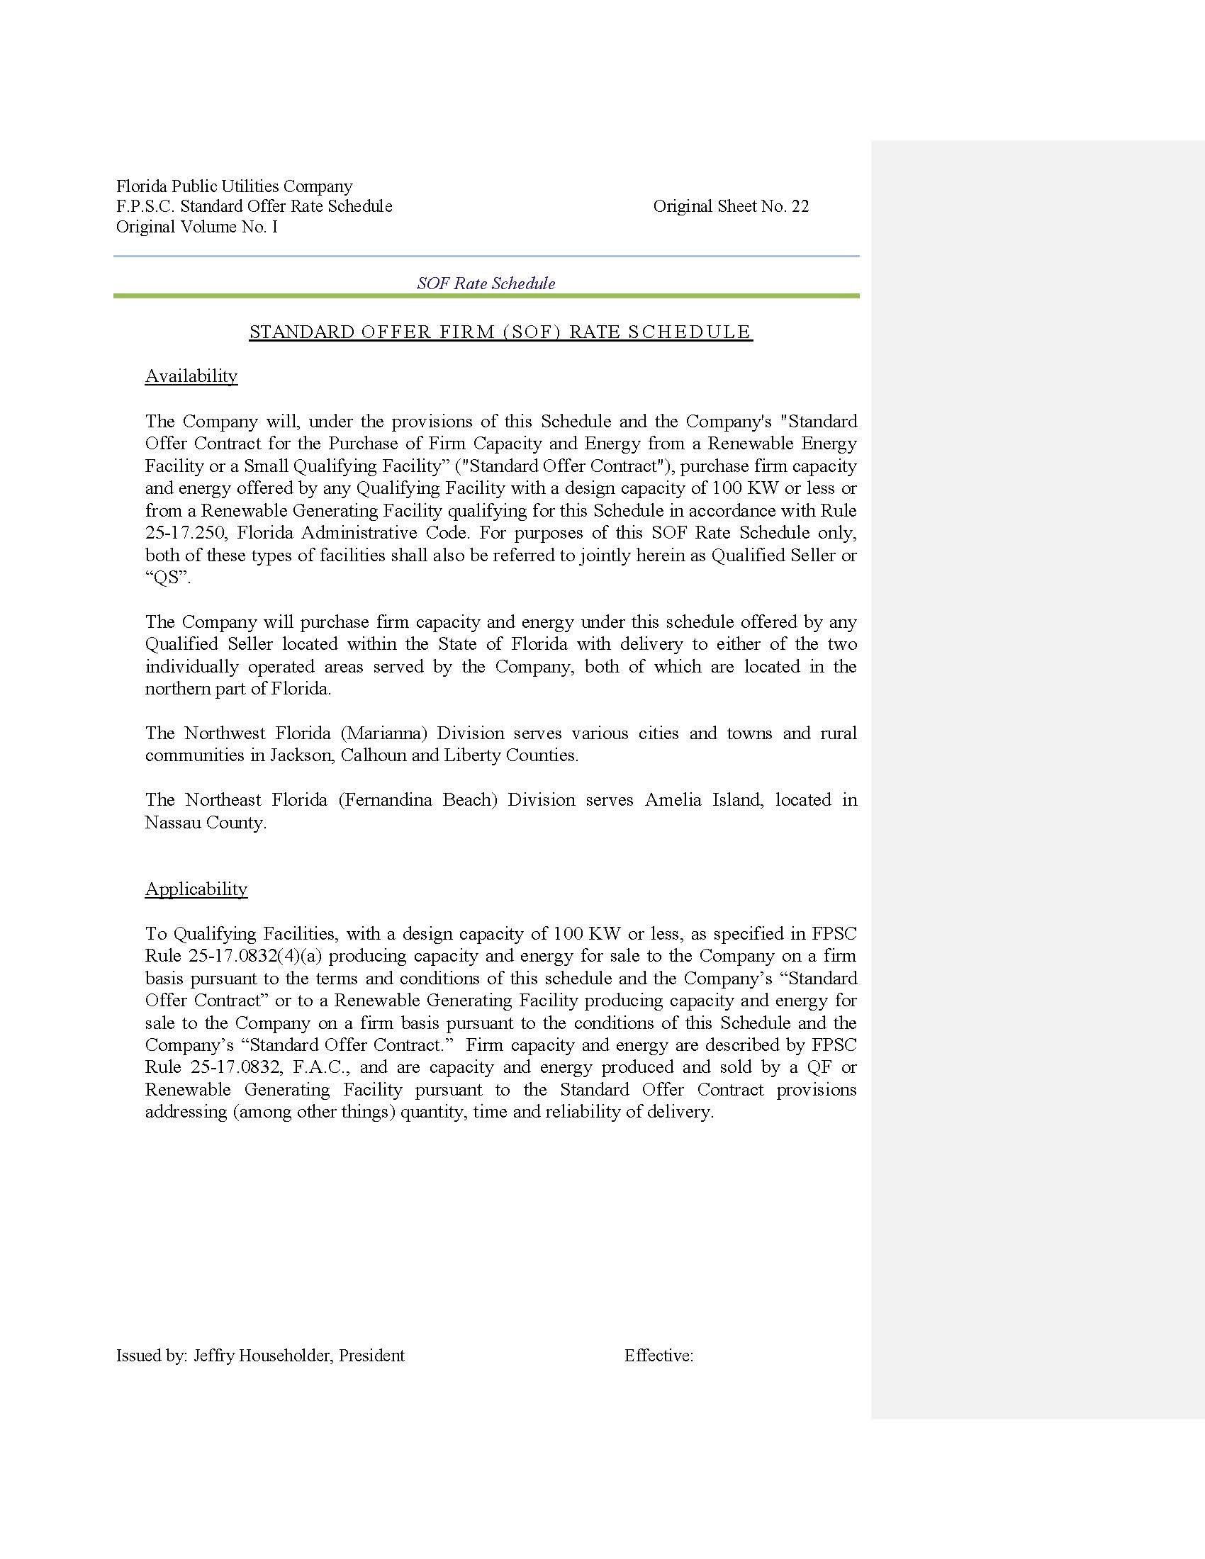

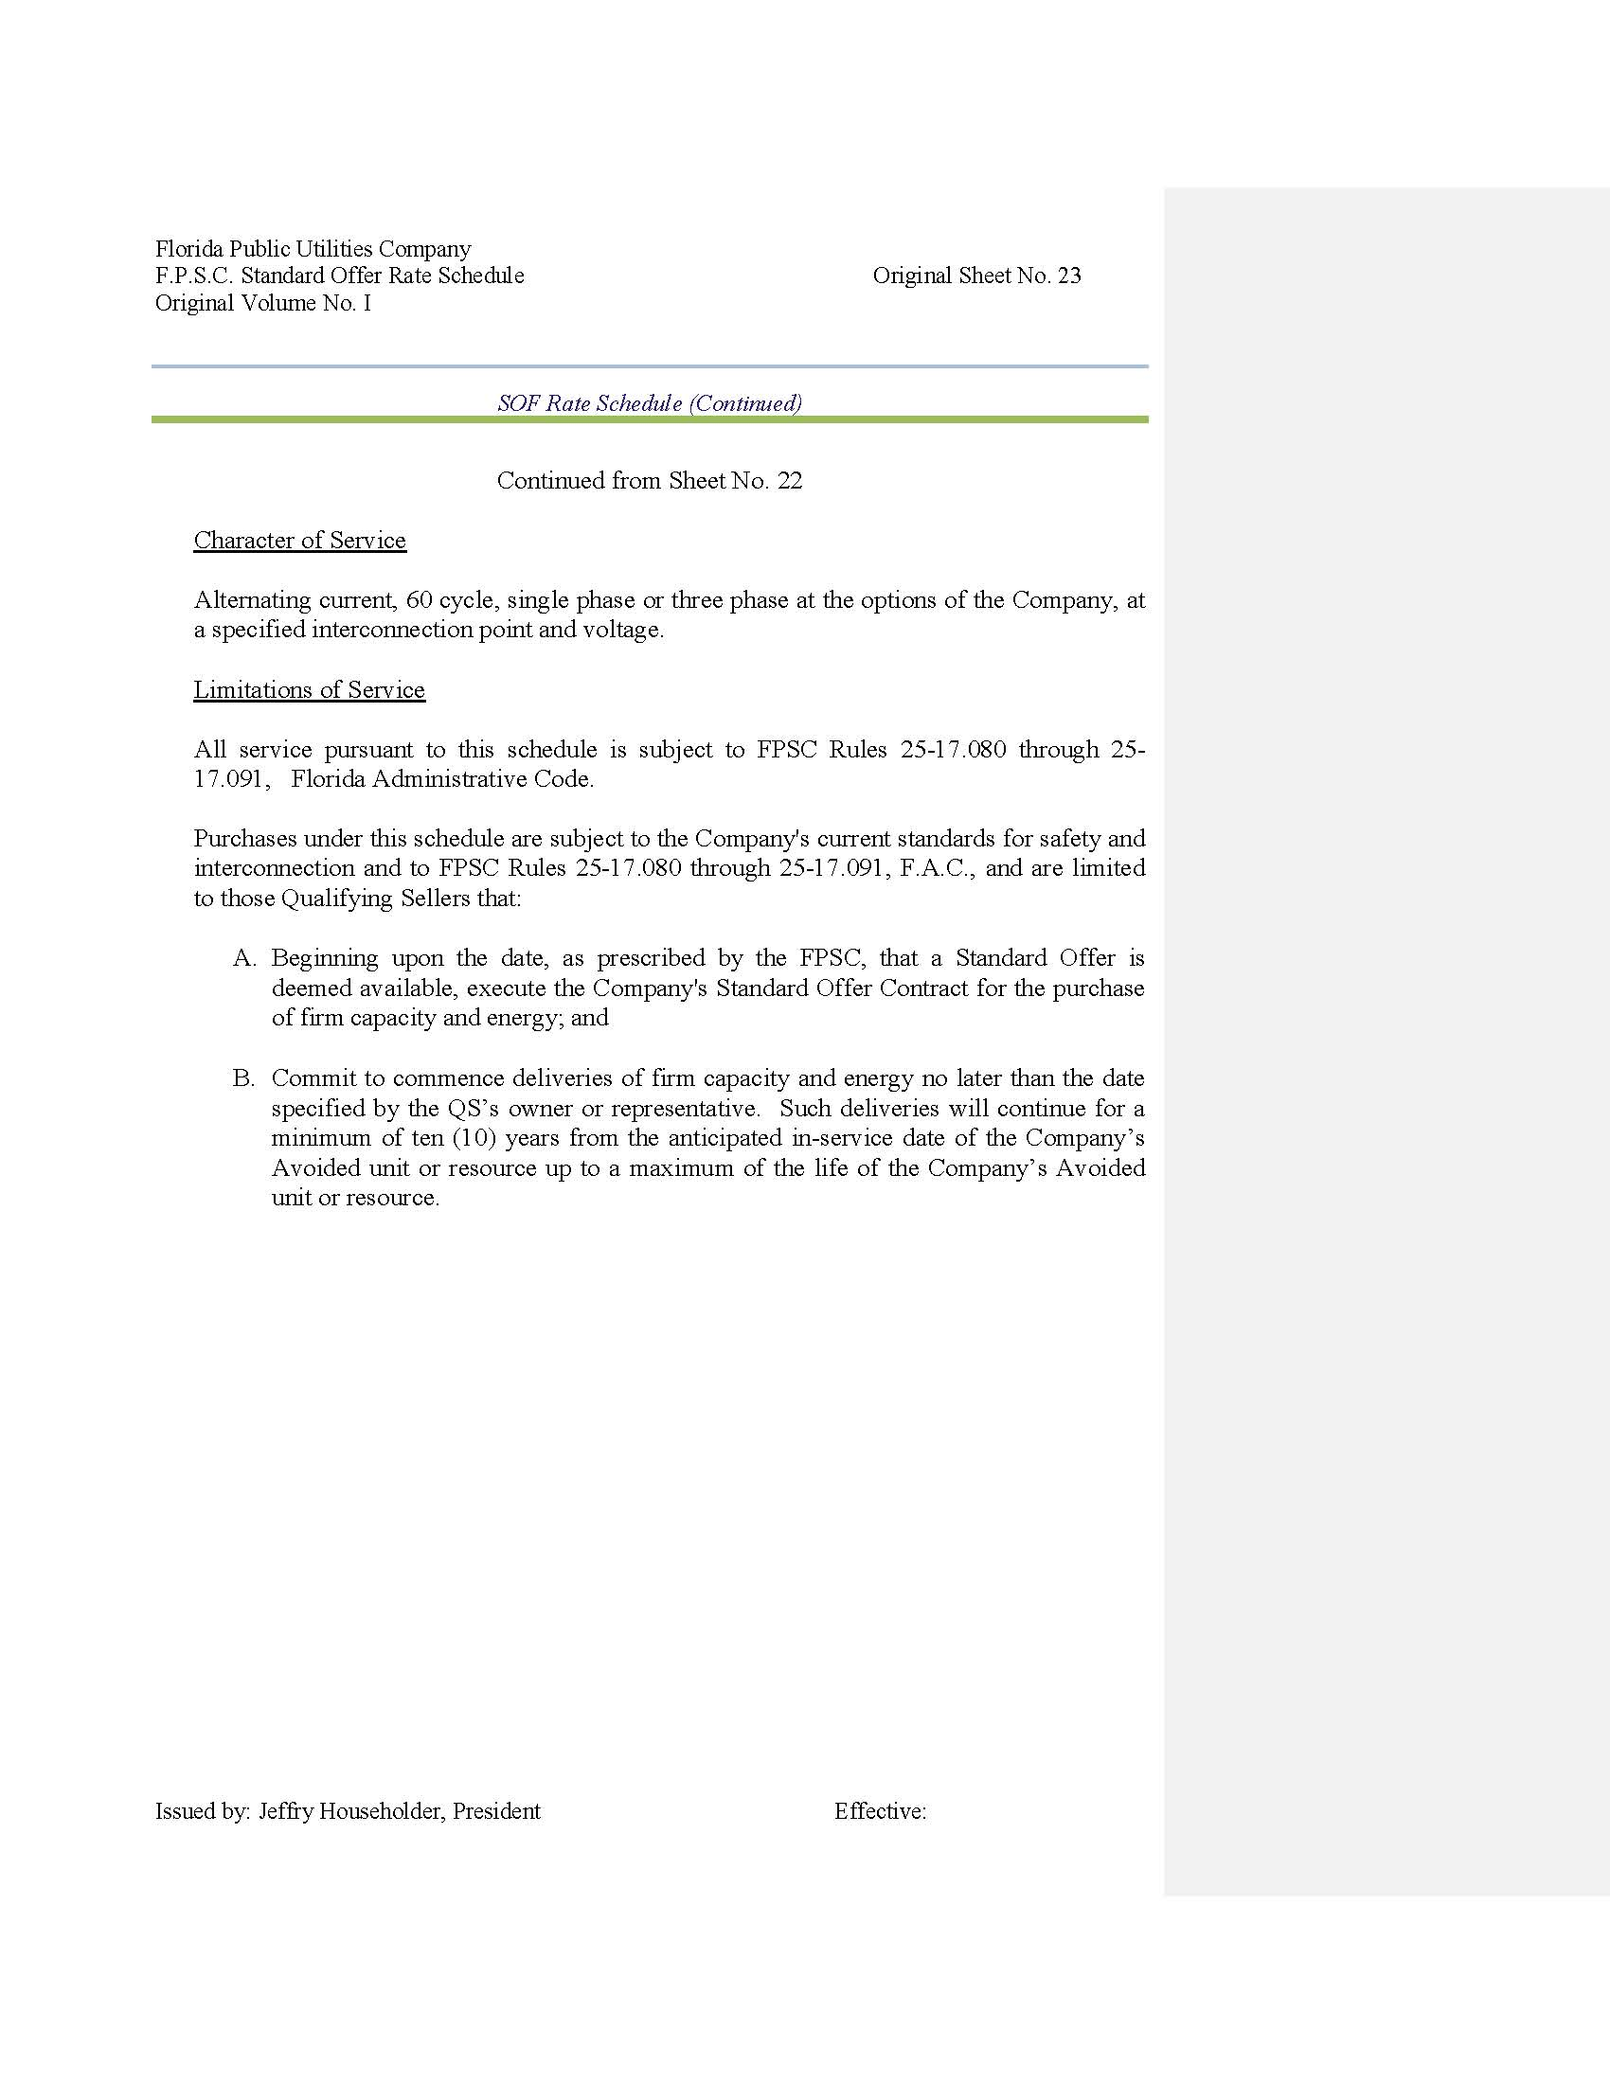

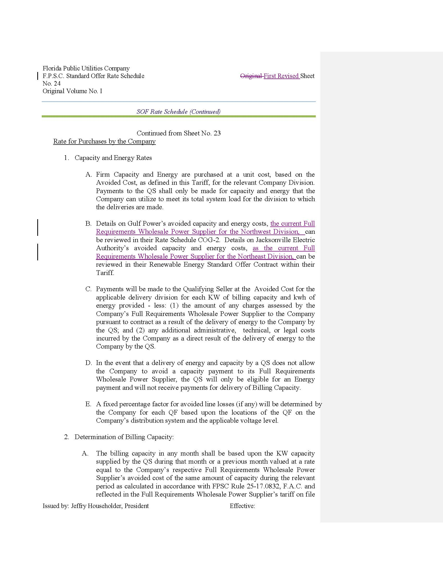

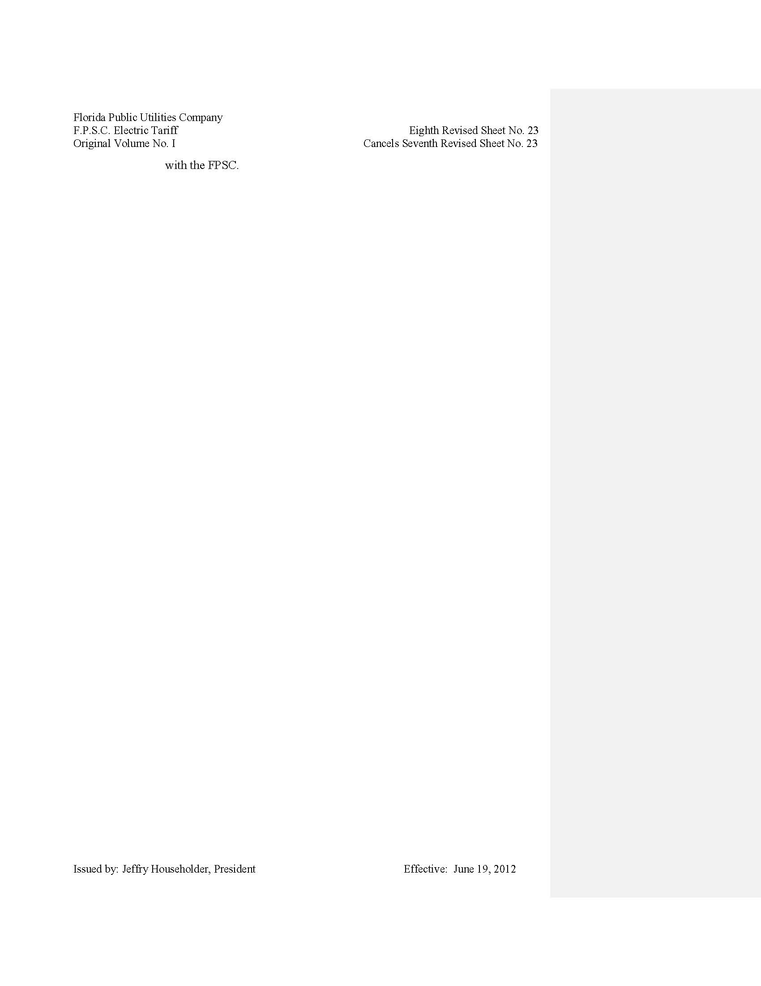

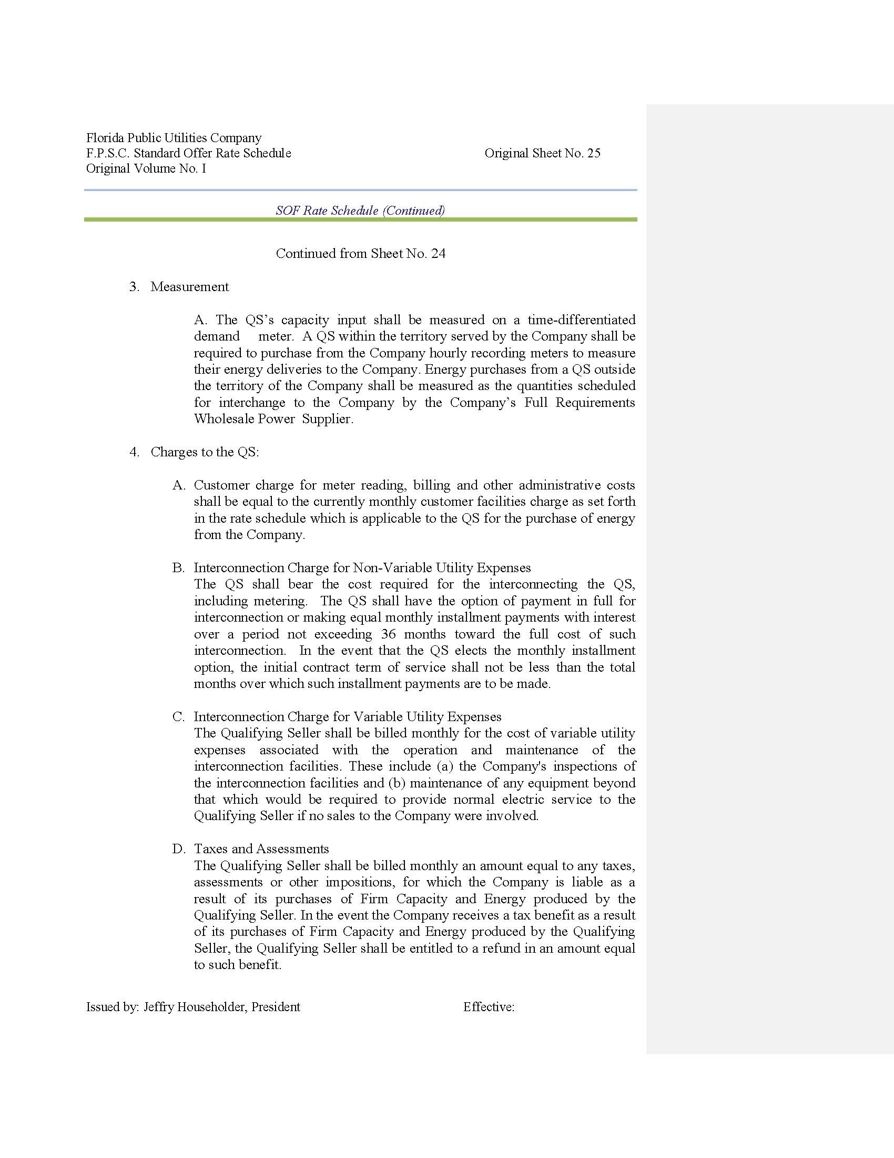

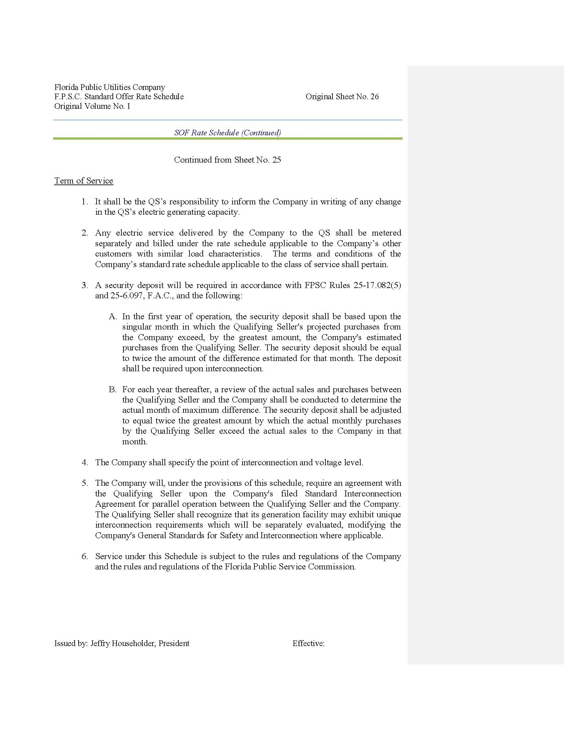

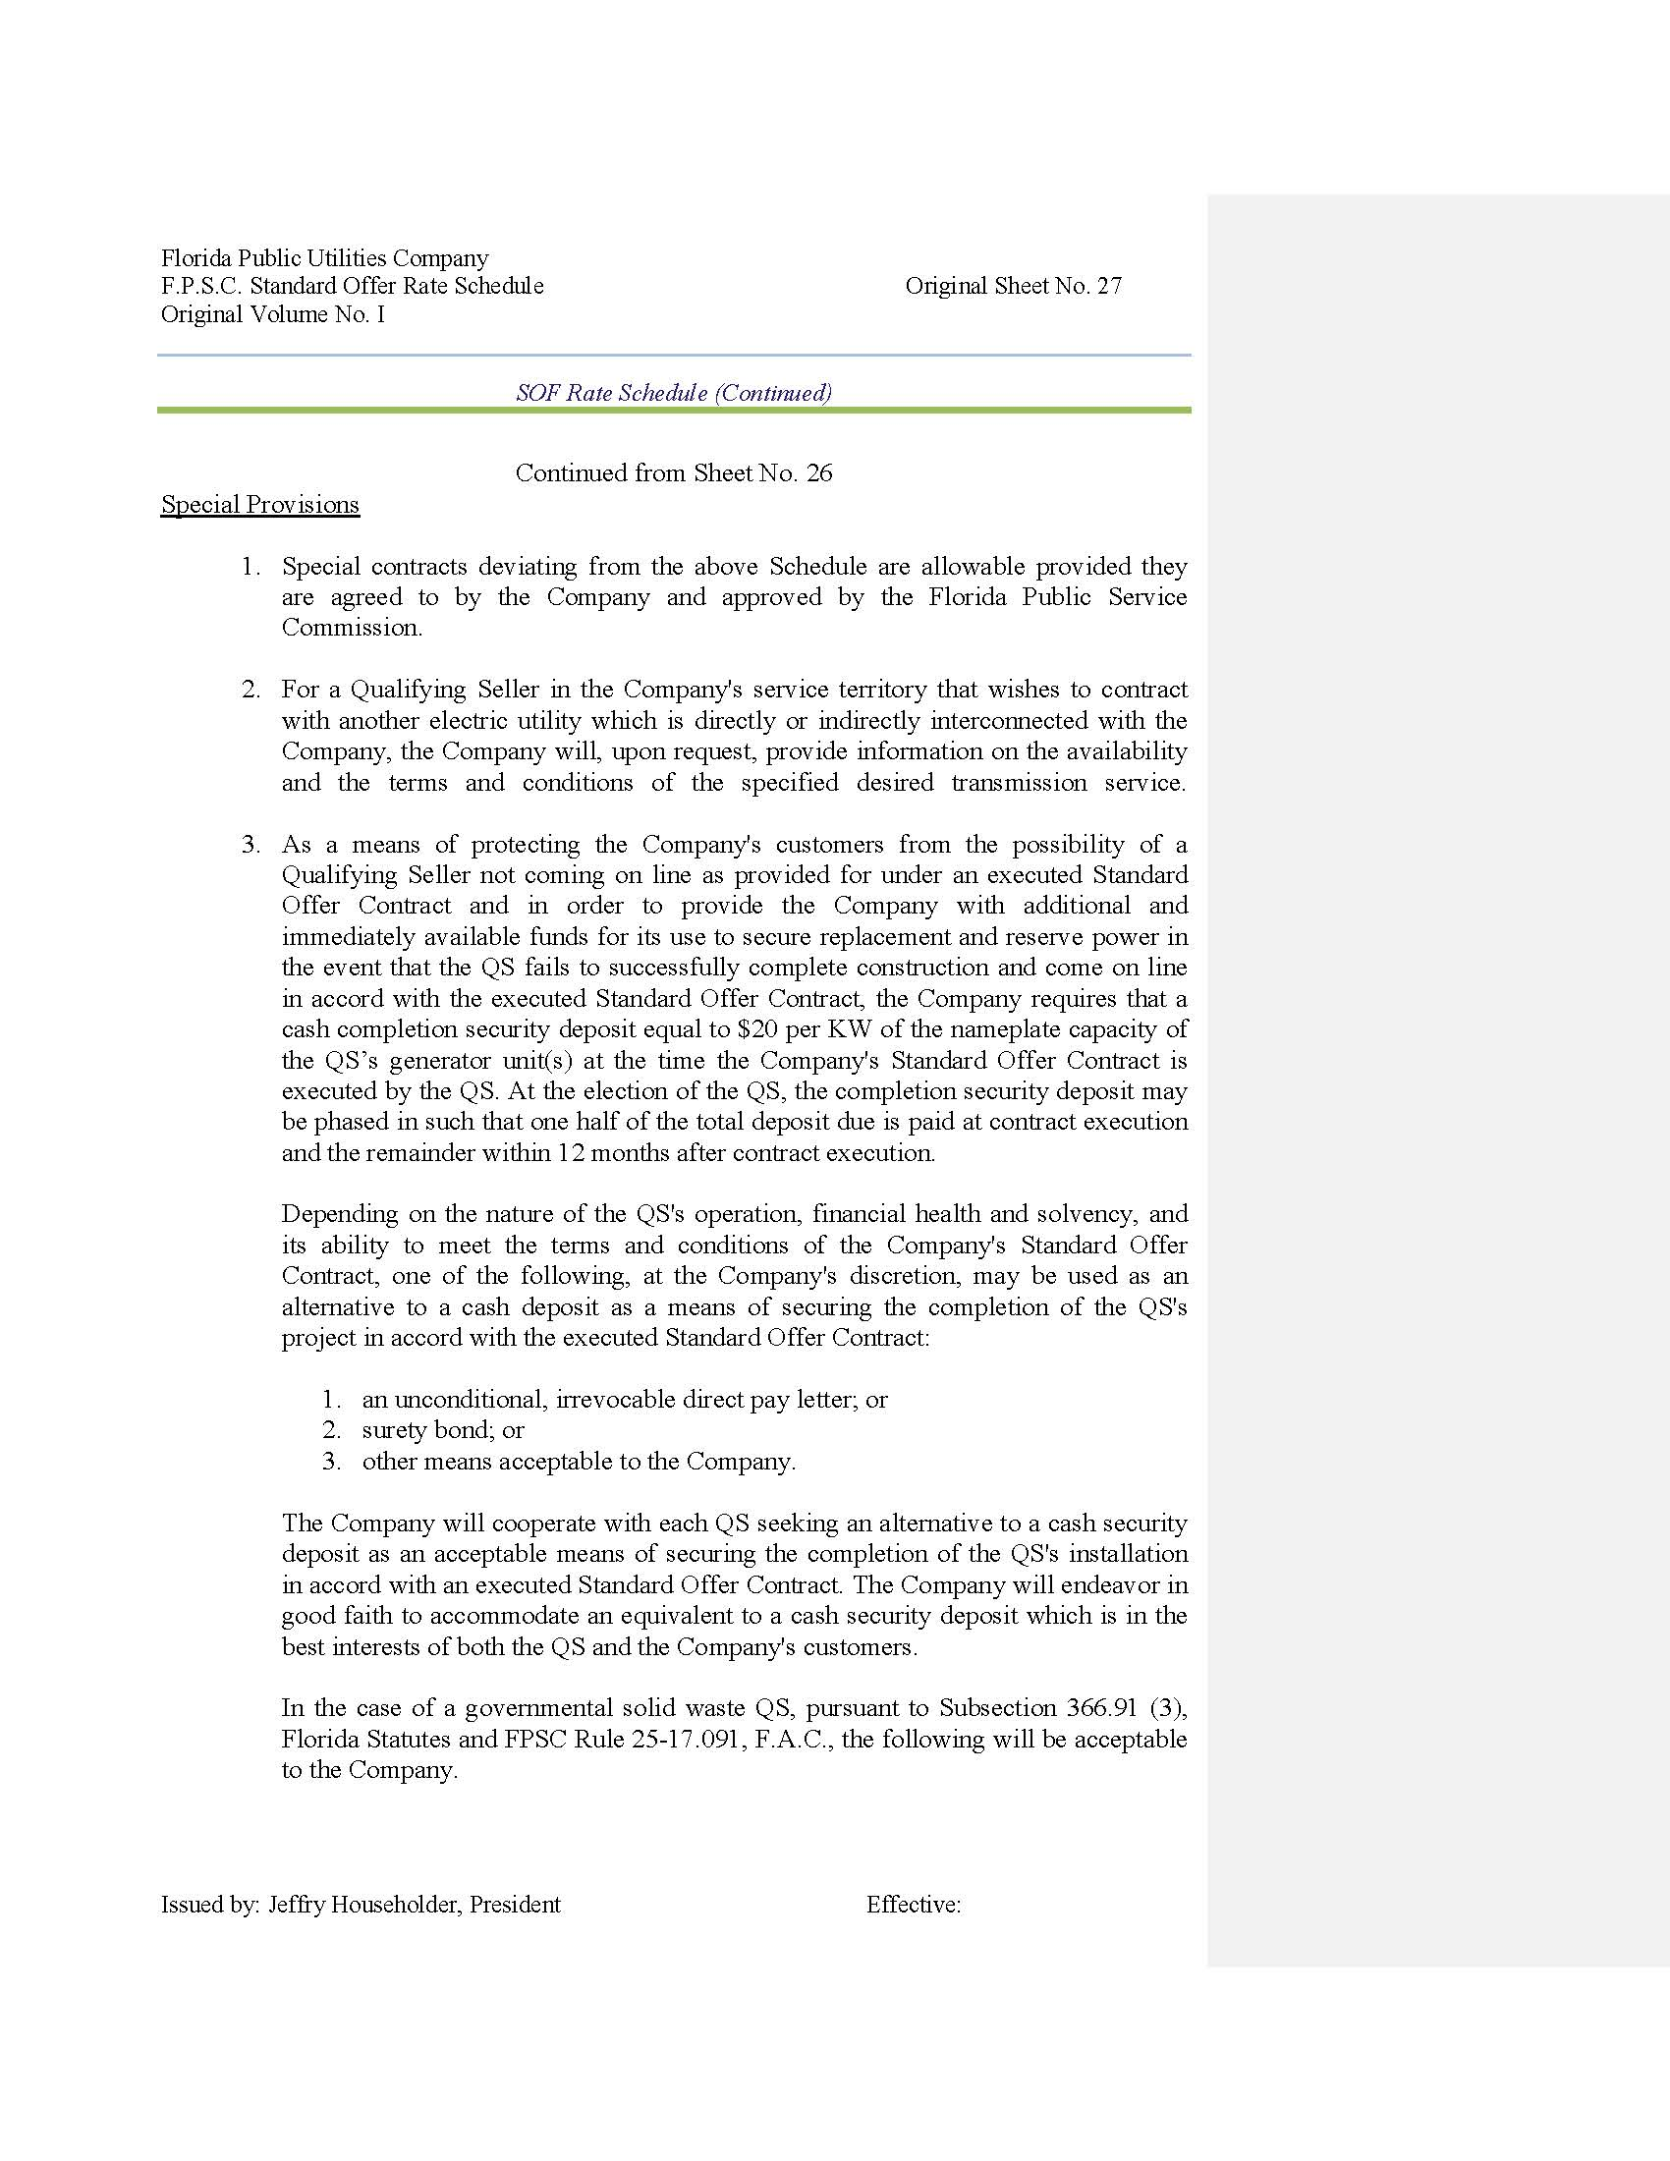

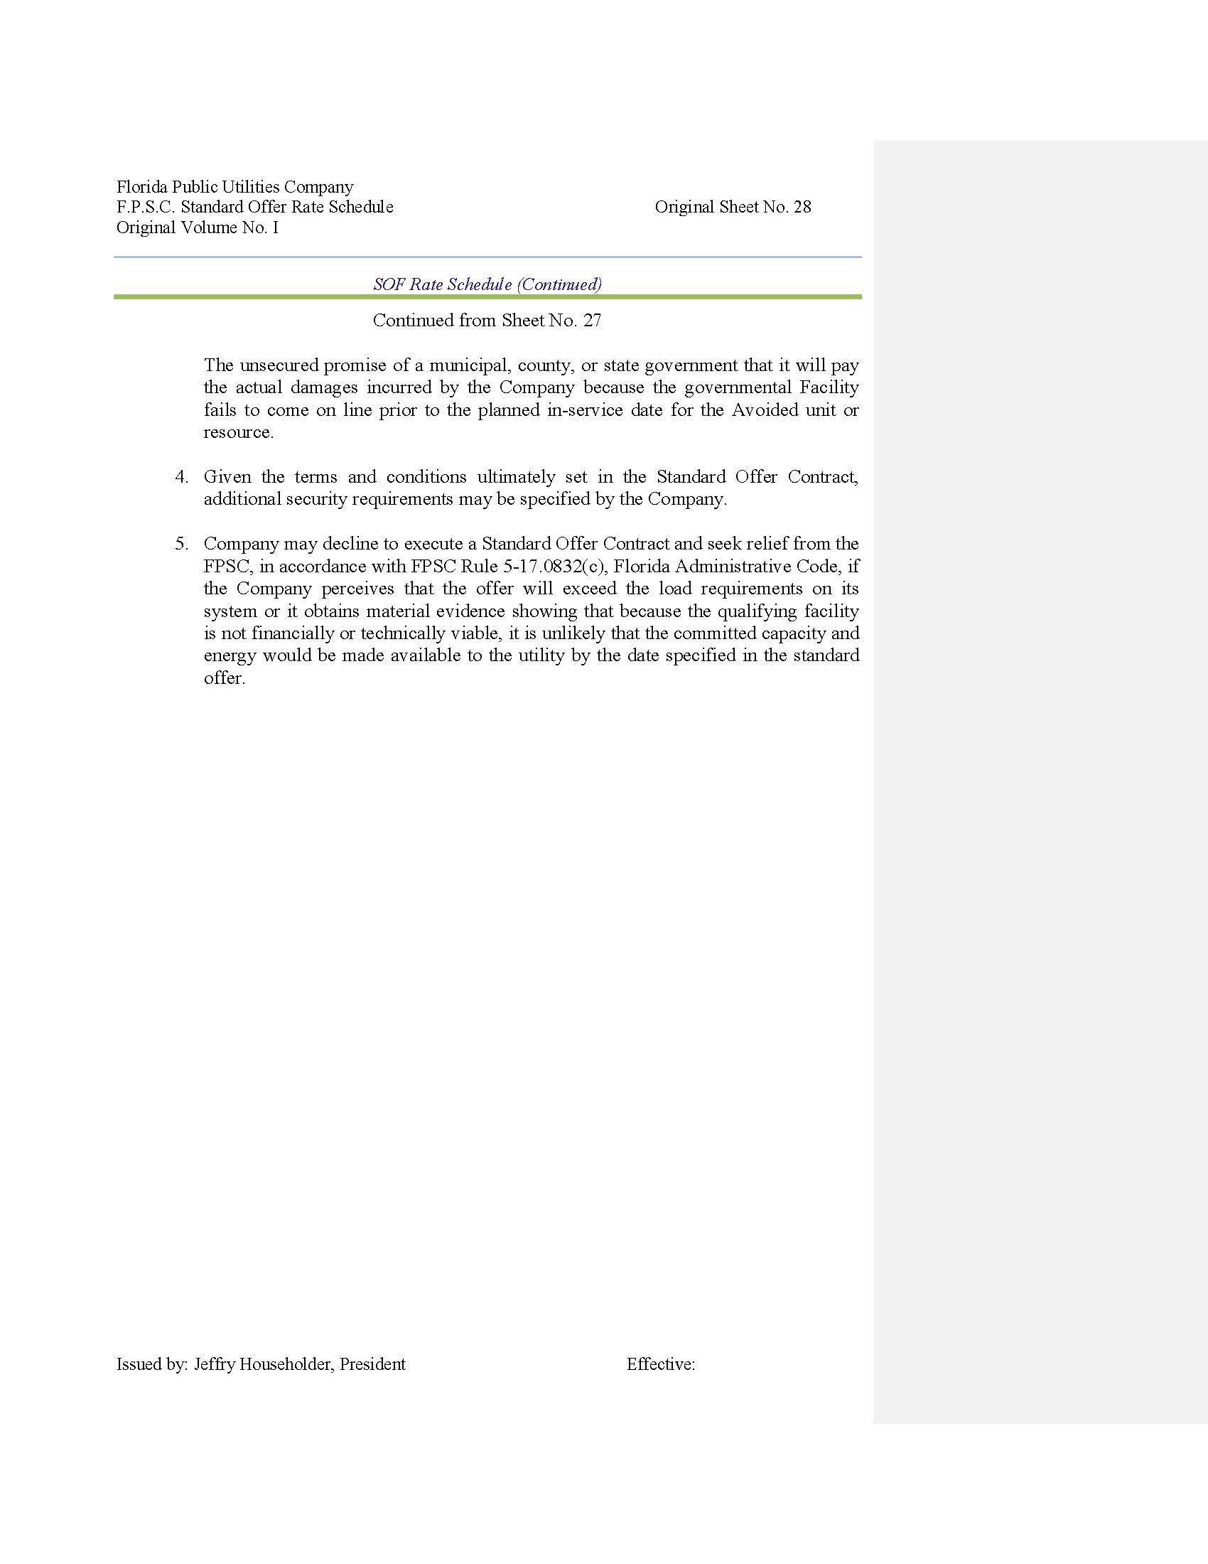

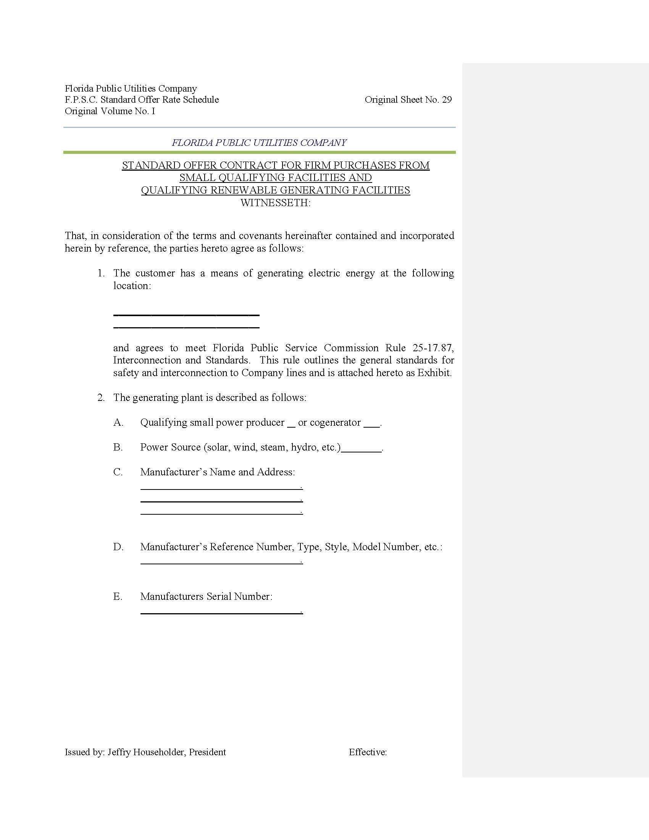

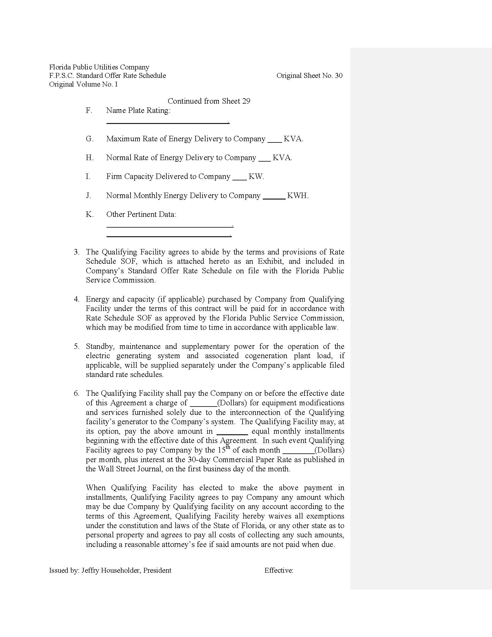

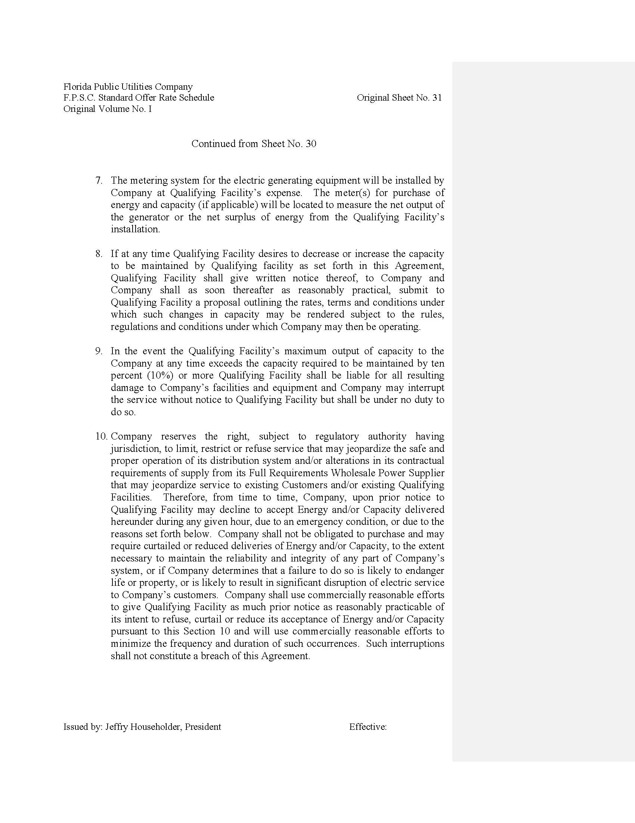

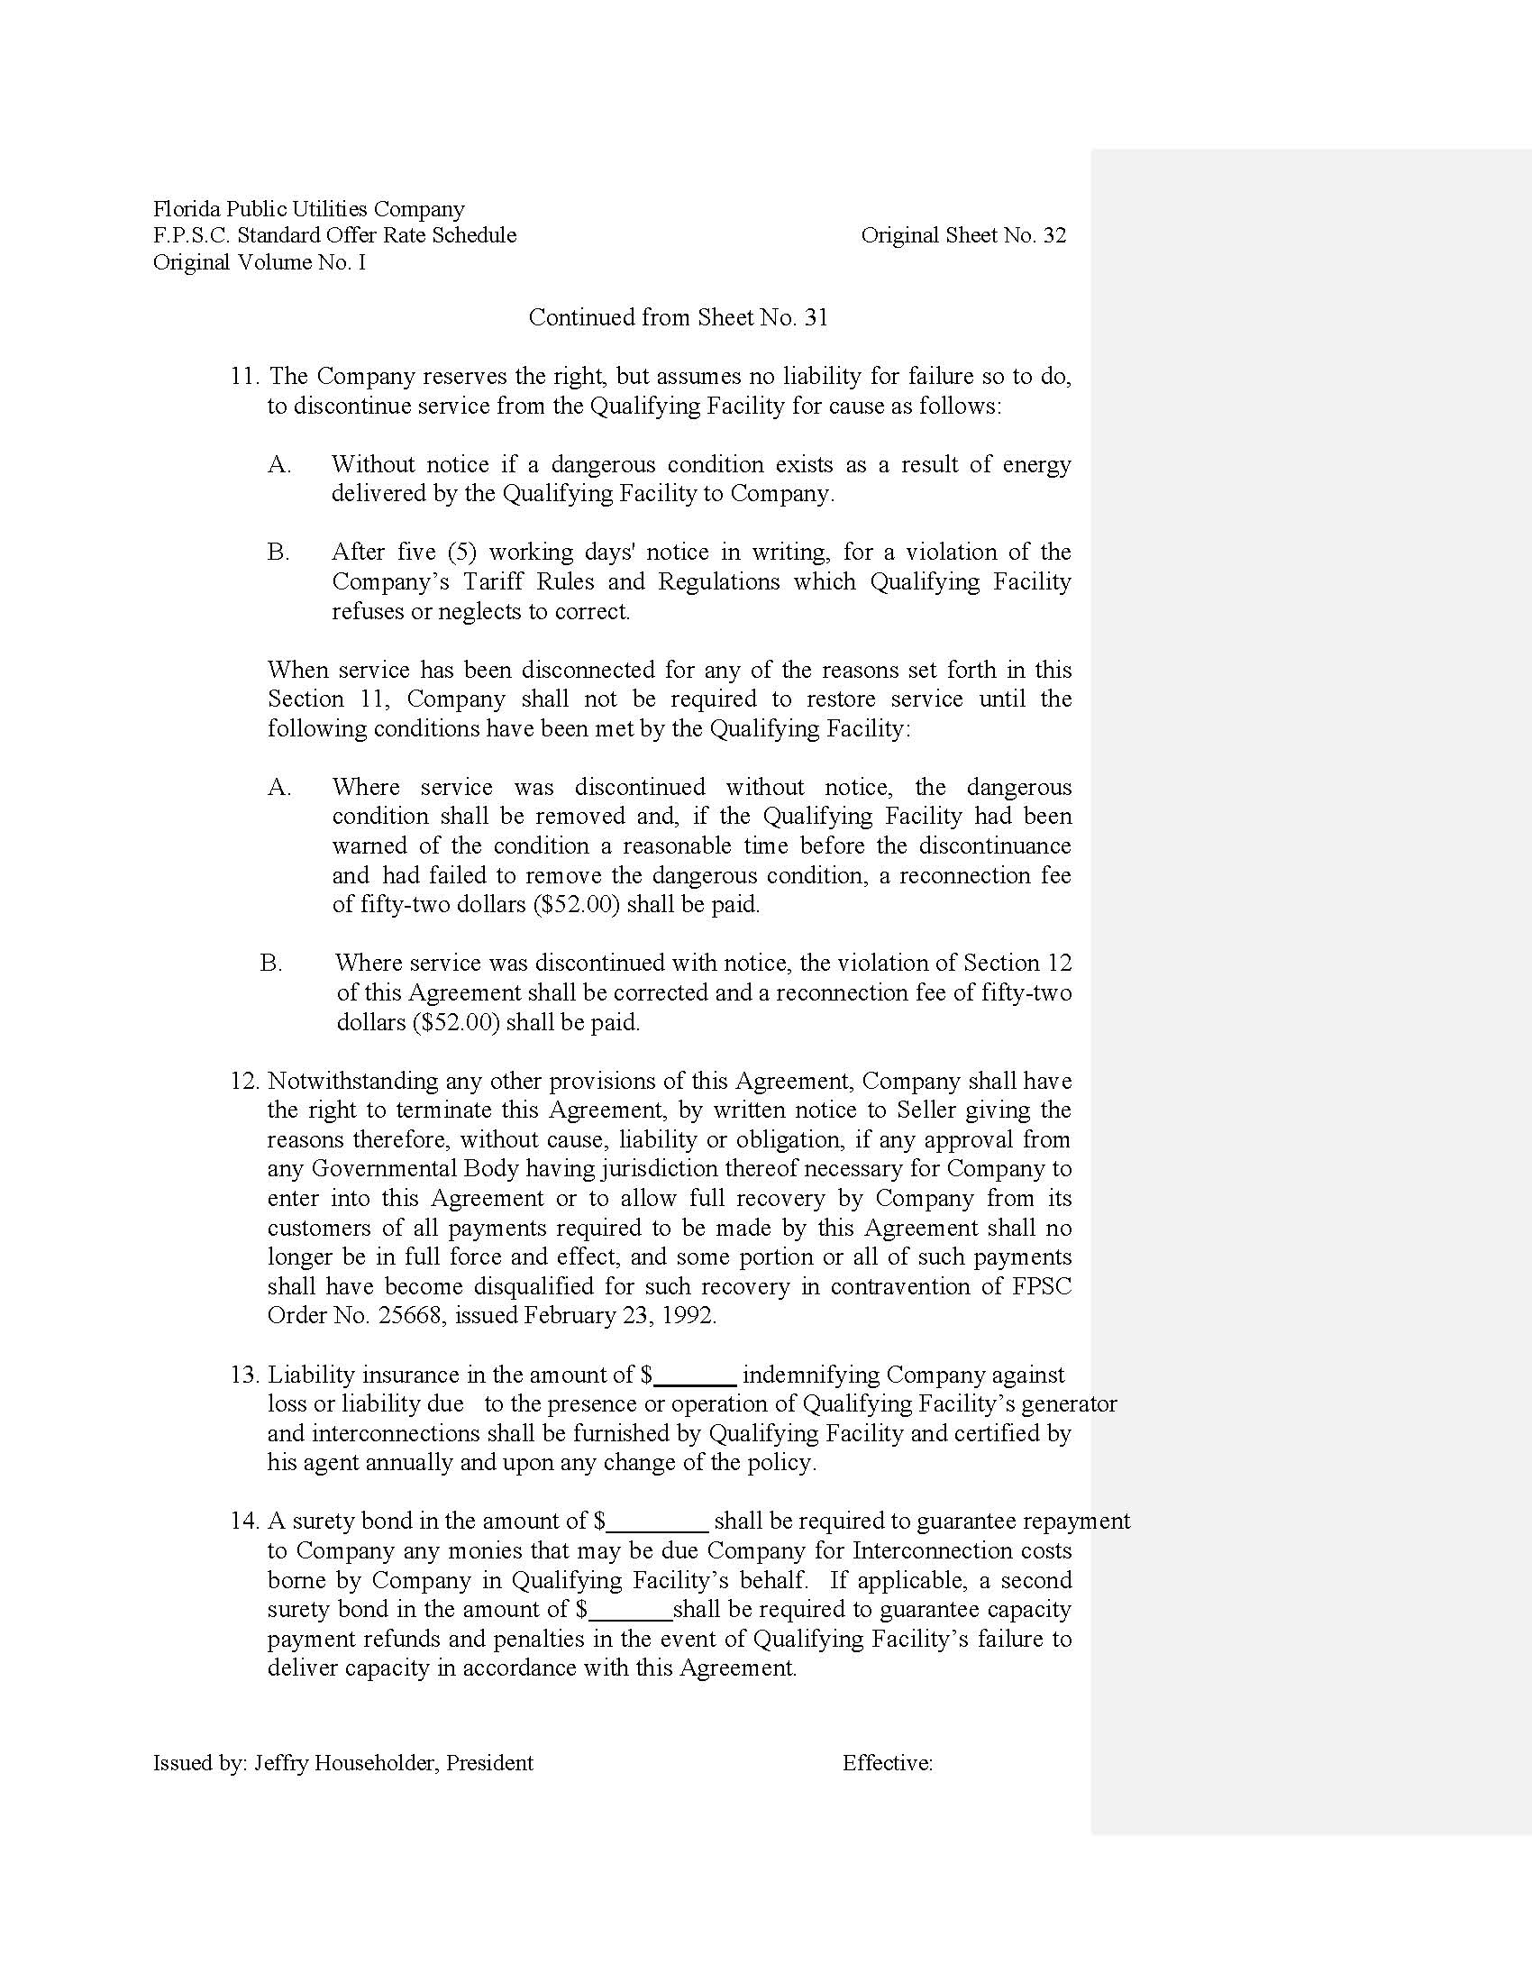

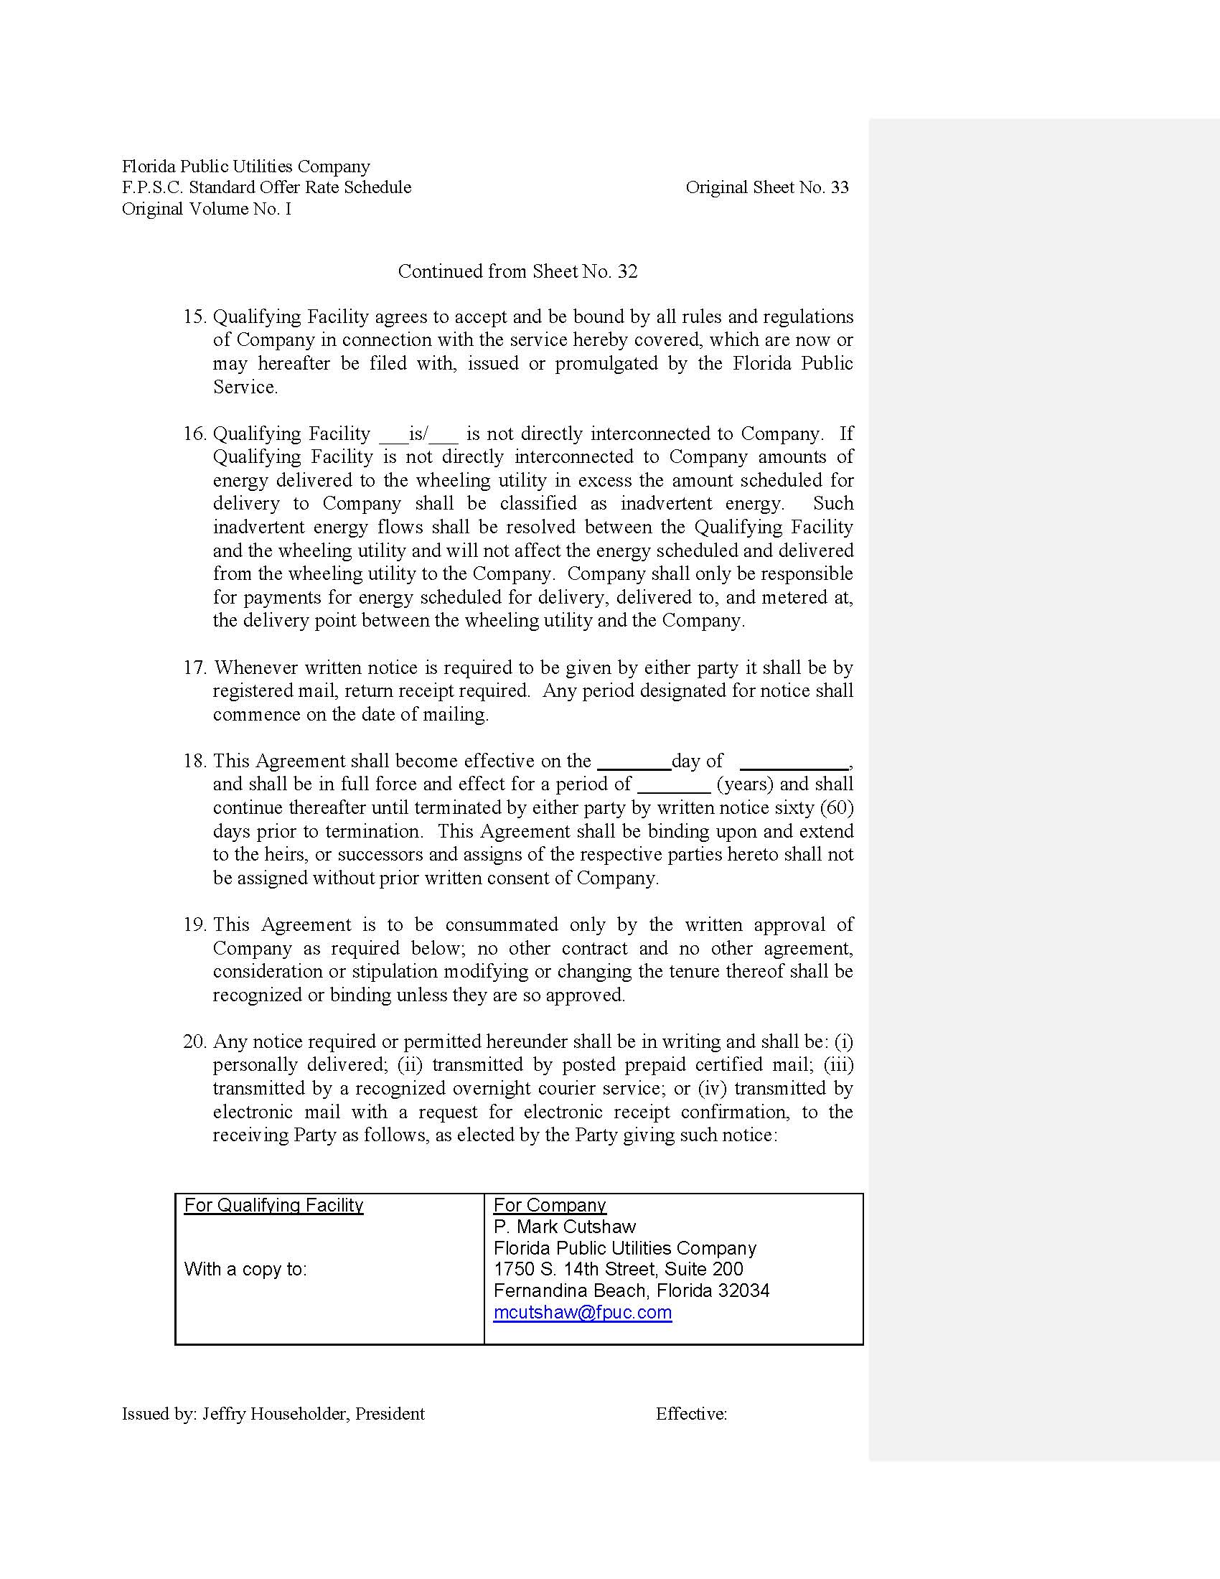

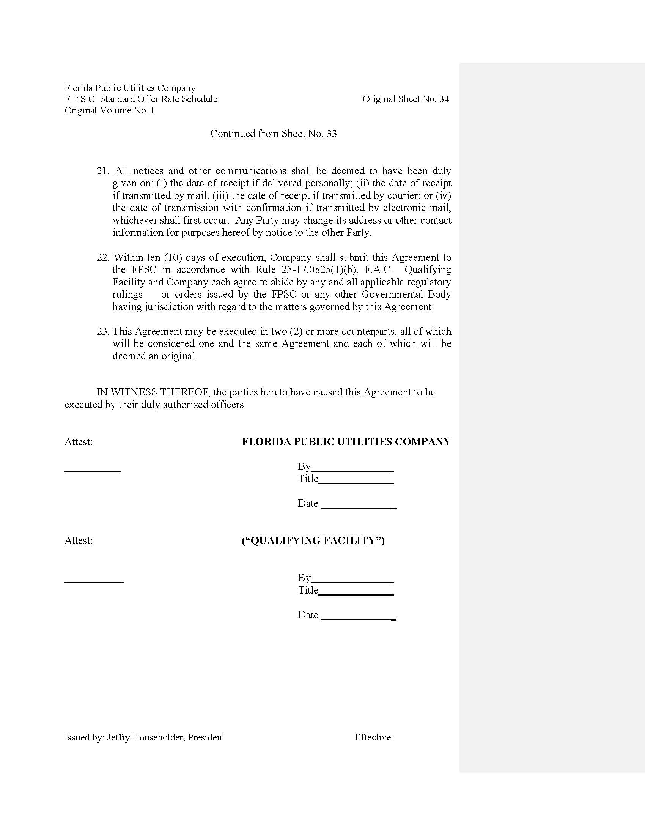

Order No. PSC-16-0531-PAA-EQ, issued November 22, 2016, in Docket No. 160074-EQ, In re: Petition for approval of new standard offer rate schedule for energy purchases from cogenerators and renewable facilities and for approval of standard offer contract for purchased of firm capacity and energy, by Florida Public Utilities Company.
Document No. 05135-2017, dated May 31, 2017, in Docket No. 170070-EQ.
Document No. 05135-2017, dated May 31, 2017, in Docket No. 170070-EQ.

