BEFORE THE FLORIDA PUBLIC SERVICE COMMISSION

In re: Petition for approval of revised underground residential distribution tariffs, by Duke Energy Florida, LLC. | DOCKET NO. 20170069-EI  ORDER NO. PSC-2017-0283-TRF-EI  ISSUED: July 24, 2017

The following Commissioners participated in the disposition of this matter:

JULIE I. BROWN, Chairman
ART GRAHAM
RONALD A. BRISÉ
DONALD J. POLMANN

ORDER APPROVING REVISED
UNDERGROUND RESIDENTIAL DISTRIBUTION TARIFFS

BY THE COMMISSION:

Background

On March 30, 2017, Duke Energy Florida, LLC (Duke or Company) filed a petition for approval of revisions to its underground residential distribution (URD) tariffs. The URD tariffs apply to new residential subdivisions and represent the additional costs Duke incurs to provide underground distribution service in place of overhead service. The proposed (legislative version) URD tariffs are contained in Attachment A of this Order. Duke’s current charges were approved in Order No. PSC-14-0396-TRF-EI (2014 Order).
This Commission suspended Duke’s proposed tariffs in Order No. PSC-17-0166-PCO-EI. Duke responded to Commission staff’s first data request on May 16, 2017. We have jurisdiction over this matter pursuant to Sections 366.03, 366.04, 366.05, and 366.06, Florida Statutes (F.S.).
Decision
Rule 25-6.078, Florida Administrative Code (F.A.C.), defines investor-owned utilities’ (IOU) responsibilities for filing updated URD tariffs. Duke has filed the instant petition pursuant to subsection (3) of the rule, which requires IOUs to file supporting data and analyses for URD tariffs at least once every three years.
The URD tariffs provide standard charges for underground service in new residential subdivisions and represent the additional costs, if any, the utility incurs to provide underground service in place of standard overhead service. The cost of standard overhead construction is recovered through base rates from all ratepayers. In lieu of overhead construction, customers have the option of requesting underground facilities. Any additional cost is paid by the customer as contribution-in-aid-of construction (CIAC). Typically, the URD customer is the developer of a subdivision.
Traditionally, three standard model subdivision designs have been the basis upon which each IOU submits URD tariff changes for Commission approval: low density, high density, and a high density subdivision where dwelling units take service at ganged meter pedestals (groups of meters at the same physical location). Examples of this last subdivision type include mobile home and recreational vehicle parks. While actual construction may differ from the model subdivisions, the model subdivisions are designed to reflect average overhead and underground subdivisions.
Table 1 shows the current and proposed URD differentials for the low density, high density, and ganged meter subdivisions. The charges shown are per-lot charges.
Table 1
Comparison of URD Differential per Lot
 | Current Differential | Proposed Differential
Low Density | $768 | $694
High Density | $459 | $403
Ganged Meter | $211 | $158
Source: 2014 Order and 2017 Petition
As shown in Table 1, the proposed URD differentials show a decrease for all model subdivisions. The calculations of the proposed URD charges include updated labor and material costs, as well as updated operational costs.
Updated Labor and Material Costs
The installation costs of both overhead and underground facilities include the labor and material costs to provide primary, secondary, and service distribution lines, as well as transformers. The cost to provide overhead service also includes poles. The cost to provide underground service includes the cost of trenching and backfilling. Duke reevaluated each subdivision design to determine if the designs still met current construction standards for the National Electric Safety Code (NESC) and Duke. According to Duke, all subdivision designs had minor modifications to meet NESC and Duke standards. Duke reported that it upgraded certain padmounted transformers in the underground designs, resulting in a minor increase in the differential cost.
Labor and material costs decreased from 2014 to 2017. Duke explained that material costs have fluctuated marginally, i.e., plus or minus five percent; thus, the decrease in labor cost is the primary driver in cost reduction. Overhead construction continues to be performed by Duke employees and underground construction continues to be performed by contractors. Labor rates for Duke employees have remained relatively flat; the decrease is due to a decrease in Duke’s other (i.e., non-pension) post-employment benefit plan. Other post-employment benefits do not include pension, but may include healthcare or life insurance premiums. In response to Commission staff’s data request, Duke explained that its predecessor company’s (Progress Energy Florida, Inc.) benefit plan was harmonized, i.e., blended, with Duke’s plan, resulting in a plan amendment which reduced benefits for a four-year period beginning in the fourth quarter of 2014.
Contractor labor costs decreased due to the move from hourly pricing to unit-based pricing. Duke explained that hourly pricing compensates contractors for the duration to complete the work, including, for example, any unforeseen delays. Under unit-based pricing, contractors are compensated based on fixed prices for specific work; therefore, contractors absorb the cost of any unforeseen delays.
Loading factors decreased from 2014 to 2017. The Design and Project Management loading factor decreased from 17.90 to 13.90 percent of labor. The Management and Supervision loading factor decreased from 35.67 to 28.86 percent of labor. Both factors decreased because the investment in distribution costs increased at a greater rate than the actual management and supervision costs.
Table 2 below compares total 2014 and 2017 labor and material costs for the three subdivisions. As Table 2 shows, the total labor and material cost differentials decreased for all three model subdivisions because the cost of underground construction decreased at a greater rate than the cost of overhead construction.

Table 2
Labor and Material Costs per Lot
 | 2014 Costs | 2017 Costs | Difference
Low Density
Underground Labor/material Costs | $1,654 | $1,477 | ($177)
Overhead Labor/material Costs | $1,168 | $1,069 | ($99)
Per lot Differential | $486 | $408 | ($78)
High Density
Underground Labor/material Costs | $1,309 | $1,181 | ($128)
Overhead Labor/material Costs | $946 | $865 | ($81)
Per lot Differential | $363 | $316 | ($47)
Ganged Meter
Underground Labor/material Costs | $753 | $686 | ($67)
Overhead Labor/material Costs | $627 | $609 | ($18)
Per lot Differential | $126 | $77 | ($49)
Source: 2014 Order and 2017 Petition
Updated Operational Costs
Rule 25-6.078(4), F.A.C., requires that the differences in net present value (NPV) of operational costs between overhead and underground systems, including average historical storm restoration costs over the life of the facilities, be included in the URD charge. The inclusion of the operational cost is intended to capture longer term costs and benefits of undergrounding.
Operational costs include operations and maintenance costs and capital costs and represent the cost differential between maintaining and operating an underground versus an overhead system over the life of the facilities. The inclusion of the storm restoration cost in the URD differential lowers the differential, since an underground distribution system generally incurs less damage than an overhead system as a result of a storm, and therefore, less restoration costs when compared to an overhead system. Duke’s operational costs, last updated for the 2014 filing, represent a five-year average (2012 – 2016). The methodology used by Duke in this filing for calculating the NPV of operational costs was approved in Order No. PSC-12-0348-TRF-EI.
Duke’s NPV calculation used a 34-year life of the facilities and a 6.80 percent discount rate. We note that operational costs may vary among IOUs as a result of differences in size of service territory, miles of coastline, regions subject to extreme winds, age of the distribution system, or construction standards.
Table 3 below compares the 2014 and 2017 NPV calculations of operational and storm restoration cost differentials between overhead and underground systems on a per lot basis. As Table 3 shows, there are minor differences in the differentials from 2014 to 2017.
Table 3
NPV of Operational Costs Differential per Lot
 | 2014 Calculation | 2017 Calculation | Difference
Low Density
Underground NPV - Operational Costs | $1,022 | $1,189 | $167
Overhead NPV - Operational Costs | $741 | $903 | $162
Per lot Differential | $282 | $286 | $4
High Density
Underground NPV - Operational Costs | $520 | $605 | $85
Overhead NPV - Operational Costs | $424 | $517 | $93
Per lot Differential | $96 | $87 | ($9)
Ganged Meter
Underground NPV - Operational Costs | $400 | $466 | $66
Overhead NPV - Operational Costs | $315 | $385 | $70
Per lot Differential | $85 | $81 | ($4)
Source: 2014 and 2017 Petitions
Other Proposed Tariff Changes
In addition to the proposed tariff changes discussed above, Duke proposed modifications to the charges and credits for feeder mains within the subdivision, customer-provided trenching and backfilling, new underground service laterals from overhead distribution systems, and for the conversion of existing service laterals from overhead to underground. Factors which contributed to the changes include the updated labor and material charges. In addition, Duke proposed a change in language in the construction contract’s facility charge from cost-specific information to a description of the costs themselves.

Conclusion
This Commission has reviewed Duke’s proposed URD tariffs and associated charges, its accompanying work papers, and its responses to Commission staff’s data request. We find that the proposed URD tariffs and associated charges are reasonable. Therefore, Duke’s proposed URD tariffs and associated charges as shown in Attachment A are hereby approved, effective July 13, 2017.
Based on the foregoing, it is

ORDERED by the Florida Public Service Commission that Duke Energy Florida, LLC’s proposed underground residential distribution tariffs and associated charges, as discussed in the body of this Order, are hereby approved. It is further

ORDERED that the effective date of Duke Energy Florida, LLC’s tariff revisions shall be July 13, 2017. It is further

ORDERED that if a protest is filed within 21 days of issuance of the Order, the tariffs shall remain in effect, with any revenues held subject to refund, pending resolution of the protest. It is further

ORDERED that if no timely protest is filed, this docket shall be closed upon the issuance of a Consummating Order.

By ORDER of the Florida Public Service Commission this 24th day of July, 2017.

/s/ Carlotta S. Stauffer
CARLOTTA S. STAUFFER
Commission Clerk
Florida Public Service Commission
2540 Shumard Oak Boulevard
Tallahassee, Florida 32399
(850) 413-6770
www.floridapsc.com

Copies furnished: A copy of this document is provided to the parties of record at the time of issuance and, if applicable, interested persons.

MAD

NOTICE OF FURTHER PROCEEDINGS

The Florida Public Service Commission is required by Section 120.569(1), Florida Statutes, to notify parties of any administrative hearing or judicial review of Commission orders that is available under Sections 120.57 or 120.68, Florida Statutes, as well as the procedures and time limits that apply. This notice should not be construed to mean all requests for an administrative hearing or judicial review will be granted or result in the relief sought.

Mediation may be available on a case-by-case basis. If mediation is conducted, it does not affect a substantially interested person's right to a hearing.

The Commission's decision on this tariff is interim in nature and will become final, unless a person whose substantial interests are affected by the proposed action files a petition for a formal proceeding, in the form provided by Rule 28-106.201, Florida Administrative Code. This petition must be received by the Office of Commission Clerk, 2540 Shumard Oak Boulevard, Tallahassee, Florida 32399-0850, by the close of business on August 14, 2017.

In the absence of such a petition, this Order shall become final and effective upon the issuance of a Consummating Order.

Any objection or protest filed in this docket before the issuance date of this order is considered abandoned unless it satisfies the foregoing conditions and is renewed within the specified protest period.

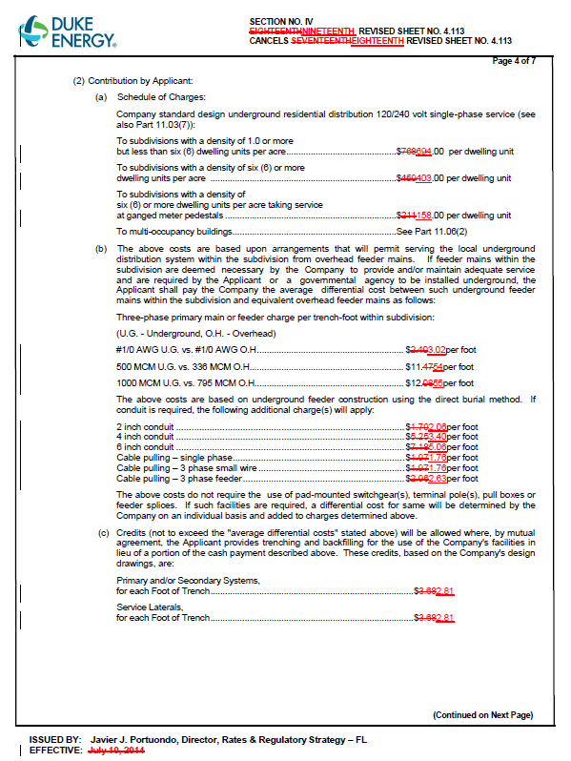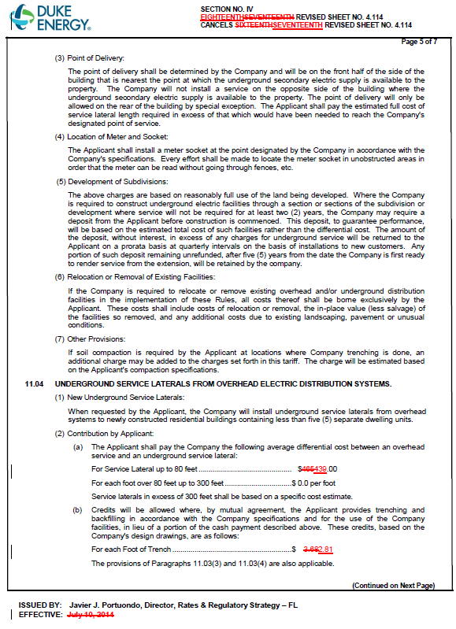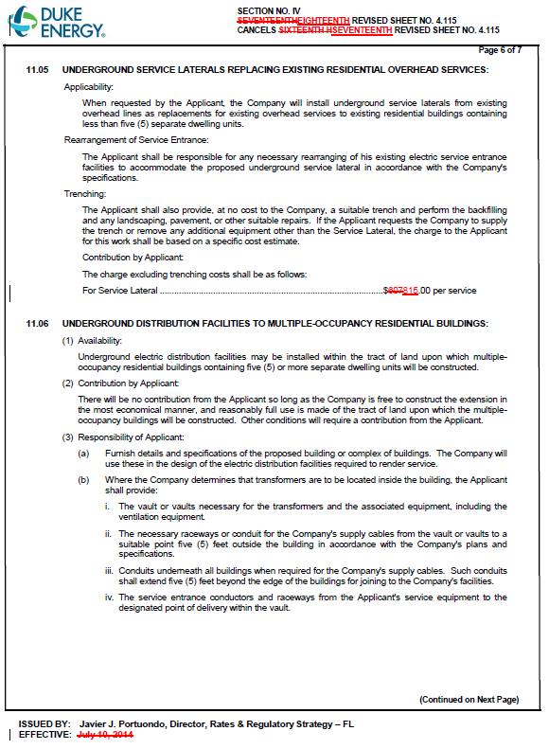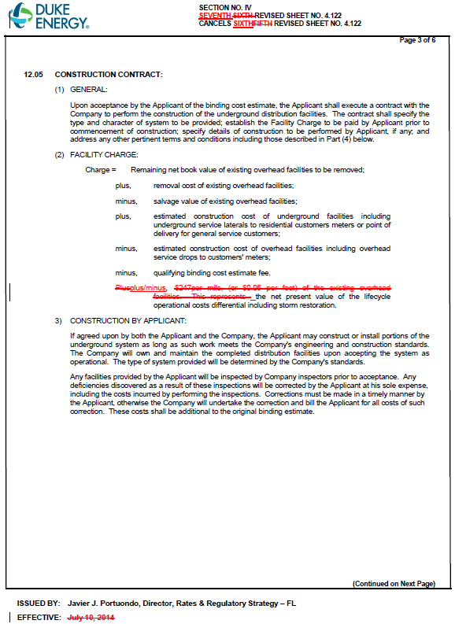

Order No. PSC-14-0396-TRF-EI, issued July 31, 2014, in Docket No. 140067-EI, In re: Petition for approval of revised underground distribution tariffs, by Duke Energy Florida, Inc.
Order No. PSC-17-0166-PCO-EI, issued May 11, 2017, in Docket No. 170069-EI, In re: Petition for approval of revised underground residential distribution tariffs, by Duke Energy Florida, Inc.
$694 is calculated as follows: $408 (Table 2) + $286 (Table 3) = $694.
Order No. PSC-12-0348-TRF-EI, issued July 5, 2012, in Docket No. 110293-EI, In re: Petition for approval of revised underground residential distribution tariffs, by Progress Energy Florida, Inc.

