BEFORE THE FLORIDA PUBLIC SERVICE COMMISSION

In re: Petition for approval of modifications to business incentive rate riders, by Gulf Power Company. | DOCKET NO. 20170209-EI  ORDER NO. PSC-2017-0458-TRF-EI  ISSUED: November 30, 2017

The following Commissioners participated in the disposition of this matter:

JULIE I. BROWN, Chairman
ART GRAHAM
RONALD A. BRISÉ
DONALD J. POLMANN
GARY F. CLARK

NOTICE OF FINAL PROPOSED AGENCY ACTION
ORDER APPROVING PROPOSED MODIFICATIONS TO TARIFFS

BY THE COMMISSION:

NOTICE is hereby given by the Florida Public Service Commission that the action discussed herein is preliminary in nature and will become final unless a person whose interests are substantially affected files a petition for a formal proceeding, pursuant to Rule 25-22.029, Florida Administrative Code (F.A.C.).

Background
On September 25, 2017, Gulf Power Company (Gulf or company) filed a petition requesting modifications to its Extra Large Business Incentive Rate Rider (XLBIR), Large Business Incentive Rate Rider (LBIR), Medium Business Incentive Rate Rider (MBIR), and Small Business Incentive Rate Rider (SBIR), known collectively as the riders. The riders collectively share a 100 megawatt (MW) subscription limitation. Gulf is requesting in this petition to remove this limitation. The company’s riders were approved by this Commission as a three-year pilot program (January 1, 2014 through December 31, 2016) pursuant to the Stipulation and Settlement Agreement in Gulf’s 2013 base rate proceeding. On June 9, 2016, we approved a limited extension of the riders, changing the termination date from December 31, 2016 to December 31, 2017. On May 16, 2017, as part of the Stipulation and Settlement Agreement in Gulf’s 2016 base rate proceeding, this Commission made the program a permanent tariff option. The XLBIR was also approved as part of the agreement. The riders, which require a five-year electric service contract (the XLBIR requires a ten-year contract), provide base rate credits for new businesses that meet certain requirements such as minimum monthly load, job creation, and capital investment. Customers must also verify that the availability of the riders is a significant factor in their location or expansion decision.
Commission staff issued a data request to Gulf on October 6, 2017, and the company responded on October 13, 2017. Attachment A contains the rider tariff sheets indicating the proposed changes. We have jurisdiction over this matter pursuant to Sections 288.035 and 366.06, Florida Statutes.
Decision
In its petition Gulf proposes to make certain changes to its Business Incentive Rate Riders effective November 7, 2017.
The riders are designed to attract new commercial and industrial customers to Gulf’s service territory and foster economic growth. The riders offer base rate electric price incentives over a four to nine-year period for new or expanding businesses that meet certain electric load and full-time employee (FTE) requirements. Table 1 shows the requirements for customers to join each rider.
Table 1
Requirements by Rider
Rider | Monthly Load | Number of FTEs | Capital Investment
XLBIR | 5 MW | 50 | $1,000,000
LBIR | 1,000 kW | 50 | $1,000,000
MBIR | 350 kW | 25 | None
SBIR | 200 kW | 10 | None
Source: Tariff Sheet Nos. 6.93, 6.95, 6.97, 6.104
Eligible customers must agree to a minimum five-year service agreement (ten-year agreement in the XLBIR) and submit documentation verifying the current number of FTEs, each year. Table 2 illustrates the credits by rider which will be applied to the customer’s base demand and energy charges.

Table 2
Reduction in Base Demand and Energy Charges
Year | XLBIR* | LBIR | MBIR | SBIR
1 | 60% | 60% | 40% | 20%
2 | 53% | 45% | 30% | 15%
3 | 47% | 30% | 20% | 10%
4 | 40% | 15% | 10% | 5%
5-9* | 33% to 7 % | None | None | None
Source: Tariff Sheet Nos. 6.93, 6.95, 6.97, 6.104
* Not shown, the credits for the XLBIR decline from 27 percent in Year 6 to 7 percent in Year 9. In Year 10, there are no credits.

In response to Commission staff’s data request, Gulf stated that it currently has two subscribers to the riders, which carry a 504 kW load, employ 94 FTEs, and have a total capital investment of $3.6 million. These subscribers have received total credits of $42,059 to date. Gulf has four additional customers that have committed to joining the riders. These four customers are expected to bring a 15.5 MW load, 5,640 jobs, and $42 million in electricity revenue to Gulf’s territory between 2017 and 2018.
In addition, Gulf has begun negotiations with prospective customers whose load would bring the riders’ total near or over the 100 MW limit. The company states that the limit hinders negotiations due to the uncertainty of the riders’ future capacity. The 100 MW limit was originally placed on a three-year pilot program. Gulf asserts that removal of the limit on the now-permanent program will enhance its effectiveness. Per Rule 25-6.0426, Florida Administrative Code, utilities can recover 95 percent of economic development expenses, not to exceed the lesser of 0.15 percent of annual revenues or $3 million. Despite this rule, Gulf is not seeking recovery of its economic development expenses as part of this request.
Gulf has demonstrated that the riders have successfully attracted new load, jobs, capital investment, and incremental base revenues to Gulf’s service territory. The riders provide benefits to the general body of ratepayers through additional revenue and load, over which fixed costs are spread. Also, at this time, Gulf is not seeking recovery of these expenses.
Based on the foregoing, it is

ORDERED by the Florida Public Service Commission that Gulf Power Company’s petition for modifications to its Business Incentive Rate Riders effective November 7, 2017 is hereby approved as set forth in the body of this Order. It is further

ORDERED that if a protest is filed within 21 days of issuance of the Order, the tariff shall remain in effect with any charges held subject to refund pending resolution of the protest. It is further

ORDERED that if no timely protest is filed, this docket shall be closed upon the issuance of a Consummating Order.

By ORDER of the Florida Public Service Commission this 30th day of November, 2017.

/s/ Carlotta S. Stauffer
CARLOTTA S. STAUFFER
Commission Clerk
Florida Public Service Commission
2540 Shumard Oak Boulevard
Tallahassee, Florida 32399
(850) 413-6770
www.floridapsc.com

Copies furnished: A copy of this document is provided to the parties of record at the time of issuance and, if applicable, interested persons.

WLT

NOTICE OF FURTHER PROCEEDINGS

The Florida Public Service Commission is required by Section 120.569(1), Florida Statutes, to notify parties of any administrative hearing or judicial review of Commission orders that is available under Sections 120.57 or 120.68, Florida Statutes, as well as the procedures and time limits that apply. This notice should not be construed to mean all requests for an administrative hearing or judicial review will be granted or result in the relief sought.

Mediation may be available on a case-by-case basis. If mediation is conducted, it does not affect a substantially interested person's right to a hearing.

The Commission's decision on this tariff is interim in nature and will become final, unless a person whose substantial interests are affected by the proposed action files a petition for a formal proceeding, in the form provided by Rule 28-106.201, Florida Administrative Code. This petition must be received by the Office of Commission Clerk, 2540 Shumard Oak Boulevard, Tallahassee, Florida 32399-0850, by the close of business on December 21, 2017.

In the absence of such a petition, this Order shall become final and effective upon the issuance of a Consummating Order.

Any objection or protest filed in this docket before the issuance date of this order is considered abandoned unless it satisfies the foregoing conditions and is renewed within the specified protest period.

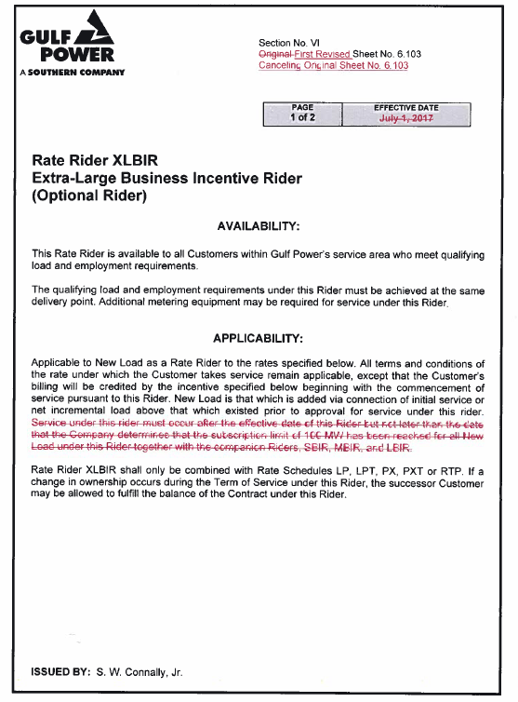

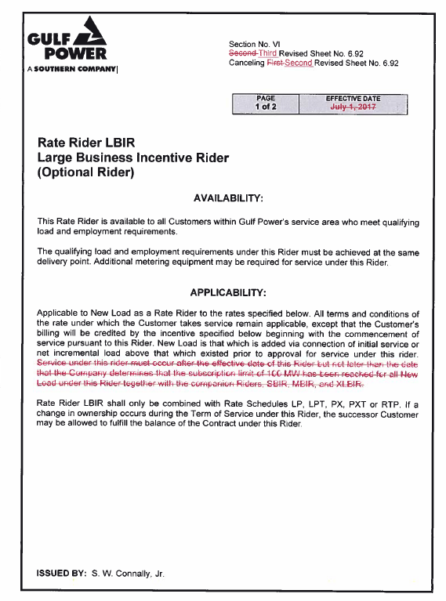

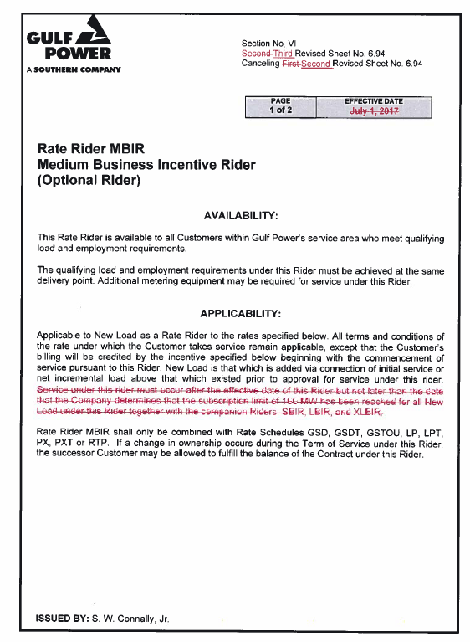

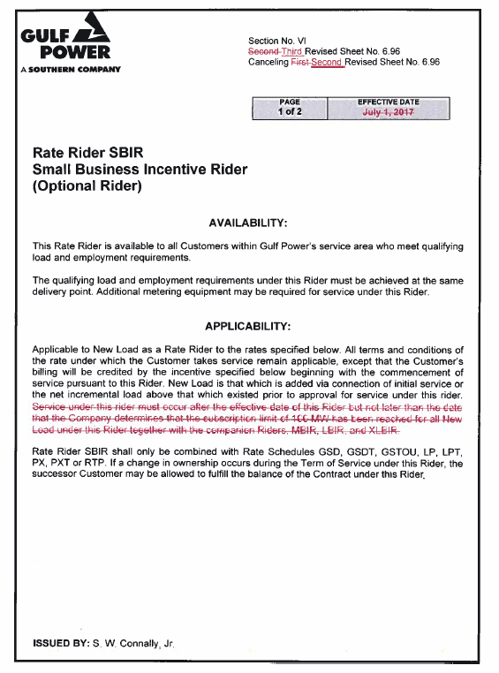

Order No. PSC-13-0670-S-EI, issued December 19, 2013, in Docket No. 130140-EI, In re: Petition for rate increase by Gulf Power Company.
Order No. PSC-16-0269-CO-EI, issued July 15, 2016, in Docket No. 20160090-EI, In re: GPC's petition for limited extension of experimental business incentive rate riders until 12/31/17.
Order No. PSC-17-0178-S-EI, issued May 16, 2017, in Docket No. 160186-EI, In re: Petition for rate increase by Gulf Power Company.

