BEFORE THE FLORIDA PUBLIC SERVICE COMMISSION

In re: Petition for limited proceeding to include reliability and modernization projects in rate base, by Florida Public Utilities Company. | DOCKET NO. 20170150-EI  ORDER NO. PSC-2017-0488-PAA-EI  ISSUED: December 26, 2017

The following Commissioners participated in the disposition of this matter:

JULIE I. BROWN, Chairman
ART GRAHAM
RONALD A. BRISÉ
DONALD J. POLMANN
GARY F. CLARK

NOTICE OF PROPOSED AGENCY ACTION
ORDER APPROVING STIPULATION AND SETTLEMENT AGREEMENT

BY THE COMMISSION:

NOTICE is hereby given by the Florida Public Service Commission that the action discussed herein is preliminary in nature and will become final unless a person whose interests are substantially affected files a petition for a formal proceeding, pursuant to Rule 25-22.029, Florida Administrative Code (F.A.C.).

CASE BACKGROUND

Florida Public Utility Company (FPUC or Utility) serves more than 32,000 customers located in North Florida. FPUC’s Northwest Division serves Jackson, Calhoun and Liberty counties, and is commonly called the “Marianna Division.” The Utility’s Northeast Division is located in the Fernandina Beach area, and serves Nassau County. FPUC does not generate any of the power it sells, but meets the needs of its customers through contracts for purchased power.
FPUC’s last request for an increase in base rates was filed on April 28, 2014. On August 29, 2014, a Joint Motion for Approval of Stipulation and Settlement (Settlement) was filed. The Commission approved the Settlement, which included a $3.75 million revenue increase, by Order No. PSC-14-0517-S-EI, issued on September 29, 2014.
On July 3, 2017, FPUC filed a petition for a limited proceeding to include in its rate base certain capital projects. The Utility has requested an increase in its total revenue requirement of $1,823,869 representing total capital expenditures of $15,241,515. The capital investments fall under one of three types of projects: (1) grid modernization and safety; (2) storm hardening; and (3) an interconnection with Florida Power & Light Company. FPUC states that the projects have been designed to enhance the capability of its grid and improve the safety and reliability of its system. Further, the Utility asserts that these projects will benefit both FPUC and its customers, and should be allowed to be recovered through base rates.
On July 21, 2017, a Joint Motion Requesting Commission Approval of Procedure for Conducting Limited Proceedings and for Subsequent Tariff Filing was filed on behalf of FPUC and OPC. On September 21, 2017, the Office of Public Counsel (OPC) filed its Notice of Intervention, which was acknowledged on September 25, 2017.
On November 28, 2017, a Joint Motion for Approval of Stipulation and Settlement Agreement (Joint Motion) was filed by FPUC and OPC requesting approval of a Stipulation and Settlement Agreement (2017 Agreement) which resolves all issues in this proceeding.
This Commission has jurisdiction over this request for a limited proceeding under Sections 366.076 (1) and 366.041, Florida Statutes (F.S.).

Settlement Agreement

The major elements of the 2017 Agreement are as follows:

- The effective date of the 2017 Agreement is the date of the Commission vote with new rates implemented in the first billing cycle of January 2018 and ending with the last billing cycle of December 2019. New rates are designed in accord with the methodology used in FPUC’s last base rate proceeding (Docket No. 140025-EI).

- Revenue requirements increase by $1,558,050 representing total capital expenditures of $13,520,303 for 12 projects outlined in Attachment 1 to the 2017 Agreement.

- FPUC can petition the Commission to seek recovery of costs associated with named tropical systems or other catastrophic storms that occur after the approval of the 2017 Agreement up to $4.00/1,000 kWh for a 12-month recovery period. If the costs incurred exceed the revenues generated by the $4.00/1,000 kWh charge, those costs shall be recovered in subsequent years as determined by the Commission. Upon complete depletion of its storm reserve, FPUC may replenish the storm reserve up to $1.5 million.

- FPUC may file for a new LED lighting rate schedule structured in the same manner as that in Docket No. 20170199-EI, In re: Petition for approval of conservation street and outdoor lighting conversion program, by Tampa Electric Company.

- FPUC shall be entitled to seek rate relief if FPUC’s reported return on equity is below the bottom of the existing range (9.25% to 11.25%) and FPUC experiences an unanticipated and unforeseen event that impacts the annual revenue requirement in excess of $800,000 (either loss of revenues or increase in expenses) within any contiguous 4 month period.

- Within 120 days of any federal tax reform, FPUC will calculate a one-time base rate adjustment which shall be credited to customers through the ECCR clause. If the tax reform results in an increase, FPUC will utilize deferral accounting to result in a net zero impact to operating income. FPUC shall defer the revenue requirement impacts to a regulatory asset to be considered for prospective recovery to be addressed in FPUC’s next base rate proceeding.

- All excess deferred taxes shall be deferred to a regulatory asset or liability, which shall be included in FPUC’s adjusted capital structure and flowed back to customers over a term consistent with current laws. FPUC reserves the right to demonstrate that the flow back period is not in the best interest of its customers and should be increased to no more than 50 percent of the remaining life of the assets associated with the excess deferred taxes.

- The $1,558,050 increase represents a 8.01% increase to base rates and would be allocated to the rate classes at a uniform percentage. The base rate portion of a 1,000 kWh residential bill would increase from $33.60 to $36.29 ($2.69 increase) as a result of the 2017 Agreement. Due to a decrease in the fuel and purchased power cost, the total residential 1,000 kWh bill including Gross Receipts Tax would decrease from $138.97 to $133.86, a $5.11 decrease effective January 2018.

- The parties have agreed that this docket should be processed as a Proposed Agency Action (PAA) and that neither OPC nor FPUC will file a protest of the 2017 Agreement rates. Further, if a protest is filed by any substantially affected person other than FPUC or OPC, the rates approved by the Commission shall be placed into effect in the first billing cycle of 2018 subject to refund with interest pending issuance of a final order in the docket.
DECISION

The standard for approval of a settlement agreement is whether it is in the public interest. A determination of public interest requires a case-specific analysis based on consideration of the proposed settlement taken as a whole. We first note that OPC, the statutory representative for all Florida ratepayers, negotiated and is a signatory to this 2017 Agreement. FPUC has stated that its purpose in filing this limited proceeding is to recover the revenues associated with the large capital improvements listed on Attachment 1 to the 2017 Agreement and thereby postpone filing for a base rate increase until 2020. These capital improvements will increase FPUC’s reliability, and, in the case of the Florida Power & Light Company interconnect, have allowed FPUC to purchase electric capacity at a substantially lower price. Additionally, many of the terms found in the 2017 Agreement proposed by the signatories are consistent with terms found in Florida Power & Light Company’s, Gulf Power Company’s, Duke Energy Florida, LLC’s and Tampa Electric Company’s most recent rate case settlements, e.g., implementation of a storm damage recovery mechanism, base rate freeze period, and federal income tax reform provisions. Based on these factors, we find that taken as a whole the 2017 Agreement provides a reasonable resolution of all the issues addressed. We find, therefore, that the 2017 Agreement, Attachment A hereto, establishes rates that are fair, just, and reasonable and is in the public interest, and hereby approve it.
Since the 2017 Agreement provides a procedural mechanism for processing this docket and for the collection subject to refund of 2017 Agreement tariff rates if timely protested by a substantially affected party, the Joint Motion Requesting Commission Approval of Procedure for Conducting Limited Proceedings and for Subsequent Tariff Filing filed on July 21, 2017, is now moot.
Based on the foregoing, it is

ORDERED by the Florida Public Service Commission that the Joint Motion of Florida Public Utilities Company and the Office of Public Counsel for Approval of Stipulation and Settlement filed on November 28, 2017, is hereby granted. It is further

ORDERED that the Stipulation and Settlement attached hereto as Attachment A, and incorporated by reference, is hereby approved. It is further

ORDERED that the tariff sheets contained in Attachment 4 to the Stipulation and Settlement are hereby approved with an effective date of the first billing cycle in January 2018. It is further

ORDERED that the provisions of this Order, issued as proposed agency action, shall become final and effective upon the issuance of a Consummating Order unless an appropriate petition, in the form provided by Rule 28-106.201, F.A.C., is received by the Office of Commission Clerk, 2540 Shumard Oak Boulevard, Tallahassee, Florida 32399-0850, by the close of business on the date set forth in the “Notice Of Further Proceedings” attached hereto. It is further

ORDERED that, if a protest is filed within 21 days of the issuance of this Order, Florida Public Utilities Company’s tariffs shall remain in effect, with any revenues held subject to refund, pending resolution of the protest. If no timely protest is filed, this docket shall be closed upon the issuance of a Consummating Order.

By ORDER of the Florida Public Service Commission this 26th day of December, 2017.

/s/ Carlotta S. Stauffer
CARLOTTA S. STAUFFER
Commission Clerk
Florida Public Service Commission
2540 Shumard Oak Boulevard
Tallahassee, Florida 32399
(850) 413-6770
www.floridapsc.com

Copies furnished: A copy of this document is provided to the parties of record at the time of issuance and, if applicable, interested persons.

SBr

NOTICE OF FURTHER PROCEEDINGS OR JUDICIAL REVIEW

The Florida Public Service Commission is required by Section 120.569(1), Florida Statutes, to notify parties of any administrative hearing that is available under Section 120.57, Florida Statutes, as well as the procedures and time limits that apply. This notice should not be construed to mean all requests for an administrative hearing will be granted or result in the relief sought.

Mediation may be available on a case-by-case basis. If mediation is conducted, it does not affect a substantially interested person's right to a hearing.

The action proposed herein is preliminary in nature. Any person whose substantial interests are affected by the action proposed by this order may file a petition for a formal proceeding, in the form provided by Rule 28-106.201, Florida Administrative Code. This petition must be received by the Office of Commission Clerk, 2540 Shumard Oak Boulevard, Tallahassee, Florida 32399-0850, by the close of business on January 16, 2018.

In the absence of such a petition, this order shall become final and effective upon the issuance of a Consummating Order.

Any objection or protest filed in this/these docket(s) before the issuance date of this order is considered abandoned unless it satisfies the foregoing conditions and is renewed within the specified protest period.

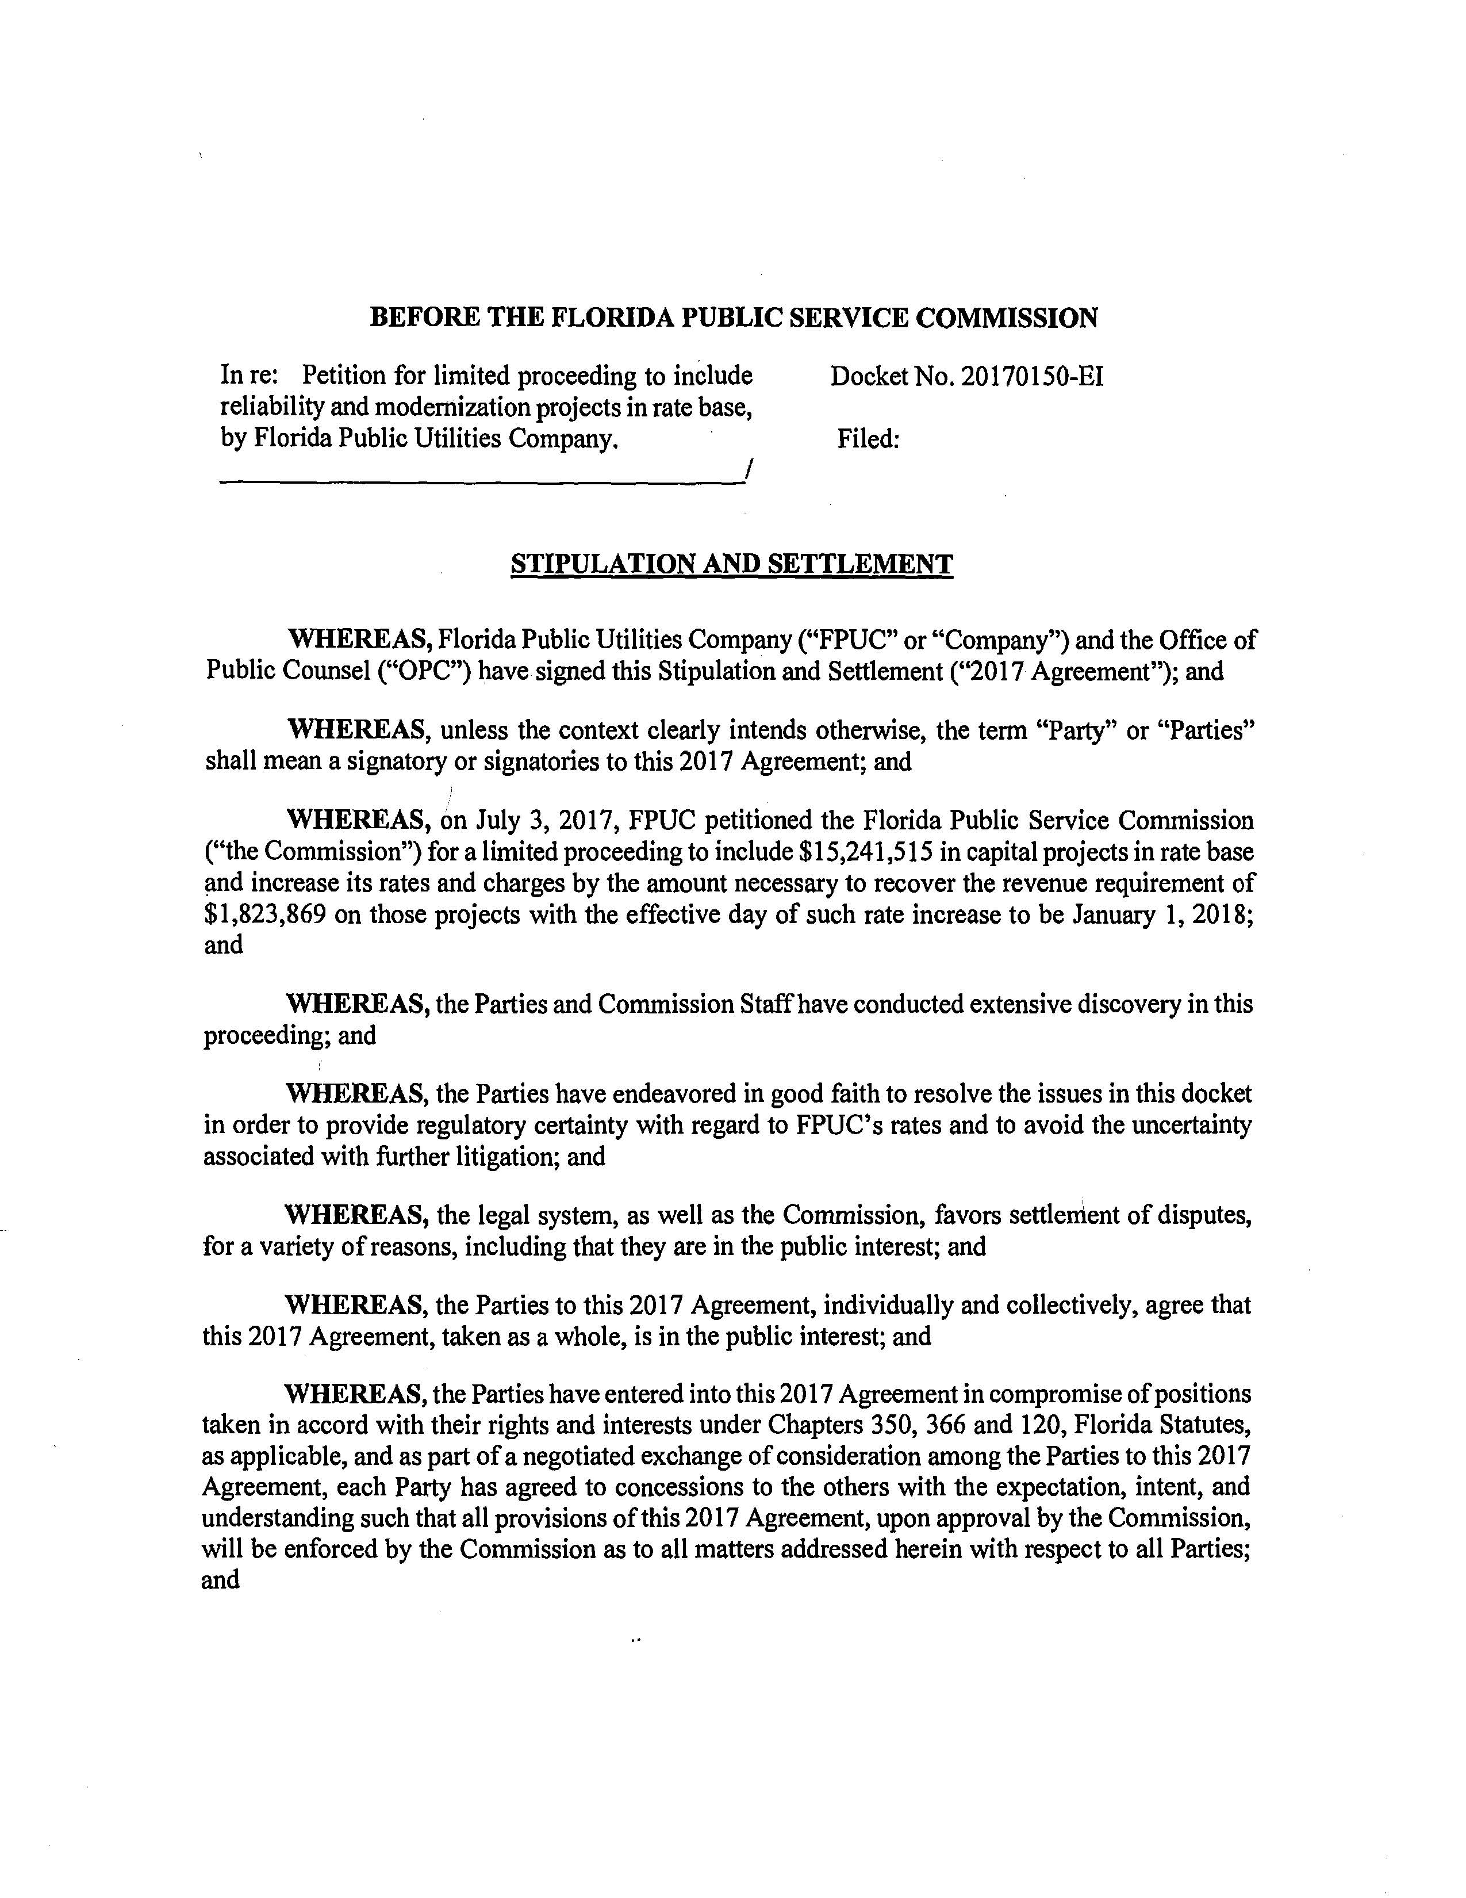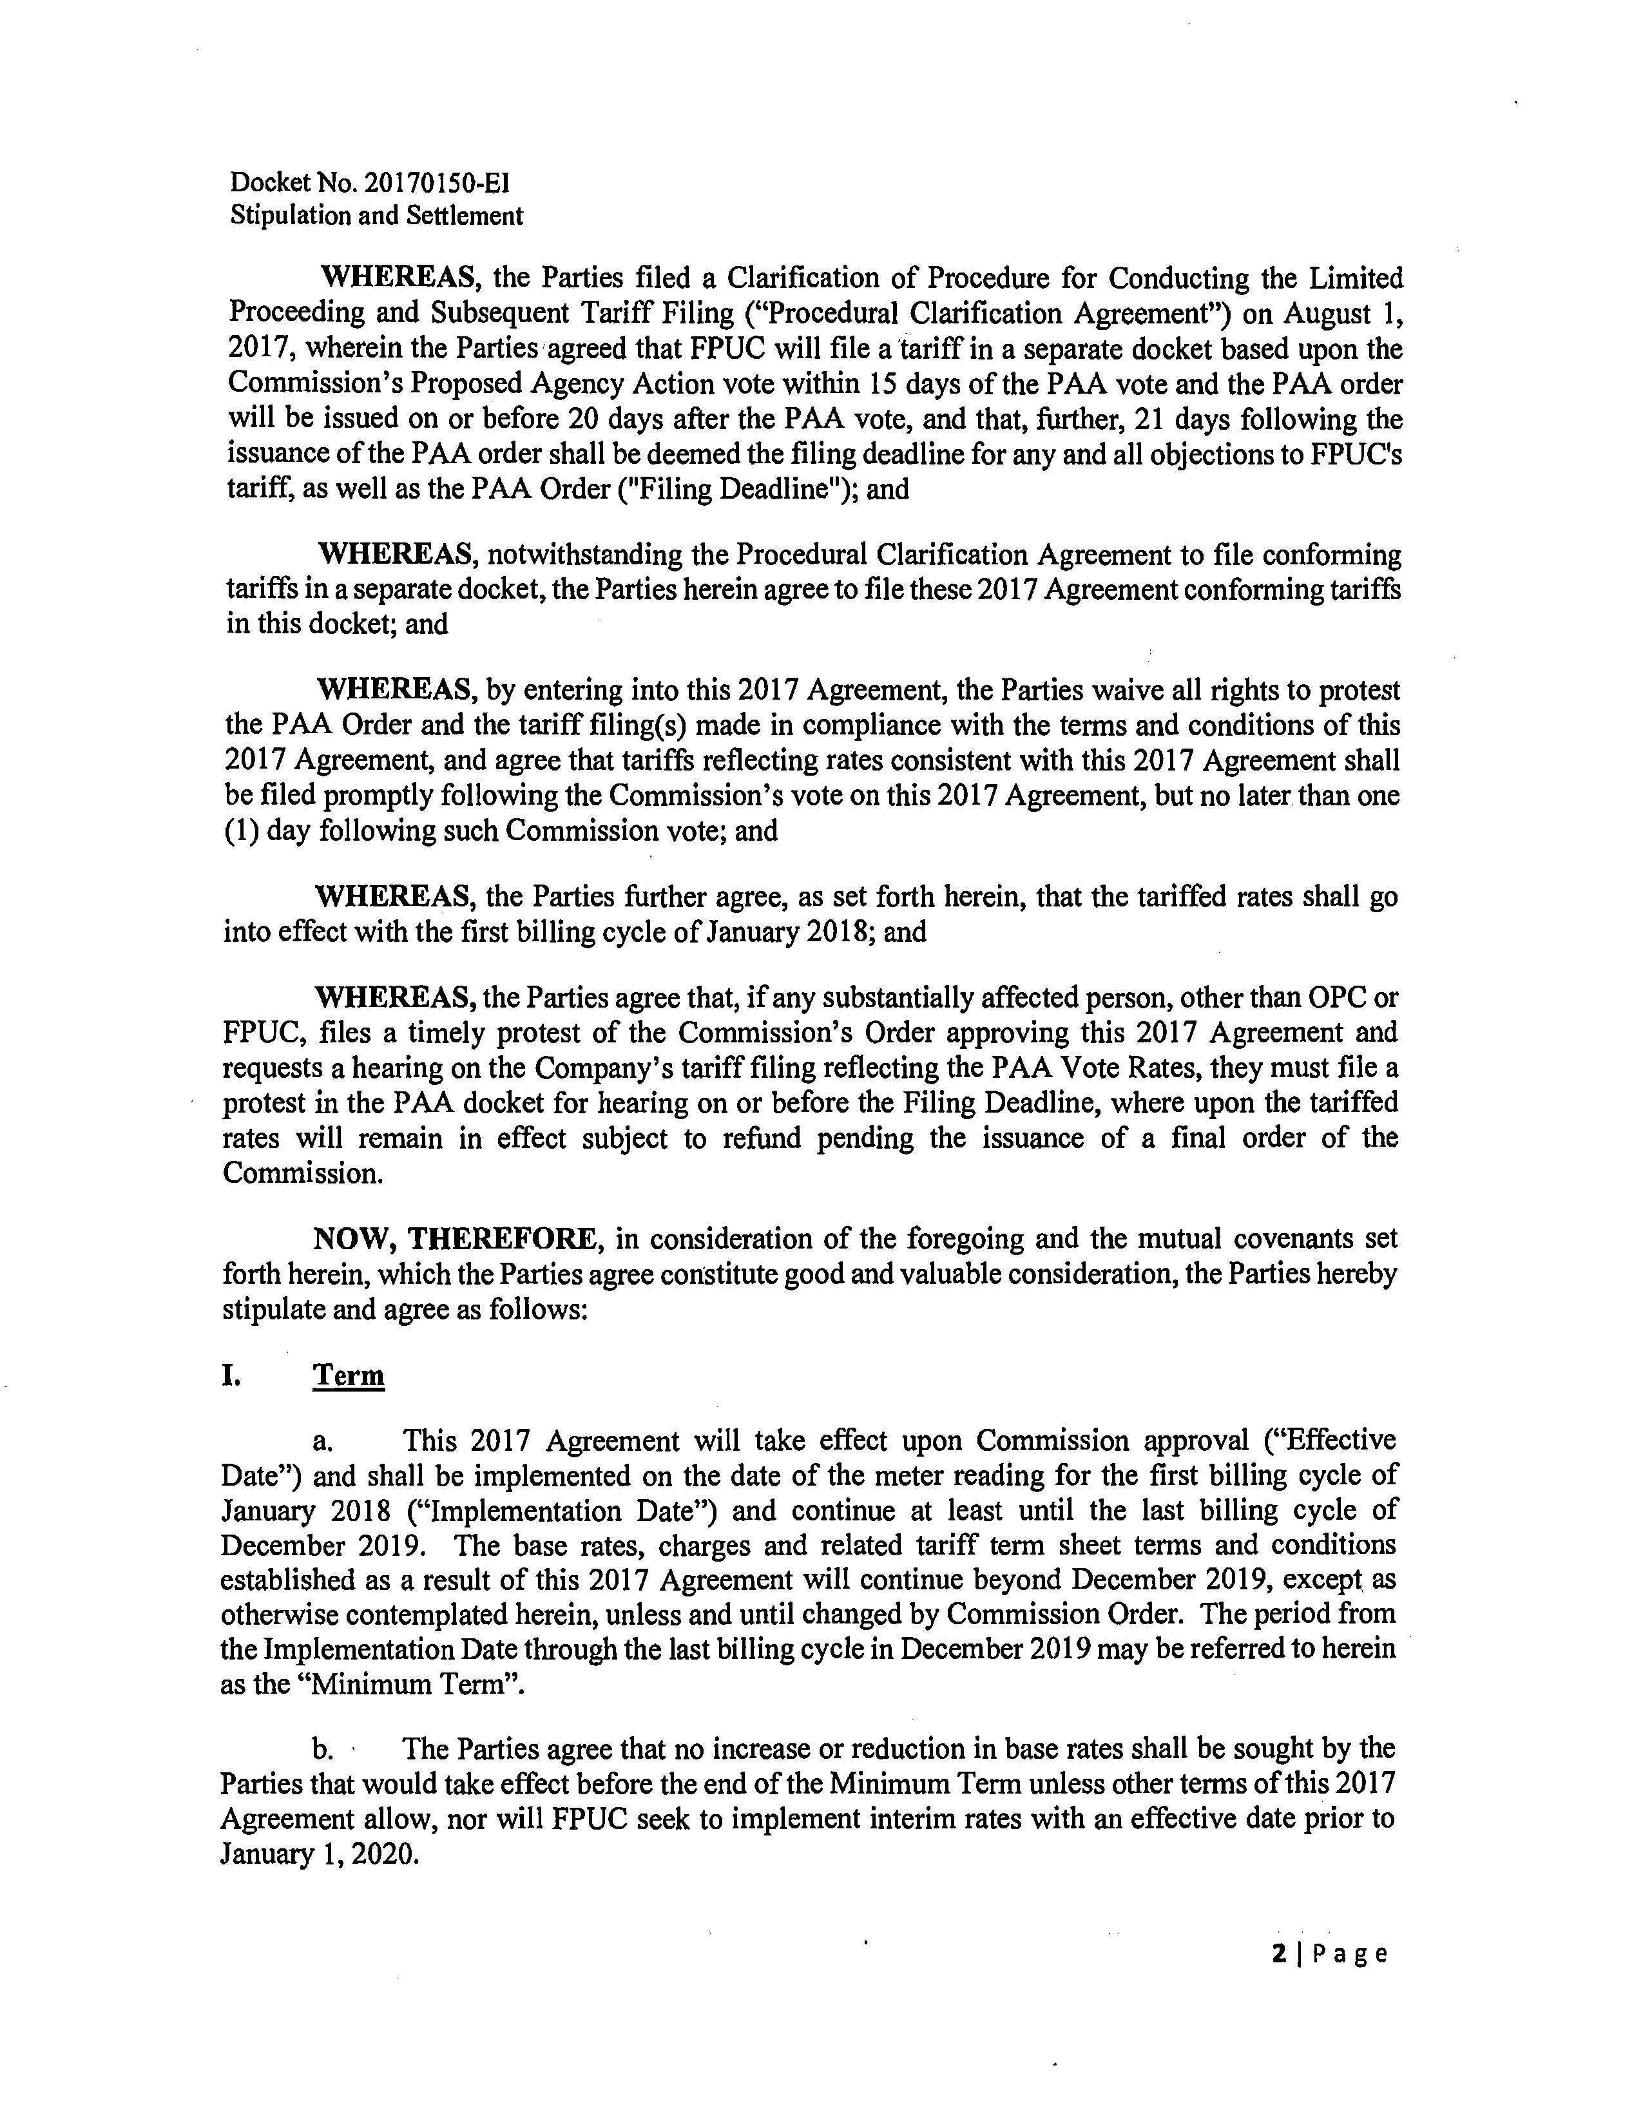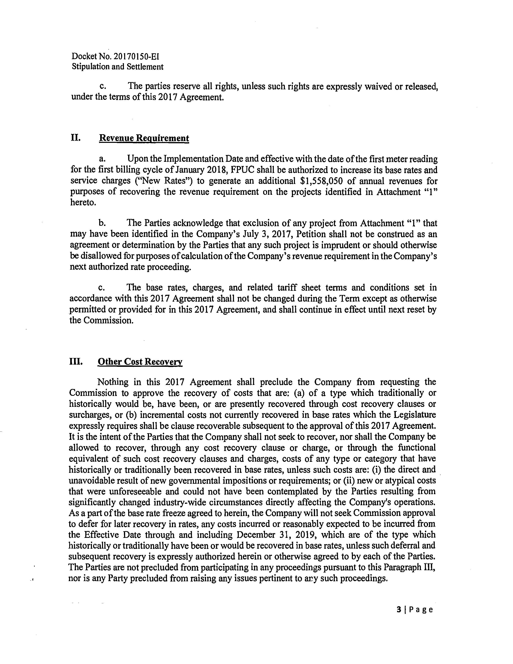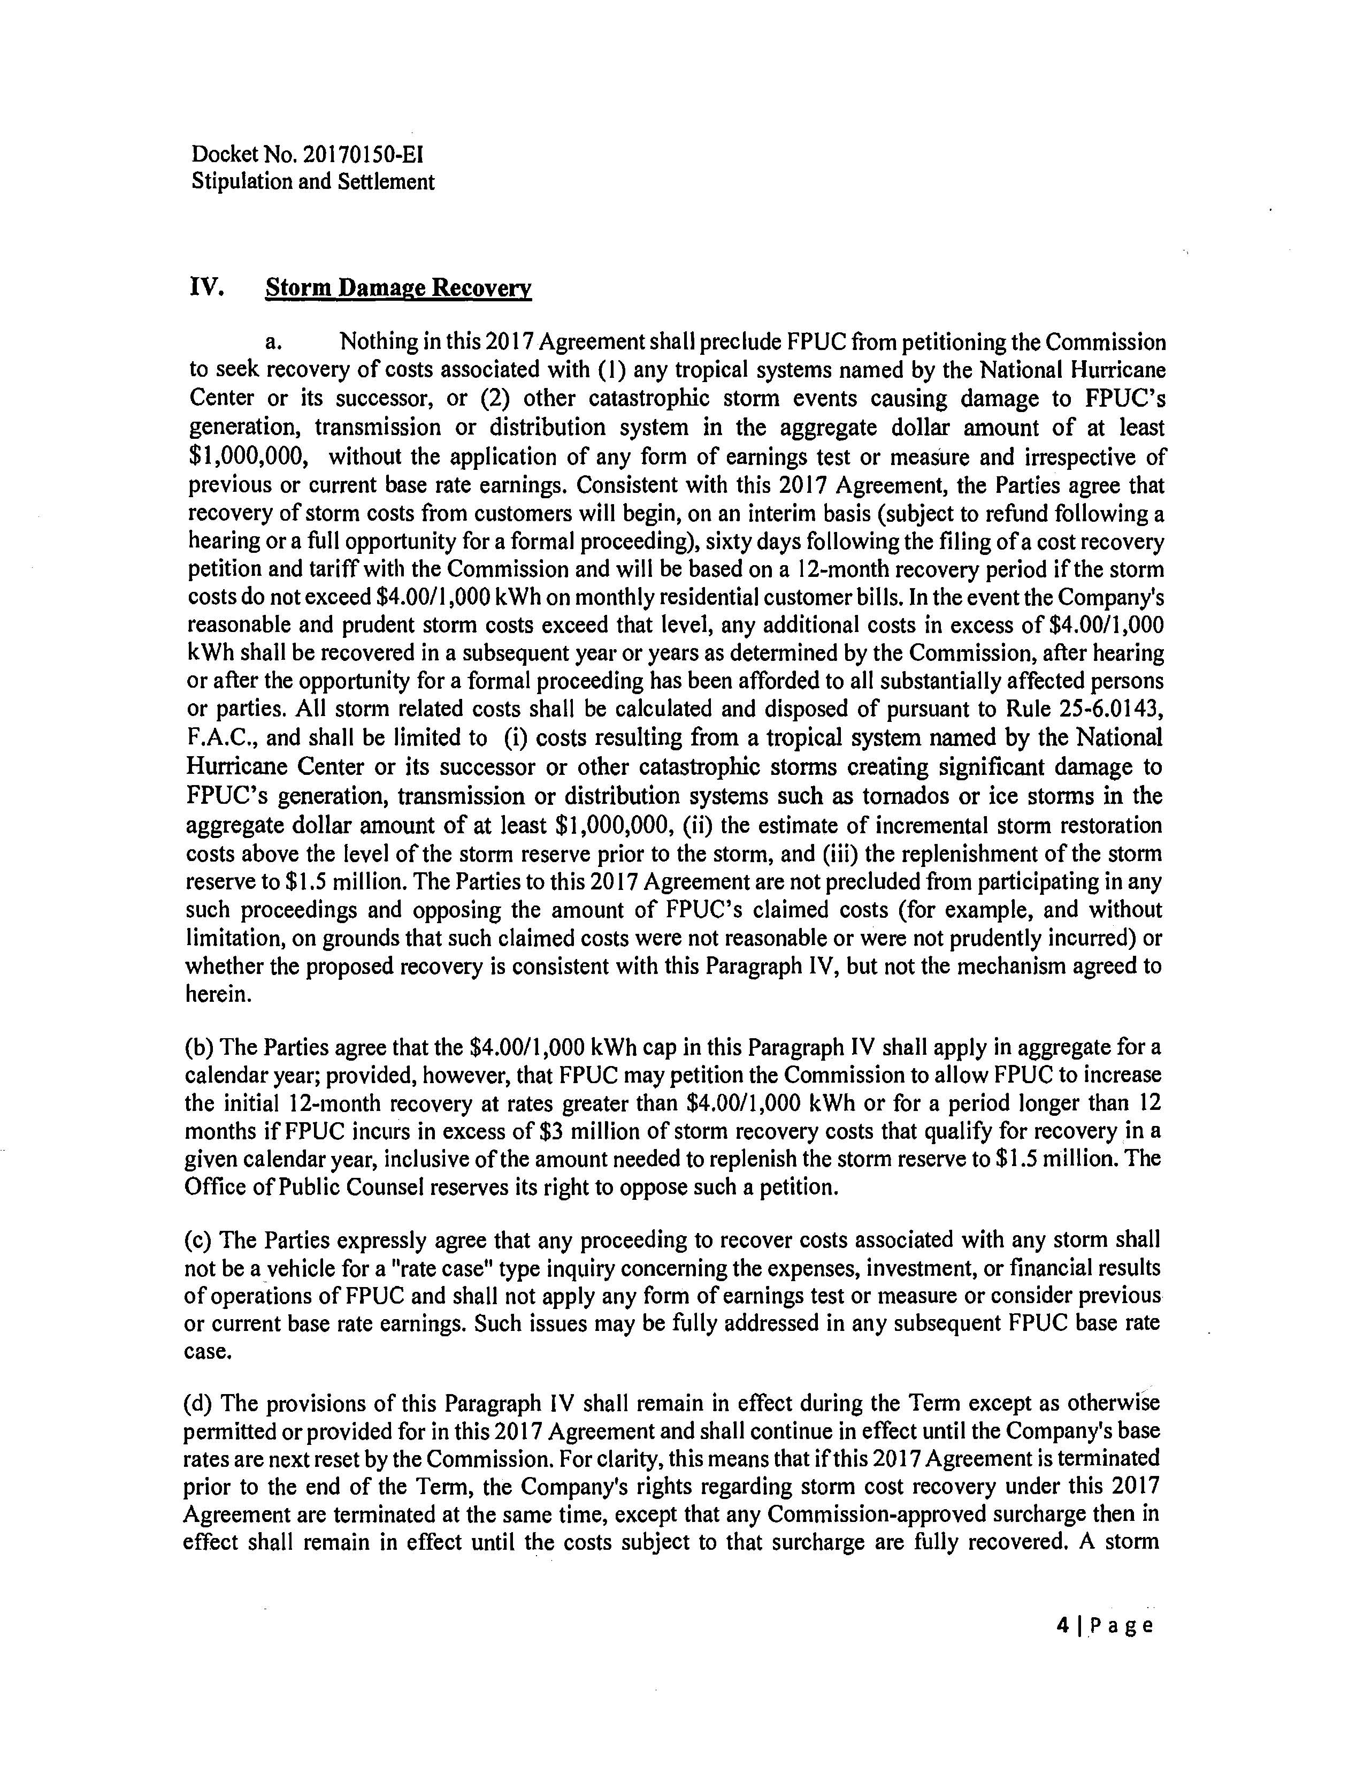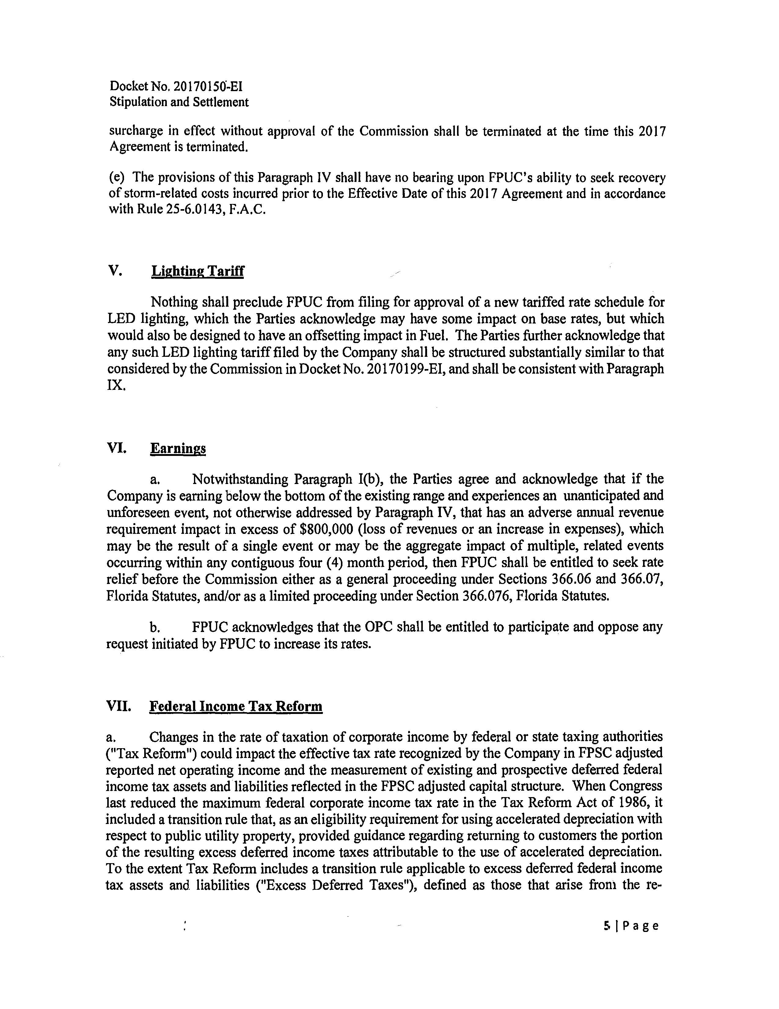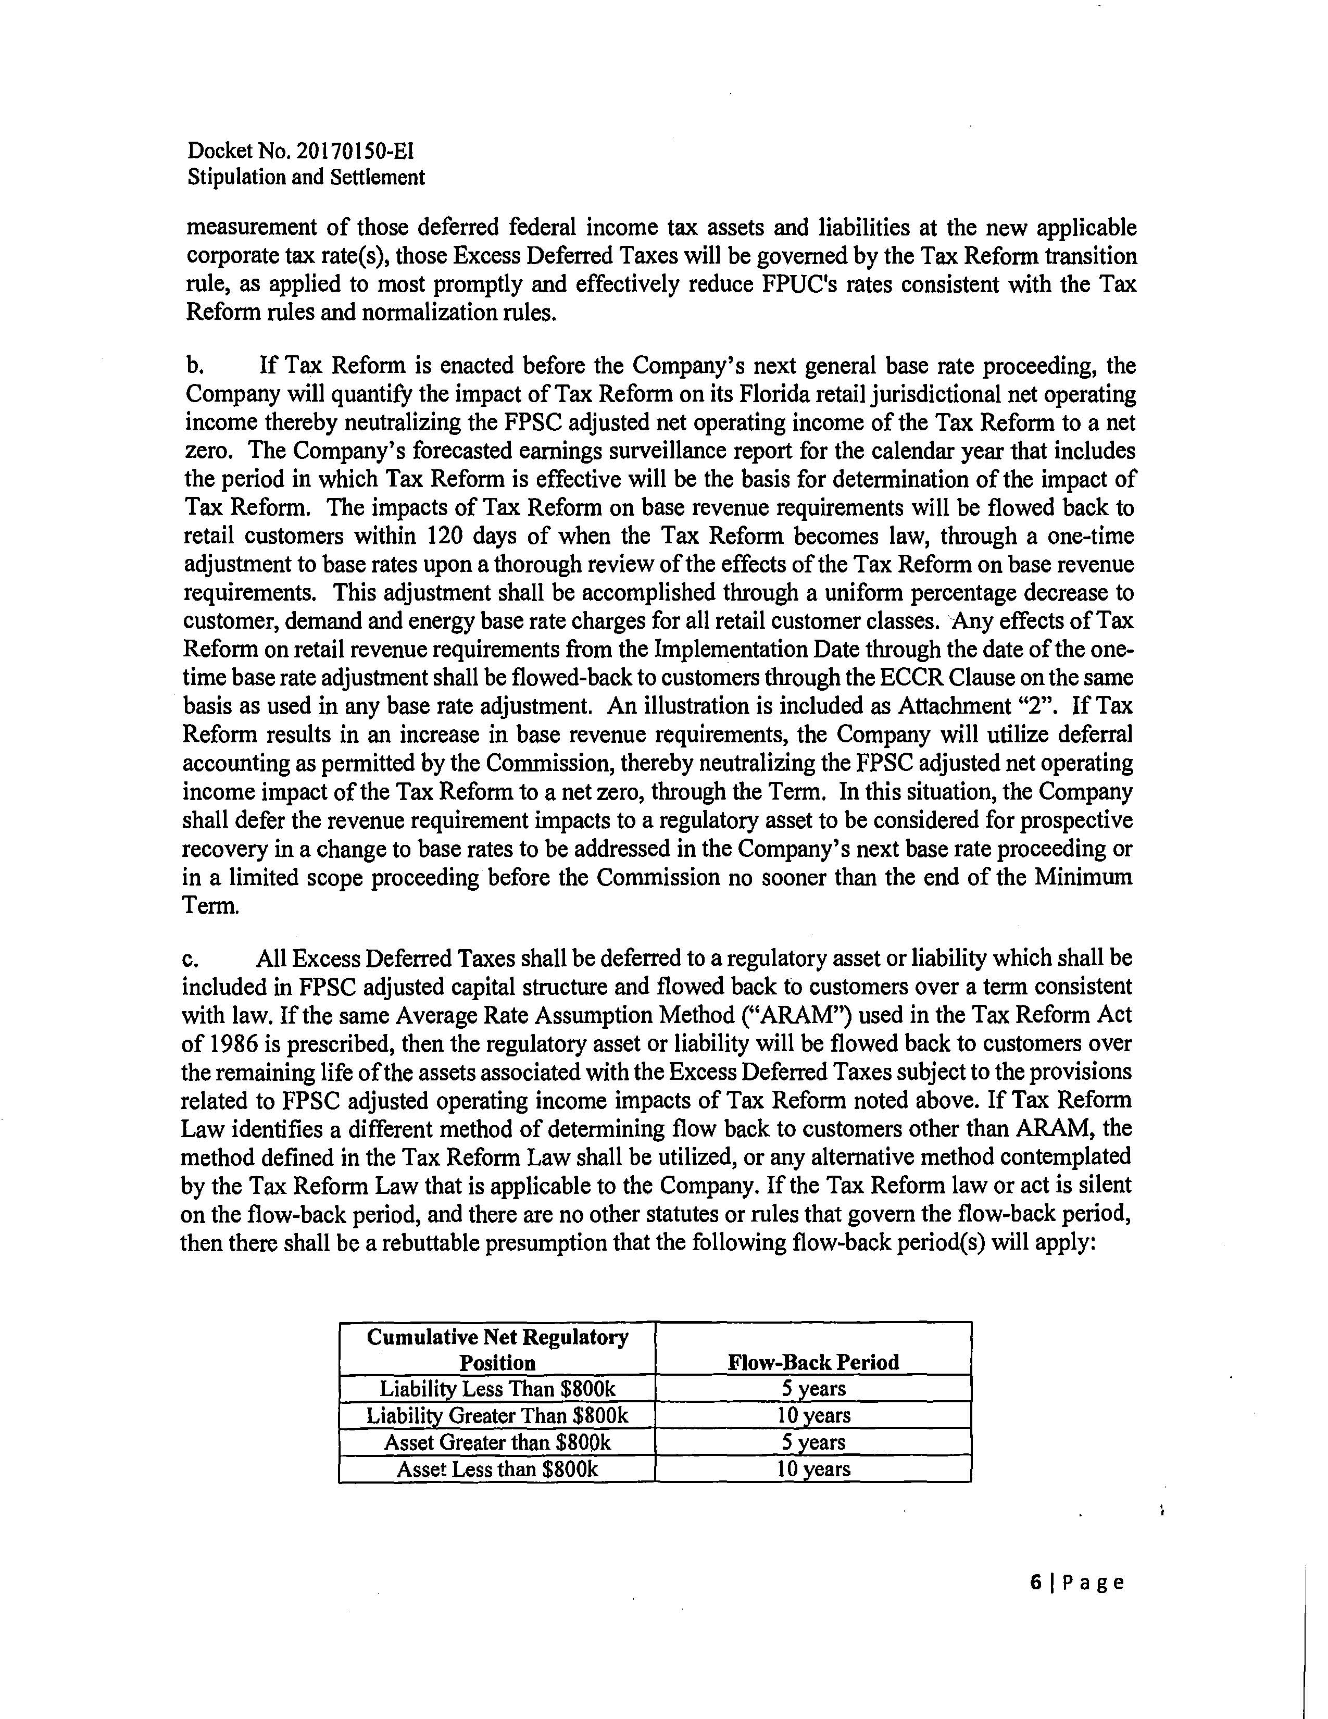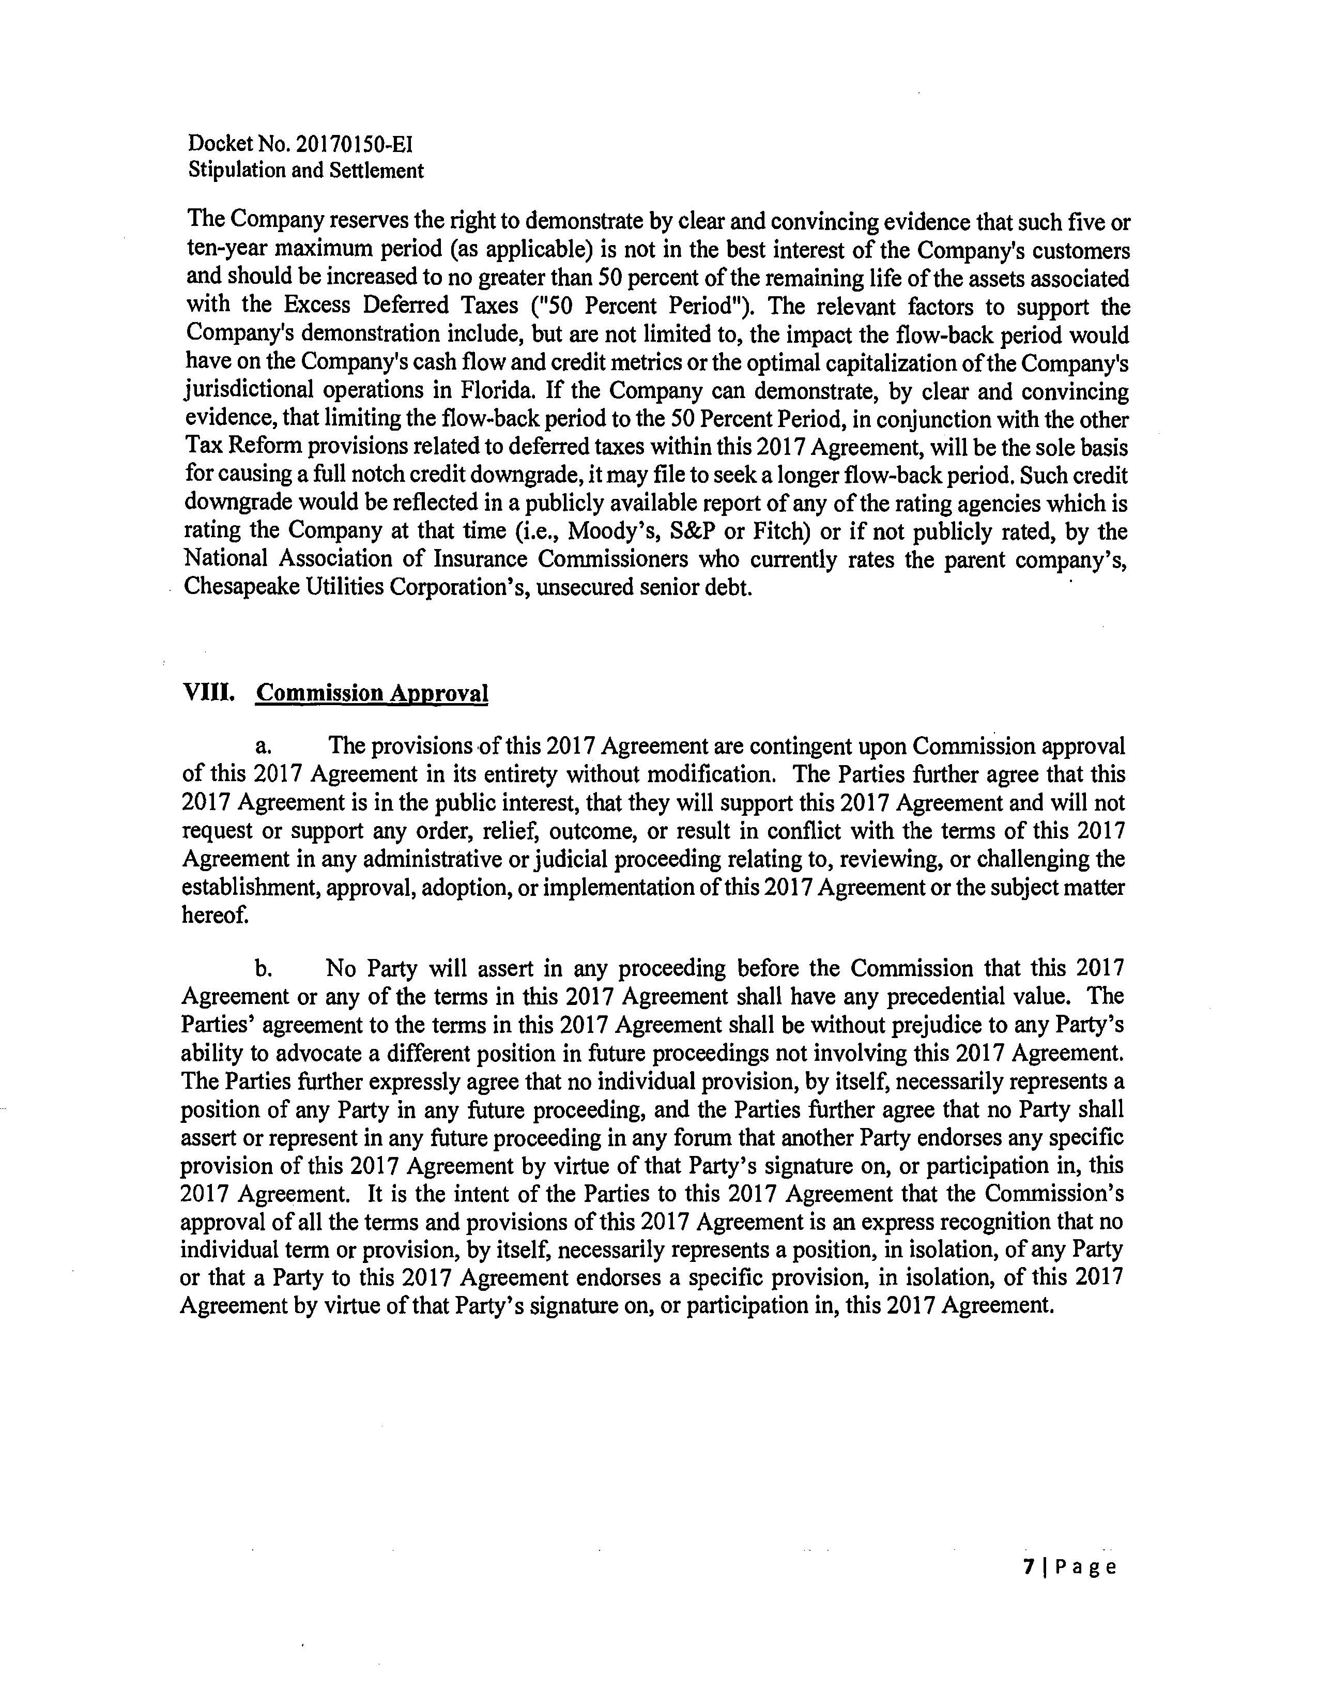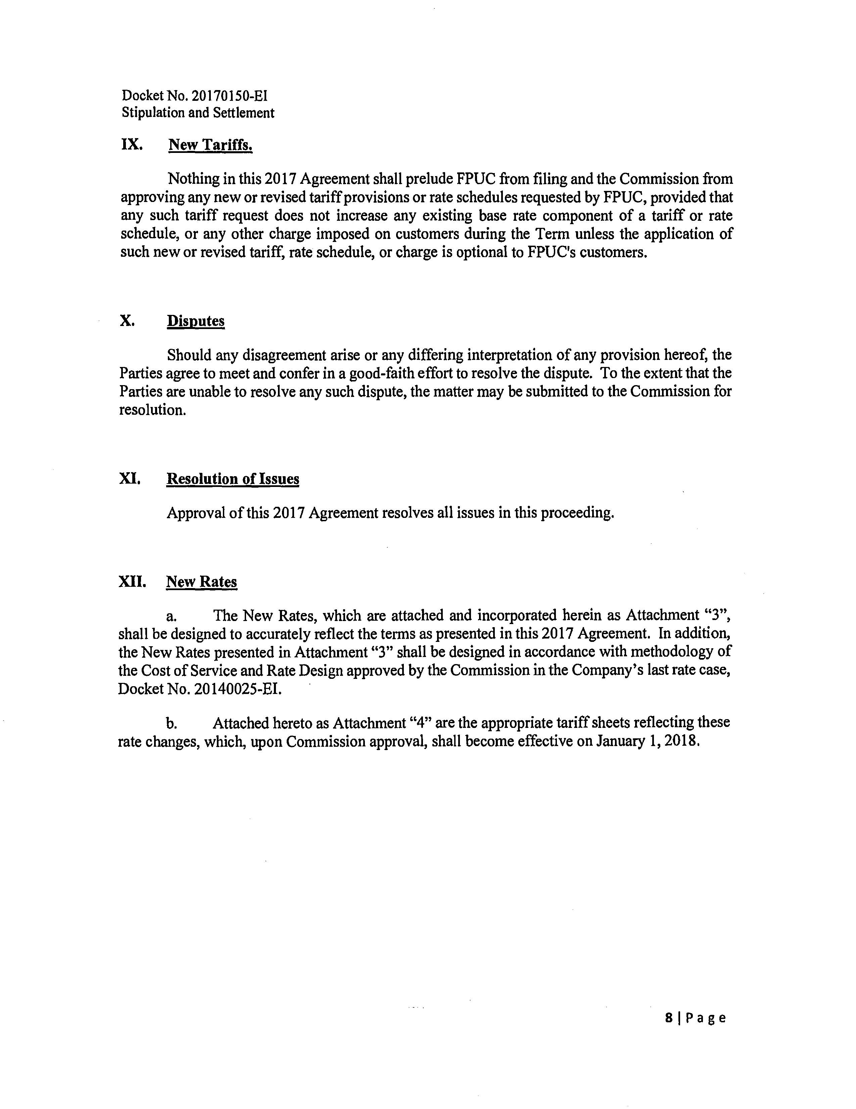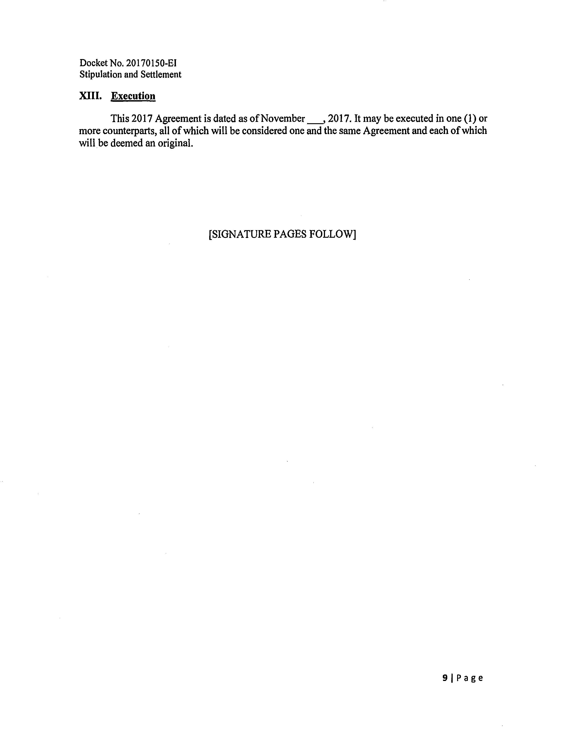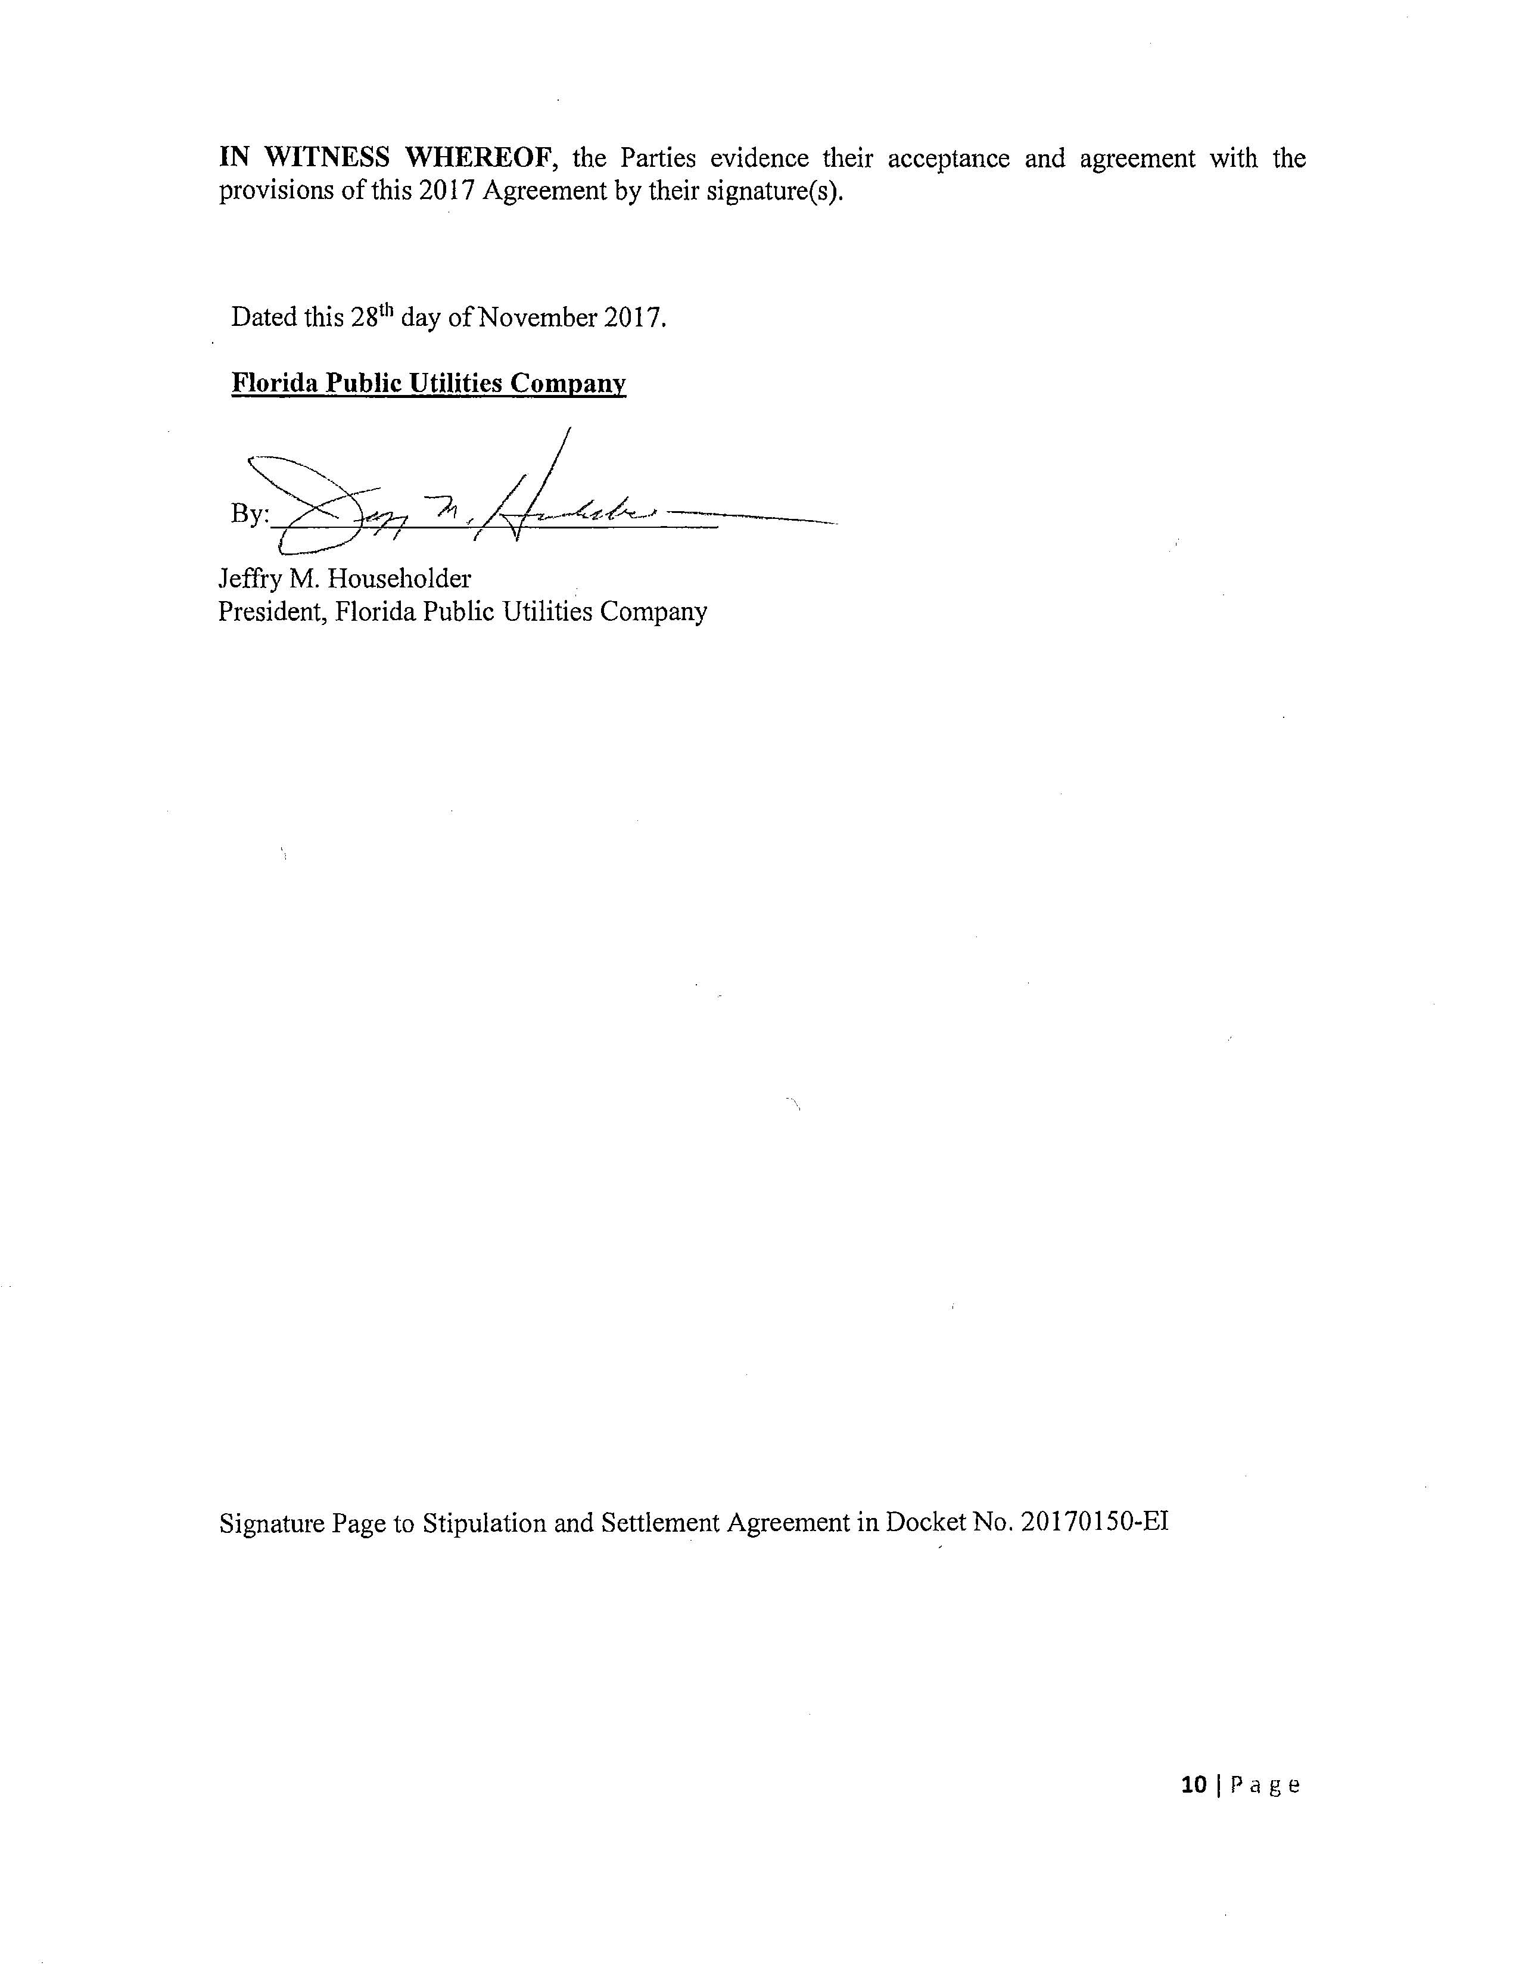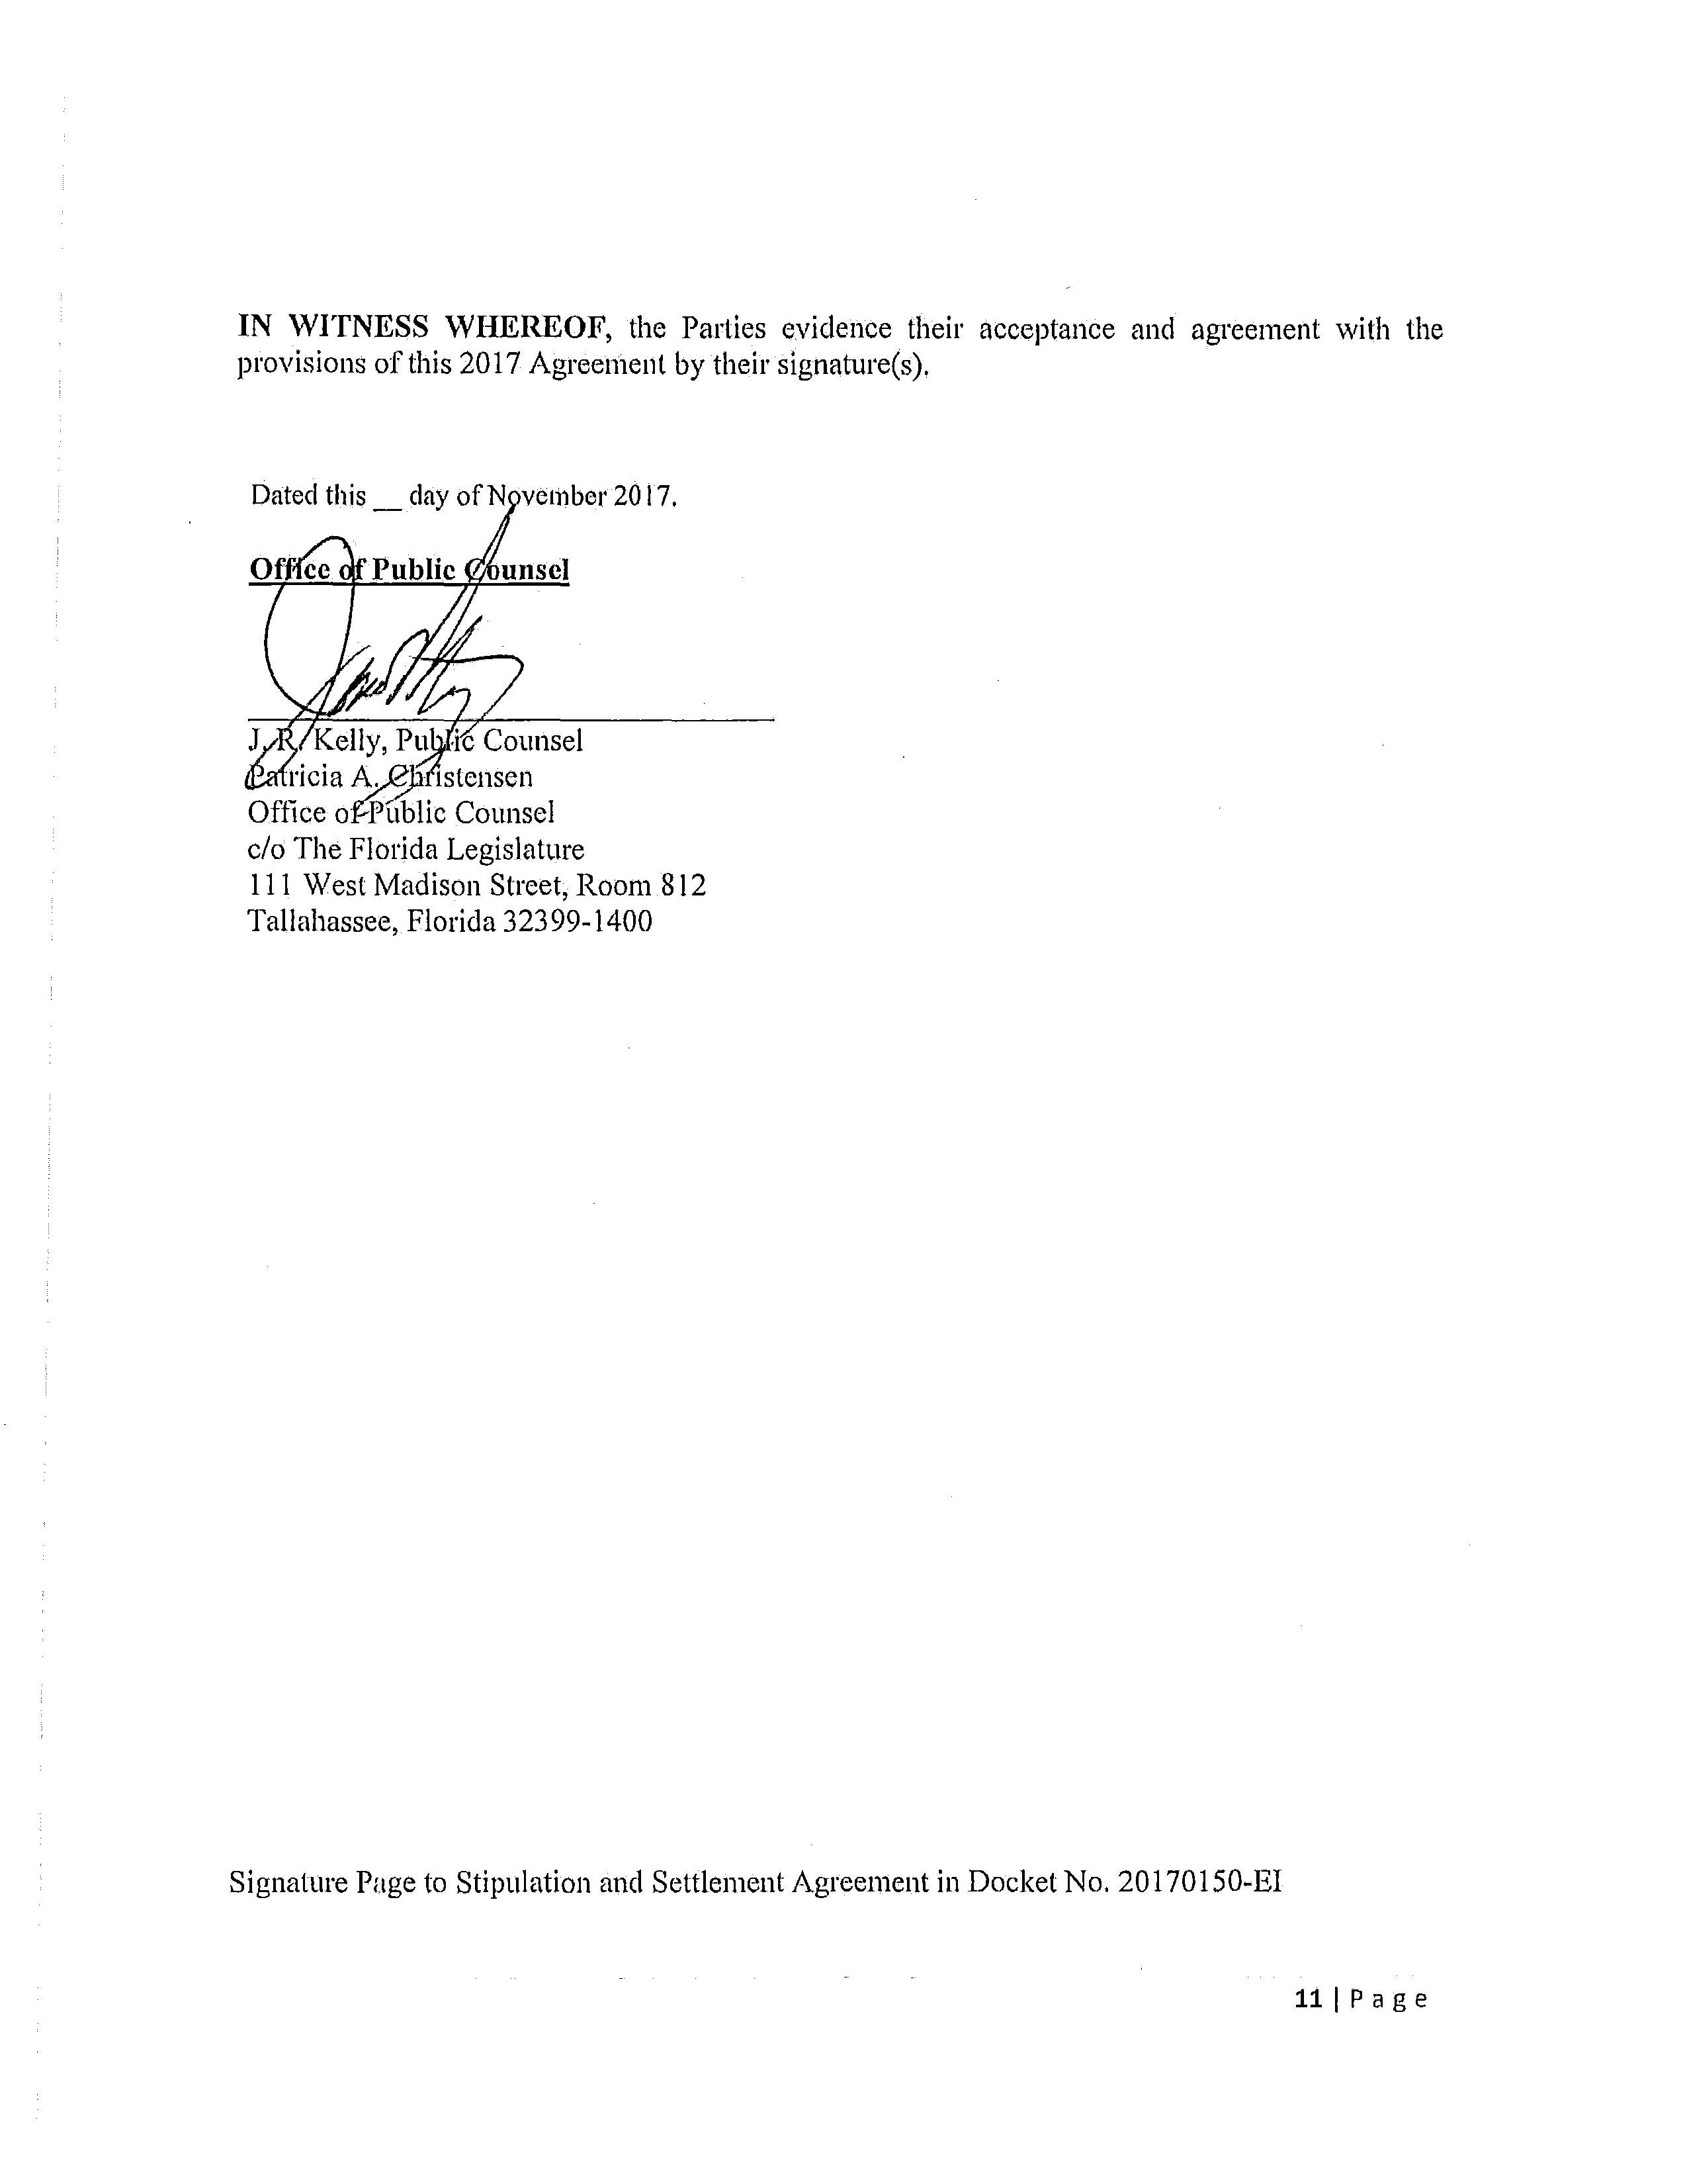
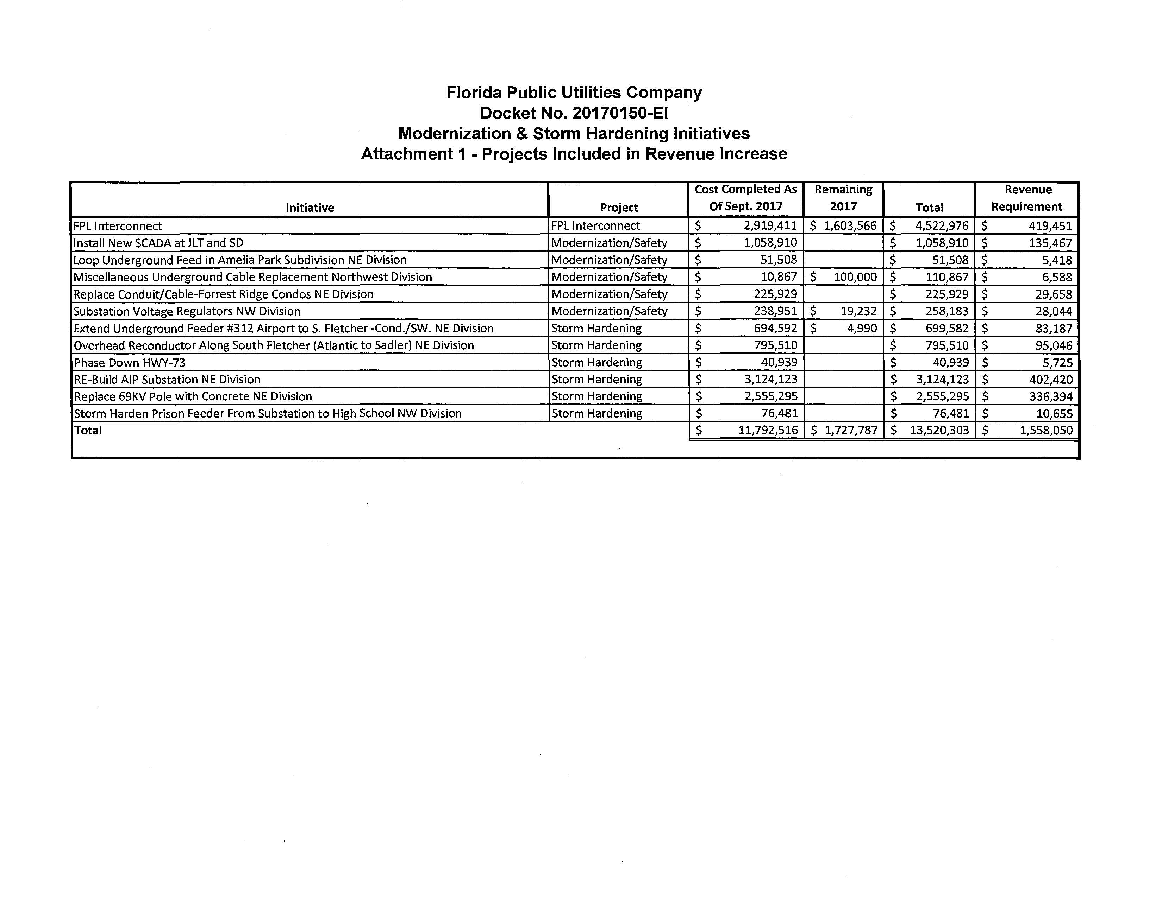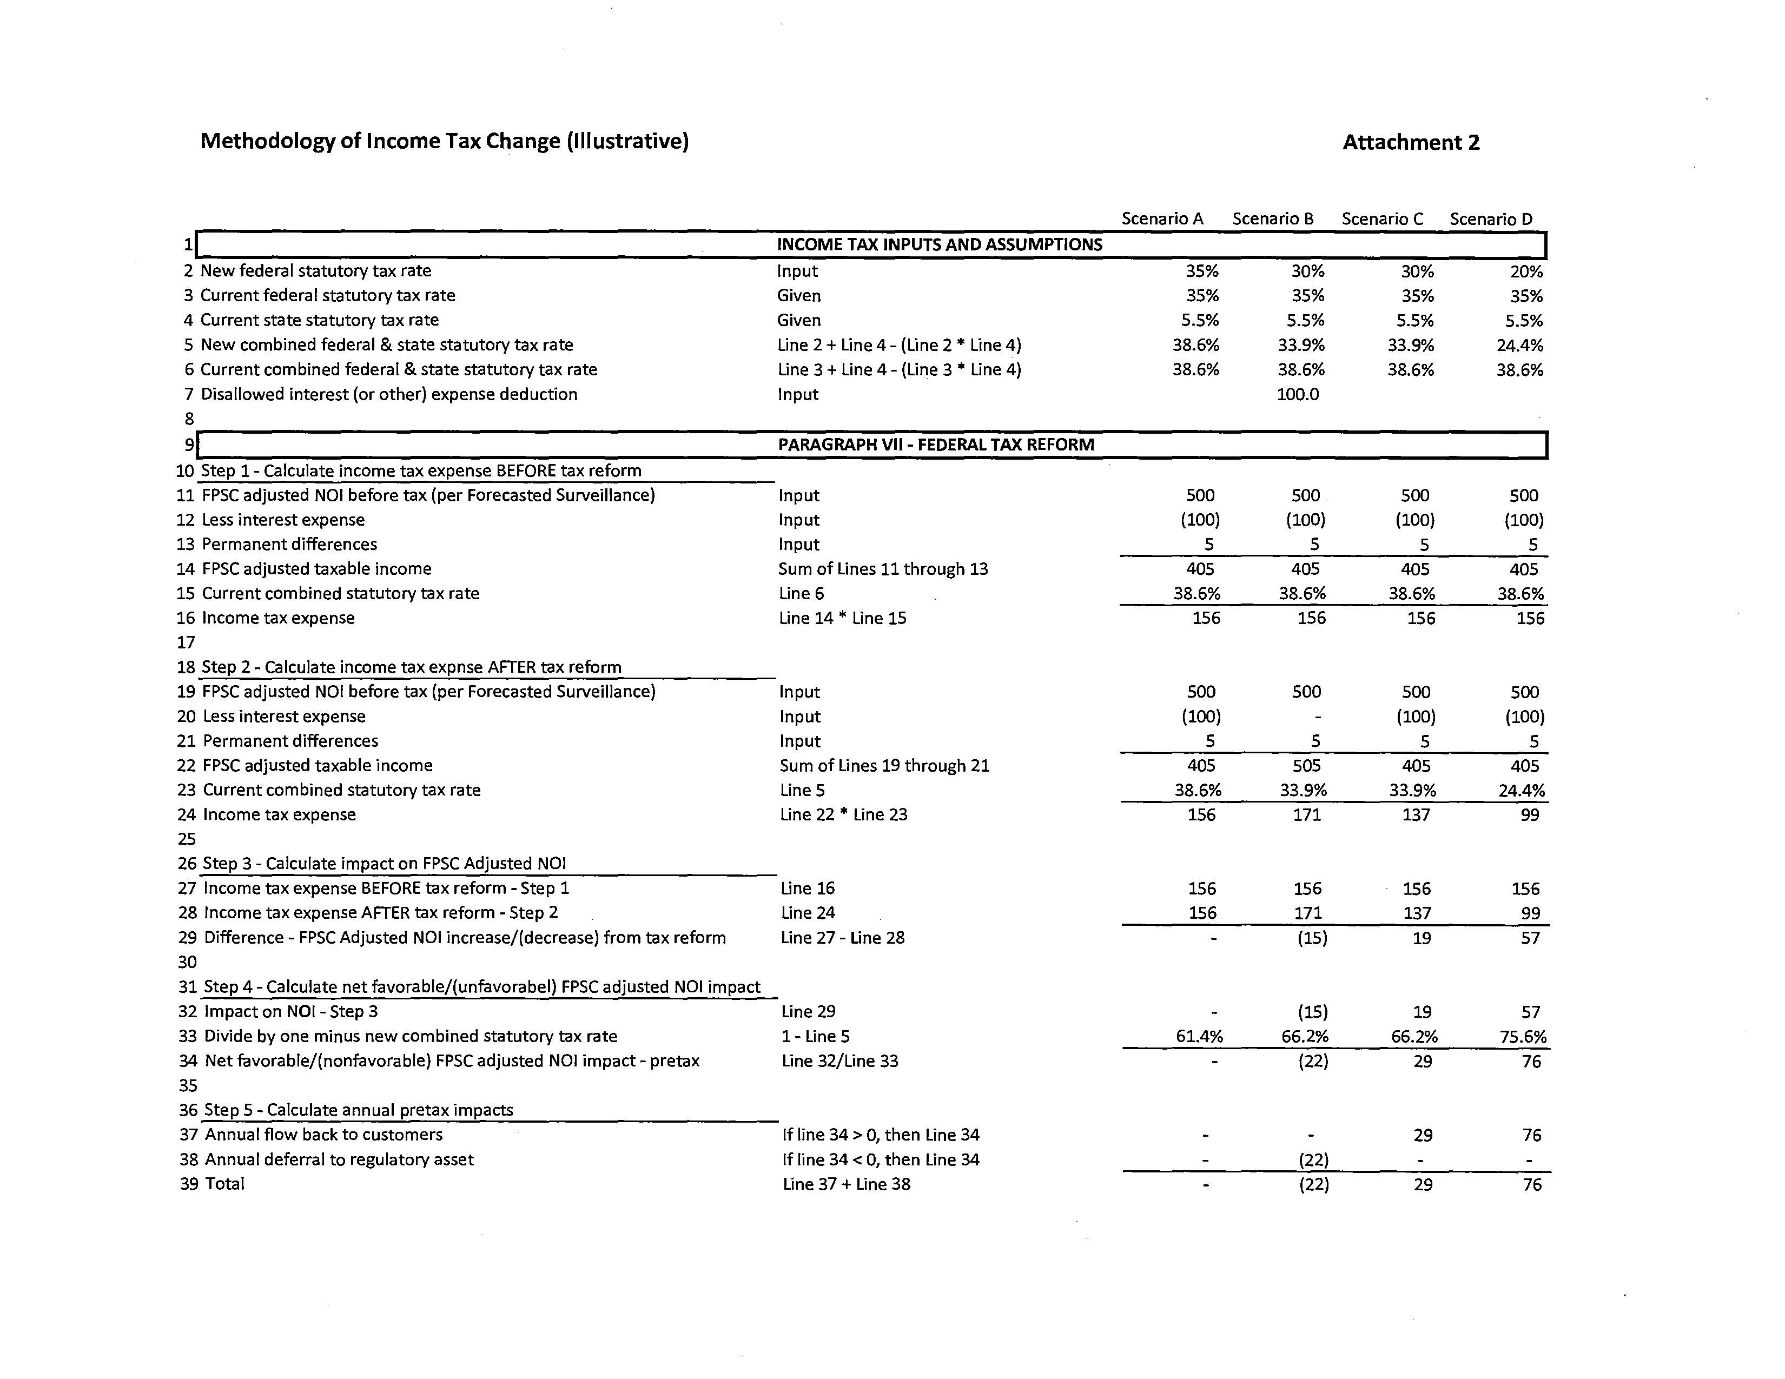
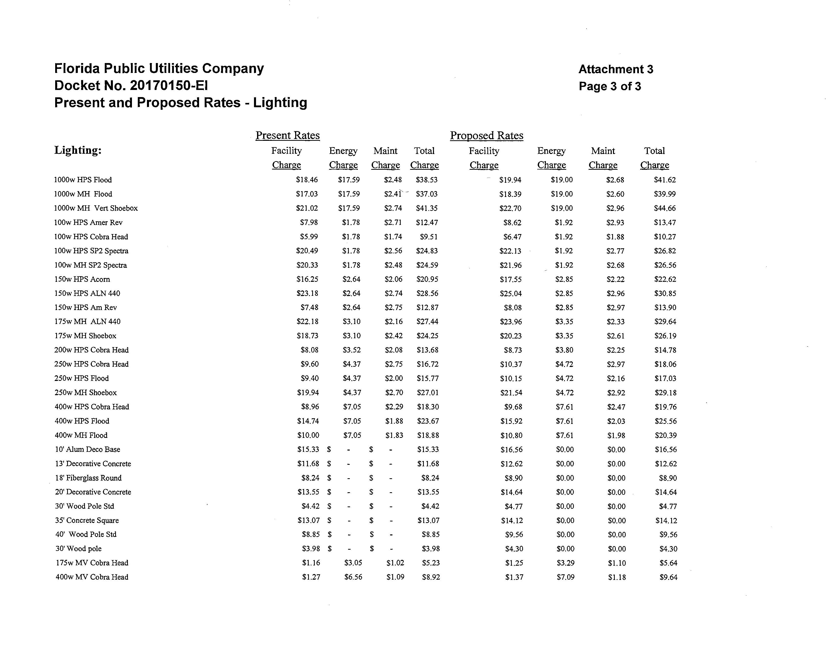
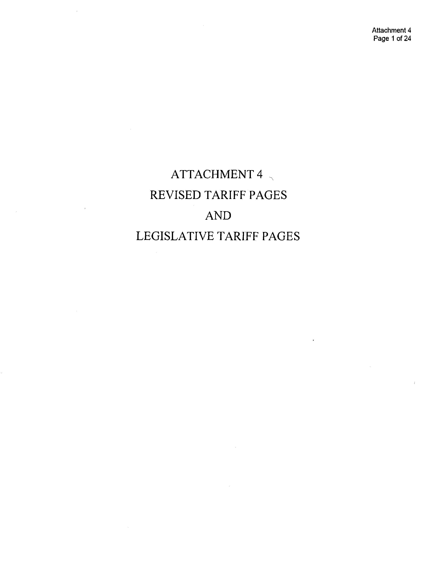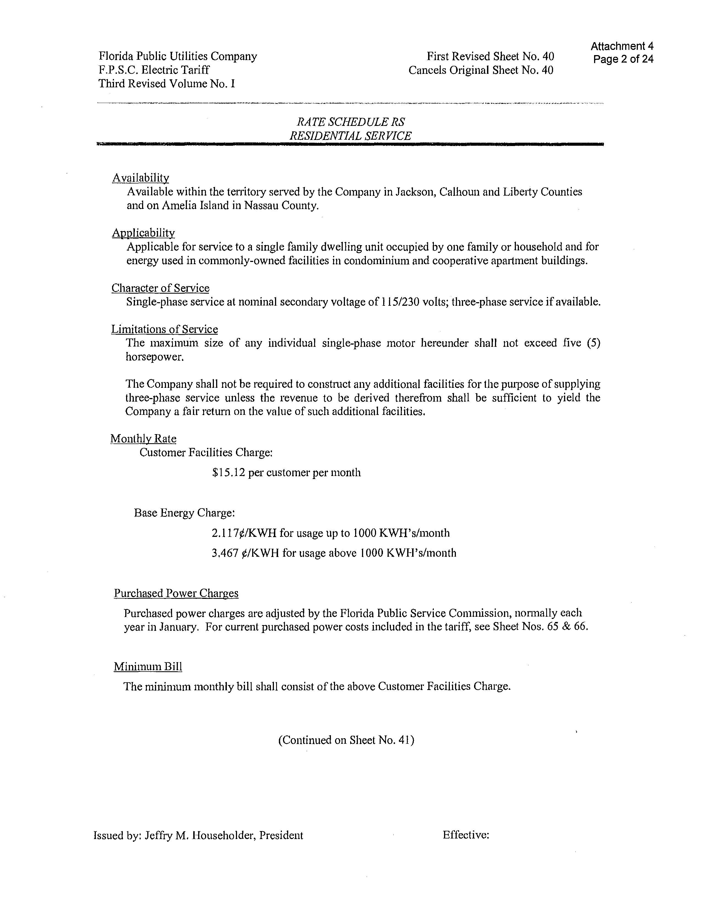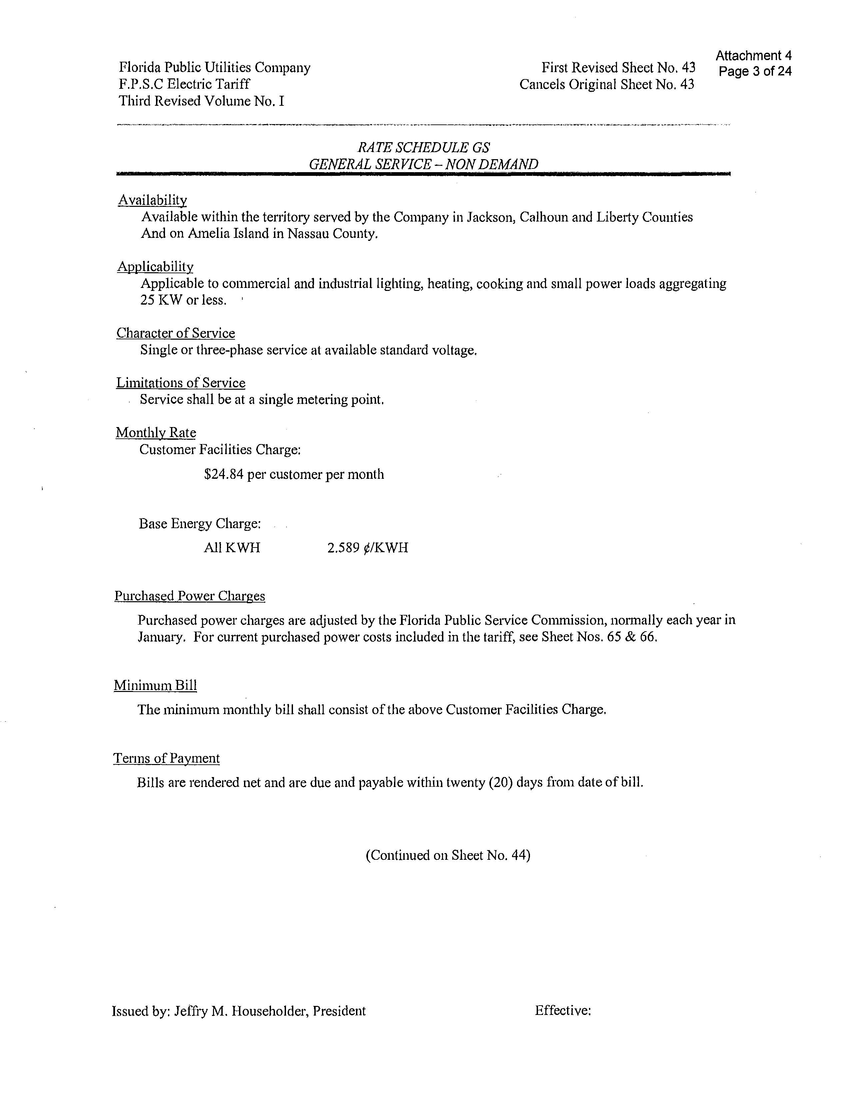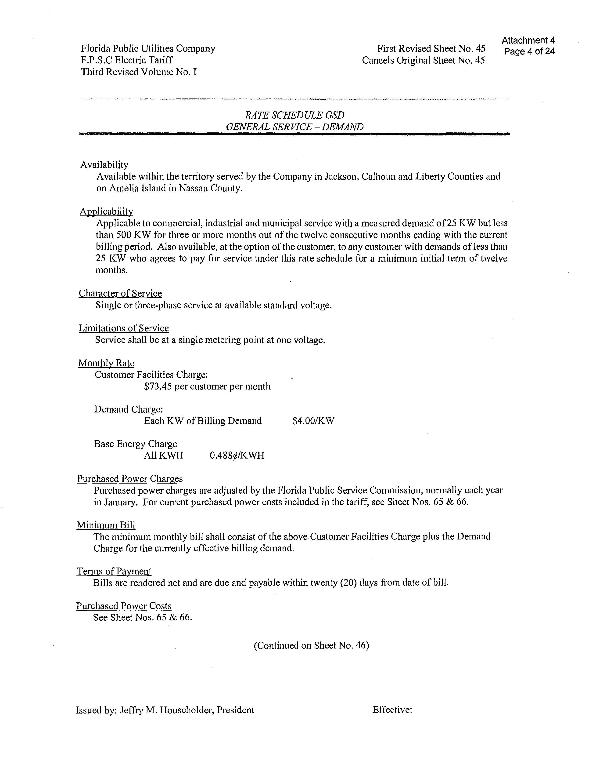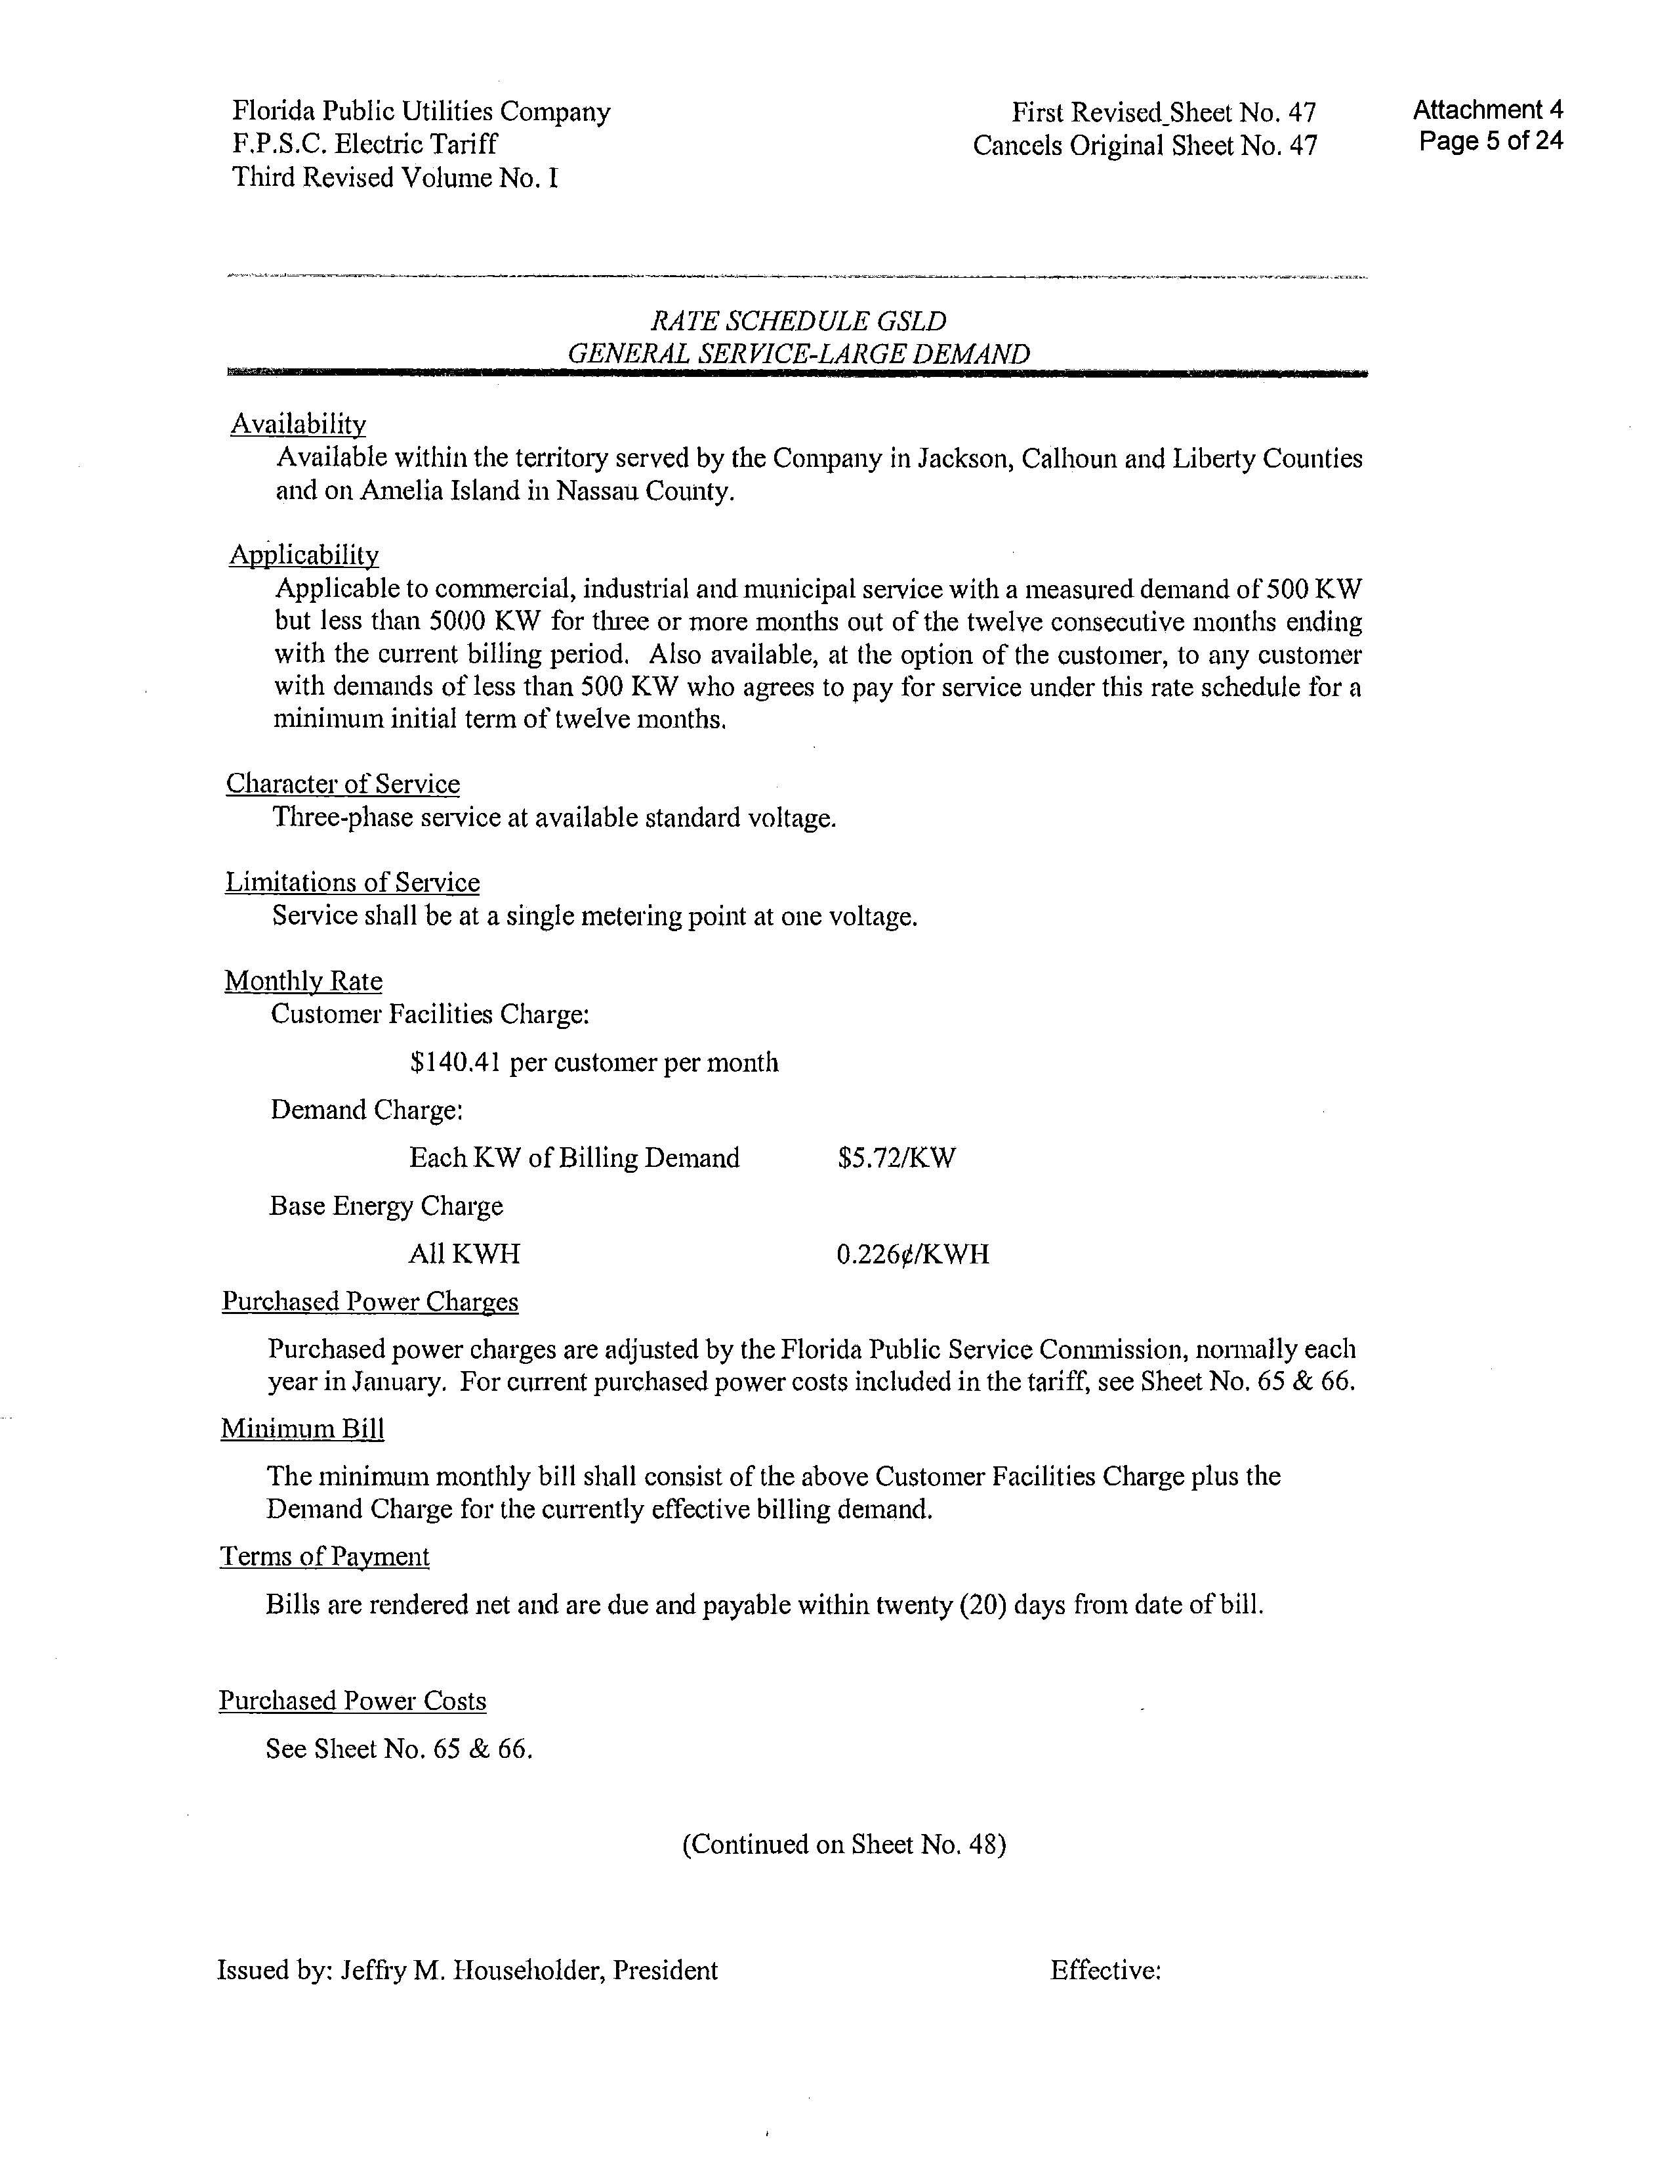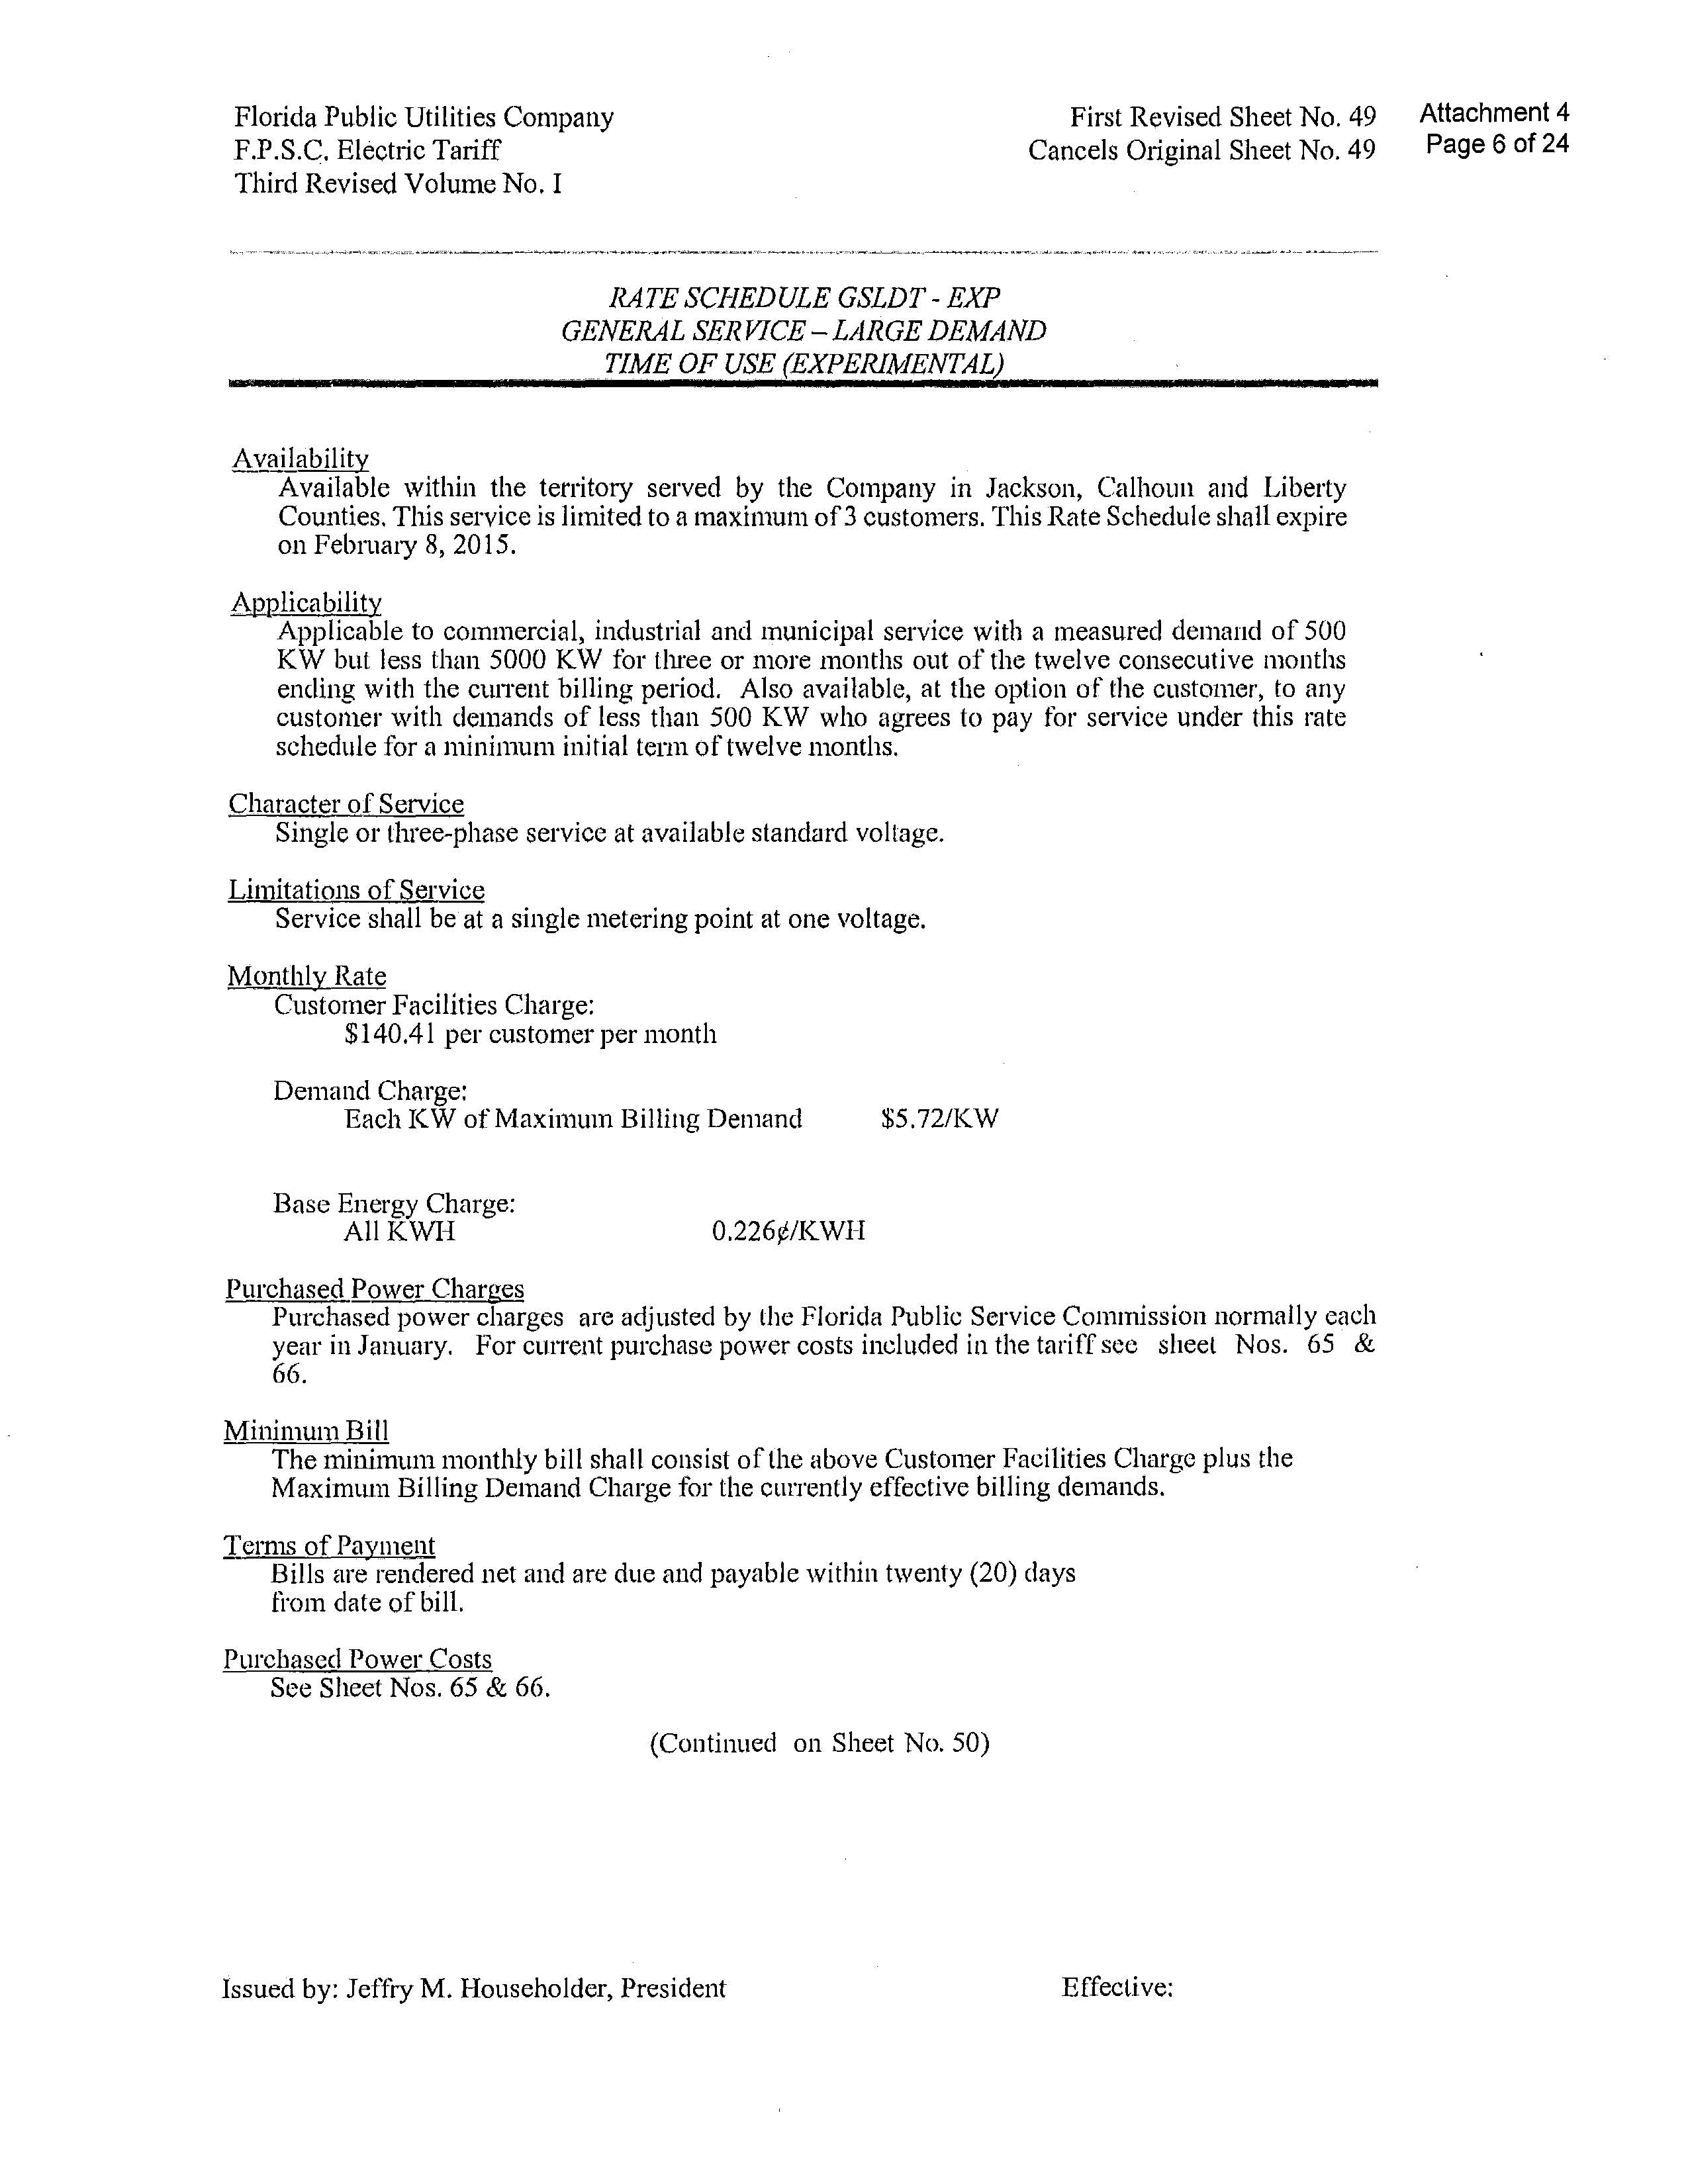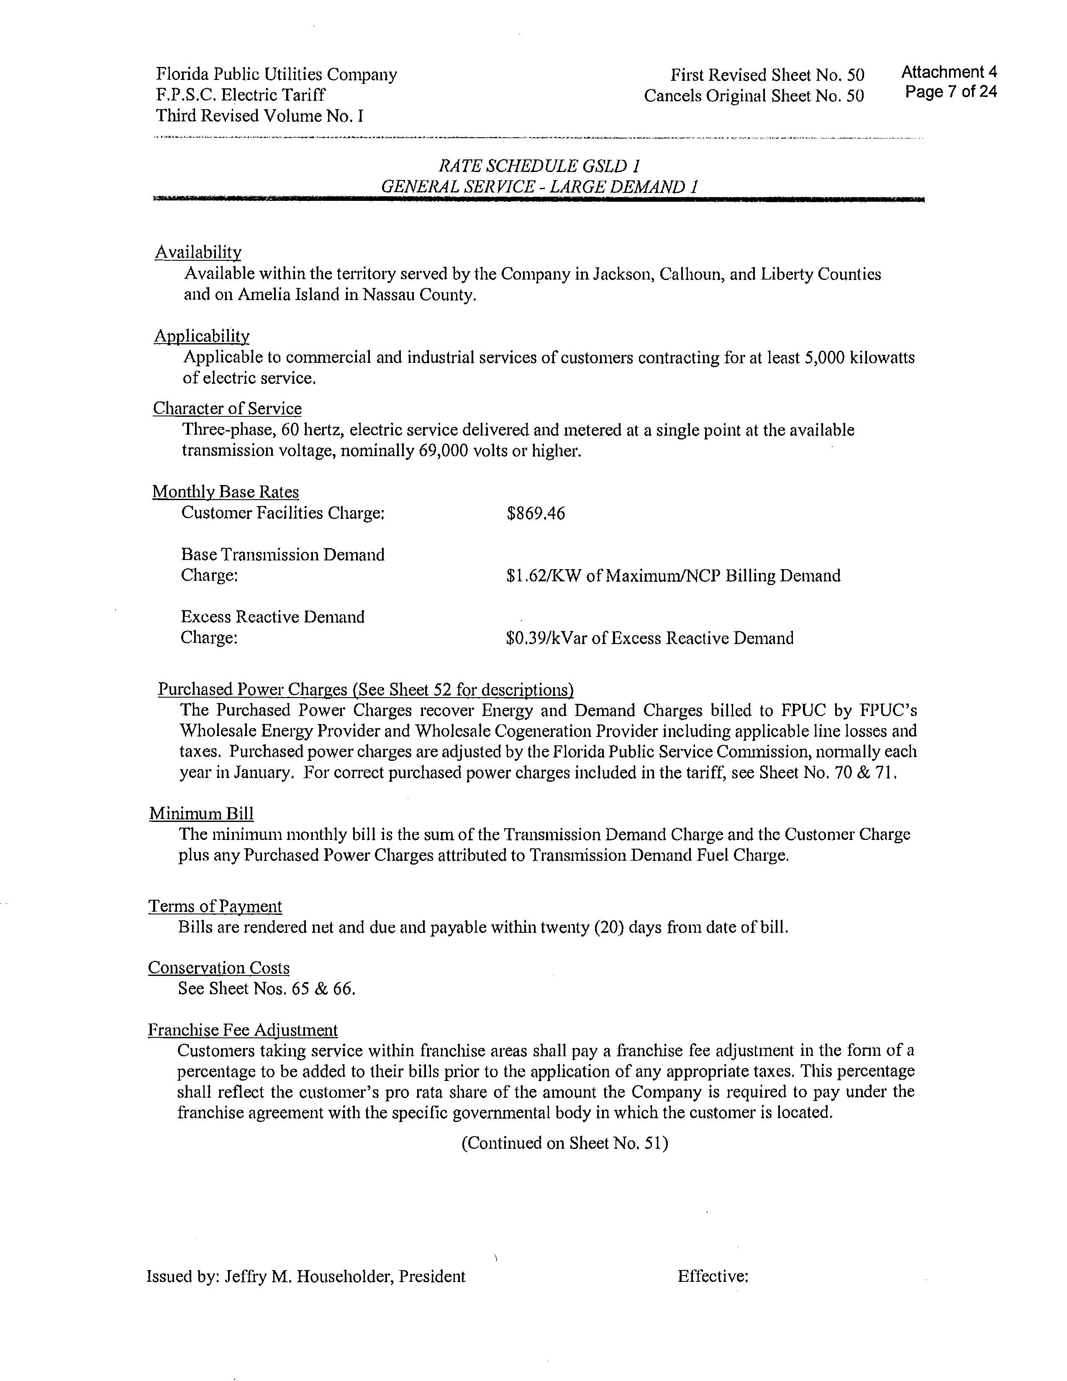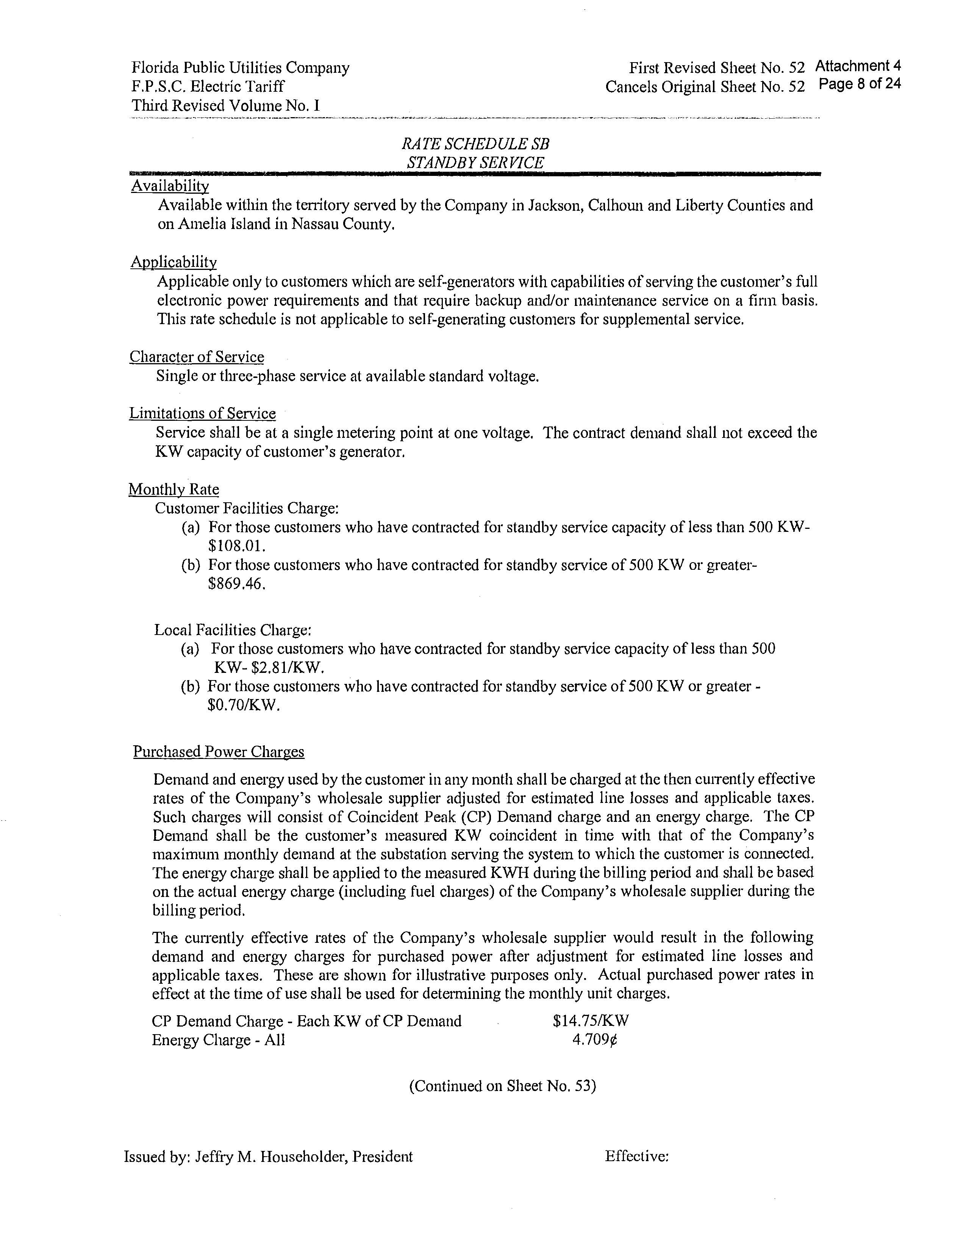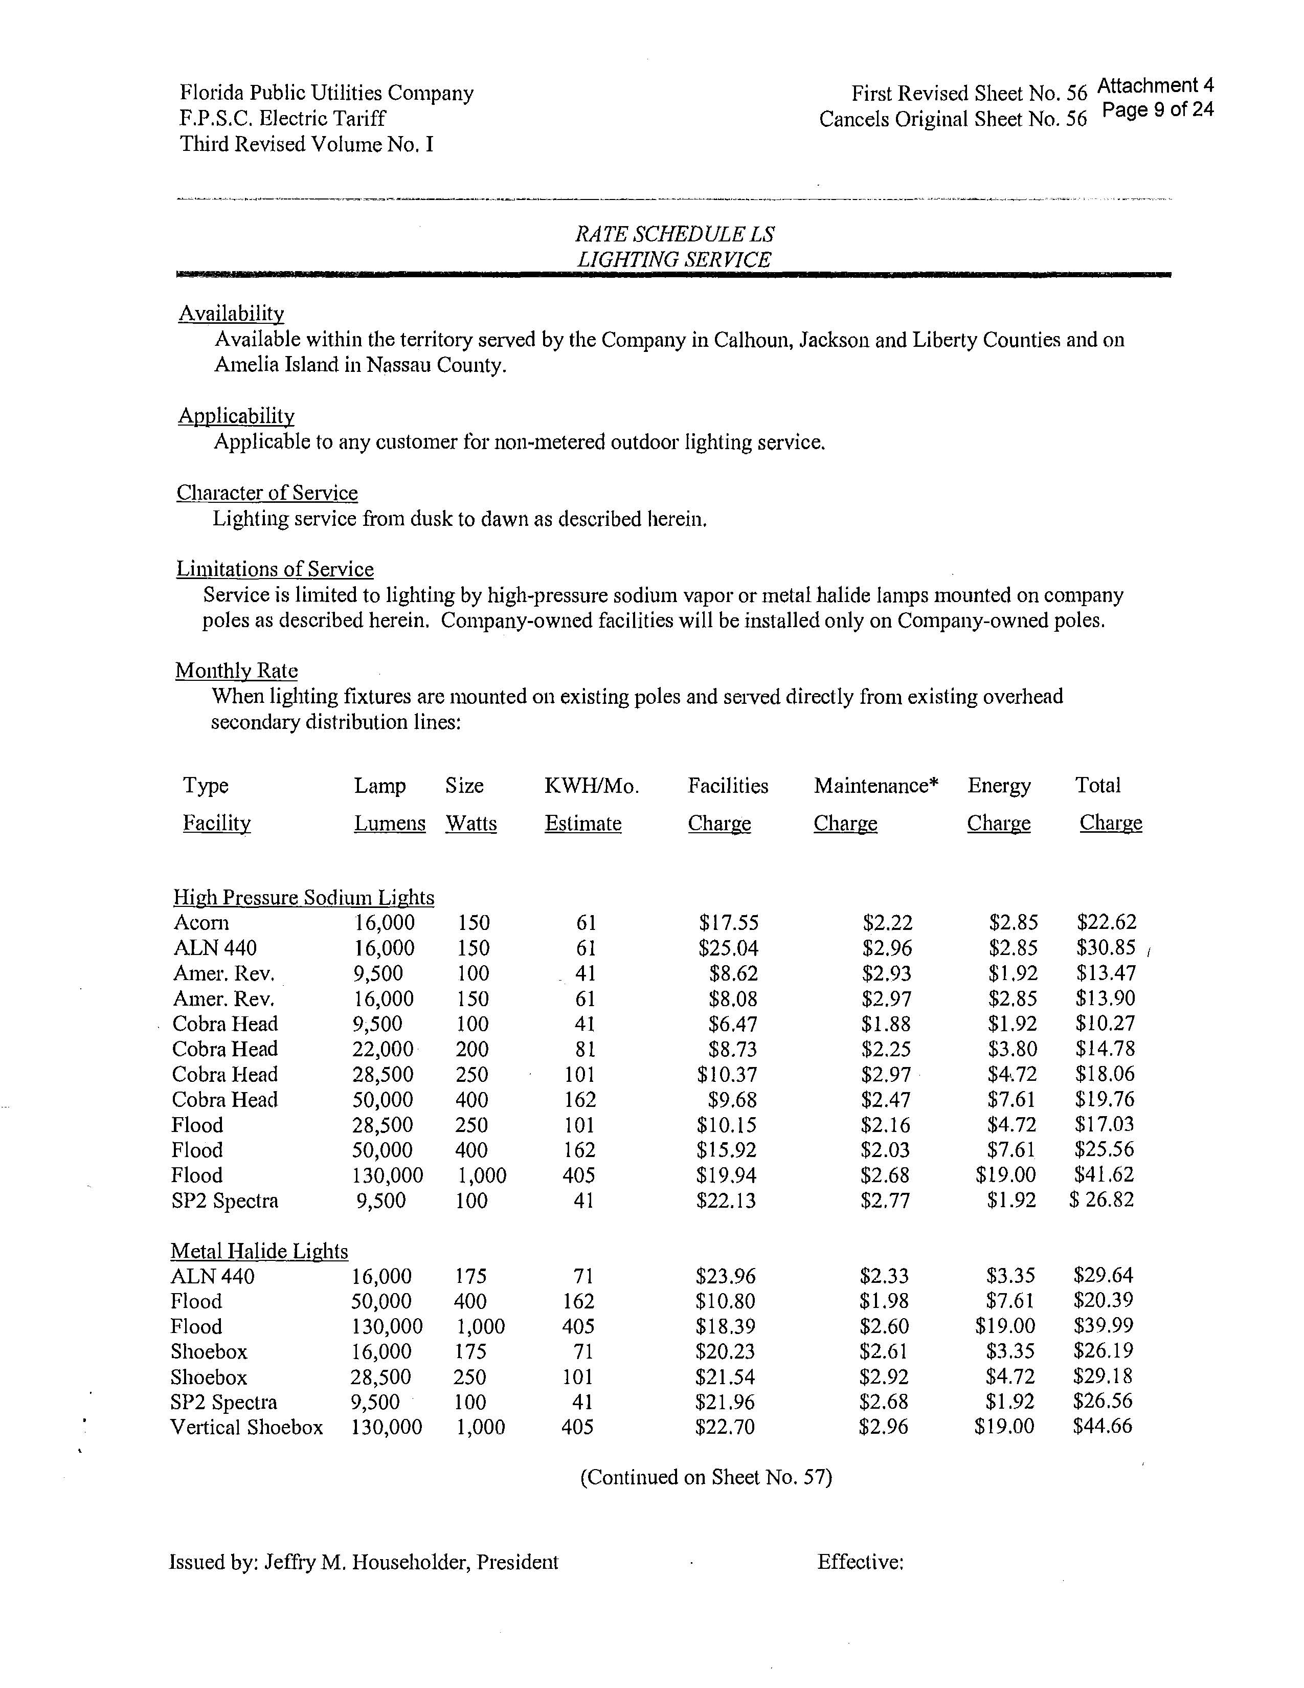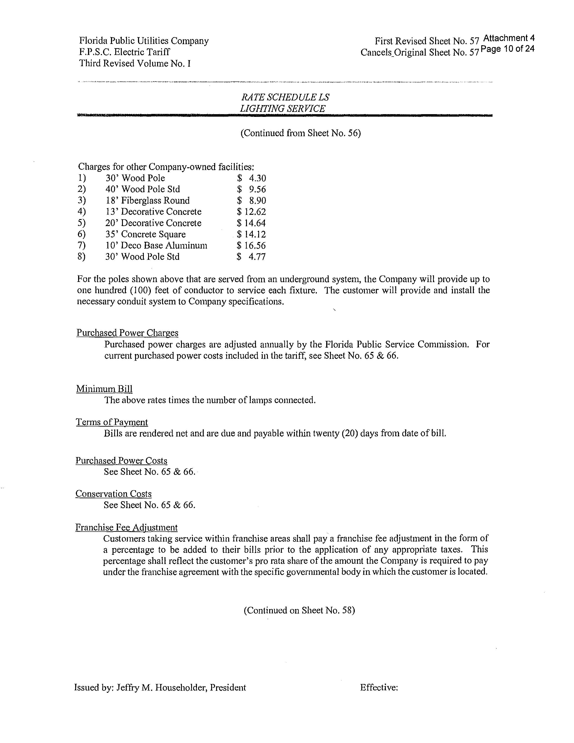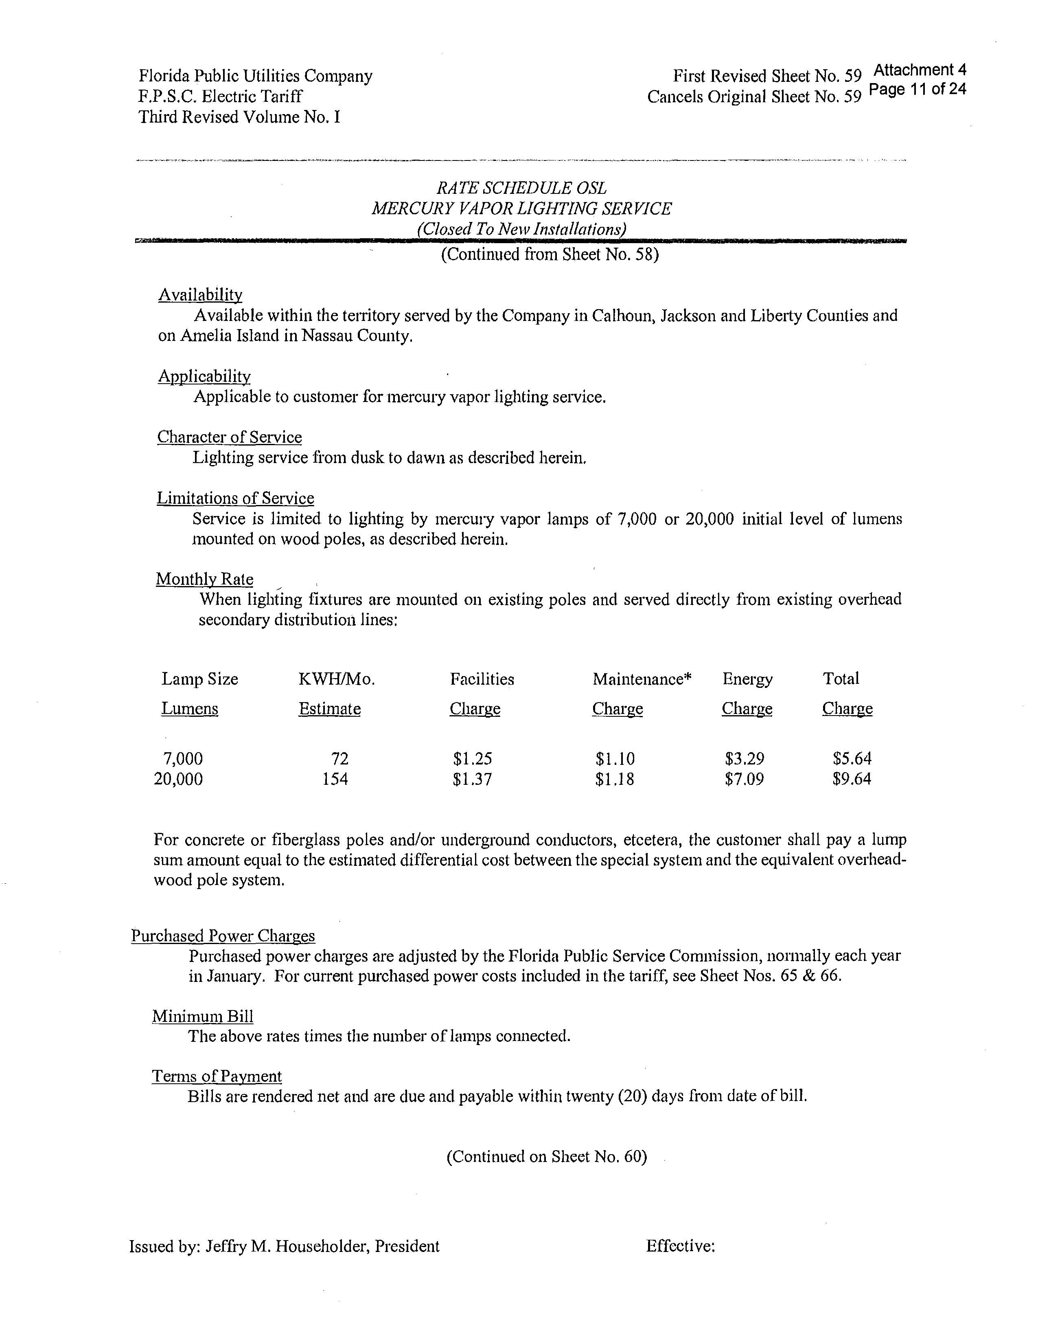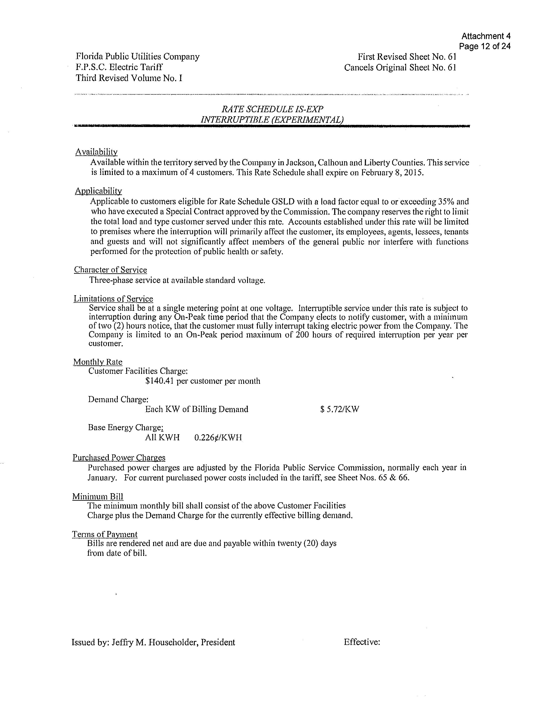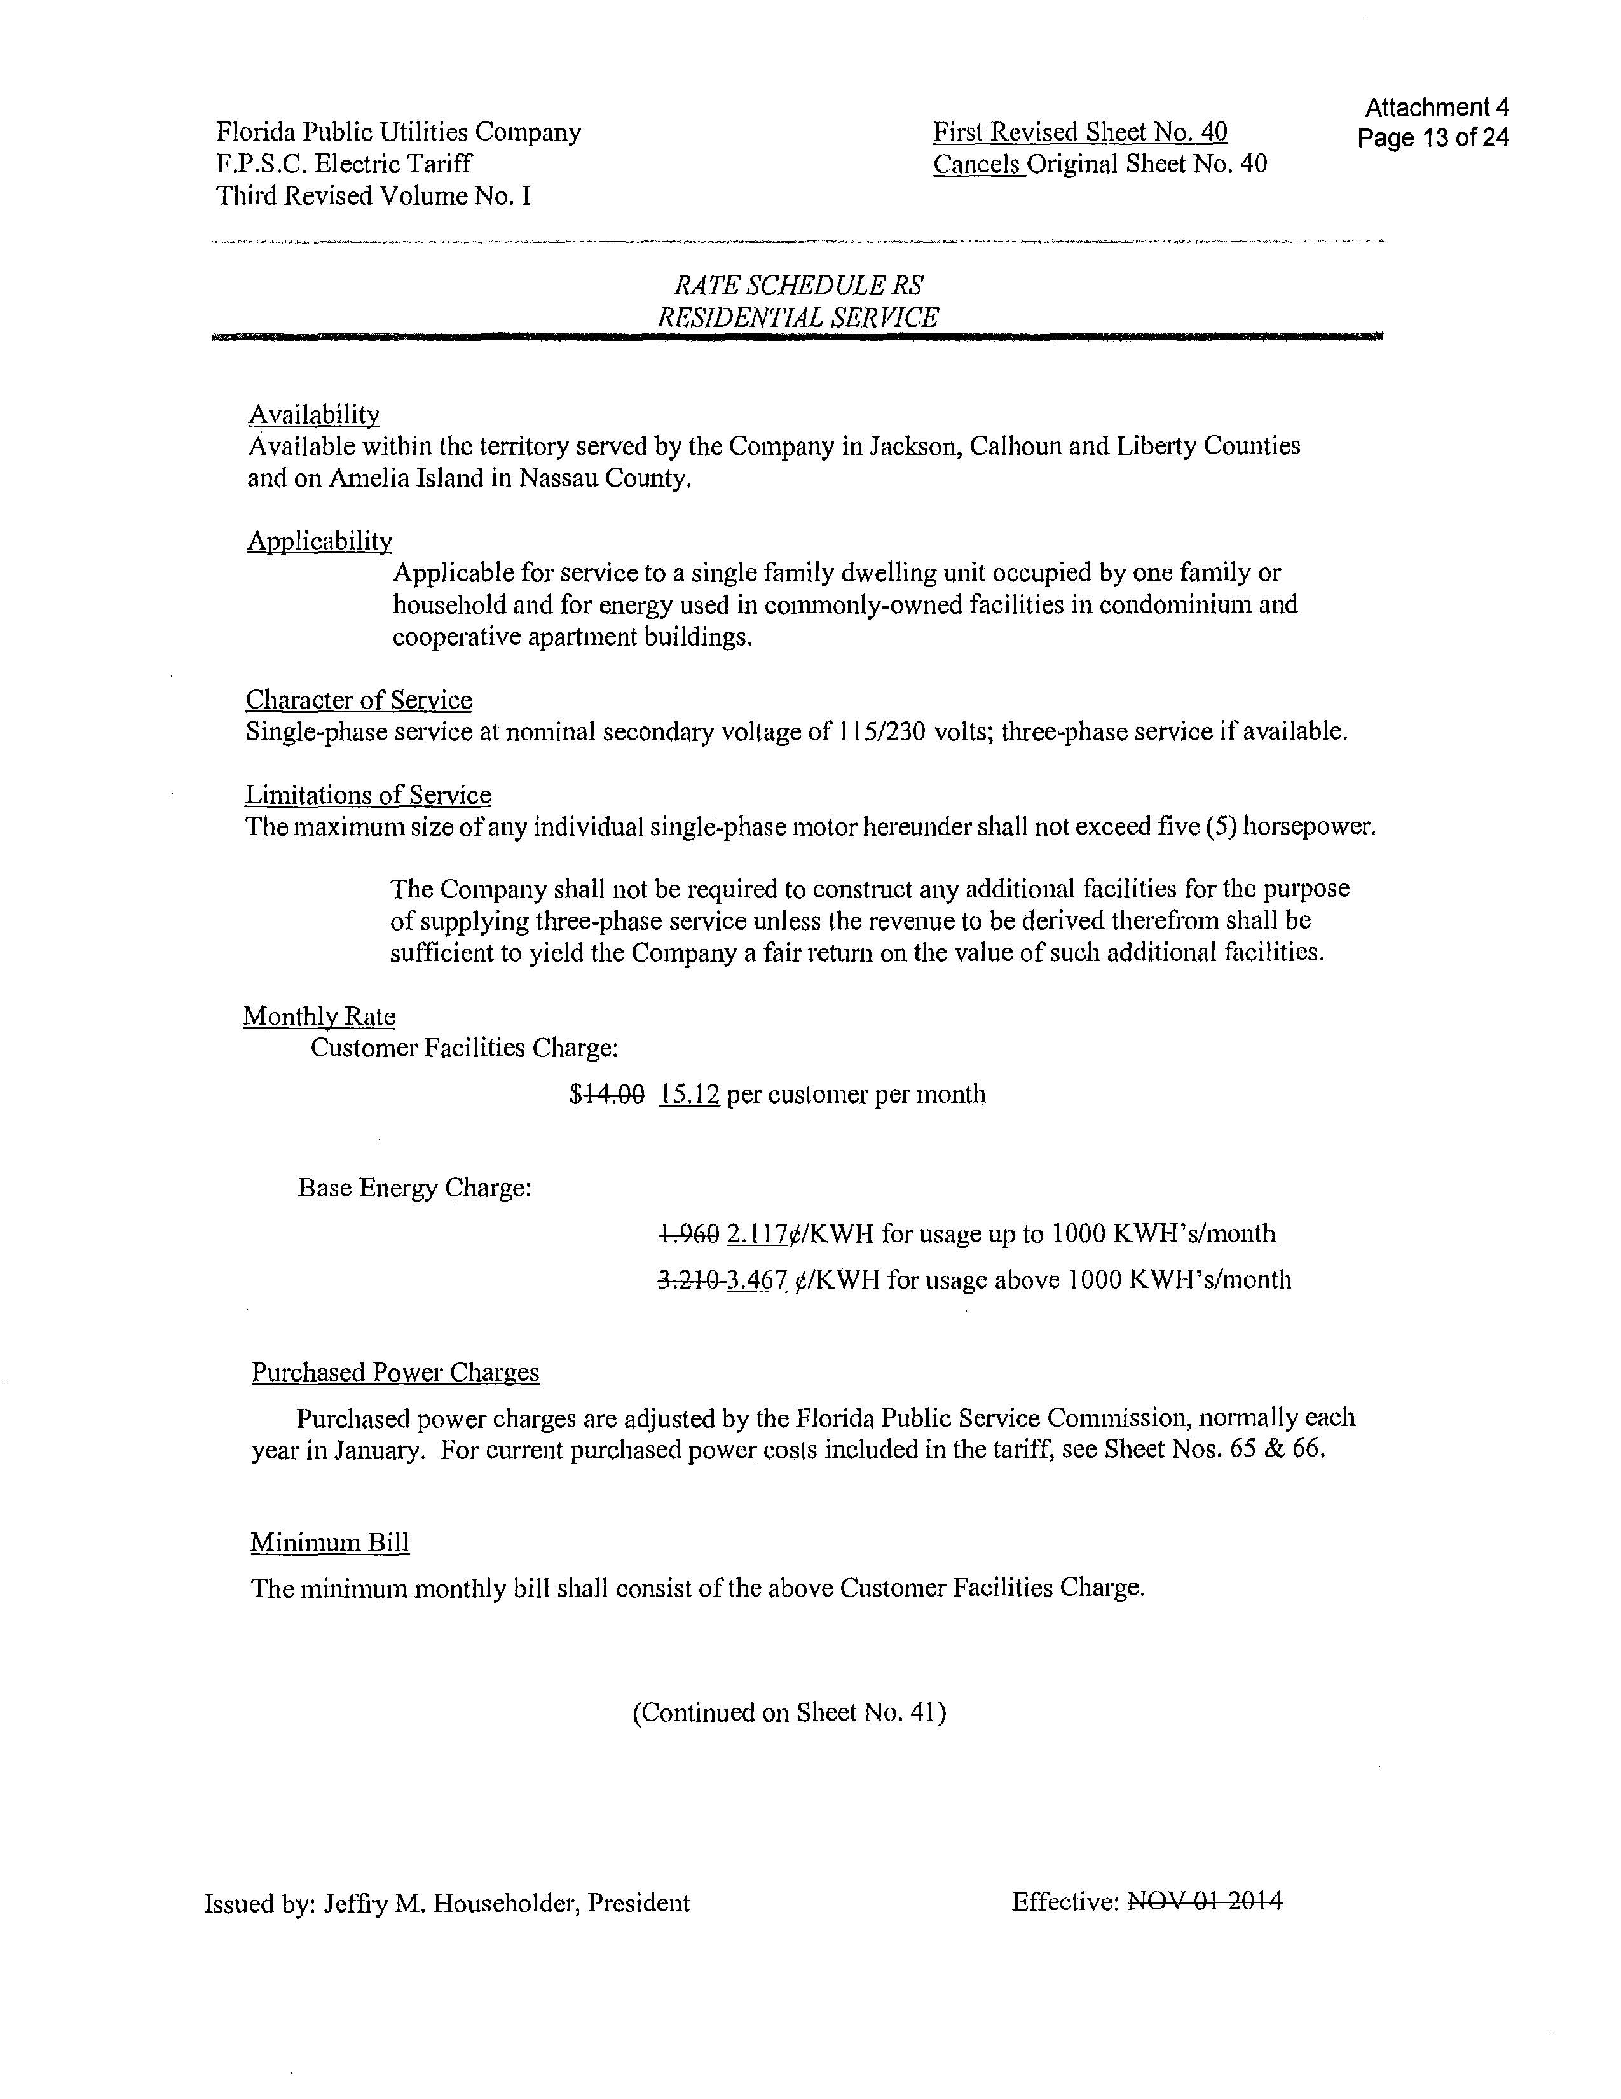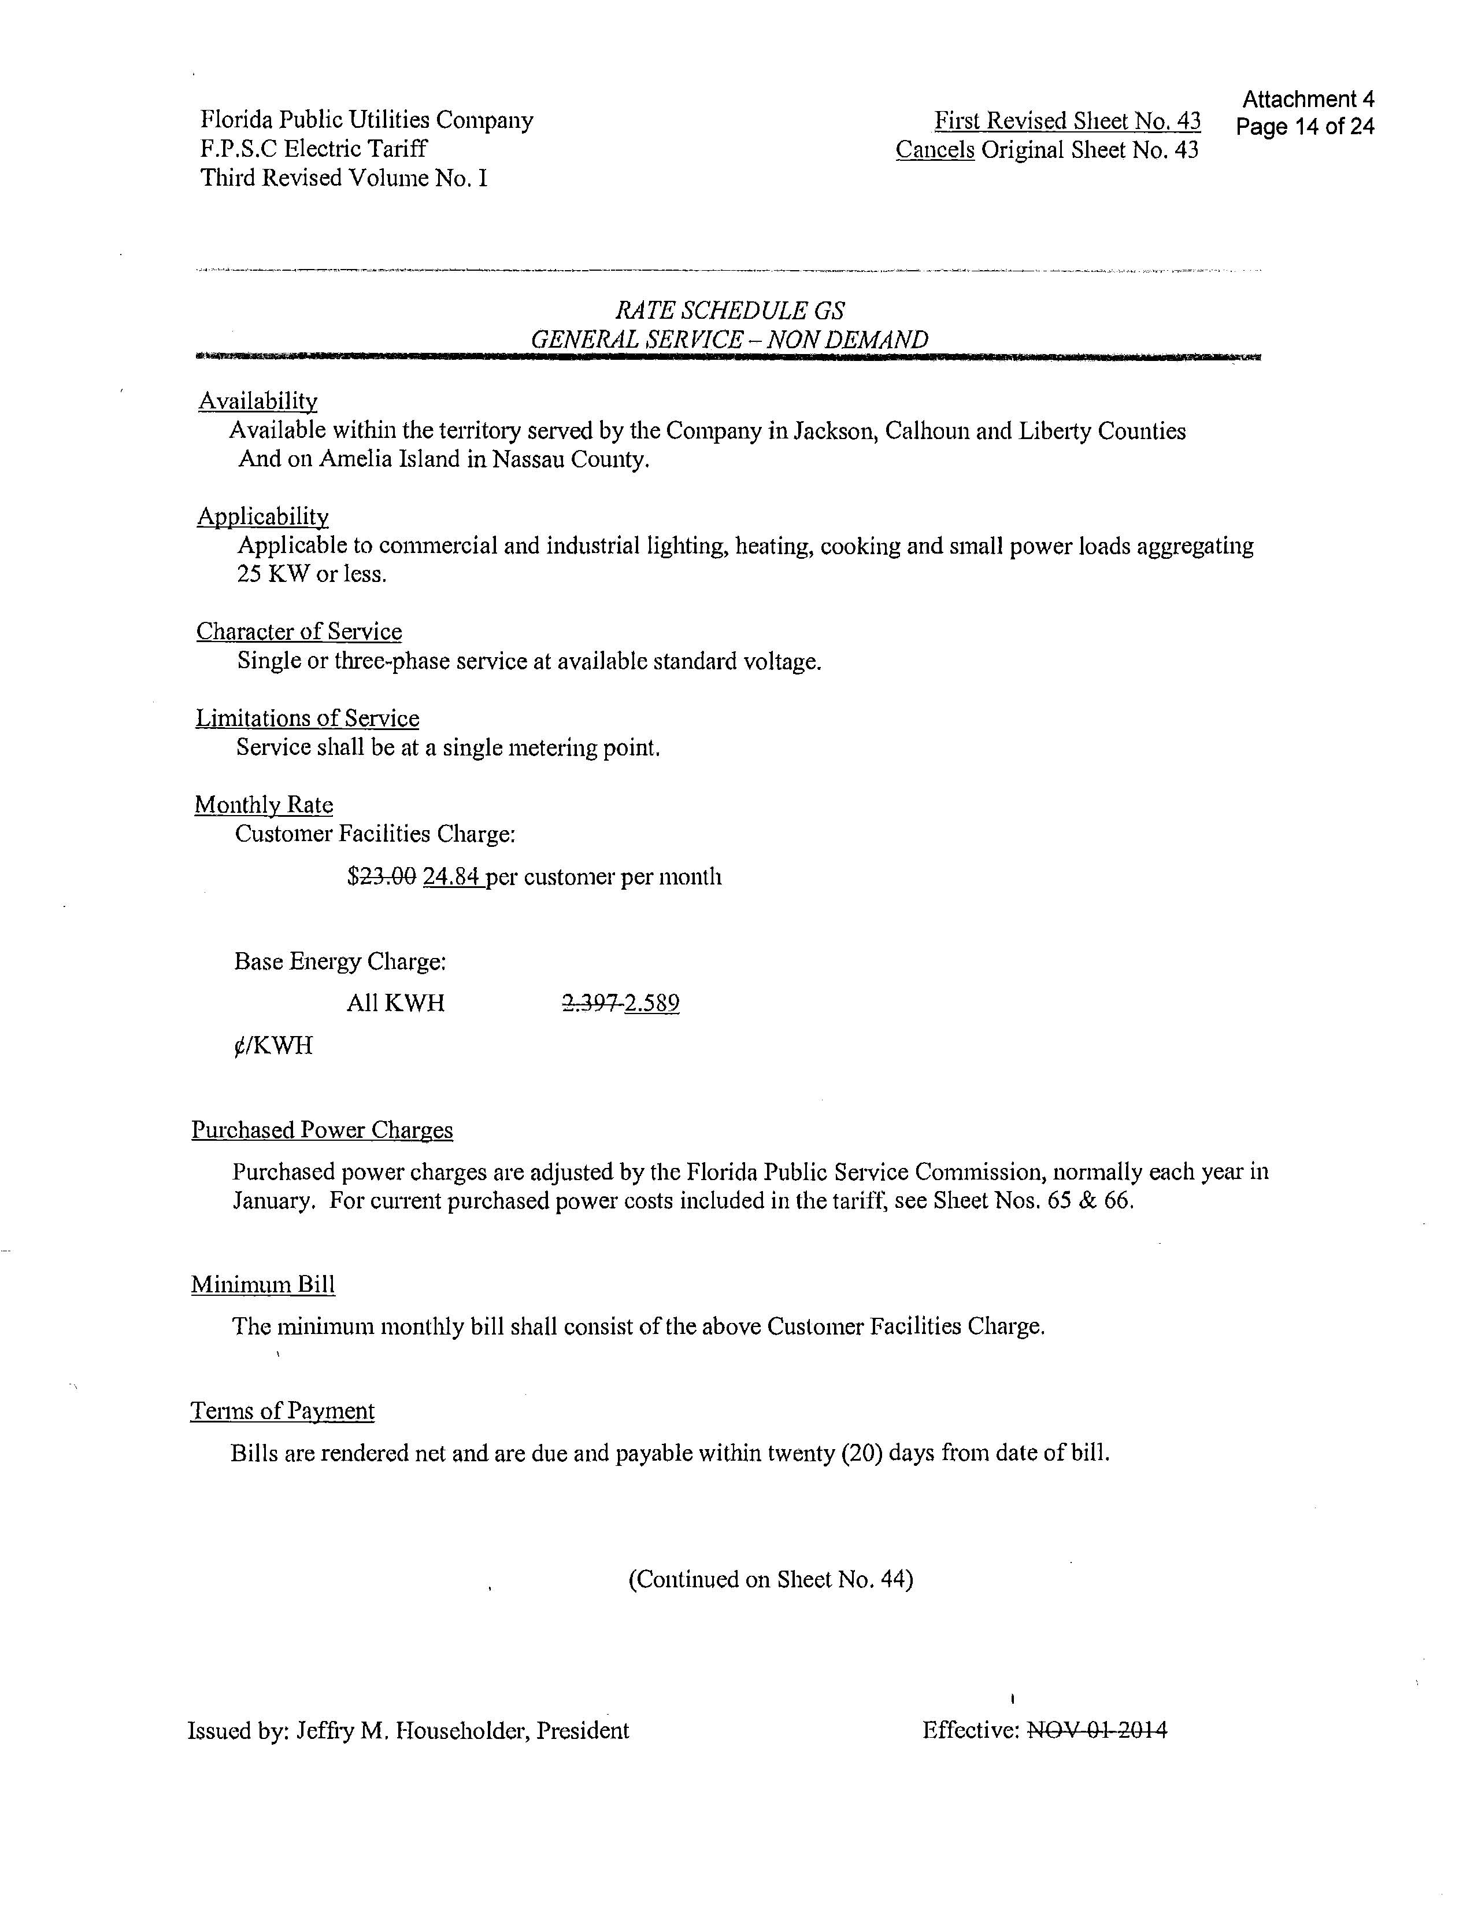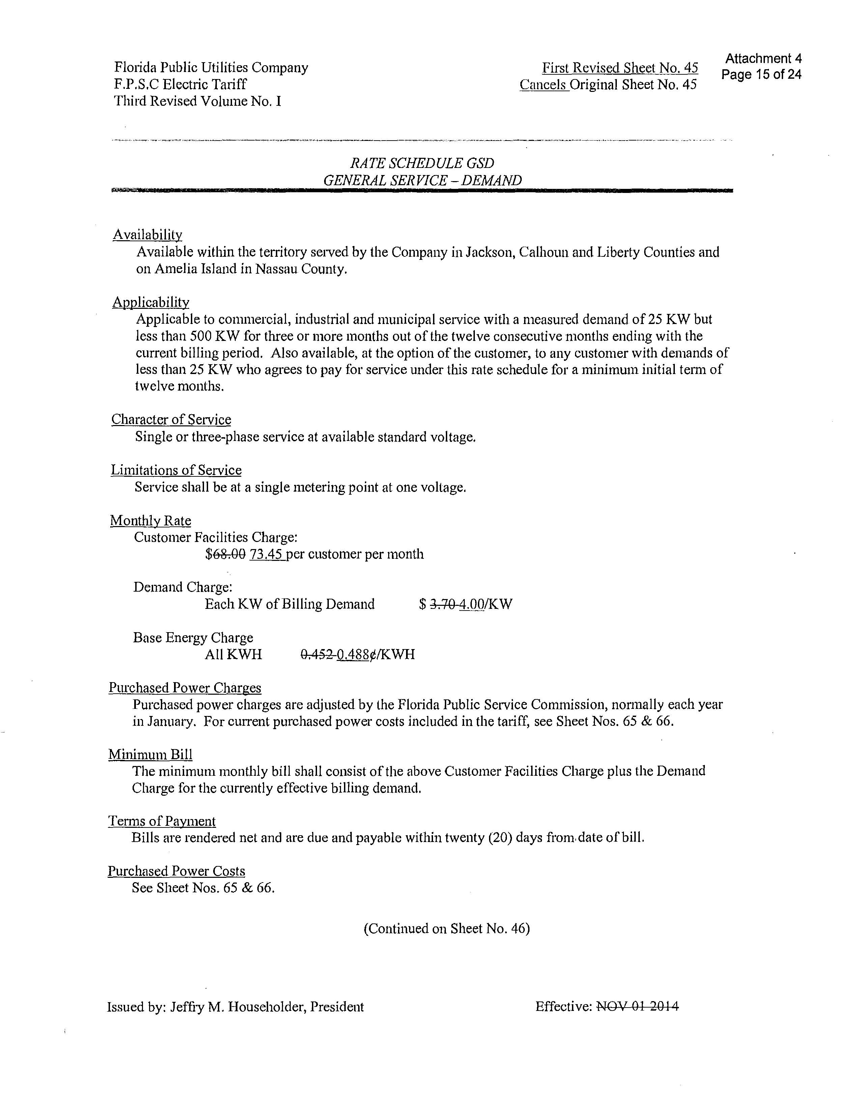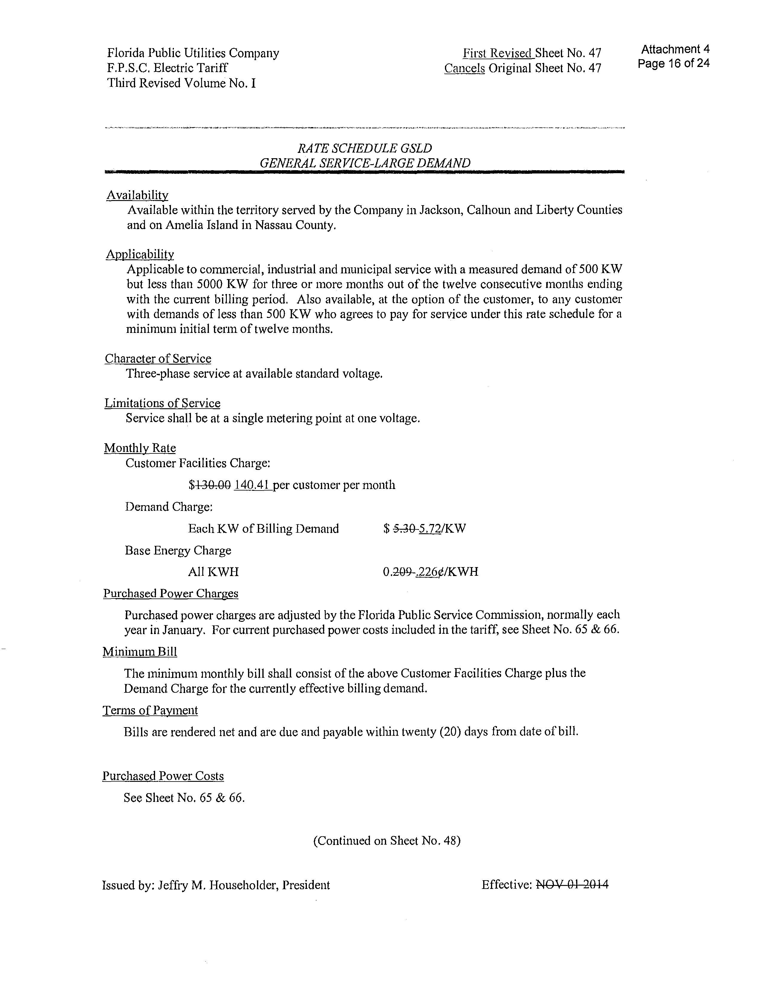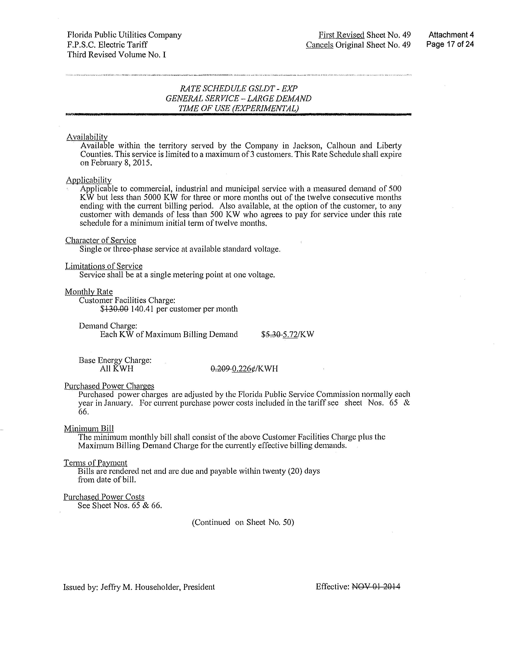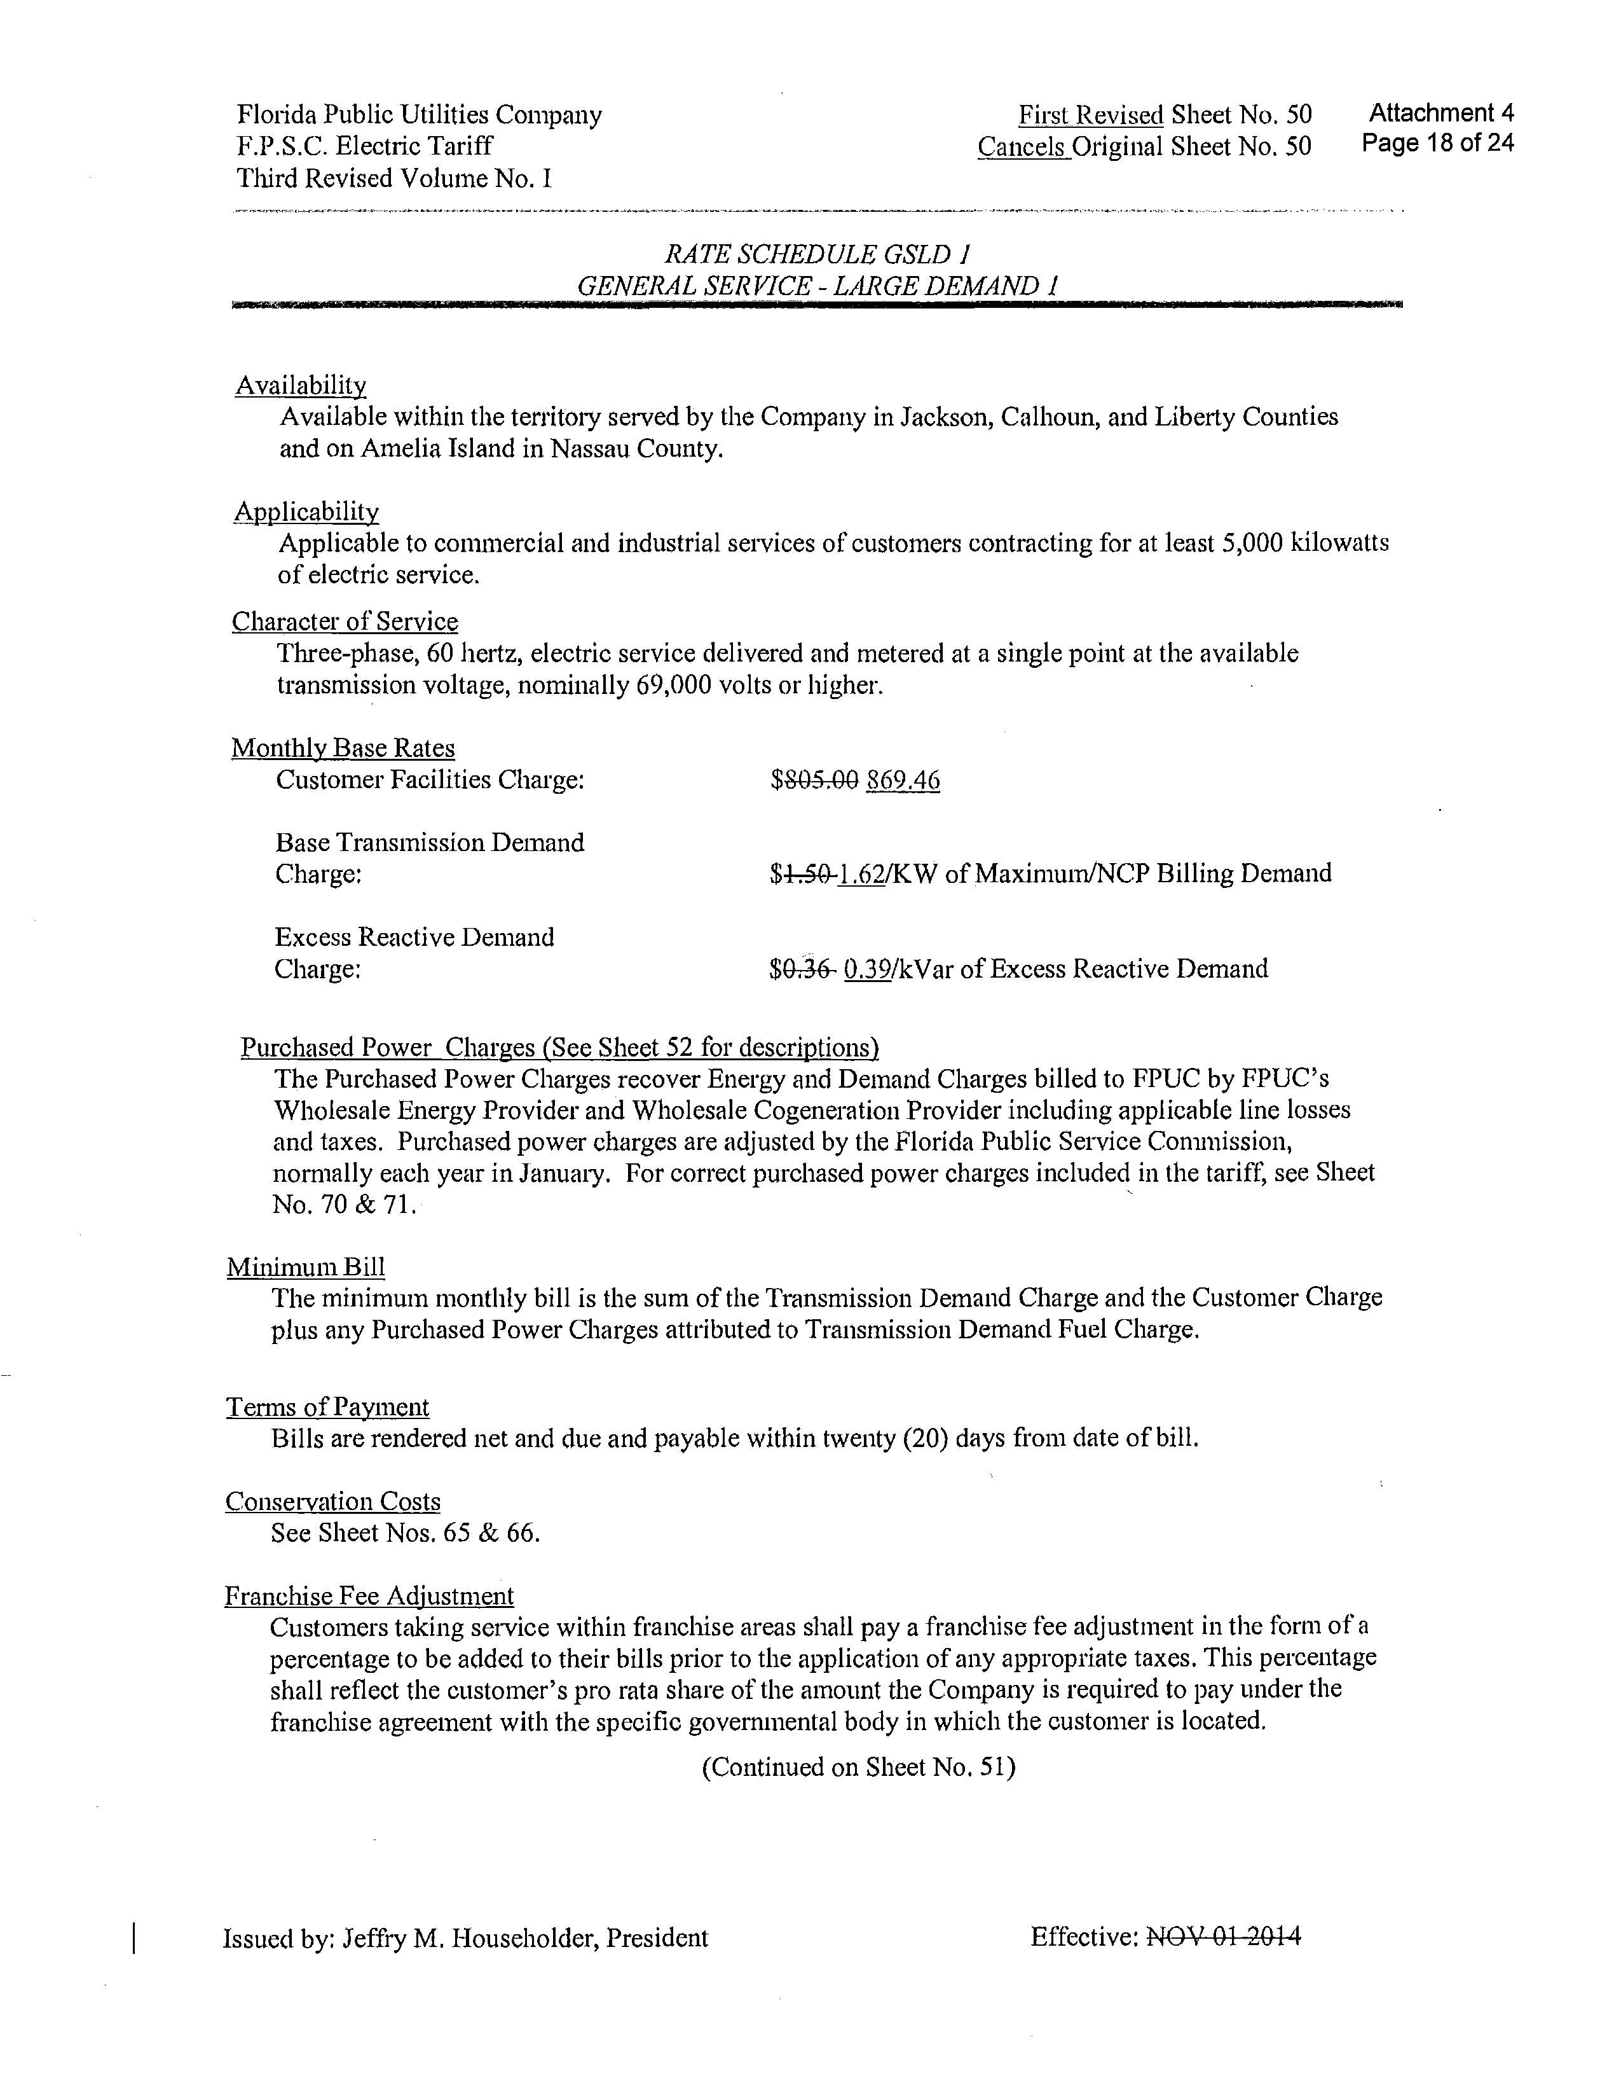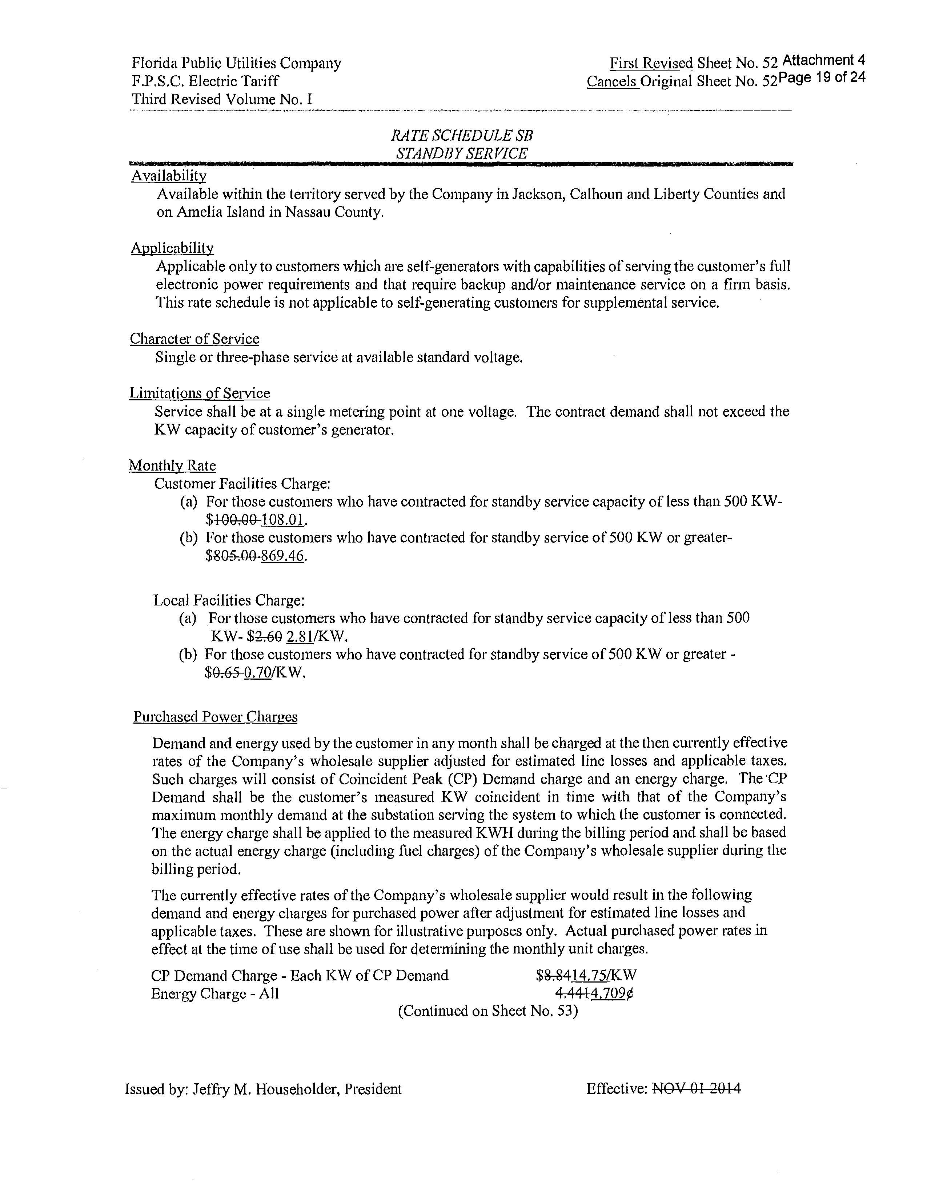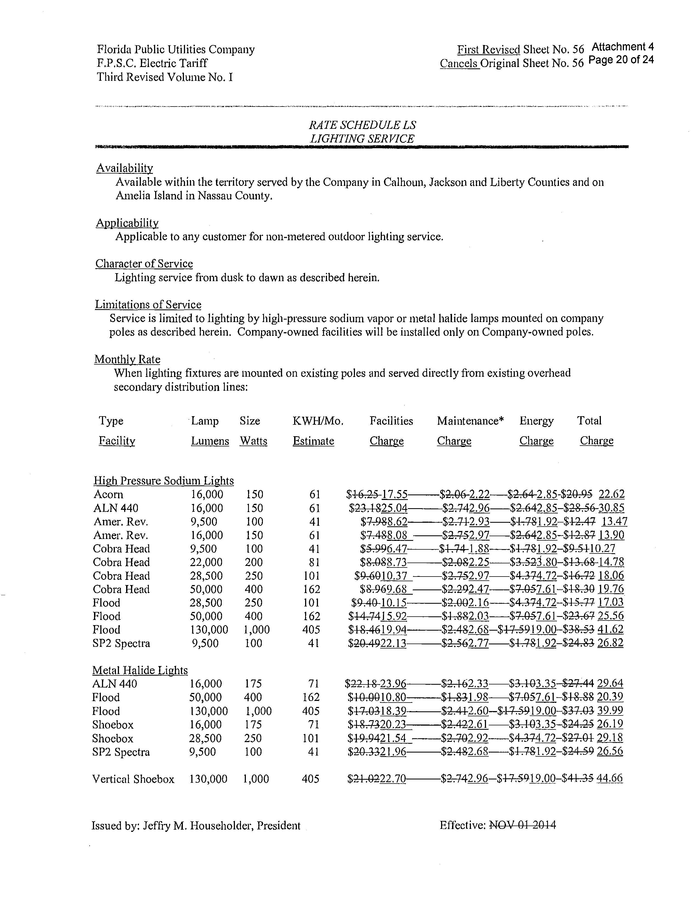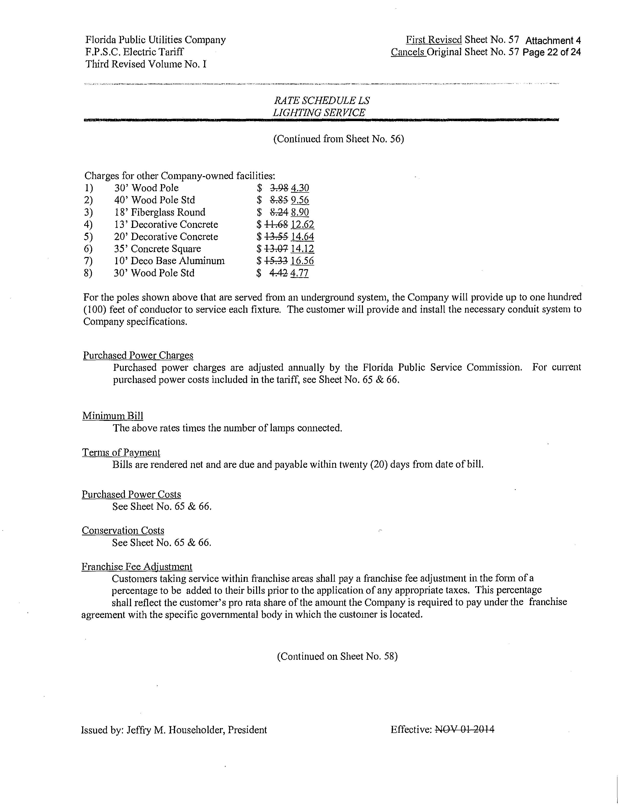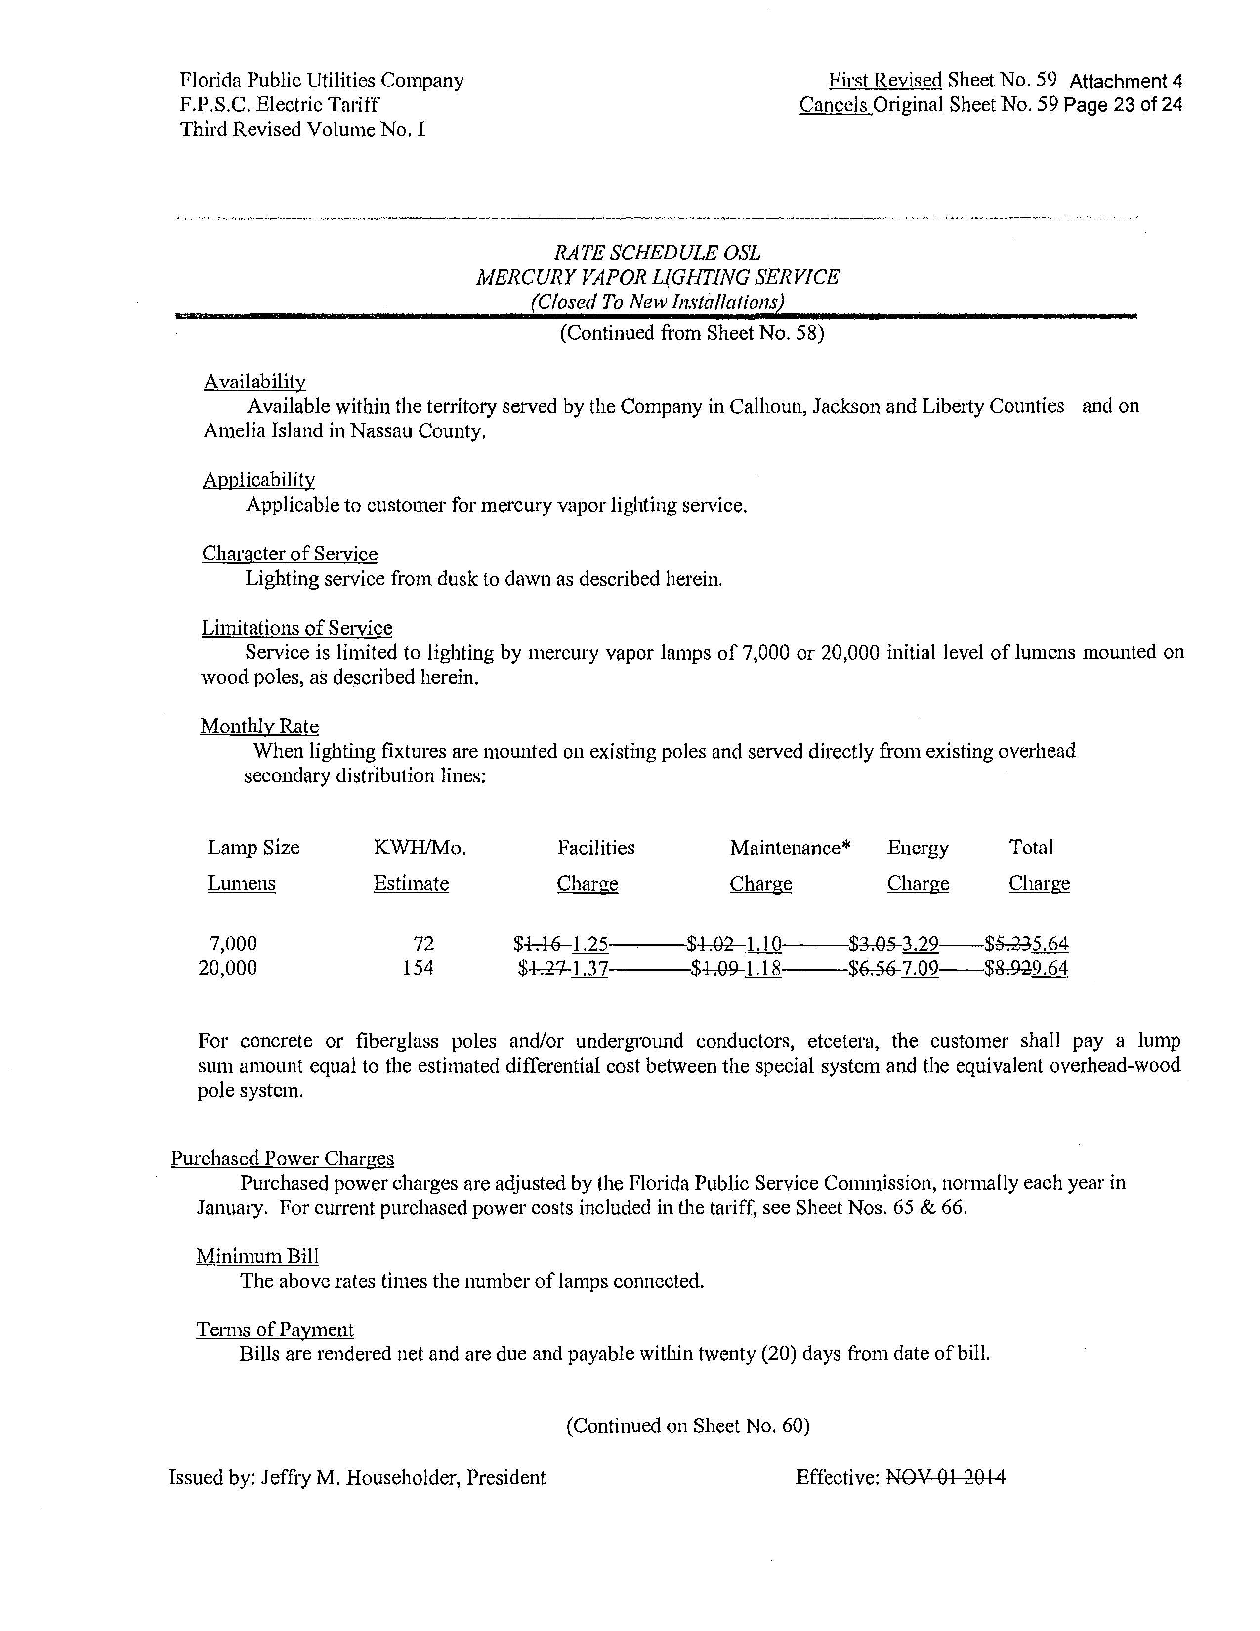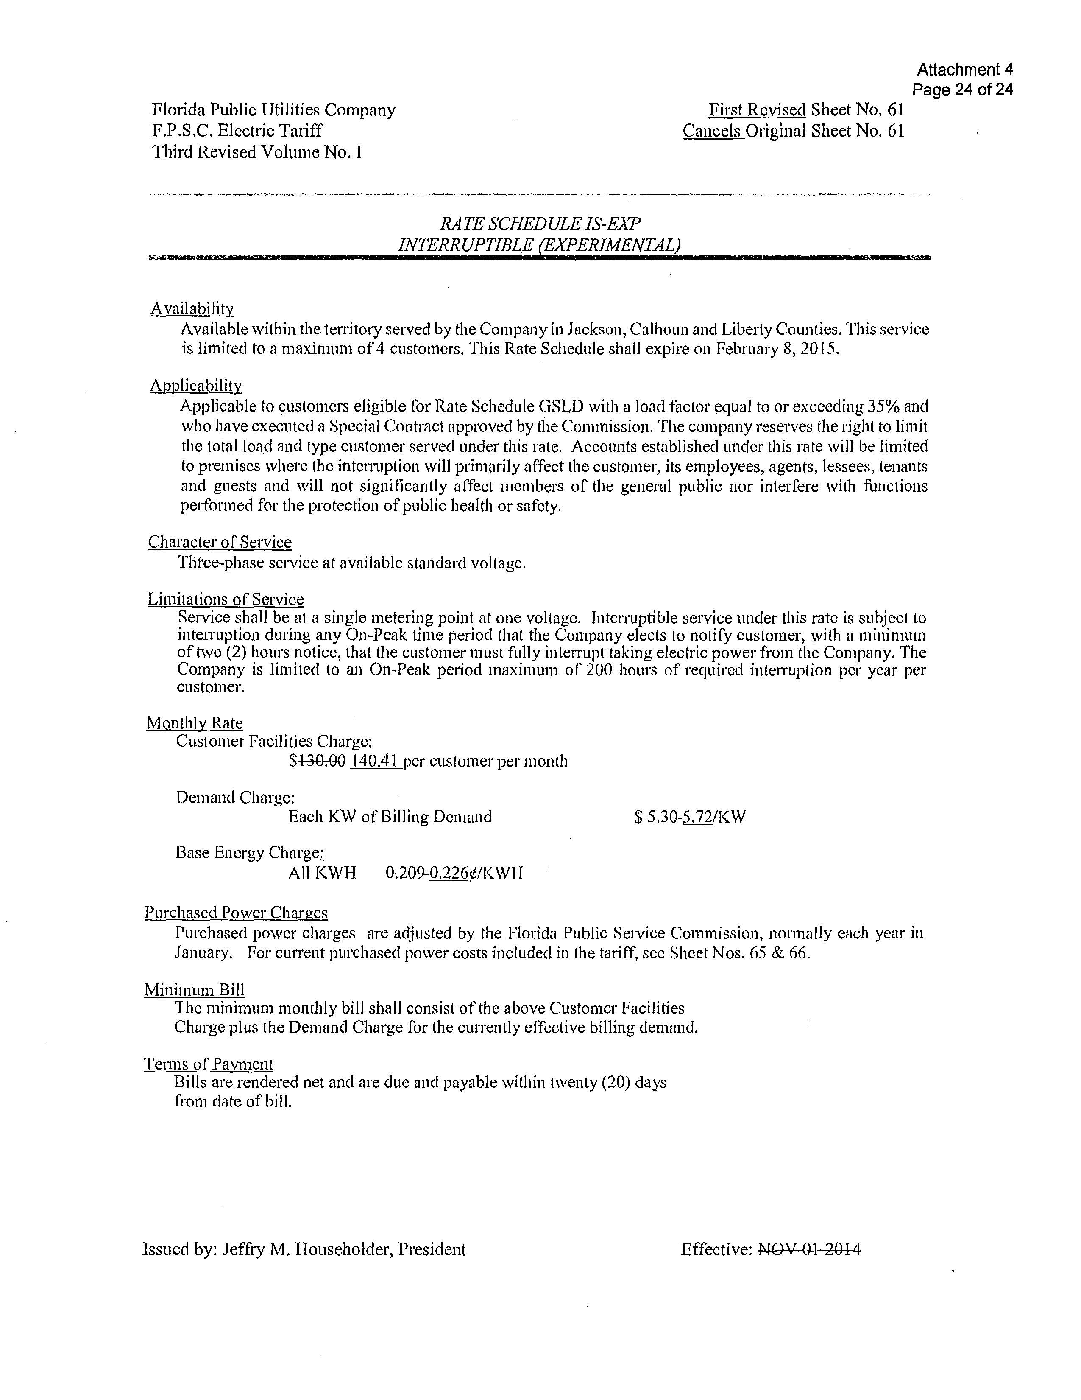

Order No. PSC-14-0517-S-EI, issued on September 29, 2014, in Docket No. 20140025-EI, In re: Application for rate increase by Florida Public Utility Company.
Document No. 06137-2017, in Docket No. 20170150-EI, In re: Petition for limited proceeding to include reliability and modernization projects in rate base, by Florida Public Utilities Company.
Order No. PSC-2017-0360-PCO-EI, issued September 25, 2017, in Docket No. 20170150-EI, In re: Petition for limited proceeding to include reliability and modernization projects in rate base, by Florida Public Utilities Company.
Order No. PSC-13-0023-S-EI, issued on January 14, 2013, in Docket No. 120015-EI, In re: Petition for increase in rates by Florida Power & Light Company; Order No. PSC-11-0089-S-EI, issued February 1, 2011, in Docket Nos. 080677 and 090130, In re: Petition for increase in rates by Florida Power & Light Company and In re: 2009 depreciation and dismantlement study by Florida Power & Light Company; Order No. PSC-13-0023-S-EIPSC-10-0398-S-EI, issued June 18, 2010, in Docket Nos. 090079-EI, 090144-EI, 090145-EI, 100136-EI, In re: Petition for increase in rates by Progress Energy Florida, Inc., In re: Petition for limited proceeding to include Bartow repowering project in base rates, by Progress Energy Florida, Inc., In re: Petition for expedited approval of the deferral of pension expenses, authorization to charge storm hardening expenses to the storm damage reserve, and variance from or waiver of Rule 25-6.0143(1)(c), (d), and (f), F.A.C., by Progress Energy Florida, Inc., and In re: Petition for approval of an accounting order to record a depreciation expense credit, by Progress Energy Florida, Inc.; Order No. PSC-05-0945-S-EI, issued September 28, 2005, in Docket No. 050078-EI, In re: Petition for rate increase by Progress Energy Florida, Inc.
Order No. PSC-13-0023-S-EI, at p. 7.
Order No. PSC-16-0560-AS-EI, issued on December 15, 2016, in Docket No. 160021-EI, In re: Petition for rate increase by Florida Power & Light Company; Order No. PSC-17-0178-S-EI, issued on May 16, 2017, in Docket No. 20160186-EI, In re: Petition for rate increase by Gulf Power Company; Order No. PSC-2017-0451-AS-EI, issued on November 20, 2017, in Docket No. 20170183-EI, In re: Application for limited proceeding to approve 2017 second revised and restated settlement agreement including certain rate adjustments by Duke Energy Florida LLC; Order No. PSC-2017-0456-S-EI, issued on November 27, 2017, in Docket No. 20170210-EI, In re: Petition for limited proceeding to approve 2017 amended and restated stipulation and settlement agreement, by Tampa Electric Company.

