BEFORE THE FLORIDA PUBLIC SERVICE COMMISSION

In re: Petition for recovery of costs associated with named tropical systems during the 2015, 2016, and 2017 hurricane seasons and replenishment of storm reserve subject to final true-up, Tampa Electric Company. | DOCKET NO. 20170271-EI  ORDER NO. PSC-2018-0125-PCO-EI  ISSUED: March 7, 2018

The following Commissioners participated in the disposition of this matter:

JULIE I. BROWN
DONALD J. POLMANN
ANDREW GILES FAY

ORDER APPROVING INTERIM STORM RECOVERY CHARGE

BY THE COMMISSION:
Background

On December 28, 2017, Tampa Electric Company (Tampa Electric or Company) filed a petition for a limited proceeding seeking authority to implement interim Storm Cost Recovery Charge factors to recover a total of $87.4 million for the incremental restoration costs related to tropical systems named by the National Hurricane Center (NHC) during the 2015, 2016, and 2017 hurricane seasons and to replenish its storm reserve subject to true-up.
On January 30, 2018, Tampa Electric filed an amended petition, updating the recovery amount to $102.5 million. In its amended petition, Tampa Electric asserts that as a result of Tropical Storms Erika and Colin, and Hurricanes Hermine, Matthew and Irma, Tampa Electric incurred total retail recoverable costs of approximately $102.5 million, less its pre-storm storm reserve balance of $55.9 million, resulting in net recoverable costs of $46.6 million. In addition, Tampa Electric proposes to replenish its storm reserve to the $55.9 million balance that existed on October 31, 2013. The regulatory assessment fee gross-up adds an additional $74,000 to the recoverable costs.
Tampa Electric filed its amended petition pursuant to the provisions of the Amended and Restated Stipulation and Settlement Agreement (ARSSA) approved by Order No. PSC-2017-0456-S-EI. Pursuant to Paragraph 5 of the ARSSA, Tampa Electric may petition this Commission to allow the Company to increase the initial 12 month recovery at rates greater than $4.00/1,000 kWh or for a period longer than 12 months if Tampa Electric incurs in excess of $100 million of storm recovery costs that qualify for recovery in a given calendar year, inclusive of the amount needed to replenish the storm reserve. In its amended petition, Tampa Electric is seeking recovery through an interim Storm Cost Recovery Charge factor of $10.07/1,000 kWh beginning with the first billing cycle in April 2018 and concluding when the storm reserve has been replenished, which is estimated to be in December 2018.
On January 30, 2018, Tampa Electric also filed an unopposed Motion to Approve Implementation Stipulation to implement the storm cost and tax cut provisions of the ARSSA. On February 13, 2018, Tampa Electric filed a motion to approve an Amended Implementation Stipulation which was signed by all the signatories to the ARSSA and the original Implementation Stipulation. The Florida Industrial Power Users Group petitioned to intervene in this docket on January 10, 2018, and intervention was granted on February 16, 2018. We have jurisdiction over this matter pursuant to Sections 366.04, 366.05, 366.06, and 366.076, Florida Statutes.
Decision
Tampa Electric filed an amended petition for a limited proceeding seeking authority to implement interim Storm Cost Recovery Charge factors to recover a total of $102.5 million for the incremental restoration costs related to named tropical storms and hurricanes during the 2015, 2016, and 2017 hurricane seasons and to replenish its storm reserve. The requested recovery of $102.5 million represents net retail recoverable costs of approximately $46.6 million, plus an additional $55.9 million to replenish the storm reserve to the balance that existed on October 31, 2013. In addition, the $102.5 million includes a regulatory assessment fee gross-up of $74,000. The amended petition was filed pursuant to the provisions of the ARSSA approved by the Commission in Order No. PSC-2017-0456-S-EI. Tampa Electric further asserts that this amount was calculated in accordance with the Incremental Cost and Capitalization Approach (ICCA) methodology prescribed in Rule 25-6.0143, Florida Administrative Code (F.A.C.).
Pursuant to Paragraph 5 of the ARSSA, Tampa Electric may petition the Commission to allow the Company to increase the initial 12 month recovery at rates greater than $4.00/1,000 kWh or for a period longer than 12 months if Tampa Electric incurs in excess of $100 million of storm recovery costs that qualify for recovery in a given calendar year, inclusive of the amount needed to replenish the storm reserve. Tampa Electric has requested an interim Storm Cost Recovery Charge factor of $10.07 on a monthly 1,000 kWh residential bill, effective from April 2018 through December 2018.
Pursuant to the ARSSA, approval of interim Storm Cost Recovery Charge factors is preliminary in nature and is subject to refund pending a further review once the total actual storm restoration costs are known. After the actual costs are reviewed for prudence and reasonableness, and are compared to the actual amount recovered through the interim storm charge, a determination will be made whether any over/under recovery has occurred. The disposition of any over/under recovery, and associated interest, would be considered by this Commission at a later date.

Tampa Electric filed tariffs to implement both its original and amended proposed interim Storm Cost Recovery Charge factors. However, following our approval of the Amended Implementation Stipulation, Tampa Electric withdrew its proposed amended Storm Cost Recovery Charge tariff. Tampa Electric’s Amended Implementation Stipulation is contained in Attachment A. The Amended Implementation Stipulation seeks to avoid volatility in customer rates by recognizing and then utilizing annual tax reform benefits resulting from the passage of the Tax Cut and Jobs Act of 2017 (Tax Act) as a direct offset to avoid implementing separate cost recovery of storm damage costs that customers would otherwise have been obligated to pay. With our approval of the Amended Implementation Stipulation, Tampa Electric will be entitled to make the appropriate adjustments to its regulated books and records to recover the entire estimated amount of storm costs that would have been recovered from customers over a nine month period in 2018 from the Company’s estimated annual tax savings over the same nine month period. Consistent with the ARSSA, a final determination of storm costs and the impact of tax reform shall be made in separate dockets and any difference will be trued-up and recovered/refunded to customers through the 2019 Environmental Capital and Cost Recovery Clause with the full impact of tax reform reflected in a change in base rates in January 2019.

Our approval of interim Storm Cost Recovery Charge factors is preliminary in nature and is subject to true-up pending further review once the total actual storm restoration costs are known. After the actual costs are reviewed for prudence and reasonableness, and are compared to the actual amount recovered through the interim Storm Cost Recovery Charge, a determination will be made whether any over/under recovery has occurred and the appropriate steps to be taken for a refund or additional charge.

Based on our review of the information provided by Tampa Electric in its amended petition, we hereby authorize Tampa Electric to implement interim Storm Cost Recovery charge factors subject to true-up. Once the total actual storm costs are known, Tampa Electric shall be required to file documentation of the storm costs for our review and true-up of any excess or shortfall. This is not a confirmation or endorsement of the prudence of Tampa Electric’s forecasted costs or plans. This order only allows Tampa Electric to begin recovery on an interim basis in accordance with the ARSSA. This interim recovery is subject to true-up following a hearing or formal proceeding where the veracity and prudence of Tampa Electric’s actual restoration costs can be fully vetted. We further find that the Amended Implementation Stipulation is in the public interest and approve it.
Based on the foregoing, it is
ORDERED by the Florida Public Service Commission that Tampa Electric Company is hereby authorized to implement its amended interim Storm Cost Recovery Charge factors subject to true-up as stated in the body of this order. It is further
ORDERED that Tampa Electric Company’s Amended Implementation Stipulation is hereby approved. It is further
ORDERED that Tampa Electric Company shall file with this Commission documentation of the actual storm costs once those costs are known. It is further
ORDERED that this docket shall remain open pending final reconciliation of actual recoverable storm costs with the amount collected pursuant to the interim Storm Cost Recovery Charge factors, and the calculation of a refund or additional charge, if warranted.
By ORDER of the Florida Public Service Commission this 7th day of March, 2018.

/s/ Carlotta S. Stauffer
CARLOTTA S. STAUFFER
Commission Clerk
Florida Public Service Commission
2540 Shumard Oak Boulevard
Tallahassee, Florida 21288
(850) 413-6770
www.floridapsc.com

Copies furnished: A copy of this document is provided to the parties of record at the time of issuance and, if applicable, interested persons.
SBr

NOTICE OF FURTHER PROCEEDINGS OR JUDICIAL REVIEW

The Florida Public Service Commission is required by Section 120.569(1), Florida Statutes, to notify parties of any administrative hearing or judicial review of Commission orders that is available under Sections 120.57 or 120.68, Florida Statutes, as well as the procedures and time limits that apply. This notice should not be construed to mean all requests for an administrative hearing or judicial review will be granted or result in the relief sought.

Mediation may be available on a case-by-case basis. If mediation is conducted, it does not affect a substantially interested person's right to a hearing.

Any party adversely affected by this order, which is preliminary, procedural or intermediate in nature, may request: (1) reconsideration within 10 days pursuant to Rule 25-22.0376, Florida Administrative Code; or (2) judicial review by the Florida Supreme Court, in the case of an electric, gas or telephone utility, or the First District Court of Appeal, in the case of a water or wastewater utility. A motion for reconsideration shall be filed with the Office of Commission Clerk, in the form prescribed by Rule 25-22.0376, Florida Administrative Code. Judicial review of a preliminary, procedural or intermediate ruling or order is available if review of the final action will not provide an adequate remedy. Such review may be requested from the appropriate court, as described above, pursuant to Rule 9.100, Florida Rules of Appellate Procedure.

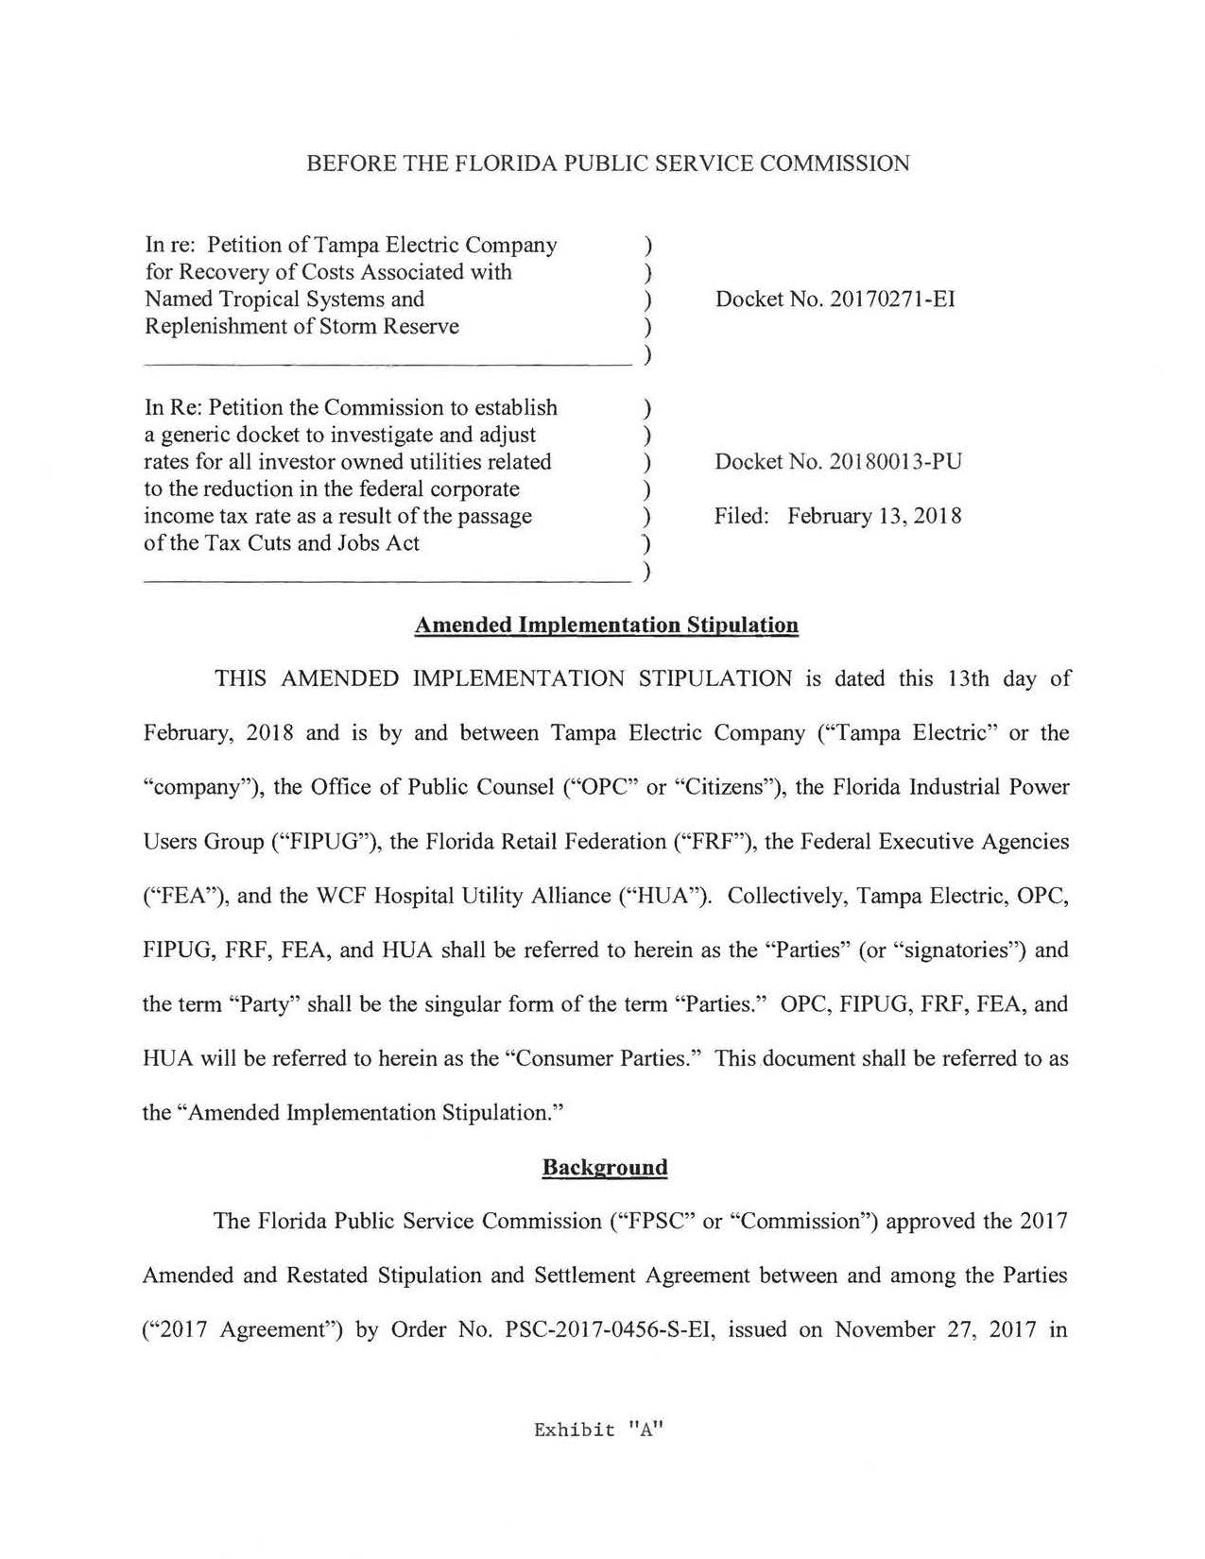

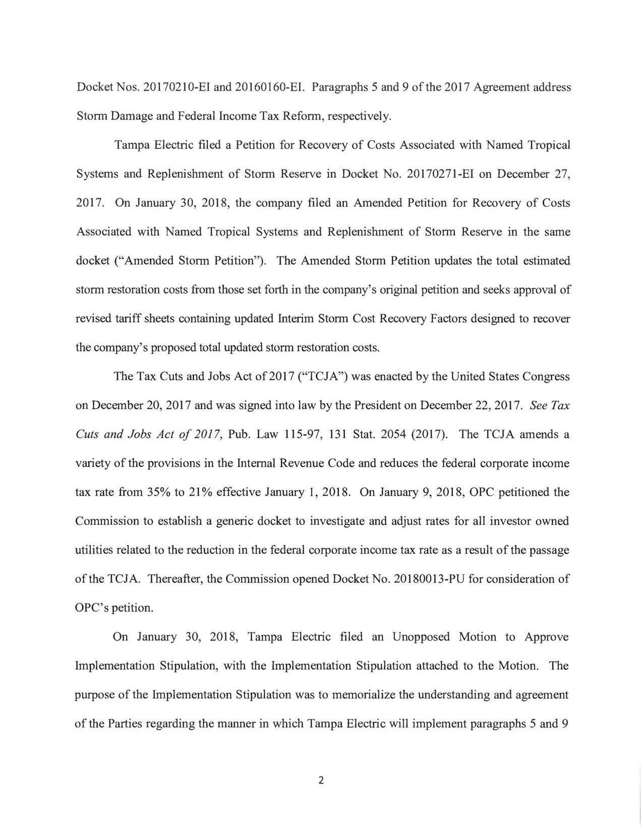

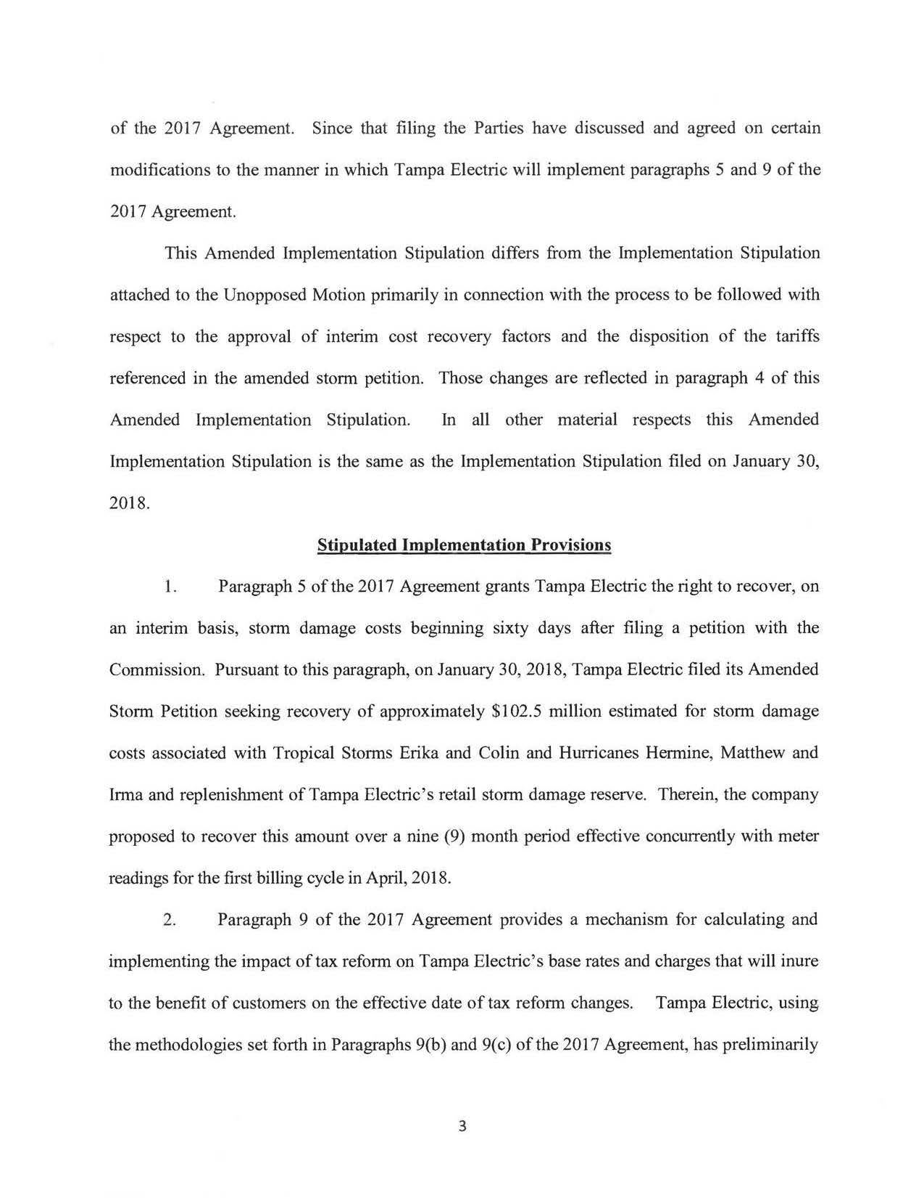

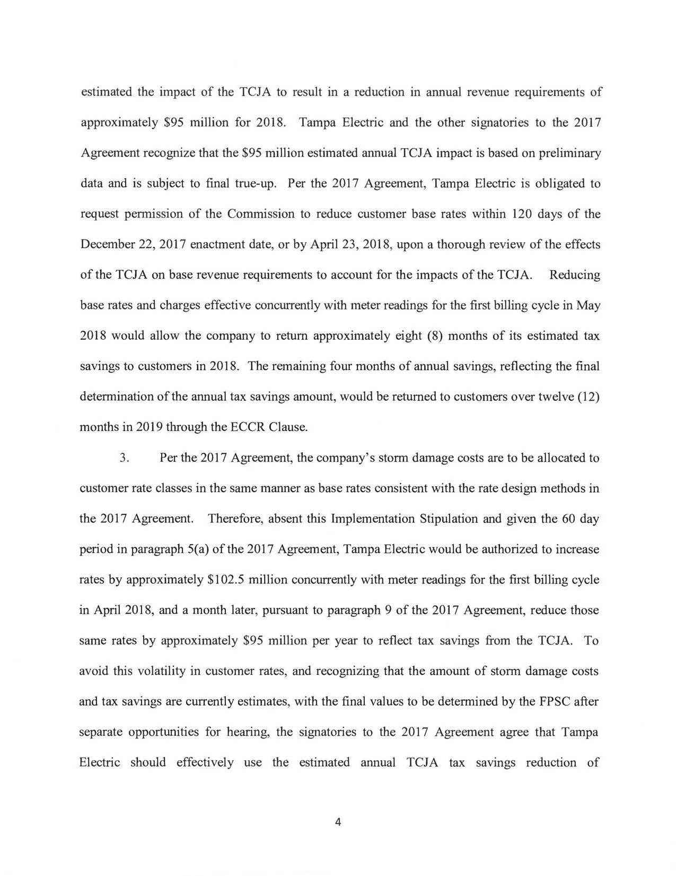

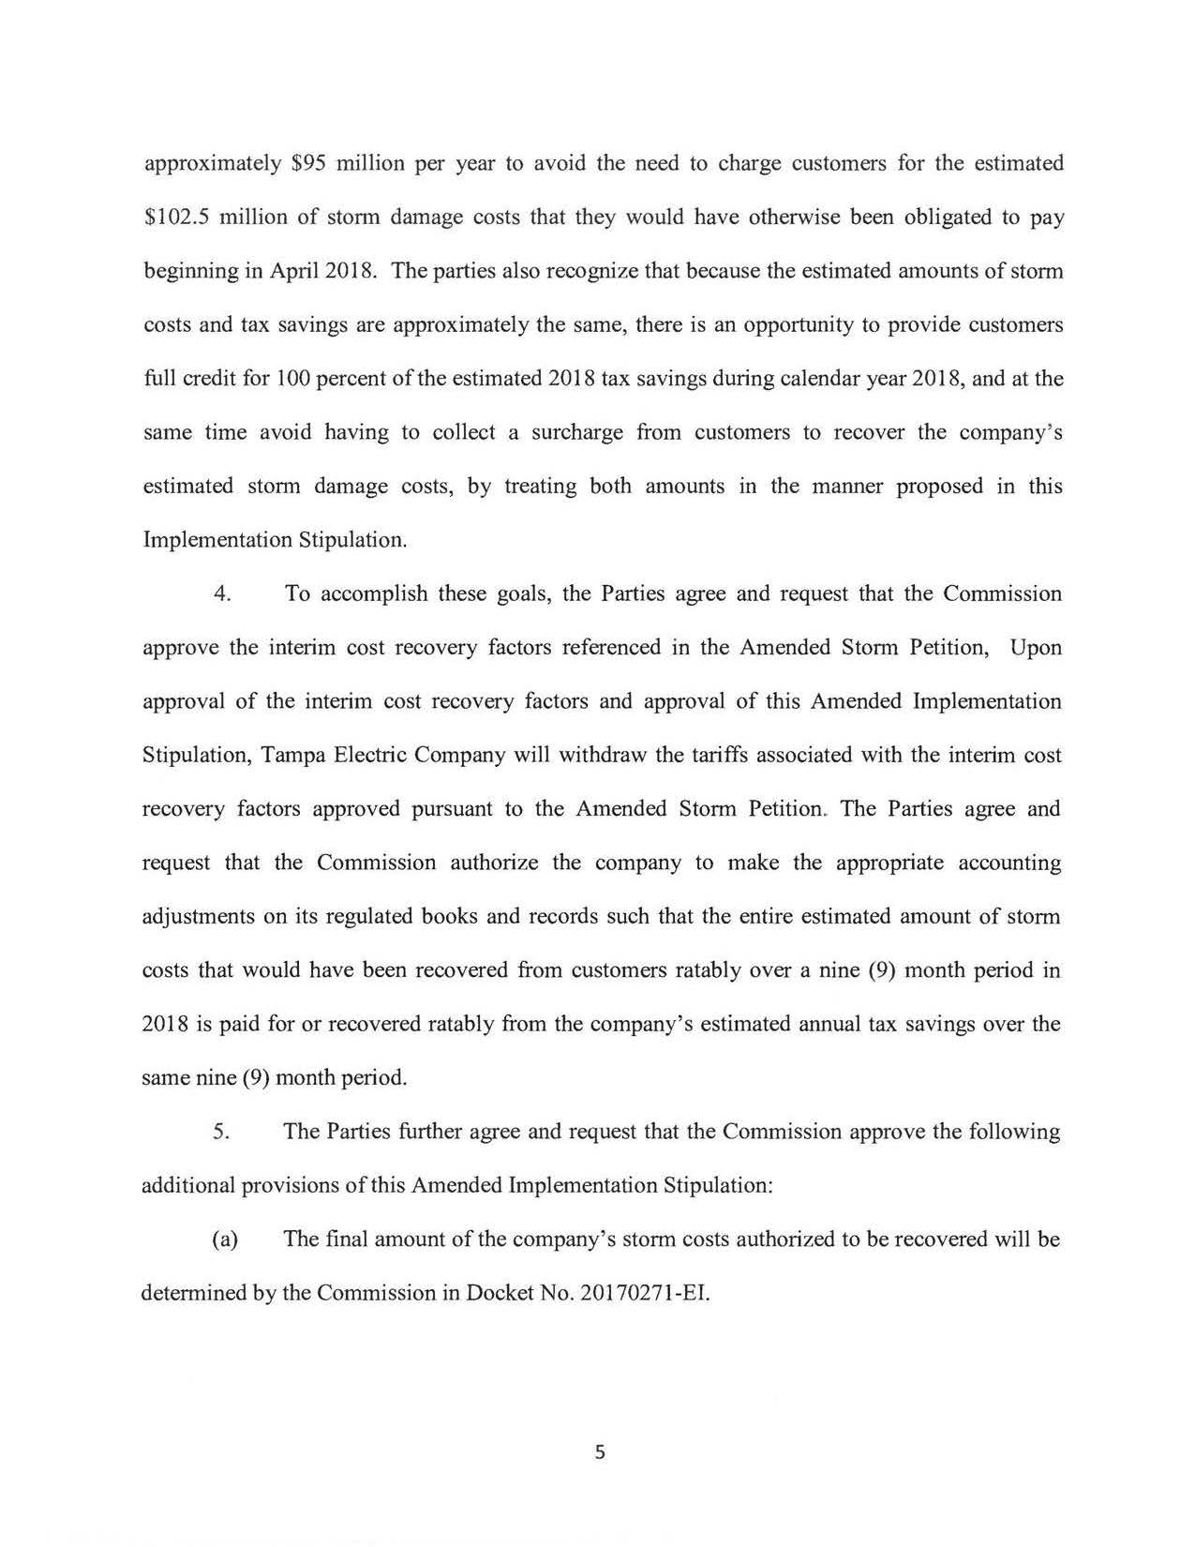

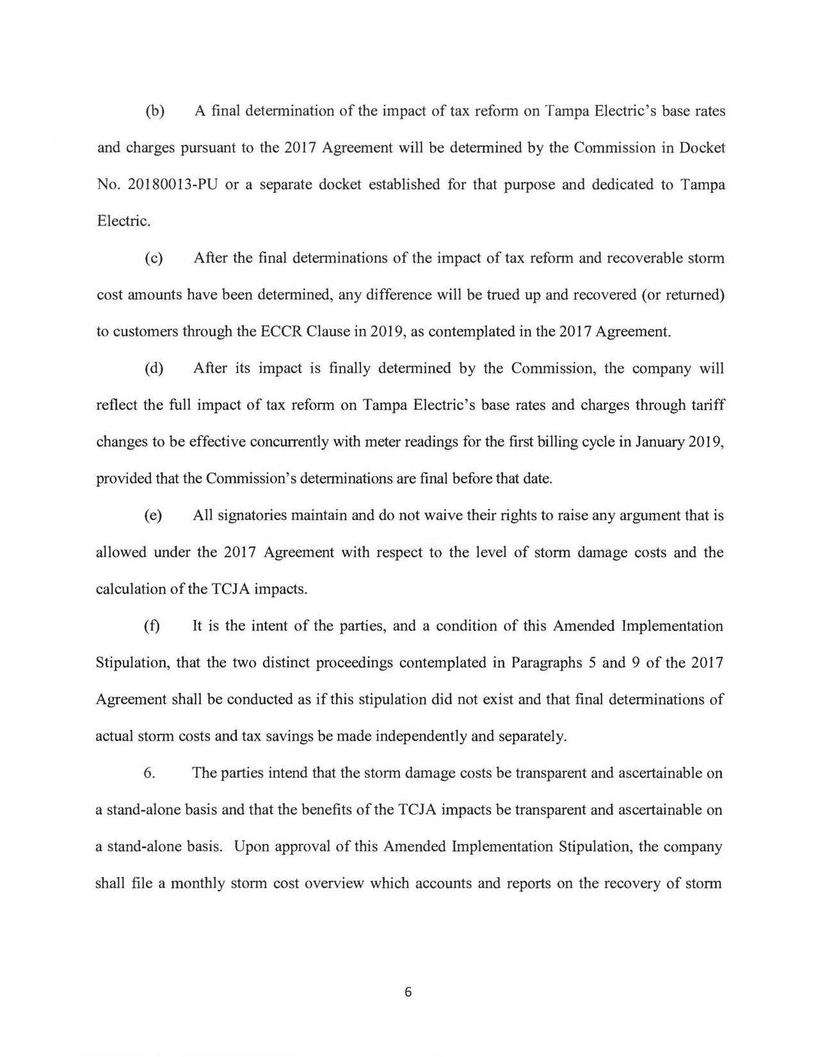

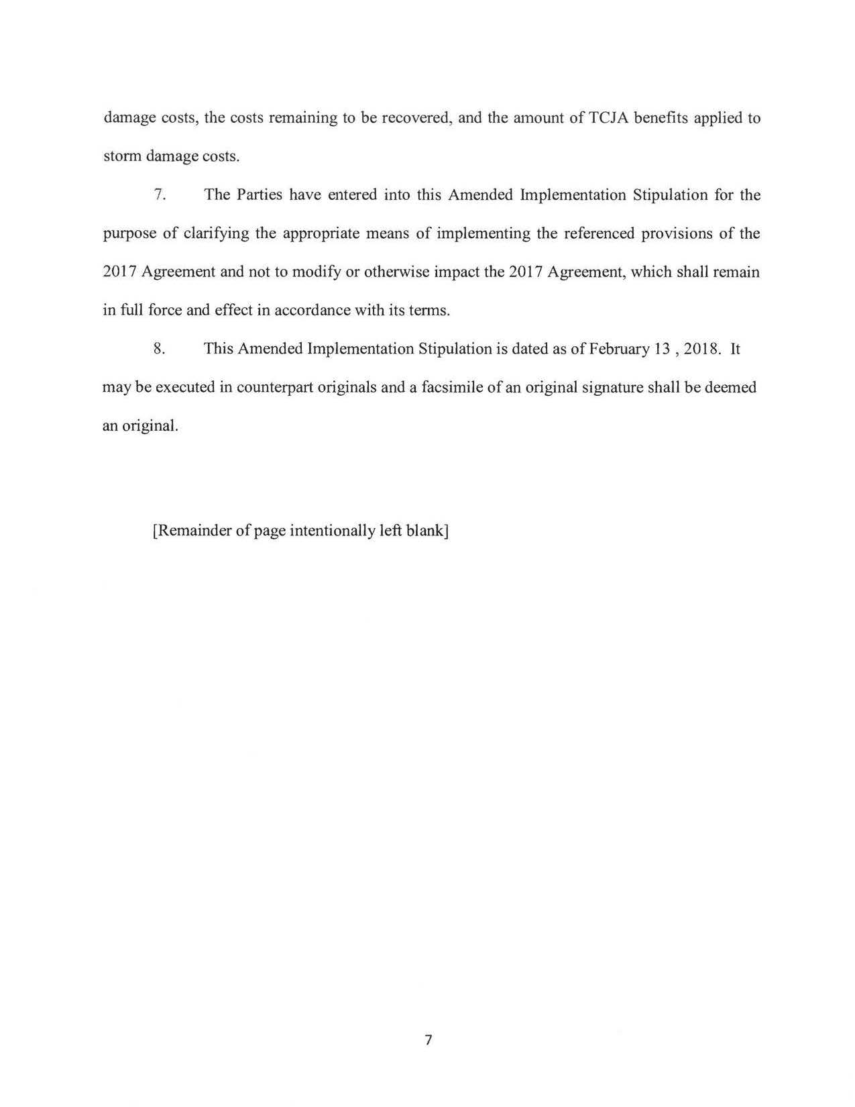

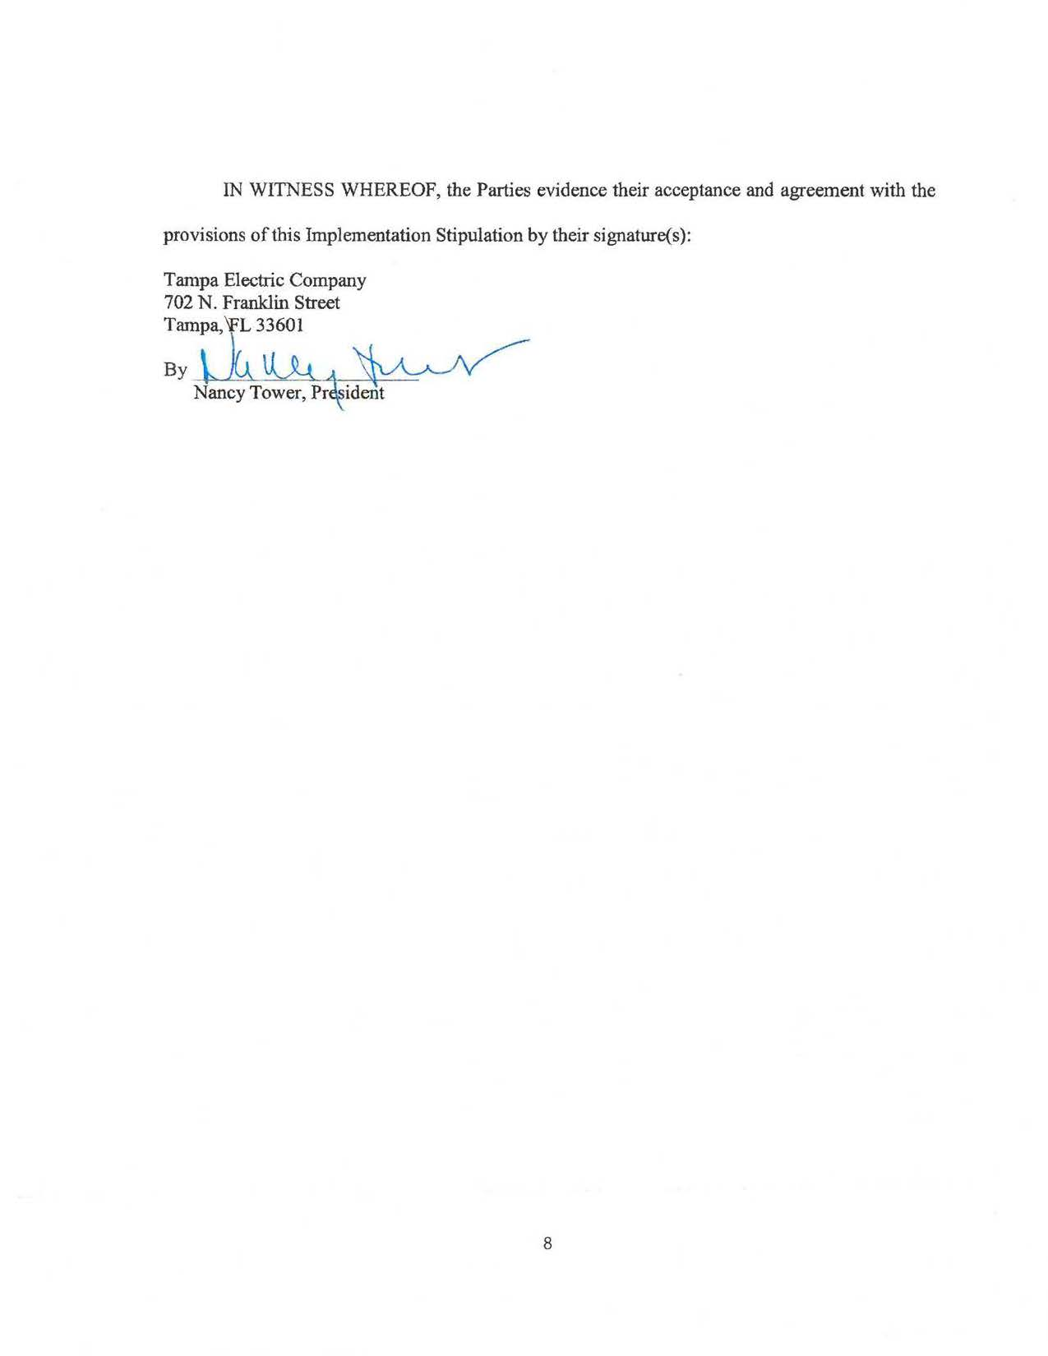

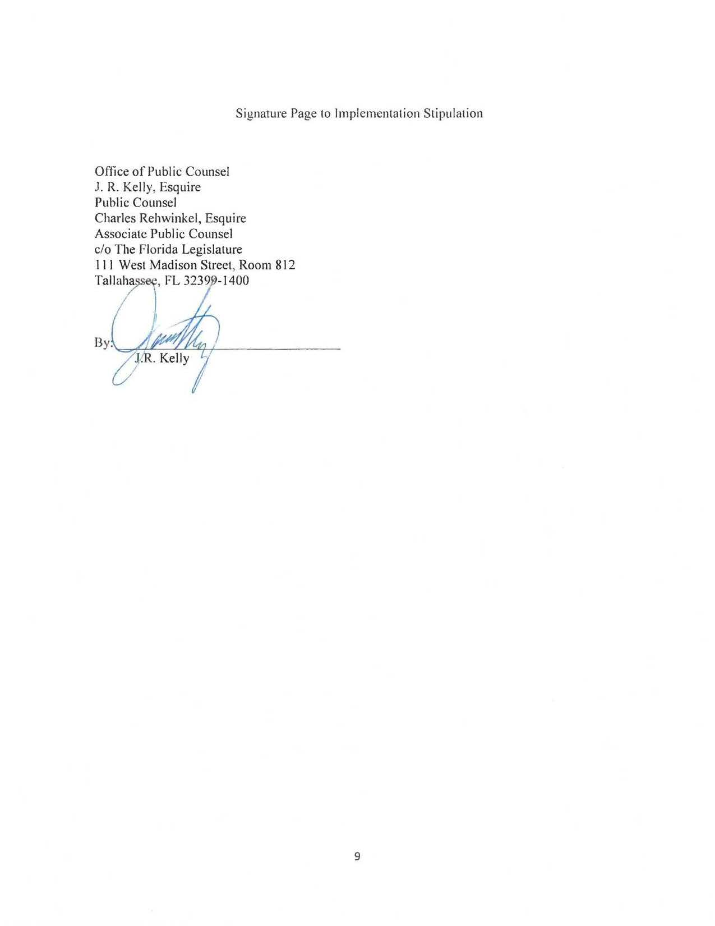

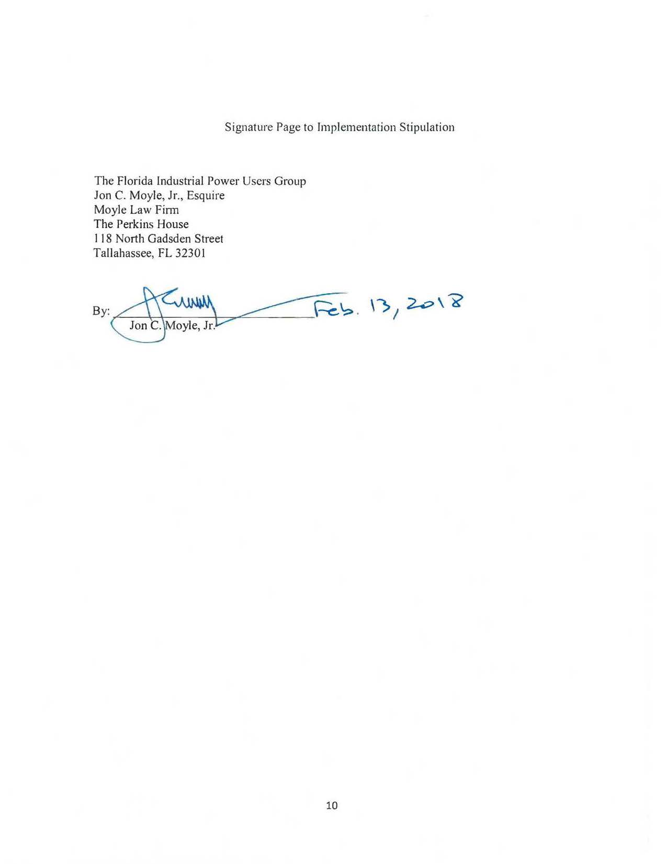

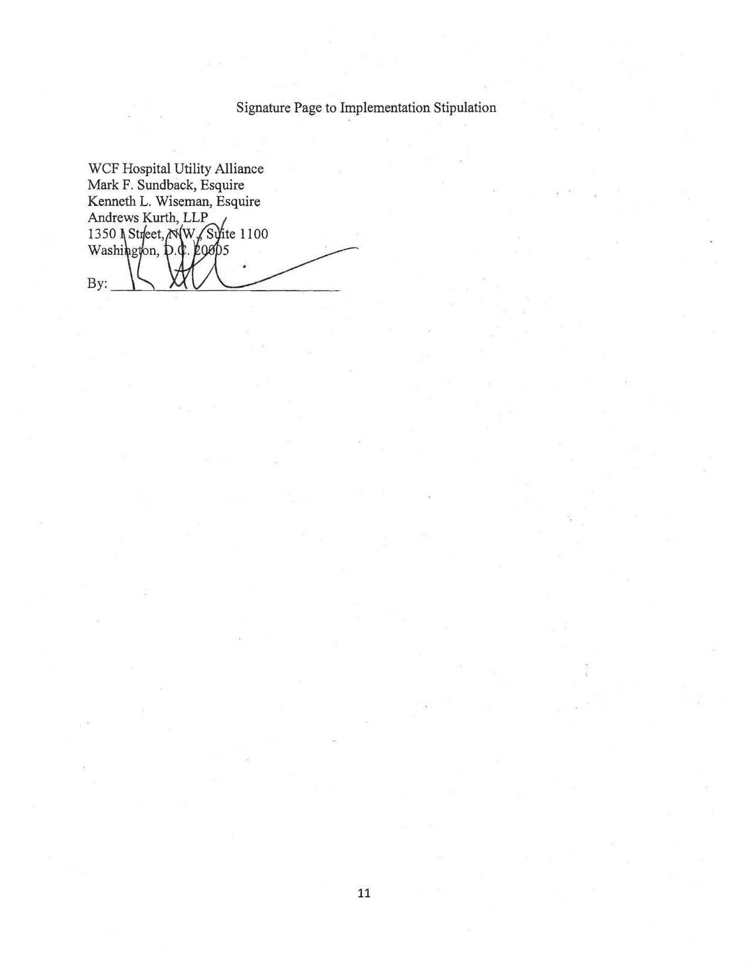

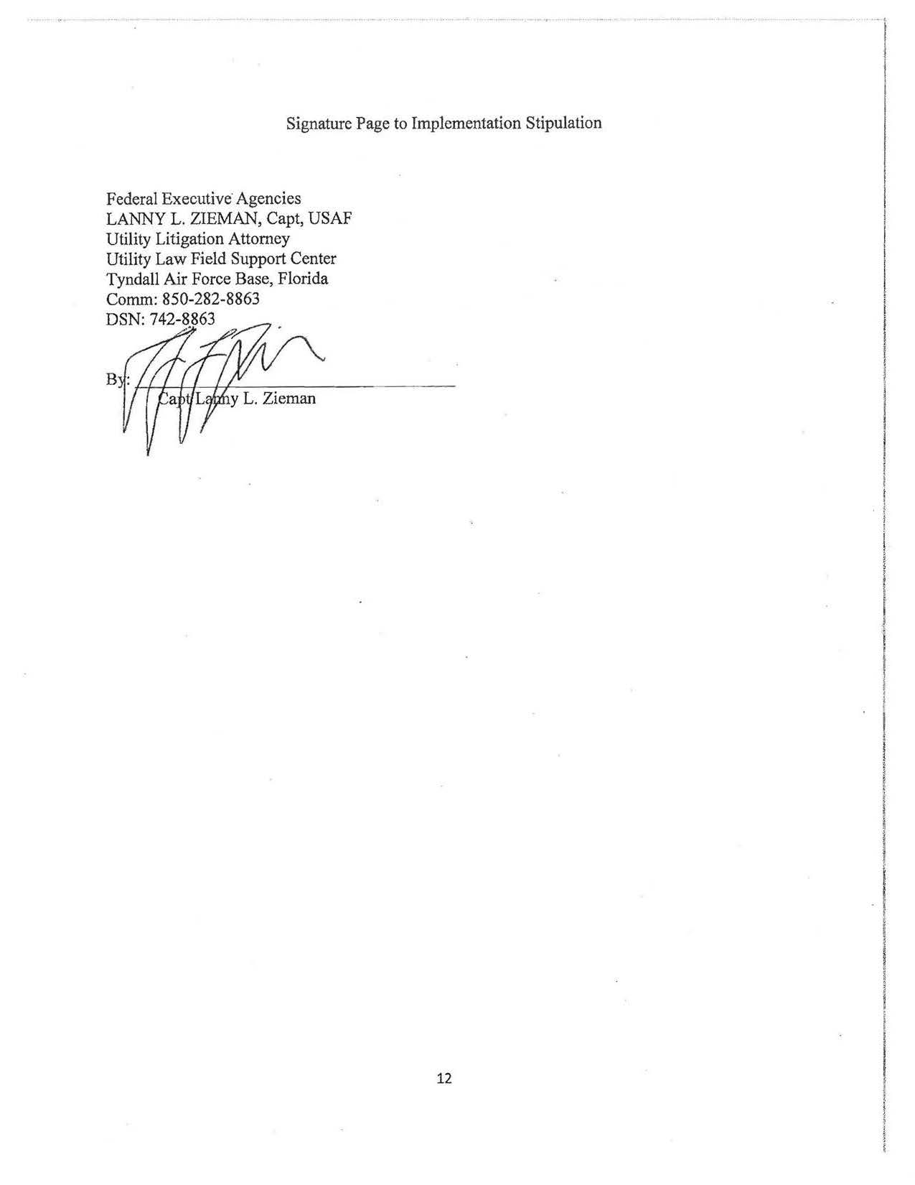

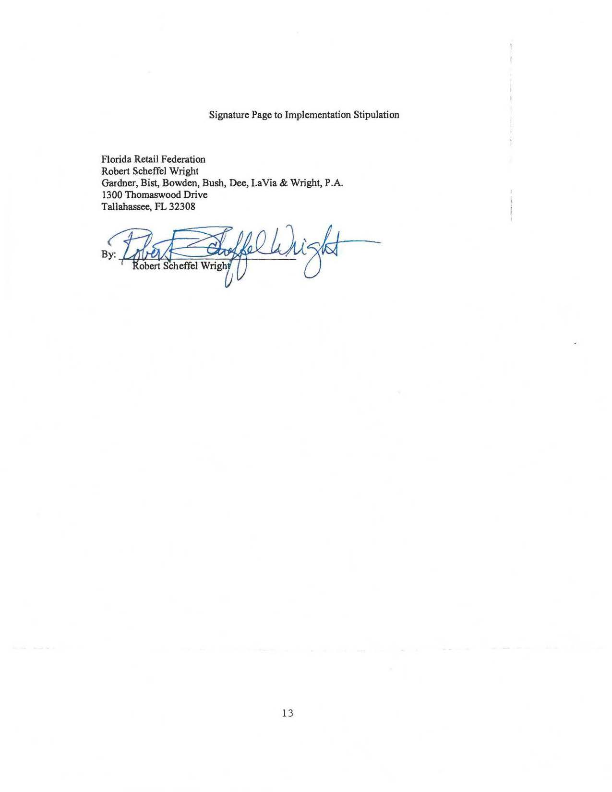

Order No. PSC-2017-0456-S-EI, issued November 27, 2017, in Docket Nos. 20170210-EI, In re: Petition for limited proceeding to approve 2017 amended and restated stipulation and settlement agreement, by Tampa Electric Company and 20160160-EI, In re: Petition for approval of energy transaction optimization mechanism, by Tampa Electric Company,
Order No. PSC-2018-0084-PCO-EI, issued on February 16, 2018, in Docket No. 20170271-EI, In re: Petition for recovery of costs associated with named tropical systems during the 2015, 2016, and 2017 hurricane seasons and replenishment of storm reserve subject to final true-up, by Tampa Electric Company
See Document No. 00787-2018, Exhibit D, Page 2 of 2 (Tampa Electric Amended Petition).
Order No. PSC-2017-0456-S-EI, issued November 27, 2017, in Docket Nos. 20170210-EI, In re: Petition for limited proceeding to approve 2017 amended and restated stipulation and settlement agreement, by Tampa Electric Company and 20160160-EI, In re: Petition for approval of energy transaction optimization mechanism, by Tampa Electric Company.

