BEFORE THE FLORIDA PUBLIC SERVICE COMMISSION

In re: Petition for limited proceeding for recovery of incremental storm restoration costs related to Hurricane Matthew by Florida Power & Light Company. | DOCKET NO. 20160251-EI  ORDER NO. PSC-2018-0359-FOF-EI  ISSUED: July 24, 2018

The following Commissioners participated in the disposition of this matter:

ART GRAHAM, Chairman
JULIE I. BROWN
DONALD J. POLMANN
GARY F. CLARK
ANDREW GILES FAY

APPEARANCES:

JOHN T. BUTLER, KENNETH M. RUBIN, and KEVIN I.C. DONALDSON, ESQUIRES, 700 Universe Boulevard, Juno Beach, Florida 33408-0420
On behalf of Florida Power & Light Company (FPL).

J.R. KELLY, CHARLES REHWINKEL, PATRICIA A. CHRISTENSEN, and STEPHANIE MORSE, ESQUIRES, Office of Public Counsel, c/o The Florida Legislature, 111 West Madison Street, Room 812, Tallahassee, Florida 32399-1400
On behalf of the Citizens of the State of Florida (OPC).

JON MOYLE and KAREN PUTNAL, ESQUIRES, Moyle Law Firm, PA, The Perkins House, 118 North Gadsden Street, Tallahassee, Florida 32301
On behalf of the Florida Industrial Power Users Group (FIPUG).

ROBERT SCHEFFEL WRIGHT and JOHN T. LAVIA, III, ESQUIRES, Gardner Law Firm, 1300 Thomaswood Drive, Tallahassee, Florida 32308,
On behalf of the Florida Retail Federaion (FRF).

SUZANNE BROWNLESS, ESQUIRE, Florida Public Service Commission, 2540 Shumard Oak Boulevard, Tallahassee, Florida 32399-0850
On behalf of the Florida Public Service Commission (Staff).

MARY ANNE HELTON, ESQUIRE, Deputy General Counsel, Florida Public Service Commission, 2540 Shumard Oak Boulevard, Tallahassee, Florida 32399-0850
Advisor to the Florida Public Service Commission.

Keith hetrick, ESQUIRE, General Counsel, Florida Public Service Commission, 2540 Shumard Oak Boulevard, Tallahassee, Florida 32399-0850
Florida Public Service Commission General Counsel.

FINAL ORDER APPROVING JOINT MOTION FOR
APPROVAL OF SETTLEMENT AGREEMENT

BY THE COMMISSION:

BACKGROUND

On December 29, 2016, pursuant to Section 366.076(1), Florida Statutes (F.S.), Florida Power & Light Company (FPL) filed its Petition for Limited Proceeding for Recovery of Incremental Storm Restoration Costs Related to Hurricane Matthew. On January 18, 2017, the Office of Public Counsel (OPC) was acknowledged as a party by Order No. PSC-2017-0030-PCO-EI. By Order No. PSC-2017-0055-PCO-EI, issued on February 20, 2017, the Commission approved the requested 2017 Interim Storm Restoration Recovery Charge subject to a final reconciliation of actual Hurricane Matthew storm costs with the amount collected pursuant to the surcharge, and the calculation of a refund or an additional charge, if warranted. On July 12, 2017, the Florida Industrial Power Users Group (FIPUG) was granted intervention by Order No. PSC-2017-0269-PCO-EI. On December 15, 2017, Order No. PSC-2017-0471-PCO-EI was issued establishing hearing dates and procedures to be followed in this docket.
On February 20, 2018, FPL filed a Petition for Approval of Final/Actual Storm Restoration Costs and Associated True-up Process Related to Hurricane Matthew requesting approval of a final/actual Recoverable Storm Amount of $316.7 million. The Florida Retail Federation (FRF) was granted intervention by Order No. PSC-2018-0176-PCO-EI, on April 5, 2018. OPC filed a Motion to Modify Key Activities Dates and Discovery Timeframes on April 18, 2018, which was granted by Order No. PSC-2018-0189-PCO-EI issued on April 19, 2018. Order No. PSC-2018-0245-PHO-EI (Prehearing Order) was issued on May 11, 2018, outlining procedures to be used at the scheduled May 22, 2018 final hearing. On May 15, 2018, FPL filed a Joint Motion for Approval of Settlement Agreement requesting that the Stipulation and Settlement (Settlement Agreement) entered into between OPC and FPL dated May 14, 2018, be approved. The Settlement Agreement is contained in Attachment A.
As a result of the Settlement Agreement being filed seven days before the scheduled final hearing, Order No. PSC-2018-0253-PCO-EI was issued cancelling the May 22, 2018 final hearing and resetting it to June 5, 2018. On May 18, 2018, FIPUG filed a response in opposition to the Settlement Agreement and reaffirmed its Prehearing Statement’s litigation positions. On May 22, 2018, FRF filed its response stating that it did not support the proposed Settlement Agreement principally because it was not included in the negotiation process which produced the agreement.
A final hearing was held on June 5, 2018, in which the testimony and exhibits of FPL’s witness Eduardo DeVarona and OPC witness Helmuth Schultz were stipulated into the record. FPL’s witnesses Manuel B. Miranda, Kim Ousdahl and Tiffany Cohen testified in support of FPL’s petition, and witnesses Ousdahl and Cohen also gave testimony regarding the terms and conditions of the Settlement Agreement. Commission staff witness Donna Brown testified about her Audit Reports dated December 5, 2017, and April 4, 2018. Thirty two exhibits were admitted into the record. At the close of the hearing, FIPUG requested that it be allowed to brief whether the Settlement Agreement should be approved, as well as the 11 issues identified in the Prehearing Order. On June 20, 2018, FIPUG filed a Notice of Change of Position stating that it would no longer object to the Settlement Agreement but would take no position. Briefs were filed by FPL, OPC and FIPUG on June 28, 2018. FRF, consistent with its representation at the final hearing on June 5, 2018, did not file a brief.

DECISION

The standard for approval of a settlement agreement is whether it is in the public interest. A determination of public interest requires a case-specific analysis based on consideration of the proposed settlement taken as a whole.

As testified to by FPL’s witnesses, the amount of storm-related revenues collected by FPL’s approved interim storm restoration recovery charge is $322.4 million. The Settlement Agreement allows FPL to recover $294.759 million in storm costs of which $20 million is reclassified as capital, $1.7 million is transferred to base rate O&M expense, and $5.99 million is an over-collection. Effective August 1, 2018, FPL will refund $27.69 million, including interest at the commercial paper rate. The Storm Reserve Level will be restored to $117.1 million in accord with FPL’s 2012 Settlement Agreement.

We note that the representative of all of FPL’s customers, OPC, negotiated and is in full support of the Settlement Agreement. While FRF opposes this Settlement Agreement, FRF has not raised any objections to any specific term of the Settlement Agreement. Rather, FRF is opposing this Settlement Agreement because it was not asked to participate in the negotiations which produced this agreement. FIPUG originally opposed the Settlement Agreement and adopted OPC’s original positions with regard to the various elements of the storm cost calculations. However, at this time FIPUG is taking no position on the Settlement Agreement. On August 1, 2018, FPL’s residential ratepayers will receive a one-time credit of $2.88 per 1,000 kWh. The refund amounts for all rate classes are contained in Attachment B. The Storm Reserve will be restored to its 2012 balance of $117.1 million which will continue to make funds immediately available to respond to any new storms as the 2018 hurricane season begins.

Based on our review of the Settlement Agreement, the exhibits entered into the record, the positions of the parties, the testimony of FPL’s witnesses, and the benefits discussed above, we find that the Settlement Agreement, taken as a whole, is in the public interest. Therefore, the Settlement Agreement is hereby approved.

Based on the foregoing, it is

ORDERED by the Florida Public Service Commission that the Joint Motion for Approval of Settlement Agreement between the Office of Public Counsel and Florida Power & Light Company dated May 15, 2018, is hereby granted and the Stipulation and Settlement Agreement, Attachment A hereto, approved. It is further

ORDERED that a one-time 2018 Interim Storm Restoration Recovery Refund starting on August 1, 2018, is hereby approved. It is further

ORDERED that Commission staff shall have administrative authority to approve 2018 Interim Storm Restoration Recovery Refund tariff sheets consistent with our ruling. It is further

ORDERED that this docket shall be closed if no appeal is timely filed.

By ORDER of the Florida Public Service Commission this 24th day of July, 2018.

/s/ Hong Wang
HONG WANG
Chief Deputy Commission Clerk
Florida Public Service Commission
2540 Shumard Oak Boulevard
Tallahassee, Florida 32399
(850) 413-6770
www.floridapsc.com

Copies furnished: A copy of this document is provided to the parties of record at the time of issuance and, if applicable, interested persons.

SBr

NOTICE OF FURTHER PROCEEDINGS OR JUDICIAL REVIEW

The Florida Public Service Commission is required by Section 120.569(1), Florida Statutes, to notify parties of any administrative hearing or judicial review of Commission orders that is available under Sections 120.57 or 120.68, Florida Statutes, as well as the procedures and time limits that apply. This notice should not be construed to mean all requests for an administrative hearing or judicial review will be granted or result in the relief sought.

Any party adversely affected by the Commission's final action in this matter may request: 1) reconsideration of the decision by filing a motion for reconsideration with the Office of Commission Clerk, 2540 Shumard Oak Boulevard, Tallahassee, Florida 32399-0850, within fifteen (15) days of the issuance of this order in the form prescribed by Rule 25-22.060, Florida Administrative Code; or 2) judicial review by the Florida Supreme Court in the case of an electric, gas or telephone utility or the First District Court of Appeal in the case of a water and/or wastewater utility by filing a notice of appeal with the Office of Commission Clerk, and filing a copy of the notice of appeal and the filing fee with the appropriate court. This filing must be completed within thirty (30) days after the issuance of this order, pursuant to Rule 9.110, Florida Rules of Appellate Procedure. The notice of appeal must be in the form specified in Rule 9.900(a), Florida Rules of Appellate Procedure.

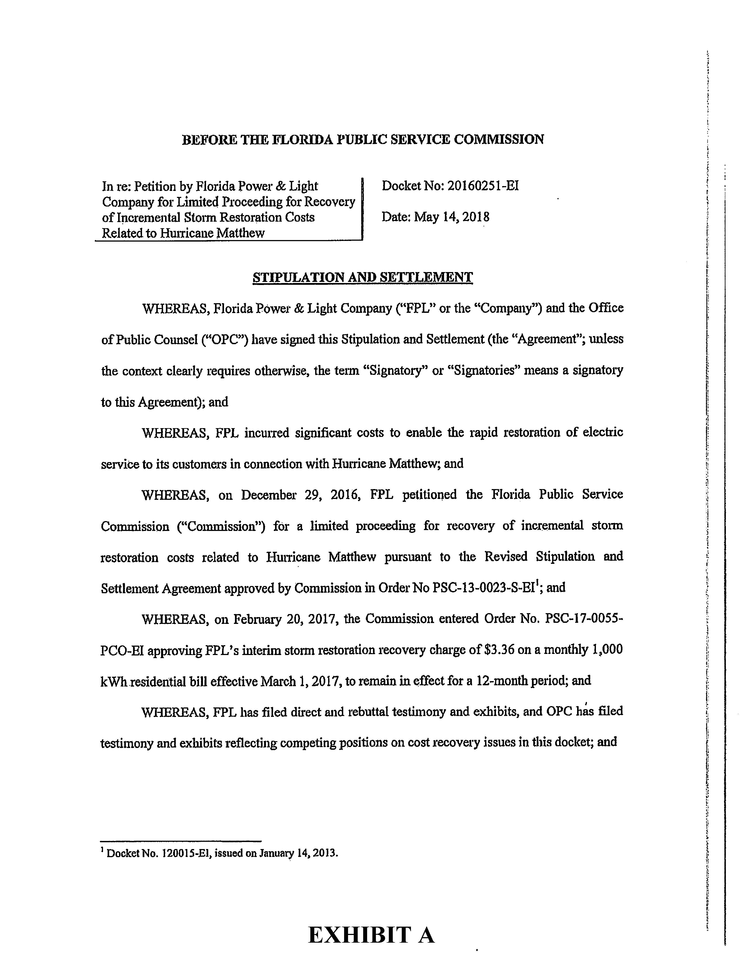

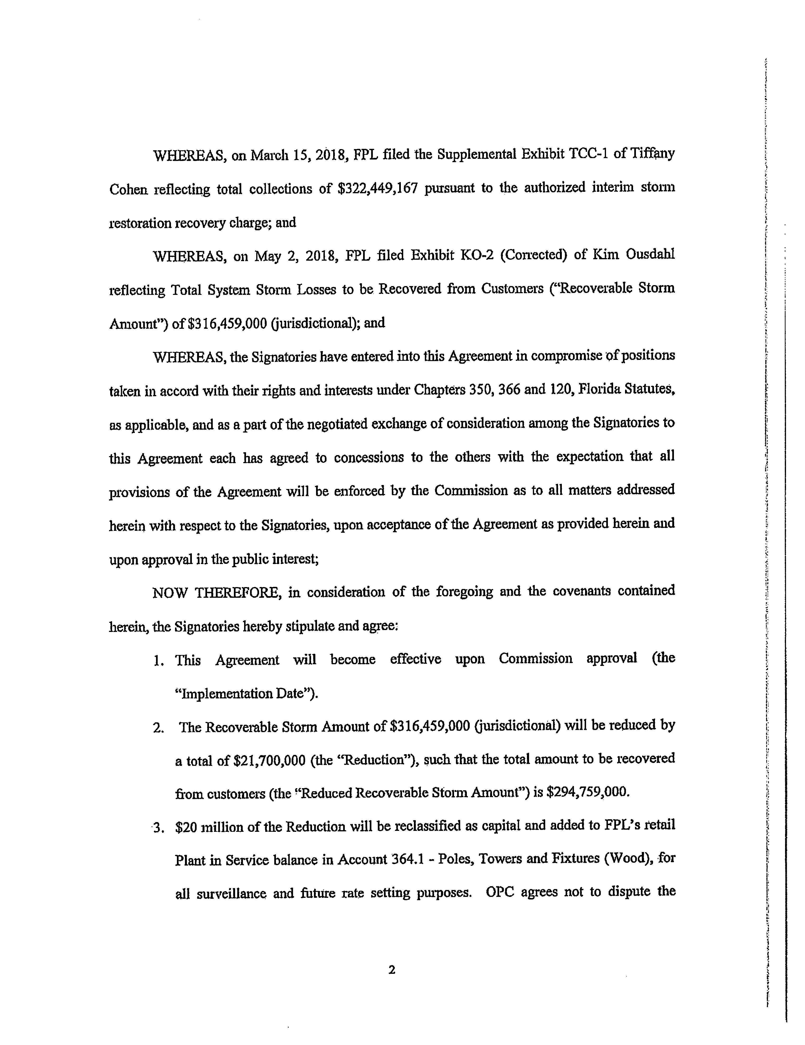

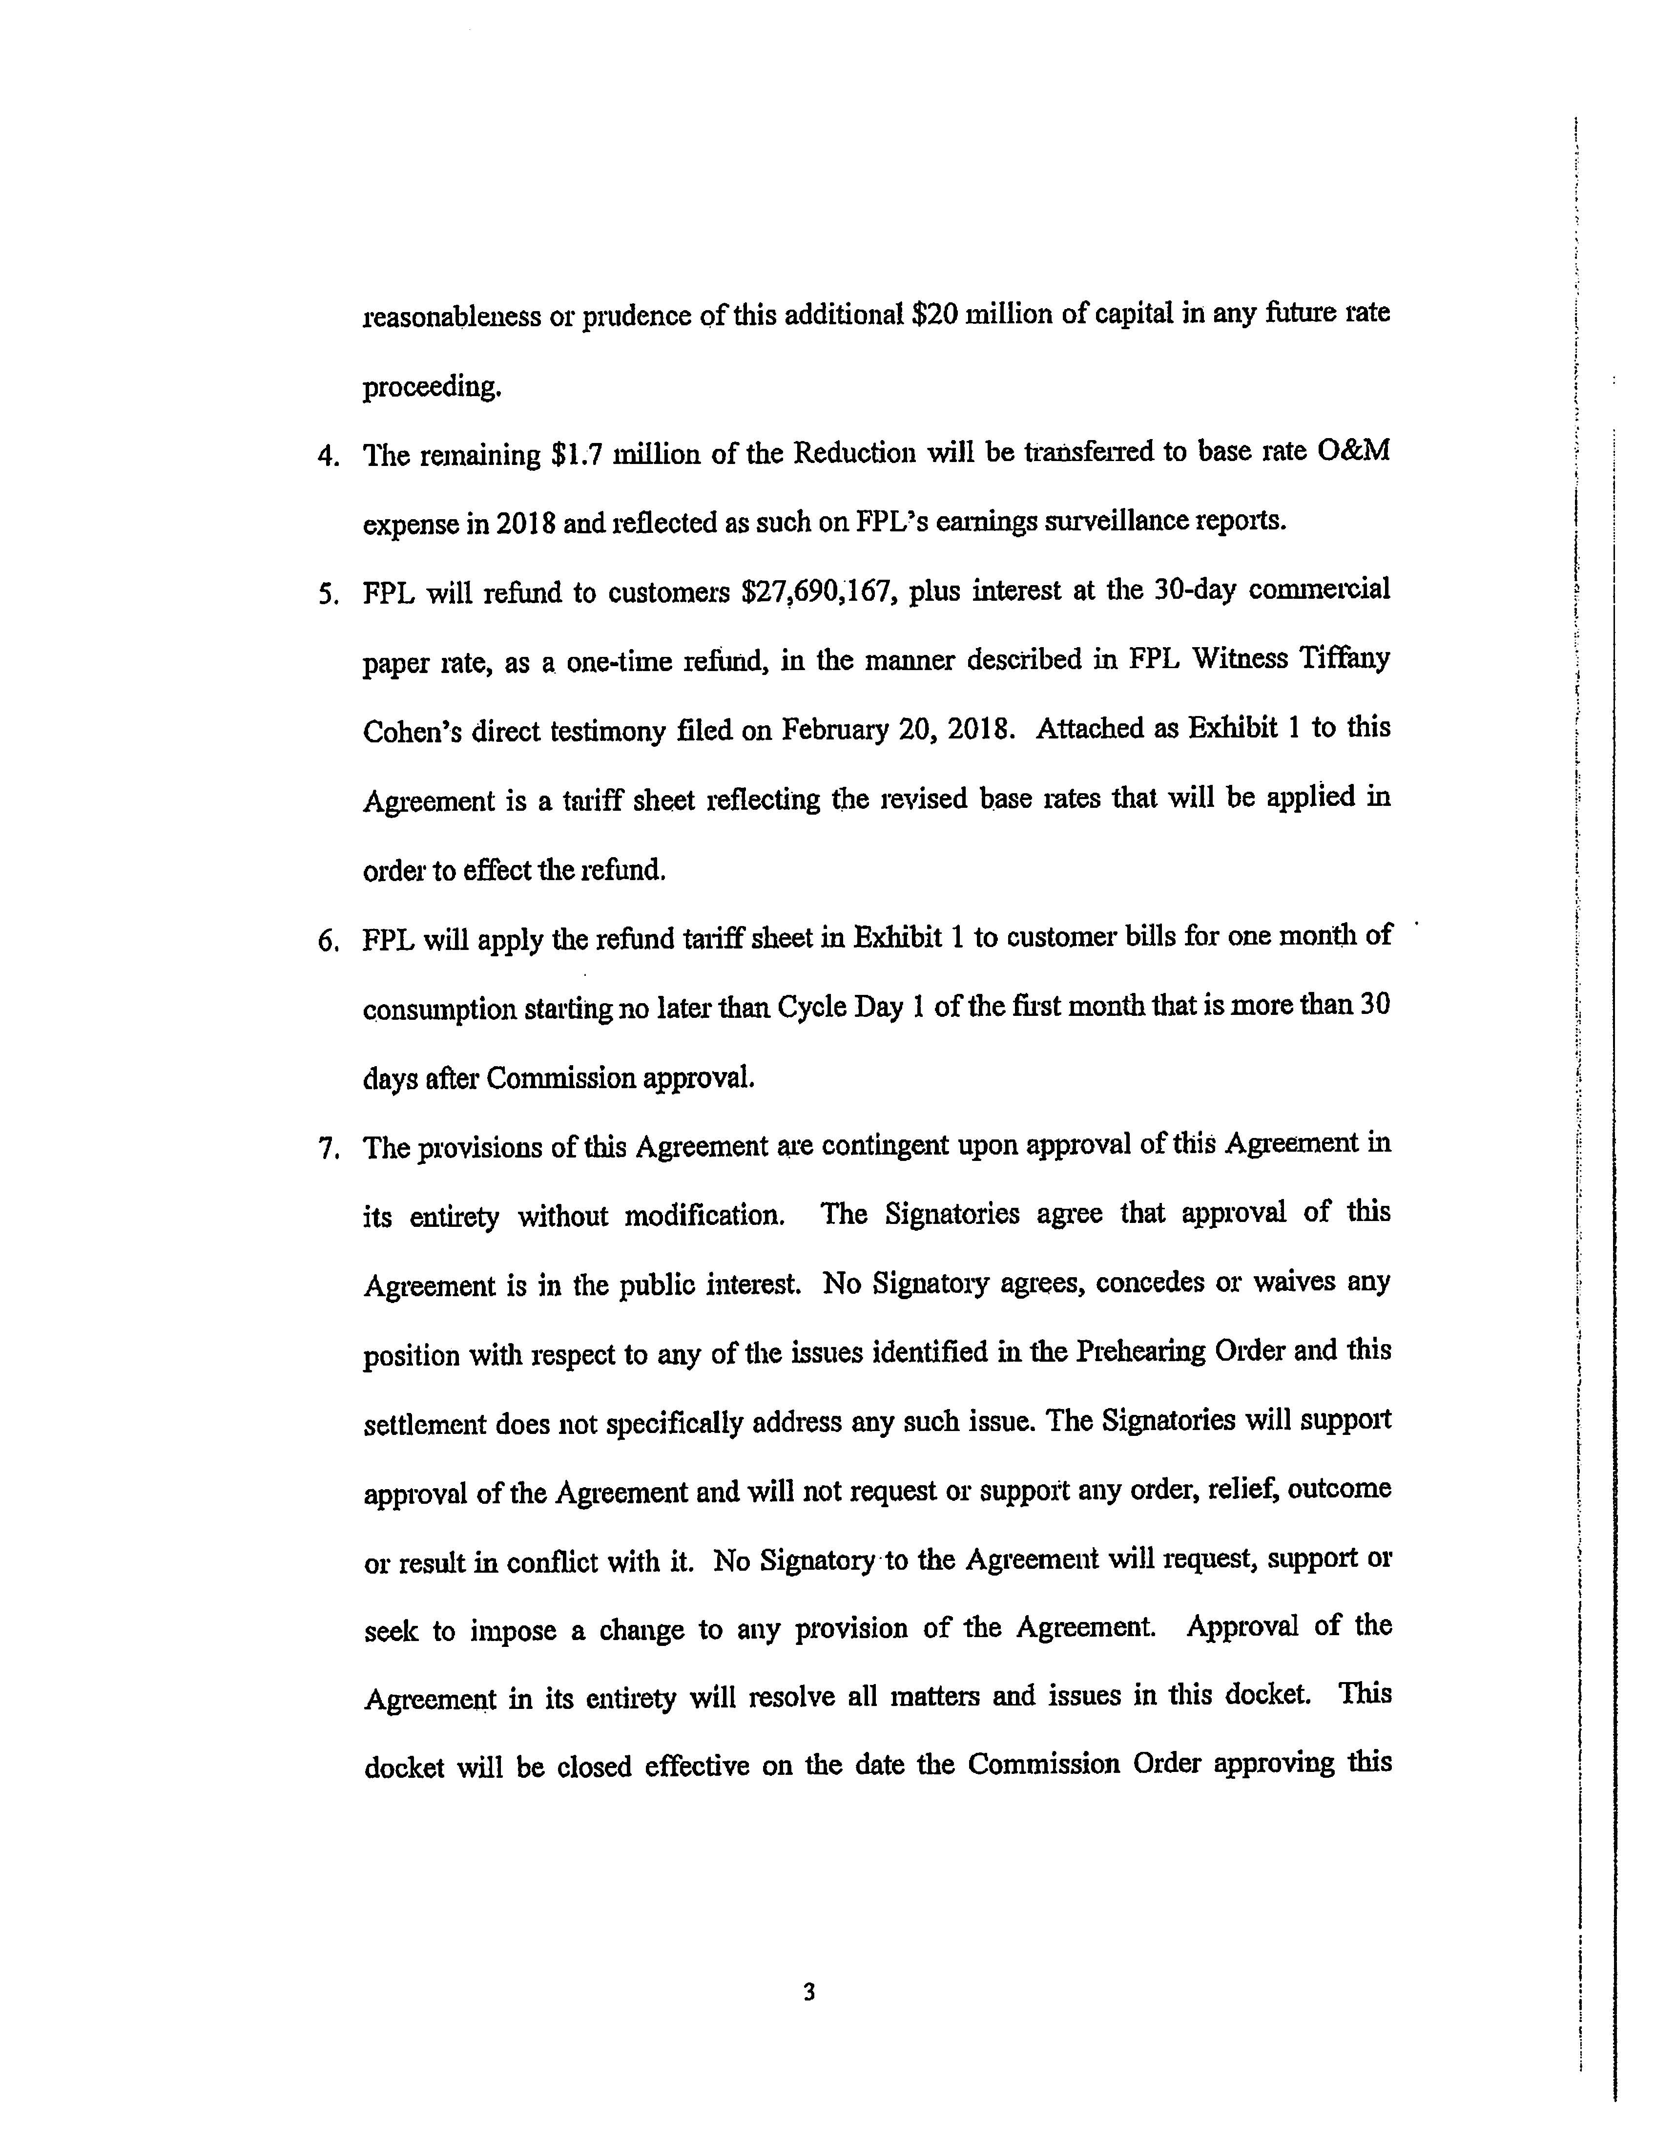

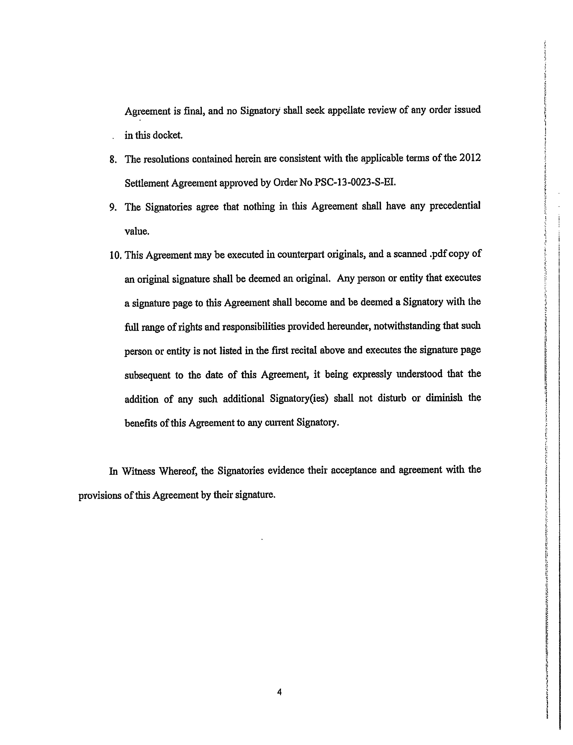

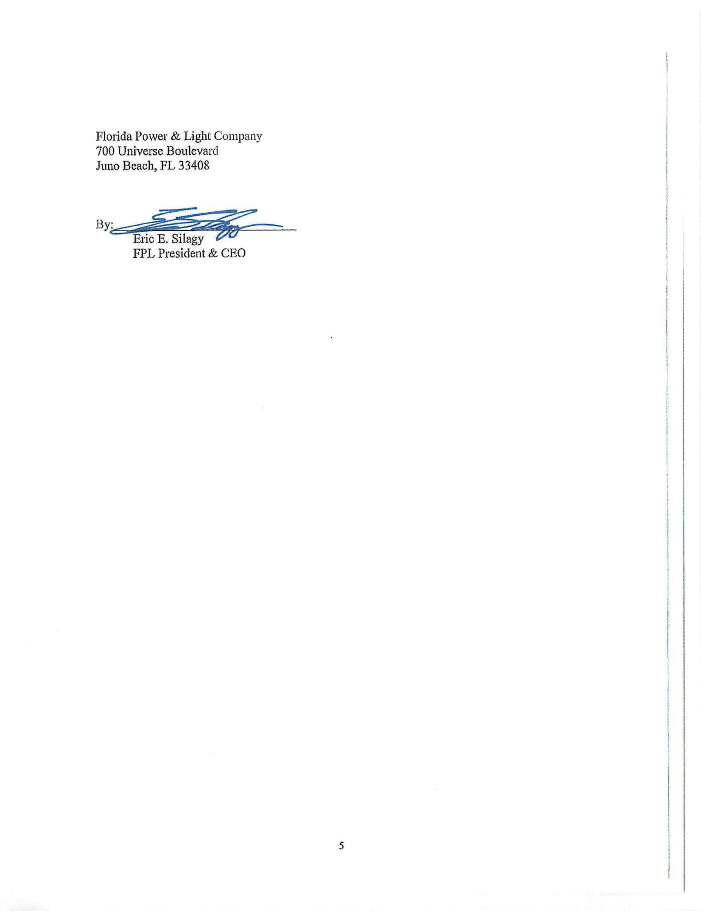

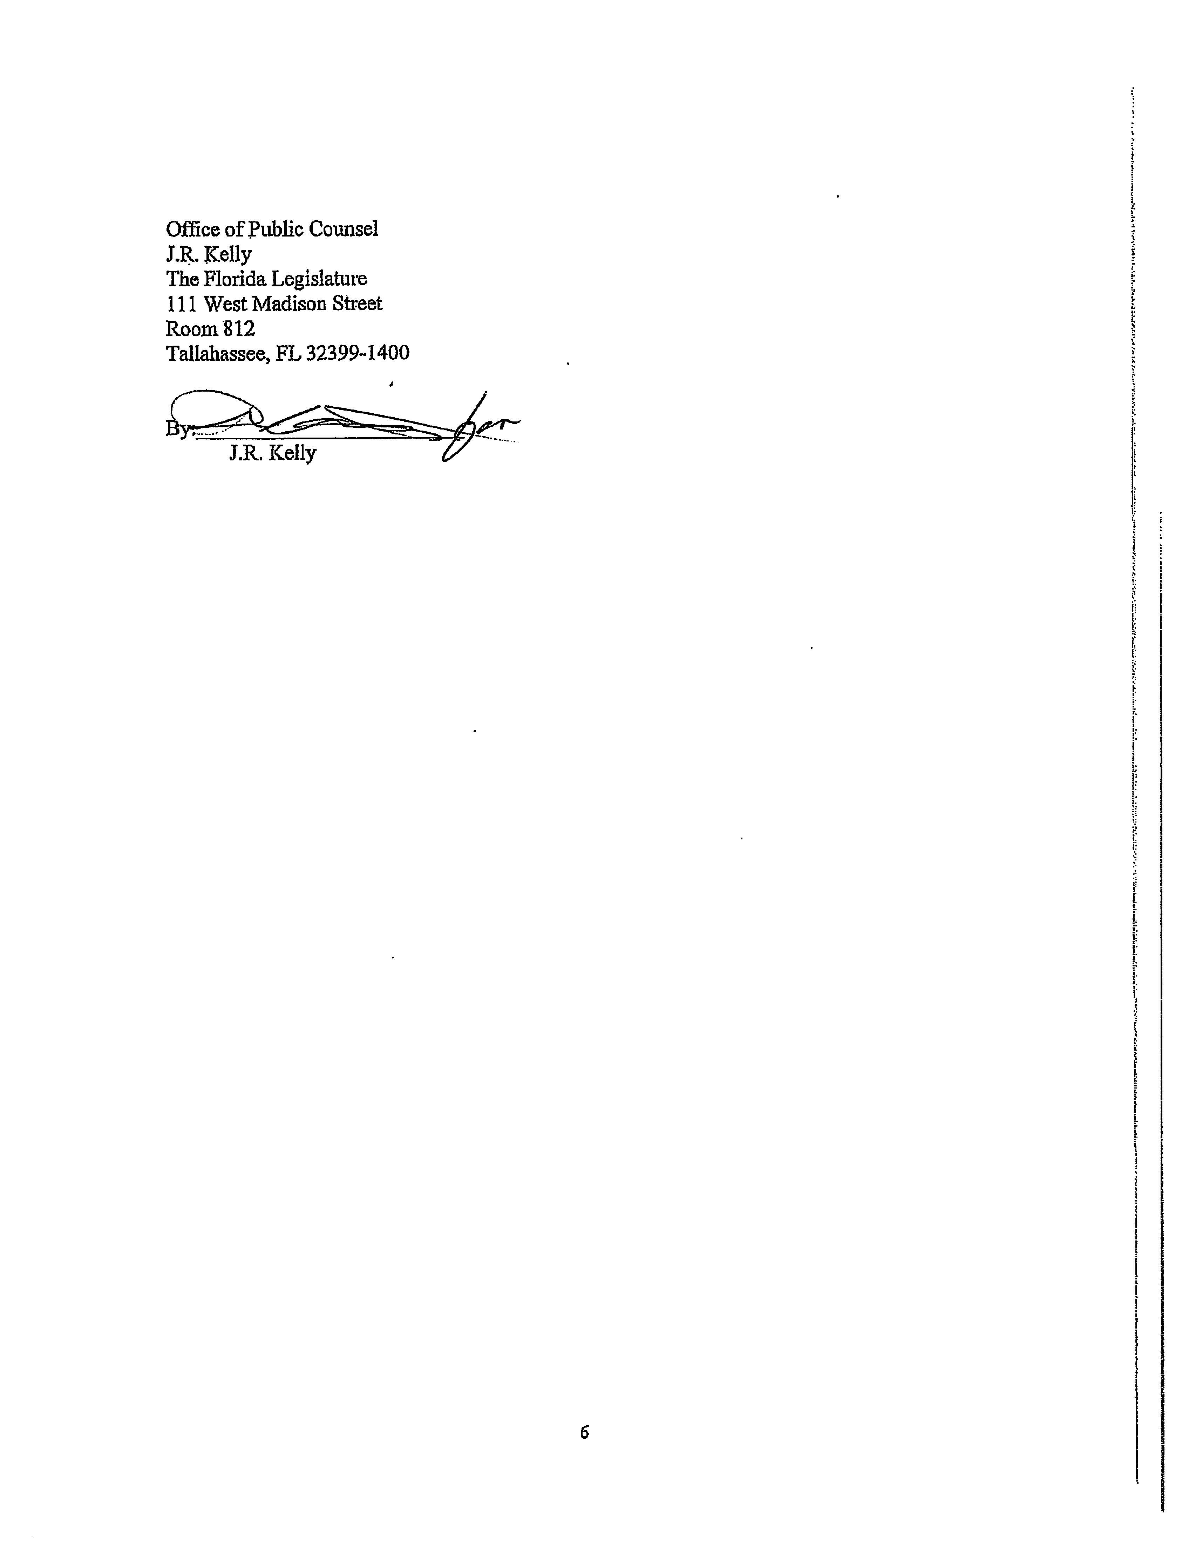

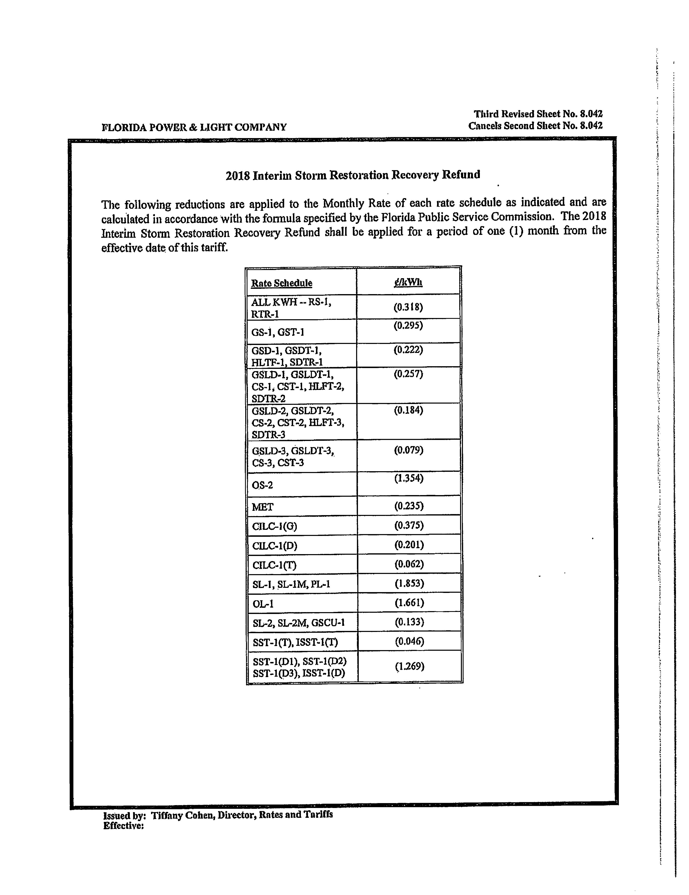

Sierra Club v. Brown, 243 So. 3d 903 (Fla. 2018); Order No. PSC-13-0023-S-EI, issued January 14, 2013, in Docket No. 120015-EI, In re: Petition for increase in rates by Florida Power & Light Company; Order No. PSC-11-0089-S-EI, issued February 1, 2011, in Docket Nos. 080677 and 090130, In re: Petition for increase in rates by Florida Power & Light Company and In re: 2009 depreciation and dismantlement study by Florida Power & Light Company; Order No. PSC-13-0023-S-EI, issued January 14, 2013, in Docket No. 120015-EI, In re: Petition for increase in rates by Florida Power & Light Company; PSC-10-0398-S-EI, issued June 18, 2010, in Docket Nos. 090079-EI, 090144-EI, 090145-EI, 100136-EI, In re: Petition for increase in rates by Progress Energy Florida, Inc., In re: Petition for limited proceeding to include Bartow repowering project in base rates, by Progress Energy Florida, Inc., In re: Petition for expedited approval of the deferral of pension expenses, authorization to charge storm hardening expenses to the storm damage reserve, and variance from or waiver of Rule 25-6.0143(1)(c), (d), and (f), F.A.C., by Progress Energy Florida, Inc., and In re: Petition for approval of an accounting order to record a depreciation expense credit, by Progress Energy Florida, Inc.; Order No. PSC-05-0945-S-EI, issued September 28, 2005, in Docket No. 050078-EI, In re: Petition for rate increase by Progress Energy Florida, Inc.
Order No. PSC-13-0023-S-EI, at p. 7.

