BEFORE THE FLORIDA PUBLIC SERVICE COMMISSION

In re: Petition for approval of tariff modifications, by Tampa Electric Company. | DOCKET NO. 20180182-EI  ORDER NO. PSC-2018-0590-TRF-EI  ISSUED: December 19, 2018

The following Commissioners participated in the disposition of this matter:

ART GRAHAM, Chairman
JULIE I. BROWN
DONALD J. POLMANN
GARY F. CLARK
ANDREW GILES FAY

ORDER APPROVING TARIFF

BY THE COMMISSION:
BACKGROUND
On October 2, 2018, Tampa Electric Company (TECO or utility) filed a petition for approval of a tariff modification relating to refusal or discontinuation of service. The proposed tariff modification is designed to protect TECO’s field employees from dangerous situations resulting from customer threats, as numerous incidents have occurred recently. This Commission approved a similar tariff for Florida Power & Light Company (FPL) in 1996. Peoples Gas System, a division of TECO, filed a similar petition in Docket No. 20180183-GU. The utility’s proposed tariff modification is shown in Attachment A. On October 3, 2018, TECO provided a letter waiving the 60-day file and suspend provision of Section 366.06(3), Florida Statutes (F.S.), until the December 11, 2018 Agenda Conference. TECO responded to staff’s data requests on October 26, 2018, and November 6, 2018. We have jurisdiction pursuant to Sections 366.04, 366.05, and 366.06, F.S.
DECISION
The utility states that its field employees have experienced a number of threats, assaults, and harassments made by customers. In response to Commission staff’s first data request, the utility detailed some of these threats, which ranged from threats against utility property to physical harm of employees.
Utilities currently have the ability to disconnect or refuse service for conditions specified in Rule 25-6.105, F.A.C. Specifically, Rule 25-6.105(5)(f), F.A.C., allows electric utilities to refuse or discontinue service for neglect or refusal to provide safe and reasonable access to the utility provided that written notice be given to the customer. Rule 25-6.105(5)(h), F.A.C., allows the utility to disconnect service without notice in the event of a condition known to the utility to be hazardous.
TECO’s current tariff provides the conditions under which TECO may refuse or discontinue service. As shown in Attachment A, the proposed tariff modification adds subsection (12) to tariff sheet No. 5.150. Subsection (12) states that the utility may refuse or discontinue service:
[f]or actions or threats made by a customer, or anyone on the customer’s premises, which are reasonably perceived by a Company employee as violent or unsafe, after affording the customer reasonable opportunity to cease from any further act of violence or unsafe condition.
As stated in the background, we approved a similar tariff for FPL in 1996. Like TECO’s proposed tariff, FPL’s approved tariff allows FPL to discontinue service as a result of threats made against employees.
To assure that unwarranted disconnections do not occur, the utility explained that the Corporate Security Department will investigate threat incidents and verify whether the actions or threats made by the customer have created a dangerous condition warranting disconnection. TECO’s head of corporate security will notify the utility’s Customer Service Department of valid incidents and will decide whether or not a disconnection notice will be issued to the customer.
In the instances where a customer’s service is being refused pursuant to the proposed tariff modification, the utility stated it will notify the customer as soon as practicable of the reason for refusal of service. The utility states that in most cases, a disconnection will have already taken place, and the restoration of service is what is being denied. TECO notes that it does not take disconnection of its customers or refusal of service lightly and that disconnecting or refusing service will be considered an extreme event that will follow other efforts to remedy the situation, up to and including law enforcement or security escorts. Once the threatening condition is resolved to the utility’s satisfaction, the utility will reconnect the customer.
Having reviewed TECO’s petition and responses to data requests we find that TECO’s proposed tariff modification is warranted. Additionally, we find that the proposed tariff modification is consistent with the tariff provision we approved for FPL and is consistent with Rule 25-6.105, F.A.C. Therefore, we hereby approve TECO’s proposed tariff modification effective on December 11, 2018.
Based on the foregoing, it is
ORDERED by the Florida Public Service Commission that modifications to Tampa Electric Company’s Fifth Revised Tariff Sheet No. 5.150, Attachment A, are hereby approved. It is further
ORDERED that Fifth Revised Tariff Sheet No. 5.150 shall become effective on December 11, 2018. It is further
ORDERED that if a protest is filed within 21 days of the issuance of this order, the tariff shall be suspended, and this docket shall remain opening pending resolution of the protest. However, if a timely protest is not filed, this docket shall be closed upon the issuance of a consummating order.
By ORDER of the Florida Public Service Commission this 19th day of December, 2018.

/s/ Carlotta S. Stauffer
CARLOTTA S. STAUFFER
Commission Clerk
Florida Public Service Commission
2540 Shumard Oak Boulevard
Tallahassee, Florida 32399
(850) 413-6770
www.floridapsc.com

Copies furnished: A copy of this document is provided to the parties of record at the time of issuance and, if applicable, interested persons.

SBr
NOTICE OF FURTHER PROCEEDINGS

The Florida Public Service Commission is required by Section 120.569(1), Florida Statutes, to notify parties of any administrative hearing or judicial review of Commission orders that is available under Sections 120.57 or 120.68, Florida Statutes, as well as the procedures and time limits that apply. This notice should not be construed to mean all requests for an administrative hearing or judicial review will be granted or result in the relief sought.

Mediation may be available on a case-by-case basis. If mediation is conducted, it does not affect a substantially interested person's right to a hearing.

The Commission's decision on this tariff is interim in nature and will become final, unless a person whose substantial interests are affected by the proposed action files a petition for a formal proceeding, in the form provided by Rule 28-106.201, Florida Administrative Code. This petition must be received by the Office of Commission Clerk, 2540 Shumard Oak Boulevard, Tallahassee, Florida 32399-0850, by the close of business on January 9, 2019.

In the absence of such a petition, this Order shall become final and effective upon the issuance of a Consummating Order.

Any objection or protest filed in this docket before the issuance date of this order is considered abandoned unless it satisfies the foregoing conditions and is renewed within the specified protest period.

ATTACHMENT A
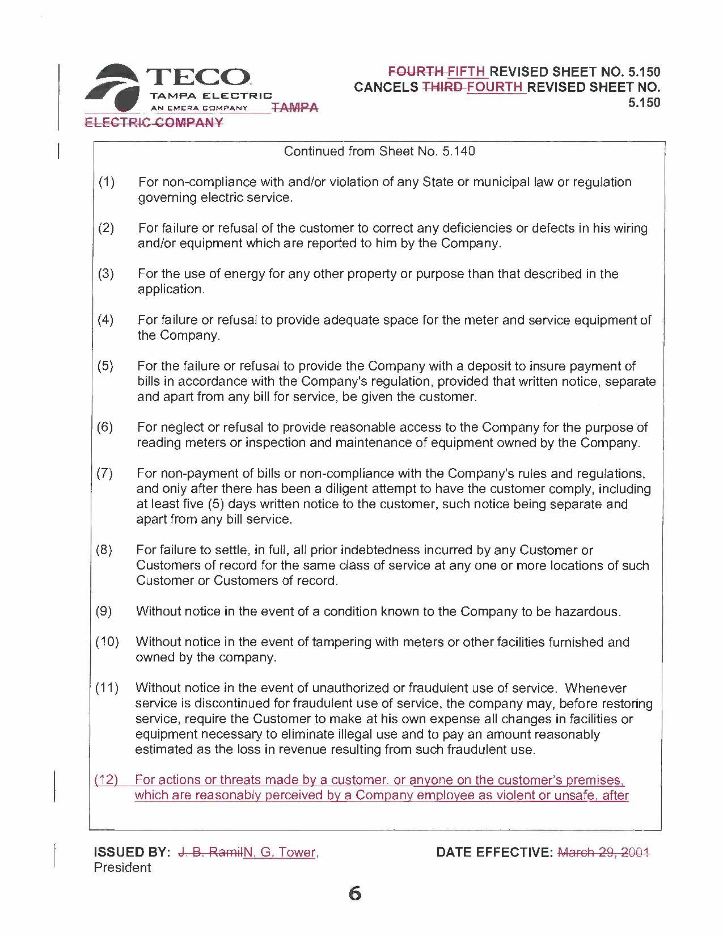
ATTACHMENT A
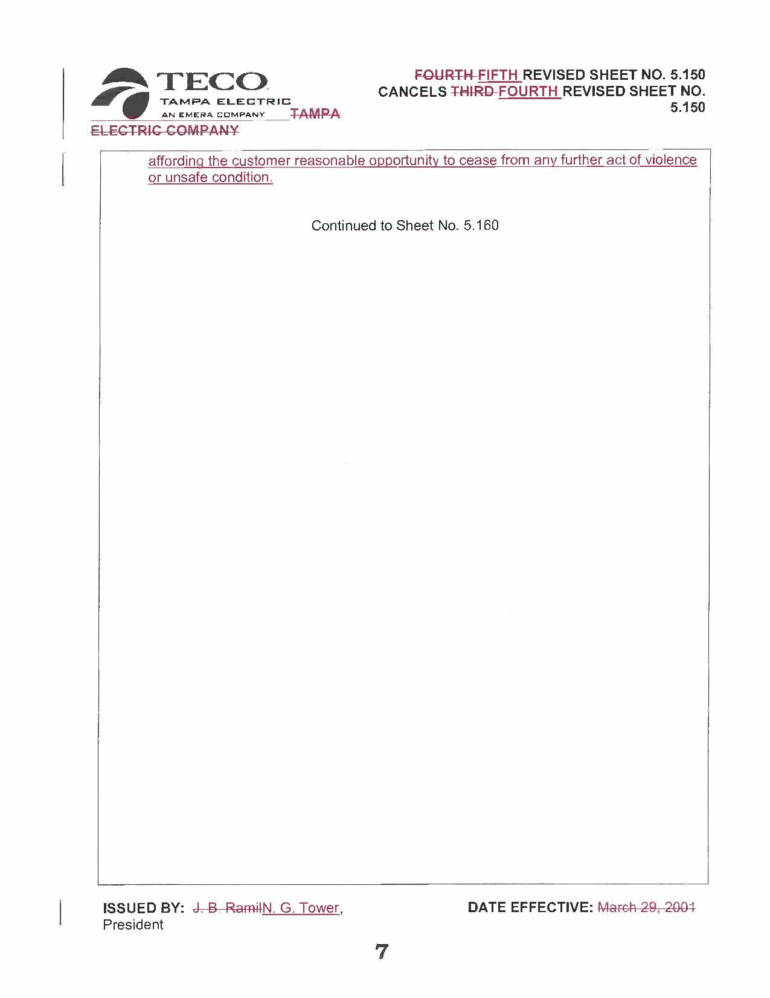

Order No. PSC-96-0585-FOF-EI, issued May 6, 1996, in Docket No. 960307-EI, In re: Proposed revision of rules and regulations, pertaining to access portion of tariff, by Florida Power & Light Company.
See FPL tariff sheet No. 6.010, section 1.6 - Discontinuance of Service.

