BEFORE THE FLORIDA PUBLIC SERVICE COMMISSION

In re: Bankruptcy compliance cancellation by Florida Public Service Commission of CLEC Certificate No. 8244, issued to Trans National Communications International, Inc., effective December 31, 2018. | DOCKET NO. 20180205-TX
In re: Bankruptcy compliance cancellation by Florida Public Service Commission of PATS Certificate No. 5995, issued to Florida Gaming Centers, Inc., effective December 31, 2018. | DOCKET NO. 20180206-TC
In re: Bankruptcy compliance cancellation by Florida Public Service Commission of CLEC Certificate No. 4847, issued to OneStar Long Distance, Inc., effective December 31, 2018. | DOCKET NO. 20180207-TX
In re: Bankruptcy compliance cancellation by Florida Public Service Commission of CLEC Certificate No. 8382, issued to Baldwin County Internet/DSSI Service, L.L.C., effective December 31, 2018. | DOCKET NO. 20180208-TX
In re: Bankruptcy compliance cancellation by Florida Public Service Commission of CLEC Certificate No. 8748, issued to iNetworks Group, Inc., effective December 31, 2018. | DOCKET NO. 20180209-TX  ORDER NO. PSC-2018-0593-PAA-TP  ISSUED: December 19, 2018

The following Commissioners participated in the disposition of this matter:

ART GRAHAM, Chairman
JULIE I. BROWN
DONALD J. POLMANN
GARY F. CLARK
ANDREW GILES FAY

NOTICE OF PROPOSED AGENCY ACTION
ORDER CANCELLING COMPETITIVE LOCAL EXCHANGE
TELECOMMUNICATIONS COMPANY CERTIFICATES
AND PAY TELEPHONE SERVICE CERTIFICATES
AND SERVICE SCHEDULES DUE TO BANKRUPTCY
ON THE COMMISSION’S OWN MOTION

BY THE COMMISSION:

NOTICE is hereby given by the Florida Public Service Commission that the action discussed herein is preliminary in nature and will become final unless a person whose interests are substantially affected files a petition for a formal proceeding, pursuant to Rule 25-22.029, Florida Administrative Code.

Case Background
Pursuant to Section 364.336, Florida Statutes (F.S.), telecommunications companies must pay a minimum annual Regulatory Assessment Fee (RAF) if the company’s certificate was active during any portion of the calendar year. Section 350.113, F.S., provides for penalties and interest on any delinquent amounts. This Order addresses telecommunications companies that currently have active certificates, but have entered either Chapter 11 bankruptcy proceedings or Chapter 7 bankruptcy proceedings. In a Chapter 11 bankruptcy proceeding, the daily operations of the company continue while the company works to reorganize its business in order to become profitable again. In a Chapter 7 bankruptcy proceeding, the company stops all operations and goes completely out of business.

Trans National Communications International, Inc. (Trans National) currently holds competitive local exchange telecommunications company (CLEC) Certificate No. 8244, issued by this Commission on December 4, 2002. Trans National filed for Chapter 11 bankruptcy on October 9, 2011, and the case was terminated on January 26, 2016. Trans National has not paid its RAFs or the penalties and interest assessed for the years 2014, 2015, 2016, 2017, and 2018.

Florida Gaming Centers, Inc. (Florida Gaming) currently holds pay telephone service (PATS) Certificate No. 5995, issued by this Commission on February 16, 1999. Florida Gaming filed for Chapter 11 bankruptcy on August 19, 2013, and the case was terminated on August 22, 2017. Florida Gaming has not paid its RAFs or the penalties and interest assessed for the years 2014, 2015, 2016, 2017, and 2018.

OneStar Long Distance, Inc. (OneStar) currently holds CLEC Certificate No. 4847, issued by this Commission on May 9, 2003. OneStar filed for Chapter 11 bankruptcy on December 31, 2003, but RAFs have not been assessed for OneStar since January 13, 2005, when the company converted to Chapter 7 bankruptcy.

Baldwin County Internet/DSSI Service, L.L.C. (Baldwin County) currently holds CLEC Certificate No. 8382, issued by this Commission on September 17, 2003. Baldwin County filed for Chapter 11 bankruptcy on April 26, 2012. RAFs have not been assessed for Baldwin County since October 15, 2012, when the company converted to Chapter 7 bankruptcy.

iNetworks Group, Inc. (iNetworks) currently holds CLEC Certificate No. 8748, issued by this Commission on March 6, 2009. RAFs have not been assessed on iNetworks since August 11, 2017, when the company filed for Chapter 7 bankruptcy.

We have jurisdiction over these matters pursuant to Section 364.336, F.S.

Analysis and Decision
I. Chapter 11 Bankruptcy Companies

Our searches of the Public Access to Court Electronic Records (PACER) system show that on October 9, 2011, Trans National filed for Chapter 11 bankruptcy in the U.S. Bankruptcy Court for the District of Massachusetts. The bankruptcy case was closed on January, 26, 2016. Trans National has not paid the RAFs, or the late penalties and interest assessed, for the years 2014, 2015, 2016, 2017, and 2018.
Trans National has not responded to our requests to update contact information or data requests. We reviewed Trans National’s records on the Florida Department of State, Division of Corporations website, which show that the company’s last annual report was filed on April 12, 2013, and that its corporate status was listed as “inactive” as of February 6, 2014. The Federal Communications Commission (FCC) Form 499 Filer Database lists Trans National as no longer active as of April 30, 2013.,
Our searches of the PACER system show that on August 19, 2013, Florida Gaming filed for Chapter 11 bankruptcy in the U.S. Bankruptcy Court for the Southern District of Florida, and that the bankruptcy case was closed on August 22, 2017. Florida Gaming has not paid the RAFs or the late penalties and interest assessed for the years 2014, 2015, 2016, 2017, and 2018.
Florida Gaming has not responded to our requests to update contact information or data requests. All mail sent by us has been returned as undeliverable by the U.S. Postal Service, and the telephone numbers on file for the company are out of service. We reviewed Florida Gaming’s records on the Florida Department of State, Division of Corporations website, which show that the company’s last annual report was filed on April 16, 2014, and that its corporate status was listed as “administrative dissolution for annual report” as of September 25, 2015. The FCC Form 499 Filer Database has no listing for Florida Gaming.
Pursuant to Chapter 11 U.S. Code §362(a), the filing of a petition for Chapter 11 bankruptcy relief acts as an automatic stay that enjoins a governmental entity from exercising its regulatory authority to collect a pre-petition debt. Additionally, in any bankruptcy liquidation or reorganization, secured creditors are given the highest priority in the distribution and, normally, receive all of the distributed assets. RAFs, late payment charges, and penalties owed to us by a company, as well as monetary settlements of cases resolving issues of failure to pay such fees, are not secured debts and, as a practical matter, are uncollectible. Therefore, we would be prevented from collecting pre-bankruptcy RAFs owed by these companies, and from assessing and collecting a penalty for failure to pay the fees.
While we are enjoined from collecting pre-petition debts, companies in Chapter 11 bankruptcy are required to pay post-petition expenses as incurred. Trans National and Florida Gaming have both exited Chapter 11 bankruptcy, but neither has paid any RAFs for any years after declaring and after exiting bankruptcy. Furthermore, as indicated above, it appears that the companies are no longer providing service in Florida.
Pursuant to Section 364.336, F.S., certificate holders must pay a minimum annual RAF if the certificate was active during any portion of the calendar year. Section 350.113, F.S., provides for penalties and interest for any delinquent amounts.
It appears that Trans National and Florida Gaming have failed to comply with Section 364.336, F.S., following their discharge from Chapter 11 bankruptcy. The companies have not paid RAFs or statutory late payment charges as detailed in Attachment A. Therefore, we shall, on our own motion, cancel Trans National’s CLEC certificate and Florida Gaming’s PATS certificate and service schedules (if any) for failure to pay RAFs following the companies’ discharge from Chapter 11 bankruptcy. The companies’ status shall be changed to “cancelled” in the Master Commission Directory, effective December 31, 2018, and the Division of Administrative and Information Technology Services (AIT) shall write off any unpaid regulatory assessment fees and statutory late payment charges, penalties, and interest instead of requesting collection services. We further find that the companies shall immediately cease and desist providing telecommunications services in Florida.
II. Chapter 7 Bankruptcy Companies
Our searches of the PACER system show that OneStar, Baldwin County, and iNetworks are currently in Chapter 7 bankruptcy. According to the U.S. Securities and Exchange Commission, “[U]nder Chapter 7, the company stops all operations and goes completely out of business. A trustee is appointed to "liquidate" (sell) the company's assets and the money is used to pay off the debt, which may include debts to creditors and investors.” ,
A company undergoing Chapter 7 bankruptcy proceedings will no longer be able to serve its customers or to meet its obligations as the holder of a certificate of authority. Upon notification that a company has initiated a Chapter 7 bankruptcy case, we cease to bill for RAFs, and we do not assess any penalties or interest, because RAFs owed are not secured debts and, as a practical matter, are uncollectible. Therefore, we shall, on our own motion, cancel OneStar, Baldwin County, and iNetworks’s CLEC certificates and service schedules (if any) because of the companies’ status as Chapter 7 bankruptcy liquidations; change the companies’ status to “cancelled” in the Master Commission Directory effective December 31, 2018; and require the companies to immediately cease and desist providing telecommunications services in Florida.

Based on the foregoing, it is

ORDERED by the Florida Public Service Commission that Trans National Communications International, Inc.’s CLEC Certificate No. 8244 and service schedule (if any) is cancelled and its status changed to “cancelled” in the Master Commission Directory, effective December 31, 2018, and that Trans National Communications International, Inc. shall immediately cease and desist providing telecommunications services in Florida. It is further

ORDERED that Florida Gaming Centers, Inc.’s PATS Certificate No. 5995 and service schedule (if any) is cancelled and its status changed to “cancelled” in the Master Commission Directory, effective December 31, 2018, and that Florida Gaming Centers, Inc. shall immediately cease and desist providing telecommunications services in Florida. It is further

ORDERED that OneStar Long Distance, Inc.’s CLEC Certificate No. 4847 and service schedule (if any) is cancelled and its status changed to “cancelled” in the Master Commission Directory, effective December 31, 2018, and that OneStar Long Distance, Inc. shall immediately cease and desist providing telecommunications services in Florida. It is further

ORDERED that Baldwin County Internet/DSSI Service, L.L.C.’s CLEC Certificate No. 8382 and service schedule (if any) is cancelled and its status changed to “cancelled” in the Master Commission Directory, effective December 31, 2018, and that Baldwin County Internet/DSSI Service, L.L.C. shall immediately cease and desist providing telecommunications services in Florida. It is further

ORDERED that iNetworks Group, Inc.’s CLEC Certificate No. 8748 and service schedule (if any) is cancelled and its status changed to “cancelled” in the Master Commission Directory, effective December 31, 2018, and that iNetworks Group, Inc. shall immediately cease and desist providing telecommunications services in Florida. It is further

ORDERED that the Division of Administrative and Information Technology Services shall write off any unpaid Regulatory Assessment Fees and statutory late payment charges, penalties, and interest accrued, instead of requesting collection services, for Trans National Communications International, Inc. and Florida Gaming Centers, Inc. It is further

ORDERED that the provisions of this Order, issued as a Proposed Agency Action, shall become final and effective upon the issuance of a Consummating Order unless an appropriate petition, in the form provided by Rule 28-106.201, Florida Administrative Code, is received by the Commission Clerk, 2540 Shumard Oak Boulevard, Tallahassee, Florida 32399-0850, by the close of business on the date set forth in the “Notice of Further Proceedings” attached hereto. It is further
ORDERED that if no person whose substantial interests are affected by this Proposed Agency Action files a protest within 21 days of the issuance of this Order, these dockets should be closed upon the issuance of a Consummating Order. If a protest is filed in one docket, the protest should not prevent the action in a separate docket from becoming final.

By ORDER of the Florida Public Service Commission this 19th day of December, 2018.

/s/ Carlotta S. Stauffer
CARLOTTA S. STAUFFER
Commission Clerk
Florida Public Service Commission
2540 Shumard Oak Boulevard
Tallahassee, Florida 32399
(850) 413-6770
www.floridapsc.com

Copies furnished: A copy of this document is provided to the parties of record at the time of issuance and, if applicable, interested persons.

RAD

NOTICE OF FURTHER PROCEEDINGS OR JUDICIAL REVIEW

The Florida Public Service Commission is required by Section 120.569(1), Florida Statutes, to notify parties of any administrative hearing that is available under Section 120.57, Florida Statutes, as well as the procedures and time limits that apply. This notice should not be construed to mean all requests for an administrative hearing will be granted or result in the relief sought.

Mediation may be available on a case-by-case basis. If mediation is conducted, it does not affect a substantially interested person's right to a hearing.

The action proposed herein is preliminary in nature. Any person whose substantial interests are affected by the action proposed by this order may file a petition for a formal proceeding, in the form provided by Rule 28-106.201, Florida Administrative Code. This petition must be received by the Office of Commission Clerk, 2540 Shumard Oak Boulevard, Tallahassee, Florida 32399-0850, by the close of business on January 9, 2019.

In the absence of such a petition, this order shall become final and effective upon the issuance of a Consummating Order.

Any objection or protest filed in this/these docket(s) before the issuance date of this order is considered abandoned unless it satisfies the foregoing conditions and is renewed within the specified protest period.

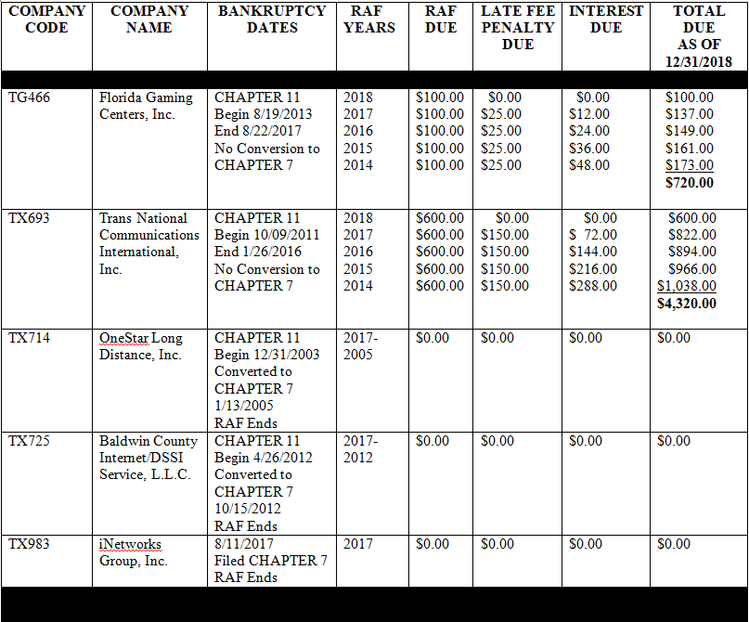

See “Bankruptcy: What Happens When Public Companies Go Bankrupt,” U.S. Securities and Exchange Commission, published February 3, 2009, https://www.sec.gov/reportspubs/investor-publications/investorpubsbankrupthtm.html.
Id.
See http://apps.fcc.gov/cgb/form499/499detail.cfm?FilerNum=817852
FCC Form 499 is used to facilitate the quarterly and annual revenue reporting requirements for telecommunications companies. The FCC Form 499 Filer Database is a compilation of all telecommunications companies that are required to file either Form 499-Q or Form 499-A. It contains company information such as the company’s name, address, designated agent, and jurisdictions in which it provides service.
See 11 U.S. Code §§503 and 721, 28 U.S. Code §959.
See “Bankruptcy: What Happens When Public Companies Go Bankrupt,” U.S. Securities and Exchange Commission, published February 3, 2009, https://www.sec.gov/reportspubs/investor-publications/investorpubsbankrupthtm.html.
See 11 U.S. Code §721.
See Attachment A.

