BEFORE THE FLORIDA PUBLIC SERVICE COMMISSION

In re: Joint petition for approval of territorial agreement in Jefferson, Madison and Taylor Counties, by Tri-County Electric Cooperative and Duke Energy Florida, LLC. | DOCKET NO. 20200217-EU  ORDER NO. PSC-2021-0041-PAA-EU  ISSUED: January 25, 2021

The following Commissioners participated in the disposition of this matter:

GARY F. CLARK, Chairman
ART GRAHAM
JULIE I. BROWN
ANDREW GILES FAY
MIKE LA ROSA

NOTICE OF PROPOSED AGENCY ACTION
ORDER APPROVING TERRITORIAL AGREEMENT

BY THE COMMISSION:

NOTICE is hereby given by the Florida Public Service Commission that the action discussed herein is preliminary in nature and will become final unless a person whose interests are substantially affected files a petition for a formal proceeding, pursuant to Rule 25-22.029, Florida Administrative Code (F.A.C.).

Background
On September 16, 2020, Tri-County Electric Cooperative (TCEC) and Duke Energy Florida, LLC (DEF) filed a joint petition seeking approval of their modified territorial agreement (Territorial Agreement) in Jefferson, Madison, and Taylor counties. We approved the joint petitioners’ original territorial agreement in Order No. PSC-92-1214-FOR-EU. The proposed modified Territorial Agreement seeks to transfer 193 TCEC customers to DEF and 225 DEF customers to TCEC. The joint petitioners have also negotiated respective service boundaries in Jefferson, Madison, and Taylor counties. The proposed Territorial Agreement is Attachment A, responses to Commission staff’s second data request correcting errors in the Territorial Agreement is Attachment B, and the maps are Attachment C. Pursuant to Rule 25-6.0440(1)(a), Florida Administrative Code (F.A.C.), the joint petitioners provided a written description of the territorial boundaries in Exhibit D of the petition. Pursuant to Rule 25-6.0440(1)(d), F.A.C., the customers subject to the transfer were notified by letter (Exhibit E of the petition).
The proposed modified Territorial Agreement establishes the new territorial boundaries reflecting the assets and customers transferred between TCEC and DEF. During the review process, Commission staff issued two data requests to the joint petitioners to which responses were received on November 4, 2020 and on November 19, 2020. We have jurisdiction over this matter pursuant to Section 366.04, Florida Statutes (F.S.).

Decision

Pursuant to Section 366.04(2)(d), F.S., and Rule 25-6.0440(2), F.A.C., we have jurisdiction to approve territorial agreements between and among rural electric cooperatives, municipal electric utilities, and other electric utilities. Unless we determine that the agreement will cause a detriment to the public interest, the agreement should be approved.

The Proposed Modified Territorial Agreement

TCEC and DEF entered into the proposed Territorial Agreement on September 15, 2020, to replace the 1992 Territorial Agreement which expired in October 2012. The joint petitioners have negotiated the agreement delineating their respective modified service boundaries in each county that is part of this proposed Territorial Agreement. In response to Commission staff’s first data request, the joint petitioners stated that since 2012, they continued to collaborate to provide service and perform due diligence activities to update and revise the agreement. Upon its approval by us, and pursuant to Section 5.3, the proposed Territorial Agreement will supersede any and all prior agreements between the parties in Jefferson, Madison, and Taylor counties. Through the proposed Territorial Agreement, the joint petitioners seek to gain operational efficiencies and customer service improvements in their respective retail service territories in Jefferson, Madison, and Taylor counties and eliminate circumstances leading to uneconomic duplication of service facilities and hazardous situations. The Territorial Agreement represents the continued effort by the parties to minimize unnecessary duplication of generation, transmission, and distribution facilities and accurately delineate their respective service boundaries which are contiguous.
The proposed Territorial Agreement has been negotiated for a term of 30 years from the date our order approving the Territorial Agreement in its entirety is no longer subject to judicial review. Pursuant to Section 6.1 of the proposed Territorial Agreement, upon the expiration of the initial 30-year term, the Territorial Agreement shall remain in effect until either party provides written notification to terminate no less than 12 months prior to the termination date in accordance with Section 8.2 of the Territorial Agreement. Pursuant to Article V of the Territorial Agreement, any modifications to this agreement will be submitted to us for approval.

Customer and Facilities Transfer

This proposed Territorial Agreement contemplates the transfer of 193 TCEC customers (12 commercial, 181 residential) to DEF and 225 DEF customers (37 commercial, 188 residential) to TCEC. Section 3.5 of the proposed Territorial Agreement contemplates the transfer of these customers and the associated facilities in segments. A segment is based on geographic location and engineering requirements needed to complete the transfer. In response to Commission staff’s first data request, the petitioners stated that the transfer of these customers will be conducted in between 10 to 15 transfer segments based on geographic location and engineering requirements. Paragraph 5 of the petition and Section 3.1 of the Territorial Agreement state that the joint petitioners intend to complete all transfers within 36 months of the effective date of this Agreement. Pursuant to Sections 3.3 and 3.4 of the proposed Agreement, the receiving party of transferred customers may elect to purchase electric distribution facilities from the transferring party for the purpose of providing electricity to those customers. Purchase price and compensation will be determined by applying an industry cost calculator such as the Handy Whitman Index or a common engineering cost estimation methodology to the original cost.

Customer Notification

Pursuant to Rule 25-6.0440(1)(d), F.A.C., in early 2020, TCEC and DEF informed customers subject to transfer by letters of the impending transfers and rate comparisons for February 2020. The written notifications indicate a February residential rate of $123.99 for 1,000 kilowatt-hours (kWh) for DEF and $131.28 for 1,000 kWh for TCEC. The sample customer notification letters are included as Exhibit E in the petition. In response to Commission staff’s first data request, the joint petitioners provided September 2020 residential rates indicating $130.26 for DEF and $125.00 for TCEC for 1,000 kWh. In response to a supplemental request by Commission staff, the joint petitioners confirmed that the transferred customers will be billed pursuant to their new utility’s rates. Paragraph 6 of the petition states that, at the time of the filing, the petitioners have not received any negative responses to the customer notifications. Additionally, no customer comments or concerns have been filed in the docket file.

Conclusion

After review of the petition, the proposed modified Territorial Agreement, and evaluation of responses to Commission staff’s data requests, we find that the proposed Territorial Agreement will not be a detriment to the public interest and will enable TCEC and DEF to serve their current and future customers in an efficient manner.
The approval of this Territorial Agreement will not be a detriment to the public interest and it will enable TCEC and DEF to avoid duplication of facilities. We hereby approve the modified Territorial Agreement between TCEC and DEF, effective on the date our order approving the 2020 Territorial Agreement becomes final.
Based on the foregoing, it is

ORDERED by the Florida Public Service Commission that the modified Territorial Agreement in Jefferson, Madison, and Taylor counties between TCEC and DEF is hereby approved, effective on the date our order approving the 2020 Territorial Agreement becomes final. It is further

ORDERED that the provisions of this Order, issued as proposed agency action, shall become final and effective upon the issuance of a Consummating Order unless an appropriate petition, in the form provided by Rule 28-106.201, Florida Administrative Code, is received by the Commission Clerk, 2540 Shumard Oak Boulevard, Tallahassee, Florida 32399-0850, by the close of business on the date set forth in the “Notice of Further Proceedings” attached hereto. It is further
ORDERED that in the event this Order becomes final, this docket shall be closed.

By ORDER of the Florida Public Service Commission this 25th day of January, 2021.

/s/ Adam J. Teitzman
ADAM J. TEITZMAN
Commission Clerk
Florida Public Service Commission
2540 Shumard Oak Boulevard
Tallahassee, Florida 32399
(850) 413-6770
www.floridapsc.com

Copies furnished: A copy of this document is provided to the parties of record at the time of issuance and, if applicable, interested persons.
SJO

NOTICE OF FURTHER PROCEEDINGS OR JUDICIAL REVIEW

The Florida Public Service Commission is required by Section 120.569(1), Florida Statutes, to notify parties of any administrative hearing that is available under Section 120.57, Florida Statutes, as well as the procedures and time limits that apply. This notice should not be construed to mean all requests for an administrative hearing will be granted or result in the relief sought.

Mediation may be available on a case-by-case basis. If mediation is conducted, it does not affect a substantially interested person's right to a hearing.

The action proposed herein is preliminary in nature. Any person whose substantial interests are affected by the action proposed by this order may file a petition for a formal proceeding, in the form provided by Rule 28-106.201, Florida Administrative Code. This petition must be received by the Office of Commission Clerk, 2540 Shumard Oak Boulevard, Tallahassee, Florida 32399-0850, by the close of business on February 15, 2021.

In the absence of such a petition, this order shall become final and effective upon the issuance of a Consummating Order.

Any objection or protest filed in this/these docket(s) before the issuance date of this order is considered abandoned unless it satisfies the foregoing conditions and is renewed within the specified protest period.

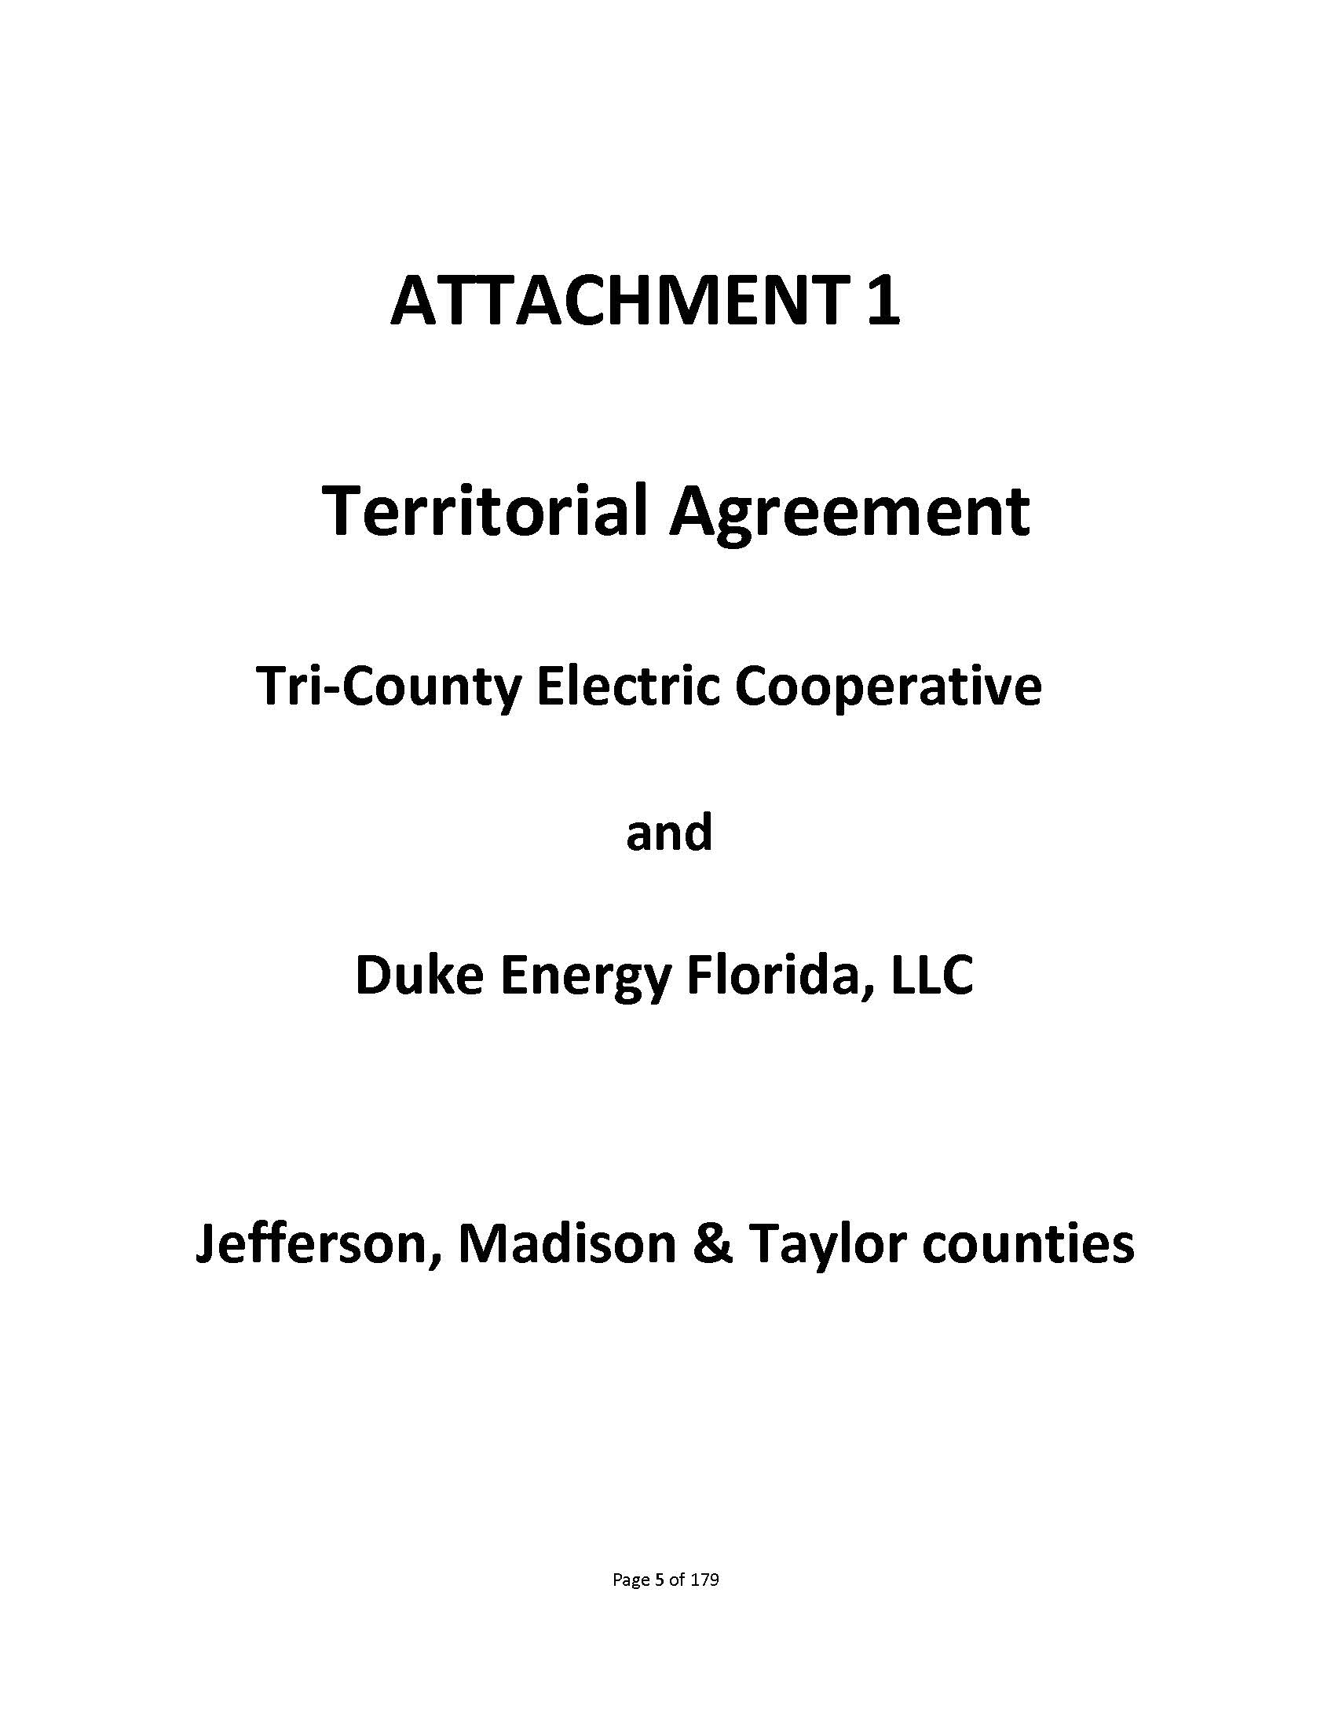

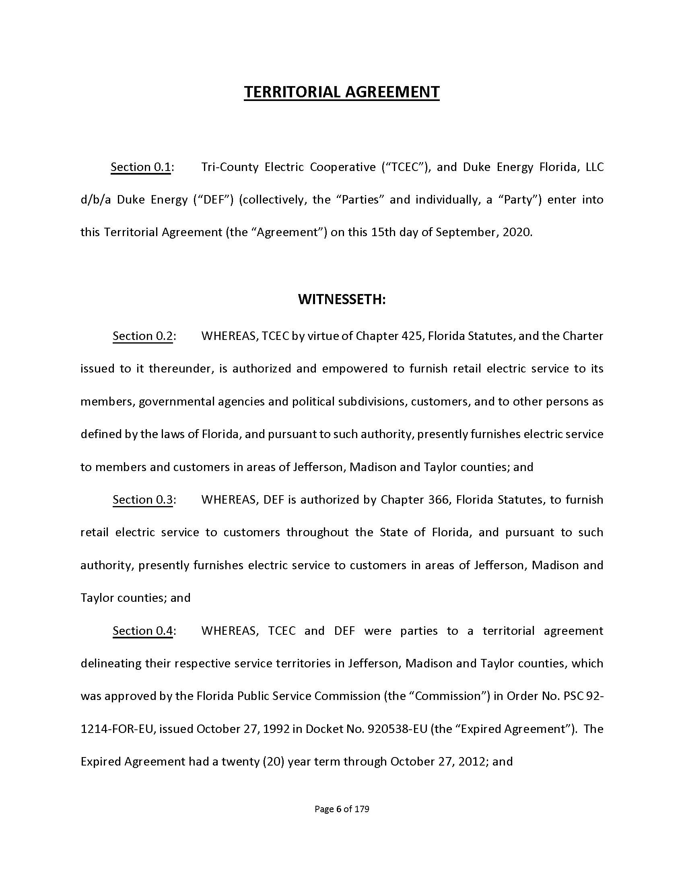

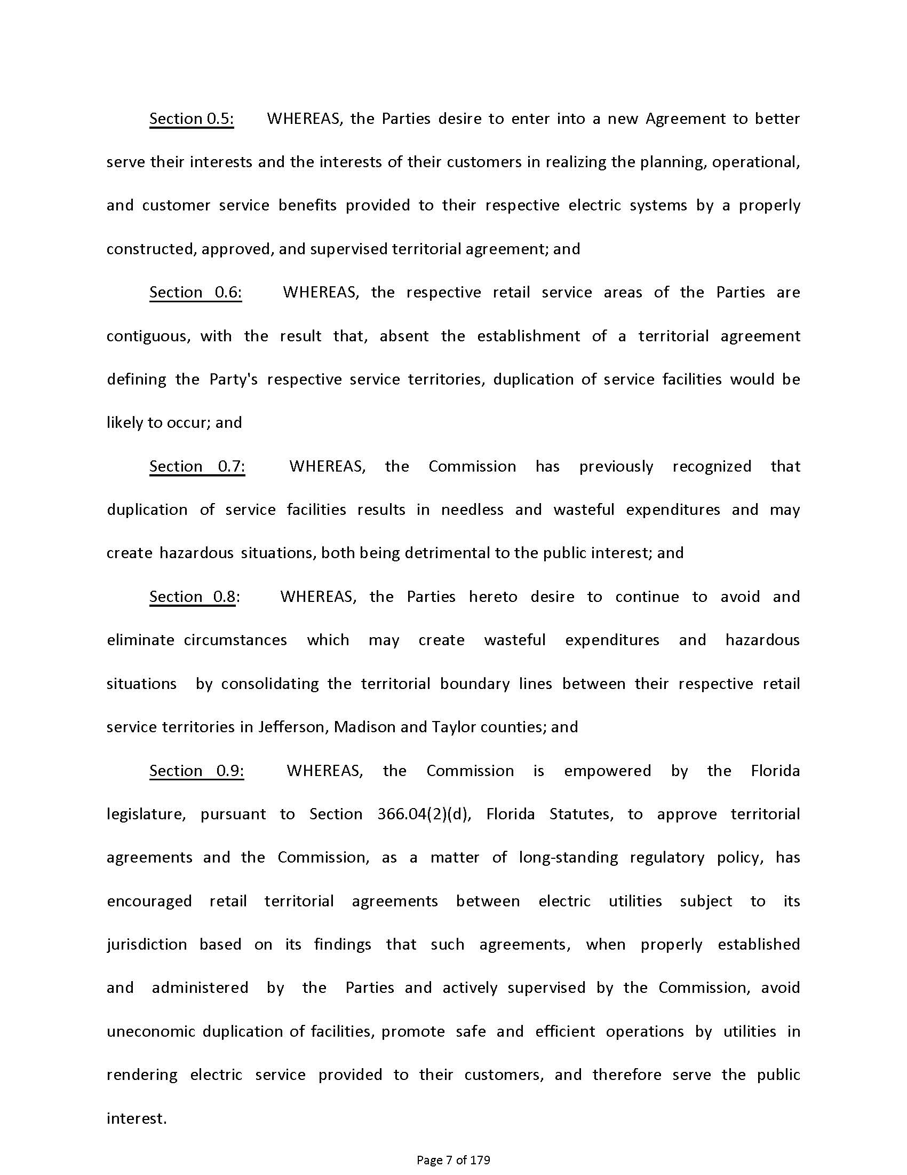

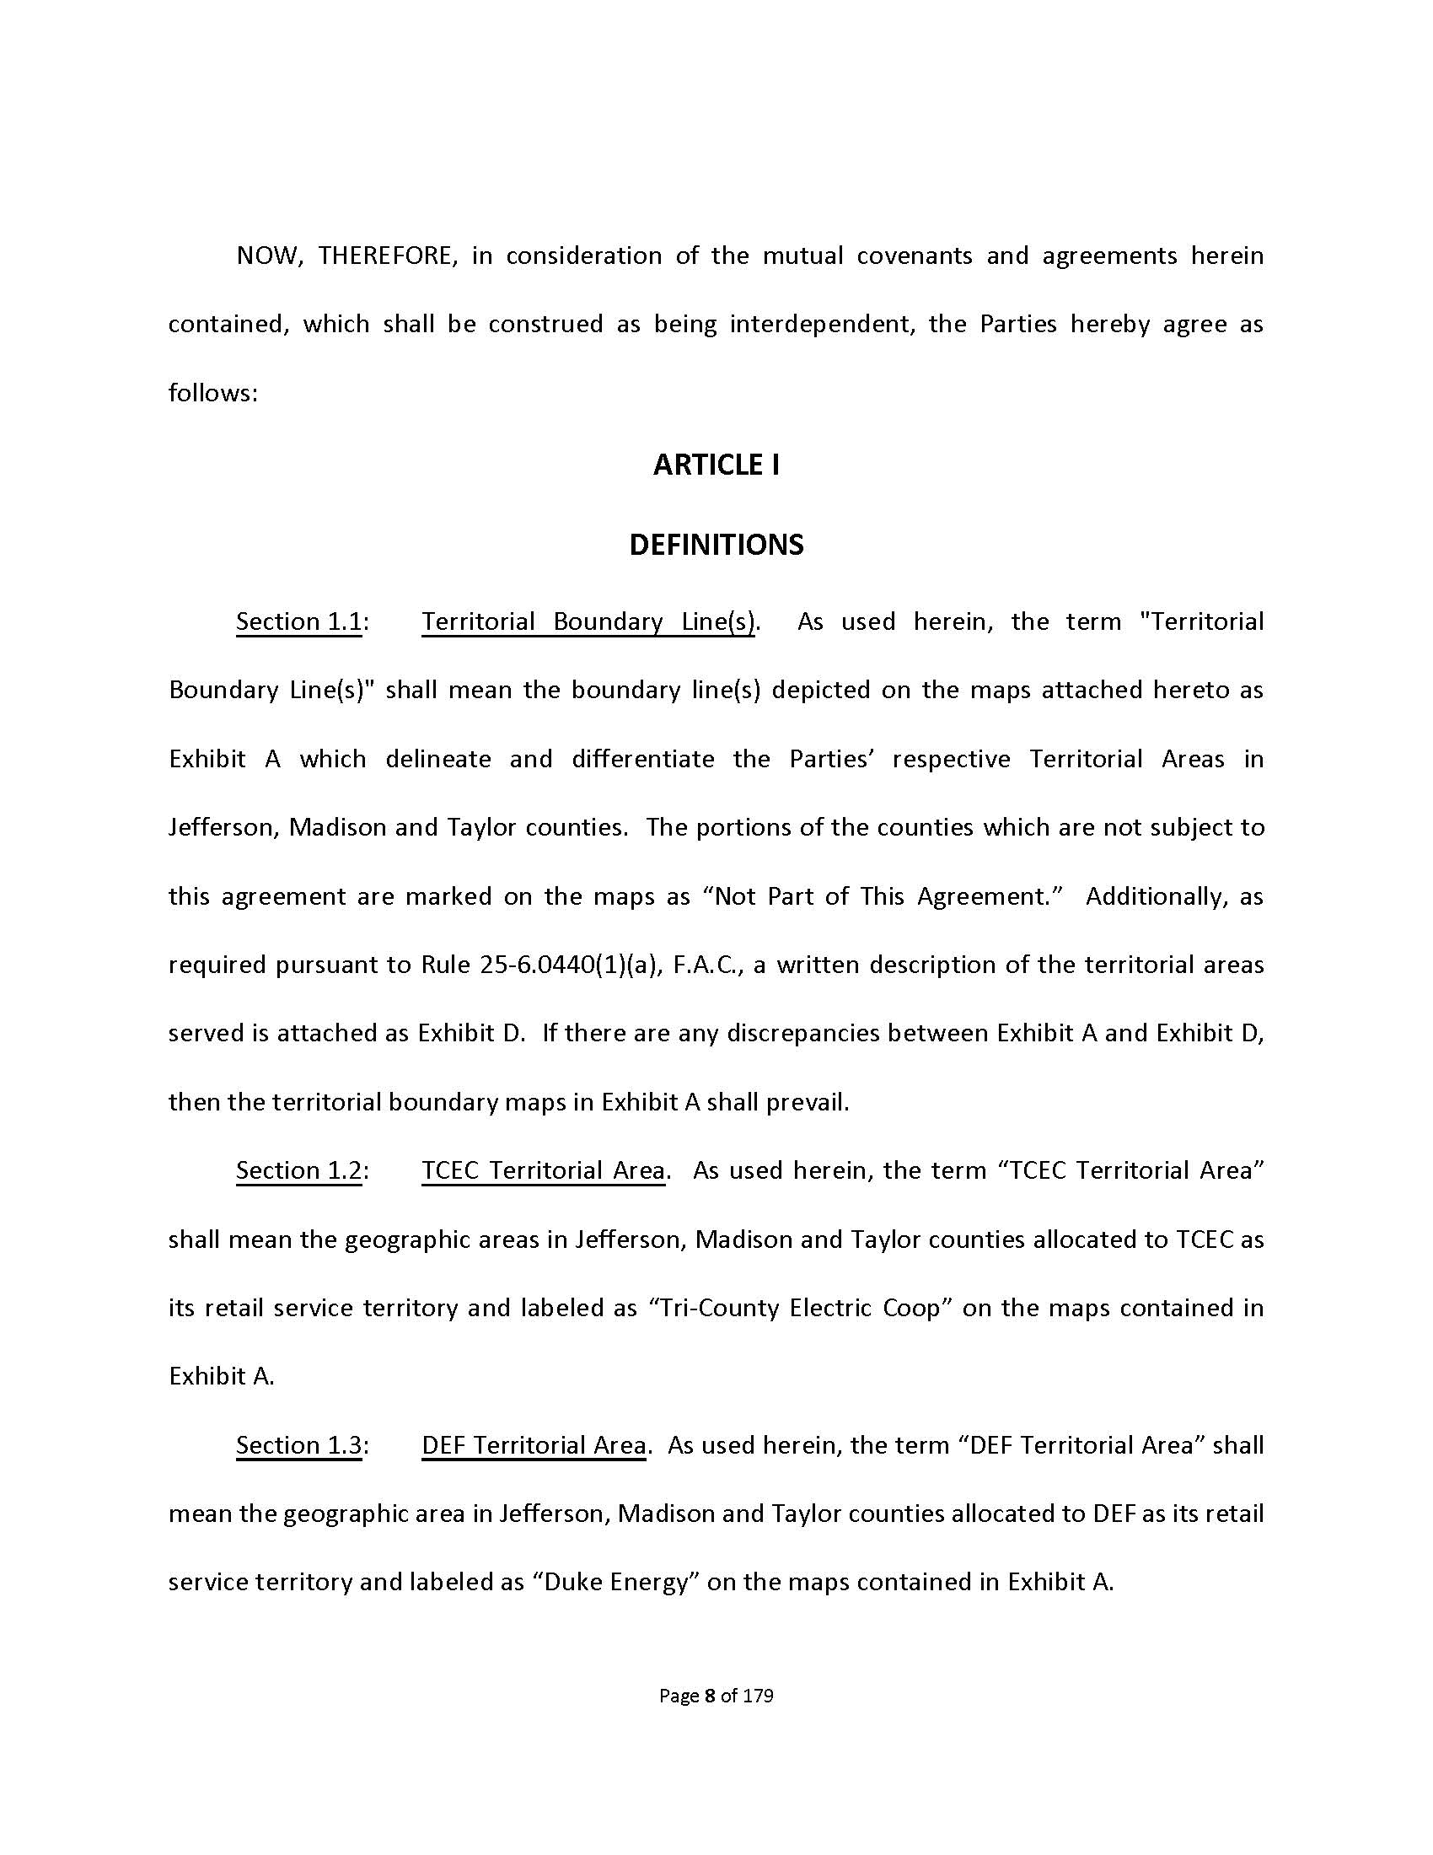

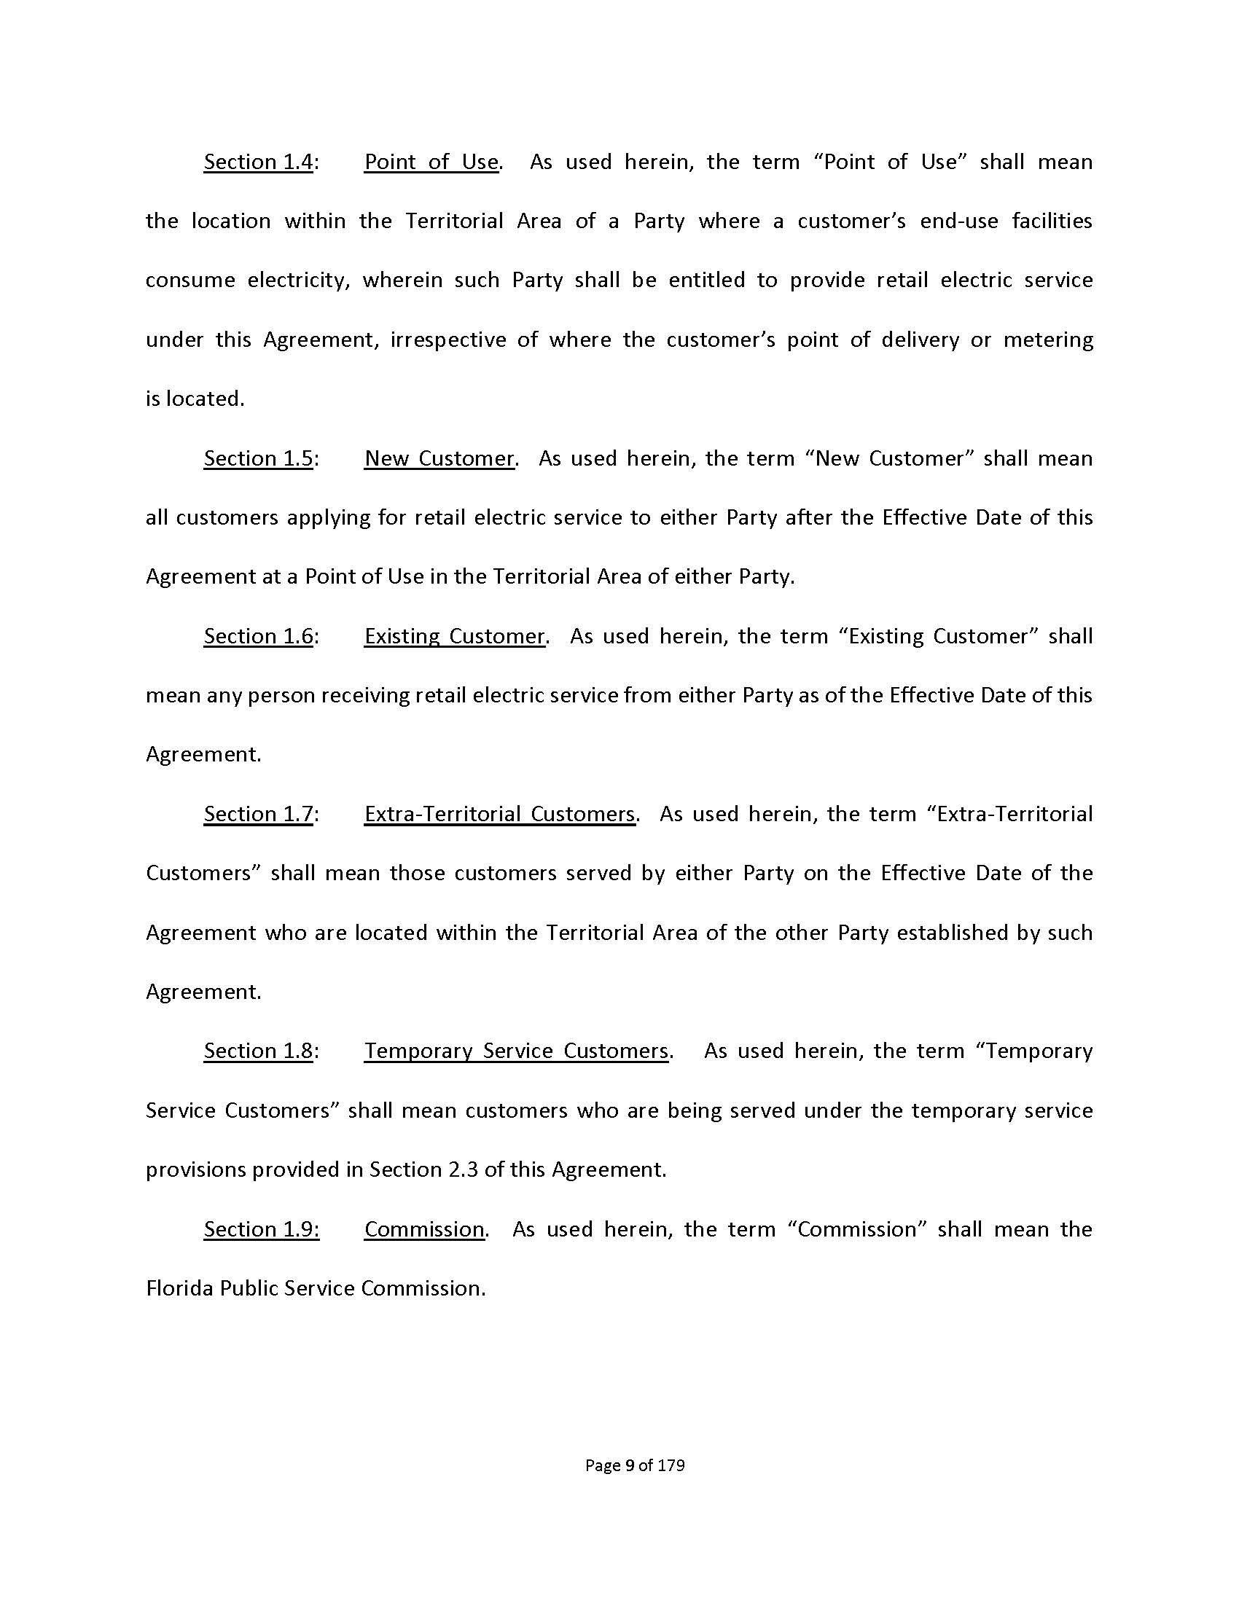

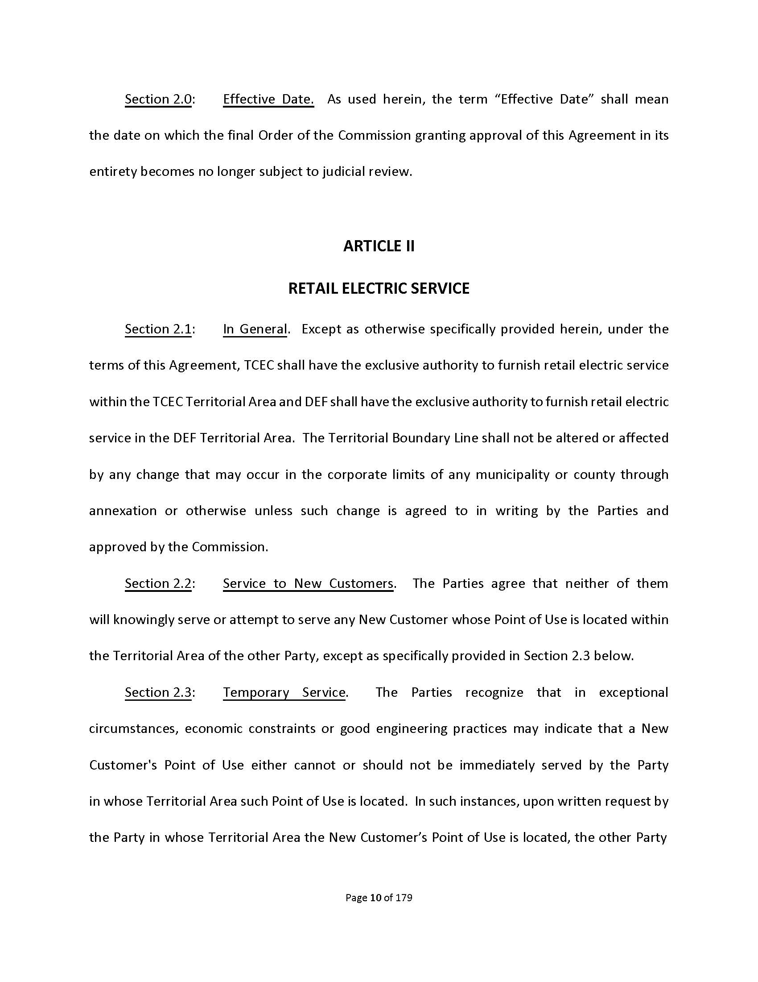

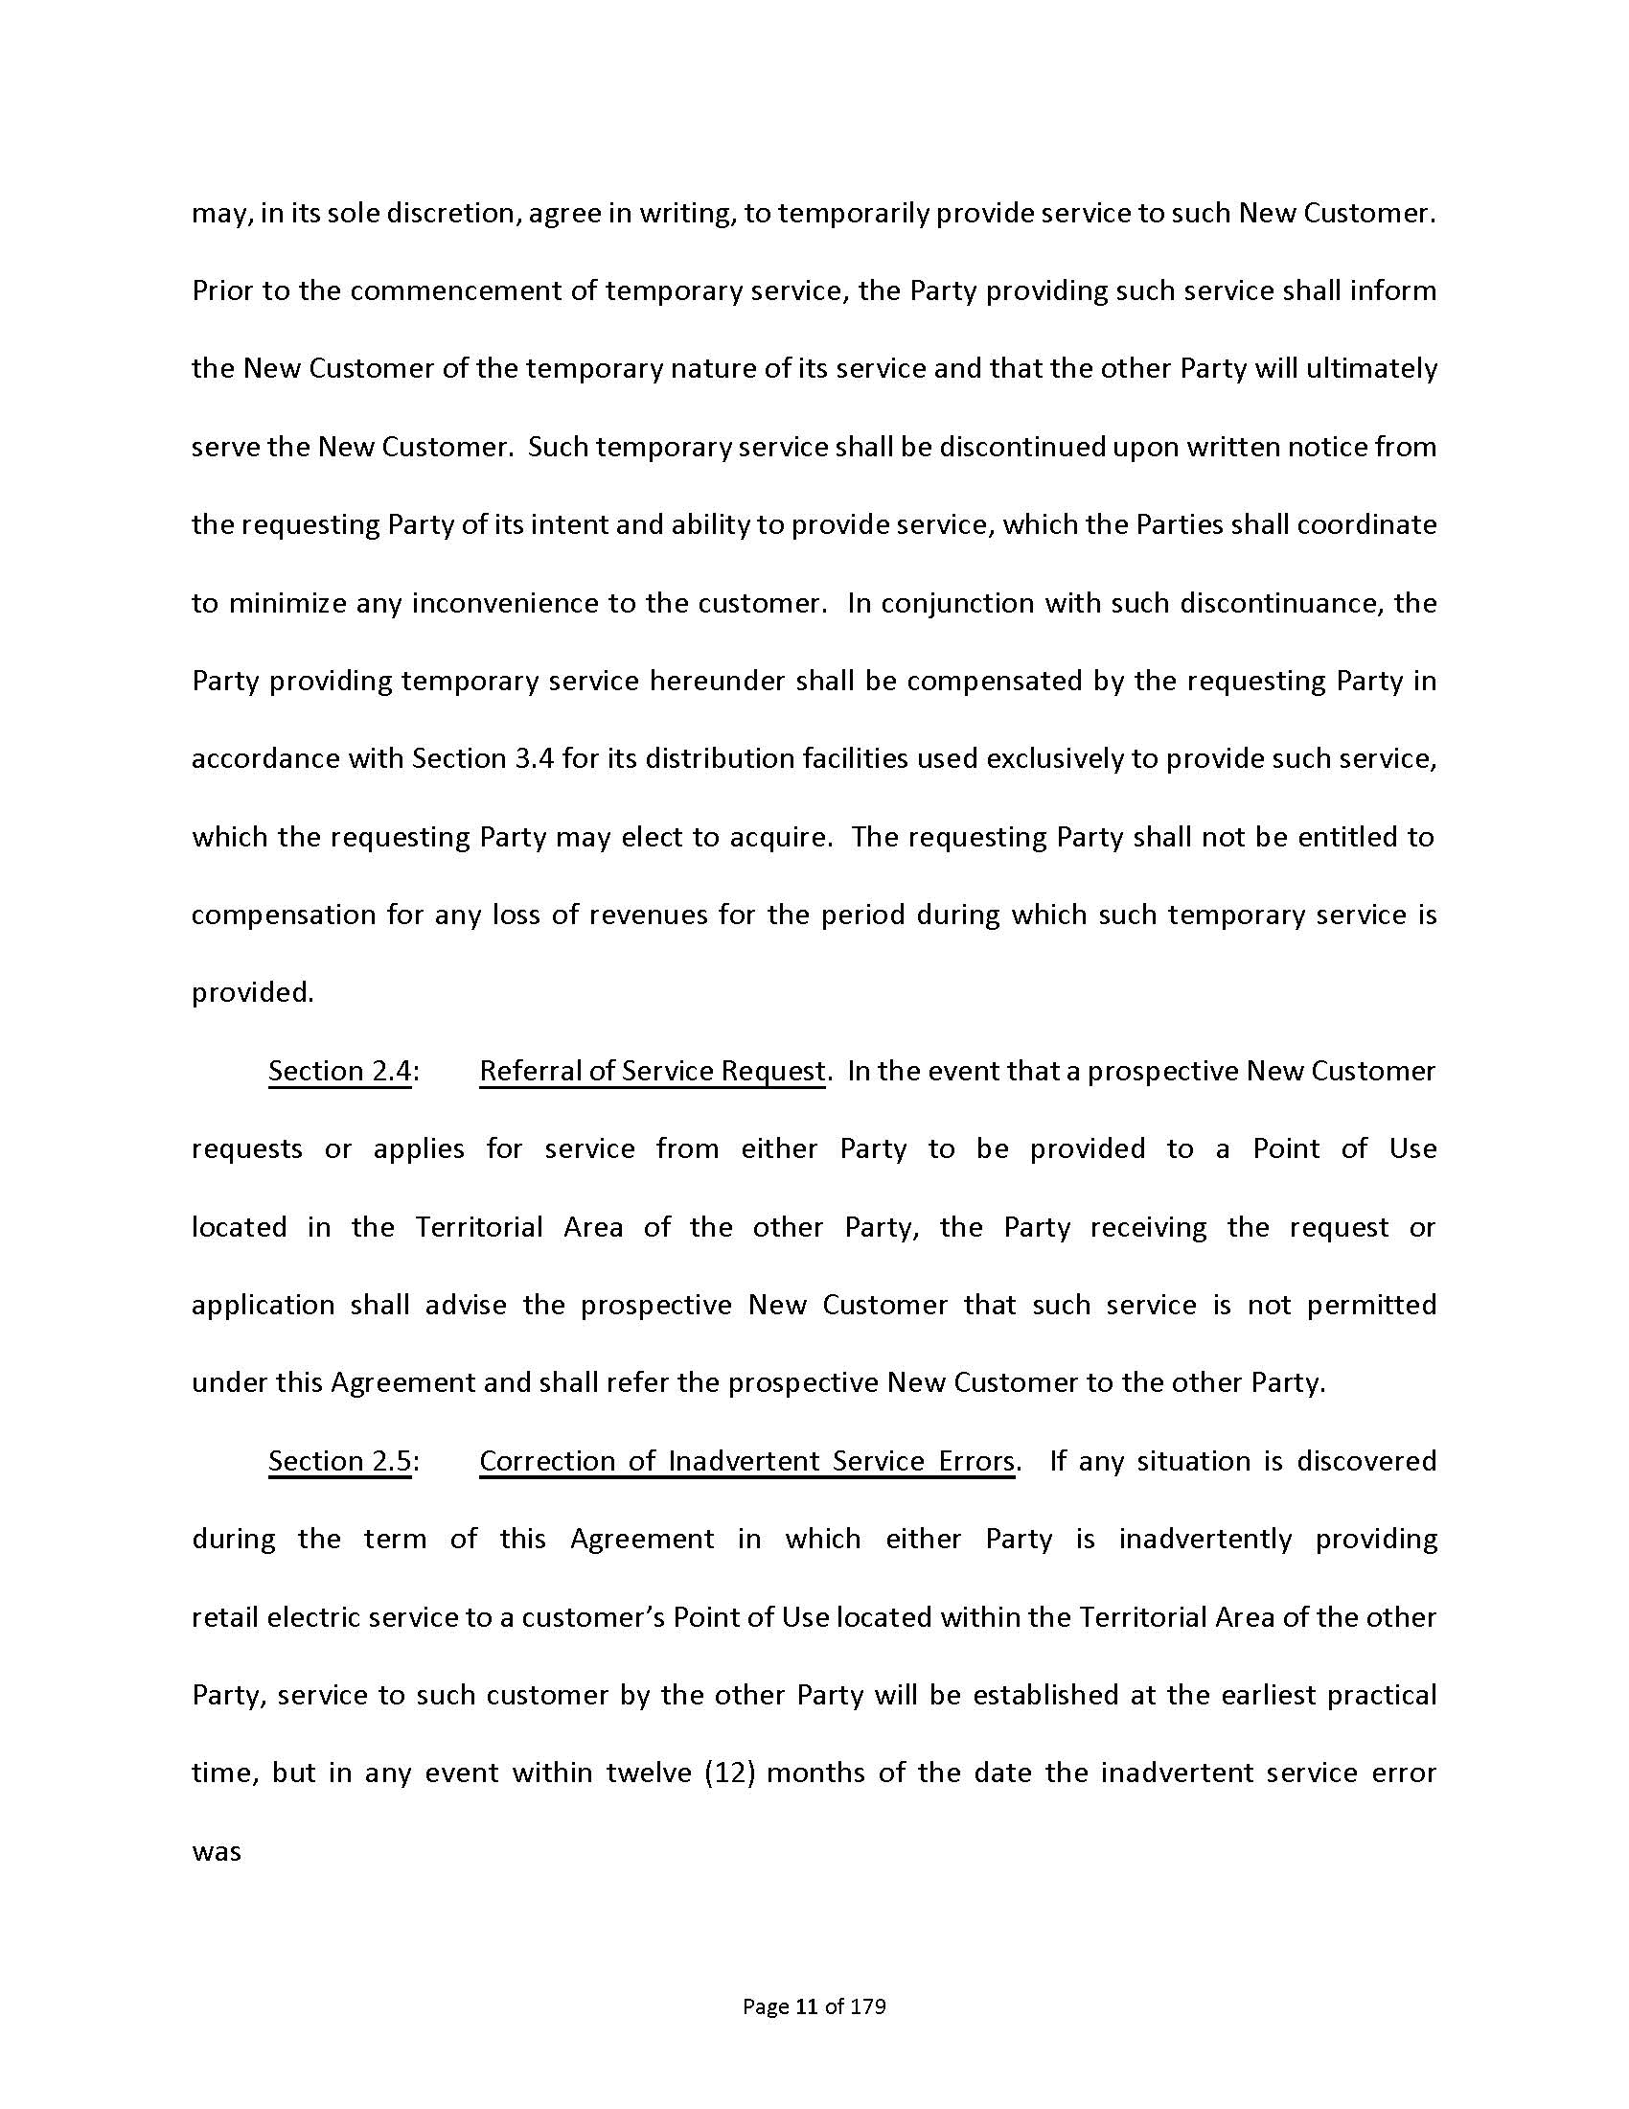

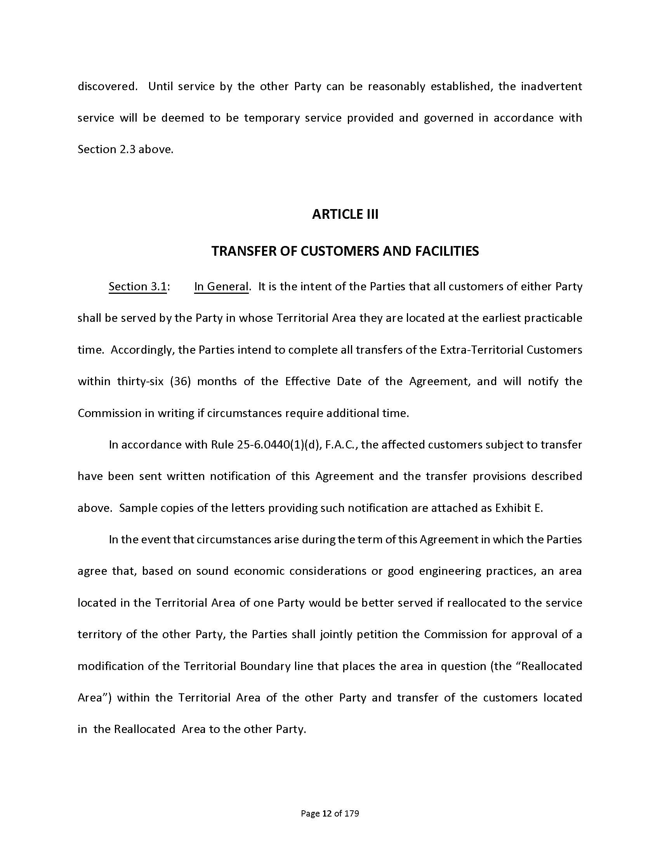

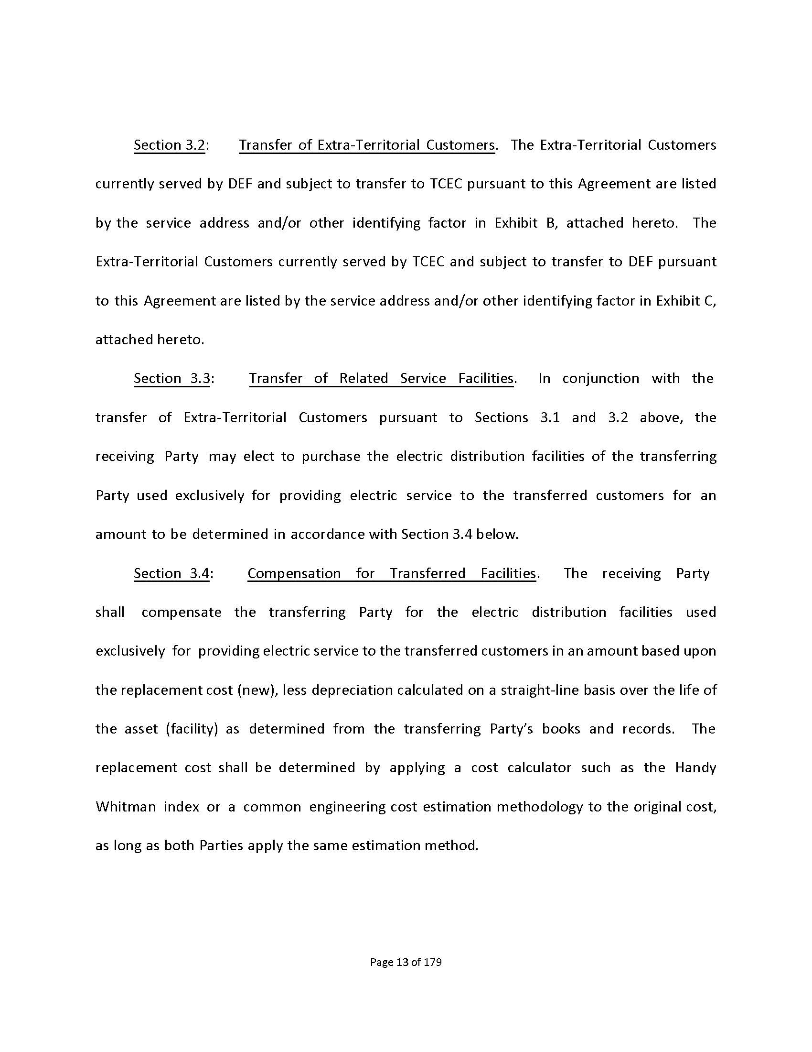

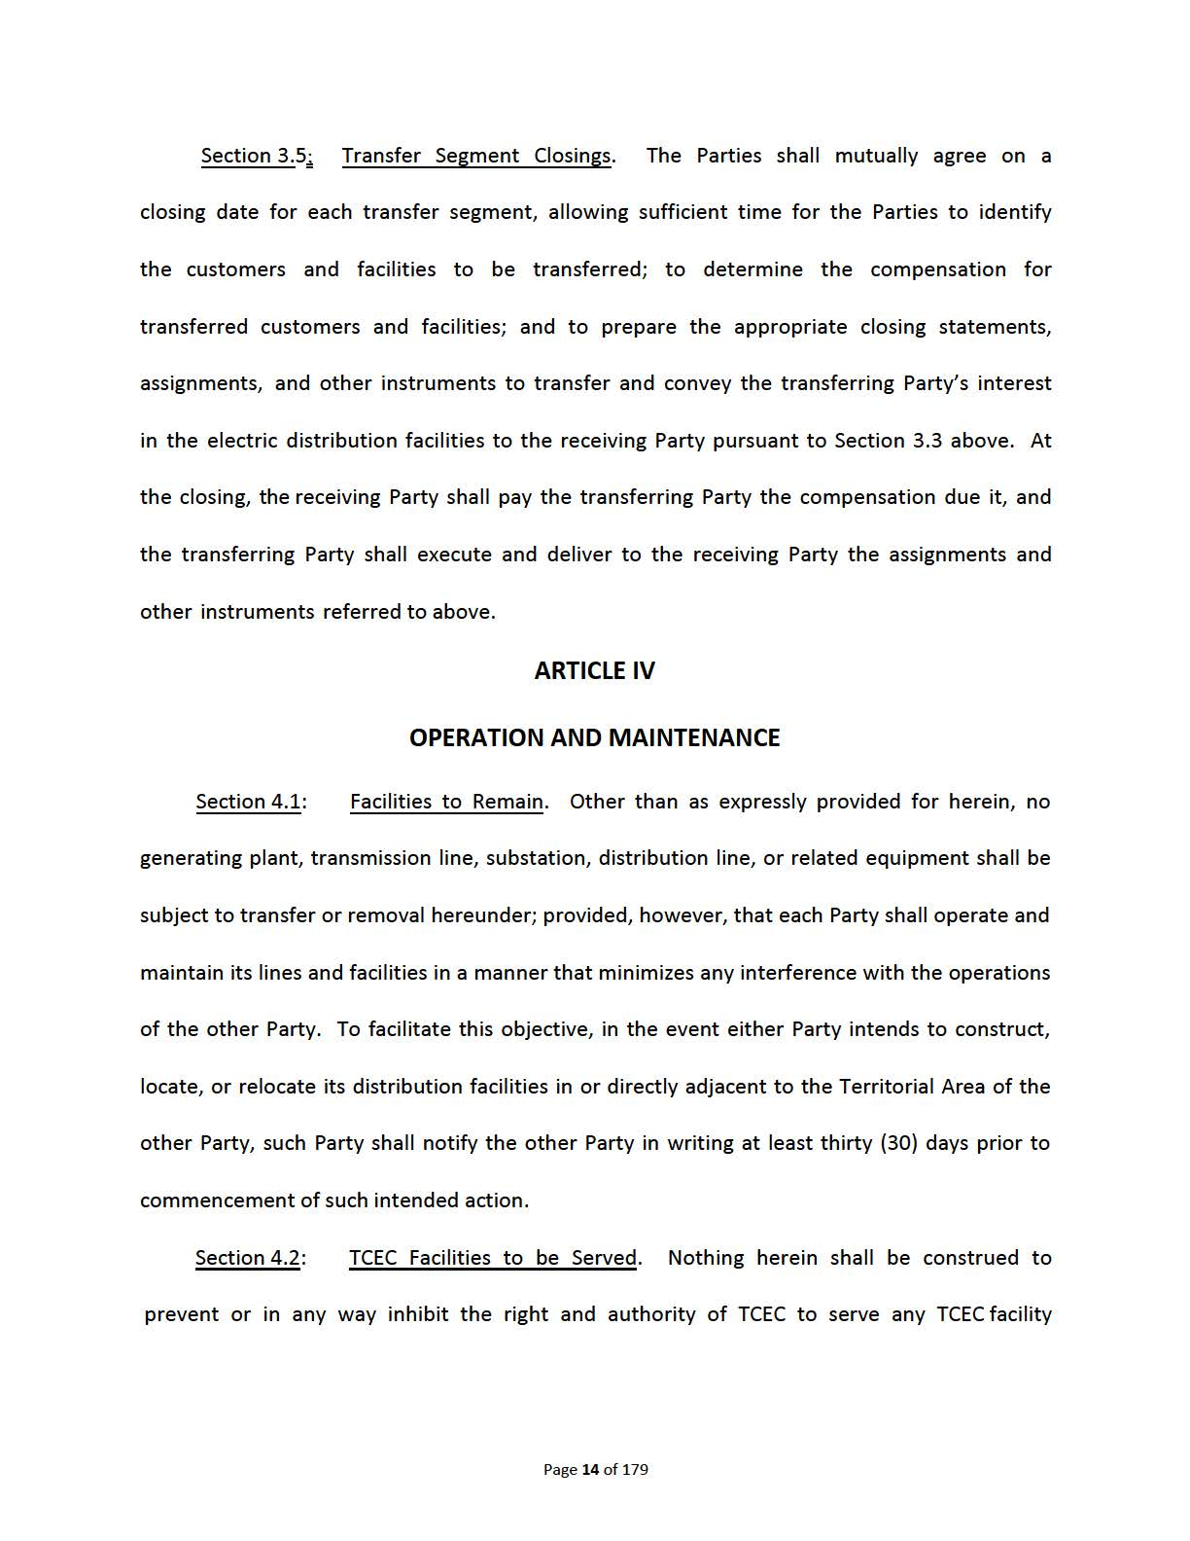
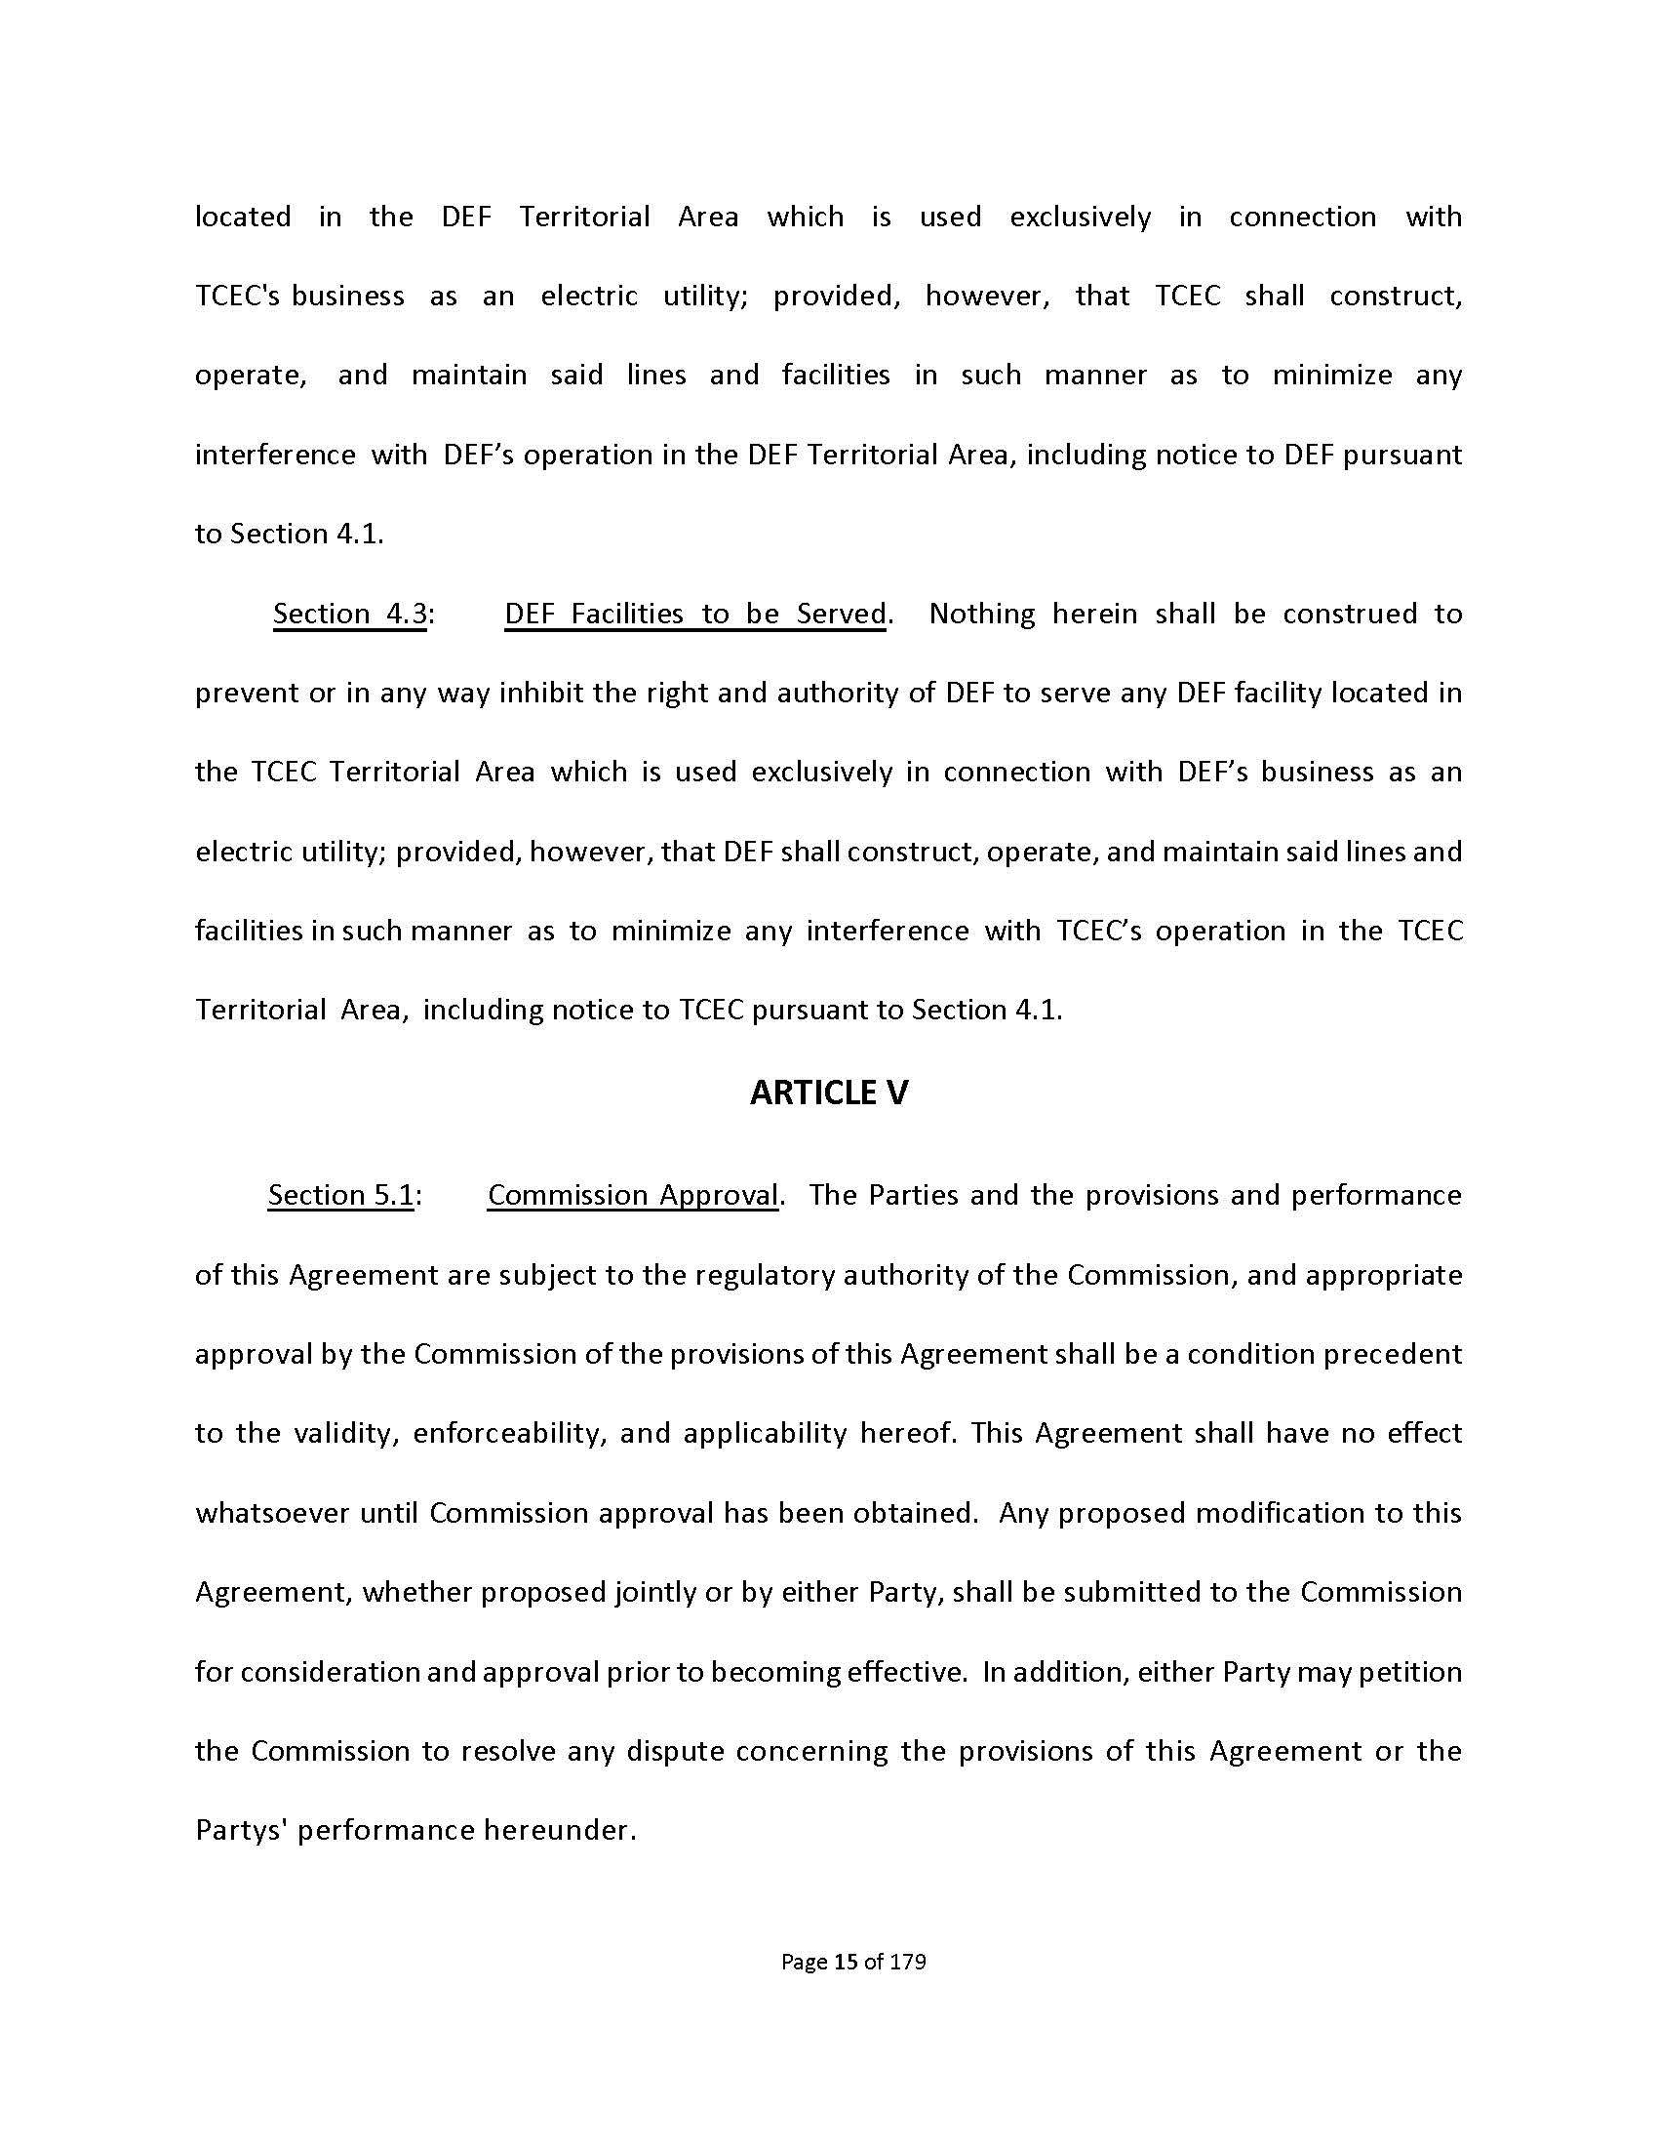

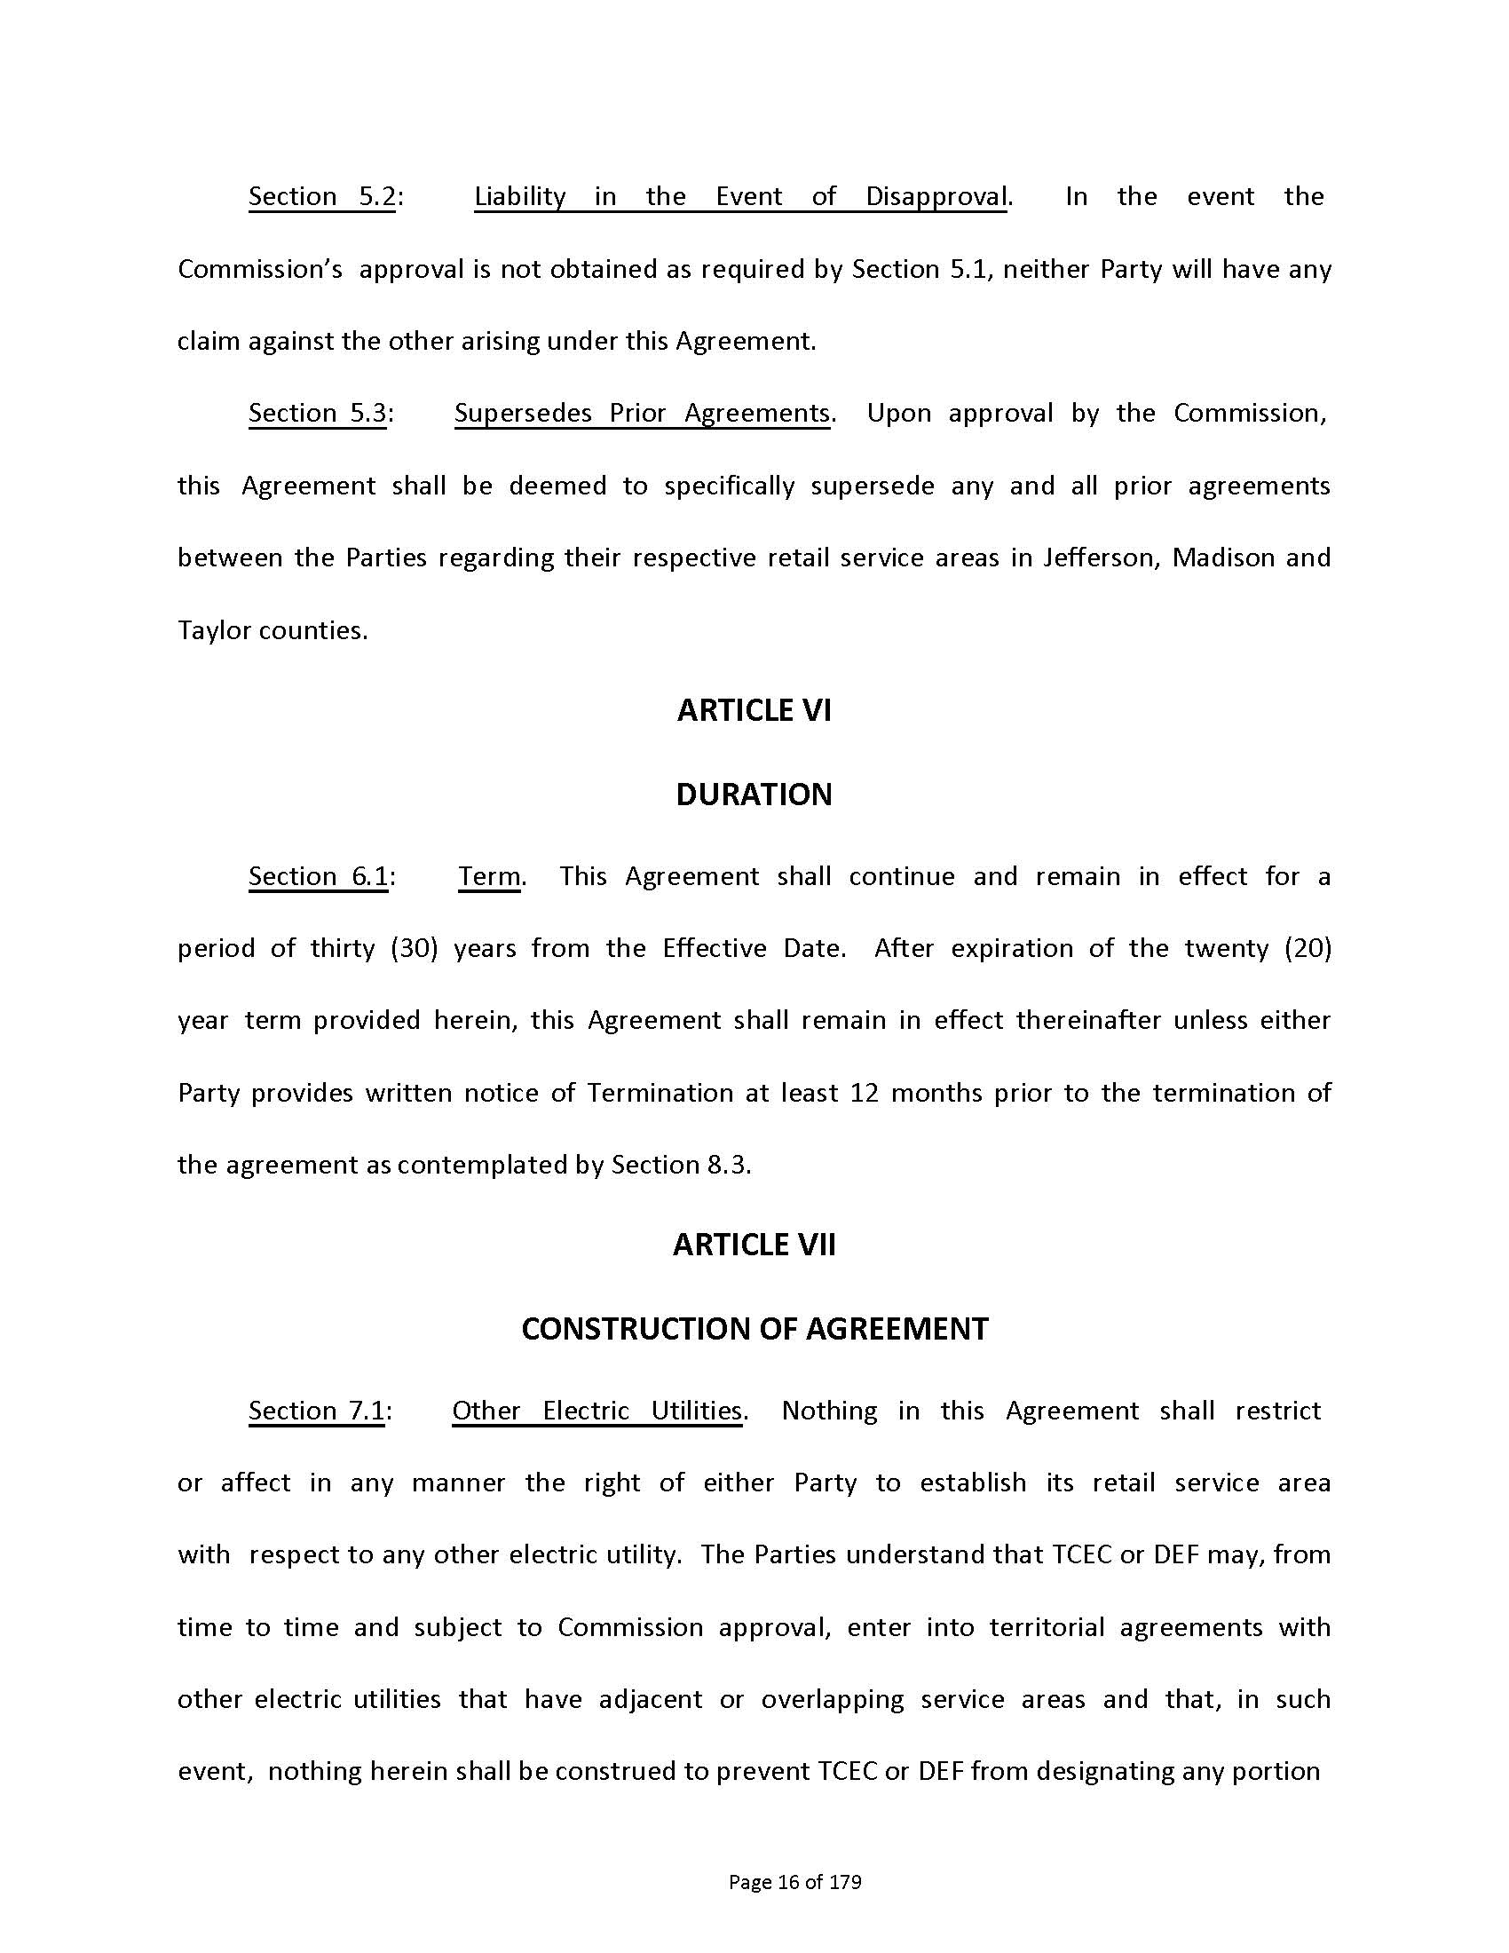

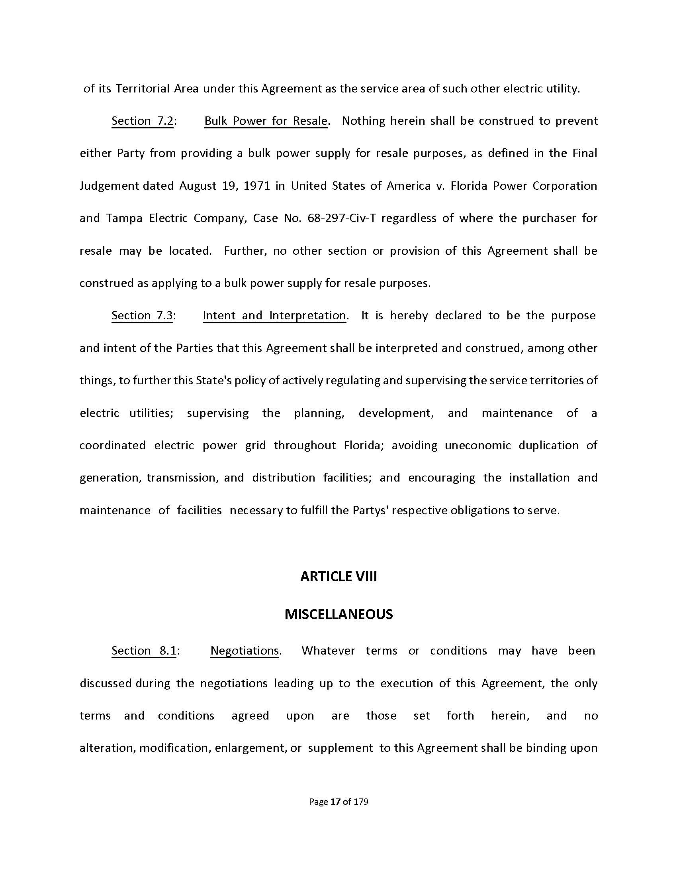

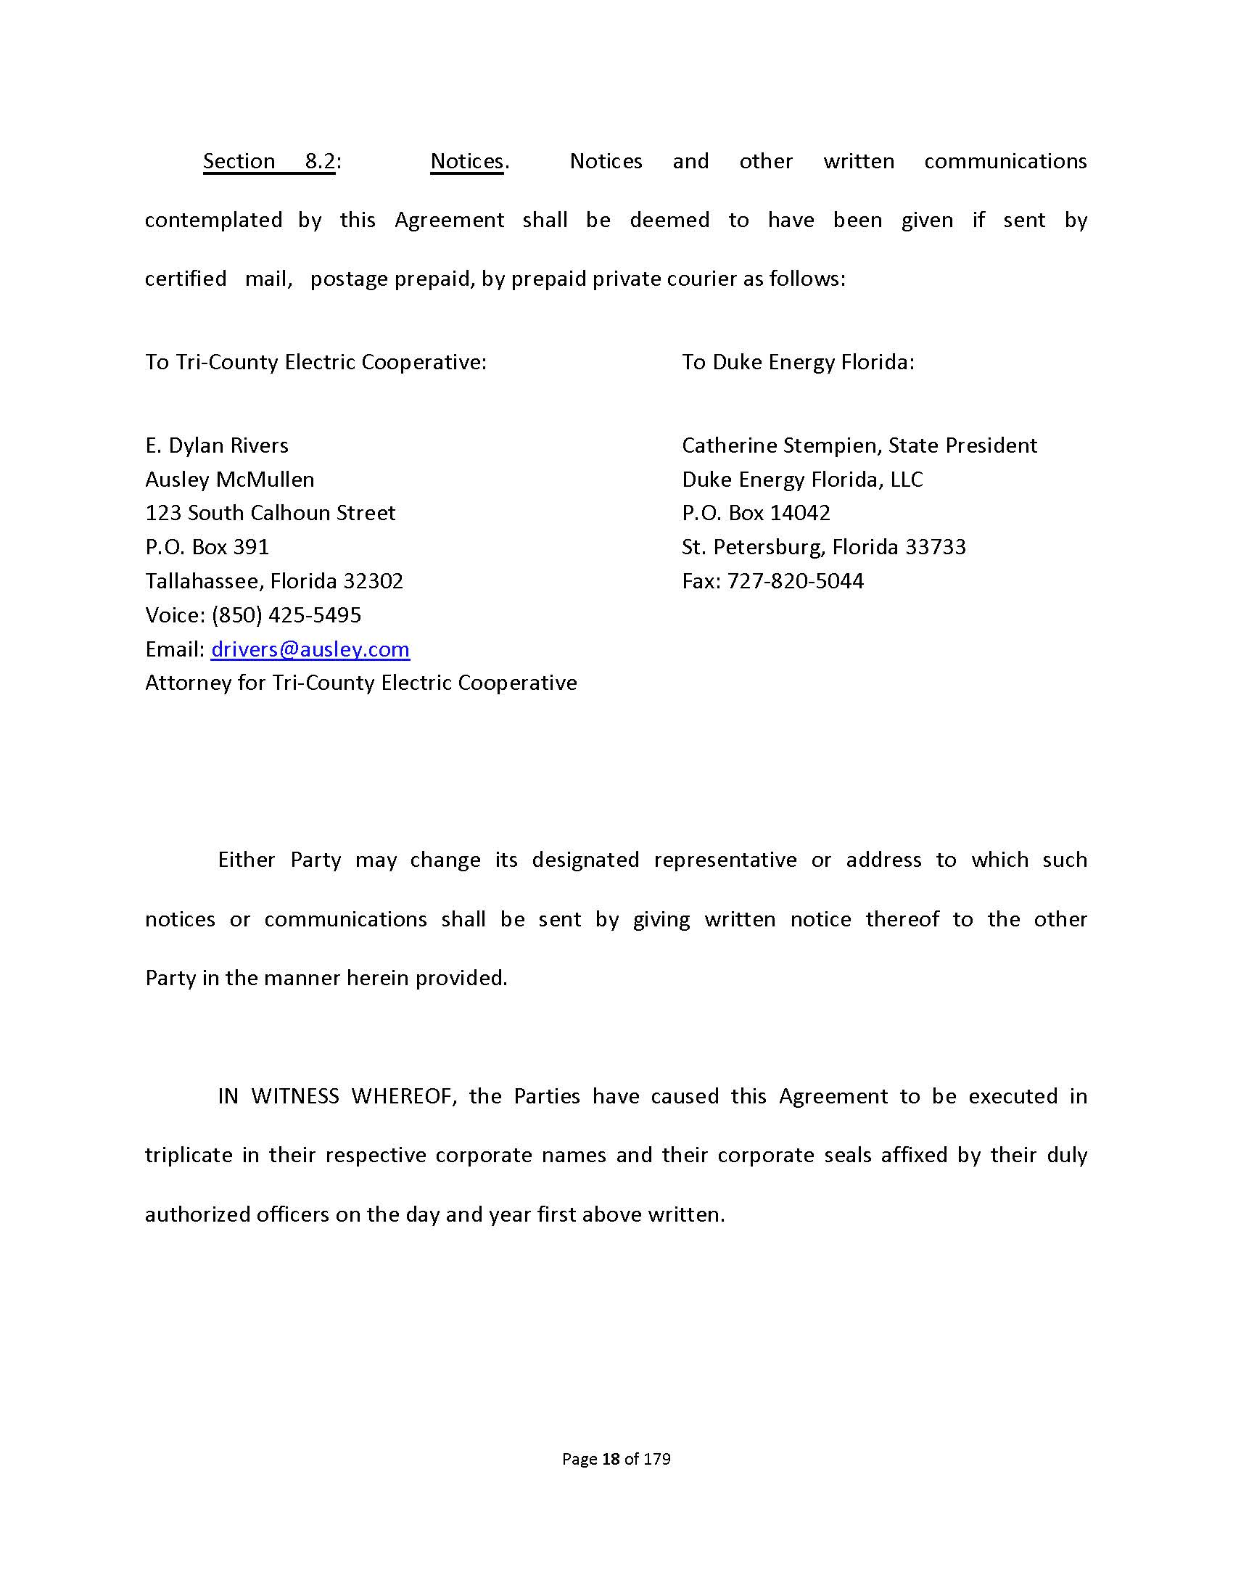

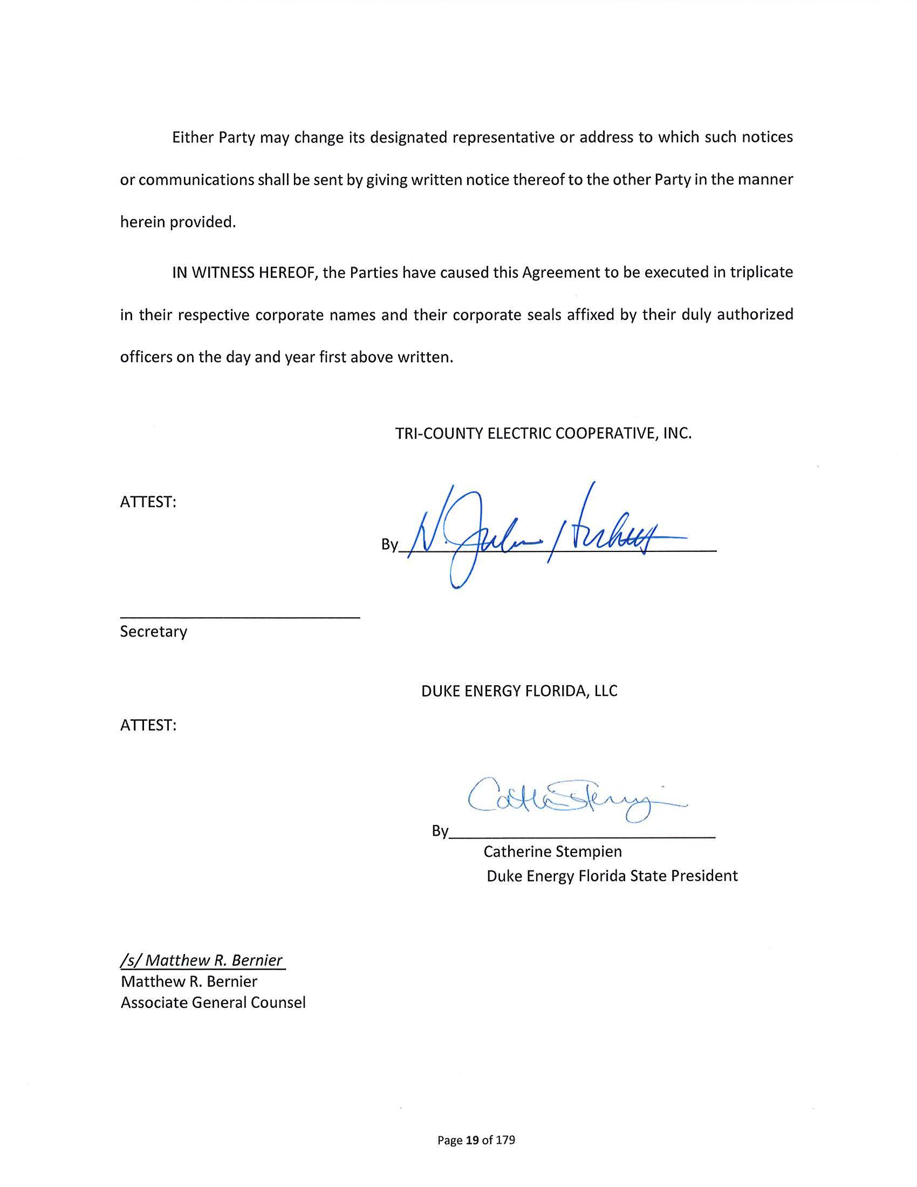

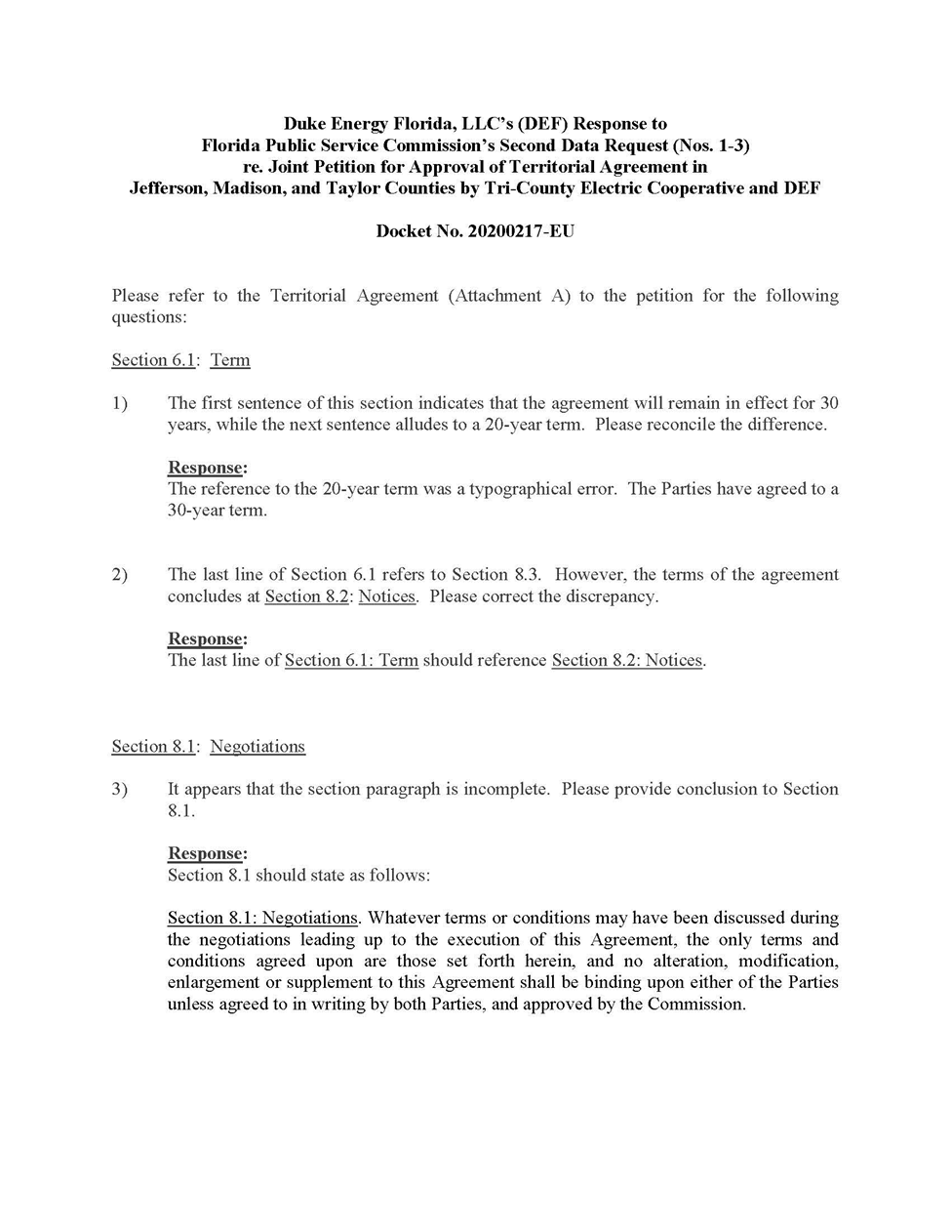

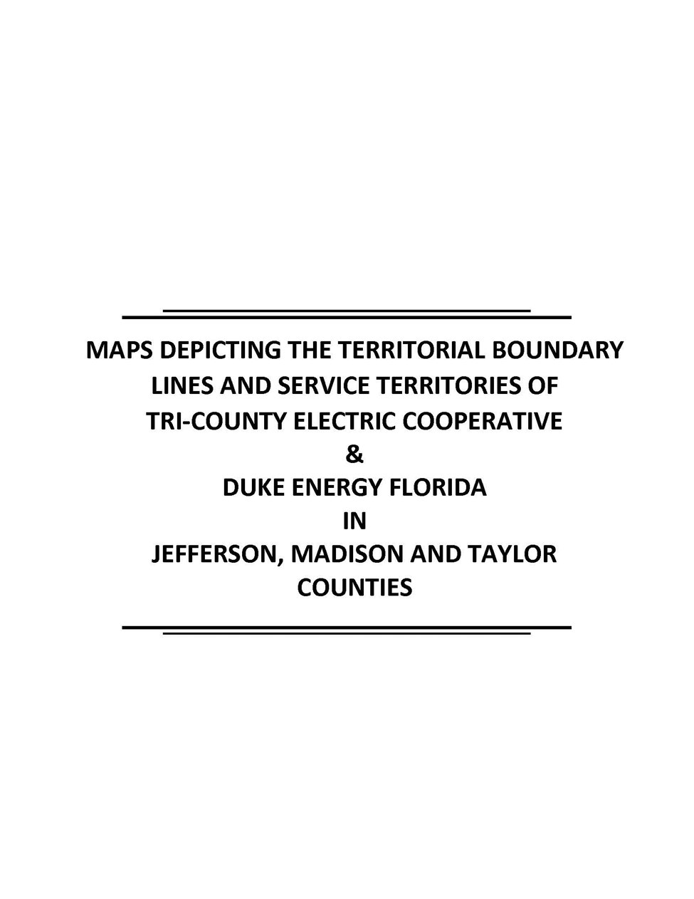

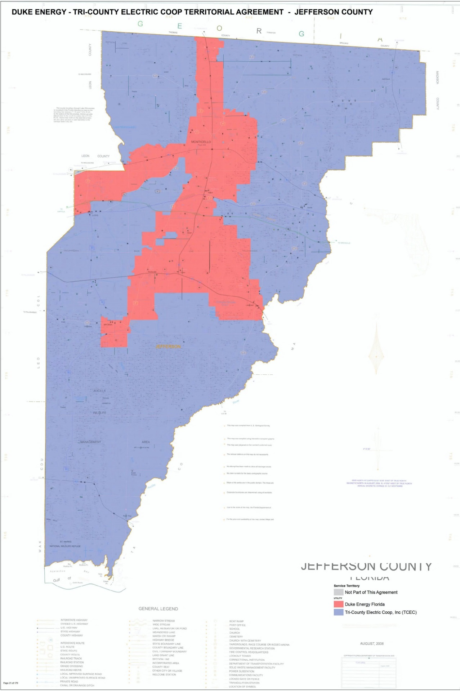
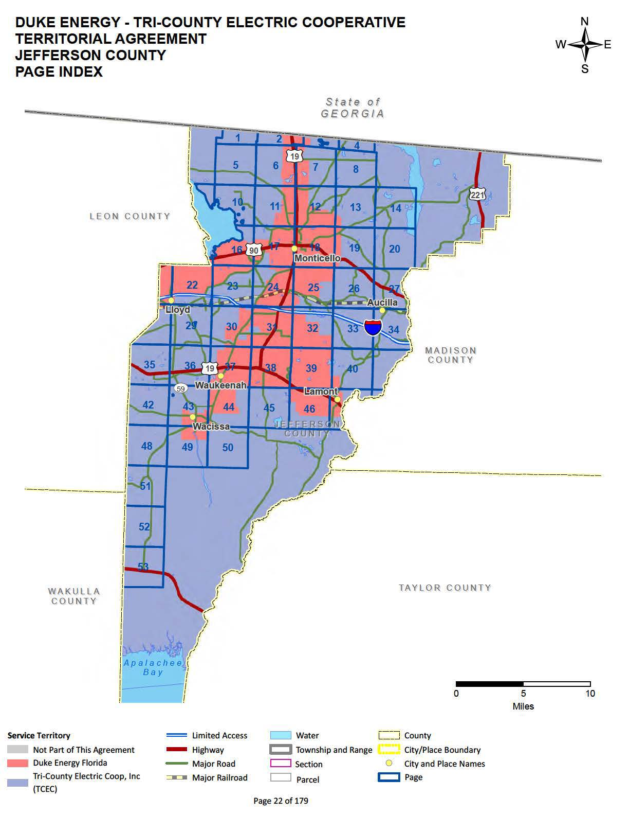
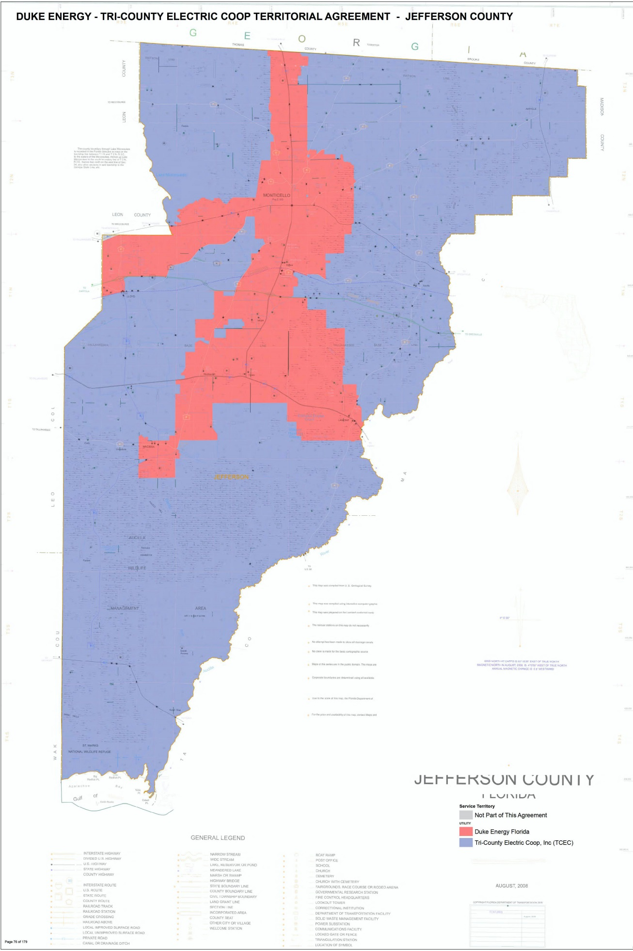
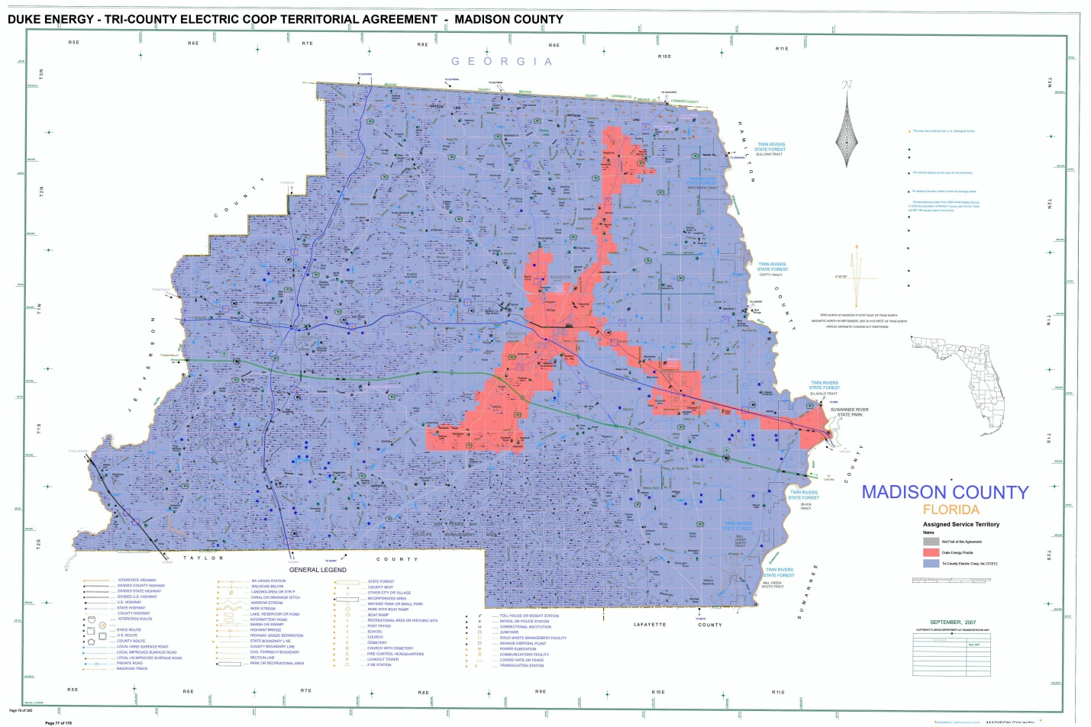

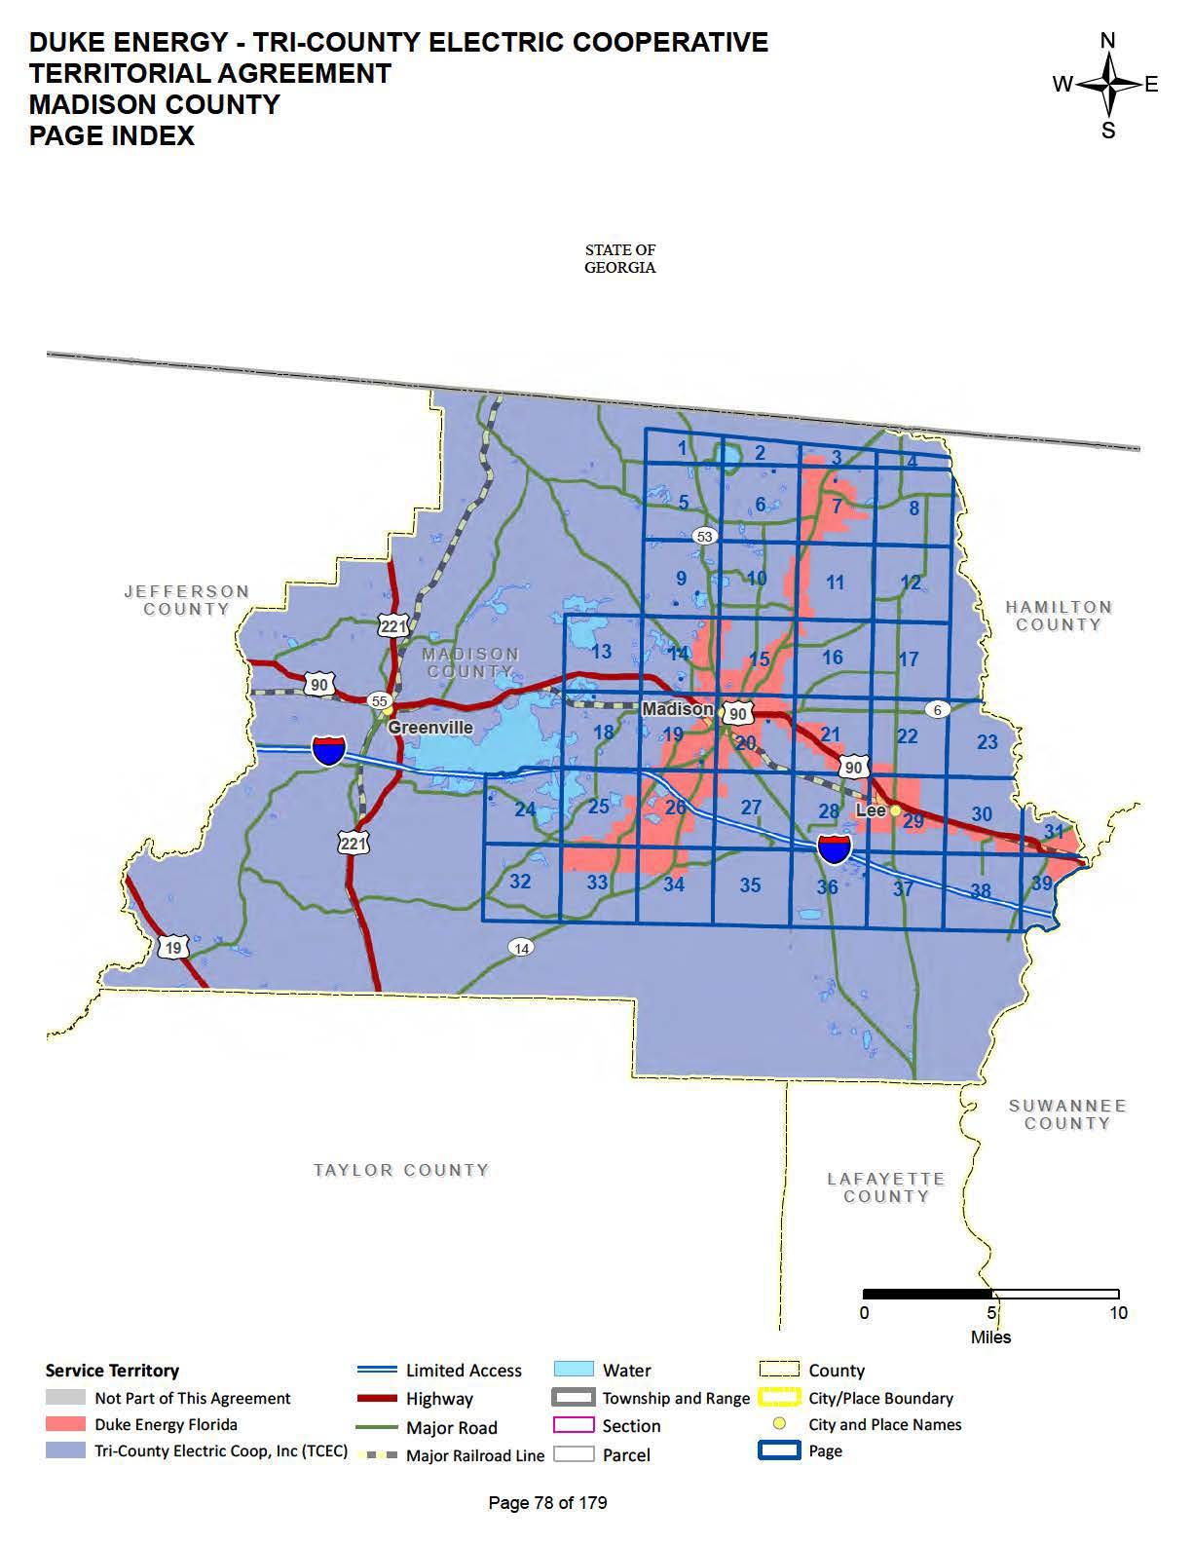
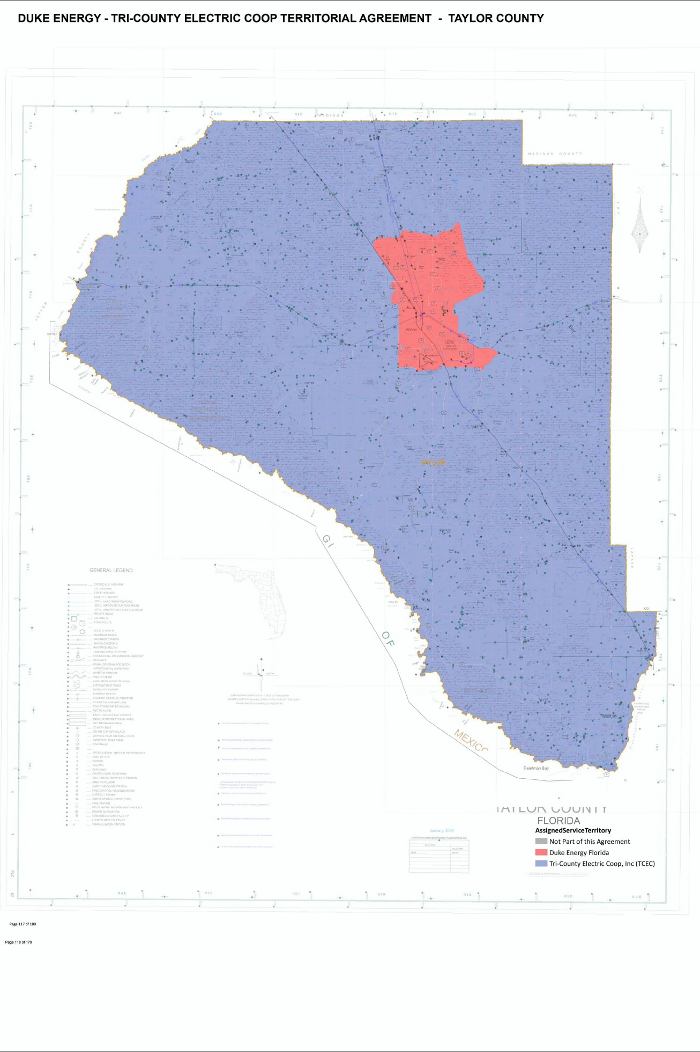
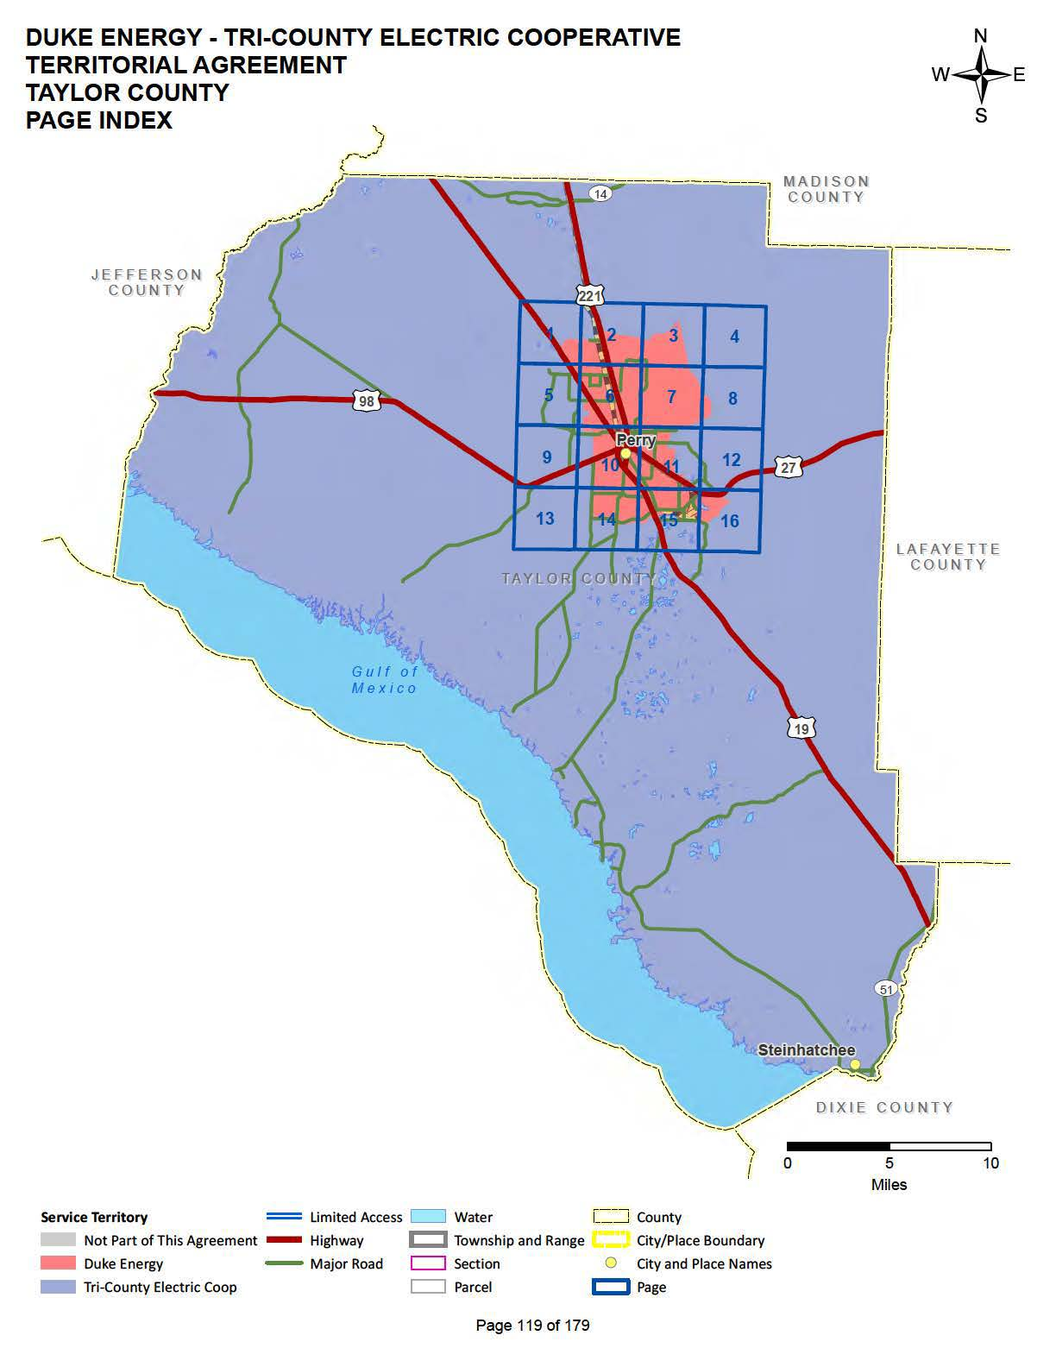

Order No. PSC-92-1214-FOR-EU, issued October 27, 1992, in Docket No. 19920538-EU, In re: Joint Petition for approval of Territorial Agreement between Florida Power Corporation and Tri-County Electric Cooperative, Inc.
Utilities Commission of the City of New Smyrna Beach v. Florida Public Service Commission, 469 So. 2d 731 (Fla. 1985).
Response No.3 in Staff’s First Data Request, Document No. 11747-2020.
Supplemental Response, Document No. 13178-2020.

