BEFORE THE FLORIDA PUBLIC SERVICE COMMISSION

In re: Petition for a limited proceeding to approve third solar base rate adjustment, by Duke Energy Florida, LLC. | DOCKET NO. 20200245-EI  ORDER NO. PSC-2021-0088-TRF-EI  ISSUED: February 22, 2021

The following Commissioners participated in the disposition of this matter:

GARY F. CLARK, Chairman
ART GRAHAM
JULIE I. BROWN
ANDREW GILES FAY
MIKE LA ROSA

ORDER GRANTING DUKE ENERGY FLORIDA, LLC’S PETITION FOR
APPROVAL OF THIRD SOLAR BASE RATE ADJUSTMENT
AND APPROVING TARIFF

BY THE COMMISSION:

Background
By Order No. PSC-2017-0451-AS-EU, issued on November 20, 2017, we approved Duke Energy Florida, LLC’s (DEF or Company) Second Revised and Restated Settlement Agreement (2017 Settlement). The 2017 Settlement allows for the inclusion into base rates of up to 700 megawatts (MW) of solar projects which meet certain criteria through a Solar Base Rate Adjustment (SoBRA) mechanism.
On April 30, 2019, we approved DEF’s First SoBRA tranche which consisted of two solar projects, Hamilton and Columbia, with a total installed capacity of 149.8 MW. On July 22, 2019, we approved DEF’s Second SoBRA tranche which consisted of three solar projects, Trenton, Lake Placid, and DeBary, with a total installed capacity of 194.4 MW.
On May 29, 2020, DEF filed a petition for approval of its Third SoBRA tranche which consisted of five solar projects, Twin Rivers, Santa Fe, Charlie Creek, Duette, and Archer, which established Docket No. 20200153-EI. On November 17, 2020, due to permitting issues for the Archer solar project located in Alachua County, DEF filed a notice of withdrawal and the docket was subsequently closed.
On November 11, 2020, DEF filed the instant petition for approval of its Third SoBRA tranche which consists of five solar projects, Twin Rivers, Santa Fe, Charlie Creek, Duette, and Sandy Creek. The petition is similar in scope to that filed in Docket No. 20200153-EI with the Archer project being replaced by the Sandy Creek project. While the total installed capacity of the projects is 374.1 MW, DEF is seeking recovery of only 355.8 MW. This recovery represents all remaining capacity available through the 2017 Settlement’s SoBRA Mechanism.
We have jurisdiction pursuant to Sections 366.06 and 366.076, Florida Statutes, (F.S.).
Decision
The Third SoBRA tranche consists of five projects: Twin Rivers, Santa Fe, Charlie Creek, Duette, and Sandy Creek. Each of the projects is designed to be approximately 75 MW. The capacity and projected in-service dates for each project are listed in Table 1. DEF is only seeking recovery through the SoBRA Mechanism of 56.6 MW of the Sandy Creek project. The recovery of the remaining 18.3 MW of capacity may be addressed in a future docket.
Table 1
Installed Capacity and Projected In-Service dates of Third SoBRA Tranche
Project Name | Capacity (MW) | Estimated In-Service Date
Twin Rivers | 74.9 | February 2021
Santa Fe | 74.9 | March 2021
Charlie Creek | 74.9 | December 2021
Duette | 74.5 | December 2021
Sandy Creek | 74.9 (56.6 SoBRA) | April 2022

Paragraph 15 of the 2017 Settlement outlines the conditions under which DEF may seek cost recovery of certain solar facilities. Subparagraph 15(c) outlines the issues to be considered for projects that are below 75 MW, such as the five in this tranche. Each applicable requirement in the 2017 Settlement is addressed individually below.
Average installed cost and overall reasonableness of costs
Subparagraph 15(a) of the 2017 Settlement specifies that the weighted average cost of all projects in a SoBRA tranche may be no more than $1,650 per kW_{ac} installed to be eligible for recovery. The 2017 Settlement states all construction costs for the projects are to be included, such as land acquisition costs. The estimated installed cost and cost per kWac for each project are listed in Table 2. The unit cost of both the weighted average of all projects and each project individually are below the $1,650/ kW_{ac} requirement. The amount listed for the Sandy Creek project is the total amount, but only a partial amount coinciding with the 56.6 MW of capacity will be allowed recovery through the SoBRA mechanism.
Table 2
Estimated Installed Cost, in Total and by Unit of Capacity
Project Name | Estimated Installed Cost  ($) | Estimated Installed Cost  ($/kW_{ac})
Twin Rivers | $100,037,587 | $1,336
Santa Fe | $108,910,046 | $1,454
Charlie Creek | $97,950,968 | $1,308
Duette | $108,572,491 | $1,457
Sandy Creek | $99,123,932 | $1,323
Weighted Average Unit Cost | - | $1,376

In three of the projects, DEF will be leasing the land for the facility instead of purchasing it. Lease costs are not included in the $/kWac calculation. In response to Commission staff’s data requests, the Company provided the estimated net present value of payments under these three leases. Even with lease costs included as part of the $/kW_{ac} calculation, the weighted average cost of all projects is less than the $1,650/kW_{ac} installed cost cap.
The installed cost of a project consists of major equipment, balance of system, construction management, transmission interconnection, and land cost. This includes but is not limited to the cost of solar panels, transformers, contractors, legal fees, development fees, and insurance. DEF utilized competitive bidding in multiple aspects of the projects, including when soliciting contractors and procuring material and equipment for the Third SoBRA tranche.
Based on our review, we find the estimated installed costs to be reasonable and the resulting weighted average cost of the combined projects in DEF’s Third SoBRA tranche to be below the installed cost cap of $1,650 per kW_{ac}, as required by the 2017 Settlement.
Cost effectiveness
Subparagraph 15(c) defines the cost-effectiveness of a SoBRA tranche to be whether the projects will lower the projected system cumulative present value revenue requirement (CPVRR) as compared to a system without the projects. This compares the cost of the added generation, transmission, operation and maintenance (O&M) and other expenses of the proposed SoBRA tranche to the avoided traditional generation, transmission, fuel, and O&M expenses that would otherwise have been incurred if the facilities were not constructed.
Overall, DEF estimates that the Third SoBRA tranche would produce savings of $37 million over the life of the projects before consideration of costs associated with carbon dioxide (CO₂) and equivalent emissions. Inclusive of CO₂ emissions costs, DEF estimates a savings of $234 million. The primary driver of the savings is avoided fuel costs, approximately $435 million, followed by avoided generation costs of $217 million, and avoided CO₂ emissions costs of $197 million. The Company also ran scenarios with high and low fuel costs, with only the low fuel and no CO₂ emission cost scenario resulting in a loss for customers (approximately $20 million). The breakeven point for the Third SoBRA tranche is expected to be in 2048 if carbon emission costs are not included and 2040 if carbon emission costs are included. The results of each scenario are listed in Table 3.
Table 3
System CPVRR Savings/(Costs) by Fuel and Emissions Scenario ($ Millions)
Fuel / Emissions  Scenario | High Fuel | Mid Fuel | Low Fuel
No CO₂ | $173 | $37 | ($20)
With CO₂ | $376 | $234 | $177

We find that DEF’s proposed Third SoBRA tranche would result in lower system costs as compared to the system without the projects, as required by the 2017 Settlement.
Need for the projects
Subparagraph 15(c) of the 2017 Settlement specifies that one of the issues to be considered is whether, when considering all relevant factors, there is a need for the SoBRA projects. Need is undefined in the 2017 Settlement, but can be reasonably interpreted to include multiple forms of need, such as economic, reliability, and fuel diversity.
As discussed above, the Third SoBRA tranche is projected to produce savings over the life of the project between $37 and $234 million, with and without CO₂ emission costs, respectively. DEF estimates that for its scenario including CO₂ emissions costs, annual customer savings begin in 2040 and continue for the life of the projects. This analysis supports a finding that there is an economic need for the projects
Regarding reliability, due to their production characteristics, solar facilities only contribute towards the reliability of the summer peak. Each of the facilities has been constructed at a direct current capacity of approximately 130 percent of the alternating current capacity, resulting in increased energy during shoulder periods, and increased contribution towards summer firm capacity. While DEF’s net firm system demand is lower in summer than in the winter, summer tends to control unit addition planning. The proposed solar facilities would improve DEF’s summer reserve margin slightly in the early years while decreasing its winter reserve margin by avoiding or deferring conventional generation, addressing a reliability need. The projects will also defer the construction of a single combustion turbine in the year 2027 that would otherwise be needed for reliability purposes.
Fuel diversity through renewable energy generation, such as the projects of DEF’s Third SOBRA tranche, is encouraged by several statutes, including Section 366.91, F.S., which states in part:
Renewable energy resources have the potential to help diversify fuel types to meet Florida’s growing dependency on natural gas for electric production, minimize the volatility of fuel costs, encourage investment within the state, improve environmental conditions, and make Florida a leader in new and innovative technologies.
The energy production of the Third SoBRA tranche would offset the remainder of the DEF system’s fuel consumption, which is primarily natural gas.
We have considered the economic, system reliability, and fuel diversity benefits to the general body of ratepayers, and find that there is a need for DEF’s proposed Third SoBRA tranche.

Compliance with paragraph 15 of the 2017 Settlement
Paragraph 15 of the 2017 Settlement contains several additional provisions applicable to review of the projects. These factors include the role of affiliate companies, the amount of capacity allowed to be sought by year, and how the calculation of the revenue requirement is to be conducted. We find that DEF has addressed all of these provisions in its Third SoBRA tranche consistent with the 2017 Settlement.
DEF’s Third SoBRA tranche meets the requirements of the 2017 Settlement and the projects are eligible for cost recovery through the SoBRA mechanism established therein.
Annual revenue requirement
In the 2017 Settlement, DEF received authorization for a framework to recover costs associated with the construction and operation of a then-conceptual series of solar generating facilities. The authorized SoBRA framework included conditions by which the Company may petition the Commission to implement project-specific estimated annual revenue requirements subject to certain agreed-upon conditions. The instant petition by the Company represents the final SoBRA-related request under the 2017 Settlement.
The Company is requesting that we approve annual revenue requirements for the five plants that comprise DEF’s Third SoBRA under the 2017 Settlement. The requested revenue requirements are associated with these five proposed generating plants: Twin Rivers, Santa Fe, Charlie Creek, Duette, and Sandy Creek. As set forth above, the Twin Rivers and Santa Fe projects are planned to go into service in early 2021, while Charlie Creek and Duette projects are planned to go into service in the fourth quarter of 2021, and the Sandy Creek project is planned to go into service during the second quarter of 2022. The capital and O&M portions of Sandy Creek’s annual revenue requirement have been reduced to 75.6 percent to reflect only 56.6 megawatts of the 74.9 megawatts of the facility’s capacity being included for recovery under the SoBRA framework. DEF may seek recovery of the remaining portion of the Sandy Creek plant in a separate proceeding.
The major classifications/components of the requested annual revenue requirement are: production and transmission costs related to capital deployment, production and transmission depreciation and depreciation-related expenses, operation and maintenance expenses, insurance and property expenses, and taxes.
The proposed cumulative annual revenue requirement associated with all five plants under the Third SoBRA is approximately $62.5 million. Pursuant to the terms of the 2017 Settlement, DEF is required to perform a true-up if the actual/final capital expenditures are different from the estimated capital expenditures, or if the facility in-service dates vary from those originally assumed. Any credit/refund is to be effectuated through the Capacity Cost Recovery Clause. Table 4 displays the proposed cumulative annual revenue requirements by plant associated with DEF’s Third SoBRA request:
Table 4
Third SoBRA Estimated Jurisdictional Annual Revenue Requirement
Plant | Revenue Requirement ($000)
Twin Rivers | $13,083
Santa Fe | 13,902
Charlie Creek | 12,475
Duette | 13,400
Sandy Creek | 9,683
Total | $62,543

The total jurisdictional annual revenue requirement associated with each of the five proposed projects is as listed in Table 4.

Tariff sheets
Because the five projects proposed by DEF in its proposed Third SOBRA have varying implementation dates, the Company has requested that the rates be implemented over three phases.

The Company stated in its petition that the Twin Rivers and Santa Fe projects are scheduled to go into commercial service in early 2021. Per the 2017 Settlement, subparagraph 15(g), “DEF shall be authorized to begin applying the base rate charges for each adjustment authorized by this Paragraph to meter readings beginning with the first billing cycle on or after the commercial in-service date of that solar generation project.” DEF has clarified that the Twin Rivers project is scheduled for a February 2021 in-service date and the Santa Fe project is scheduled for a March 2021 in-service date; therefore, under the scheduled in-service dates the tariffs, as shown in Attachment A, would be effective with the first billing cycle in April 2021. The Company shall provide notification in the docket file of the actual in-service dates of these projects.

The proposed tariffs reflecting the revenue requirements for the Twin Rivers and Santa Fe projects are appended hereto as Attachment A. These tariffs reflect a total revenue requirement of $13,083,000 for the Twin Rivers project and $13,902,000 for the Santa Fe project. The uniform percentage increase calculations for the class revenue increases and resulting base rate increases are shown in Exhibit C to the petition, which are calculated using the methodology approved in subparagraph 15(e) of the 2017 Settlement. For a residential customer using 1,000 kilowatt-hours, the monthly base rate increase will be $0.78.

DEF stated in its petition that the Charlie Creek project and Duette project are anticipated to go online in the last quarter of 2021 and that the Sandy Creek project is anticipated to go online in the second quarter of 2022. The Company requested that we grant Commission staff administrative authority to approve the tariffs associated with these projects at the time the units go online. As with the Twin Rivers and Santa Fe projects, the Company shall provide notification in the docket file of the actual in-service date of these projects.

We approve the tariff sheets appended hereto as Attachment A, which reflect the annual revenue requirements for the Twin Rivers and Santa Fe projects, effective with the first billing cycle on or after the commercial in-service date of both units. In addition, we grant Commission staff administrative authority to approve tariffs for the Charlie Creek and Duette projects for implementation effective with the first billing cycle on or after the commercial in-service date of both units and the Sandy Creek project for implementation effective with the first billing cycle on or after the commercial in-service date of that unit, using the annual revenue requirements listed above in Table 4 for each of these projects.

Based on the foregoing, it is

ORDERED by the Florida Public Service Commission that the Petition for a limited proceeding to approve third solar base rate adjustment, filed by Duke Energy Florida, LLC, is approved as set forth herein. It is further

ORDERED that Commission staff shall have administrative authority to approve tariffs for the Charlie Creek and Duette projects for implementation effective with the first billing cycle on or after the commercial in-service date of both units, and the Sandy Creek project for implementation effective with the first billing cycle on or after the commercial in-service date of that unit, using the annual revenue requirements listed above in Table 41 for each of these projects. It is further

ORDERED that if a protest is filed within 21 days of issuance of the Order, the tariff shall remain in effect with any charges held subject to refund pending resolution of the protest. It is further

ORDERED that if no timely protest is filed, this docket shall be closed upon the issuance of a Consummating Order.

By ORDER of the Florida Public Service Commission this 22nd day of February, 2021.

/s/ Adam J. Teitzman
ADAM J. TEITZMAN
Commission Clerk
Florida Public Service Commission
2540 Shumard Oak Boulevard
Tallahassee, Florida 32399
(850) 413-6770
www.floridapsc.com

Copies furnished: A copy of this document is provided to the parties of record at the time of issuance and, if applicable, interested persons.

SPS

NOTICE OF FURTHER PROCEEDINGS

The Florida Public Service Commission is required by Section 120.569(1), Florida Statutes, to notify parties of any administrative hearing or judicial review of Commission orders that is available under Sections 120.57 or 120.68, Florida Statutes, as well as the procedures and time limits that apply. This notice should not be construed to mean all requests for an administrative hearing or judicial review will be granted or result in the relief sought.

Mediation may be available on a case-by-case basis. If mediation is conducted, it does not affect a substantially interested person's right to a hearing.

The Commission's decision on this tariff is interim in nature and will become final, unless a person whose substantial interests are affected by the proposed action files a petition for a formal proceeding, in the form provided by Rule 28-106.201, Florida Administrative Code. This petition must be received by the Office of Commission Clerk, 2540 Shumard Oak Boulevard, Tallahassee, Florida 32399-0850, by the close of business on March 15, 2021.

In the absence of such a petition, this Order shall become final and effective upon the issuance of a Consummating Order.

Any objection or protest filed in this docket before the issuance date of this order is considered abandoned unless it satisfies the foregoing conditions and is renewed within the specified protest period.

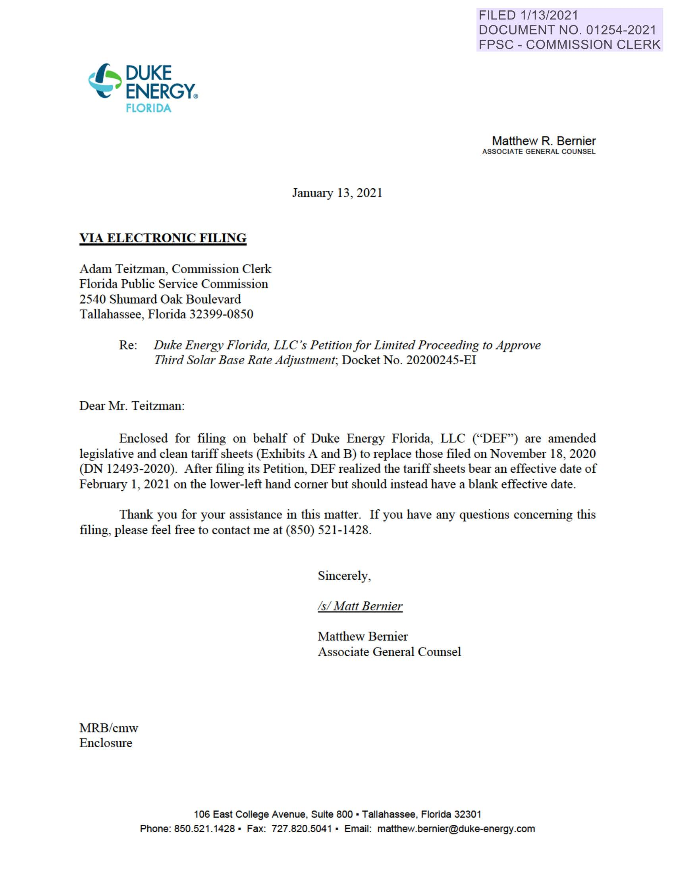

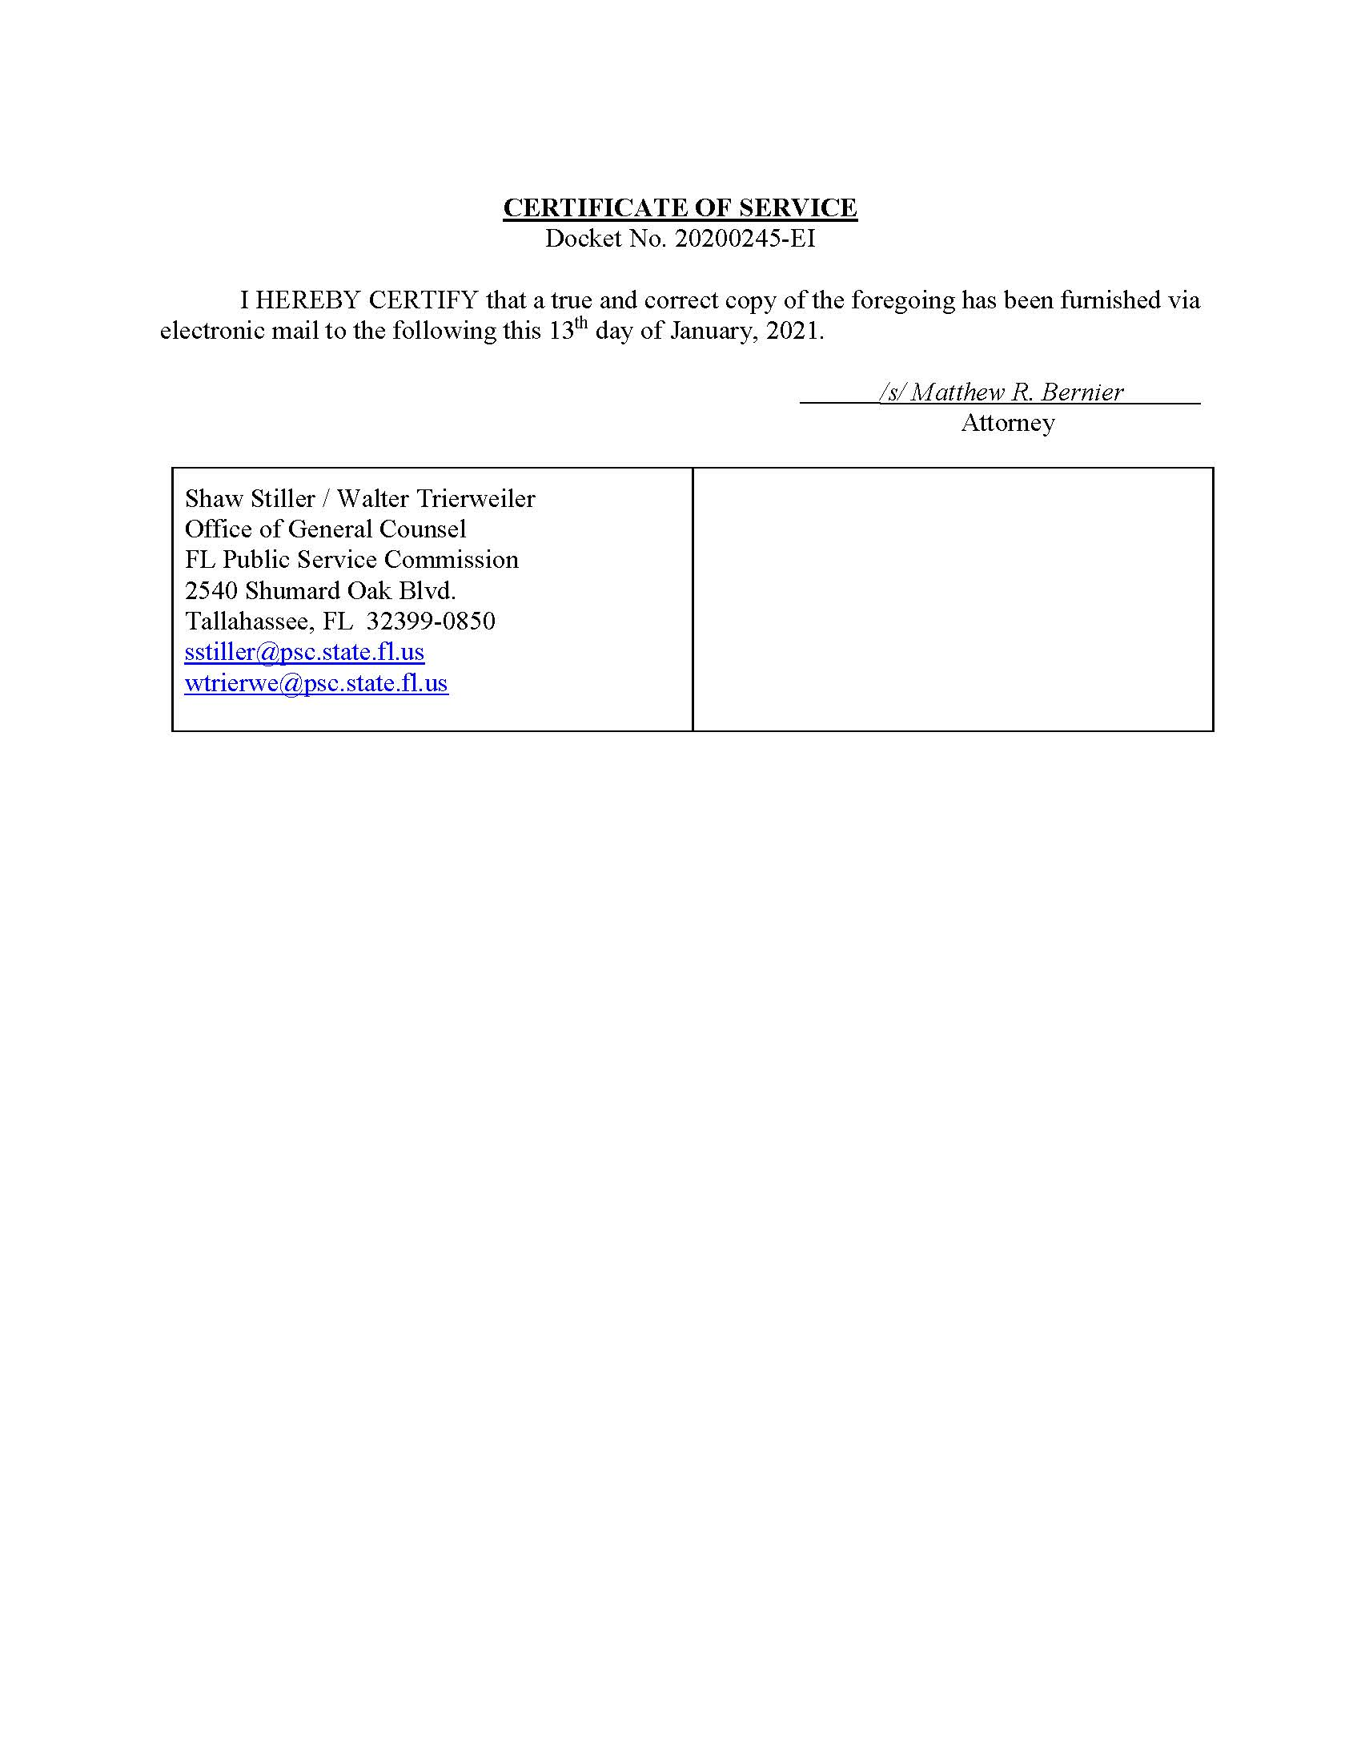

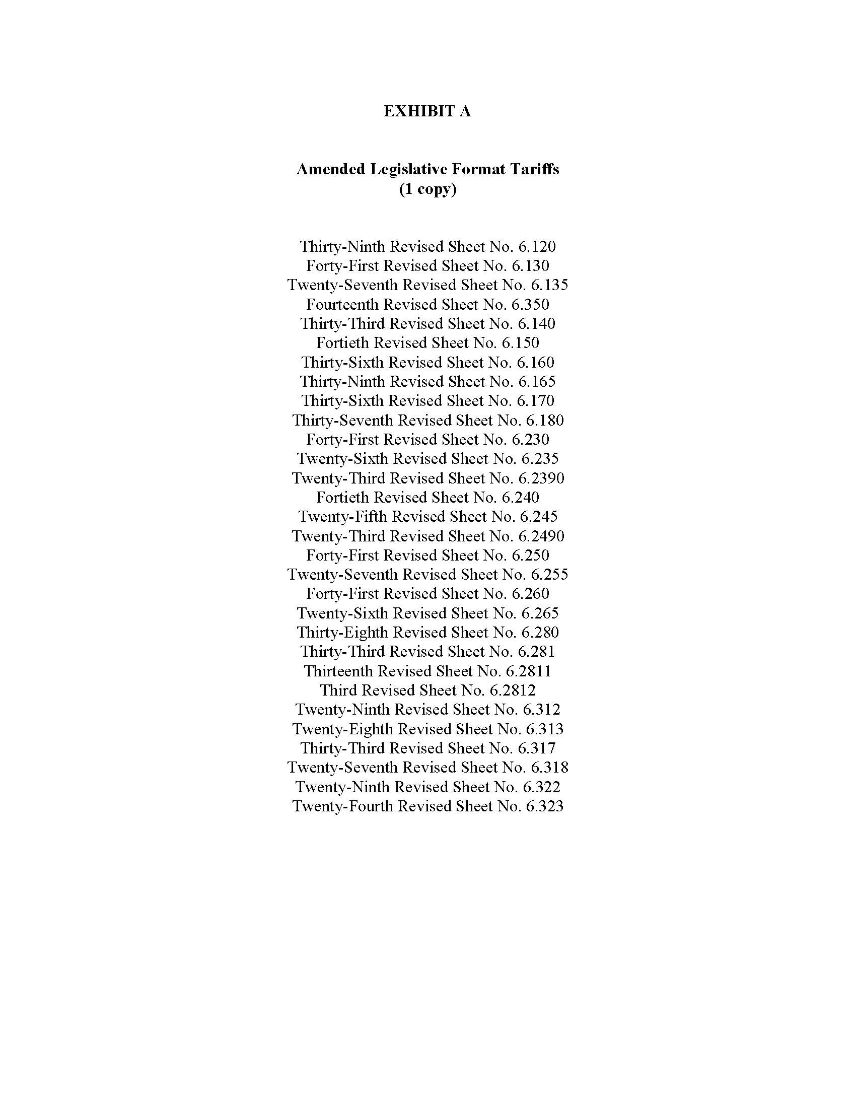

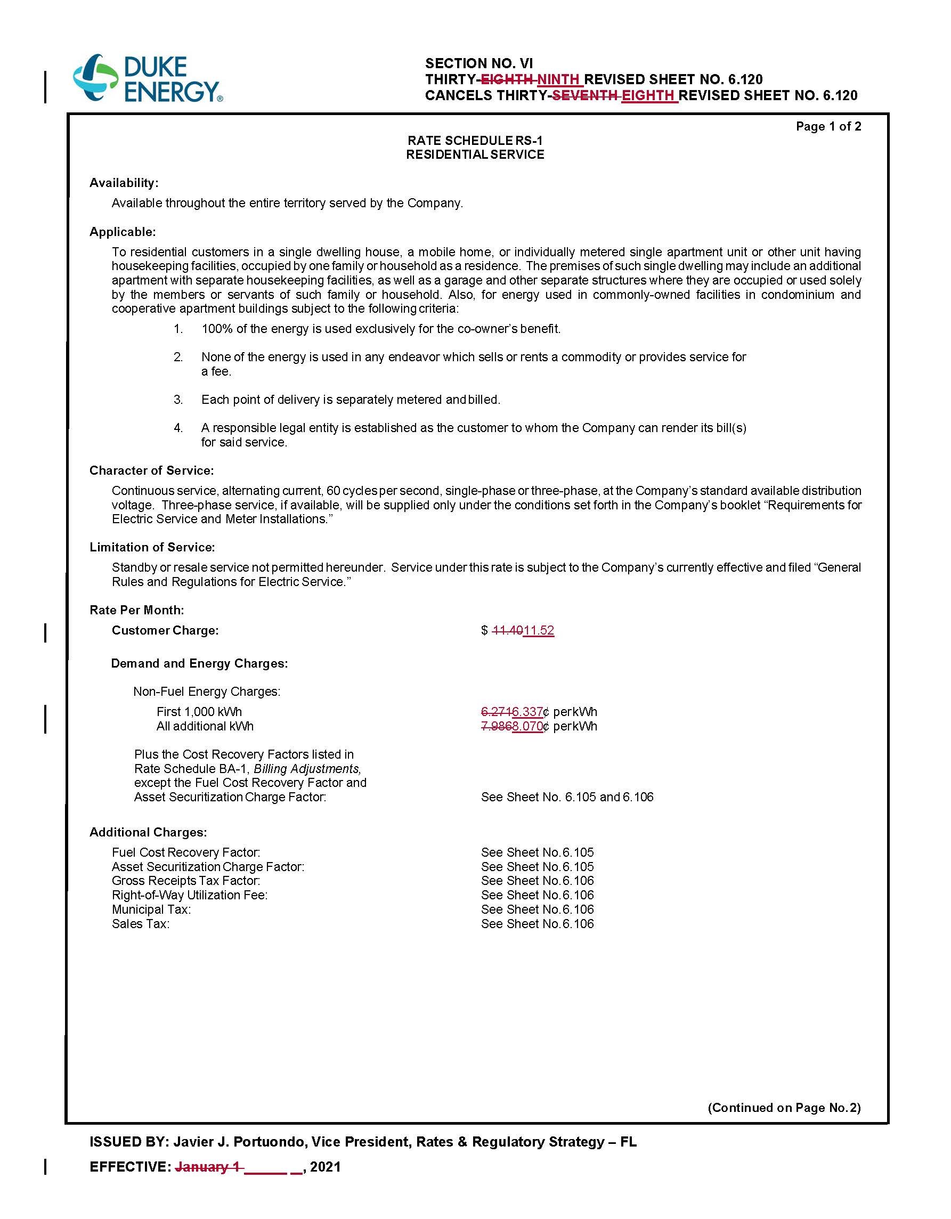

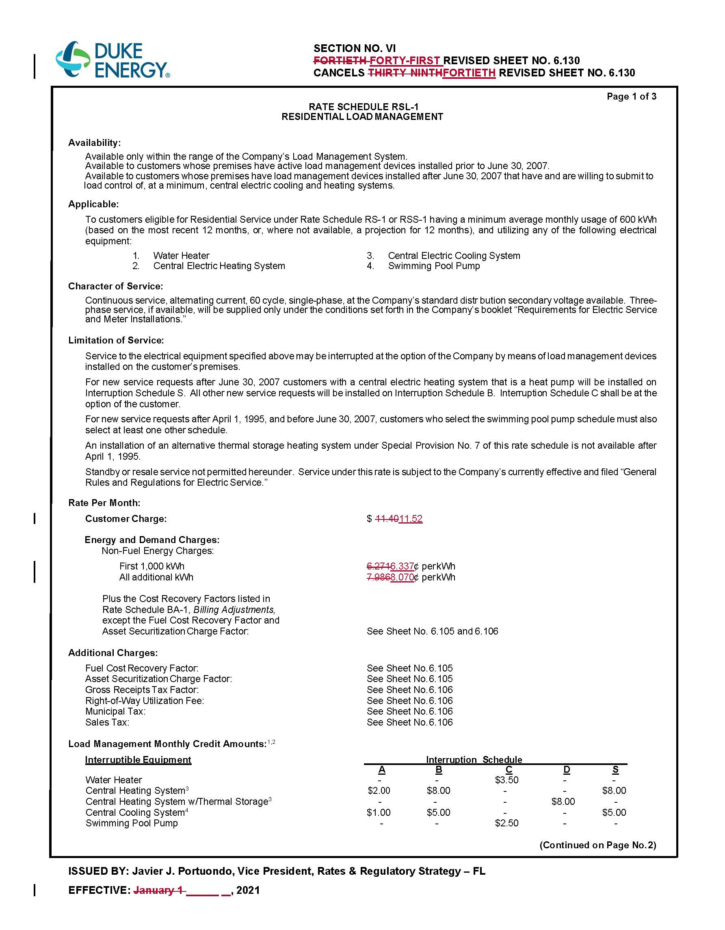

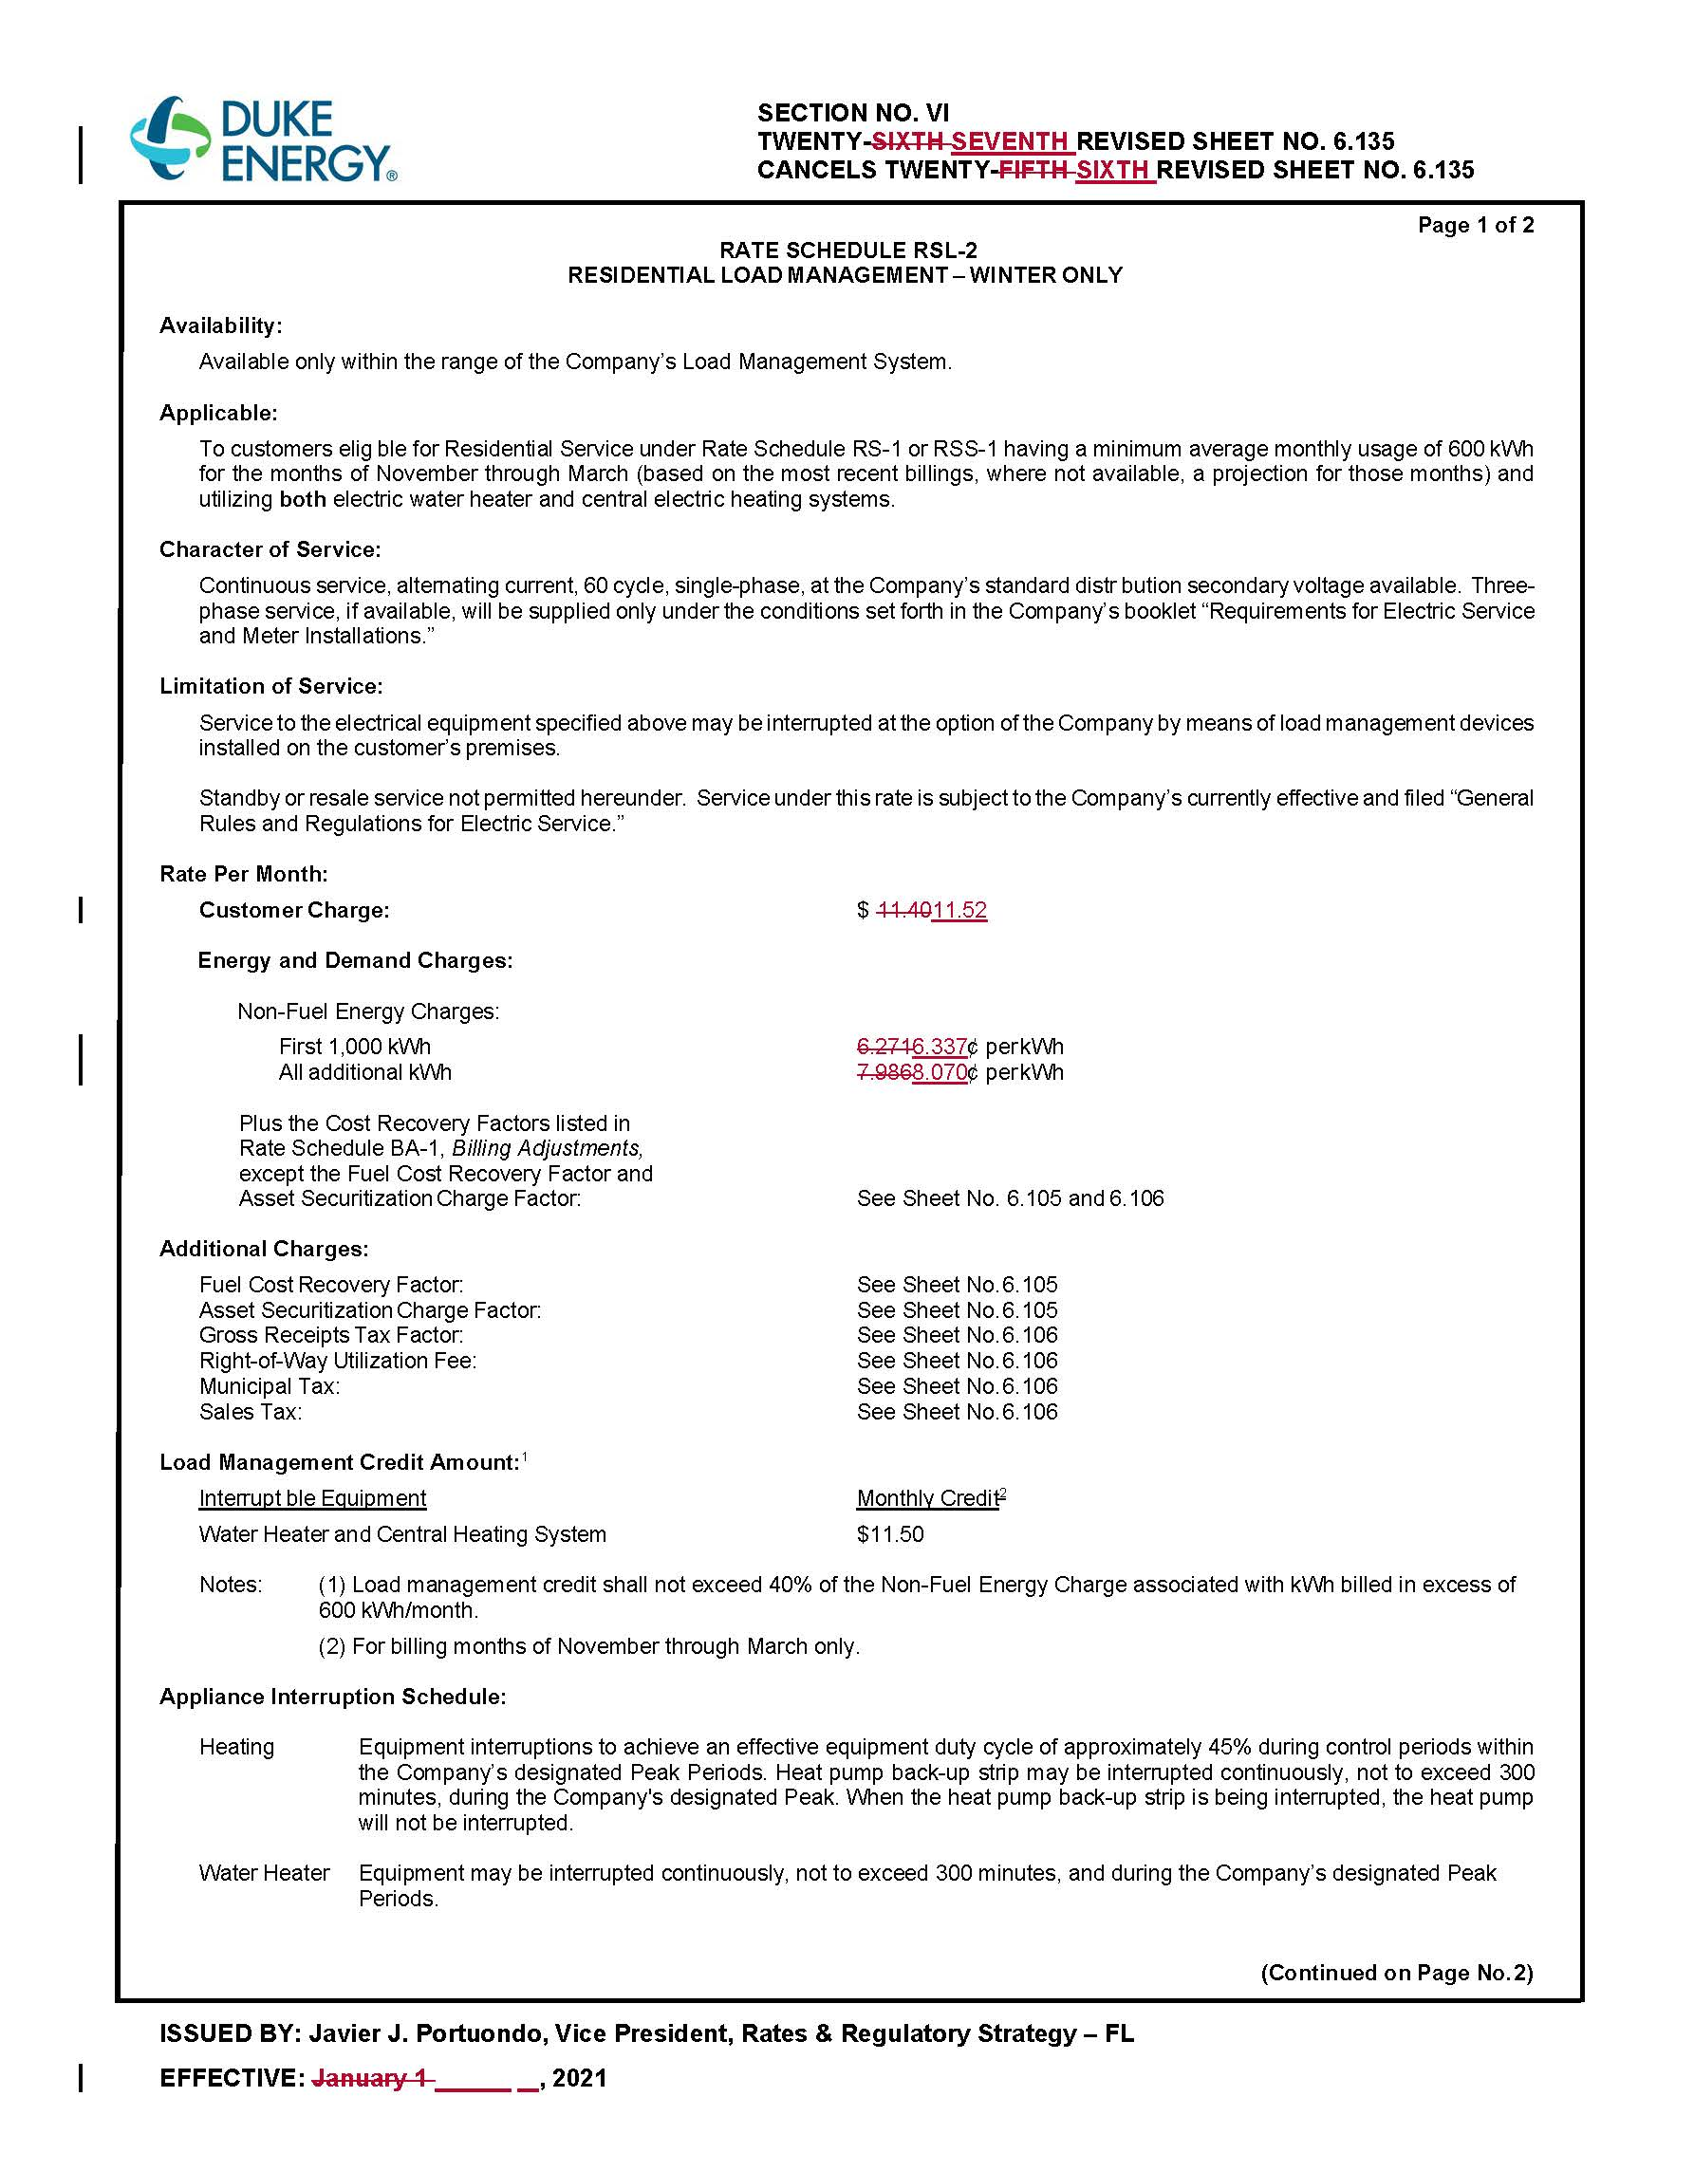

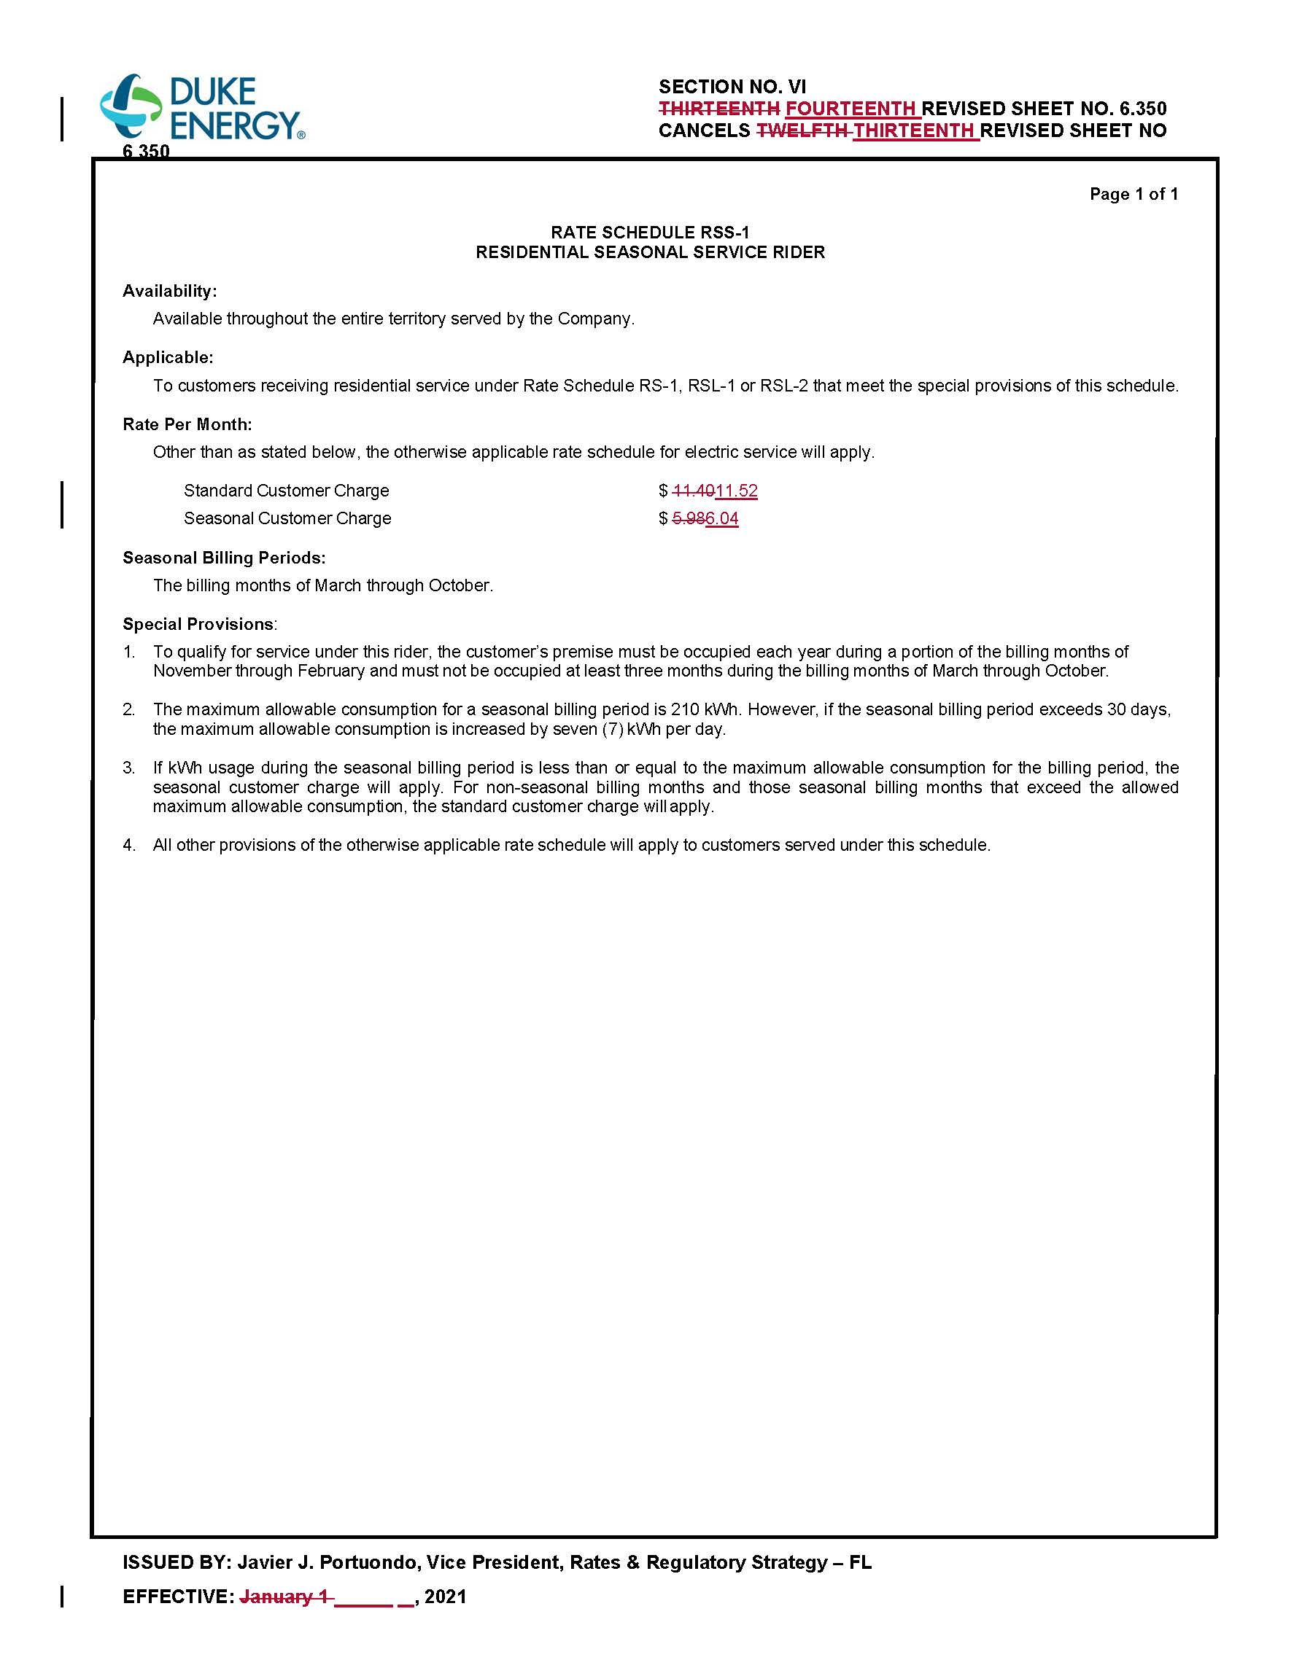

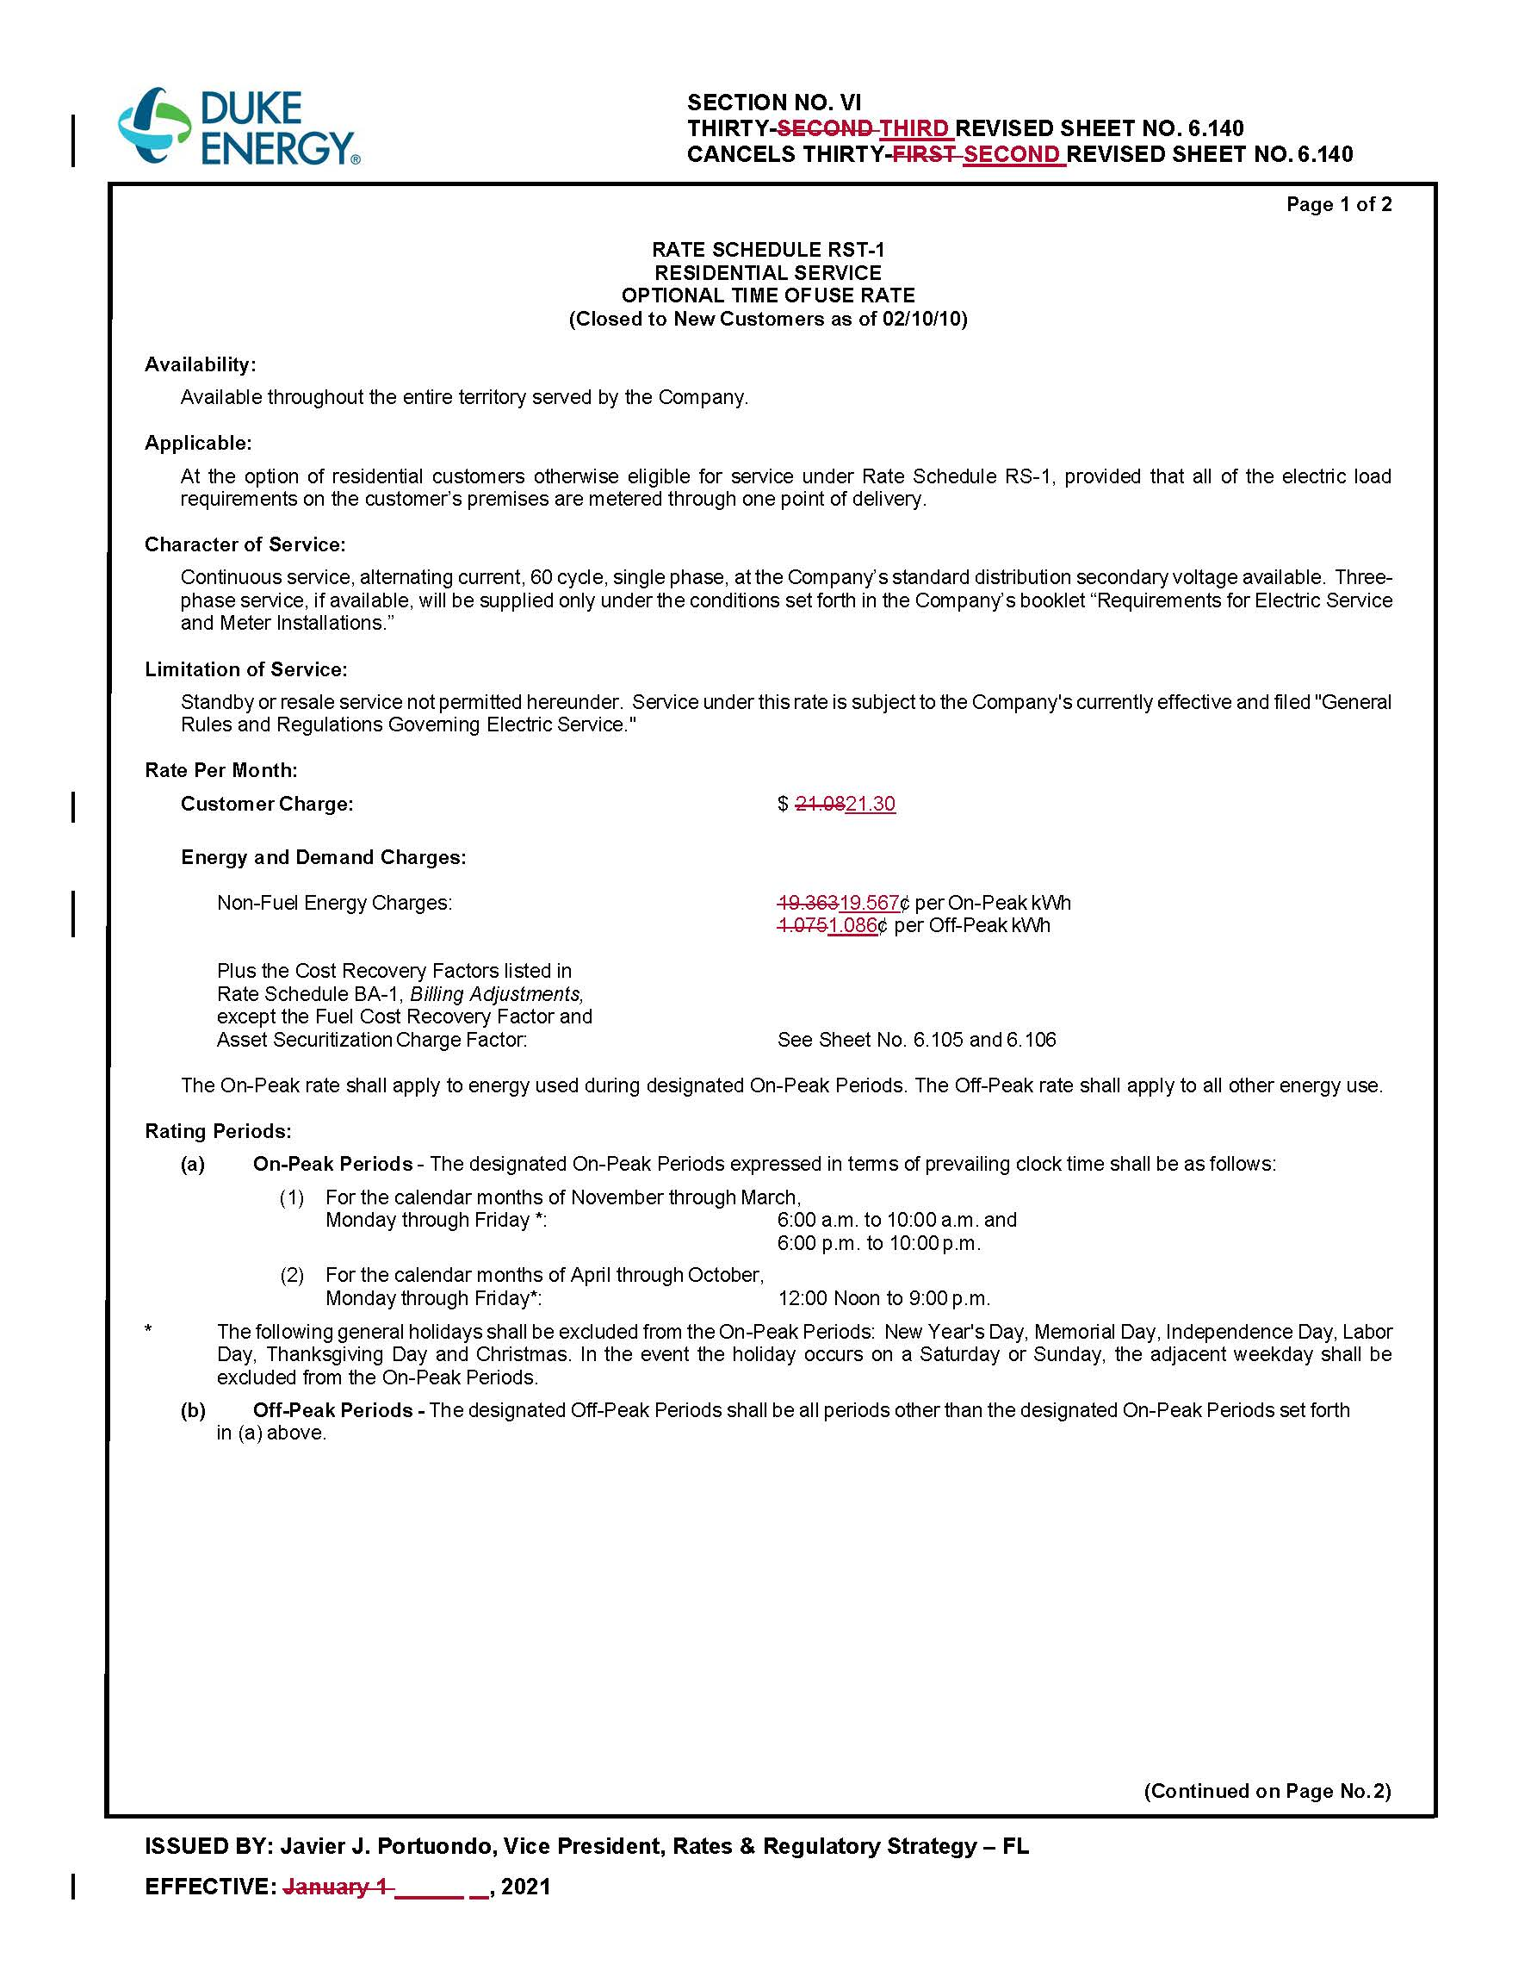

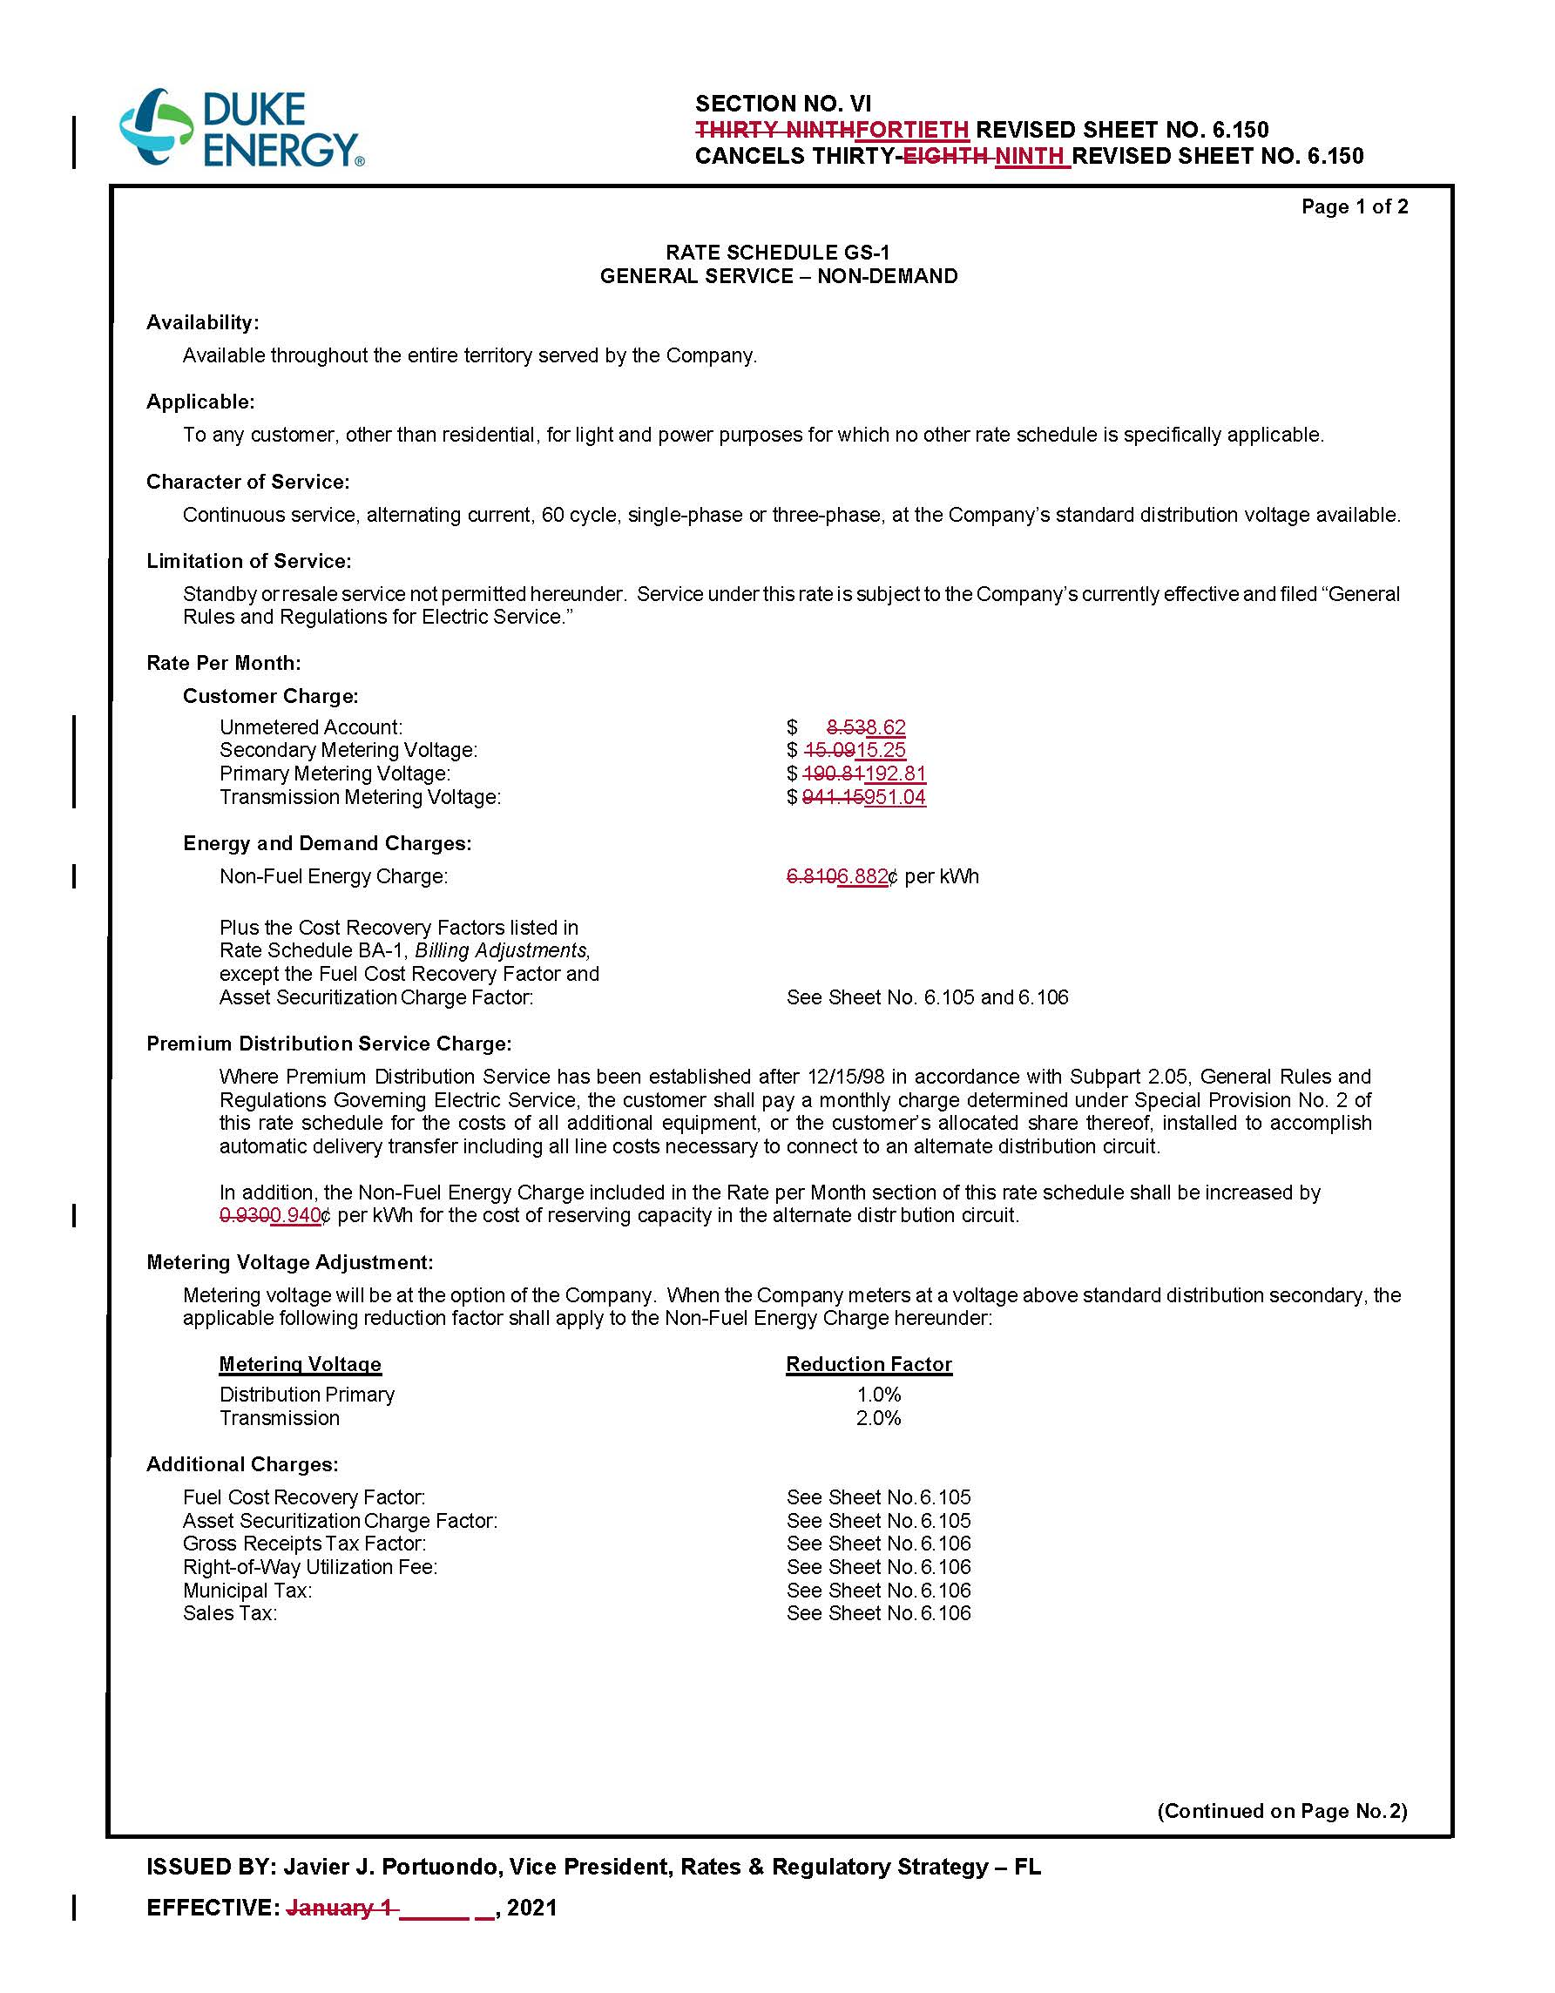

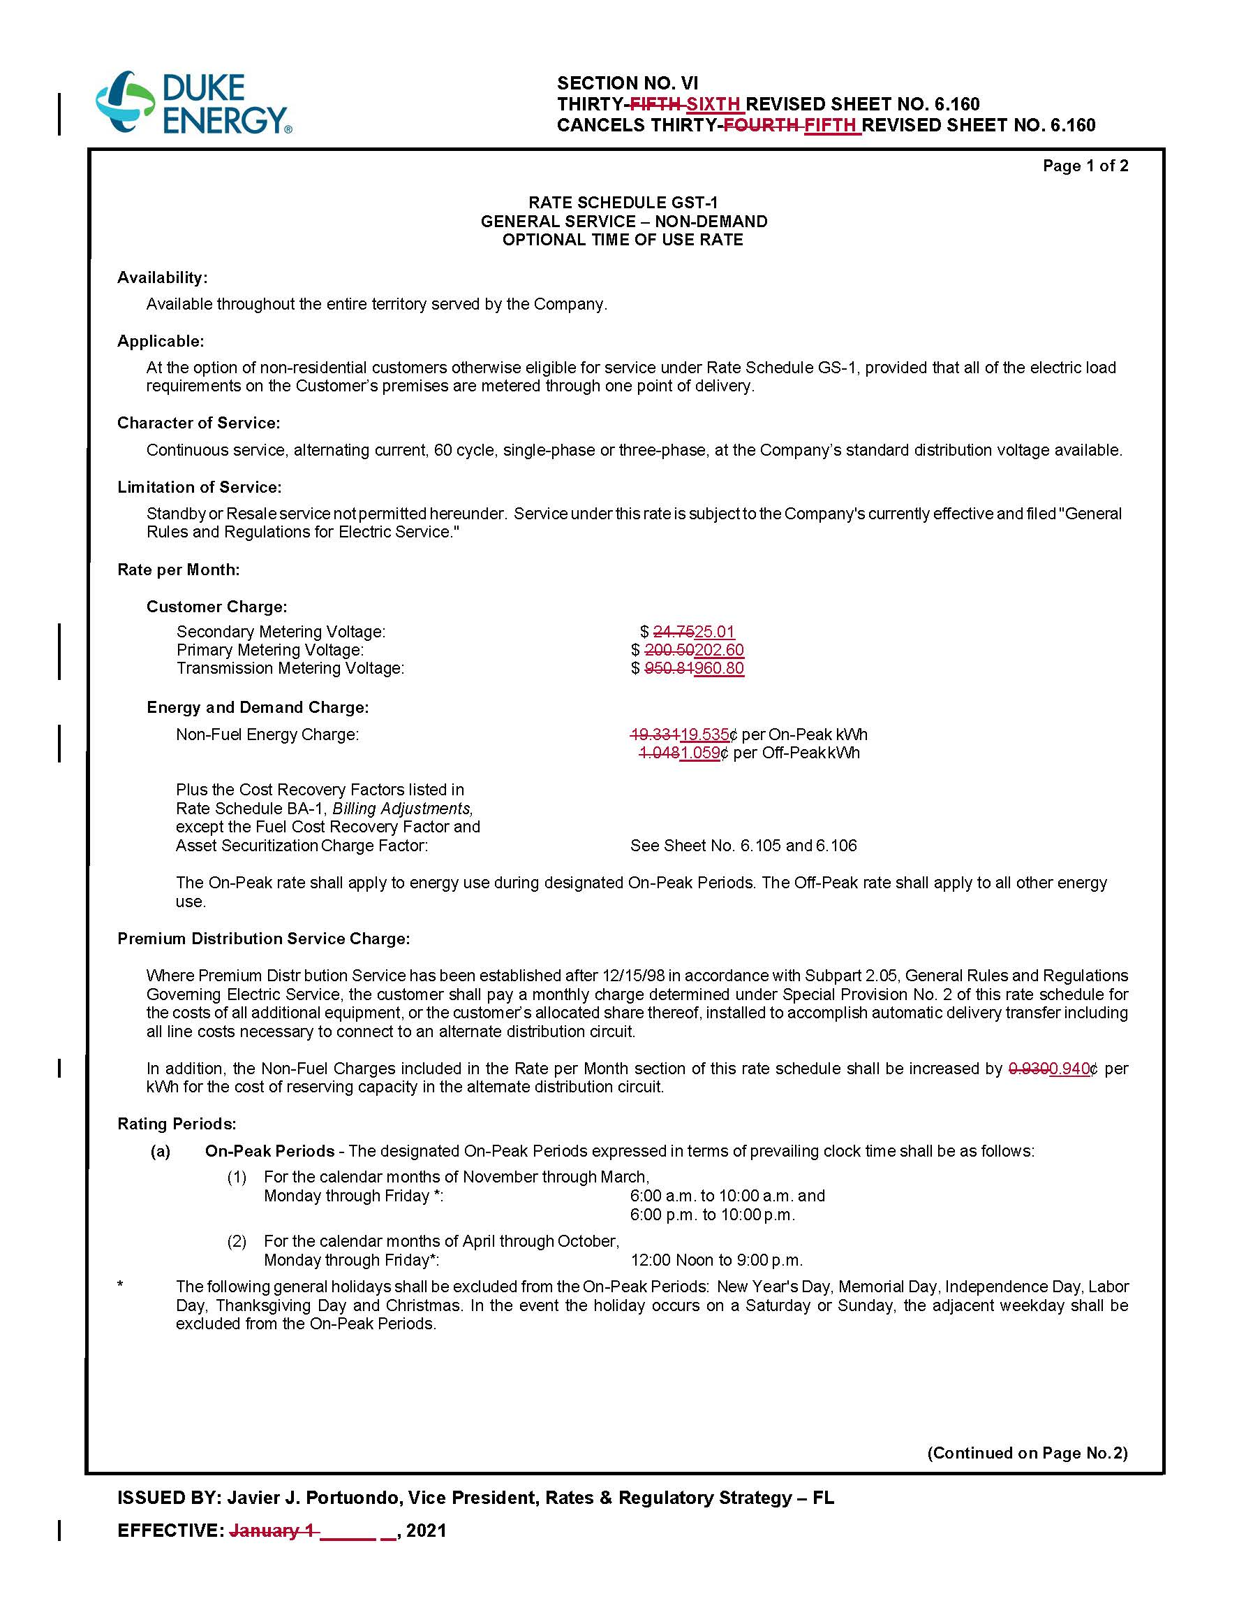

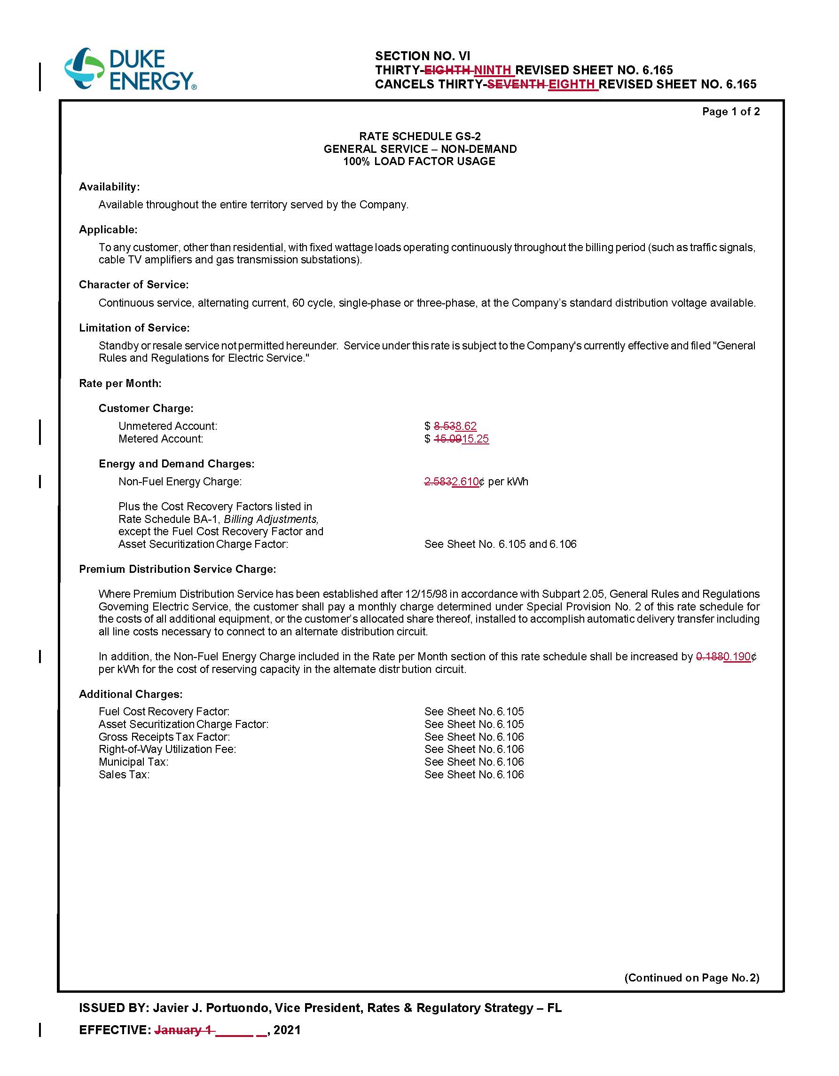

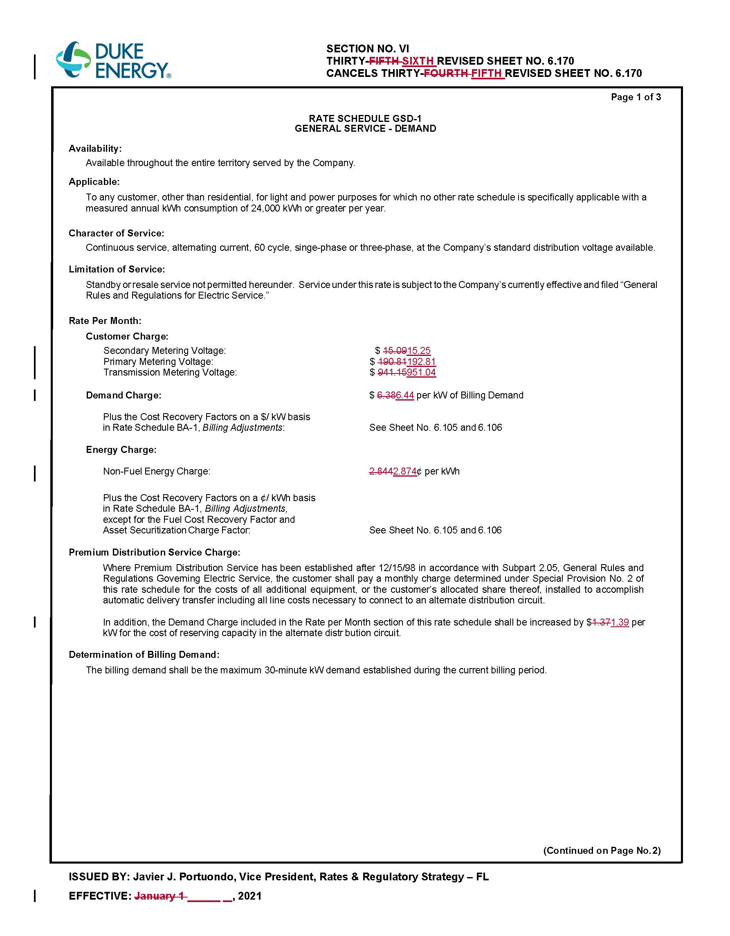

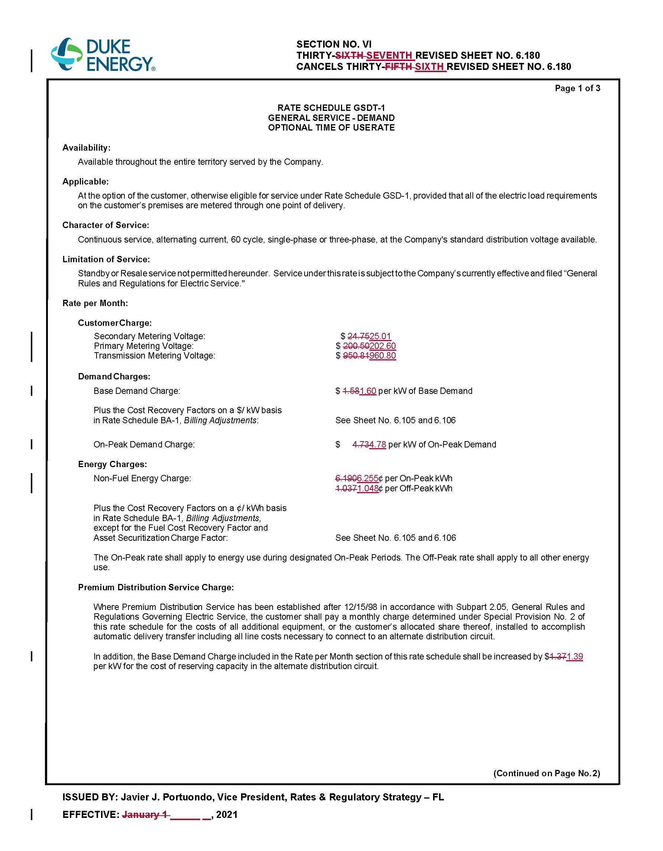
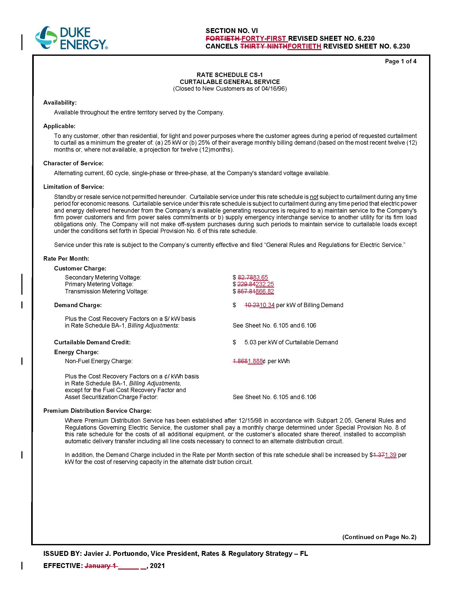

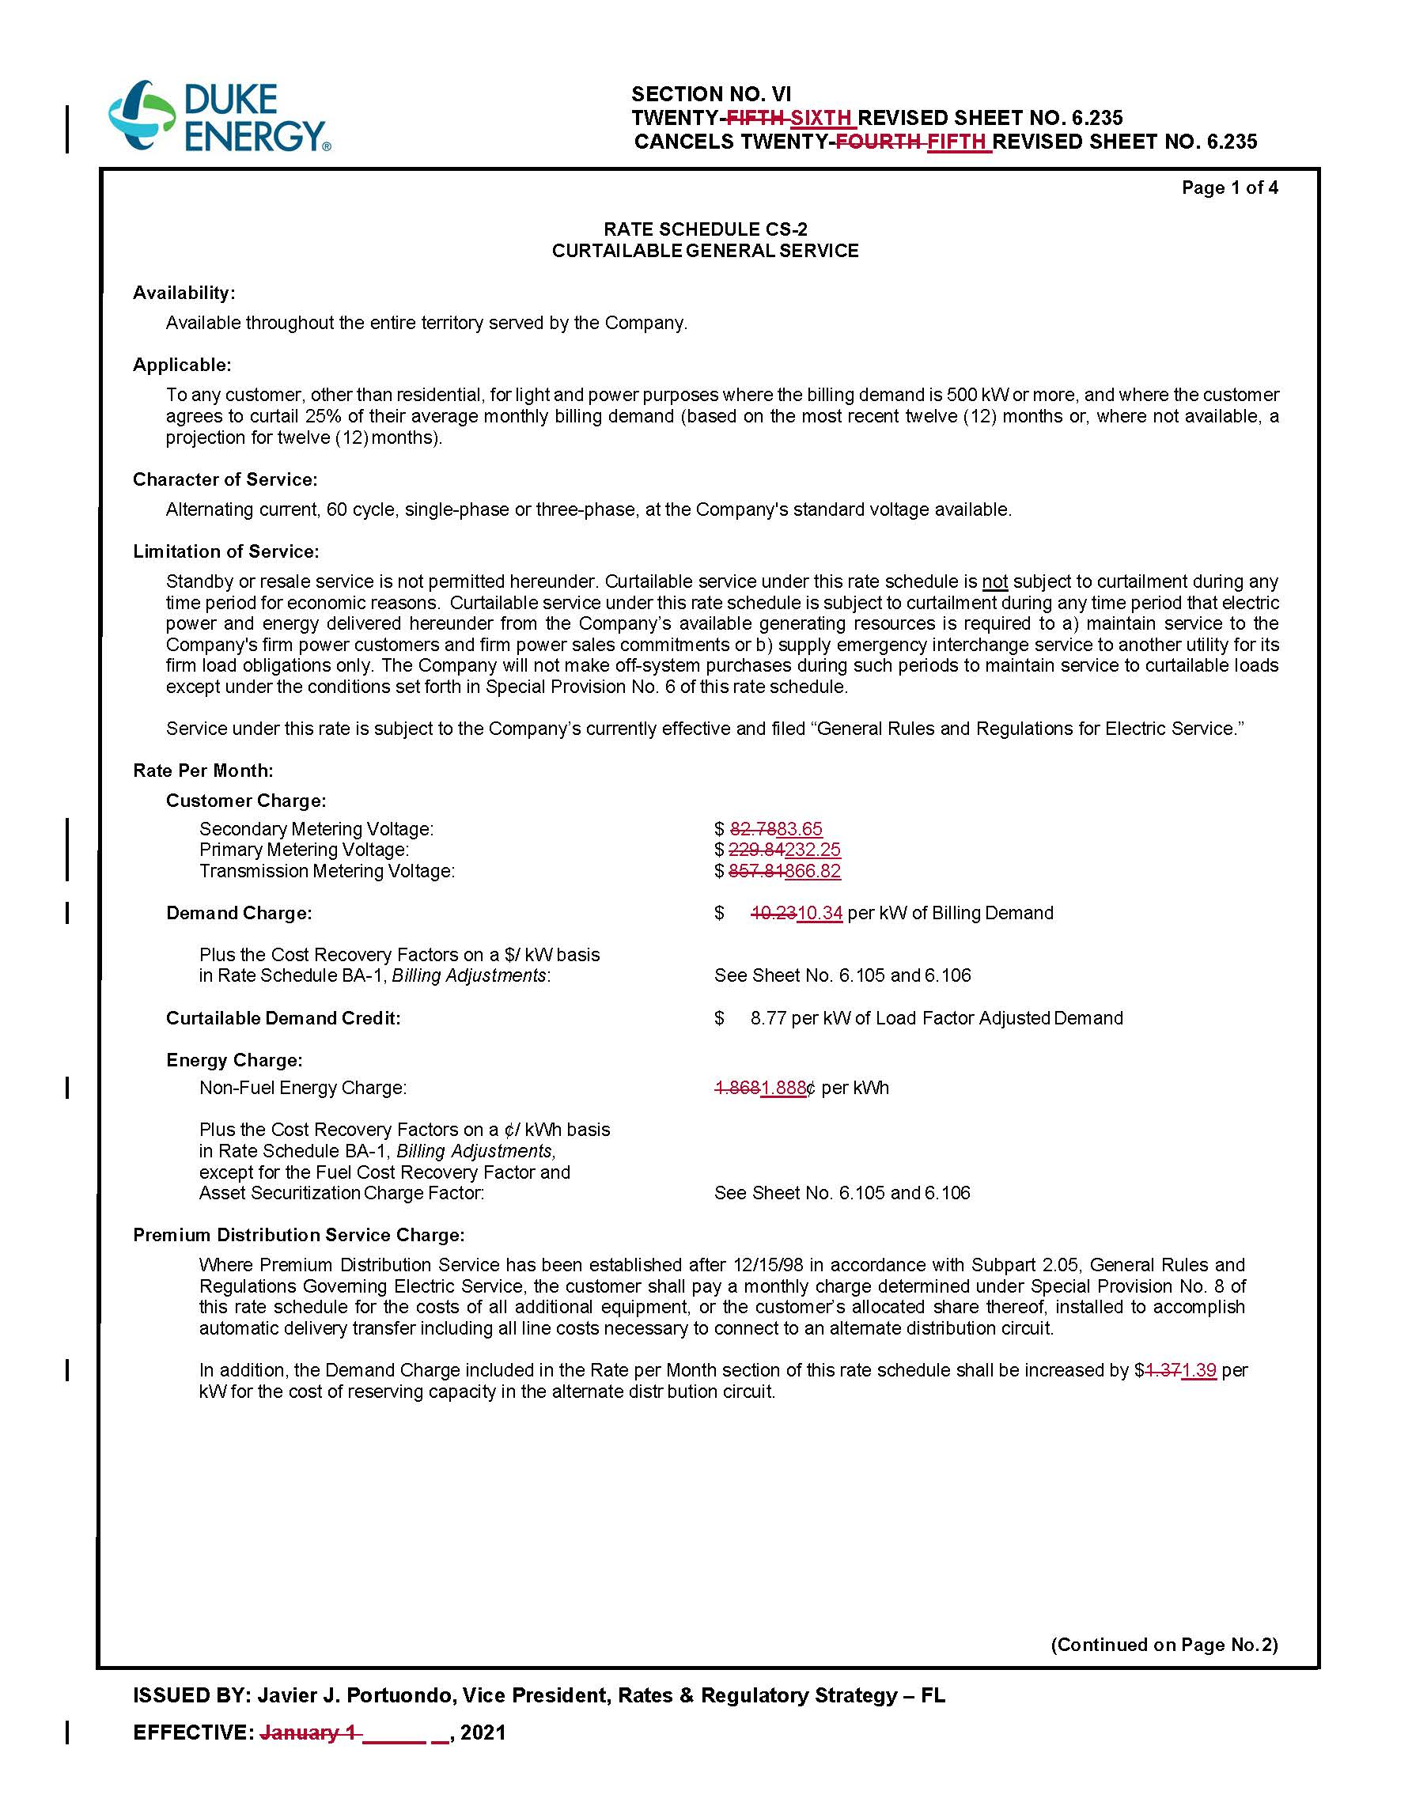

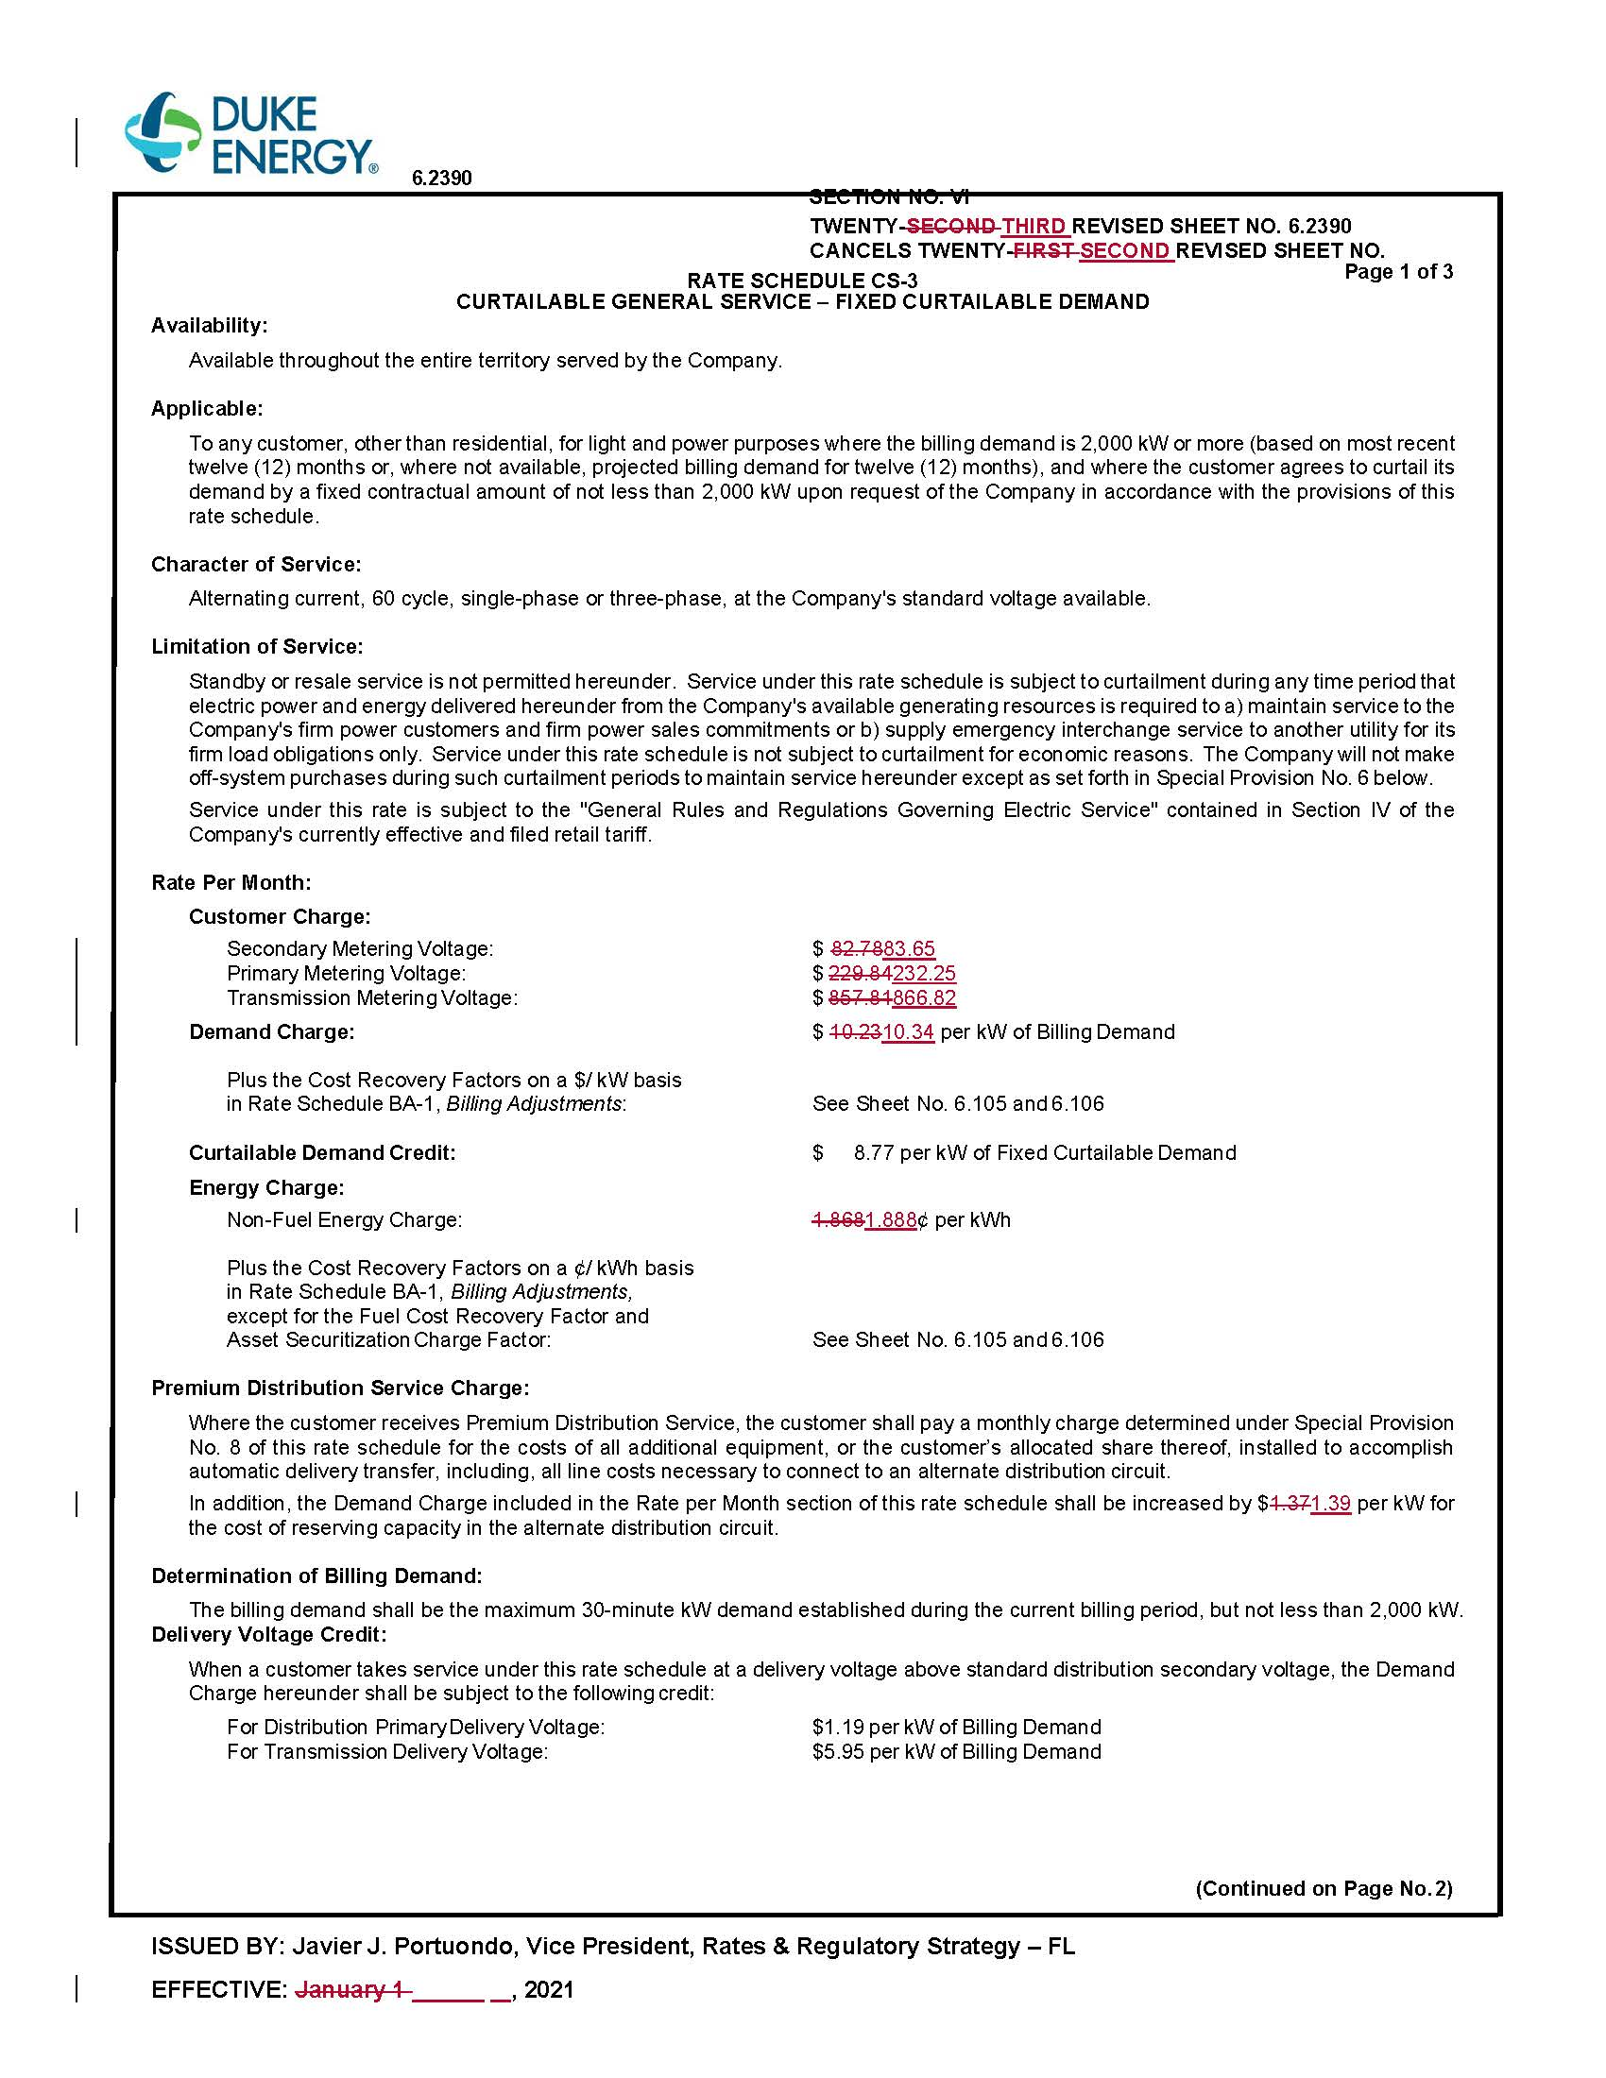

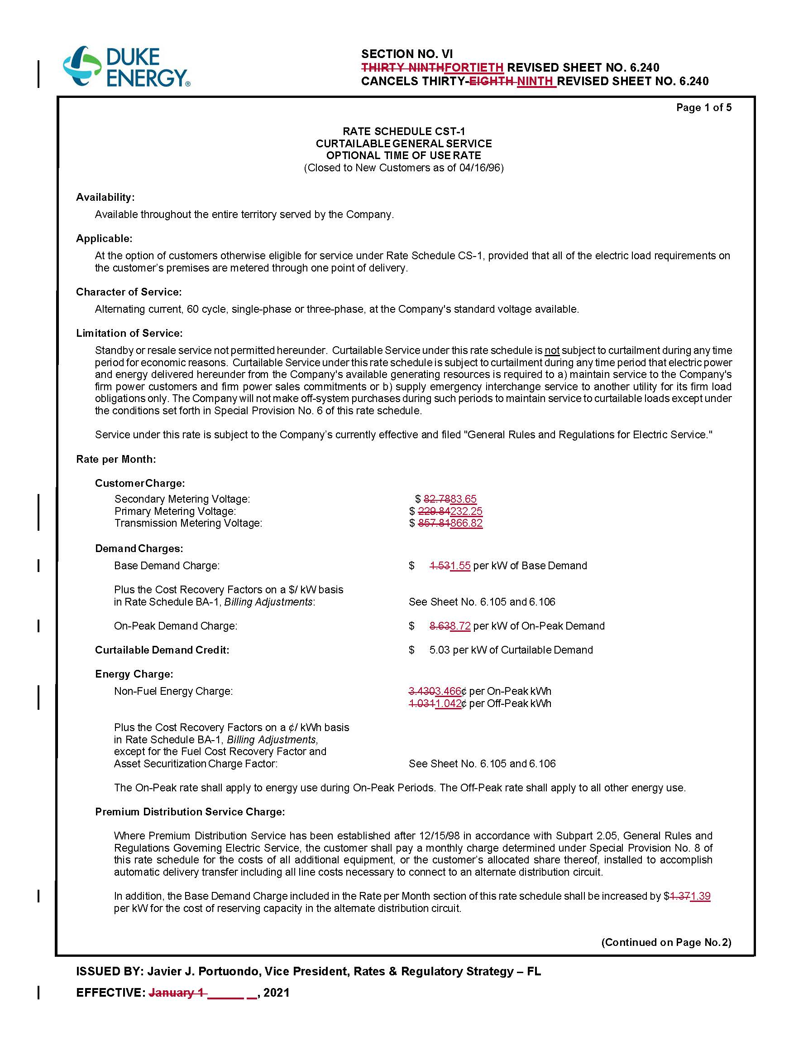

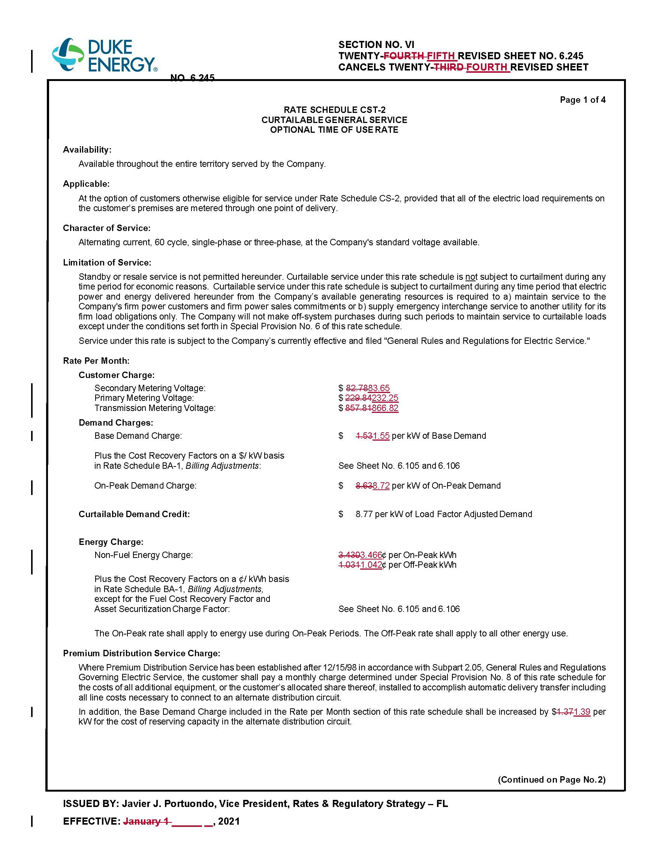

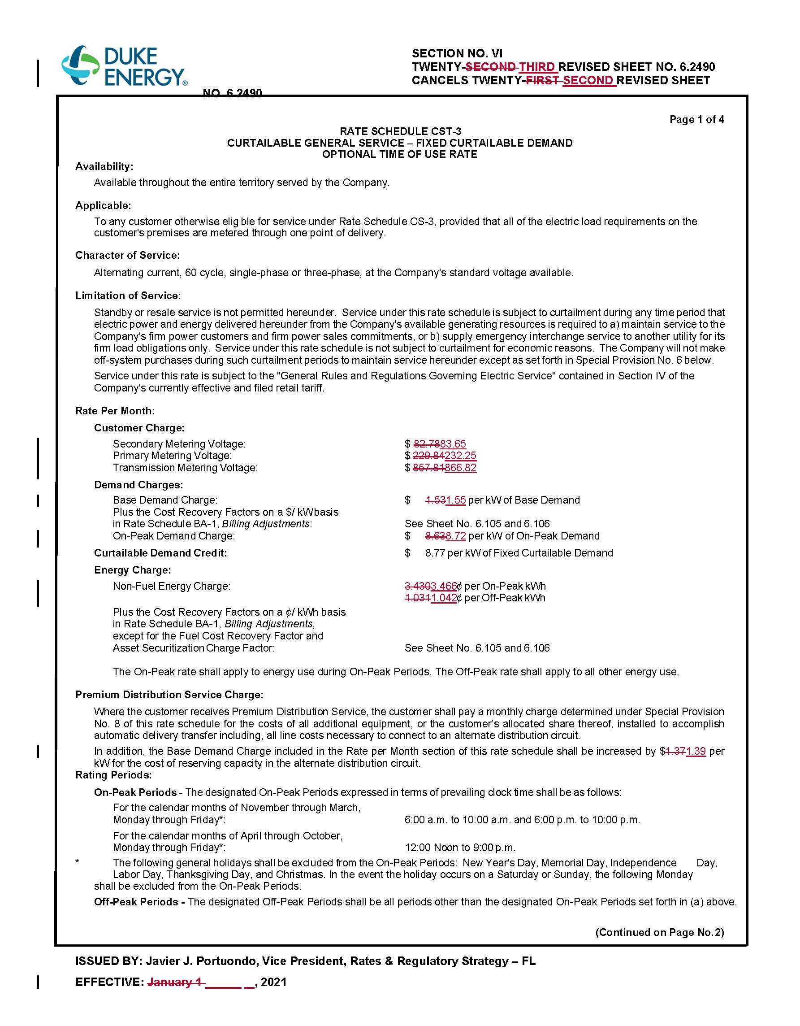

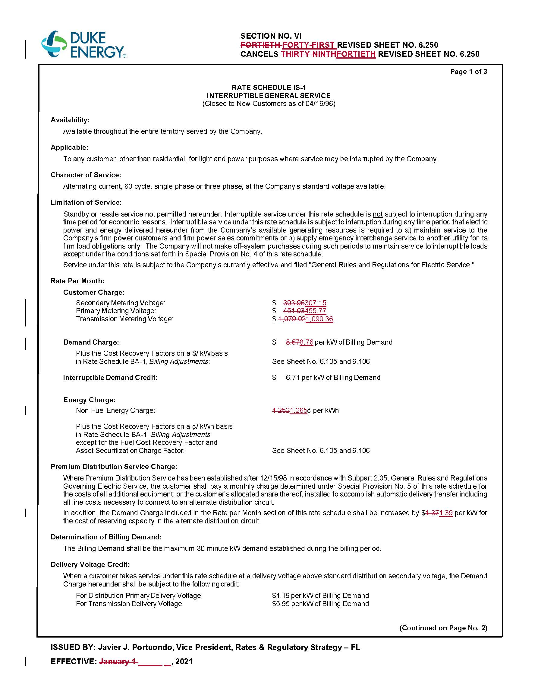

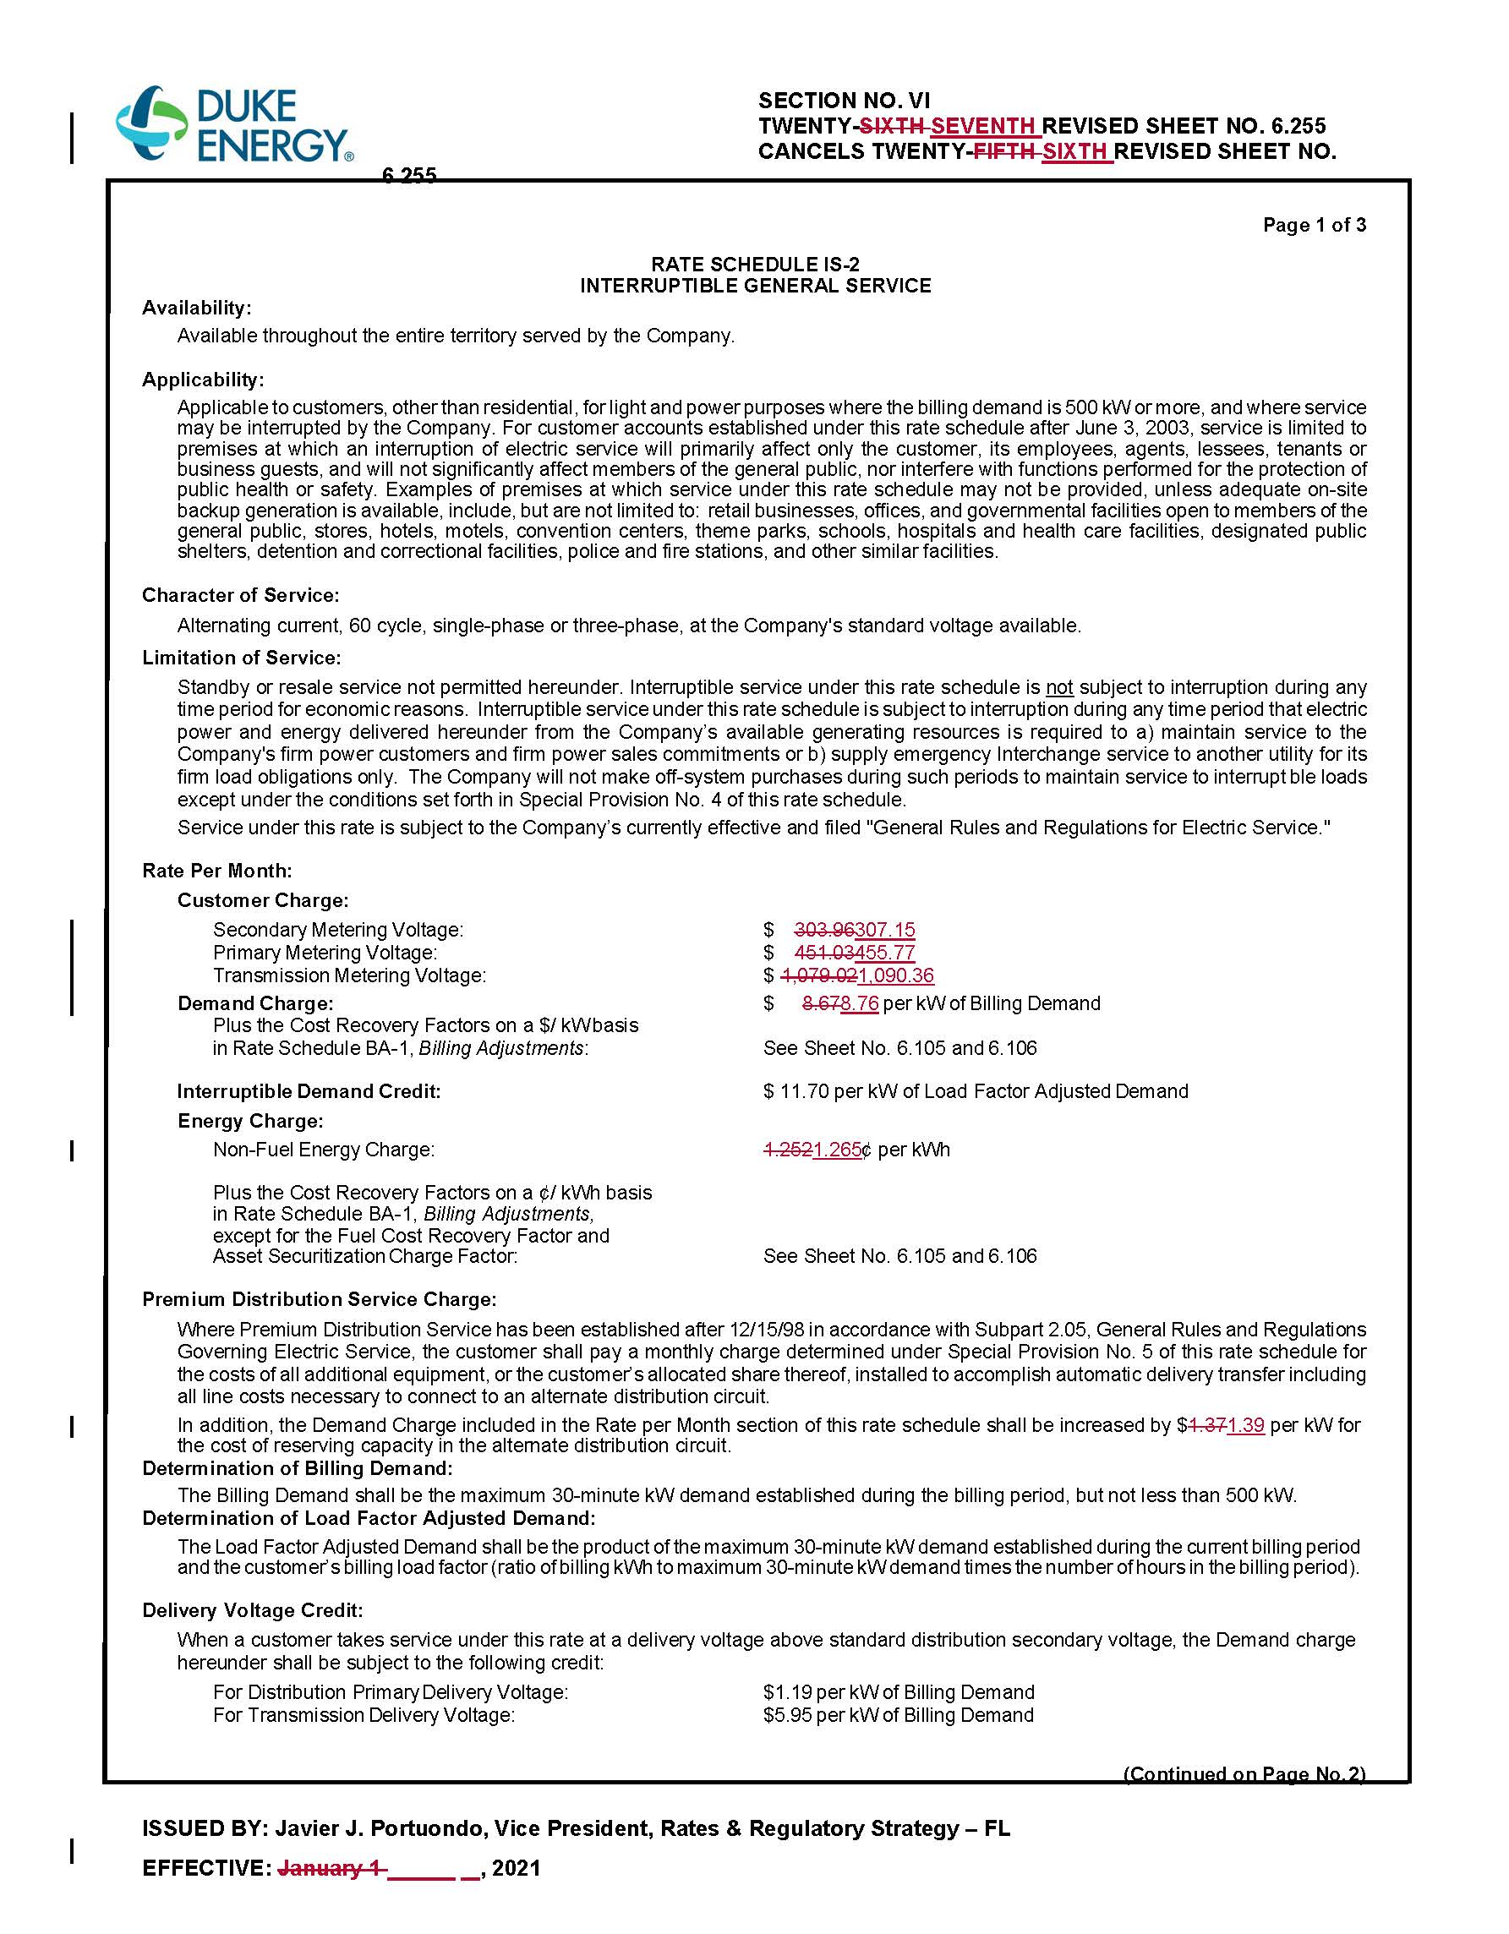

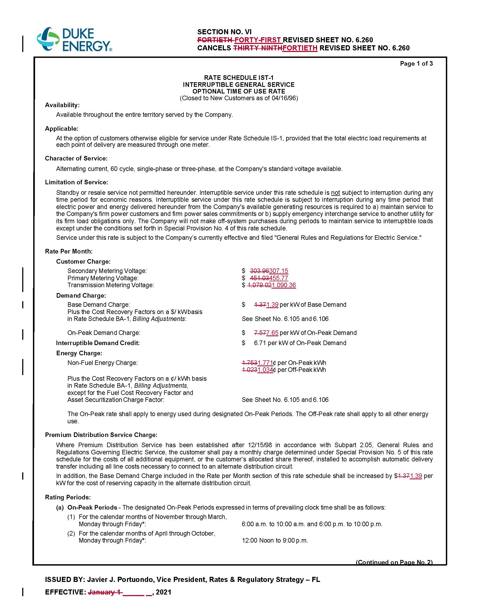

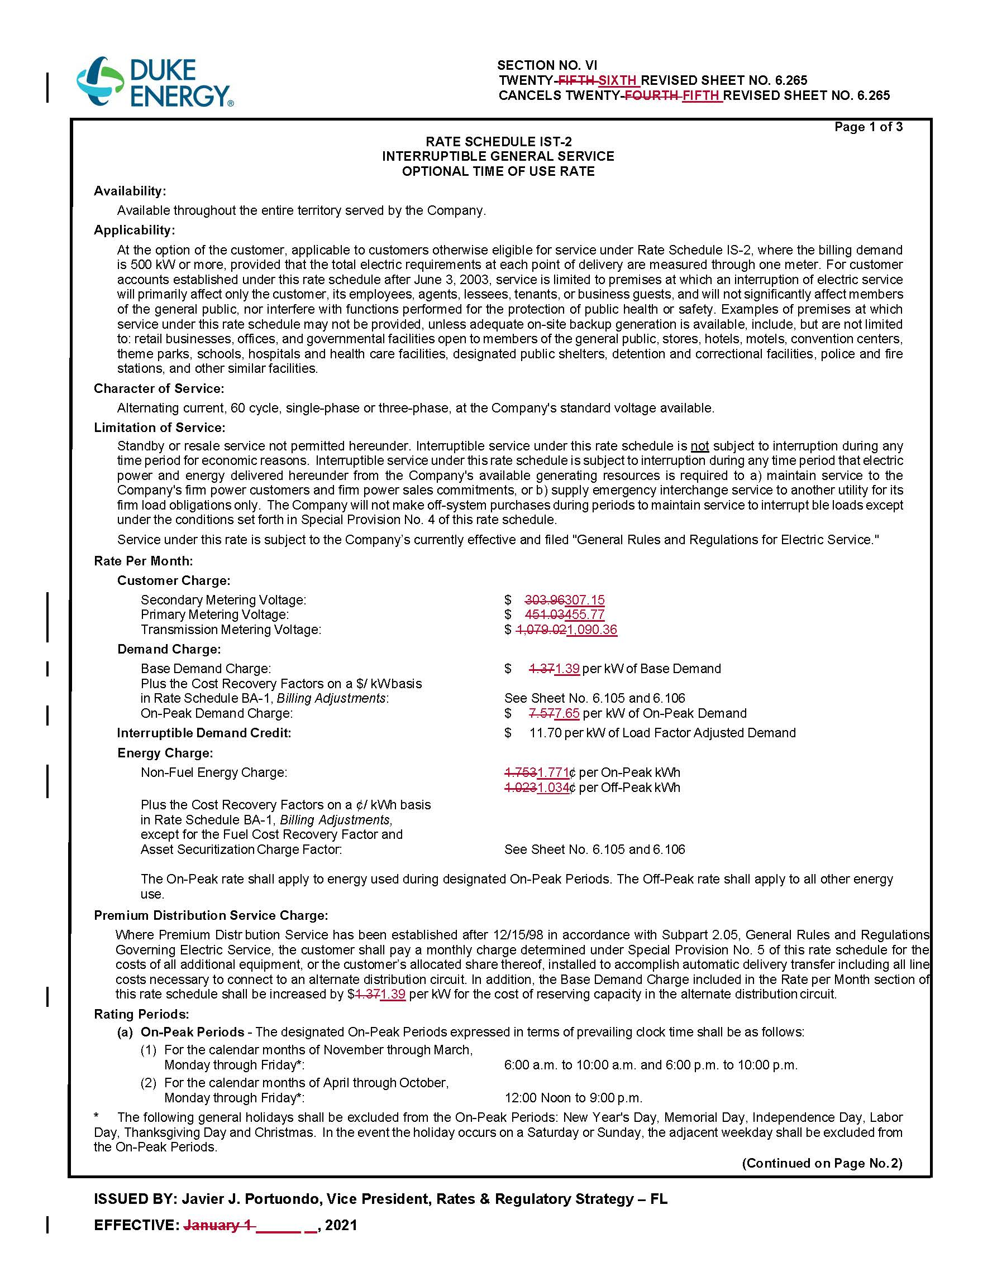

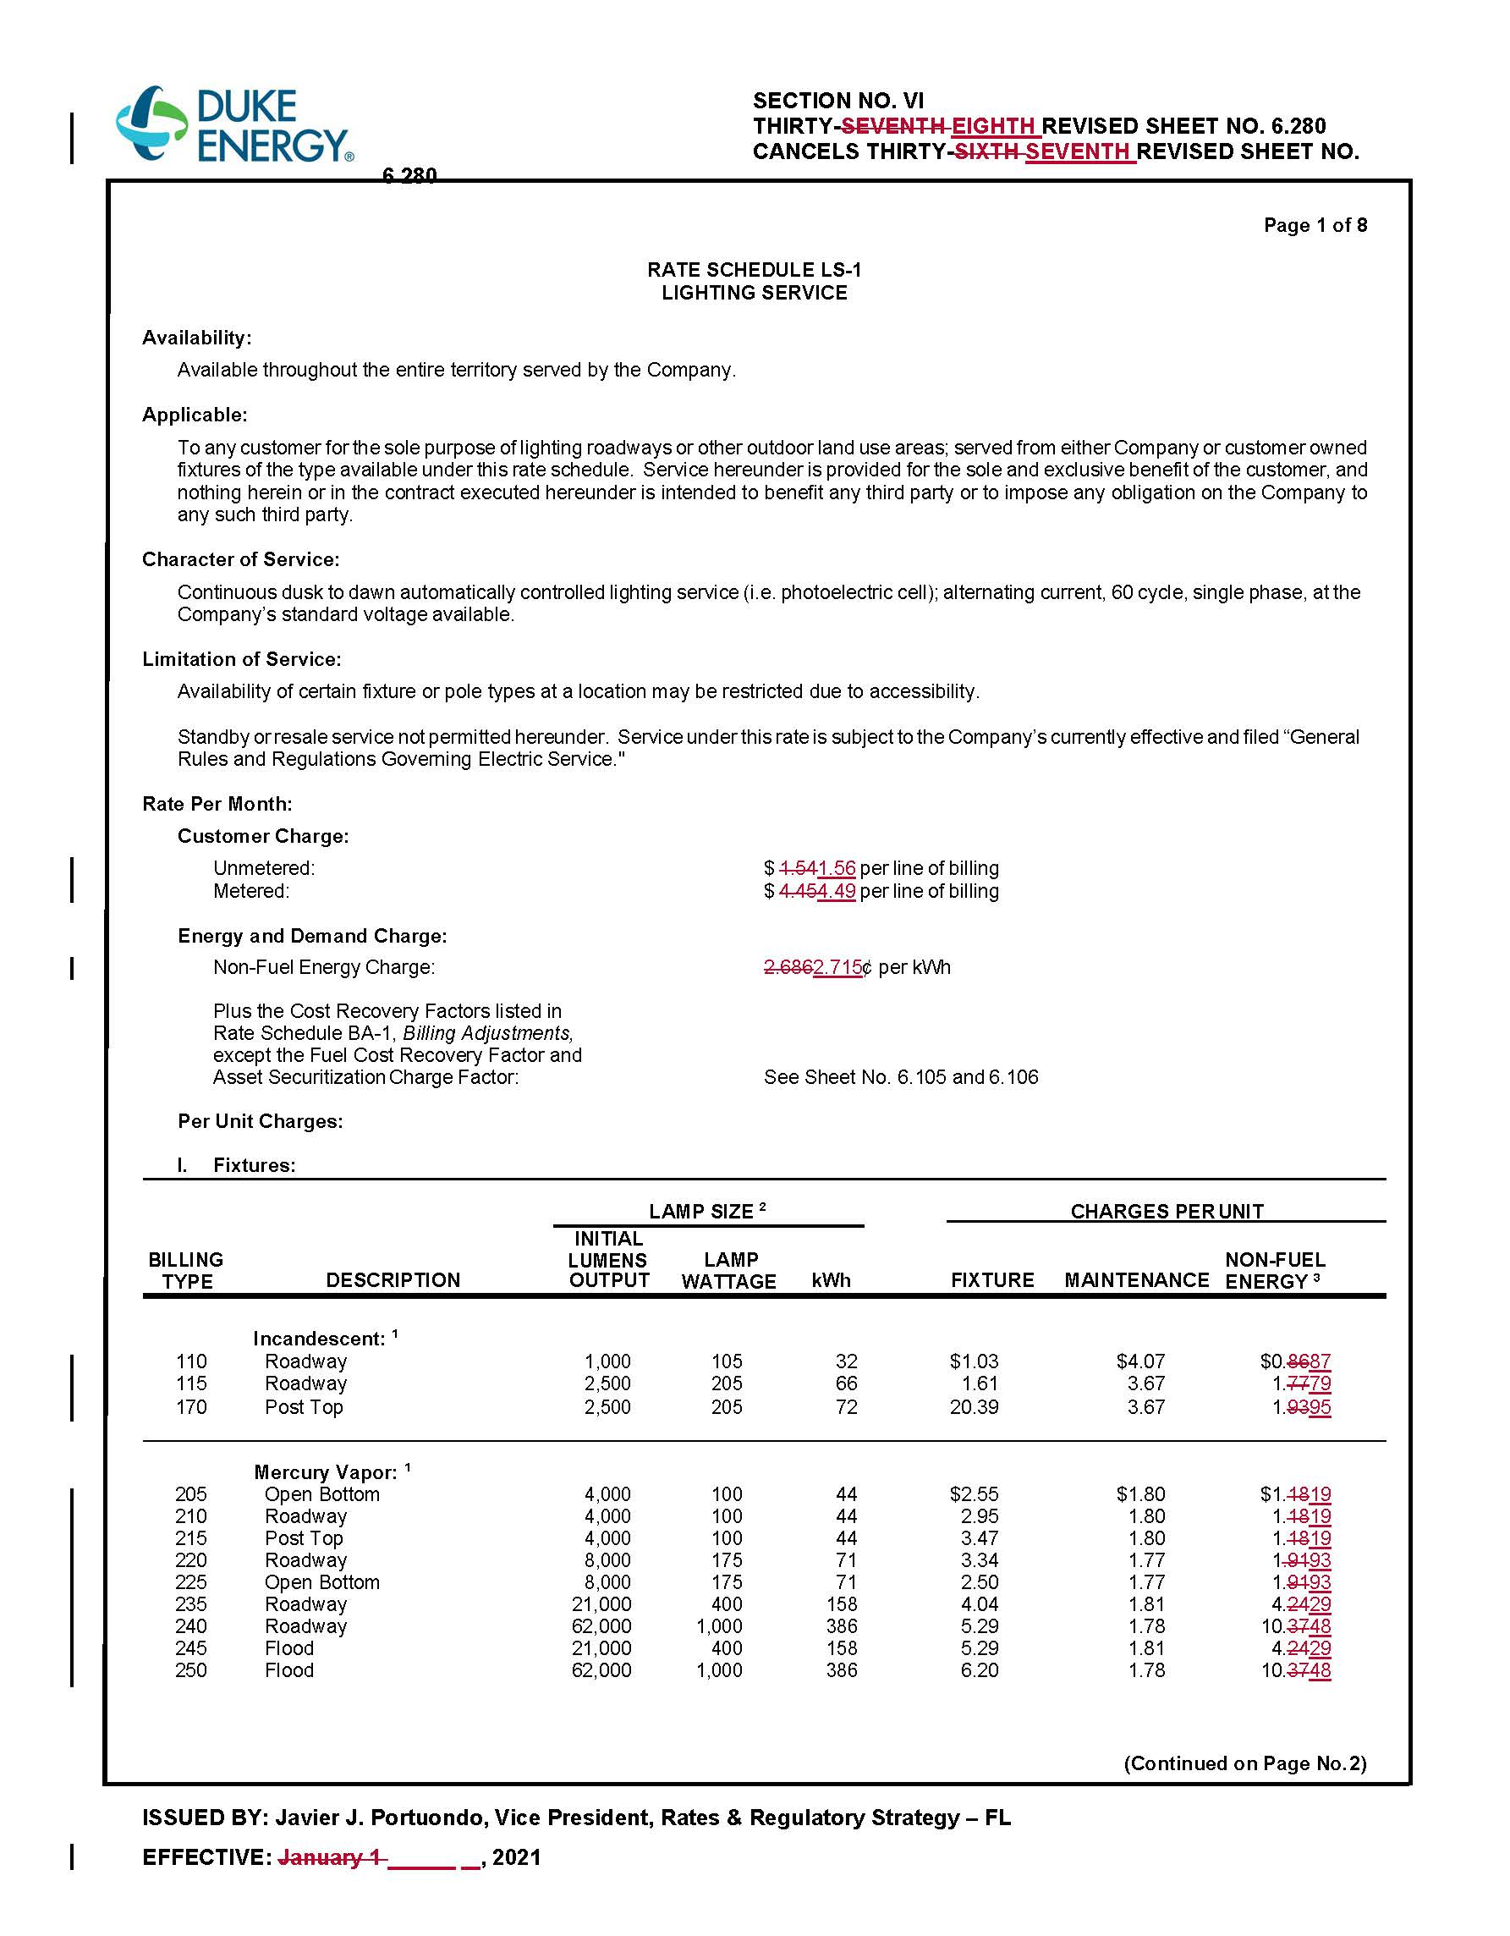

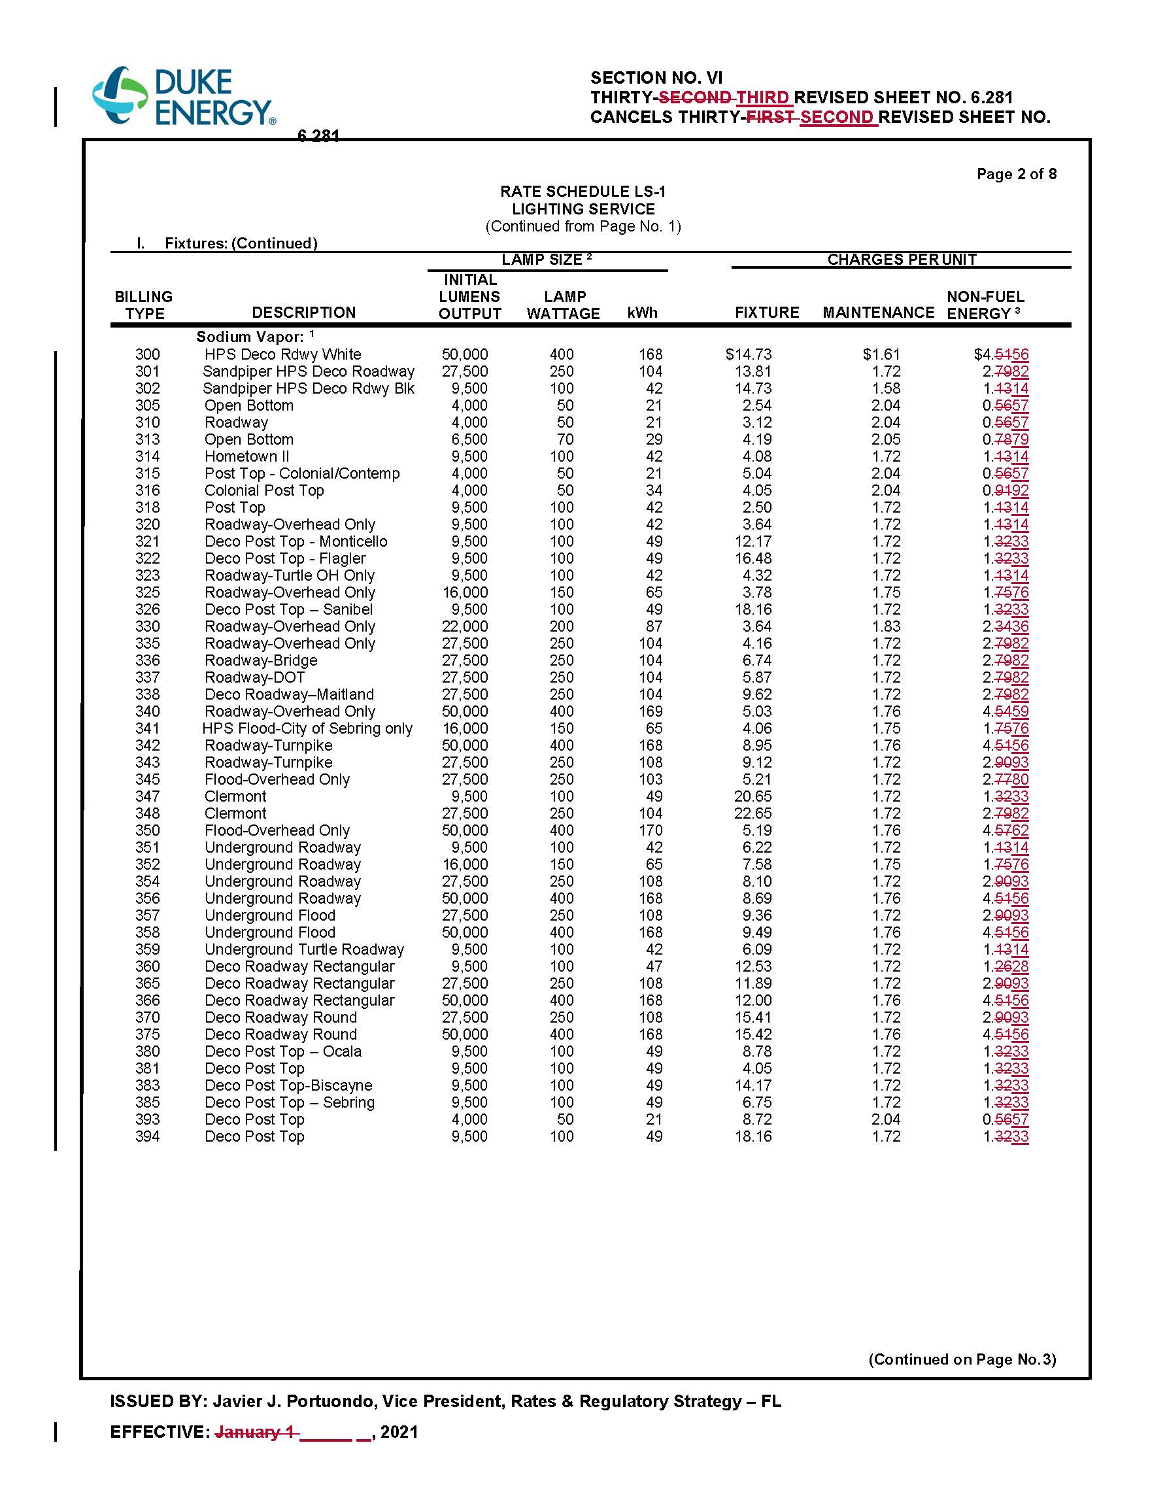

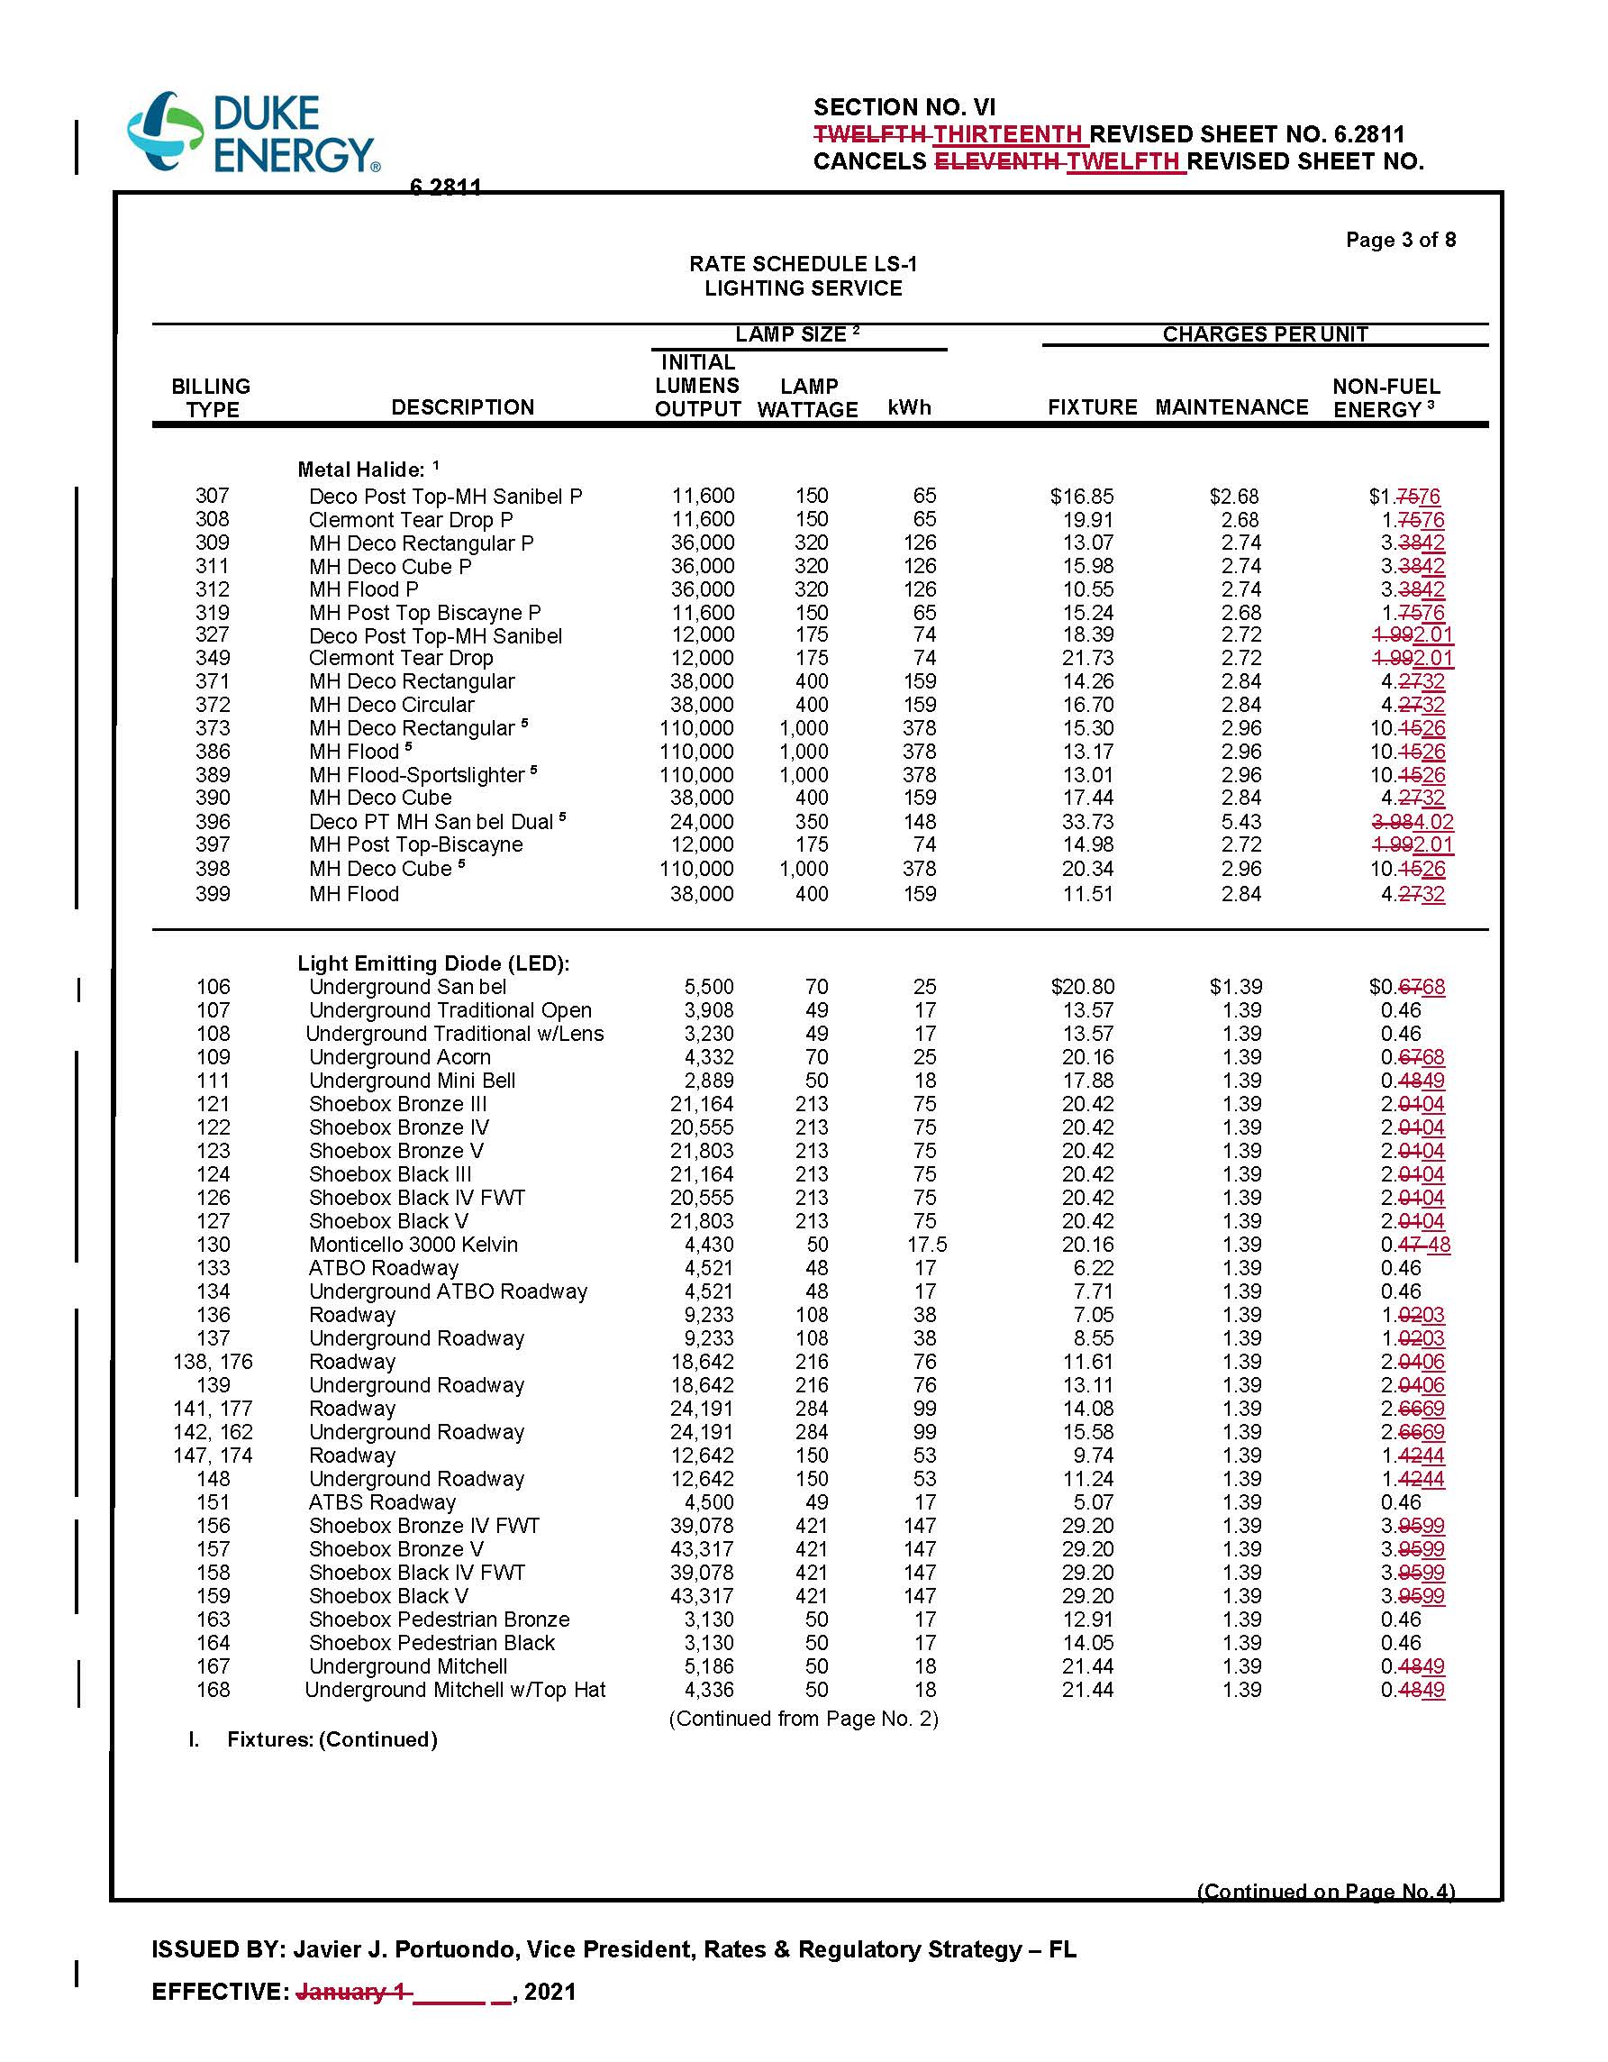

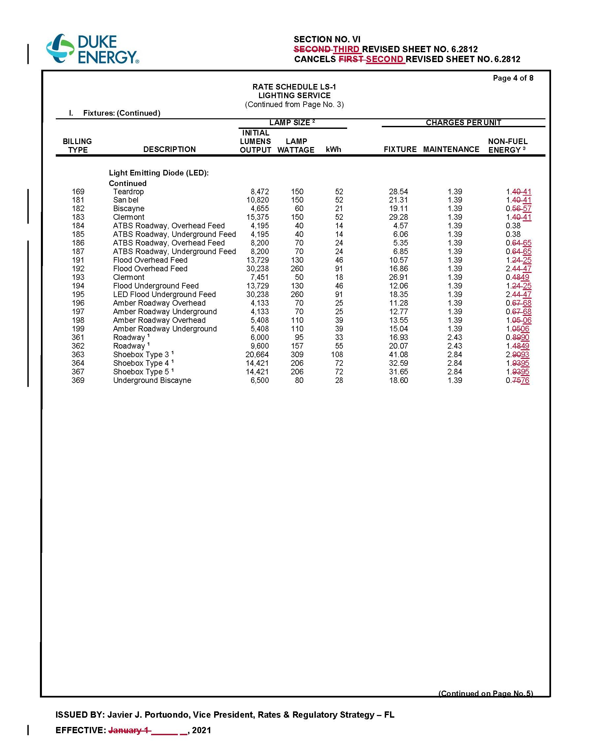

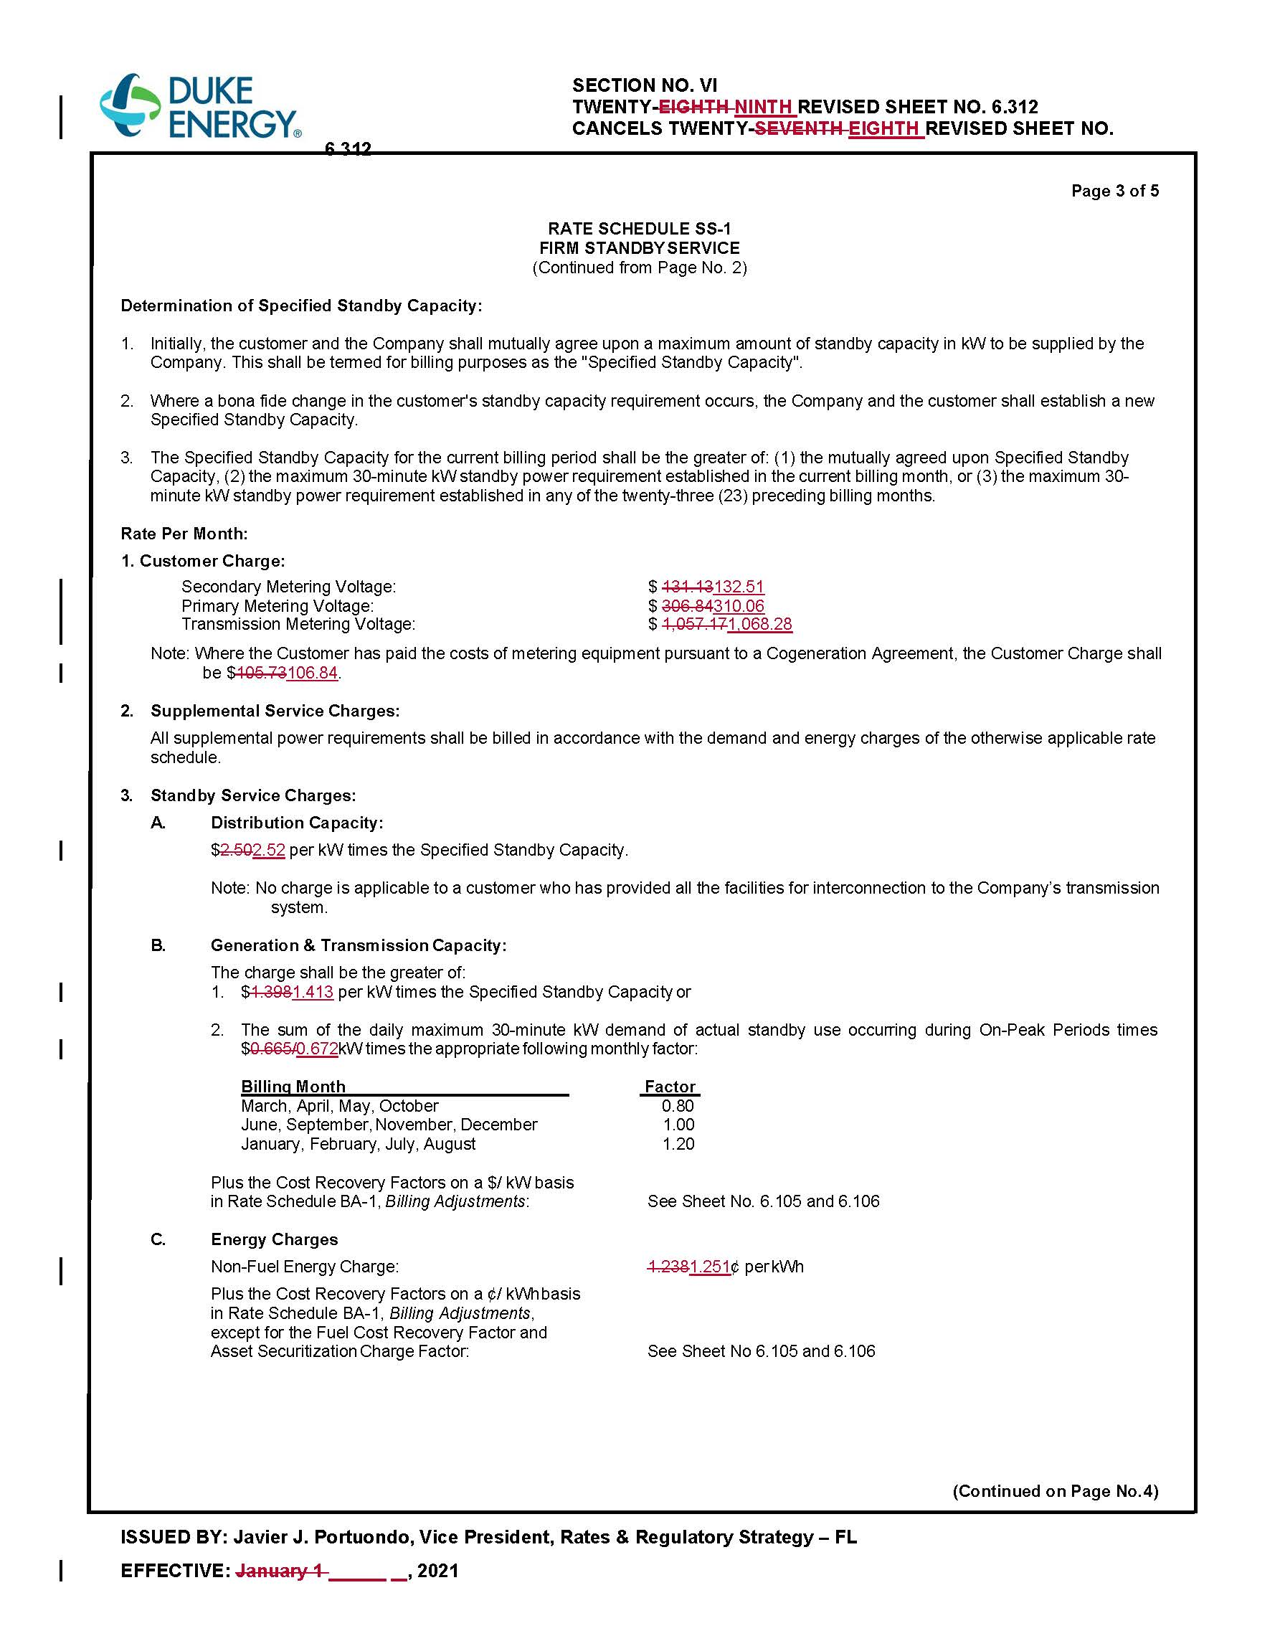

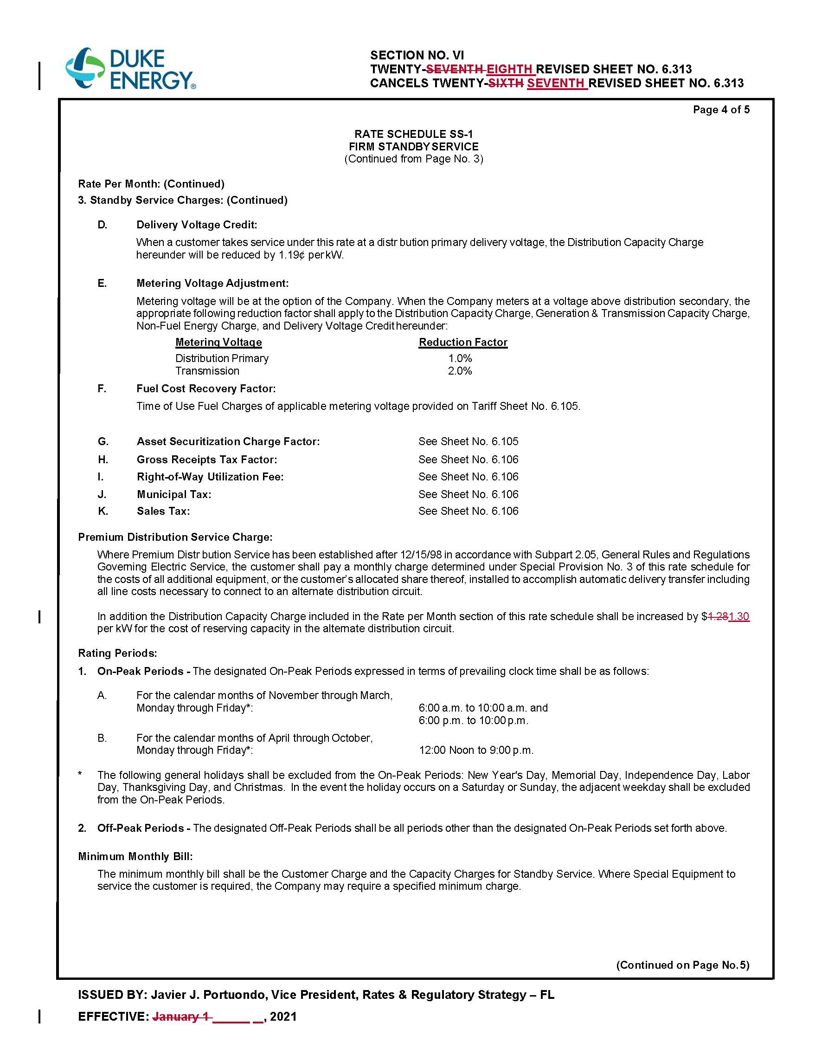

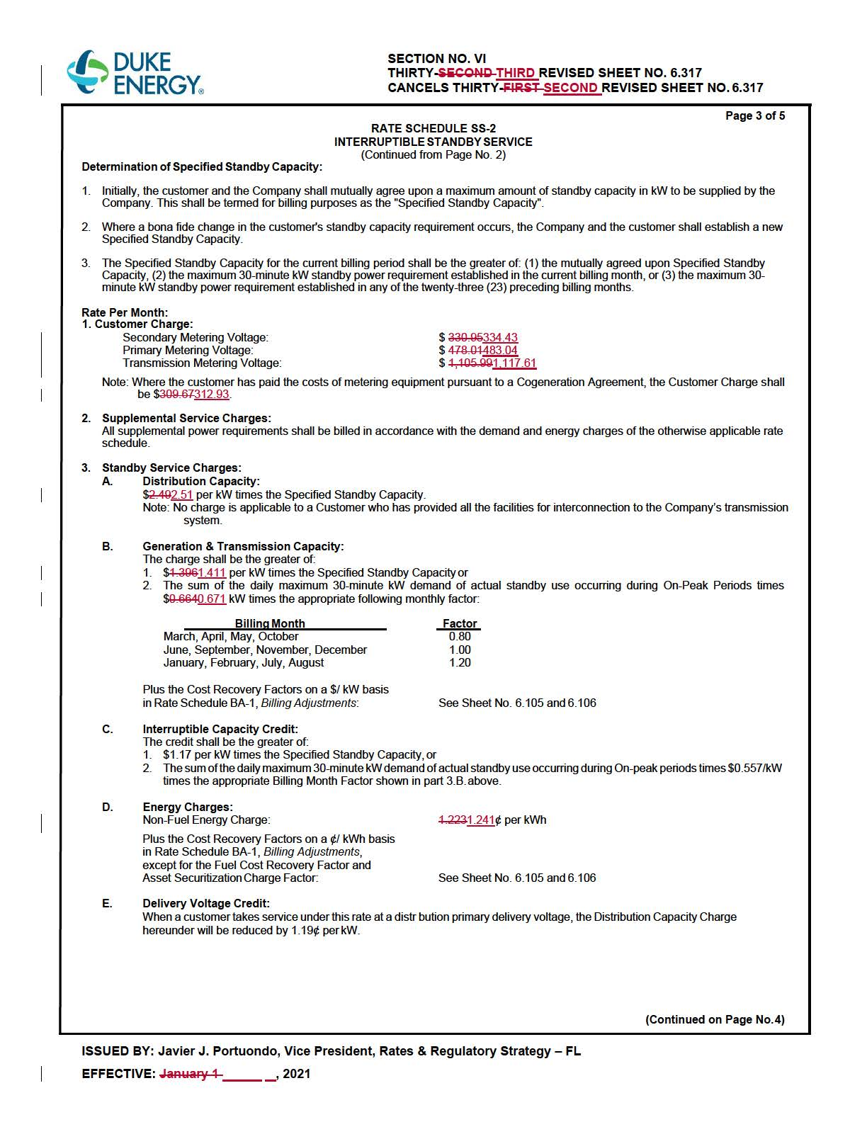

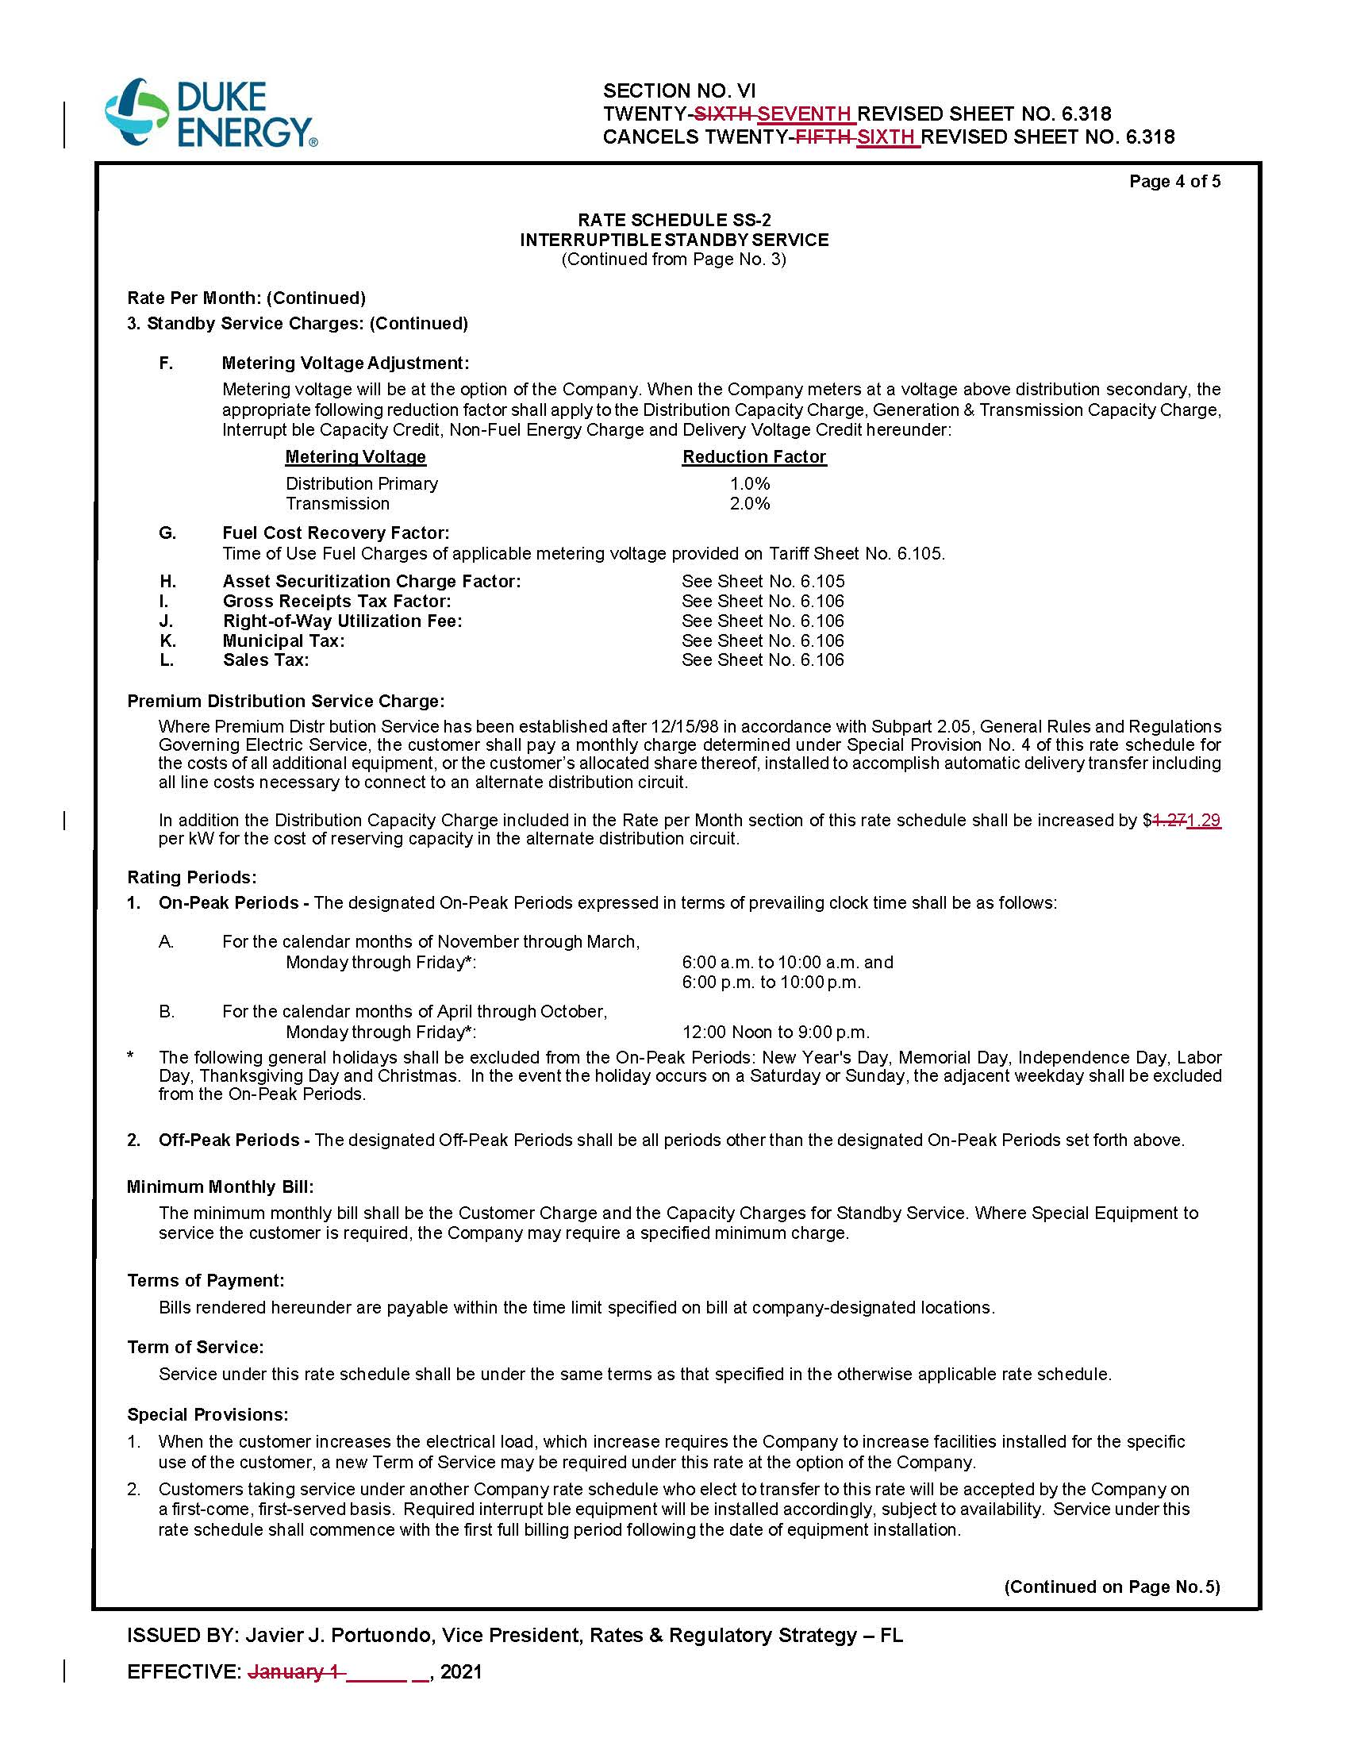

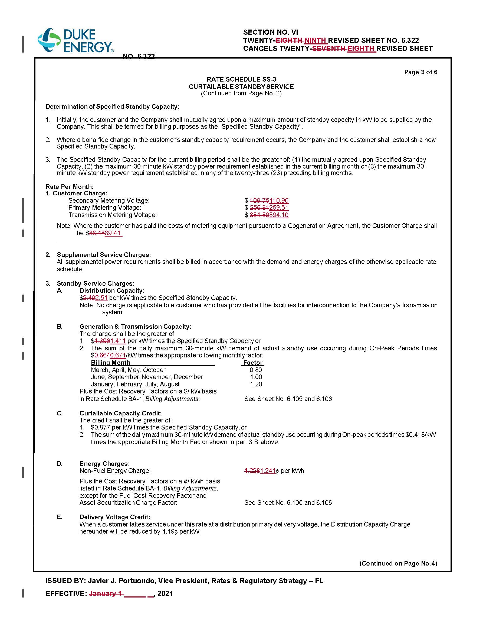

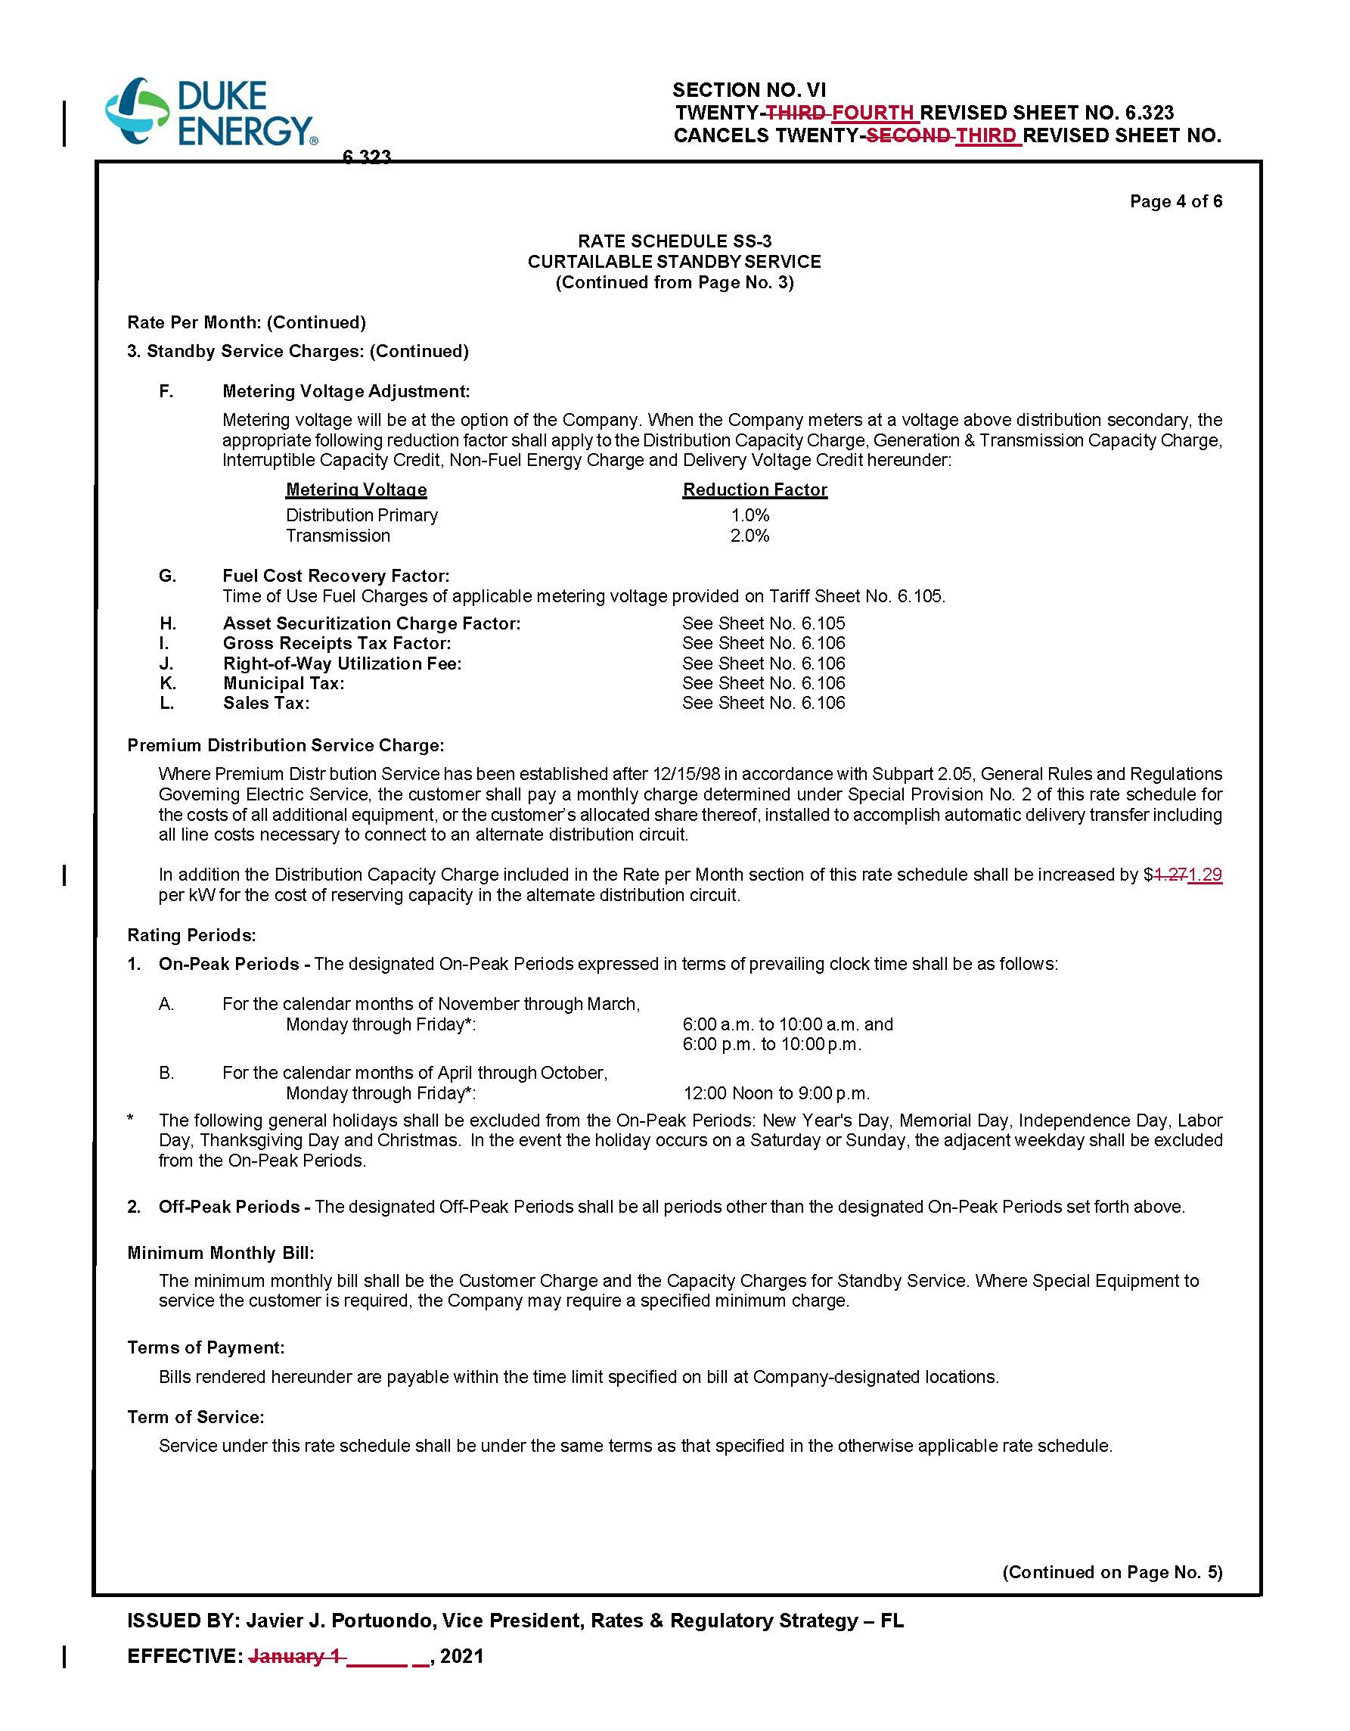

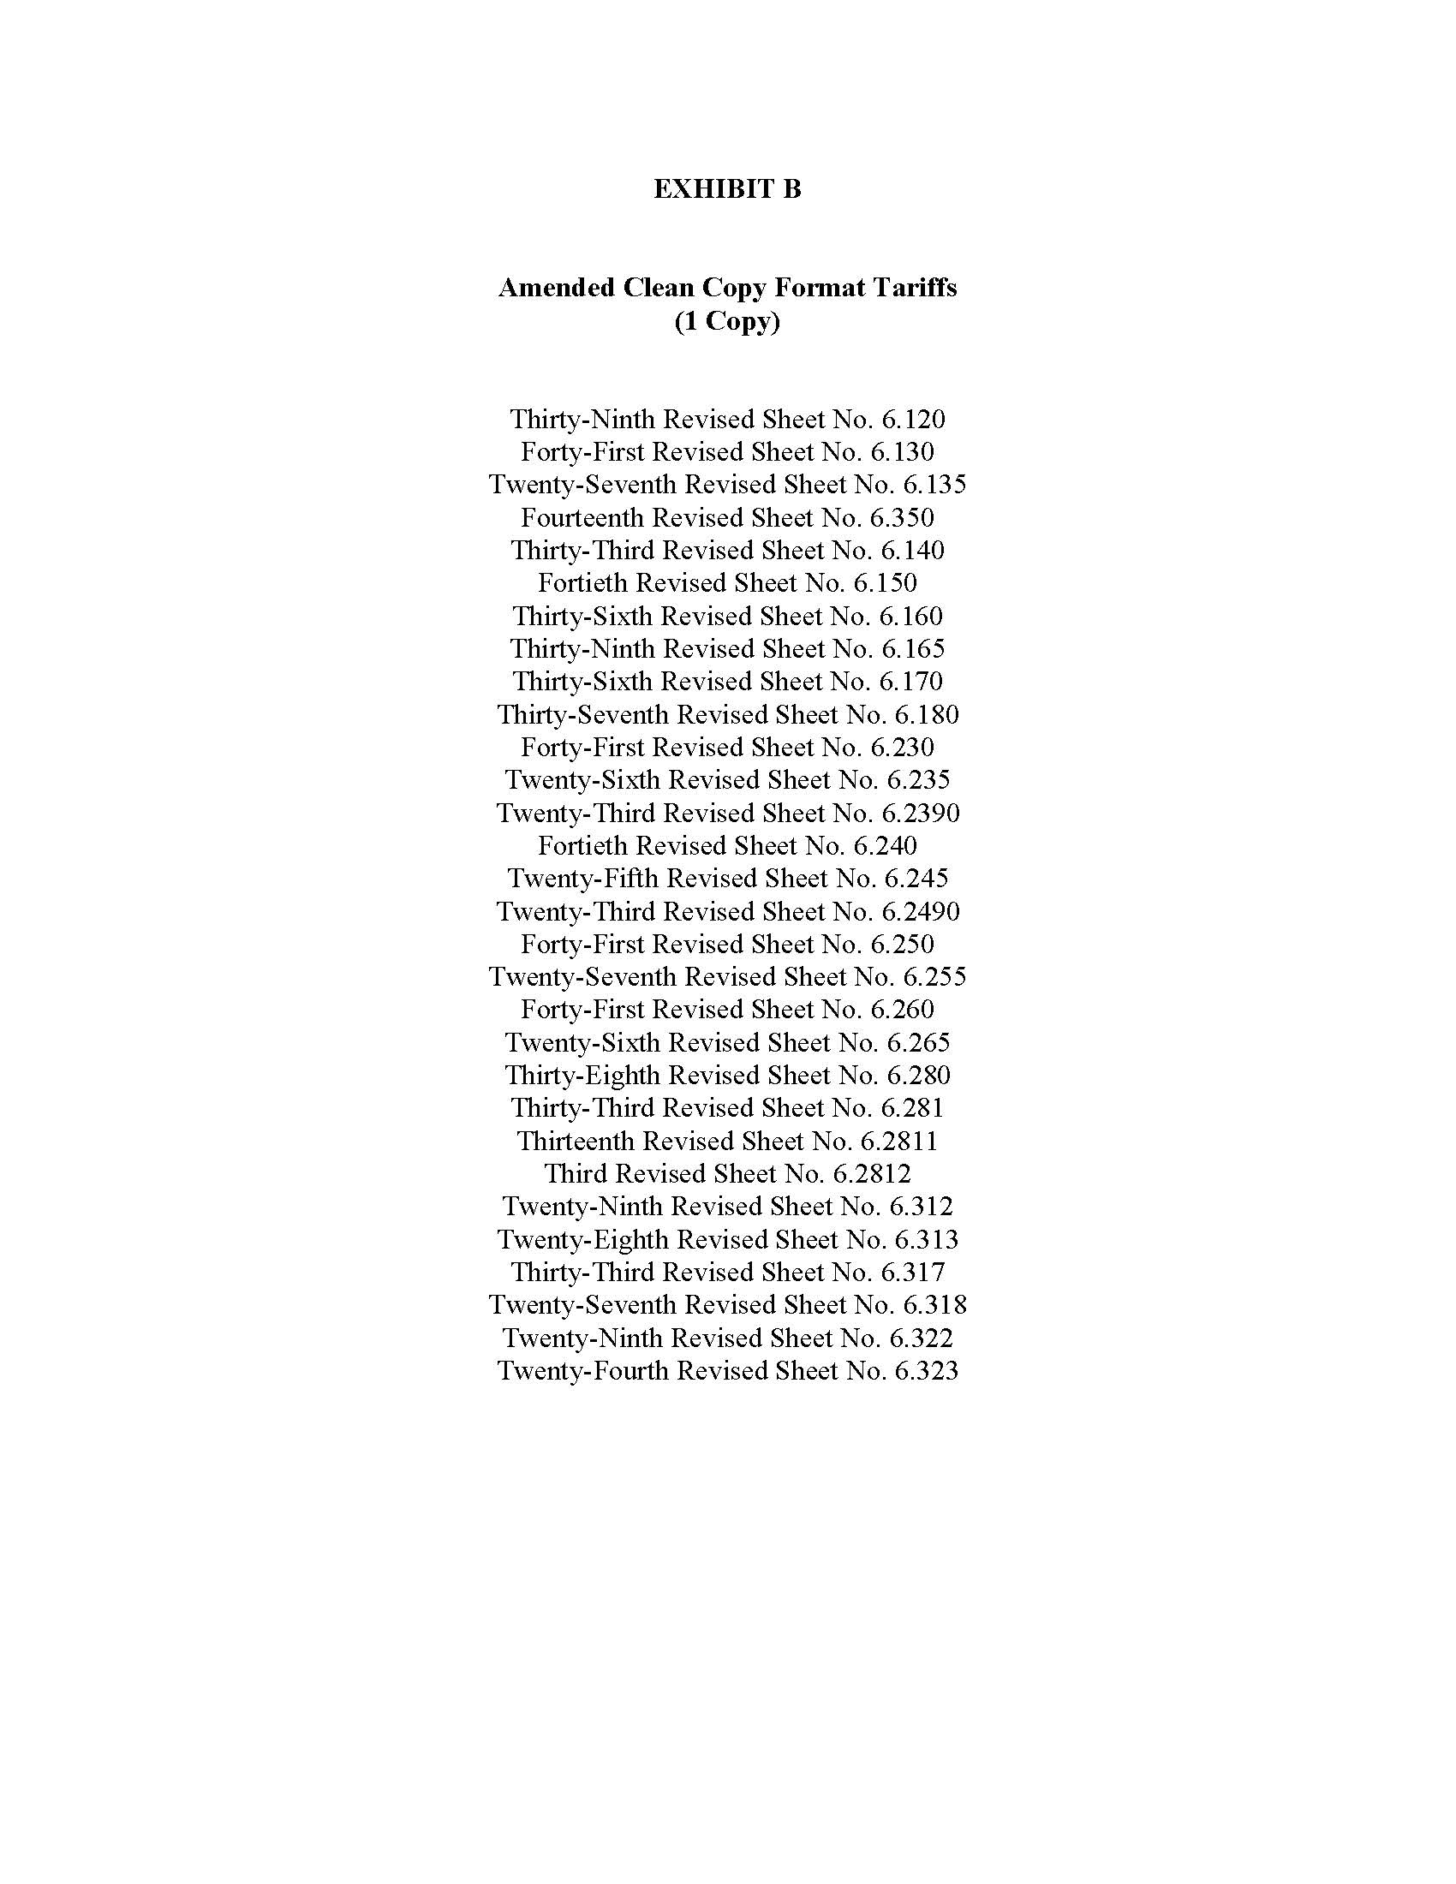

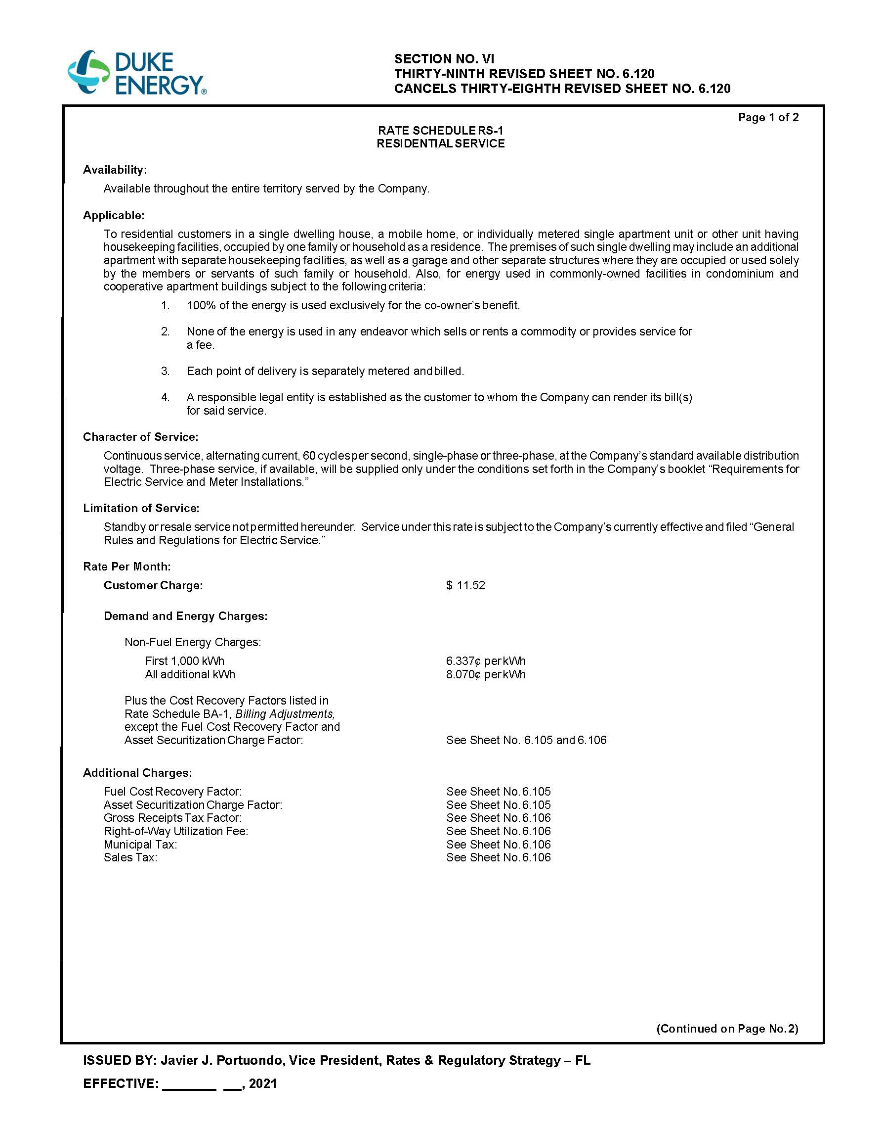

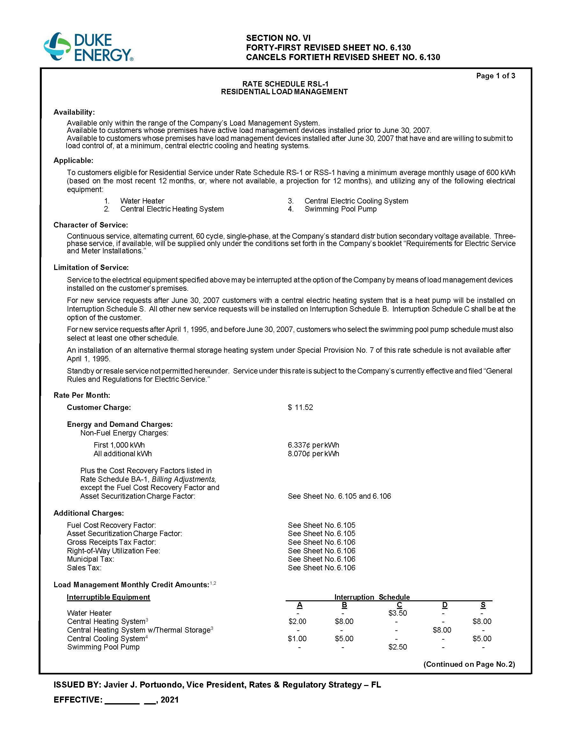

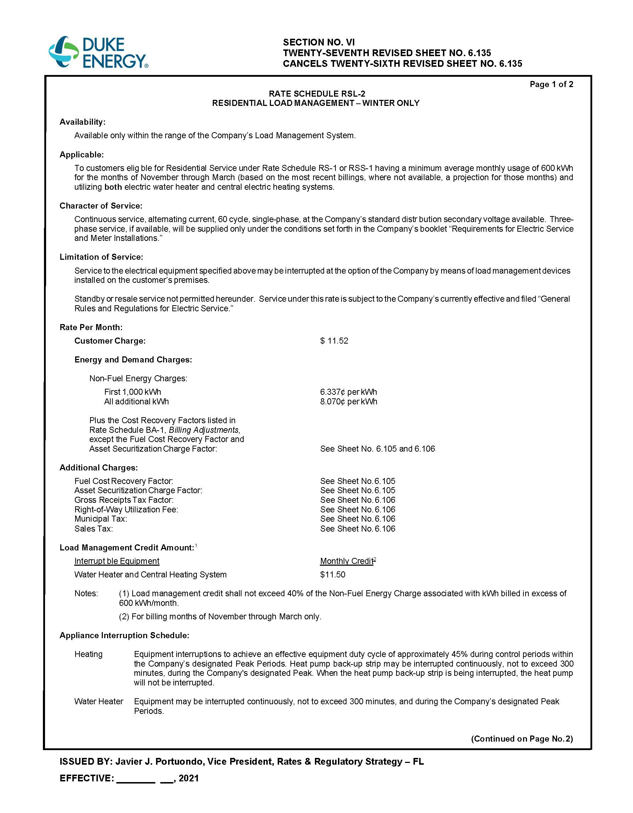
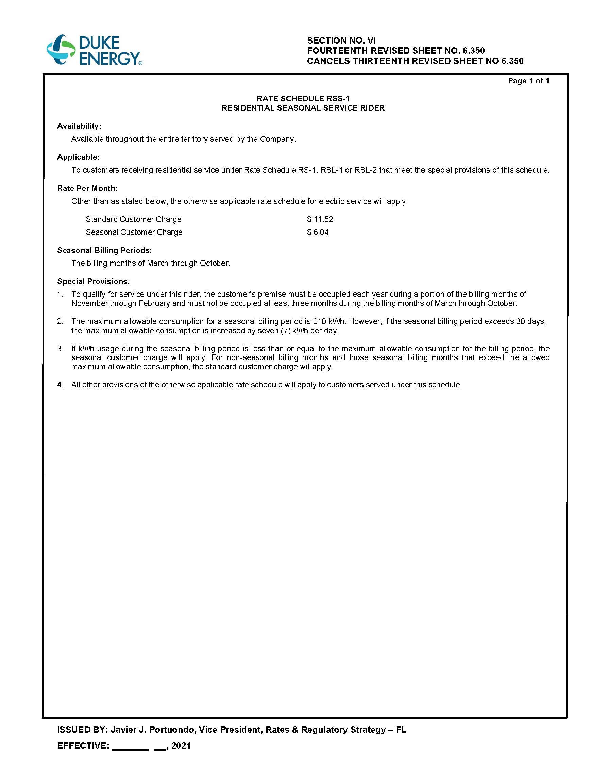

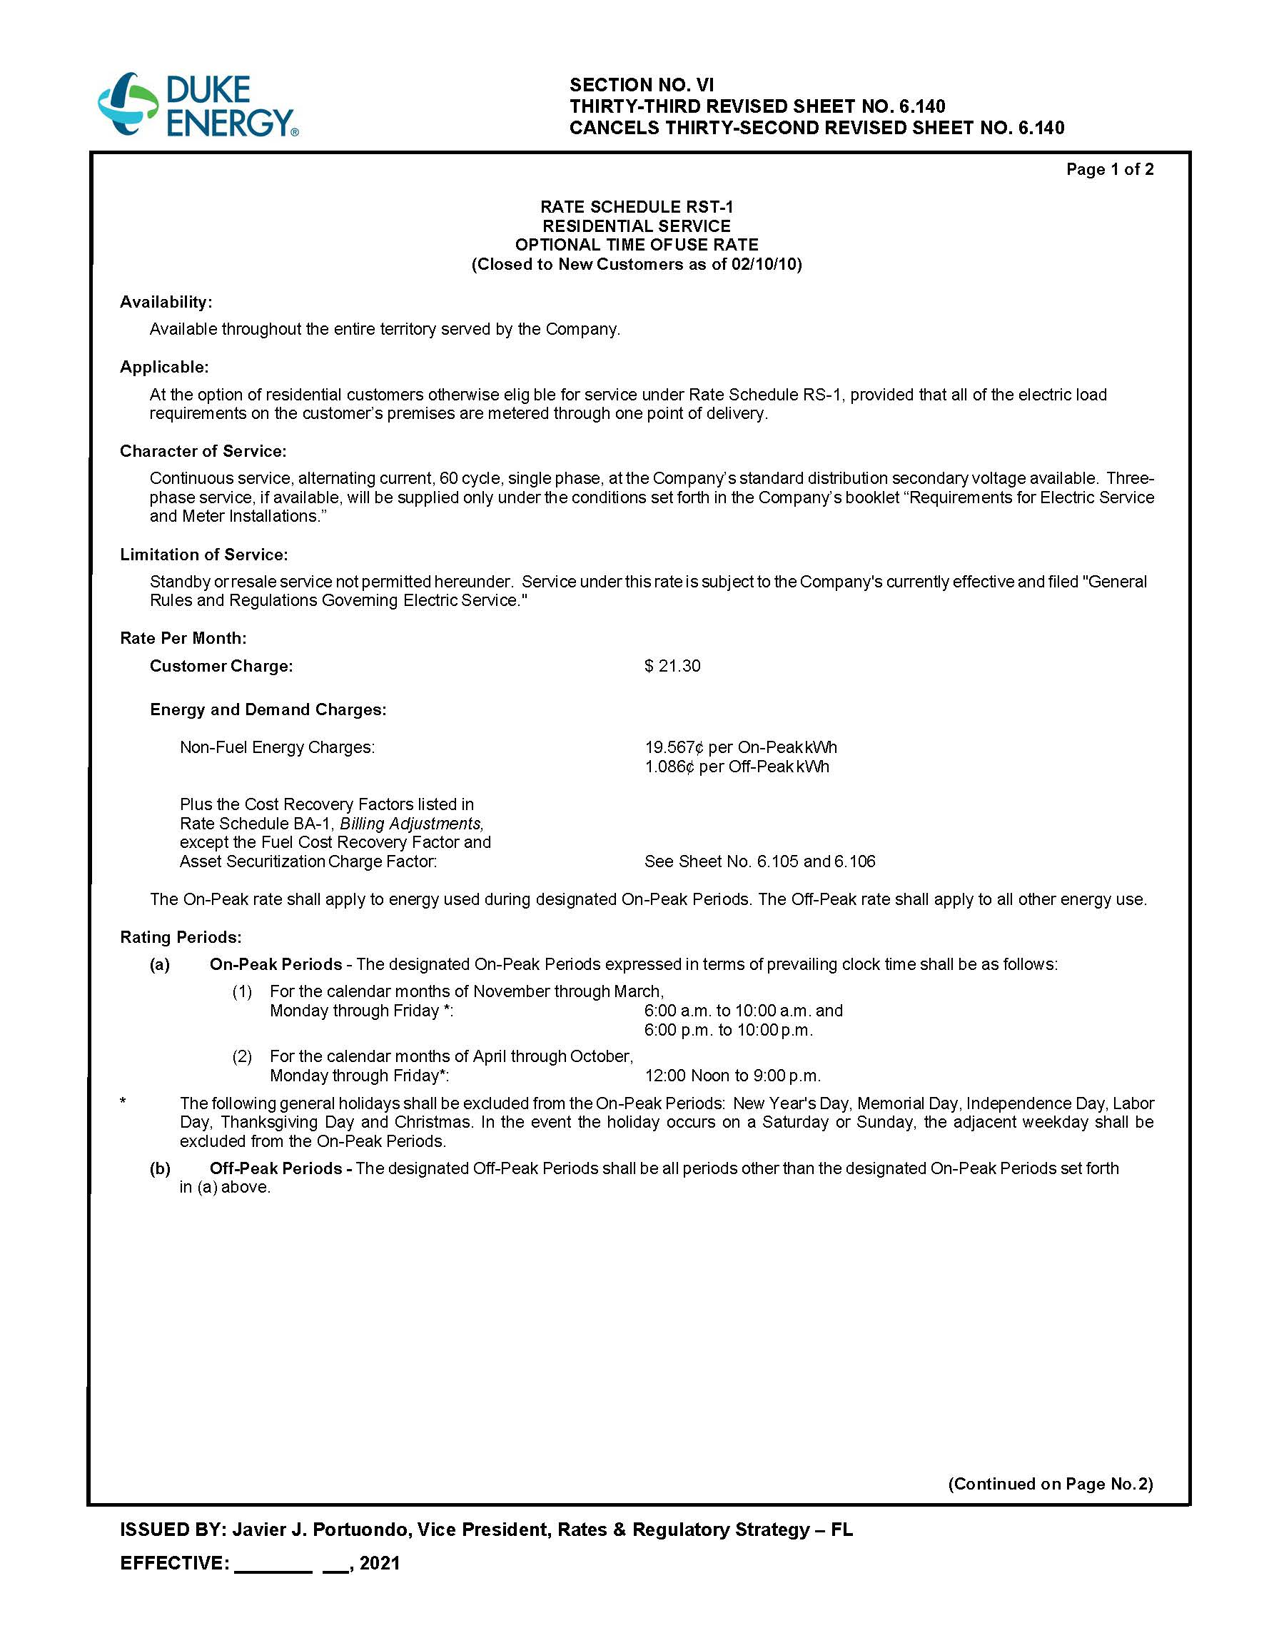

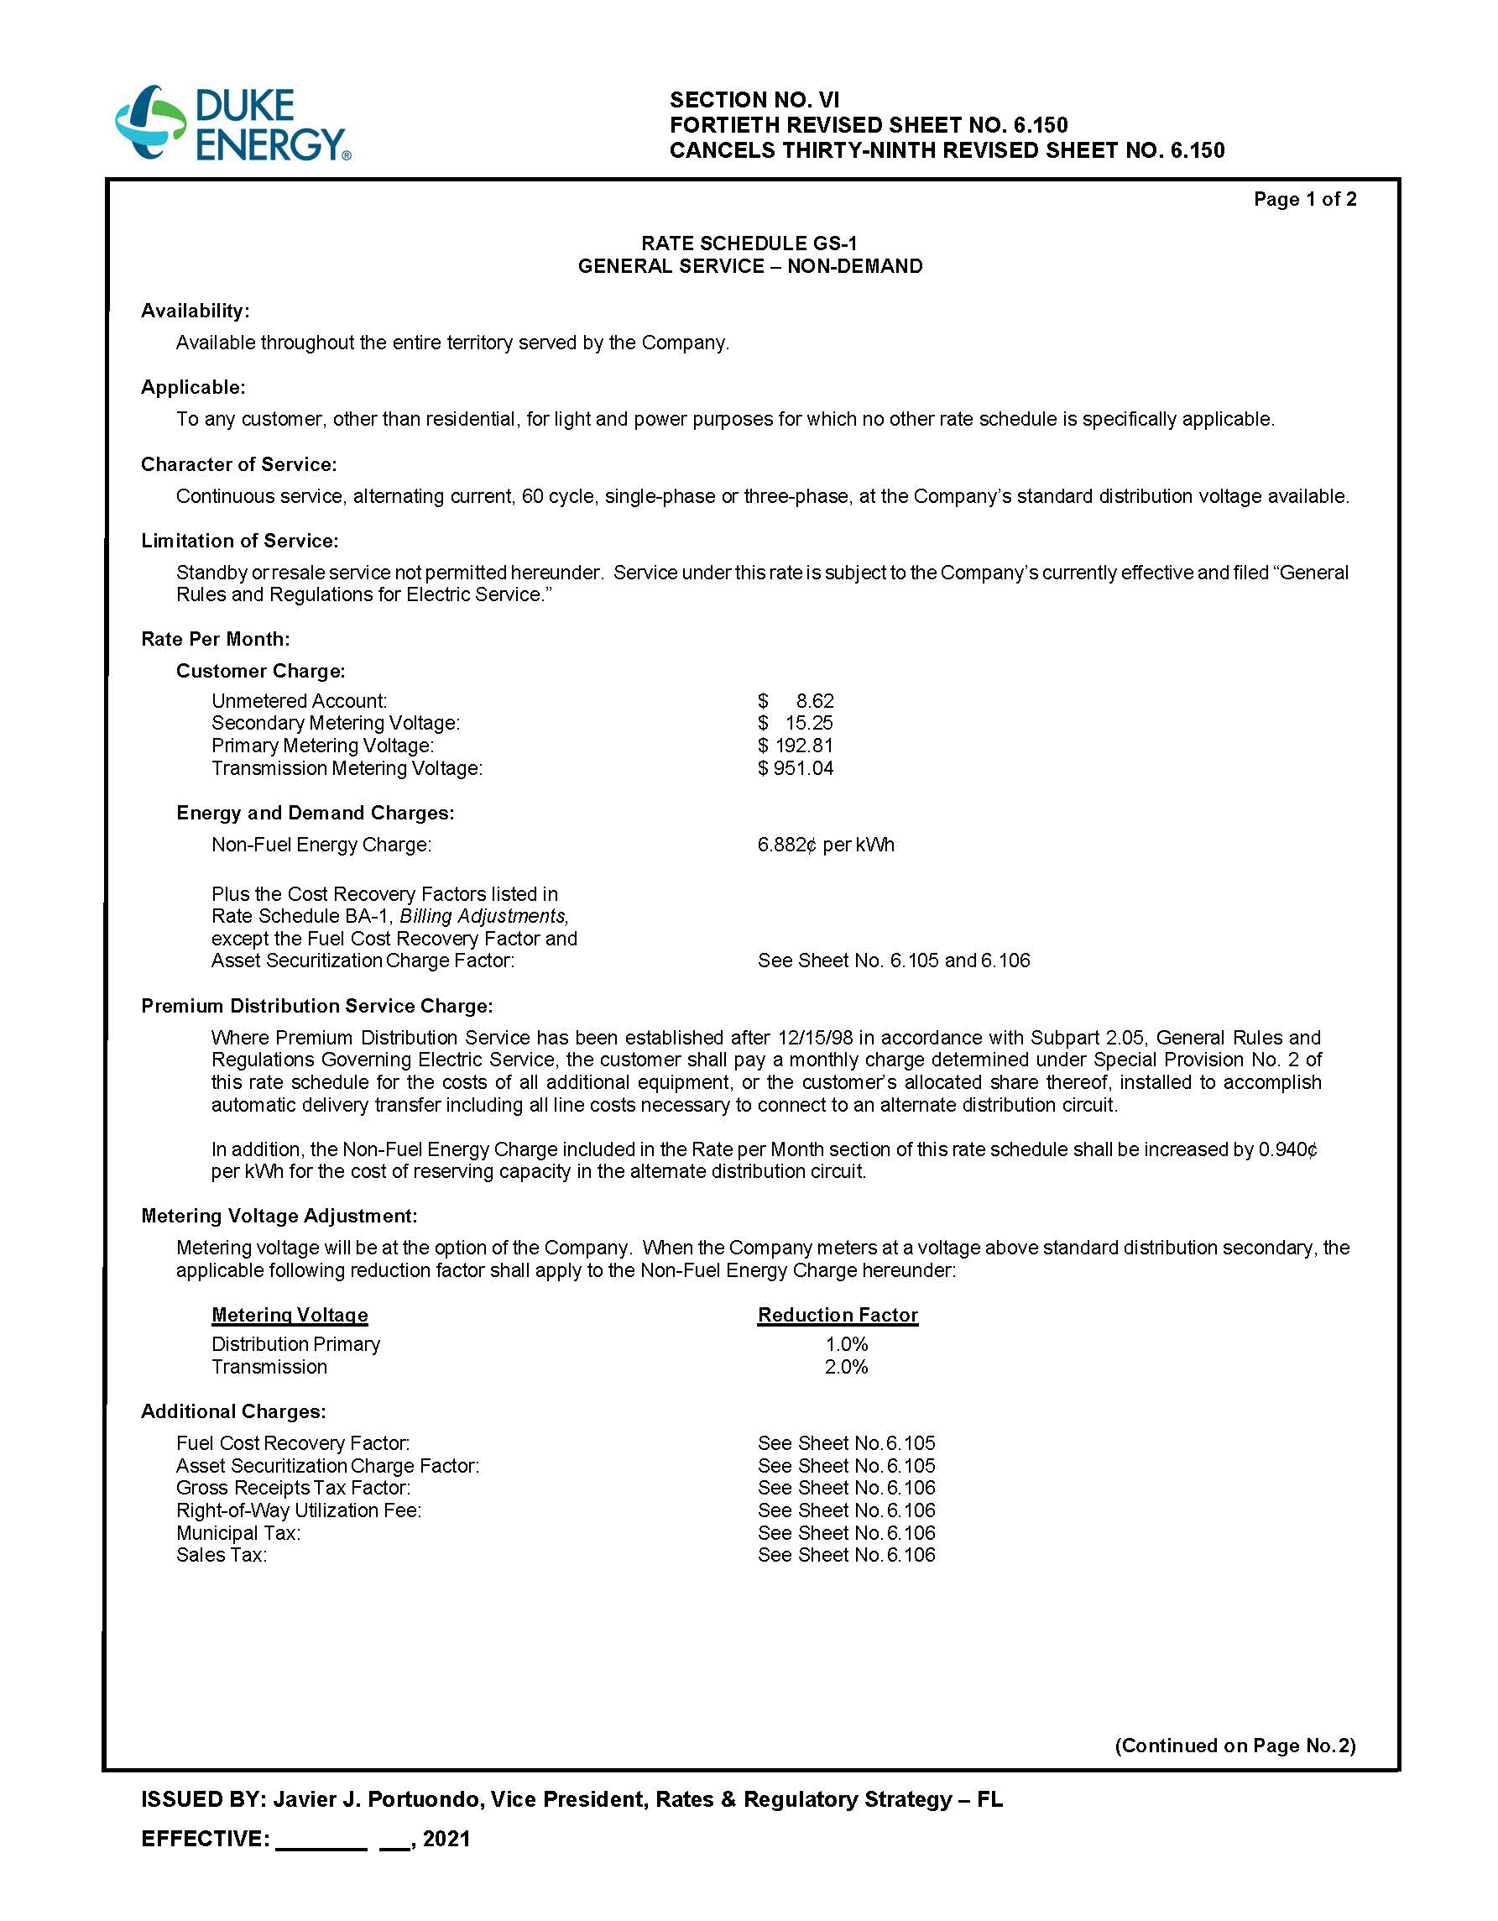

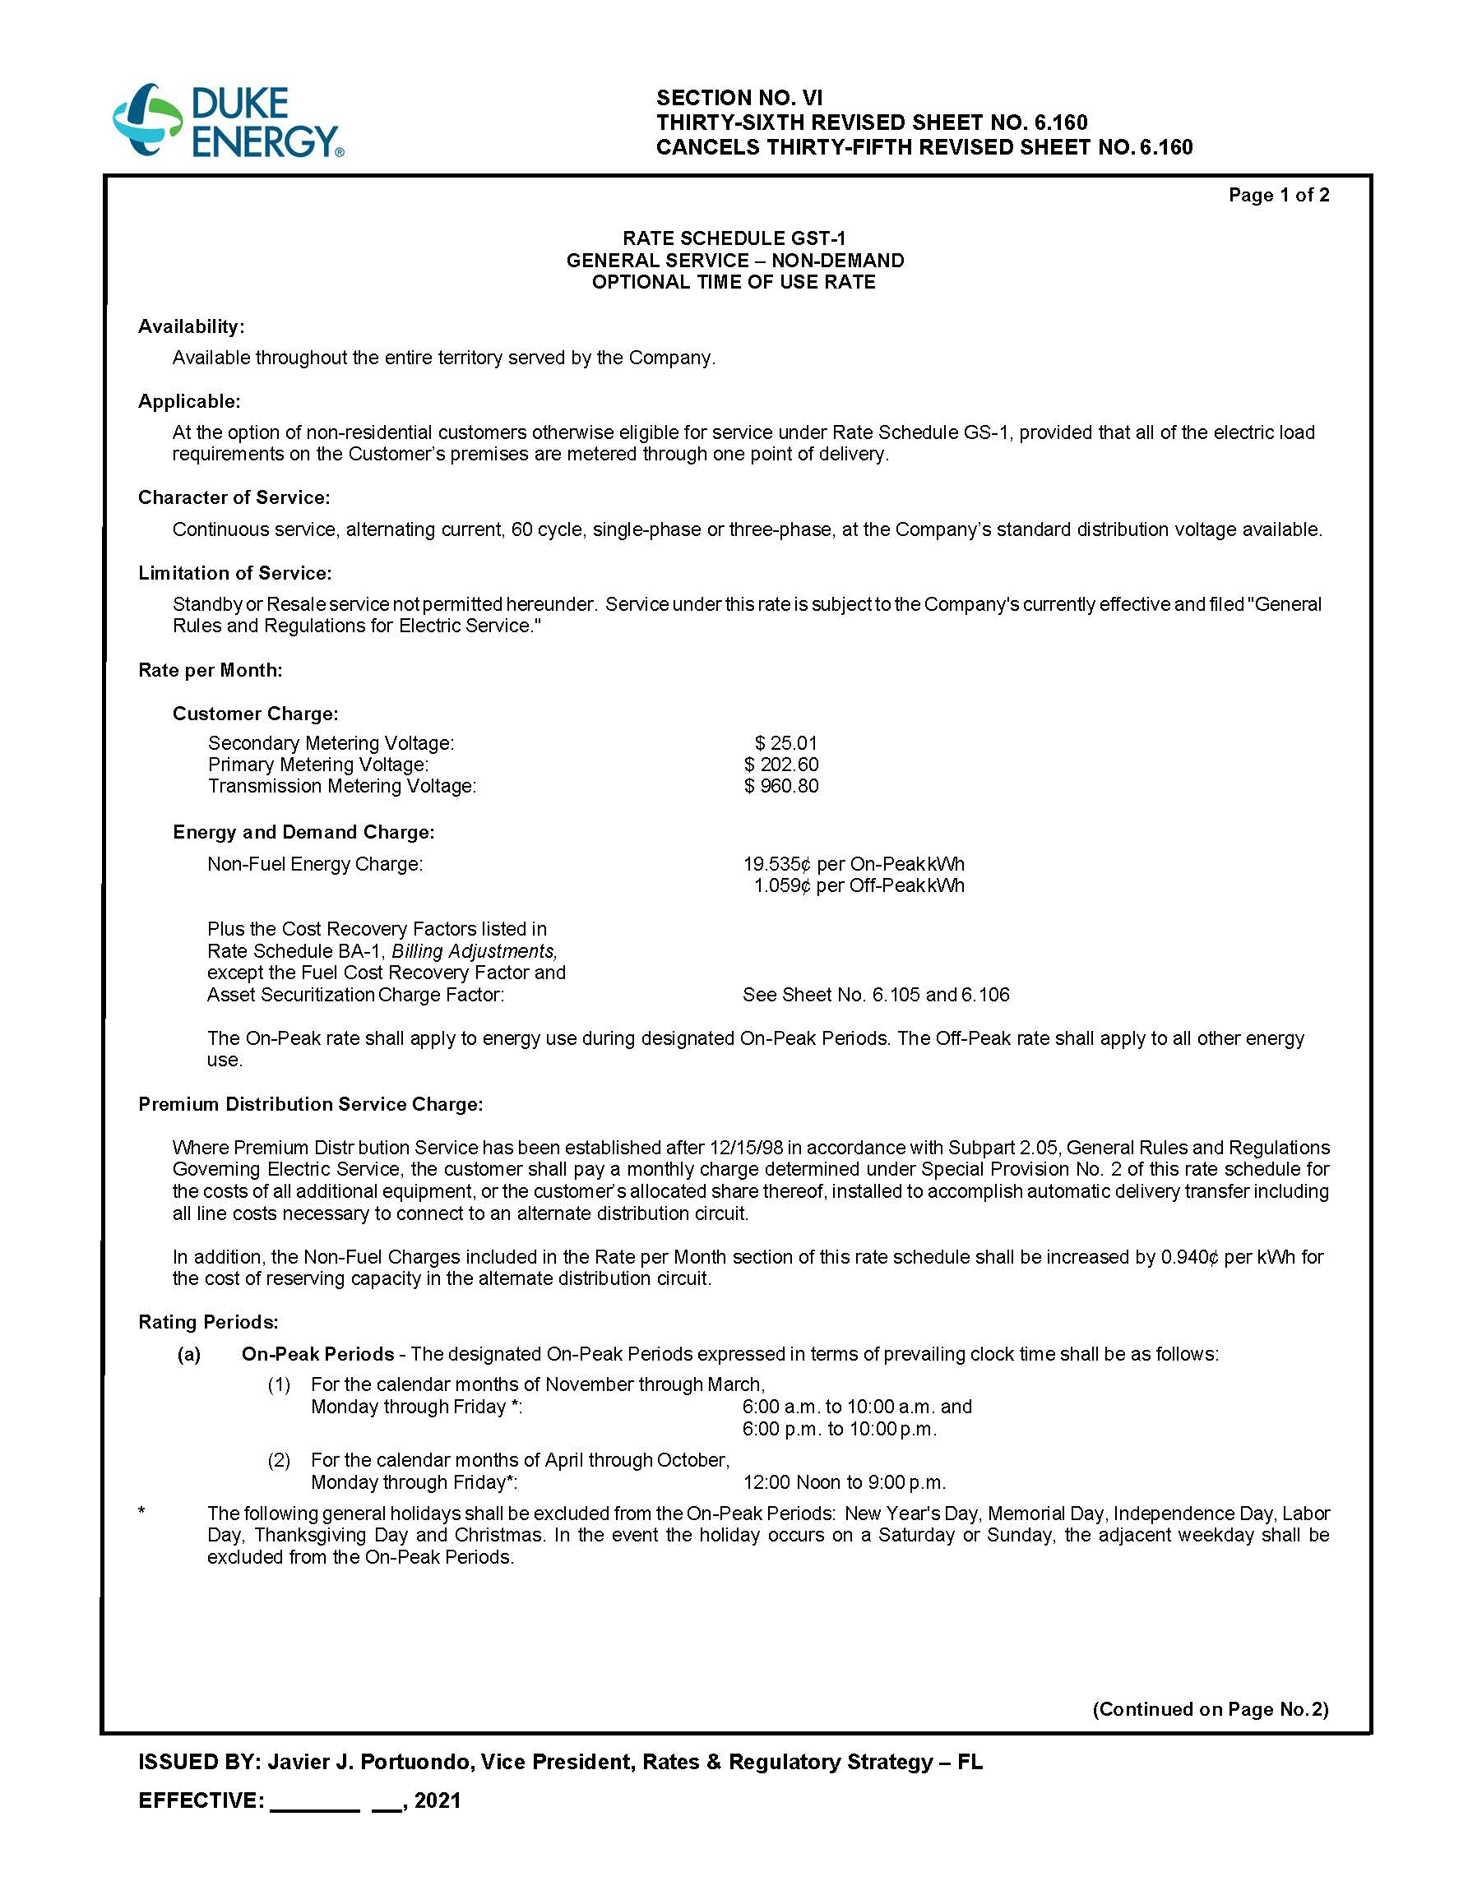

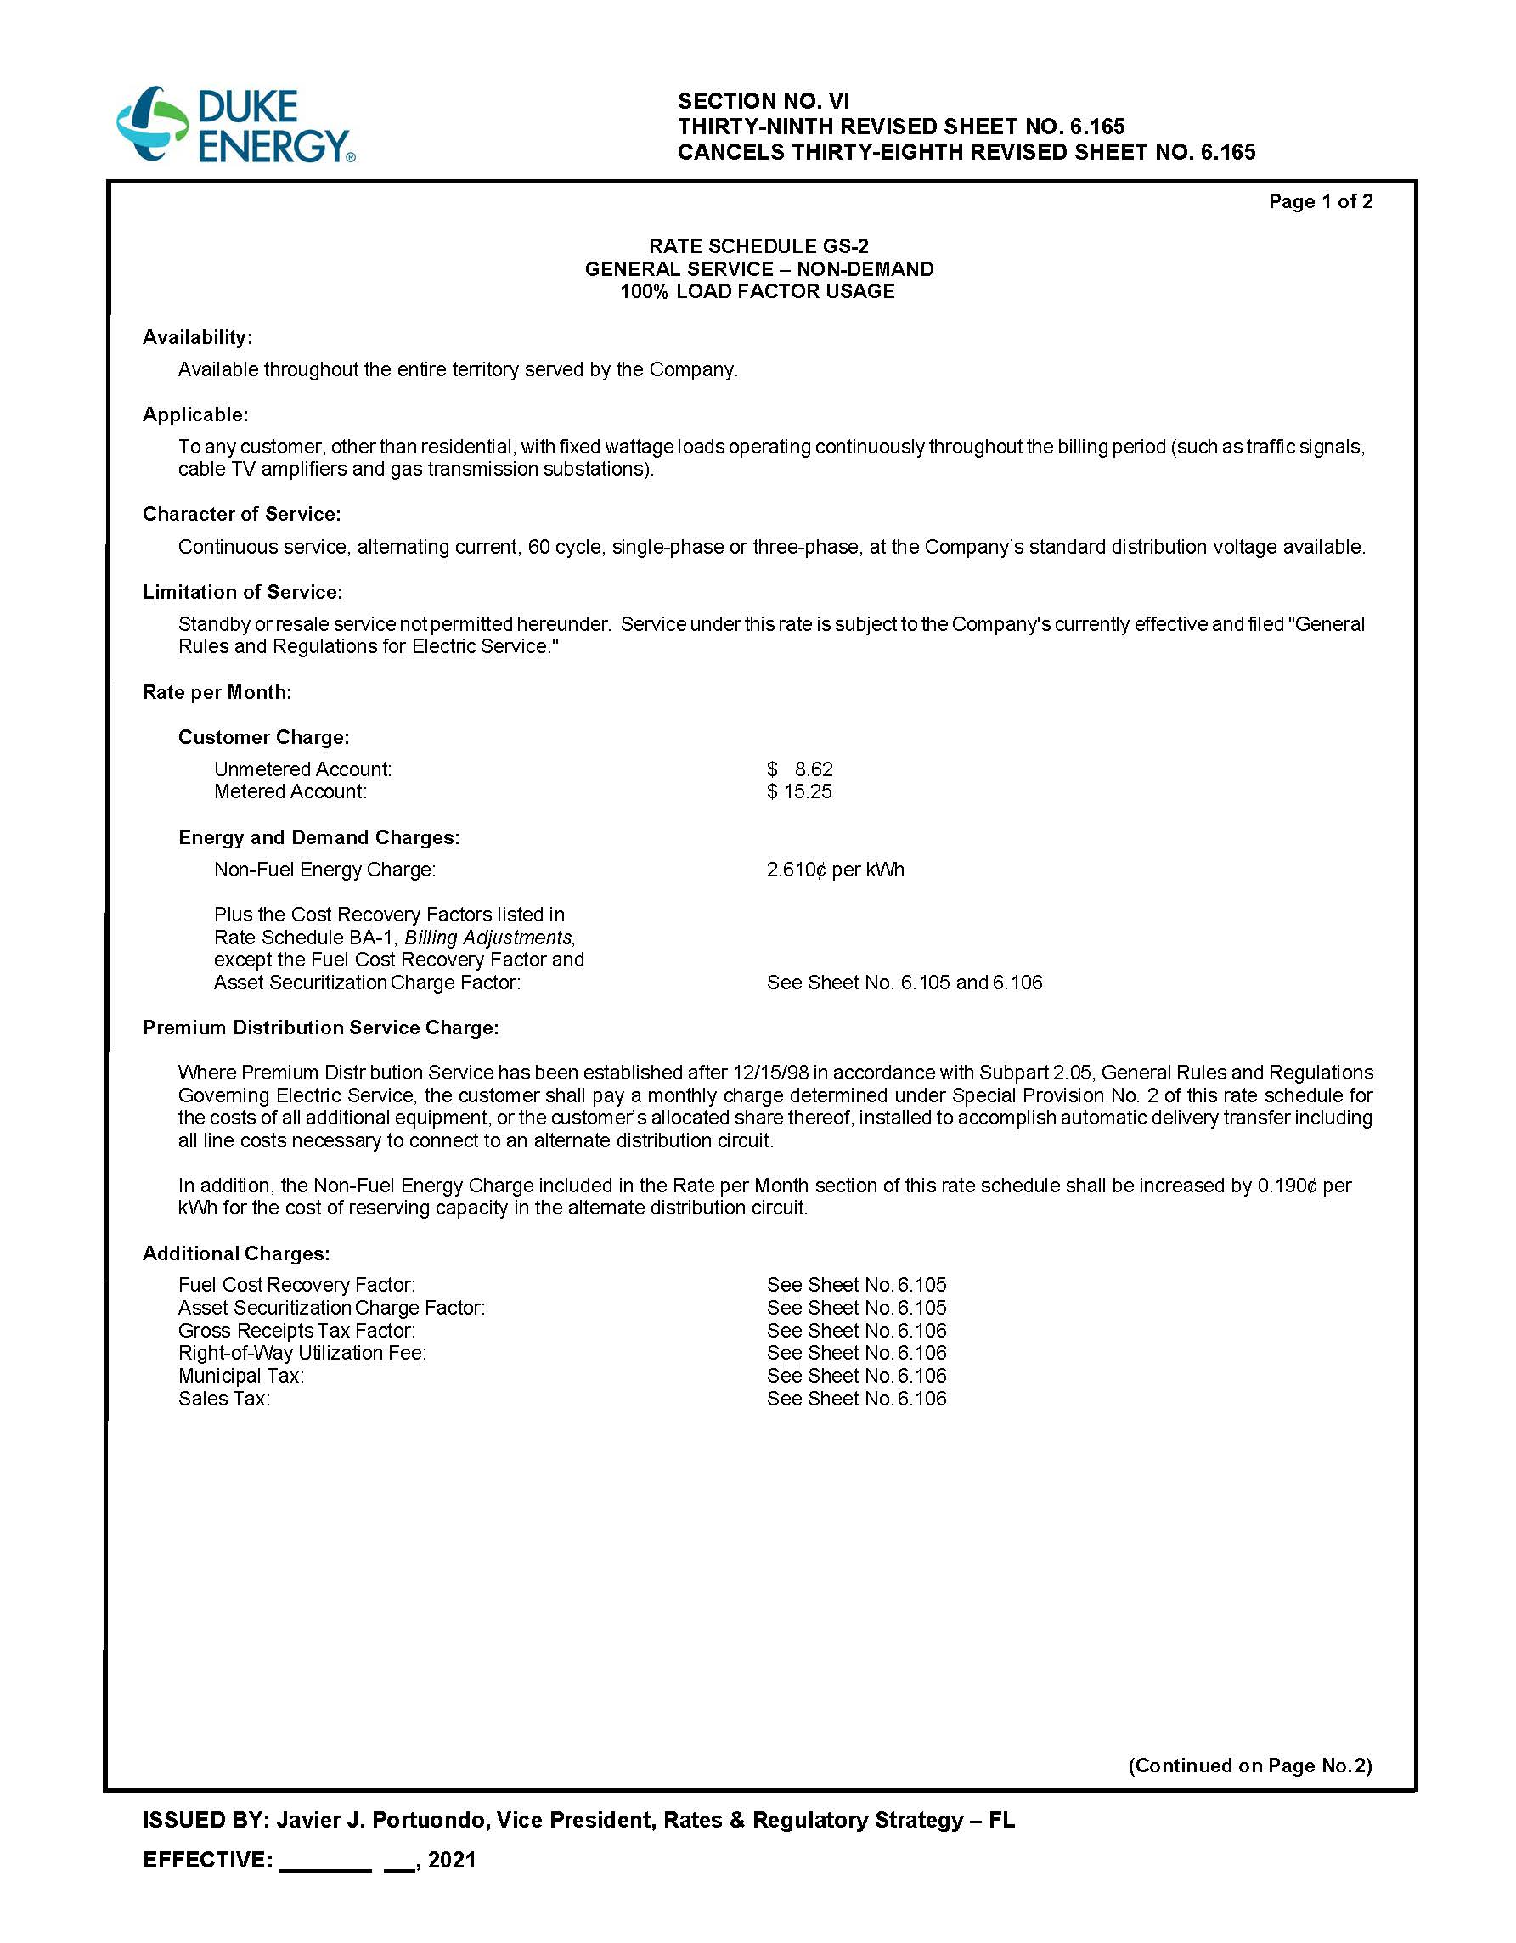

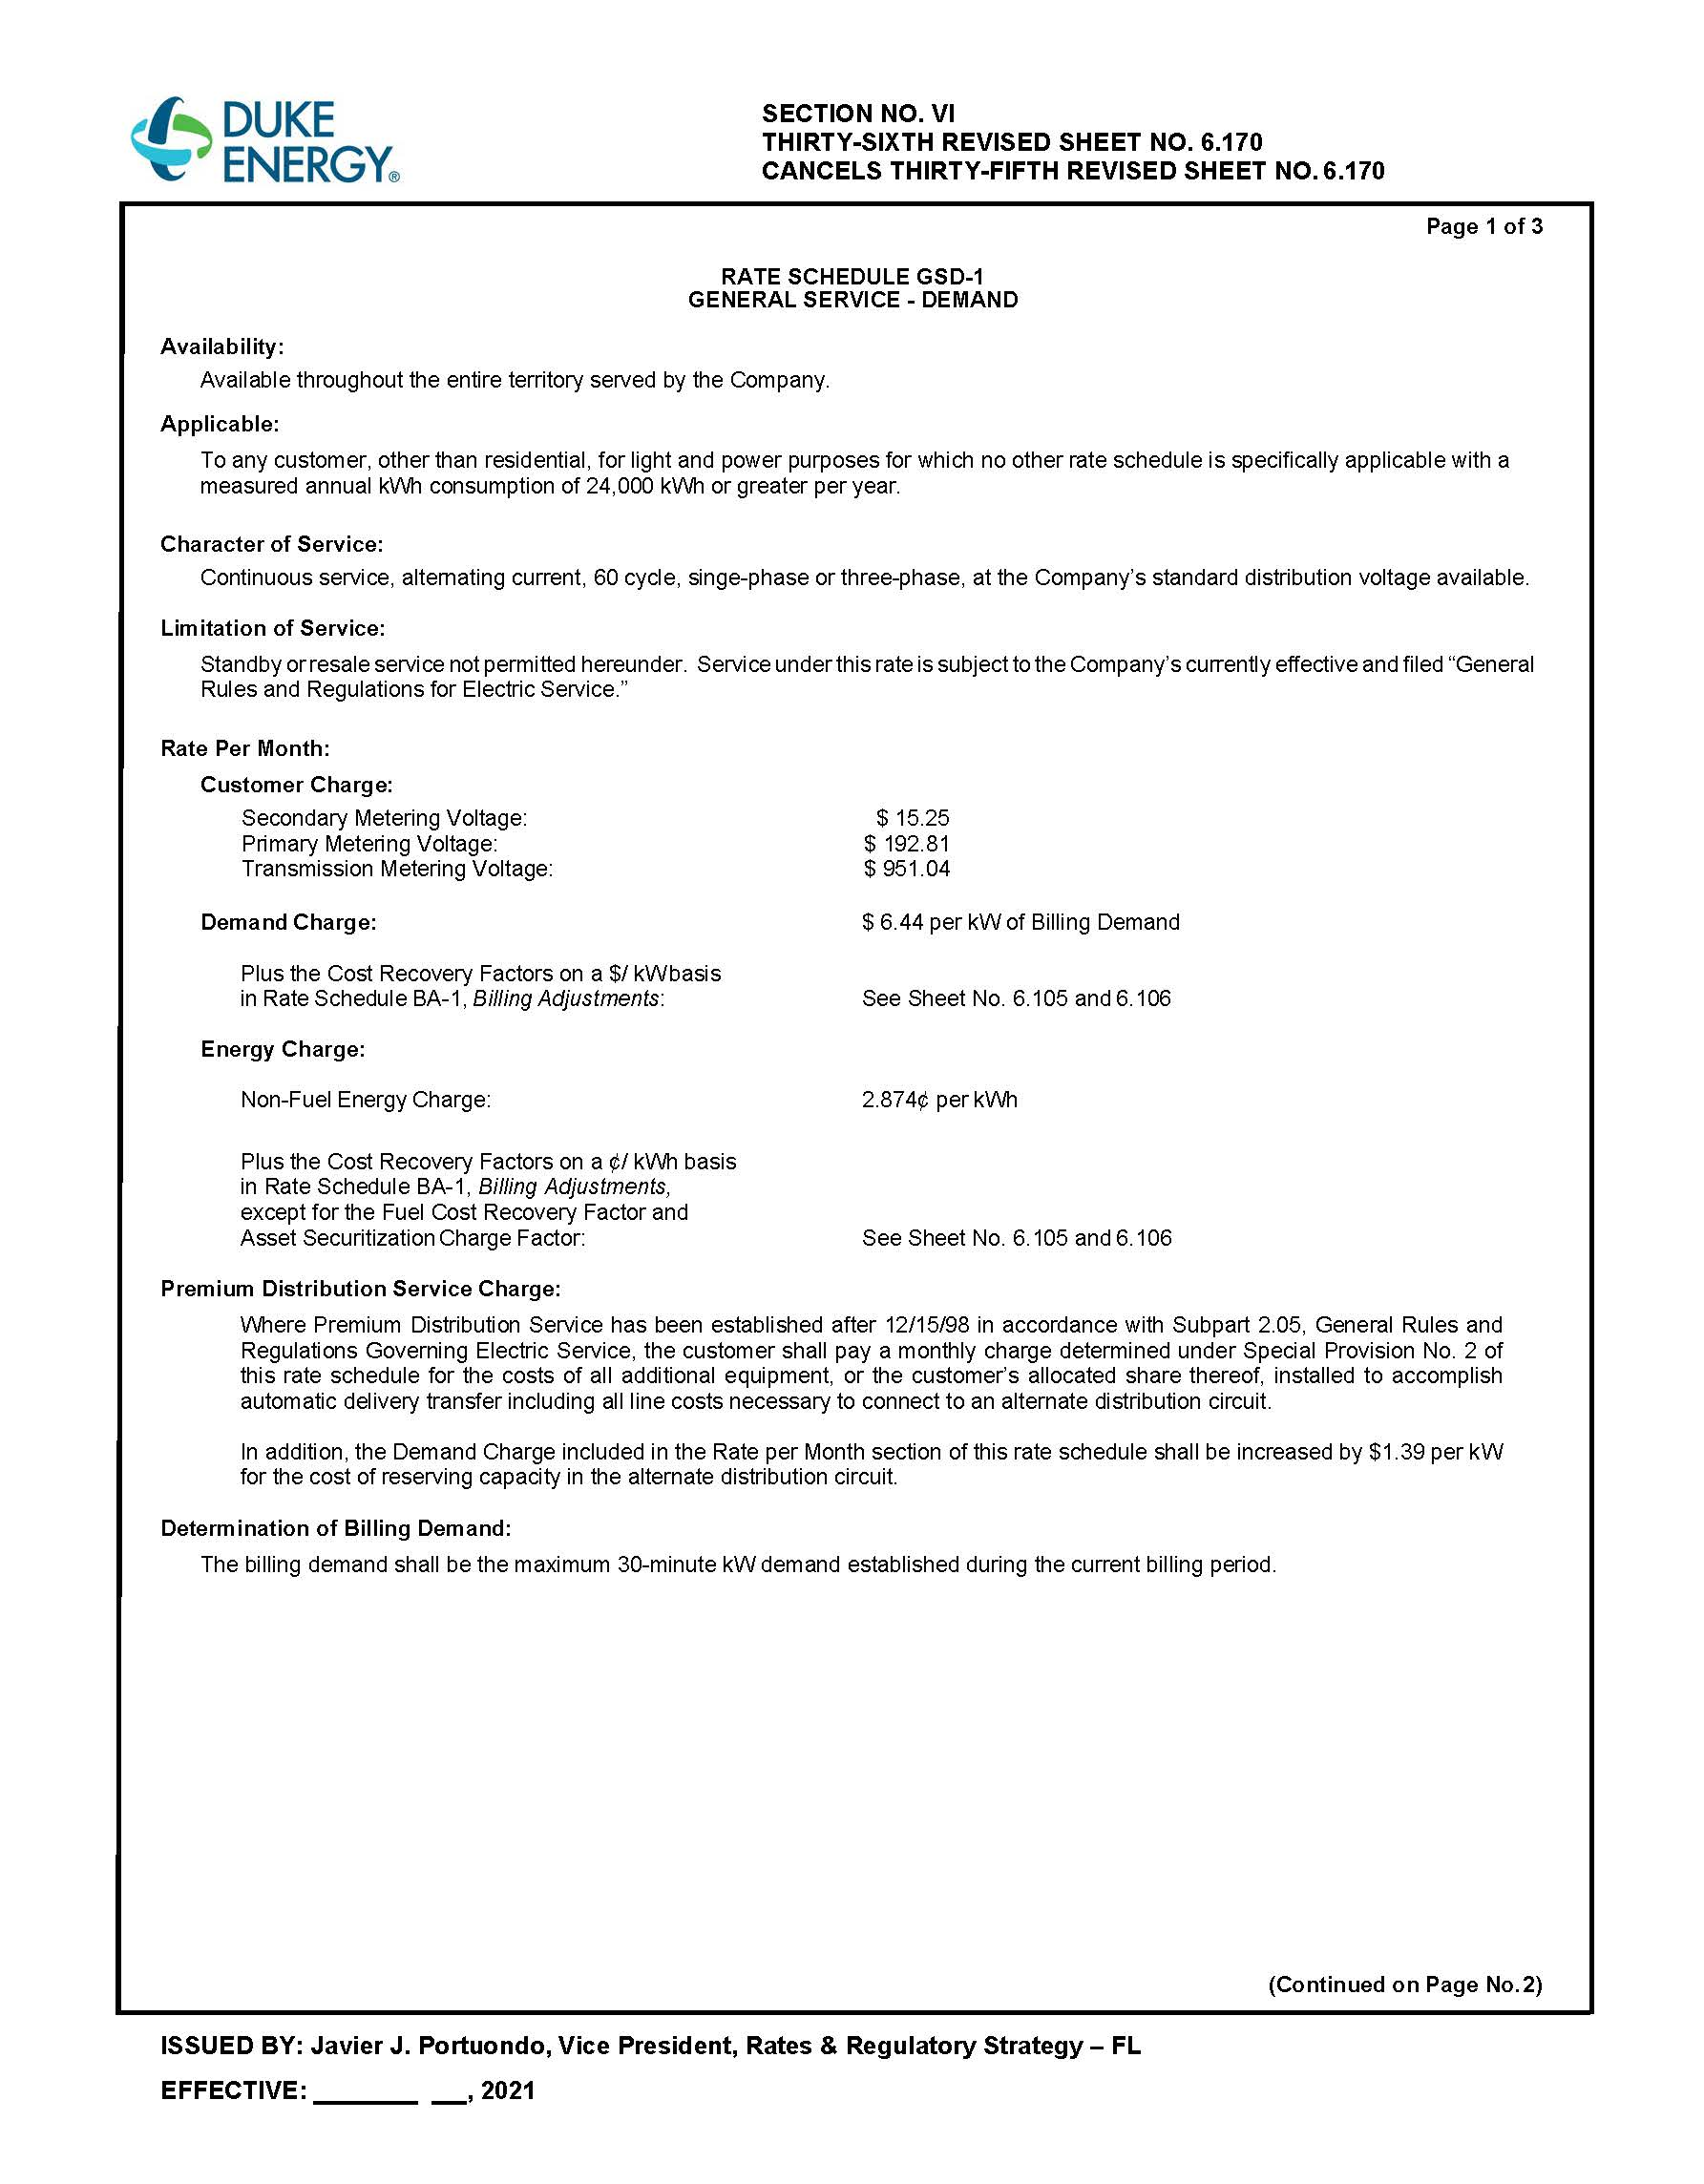

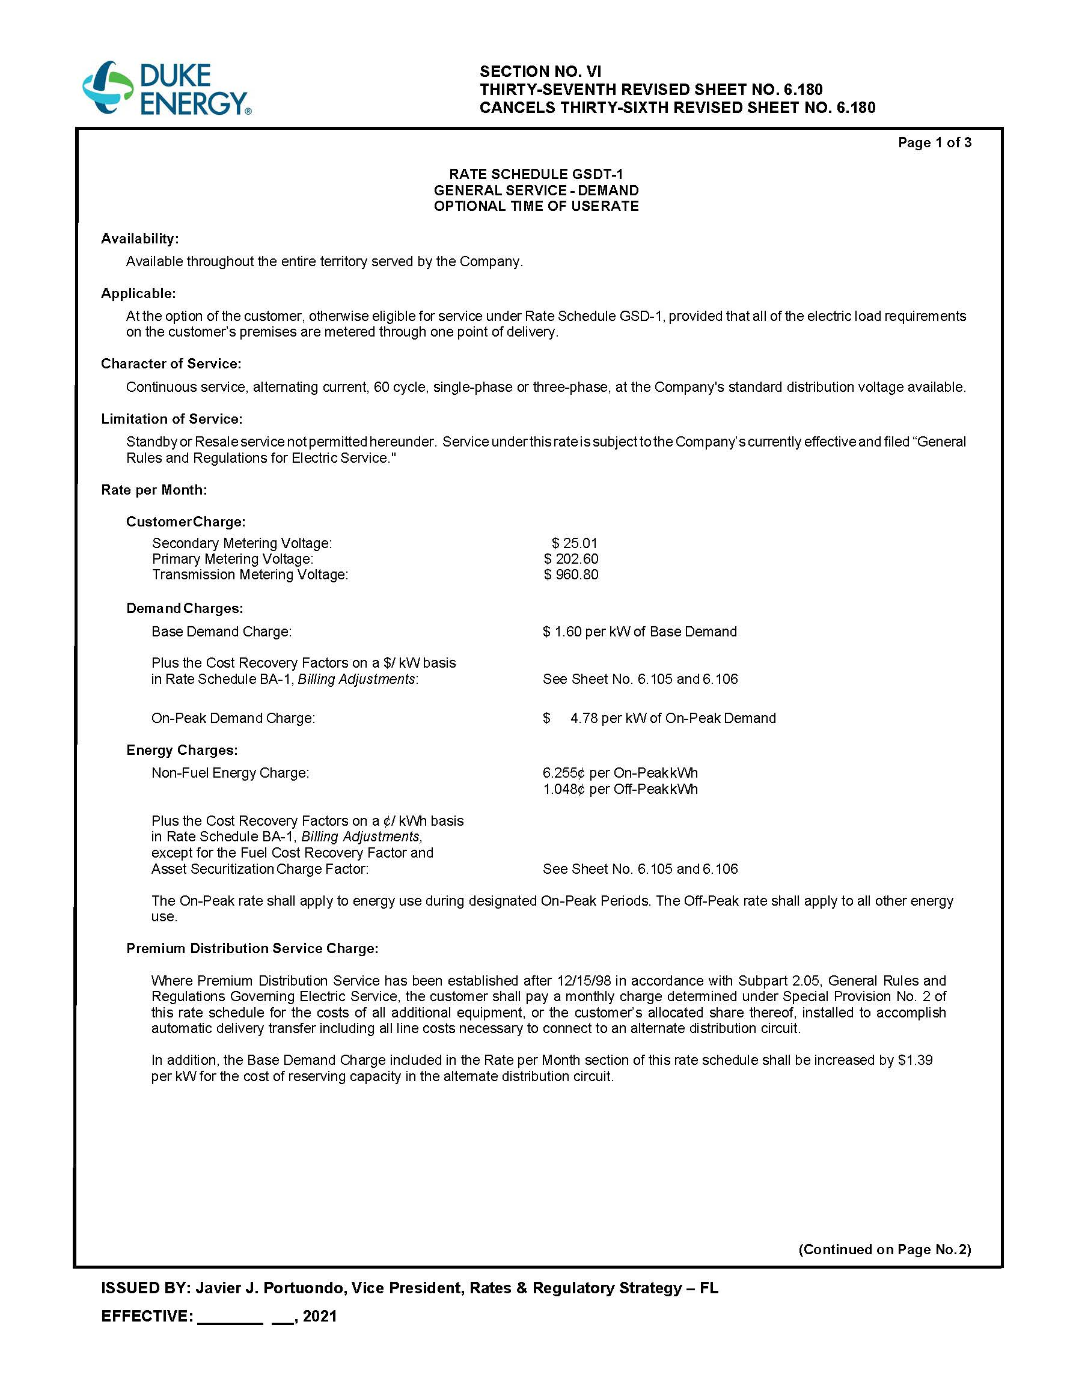
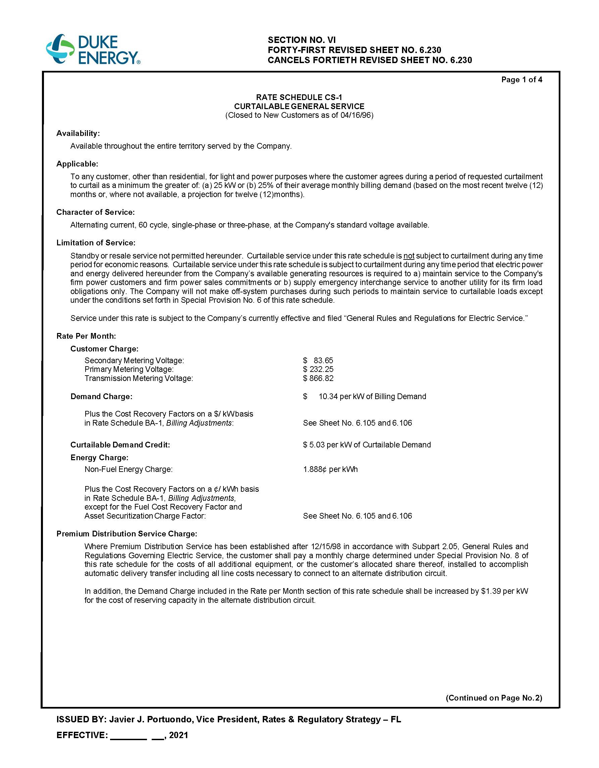

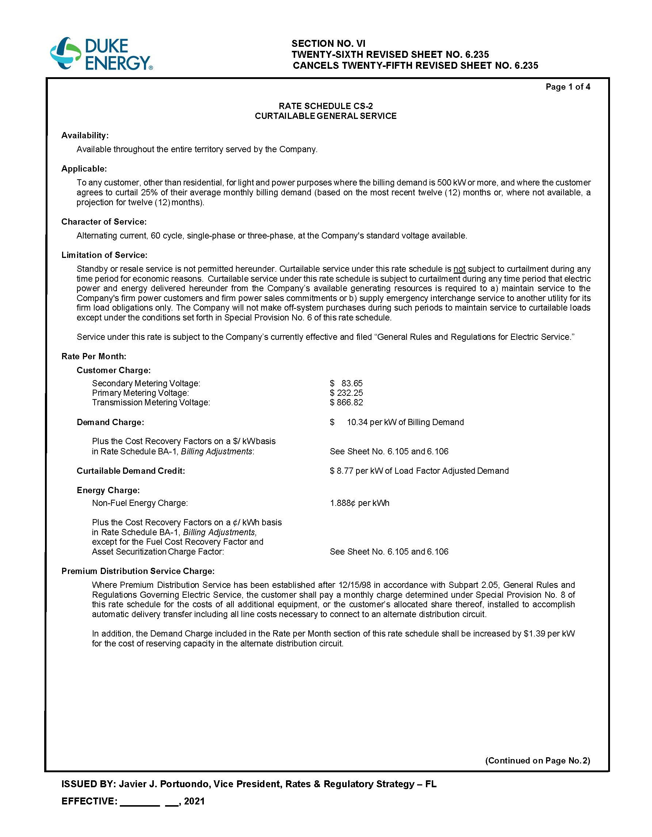

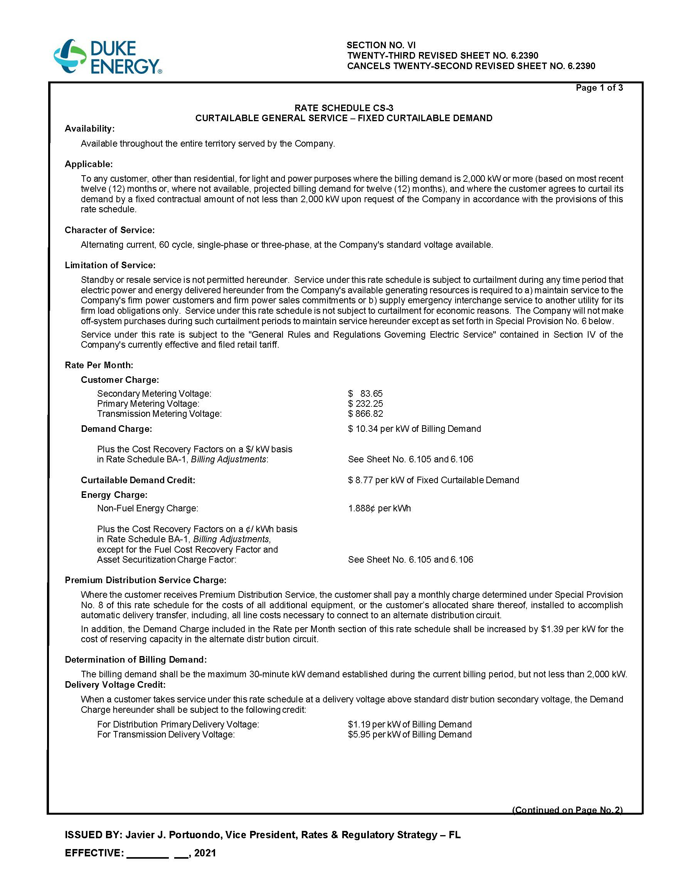

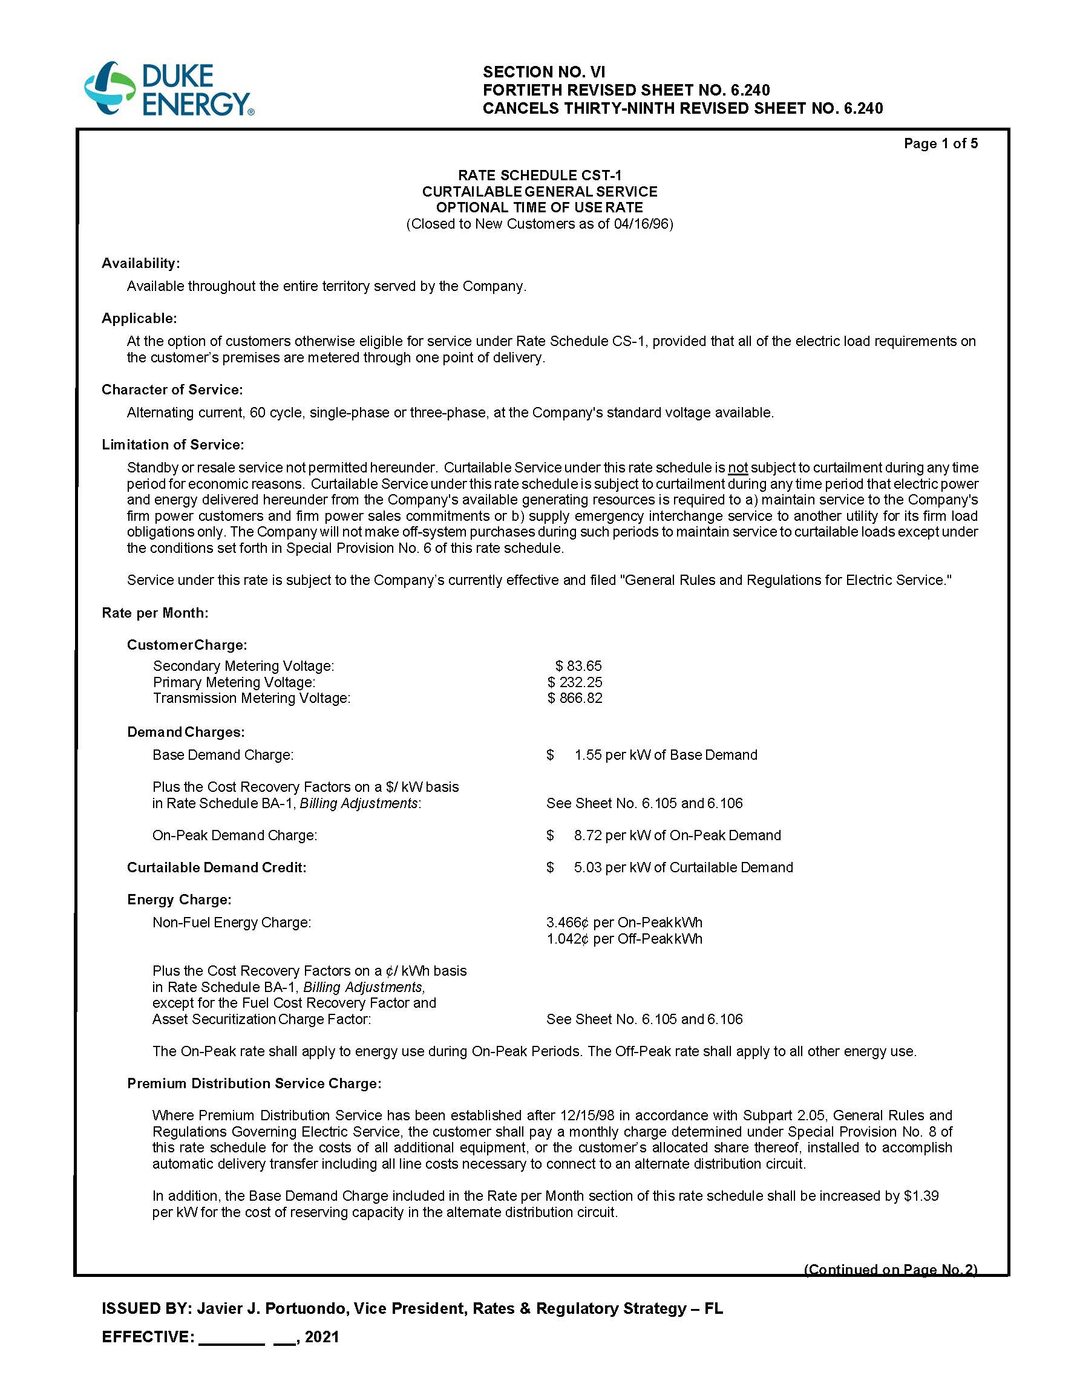

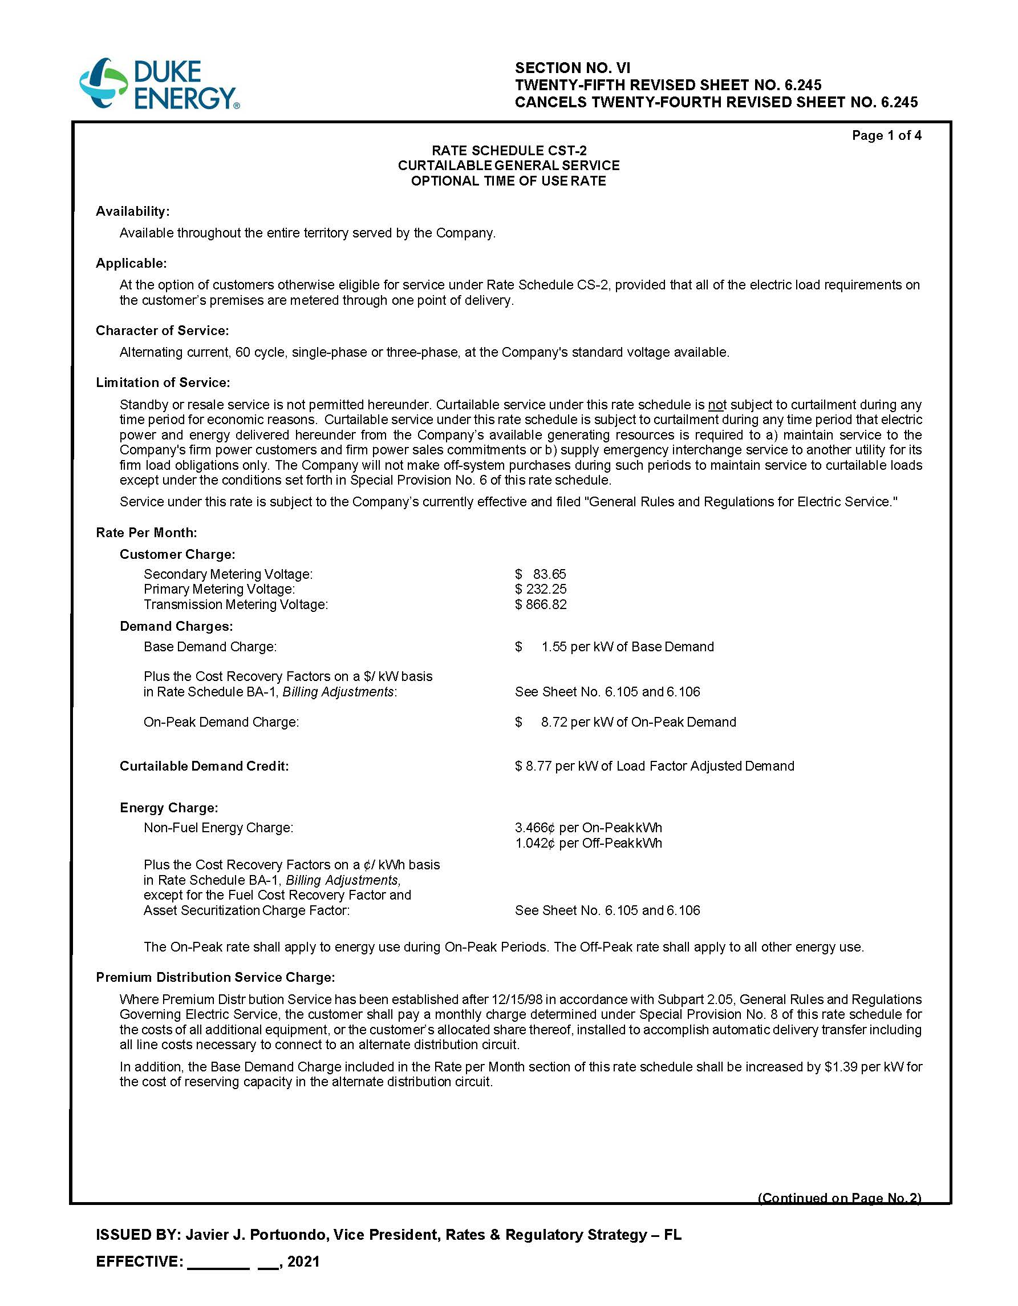

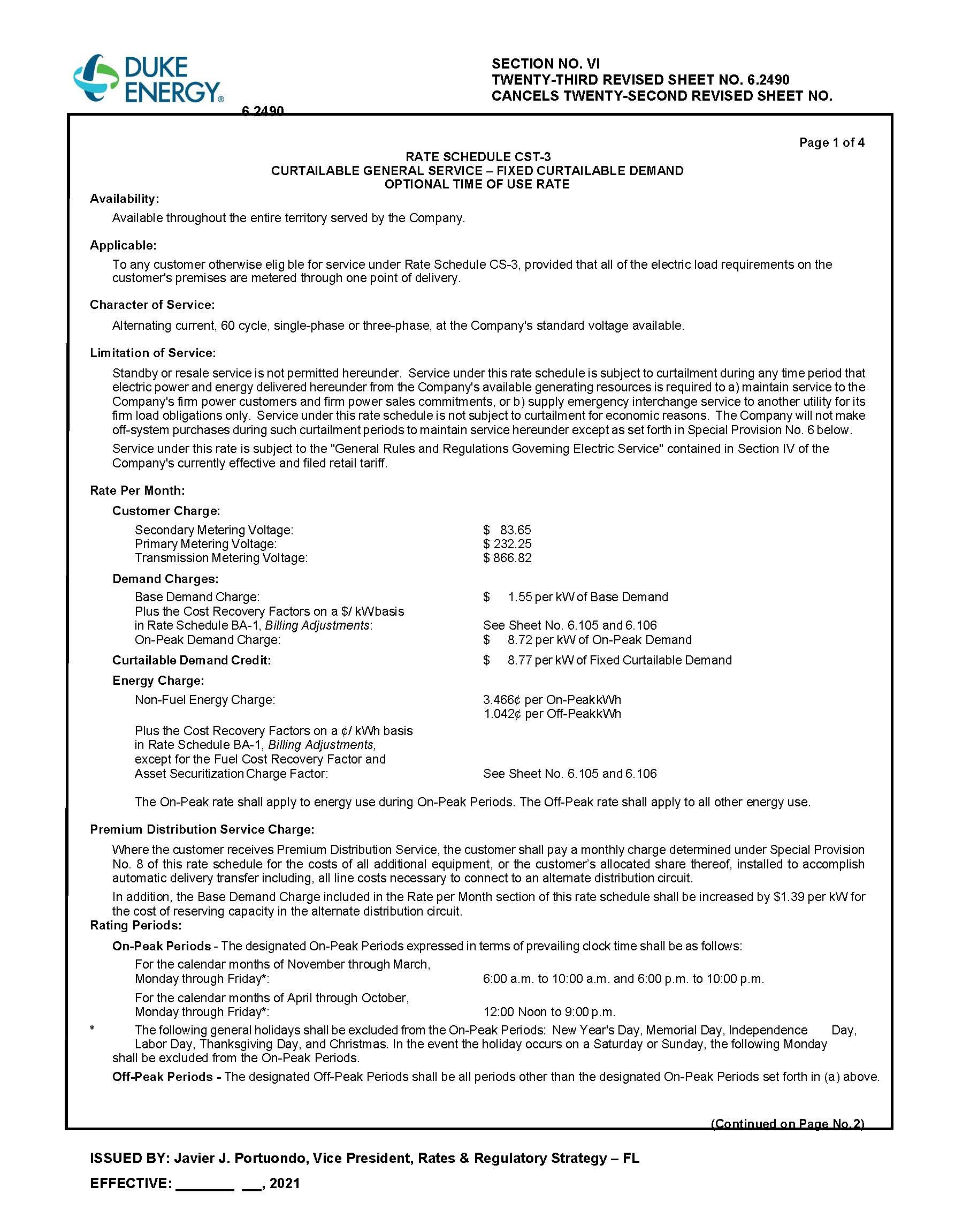

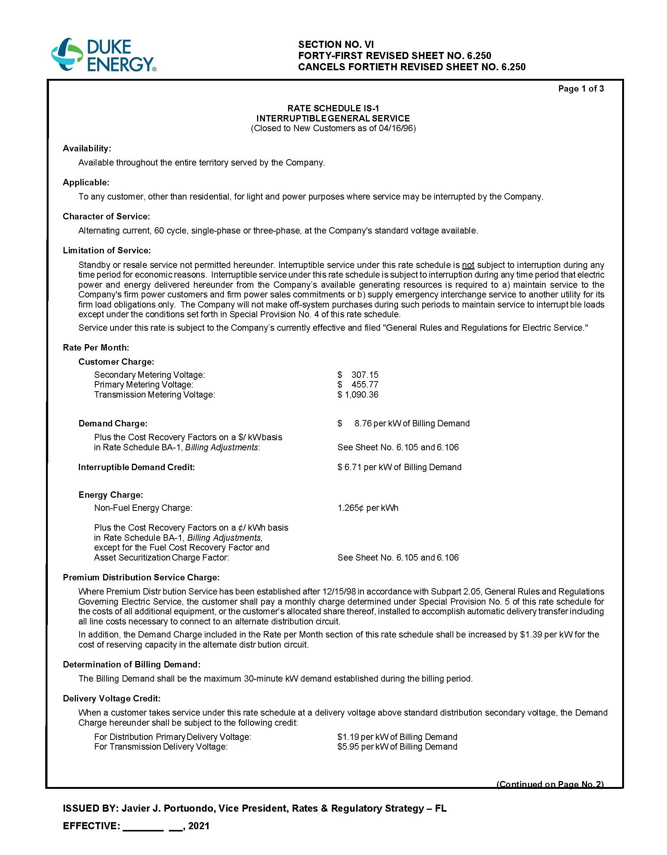

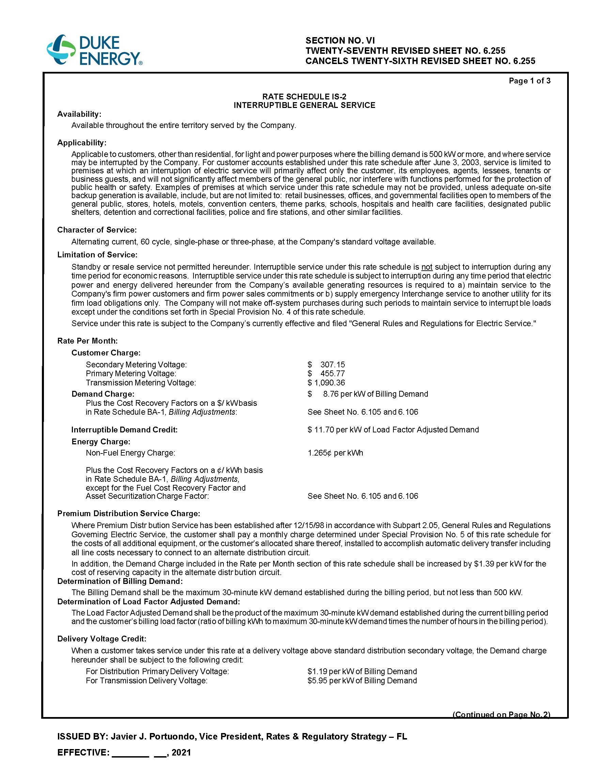

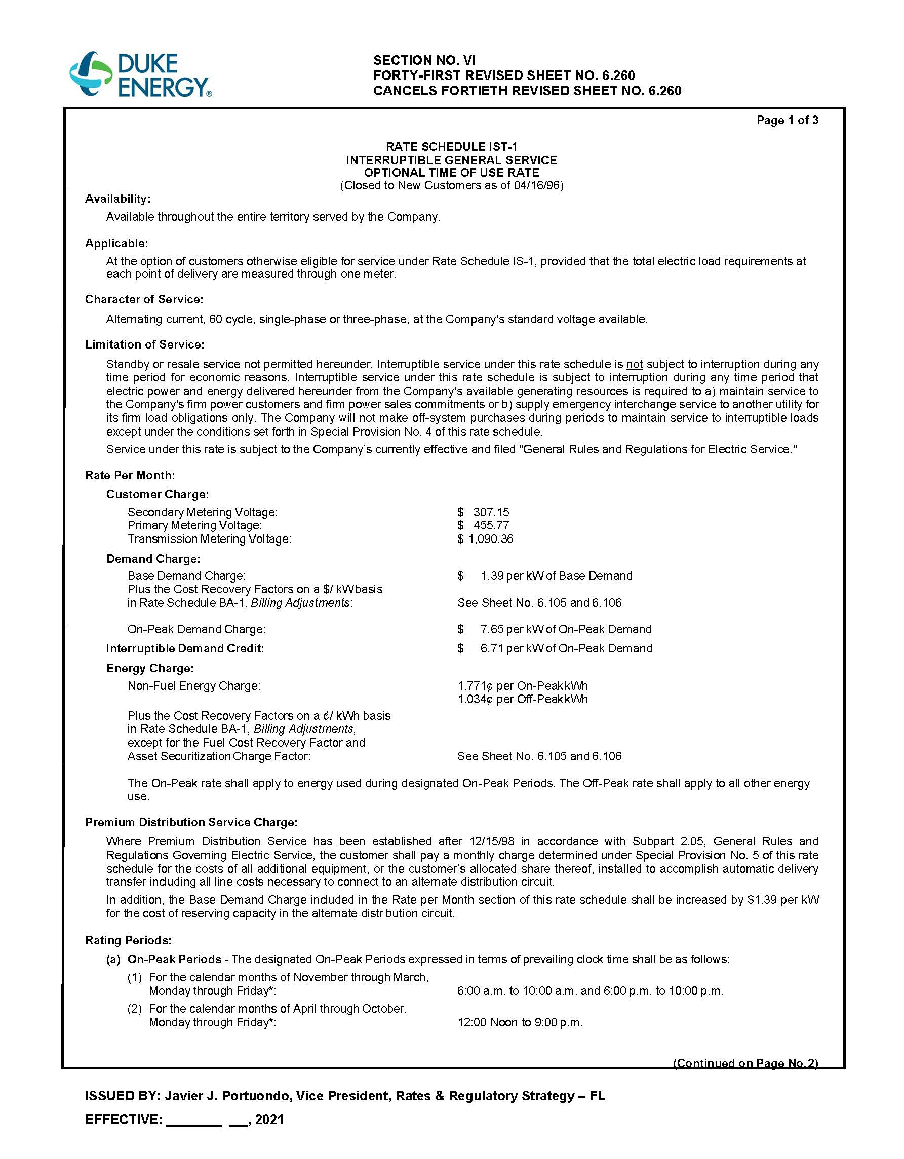

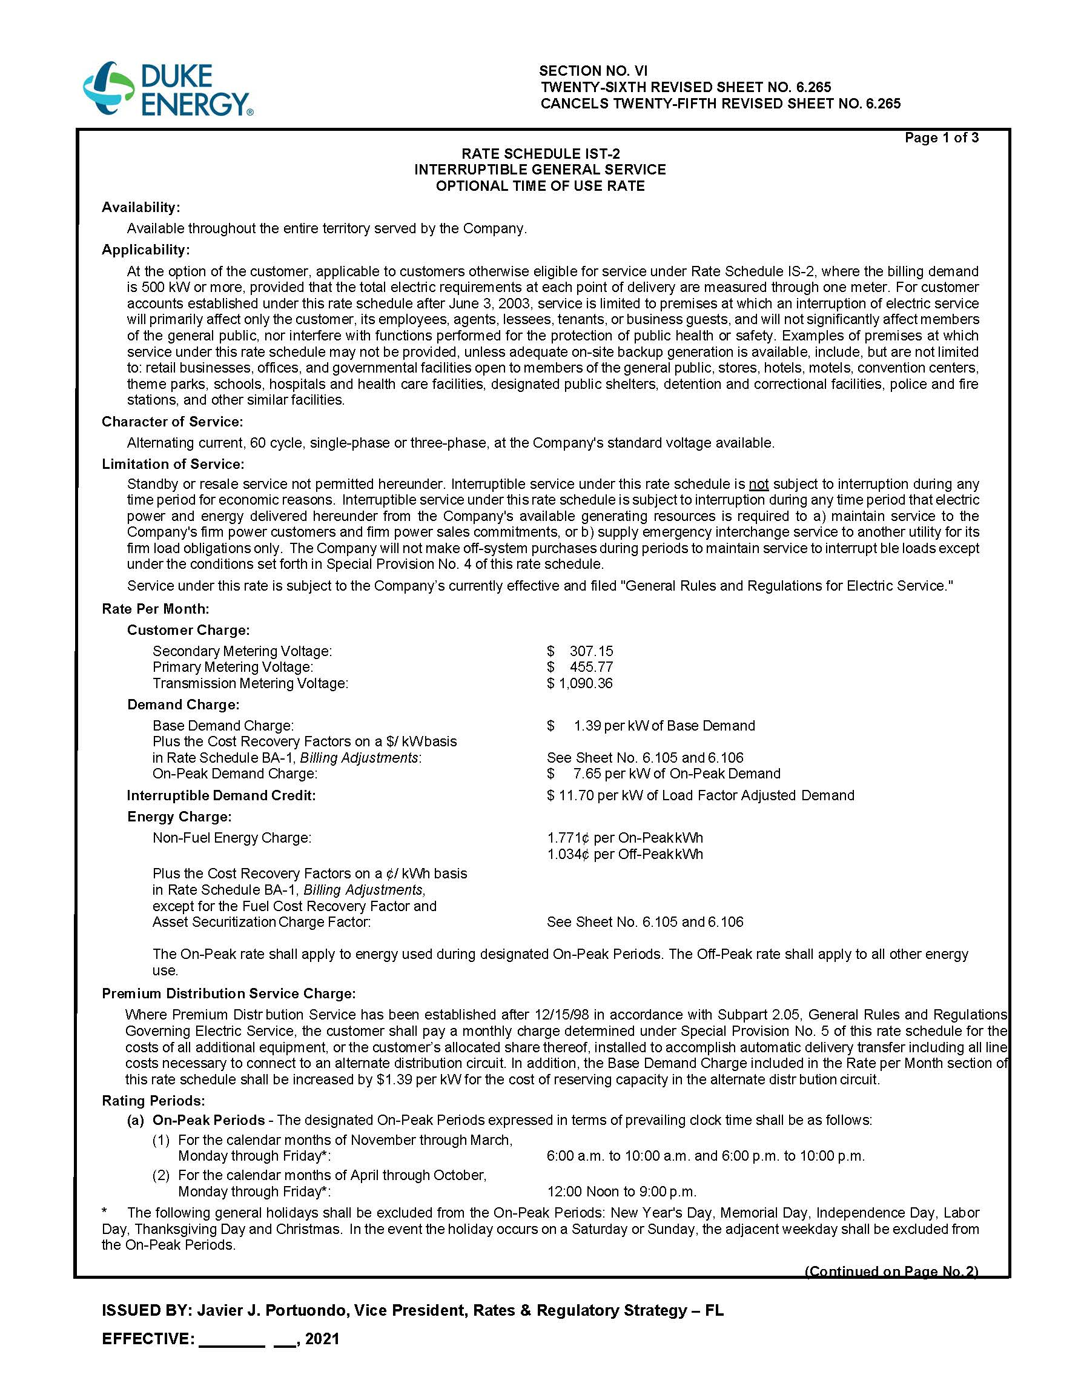

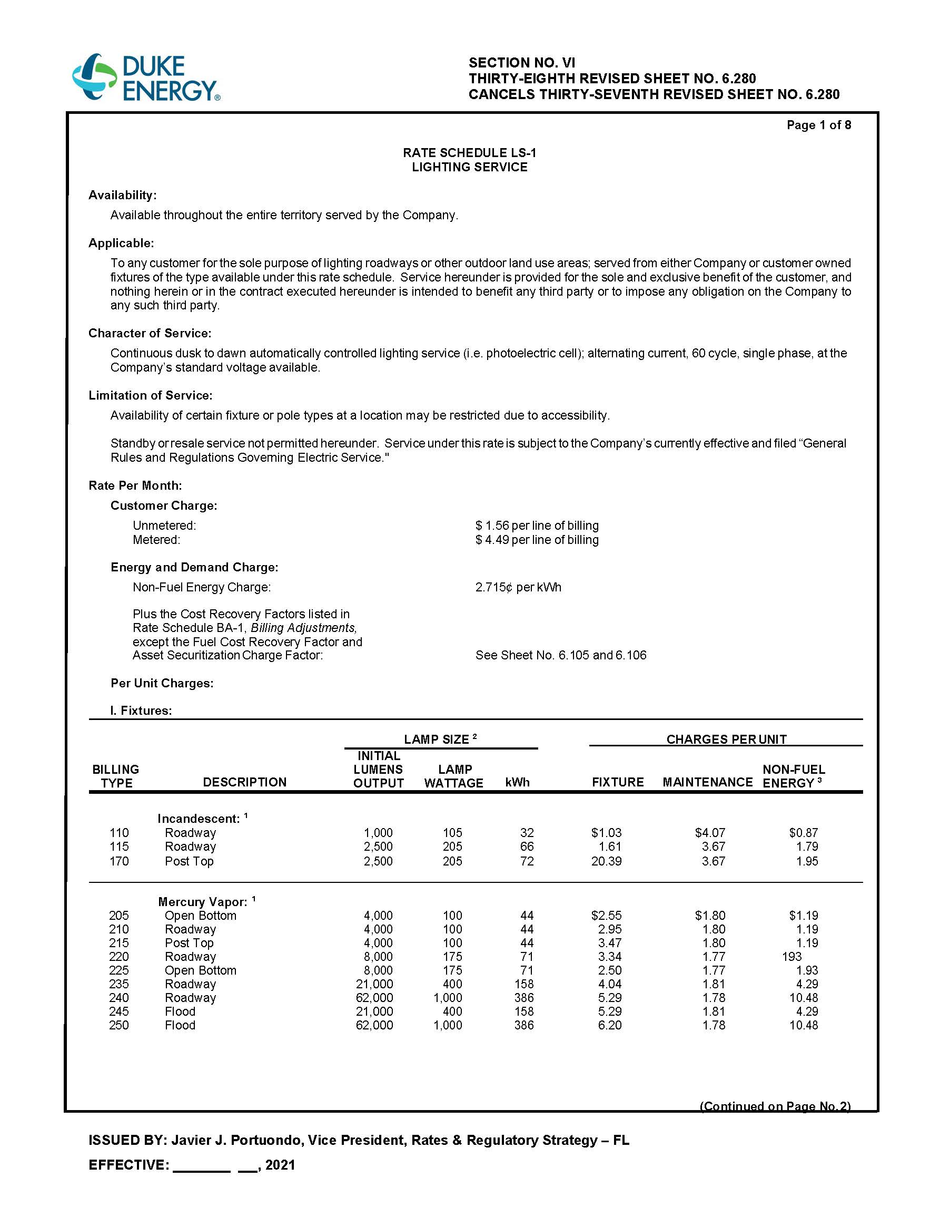

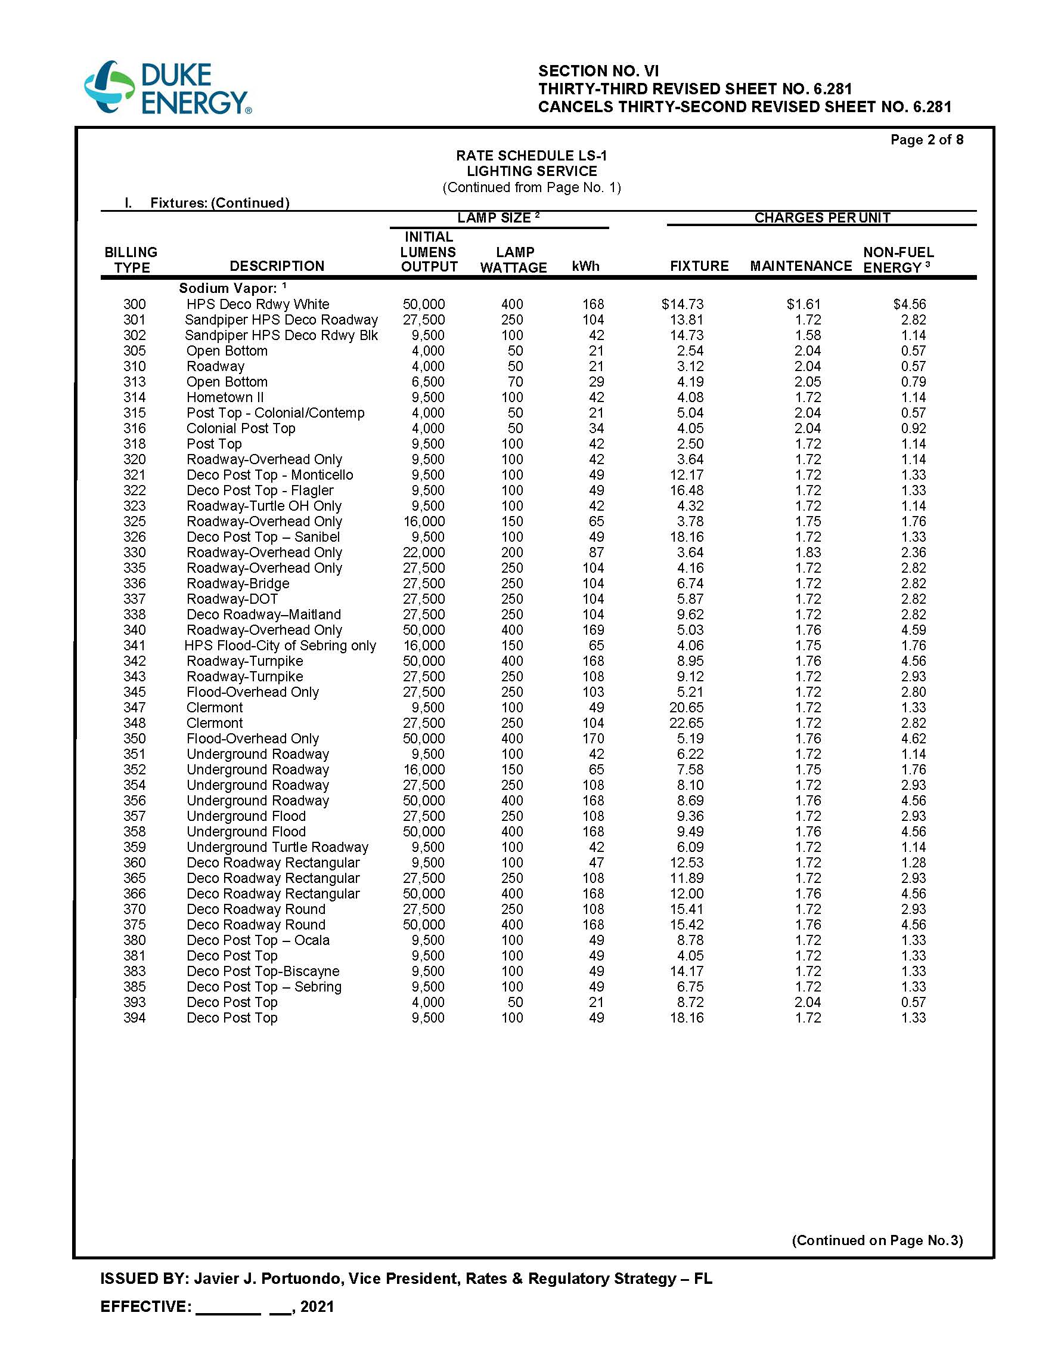

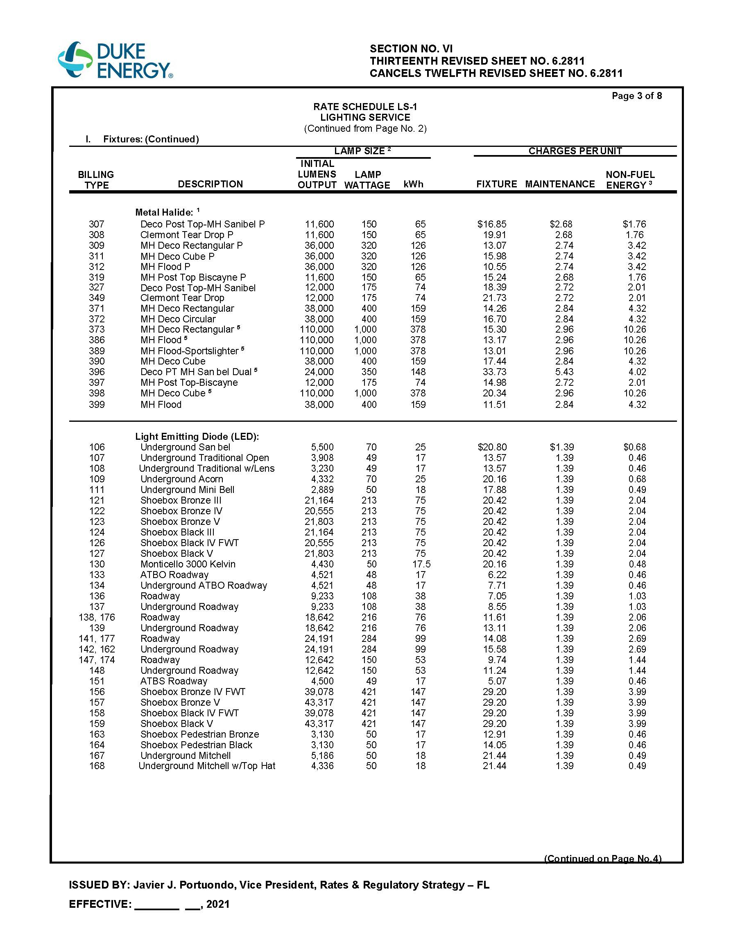

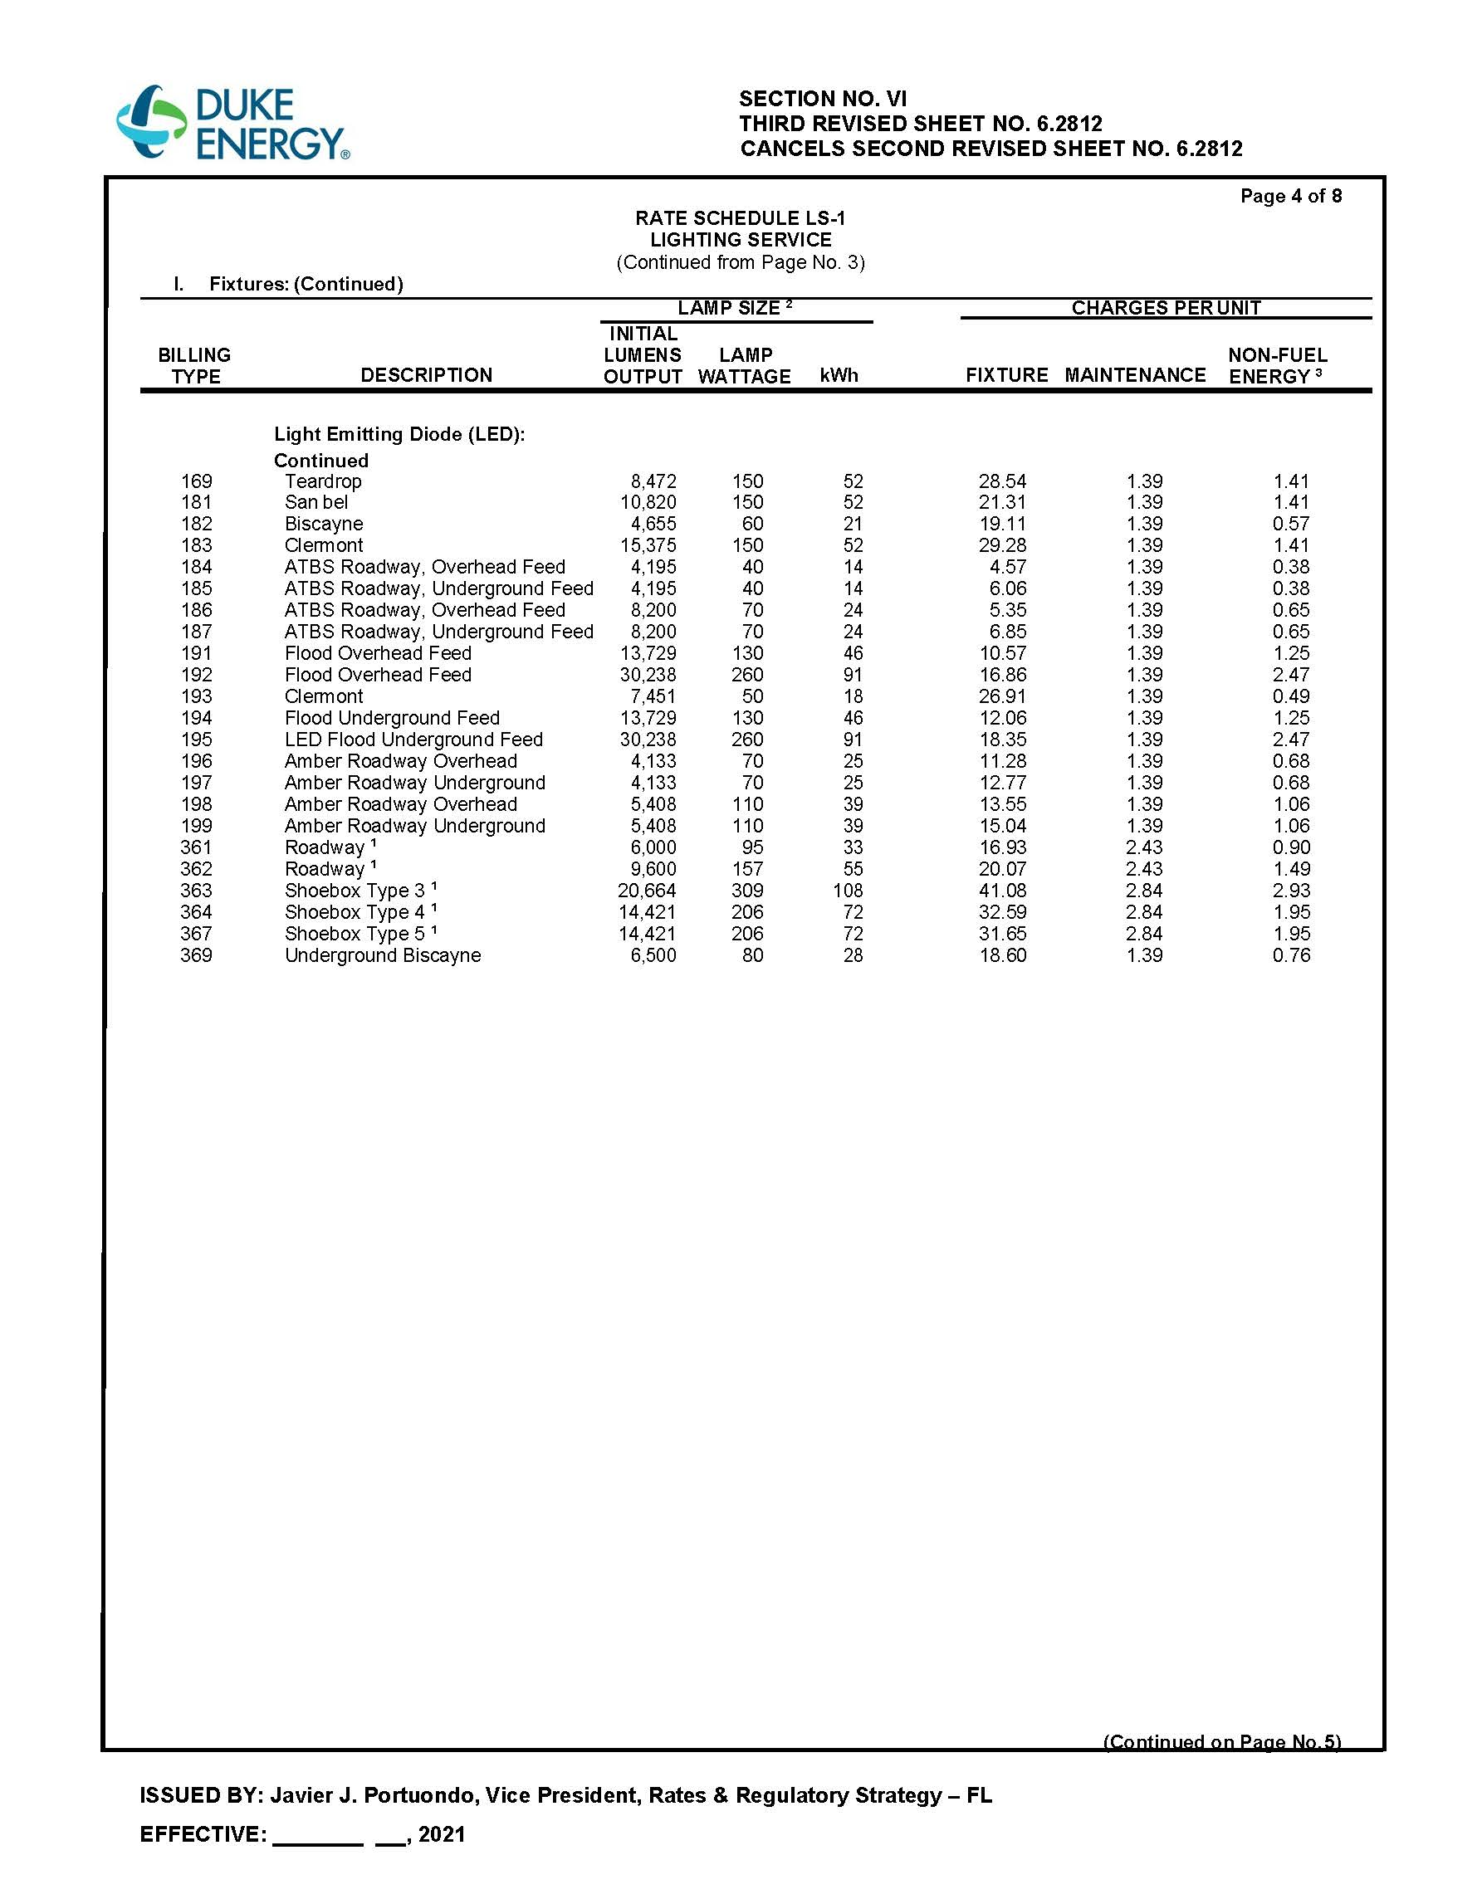

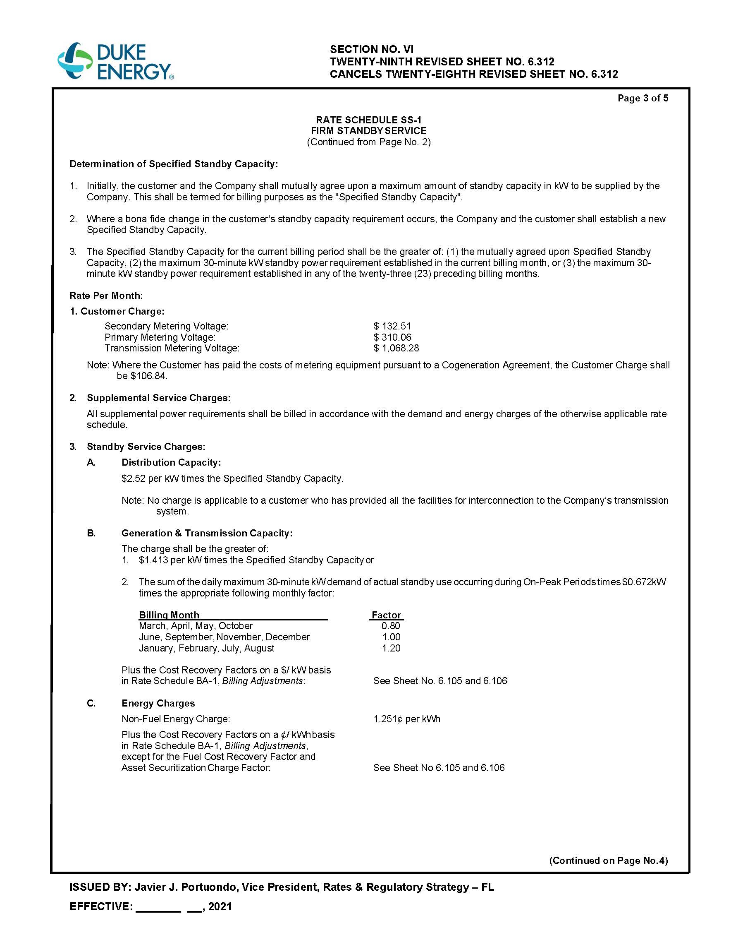

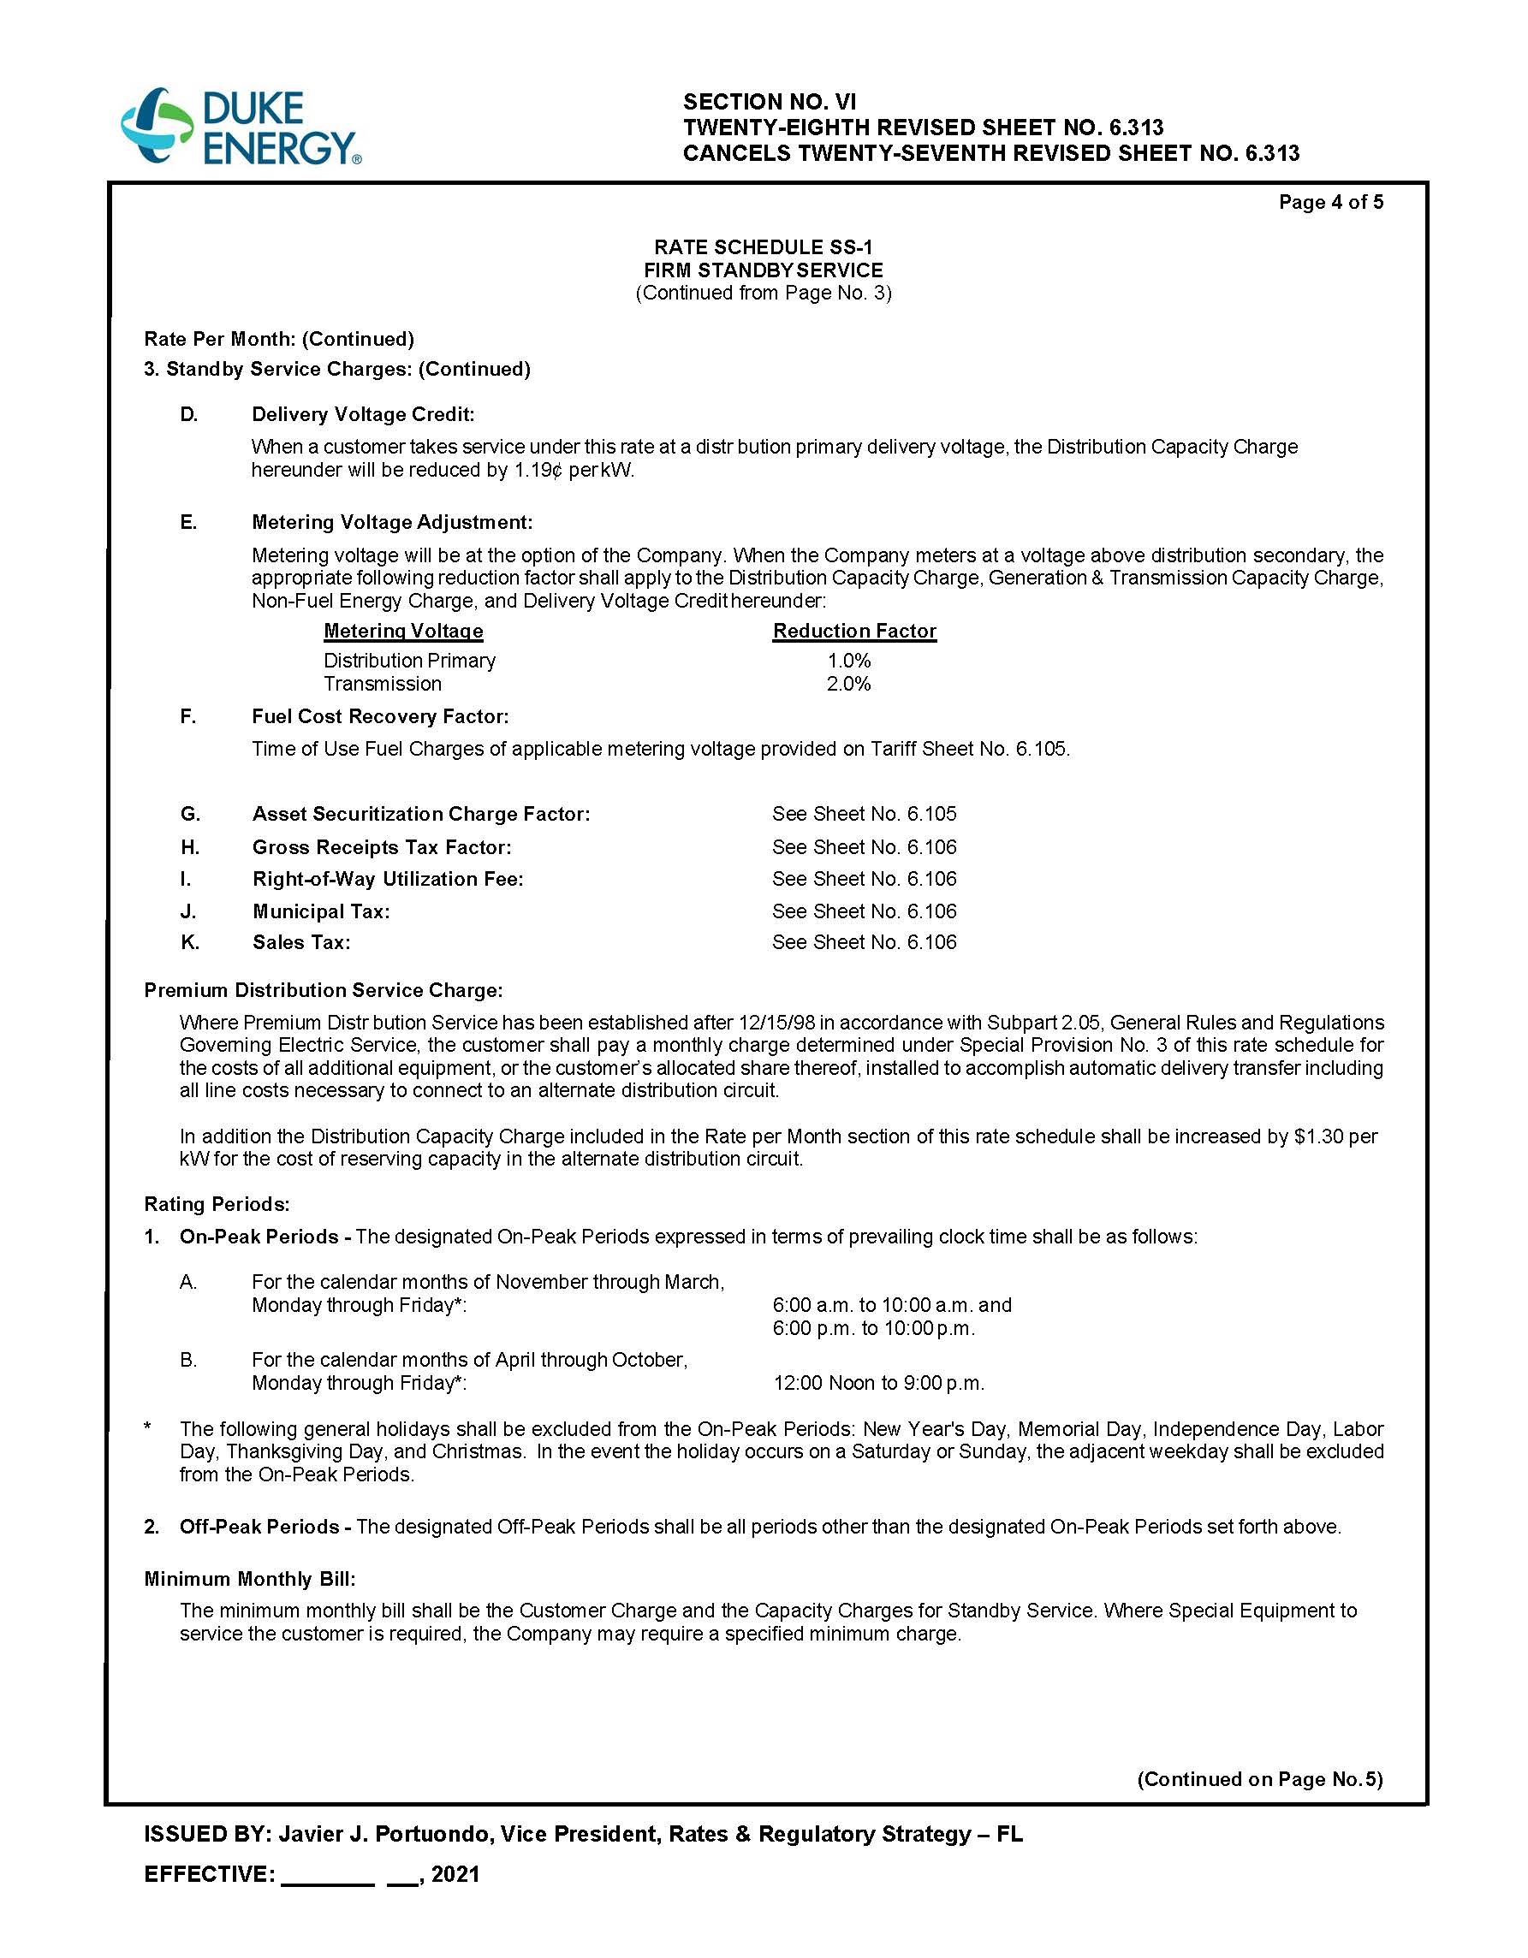

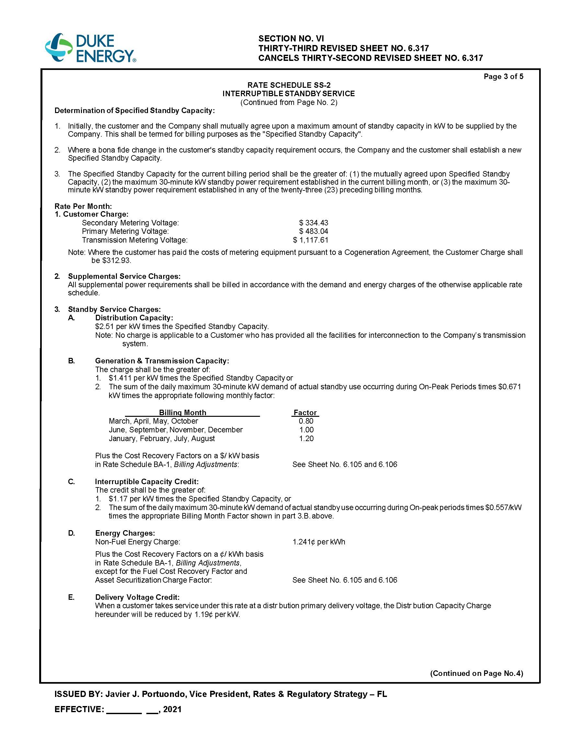

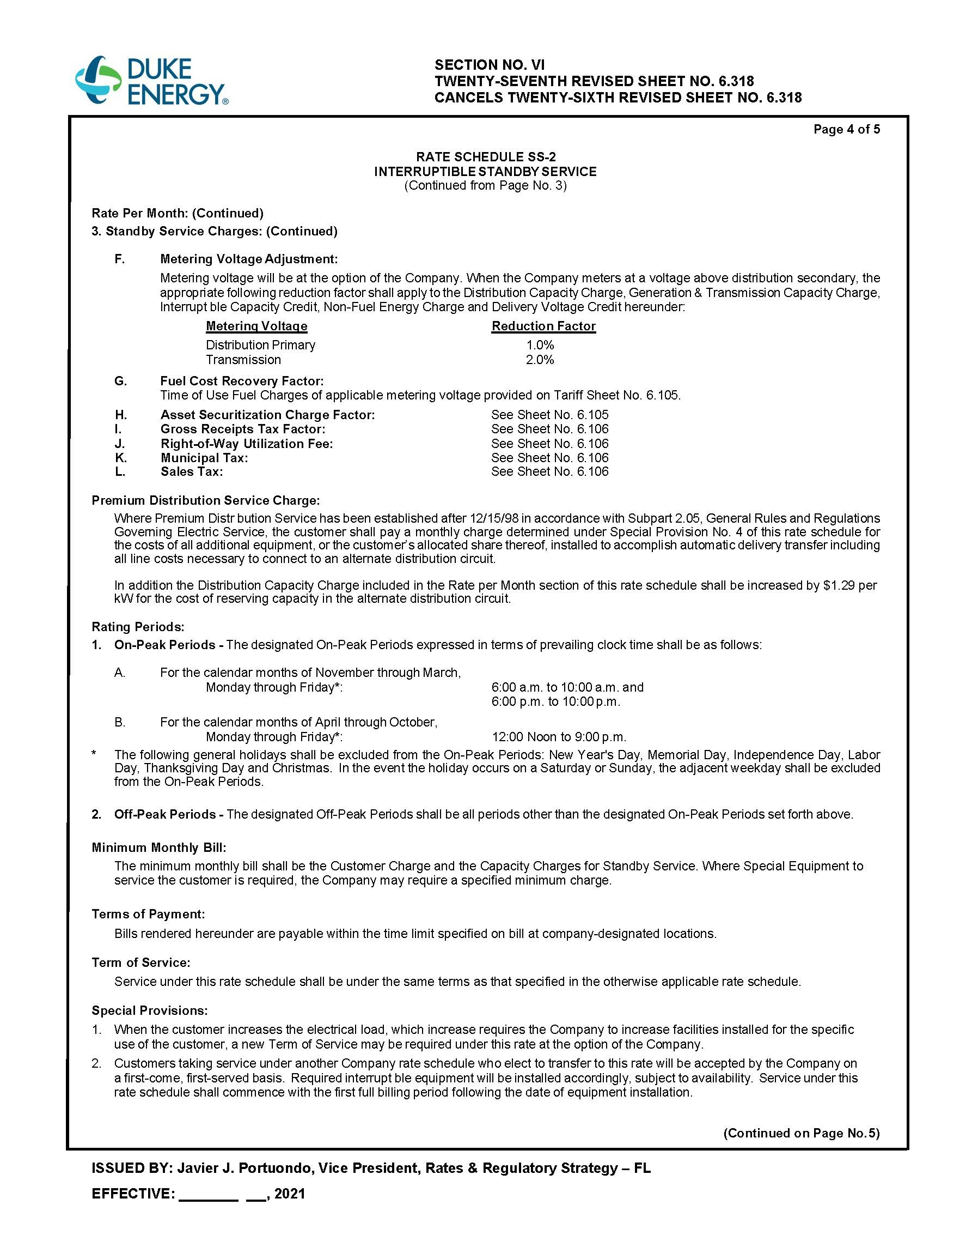

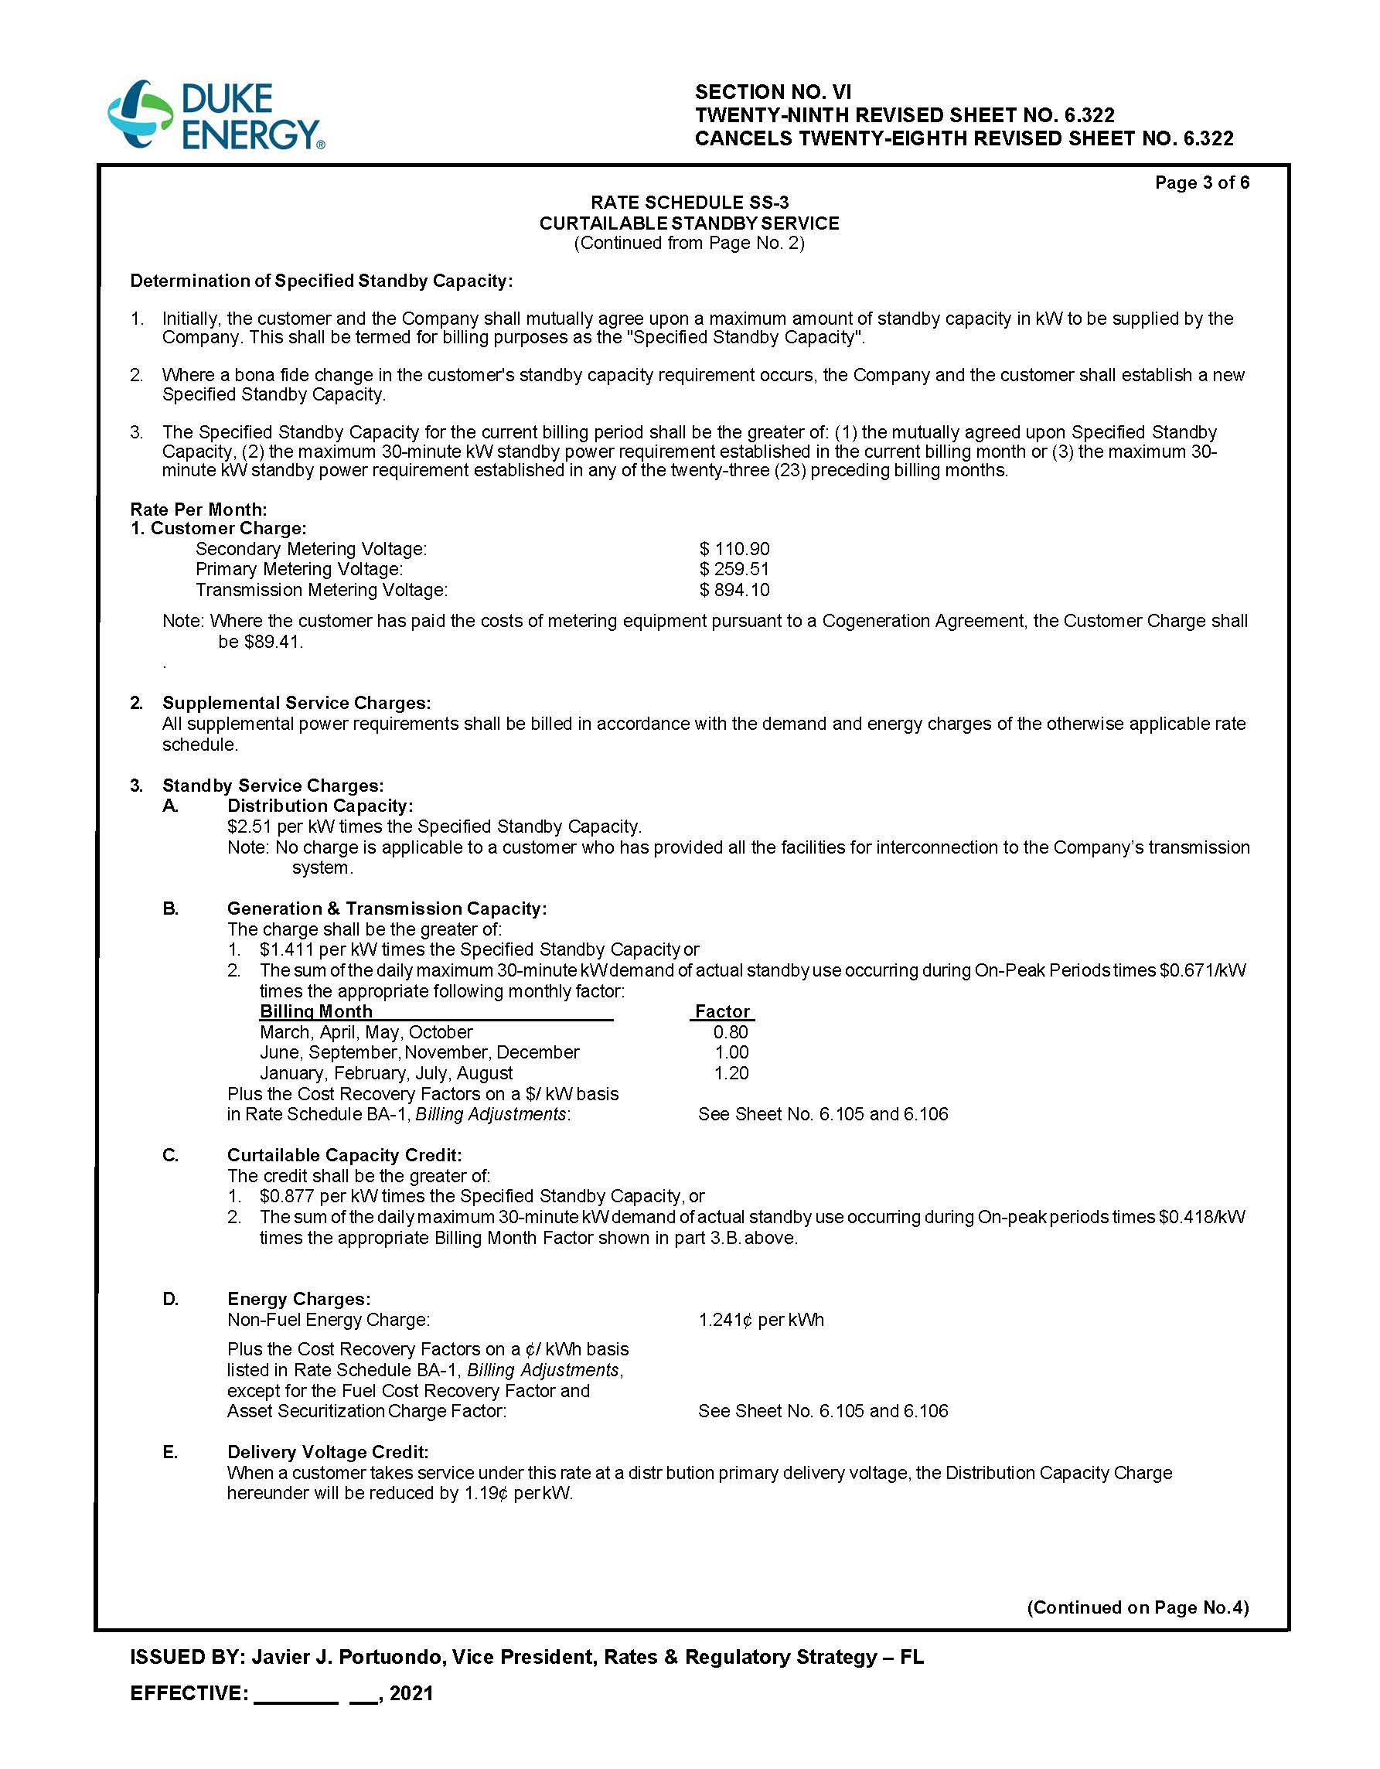

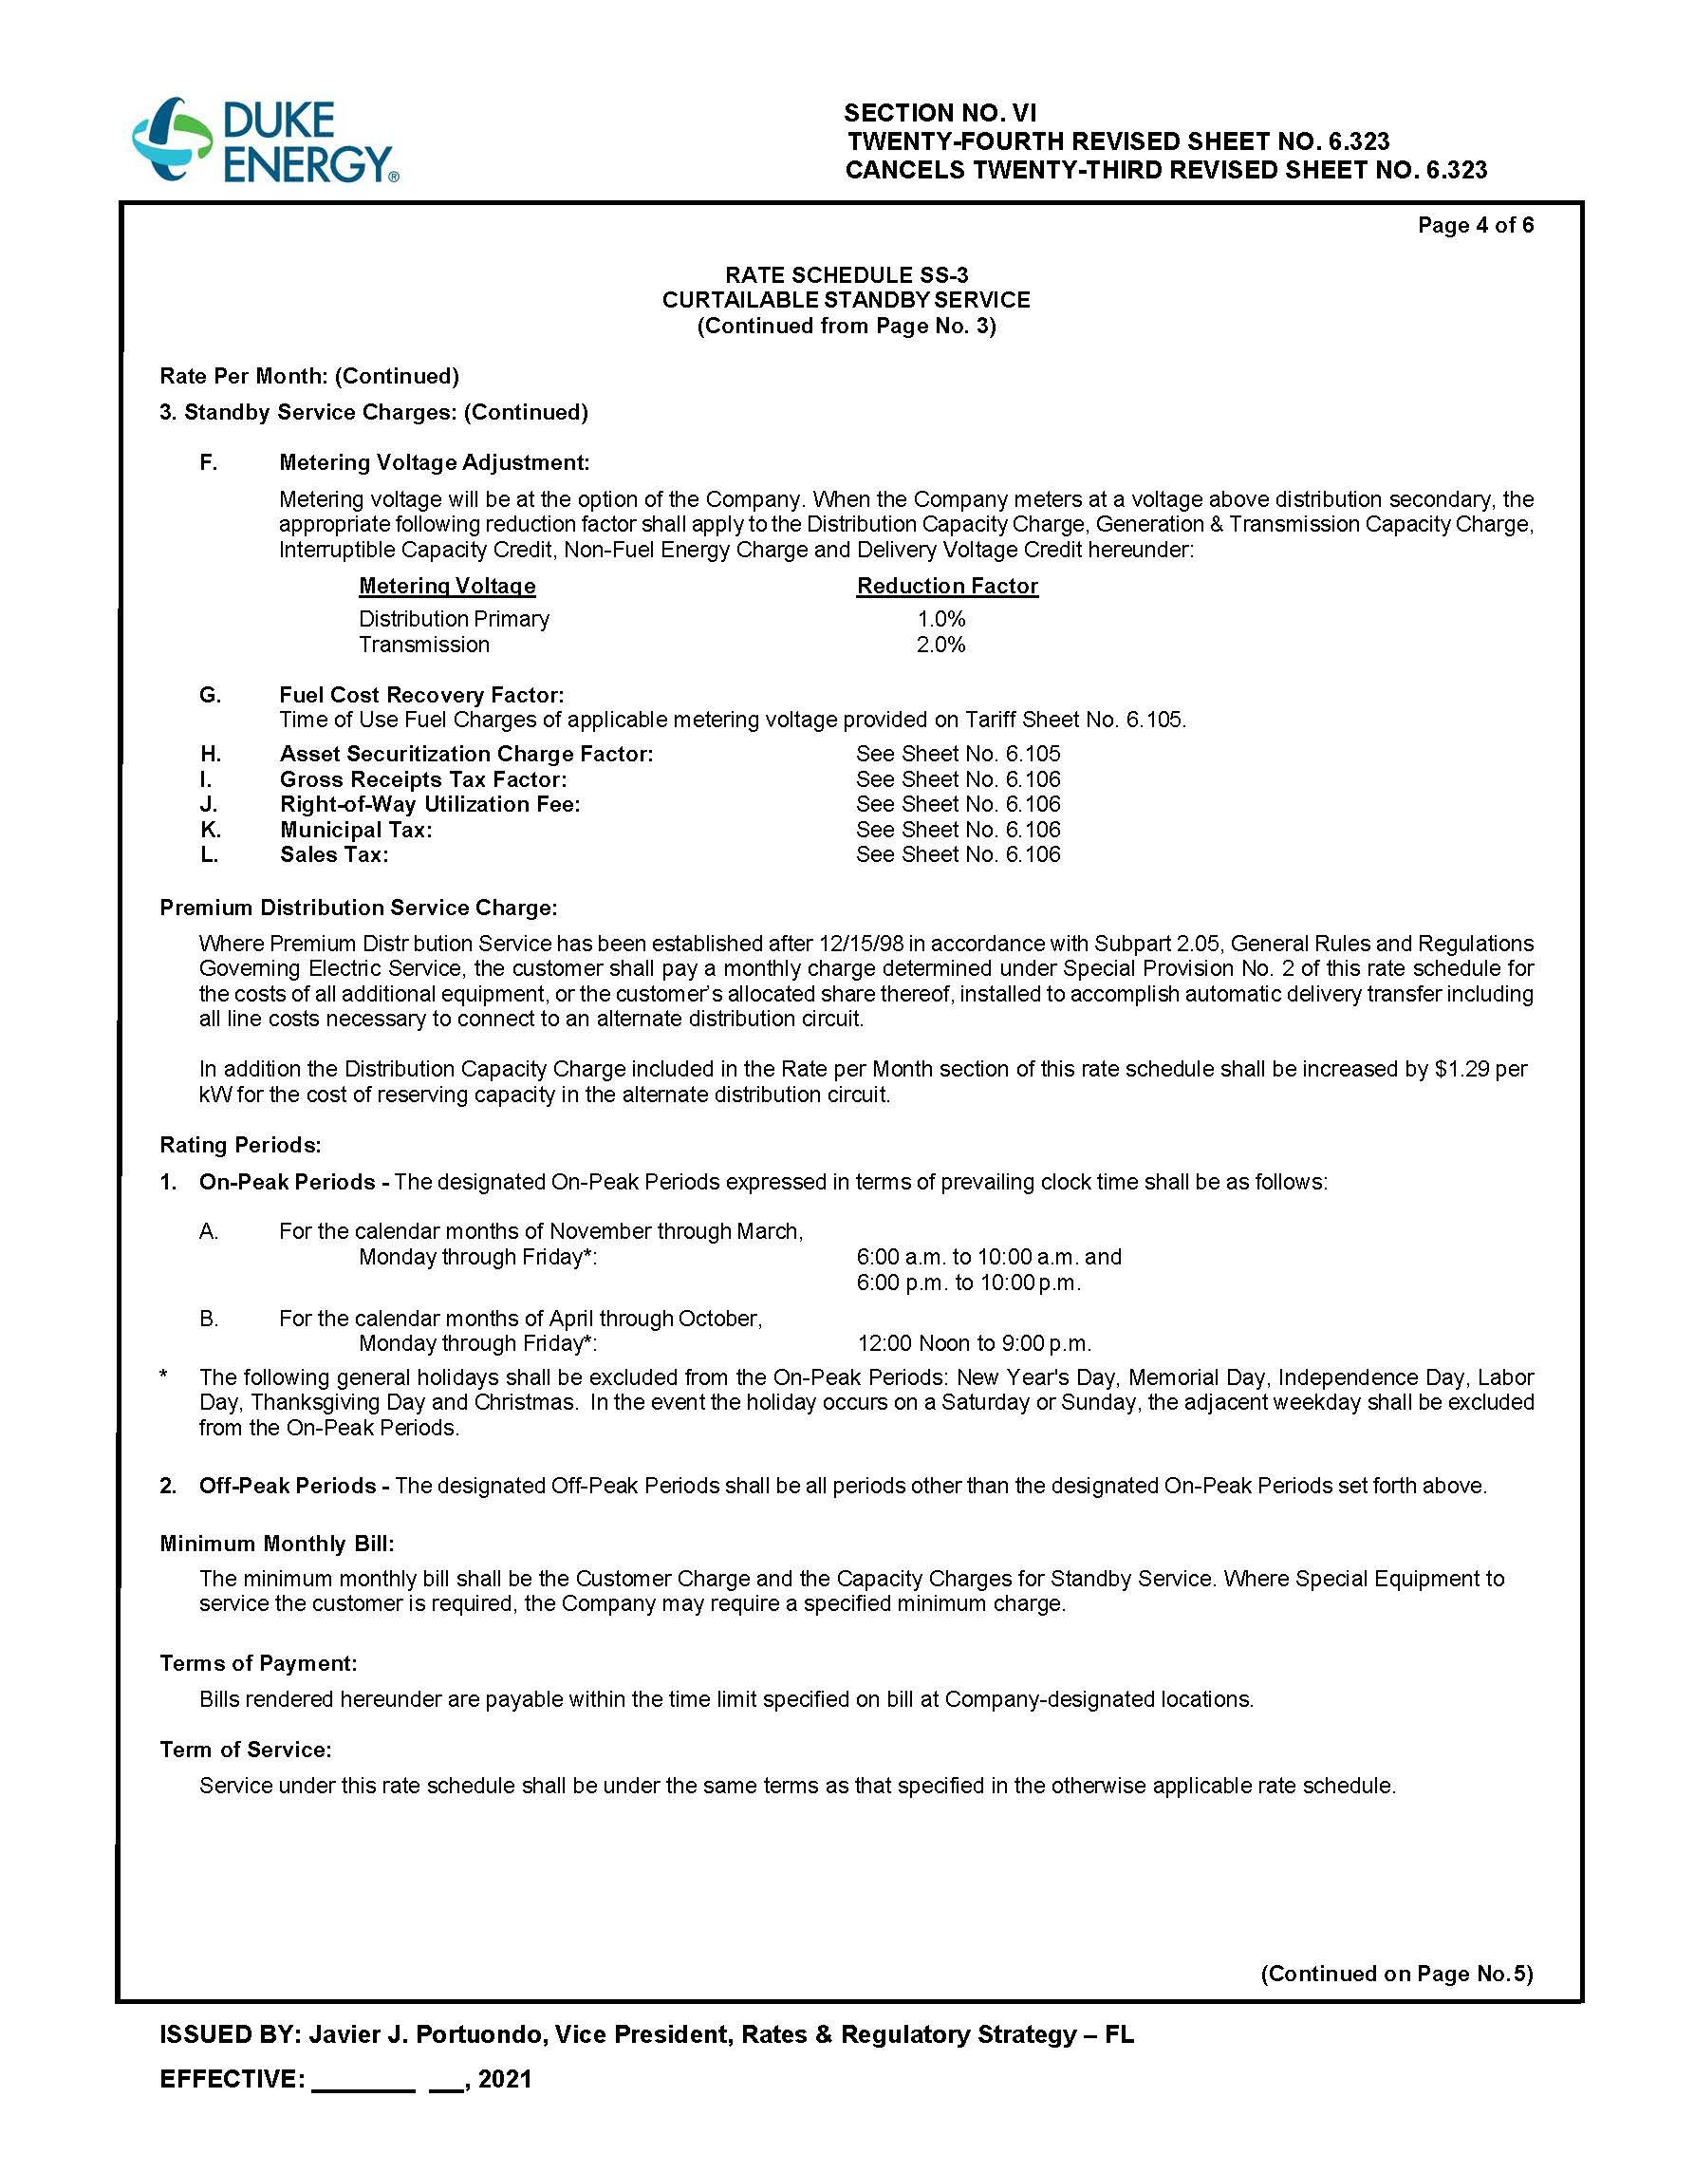

Order No. PSC-2017-0451-AS-EU, issued November 20, 2017, in Docket No. 20170183-EI, In re: Application for limited proceeding to approve 2017 second revised and restated settlement agreement, including certain rate adjustments, by Duke Energy Florida, LLC.
Order No. PSC-2019-0159-FOF-EI, issued April 30, 2019, in Docket No. 20180149-EI, In re: Duke Energy Florida, LLC's Petition for Limited Proceeding to Approve First Solar Base Rate Adjustment.
Order No. PSC-2019-0292-FOF-EI, issued July 22, 2019, in Docket No. 20190072-EI, In re: Duke Energy Florida, LLC's Petition for Limited Proceeding to Approve Second Solar Base Rate Adjustment.
Document No. 02844-2020 filed May 29, 2020, in Docket No. 20200153-EI, In re: Duke Energy Florida, LLC's Petition for Limited Proceeding to Approve Third Solar Base Rate Adjustment.
Document No. 12493-2020 filed November 18, 2020, in Docket No. 20200245-EI, In re: Duke Energy Florida, LLC's Petition for Limited Proceeding to Approve Third Solar Base Rate Adjustment.
Order No. PSC-2017-0451-AS-EU, issued November 20, 2017, in Docket No. 20170183-EI, In re: Application for limited proceeding to approve 2017 second revised and restated settlement agreement, including certain rate adjustments, by Duke Energy Florida, LLC; Docket No. 20100437-EI, In re: Examination of the outage and replacement fuel/power costs associated with the CR3 steam generator replacement project, by Progress Energy Florida, Inc.; Docket No. 20150171-EI, In re: Petition for issuance of nuclear asset-recovery financing order, by Duke Energy Florida, Inc. d/b/a Duke Energy; Docket No. 20170001-EI, In re: Fuel and purchased power cost recovery clause with generating performance incentive factor; Docket No. 20170002-EG, In re: Energy conservation cost recovery clause; Docket No. 20170009-EI, In re: Nuclear cost recovery clause.
2017 Settlement, Section 15.
Sandy Creek project’s annual revenue requirement represents only 75.6 percent of the total, which is the amount being included for recovery under the SoBRA framework.

