BEFORE THE FLORIDA PUBLIC SERVICE COMMISSION

In re: Petition for limited proceeding for recovery of incremental storm restoration costs related to Hurricane Sally, by Gulf Power Company. | DOCKET NO. 20200241-EI  ORDER NO. PSC-2021-0112-PCO-EI  ISSUED: March 22, 2021

The following Commissioners participated in the disposition of this matter:

GARY F. CLARK, Chairman
ART GRAHAM
ANDREW GILES FAY
MIKE LA ROSA

ORDER APPROVING GULF POWER’S PETITION FOR RECOVERY OF
INCREMENTAL STORM RESTORATION COSTS FOR HURRICANE SALLY

BY THE COMMISSION:

Background
On November 10, 2020, Gulf Power Company (Gulf or Company) filed a petition for a limited proceeding seeking authority to implement an interim storm restoration recovery charge to recover incremental storm restoration costs related to Hurricane Sally. Gulf estimates a total of $206 million for incremental restoration costs related to Hurricane Sally. In its petition, Gulf asserts that prior to Hurricane Sally, Gulf’s Storm Reserve was fully depleted and in a deficit position, primarily due to incremental costs incurred from Hurricane Michael. Gulf filed its petition pursuant to the provisions of the Stipulation and Settlement Agreement (SSA) approved by us in Order No. PSC-2017-0178-S-EI. Pursuant to Paragraph 7(a) of the SSA, Gulf can recover storm costs, not exceeding $4.00/1,000 kilowatt hour (kWh) on monthly residential customer bills, on an interim basis, beginning 60 days following the filing of a petition for recovery. In addition, pursuant to Paragraph 7(b), Gulf may petition us to allow for a charge greater than $4.00/1,000 kWh, or a period longer than 12 months, if costs exceed $100 million in a calendar year. In its petition, Gulf has requested an interim storm restoration charge applicable to all rate classes, effective March 1, 2021. For residential customers, the proposed charge would be $3.00 on a 1,000 kWh bill. On December 16, 2020, Gulf agreed to waive the 60-day time frame set forth in the SSA and requested that we approve the storm restoration recovery charge to become effective March 2, 2021.

The Office of Public Counsel’s intervention in this docket was acknowledged in Order No. PSC-2020-0484-PCO-EI, issued December 9, 2020.
We have jurisdiction over this matter pursuant to Sections 366.04, 366.05, 366.06, and 366.076, Florida Statutes.

Decision
Gulf filed its petition for a limited proceeding seeking authority to implement an interim storm restoration recovery charge applicable to all rate classes to recover an estimated total of $206 million for incremental restoration costs related to Hurricane Sally. In addition, the $206 million also includes $900,000 of interest on the unamortized storm reserve balance. Also, Gulf’s Storm Reserve is fully depleted, primarily due to the incremental costs incurred from Hurricane Michael. Gulf has requested an interim storm restoration recovery charge of 0.3 cents per kWh, which equates to $3.00 on a 1,000 kWh residential electric bill, effective March 2, 2020. As discussed below, the interim storm charge would vary by rate class. Gulf estimates that the interim charge collected from all rate classes will yield approximately $24 million per year. Gulf residential customer bills currently reflect a monthly Hurricane Michael storm recovery charge of $8.00 on a 1,000 kWh to be in effect till September 2023. The combination of the Hurricane Michael recovery charge and the Hurricane Sally interim recovery charge sum to $11.00 on a 1,000 kWh residential electric bill. Once Gulf has fully recovered the Hurricane Michael storm costs, Gulf proposes to seek our approval to increase the Hurricane Sally storm restoration recovery charge to $10.00 on a 1,000 kWh residential electric bill and for this level to remain in place until the Hurricane Sally costs are fully recovered and the Storm Reserve is replenished to approximately $41 million.
In its petition, Gulf asserts that it incurred total retail recoverable costs of approximately $206 million as a result of Hurricane Sally. Gulf represents that this amount was calculated in accordance with the Incremental Cost and Capitalization Approach (ICCA) methodology prescribed in Rule 25-6.0143, Florida Administrative Code (F.A.C.).
The approval of an interim storm restoration recovery charge is preliminary in nature and is subject to refund pending a further review once the total actual storm restoration costs are known. After the actual costs are reviewed for reasonableness and prudence, and are compared to the actual amount recovered through the interim storm restoration recovery charge, a determination will be made whether any over/under recovery has occurred. The disposition of any over/under recovery, and associated interest, would be considered by us at a later date.
Based on a review of the information provided by Gulf in its petition, we approve Gulf’s petition to implement an interim storm restoration recovery charge, subject to refund. Once the total actual storm costs are known, Gulf shall be required to file documentation of the storm costs for our review and true up of any excess or shortfall.
Gulf has proposed to begin applying the interim storm restoration recovery charge to customer bills on March 2, 2021, and to include the charge in the non-fuel energy surcharge on customer bills. In support of its rate calculations, Gulf provided Exhibit 3 to the petition, which illustrates the computation of the proposed interim storm restoration recovery charge for each rate class. Gulf represented that it followed the methodology for allocation of storm costs among rate classes consistent with the cost of service study filed in its 2016 rate case in Docket No. 20160186-EI. Upon review, we find Gulf’s calculations and the allocation methodology to be appropriate and reasonable.
Application of the allocation methodology for the residential customer rate class results in a proposed interim storm recovery charge of 0.3 cents per kWh, which equates to $3.00 on a 1,000 kWh residential electric bill. The proposed interim charges for all rate classes are captured in Original Sheet No. 6.25.1, which is included in Attachment A.
Based on its review of the information provided by Gulf, we hereby approve Gulf's proposed interim storm restoration recovery charge tariff as shown in Attachment A. The effective date for the approved is March 2, 2021.

All funds collected subject to refund shall be secured by a corporate undertaking. The criteria for a corporate undertaking include sufficient liquidity, ownership equity, profitability, and interest coverage to guarantee any potential refund. We reviewed Gulf’s financial statements to determine if the Utility can support a corporate undertaking to guarantee the funds collected for recovery of incremental storm restoration costs related to Hurricane Sally. Gulf’s 2019, 2018, and 2017 financial statements were used to determine the financial condition of the Company. Gulf’s financial performance demonstrates adequate levels of liquidity, ownership equity, profitability, and interest coverage to guarantee the potential refund.

We find that Gulf possesses adequate resources to support a corporate undertaking in the amount requested and that a corporate undertaking is acceptable. This brief financial analysis is only appropriate for deciding if the Company can support a corporate undertaking in the amount proposed and was not considered in our evaluation of other issues in this proceeding.
Based on the foregoing, it is

ORDERED by the Florida Public Service Commission that Gulf Power Company’s petition to implement an interim storm restoration recovery charge, subject to refund, is hereby approved. Once the total actual storm costs are known, the utility shall file documentation of the storm costs for our review and true up of any excess or shortfall. It is further

ORDERED that Gulf's proposed interim storm restoration recovery charge tariff as shown in Attachment A, is approved with the effective date of March 2, 2021. It is further

ORDERED that the appropriate security to guarantee the funds collected subject to refund is a corporate undertaking. It is further
ORDERED that this docket shall remain open pending final reconciliation of actual recoverable Hurricane Sally storm costs with the amount collected pursuant to the interim storm restoration recovery charge, and the calculation of a refund or additional charge if warranted.

By ORDER of the Florida Public Service Commission this 22nd day of March, 2021.

/s/ Adam J. Teitzman
ADAM J. TEITZMAN
Commission Clerk
Florida Public Service Commission
2540 Shumard Oak Boulevard
Tallahassee, Florida 32399
(850) 413-6770
www.floridapsc.com

Copies furnished: A copy of this document is provided to the parties of record at the time of issuance and, if applicable, interested persons.

WLT

NOTICE OF FURTHER PROCEEDINGS OR JUDICIAL REVIEW

The Florida Public Service Commission is required by Section 120.569(1), Florida Statutes, to notify parties of any administrative hearing or judicial review of Commission orders that is available under Sections 120.57 or 120.68, Florida Statutes, as well as the procedures and time limits that apply. This notice should not be construed to mean all requests for an administrative hearing or judicial review will be granted or result in the relief sought.

Mediation may be available on a case-by-case basis. If mediation is conducted, it does not affect a substantially interested person's right to a hearing.

Any party adversely affected by this order, which is preliminary, procedural or intermediate in nature, may request: (1) reconsideration within 10 days pursuant to Rule 25-22.0376, Florida Administrative Code; or (2) judicial review by the Florida Supreme Court, in the case of an electric, gas or telephone utility, or the First District Court of Appeal, in the case of a water or wastewater utility. A motion for reconsideration shall be filed with the Office of Commission Clerk, in the form prescribed by Rule 25-22.0376, Florida Administrative Code. Judicial review of a preliminary, procedural or intermediate ruling or order is available if review of the final action will not provide an adequate remedy. Such review may be requested from the appropriate court, as described above, pursuant to Rule 9.100, Florida Rules of Appellate Procedure.

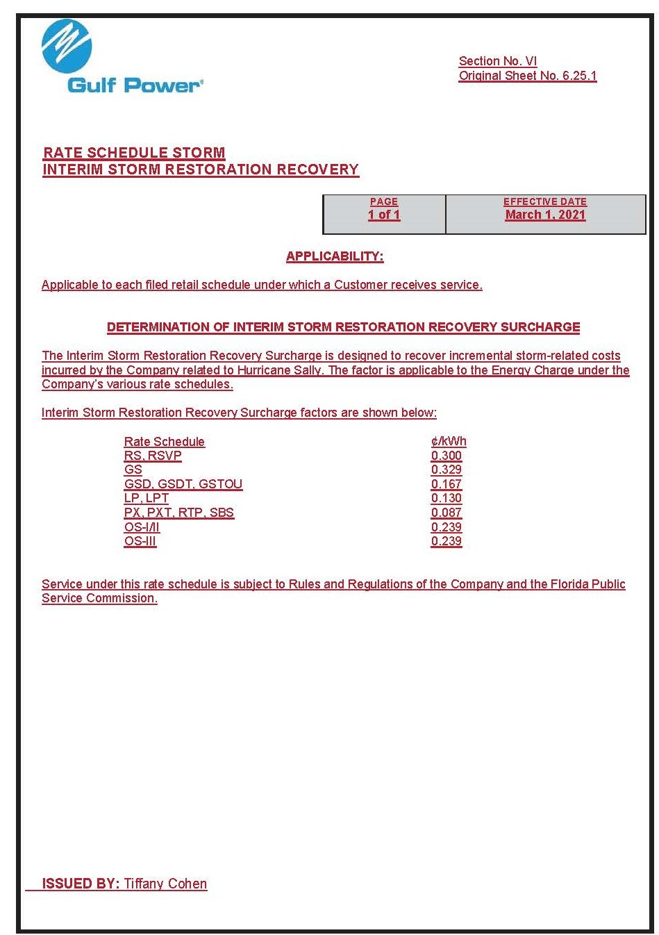

Order No. PSC-2017-0178-S-EI, issued May 16, 2017, in Docket No. 160186-EI, In re: Petition for rate increase by Gulf Power Company; and Docket No. 160170-EI, In re: Petition for approval of 2016 depreciation and dismantlement studies, approval of proposed depreciation rates and annual dismantlement accruals and Plant Smith Units 1 and 2 regulatory asset amortization, by Gulf Power Company.
Order No. PSC-2020-0349-S-EI, issued October 8, 2020, in Docket No. 20190038-EI, In re: Petition for limited proceeding for recovery of incremental storm restoration costs related to Hurricane Michael, by Gulf Power Company.

