BEFORE THE FLORIDA PUBLIC SERVICE COMMISSION

In re: Fuel and purchased power cost recovery clause with generating performance incentive factor. | DOCKET NO. 20210001-EI  ORDER NO. PSC-2021-0142-PCO-EI  ISSUED: April 21, 2021

The following Commissioners participated in the disposition of this matter:

GARY F. CLARK, Chairman
ART GRAHAM
ANDREW GILES FAY
MIKE LA ROSA

ORDER APPROVING FLORIDA POWER & LIGHT
COMPANY’S PETITION FOR MID-COURSE CORRECTION

BY THE COMMISSION:

On February 26, 2021, Florida Power & Light Company (FPL or Company) filed for a mid-course correction (MCC Petition) of its 2021 fuel cost recovery factors. FPL’s current fuel factors were originally approved on November 3, 2020. Underlying the approval of FPL’s 2021 factors was our review of the Company’s projected 2021 fuel and capacity related service costs. These service costs are recovered through the fuel and capacity cost recovery factors that are set/reset annually in this docket.
BACKGROUND
Mid-Course Corrections

Mid-course corrections are used by the Commission between annual fuel clause hearings whenever costs deviate from revenue by a significant margin. Cost recovery factors are usually effective for a period of 12 months. However, we require that if an investor-owned electric company’s fuel or capacity cost recovery position is projected to exceed a specified range within the standard 12-month timeframe, then a filing and analysis into the continued reasonableness of the prevailing cost recovery factors must be performed. This requirement is codified by Rule 25-6.0424, Florida Administrative Code (F.A.C.), and is commonly referred to as the “mid-course correction rule.” Our mid-course correction rule and its codified procedures are discussed in greater detail below.
On February 26, 2021, the Company filed its MCC Petition and supporting documentation proposing a mid-course correction of its customer fuel charges. Specifically, we are being asked to approve an increase in customer fuel charges due to the Company now projecting an under-recovery of fuel costs in 2021 that exceeds the 10 percent threshold. The proposed revisions to FPL’s currently-authorized fuel charges are being driven by both actual 2020 and projected 2021 fuel costs being greater than originally projected, as well as other factors discussed below.

FPL has requested that the proposed fuel factors and associated tariffs become effective beginning April 1, 2021, the date of our vote. This scenario is referred to herein as FPL’s “as-filed request.” The proposed fuel cost recovery factors are assumed effective through December 2021, or for nine months unless further amended by this Commission. FPL provided notice in its customer bills mailed at the beginning of March of its request for a mid-course correction of its fuel charges effective on April 1, 2021, subject to our approval.

Recovery amounts

During the data collection phase of analyzing the Company’s MCC Petition, various recovery options in both recovery amounts and recovery durations were developed. Specifically, with respect to varying the recovery amounts, the mid-course correction total net true-up of $302,560,580 was bifurcated into two components: the “final 2020 true-up” of $72,891,803 and the “estimated 2021 true-up” of $229,668,778. With respect to varying the recovery durations, both the final 2020 true-up and the estimated 2021 true-up were spread over the remaining nine months of the year, or from April 2021 through December 2021, as well as over the remaining eight months of the year, or from May 2021 through December 2021. The results of these analyses are discussed below.

We have jurisdiction over the subject matter of this proceeding by the provisions of Chapter 366, Florida Statutes (F.S.), including Sections 366.04, 366.05, and 366.06, F.S.
DECISION

FPL participated in the most-recent fuel hearing which took place on November 3, 2020. The Fuel Order issued from the 2020 fuel hearing set forth FPL’s fuel, purchased power, and capacity-related cost recovery factors effective with the first billing cycle of 2021. However, the currently-authorized fuel cost recovery factors are now projected to under-recover the Company’s 2021 fuel cost by greater than 10 percent. The proposed final 2020 fuel true-up is incorporated into this projected under-recovery.
FPL’s currently-authorized capacity cost recovery factors remain sufficient in returning the required amount of revenue, therefore no change for those factors is being sought in this mid-course correction process. The Company’s petition satisfies all filing requirements of Rule 25-6.0424(1)(b), F.A.C.

FPL Mid-Course Correction - As Filed

The Company filed its MCC Petition on February 26, 2021. In accordance with the noticing requirement of Rule 25-6.0424(2), F.A.C., FPL filed a letter on November 13, 2020, informing this Commission that based on its latest fuel cost projections, it might be in an under-recovery position of greater than 10 percent for the upcoming 2021 new year. However, at that time, in analyzing settlement prices for natural gas, the Company determined that while volatile, the general direction of prices were declining. Thus, with an indication of potential improvement in its cost recovery position, FPL stated it would continue to monitor the prevailing settlement prices and defer a decision on filing for a mid-course correction of fuel charges by one month.

On December 11, 2020, the Company provided an update to its initial notice filed a month prior in November. FPL had reevaluated its fuel cost recovery position and based upon then prevailing settlement prices for natural gas, it was now projecting its fuel cost under-recovery to be below the 10 percent threshold set forth by Rule 25-6.0424 F.A.C. Based on this assessment, FPL concluded that a mid-course correction of fuel charges was not warranted.

However, in February of 2021, as conditions changed around its sales, cost, and revenue projections for 2021, the Company determined that filing for a mid-course correction of its customer fuel charges would be required. FPL has proposed to address a newly-projected 2021 fuel cost under-recovery of $302,560,580 by increasing its cost recovery factors for the remaining nine months of 2021, or from April through December 2021. The projected 2021 under-recovery of fuel costs is associated with higher actual and re-projected prices for natural gas than originally assumed. Other factors include variations in both sales and revenue than originally assumed.
2020 Under-Recovery

Accounting for the Company’s 2021 mid-course correction begins with its under-recovery of fuel costs in 2020. In 2020, the Company incurred fuel costs greater than it had last projected. FPL’s final (re)projection of 2020 fuel costs was filed on July 27, 2020, as part of its Petition for Approval of Fuel Cost Recovery and Capacity Cost Recovery Actual/Estimated True-Up for the Period January 2020 through December 2020. The Company’s 2020 actual/estimated filing reflects actual data for January through June 2020, and estimated fuel cost and revenue data for July through December 2020. In its actual/estimated filing, the Company had projected that the average delivered cost of natural gas for July through December 2020 would be $3.47 per MMBtu. However, FPL’s actual cost of natural gas for July through December 2020 averaged $3.58 per MMBtu (3.17 percent increase). This and other factors, such as sales and revenue differences, resulted in a final 2020 under-recovery of $72,891,803.

Projected 2021 Under-Recovery

FPL’s original/first 2021 fuel cost projection filed for the purposes of cost recovery was on September 3, 2020, in Docket No. 20200001-EI, as part of the Company’s Petition for Approval of Fuel Cost Recovery and Capacity Cost Recovery Factors for January through December 2021. This original projection of 2021 natural gas costs was formulated using forward market data as of July 1, 2020. Using July 1, 2020 data, FPL projected an average natural gas cost of $4.24 per MMBtu for calendar year 2021. However, FPL now projects based on forward market data as of mid-February 2021 that the average cost of natural gas in 2021 will be $4.67 per MMBtu. This new projection represents an increase of 10.1 percent over the original projection. Further, the Company now expects fewer sales (0.82 percent decrease) and reduced revenue (1.31 percent decrease) in 2021 over the original projection.

Table 1 shows the fuel cost and revenue differences between the original and updated 2021 projections, as well as the other primary accounting components for determining the Company’s fuel cost recovery position under Rule 25-6.0424, F.A.C.
Table 1
Mid-Course Correction Components
Category | Original Projection  ($) | Mid-Course  Projection  ($) | Difference from Original Projection  (%)
Total Retail Fuel & Net Power Transaction Costs | 2,594,384,059 | 2,789,828,527 | 7.53%
Total Jurisdictional Period-Applicable Fuel Revenues | 2,594,384,059 | 2,560,308,200 | (1.31%)
MCC Actual/Estimated 2021 True-Up | - | (229,520,327) | -
Interest Provision | - | (148,450) | -
Final 2020 True-Up | - | (72,891,803) | -
Projected 2021 End of Period Total Net True-Up | - | (302,560,580) | -
Source: FPL MCC Petition, Appendix A, Page 3 of 88.

Following the methodology prescribed in Rule 25-6.0424, F.A.C., the mid-course percentage is equal to the estimated end-of-period total net true-up amount, including interest, divided by the current period’s total actual and estimated jurisdictional fuel revenue applicable to period, or ($302,560,580)/$2,560,308,200. This calculation results in a mid-course correction level of (11.82) percent.

Fuel Factor

FPL’s currently-approved levelized fuel factor for non-time-of-use rates is 2.444 cents per kWh. The Company is requesting (as-filed) to increase the current levelized fuel factor for non-time-of-use rates to 2.792 cents per kWh, or by 14.24 percent.

Bill Impact – Effective April 1

Table 2 displays the bill impact on a typical residential customer using 1,000 kWh of electricity a month under FPL’s request as-filed.

Table 2
Monthly Residential Billing Detail at 1,000 kWh
Invoice Component | Currently-Approved Charges  for 2021  ($) | Proposed Charges for  April-Dec. 2021  ($) | Approved to Proposed Difference  ($) | Approved to Proposed Difference  (%)
Base Charge | $69.90 | $69.90 | $0.00 | -
Fuel Charge | 21.23 | 24.73 | 3.50 | 16.49%
Conservation Charge | 1.49 | 1.49 | 0.00 | -
Capacity Charge | 2.04 | 2.04 | 0.00 | -
Environmental Charge | 1.49 | 1.49 | 0.00 | -
Storm Protection Plan | 0.42 | 0.42 | 0.00 | -
Gross Receipts Tax | 2.48 | 2.57 | 0.09 | 3.63%
Total | $99.05 | $102.64 | $3.59 | 3.62%
Source: FPL MCC Petition, Schedule E-10.

FPL’s current total residential charge for the first 1,000 kWh of usage for January through December 2021 is $99.05. If the Company’s as-filed mid-course correction proposal is approved, then the current total residential charge for the first 1,000 kWh of usage for April through December 2021 will be $102.64, for an increase of 3.62 percent. Concerning non-residential customers, FPL reported that bill increases based on average levels of usage for commercial customers would range from approximately 3.60 to 4.50 percent, and approximately 7.80 percent for industrial customers. FPL’s proposed tariffs are shown on Attachment A. FPL has provided notice of its request for a mid-course correction with its March customer bills subject to our approval.

Bill Impact – Effective May 1

Table 3 displays the bill impact to a residential customer using 1,000 kWh of electricity a month if the cost recovery factors are developed for recovering the entire MCC amount of $302,560,580 with a May 1, 2021, effective date.

Table 3
Monthly Residential Billing Detail at 1,000 kWh
Invoice Component | Currently-Approved Charges  for 2021  ($) | Revised Charges for  May-Dec. 2021  ($) | Approved to Revised Difference  ($) | Approved to Revised Difference  (%)
Base Charge | $69.90 | $69.90 | $0.00 | -
Fuel Charge | 21.23 | 25.10 | 3.87 | 18.23%
Conservation Charge | 1.49 | 1.49 | 0.00 | -
Capacity Charge | 2.04 | 2.04 | 0.00 | -
Environmental Charge | 1.49 | 1.49 | 0.00 | -
Storm Protection Plan | 0.42 | 0.42 | 0.00 | -
Gross Receipts Tax | 2.48 | 2.58 | 0.10 | 4.03%
Total | $99.05 | $103.02 | $3.97 | 4.01%
Source: FPL Responses to Staff’s Second Data Request, No. 1, Attachment No. 1, Schedule E-10.

FPL’s current total residential charge for the first 1,000 kWh of electricity usage for January through December 2021 is $99.05. If the Company’s mid-course correction of its fuel charges is approved, with an effective date of May 1, 2021 rather than April 1, 2021, then the current total residential charge for the first 1,000 kWh of usage for May through December 2021 would be $103.02, for an increase of 4.01 percent. FPL’s tariffs for the May 1, 2021 effective date scenario are shown on Attachment B.

Bill Impact – Optional Cost Recovery Amounts and Effective Dates

With respect to varying the recovery amounts, the mid-course correction total net true-up of $302,560,580 was divided into two components: the “final 2020 true-up” of $72,891,803, and the “estimated 2021 true-up” of $229,668,778. However, if the mid-course correction total net true-up of $302,560,580 were split into two components, then neither the final 2020 true-up nor the estimated 2021 true-up alone would exceed the 10 percent over- or under-recovery threshold pursuant to Rule 25-6.0424(1)(a), F.A.C. With respect to varying the recovery durations, both the final 2020 true-up and the estimated 2021 true-up were spread over the remaining nine months of the year, or from April 2021 through December 2021, as well as over the remaining eight months of the year, or from May 2021 through December 2021. Under either scenario, the residual over- or under-recovery of fuel revenue will be first trued up and carried forward to calendar year 2022.

Table 4 shows the bill impact on a residential customer using 1,000 kWh of electricity a month and under the optional scenarios discussed above:
Table 4
Certain Fuel Factors Relative to Various Cost
Recovery Amounts and Effective Dates
Specific Fuel Factors | Effective Date of April 1 |  | Effective Date of May 1
 | 2020 Final  True-Up | 2021 MCC A/E True-Up | 2020 Final  True-up | 2021 MCC A/E True Up
 | Cents per kWh
Levelized Fuel Cost Recovery Factor | 2.528¢ | 2.708¢ | 2.537¢ | 2.736¢
RS-1 Inverted Fuel Factor, First 1,000 kWh | 2.208¢ | 2.389¢ | 2.217¢ | 2.417¢
 | Dollars per 1,000 kWh
RS-1 Inverted Fuel Charge, First 1,000 kWh | $22.08 | $23.89 | $22.17 | $24.17
Effective Level of Increase at 1,000 kWh | $0.85 | $2.66 | $0.94 | $2.94
Source: FPL Response to Staff’s Third Data Request, No. 1.

The currently-approved residential (RS-1 Inverted) fuel charge for the first 1,000 kWh of electricity usage is $21.23. The proposed as-filed residential fuel charge for the first 1,000 kWh of electricity usage is $24.73 (Table 2). If the effective date was moved to May 1, the charge would be $25.10 (Table 3). Our approval of an alternate recovery option would require FPL to file revised tariffs for administrative approval by our staff.
Based on the above, we find that FPL’s fuel cost recovery factors should be adjusted to reflect a projected end-of-year 2021 under-recovery of fuel cost in the amount of $302,560,580.
Effective Date

FPL has requested that any newly-revised fuel cost recovery factors become effective on April 1, 2021, the date of our vote. The effective date of rates and charges has been addressed by the Florida Supreme Court in Gulf Power Company v. Cresse (Gulf Power), 410 So. 2d 492 (1982). In Gulf Power, this Commission voted on November 3, 1980, to increase Gulf’s rates exactly eight months after Gulf filed its petition for a rate increase and associated rate schedules. This Commission further directed Gulf to file revised rate schedules to become effective and applicable to bills rendered for meter readings taken on and after November 10, 1980. Gulf filed its revised rate schedules and began to collect the new rates. On February 9, 1981, this Commission on its own motion revised the effective date to December 3, 1980, thirty days after the date of the vote increasing rates.

On appeal, the Court considered two issues related to the effective date of rates: 1) Is the effective date of Commission action when the official vote is taken or when the written order is issued? and 2) Was the Commission correct in ordering the new rates to become effective thirty days after the effective date? The Court agreed with this Commission that “to permit Gulf to bill at the new rates on the day following the suspension period, which in this case was the effective date of the Commission’s approval of the rate increase, would result in the billing of energy consumed before the end of the suspension period and before the effective date of Commission action.” The Court further found that the effective date of this Commission’s action is the date that the official vote is taken. The Court also stated that its decision would not prohibit companies from applying new rates to “all the energy consumed after the effective date of rate changes...”

The Court based its decision on the regulatory principle that rates can only be increased prospectively, not applied retroactively. The Gulf Power decision did not specifically address the issue of the timing or type of notice of a rate increase that must be given. Additionally, the rates being increased in the Gulf Power decision were base rates which could only be changed by future Commission action.

Subsequent to the Gulf Power decision, this Commission considered Tampa Electric Company’s (TECO) request to increase its fuel cost recovery factors by 3.3 percent and imposed a 30-day notice requirement for the factor increase stating that:

We note that TECO’s proposed mid-course correction is based on an effective date beginning with the first billing cycle in June 2000, and, thus, falls short of the normal 30-day notice requirement for rate increases. While we recognize that a delay in implementation of these new factors will lessen the intended mitigatory effect of the mid-course correction, we find that providing customers with the full 30 days’ notice in this instance is appropriate. Accordingly, we find that TECO’s new fuel cost recovery factors shall be effective beginning with billings on June 15, 2000, 30 days from the date of our vote on this matter. This delay will allow TECO’s customers the opportunity to adjust their usage in light of the new factors and should not significantly lessen the mitigatory effect of this mid-course correction.

However, in 2001 we voted to approve FPL’s proposed factor increase of 7.5 percent at its March 13 Commission Conference with an effective date of April 2 stating:

FPL has requested that its mid-course correction become effective beginning with FPL’s cycle 3 billings for April 2001, which falls on April 2, 2001. Although this effective date would not allow a full 30-day notice to customers, we find FPL’s proposal reasonable. Due to the magnitude of the under-recovery, we believe it is important that the new factors be implemented as soon as possible to mitigate the monthly billing impact of the mid-course correction. The April 2, 2001 effective date will also ensure that all customers are billed under the new rates for the same amount of time.

We also noted that at our February 6, 2001 Commission Conference we had also increased the purchased gas adjustment significantly for eight natural gas utilities effective for all meter readings taken on or after February 6, 2001, the date of the vote. We based our decision in the gas cases on the fact that there was no indication that natural gas prices would experience any meaningful decrease in the next several months and that ratepayers would suffer no harm because any costs disallowed as imprudent in the final hearing would be credited to them through the docket’s true-up mechanism.

Over the last 20 years in the Fuel Clause docket, this Commission has balanced the requirement that a 30-day notice between our vote and rate implementation be given against the rate impacts of delaying implementation and harm to ratepayers if less than a 30-day notice is given. During this period, we have not approved either a fuel cost recovery factor rate increase or decrease effective the date of our vote. However, this Commission has on many occasions approved fuel cost recovery factor rate decreases effective less than 30 days from the date of our vote with the range of notice being from 25 to 2 days. The rationale for that action being that it was in the customers’ best interests to implement the lower rate as soon as possible. With regard to fuel cost recovery factor rate increases we have imposed the 30-day notice requirement in the majority of cases but have allowed less than 30-days notice with the range of notice being from 29 to 14 days. In two of these cases, we noted that the utility had given its customers 30 days notice before the date of the vote that a fuel cost recovery factor increase had been requested and provided the proposed effective date of the higher rates.

In the current case, FPL has notified its customers of the proposed increase in fuel cost recovery factors effective the date of our April 1 vote via bill inserts in its March billing which state that FPL “is asking the Florida Public Service Commission to approve a temporary increase in residential and business customer bills due to rising natural gas prices, which was further compounded by extreme cold weather and increased demand throughout the country.” The bill insert goes on to state: “If approved, the changes to customer bills will be effective in April and run through December 2021. According to our estimates, your bill is expected to increase by 4.19%.” The bill insert also refers customers to FPL’s website which lists the April 2021 proposed residential and business rates.
If the proposed rate increase is effective April 1, the residential (RS-1 Inverted, first 1,000 kWh) fuel cost recovery factor is 2.473 cents per kWh. If the proposed rate increase is effective May 1, the fuel cost recovery factor is 2.510 cents per kWh, a difference of 0.037 cents per kWh, or 37 cents for 1,000 kWh usage. Given these amounts an effective date of May 1 will not significantly increase the average residential customer’s bill. We have historically favored giving customers 30 days notice of any rate increase. This time limit is imposed in order to give customers an opportunity to adjust their usage in light of the rate increase. Here the utility is requesting that the effective date of the increase be the same day as our vote, giving the customers no opportunity at all to modify their consumption. Additionally, the bulk of FPL’s estimated under-recovery for 2021 is due to its revised natural gas price projections for the remainder of 2021. While FPL’s price projections appear to be reasonable at this time, natural gas prices are subject to market volatility and may decrease from current projections over the course of 2021 reducing the actual under-recovery FPL experiences below ten percent.

Based on these facts, we find that there is no compelling reason to deviate from our standard practice and the holding of our 2000 TECO decision, Order No. PSC-00-1081-PCO-EI, and find that the effective date for FPL’s revised fuel cost recovery factors, as stated on Attachment B, shall be May 1, 2021, 30 days from the date of our vote.

Based on the foregoing, it is

ORDERED by the Florida Public Service Commission that Florida Power & Light Company’s Petition for Mid-Course Correction to its Fuel Adjustment Factors is hereby granted as stated in the body of this Order. It is further

ORDERED that Fifty-Eighth Revised Sheet No. 8.030 and Thirty-Fourth Revised Tariff Sheet No. 8.030.1, Billing Adjustments, as stated on Attachment B, are hereby approved effective May 1, 2021. It is further

ORDERED that the 20210001-EI fuel clause docket is an on-going proceeding and shall remain open.

By ORDER of the Florida Public Service Commission this 21st day of April, 2021.

/s/ Adam J. Teitzman
ADAM J. TEITZMAN
Commission Clerk
Florida Public Service Commission
2540 Shumard Oak Boulevard
Tallahassee, Florida 32399
(850) 413-6770
www.floridapsc.com

Copies furnished: A copy of this document is provided to the parties of record at the time of issuance and, if applicable, interested persons.

SBr

NOTICE OF FURTHER PROCEEDINGS OR JUDICIAL REVIEW

The Florida Public Service Commission is required by Section 120.569(1), Florida Statutes, to notify parties of any administrative hearing or judicial review of Commission orders that is available under Sections 120.57 or 120.68, Florida Statutes, as well as the procedures and time limits that apply. This notice should not be construed to mean all requests for an administrative hearing or judicial review will be granted or result in the relief sought.

Mediation may be available on a case-by-case basis. If mediation is conducted, it does not affect a substantially interested person's right to a hearing.

Any party adversely affected by this order, which is preliminary, procedural or intermediate in nature, may request: (1) reconsideration within 10 days pursuant to Rule 25-22.0376, Florida Administrative Code; or (2) judicial review by the Florida Supreme Court, in the case of an electric, gas or telephone utility, or the First District Court of Appeal, in the case of a water or wastewater utility. A motion for reconsideration shall be filed with the Office of Commission Clerk, in the form prescribed by Rule 25-22.0376, Florida Administrative Code. Judicial review of a preliminary, procedural or intermediate ruling or order is available if review of the final action will not provide an adequate remedy. Such review may be requested from the appropriate court, as described above, pursuant to Rule 9.100, Florida Rules of Appellate Procedure.

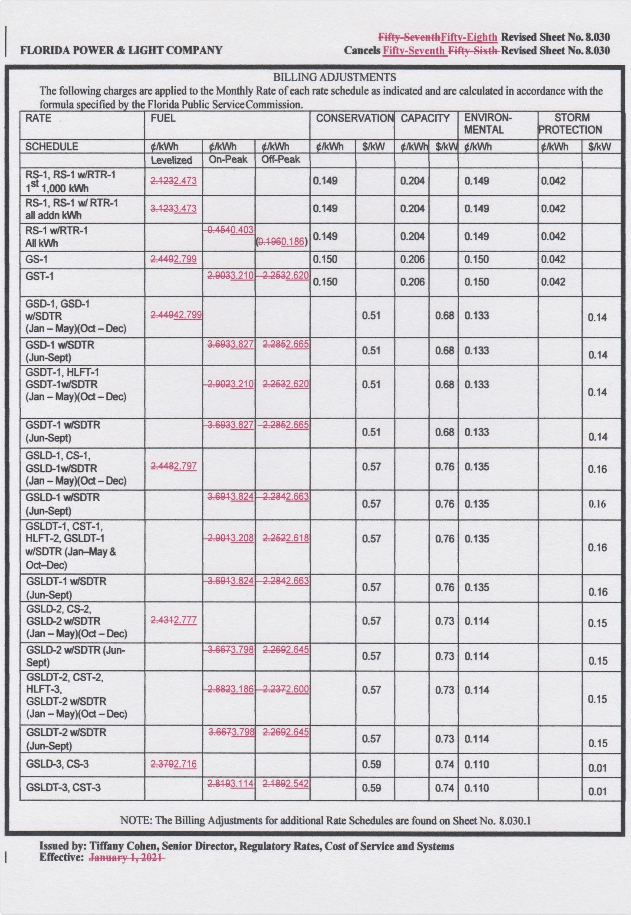
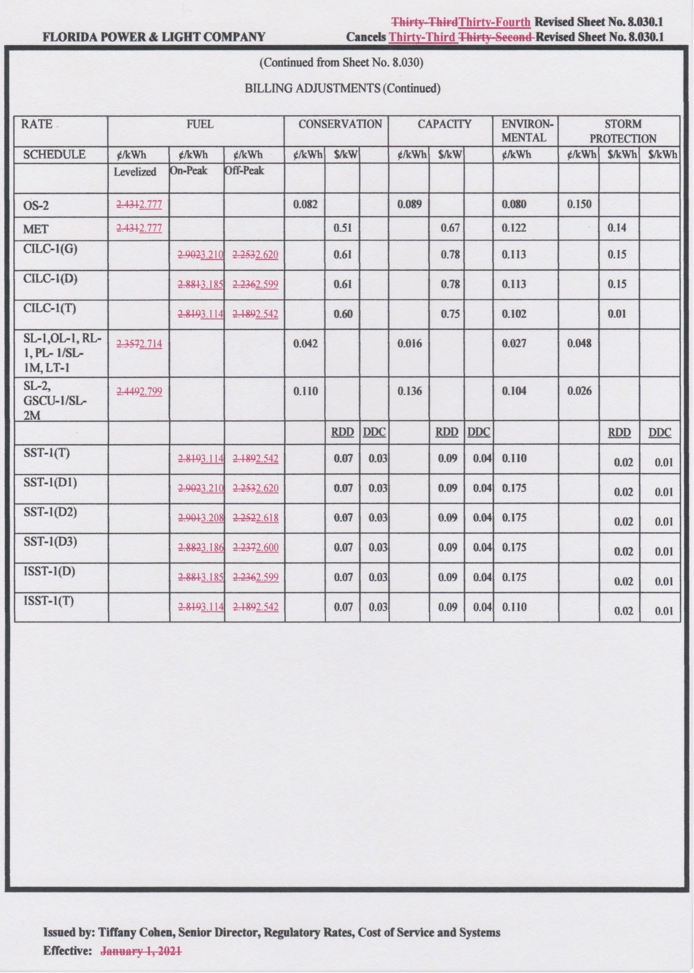
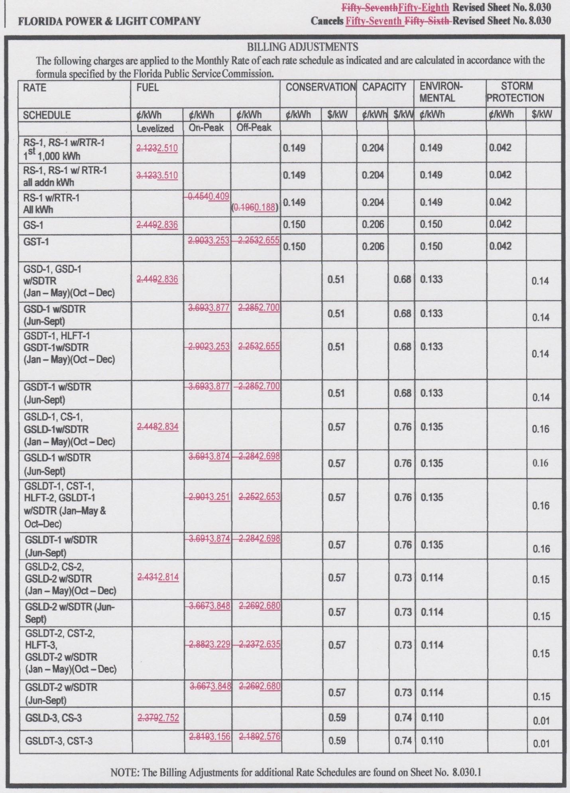
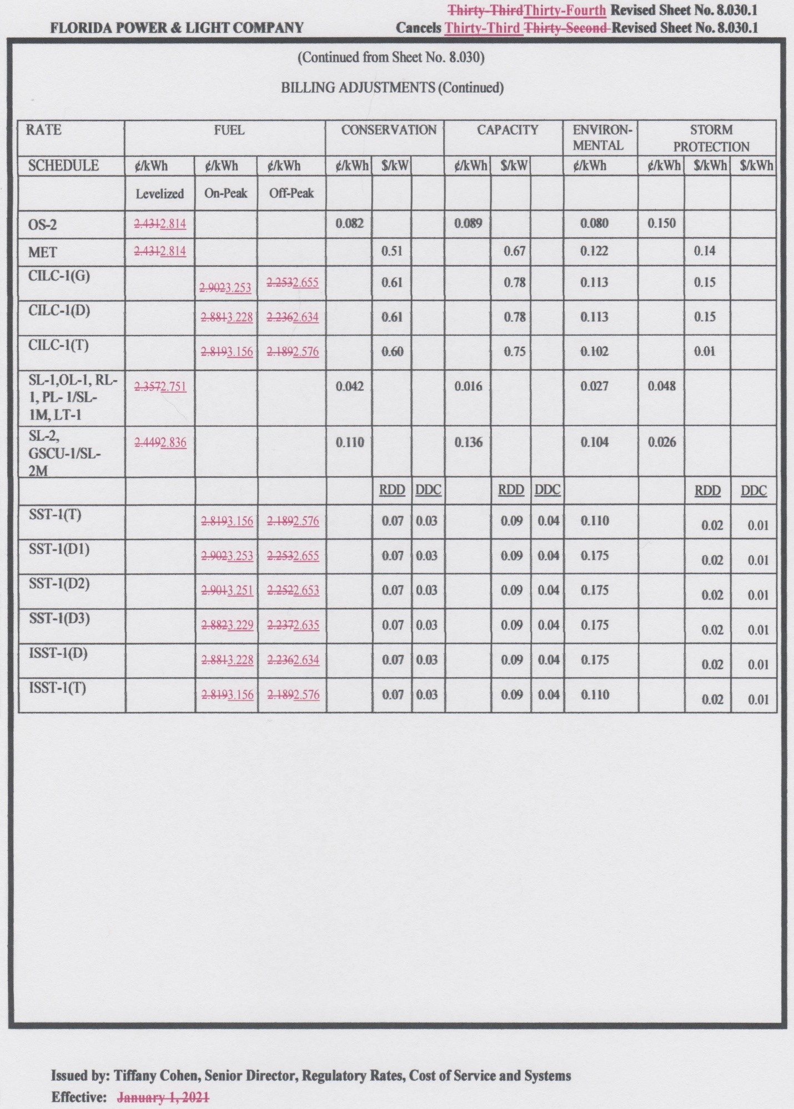

Order No. PSC-2020-0439-FOF-EI, issued November 16, 2020, in Docket No. 20200001-EI, In re: Fuel and purchased power cost recovery clause with generating performance incentive factor.
Document No. 02487-2021.
Document No. 02652-2021, filed March 8, 2021, FPL’s Responses to Staff’s First Data Request, No. 6 (to include attachments).
Document No. 02487-2021.
Document No. 11989-2020.
Document No. 13407-2020.
Document No. 04070-2020.
Document No. 05943-2020.
Order No. PSC-2020-0439-FOF-EI.
Document No. 02652-2021, filed March 8, 2021, FPL’s Responses to Staff’s First Data Request, No. 4.
Order No. PSC-2020-0439-FOF-EI.
Gulf Power, 410 So. 2d at 493.
Id.
Gulf Power, 410 So. 2d at 493-4.
Gulf Power, 410 So. 2d at 494, Footnote 2.
Order No. PSC-00-1081-PCO-EI, issued June 5, 2000, in Docket No. 20000001-EI In re: Fuel and purchased power cost recovery clause and generating performance incentive factor.
Order No. PSC-01-0963-PCO-EI, issued April 18, 2001, in Docket No. 20010001-EI, In re: Fuel and purchased power cost recovery clause and generating performance incentive factor.
Order No. PSC-01-0409-PCO-GU, issued February 19, 2001, in Docket No. 20010003-GU, In re: Purchased gas adjustment (PGA) true-up.
Id.
Order No. PSC-08-0825-PCO-EI, issued December 22, 2008, in Docket No. 080001-EI, In re: Fuel and purchased power cost recovery clause with generating performance incentive factor; Order No. PSC-09-0254-PCO-EI, issued April 27, 2009, in Docket No. 090001-EI, In re: Fuel and purchased power cost recovery clause with generating performance incentive factor; Order No. PSC-11-0581-PCO-EI, issued on December 19, 2011, in Docket No. 110001-EI, In re: Fuel and purchased power cost recovery clause with generating performance incentive factor; Order No. PSC-12-0342-PCO-EI, issued July 2, 2012, in Docket No. 120001-EI, In re: Fuel and purchased power cost recovery clause with generating performance incentive factor; Order No. PSC-2012-0082-PCO-EI, issued February 24, 2012, in Docket No. 120001-EI, In re: Fuel and purchased power cost recovery clause with generating performance incentive factor; Order No. PSC-15-0161-PCO-EI, issued April 30, 2015, in Docket No. 150001-EI, In re: Fuel and purchased power cost recovery clause with generating performance incentive factor; Order No. PSC-2018-0313-PCO-EI, issued June 18, 2018, in Docket No. 20180001-EI, In re: Fuel and purchased power cost recovery clause with generating performance incentive factor; Order PSC-2020-0154-PCO-EI, issued May 14, 2020, in Docket No. 20200001-EI, In re: Fuel and purchased power cost recovery clause with generating performance incentive factor.
Order No. PSC-03-0381-PCO-EI, issued March 19, 2003, in Docket No. 030001-EI, In re: Fuel and purchased power cost recovery clause with generating performance incentive factor; Order No. PSC-03-0382-PCO-EI, issued March 19, 2003, in Docket No. 030001-EI, In re: Fuel and purchased power cost recovery clause with generating performance incentive factor; Order No. PSC-03-0400, issued March 24, 2003, in Docket No. 030001-EI, In re: Fuel and purchased power cost recovery clause with generating performance incentive factor; Order No. PSC-03-0849-PCO-EI, issued July 22, 2003, in Docket No. 030001-EI, In re: Fuel and purchased power cost recovery clause with generating performance incentive factor; Order No. PSC-09-0213-PCO-EI, issued April 9, 2009, in Docket No. 090001-EI, In re: Fuel and purchased power cost recovery clause with generating performance incentive factor; Order No. PSC-2019-0109-PCO-EI, issued March 22, 2019, in Docket No. 20190001-EI, In re: Fuel and purchased power cost recovery clause with generating performance incentive factor.
Order No. PSC-09-0213-PCO-EI; Order No. PSC-2019-0109-PCO-EI.
DN 02652-2021, Response to Staff’s First Data Request No. 6.

