BEFORE THE FLORIDA PUBLIC SERVICE COMMISSION

In re: Petition for evaluation of Hurricane Dorian storm costs, by Florida Power & Light Company. | DOCKET NO. 20200172-EI  ORDER NO. PSC-2021-0188-S-EI  ISSUED: May 25, 2021

The following Commissioners participated in the disposition of this matter:

GARY F. CLARK, Chairman
ART GRAHAM
ANDREW GILES FAY
MIKE LA ROSA
APPEARANCES:

KENNETH M. RUBIN, and JOEL T. BAKER, ESQUIRES, 700 Universe Boulevard, Juno Beach, Florida 33408-0420
On behalf of Florida Power & Light Company (FPL).

RICHARD, GENTRY, ANASTACIA PIRRELLO and PATRICIA CHRISTENSEN, ESQUIRES, Office of Public Counsel, c/o The Florida Legislature, 111 West Madison Street, Room 812, Tallahassee, Florida 32399-1400
On behalf of the Citizens of the State of Florida (OPC).

SUZANNE BROWNLESS and SHAW STILLER, ESQUIRES, Florida Public Service Commission, 2540 Shumard Oak Boulevard, Tallahassee, Florida 32399-0850
On behalf of the Florida Public Service Commission (Staff).

MARY ANNE HELTON, ESQUIRE, Deputy General Counsel, Florida Public Service Commission, 2540 Shumard Oak Boulevard, Tallahassee, Florida 32399-0850
Advisor to the Florida Public Service Commission.

KEITH HETRICK, ESQUIRE, General Counsel, Florida Public Service Commission, 2540 Shumard Oak Boulevard, Tallahassee, Florida 32399-0850
Florida Public Service Commission General Counsel.

ORDER APPROVING STIPULATION AND SETTLEMENT

BY THE COMMISSION:
BACKGROUND

On June 29, 2020, Florida Power & Light Company (FPL) filed a petition for a determination that its actions in responding to Hurricane Dorian were prudent and that the associated Hurricane Dorian storm restoration costs were reasonable. The Office of Public Counsel (OPC) filed a Notice of Intervention on June 30, 2020, which was acknowledged by Order No. PSC-2020-0232-PCO-EI on July 14, 2020. By Order No. PSC-2020-0311-PCO-EI, issued September 14, 2020, this matter was set for hearing on February 23 and 24, 2021. On October 23, 2020, OPC and FPL filed a motion to extend due dates for testimony and exhibits which was granted by Order No. PSC-2020-0418-PCO-EI, issued November 8, 2020.

On January 27, 2021, OPC and FPL filed a joint motion for continuance of the final hearing scheduled for February 23 and 24, 2021, in order to allow the parties to negotiate and execute a settlement agreement. This motion was granted by Order No. PSC-2021-0060-PCO-EI, issued January 28, 2021. On March 15, 2021, the parties filed a motion to approve a Stipulation and Settlement Agreement (Settlement) dated March 9, 2021, which resolved all outstanding issues in the case. The Settlement is contained in Attachment A to this order. A final hearing was held on May 4, 2021. At the final hearing, the testimonies of Manuel B. Miranda, David Hughes, and Clare Gerard on behalf of FPL, and Lane Kollen on behalf of OPC, were admitted into the record as though read. A Comprehensive Exhibit List was also admitted into the record as well as the exhibits identified thereon. The parties, supporting the Settlement, waived the right to file post-hearing briefs, and a bench vote was taken at the conclusion of the hearing.

We have jurisdiction pursuant to Sections 366.04, 366.05, and 366.06, Florida Statutes.

DECISION

Hurricane Dorian formed on August 24, 2019, and gradually strengthened as it moved toward the Lesser Antilles, becoming a hurricane on August 28, 2019. The National Hurricane Center’s forecasts located the center of Hurricane Dorian over the Florida peninsula as a major hurricane on August 28, 2019, and a state of emergency was declared by Governor DeSantis in all 67 counties at that time. On August 29, 2019, FPL activated its Command Center and began mobilizing a workforce of employees and contractors, opening staging sites and pre-positioning crews in the parts of FPL’s service area projected to be hardest hit by the storm. On August 30, 2019, the National Hurricane Center forecast that Hurricane Dorian would make landfall in South Florida. On August 31, 2019, Hurricane Dorian was classified as a Category 4 storm. On September 1, 2019, Hurricane Dorian reached Category 5 intensity and made landfall in Elbow Cay, Bahamas and several hours later in Grand Bahama. From September 1 through 5, 2019, Hurricane Dorian essentially followed the east coast of Florida as it traveled north without making landfall. However, even though Hurricane Dorian did not make landfall in FPL’s service territory its winds did cause power outages to 184,000 FPL customers due to toppled trees, vegetation, and wind-blown debris. On average, customer outages were restored in just over an hour and no outage exceeded more than 24 hours. FPL provided extensive detailed contractor invoice-related information with its petition and OPC conducted extensive discovery on restoration costs as well.

FPL incurred $242.4 million in storm-related costs which were expensed after removing below the line costs, third party reimbursements, and capitalizable costs. The parties agree that all Hurricane Dorian storm related costs were prudently incurred. The Settlement provides that:

- The effective date of the Settlement is the date the final order in this docket is issued.

- FPL will treat $5 million of incremental storm restoration costs as non-incremental costs recognized as base Operations and Maintenance expense.

- FPL will reduce the overall Reserve Amount, as defined in Section 12 of the 2016 Rate Case Settlement Agreement in Docket No. 20160021-EI, by $5 million.

- Nothing in the Settlement will have precedential value.

- The direct testimony and exhibits of FPL witnesses Manuel B. Miranda, David Hughes, and Clare Gerard, as well as those of OPC witness Lane Kollen shall be entered into the record.

- The Settlement is contingent upon approval by the Commission in its entirety without modification.

The standard for approval of a settlement agreement is whether it is in the public interest. A determination of public interest requires a case-specific analysis based on consideration of the proposed settlement taken as a whole. In this case, FPL acted prudently in deploying its employees and contractors in light of a Category 4 storm which could have caused significant damage had it made landfall as was predicted by the National Hurricane Center on August 30, 2019. Further, FPL was prudent in continuing to keep resources in place to respond to Hurricane Dorian from September 1-5, 2019. Hurricanes are unpredictable and the storm could have made landfall at any time during this period. OPC has conducted extensive discovery in this case and has reviewed detailed material concerning contractor costs supplied by FPL. After this extensive review, as statutory representative of Florida’s citizens, OPC negotiated this Settlement of all issues. In light of OPC’s participation in this Settlement and the unique circumstances of Hurricane Dorian’s storm path, we find that the Settlement when taken as a whole provides a reasonable resolution of issues regarding storm restoration costs associated with Hurricane Dorian. Therefore, we find that the Settlement is in the public interest and hereby approve it.

Based on the foregoing, it is

ORDERED by the Florida Public Service Commission that the Joint Motion of Office of Public Counsel and Florida Power & Light Company to Approve Stipulation and Settlement Agreement is hereby granted. It is further

ORDERED that the Stipulation and Settlement Agreement, attached hereto as Attachment A, and incorporated by reference, is hereby approved. It is further

ORDERED that the effective date of the Stipulation and Settlement Agreement, attached hereto as Attachment A, shall become effective on the issuance date of this Order.

By ORDER of the Florida Public Service Commission this 25th day of May, 2021.

/s/ Adam J. Teitzman
ADAM J. TEITZMAN
Commission Clerk
Florida Public Service Commission
2540 Shumard Oak Boulevard
Tallahassee, Florida 32399
(850) 413-6770
www.floridapsc.com

Copies furnished: A copy of this document is provided to the parties of record at the time of issuance and, if applicable, interested persons.

SBr

NOTICE OF FURTHER PROCEEDINGS OR JUDICIAL REVIEW

The Florida Public Service Commission is required by Section 120.569(1), Florida Statutes, to notify parties of any administrative hearing or judicial review of Commission orders that is available under Sections 120.57 or 120.68, Florida Statutes, as well as the procedures and time limits that apply. This notice should not be construed to mean all requests for an administrative hearing or judicial review will be granted or result in the relief sought.

Any party adversely affected by the Commission's final action in this matter may request: 1) reconsideration of the decision by filing a motion for reconsideration with the Office of Commission Clerk, 2540 Shumard Oak Boulevard, Tallahassee, Florida 32399-0850, within fifteen (15) days of the issuance of this order in the form prescribed by Rule 25-22.060, Florida Administrative Code; or 2) judicial review by the Florida Supreme Court in the case of an electric, gas or telephone utility or the First District Court of Appeal in the case of a water and/or wastewater utility by filing a notice of appeal with the Office of Commission Clerk, and filing a copy of the notice of appeal and the filing fee with the appropriate court. This filing must be completed within thirty (30) days after the issuance of this order, pursuant to Rule 9.110, Florida Rules of Appellate Procedure. The notice of appeal must be in the form specified in Rule 9.900(a), Florida Rules of Appellate Procedure.

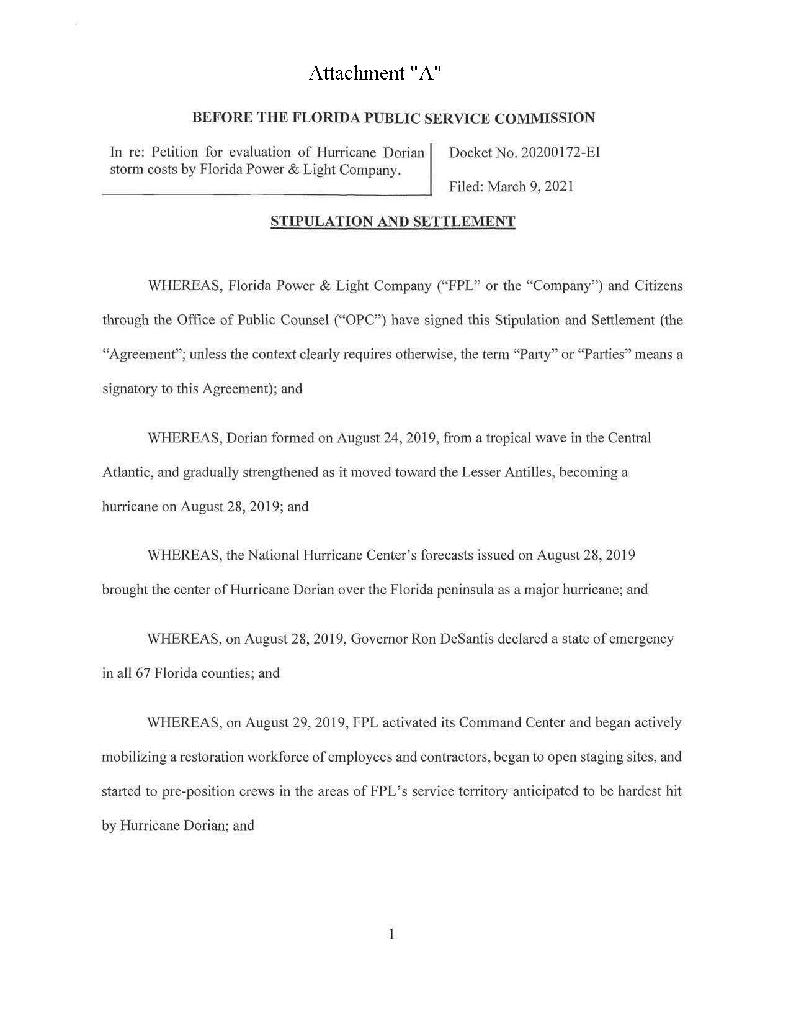

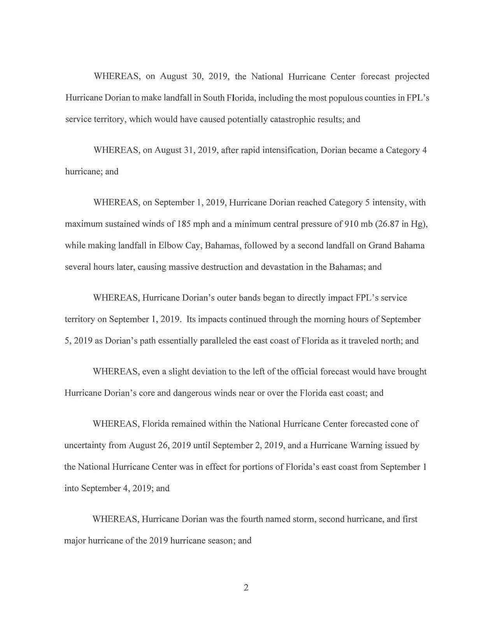
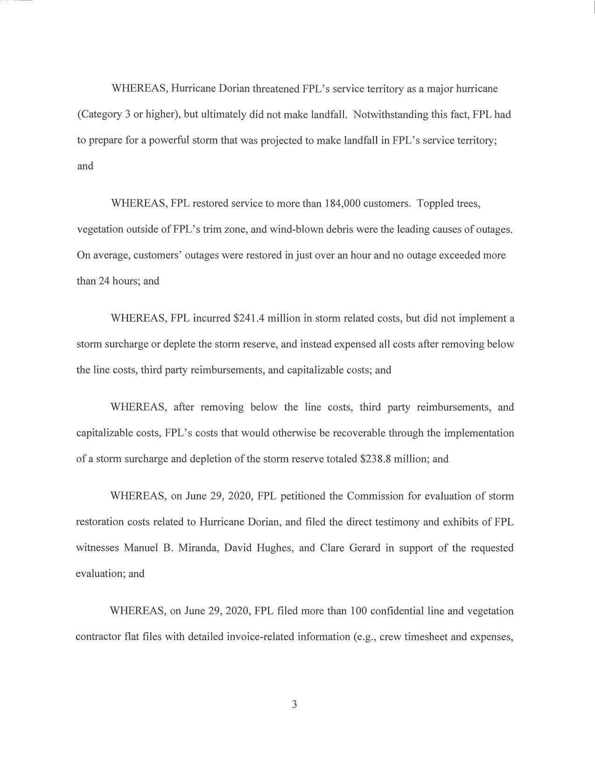

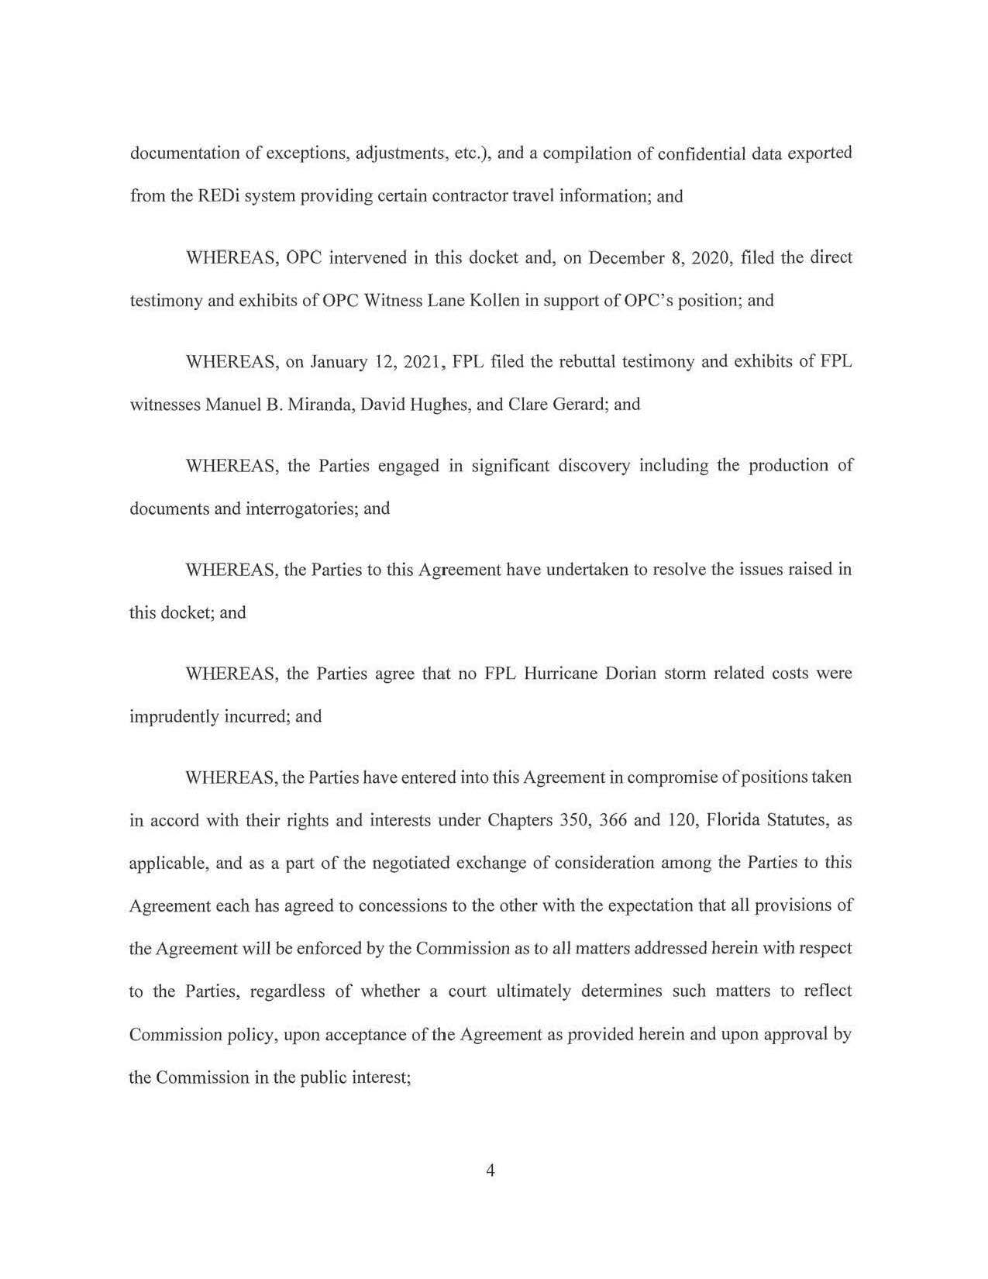

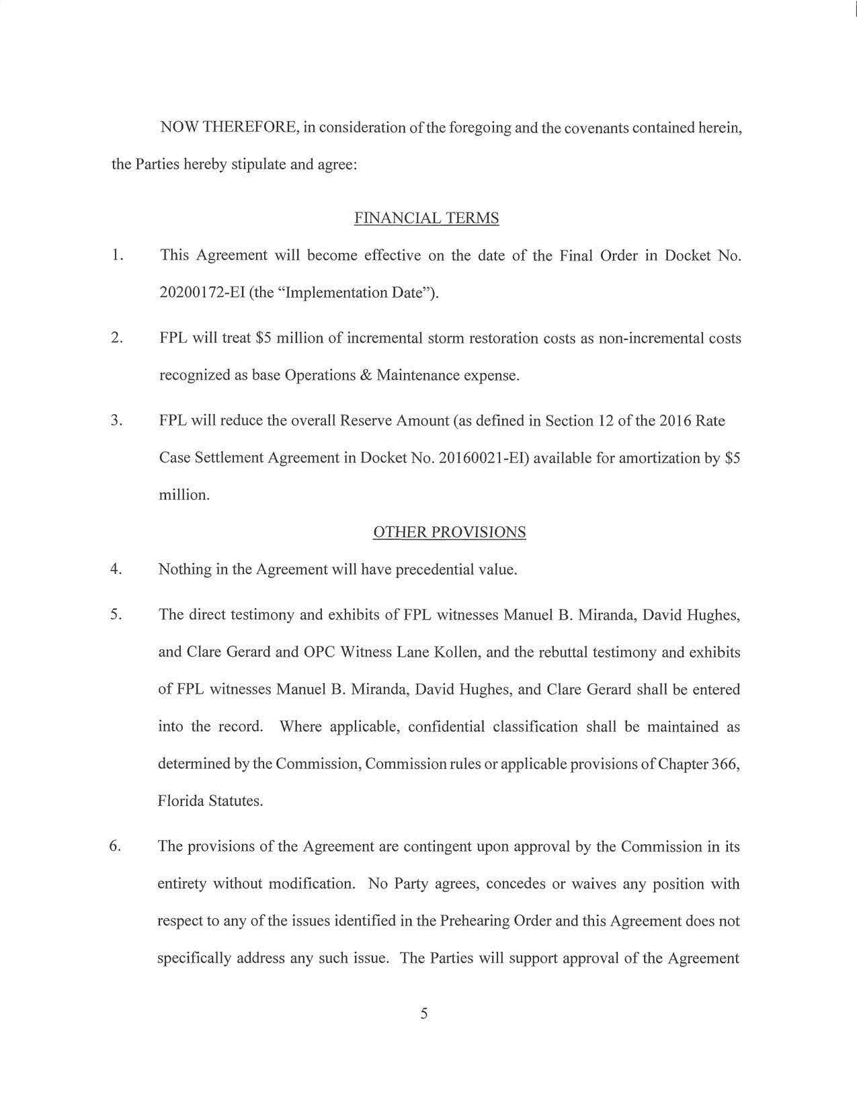

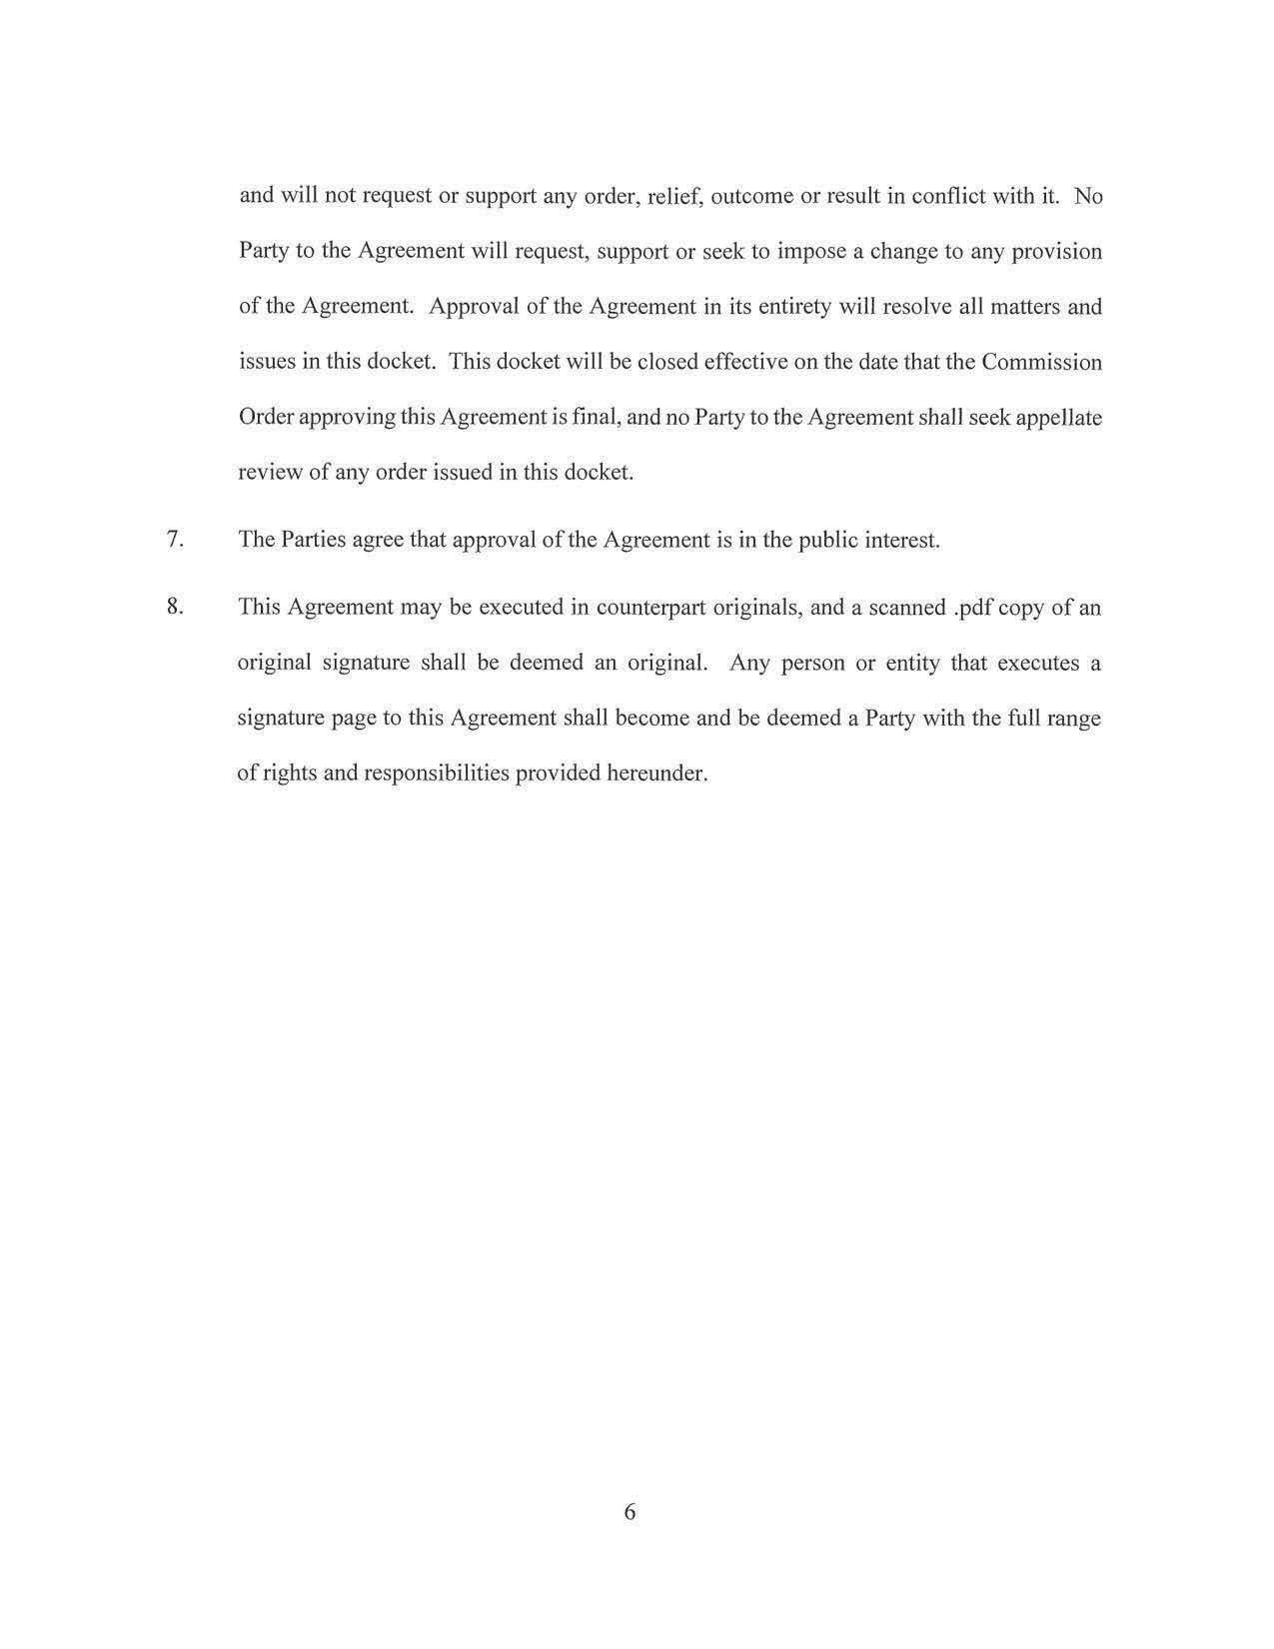

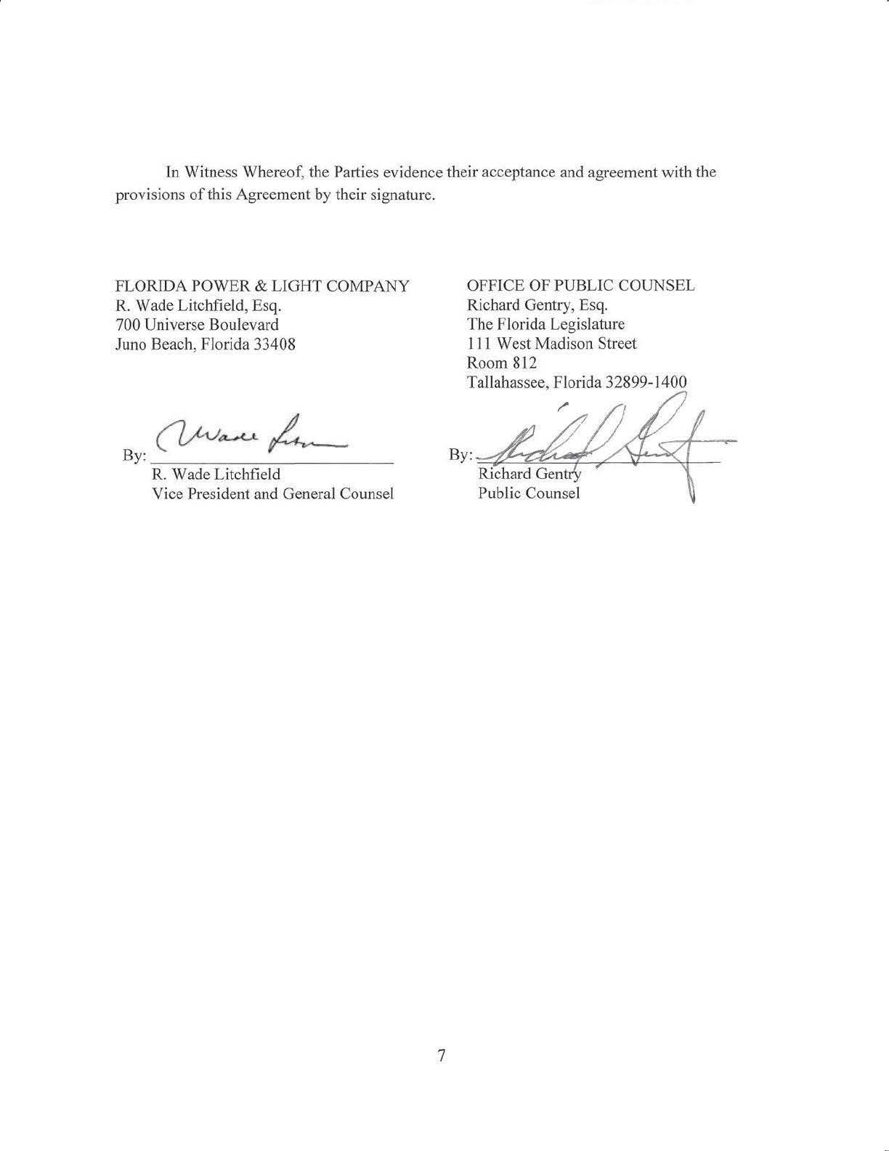

Order No. PSC-16-0560-AS-EI, issued December 15, 2016, in Docket No. 160021-EI, In re: Petition for rate increase by Florida Power & Light Company.
Order No. PSC-2017-0488-PAA-EI, issued on December 26, 2017, in Docket No. 20170150-EI, In re: Petition for limited proceeding to include reliability and modernization projects in rate base, by Florida Public Utilities Company; Order No. PSC-13-0023-S-EI, issued on January 14, 2013, in Docket No. 120015-EI, In re: Petition for increase in rates by Florida Power & Light Company; Order No. PSC-11-0089-S-EI, issued February 1, 2011, in Docket Nos. 080677 and 090130, In re: Petition for increase in rates by Florida Power & Light Company and In re: 2009 depreciation and dismantlement study by Florida Power & Light Company; Order No. PSC-13-0023-S-EIPSC-10-0398-S-EI, issued June 18, 2010, in Docket Nos. 090079-EI, 090144-EI, 090145-EI, 100136-EI, In re: Petition for increase in rates by Progress Energy Florida, Inc., In re: Petition for limited proceeding to include Bartow repowering project in base rates, by Progress Energy Florida, Inc., In re: Petition for expedited approval of the deferral of pension expenses, authorization to charge storm hardening expenses to the storm damage reserve, and variance from or waiver of Rule 25-6.0143(1)(c), (d), and (f), F.A.C., by Progress Energy Florida, Inc., and In re: Petition for approval of an accounting order to record a depreciation expense credit, by Progress Energy Florida, Inc.; Order No. PSC-05-0945-S-EI, issued September 28, 2005, in Docket No. 050078-EI, In re: Petition for rate increase by Progress Energy Florida, Inc.
Order No. PSC-13-0023-S-EI, at p. 7.

