BEFORE THE FLORIDA PUBLIC SERVICE COMMISSION

In re: Limited proceeding to consider Duke Energy Florida, LLC's unopposed motion to approve rate mitigation agreement. | DOCKET NO. 20210158-EI  ORDER NO. PSC-2021-0425-FOF-EI  ISSUED: November 16, 2021

The following Commissioners participated in the disposition of this matter:

GARY F. CLARK, Chairman
ART GRAHAM
ANDREW GILES FAY
MIKE LA ROSA
GABRIELLA PASSIDOMO

APPEARANCES:

MATTHEW BERNIER, ESQUIRE, 106 East College Avenue, Tallahassee, Florida 32301-7740; and DIANNE M. TRIPLETT, ESQUIRE, 299 First Avenue North, St. Petersburg, Florida 33701
On behalf of Duke Energy Florida, LLC (DEF)

RICHARD GENTRY, CHARLES REHWINKEL, and ANASTACIA PIRRELLO, ESQUIRES, Office of Public Counsel, c/o The Florida Legislature, 111 West Madison Street, Room 812, Tallahassee, Florida 32399-1400
On behalf of the Citizens of the State of Florida (OPC)

JON C. MOYLE, JR., ESQUIRE, Moyle Law Firm, PA, The Perkins House, 118 North Gadsden Street, Tallahassee, Florida 32301
On behalf of the Florida Industrial Power Users Group (FIPUG)

ROBERT SCHEFFEL WRIGHT, ESQUIRE, Gardner, Bist, Bowden, Dee, LaVia, Wright, Perry & Harper, PA, 1300 Thomaswood Drive, Tallahassee, Florida 32308
On behalf of Florida Retail Federation (FRF)

JAMES W. BREW and LAURA WYNN BAKER, ESQUIRES, Stone Mattheis Xenopoulos & Brew, PC, 1025 Thomas Jefferson St., NW, Eighth Floor, West Tower, Washington, DC 20007
On behalf of White Springs Agricultural Chemicals, Inc. d/b/a PCS Phosphate – White Springs (PCS Phosphate)

MICHAEL K. LAVANGA, ESQUIRE, Stone Mattheis Xenopoulos & Brew, PC, 1025 Thomas Jefferson St., NW, Eighth Floor, West Tower, Washington, DC 20007
On behalf of Nucor Steel Florida, Inc.

GEORGE CAVROS, ESQUIRE, Southern Alliance for Clean Energy, 120 E. Oakland Park Blvd., Suite 105, Fort Lauderdale, FL 33334
On behalf of Southern Alliance for Clean Energy (SACE).

STEPHANIE U. EATON, ESQUIRE, Spilman Thomas & Battle, PLLC, 110 Oakwood Drive, Suite 500, Winston-Salem, NC 27103
On behalf of Walmart, Inc. (Walmart).

JENNIFER CRAWFORD and RYAN SANDY, ESQUIRE, Florida Public Service Commission, 2540 Shumard Oak Boulevard, Tallahassee, Florida 32399-0850
On behalf of the Florida Public Service Commission (Staff)

MARY ANNE HELTON, ESQUIRE, Deputy General Counsel, Florida Public Service Commission, 2540 Shumard Oak Boulevard, Tallahassee, Florida 32399-0850
Advisor to the Florida Public Service Commission

KEITH C. HETRICK, ESQUIRE, General Counsel, Florida Public Service Commission, 2540 Shumard Oak Boulevard, Tallahassee, Florida 32399-0850
Florida Public Service Commission General Counsel

FINAL ORDER APPROVING RATE MITIGATION AGREEMENT

BY THE COMMISSION:

Background

On September 3, 2021, Duke Energy Florida, LLC (DEF) filed an Unopposed Motion to Approve Rate Mitigation Agreement (Motion), in Docket Nos. 20210001-EI, In re: Fuel and purchased power cost recovery clause with generating performance incentive factor, 20210010-EI, In re: Storm protection plan cost recovery clause, and 20210097-EI, In re: Petition for limited proceeding for recovery of incremental storm restoration costs related to Hurricanes Eta and Isaias, by Duke Energy Florida, LLC. Due to the continued increase in forecasted natural gas prices, DEF is projecting a $246.8 million under-recovery of fuel costs for 2021, that would otherwise be due from DEF’s customers starting in 2022. Recognizing the impact these fuel price increases will have on DEF’s customers, DEF states that it has worked collaboratively with a number of interested parties to develop a creative means to mitigate the rate impacts of this increase. The resulting Rate Mitigation Agreement (attached hereto as Attachment A) addresses issues or cost recovery associated with the three dockets referenced above, as well as some matters not previously raised in those dockets. Therefore, Docket No. 20210158-EI was opened to address DEF’s Motion and the proposed Rate Mitigation Agreement.

DEF, the Office of Public Counsel, Florida Industrial Power Users Group, Florida Retail Federation, White Springs Agricultural Chemicals, Inc. d/b/a PCS Phosphate, Southern Alliance for Clean Energy, and Nucor Steel Florida, Inc. are signatories to the Rate Mitigation Agreement. DEF represents that the signatories do not oppose granting DEF’s Motion. DEF represents that Tampa Electric Company, Florida Power & Light Company, Gulf Power Company, and Florida Public Utilities Company, who are parties to Docket Nos. 20210001-EI and 20210010-EI, take no position on the Motion. Finally, DEF represents that Walmart Inc., which is a party to Docket No. 20210010-EI, does not oppose the granting of DEF’s Motion.

Pursuant to Order No. PSC-2021-0371-PCO-EI, DEF’s Motion and the proposed Rate Mitigation Agreement was scheduled for hearing on November 2, 2021. The purpose of the hearing was to consider whether it is in the public interest to approve the proposed Rate Mitigation Agreement. To promote transparency and access to this proceeding, all parties to Docket Nos. 20210001-EI, 20210010-EI, and 20210097-EI, as well as Florida Retail Federation and Southern Alliance for Clean Energy, were also made parties in Docket No. 20210158-EI.

At the November 2nd hearing, opening statements were taken by the parties, who either spoke in favor of the Rate Mitigation Agreement, or had no opposition to it being granted. DEF proffered witness Christopher Menendez, DEF’s Director of Rates and Regulatory Planning, to answer questions regarding the Rate Mitigation Agreement. DEF’s Motion, the Rate Mitigation Agreement, and DEF’s responses to staff’s data requests were entered into the record at hearing. An opportunity to provide public comment was also noticed for the hearing; however, no request for public comment was made.

We have jurisdiction pursuant to Sections 366.04, 366.05, 366.06, and 366.076, Florida Statutes (F.S.).

Decision

DEF’s Rate Mitigation Agreement includes four major provisions to lessen the immediate impact of new 2022 customer rates. The total rate mitigation, on a residential 1,000 kWh bill, is $5.35 to $5.43 per month for January 2022 through April 2022, and $4.58 to $4.67 on average for 2022. The four major provisions are as follows:

- The first provision involves DEF recovering its estimated 2021 true-up under-recovery of $246.8 million over two years, beginning with January 2022 billing, with 50 percent of the balance, or approximately $123.4 million, recovered in 2022 rates and the remaining balance recovered in 2023 rates. This provision reduces the 2022 fuel portion of a typical residential bill (first 1,000 kWh) from $39.95 to $36.81, or by $3.14 per month.

- The second provision relates to true-up credits for certain DEF Solar Base Rate Adjustment plants. Specifically, DEF will reflect certain reductions in the capacity cost recovery clause (CCRC) to account for the true-ups associated with the Santa Fe and Twin Rivers solar plants. The credits will be applicable to January through April 2022 bills. The effect on the residential CCRC factor is a reduction of 0.078 cents per kWh (January 2022 – April 2022), or from 1.181 cents per kWh, to 1.103 cents per kWh. For a typical residential (monthly) bill of 1,000 kWh, this provision results in a reduction of $0.78 per month for January 2022 through April 2022.

- DEF’s third provision relates to the recovery of storm costs. Starting with January 2022 bills, DEF will voluntarily forego collection of the storm surcharge associated with Hurricanes Eta and Isaias as approved by Order No. PSC-2021-0271-PCO-EI. DEF will charge the remaining uncollected storm costs (estimated at $9.2 million) to DEF’s storm reserve while reserving the right to collect the remainder of the unrecovered storm cost balance. The impact of this provision on a typical residential (monthly) bill of 1,000 kWh is valued at $0.55 per month. DEF is also voluntarily agreeing to forego its right to recover costs related to Hurricane Elsa through the storm surcharge and will instead charge those uncollected estimated storm costs to the storm reserve, reserving the right to collect the unrecovered storm costs at a future time. Preliminary cost estimates for Hurricane Elsa range from $15 million to $18 million. For a typical residential (monthly) bill of 1,000 kWh, this provision results in an estimated reduction of $0.45 to $0.53 per month.

- The fourth provision of the Rate Mitigation Agreement will accelerate cost savings resulting from the Federal Energy Regulatory Commission’s (FERC) approval of DEF’s petition to capitalize certain costs in FERC Operations & Maintenance Account 593, Maintenance of Overheard Lines. The approved waiver allows costs charged to Account 593 to be capitalized instead of expensed, for a period through 2032. These are costs incurred as part of DEF’s Storm Protection Plan. DEF’s approved Storm Protection Plan Cost Recovery Clause (SPPCRC) 2022 factors did not include the impact of the waiver, as FERC approval had not yet occurred when DEF prepared the SPPCRC filings. Through the Rate Mitigation Agreement, DEF will prospectively update the SPPCRC 2022 factors to reflect the capitalization of the FERC 593 costs (approximately $9.2 million for 2022). For a typical residential (monthly) bill of 1,000 kWh, this provision results in a reduction of $0.29 per month, or from the currently-approved $3.29 to a revised $3.00.

The standard for approval of a settlement agreement is whether it is in the public interest. A determination of public interest requires a case-specific analysis based on consideration of the proposed settlement taken as a whole.
Having reviewed the record in this matter, and having heard the arguments of the parties and witness testimony in this proceeding, we find that the Rate Mitigation Agreement, taken as a whole, is in the public interest, results in rates that are fair, just, and reasonable, and provides benefits to DEF’s customers by mitigating the impact of increased costs to customers’ rates. Therefore, the Rate Mitigation Agreement is hereby approved

Based on the foregoing, it is

ORDERED by the Florida Public Service Commission that the Rate Mitigation Agreement, attached hereto as Attachment A and incorporated by reference, is hereby approved, effective the date of our vote, November 2, 2021. It is further

ORDERED that this docket shall be closed.

By ORDER of the Florida Public Service Commission this 16th day of November, 2021.

ADAM J. TEITZMAN
Commission Clerk
Florida Public Service Commission
2540 Shumard Oak Boulevard
Tallahassee, Florida 32399
(850) 413-6770
www.floridapsc.com

Copies furnished: A copy of this document is provided to the parties of record at the time of issuance and, if applicable, interested persons.

JSC

NOTICE OF FURTHER PROCEEDINGS OR JUDICIAL REVIEW

The Florida Public Service Commission is required by Section 120.569(1), Florida Statutes, to notify parties of any administrative hearing or judicial review of Commission orders that is available under Sections 120.57 or 120.68, Florida Statutes, as well as the procedures and time limits that apply. This notice should not be construed to mean all requests for an administrative hearing or judicial review will be granted or result in the relief sought.

Any party adversely affected by the Commission's final action in this matter may request: 1) reconsideration of the decision by filing a motion for reconsideration with the Office of Commission Clerk, 2540 Shumard Oak Boulevard, Tallahassee, Florida 32399-0850, within fifteen (15) days of the issuance of this order in the form prescribed by Rule 25-22.060, Florida Administrative Code; or 2) judicial review by the Florida Supreme Court in the case of an electric, gas or telephone utility or the First District Court of Appeal in the case of a water and/or wastewater utility by filing a notice of appeal with the Office of Commission Clerk, and filing a copy of the notice of appeal and the filing fee with the appropriate court. This filing must be completed within thirty (30) days after the issuance of this order, pursuant to Rule 9.110, Florida Rules of Appellate Procedure. The notice of appeal must be in the form specified in Rule 9.900(a), Florida Rules of Appellate Procedure.

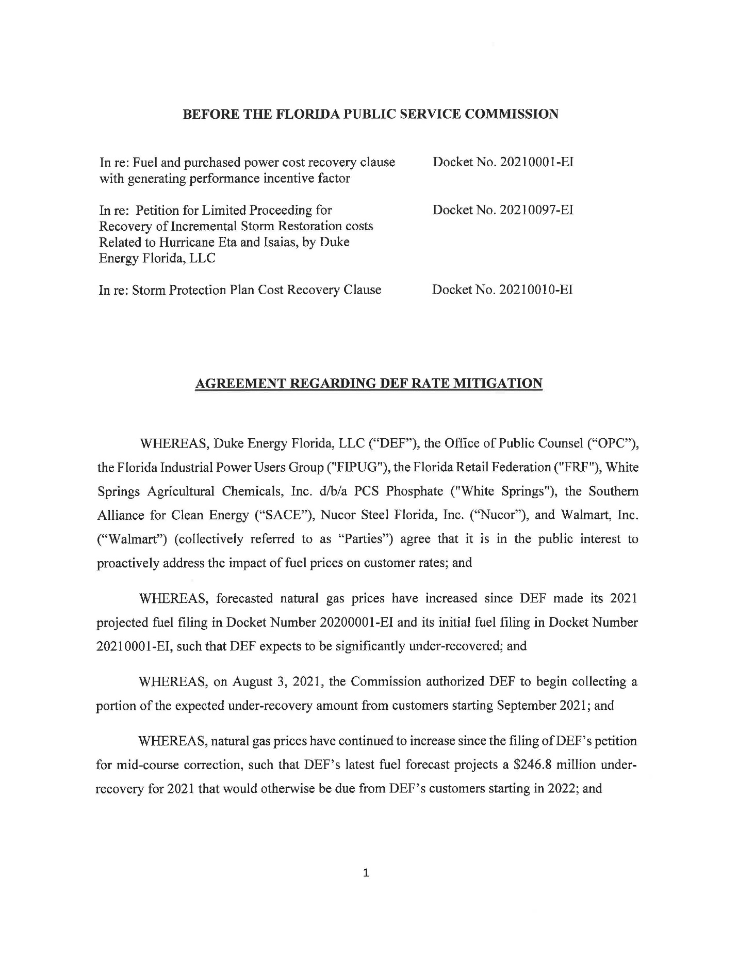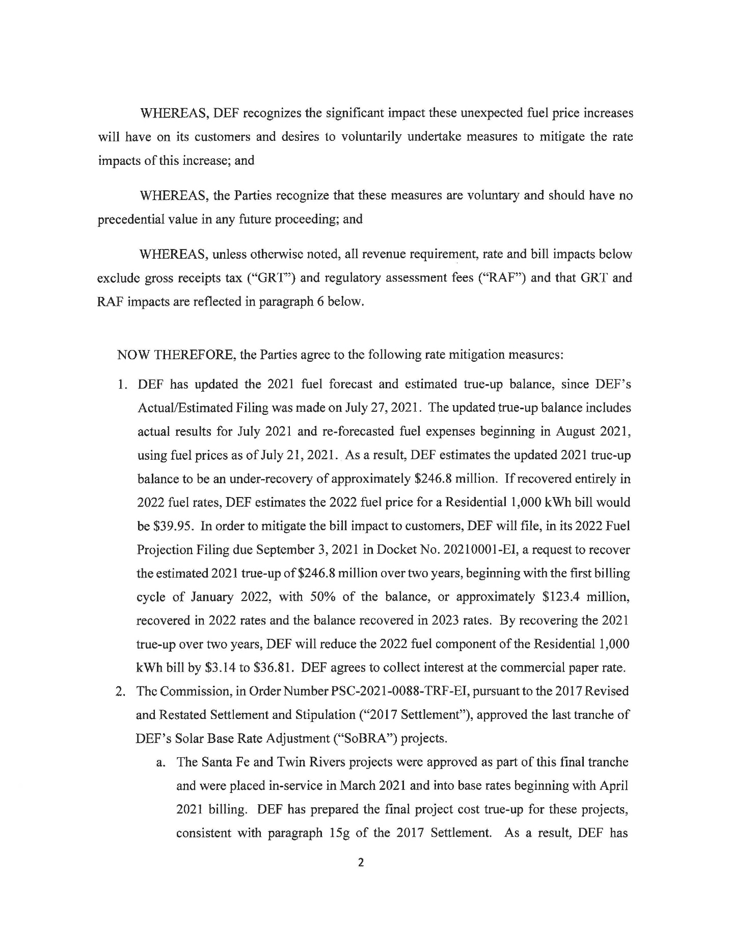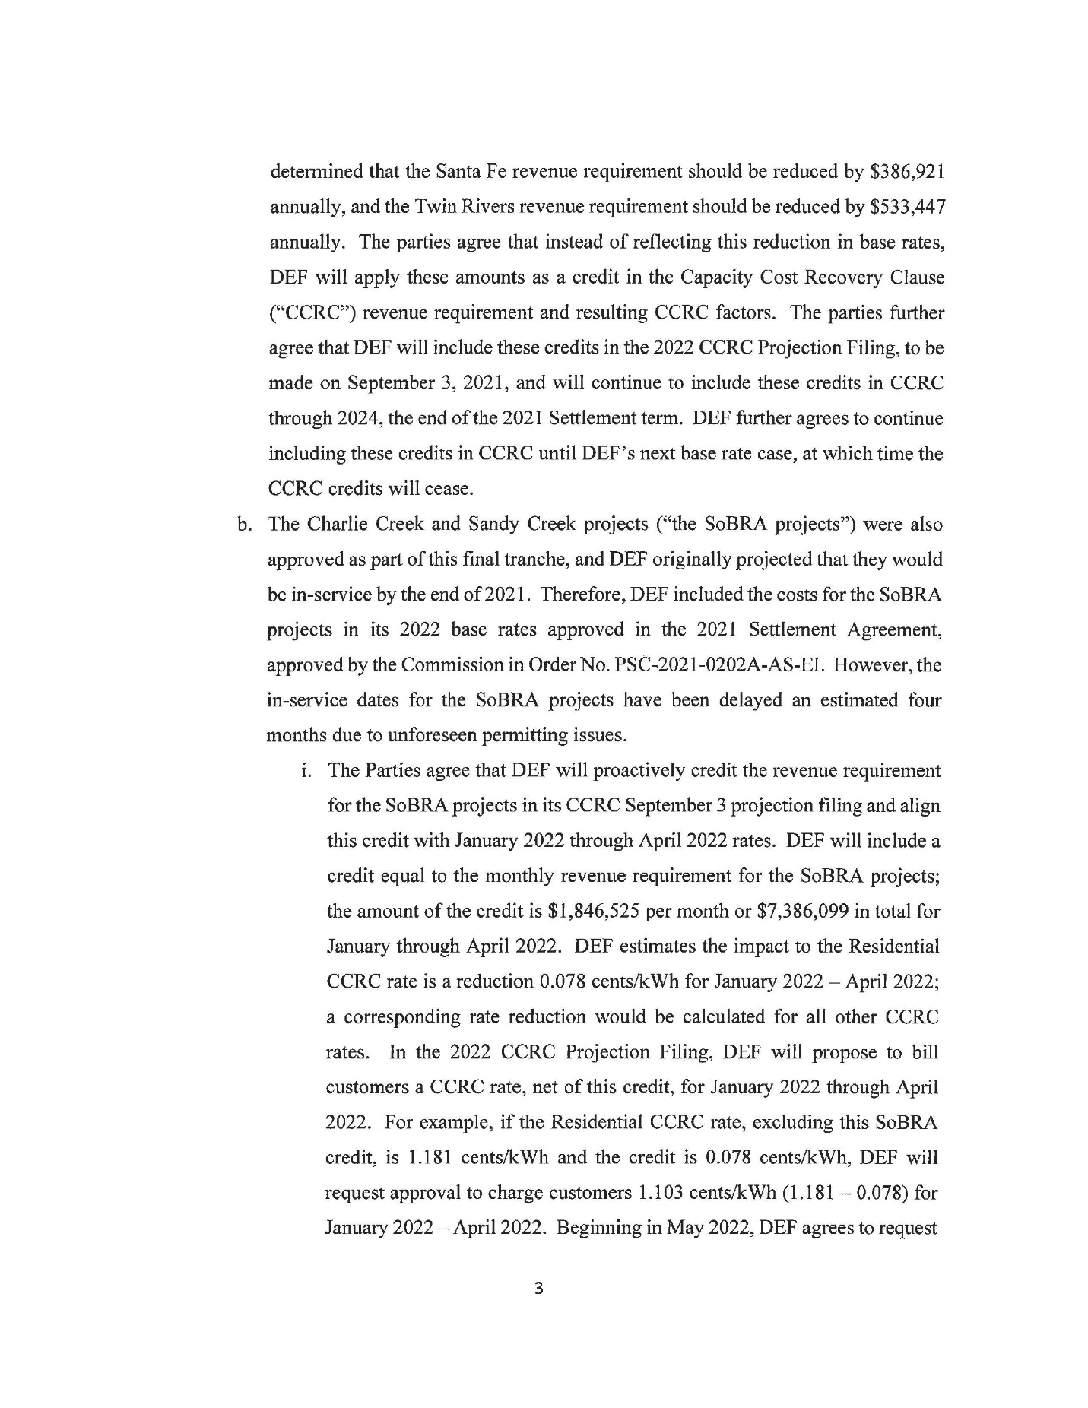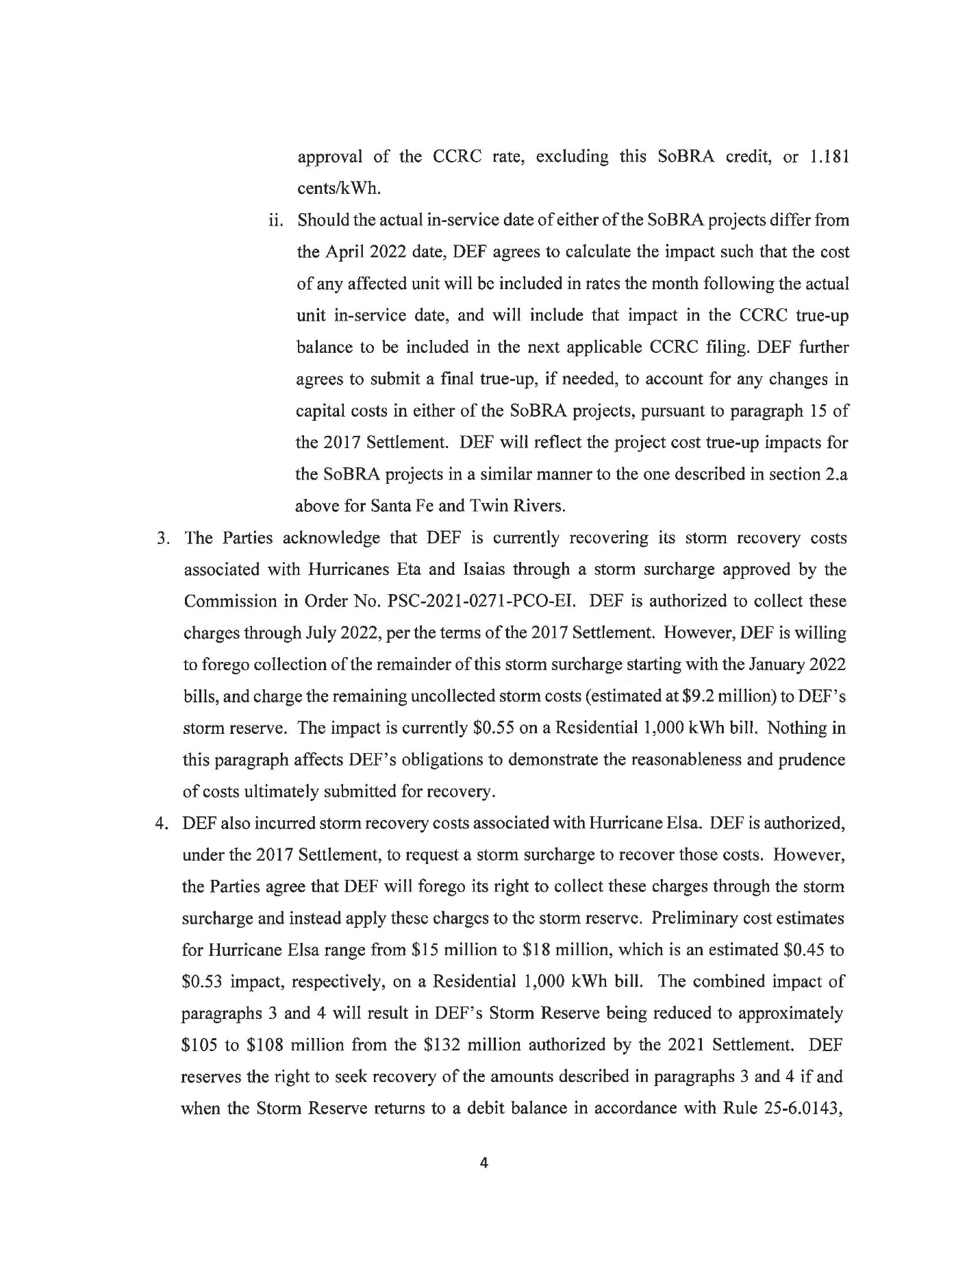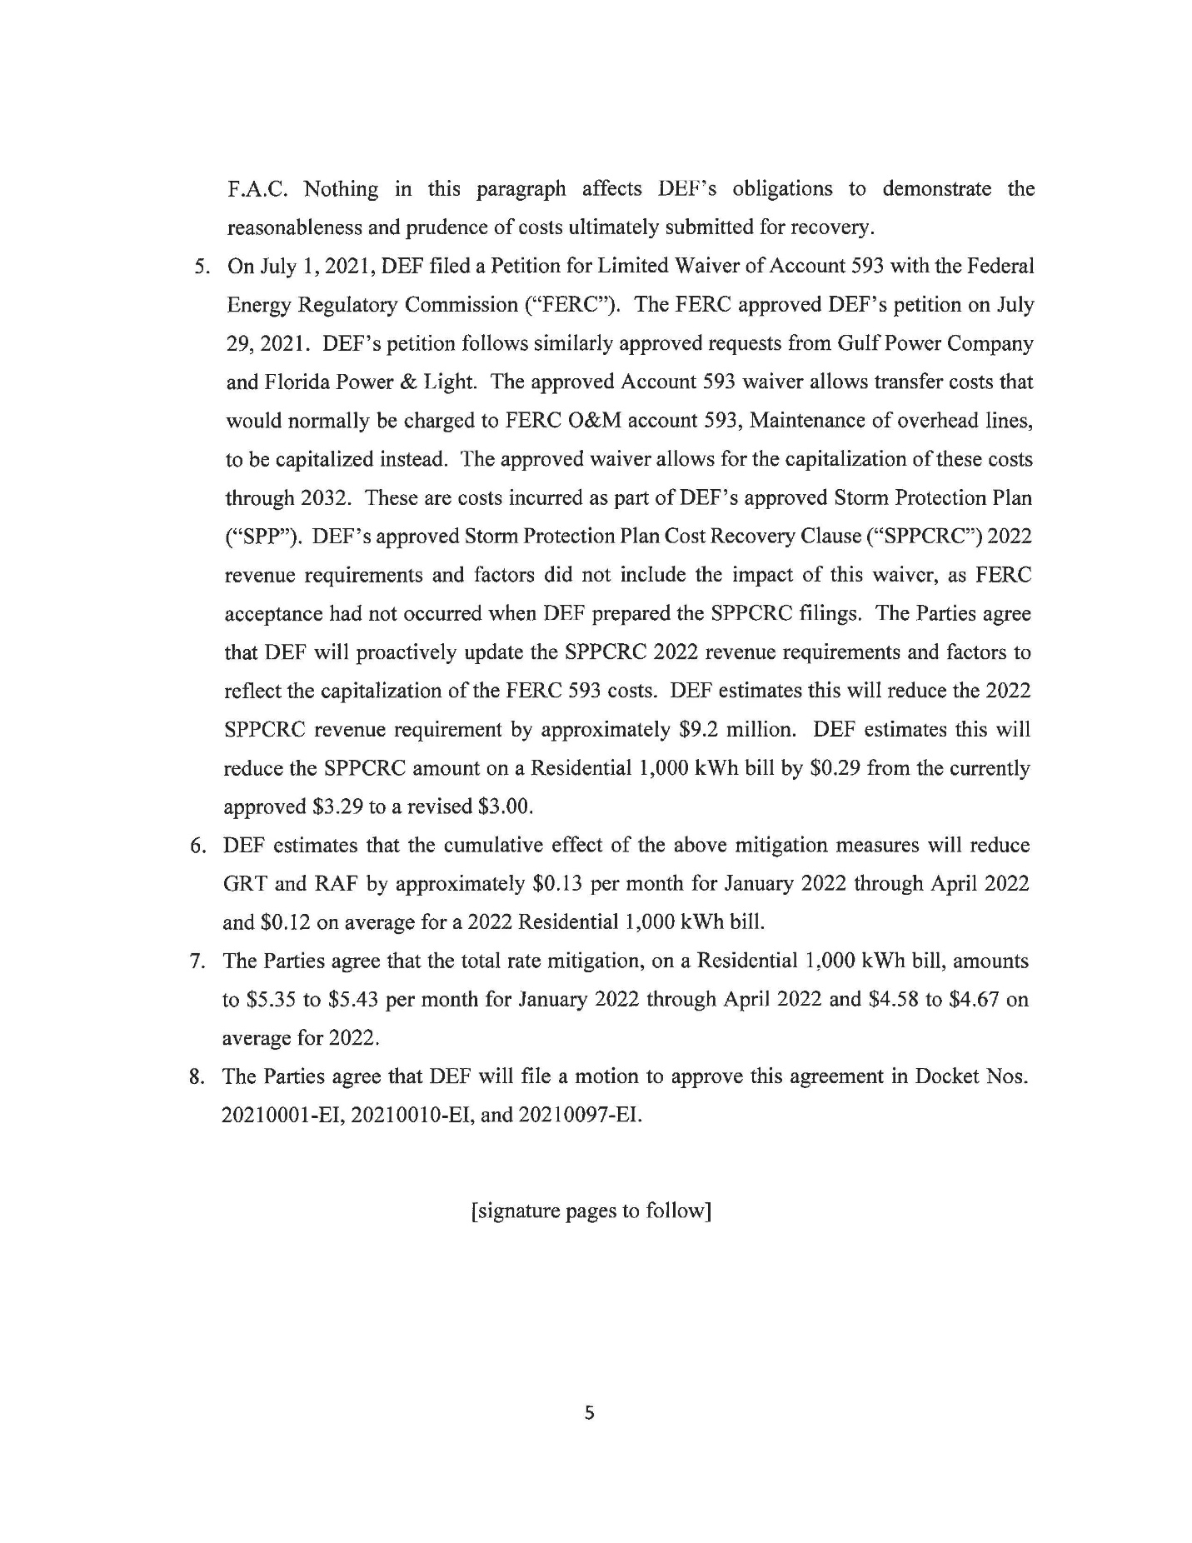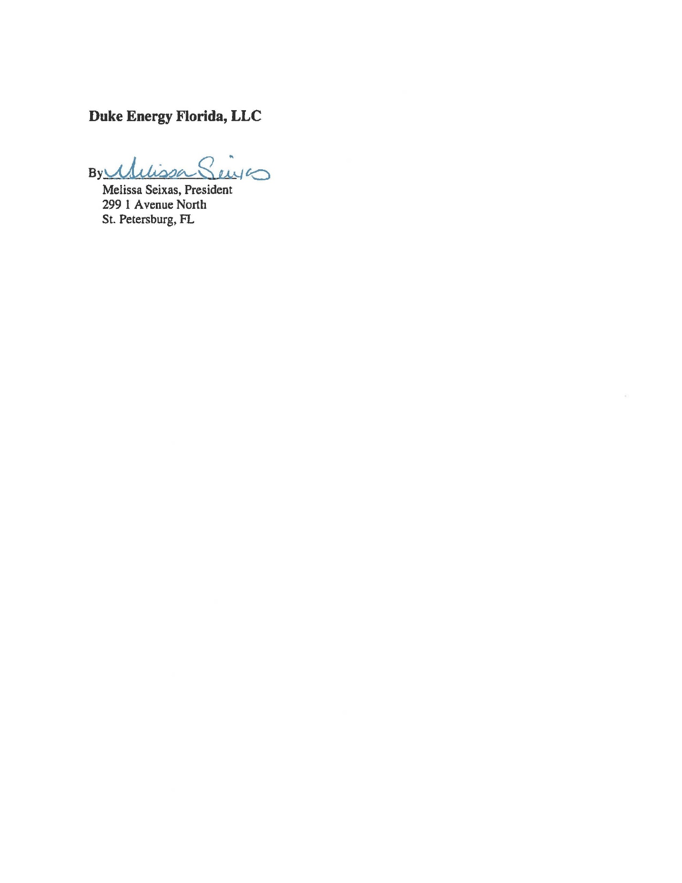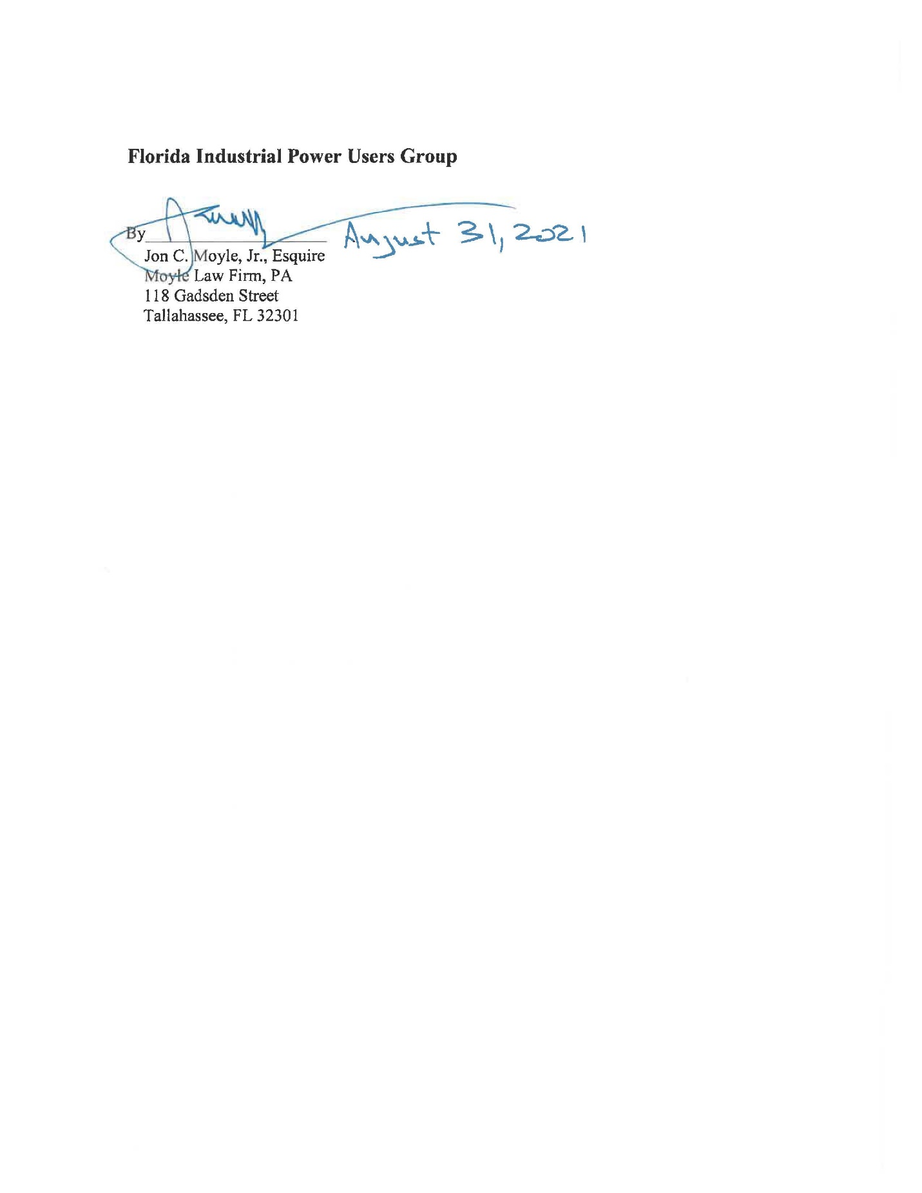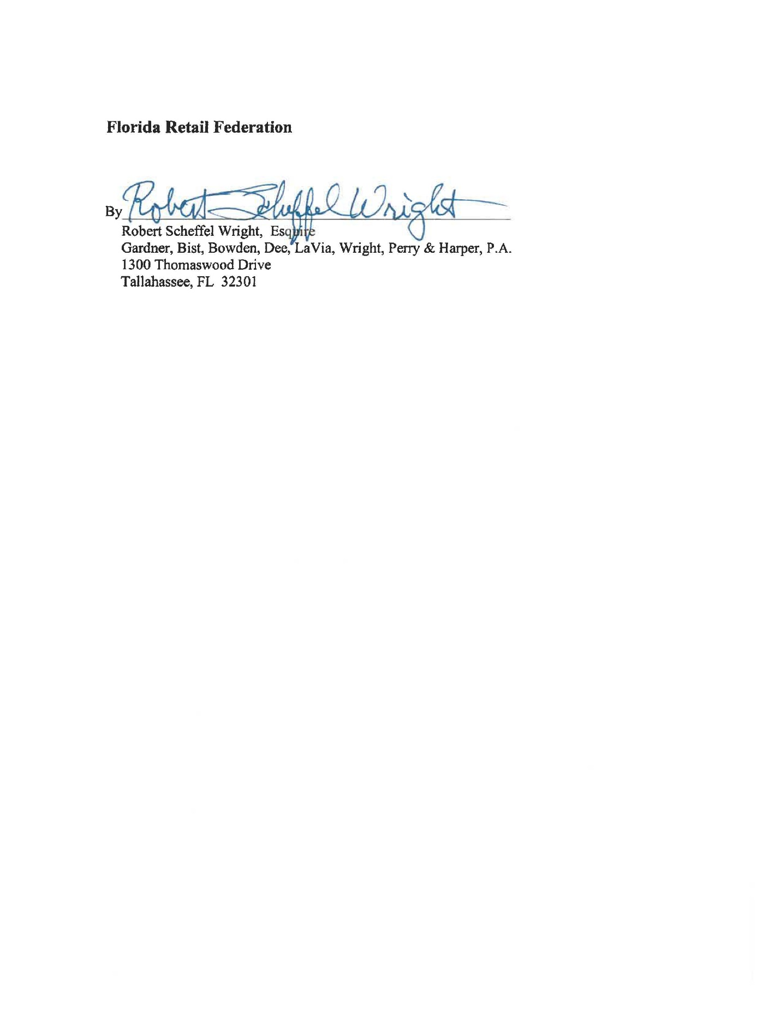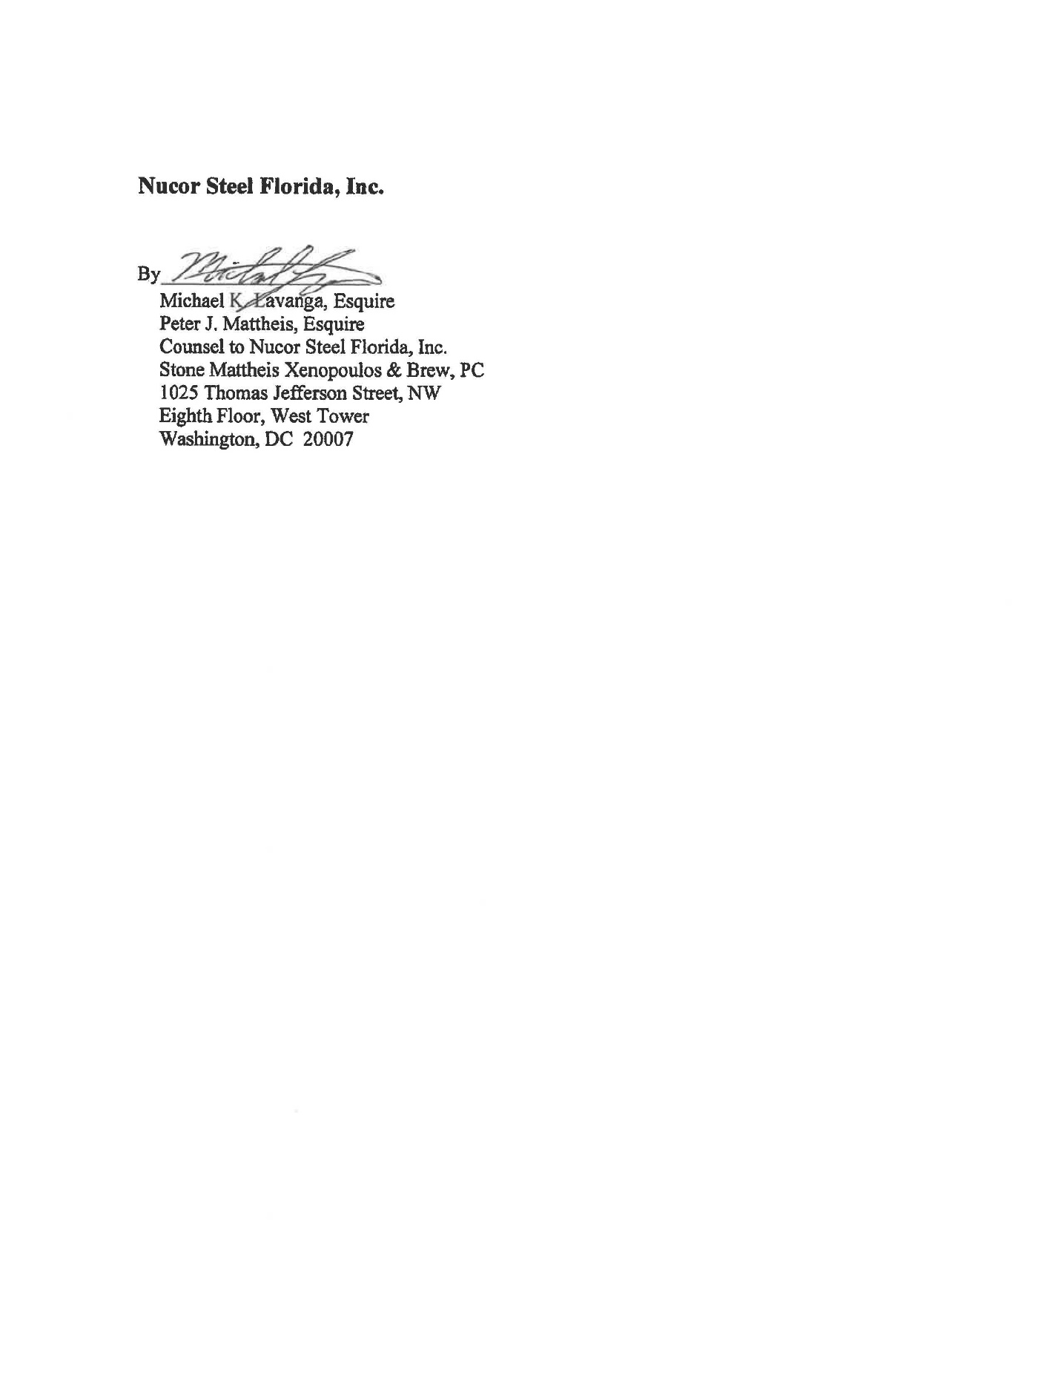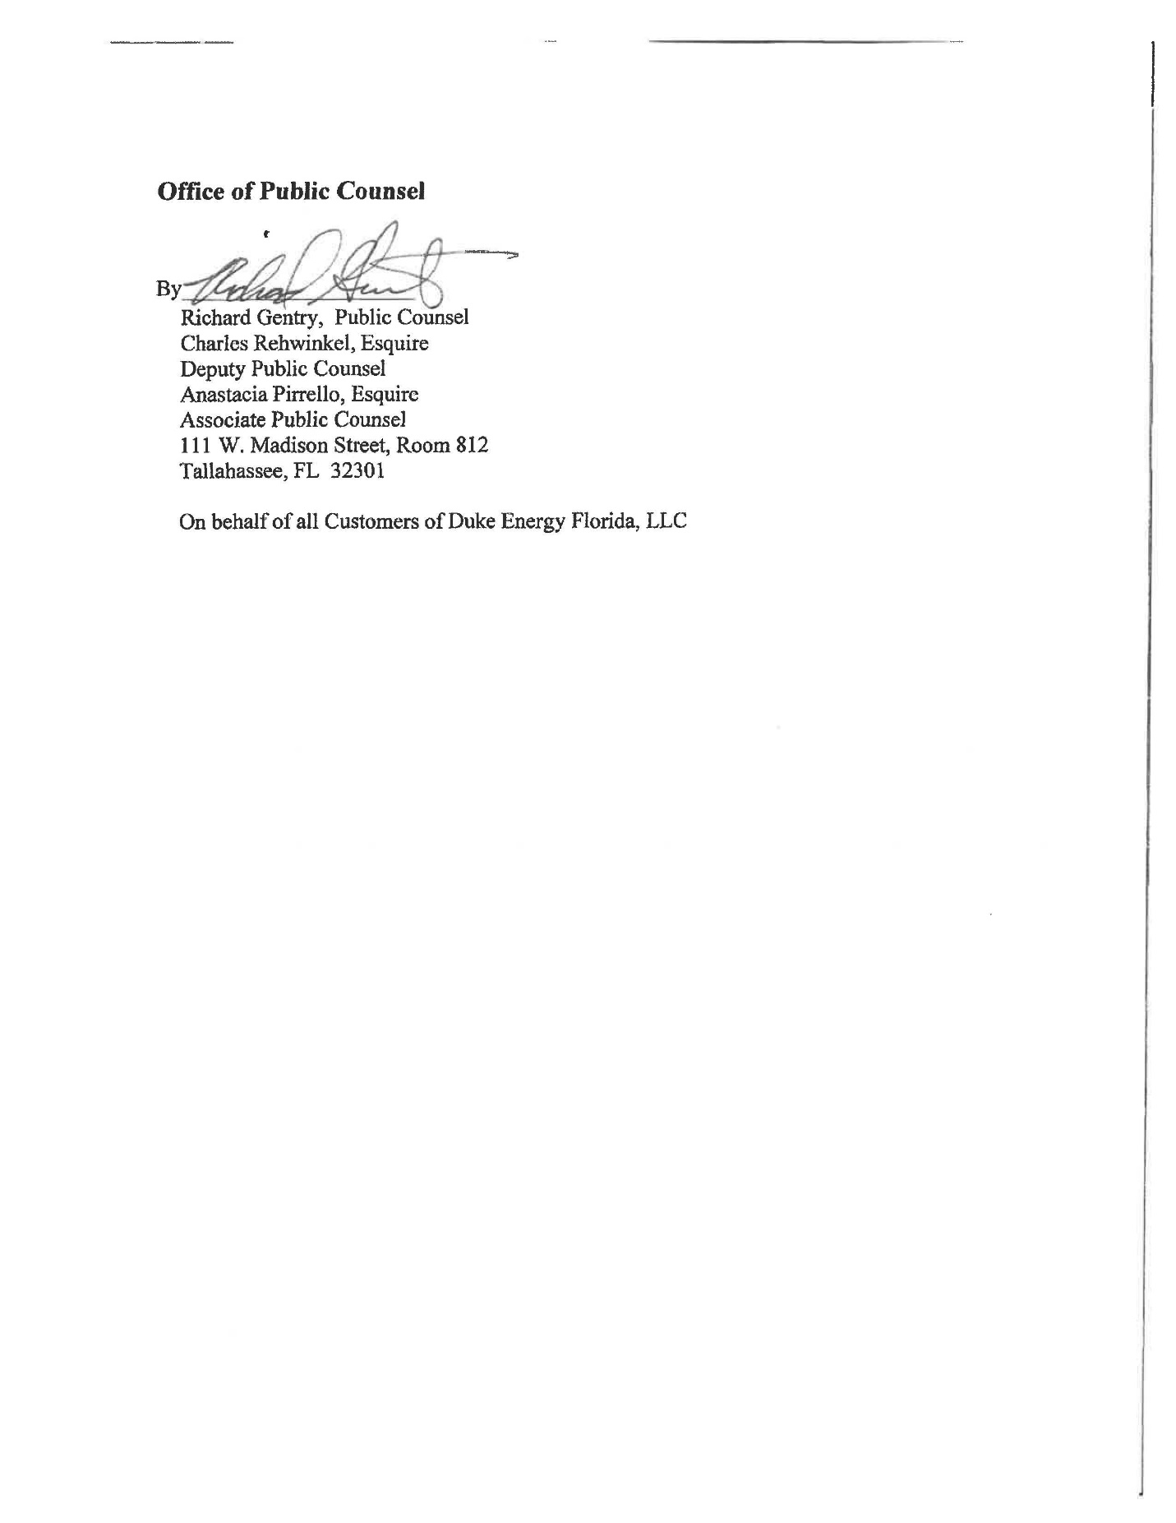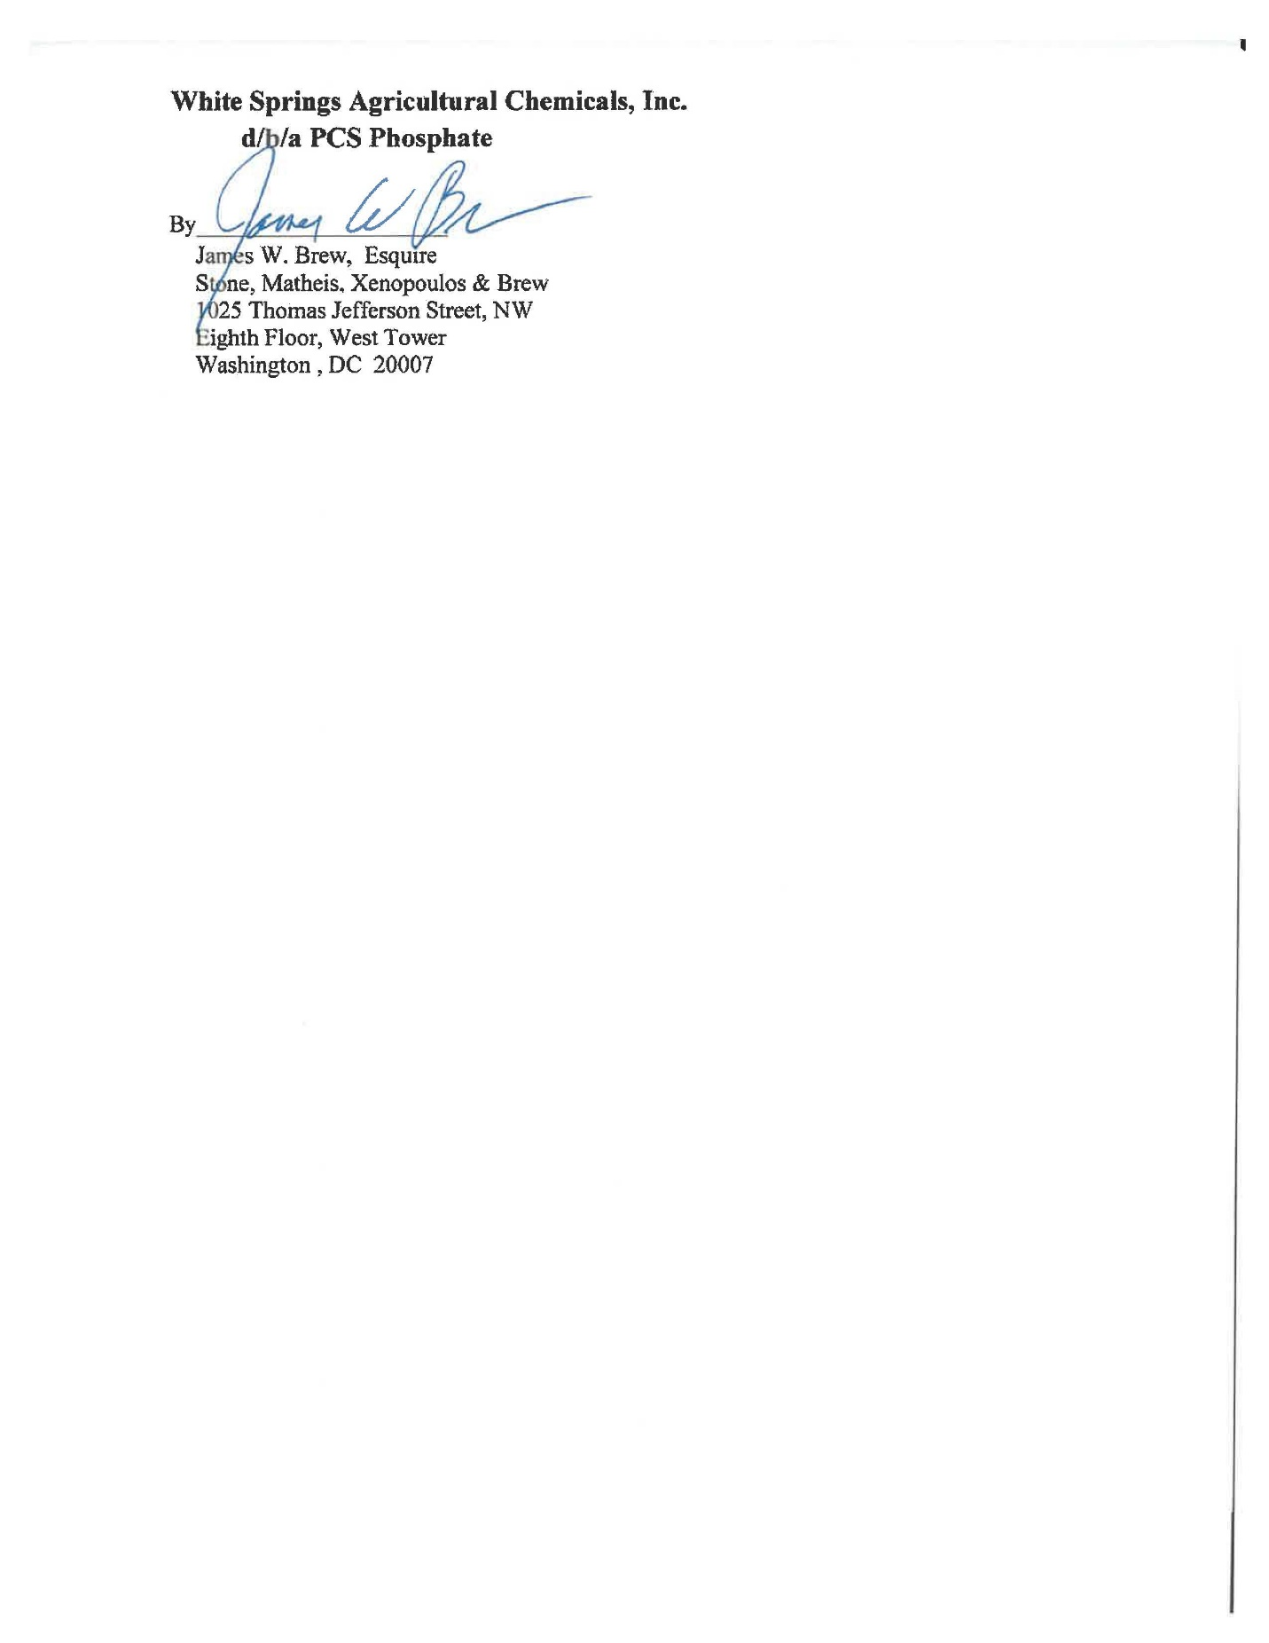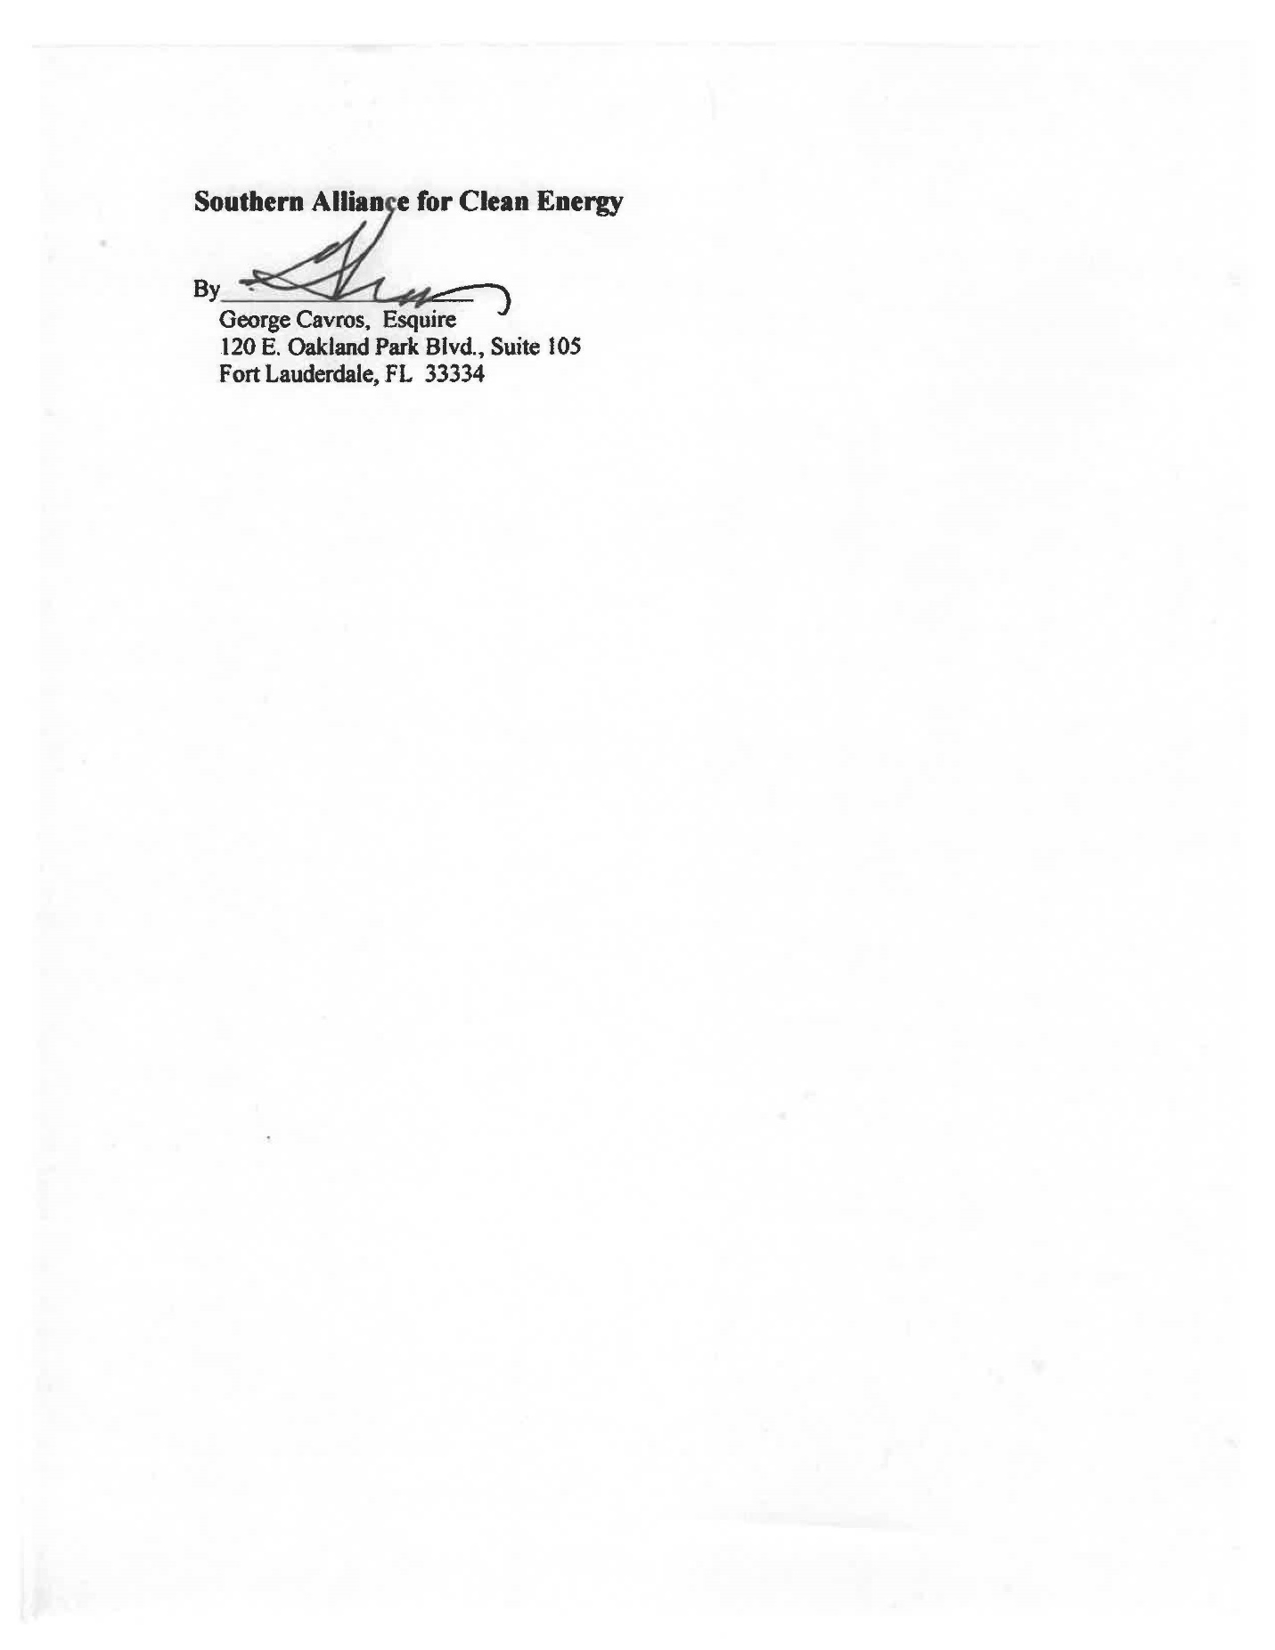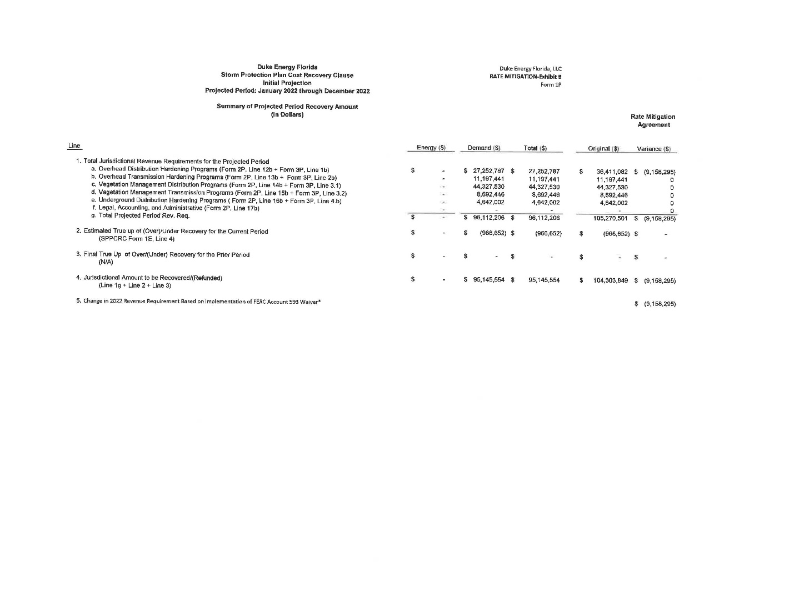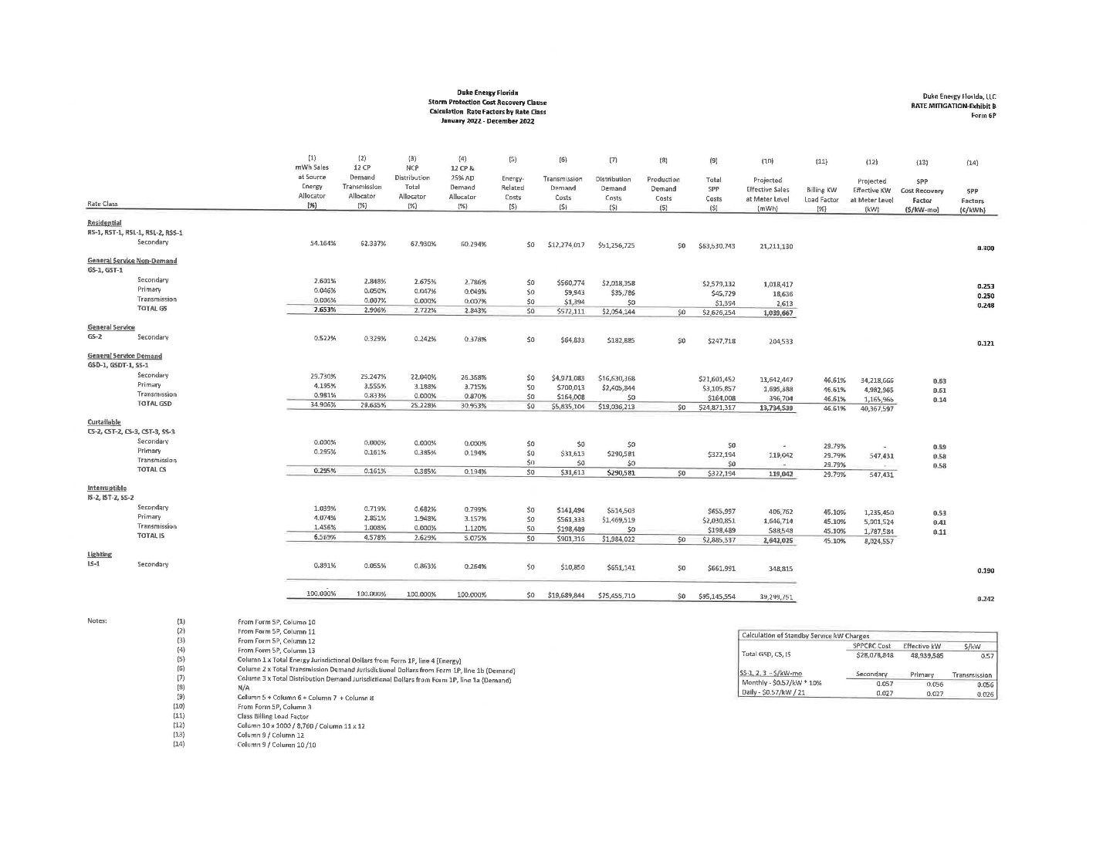

Issued July 28, 2021, in Docket No. 20210097-EI, In re: Petition for limited proceeding for recovery of incremental storm restoration costs related to Hurricanes Eta and Isaias, by Duke Energy Florida, LLC.
Order No. PSC-2021-0324-FOF-EI, issued August 26, 2021, in Docket No. 20210010-EI, In re: Storm protection plan cost recovery clause.
Order No. PSC-13-0023-S-EI, issued on January 14, 2013, in Docket No. 120015-EI, In re: Petition for increase in rates by Florida Power & Light Company; Order No. PSC-11-0089-S-EI, issued February 1, 2011, in Docket Nos. 080677 and 090130, In re: Petition for increase in rates by Florida Power & Light Company and In re: 2009 depreciation and dismantlement study by Florida Power & Light Company; Order No. PSC-10-0398-S-EI, issued June 18, 2010, in Docket Nos. 090079-EI, 090144-EI, 090145-EI, 100136-EI, In re: Petition for increase in rates by Progress Energy Florida, Inc., In re: Petition for limited proceeding to include Bartow repowering project in base rates, by Progress Energy Florida, Inc., In re: Petition for expedited approval of the deferral of pension expenses, authorization to charge storm hardening expenses to the storm damage reserve, and variance from or waiver of Rule 25-6.0143(1)(c), (d), and (f), F.A.C., by Progress Energy Florida, Inc., and In re: Petition for approval of an accounting order to record a depreciation expense credit, by Progress Energy Florida, Inc.; Order No. PSC-05-0945-S-EI, issued September 28, 2005, in Docket No. 050078-EI, In re: Petition for rate increase by Progress Energy Florida, Inc.
Order No. PSC-13-0023-S-EI, at p. 7.

