BEFORE THE FLORIDA PUBLIC SERVICE COMMISSION

In re: Joint petition for approval of modification to territorial agreement in Polk County, by City of Lakeland and City of Bartow. | DOCKET NO. 20220075-EU  ORDER NO. PSC-2022-0273-PAA-EU  ISSUED: July 14, 2022

The following Commissioners participated in the disposition of this matter:

ANDREW GILES FAY, Chairman
ART GRAHAM
GARY F. CLARK
MIKE LA ROSA
GABRIELLA PASSIDOMO

NOTICE OF PROPOSED AGENCY ACTION
ORDER APPROVING TERRITORIAL AGREEMENT

BY THE COMMISSION:

NOTICE is hereby given by the Florida Public Service Commission that the action discussed herein is preliminary in nature and will become final unless a person whose interests are substantially affected files a petition for a formal proceeding, pursuant to Rule 25-22.029, Florida Administrative Code (F.A.C.).

BACKGROUND

On April 13, 2022, the City of Lakeland, on behalf of Lakeland Electric (Lakeland) and the City of Bartow (Bartow), filed a joint petition for approval of a modification (New Territorial Agreement) to their territorial agreement first approved by the Commission in 1984 (Legacy Agreement) in Polk County. In 2006, Lakeland and Bartow entered into an informal agreement to swap a portion of each other’s service territory. While the intent of both parties was to formalize their agreement and submit it to their respective city councils and the Commission, those actions were never completed by the parties. No customers were impacted by this informal agreement, as the affected territories at the time were vacant land. While the Legacy Agreement expired in 2009, the utilities have continued to operate under the general parameters of that agreement.
The proposed New Territorial Agreement reflects the 2006 service territory swap and new subdivision developments that have occurred since 2006. The proposed New Territorial Agreement is included in Attachment A to this order. The relevant maps including a map depicting the swapped territory and timeline of subdivision development are shown in Attachment B to this order.
During the review process, Commission staff issued its first data request to the joint petitioners on April 15, 2022. After review of this request, the joint petitioners requested an informal meeting with Commission staff to discuss the unique circumstances involving the proposed New Territorial Agreement. An informal conference call was held on April 21, 2022, during which the joint petitioners provided additional information not contained in the petition and explained the circumstances leading up to the proposed New Territorial Agreement.

As a result of the discussions and additional information received at the informal conference call, Commission staff withdrew its first data request on April 26, 2022, to allow the joint petitioners to file a supplemental response, which included additional information and maps. The supplemental response was filed on April 29, 2022. After review of the supplemental information, Commission staff issued its second data request on May 10, 2022, for which responses were filed on May 20, 2022. We have jurisdiction over this matter pursuant to Section 366.04, Florida Statutes (F.S.).
DECISION

Pursuant to Section 366.04(2)(d), F.S., and Rule 25-6.0440(2), Florida Administrative Code (F.A.C.), we have jurisdiction to approve territorial agreements between and among rural electric cooperatives, municipal electric utilities, and other electric utilities. Unless we determine that the modification to the Legacy Agreement will cause a detriment to the public interest, the proposed New Territorial Agreement should be approved.
The Proposed New Territorial Agreement

In 1983, Lakeland and Bartow entered into a territorial agreement which was approved by the Commission in 1984. The Legacy Agreement had a term of 25 years (1984-2009). In 2006, Lakeland and Bartow informally agreed to swap a portion of their respective electric service areas because it allowed for better infrastructure access to serve future development. While the utilities entered into a written agreement dated May 19, 2006, to swap this territory, they did not seek nor receive our approval of this agreement as required by Rule 25-6.0440(1), F.A.C. The May 19, 2006 agreement indicates that the joint petitioners intended to file a petition with this Commission to amend their service territories. However, the joint petitioners explained that as a result of utility staffing changes and administrative oversight, a timely petition was not
filed.

In the 2006 territory swap, Bartow acquired from Lakeland the Wind Meadows subdivision which is comprised of 39.65 acres. During the time of the territory swap, the Wind Meadows was a platted subdivision (no customers) and it is located within Bartow’s city limits. Between August 2006 and April 2022, the Wind Meadows subdivision was developed and now consists of 134 homes. The joint petitioners explained that in 2006, Bartow had the capacity and readily accessible facilities available to serve the future Wind Meadows subdivision.

In return, in 2006 Lakeland acquired 58.19 acres of vacant pastureland from Bartow’s service territory. In May 2022, construction started and the pastureland is being developed as the Wind Meadows South subdivision, with 145 potential new residential customers. During the recent platting and development of the Wind Meadows South subdivision on this pastureland, the developer and Lakeland realized that the 2006 service territory swap and boundary adjustment had not been submitted to us for approval. Thereafter, the parties also became aware that the Legacy Agreement had expired in 2009, at the end of its 25-year term. From 2009 to date, the parties have continued to abide by the terms of the Legacy Agreement as modified by the informal agreement and have worked cooperatively to serve their customers. There are currently no outstanding service issues or territorial disputes between these utilities.

To remedy the unapproved territory swap and the expired territorial agreement, on April 4, 2022, the joint petitioners entered into the New Territorial Agreement (see Attachment A). Through the New Territorial Agreement, Lakeland and Bartow desire to define specific areas of their respective electric service areas corresponding to the Wind Meadows and Wind Meadows South subdivisions in Polk County. The swapped territory and the above discussed subdivisions, along with their development timelines, are depicted on a map in Attachment B to this order.

The proposed New Territorial Agreement does not contemplate any customer or facility transfers and therefore no customer notification is required pursuant to Rule 25-6.0440(1)(d), F.A.C. If there is a need to transfer customers and facilities in the future during the term of the agreement, pursuant to Article 2, the transfers will be based on sound economic and engineering practices.

The proposed New Territorial Agreement is for an initial term of 15 years and after that, the agreement would automatically renew for successive 5-year terms. If either of the parties desire not to renew for successive 5-year terms, the party shall provide to the other party written notification of their desire to not renew, no less than 12 months prior to automatic extension date. Any modifications to this proposed agreement will be submitted to this Commission for review and approval.

Upon review of the joint petition and the supplemental information provided in responses to our staff’s data requests and at the informal meeting with the joint petitioners, we find that the proposed New Territorial Agreement will not cause a detriment to the public interest, will eliminate any potential uneconomic duplication of facilities, and will not cause a decrease in reliability of electric service to the present or future customers of Lakeland or Bartow. For these reasons, we hereby approve the proposed new Territorial Agreement between Lakeland and Bartow in Polk County included as Attachment A to this order.

Based on the foregoing, it is

ORDERED by the Florida Public Service Commission that the New Territorial Agreement between the City of Bartow, Florida and the City of Lakeland, Florida dated April 4, 2022, attached hereto as Attachment A, is hereby approved. It is further

ORDERED that the provisions of this order, issued as proposed agency action, shall become final and effective upon the issuance of a Consummating Order unless an appropriate petition, in the form provided by Rule 28-106.201, Florida Administrative Code, is received by the close of business on the date set forth in the “Notice of Further Proceedings” attached hereto. It is further

ORDERED that in the event this order becomes final, this docket shall be closed.

By ORDER of the Florida Public Service Commission this 14th day of July, 2022.

/s/ Adam J. Teitzman
ADAM J. TEITZMAN
Commission Clerk
Florida Public Service Commission
2540 Shumard Oak Boulevard
Tallahassee, Florida 32399
(850) 413-6770
www.floridapsc.com

Copies furnished: A copy of this document is provided to the parties of record at the time of issuance and, if applicable, interested persons.

SBr

NOTICE OF FURTHER PROCEEDINGS OR JUDICIAL REVIEW

The Florida Public Service Commission is required by Section 120.569(1), Florida Statutes, to notify parties of any administrative hearing that is available under Section 120.57, Florida Statutes, as well as the procedures and time limits that apply. This notice should not be construed to mean all requests for an administrative hearing will be granted or result in the relief sought.

Mediation may be available on a case-by-case basis. If mediation is conducted, it does not affect a substantially interested person's right to a hearing.

The action proposed herein is preliminary in nature. Any person whose substantial interests are affected by the action proposed by this order may file a petition for a formal proceeding, in the form provided by Rule 28-106.201, Florida Administrative Code. This petition must be received by the Office of Commission Clerk, 2540 Shumard Oak Boulevard, Tallahassee, Florida 32399-0850, by the close of business on August 4, 2022.

In the absence of such a petition, this order shall become final and effective upon the issuance of a Consummating Order.

Any objection or protest filed in this/these docket(s) before the issuance date of this order is considered abandoned unless it satisfies the foregoing conditions and is renewed within the specified protest period.

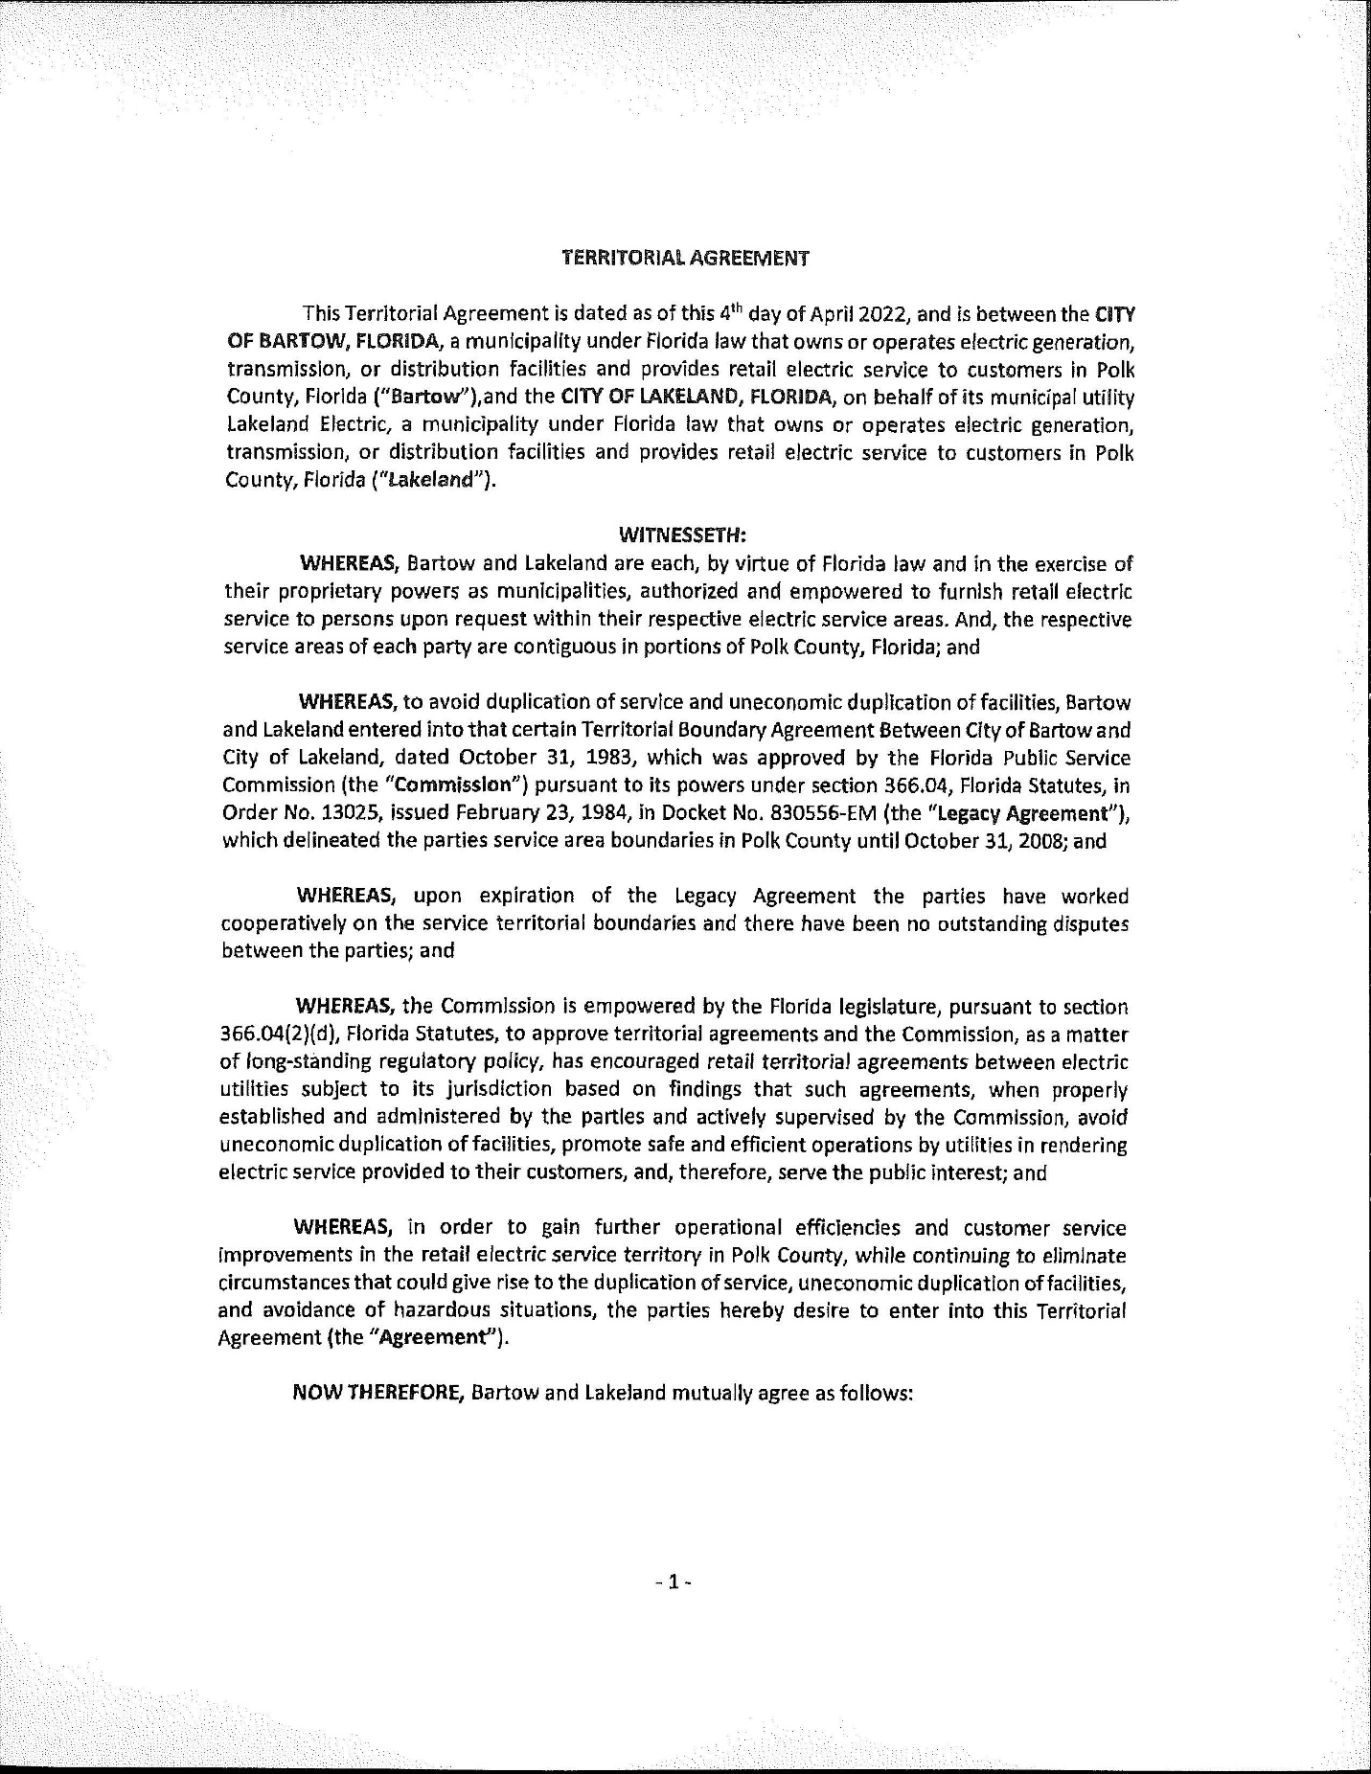

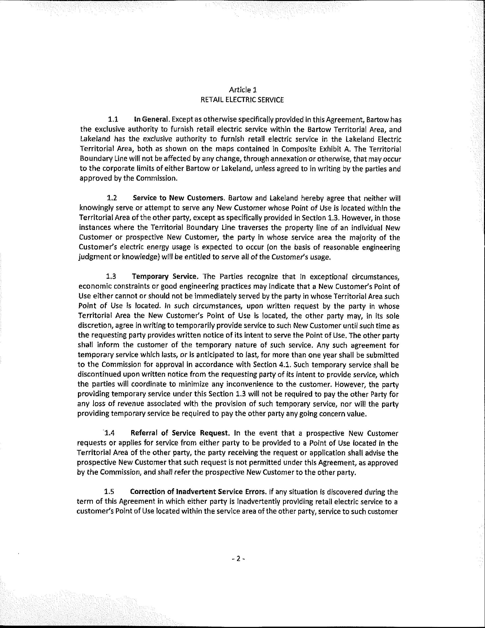

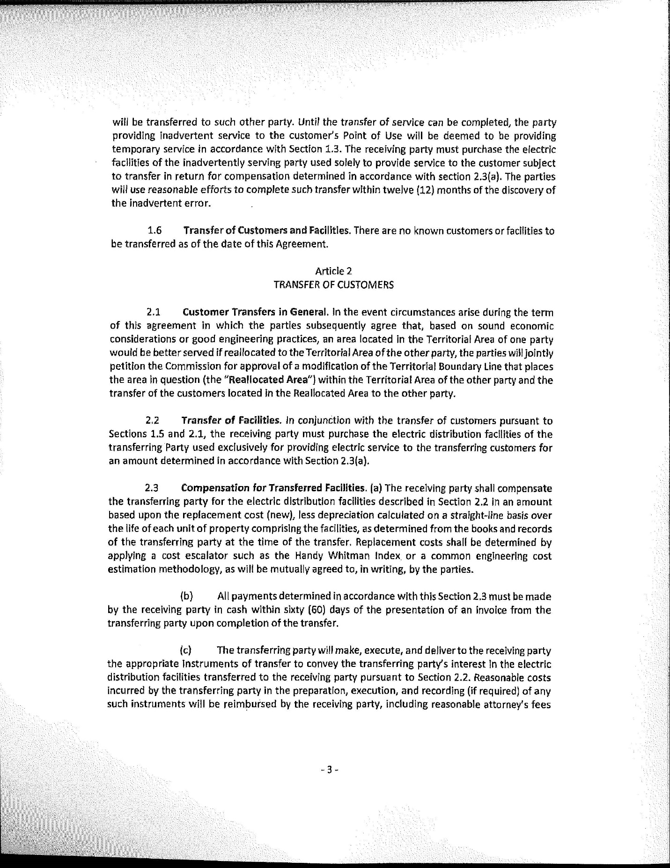

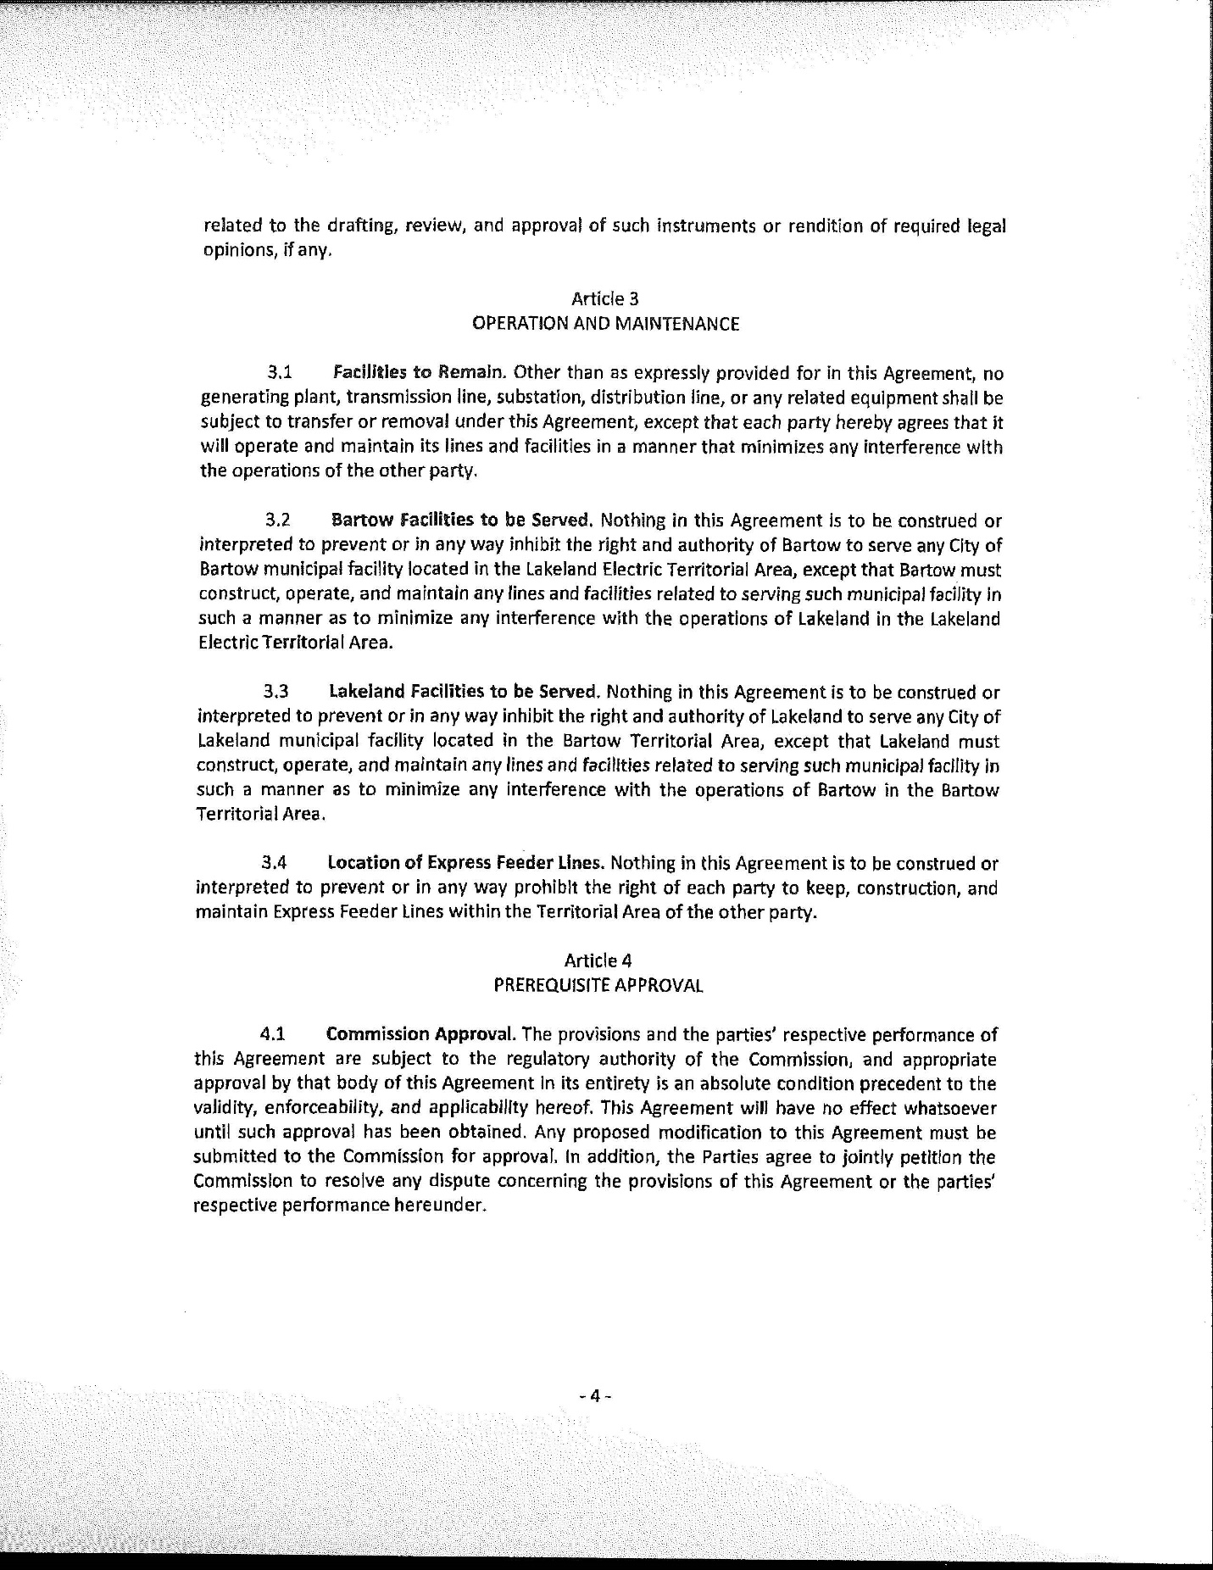

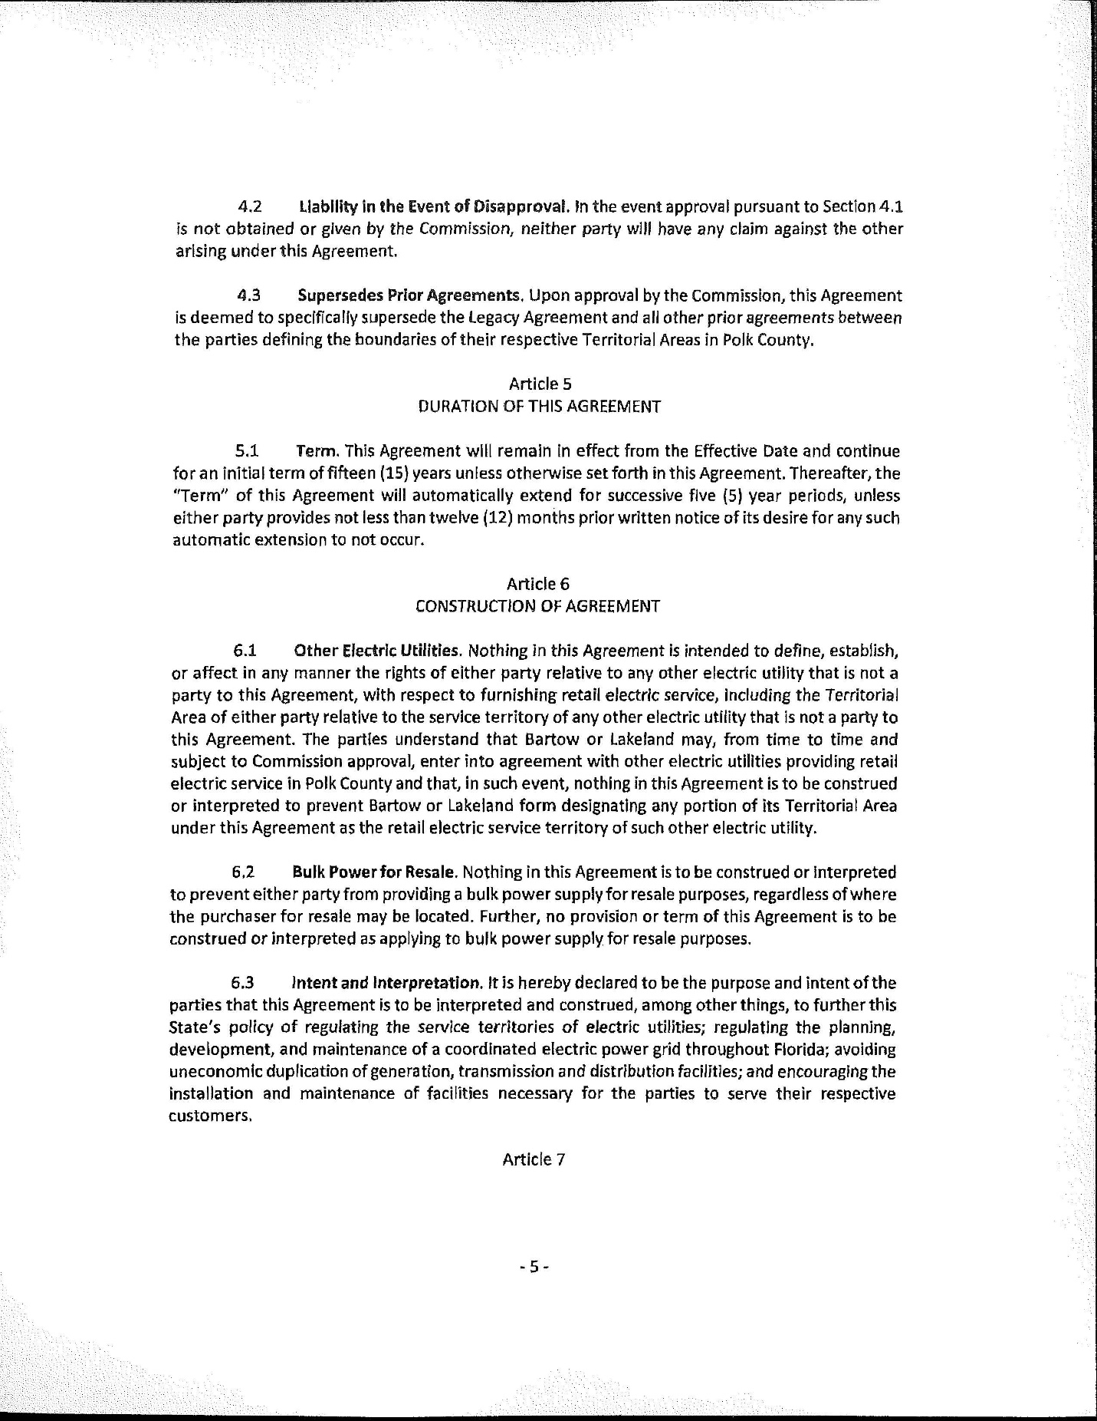

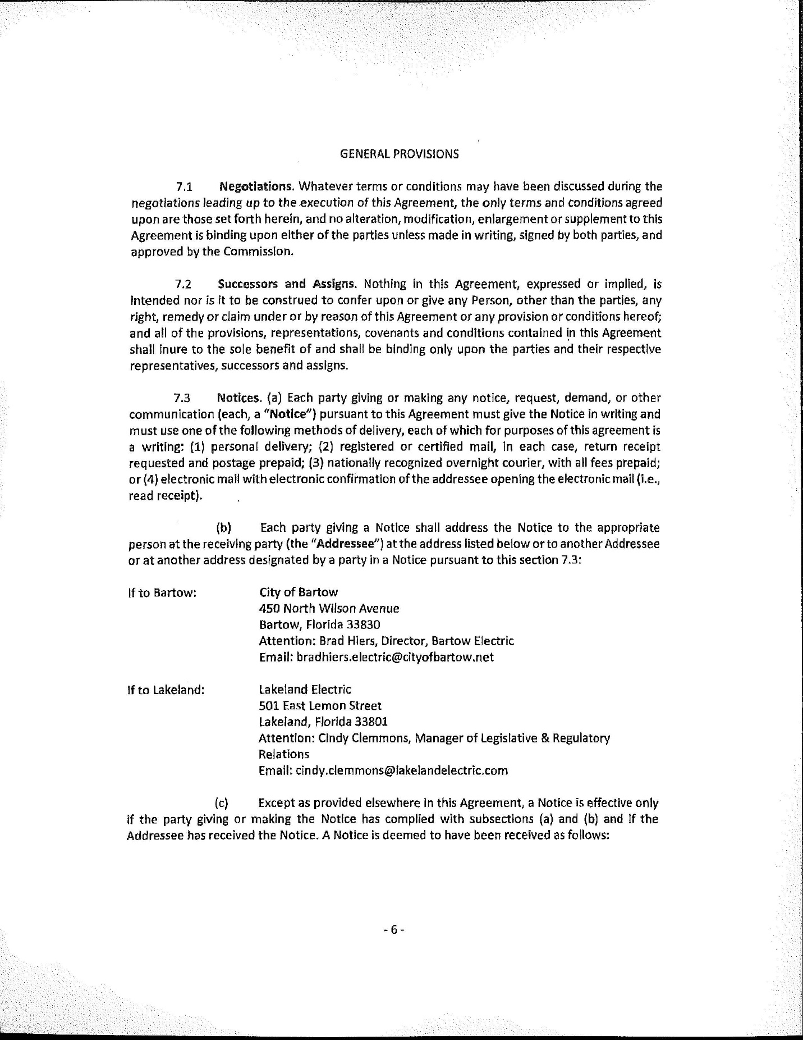

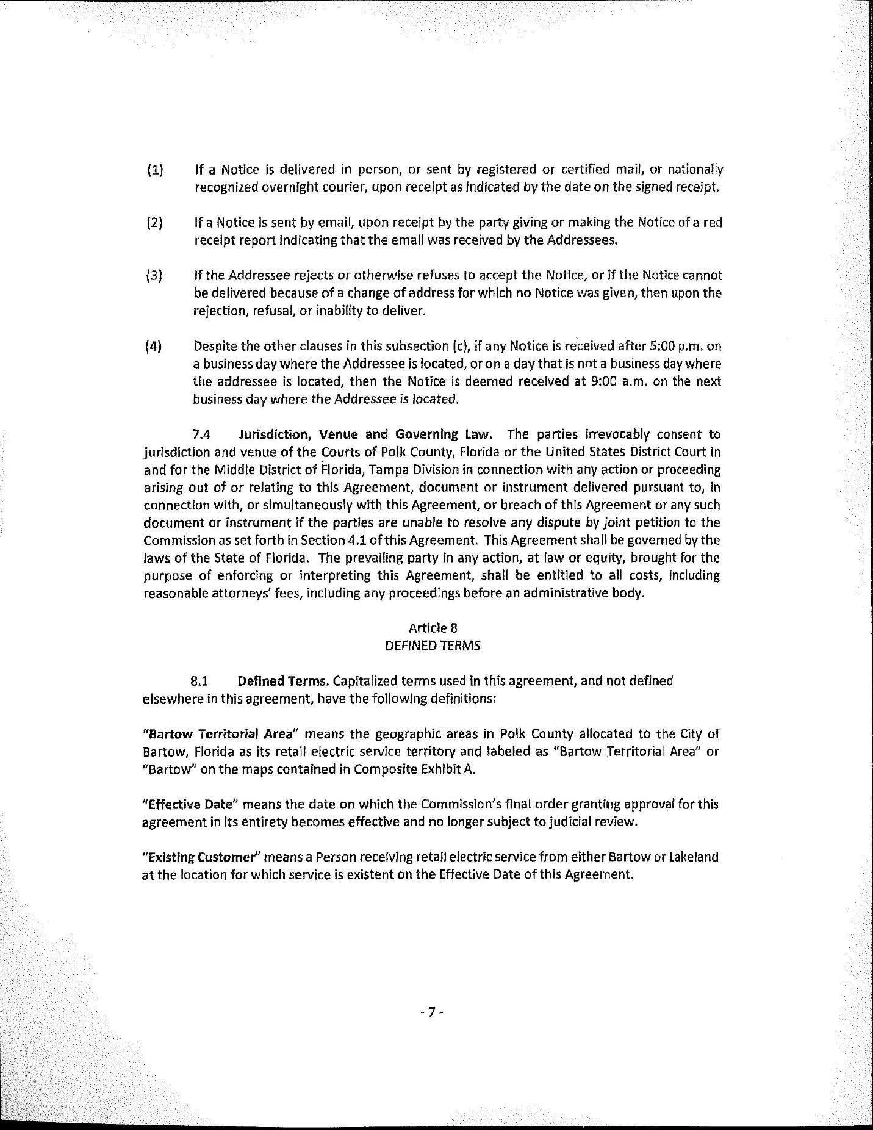

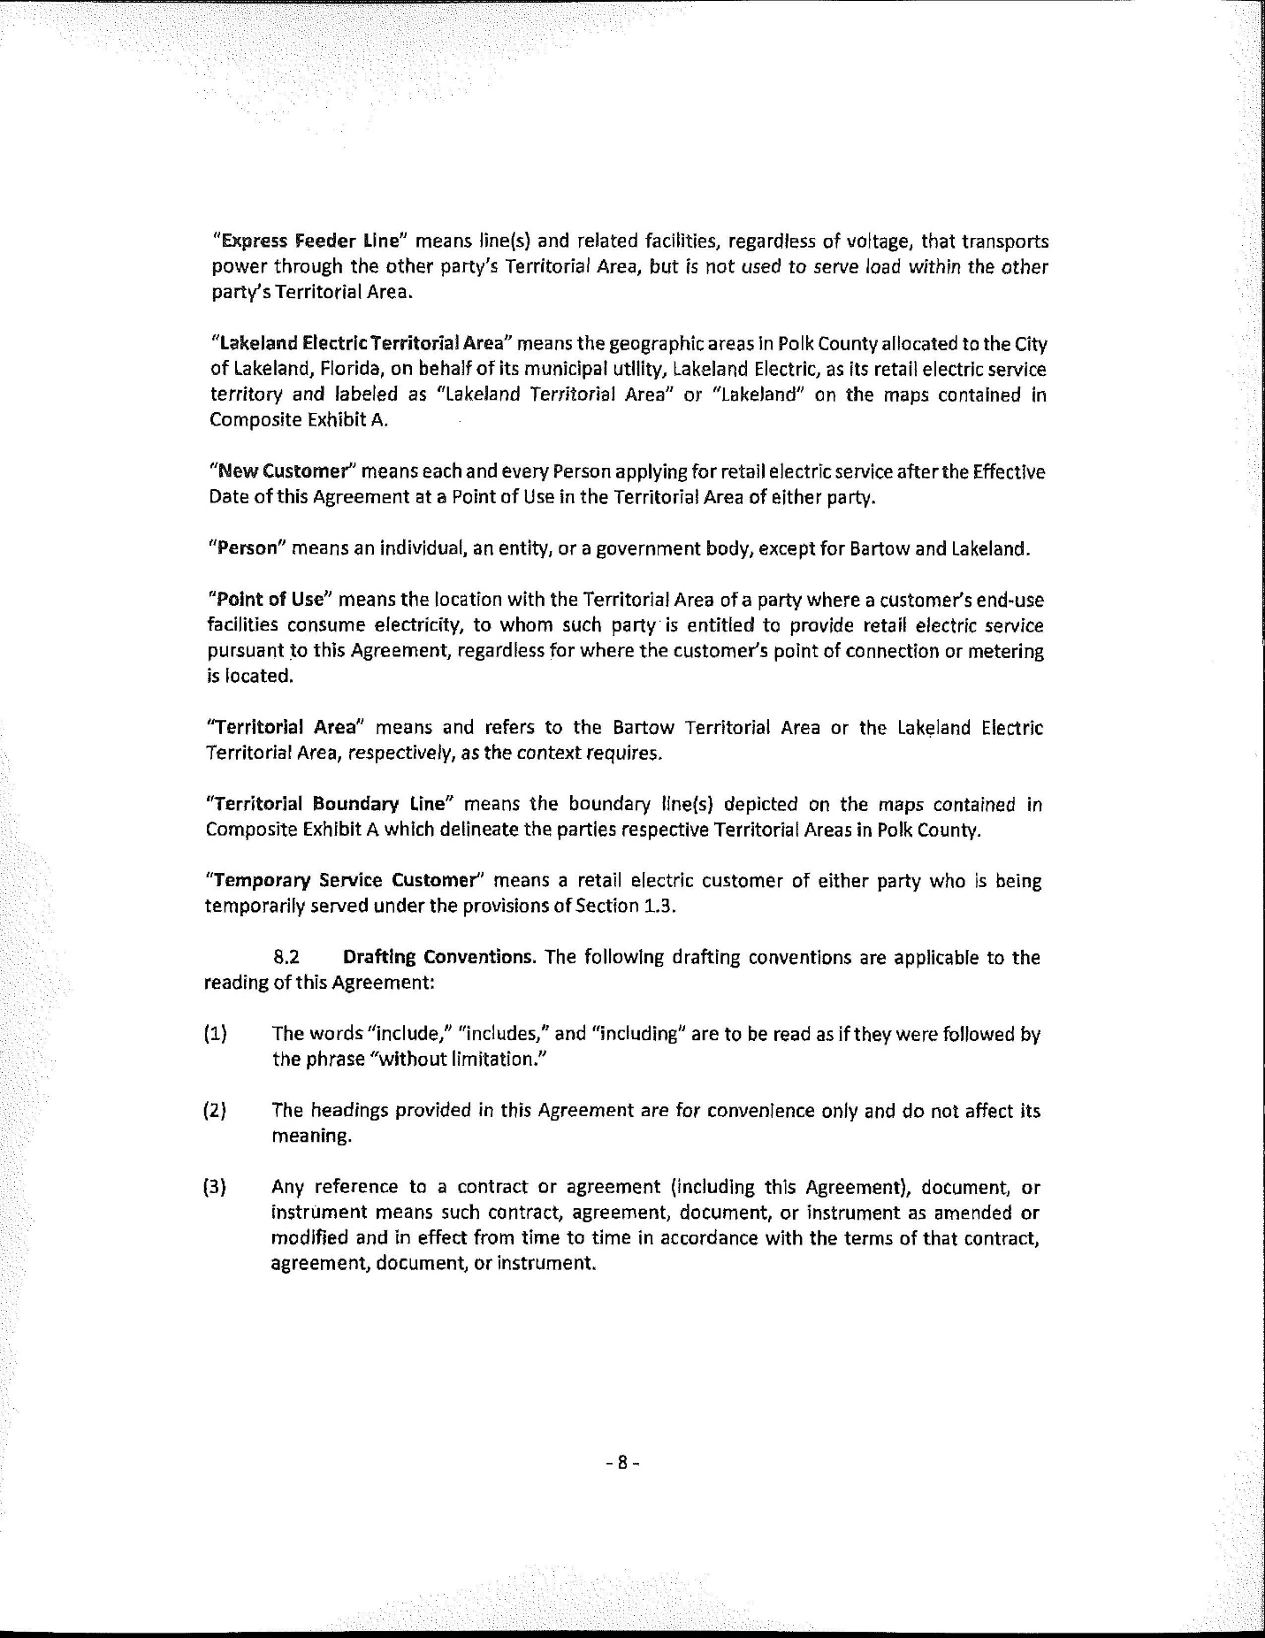

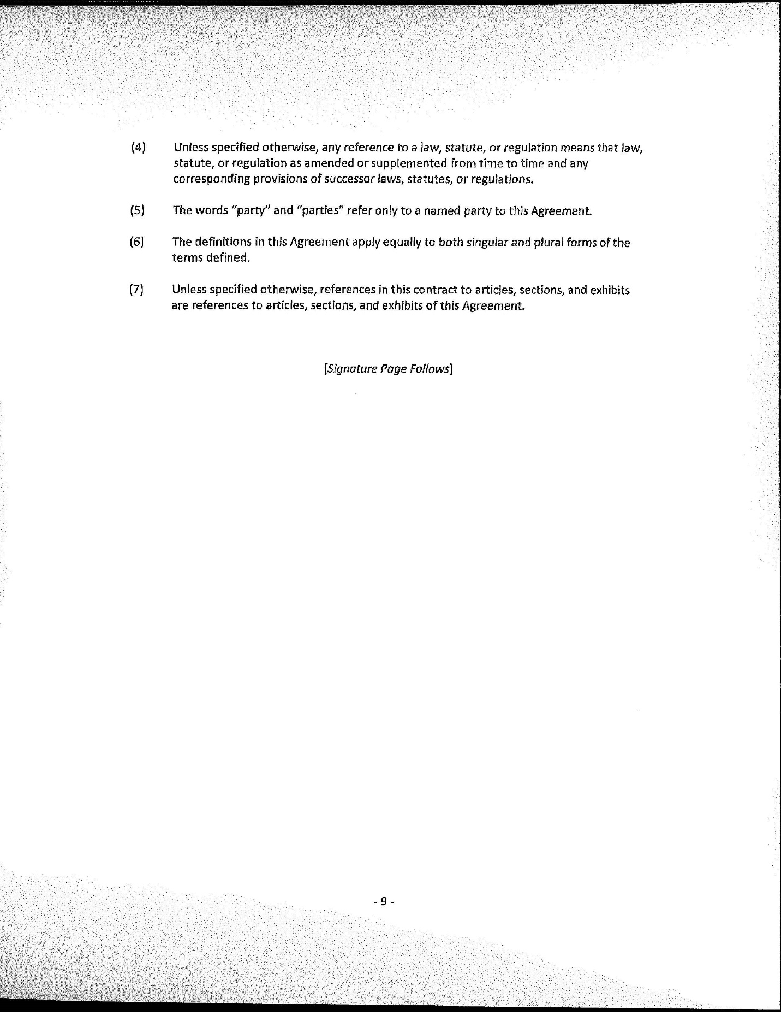

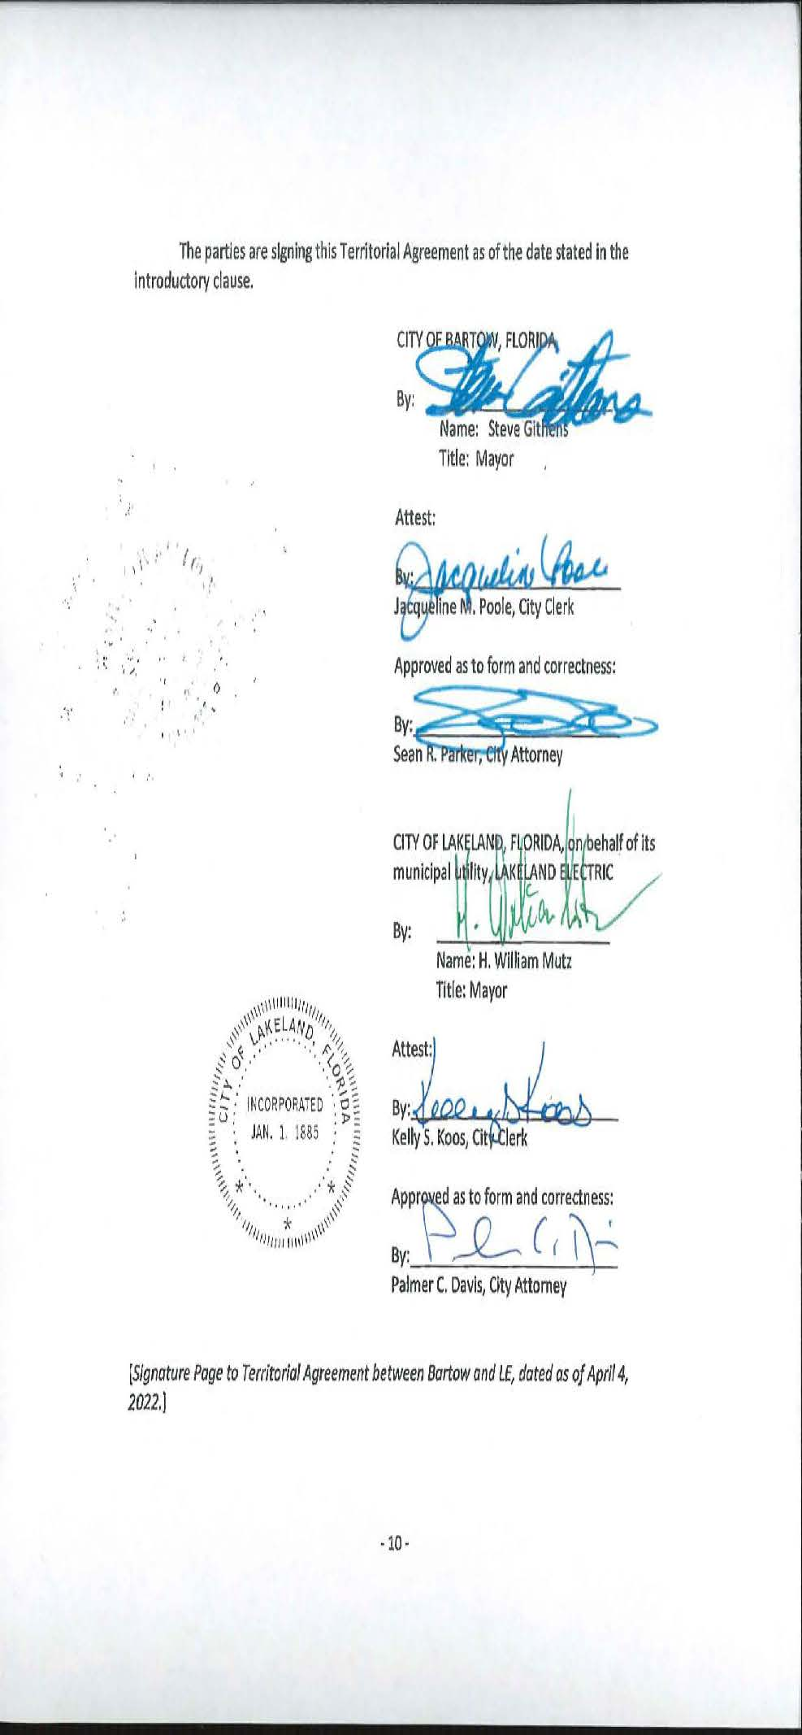

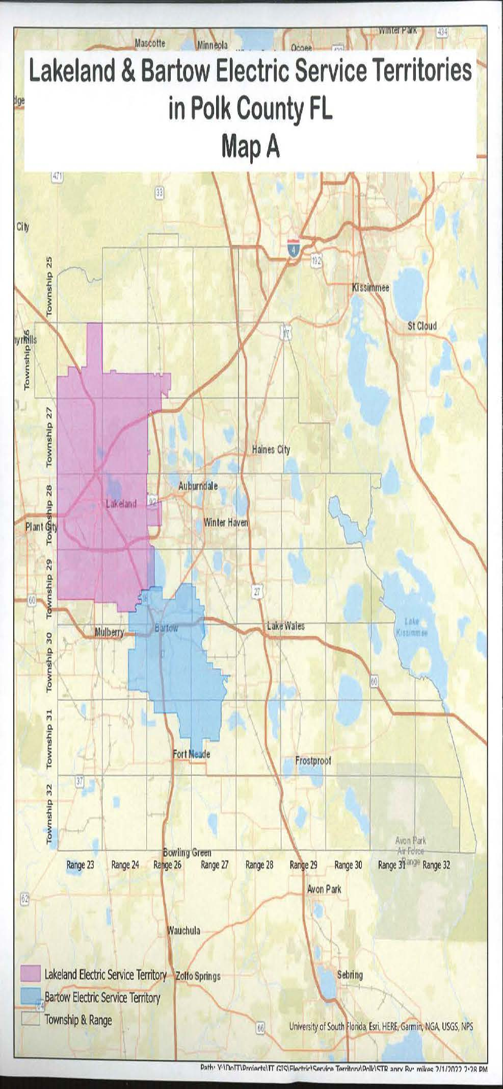

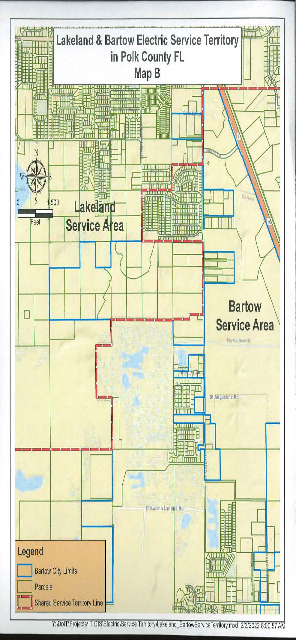

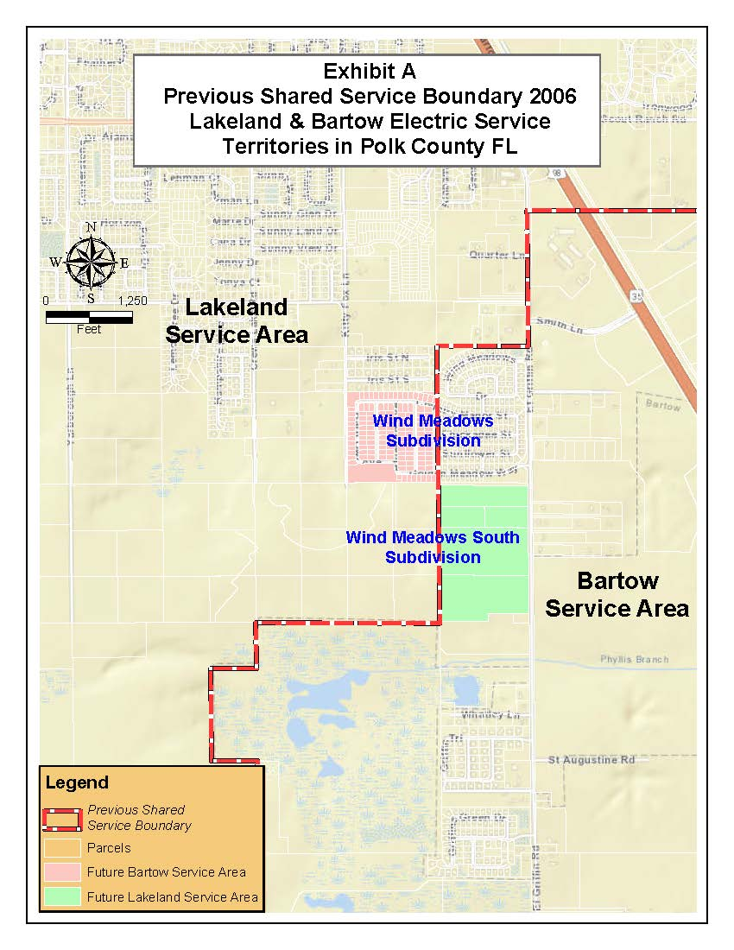
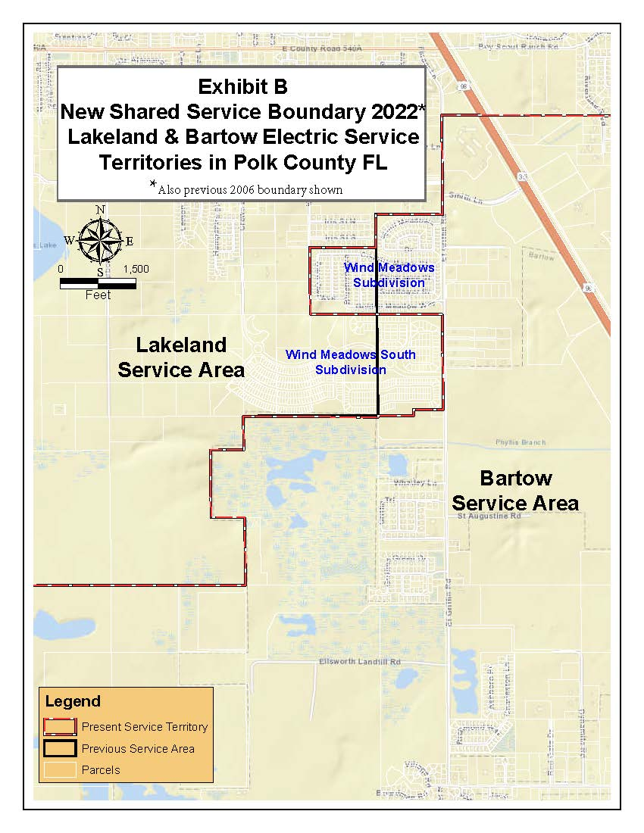
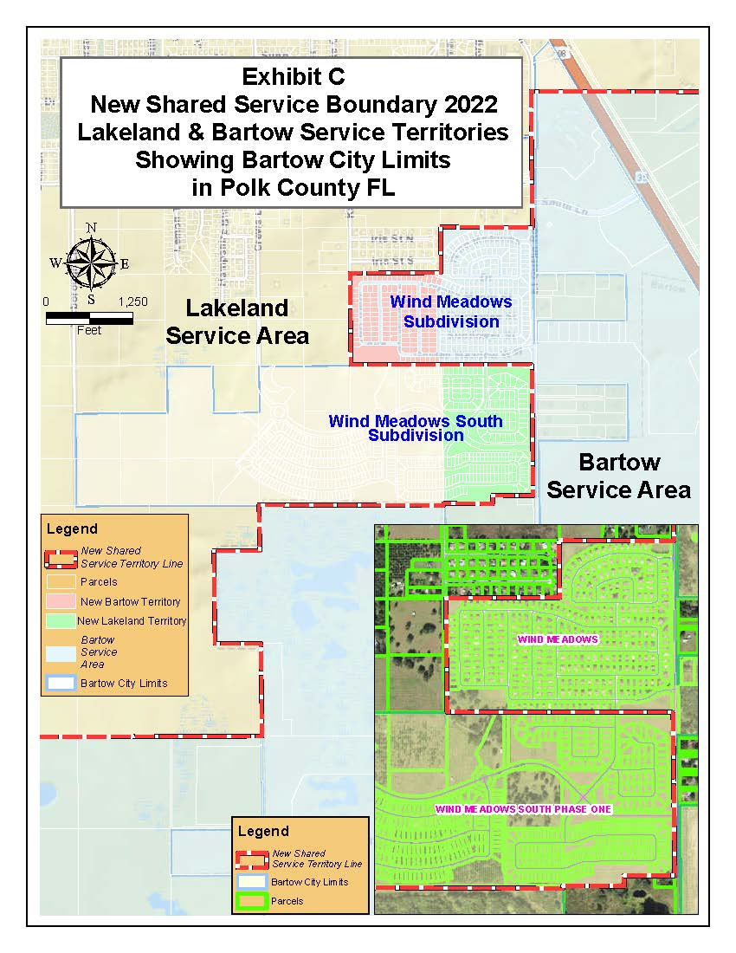
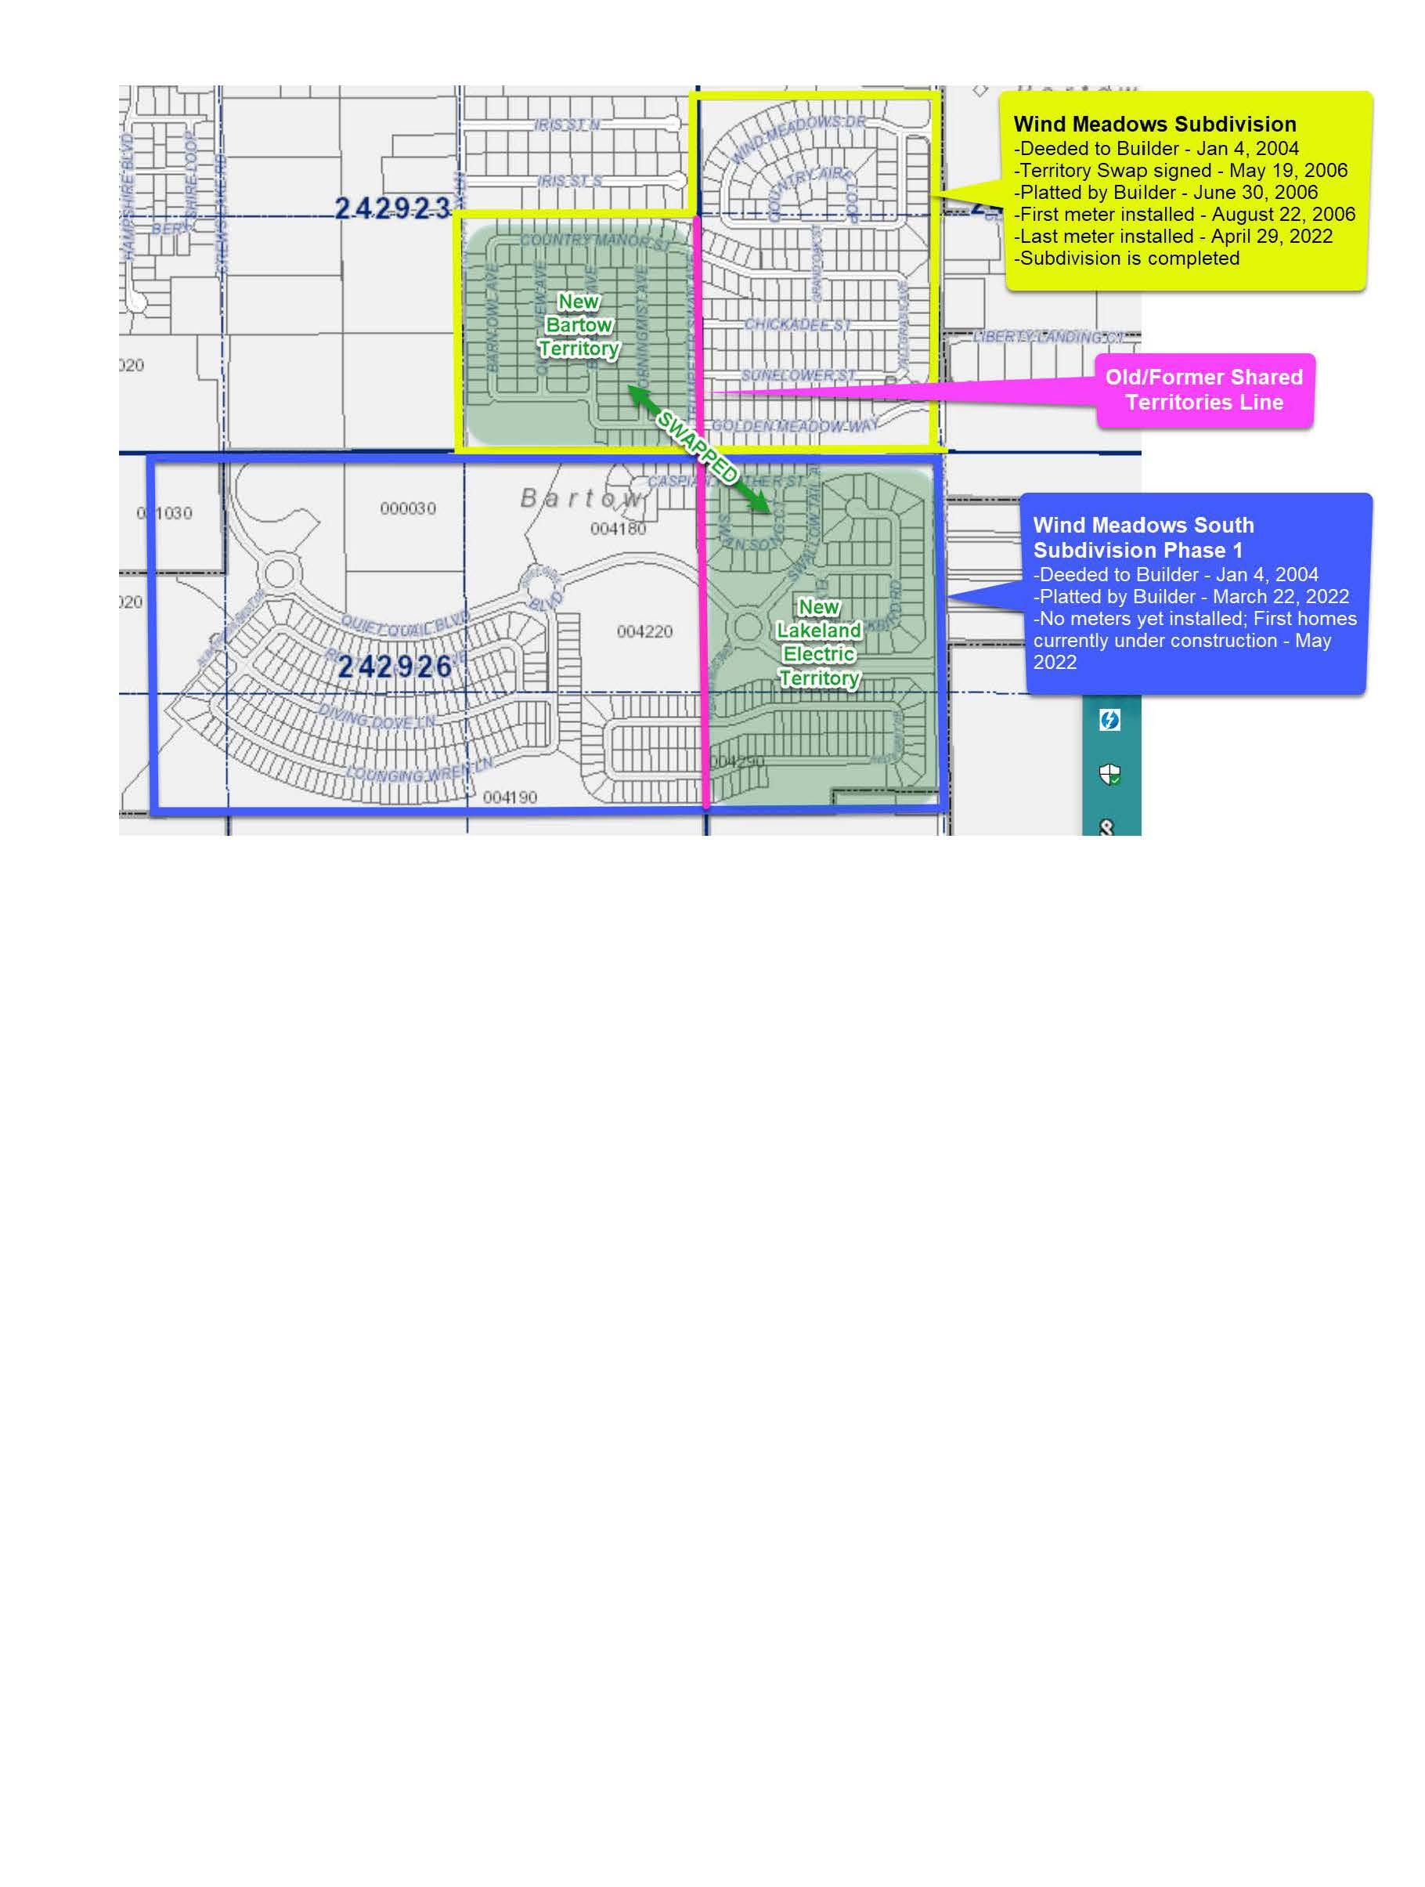

Order No. 13025, issued February 23, 1984, in Docket No. 19830566-EM, In re: Joint Stipulation and Petition for Approval of Territorial Agreement between City of Lakeland and City of Bartow.
Utilities Commission of the City of New Smyrna Beach v. Florida Public Service Commission, 469 So. 2d 731 (Fla. 1985).
Paragraph 4 of the Supplemental Information (Document No. 02715-2022) and as explained during the April 21, 2022 informal meeting.
Response 2 in Staff’s Second Data Request (Document No. 03048-2022).

