BEFORE THE FLORIDA PUBLIC SERVICE COMMISSION

|  |  |
| --- | --- |
| In re: Joint petition for approval of territorial agreement in Santa Rosa County, by the City of Gulf Breeze and the Okaloosa Gas District. | DOCKET NO. 20220158-GU  ORDER NO. PSC-2023-0061-PAA-GU  ISSUED: January 23, 2023 |

The following Commissioners participated in the disposition of this matter:

ANDREW GILES FAY, Chairman

ART GRAHAM

GARY F. CLARK

MIKE LA ROSA

GABRIELLA PASSIDOMO

NOTICE OF PROPOSED AGENCY ACTION

ORDER APPROVING TERRITORIAL AGREEMENT

BY THE COMMISSION:

NOTICE is hereby given by the Florida Public Service Commission that the action discussed herein is preliminary in nature and will become final unless a person whose interests are substantially affected files a petition for a formal proceeding, pursuant to Rule 25-22.029, Florida Administrative Code (F.A.C.).

Background

On September 9, 2022, the City of Gulf Breeze (Gulf Breeze) and the Okaloosa Gas District (District), collectively the parties, filed a joint petition seeking our approval of a new Territorial Agreement (Agreement) delineating their respective portions of service boundaries in southern Santa Rosa County. Presently, both Gulf Breeze and the Gas District provide retail natural gas service to customers in contiguous areas of southern Santa Rosa County.

The parties currently do not have a Commission-approved territorial agreement. The purpose of the proposed Agreement is to define the parties’ respective service areas in southern Santa Rosa County pursuant to amended Chapter 2021-262, Laws of Florida, and to comply with the legislative directive that the Disputed Area be determined by a final Order by us. The Agreement and composite maps depicting the dividing line between Gulf Breeze and the District service areas in southern Santa Rosa County are shown in Attachment A and Chapter 2021-262, Laws of Florida, is shown in Attachment B to this Order.

The redrawing of the subject boundary will transfer one Gulf Breeze residential customer and associated infrastructure to the District. The customer has been notified of the transfer.

Commission staff issued a data request to the parties for which the responses were received on November 22, 2022. We have jurisdiction over this matter pursuant to Section 366.04, Florida Statutes (F.S.).

Decision

Pursuant to Section 366.04(3)(a), F.S., and Rule 25-7.0471, F.A.C., we have jurisdiction to approve territorial agreements between natural gas utilities. For purposes of this subsection, Section 366.04(3)(c), F.S., defines natural gas utility to include municipalities and gas districts. Unless we determine that the Agreement will cause a detriment to the public interest, it should be approved.[1] Gulf Breeze is a Florida municipal corporation which owns and operates a natural gas distribution system and has been providing natural gas service since 1964. Its service area includes portions of Escambia and Santa Rosa counties and currently provides retail natural gas service to 4,780 customers in Santa Rosa County.

The District is an independent special district created by the Florida Legislature in 1953 to own and operate natural gas transmission and distribution systems in Okaloosa County.[2] In 2000, the Legislature expanded in Chapter 2000-443, Laws of Florida, the District’s service area to include portions of Santa Rosa and Walton counties. The District provides natural gas service to 50,994 residential, commercial, and industrial customers, as well as military installations, within its entire service area.[3] As stated in paragraph 4 of the petition, the District currently serves 4,798 customers in Santa Rosa County. The District’s member municipalities are Crestview, Niceville, Valparaiso, and Fort Walton Beach.

In 2021, the Florida Legislature again expanded the service area of the District to include all of Santa Rosa County with two defined areas excluded. The first excluded area is:

The area within the corporate limits of the City of Gulf Breeze and the area from the eastern boundary of the corporate limits of the City of Gulf Breeze extending easterly approximately 11 miles to the line defined as the eastern boundary of Sections 4, 9, 16, 21, and 28 of Township 2 South, Range 27 West, which extends north and south from Santa Rosa Sound to East Bay.

The second excluded area (Disputed Area) is:

The area from the line defined as the eastern boundary of Sections 4, 9, 16, 21, and 28 of Township 2 South, Range 27 West, which extend north and south from Santa Rosa Sound to East Bay, and extending easterly to the line starting at the intersection of US Highway 98 and Shannon Drive, going due south to Santa Rosa Sound, thence turning due north continuing to Manatee Road; thence turning west until the intersection of Basswood Drive; thence turning north until intersecting the Tom King Bayou tributary south of Cove Road; thence following this branch northwest to Tom King Bayou, thence north to East Bay is presently claimed as a service area by the District and by the City of Gulf Breeze and shall not be deemed to be included or excluded as a service area for the District. The service rights for this area shall be determined by a final nonappealable order of the Florida Public Service Commission or any successor agency.

Chapter 2021-262, Laws of Florida 2021 (emphasis added).

In response to our staff’s data request, the joint petitioners explained that historically the service areas of the two parties have been geographically dispersed such that an agreement was not necessary.[4] However, over the years, as a consequence of natural growth, portions of the parties’ service areas have begun to converge in southern Santa Rosa County near the Dividing Line as defined in the proposed Agreement (separating Gulf Breeze and the District’s service area).

With respect to the Disputed Area referenced in Chapter 2021-262, Laws of Florida, the parties explained that after discussions among the parties and members of the local legislative delegation, the Disputed Area was excluded from the service area determination in recognition of the fact that the City and the District both provided service to the area and claimed certain rights. Therefore, resolution of service rights was reserved for determination by us.[5]

1. Proposed Territorial Agreement

The proposed Agreement defines the Parties’ respective service territories in the Disputed Area by establishing a “Dividing Line” that transects the Disputed Area. The Dividing Line is shown on composite Exhibit B of Attachment A to this order (page 10 of 10 of Attachment A). The joint petitioners assert that the proposed new Agreement will formalize the Dividing Line, comply with the legislative directive, eliminate duplication of service and expenditures, and avoid the potential for future disputes. The joint petitioners also assert that the proposed boundary modification will not decrease service reliability to their existing or future customers.

The proposed Agreement will become effective on the day this Order becomes final and will continue in effect until termination or modification is approved by us or mandated by a government entity. In response to Commission staff’s data request, the parties confirmed that there is no specified termination date for the proposed Agreement.[6]

1. Infrastructure and Customer Transfer and Notification

The Parties explained in the petition that the Dividing Line in the Agreement has been drawn to avoid the need to transfer any customers or utility facilities, with the exception of one residential customer of Gulf Breeze. Pursuant to Section 4(b) of the Agreement, the customer will be transferred following the effective date of this Agreement and upon written notification from the District stating it is prepared to provide service to the transferred customer. On August 17, 2022, Gulf Breeze notified the customer of the transfer and provided rate comparisons. Pursuant to the customer notification, the District will waive the $55 service activation fee and Gulf Breeze will credit the customer’s $50 deposit towards any outstanding amounts due and refund the remainder.[7] The parties assert that they have not received a response or objections from the customer.

Along with the customer transfer, approximately 1,200 feet of pipeline and associated infrastructure will be transferred to the District. The District will pay $24,163.05, representing the depreciated value of the infrastructure to Gulf Breeze.

1. Conclusion

After review of the joint petition and the petitioners’ joint responses to staff’s data request, we find that the proposed Agreement is in the public interest and will enable Gulf Breeze and the District to serve their current and future customers efficiently. The proposed Agreement will define the parties’ respective service areas in southern Santa Rosa County pursuant to the amended Chapter 2021-262, Laws of Florida, and comply with the legislative directive that the Disputed Area be determined by a final order by us. Additionally, the proposed Agreement will avoid duplication of service and mitigate the potential for future disputes. Therefore, we shall approve the proposed Territorial Agreement between the City Gulf Breeze and the Okaloosa Gas District in southern Santa Rosa County.

Based on the foregoing, it is

ORDERED by the Florida Public Service Commission that the proposed territorial agreement in Santa Rosa County by the City of Gulf Breeze and the Okaloosa Gas District is hereby approved. It is further

ORDERED that the provisions of this Order, issued as proposed agency action, shall become final and effective upon the issuance of a Consummating Order unless an appropriate petition, in the form provided by Rule 28-106.201, Florida Administrative Code, is received by the Commission Clerk, 2540 Shumard Oak Boulevard, Tallahassee, Florida 32399-0850, by the close of business on the date set forth in the “Notice of Further Proceedings” attached hereto. It is further

ORDERED that in the event this Order becomes final, this docket shall be closed.

By ORDER of the Florida Public Service Commission this 23rd day of January, 2023.

|  |  |
| --- | --- |
|  | /s/ Adam J. Teitzman |
|  | ADAM J. TEITZMAN  Commission Clerk |

Florida Public Service Commission

2540 Shumard Oak Boulevard

Tallahassee, Florida 32399

(850) 413‑6770

www.floridapsc.com

Copies furnished: A copy of this document is provided to the parties of record at the time of issuance and, if applicable, interested persons.

DD

NOTICE OF FURTHER PROCEEDINGS OR JUDICIAL REVIEW

The Florida Public Service Commission is required by Section 120.569(1), Florida Statutes, to notify parties of any administrative hearing that is available under Section 120.57, Florida Statutes, as well as the procedures and time limits that apply. This notice should not be construed to mean all requests for an administrative hearing will be granted or result in the relief sought.

Mediation may be available on a case-by-case basis. If mediation is conducted, it does not affect a substantially interested person's right to a hearing.

The action proposed herein is preliminary in nature. Any person whose substantial interests are affected by the action proposed by this order may file a petition for a formal proceeding, in the form provided by Rule 28-106.201, Florida Administrative Code. This petition must be received by the Office of Commission Clerk, 2540 Shumard Oak Boulevard, Tallahassee, Florida 32399-0850, by the close of business on February 13, 2023.

In the absence of such a petition, this order shall become final and effective upon the issuance of a Consummating Order.

Any objection or protest filed in this/these docket(s) before the issuance date of this order is considered abandoned unless it satisfies the foregoing conditions and is renewed within the specified protest period.

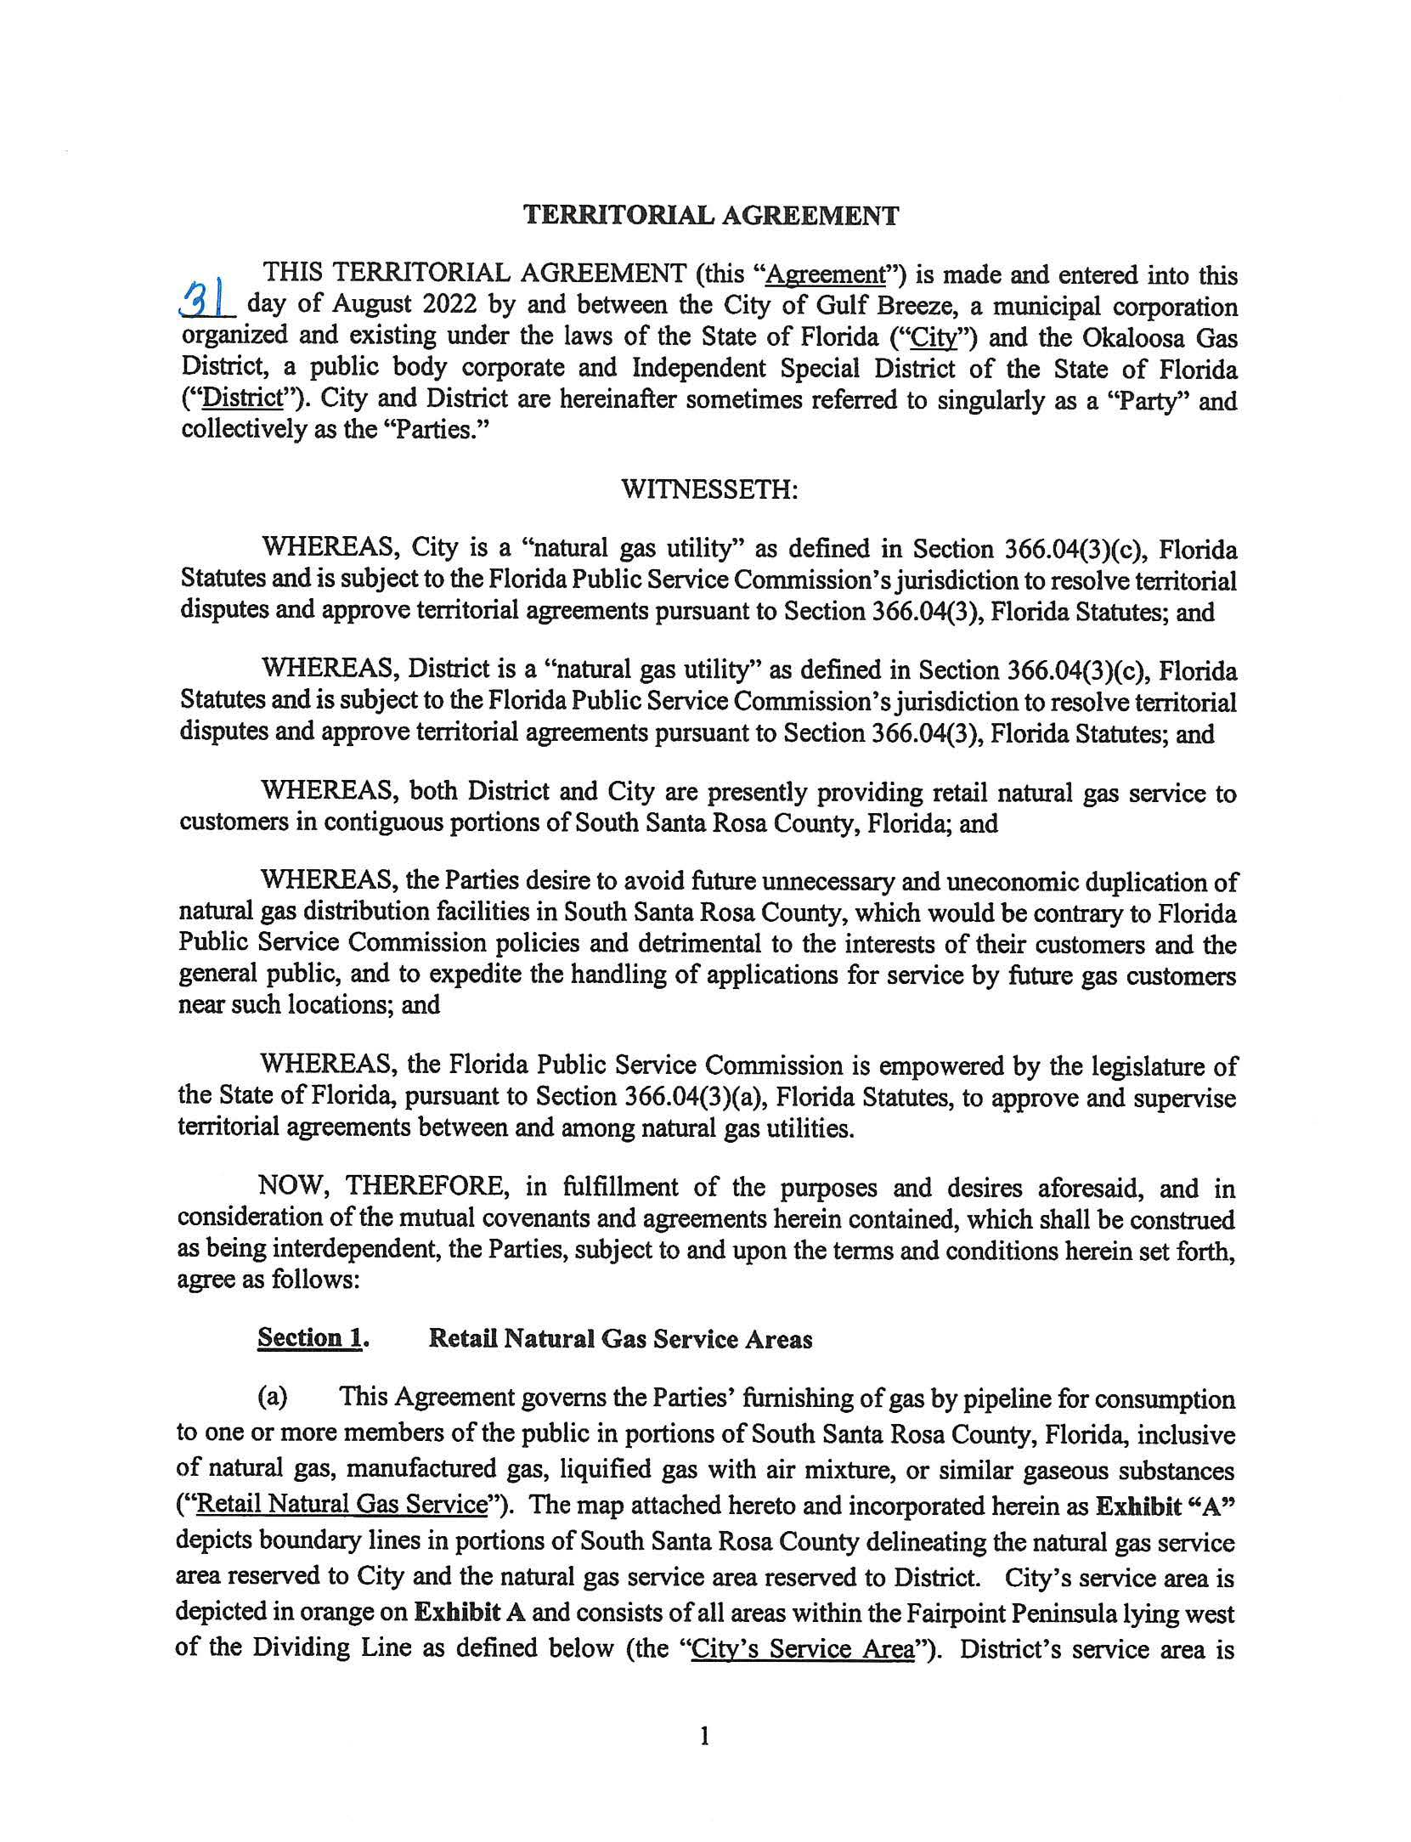

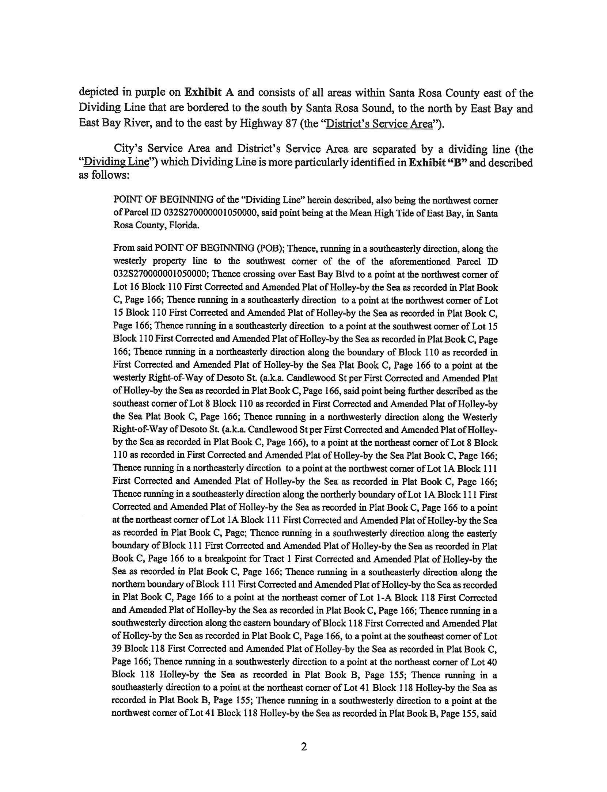

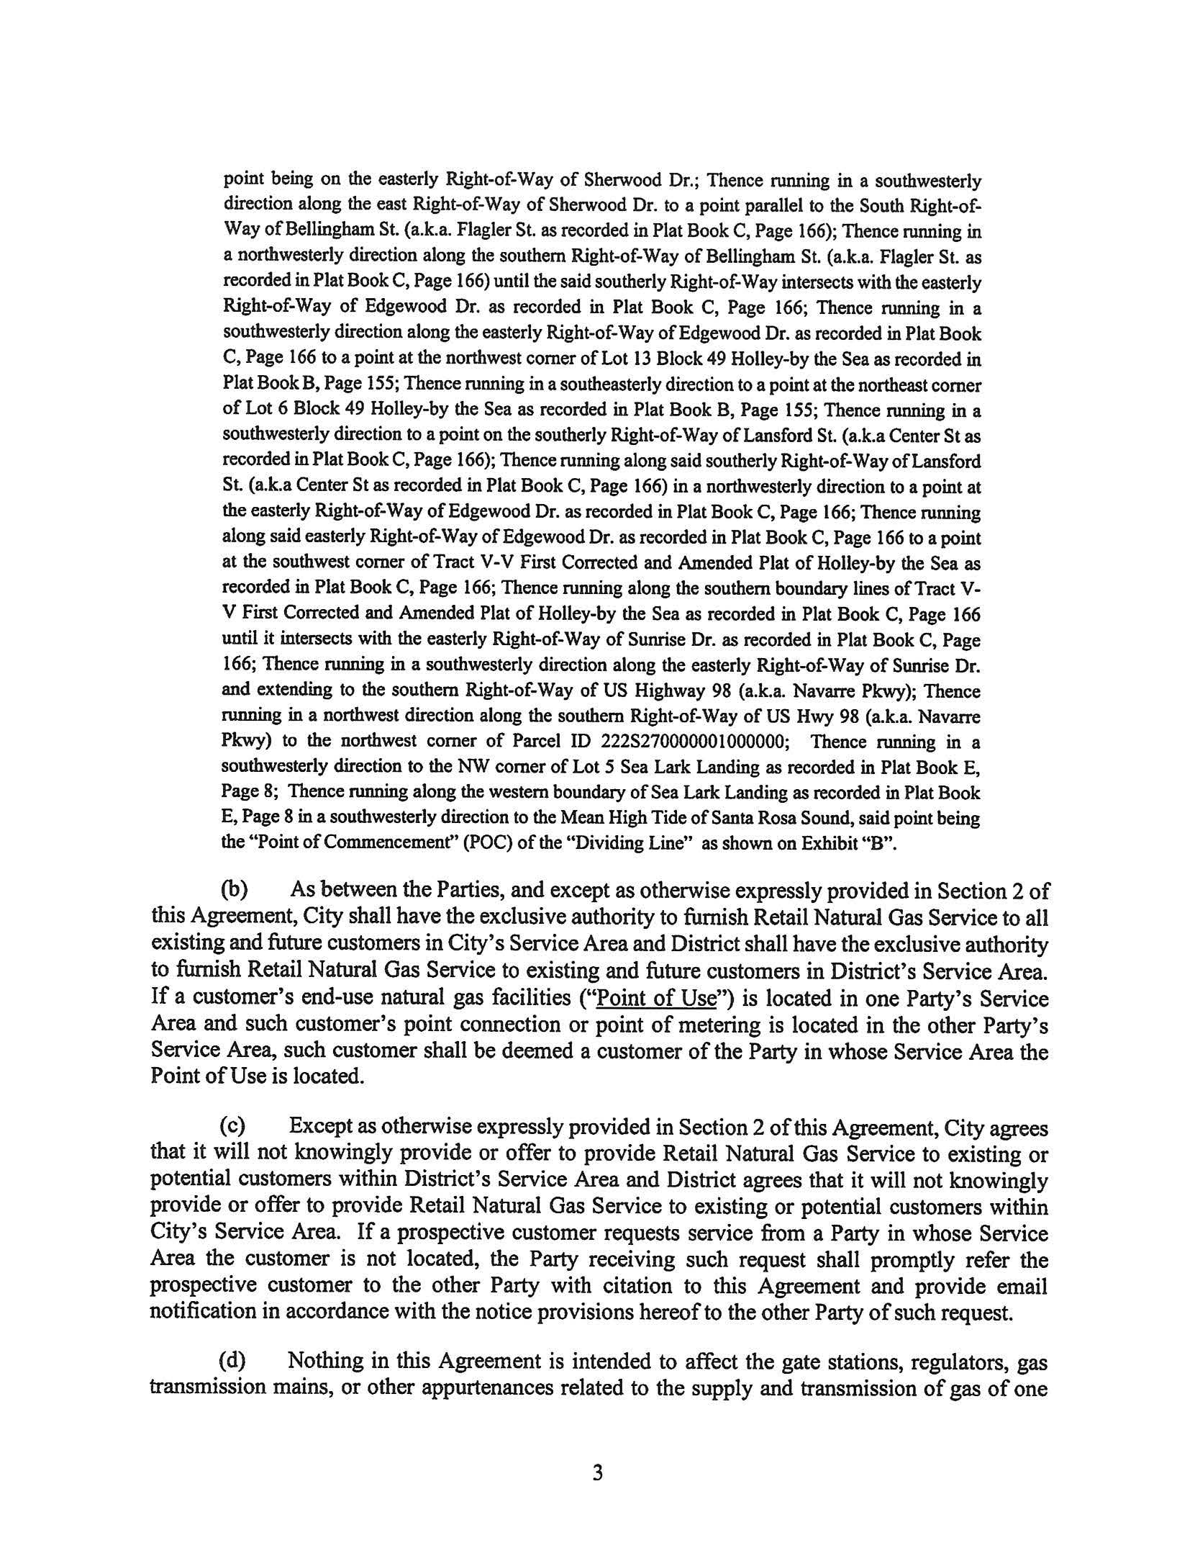

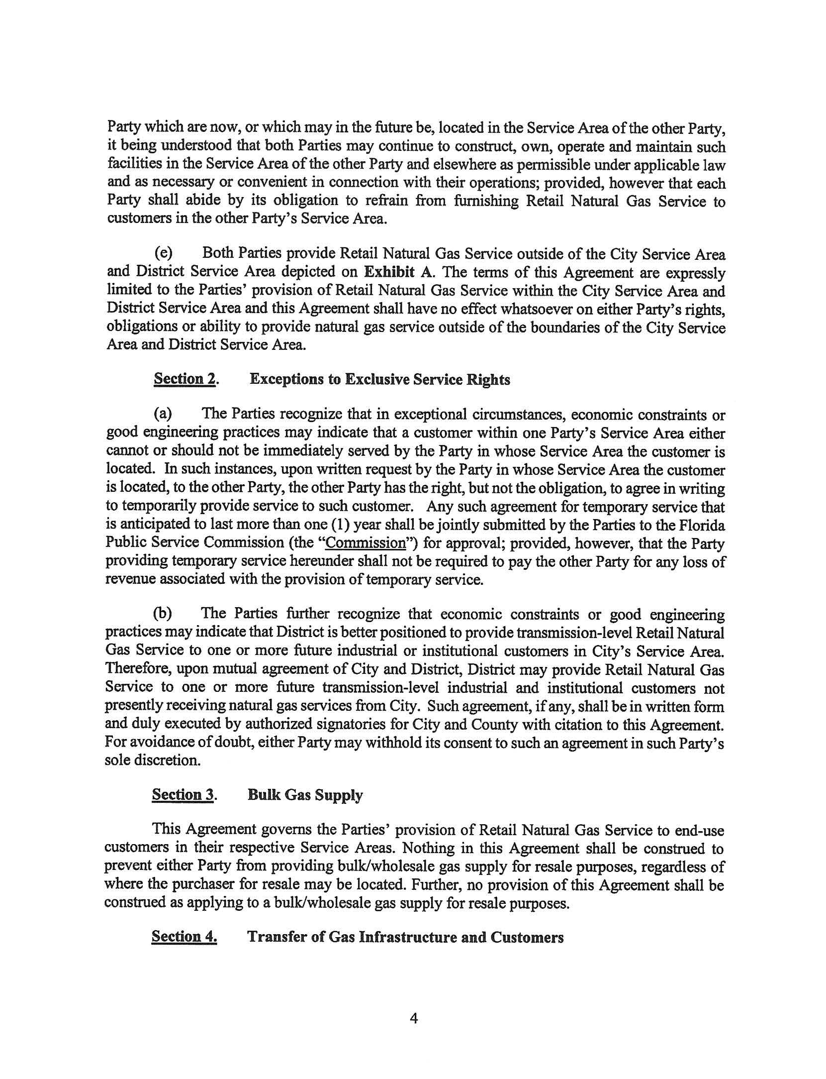

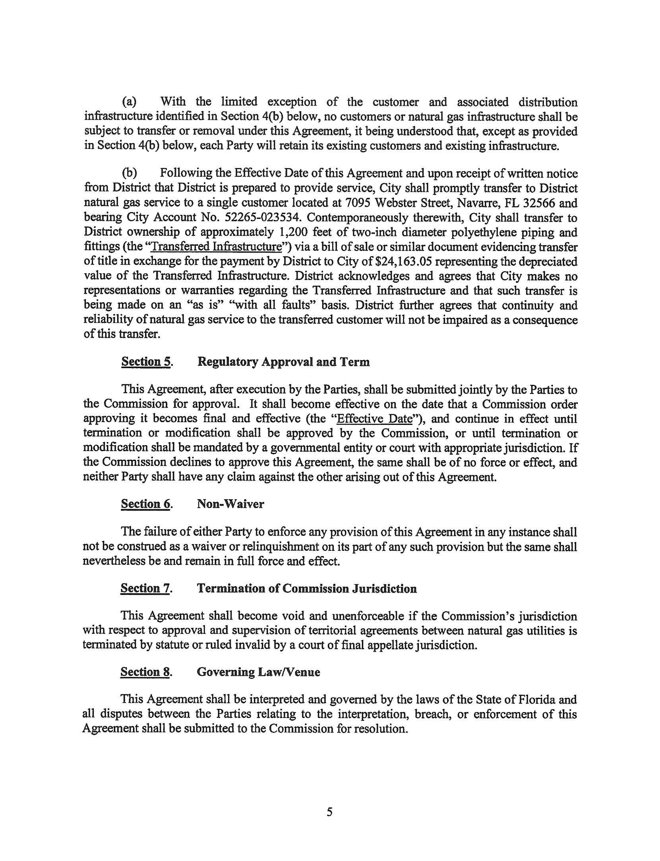

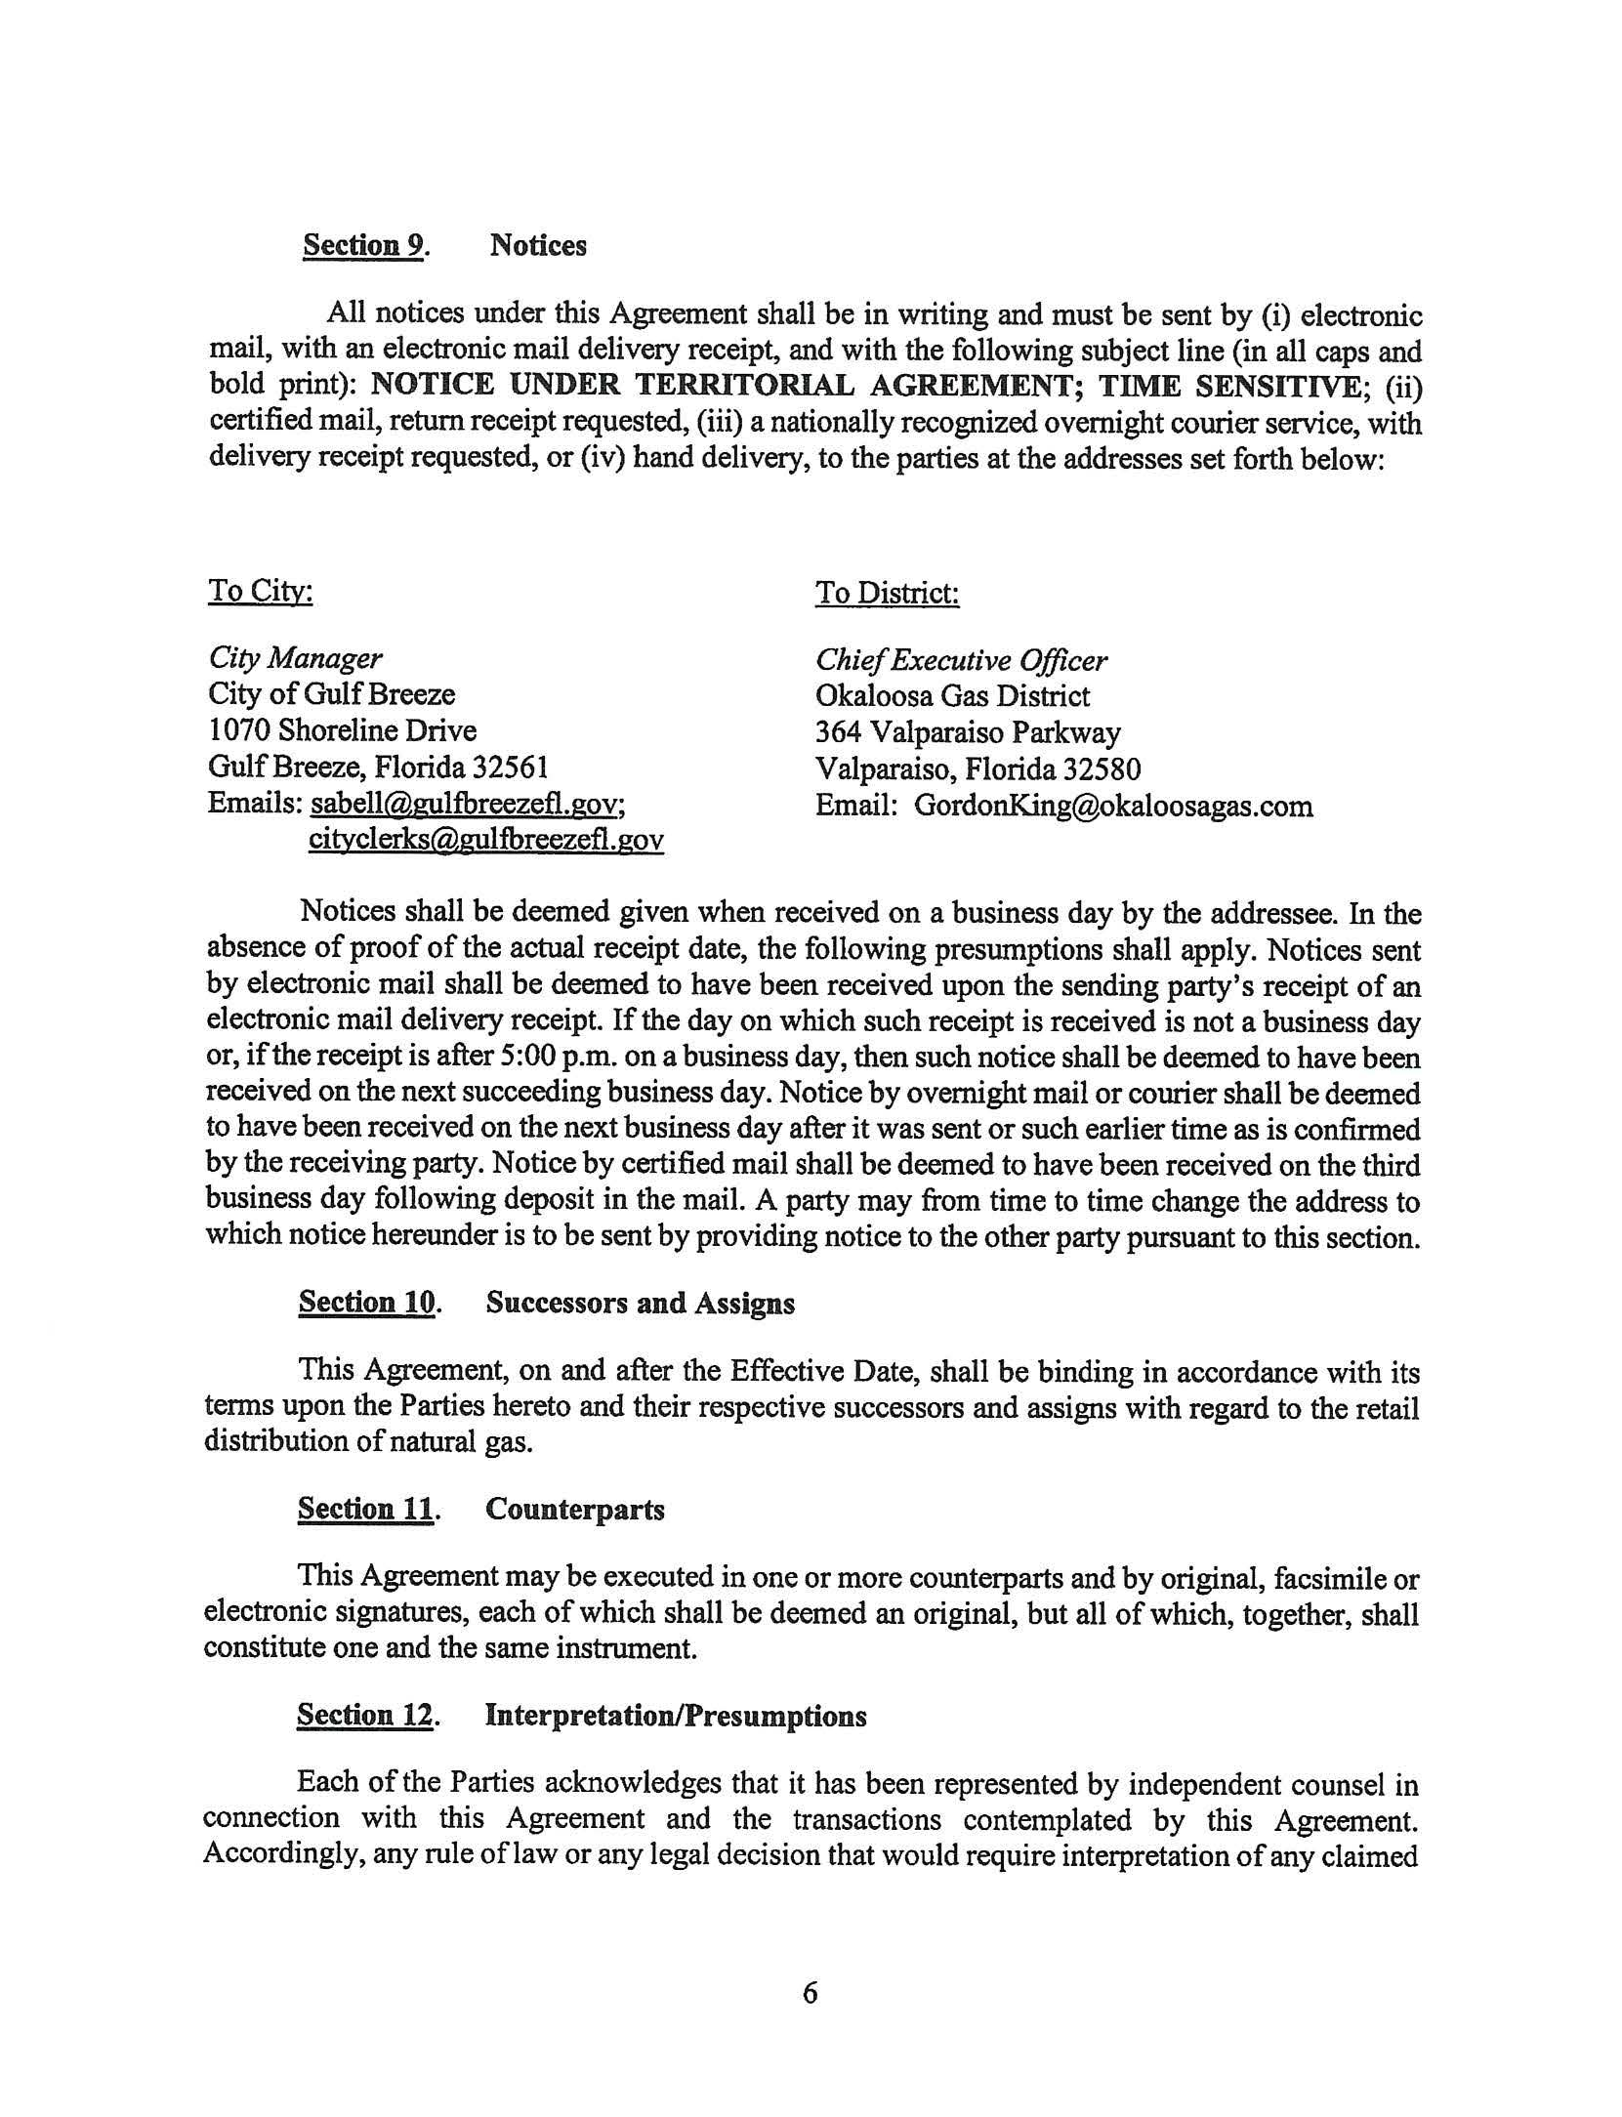

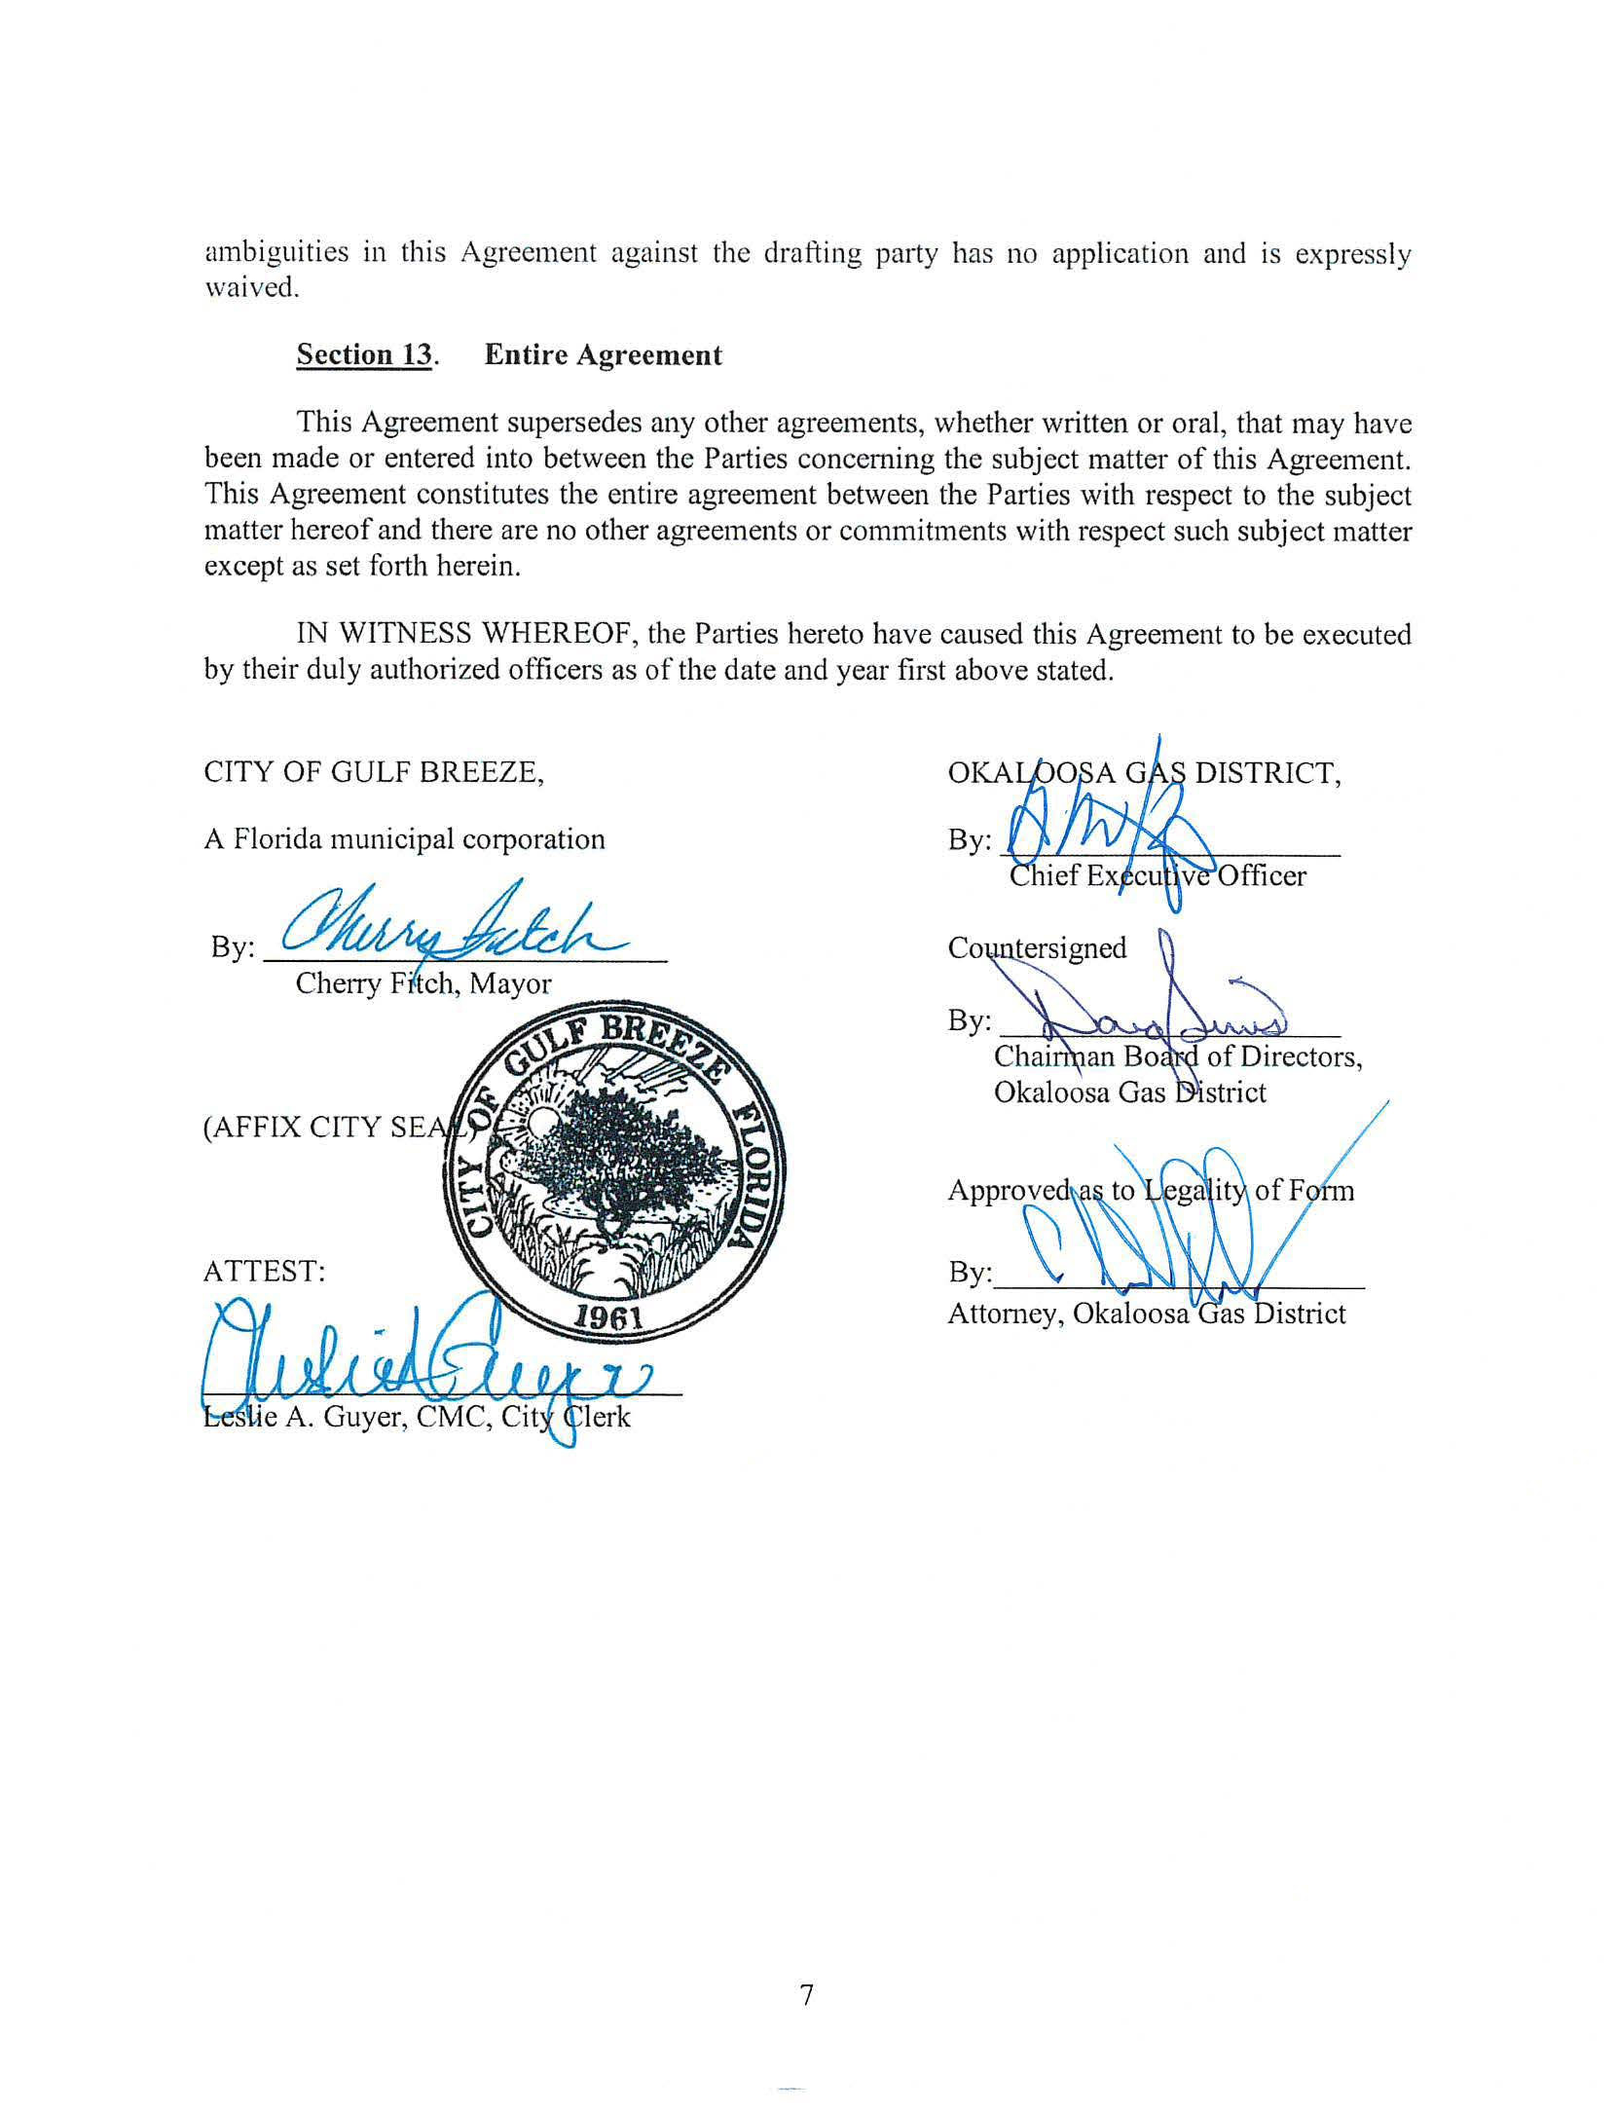



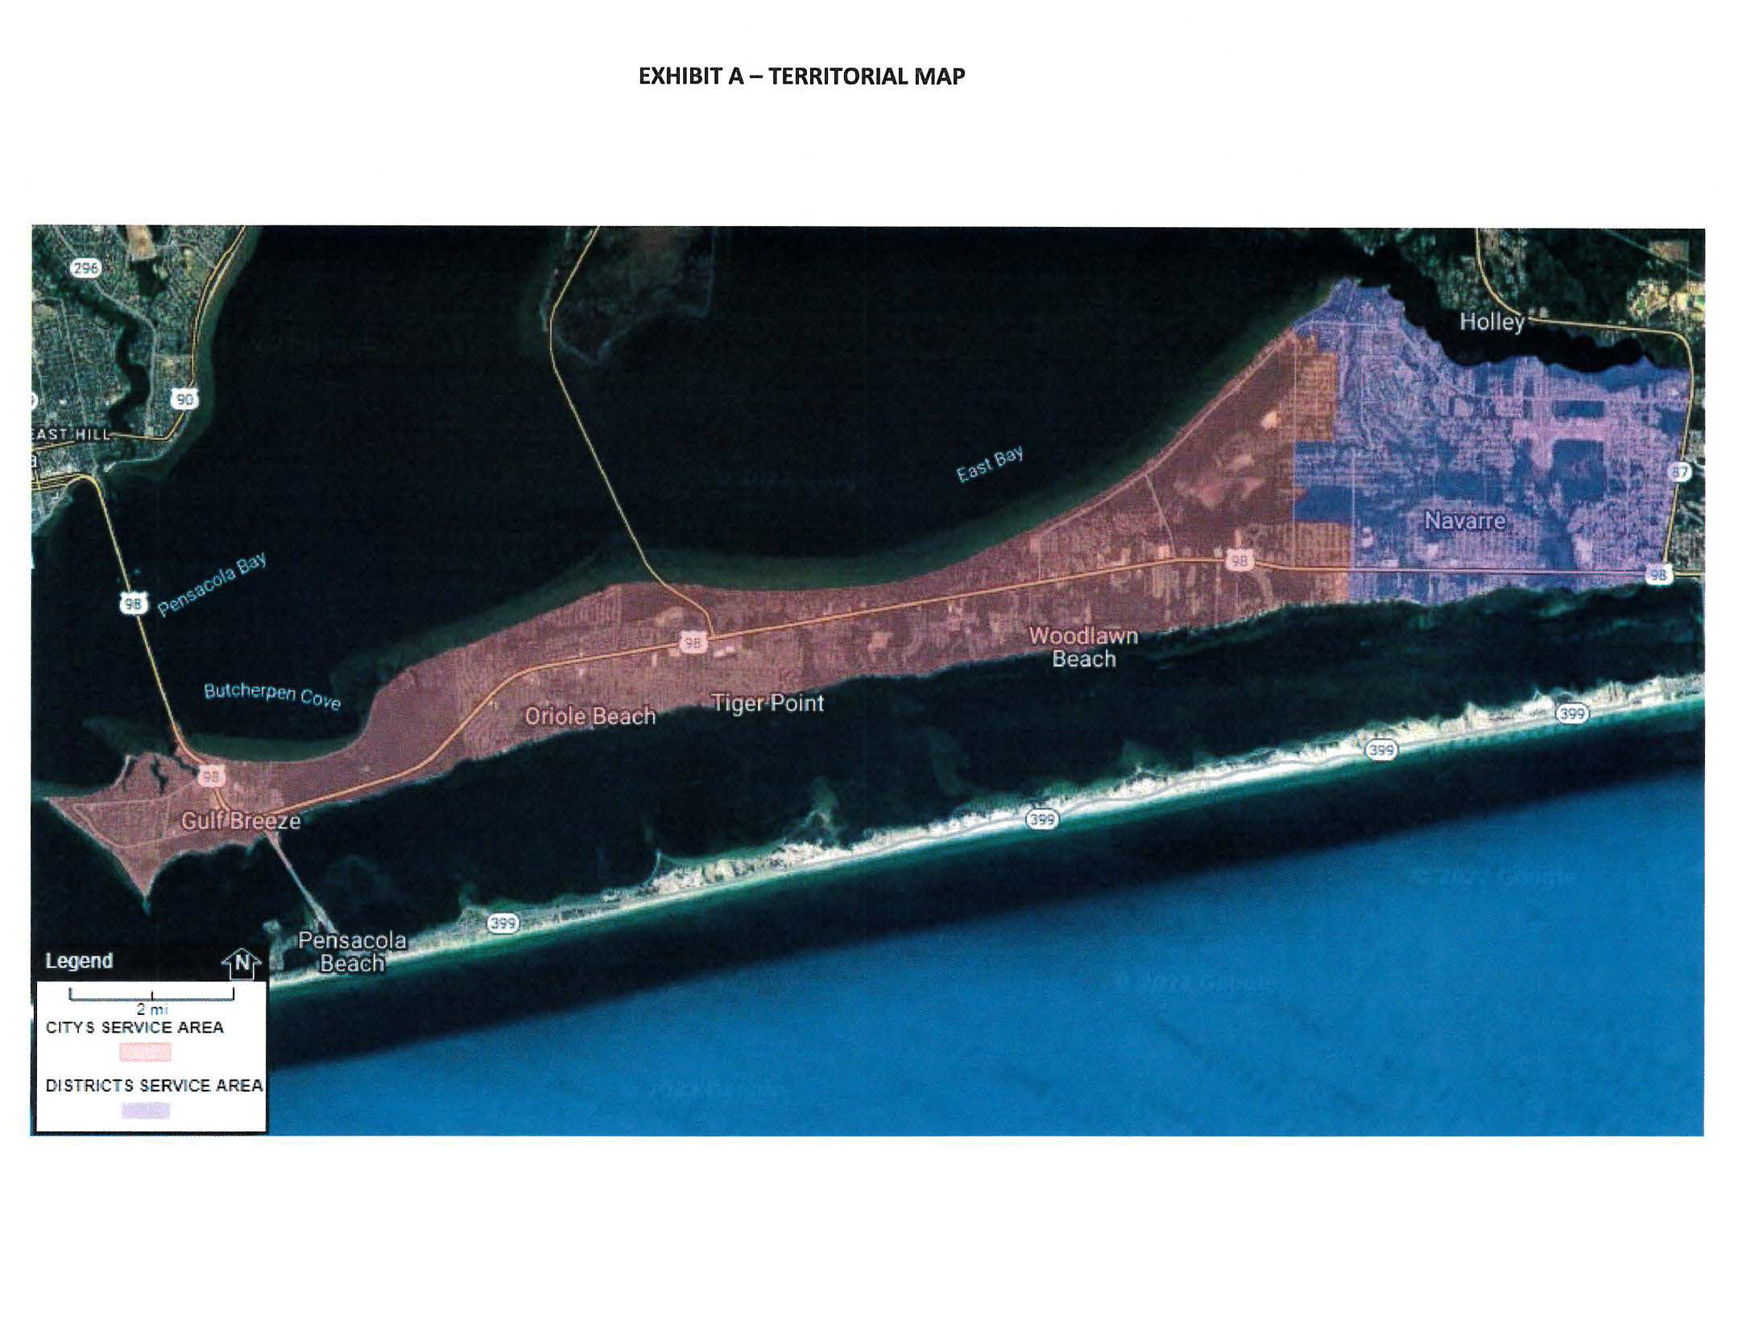

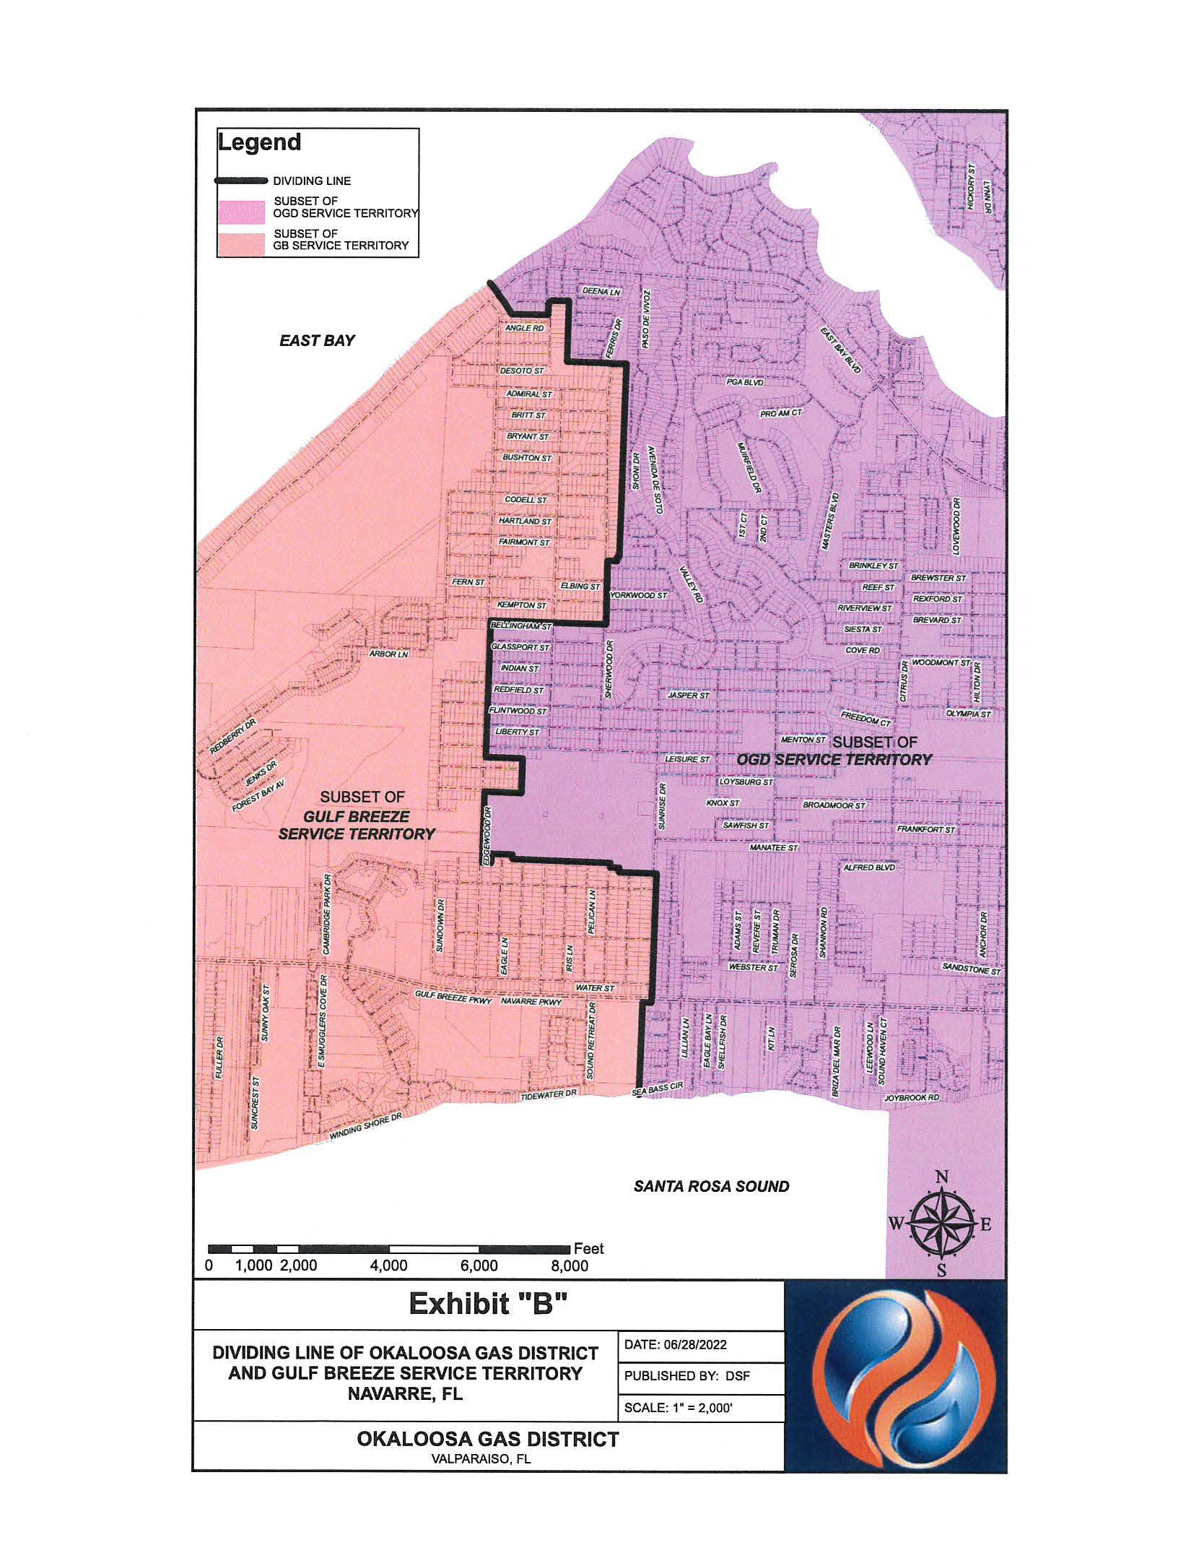

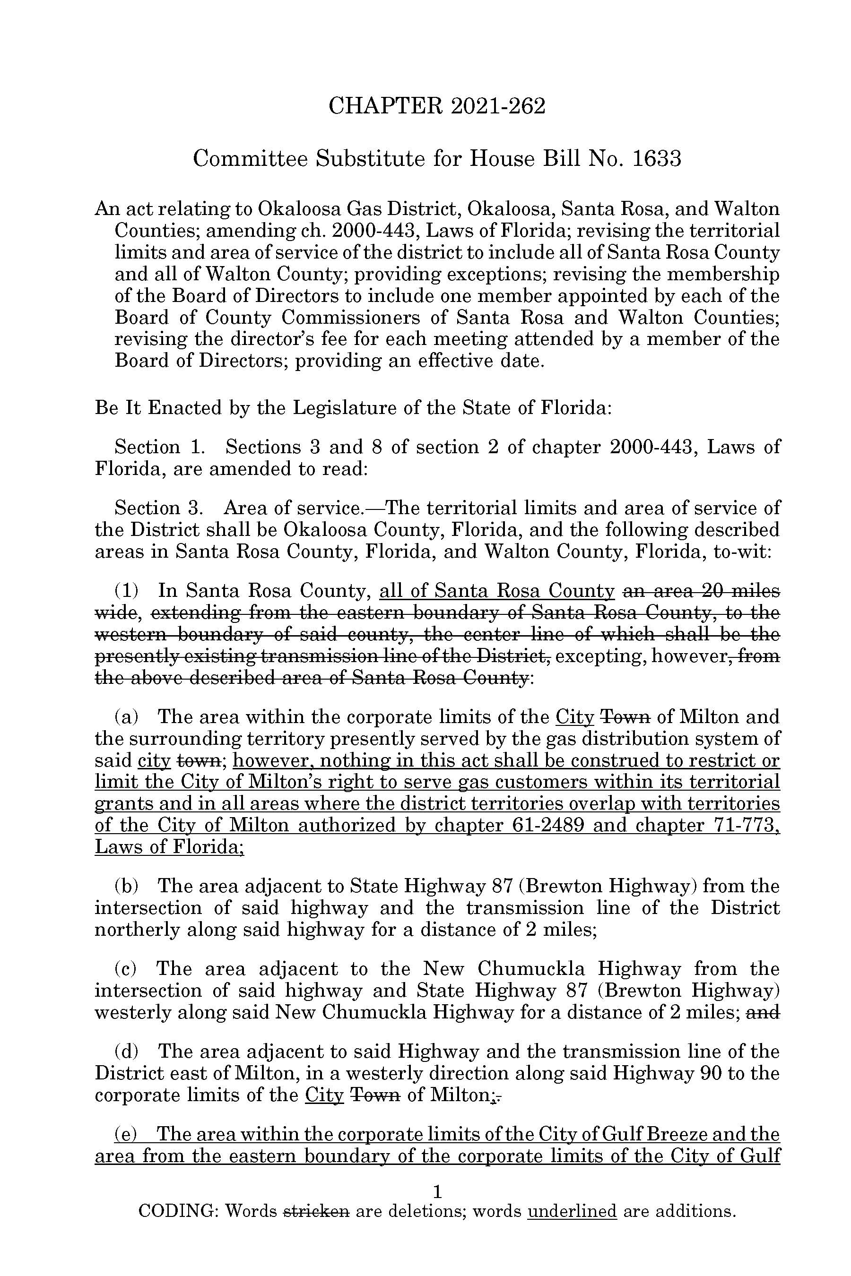

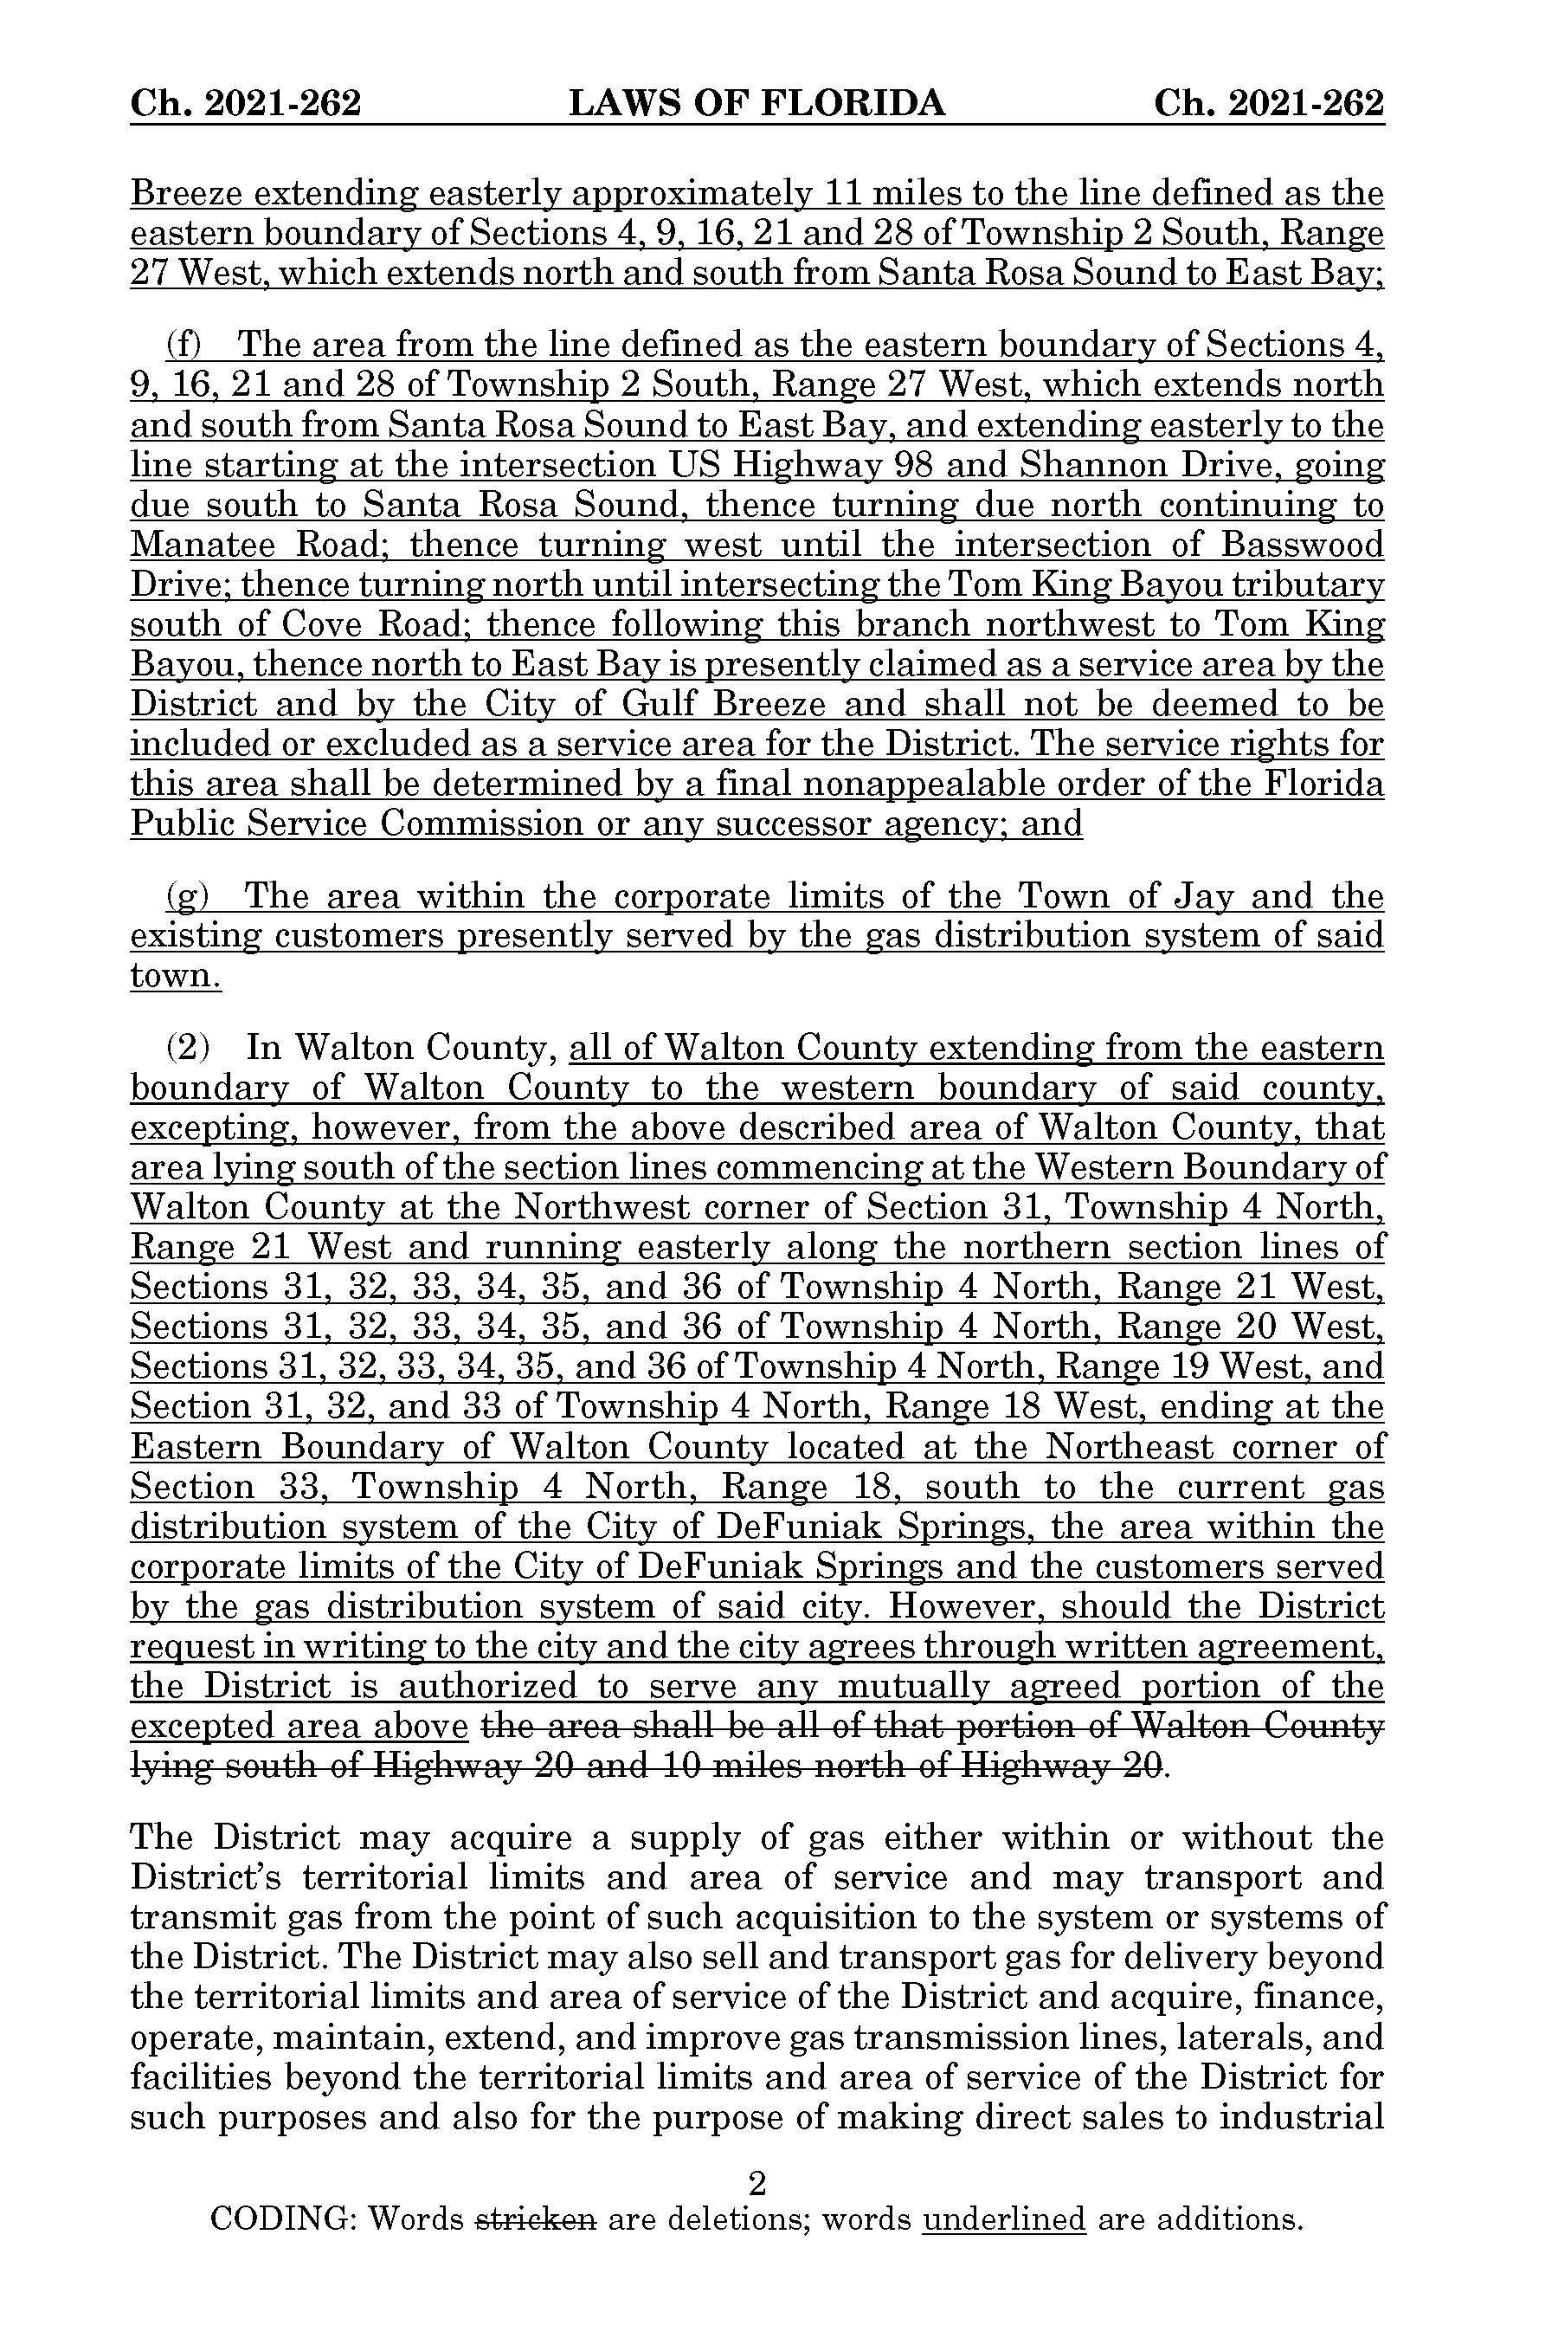

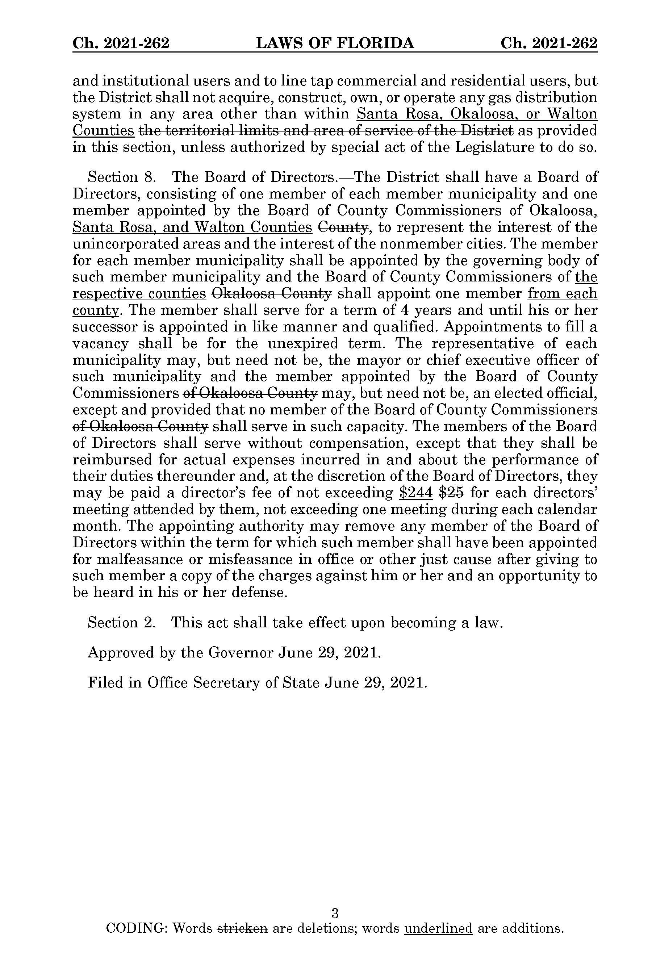

1. *Utilities Commission of the City of New Smyrna Beach v. Florida Public Service Commission*, 469 So. 2d 731 (Fla. 1985).
2. Chapter 29334, Laws of Florida.
3. Response 2 in Staff’s First Data Request, Document No. 11563-2022.
4. Response No. 3 in Staff’s First Data Request, Document No. 11563-2022.
5. Response No. 6 in Staff’s First Data Request, Document No. 11563-2022.
6. Response No. 4 in Staff’s First Data Request, Document No. 11563-2022.
7. Response No. 5 in Staff’s First Data Request, Document No. 11563-2022.