BEFORE THE FLORIDA PUBLIC SERVICE COMMISSION

In re: Joint petition for approval of amendment to territorial agreement in Pasco County, by Florida Public Utilities Company and Peoples Gas System, Inc. | DOCKET NO. 20230125-GU  ORDER NO. PSC-2024-0043-PAA-GU  ISSUED: February 19, 2024

The following Commissioners participated in the disposition of this matter:

MIKE LA ROSA, Chairman
ART GRAHAM
GARY F. CLARK
ANDREW GILES FAY
GABRIELLA PASSIDOMO

NOTICE OF PROPOSED AGENCY ACTION
ORDER APPROVING AMENDMENT OF TERRITORIAL AGREEMENT

BY THE COMMISSION:

NOTICE is hereby given by the Florida Public Service Commission that the action discussed herein is preliminary in nature and will become final unless a person whose interests are substantially affected files a petition for a formal proceeding, pursuant to Rule 25-22.029, Florida Administrative Code (F.A.C.).

Background
On November 3, 2023, Florida Public Utilities Company (FPUC) and Peoples Gas System, Inc. (Peoples), collectively the joint petitioners, filed a petition seeking our approval of a first amendment (Amendment No. 1) to the Amended and Restated Territorial Agreement – Pasco County (Pasco Agreement). In November 2007, we approved the Pasco Agreement, along with a Master Territorial Agreement (Master Agreement) and a gas transportation agreement between the Florida Division of Chesapeake Utilities Corporation and Peoples. This Master Agreement contains terms and conditions that govern all territorial agreements entered into by Peoples and Chesapeake. The joint petitioners, through Amendment No. 1, seek our approval to adjust the utilities’ shared service boundary.

During the review of this joint petition, our staff issued a data request to the joint petitioners on November 17, 2023, for which responses were received on December 13, 2023.

On January 10, 2024, the parties filed a corrected version of Amendment No. 1. The corrected version, initialed by counsel, contains the date that the amendment was entered into by the parties (October 31, 2023), which was inadvertently omitted in the original version submitted with the petition. No other changes were made to the corrected version of Amendment No. 1. Amendment No. 1 is shown as Attachment A to this order.

We have jurisdiction over this matter pursuant to Section 366.04, Florida Statutes (F.S.).

Decision
- Proposed Amendment to Territorial Agreement

FPUC and Peoples began territorial agreement discussions after a developer announced plans for a commercial complex in Service Area B. The previously undeveloped parcel of land in FPUC’s service territory is located geographically a considerable distance from the company’s existing natural gas facilities, but very close to existing facilities operated by Peoples. The proposed Amendment No. 1 will facilitate serving the new commercial development within the geographic area described in Amendment No. 1 – Exhibit A as Service Area B (Attachment A). Service Area B is about 12,212 acres in size, and the new commercial development is projected to include a grocery store and other retail outparcels totaling about 60,000 square feet. The joint petitioners assert that in the next 5 to 10 years, further development within the Service Area B could result in up to 1,000 new residential and commercial customers.

FPUC determined that its nearest facilities to Service Area B are approximately 24 miles away in Plant City. The utility asserted that construction of new facilities from its existing facilities in Plant City to Service Area B would cost several million dollars. Although a specific estimate was not developed, FPUC determined it was unable to extend service to the development economically and thus pursued the territorial modifications set forth in this petition.

Peoples, on the other hand, has natural gas facilities about 320 feet away from Service Area B on County Road 577 (Curley Road). To provide natural gas services to Service Area B, Peoples would need to construct 170 linear feet of main lines, 150 linear feet of service lines, and a distinct regulator station, which Peoples estimate would cost $105,000. Based on the comparative difference in the amount of required infrastructure, Peoples can more economically serve the commercial development than FPUC and is willing to do so.

Pursuant to Paragraphs 3.D. and 3.E. of the Master Agreement, the joint petitioners have entered into Amendment No. 1 which, if approved, would transfer Service Area B from FPUC to Peoples. Pursuant to Paragraph 5 of Amendment No. 1, the terms and conditions of the Pasco Agreement would remain unchanged going forward. Prior to the second anniversary of our approval of Amendment No. 1, and no more frequently than every five years thereafter, Peoples and FPUC will confer regarding the status of the amendment.

The joint petitioners state that the approval and implementation of Amendment No. 1 will not cause a decrease in the availability or reliability of natural gas service provided by either entity, or to the existing or future ratepayers of either entity, consistent with the standards set forth in Section 366.04, F.S., and Rule 25-7.0471(2)(c), F.A.C. As stated in paragraph 6 of the petition, approval of Amendment No. 1 will enable as many residential and business customers in Pasco County as possible to receive economical and reliable natural gas service and will not necessitate the transfer of any existing customers or facilities between the joint petitioners. Moreover, as stated in paragraph 6, absent the subject amendment, certain customers in Pasco County would be unable to obtain natural gas service; thus, the approval of Amendment No. 1 would be in the public interest.

- Rule Considerations

Rule 25-7.0471(2), F.A.C., addresses the standards we must consider when approving territorial agreements for natural gas utilities. The Rule states:

(2) Standards for Approval. In approving territorial agreements, the Commission shall consider:
(a) The reasonableness of the purchase price of any facilities being transferred;
(b) The reasonable likelihood that the agreement, in and of itself, will not cause a decrease in the reliability of natural gas service to the existing or future ratepayers of any utility party to the agreement, and
(c) The reasonable likelihood that the agreement will eliminate existing or potential uneconomic duplication of facilities.
(d) Other relevant factors that may arise from the circumstances of a particular case.

In our review, we considered each component of Rule 25-7.0471(2), F.A.C. Regarding paragraph (2)(a), we note that FPUC agreed to transfer the pertinent area to Peoples without compensation, which is reasonable because no facilities are being transferred. Regarding paragraph (2)(b), the joint petitioners’ have confirmed that the availability and reliability of service to existing or future customers will not be decreased for either petitioner. The joint petitioners verified that there are no natural gas facilities in Service Area B and that construction would be necessary to service that geographic area. Paragraph (2)(c) has been appropriately considered because, under the proposed territorial agreement, uneconomic duplication of facilities will not occur because Peoples facilities are better positioned to serve the area economically and efficiently. We find that paragraph(2)(d) gives us the flexibility to address any other relevant concerns that are case-specific. The joint petitioners assert that there are none.

Under Rule 25-7.0471(1)(e), F.A.C., a proposed territorial agreement must provide information regarding the degree of acceptance by affected customers. We note, however, that in the instant case, there are no current customers and under this proposed territorial agreement, no facility transfers are contemplated. In addition, representatives from FPUC and Peoples have notified us that the developer is aware of, and has no objection to, the proposed territorial agreement.

- Conclusion

We approve the proposed Amendment No. 1, which transfers a portion of FPUC’s service territory to Peoples. The proposed Amendment No. 1 will facilitate the provision of economical and reliable natural gas service by Peoples to residential and business customers in the proposed transfer area identified as Service Area B in Amendment No. 1 – Exhibit A, thereby avoiding duplication of facilities and services.

Based on the foregoing, it is

ORDERED by the Florida Public Service Commission that the proposed Amendment No. 1 to the Amended and Restated Territorial Agreement – Pasco County between Florida Public Utilities Company and Peoples Gas System, Inc., shall be approved. It is further

ORDERED that the provisions of this Order, issued as proposed agency action, shall become final and effective upon the issuance of a Consummating Order unless an appropriate petition, in the form provided by Rule 28-106.201, Florida Administrative Code, is received by the Commission Clerk, 2540 Shumard Oak Boulevard, Tallahassee, Florida 32399-0850, by the close of business on the date set forth in the “Notice of Further Proceedings” attached hereto. It is further

ORDERED that in the event this Order becomes final, this docket shall be closed.

By ORDER of the Florida Public Service Commission this 19th day of February, 2024.

/s/ Adam J. Teitzman
ADAM J. TEITZMAN
Commission Clerk
Florida Public Service Commission
2540 Shumard Oak Boulevard
Tallahassee, Florida 32399
(850) 413-6770
www.floridapsc.com

Copies furnished: A copy of this document is provided to the parties of record at the time of issuance and, if applicable, interested persons.

DD

NOTICE OF FURTHER PROCEEDINGS OR JUDICIAL REVIEW

The Florida Public Service Commission is required by Section 120.569(1), Florida Statutes, to notify parties of any administrative hearing that is available under Section 120.57, Florida Statutes, as well as the procedures and time limits that apply. This notice should not be construed to mean all requests for an administrative hearing will be granted or result in the relief sought.

Mediation may be available on a case-by-case basis. If mediation is conducted, it does not affect a substantially interested person's right to a hearing.

The action proposed herein is preliminary in nature. Any person whose substantial interests are affected by the action proposed by this order may file a petition for a formal proceeding, in the form provided by Rule 28-106.201, Florida Administrative Code. This petition must be received by the Office of Commission Clerk, 2540 Shumard Oak Boulevard, Tallahassee, Florida 32399-0850, by the close of business on March 11, 2024.

In the absence of such a petition, this order shall become final and effective upon the issuance of a Consummating Order.

Any objection or protest filed in this/these docket(s) before the issuance date of this order is considered abandoned unless it satisfies the foregoing conditions and is renewed within the specified protest period.

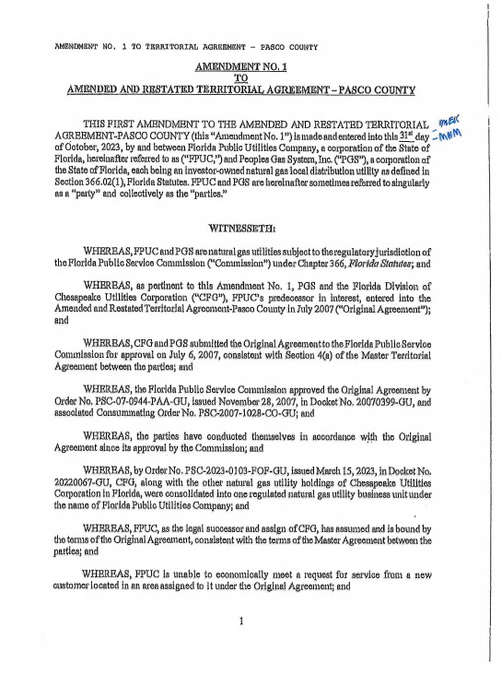
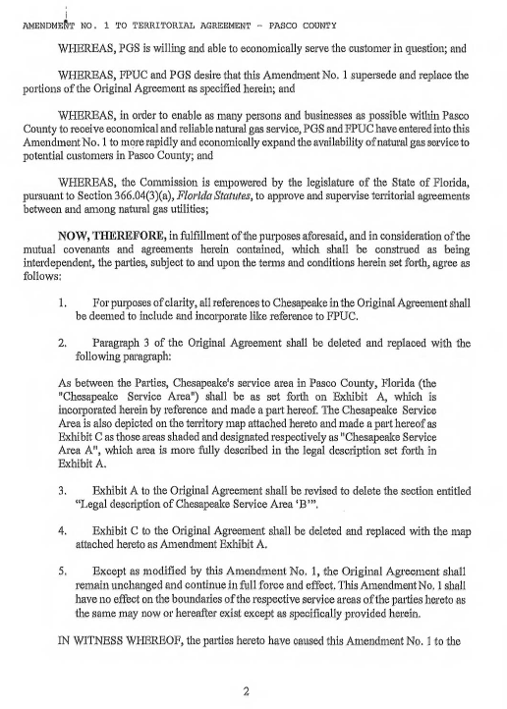
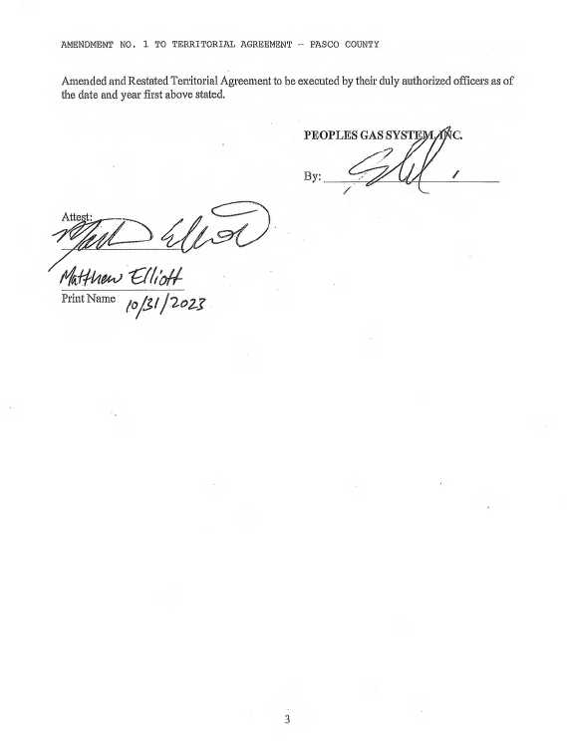
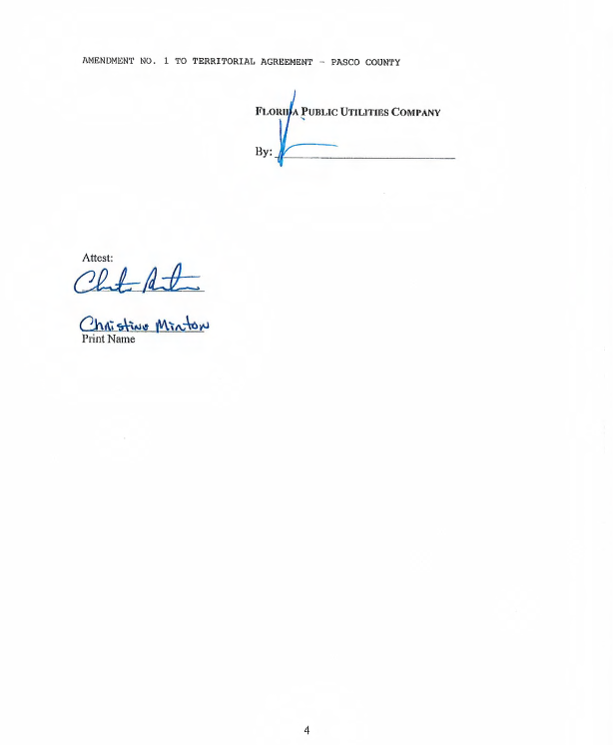
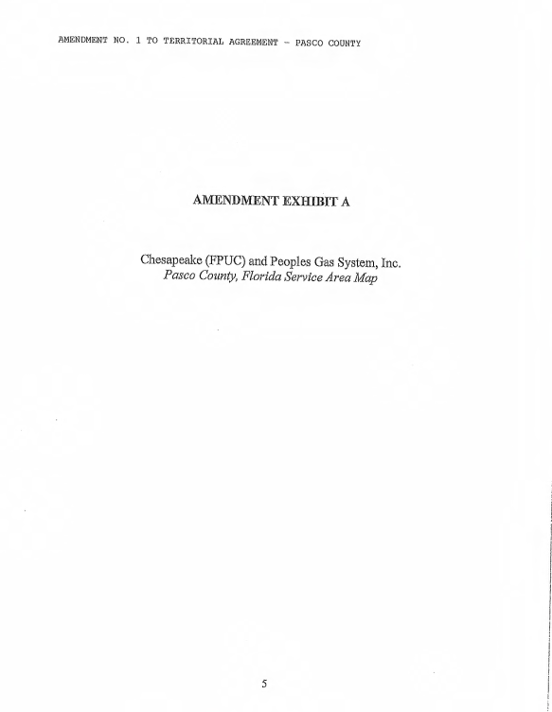
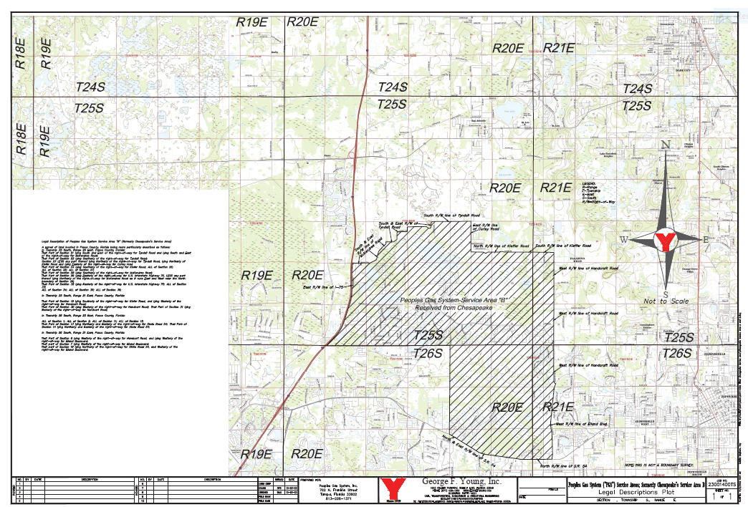

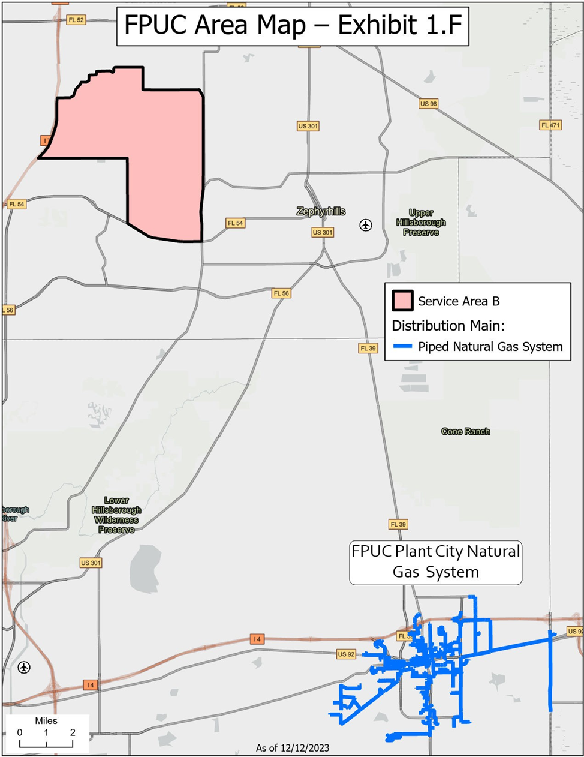

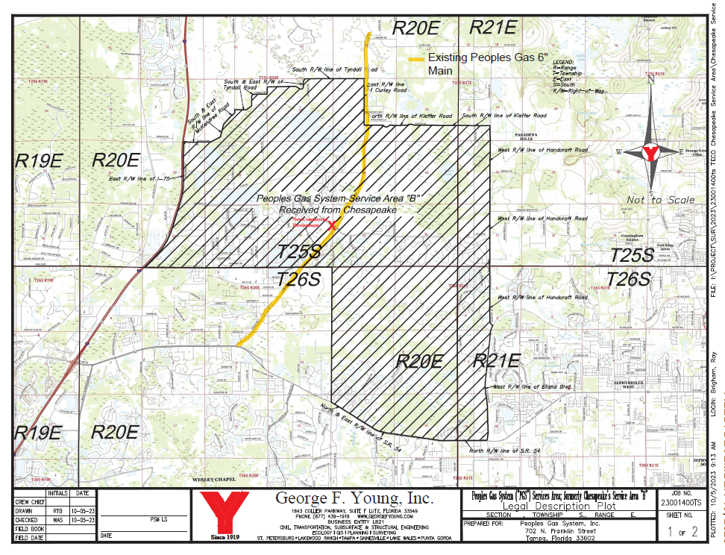

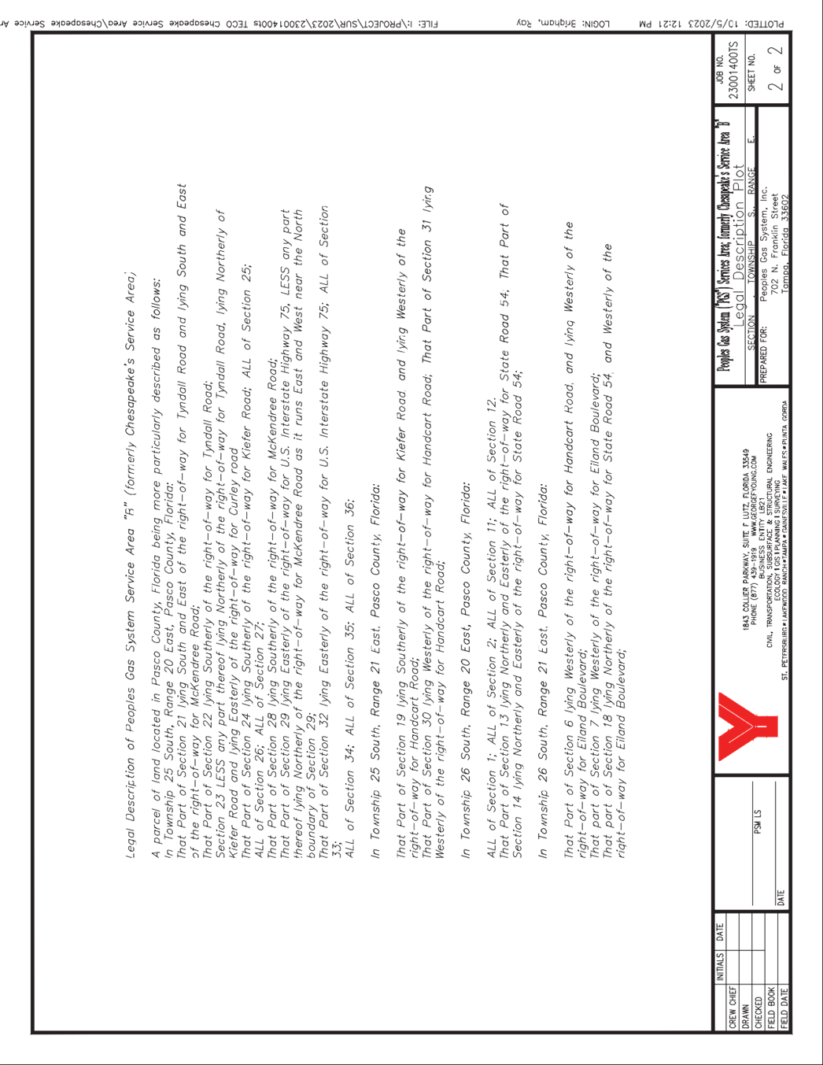

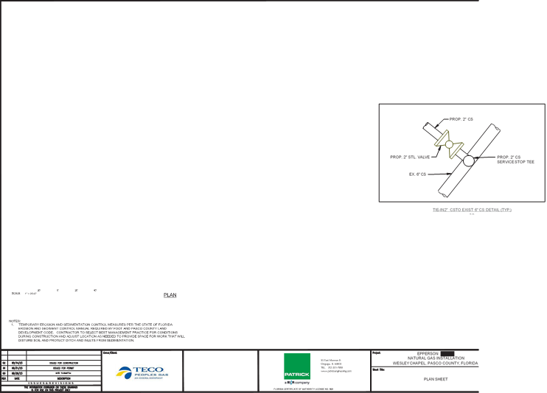
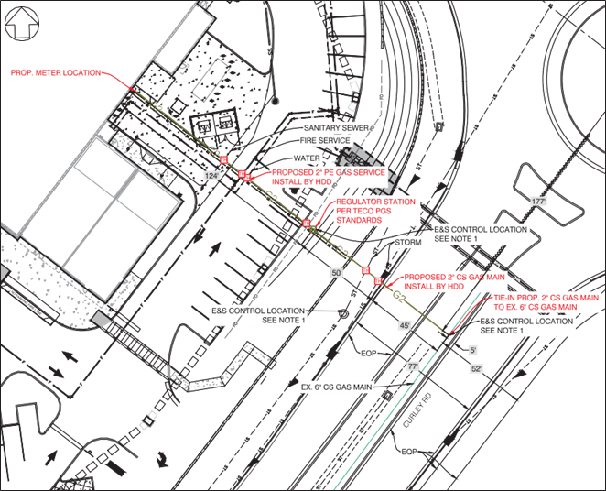

By ORDER NO. PSC-2024-0043-PAA-GUPSC-2023-0103-FOF-GU, issued March 15, 2023, in Docket No. 20220067-GU, the Florida Division of Chesapeake Utilities Corporation, as well as FPUC’s Indiantown Division and Fort Meade Division, were consolidated with Florida Public Utilities Corporation, under the name of Florida Public Utilities Company. FPUC has assumed the rights and responsibilities under all pertinent agreements entered into by its predecessor, the Florida Division of Chesapeake Utilities Corporation, also known as CFG.
ORDER NO. PSC-2024-0043-PAA-GUPSC-2007-0944-PAA-GU, issued November 28, 2007, in Docket No. 20070399-GU, In re: Joint Petition for approval of territorial agreement in Pasco County, master territorial agreement, and gas transportation agreement, by Peoples Gas System and the Florida Division of Chesapeake Utilities Corporation.
Id.
See Document No. 00141-2024.
Document No. 06579-2023, Staff’s First Data Request, No. 5.
Document No. 06579-2023, Staff’s First Data Request, No. 1.
Id.
See Footnote 2, citing the Master Agreement approved by ORDER NO. PSC-2024-0043-PAA-GUPSC-2007-0944-PAA-GU.
Document No. 06579-2023, Staff’s First Data Request, No. 4.
Document No. 06579-2023, Staff’s First Data Request, No. 3.
Document No. 06579-2023, Staff’s First Data Request, No. 4.
Id.
Id.

