BEFORE THE FLORIDA PUBLIC SERVICE COMMISSION

In re: Petition for approval of tariff modifications to implement transportation balancing charge rider, by Florida City Gas. | DOCKET NO. 20230110-GU  ORDER NO. PSC-2024-0076-TRF-GU  ISSUED: March 22, 2024

The following Commissioners participated in the disposition of this matter:

MIKE LA ROSA, Chairman
ART GRAHAM
GARY F. CLARK
ANDREW GILES FAY
GABRIELLA PASSIDOMO

ORDER APPROVING TRANSPORTATION BALANCING CHARGE RIDER

BY THE COMMISSION:

Background
On September 26, 2023, Florida City Gas (FCG or utility) filed a petition for approval of tariff modifications to implement a new transportation balancing charge rider (balancing charge or rider).
FCG is an investor-owned natural gas utility that provides service to two different types of gas supply customers: sales customers and transportation customers. Sales customers purchase gas from the utility and are charged the Purchased Gas Adjustment (PGA) for the cost of natural gas, in addition to base rates. Transportation customers are commercial and industrial customers that elect to purchase their natural gas supply from a gas marketer authorized as a third party supplier by FCG. Transportation customers negotiate directly with third party suppliers (TPS) for the purchase of the natural gas commodity and are not charged the PGA by the utility. The proposed rider is a dollar-per-therm charge that would be included in the monthly gas bill for transportation customers only.
Natural gas imbalances occur when the quantity of natural gas nominated and delivered from the source to FCG’s interconnections differs from the amount of gas actually consumed by customers. Imbalances are created by sales customers and transportation customers. The utility balances the system on behalf of its sales customers; for transportation customers the TPS typically takes steps to mitigate delivery and consumption imbalances. FCG does not hold capacity on behalf of transportation customers or their TPS; therefore the TPS is responsible for transporting the natural gas and obtain firm interstate capacity to do so.
FCG is responsible for balancing the system in order to maintain the appropriate supply of natural gas and avoid imbalance penalties from interstate pipelines. The utility uses available interstate and intrastate capacity and storage to vary (swing) the level of gas to resolve system imbalances. The costs associated with the capacity and storage used to resolve imbalances are currently recovered solely through the PGA from sales customers. Currently, no cost recovery mechanism exists for transportation customers, as a result, the cost of imbalances incurred by transportation customers is subsidized by sales customers.
The proposed rider is similar to the swing service riders first implemented by Peoples Gas System in 2000 and modified in 2015, and by Florida Public Utilities Company in 2016. The methods used to calculate the balancing charge differ slightly from the methods used to calculate the swing service riders, but the balancing charge performs the same function of mitigating subsidization between sales and transportation customers.
We suspended the proposed tariffs on November 9, 2023, in Order No. PSC-2023-0357-PCO-GU. FCG supplied additional information in responses to staff’s first and second data requests on November 6, 2023 and December 21, 2023, respectively. This order hereby approves the proposed rider and associated tariffs. The approved tariffs are attached to this order as Attachment A.
We have jurisdiction over this matter pursuant to Sections 366.03, 366.04, 366.05, and 366.06, Florida Statutes (F.S.).

Decision

In its petition, FCG explained that the purpose of the proposed rider is to recover the cost of transportation and storage fees incurred on behalf of transportation customers. Of the $12.8 million in total capacity and storage costs included in the projection for the PGA for calendar year 2024, the utility calculated that transportation customers are projected to be responsible for about $1 million. As approved, the rider is a dollar-per-therm charge applicable to transportation customers. The utility will book all revenues recovered from the charge as a credit to the utility’s annual PGA filing, as discussed further in this order.

Calculation of Transportation Balancing Charge
FCG proposed to calculate the balancing charge by allocating a portion of the total capacity and storage costs currently recovered through the PGA based on the monthly average system-wide total TPS imbalance as a percentage of FCG’s total capacity and storage. Appendix 4 to the petition provides the calculation of TPS imbalances as a percentage of FCG’s total capacity and storage and the resulting two-year average imbalance of 7.85 percent (7.81 percent for 2021 and 7.88 percent for 2022).
In its PGA projection filing for 2024, FCG estimated that its capacity and storage costs would be about $12.8 million. These costs were included and approved by us for the calculation of the 2024 PGA factor. Allocating 7.85 percent of the total capacity and storage costs to transportation customers results in approximately $1 million to be collected by the rider from transportation customers, as shown on Appendix 3 to the petition. Appendix 3 shows that the utility uses Bay Gas Storage (located in Mobile, Alabama) and transports natural gas into Florida on the Florida Gas Transmission interstate pipeline and Peninsula intrastate pipeline.
FCG would then apportion the 2024 balancing charge revenue requirement ($1,004,482) to individual transportation customer classes by forecasted annual therms to develop the per-therm charge, as calculated in Appendix 5 to the petition. FCG has calculated the balancing charge to be $0.00780/therm.
We find that the proposed methodology to calculate the balancing charge is reasonable because it allocates the costs of storage and capacity from imbalances to the more appropriate cost-causers, further reducing cross-subsidization between customer classes.
In response to staff’s data request, FCG stated that the utility opted to calculate the average TPS imbalance using two years for its initial filing, as opposed to a multi-year average, as described in proposed tariff sheet No. 82. FCG explained that it relied upon the most accurate and complete data available for full calendar years and that the utility did not use calendar year 2020 due to impacts of COVID-19.

Future Revisions to Transportation Balancing Charge
Pursuant to subsection D of proposed tariff sheet No. 82, FCG has proposed to file an updated rider charge if there are future material changes in the total capacity and storage costs booked to the PGA. Furthermore, the utility has proposed to track the average monthly TPS balances on an annual basis and file an updated charge for our approval if the three-year average monthly system-wide total TPS imbalances change by more than 10 percent. FCG explained that although the utility used a combined two-year monthly average to estimate the initial imbalance, FCG believes using a three-year average going forward is a reasonable method to track TPS imbalances on a rolling basis each year.
We find that FCG’s proposal for future revisions to the balancing charge is a reasonable methodology to track changes to TPS imbalances and their associated storage and capacity costs.

Transportation Balancing Charge Revenue Credit to the PGA
In its petition at paragraph 14, the utility asserts that its interstate and intrastate costs are currently being charged to the PGA cost recovery clause and paid exclusively by sales customers. As background information, the PGA clause authorizes investor-owned natural gas utilities within our jurisdiction to recover prudently incurred commodity and gas transportation costs on a dollar-for-dollar basis for the gas it purchases and resells to its customers. Through an annual hearing process, the utilities file true-up and projection schedules, and we evaluate the actual and estimated costs presented in order to set a yearly maximum levelized upper limit factor, or cap for the upcoming (or forward) year. True-up balances from a prior year are used in the calculation to set the forward year PGA cap that sales customers pay.
FCG asserts that because transportation customer volumes can fluctuate, it will not prepare a forecast of per-therm revenue that the proposed balancing charge will generate. Instead, FCG plans to collect such revenues and apply them as a credit in the annual true-up filing for the PGA. The application of the rider as a credit in the utility’s final true-up schedule will effectively reduce the subsidization burden that sales customers have been carrying, since the credit is included in the costs that are used in establishing the forward-year PGA factor.

Customer Bill Impacts
The proposed rider would result in an increase in costs assigned to transportation customers, and a corresponding reduction of costs assigned to sales customers in the PGA. FCG provided estimated monthly bill impacts for average commercial and industrial transportation customers in Appendix 6 to the petition. Small commercial GS-1 transportation customers who consume 174 therms per month would see an increase of approximately $1.39, including Gross Receipts Tax.
FCG provided estimated impacts of the balancing charge on the PGA in response to staff’s data request. All things remaining equal and assuming that balancing charge revenues are recovered equally over a twelve-month period, FCG estimated that a credit of approximately $1 million to the PGA would reduce the maximum levelized 2024 PGA factor from $0.84816 per therm to $0.82773 per therm, a reduction of approximately two cents per therm for the sales customers. FCG notes that the savings actually realized by sales customers depends on several factors, such as the actual balancing charge revenues recovered and credited, effective date of the rider, applicable annual PGA cycle, and a sales customer’s individual usage.

Effective Date
In its petition, FCG stated that modifications to the utility’s billing system are necessary to implement the proposed balancing charge. FCG requested that we approve the balancing charge to become effective from the later of 30 days after our vote approving the proposed tariffs, or once the billing system modifications are complete. FCG shall notify staff once all billing system modifications are complete and the rider is ready to be implemented.
FCG explained that the utility provided notice of the proposed rider to all TPS on the system, as well as all existing transportation customers within 30 days of filing its petition. We have reviewed the customer noticing and confirmed that the notice reflects FCG’s balancing charge as proposed in its petition. FCG has also proposed to notify customers through a bill message immediately prior to the effective date of the rider.

Conclusion
Based on the information provided in FCG’s petition and in response to staff’s data requests, we approve FCG’s proposed transportation balancing charge and associated tariff, as provided in Attachment A to this order. The proposed balancing charge allows FCG to recover capacity and storage costs in a more equitable manner between transportation and sales customers and reduce cross-subsidization between transportation and sales customers. FCG shall incorporate actual revenues received from the balancing charge as a credit in the monthly PGA filings and in the annual final actual PGA true-up filing. The utility shall notify staff when the billing system modifications have been completed. The proposed tariffs shall become effective once all necessary billing system modifications have been completed.

Based on the foregoing, it is

ORDERED by the Florida Public Service Commission that Florida City Gas’ transportation balancing charge and associated tariff is approved. The rider allows FCG to recover capacity and storage costs in a more equitable manner between transportation and sales customers and reduce cross-subsidization between transportation and sale customers. FCG shall incorporate actual revenues received from the balancing charge as a credit in the monthly PGA filings and in the annual final actual PGA true-up filing. The utility shall notify staff when the billing system modifications have been completed. The tariffs shall become effective once all necessary billing system modifications have been completed.

ORDERED that if a protest is filed within 21 days of issuance of the Order, the tariff shall remain in effect with any charges held subject to refund pending resolution of the protest. It is further

ORDERED that if no timely protest is filed, this docket shall be closed upon the issuance of a Consummating Order.

By ORDER of the Florida Public Service Commission this 22nd day of March, 2024.

/s/ Adam J. Teitzman
ADAM J. TEITZMAN
Commission Clerk
Florida Public Service Commission
2540 Shumard Oak Boulevard
Tallahassee, Florida 32399
(850) 413-6770
www.floridapsc.com

Copies furnished: A copy of this document is provided to the parties of record at the time of issuance and, if applicable, interested persons.

MRT

NOTICE OF FURTHER PROCEEDINGS

The Florida Public Service Commission is required by Section 120.569(1), Florida Statutes, to notify parties of any administrative hearing or judicial review of Commission orders that is available under Sections 120.57 or 120.68, Florida Statutes, as well as the procedures and time limits that apply. This notice should not be construed to mean all requests for an administrative hearing or judicial review will be granted or result in the relief sought.

Mediation may be available on a case-by-case basis. If mediation is conducted, it does not affect a substantially interested person's right to a hearing.

The Commission's decision on this tariff is interim in nature and will become final, unless a person whose substantial interests are affected by the proposed action files a petition for a formal proceeding, in the form provided by Rule 28-106.201, Florida Administrative Code. This petition must be received by the Office of Commission Clerk, 2540 Shumard Oak Boulevard, Tallahassee, Florida 32399-0850, by the close of business on April 12, 2024.

In the absence of such a petition, this Order shall become final and effective upon the issuance of a Consummating Order.

Any objection or protest filed in this docket before the issuance date of this order is considered abandoned unless it satisfies the foregoing conditions and is renewed within the specified protest period.

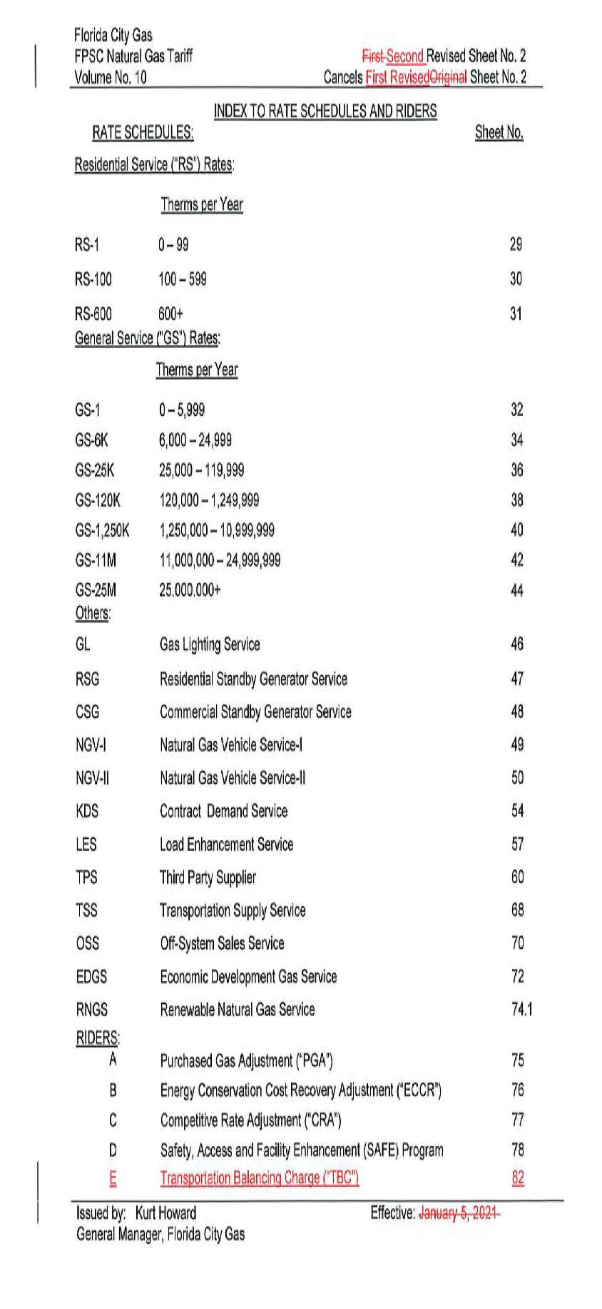

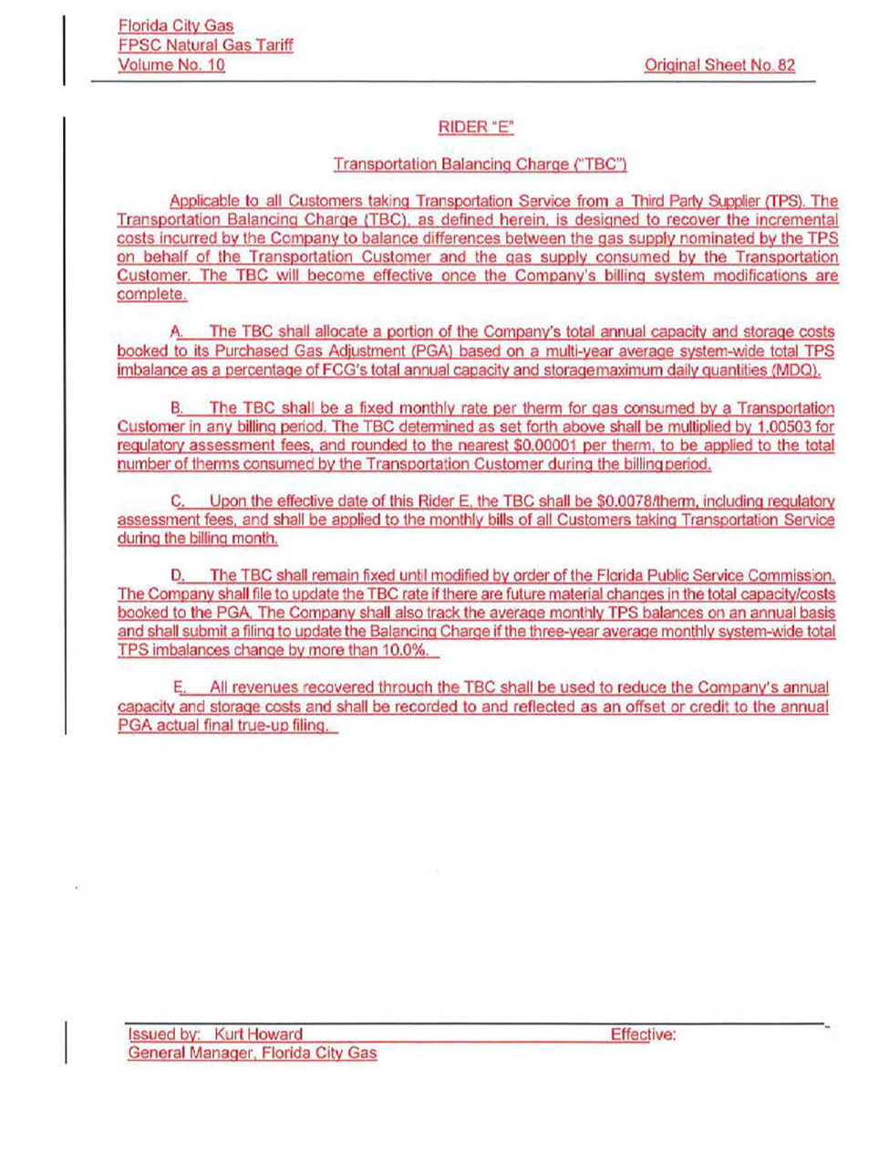

Order No. PSC-00-0184-TRF-GU, issued October 4, 2000, in Docket No. 000810, In re: Petition for approval of modifications to tariff provisions governing transportation of customer-owned gas and tariff provisions to implement Rule 25-7.035, F.A.C., by Tampa Electric Company d/b/a Peoples Gas System.
Order No. PSC-15-0570-TRF-GU, issued December 17, 2015, in Docket No. 150220-GU, In re: Petition for approval of tariff modifications related to the swing service charge, by Peoples Gas System.
Order No. PSC-16-0422-TRF-GU, issued October 3, 2016, in Docket No. 160085-GU, In re: Joint petition for approval of swing service rider, by Florida Public Utilities Company, Florida Public Utilities Company-Indiantown Division, Florida Public Utilities Company-Fort Meade, and Florida Division of Chesapeake Utilities Corporation.
Order No. PSC-2023-0357-PCO-GU, issued November 9, 2023, in Docket No. 20230110-GU, In re: Petition for approval of tariff modifications to implement transportation balancing charge rider, by Florida City Gas.
Document No. 06166-2023, FCG responses to staff’s first data request, and Document No. 06711-2023, FCG’s responses to staff’s second data request.
The 2024 PGA filing includes $12,863,340 in storage and capacity costs. However, Appendix 3 to the petition shows that $12,795,953 was booked to the PGA. FCG explains this difference is due to the number of days in the month of February. The 2024 PGA filing included 29 days, while the filing in this docket used only 28.
Order No. PSC-2023-0347-FOF-GU, issued November 16, 2023, in Docket No. 20230003-GU, In re: Purchased gas adjustment (PGA) true-up.
There are four customer classes not included in the calculation on Appendix 5, as they do not currently hold any transportation customers. FCG explained that the balancing charge would also be applicable if any transportation customers took service under these rate schedules in the future, in response to staff’s first data request, No. 16.
Document No. 06166-2023, FCG’s Responses to Staff’s First Data Request, No. 4.
Id.
By our approval of an annual “cap,” we authorize investor-owned natural gas utilities the managerial discretion to evaluate real (market-driven) commodity and gas transportation costs incurred, and adjust on a monthly basis the actual factor it charges customers to recover the incurred costs, as long as the amount charged to customers is at or below the authorized upper limit. No other cost recovery clause functions as the PGA does, wherein the utility can “flex” the recovery factor that is charged to customers.
FCG suggests that balancing charge revenue credits will be listed as a subpart to Line 1 on Schedule A-7 of the company’s final PGA true-up filing, as well as on the monthly A-2 Schedules.
FCG’s Responses to Staff’s First Data Request, No. 6.

