BEFORE THE FLORIDA PUBLIC SERVICE COMMISSION

In re: Fuel and purchased power cost recovery clause with generating performance incentive factor. | DOCKET NO. 20240001-EI  ORDER NO. PSC-2024-0091-PCO-EI  ISSUED: April 10, 2024

The following Commissioners participated in the disposition of this matter:

MIKE LA ROSA, Chairman
ART GRAHAM
GARY F. CLARK
ANDREW GILES FAY

ORDER APPROVING FLORIDA POWER & LIGHT COMPANY’S
MID-COURSE CORRECTION

BY THE COMMISSION:
BACKGROUND

On March 13, 2024, Florida Power & Light Company (FPL or Company), filed for revision of its currently-effective 2024 fuel cost recovery factors (MCC Petition). FPL’s currently-effective 2024 fuel factors were approved last year at the November 1, 2023 final hearing. Underlying the approval of FPL’s 2024 fuel factors was the Florida Public Service Commission’s (Commission) review of the Company’s projected 2024 fuel- and capacity-related costs. These costs are recovered through fuel and capacity cost recovery factors that are set/reset annually in this docket.

Mid-Course Corrections

Mid-course corrections are used by this Commission between annual clause hearings whenever costs deviate from revenue by a significant margin. Under Rule 25-6.0424, Florida Administrative Code (F.A.C.), which is commonly referred to as the “mid-course correction rule,” a utility must notify us whenever it expects to experience an under- or over-recovery of certain service costs greater than 10 percent. The notification of a 10 percent cost-to-revenue variance shall include a petition for mid-course correction to the fuel cost recovery or capacity cost recovery factors, or shall include an explanation of why a mid-course correction is not practical. The mid-course correction rule and its codified procedures are further discussed throughout this order.

FPL’s Petition

In its MCC Petition, the Company currently estimates a net $661,767,174 million reduction in fuel-related costs for the 2024 period relative to its previous estimate. FPL is proposing to apply this cost reduction to the time period May 2024 through December 2024, thereby reducing fuel cost recovery factors for the remainder of the year. Thus, the Company is requesting that its revised fuel cost recovery factors and associated tariff become effective beginning with the first billing cycle of May 2024. The proposed effective date is further discussed below.

We are vested with jurisdiction over the subject matter of this proceeding by the provisions of Chapter 366, Florida Statutes (F.S.), including Sections 366.04, 366.05, and 366.06, F.S.
DECISION

FPL participated in our most-recent fuel hearing which took place on November 1, 2023. The fuel order stemming from this proceeding set forth the Company’s fuel and capacity cost recovery factors effective with the first billing cycle of January 2024. This order also authorized changes to FPL’s fuel cost recovery factors coinciding with the in-service of the 2024 Solar Base Rate Adjustment Project (2024 SoBRA Project). The Company’s 2024 SoBRA Project-related generating plants went into service as anticipated or prior to the planned February 2024 completion date; thus, FPL’s current fuel cost recovery factors became effective at that time.

FPL Fuel and Purchased Power Mid-Course Correction

FPL filed for a mid-course correction of its fuel charges on March 13, 2024. The Company’s MCC Petition and supporting documentation satisfies the filing requirements of Rule 25-6.0424(1)(b), F.A.C.
In accordance with the noticing requirement of Rule 25-6.0424(2), F.A.C., FPL filed a letter on January 11, 2024, informing the Commission that it was projecting an over-recovery position of greater than 10 percent for the current period ending December 31, 2024. The main factors influencing the decline in actual and projected natural gas prices in 2024 are elevated quantities of natural gas in storage and milder weather compared to previous years.
Additionally, FPL included a $5 million fuel cost credit in its request which reflects a stipulated position proposed by FPL and the Office of Public Counsel to resolve replacement power cost matters with respect to the Company’s nuclear operations., This stipulation was approved on March 26, 2024.

The factors proposed in this proceeding are currently contemplated to be charged for 8 months. As is typical procedure, later this year newly developed 12-month-applicable factors will be proposed for authorization to begin with the first billing cycle of January 2025.

Actual Period-Ending 2023 Fuel Cost Recovery Position

FPL’s net fuel cost recovery position at the end of 2023 is an under-recovery of ($956,463,844). This amount includes FPL’s 2023 actual/estimated over-recovery of $207,586,520.

Decreased pricing for natural gas is the primary driver of the 2023 over-recovery identified above. More specifically, the Company estimated an annual natural gas cost of $4.37 per million British thermal unit (MMBtu) in its 2023 actual/estimated filing. This figure includes delivery costs. However, as indicated in the Company’s December 2023 A-Schedule, FPL’s average 2023 cost of natural gas was $4.22 per MMBtu, representing a difference of 3.4 percent. Natural gas-fired generation comprised approximately 73.0 percent of FPL’s generation mix in 2023.

Projected 2024 Fuel Cost Recovery Position

FPL’s 2024 fuel-related revenue requirement has decreased substantially since the filing of its last cost projection in September 2023. More specifically, the results of this updated estimate are a reduction in FPL’s estimated 2024 fuel-related costs in the amount of $624,476,902. The amount of the 2023 (period-specific net true-up) over-recovery proposed for refund through new 2024 rates is $37,290,272. Thus, the proposed net or decremental amount for inclusion into 2024 rates is $661,767,174.

The primary factor driving the change in projected 2024 fuel costs is lower assumed pricing for natural gas. More specifically, the underlying market-based natural gas price data used for the 2024 fuel cost projection was sourced on August 1, 2023. This underlying data was used to produce an estimated average 2024 delivered natural gas cost of approximately $5.20 per MMBtu. However, as noted above and indicated in its MCC Petition, FPL now estimates its average cost of natural gas in 2024 will be $4.17 per MMBtu, representing a decrease of 20.0 percent. The updated cost estimate was based on natural gas futures/prices sourced on March 1, 2024, or roughly seven months later than the previous estimate used to set current rates. Natural gas-fired generation is projected to comprise approximately 70.2 percent of FPL’s generation mix in 2024.

Recovery Period and Interest Premium

As proposed, FPL’s refund period for its projected 2024 over-recovery is 8 months (beginning May 2024 and ending December 2024). FPL utilized the 30-day AA Financial Commercial Paper Rate published by the Commission to determine its actual 2023 and 2024 (January and February) interest amounts. The projected 2024 monthly interest rate was assumed for all forward months by using the 30-day AA Financial Commercial Paper Rate published on the first business day of March 2024 of 0.441 percent (monthly).

Mid-Course Correction Percentage

Following the methodology prescribed in Rule 25-6.0424(1)(a), F.A.C., the mid-course percentage is equal to the estimated end-of-period total net true-up, including interest, divided by the current period’s total actual and estimated jurisdictional fuel revenue applicable to period, or $661,767,174 / $3,362,375,577. This calculation results in a mid-course correction level of approximately 19.7 percent at December 31, 2024.

Fuel Factor

FPL’s currently-approved annual levelized fuel factor beginning with the first February 2024 billing cycle is 3.718 cents per kilowatt-hour (kWh). The Company is requesting to decrease its currently-approved 2024 annual levelized fuel factor beginning May 2024 to 2.970 cents per kWh, a decrease of approximately 20.1 percent.

Bill Impacts

In Tables 1 and 2 below, the bill impacts of the MCC on typical residential customers using 1,000 kWh of electricity a month in FPL’s Peninsular service territory and FPL’s Northwest (former Gulf Power Company) service territory are shown.
Table 1
FPL Peninsular Service Territory
Monthly Residential Billing Detail for the First 1,000 kWh
Invoice Component | Currently-Approved Charges  April 2024  ($) | Proposed Charges  Beginning  May 2024  ($) | Difference  ($) | Difference  (%)
Base Charge | $80.72 | $80.72 | $0.00 | 0.0%
Fuel Charge | 34.19 | 26.70 | (7.49) | (21.9%)
Conservation Charge | 1.24 | 1.24 | 0.00 | 0.0%
Capacity Charge | 1.70 | 1.70 | 0.00 | 0.0%
Environmental Charge | 3.32 | 3.32 | 0.00 | 0.0%
Storm Protection Plan Charge | 5.57 | 5.57 | 0.00 | 0.0%
Storm Restoration Surcharge | 0.00 | 0.00 | 0.00 | 0.0%
Transition Rider | (1.19) | (1.19) | 0.00 | 0.0%
Gross Receipts Tax | 3.33 | 3.13 | (0.20) | (6.0%)
Total | $128.88 | $121.19 | ($7.69) | (6.0%)
Source: Document No. 01142-2024.

Bill Impacts - FPL Peninsular Service Territory

FPL’s currently-approved total residential charge for the first 1,000 kWh of usage for April 2024 is $128.88. If the Company’s mid-course correction is approved, then the current total residential charge for the first 1,000 kWh of usage beginning in May will be $121.19, a decrease of 6.0 percent. For non-residential customers, FPL reported that bill decreases based on average levels of usage for small-size commercial customers would range from approximately 9.6 to 10 percent, 9.7 percent for medium-size commercial customers, 9.8 percent for large-size commercial customers, and 12.5 percent for industrial customers.

Table 2
FPL Northwest Service Territory
Monthly Residential Billing Detail for the First 1,000 kWh
Invoice Component | Currently-Approved Charges April 2024  ($) | Proposed Charges  Beginning  May 2024  ($) | Difference  ($) | Difference  (%)
Base Charge | $80.72 | $80.72 | $0.00 | 0.0%
Fuel Charge | 34.19 | 26.70 | (7.49) | (21.9%)
Conservation Charge | 1.24 | 1.24 | 0.00 | 0.0%
Capacity Charge | 1.70 | 1.70 | 0.00 | 0.0%
Environmental Charge | 3.32 | 3.32 | 0.00 | 0.0%
Storm Protection Plan Charge | 5.57 | 5.57 | 0.00 | 0.0%
Storm Restoration Surcharge | 0.00 | 0.00 | 0.00 | 0.0%
Transition Rider | 12.64 | 12.64 | 0.00 | 0.0%
Gross Receipts Tax | 3.70 | 3.49 | (0.21) | (5.7%)
Total | $143.08 | $135.38 | ($7.70) | (5.4%)

Source : Document No. 01142-2024

Bill Impacts - FPL Northwest Service Territory

FPL’s currently-approved Northwest total residential charge for the first 1,000 kWh of usage for April 2024 is $143.08. If the Company’s mid-course correction is approved, the current total Northwest residential charge for the first 1,000 kWh of usage beginning in May will be $135.38, a decrease of 5.4 percent. For non-residential customers, FPL reported that bill decreases based on average levels of usage for small-size commercial customers would range from approximately 9.0 to 8.7 percent, and 8.8 percent for medium-size commercial customers, and 8.8 percent for large-size commercial customers. A figure associated with an industrial class for the Northwest service territory was not identified.

FPL’s MCC Petition indicates a need for its fuel cost recovery factors to be revised. More specifically, the Company’s underlying 2024 projected fuel-related revenue requirement has been reduced by $624,476,902. Additionally, the Company proposes to incorporate its period-specific final 2023 fuel cost true-up (over-recovery) of $37,290,272 into the current period. Thus, FPL’s current fuel cost recovery factors should be reduced by $661,767,174. The revised fuel cost recovery factors reflecting this revision are shown on Appendix A.

For these reasons, we authorize adjustments to FPL’s fuel cost recovery factors for the purpose of incorporating the Company’s projected net 2024 fuel cost reduction. Accordingly, FPL’s currently-authorized 2024 fuel cost recovery factors should be reduced by $661,767,174.

Effective date

Over the last 20 years in the Fuel Clause docket, we have considered the effective date of rates and charges of revised fuel cost factors on a case-by-case basis. We have approved rate decreases to be effective less than 30 days after the date of our vote because it was in the customers’ best interests for the rate decrease to be implemented as soon as possible. In its MCC Petition, FPL proposes to decrease its 2024 fuel factors beginning with the first billing cycle of May 2024. Further, FPL has stated that it would include a message on customer bills in the April billing cycle explaining that the utility’s proposed rate decrease is set to begin in May.
The Company has engaged in numerous outreach efforts regarding the potential bill impacts of this proceeding. Specifically, FPL issued a press release on March 13, 2024, informing its customers of the potential adjustments related to the mid-course correction through a web-based billing information portal titled “Rates and Your Bill.” For these reasons, we find that the fuel cost recovery factors shown on Appendix A shall become effective with the billing cycle of May 2024.

Therefore, it is

ORDERED by the Florida Public Service Commission that adjustments shall be made to FPL’s fuel cost recovery factors for the purpose of incorporating the Company’s projected net 2024 fuel cost reduction. Accordingly, FPL’s currently authorized 2024 fuel cost recovery factors should be reduced by $661,767,174. It is further
ORDERED that the fuel cost recovery factors, as shown on Appendix A to this order, shall become effective with the first billing cycle of May 2024. It is further
ORDERED that the fuel and purchased power cost recovery clause docket is an ongoing proceeding and shall remain open.
By ORDER of the Florida Public Service Commission this 10th day of April, 2024.

ADAM J. TEITZMAN
Commission Clerk
Florida Public Service Commission
2540 Shumard Oak Boulevard
Tallahassee, Florida 32399
(850) 413-6770
www.floridapsc.com

Copies furnished: A copy of this document is provided to the parties of record at the time of issuance and, if applicable, interested persons.

SBr
NOTICE OF FURTHER PROCEEDINGS OR JUDICIAL REVIEW

The Florida Public Service Commission is required by Section 120.569(1), Florida Statutes, to notify parties of any administrative hearing or judicial review of Commission orders that is available under Sections 120.57 or 120.68, Florida Statutes, as well as the procedures and time limits that apply. This notice should not be construed to mean all requests for an administrative hearing or judicial review will be granted or result in the relief sought.

Mediation may be available on a case-by-case basis. If mediation is conducted, it does not affect a substantially interested person's right to a hearing.

Any party adversely affected by this order, which is preliminary, procedural or intermediate in nature, may request: (1) reconsideration within 10 days pursuant to Rule 25-22.0376, Florida Administrative Code; or (2) judicial review by the Florida Supreme Court, in the case of an electric, gas or telephone utility, or the First District Court of Appeal, in the case of a water or wastewater utility. A motion for reconsideration shall be filed with the Office of Commission Clerk, in the form prescribed by Rule 25-22.0376, Florida Administrative Code. Judicial review of a preliminary, procedural or intermediate ruling or order is available if review of the final action will not provide an adequate remedy. Such review may be requested from the appropriate court, as described above, pursuant to Rule 9.100, Florida Rules of Appellate Procedure.
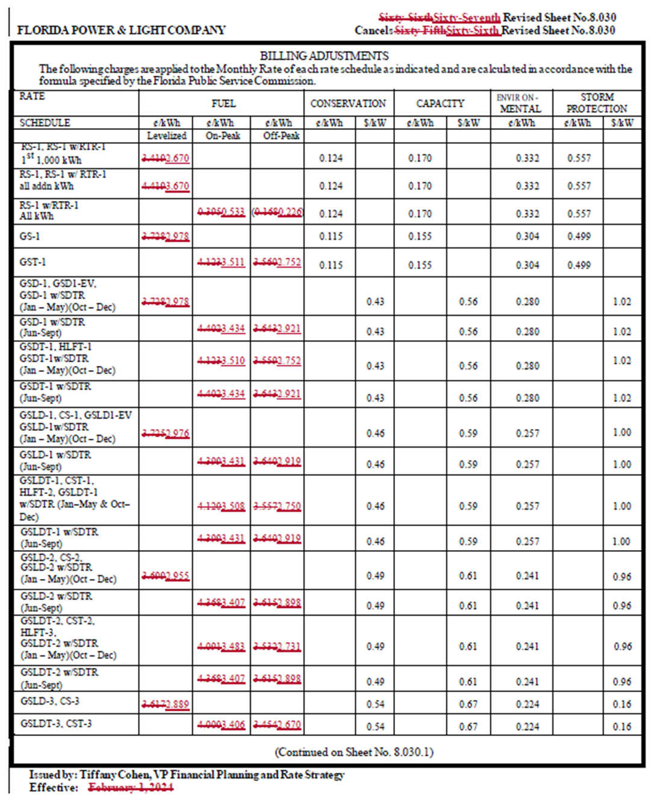
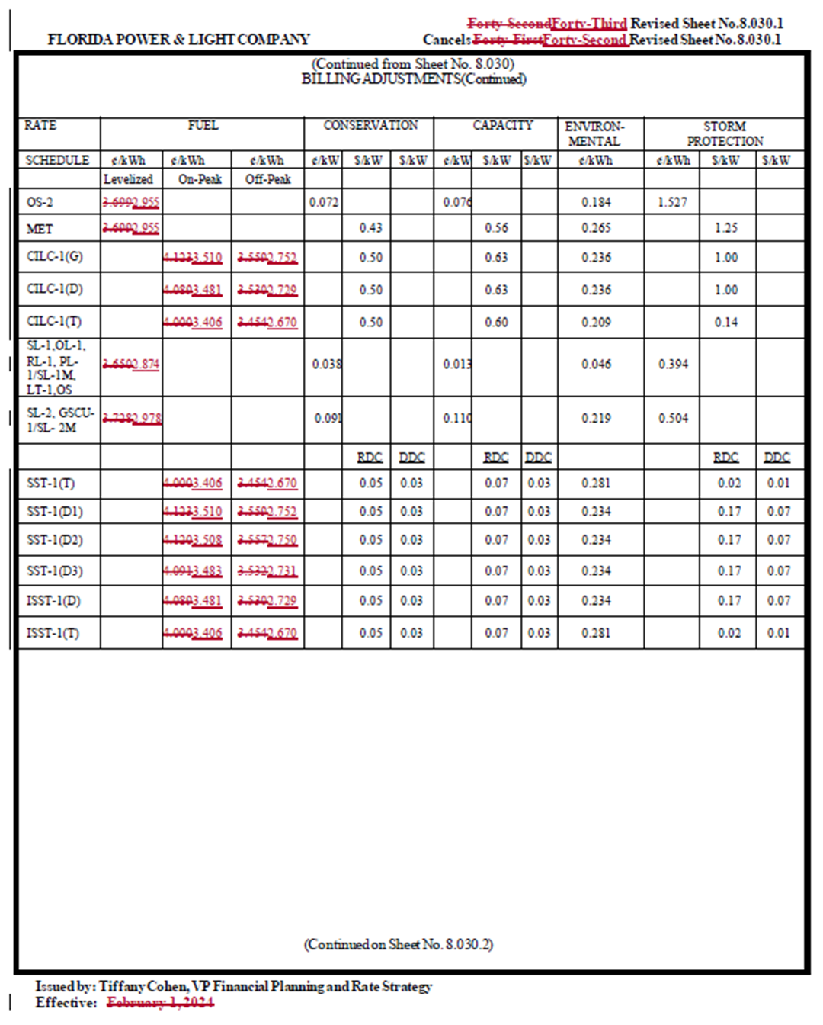

Document No. 01142-2024.
Order No. PSC-2023-0343-FOF-EI, issued November 16, 2023, in Docket No. 20230001-EI, In re: Fuel and purchased power cost recovery clause with generating performance incentive factor.
Order No. PSC-2023-0343-FOF-EI.
Id., and Order No. PSC-2021-0446A-S-EI, issued December 9, 2021, in Docket No. 20210015-EI, In re: Petition for rate increase by Florida Power & Light Company.
Document No. 01142-2024.
Document No. 00155-2024.
https://www.eia.gov/outlooks/steo/archives/mar24.pdf
Order No. PSC-2023-0207-PCO-EI, issued July 24, 2023, in Docket No. 20230001-EI, In re: Fuel and purchased power cost recovery clause with generating performance incentive factor.
Document No. 01142-2024. This credit can be found on page 2 of 126, Schedule E1-B, Line 19.
Order No. PSC-2023-0207-PCO-EI.
Document No. 00388-2024. Further, the Company’s estimated end-of-period 2023 under-recovery in the amount of ($993,754,116) is embedded in current rates per Order No. PSC-2023-0343-FOF-EI. This amount constitutes the remainder of the $1.2 billion under-recovery of 2022 fuel costs ordered to be collected in 2024. See Order No. PSC-2023-0108-PCO-EI, issued March 23, 2023, in Docket No. 20230001-EI, In re: Fuel and purchased power cost recovery clause with generating performance incentive factor.
Document No. 04332-2023.
Id.
Document No. 00388-2024.
Id.
Document No. 05080-2023.
Document No. 01142-2024.
Hearing Exhibit No. 61, entered in Docket No. 20230001-EI.
Document No. 05080-2023.
Document No. 01142-2024.
Id.
Id.
Id.
Document No. 01184-2024.
Rates as published monthly by the Florida Public Service Commission’s Division of Accounting & Finance.
Document No. 01142-2024, Schedule E1-B.
Order No. PSC-2023-0343-FOF-EI.
Document No. 01142-2024.
FPL’s 12-month-applicable Storm Restoration Surcharge originally authorized by Order No. PSC-2023-0110-PCO-EI, issued March 23, 2023, in Docket No. 20230017-EI, In re: Petition for limited proceeding for recovery of incremental storm restoration costs related to Hurricanes Ian and Nicole, by Florida Power & Light Company, and as amended by Order No. PSC-2023-0354-PCO-EI, in Docket No. 20230017-EI, issued November 27, 2023, In re: Petition for limited proceeding for recovery of incremental storm restoration costs related to Hurricanes Ian and Nicole, by Florida Power & Light Company in the amount of $6.65 per month will conclude following March 2024.
Order No. PSC-2023-0343-FOF-EI.
Document No. 01184-2024.
FPL’s 12-month-applicable Storm Restoration Surcharge originally authorized by Order No. PSC-2023-0110-PCO-EI, and as amended by Order No. PSC-2023-0354-PCO-EI in the amount of $6.65 per month, will conclude following March 2024.
Order No. PSC-2023-0343-FOF-EI.
Document No. 01184-2024.
Order No. PSC-2023-0185-PCO-EI, issued June 27, 2023, in Docket No. 20230001-EI, In re: Fuel and purchased power cost recovery clause with generating performance incentive factor.
Document No. 01184-2024.
Id.

