BEFORE THE FLORIDA PUBLIC SERVICE COMMISSION

In re: Petition for approval of revisions to budget billing tariffs, by Florida Public Utilities Company. | DOCKET NO. 20230136-PU  ORDER NO. PSC-2024-0114-TRF-PU  ISSUED: April 22, 2024

The following Commissioners participated in the disposition of this matter:

MIKE LA ROSA, Chairman
ART GRAHAM
GARY F. CLARK
ANDREW GILES FAY

ORDER APPROVING REVISIONS TO BUDGET BILLING TARIFFS

BY THE COMMISSION:

Background
On December 15, 2023, Florida Public Utilities Company (FPUC or Company) filed a petition seeking our approval of revisions to its optional budget billing program (program) tariffs for both its electric and natural gas divisions. FPUC also proposed to expand the program to include certain small general service customers, to remove unnecessary language related to bill format, and to revise the terms and conditions of the program. Furthermore, FPUC has proposed to add details to its electric budget billing tariffs to align with its natural gas program tariffs. The Company states that the proposed tariff revisions are intended to provide consistency across the business units under FPUC’s parent company, Chesapeake Utilities Corporation (CUC).
Currently, FPUC’s Customer Information and Billing System (CIS) services are provided by ECIS, a Vertex business solutions product the Company has been using for over 20 years. FPUC’s parent company, CUC, will be replacing the current system at the completion of its contract on December 31, 2024. CUC is currently working with SAP (a software company for the management of business processes) and IBM to transition to FPUC’s new billing system known as 1CX with an estimated transition date of August 2024. FPUC requests approval of its proposed tariff revisions to be effective on the actual date of the transition date to the new CIS, expected to be completed in August 2024.
As part of the review process, our staff issued a data request to FPUC. On January 31, 2024, FPUC filed its response to that request, which included a corrected version of First Revised Sheet No. 41. All proposed Revised Tariff Sheets are appended to this Order as Attachment A.
On February 22, 2024, we suspended the proposed tariffs. We have jurisdiction over this matter pursuant to Sections 366.04, 366.05, and 366.06, Florida Statutes (F.S.).

Decision
The Company explained in its petition that the need for consistency in the program across both electric and natural gas divisions became evident as it worked through the process of changing to the new billing system. The Company is not currently seeking our approval of its new CIS platform. In its response to our staff’s data request, the Company stated that it has not yet determined the timing or mechanism for recovery of the costs associated with the implementation of the 1CX system.

Natural Gas Budget Billing Program

FPUC’s natural gas budget billing program tariff is an option for residential customers designed to help them stabilize their monthly payments. To qualify for the program, a customer must be a year-round customer with 12 months of consecutive bills and not owe past payments to the Company (i.e., have a zero balance). The customer’s monthly payment is based on an average of the previous 12 months of bills and applicable fees and taxes. FPUC currently has 194 residential natural gas customers enrolled in its program. Pursuant to the currently effective tariff, the budgeted monthly payment is recalculated from time to time and if the recalculated monthly payment varies by 10 percent or more from the budget monthly payment, the Company may begin charging the recalculated amount on the customer’s next bill. Additionally, a customer’s budgeted monthly payment will be recalculated on each anniversary of the customer’s initial participation in the Program.

Proposed Tariff Revisions

In its petition, FPUC proposed to remove the requirement that the recalculated budgeted monthly payment vary by 10 percent before the utility may begin charging the recalculated amount. In response to our staff’s data request, FPUC stated that removing the 10 percent variable requirement would allow the system to calculate based on the factors necessitating the change, which would produce a more accurate budget billing amount. The Company also explained that it would recalculate budgeted monthly payments due to circumstances including changes to rates, taxes, or new load which would impact a customer’s usage. We find that this methodology is reasonable, and that it should reduce the imbalances between the budgeted monthly payment and a customer’s actual total bill.
In addition to the above proposed tariff revision, the Company is also proposing to expand its budget billing program to include non-residential customers in Rate Schedules GS-1 (customers using less than 1,000 therms annually) and GS-2 (customers using 1,000 to 4,999 therms annually). FPUC asserts that the proposal will enable general service customers to better budget their utility expenses and states that this proposed expansion will not impact the general body of ratepayers. FPUC is also proposing to remove the requirement that customers who request to end their participation in the program may not rejoin the program until after six months. Finally, FPUC proposes to reserve the right to waive the requirement that customers must join the program with a zero balance, on a not-unduly discriminatory basis.

Electric Budget Billing Program

FPUC currently has 258 residential electric customers enrolled in its budget billing program. The existing tariff provides that a customer participating in the program will remain a program participant unless the customer requests termination from the program or is delinquent in payment. In comparison to the natural gas budget billing tariff discussed above, existing budget billing electric tariffs are less detailed. The terms for FPUC’s electric budget billing program are quoted in their entirety in Paragraph 8 of the Petition.

Proposed Tariff Revisions

In order to add details similar to the natural gas budget billing tariff, FPUC proposed to add language to the electric budget billing tariff stating that the customer must be a year-round customer with 12 months of consecutive bills and not owe past due payments to the Company to enroll in the program. The customer’s monthly payment will be based on an average of the previous 12 months of bills and applicable fees and taxes. FPUC has also proposed program tariff language to state that the budgeted monthly payment may be recalculated from time to time, and that the Company may begin charging the recalculated amount on the customer’s next bill. Additionally, a customer’s budgeted monthly payment will be recalculated on each anniversary of the customer’s initial participation in the program. We find that the above tariff modifications better specify the terms of the program and align more closely with the natural gas budget billing tariff.
Other revisions include removing language on applying a factor which typically has not been utilized, removing the monthly 10 percent payment variable margin (the new CIS platform will automatically calculate the customers budget billing amount), and removing the terminated customer waiting period before reenrolling in the budget billing program.
In addition to the above discussed proposed tariff revisions, the Company is also proposing to expand its electric budget billing program to customers in Rate Schedules GS-Non Demand (customers using 25 kilowatts or less), and GS-Demand (customers using 25 to 500 kilowatts). The Company asserts that the proposal would enable smaller commercial customers to better budget their utility expenses and the proposed expansion would not impact the general body of ratepayers.
Overall, the added detail to the electric budget billing tariffs will provide more consistency with the natural gas tariff. Furthermore, the replacement of the CIS platform will allow FPUC to enhance its billing and payment platforms, streamline and automate the billing system, consolidate customer information, and onboard customers quickly.

Conclusion

We hereby approve FPUC's proposed revisions to its optional budget billing program tariffs for its electric and natural gas divisions, including the expansion of the program to general service customers. The Revised Tariffs, appended to this Order as Attachment A, shall be effective on the actual date of the transition of the existing CIS platform to the new CIS platform expected to occur in August 2024. No later than 30 days prior to the transition date, the Company shall notify us in writing of the actual transition date.

Based on the foregoing, it is

ORDERED by the Florida Public Service Commission that Florida Public Utilities Company’s Revised Tariffs for its optional budget billing program for both its electric and natural gas divisions, appended to this Order as Attachments A, are hereby approved. It is further

ORDERED that the Revised Tariffs shall be effective on the actual date of the transition of the existing customer information and billing system to the new platform, anticipated to be August 2024. It is further

ORDERED that the Company shall provide us at least thirty days prior written notice of the actual transition date. It is further

ORDERED that if a protest is filed within 21 days of issuance of the Order, the tariff shall remain in effect with any charges held subject to refund pending resolution of the protest. It is further

ORDERED that if no timely protest is filed, this docket shall be closed upon the issuance of a Consummating Order.

By ORDER of the Florida Public Service Commission this 22nd day of April, 2024.

/s/ Adam J. Teitzman
ADAM J. TEITZMAN
Commission Clerk
Florida Public Service Commission
2540 Shumard Oak Boulevard
Tallahassee, Florida 32399
(850) 413-6770
www.floridapsc.com

Copies furnished: A copy of this document is provided to the parties of record at the time of issuance and, if applicable, interested persons.

SPS

NOTICE OF FURTHER PROCEEDINGS

The Florida Public Service Commission is required by Section 120.569(1), Florida Statutes, to notify parties of any administrative hearing or judicial review of Commission orders that is available under Sections 120.57 or 120.68, Florida Statutes, as well as the procedures and time limits that apply. This notice should not be construed to mean all requests for an administrative hearing or judicial review will be granted or result in the relief sought.

Mediation may be available on a case-by-case basis. If mediation is conducted, it does not affect a substantially interested person's right to a hearing.

The Commission's decision on this tariff is interim in nature and will become final, unless a person whose substantial interests are affected by the proposed action files a petition for a formal proceeding, in the form provided by Rule 28-106.201, Florida Administrative Code. This petition must be received by the Office of Commission Clerk, 2540 Shumard Oak Boulevard, Tallahassee, Florida 32399-0850, by the close of business on May 13, 2024.

In the absence of such a petition, this Order shall become final and effective upon the issuance of a Consummating Order.

Any objection or protest filed in this docket before the issuance date of this order is considered abandoned unless it satisfies the foregoing conditions and is renewed within the specified protest period.

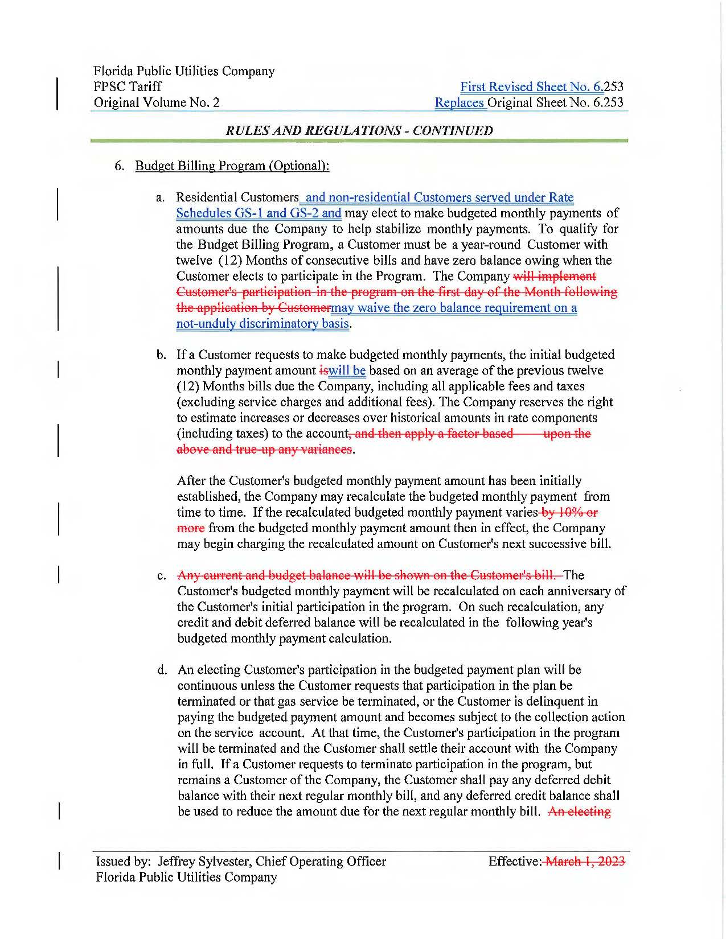
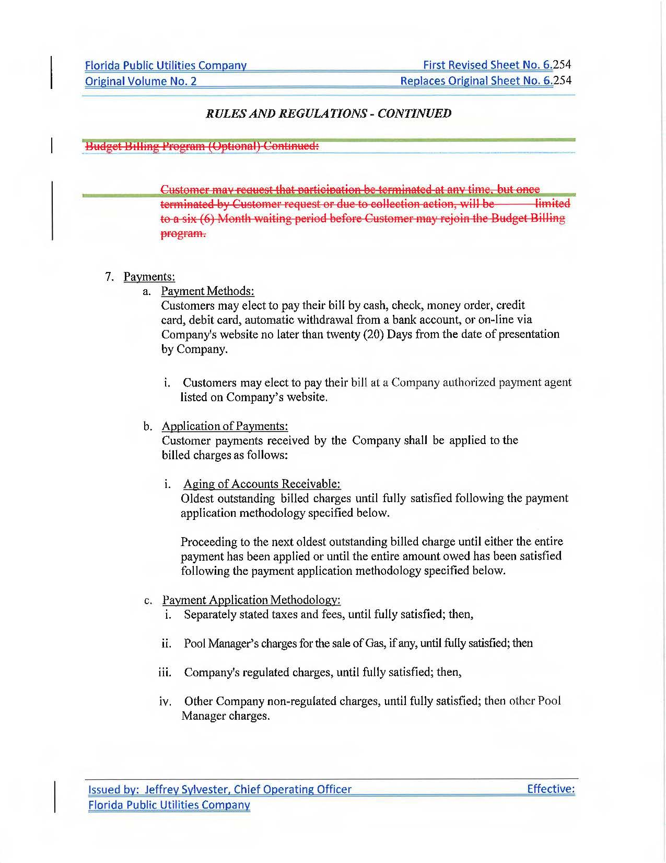
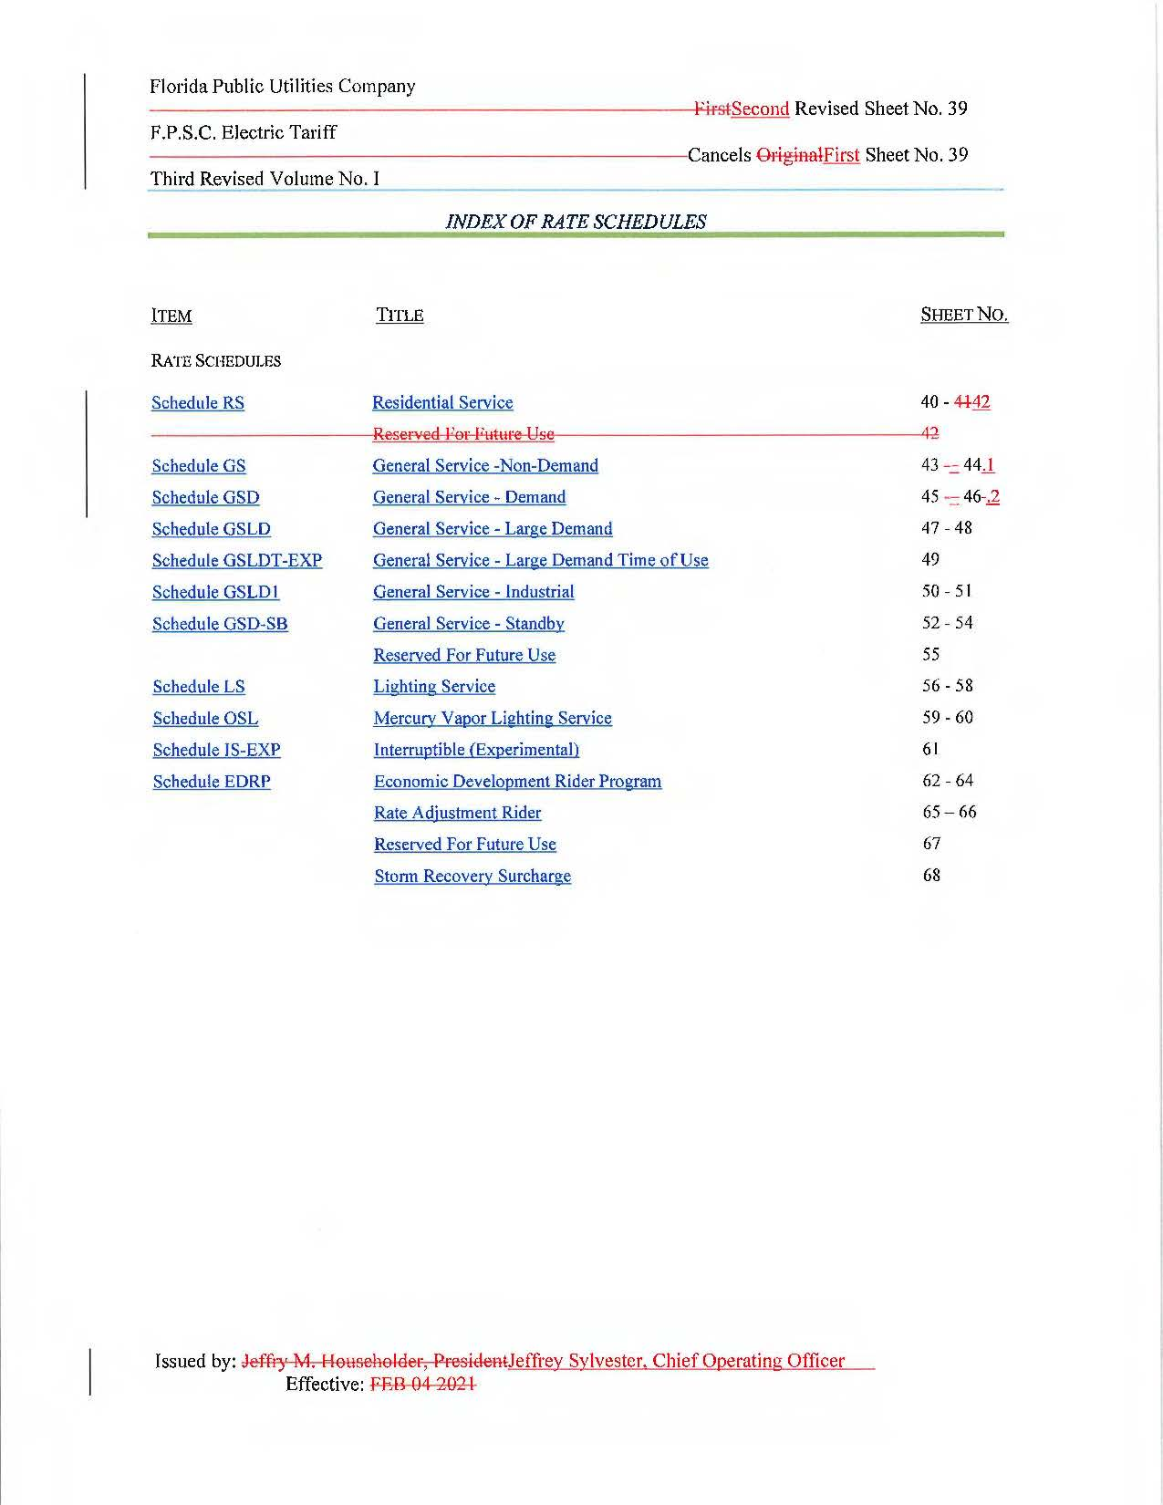
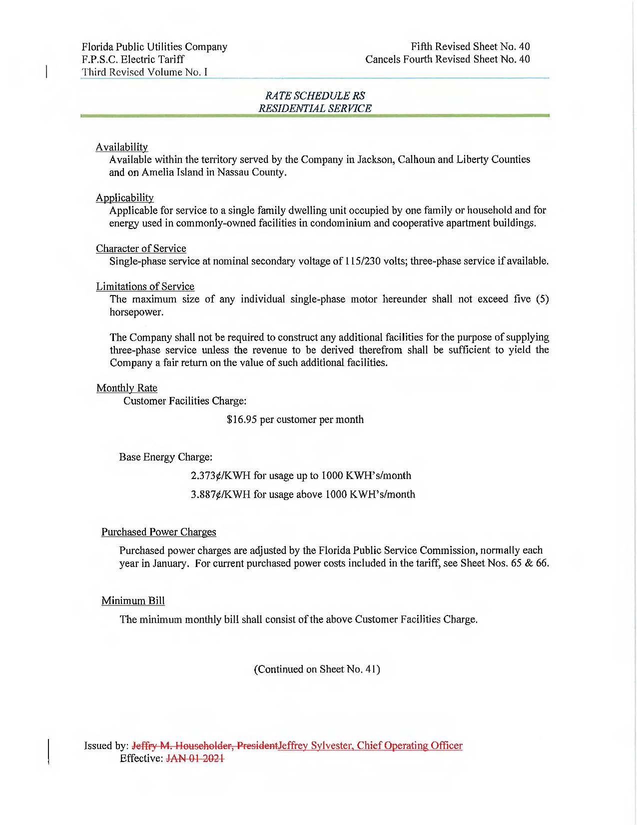
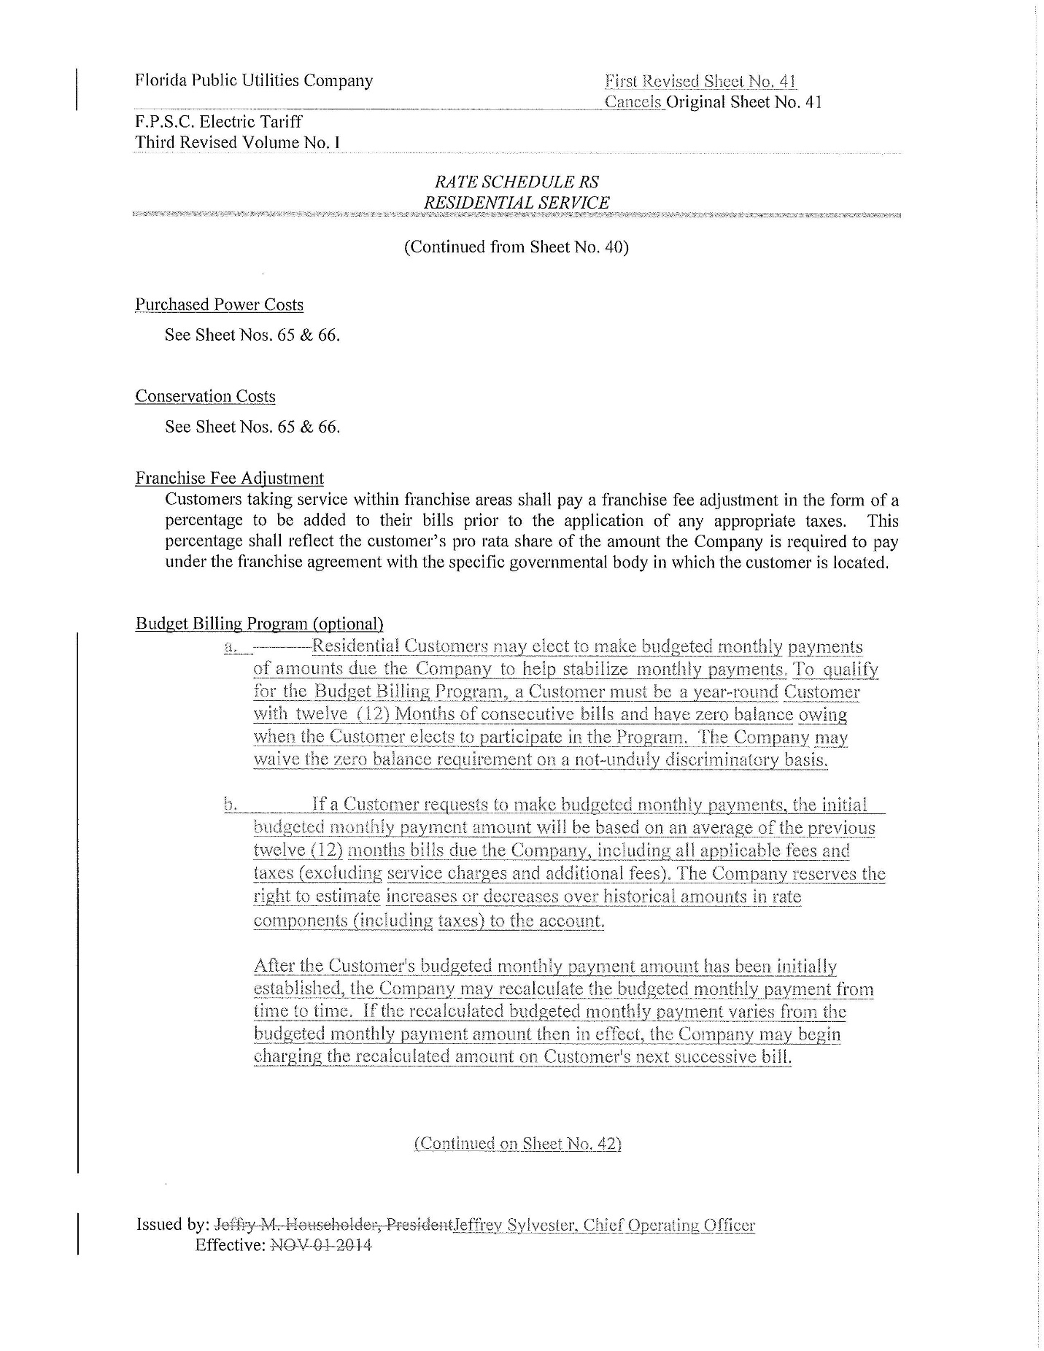
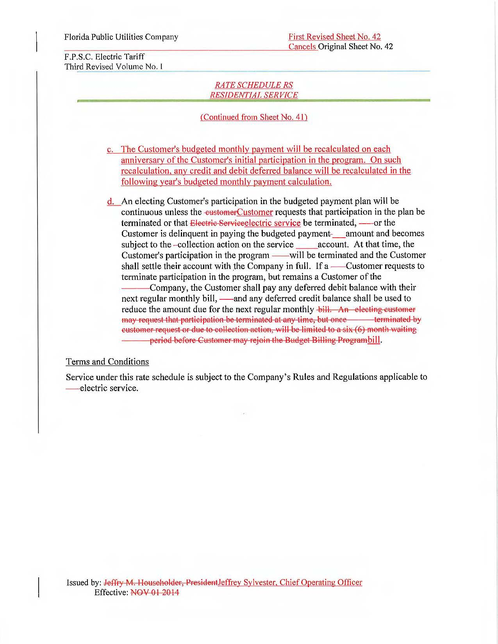
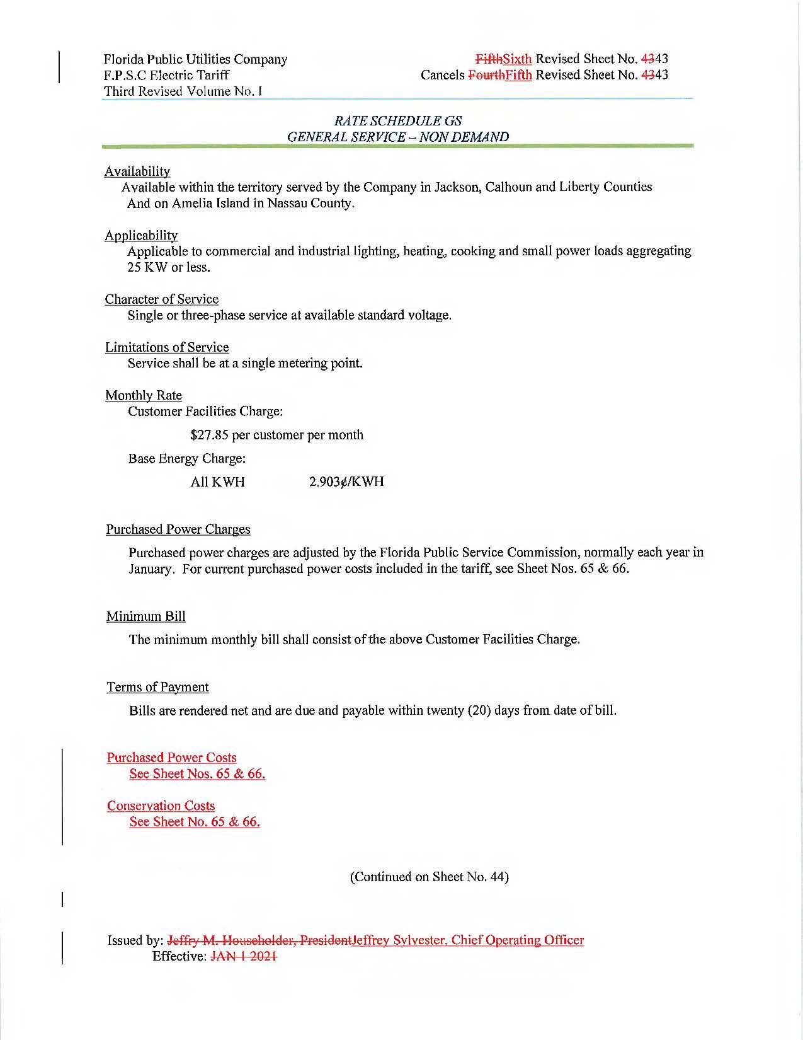
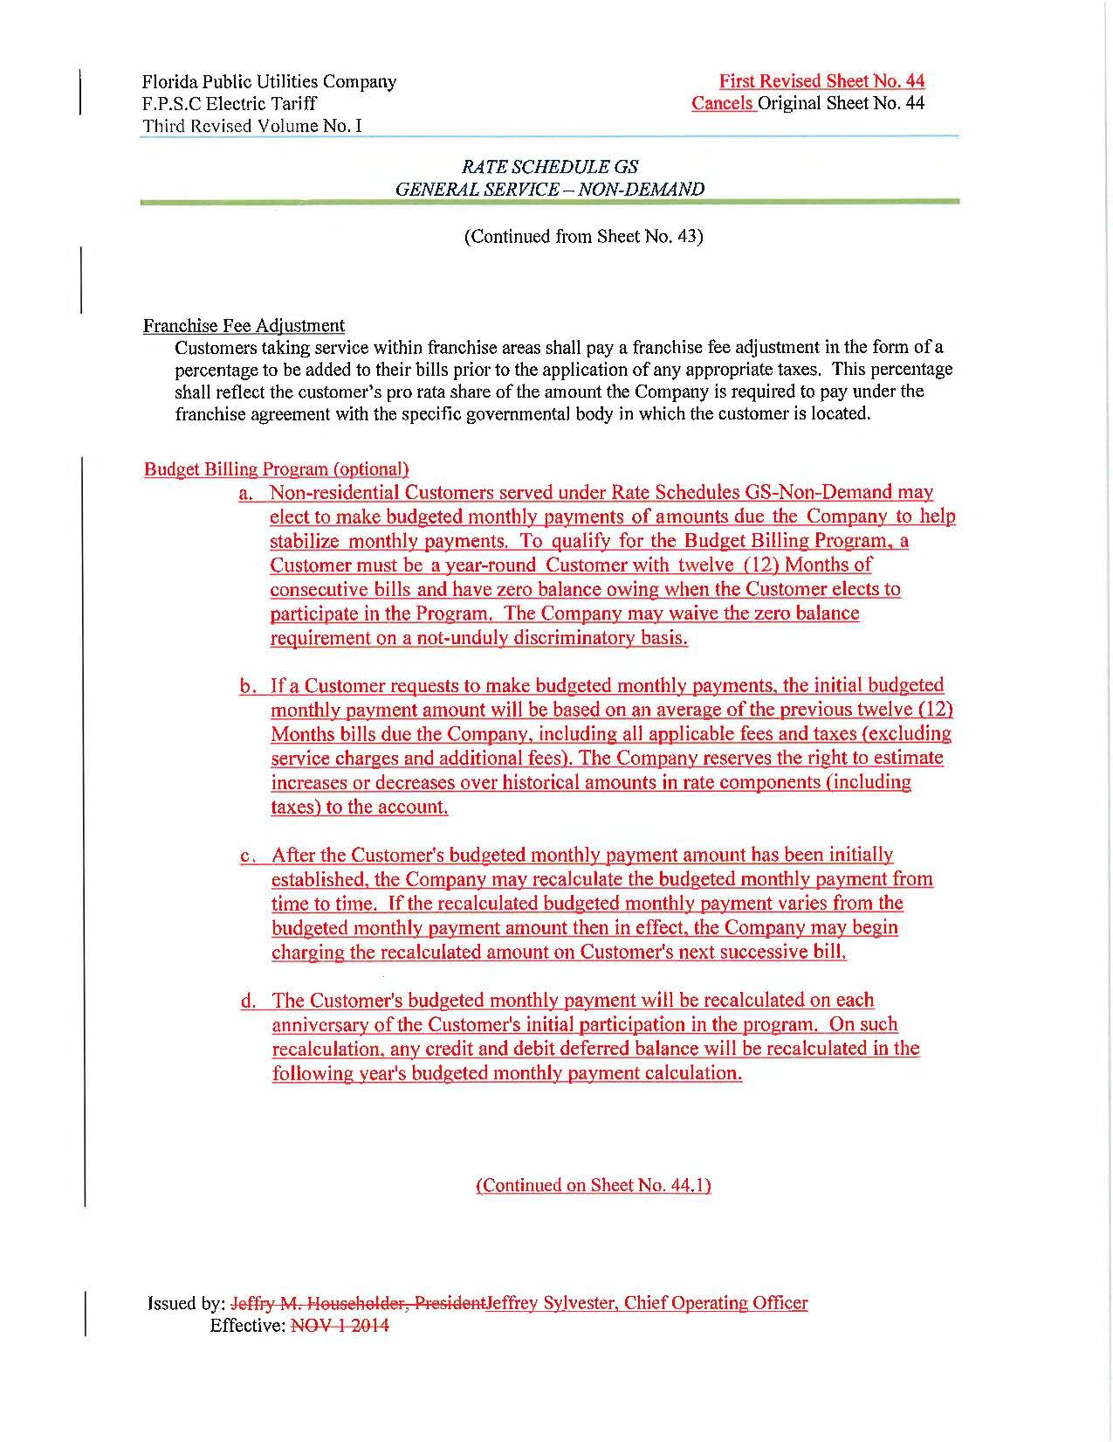
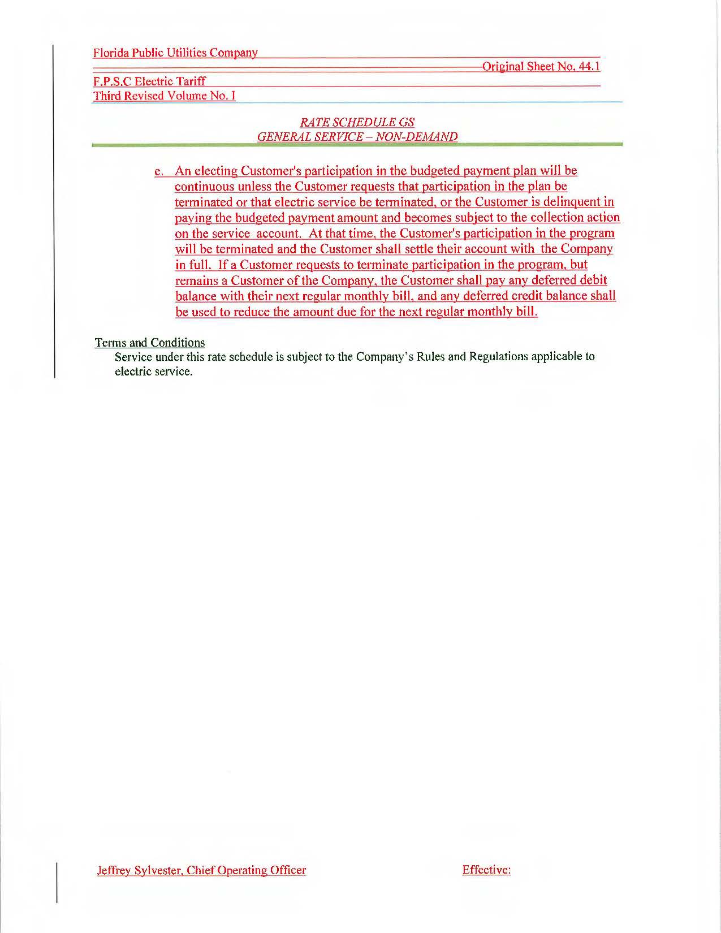
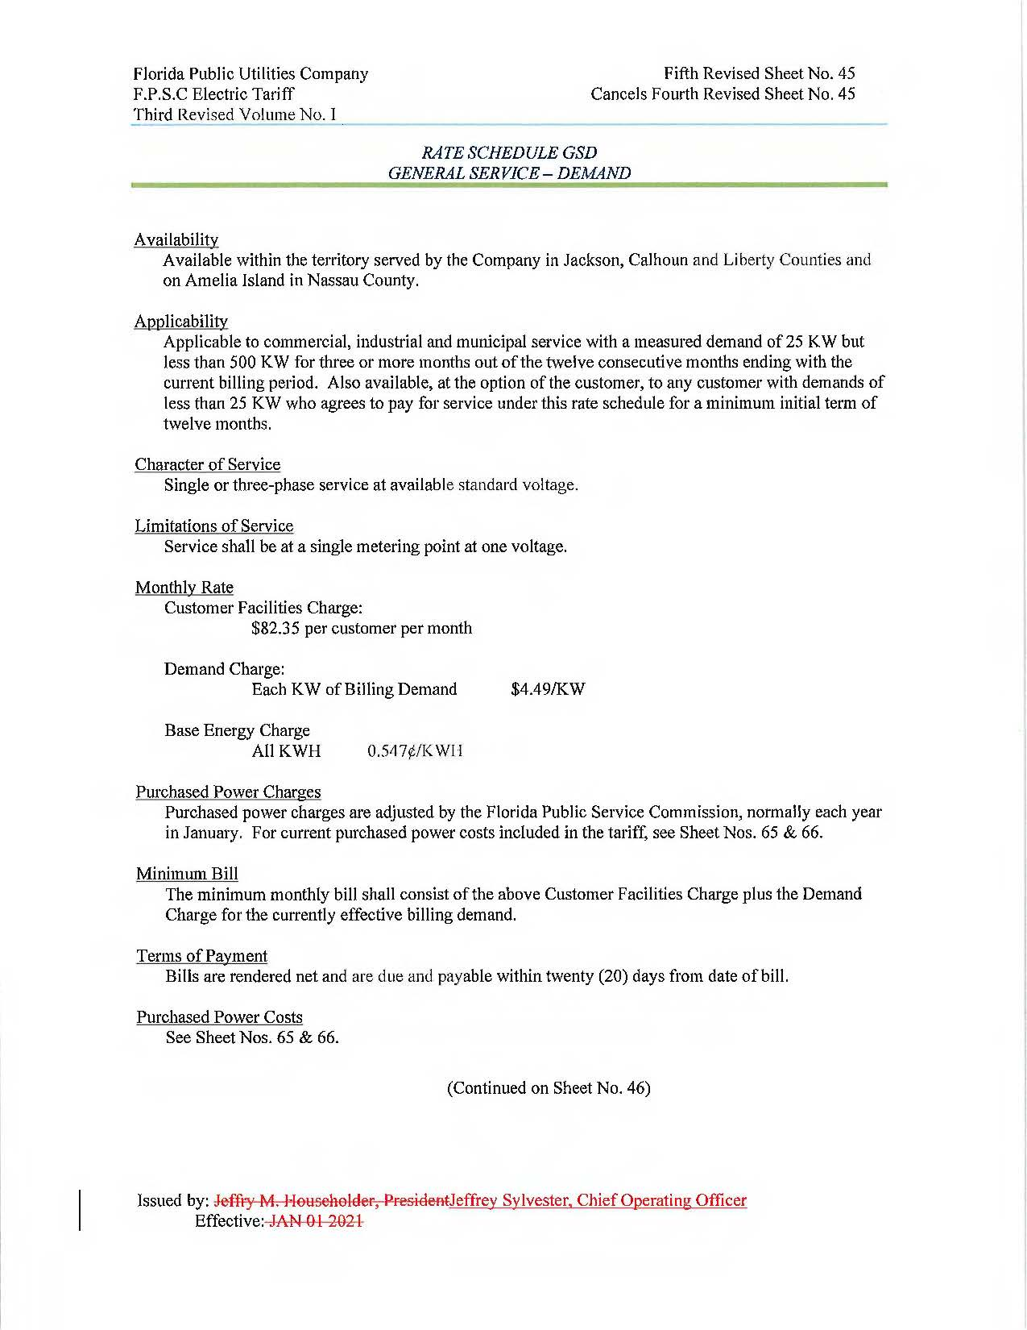
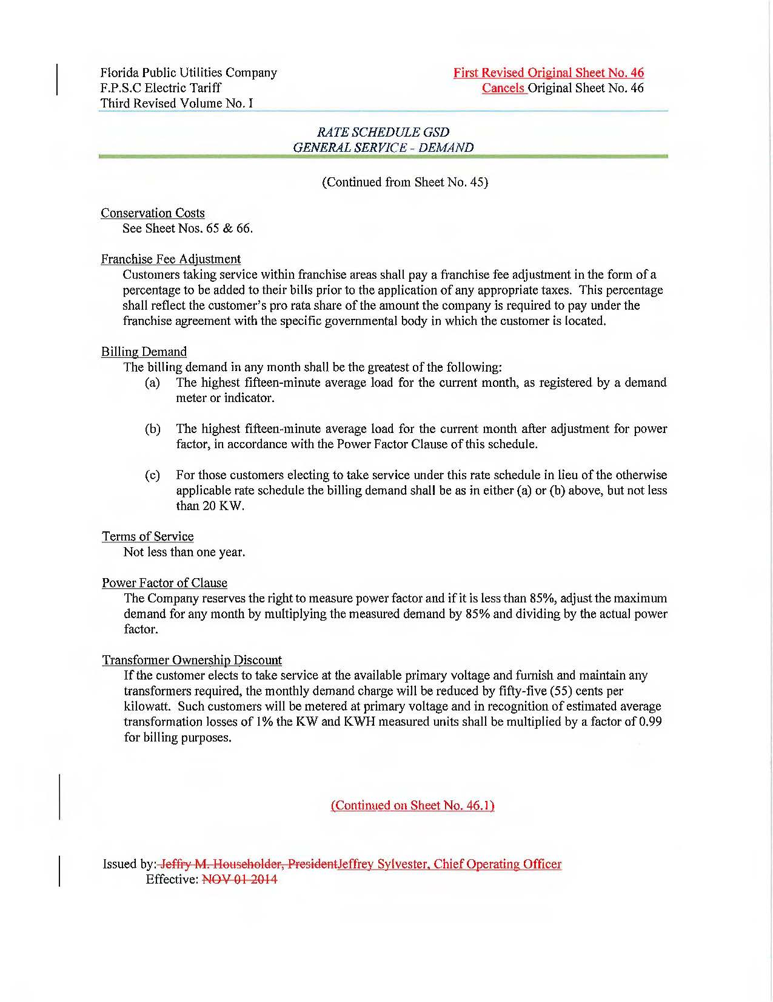
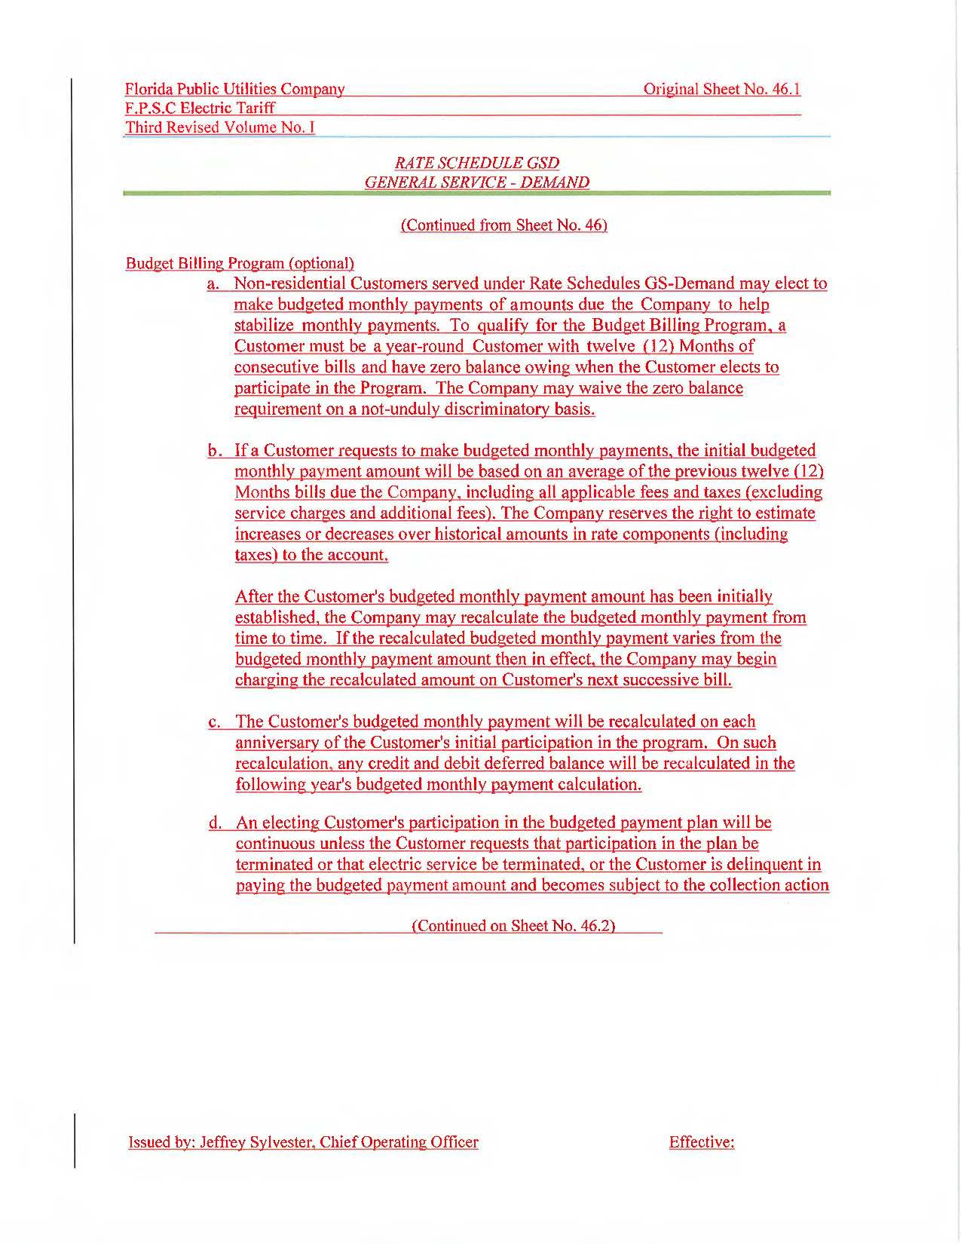
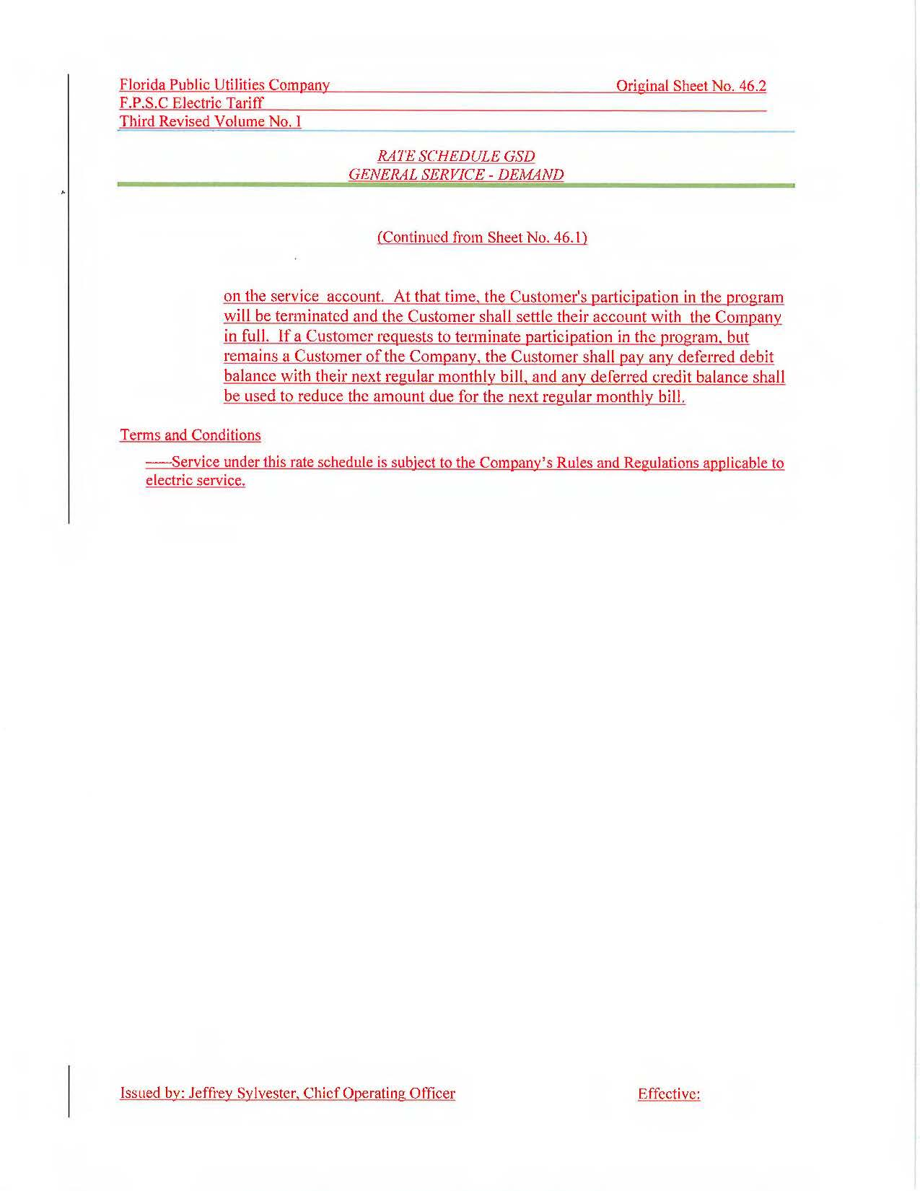

Approval of the new billing system is not an issue in this docket.
Order No. PSC-2024-0045-PCO-PU, issued February 22, 2024, in Docket No. 20230136-PU, In re: Petition for approval of revisions to budget billing tariffs, by Florida Public Utilities Company.
We have approved budget billing programs and tariffs for Florida Power & Light Company, Tampa Electric Company, Duke Energy Florida, and Peoples Gas System. See Order No. PSC-05-0951-TRF-EI, issued October 6, 2005, in Docket No. 050486-EI, In re: Petition for approval of optional budget billing program for GS-1 rate customers by Florida Power & Light Company; Order No. PSC-2015-0416-TRF-EI, issued October 1, 2015, in Docket No. 20150159-EI, In re: Petition for approval of tariff revisions to implement customer relationship management (CRM) project, by Tampa Electric Company; Order No. PSC-2018-0372-TRF-EI, issued July 30, 2018, in Docket No. 20180123-EI, In re: Petition for approval of modifications to Section No. IV, general rules and regulations governing electric service, Part VIII billing, residential and non-residential budget billing, by Duke Energy Florida, LLC; and Order No. PSC-2015-0415-TRF-GU, issued October 1, 2015, in Docket No. 20150160-GU, In re: Petition for approval of tariff revisions to implement customer relationship management (CRM) project, by Peoples Gas System.

