BEFORE THE FLORIDA PUBLIC SERVICE COMMISSION

In re: Petition for approval of transportation service agreement with Florida Public Utilities Company by Peninsula Pipeline Company, Inc. | DOCKET NO. 20240031-GU  ORDER NO. PSC-2024-0169-PAA-GU  ISSUED: May 23, 2024

The following Commissioners participated in the disposition of this matter:

MIKE LA ROSA, Chairman
ART GRAHAM
GARY F. CLARK
ANDREW GILES FAY
GABRIELLA PASSIDOMO

NOTICE OF PROPOSED AGENCY ACTION
ORDER APPROVING TRANSPORTATION SERVICE AGREEMENT

BY THE COMMISSION:

NOTICE is hereby given by the Florida Public Service Commission that the action discussed herein is preliminary in nature and will become final unless a person whose interests are substantially affected files a petition for a formal proceeding, pursuant to Rule 25-22.029, Florida Administrative Code (F.A.C.).

BACKGROUND

On February 7, 2024, Peninsula Pipeline Company, Inc. (Peninsula) filed a petition for approval of a firm transportation service agreement between Peninsula and Florida Public Utilities Company (FPUC) for Plant City and Lake Mattie system expansions. The completion of the Plant City and Lake Mattie system expansions are intended to enhance delivery of natural gas to FPUC’s natural gas systems in the service territory in Hillsborough and Polk County. FPUC is a local distribution company subject to the regulatory jurisdiction of the Commission pursuant to Chapter 366, Florida Statutes (F.S.) Peninsula operates as an intrastate natural gas transmission company as defined by Section 368.103(4), F.S.
Peninsula provides gas transportation service only; it does not engage in the sale of natural gas to customers. By Order No. PSC-07-1012-TRF-GP (2007 Order), Peninsula received approval of an intrastate gas pipeline tariff that allows it to construct and operate intrastate pipeline facilities and to actively pursue agreements with natural gas customers. Pursuant to the 2007 Order, Peninsula is allowed to enter into gas transmission agreements that meet certain criteria without prior Commission approval. However, Peninsula is requesting Commission approval of this proposed agreement as it does not fit any of the enumerated criteria. Additionally, Peninsula and FPUC (collectively “the parties”) are subsidiaries of Chesapeake Utility Corporation, and agreements between affiliated companies must be approved by the Commission pursuant to Section 368.105, F.S., and the 2007 Order.
The proposed agreements would be effective for 20 years after the date of execution, and extended on a year-to-year basis after this initial term, unless either party chooses to terminate via written notice submitted 90 days prior to the expiration of the current term. Either party may request modification of the rates or terms of the agreement, to be made effective in the next renewed term, no less than 120 days before the expiration of the current term. However, the parties acknowledge that any amendments to the proposed agreements would require further Commission approval.
Peninsula would recover the pipeline and district regulator construction costs through the monthly reservation charge to FPUC as shown in Exhibit A to the proposed agreements. The monthly reservation charge is designed to recover costs such as, but not limited to, engineering, permitting, materials, and installation costs associated with pipeline and related facilities, ongoing maintenance including Pipeline and Hazardous Materials Safety Administration compliance, safety requirements, property taxes, gas control, and Peninsula’s return on investment.
FPUC would recover its payments to Peninsula through the Purchased Gas Adjustment (PGA) and swing service mechanisms. The PGA allows FPUC to periodically adjust the price of natural gas supplied to its customers to reflect the actual cost of gas purchased and delivered on behalf of the customers. The swing service rider allows FPUC to recover intrastate capacity costs from their transportation customers and is a cents per therm charge that is included in the monthly customer gas bill of transportation customers. While FPUC would incur costs associated with this service expansion, new load added to the system would help spread the costs over a larger customer base.
Pursuant to the proposed agreements (Attachments A and B), Peninsula would construct, own, and operate new natural gas pipelines and acquire from FPUC existing assets to allow them to more adequately provide service to Plant City and Lake Mattie. Maps of the proposed projects are included in Attachment C.
During the evaluation of the petition, two data requests to the parties were issued for which responses were received on April 2 and 8, 2024. Commission staff and the parties held a phone conference on April 17, 2024, to ask further questions and discuss the proposed agreement. On April 18, 2024, the parties filed a revised transportation service agreement related to the Lake Mattie project and a revised Exhibit A to the transportation service agreement, as well as a revised map for the Lake Mattie project. On April 22, 2024, the parties filed a second revised Exhibit A to correct an error in a confidential number contained in Exhibit A filed on April 18, 2024. We have jurisdiction over this matter pursuant to Sections 366.05(1), 366.06, and 368.105, F.S.
DECISION

Approval of Plant City Transportation Service Agreement

Proposed Plant City Expansion Project
The parties have entered into the proposed firm transportation service agreement to enable FPUC to increase capacity to meet current and future demand needs in Plant City.
The proposed Plant City expansion project would consist of approximately 2.4 miles of 4-inch coated steel pipeline, three new delivery points, a new interconnect with Florida Gas Transmission (FGT), and Peninsula’s acquisition of assets from FPUC. The acquired assets from FPUC consist of about 1,700 feet of 4-inch coated steel pipeline located near the planned interconnect with FGT. This project is expected to be completed by the end of 2024.
The Plant City expansion would begin with the acquisition of about 1,700 feet of 4-inch coated steel pipeline from FPUC, which Peninsula would interconnect with FGT using a newly constructed gate station. From the acquired assets, Peninsula would build three extensions leading to three new delivery points, for a total of approximately 12,225 feet.

Anticipated System Benefits
FPUC states that the proposed Plant City transportation service agreement and expansion project would help FPUC serve current demand, as well as meet demands of projected growth. Future developments are planned along both Sam Allen Road and Wilder Road, both of which are proposed to receive natural gas access per the expansion outlined in the petition. The project is expected to provide an additional 5,000 dekatherms of natural gas capacity per day.

Negotiated Monthly Reservation Payments to Peninsula
The negotiated monthly reservation charge listed in Attachment A is consistent with market rates, within the guidelines of Section 368.105(3)(b), F.S. The costs to Peninsula associated with constructing the expansion would be recovered through use of the monthly reservation charge. Peninsula would purchase the assets from FPUC for their net book value of $174,008.97. FPUC customers would pay for their use of these assets through this monthly reservation charge alone, which was calculated using an engineering estimate placing the assets at a lower value of $147,000. The assets discussed above were not included in FPUC’s rate base during the latest rate case proceeding in 2022; therefore, FPUC’s general body of ratepayers are currently not paying for those assets. For this reason we find that the parties’ initial firm transportation agreement is appropriate as proposed.
Conclusion
Based on our review of the petition and the parties’ responses to data requests, we approve the proposed firm transportation service agreement associated with the Plant City project between Peninsula and FPUC, dated January 30, 2024, included as Attachment A. The firm transportation service agreement is reasonable and meets the requirements of Section 368.105, F.S. Furthermore, the proposed agreement benefits FPUC’s current and future customers by extending to new delivery points which will permit FPUC to serve both existing residents and planned developments.

Approval of Lake Mattie Transportation Service Agreement

Proposed Transportation Service Agreement for Lake Mattie
The parties have entered into the proposed firm transportation service agreement to enhance FPUC’s diversity of gas supply to Polk County. The parties state that FPUC’s current service would be strengthened by introducing multiple sources of gas from interstate pipelines in the area. Paragraph 20 of the petition states that, “Through working with the Economic Development Council of Haines City, FPUC projects significant new demand consisting of a mix of customer demand over the next 10 years in Haines City that FPUC’s system in the area is not currently capable of serving without additional access to interstate capacity provided by this project.”

Proposed Lake Mattie Expansion Project
Peninsula proposes construction of 13.8 miles of 4-inch coated steel pipeline, an interconnect with the Florida Southeast Connection pipeline, three district regulator stations, and the acquisition of assets from FPUC. All phases of the project are expected to be completed by the third quarter of 2025.
The expansion would first begin by acquiring certain assets from FPUC. Peninsula would acquire a city gate and 1.2 miles of 4-inch steel pipe from FPUC at book value. Peninsula would construct a new district regulator system at the end of the acquired assets. This acquisition is necessary for Peninsula to upgrade the systems to be able to handle a greater volume.
The second phase of the expansion would begin with Peninsula building an extension of 4.5 miles of new 4-inch coated steel, and building a new interconnect with the existing Lake Mattie system. At the end of the extension, Peninsula would build a new district regulator system.
The final phase of the expansion would begin with Peninsula building an interconnect with the Florida Southeast Connection pipeline, and 4.5 miles of 4-inch coated steel which would connect to an existing district regulator that interconnects with the existing Lake Mattie system.

Anticipated System Benefits
The parties assert that this expansion project is beneficial to FPUC’s customers. The planned expansions are intended to enhance the diversity of gas supply, as well as provide additional gas to meet projected future growth. The Lake Mattie project is expected to supply an additional 8,700 dekatherms of capacity per day, which would enable FPUC to meet its current and future customer demand.

Negotiated Monthly Reservation Payments to Peninsula
The parties assert that the negotiated monthly reservation charge shown in Attachment B is consistent with market rates and within the guidelines of Section 368.105(3)(b), F.S. The costs to Peninsula associated with constructing the expansion would be recovered through use of the monthly reservation charge. Peninsula would purchase the assets from FPUC for their net book value of $276,126.15. FPUC customers would pay for the use of these assets through this monthly reservation charge alone, which was be calculated using the net book value.

Revised Monthly Reservation Payments to Peninsula
A phone conference was held with the parties to clarify responses provided to staff’s second data request. Through that discussion, the parties clarified that the assets discussed above are currently in FPUC’s rate base and would remain there until the next rate proceeding, at which point the assets would be removed from rate base to reflect the asset transfer. The parties filed an amended agreement and amended Exhibit A to remove the net book value purchase price from the calculation of the reservation charge and avoid the recovery of these assets through base rates as well as the PGA and swing service rider. We have reviewed the amended Exhibit A and agree with the parties that the revisions to the agreement are appropriate.
Conclusion
Having reviewed the petition and the responses to data requests, we hereby approve the proposed firm transportation service agreement associated with the Lake Mattie project between Peninsula and FPUC, dated April 18, 2024, and the second revised Exhibit A included as Attachment B. The firm transportation service agreement is reasonable and meets the requirements of Section 368.105, F.S. Furthermore, the proposed agreement will benefit FPUC’s current and future customers by interconnecting the Lake Mattie system with the Florida Southeast Connection pipeline, thereby ensuring FPUC will be able to meet the demands of projected growth.
Based on the foregoing, it is
ORDERED by the Florida Public Service Commission that Peninsula Pipeline Company, Inc.’s petition for approval of a transportation service agreement between Peninsula Pipeline Company, Inc. and Florida Public Utilities Company is hereby granted as stated herein. It is further
ORDERED that the Plant City transportation service agreement between Peninsula Pipeline Company, Inc. and Florida Public Utilities Company dated January 30, 2024, included herein as Attachment A, is hereby approved. It is further
ORDERED that the Lake Mattie transportation service agreement between Peninsula Pipeline Company, Inc. and Florida Public Utilities Company dated April 18, 2024, including revised Exhibit A contained within Attachment B, is hereby approved. It is further
ORDERED that the provisions of this order, issued as proposed agency action, shall become final and effective upon the issuance of a Consummating Order unless an appropriate petition, in the form provided by Rule 28-106.201, F.A.C., is received by the Office of Commission Clerk, 2540 Shumard Oak Boulevard, Tallahassee, Florida 32399-0850, by the close of business on the date set forth in the “Notice of Further Proceedings” attached hereto.
By ORDER of the Florida Public Service Commission this 23rd day of May, 2024.

/s/ Adam J. Teitzman
ADAM J. TEITZMAN
Commission Clerk
Florida Public Service Commission
2540 Shumard Oak Boulevard
Tallahassee, Florida 32399
(850) 413-6770
www.floridapsc.com

Copies furnished: A copy of this document is provided to the parties of record at the time of issuance and, if applicable, interested persons.
SBr

NOTICE OF FURTHER PROCEEDINGS OR JUDICIAL REVIEW

The Florida Public Service Commission is required by Section 120.569(1), Florida Statutes, to notify parties of any administrative hearing that is available under Section 120.57, Florida Statutes, as well as the procedures and time limits that apply. This notice should not be construed to mean all requests for an administrative hearing will be granted or result in the relief sought.

Mediation may be available on a case-by-case basis. If mediation is conducted, it does not affect a substantially interested person's right to a hearing.

The action proposed herein is preliminary in nature. Any person whose substantial interests are affected by the action proposed by this order may file a petition for a formal proceeding, in the form provided by Rule 28-106.201, Florida Administrative Code. This petition must be received by the Office of Commission Clerk, 2540 Shumard Oak Boulevard, Tallahassee, Florida 32399-0850, by the close of business on June 13, 2024.

In the absence of such a petition, this order shall become final and effective upon the issuance of a Consummating Order.

Any objection or protest filed in this/these docket(s) before the issuance date of this order is considered abandoned unless it satisfies the foregoing conditions and is renewed within the specified protest period.

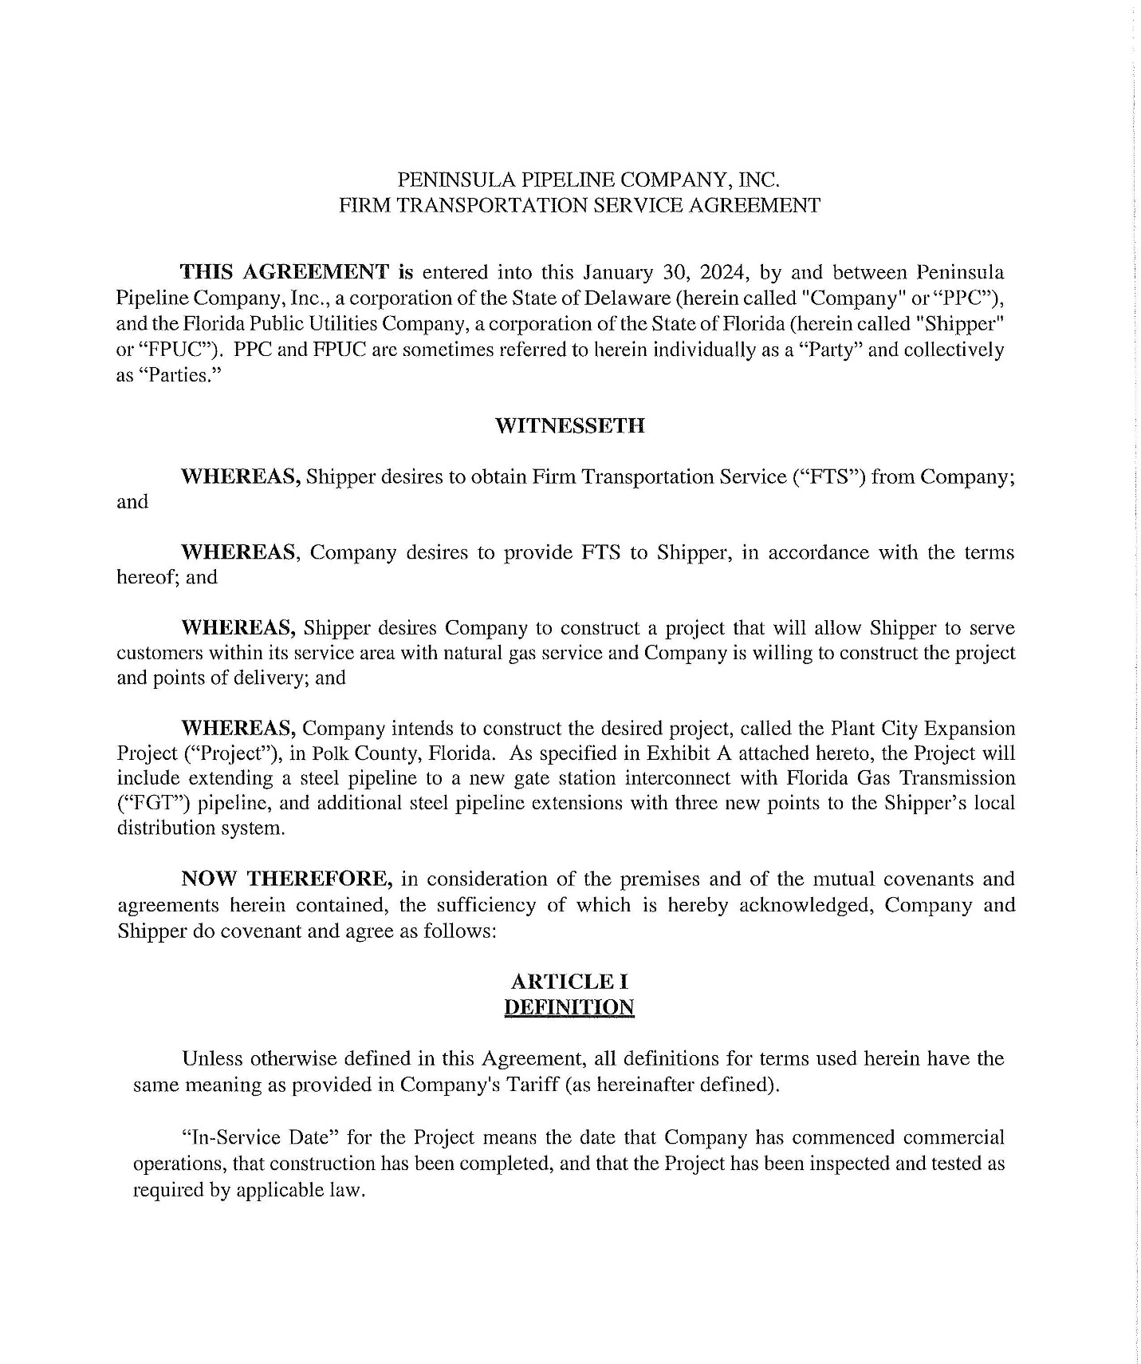

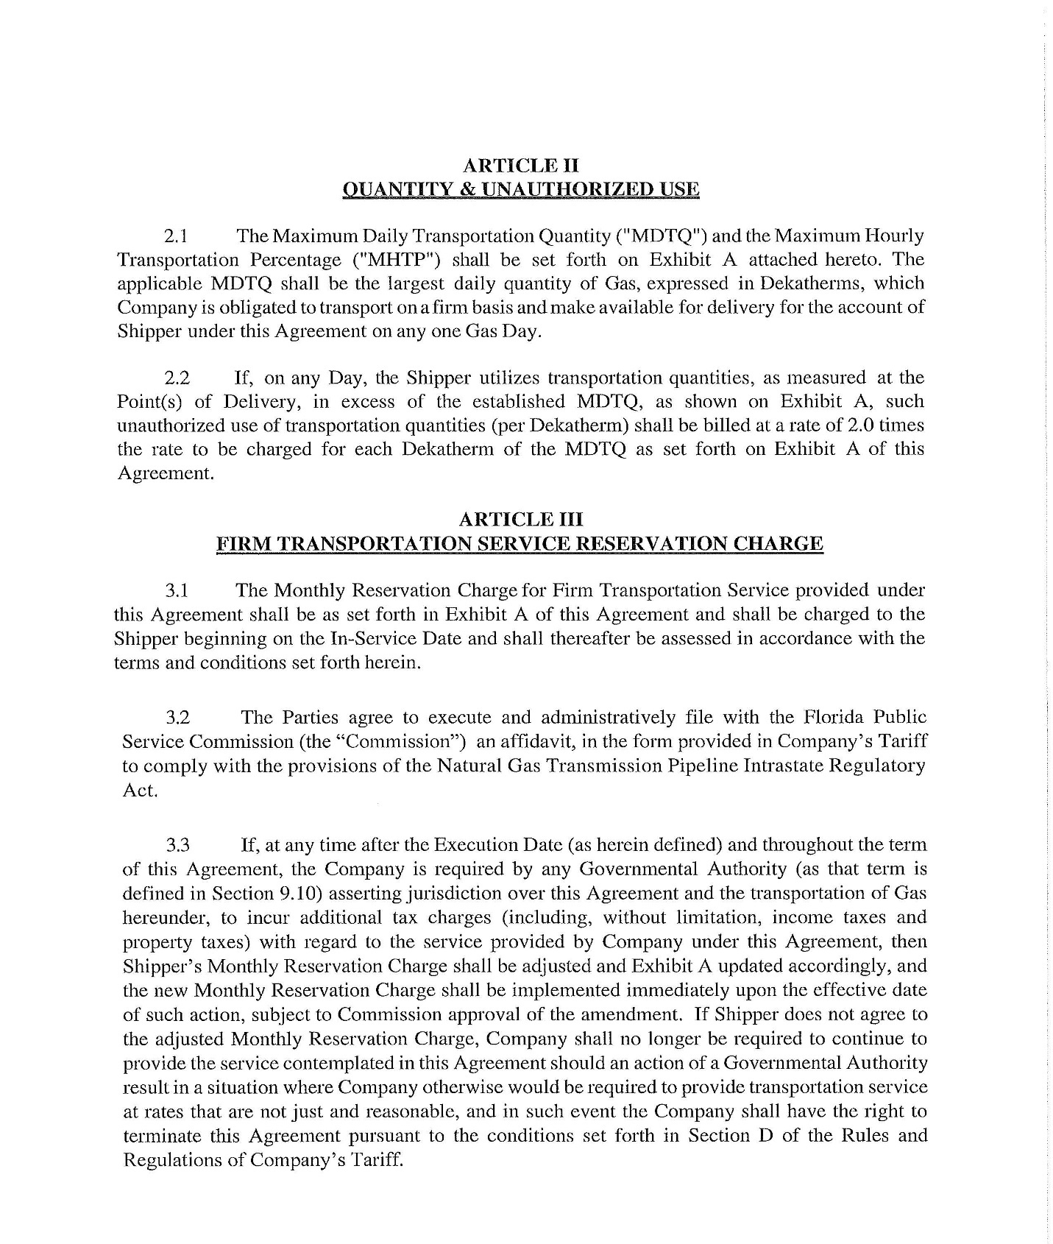

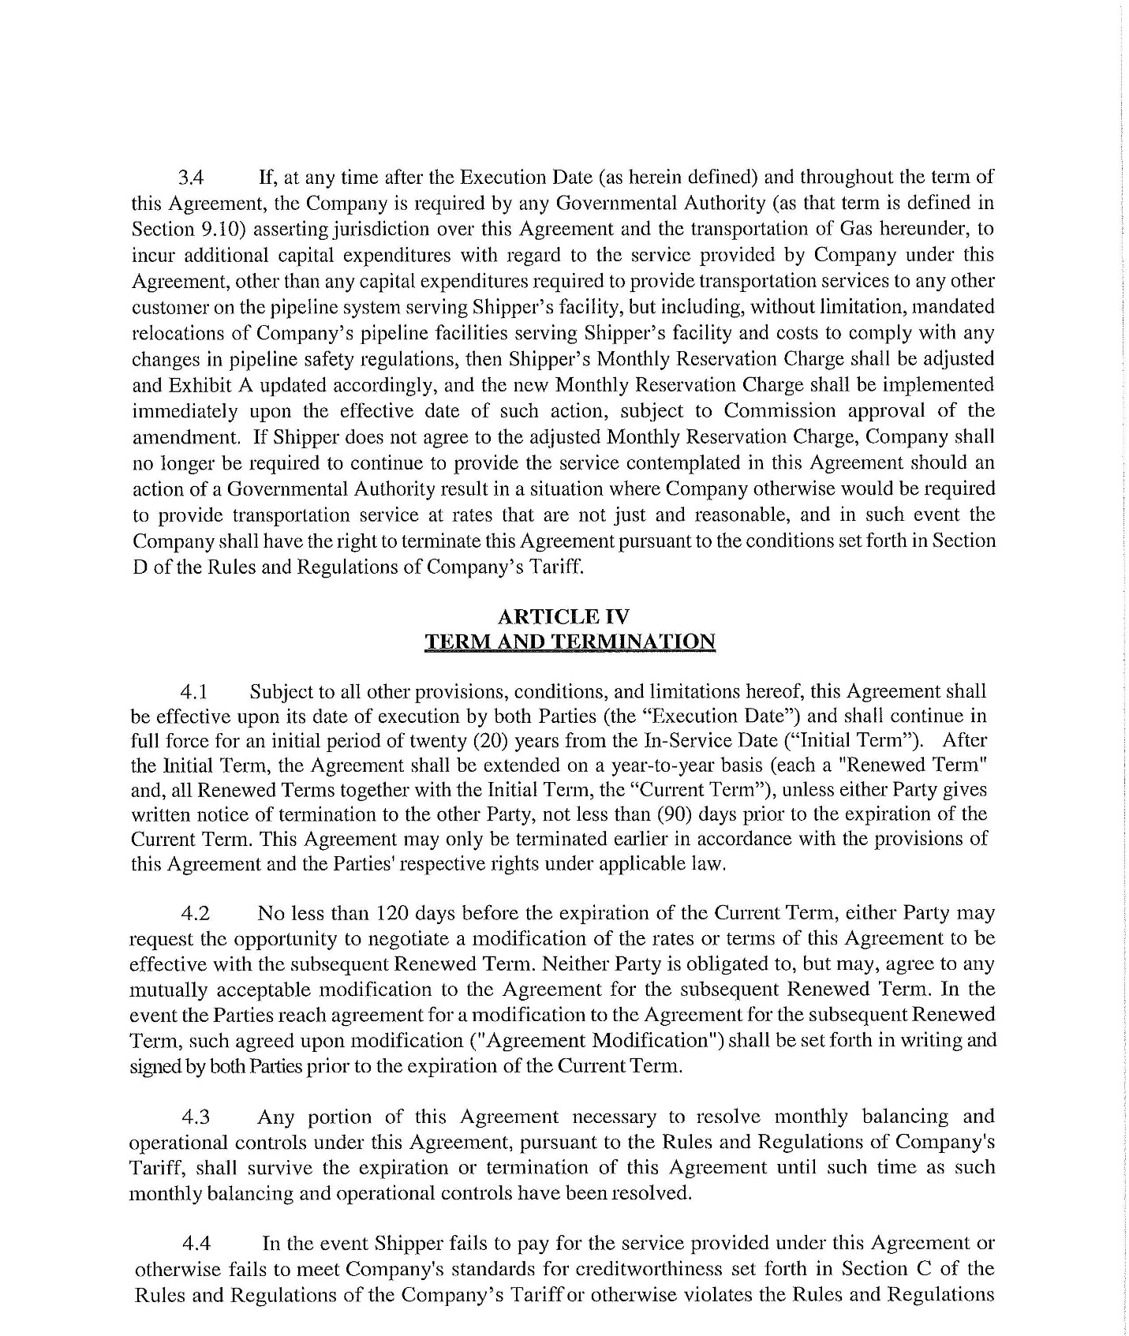

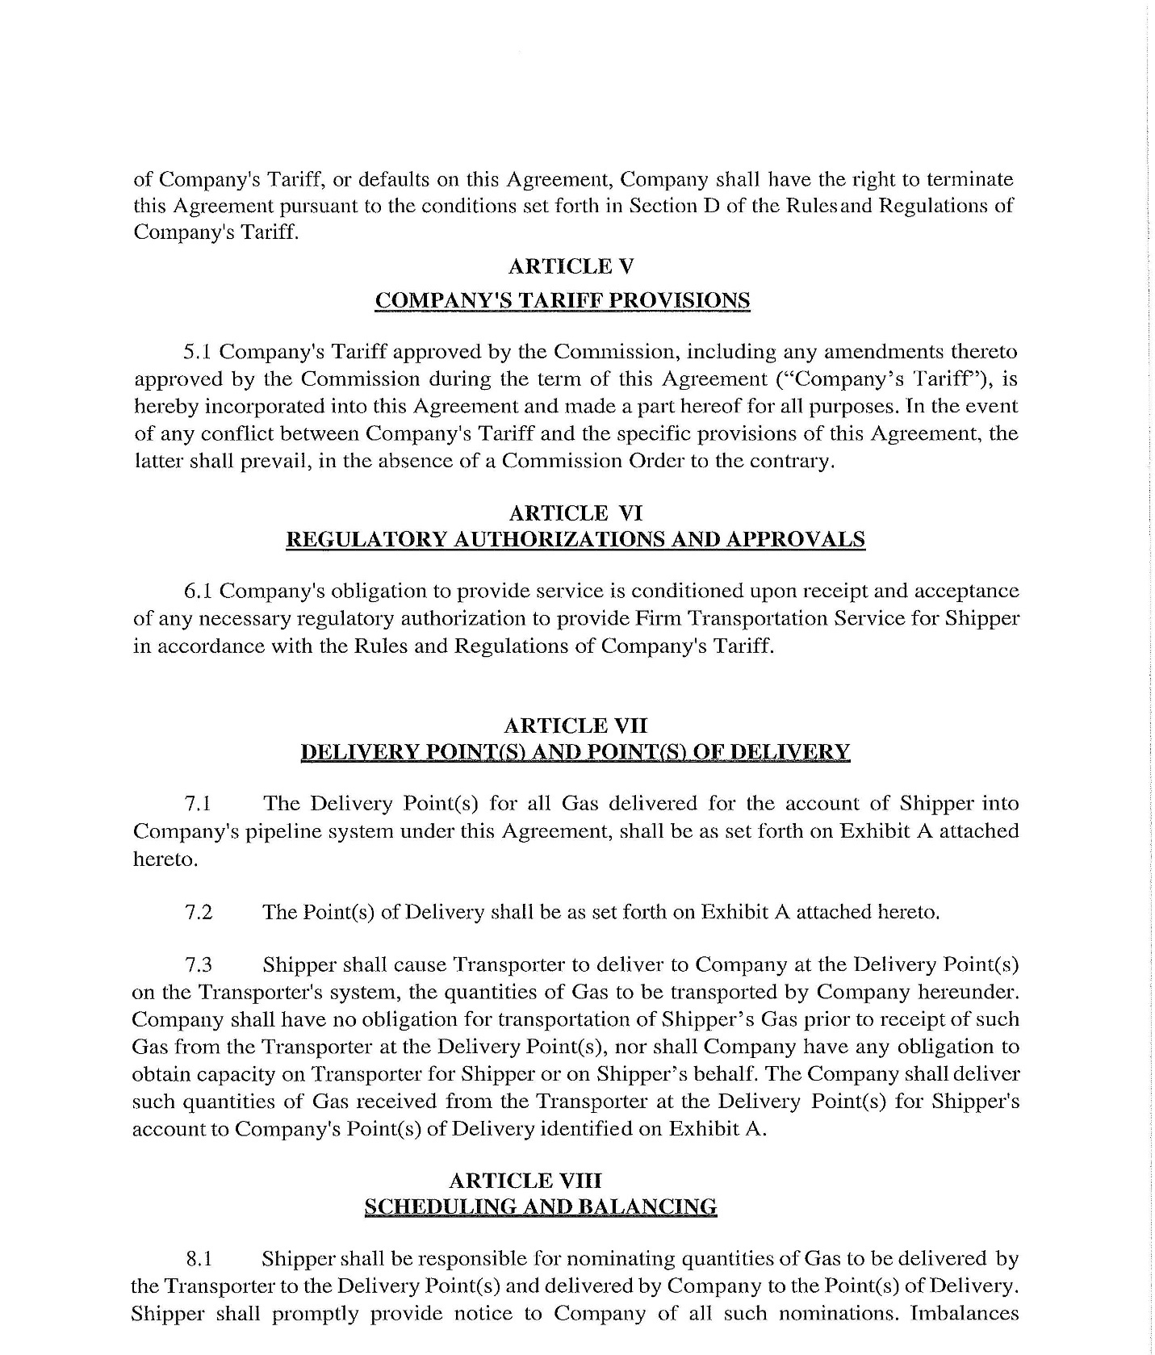

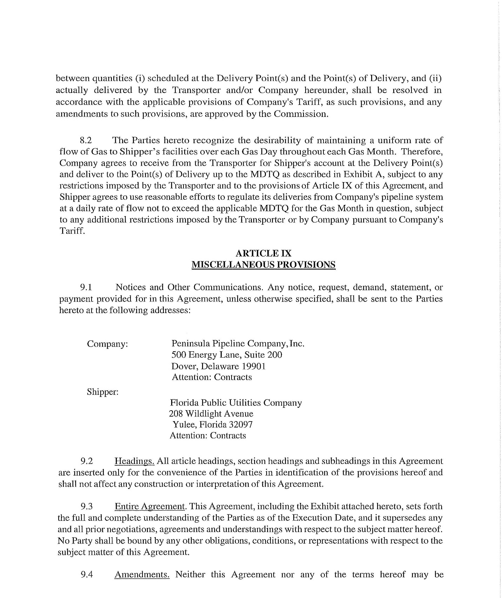

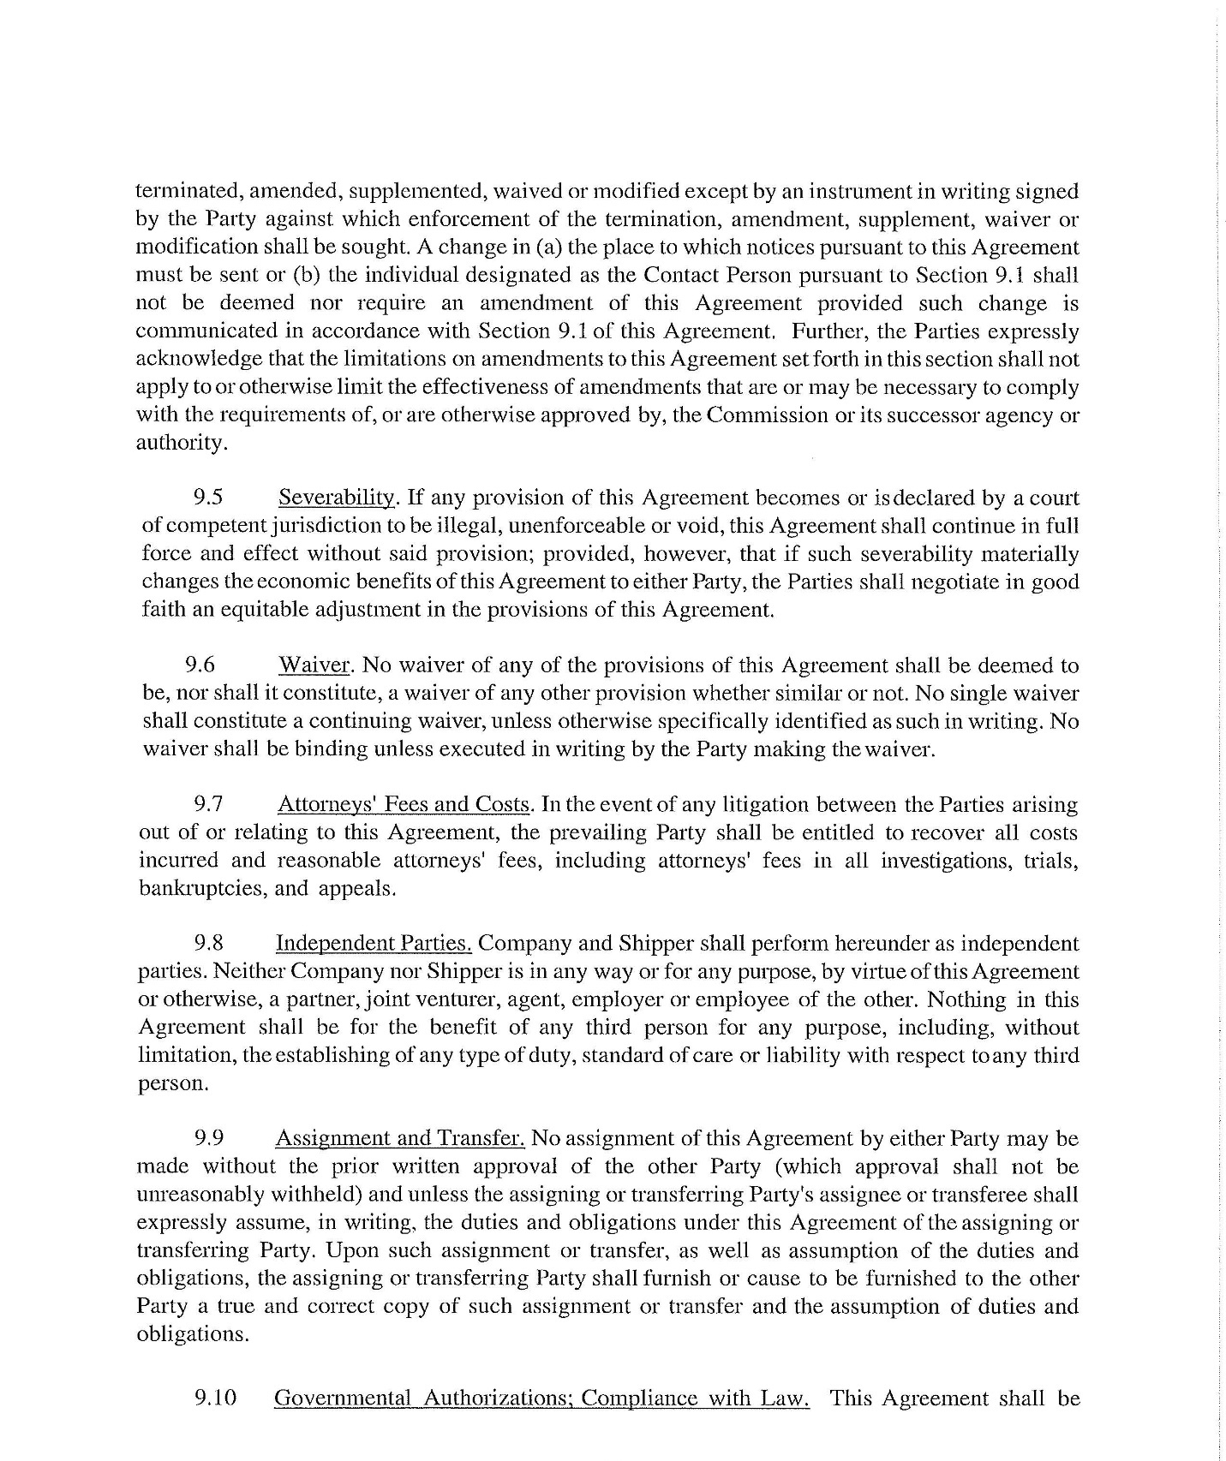

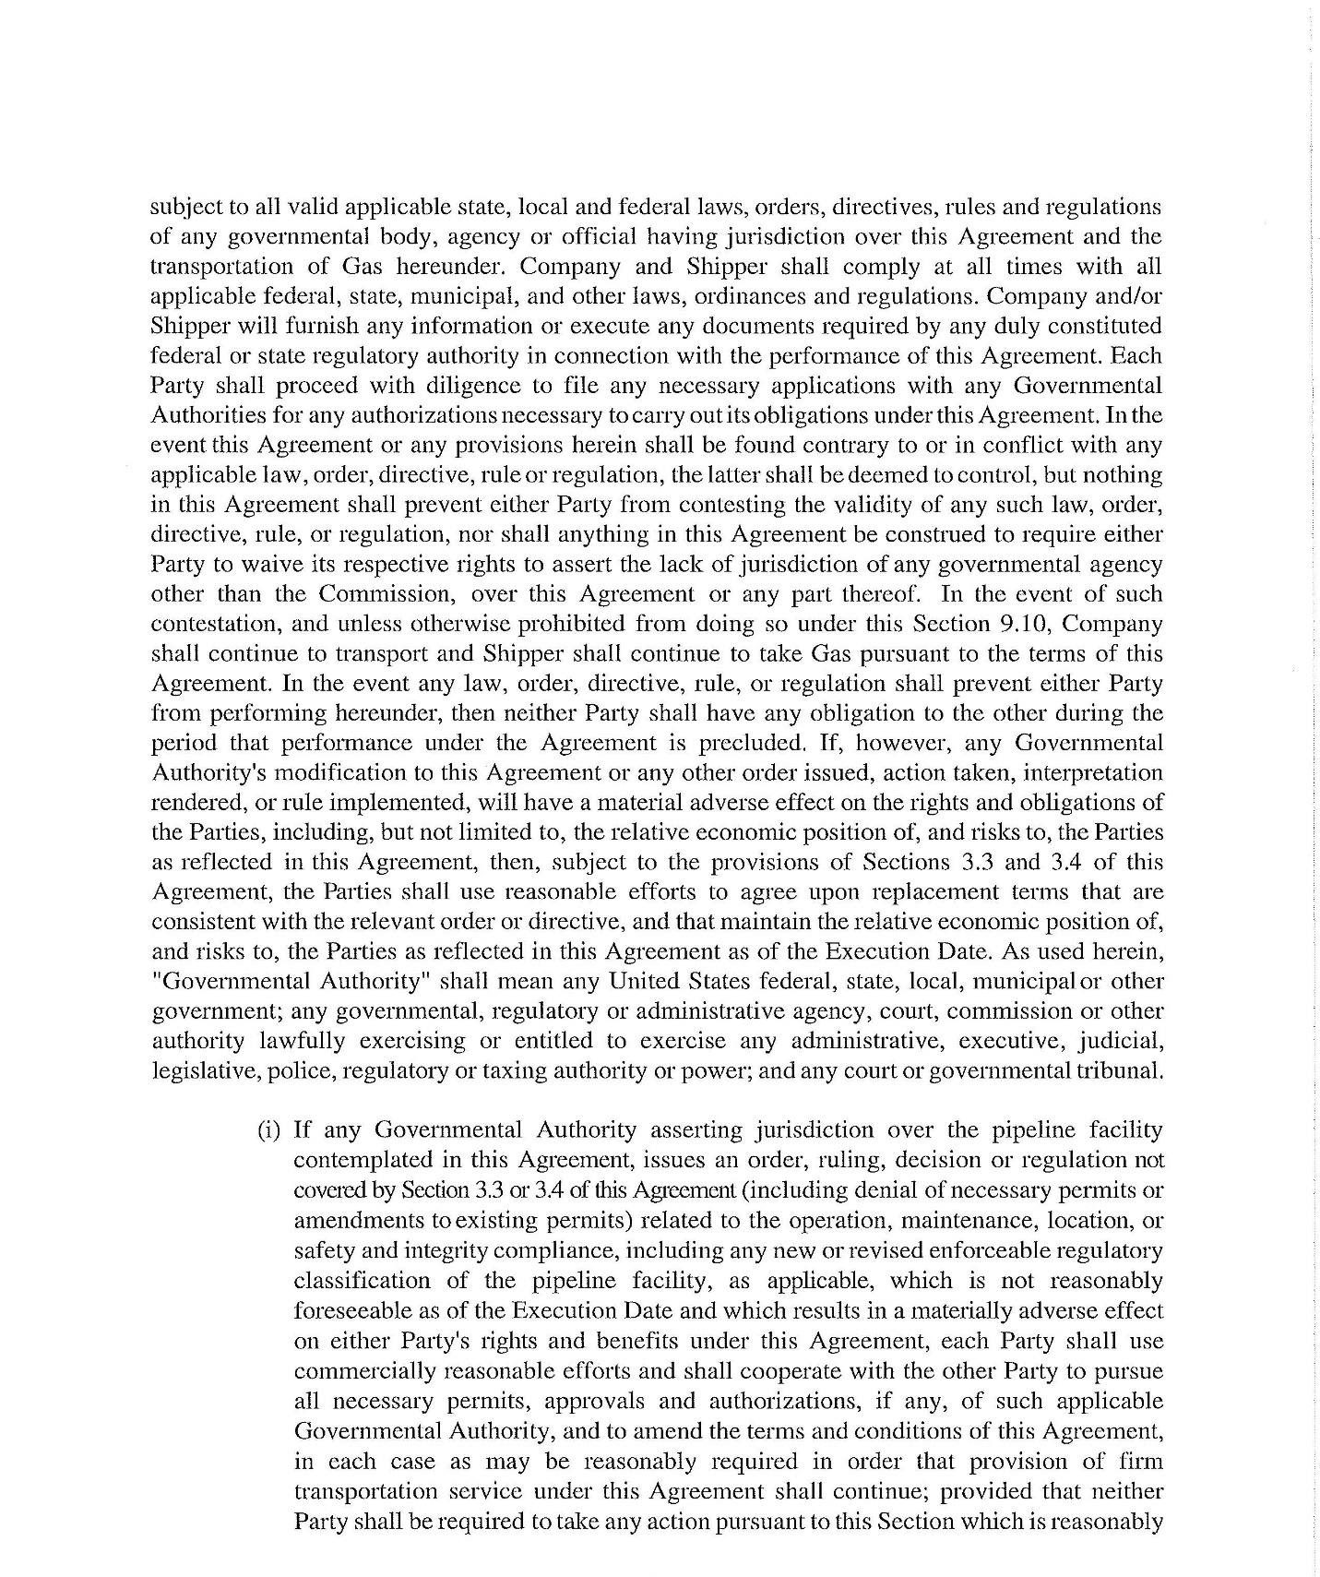

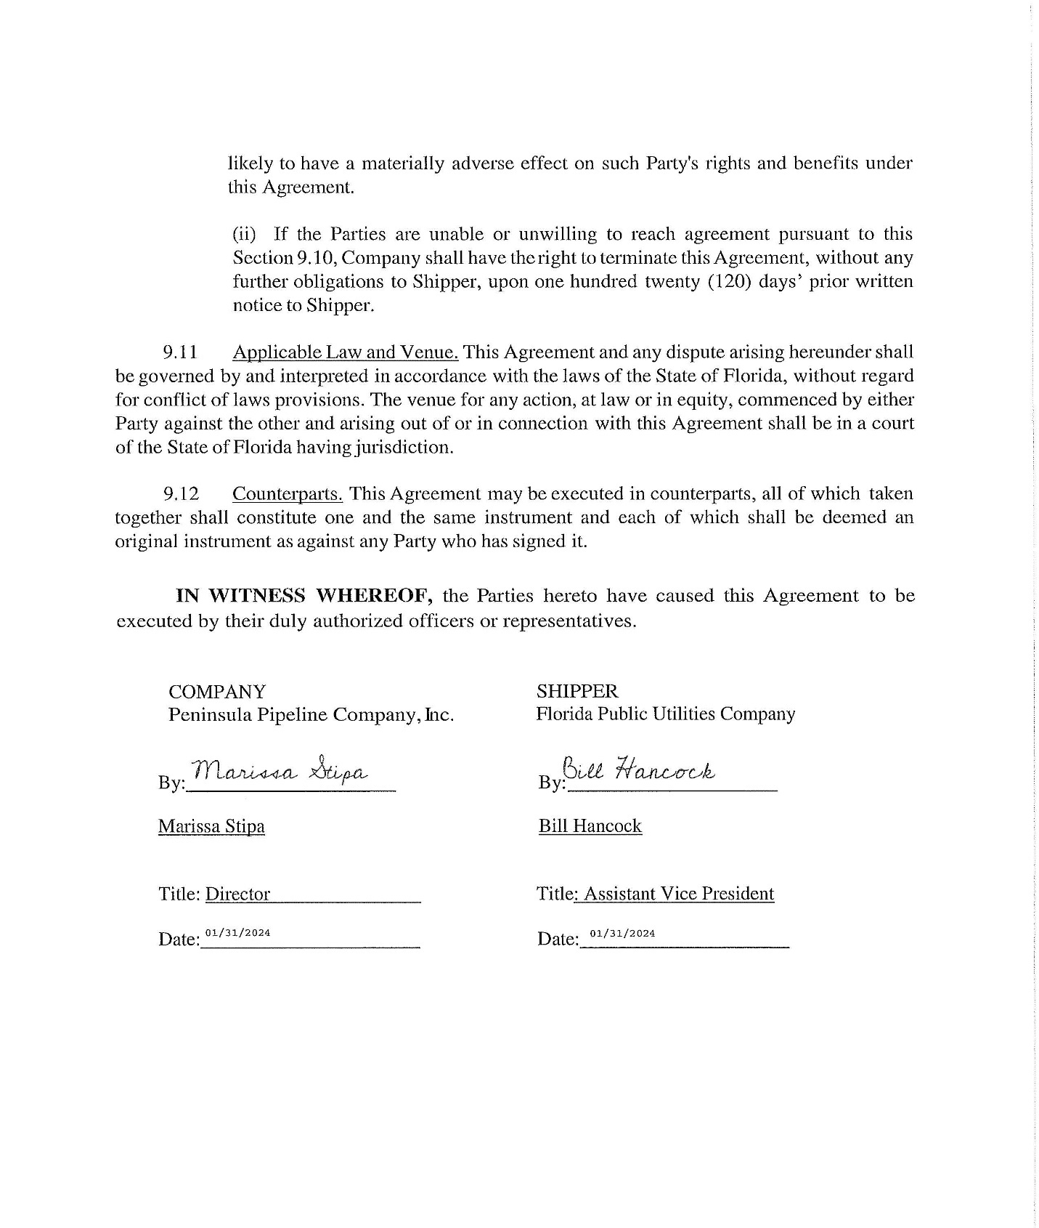

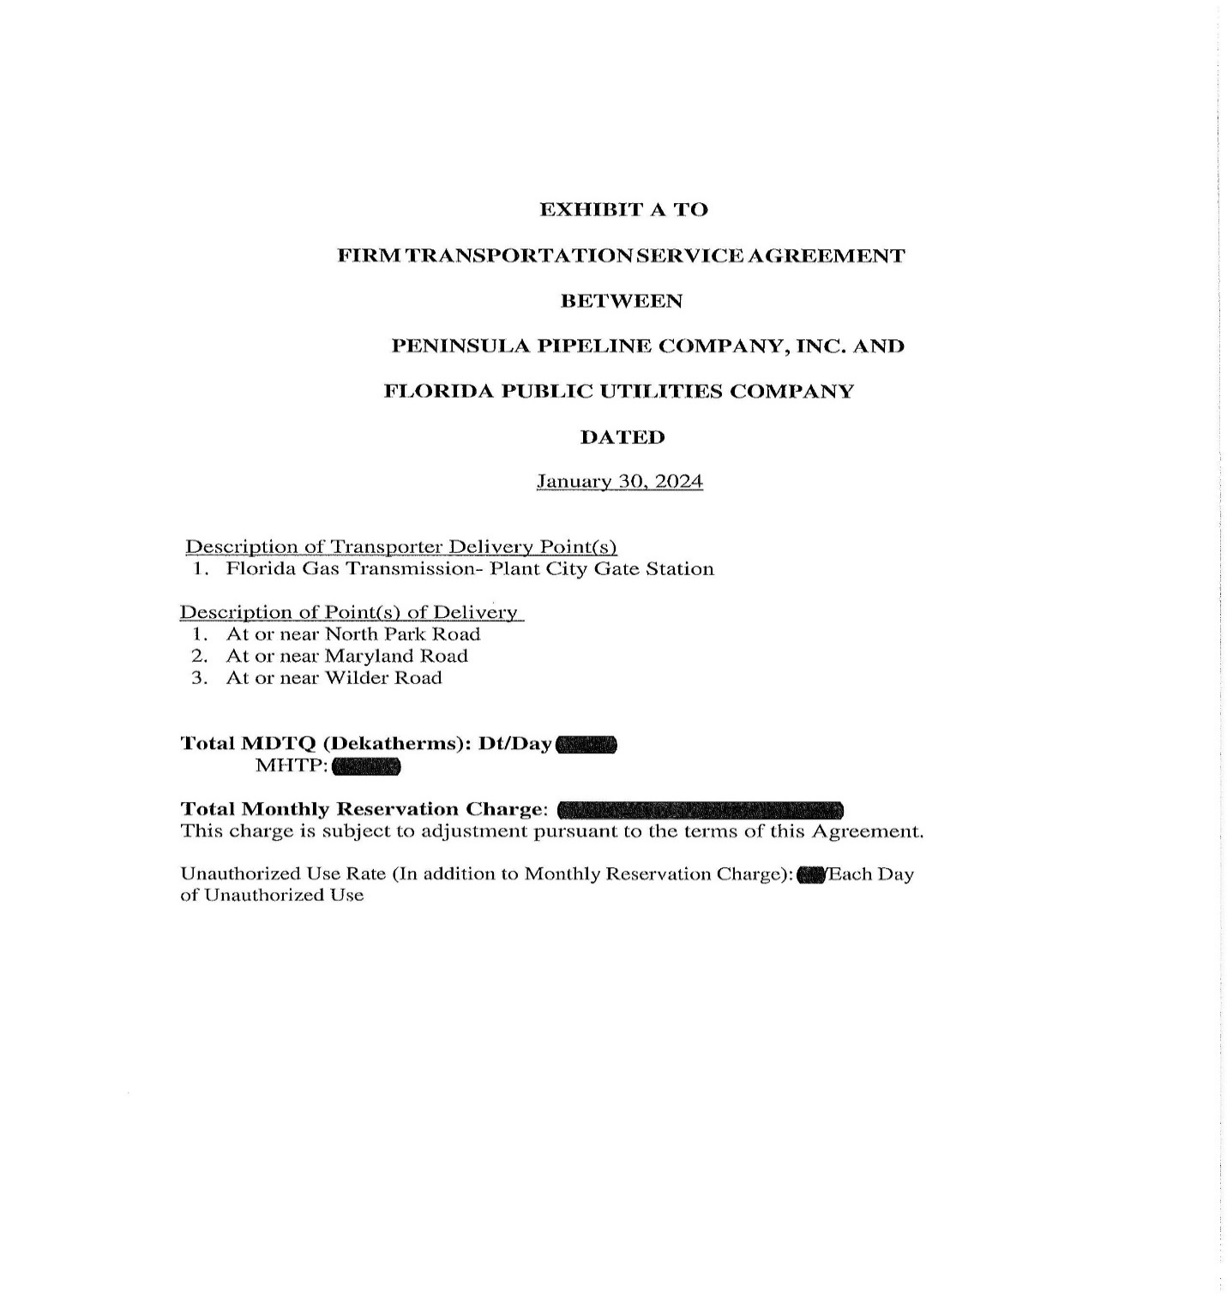

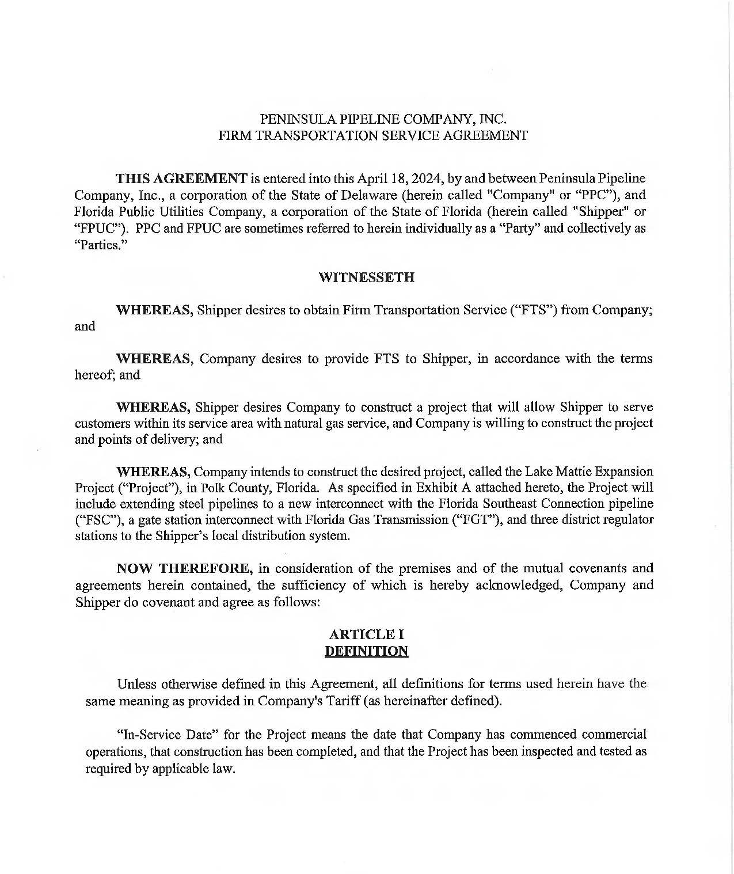

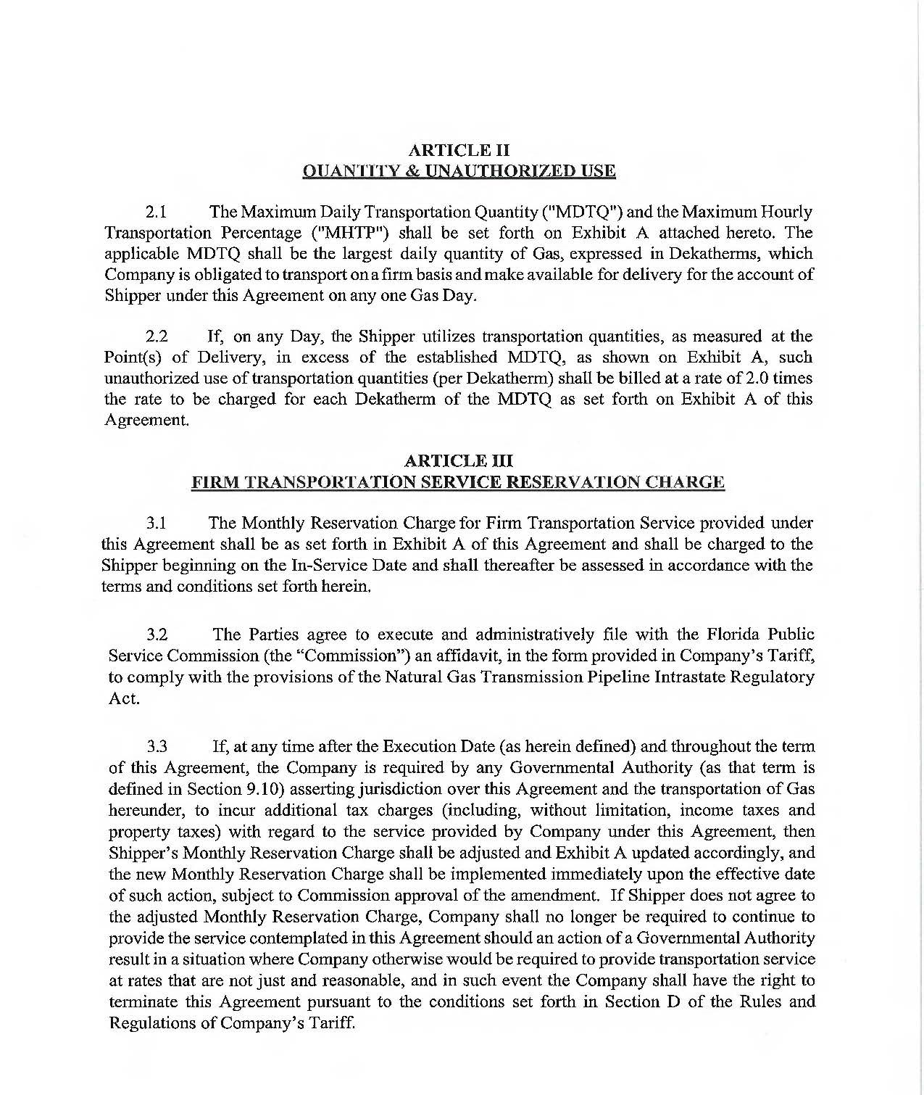

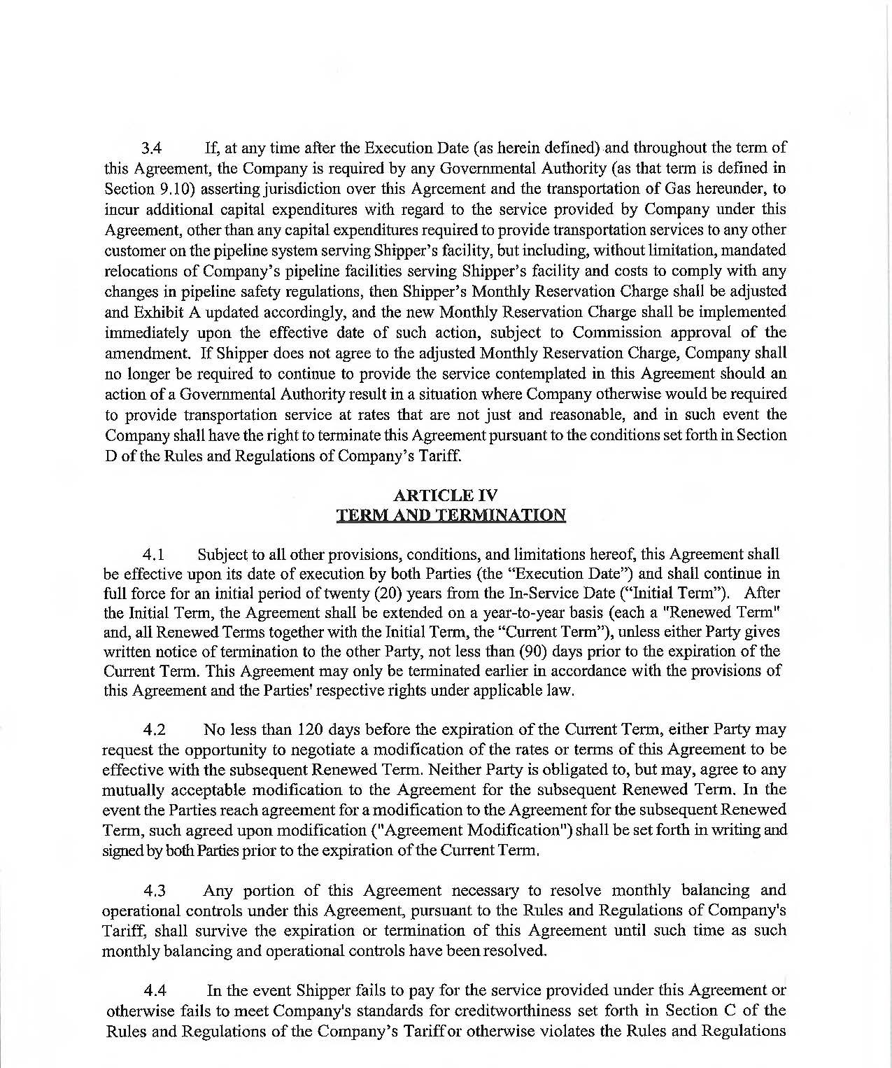
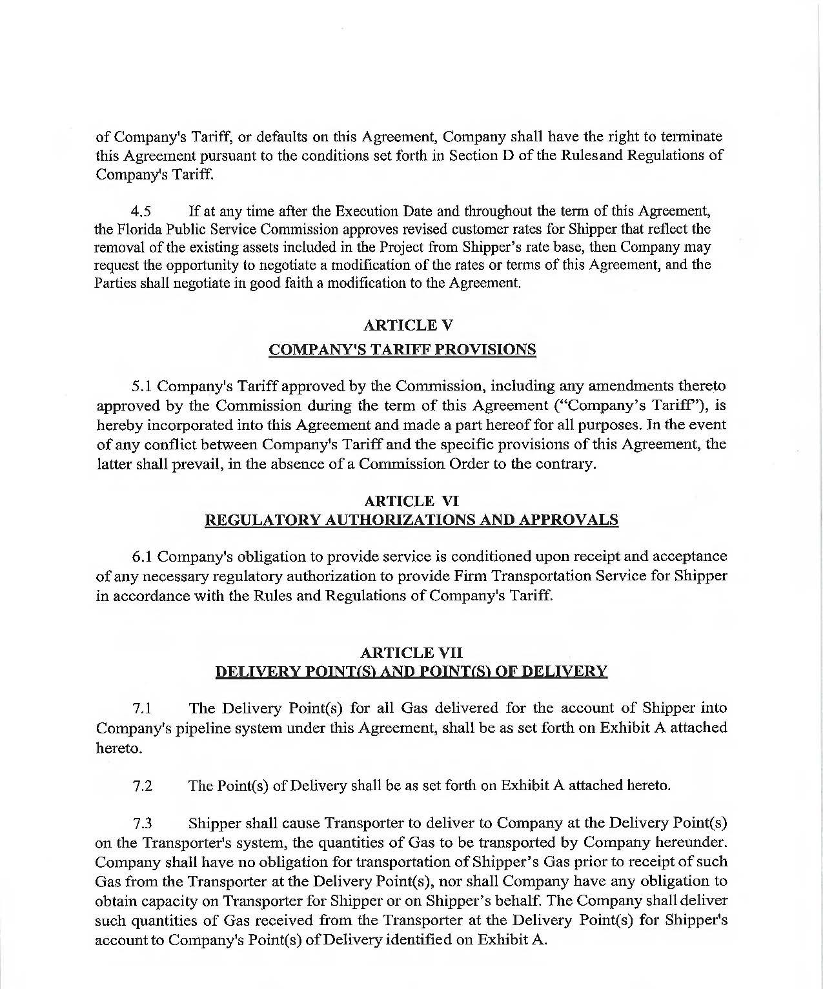

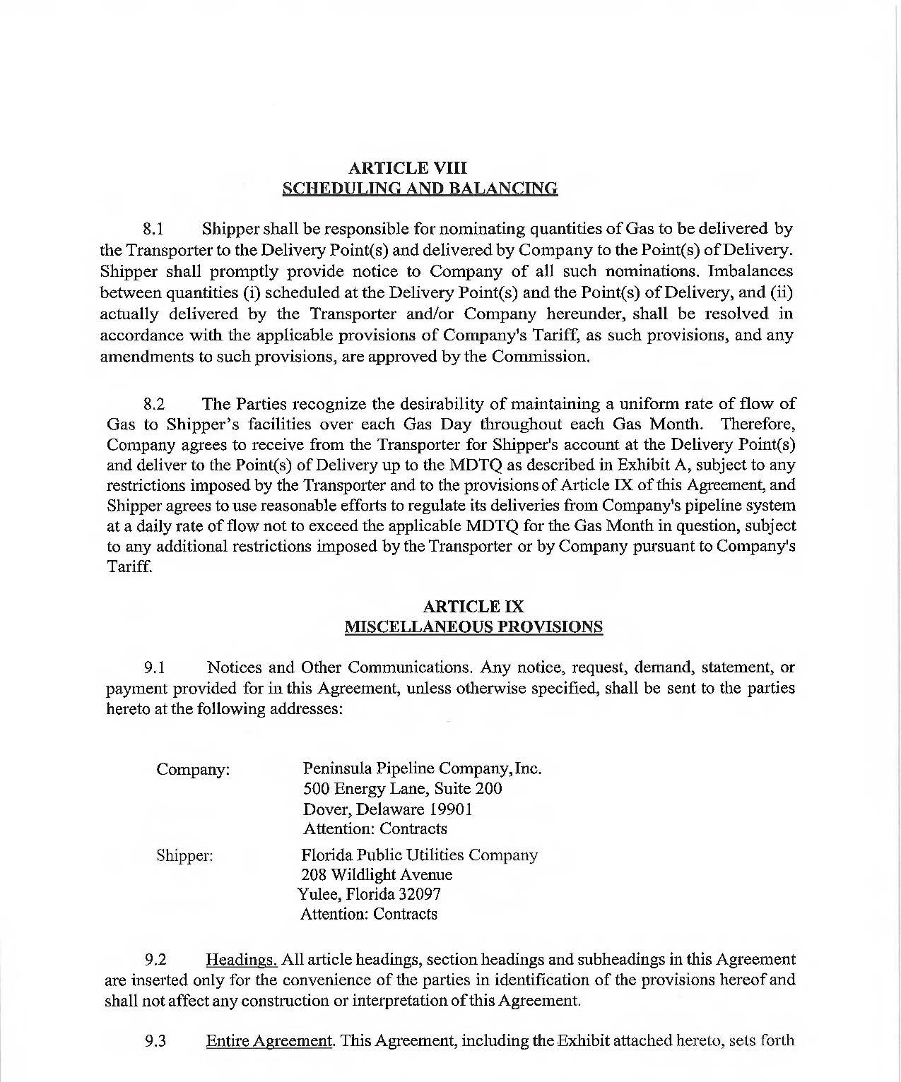

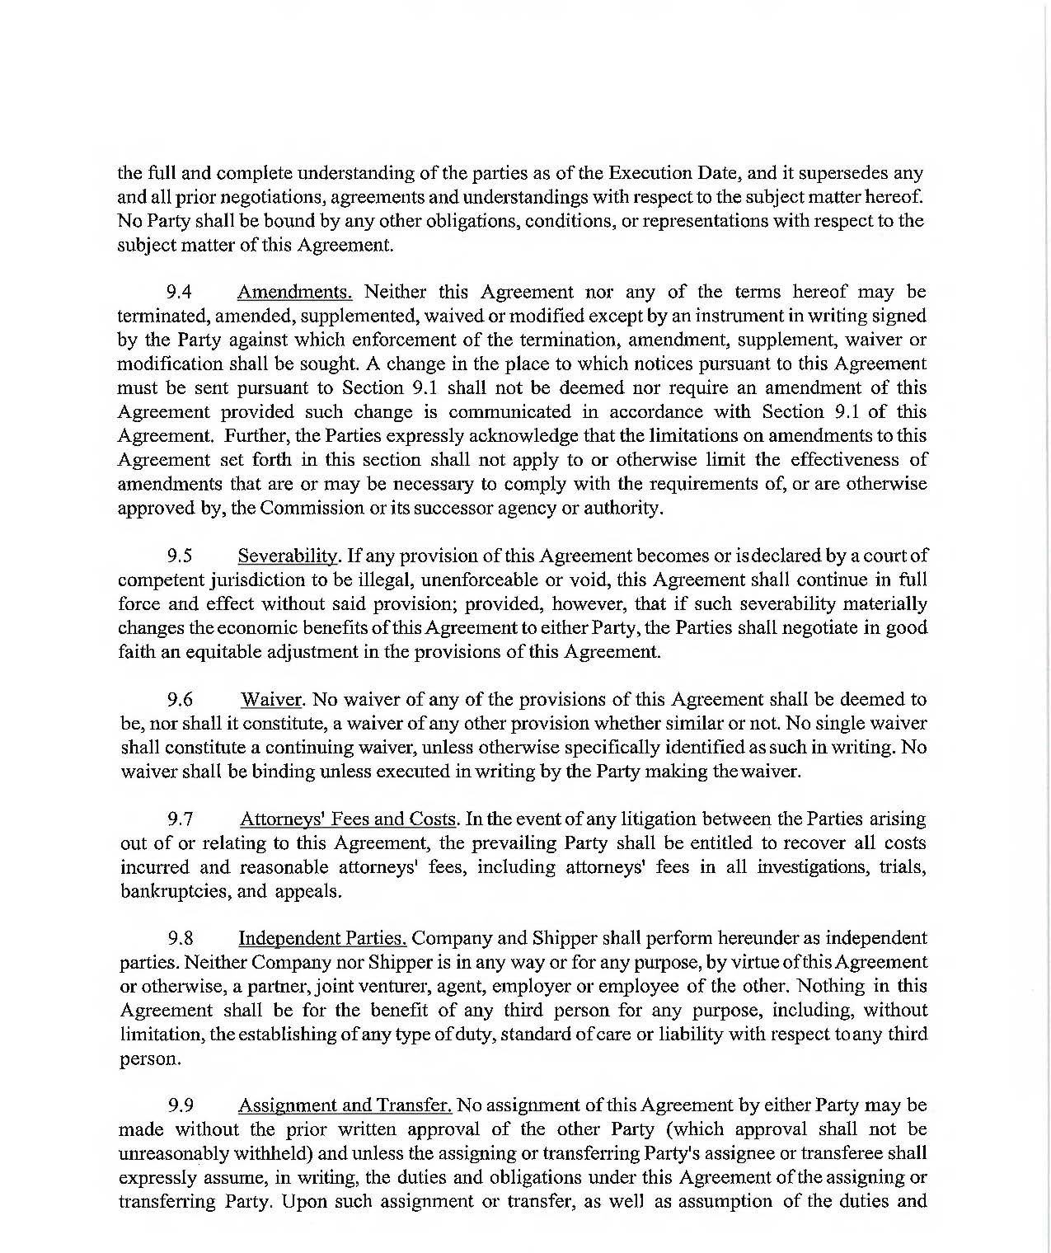

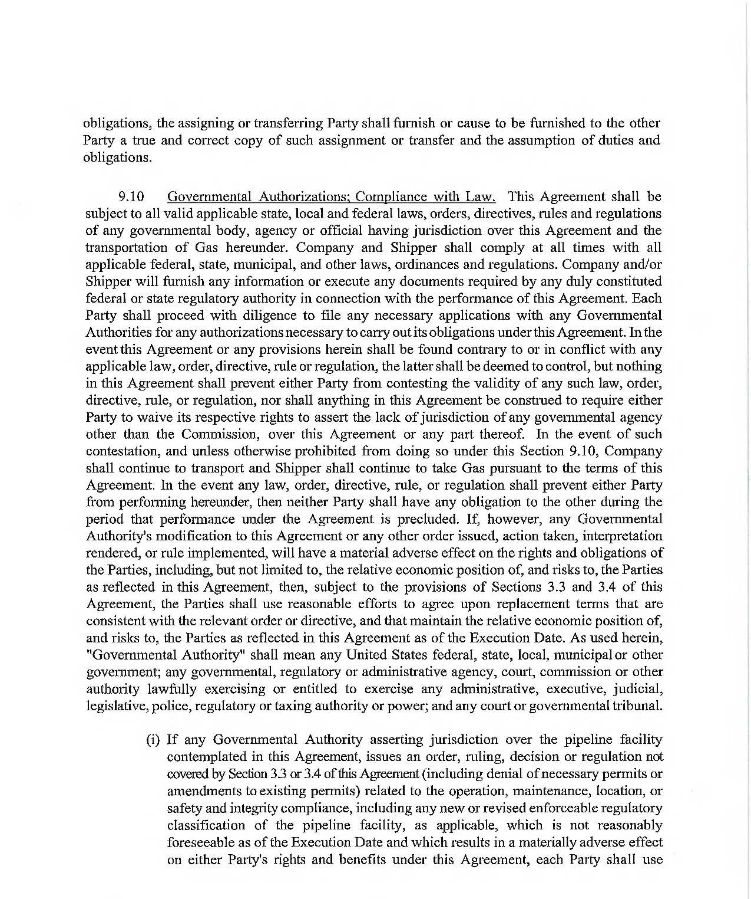

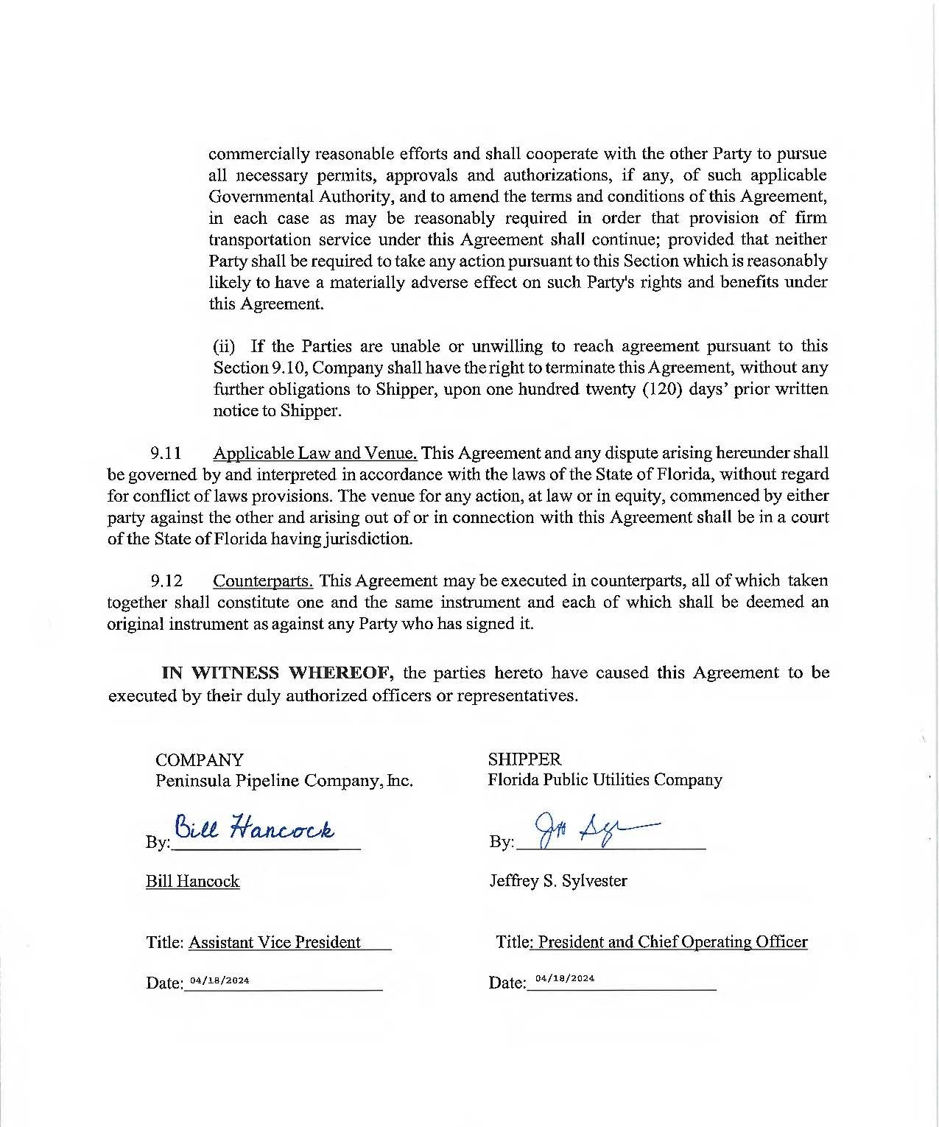

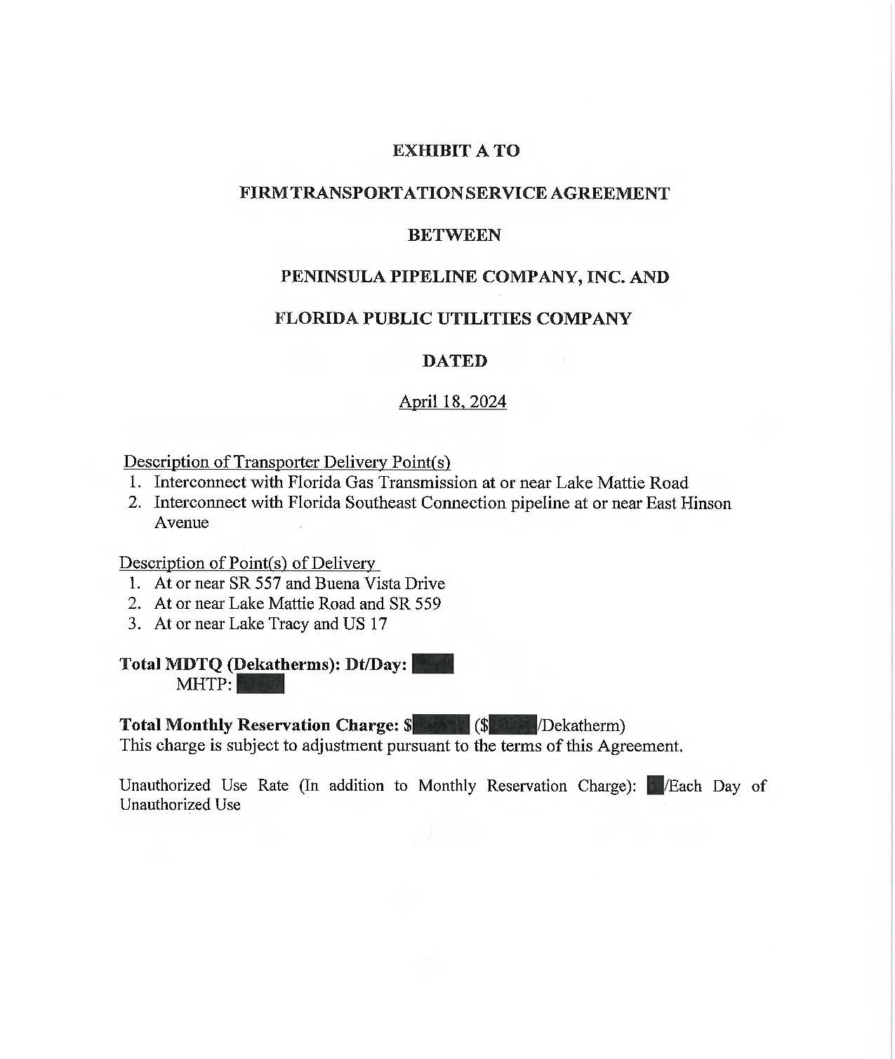

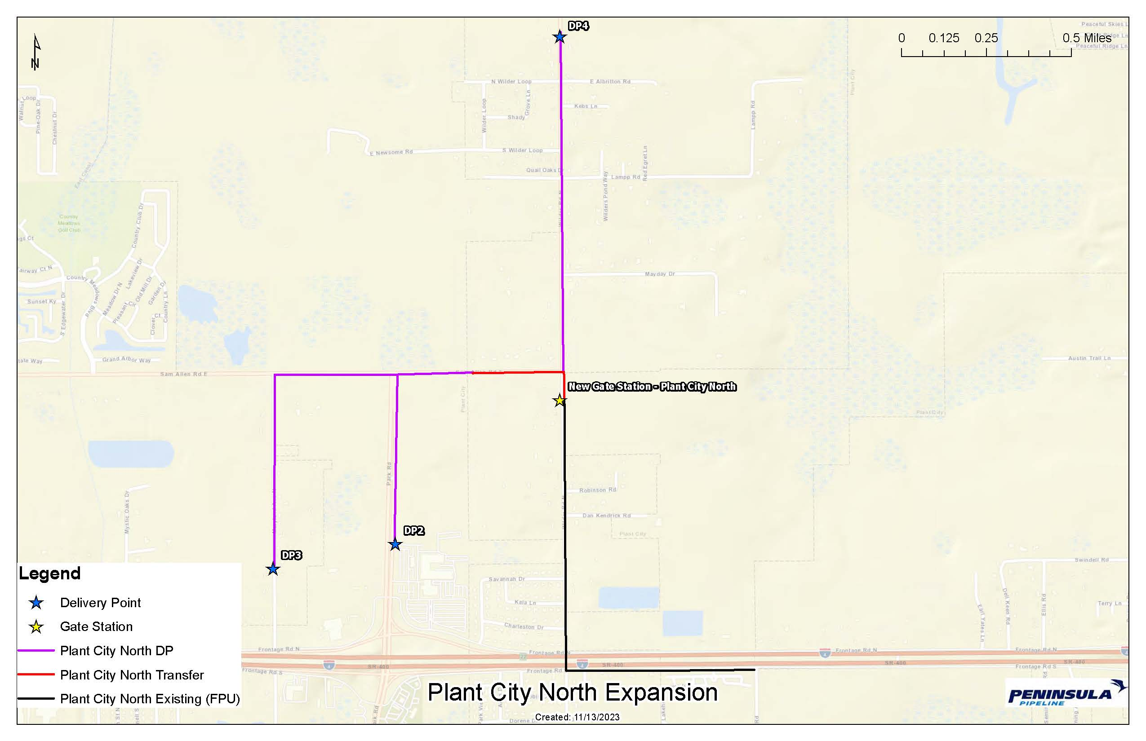

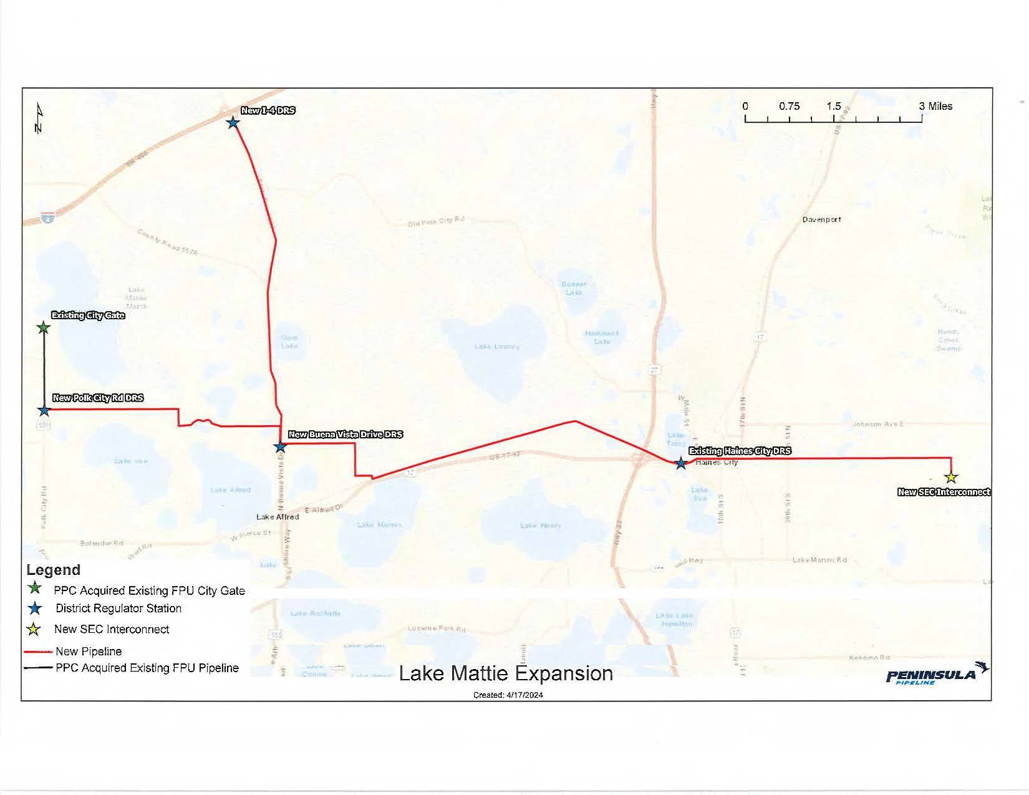

Order No. PSC-06-0023-DS-GP, issued January 9, 2006, in Docket No. 20050584-GP, In re: Petition for declaratory statement by Peninsula Pipeline Company, Inc. concerning recognition as a natural gas transmission company under Section 368.101, F.S., et seq.
Order No. PSC-07-1012-TRF-GP, issued December 21, 2007, in Docket No. 070570-GP, In re: Petition for approval of natural gas transmission pipeline tariff by Peninsula Pipeline Company, Inc.
Peninsula Pipeline Company, Inc., Intrastate Pipeline Tariff, Original Vol. 1, Original Sheet No. 11, Section 3.
Peninsula Pipeline Company, Inc., Intrastate Pipeline Tariff, Original Vol. 1, Original Sheet No. 12, Section 4.
Joint Responses to Staff’s First Data Request, Document No. 01541-2024
Joint Responses to Staff’s Second Data Request, Document No. 01690-2024
Joint responses to Staff’s Second Data Request, Document No. 01690-2024.
Document No. 02041-2024

