BEFORE THE FLORIDA PUBLIC SERVICE COMMISSION

In re: Petition to implement long-term debt cost true-up mechanism, by Peoples Gas System, Inc. | DOCKET NO. 20240028-GU  ORDER NO. PSC-2024-0170-TRF-GU  ISSUED: May 23, 2024

The following Commissioners participated in the disposition of this matter:

MIKE LA ROSA, Chairman
ART GRAHAM
GARY F. CLARK
ANDREW GILES FAY
GABRIELLA PASSIDOMO

ORDER APPROVING PEOPLES GAS SYSTEM, INC.’S
LONG-TERM DEBT COST RATE

BY THE COMMISSION:

Background
Peoples Gas System, Inc. (PGS or Company) is a wholly-owned subsidiary of TECO Gas Operations, Inc., which is a subsidiary of TECO Energy, Inc., which is a wholly-owned subsidiary of Emera United States Holdings, Inc., which is a wholly-owned subsidiary of Emera Incorporated. PGS owns and operates natural gas distribution facilities in Florida and provides service to 470,000 customers in 39 of Florida’s 67 counties. On January 1, 2023, PGS ceased to be a division of Tampa Electric Company and was spun-off into its own entity. As a new entity, PGS ceased obtaining long-term debt capital from its affiliate, Tampa Electric Company, and issued its own debt on December 19, 2023. The Company’s current rates were approved by Order No. PSC-2023-0388-FOF-GU, issued December 27, 2023 (2023 Rate Case Order), which included approval of the Long-Term Debt Cost Rate True-Up Mechanism (LTDR True-Up Mechanism).
On February 2, 2024, PGS filed its petition to implement the aforementioned LTDR True-Up Mechanism. The LTDR True-Up Mechanism allows the Company to make a one-time adjustment to its estimated cost of long-term debt for the projected test year ending December 31, 2024, to reflect the actual embedded cost of PGS’s inaugural long-term debt issuance in its revenue requirement and rates.
In its petition, PGS is seeking approval of an increase of the long-term debt cost rate from 5.54 percent to 5.64 percent, which would increase the weighted average cost of capital from 7.02 percent to 7.05 percent, and thereby increase the incremental base rate revenue increase approved in the 2023 Rate Case Order by $874,085. The Company also requested our approval of the updated base rates and charges and associated tariffs, effective for the first billing cycle of June 2024. PGS also requested we specify the amount of incremental revenue requirement from January 1, 2024, to the effective date of the Company’s updated 2024 tariffs to be deferred by the Company for recovery through the Cast Iron/Bare Steel Replacement Rider for 2025 as approved in the 2023 Rate Case Order.
During the review process, Commission staff issued two data requests to PGS. The first data request was issued on February 13, 2024, and the Company’s response was received on February 23, 2024. The second data request was issued on February 29, 2024, and a response was received on March 11, 2024. By Order No. PSC-2024-0090-PCO-GU, we suspended the proposed tariffs. We have jurisdiction over this matter pursuant to Sections 366.03, 366.04, 366.05, 366.06, and 366.076, Florida Statutes (F.S.).

Decision

Long-Term Debt Rate True-Up Mechanism

The LTDR True-Up Mechanism we approved in the 2023 Rate Case Order allows PGS to make a one-time adjustment to the Company’s forecasted long-term debt cost rate after its inaugural long-term debt issuance. In the 2023 Rate Case Order, we approved a long-term debt cost rate of 5.54 percent. PGS completed its inaugural long-term debt issuance on December 19, 2023, by issuing a total of $925 million of long-term debt in the following amounts and maturities: $350 million at five years, $350 million at ten years, and $225 million at thirty years. The embedded cost rate of the three debt issuances, including debt issuing expense, is 5.64 percent. We reviewed the Company’s calculation of 5.64 percent for the embedded cost of long-term debt in Exhibit One attached to its petition and verified its accuracy. PGS used the same methodology to calculate the actual long-term debt cost rate of 5.64 percent that we approved in the 2023 Rate Case Order.
In early 2023, PGS forecasted to issue approximately $825 million of long-term debt on September 30, 2023, and expected approximately $910 million of intercompany debt to be outstanding at the time the intercompany loan with Tampa Electric Company was paid off. Ultimately, PGS issued $100 million more than forecasted based on the amount of intercompany debt outstanding at the time of the Company’s inaugural long-term debt issuance (December 19, 2023). In response to Commission staff’s second data request, PGS explained that the purpose for the additional $100 million was to satisfy the combined intercompany long-term and short-term debt outstanding of $956 million. PGS’s implementation of the LTDR True-Up Mechanism complies with our 2023 Rate Case Order; therefore, we approve PGS’s request to increase its cost rate for long-term debt from 5.54 percent to 5.64 percent for the test year ending December 31, 2024.

Weighted Average Cost of Capital
By updating the forecasted long-term debt cost rate of 5.54 percent with the actual cost rate of 5.64 percent, and making no other changes to PGS’s capital structure approved in the 2023 Rate Case Order, the weighted average cost of capital increased from 7.02 percent to 7.05 percent. The balance of long-term debt in the updated capital structure is unchanged from the balance of $830,722,209 approved in the 2023 Rate Case Order. We reviewed the Company’s revised capital structure in its petition and verified it is calculated correctly pursuant to the 2023 Rate Case Order. Therefore, we approve PGS’s request to increase the weighted average cost of capital from 7.02 percent to 7.05 percent for the test year ending December 31, 2024.

Incremental Base Rate Revenue Requirement
In the 2023 Rate Case Order, we approved PGS’s incremental base rate revenue requirement of $117,839,527 based on an overall rate of return of 7.02 percent. Updating the 7.02 percent overall rate of return to 7.05 percent, the incremental revenue requirement increased to $118,713,612. This equates to an increase of $874,085 or 0.74 percent. We reviewed PGS’s updated incremental base rate revenue increase calculations in its petition and verified it was calculated correctly pursuant to the 2023 Rate Case Order. Therefore, we approve an increase in the amount of the incremental base rate revenue requirement from $117,839,527 to $118,713,612 for the test year ending December 31, 2024.

Effective Date

As discussed above, PGS requested to increase the incremental base rate revenue requirement from $117,839,527 to $118,713,612 for the test year ending December 31, 2024, which results in an increase of $874,085. PGS allocated this amount to the monthly customer charge and distribution charge in all its rate classes as shown in its petition. A residential customer in the RS-2 rate schedule, using 14 therms per month would see a bill increase of $0.06, from $29.27 to $29.33, excluding clause factors and taxes.
In response to Commission staff’s second data request, PGS stated that it intends to notify its customers of the rate changes at least 30 days prior to their effective date, via bill inserts, email notification for electronic bill customers and the PGS website. Our staff has reviewed the proposed customer notice, which was provided in response to staff’s second data request.
PGS requested that the proposed tariffs be effective with the first billing cycle in June 2024 or soon thereafter. The proposed tariffs, calculations of the revised base rate charges and PGS’s responses to data requests are approved and shall be effective with the first billing cycle in July 2024.

Deferral of Recovery
In the 2023 Rate Case Order, we approved PGS’s proposal that for the time period between when the new approved base rates went into effect (January 1, 2024) and the implementation date of the LTDR True-Up Mechanism adjusted base rates (first billing cycle of July 2024), the Company will defer the rate impact of the LTDR True-Up Mechanism to its balance sheet for refund or collection through the Cast Iron/Bare Steel Replacement (CI/BSR) Rider in the subsequent year if the amount of the LTDR True-Up Mechanism is greater than $500,000. As discussed above, the impact of the LTDR True-Up Mechanism on the incremental revenue requirement is $874,085. Therefore, the recovery of the incremental revenue requirement for the six-month period from January 1, 2024, through June 30, 2024, shall be recovered through the CI/BSR Rider for 2025. Therefore, we approve PGS’s request to defer recovery of the incremental revenue increase for the six-month period from January 1, 2024, through June 30, 2024, to the CI/BSR Rider for 2025. The Company shall include the actual incremental amount for recovery in the 2024 CI/BSR Rider docket.

Based on the foregoing, it is

ORDERED by the Florida Public Service Commission that Peoples Gas System, Inc.’s cost rate for long-term debt is increased from 5.54 percent to 5.64 percent for the test year ending December 31, 2024. It is further
ORDERED that PGS’s weighted average cost of capital is increased from 7.02 percent to 7.05 percent for the test year ending December 31, 2024. It is further

ORDERED that PGS’s incremental base rate revenue requirement approved in the 2023 Rate Case Order is increased from $117,839,527 to $118,713,612 for the test year ending December 31, 2024. It is further

ORDERED that PGS’s updated base rates, charges, and tariffs reflected in Attachment A to this order shall go into effect with the first billing cycle in July 1, 2024. It is further

ORDERED that recovery pf the incremental revenue increase for the six-month period from January 1, 2024, through June 30, 2024, is deferred to the Cast Iron/Bare Steel Replacement Rider for 2025. The Company shall include the actual incremental amount for recovery in the 2024 Cast Iron/Bare Steel Replacement Rider docket. It is further

ORDERED that if a protest is filed within 21 days of issuance of this order, the tariff shall remain in effect with any charges held subject to refund pending resolution of the protest. It is further

ORDERED that if no timely protest is filed, this docket shall be closed upon the issuance of a Consummating Order.

By ORDER of the Florida Public Service Commission this 23rd day of May, 2024.

/s/ Adam J. Teitzman
ADAM J. TEITZMAN
Commission Clerk
Florida Public Service Commission
2540 Shumard Oak Boulevard
Tallahassee, Florida 32399
(850) 413-6770
www.floridapsc.com

Copies furnished: A copy of this document is provided to the parties of record at the time of issuance and, if applicable, interested persons.

MRT
NOTICE OF FURTHER PROCEEDINGS

The Florida Public Service Commission is required by Section 120.569(1), Florida Statutes, to notify parties of any administrative hearing or judicial review of Commission orders that is available under Sections 120.57 or 120.68, Florida Statutes, as well as the procedures and time limits that apply. This notice should not be construed to mean all requests for an administrative hearing or judicial review will be granted or result in the relief sought.

Mediation may be available on a case-by-case basis. If mediation is conducted, it does not affect a substantially interested person's right to a hearing.

The Commission's decision on this tariff is interim in nature and will become final, unless a person whose substantial interests are affected by the proposed action files a petition for a formal proceeding, in the form provided by Rule 28-106.201, Florida Administrative Code. This petition must be received by the Office of Commission Clerk, 2540 Shumard Oak Boulevard, Tallahassee, Florida 32399-0850, by the close of business on June 13, 2024.

In the absence of such a petition, this Order shall become final and effective upon the issuance of a Consummating Order.

Any objection or protest filed in this docket before the issuance date of this order is considered abandoned unless it satisfies the foregoing conditions and is renewed within the specified protest period.

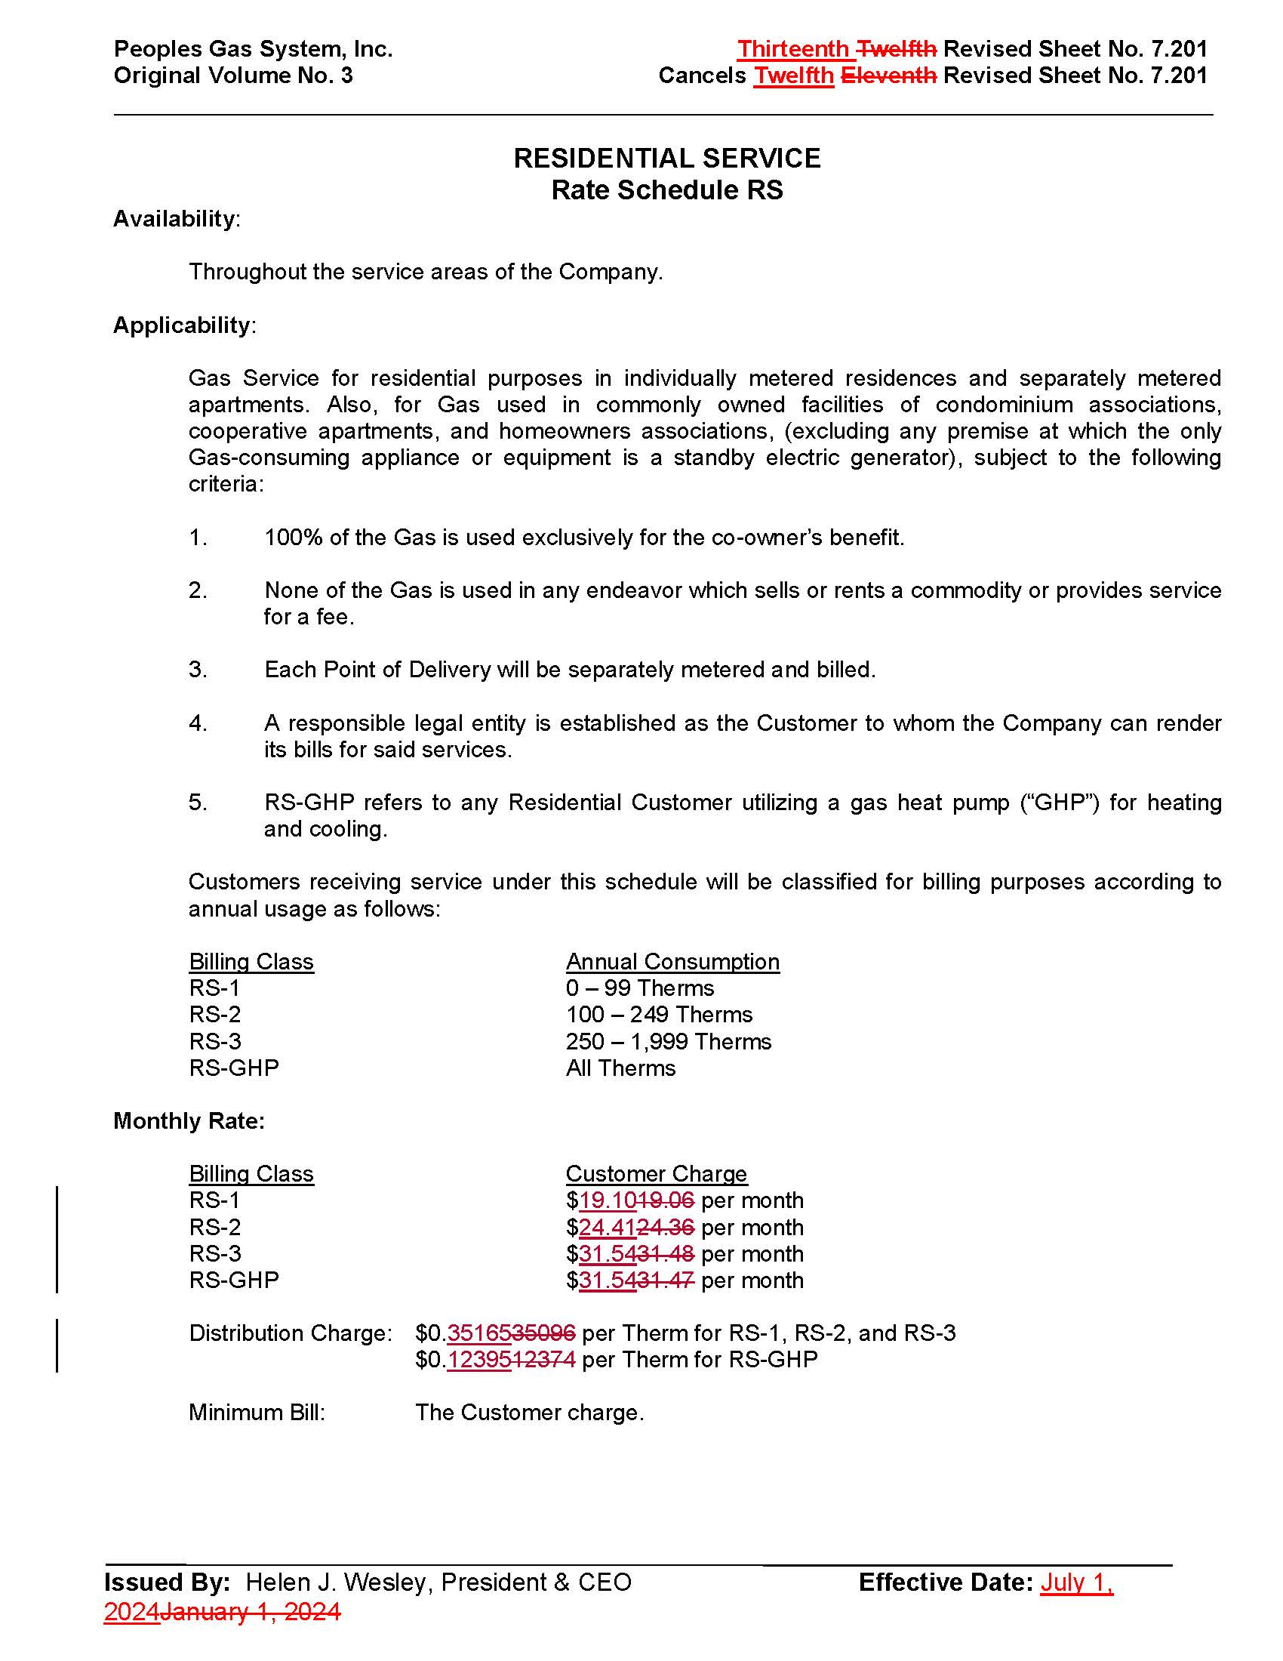

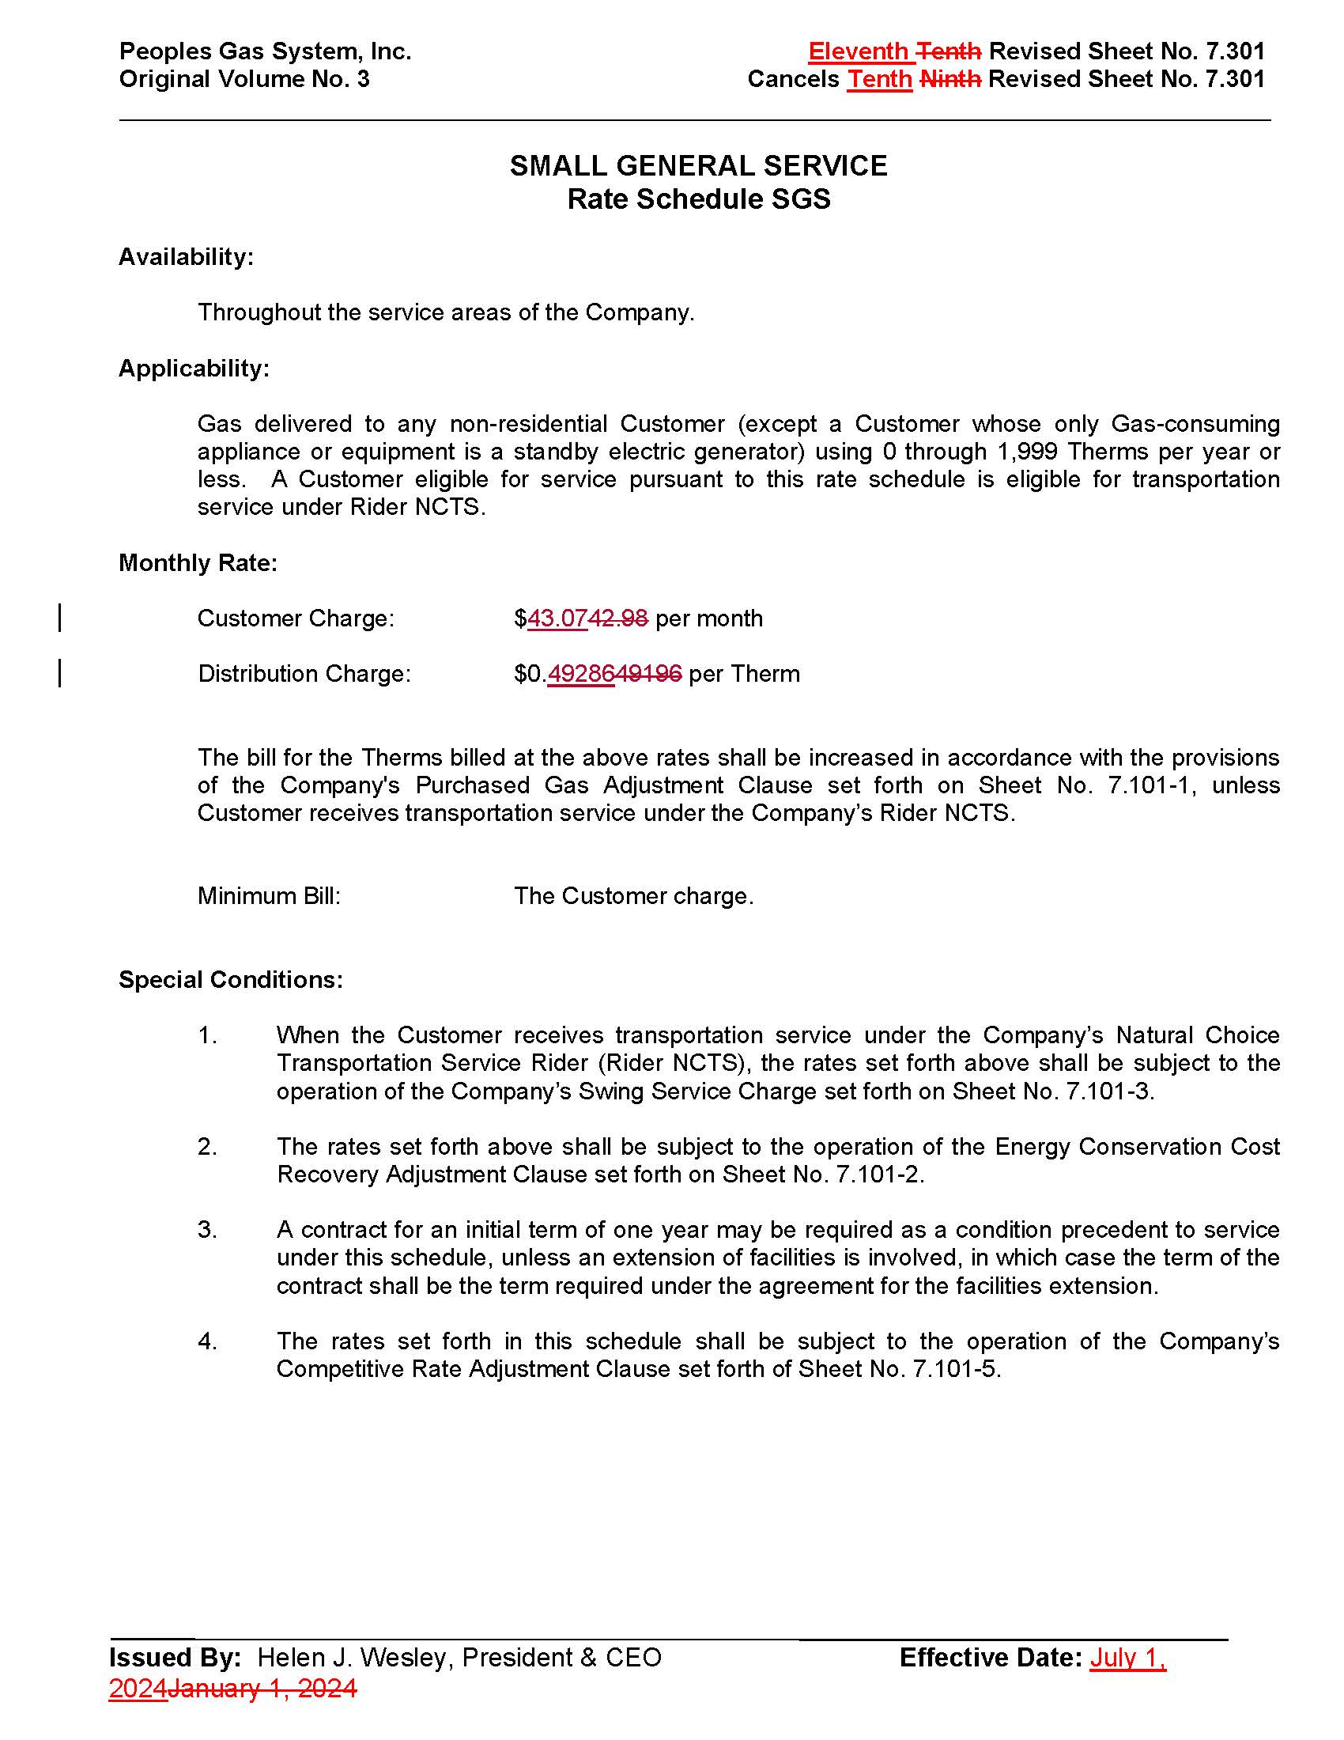

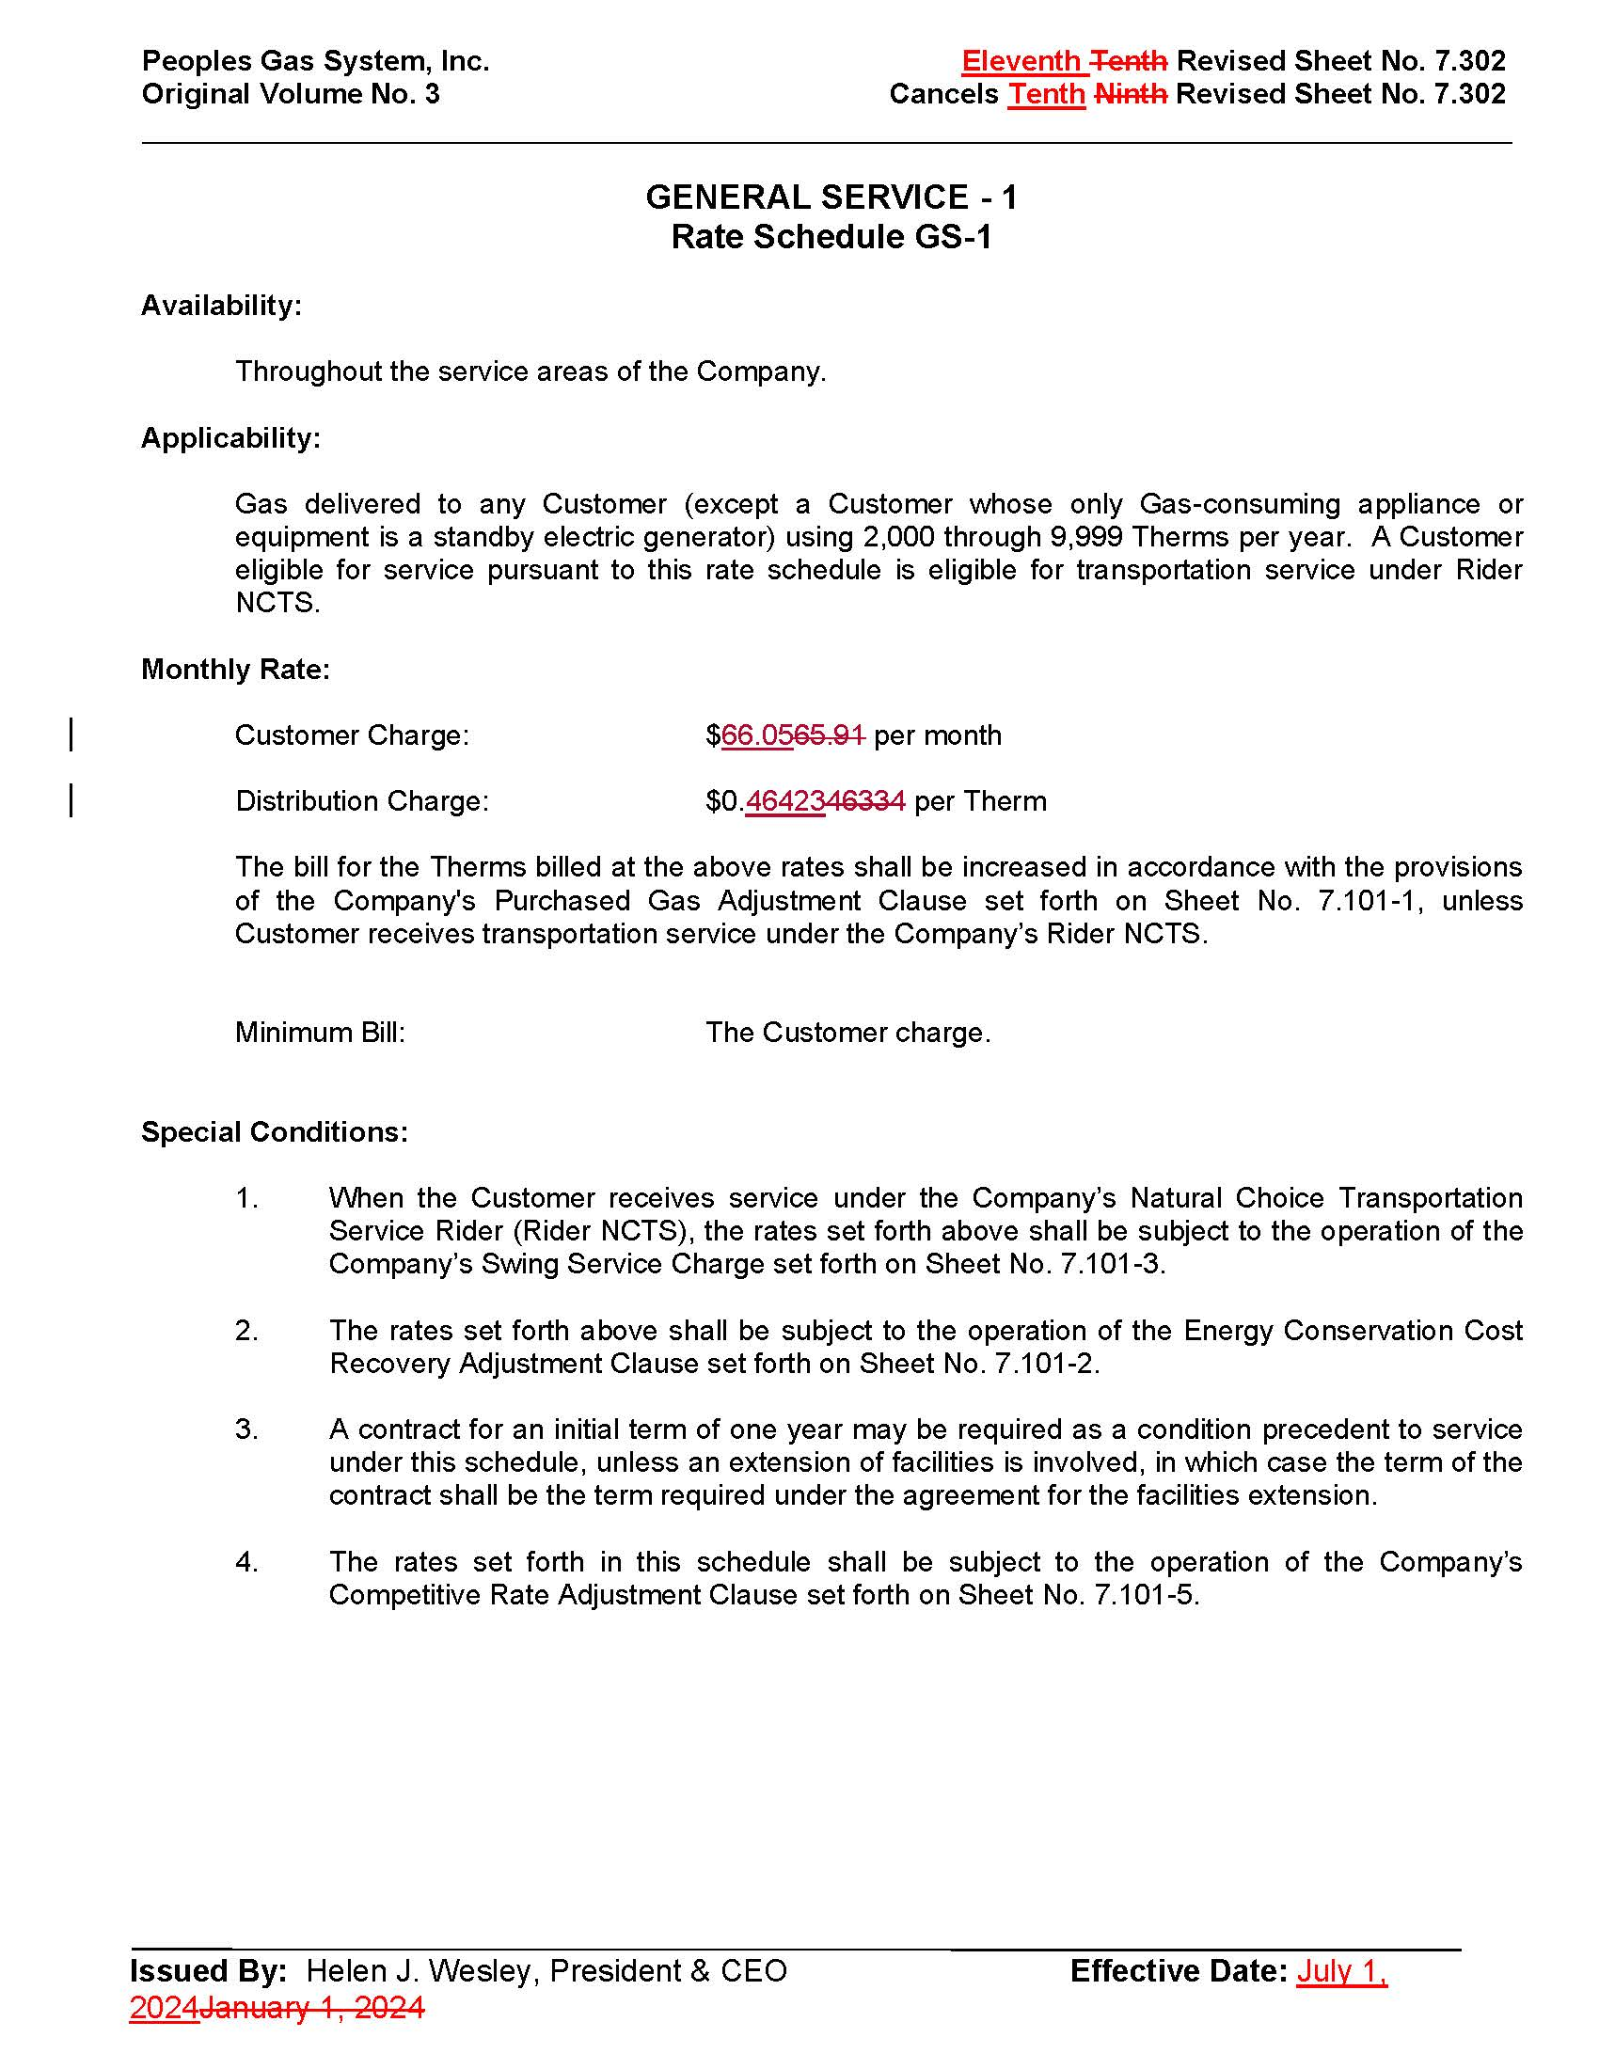

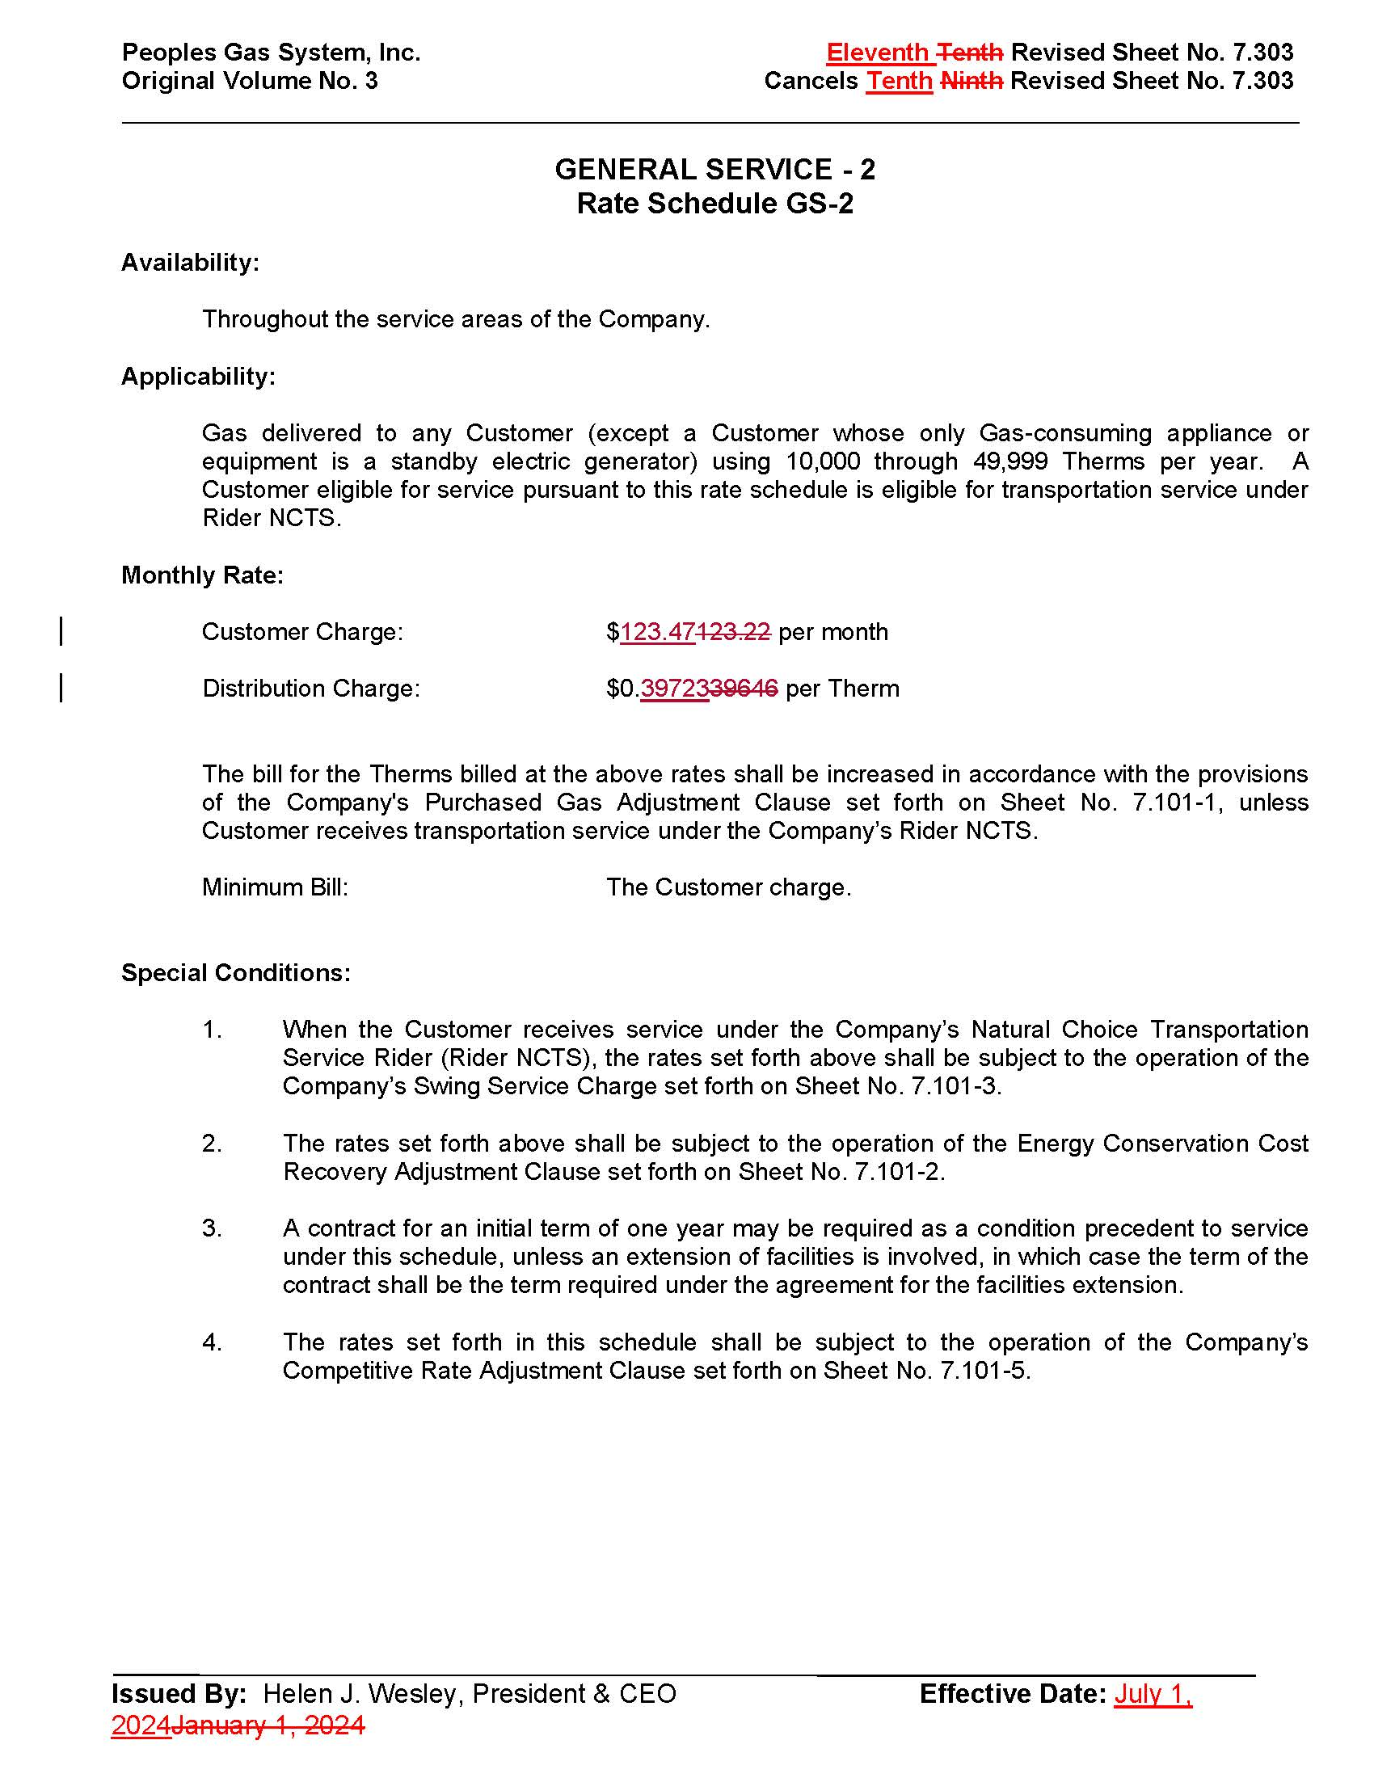

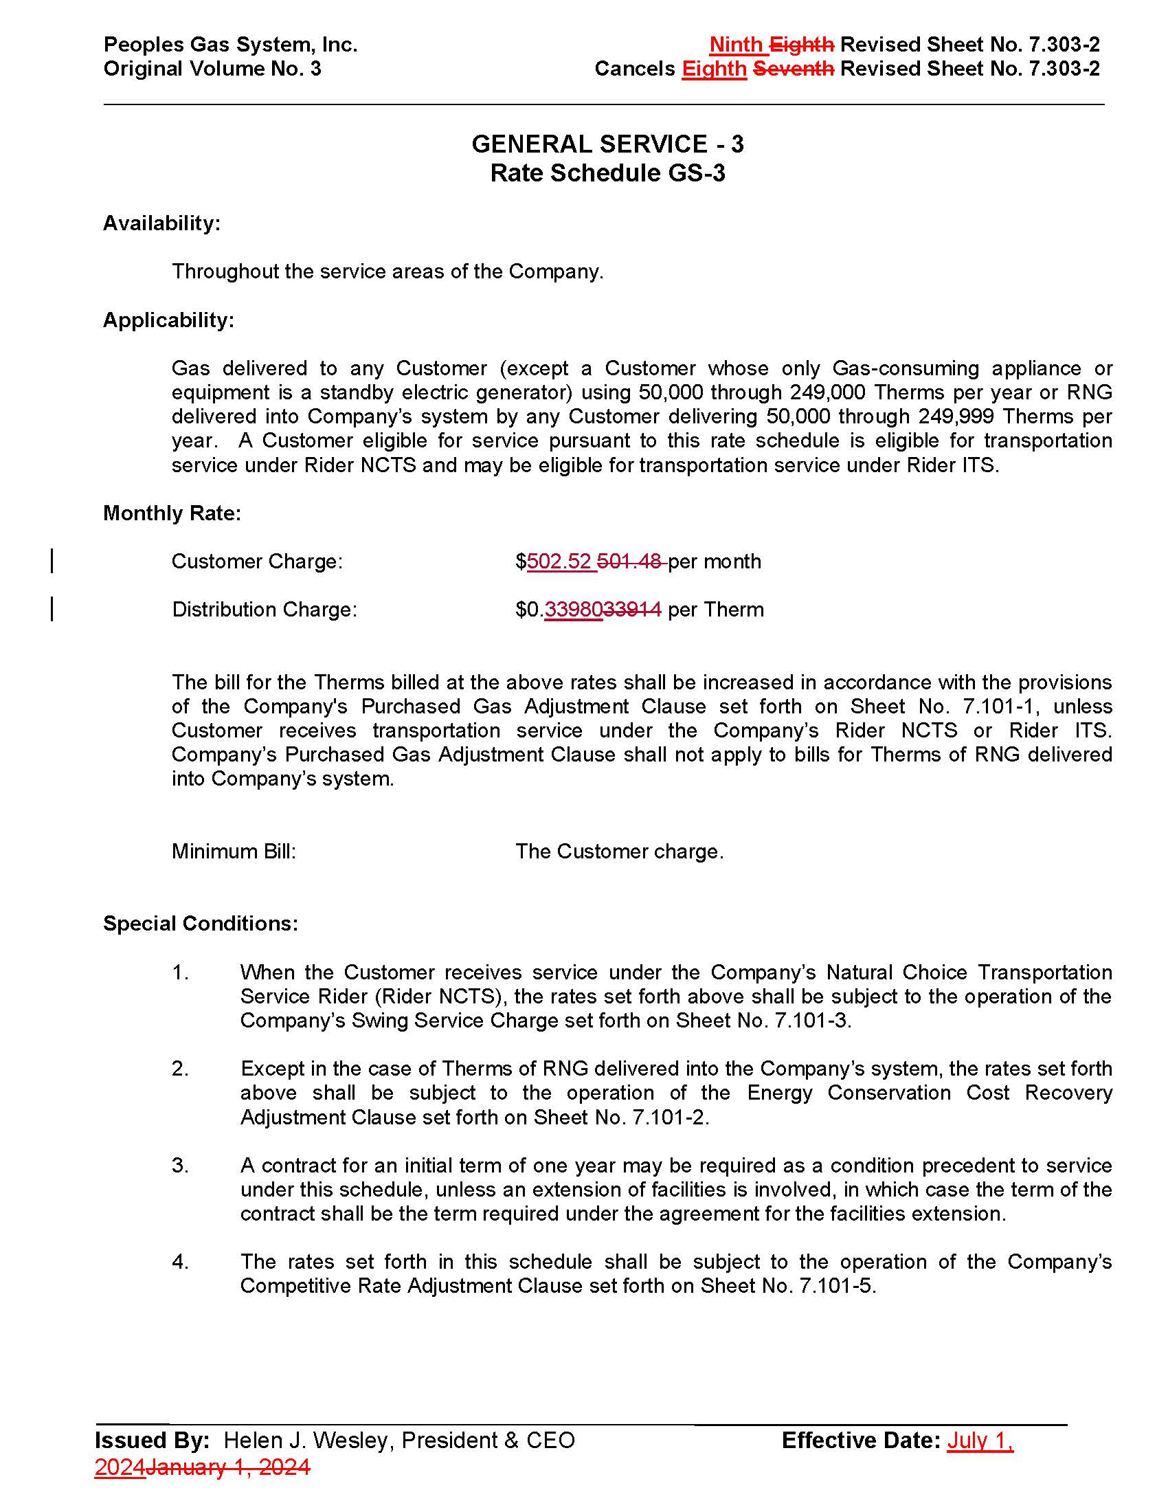

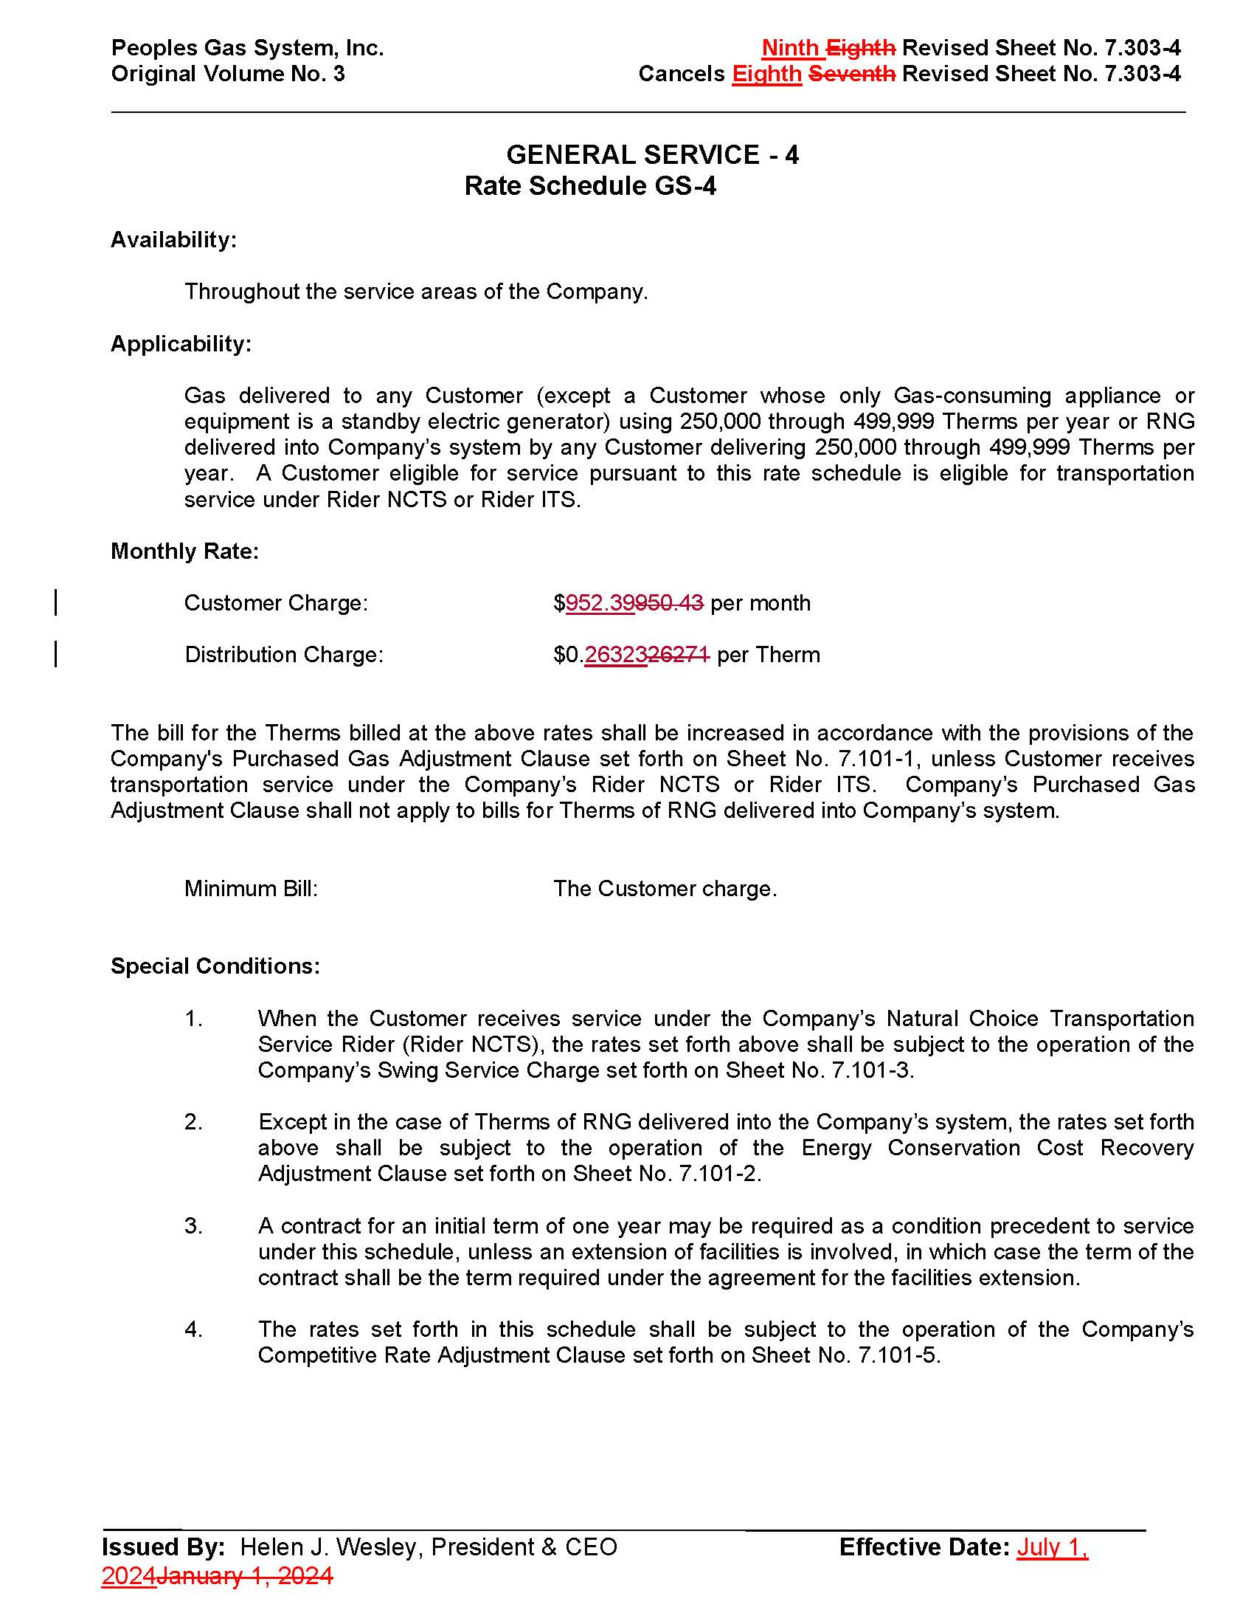

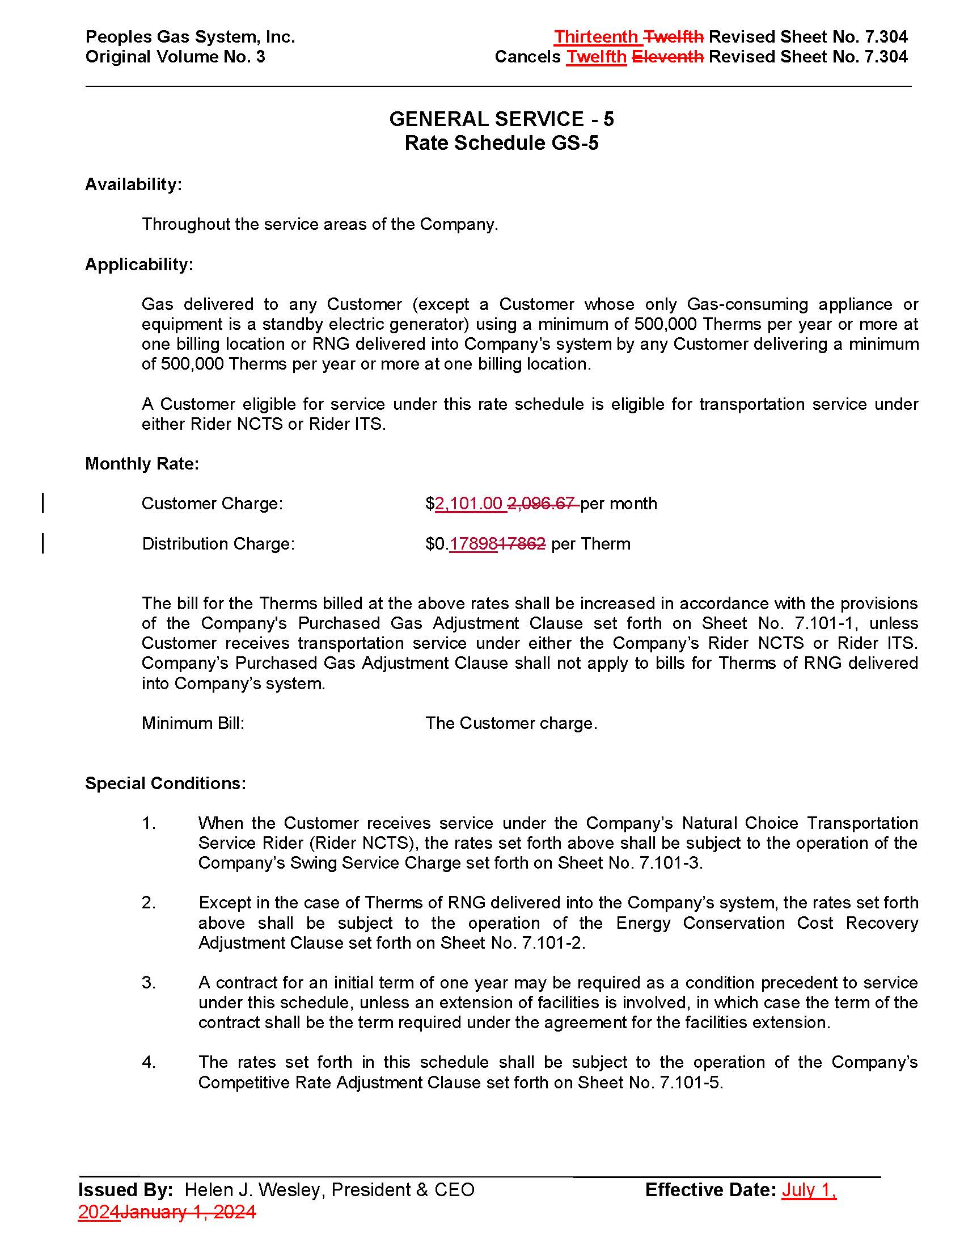

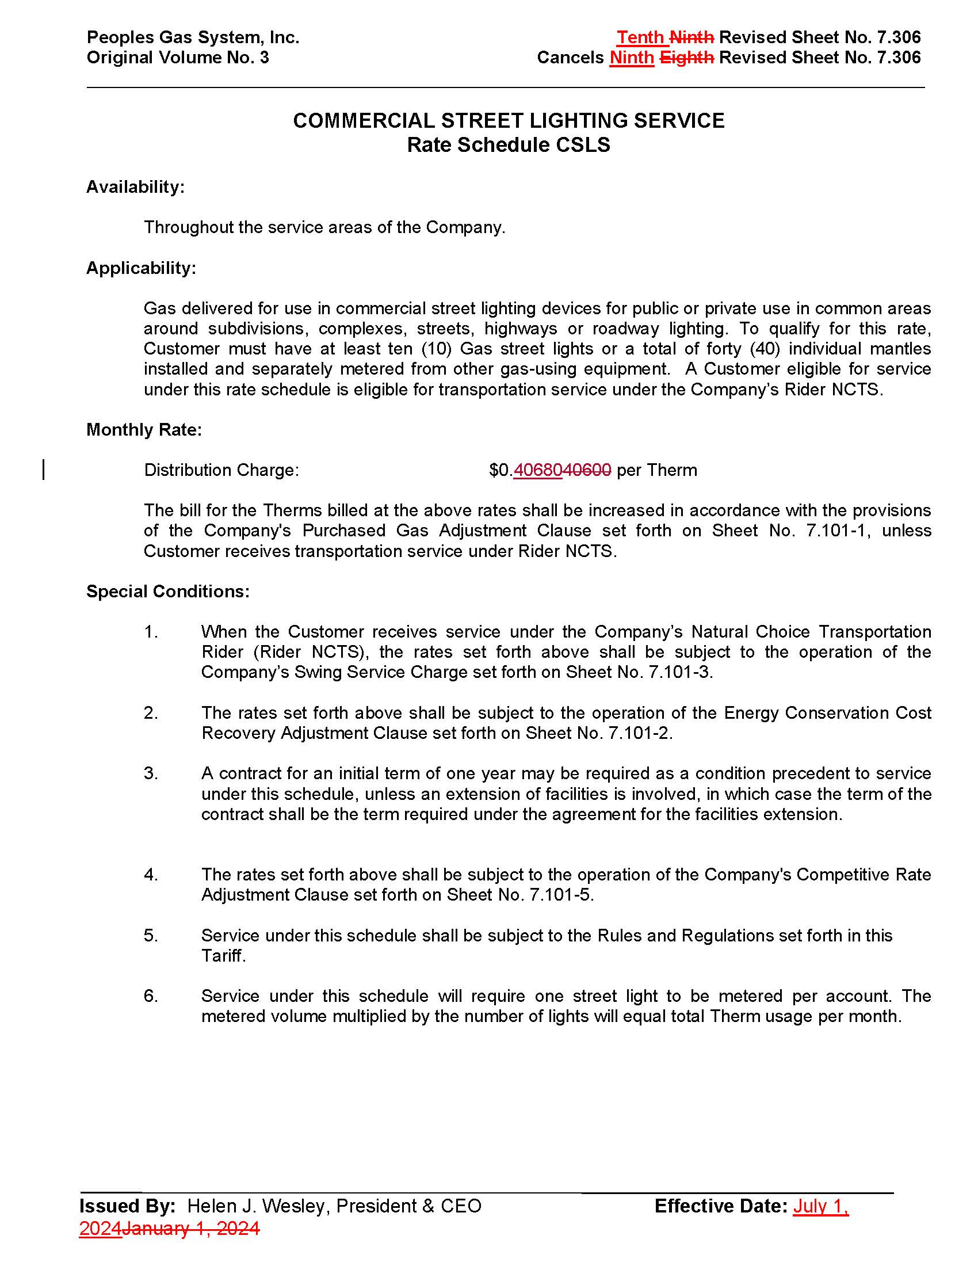

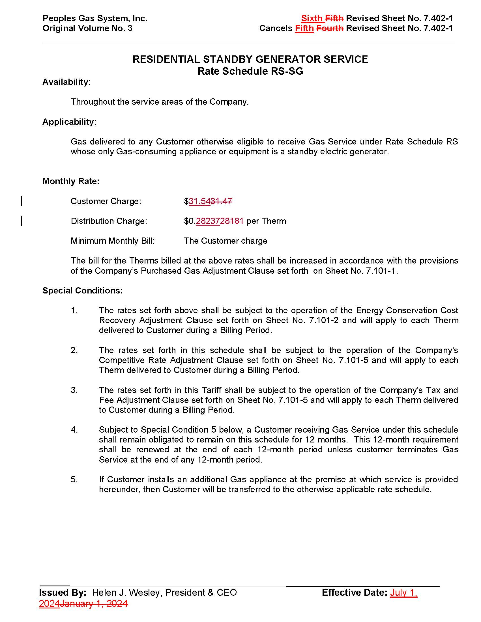

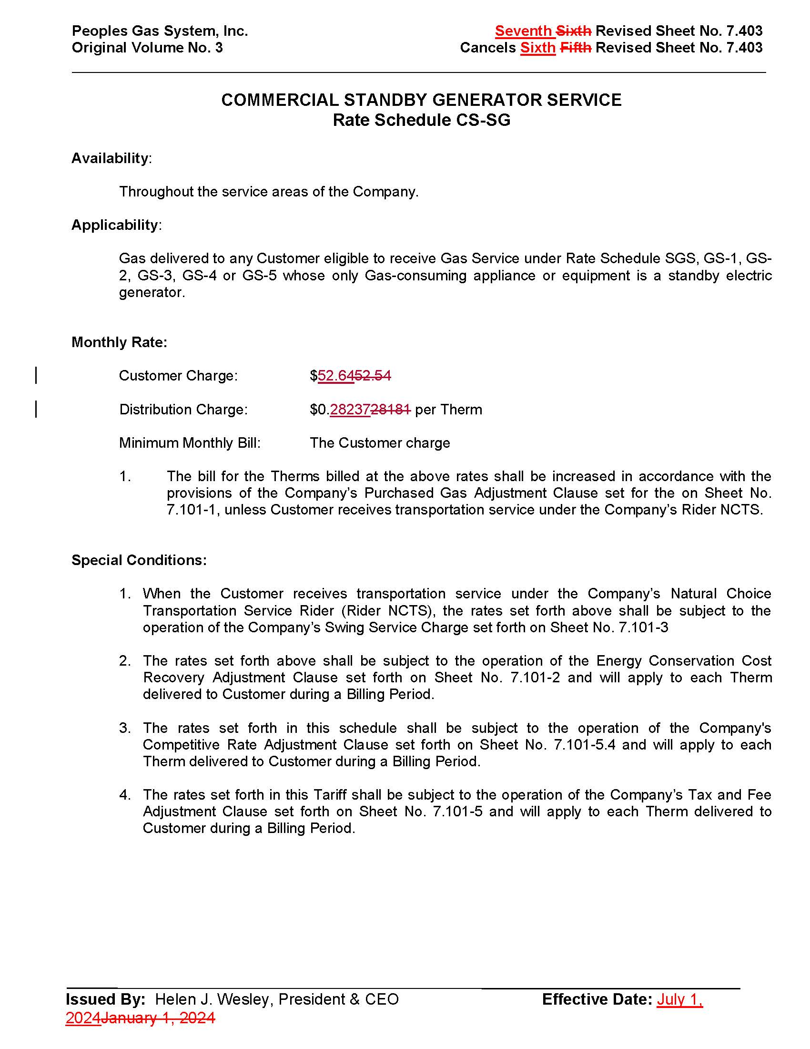

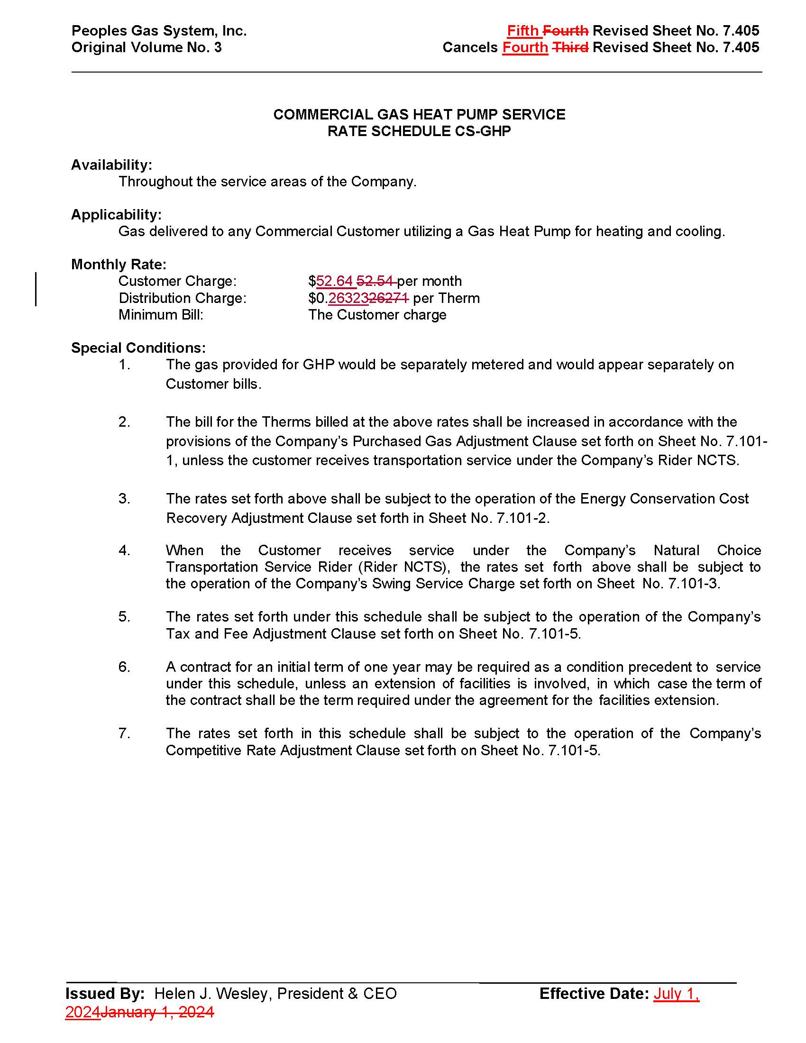

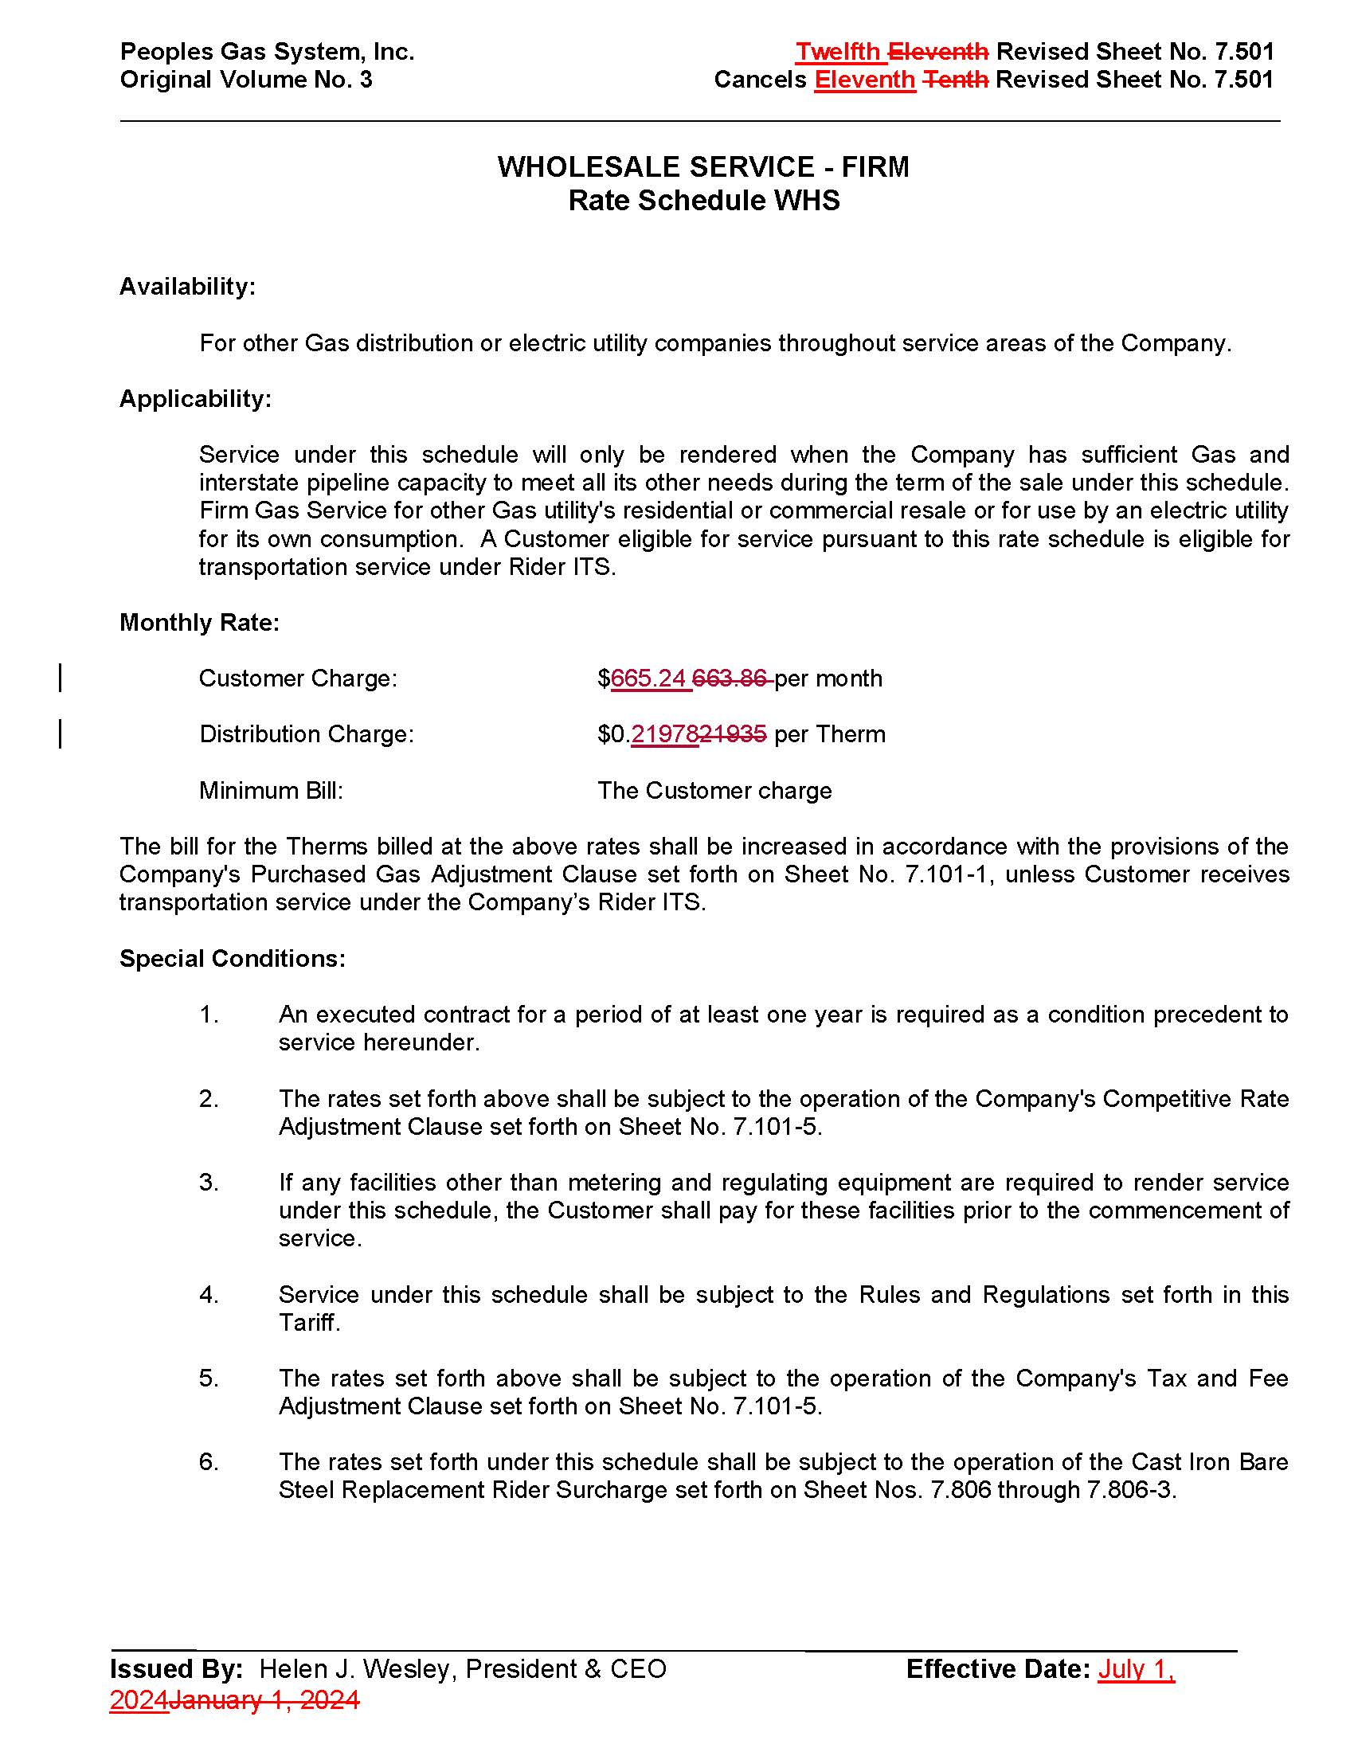

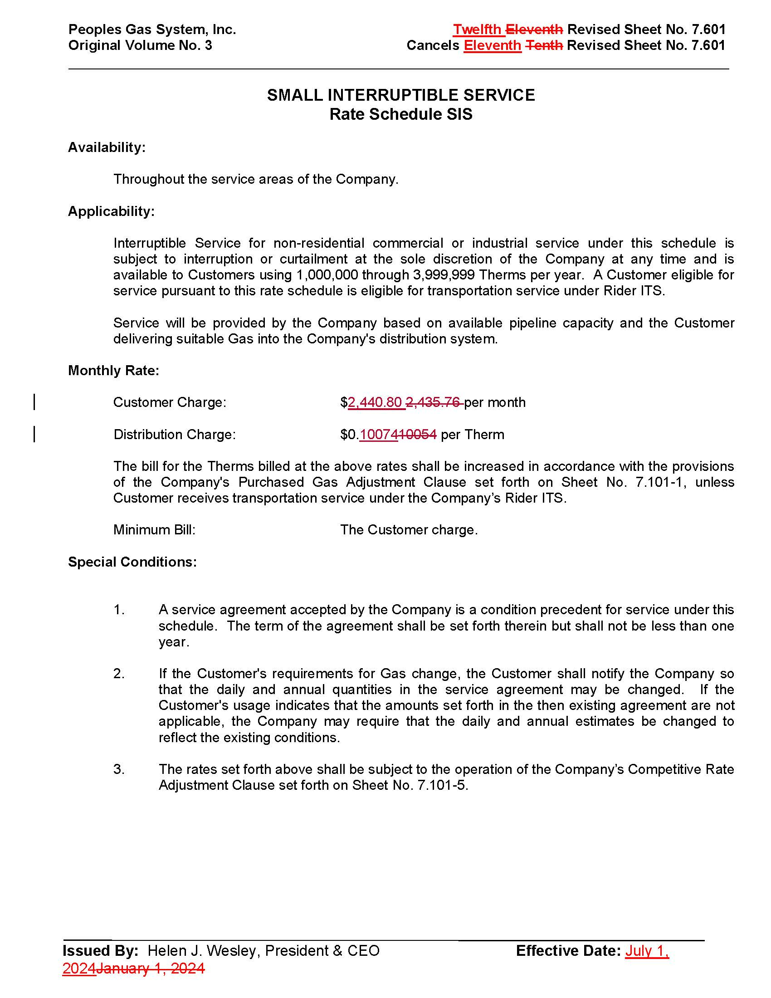

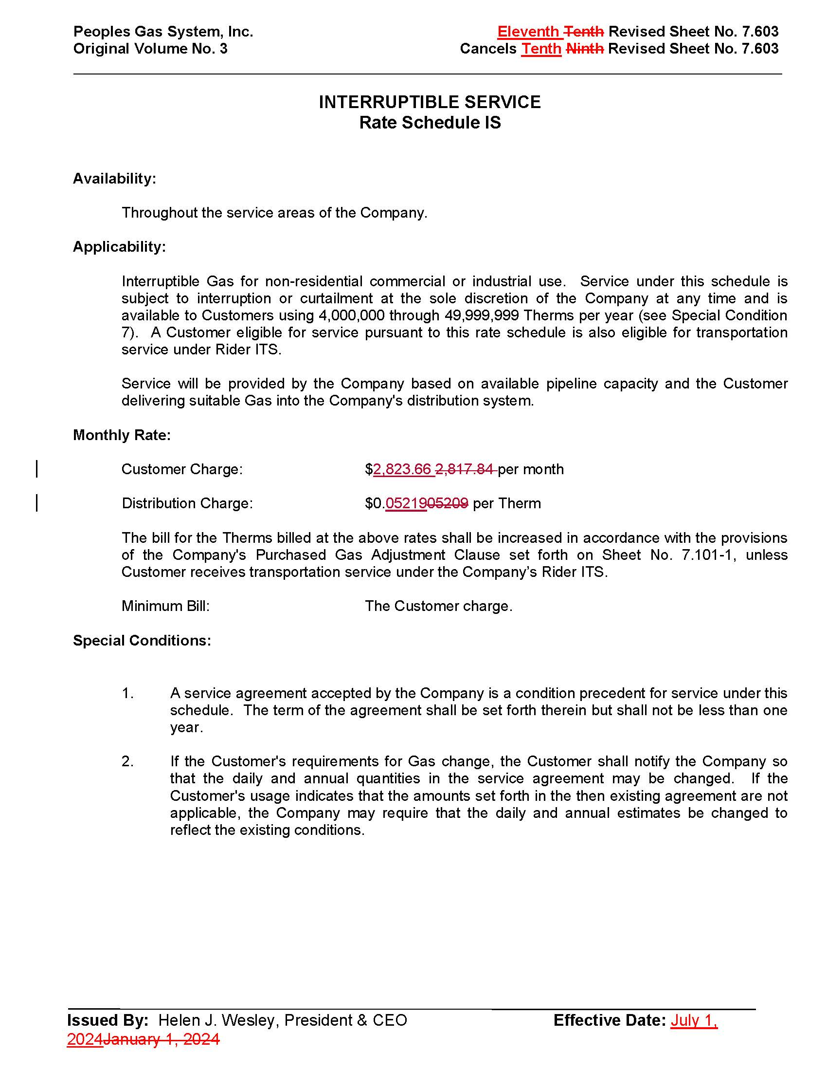

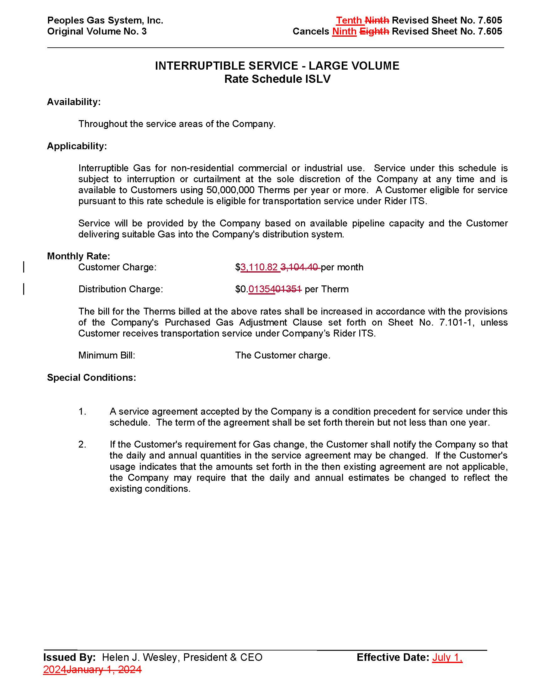

Order No. PSC-2023-0388-FOF-GU, issued December 27, 2023, in Docket No. 20230023-GU, In re: Petition for rate increase by Peoples Gas System, Inc.
Id., p. 107-109.
Document No. 00892-2024
Document No. 01103-2024
Order No. PSC-2024-0090-PCO-GU, issued April 8, 2024, in Docket No. 20240028-GU, In re: Petition for rate increase by Peoples Gas System, Inc.
Order No. PSC-2023-0388-FOF-GU, issued December 27, 2023, in Docket No. 20230023-GU, In re: Petition for rate increase by Peoples Gas System, Inc., p. 107-110.
Id. at p. 45-51.
Document No. 00534-2024, p. 11.
Document No. 00534-2024, p. 3.
Document No. 01103-2024
Document No. 00534-2024, p. 13.
Order No. PSC-2023-0388-FOF-GU, issued December 27, 2023, in Docket No. 20230023-GU, In re: Petition for rate increase by Peoples Gas System, Inc., Attachment 5, p. 121.
The overall rate of return is synonymous with the average weighted average cost of capital.
Document No. 00534-2024, p. 15.
Response No. 10 in Staff’s Second Data Request, Document No. 01103-2024.

