BEFORE THE FLORIDA PUBLIC SERVICE COMMISSION

In re: Petition for limited proceeding for recovery of incremental storm restoration costs related to Hurricanes Ian and Nicole, by Florida Power & Light Company. | DOCKET NO. 20230017-EI  ORDER NO. PSC-2024-0192-PHO-EI  ISSUED: June 14, 2024

PREHEARING ORDER

Pursuant to Notice and in accordance with Rule 28-106.209, Florida Administrative Code (F.A.C.), a Prehearing Conference was held on June 11, 2024, in Tallahassee, Florida, before Commissioner Art Graham, as Prehearing Officer.

APPEARANCES:

CHRISTOPHER T. WRIGHT and JOEL T. BAKER, ESQUIRES, 700 Universe Blvd., Juno Beach, Florida 33408
On behalf of Florida Power & Light Company (FPL).

WALT TRIERWEILER, Public Counsel, CHARLES REHWINKEL, and PATRICIA A. CHRISTENSEN, ESQUIRES, Office of Public Counsel, c/o The Florida Legislature, 111 W. Madison Street, Room 812, Tallahassee, Florida 32399
On behalf of Office of Public Counsel (OPC).

STEPHANIE U. EATON, ESQUIRE, Spilman, Thomas & Battle, PLLC, 110 Oakwood Drive, Suite 500, Winston-Salem, North Carolina 27103
On behalf of Walmart, Inc. (Walmart).

DERRICK PRICE WILLIAMSON and STEVEN W. LEE, ESQUIRES, Spilman, Thomas & Battle, PLLC, 1100 Bent Creek Blvd., Suite 101, Mechanicsburg, Pennsylvania 17050
On behalf of Walmart, Inc. (Walmart).

SHAW STILLER and DANIEL DOSE ESQUIRES, Florida Public Service Commission, 2540 Shumard Oak Boulevard, Tallahassee, Florida 32399-0850
On behalf of the Florida Public Service Commission (Staff).

MARY ANNE HELTON, ESQUIRE, Deputy General Counsel, Florida Public Service Commission, 2540 Shumard Oak Boulevard, Tallahassee, Florida 32399-0850
Advisor to the Florida Public Service Commission.

KEITH C. HETRICK, ESQUIRE, General Counsel, Florida Public Service Commission, 2540 Shumard Oak Boulevard, Tallahassee, Florida 32399-0850
Florida Public Service Commission General Counsel

I. CASE BACKGROUND

On January 23, 2023, Florida Power & Light Company (FPL) filed a Petition for limited proceeding for recovery of incremental storm restoration costs related to Hurricanes Ian and Nicole. The petition was filed pursuant to the provisions of the Stipulation and Settlement Agreement approved by Final Order of the Commission as a full resolution of FPL’s most recent base rate case. Under that Settlement and Final Order, FPL can begin recovery of storm costs 60 days following the filing of a petition for recovery.

In its petition, FPL sought authority to implement an interim storm restoration recovery surcharge to recover an estimated total of $1.3 billion for incremental restoration costs related to Hurricanes Ian and Nicole and to replenish the storm reserve to the pre-storm level of $219.9 million. FPL also prepared an alternate storm charge calculation seeking authority to implement an interim storm restoration recovery charge to recover an estimated total of $1.5 billion. This alternate calculation combines the incremental restoration costs related to Hurricanes Ian and Nicole with the remaining amounts to be collected for Hurricanes Michael, Sally, and Zeta, which we previously approved for recovery by Gulf Power Company, and to replenish the storm reserve. The Commission granted FPL’s petition by Order No. PSC-2023-0110-PCO-EI, issued March 3, 2023, and approved a consolidated interim storm surcharge using FPL’s alternate storm charge calculation to cover restoration costs and to replenish the storm reserve. The Commission ordered that this docket remain open pending final disposition (true-up) of storm costs.
On July 28, 2023, FPL filed in this docket a petition for a temporary waiver of or variance from Rule 25-6.0143(1)(g), Florida Administrative Code (F.A.C.). FPL requested a waiver of the portion of this Rule that required it to file its petition and documentation concerning disposition of deferred storm costs related to Hurricanes Ian and Nicole not later than September 30, 2023. FPL requested that it be allowed until December 31, 2023, to file its petition and supporting documentation. By Order PSC-2023-0298-PAA-EI, issued October 2, 2023, the Commission granted FPL’s petition and established December 31, 2023, as the utility’s filing deadline.
On September 5, 2023, FPL filed a supplemental petition to reduce the interim storm surcharge based on its internal review and finalization of the invoices and storm costs associated with Hurricanes Ian and Nicole. As a result of this internal process, the estimated incremental storm restoration cost related to the two storms decreased from the original estimate of $1.3 billion to $1.1 billion. Thus, the total estimate reflected in the alternative storm charge calculation decreased from $1.5 billion to $1.3 billion. FPL proposed amended (reduced) interim storm restoration charges applicable to all rate classes, effective with the first billing cycle of January 2024 and continuing through March 2024, subject to a final true-up. The Commission approved FPL’s petition and reduced the interim storm surcharge by Order No. PSC-2023-0354-PAA-EI, issued November 27, 2023.

The Commission acknowledged intervention by the Office of Public Counsel (OPC) in this docket by Order No. PSC-2023-0081-FOF-EI, issued February 10, 2023. Intervention was granted to Walmart, Inc. (Walmart) by Order No. PSC-2023-0381-PCO-EI, issued December 20, 2023. A petition for intervention by Jet Blast, Inc., filed May 8, 2024, was denied.
On December 14, 2023, Order No. PSC-2023-0372-PCO-EI was issued, establishing controlling dates for this proceeding and scheduling an administrative hearing for these matters on June 18-20, 2024.

II. CONDUCT OF PROCEEDINGS

Pursuant to Rule 28-106.211, F.A.C., this Prehearing Order is issued to prevent delay and to promote the just, speedy, and inexpensive determination of all aspects of this case.

III. JURISDICTION

This Commission is vested with jurisdiction over the subject matter by the provisions of Chapter 120 and 366, Florida Statutes (F.S.). This hearing will be governed by said Chapter and Chapters 25-6, 25-22, and 28-106, F.A.C., as well as any other applicable provisions of law.

IV. PROCEDURE FOR HANDLING CONFIDENTIAL INFORMATION

Information for which proprietary confidential business information status is requested pursuant to Section 366.093, F.S., and Rule 25-22.006, F.A.C., shall be treated by the Commission as confidential. The information shall be exempt from Section 119.07(1), F.S., pending a formal ruling on such request by the Commission or pending return of the information to the person providing the information. If no determination of confidentiality has been made and the information has not been made a part of the evidentiary record in this proceeding, it shall be returned to the person providing the information. If a determination of confidentiality has been made and the information was not entered into the record of this proceeding, it shall be returned to the person providing the information within the time period set forth in Section 366.093, F.S. The Commission may determine that continued possession of the information is necessary for the Commission to conduct its business.

It is the policy of this Commission that all Commission hearings be open to the public at all times. The Commission also recognizes its obligation pursuant to Section 366.093, F.S., to protect proprietary confidential business information from disclosure outside the proceeding. Therefore, any party wishing to use any proprietary confidential business information, as that term is defined in Section 366.093, F.S., at the hearing shall adhere to the following:

  - When confidential information is used in the hearing that has not been filed as prefiled testimony or prefiled exhibits, parties must have copies for the Commissioners, necessary staff, and the court reporter, in red envelopes clearly marked with the nature of the contents and with the confidential information highlighted. Any party wishing to examine the confidential material that is not subject to an order granting confidentiality shall be provided a copy in the same fashion as provided to the Commissioners, subject to execution of any appropriate protective agreement with the owner of the material.

  - Counsel and witnesses are cautioned to avoid verbalizing confidential information in such a way that would compromise confidentiality. Therefore, confidential information should be presented by written exhibit when reasonably possible.

At the conclusion of that portion of the hearing that involves confidential information, all copies of confidential exhibits shall be returned to the proffering party. If a confidential exhibit has been admitted into evidence, the copy provided to the court reporter shall be retained in the Office of Commission Clerk’s confidential files. If such material is admitted into the evidentiary record at hearing and is not otherwise subject to a request for confidential classification filed with the Commission, the source of the information must file a request for confidential classification of the information within 21 days of the conclusion of the hearing, as set forth in Rule 25-22.006(8)(b), F.A.C., if continued confidentiality of the information is to be maintained.

V. PREFILED TESTIMONY AND EXHIBITS; WITNESSES

Testimony of all witnesses to be sponsored by the parties and Staff has been prefiled and will be inserted into the record as though read after the witness has taken the stand and affirmed the correctness of the testimony and associated exhibits. All testimony remains subject to timely and appropriate objections. Upon insertion of a witness' testimony, exhibits appended thereto may be marked for identification. Each witness will have the opportunity to orally summarize his or her testimony at the time he or she takes the stand. Summaries of testimony shall be limited to three minutes.

Witnesses are reminded that, on cross-examination, responses to questions calling for a simple yes or no answer shall be so answered first, after which the witness may explain his or her answer. After all parties and Staff have had the opportunity to cross-examine the witness, the exhibit may be moved into the record. All other exhibits may be similarly identified and entered into the record at the appropriate time during the hearing.

The Commission frequently administers the testimonial oath to more than one witness at a time. Therefore, when a witness takes the stand to testify, the attorney calling the witness is directed to ask the witness to affirm whether he or she has been sworn.

The parties shall avoid duplicative or repetitious cross-examination. Further, friendly cross-examination will not be allowed. Cross-examination shall be limited to witnesses whose testimony is adverse to the party desiring to cross-examine. Any party conducting what appears to be a friendly cross-examination of a witness should be prepared to indicate why that witness's direct testimony is adverse to its interests.

VI. ORDER OF WITNESSES

Each witness whose name is preceded by an asterisk (*) has been stipulated and excused. The testimony and exhibits of stipulated witnesses shall be introduced into the record in the order presented below.

Witness | Proffered By | Issues #
Direct
*Michael Jarro | FPL | 3-6, 8-10
*Keith Ferguson | FPL | 1-12
*Amber De Lucenay | FPL | 2, 5-6
*Tiffany C. Cohen | FPL | 13-15
*Yen Ngo | Staff | As Needed

VII. BASIC POSITIONS

FPL: FPL’s service area was impacted in 2022 by Hurricanes Ian and Nicole, both National Hurricane Center-classified storms that caused widespread devastation, flooding, and customer service outages. Hurricane Ian made landfall near Fort Myers Beach, Florida on September 28, 2022, as a catastrophic Category 4 storm with sustained winds of 150 miles per hour (“mph”). The storm required FPL to engage in extensive restoration efforts to restore service to more than 2.1 million affected customers. Hurricane Nicole made its first of three landfalls near Vero Beach, Florida on November 10, 2022, as a Category 1 storm with sustained winds of 75 mph, and likewise required FPL to engage in extensive restoration efforts to restore service to more than 480,000 customers.

FPL undertook reasonable, necessary, and prudent measures to prepare for and respond to the impacts of both Hurricanes Ian and Nicole. These preparations included complex and comprehensive logistical arrangements for mobilizing FPL employees, external contractors, and mutual aid utilities to support the restoration effort. Logistical arrangements and coordination of resources included, but were not limited to, staging sites, lodging, food, communications, and fuel delivery. FPL’s proactive approach to storm preparation, mobilization and pre-staging of resources, and execution of storm related activities was highly successful in restoring service to its customers safely and as quickly as reasonably practicable.

In total, FPL restored service to more than 2.1 million customers impacted by Hurricane Ian. Approximately 66% of these customers were restored within the first full day of restoration and 95% of these customers were restored within the first six full days of restoration. By October 7, 2022 (i.e., within eight full days of restoration), FPL restored power to 99% of the affected customers, essentially completing the restoration effort for all customers that could feasibly receive power. FPL restored power to essentially all of its more than 480,000 customers impacted by Hurricane Nicole in less than 24 hours after the storm exited Florida.

FPL’s investments over the past decade in smart grid technology, undergrounding power lines, and strengthening the energy grid enabled FPL to avoid outages and restore power faster where outages occurred. There was no significant structural damage to FPL’s power generating facilities, including the 38 solar energy centers exposed to storm conditions, and not a single transmission structure failed during Hurricane Ian. Similarly, for Hurricane Nicole, there was no significant structural damage to FPL’s power generating facilities, and not a single transmission structure failed. In both storms, FPL’s storm-hardened and underground facilities performed well. Smart investments in FPL’s energy grid also helped the Company restore service to customers before it was safe to send crews into the field, and helped to avoid more than 400,000 outages during Hurricane Ian and more than 150,000 during Hurricane Nicole.

FPL followed a detailed, deliberate, and comprehensive process to review contractor invoices associated with Hurricanes Ian and Nicole in accordance with the Stipulation and Settlement of FPL’s Hurricane Irma storm restoration costs approved by Commission Order No. PSC-2019-0319-S-EI in Docket No. 20180049-EI (“Irma Settlement”). This process included invoice receipt, individual invoice review, and follow-up analysis to ensure that invoices were paid in conformance with the applicable contract terms.

In total, FPL incurred actual retail incremental storm restoration costs of $1,023.393 million associated with Hurricane Ian and actual retail incremental storm restoration costs of $118.423 million associated with Hurricane Nicole. Pursuant to Section 18 of the Irma Settlement, FPL engaged an outside independent audit firm to examine FPL’s storm restoration costs and processes associated with Hurricane Ian. This audit validated that FPL’s storm restoration costs were accurately presented, appropriately supported, and incurred within the time period allowed for recovery.

FPL’s total Recoverable Storm Amount is $1,298.027 million, as shown on Exhibit KF-3. FPL petitioned for recovery of these costs consistent with the Stipulation and Settlement approved in Order No. PSC-2021-0446-S-EI and has collected those costs though the Interim Storm Charge approved by Order Nos. PSC-2023-0110-PCO-EI and PSC-2023-0354-PCO-EI.

After the Commission has made its final determination of the final actual Recoverable Storm Amount in this proceeding, FPL will compare the approved Recoverable Storm Amount to the actual total revenues collected from the Interim Storm Charge, as set forth in Exhibit TCC-1, in order to determine any excess or shortfall in recovery. FPL will make a compliance filing with the Commission that sets forth the calculation of the appropriate true-up rates to apply to customer bills for a one-month period in order to refund the excess to or collect the shortfall from customers. The true-up rates will be designed consistent with the cost allocation used for the Interim Storm Charge rates approved in Order Nos. PSC-2023-0110-PCO-EI and PSC-2023-0354-PCO-EI.

OPC: The burden of proof in a Commission proceeding is always on a utility seeking a rate change and upon other parties seeking to change established rates. Fla. Power Corp. v. Cresse, 413 So. 2d 1187, 1191 (Fla. 1982). Florida Power & Light (FPL) has the burden to prove whether the Commission should approve FPL’s Petition for limited proceeding for recovery of incremental storm restoration costs related to Hurricanes Ian and Nicole, by Florida Power & Light Company.

As a result of the stipulation entered into among the parties to Docket No. 20180049-EI and approved in Order No. PSC-2019-0319-S- EI (Irma Settlement), issued August 1, 2019, FPL agreed to follow certain process provisions related to incurring storm restoration costs. Pursuant to Paragraph 18 of the Irma Settlement, FPL also agreed to engage an independent accounting firm to audit its compliance with the agreed process provisions for the first named tropical system named by the National Hurricane Center for which claimed damages exceed $250 million.

The OPC has reviewed FPL’s audit plan, audit report and audit workpapers, and the OPC further conducted discovery involving a review of a representative sample of invoices and cost documentation. After conducting this review and cooperatively meeting with FPL and their outside auditors, the OPC determined that the company has materially complied with the Irma Settlement and that the audit was well designed and executed. FPL has also demonstrated that it maintains processes that ensure their positive stewardship of the resources they acquire for restoring service after severe weather events.

Based on the entirety of the circumstances, FPL’s petition meets the burden of proof established by the Irma Settlement and other applicable laws. OPC and FPL have agreed to stipulations to resolve all outstanding issues. OPC represents that these stipulations are reasonable and prudent resolutions to the issues and are in the public interest. As a result of the due diligence performed by the OPC and the cooperation by FPL in this matter, OPC is in support of FPL’s continued commitment to implement and update the process provision in the Irma Settlement so that current and future customers only pay for prudent, cost-effective storm restoration costs incurred due to extreme weather events.

Walmart: Walmart takes no position regarding the majority of Issues raised in this Docket, as set forth in Section V. below. However, Walmart supports Florida Power & Light Company's ("FPL") plan to refund storm cost charges that it over-collected from customers in the same manner in which those storm cost charges were originally collected, i.e., via energy charges for all customers, as set forth in Issue 14. Walmart reserves the right to raise issues addressed in its Comments filed on March 7, 2023, in FPL's next storm cost recovery proceeding.

STAFF: Staff's positions are preliminary and based on materials filed by the parties and on discovery. The preliminary positions are offered to assist the parties in preparing for the hearing. Staff's final positions will be based upon all the evidence in the record and may differ from the preliminary positions stated herein.

VIII. ISSUES AND POSITIONS

ISSUE 1: Should the incremental cost and capitalization approach (ICCA) found in Rule 25-6.0143, F.A.C., be used to determine the reasonable and prudent amounts to be included in the restoration costs?

FPL: Yes. The Incremental Cost and Capitalization Approach prescribed in Rule 25-6.0143, Florida Administrative Code, should be used to calculate FPL’s Hurricanes Ian and Nicole storm costs, including removing below-the-line expenses and calculating storm capital costs. (Ferguson)

OPC: Based on the entirety of the circumstances, FPL’s petition meets the burden of proof established by the Irma Settlement and other applicable laws. As a result of the due diligence performed by the OPC and the cooperation by FPL in this matter, OPC is in support of FPL’s commitment to an ongoing, continuous storm restoration process improvement plan so that current and future customers only pay for prudent, cost-effective storm restoration costs incurred due to extreme weather events. OPC agrees with FPL.

Walmart: Walmart takes no position.

STAFF: Staff has no position at this time.

ISSUE 2: Has FPL complied with the terms of the 2019 Stipulation and Settlement, approved by Order No. PSC-2019-0319-S-EI, issued August 1, 2019? If not, why not?

FPL: Yes. FPL has complied with the terms of the 2019 Stipulation and Settlement, approved by Order No. PSC-2019-0319-S-EI, issued August 1, 2019. (Ferguson, De Lucenay)

OPC: Based on the entirety of the circumstances, FPL’s petition meets the burden of proof established by the Irma Settlement and other applicable laws. As a result of the due diligence performed by the OPC and the cooperation by FPL in this matter, OPC is in support of FPL’s commitment to an ongoing, continuous storm restoration process improvement plan so that current and future customers only pay for prudent, cost-effective storm restoration costs incurred due to extreme weather events. OPC agrees with FPL.

Walmart: Walmart takes no position.

STAFF: Staff has no position at this time.

ISSUE 3: What is the reasonable and prudent amount of regular payroll expense to be included in the restoration costs?

FPL: The reasonable and prudent regular payroll expense to be included in storm restoration costs for Hurricane Ian and Hurricane Nicole is $6.001 million and $2.342 million, respectively, as set forth in the table below and as shown on Exhibits KF-1 and KF-2. These are the costs FPL incurred for employee time spent in direct support of storm related activities including but not limited to restoration, which excludes bonuses and incentive compensation.

Reasonable and Prudent Amount of Regular Payroll Expense
($000s)

Storm | Total Storm Restoration Costs Incurred | Less Capitalized Costs | Less ICCA Adjustments | Recoverable Incremental Storm Costs
Ian | $15,263 | $3,789 | $5,472 | $6,001
Nicole | $3,075 | $112 | $621 | $2,342

(Jarro, Ferguson)

OPC: Based on the entirety of the circumstances, FPL’s petition meets the burden of proof established by the Irma Settlement and other applicable laws. As a result of the due diligence performed by the OPC and the cooperation by FPL in this matter, OPC is in support of FPL’s commitment to an ongoing, continuous storm restoration process improvement plan so that current and future customers only pay for prudent, cost-effective storm restoration costs incurred due to extreme weather events. OPC agrees with FPL.

Walmart: Walmart takes no position.

STAFF: Staff has no position at this time.

ISSUE 4: What is the reasonable and prudent amount of overtime payroll expense to be included in the restoration costs?

FPL: The reasonable and prudent amount of overtime payroll expense to be included in storm restoration costs for Hurricane Ian and Hurricane Nicole is $28.715 million and $6.135 million, respectively, as set forth in the table below and as shown on Exhibits KF-1 and KF-2. These are the costs FPL incurred for employee time spent in direct support of storm related activities including but not limited to restoration, which excludes bonuses and incentive compensation.
Reasonable and Prudent Amount of Overtime Payroll Expense
($000s)

Storm | Total Storm Restoration Costs Incurred | Less ICCA Adjustments | Recoverable Incremental Storm Costs
Ian | $29,277 | $562 | $28,715
Nicole | $6,222 | $87 | $6,135

(Jarro, Ferguson)

OPC: Based on the entirety of the circumstances, FPL’s petition meets the burden of proof established by the Irma Settlement and other applicable laws. As a result of the due diligence performed by the OPC and the cooperation by FPL in this matter, OPC is in support of FPL’s commitment to an ongoing, continuous storm restoration process improvement plan so that current and future customers only pay for prudent, cost-effective storm restoration costs incurred due to extreme weather events. OPC agrees with FPL.

Walmart: Walmart takes no position.

STAFF: Staff has no position at this time.

ISSUE 5: What is the reasonable and prudent amount of contractor costs to be included in the restoration costs?

FPL: The reasonable and prudent amount of contractor costs to be included in storm restoration costs for Hurricane Ian and Hurricane Nicole is $564.784 million and $64.083 million, respectively, as forth in the table below and as shown on Exhibits KF-1 and KF-2. These are the costs FPL incurred for line crews and mutual aid utilities that were necessary to support FPL’s storm restoration effort.
Reasonable and Prudent Amount of Contractor Costs
($000s)

Storm | Total Storm Restoration Costs Incurred | Less Capitalized Costs | Less ICCA Adjustments | Recoverable Incremental Storm Costs
Ian | $621,490 | $55,511 | $1,195 | $564,784
Nicole | $65,138 | $661 | $393 | $64,083

(Jarro, Ferguson, De Lucenay)

OPC: Based on the entirety of the circumstances, FPL’s petition meets the burden of proof established by the Irma Settlement and other applicable laws. As a result of the due diligence performed by the OPC and the cooperation by FPL in this matter, OPC is in support of FPL’s commitment to an ongoing, continuous storm restoration process improvement plan so that current and future customers only pay for prudent, cost-effective storm restoration costs incurred due to extreme weather events. OPC agrees with FPL.

Walmart: Walmart takes no position.

STAFF: Staff has no position at this time.

ISSUE 6: What is the reasonable and prudent amount of vegetation and line clearing costs to be included in the restoration costs?

FPL: The reasonable and prudent amount of vegetation and line clearing costs to be included in the restoration costs for Hurricane Ian and Hurricane Nicole is $165.704 million and $23.451 million, respectively, as shown on Exhibits KF-1 and KF-2. Since FPL recovers all actual vegetation costs incurred through the storm charge or the Storm Protection Plan Cost Recovery Clause, there is no ICCA adjustment applicable. (Jarro, Ferguson, De Lucenay)

OPC: Based on the entirety of the circumstances, FPL’s petition meets the burden of proof established by the Irma Settlement and other applicable laws. As a result of the due diligence performed by the OPC and the cooperation by FPL in this matter, OPC is in support of FPL’s commitment to an ongoing, continuous storm restoration process improvement plan so that current and future customers only pay for prudent, cost-effective storm restoration costs incurred due to extreme weather events. OPC agrees with FPL.

Walmart: Walmart takes no position.

STAFF: Staff has no position at this time.

ISSUE 7: What is the reasonable and prudent amount of employee expenses to be included in the restoration costs?

FPL: The reasonable and prudent amount of employee expenses to be included in the restoration costs for Hurricane Ian and Hurricane Nicole is $0.614 million and $0.028 million, respectively, as shown on Exhibits KF-1 and KF-2. (Ferguson)

OPC: Based on the entirety of the circumstances, FPL’s petition meets the burden of proof established by the Irma Settlement and other applicable laws. As a result of the due diligence performed by the OPC and the cooperation by FPL in this matter, OPC is in support of FPL’s commitment to an ongoing, continuous storm restoration process improvement plan so that current and future customers only pay for prudent, cost-effective storm restoration costs incurred due to extreme weather events. OPC agrees with FPL.

Walmart: Walmart takes no position.

STAFF: Staff has no position at this time.

ISSUE 8: What is the reasonable and prudent amount of materials and supplies expense to be included in the restoration costs?

FPL: The reasonable and prudent amount of materials and supplies expense to be included in storm restoration costs for Hurricane Ian and Hurricane Nicole is $16.024 million and $0.959 million, respectively, as forth in the table below and as shown on Exhibits KF-1 and KF-2.

Reasonable and Prudent Amount of Materials and Supplies Expense
($000s)

Storm | Total Storm Restoration Costs Incurred | Less Capitalized Costs | Recoverable Incremental Storm Costs
Ian | $47,790 | $31,766 | $16,024
Nicole | $2,010 | $1,051 | $959

(Jarro, Ferguson)

OPC: Based on the entirety of the circumstances, FPL’s petition meets the burden of proof established by the Irma Settlement and other applicable laws. As a result of the due diligence performed by the OPC and the cooperation by FPL in this matter, OPC is in support of FPL’s commitment to an ongoing, continuous storm restoration process improvement plan so that current and future customers only pay for prudent, cost-effective storm restoration costs incurred due to extreme weather events. OPC agrees with FPL.

Walmart: Walmart takes no position.

STAFF: Staff has no position at this time.

ISSUE 9: What is the reasonable and prudent amount of logistics costs to be included in the restoration costs?

FPL: The reasonable and prudent amount of logistic costs to be included in the restoration costs for Hurricanes Ian and Nicole are $204.781 million and $16.841 million, respectively, as shown on Exhibits KF-1 and KF-2. (Jarro, Ferguson)

OPC: Based on the entirety of the circumstances, FPL’s petition meets the burden of proof established by the Irma Settlement and other applicable laws. As a result of the due diligence performed by the OPC and the cooperation by FPL in this matter, OPC is in support of FPL’s commitment to an ongoing, continuous storm restoration process improvement plan so that current and future customers only pay for prudent, cost-effective storm restoration costs incurred due to extreme weather events. OPC agrees with FPL.

Walmart: Walmart takes no position.

STAFF: Staff has no position at this time.

ISSUE 10: What is the reasonable and prudent total amount of costs to be included in the restoration costs?

FPL: The reasonable and prudent total amount of retail incremental costs to be included in the restoration costs for Hurricane Ian and Hurricane Nicole is $1,023.393 million and $118.423 million, respectively, which excludes capital costs, ICCA adjustments, and below-the-line expenses, as shown on Exhibits KF-1 and KF-2. FPL’s total Recoverable Storm Amount, which includes the actual retail incremental storm restoration costs associated with Hurricane Ian, the actual retail incremental storm restoration costs associated with Hurricane Nicole, the replenishment of FPL’s storm reserve in accordance with Paragraph 10 of the Stipulation and Settlement approved in Order No. PSC-2021-0446-S-EI, and the remaining amounts to be collected for Hurricanes Michael, Sally, and Zeta, which were previously approved by the Commission, is $1,298.027 million as shown on Exhibit KF-3. (Jarro, Ferguson)

OPC: Based on the entirety of the circumstances, FPL’s petition meets the burden of proof established by the Irma Settlement and other applicable laws. As a result of the due diligence performed by the OPC and the cooperation by FPL in this matter, OPC is in support of FPL’s commitment to an ongoing, continuous storm restoration process improvement plan so that current and future customers only pay for prudent, cost-effective storm restoration costs incurred due to extreme weather events. OPC agrees with FPL.

Walmart: Walmart takes no position.

STAFF: Staff has no position at this time.

ISSUE 11: What is the reasonable and prudent amount of storm-related costs that should be capitalized?

FPL: The reasonable and prudent amount of storm-related costs that should be capitalized for Hurricane Ian and Hurricane Nicole is $95.642 million and $1.945 million, respectively, as shown on Exhibits KF-1 and KF-2. To determine the amount of capitalized costs, FPL used Part (1)(d) of Rule 25-6.0143, which states that “…the normal cost for the removal, retirement and replacement of those facilities in the absence of a storm, is the basis for calculating storm restoration capital.” (Ferguson)

OPC: Based on the entirety of the circumstances, FPL’s petition meets the burden of proof established by the Irma Settlement and other applicable laws. As a result of the due diligence performed by the OPC and the cooperation by FPL in this matter, OPC is in support of FPL’s commitment to an ongoing, continuous storm restoration process improvement plan so that current and future customers only pay for prudent, cost-effective storm restoration costs incurred due to extreme weather events. OPC agrees with FPL.

Walmart: Walmart takes no position.

STAFF: Staff has no position at this time.

ISSUE 12: What is the appropriate accounting treatment associated with any storm costs found to have been imprudently incurred?

FPL: In the event that the Commission were to find that any of FPL’s Hurricane Ian or Hurricane Nicole storm related costs were impudently incurred based on the actual conditions and circumstances at the time decisions were made, such costs would be charged below-the-line, with a corresponding adjustment to the applicable total Recoverable Storm Amount, capital, or above-the-line base O&M, and would not be recovered from customers. (Ferguson)

OPC: Based on the entirety of the circumstances, FPL’s petition meets the burden of proof established by the Irma Settlement and other applicable laws. As a result of the due diligence performed by the OPC and the cooperation by FPL in this matter, OPC is in support of FPL’s commitment to an ongoing, continuous storm restoration process improvement plan so that current and future customers only pay for prudent, cost-effective storm restoration costs incurred due to extreme weather events. OPC agrees with FPL.

Walmart: Walmart takes no position.

STAFF: Staff has no position at this time.

ISSUE 13: Should the Commission approve FPL’s proposed tariffs and associated charges?

FPL: FPL’s Interim Storm Charge has been fully recovered and terminated as of March 31, 2024. The Commission should approve FPL’s proposed one-time true-up methodology of the revenues collected through the Interim Storm Charge as set forth in Issue 14 below. Staff should be authorized to review and verify the final true-up rates contained in FPL’s compliance filing referenced in Issue 14 below. (Cohen)

OPC: Based on the entirety of the circumstances, FPL’s petition meets the burden of proof established by the Irma Settlement and other applicable laws. As a result of the due diligence performed by the OPC and the cooperation by FPL in this matter, OPC is in support of FPL’s commitment to an ongoing, continuous storm restoration process improvement plan so that current and future customers only pay for prudent, cost-effective storm restoration costs incurred due to extreme weather events. OPC agrees with FPL.

Walmart: Walmart understands that FPL's Storm Charges have been fully recovered and terminated as of March 31, 2024. Without waiving its right to challenge rate design or cost allocation in future Dockets, Walmart joins the Stipulation entered into between the Office of Public Counsel ("OPC") and FPL related to this Issue, and specifically FPL's proposal to refund its over-collection as set forth in Issue 14.

STAFF: Staff has no position at this time.

ISSUE 14: If applicable, how should any under-recovery or over-recovery be handled?

FPL: After the Commission has made its final determination of the final actual Recoverable Storm Amount in this proceeding, FPL will compare the approved Recoverable Storm Amount to the actual total revenues collected from the Interim Storm Charge, as set forth in Exhibit TCC-1, in order to determine any excess or shortfall in recovery. Interest will be applied to any excess or shortfall at the thirty-day commercial paper rate consistent with Rule 25-6.109, Florida Administrative Code. FPL will make a compliance filing with the Commission that sets forth the calculation of the appropriate true-up rates to apply to customer bills for a one-month period in order to refund the excess or collect the shortfall. The true-up rates will be designed in a manner that is consistent with the cost allocation used for the Interim Storm Charge rates filed and approved in Order Nos. PSC-2023-0110-PCO-EI and PSC-2023-0354-PCO-EI. FPL will apply the true-up rates through the non-fuel energy charge on customers’ bills starting on Cycle Day 1 of the first month that is more than thirty days after Commission approval. FPL will notify customers of the change in their rates due to the one-time true-up at least thirty days in advance in the form of a message on their bill, with more detailed information regarding the revised Interim Storm Charge tariff provided on FPL’s website, www.FPL.com/rates. (Cohen)

OPC: Based on the entirety of the circumstances, FPL’s petition meets the burden of proof established by the Irma Settlement and other applicable laws. As a result of the due diligence performed by the OPC and the cooperation by FPL in this matter, OPC is in support of FPL’s commitment to an ongoing, continuous storm restoration process improvement plan so that current and future customers only pay for prudent, cost-effective storm restoration costs incurred due to extreme weather events. OPC agrees with FPL.

Walmart: Walmart understands that after the Commission has made its final determination of the final actual Recoverable Storm Amount in this proceeding, FPL will compare the approved Recoverable Storm Amount to the actual total revenues collected from the Interim Storm Charge, as set forth in Exhibit TCC-1, in order to determine any excess or shortfall in recovery. Interest will be applied to any excess or shortfall at the thirty-day commercial paper rate consistent with Rule 25-6.109, Florida Administrative Code. FPL will make a compliance filing with the Commission that sets forth the calculation of the appropriate true-up rates to apply to customer bills for a one-month period in order to refund the excess. The true-up rates will be designed in a manner that is consistent with the cost allocation used for the Interim Storm Charge rates filed and approved in Order Nos. PSC-2023-0110-PCO-EI and PSC-2023-0354-PCO-EI. FPL will apply the true-up rates through the non-fuel energy charge on customers' bills starting on Cycle Day 1 of the first month that is more than thirty days after Commission approval, and will provide notification to customers of the same. Without waiving its right to challenge rate design or cost allocation in future Dockets, Walmart joins the Stipulation entered into between OPC and FPL related to this Issue, and specifically supports FPL's proposal to refund its over-collection in the same manner in which the charges were originally collected (i.e., via energy charges).

STAFF: Staff has no position at this time.

ISSUE 15: Should this docket be closed?

FPL: Upon FPL’s submission of the compliance filing set forth in Issue 14 above, this docket should be closed. (Cohen)

OPC: No.

Walmart: [No position stated].

STAFF: Staff has no position at this time.

IX. EXHIBIT LIST

Each exhibit that is preceded by an asterisk (*) has been stipulated. All stipulated exhibits shall be introduced into the record in the order presented below.

Witness | Proffered By |  | Description
Direct
*Michael Jarro | FPL | MJ-1 | Hurricane Ian - National Hurricane Center’s Forecast Track
*Michael Jarro | FPL | MJ-2 | Hurricane Ian – Satellite View
*Michael Jarro | FPL | MJ-3 | Hurricane Nicole – National Hurricane Center’s Forecast Track
*Michael Jarro | FPL | MJ-4 | Hurricane Nicole – Satellite View
*Michael Jarro | FPL | MJ-5 | FPL’s T&D Hurricane Ian Restoration Costs
*Michael Jarro | FPL | MJ-6 | FPL’s T&D Hurricane Nicole Restoration Costs
*Keith Ferguson | FPL | KF-1 | Hurricane Ian Incremental Cost and Capitalization Approach Adjustments as of June 1, 2023
*Keith Ferguson | FPL | KF-2 | Hurricane Nicole Incremental Cost and Capitalization Approach Adjustments as of June 1, 2023
*Keith Ferguson | FPL | KF-3 | Total Storm Costs to be Recovered from Customers
*Keith Ferguson | FPL | KF-4 | PwC Engagement Letter
*Keith Ferguson | FPL | KF-5 | PwC Attestation Report
*Tiffany C. Cohen | FPL | TCC-1 | Consolidated Interim Storm Restoration Recovery Charge Revenues
*Yen Ngo | Staff | YN-1 | Audit Report of Florida Power & Light

Parties and Staff reserve the right to identify additional exhibits for the purpose of cross-examination.

X. PROPOSED STIPULATIONS

On May 29, 2024, FPL and OPC entered into a set of stipulations attached to this Prehearing Order as Attachment A. On June 12, 2024, Walmart filed a statement that it agrees with paragraphs 1-4 and 12-13, and takes no position on paragraphs 5-11 and 14-16 of Attachment A. If approved by the Florida Public Service Commission, the stipulations in Attachment A will fully resolve the Parties' respective issues in Docket No. 20230017-EI, and Issues 1-15 will be moot.

XI. PENDING MOTIONS

There are no pending motions at this time.

XII. PENDING CONFIDENTIALITY MATTERS

- FPL’s request for confidential classification filed on November 20, 2023 [DN 06137-2023].

- FPL’s request for confidential classification filed on January 25, 2024 [DN 00336-2024].

XIII. POST-HEARING PROCEDURES

If no bench decision is made, each party shall file a post-hearing statement of issues and positions. A summary of each position, set off with asterisks, shall be included in that statement. If a party's position has not changed since the issuance of this Prehearing Order, the post-hearing statement may simply restate the prehearing position; however, if the prehearing position is longer than 50 words, it must be reduced to no more than 50 words. If a party fails to file a post-hearing statement, that party shall have waived all issues and may be dismissed from the proceeding.

Pursuant to Rule 28-106.215, F.A.C., a party's proposed findings of fact and conclusions of law, if any, statement of issues and positions, and brief, shall together total no more than 40 pages and shall be filed at the same time.

XIV. RULINGS

Opening statements, if any, shall not exceed three minutes per party.

It is therefore,

ORDERED by Commissioner Art Graham, as Prehearing Officer, that this Prehearing Order shall govern the conduct of these proceedings as set forth above unless modified by the Commission.

By ORDER of Commissioner Art Graham, as Prehearing Officer, this 14th day of June, 2024.

/s/ Art Graham
ART GRAHAM
Commissioner and Prehearing Officer
Florida Public Service Commission
2540 Shumard Oak Boulevard
Tallahassee, Florida 32399
(850) 413-6770
www.floridapsc.com

Copies furnished: A copy of this document is provided to the parties of record at the time of issuance and, if applicable, interested persons.

SPS

NOTICE OF FURTHER PROCEEDINGS OR JUDICIAL REVIEW

The Florida Public Service Commission is required by Section 120.569(1), Florida Statutes, to notify parties of any administrative hearing or judicial review of Commission orders that is available under Sections 120.57 or 120.68, Florida Statutes, as well as the procedures and time limits that apply. This notice should not be construed to mean all requests for an administrative hearing or judicial review will be granted or result in the relief sought.

Mediation may be available on a case-by-case basis. If mediation is conducted, it does not affect a substantially interested person's right to a hearing.

Any party adversely affected by this order, which is preliminary, procedural or intermediate in nature, may request: (1) reconsideration within 10 days pursuant to Rule 25-22.0376, Florida Administrative Code; or (2) judicial review by the Florida Supreme Court, in the case of an electric, gas or telephone utility, or the First District Court of Appeal, in the case of a water or wastewater utility. A motion for reconsideration shall be filed with the Office of Commission Clerk, in the form prescribed by Rule 25-22.0376, Florida Administrative Code. Judicial review of a preliminary, procedural or intermediate ruling or order is available if review of the final action will not provide an adequate remedy. Such review may be requested from the appropriate court, as described above, pursuant to Rule 9.100, Florida Rules of Appellate Procedure.

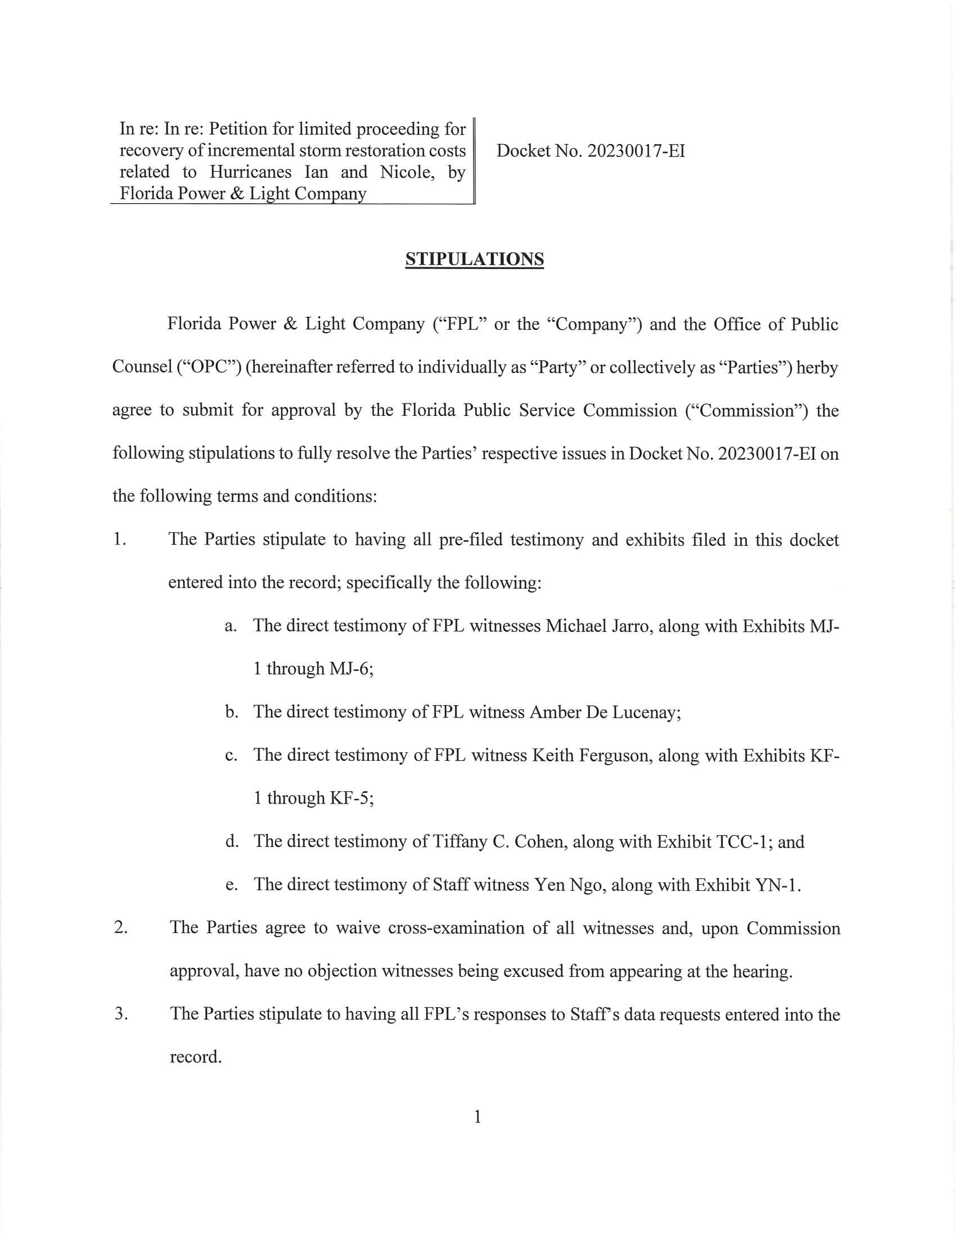

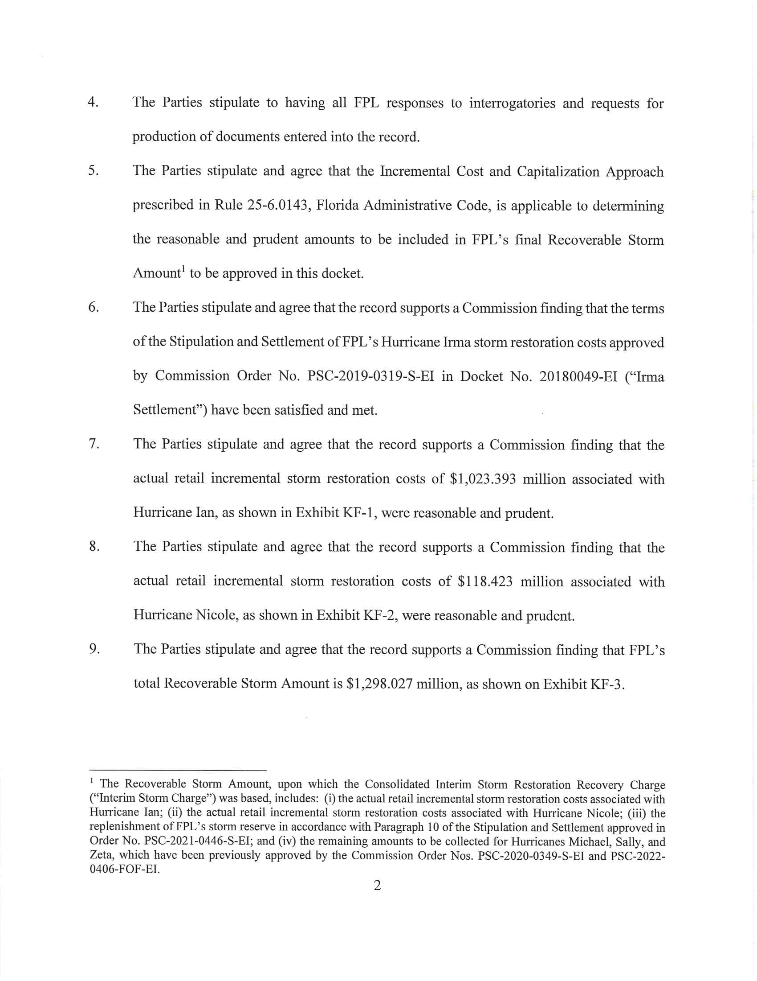

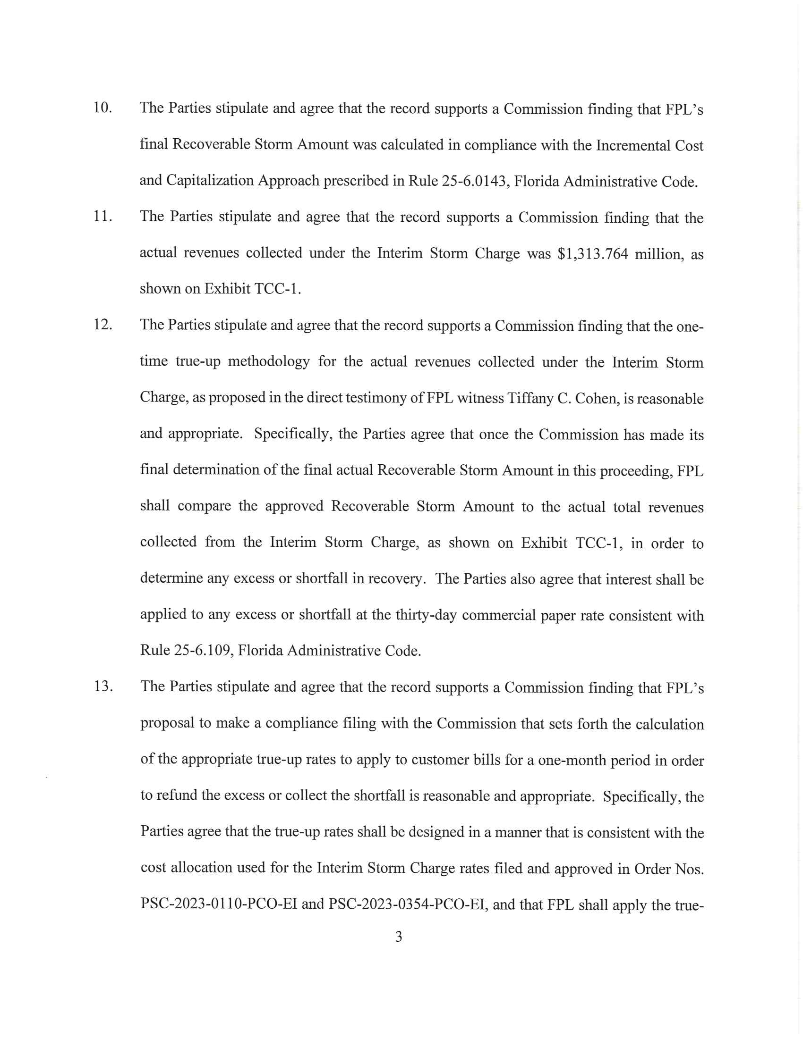

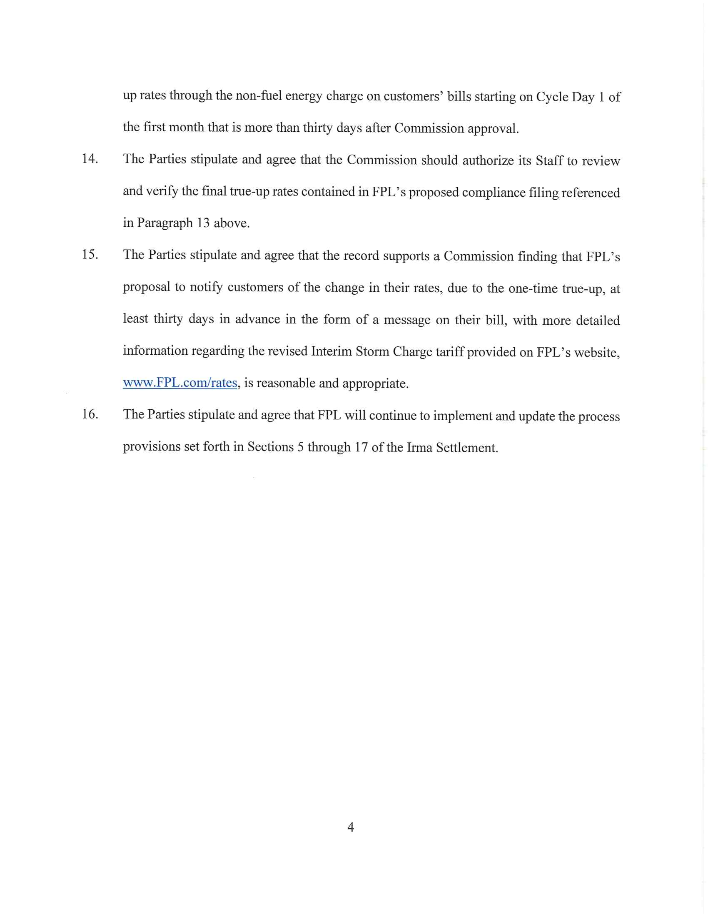

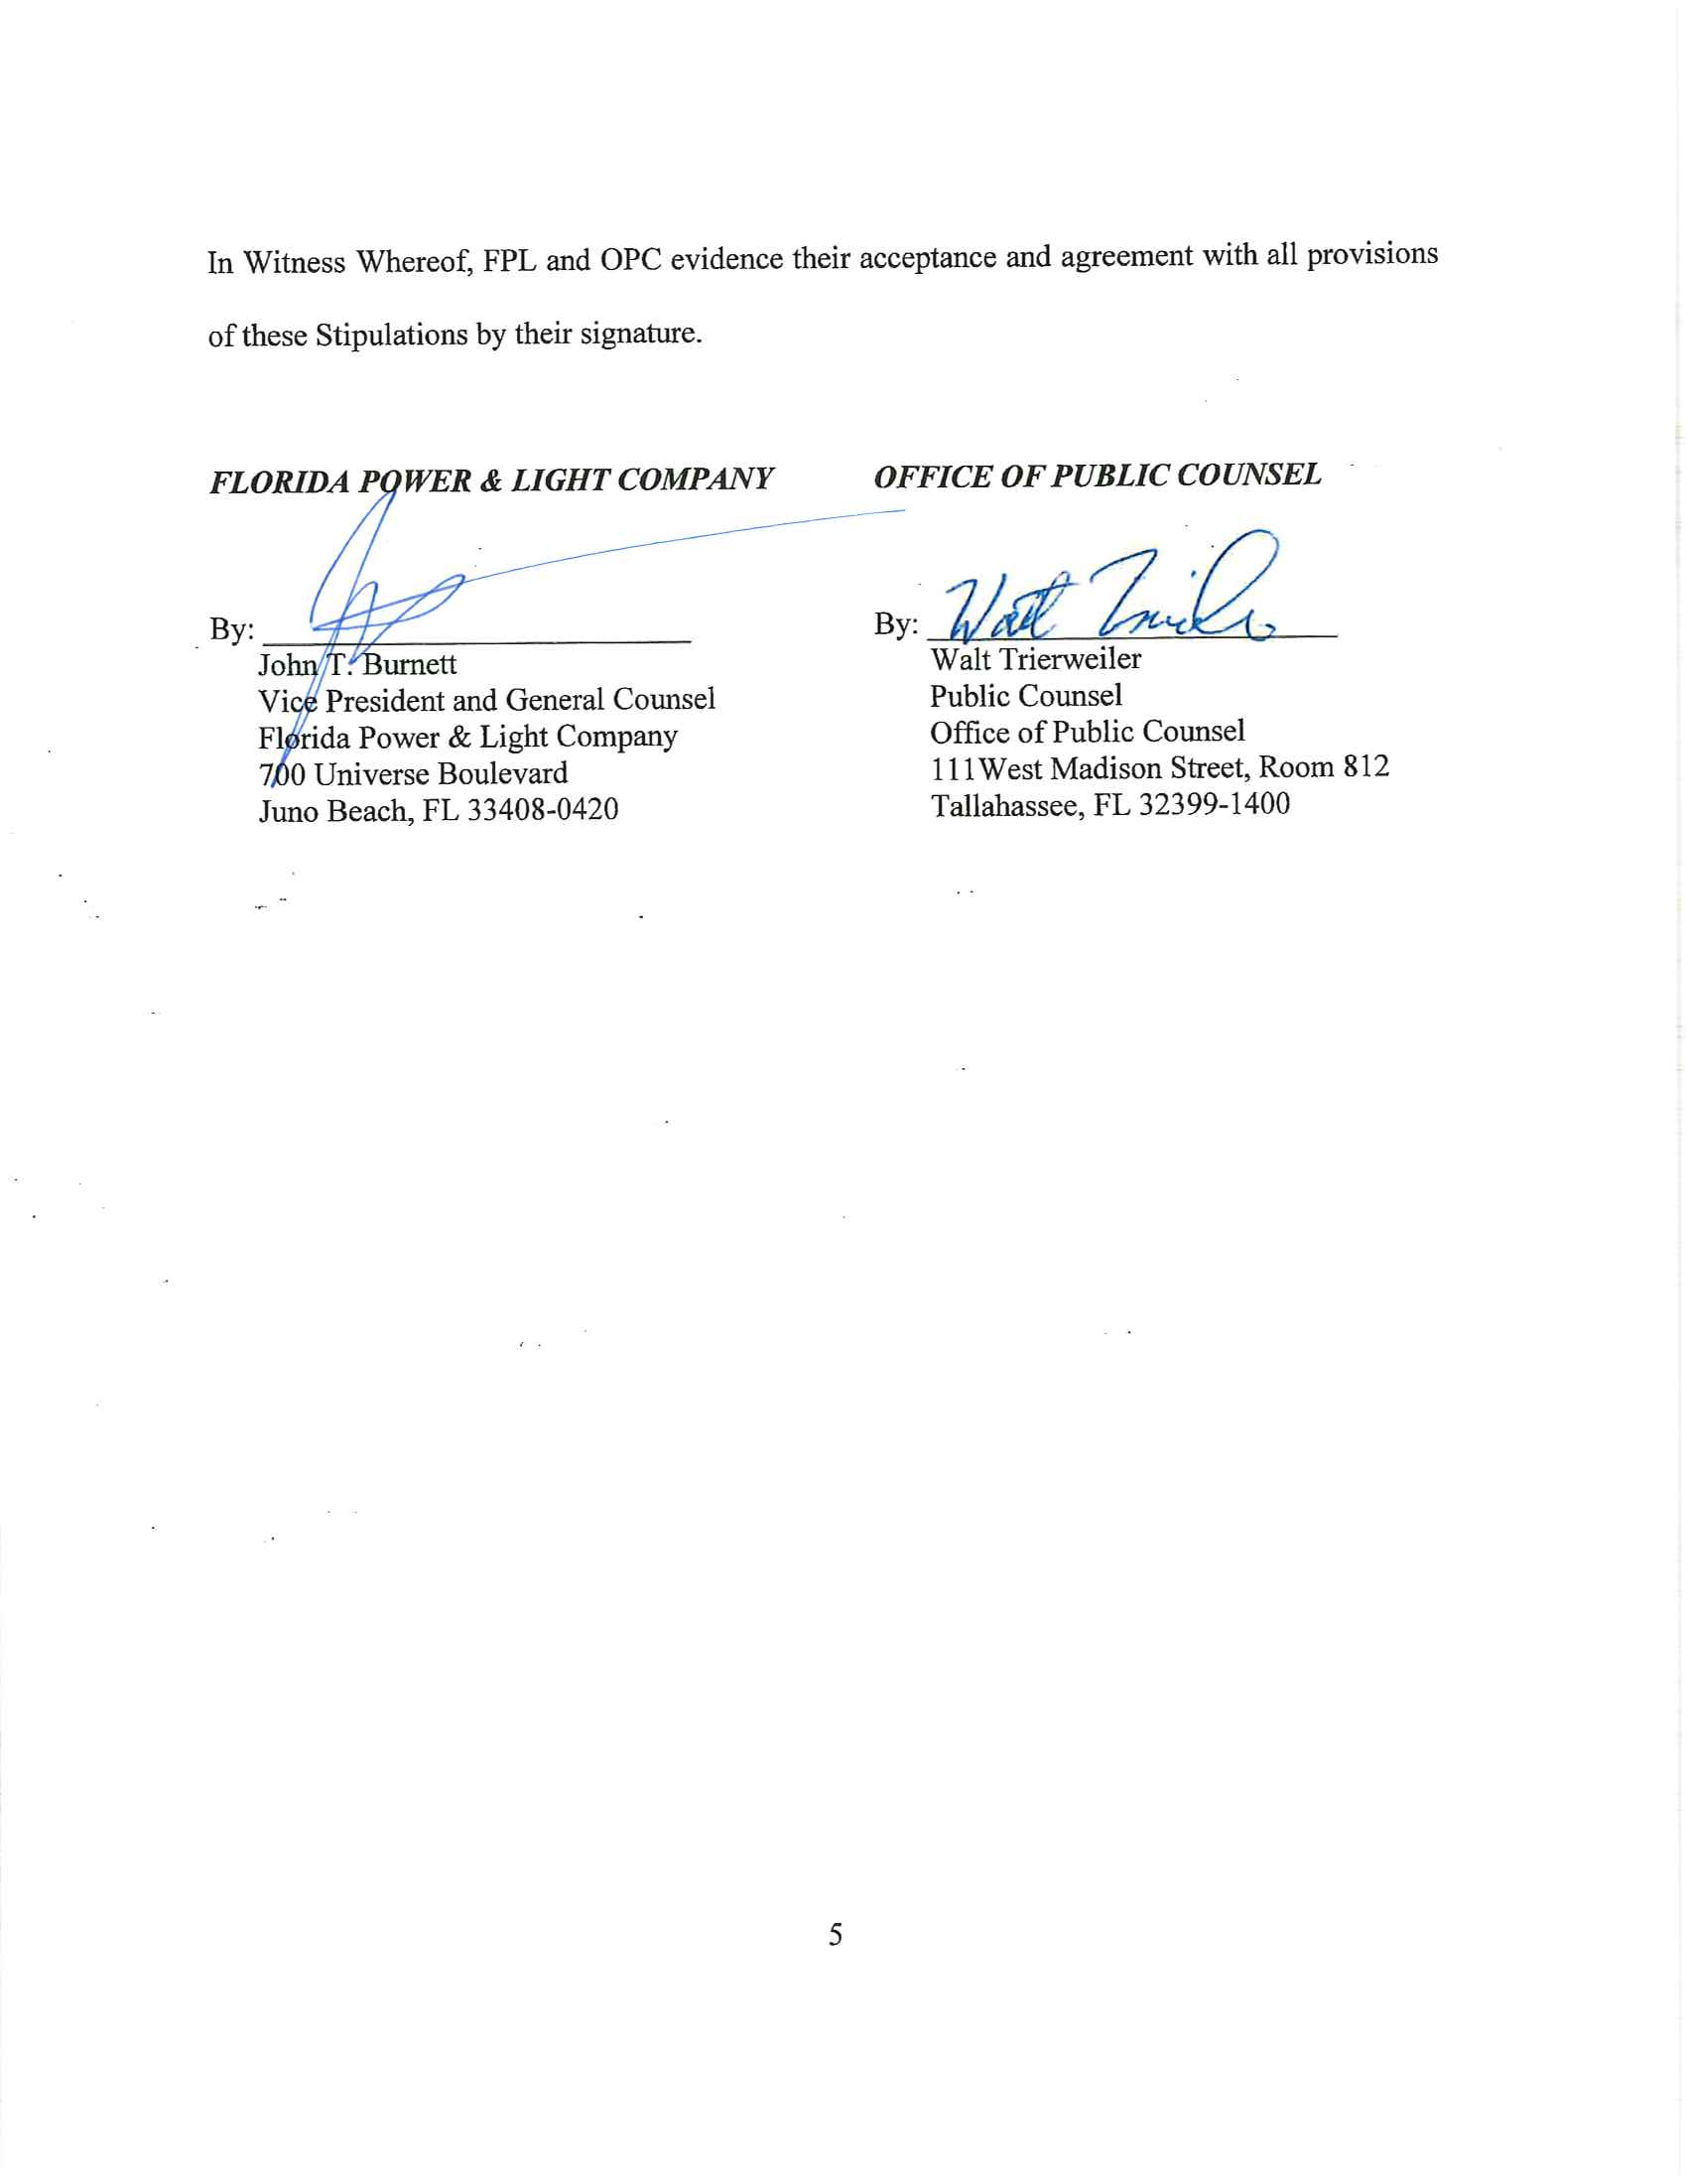

Order No. PSC-2021-0446-S-EI, issued December 2, 2021, in Docket No. 20210015-EI, In re: Petition for rate increase by Florida Power & Light Company.
Order Nos. PSC-2019-0221-PCO-EI and PSC-2022-0406-FOF-EI.
FPL’s total Recoverable Storm Amount, upon which the Consolidated Interim Storm Restoration Recovery Charge was based, includes: (i) the actual retail incremental storm restoration costs associated with Hurricane Ian; (ii) the actual retail incremental storm restoration costs associated with Hurricane Nicole; (iii) the replenishment of FPL’s storm reserve in accordance with Paragraph 10 of the Stipulation and Settlement approved in Order No. PSC-2021-0446-S-EI; and (iv) the remaining amounts to be collected for Hurricanes Michael, Sally, and Zeta, which have been previously approved by the Commission Order Nos. PSC-2020-0349-S-EI and PSC-2022-0406-FOF-EI.

