BEFORE THE FLORIDA PUBLIC SERVICE COMMISSION

|  |  |
| --- | --- |
| In re: Petition for designation as an eligible telecommunications carrier in the State of Florida, by Air Voice Wireless, LLC d/b/a AirTalk Wireless. | DOCKET NO. 20240112-TP  ORDER NO. PSC-2024-0456-PAA-TP  ISSUED: October 21, 2024 |

The following Commissioners participated in the disposition of this matter:

MIKE LA ROSA, Chairman

ART GRAHAM

GARY F. CLARK

ANDREW GILES FAY

GABRIELLA PASSIDOMO

NOTICE OF PROPOSED AGENCY ACTION ORDER

GRANTING ELIGIBLE TELECOMMUNICATIONS CARRIER DESIGNATION

BY THE COMMISSION:

NOTICE is hereby given by the Florida Public Service Commission that the action discussed herein is preliminary in nature and will become final unless a person whose interests are substantially affected files a petition for a formal proceeding, pursuant to Rule 25-22.029, Florida Administrative Code (F.A.C.).

Background

Air Voice Wireless, LLC d/b/a AirTalk Wireless (Air Voice or Company) seeks designation as an eligible telecommunications carrier (ETC) for the sole purpose of providing Lifeline services to qualifying consumers throughout Florida. Air Voice is a provider of commercial mobile radio service (CMRS) and offers prepaid wireless telecommunications services to consumers as a reseller. Specifically, Air Voice uses the network infrastructure and wireless transmission facilities of AT&T to operate as a Mobile Virtual Network Operator. Air Voice is currently designated as an ETC providing Lifeline service in 40 other states.

As a CMRS provider, Air Voice is regulated as a common carrier pursuant to 47 U.S.C. § 153(11).[1] Air Voice is a Texas Limited Liability Company (LLC) authorized to do business as a foreign LLC in the State of Florida. Air Voice is a wholly owned subsidiary of VTel Holdings, LLC which is wholly owned by Henry Hung Do.

Air Voice asserts that it meets all applicable federal requirements for designation as a Lifeline only ETC in Florida pursuant to 47 U.S.C. § 214(e) and 47 C.F.R. § 54.201. Air Voice acknowledges and asserts that, if approved it will comply with Sections 364.10 and 364.105, Florida Statutes (F.S.), and Rule 25-4.0665, Florida Administrative Code (F.A.C.), which govern Lifeline service and provide transitional discount for customers who no longer qualify for Lifeline. In addition to the federal rules and statutes discussed above, we have jurisdiction in this matter pursuant to Section 364.10, F.S.

Section 214(e)(2) of the Telecommunications Act of 1996 (the Act) provides state public utility commissions with “primary responsibility” for the designation of ETCs. In addition, Section 364.10(3) F.S. specifically grants us jurisdiction to address wireless ETC petitions for Lifeline purposes only.

Decision

1. Requirements for ETC Designation

This Order addresses whether Air Voice qualifies for ETC designation to provide Lifeline service throughout the State of Florida. ETC designation is necessary for telecommunications companies to participate in the federal Lifeline program. Section 364.10(3), F.S. allows us to approve wireless Lifeline ETC petitions by requesting carriers. Federal rules outline the requirements for ETC designation. To obtain ETC designation to provide Lifeline services, federal rules require that carriers:

1. Be a common carrier;
2. Offer the services that are supported by the federal universal support mechanisms either using its own facilities or a combination of its own facilities and resale of another carrier’s services;
3. Advertise the availability of its Lifeline service through a media of general distribution;
4. Provide voice grade access to the public switch network or its functional equivalent;
5. Offer minutes of use for local service at no additional charge to end users;
6. Provide access to the emergency services available by local government or other public safety organizations;
7. Provide Broadband Internet Access Service;
8. Demonstrate financial and technical capability to provide Lifeline service; and
9. Not charge Lifeline customers a monthly number-portability charge.

In addition, Florida law requires the following for ETC designation:

1. Offer discounted transitional basic telecommunications service.
2. Participate in the Lifeline Promotion Process.
3. Forbearance of Facilities Requirement

Air Voice plans to offer all of the supported services enumerated under Section 254(c) of the Act through its wireless resale agreement with AT&T. Therefore, it sought forbearance of the facilities requirement from the Federal Communications Commission (FCC). On December 26, 2012, the FCC approved Air Voice’s compliance plan that is a condition for obtaining forbearance from the facilities requirement for the provision of Lifeline service. As part of its compliance plan Air Voice committed to do the following:

1. Provide the supported services throughout the carrier’s designated area;
2. Remain functional in emergency situations;
3. Comply with the Cellular Telecommunications and Internet Association's Consumer Code for Wireless Service;
4. Demonstrate that it is financially and technically capable of providing the Lifeline service in compliance with federal rules; and
5. Describe the terms and conditions of the broadband Internet access service plans offered to Lifeline subscribers.

Because Air Voice will offer the supported services and is compliant with the FCC requirements pursuant to 47 U.S.C. § 214(e) and 47 C.F.R. § 54.201, as well as the Florida specific requirements, Air Voice is eligible for designation as a Lifeline only ETC in Florida.

1. Financial, Managerial, and Technical Capabilities

The Company has operated as an ETC in 40 states and has not been subject to any ETC revocation proceedings. While Air Voice has had ownership changes and enforcement actions by the FCC, which were resolved promptly, the Company has not had any bankruptcies under the current ownership. At present, the Company is in good standing with the FCC. The Company has over 25 years of technical and managerial experience, and it does not rely exclusively on Lifeline reimbursements for its operating revenues. As Air Voice will be providing resold wireless service, it will also rely upon the managerial and technical expertise of its underlying carrier.

1. Public Interest

State commissions are required to find that ETC designation is in the public interest. Air Voice asserts granting its ETC designation will increase options for Lifeline eligible consumers by providing an additional choice of providers. Moreover, Air Voice contends that wireless service offers a more reliable mode of communication. After a thorough evaluation, we determined that in addition to broadening consumer choice and improving service stability, Air Voice’s offerings are competitive and comparable to existing services. Therefore, we believe that granting Air Voice ETC designation would serve the public interest.

1. Conclusion

We have reviewed Air Voice’s petition for ETC designation in Florida. Air Voice meets all the requirements for designation as an ETC. Additionally, the Company has demonstrated sufficient financial, managerial, and technical capabilities. Therefore, we grant Air Voice designation in the service areas identified in Attachment A of this Order. We further order that if there is a future change of Company ownership, the new owners should be required to file a petition with us to demonstrate that it is in the public interest to maintain the Company’s ETC designation.

Based on the foregoing, it is

ORDERED by the Florida Public Service Commission that Air Voice Wireless, LLC d/b/a AirTalk Wireless’s Petition for Designation as Eligible Telecommunications Carrier throughout the State of Florida is GRANTED. It is further

ORDERED that Air Voice Wireless, LLC d/b/a AirTalk Wireless is designated an eligible telecommunications carrier for the sole purpose of providing Lifeline service to qualifying consumers in the State of Florida. It is further

ORDERED that if there is a future change in Air Voice Wireless, LLC d/b/a AirTalk Wireless's ownership, the new owners shall file a petition with the Commission to demonstrate that it is in the public interest to maintain the ETC designation. It is further

ORDERED that the provisions of this Order, issued as proposed agency action, shall become final and effective upon the issuance of a Consummating Order unless an appropriate petition, in the form provided by Rule 28-106.20 l. F.A.C., is received by the Commission Clerk, 2540 Shumard Oak Boulevard, Tallahassee, Florida 32399-0850, by the close of business on the date set forth in the "Notice of Further Proceedings or Judicial Review" attached hereto. It is further

ORDERED that in the event this Order becomes final, this docket shall be closed.

By ORDER of the Florida Public Service Commission this 21st day of October, 2024.

|  |  |
| --- | --- |
|  | /s/ Adam J. Teitzman |
|  | ADAM J. TEITZMAN  Commission Clerk |

Florida Public Service Commission

2540 Shumard Oak Boulevard

Tallahassee, Florida 32399

(850) 413‑6770

www.floridapsc.com

Copies furnished: A copy of this document is provided to the parties of record at the time of issuance and, if applicable, interested persons.

SF

NOTICE OF FURTHER PROCEEDINGS OR JUDICIAL REVIEW

The Florida Public Service Commission is required by Section 120.569(1), Florida Statutes, to notify parties of any administrative hearing that is available under Section 120.57, Florida Statutes, as well as the procedures and time limits that apply. This notice should not be construed to mean all requests for an administrative hearing will be granted or result in the relief sought.

Mediation may be available on a case-by-case basis. If mediation is conducted, it does not affect a substantially interested person's right to a hearing.

The action proposed herein is preliminary in nature. Any person whose substantial interests are affected by the action proposed by this order may file a petition for a formal proceeding, in the form provided by Rule 28-106.201, Florida Administrative Code. This petition must be received by the Office of Commission Clerk, 2540 Shumard Oak Boulevard, Tallahassee, Florida 32399-0850, by the close of business on November 12, 2024.

In the absence of such a petition, this order shall become final and effective upon the issuance of a Consummating Order.

Any objection or protest filed in this/these docket(s) before the issuance date of this order is considered abandoned unless it satisfies the foregoing conditions and is renewed within the specified protest period.

**EXHIBIT A**

DESIGNATED SERVICE AREA

AirVoice is proposing to offer Lifeline supported service throughout the State of Florida, as illustrated in the following coverage map for AirVoice’s underlying carrier, AT&T:

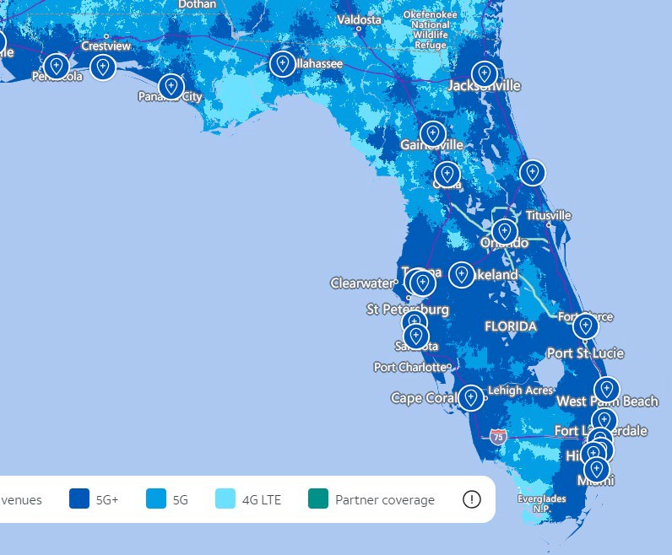

1. 47 U.S.C. § 153(11) (defining a common carrier as “any person engaged as a common carrier for hire, in interstate or foreign communications by wire or radio . . . .”); 47 U.S.C. § 332(c)(1)(A) (treating commercial mobile service providers as common carriers).