BEFORE THE FLORIDA PUBLIC SERVICE COMMISSION

|  |  |
| --- | --- |
| In re: Petition for approval of swing service rider, by Florida Public Utilities Company, Florida Public Utilities Company-Indiantown Division, Florida Public Utilities Company-Fort Meade, and Florida Division of Chesapeake Utilities Corporation. | DOCKET NO. 20240135-GU  ORDER NO. PSC-2024-0487-TRF-GU  ISSUED: November 25, 2024 |

The following Commissioners participated in the disposition of this matter:

MIKE LA ROSA, Chairman

ART GRAHAM

GARY F. CLARK

ANDREW GILES FAY

GABRIELLA PASSIDOMO

ORDER APPROVING SWING SERVICE RIDER RATES

BY THE COMMISSION:

Background

On September 3, 2024, Florida Public Utilities Company (FPUC or utility) filed a petition for approval of revised swing service rider rates and associated tariffs for the period January through December 2025. The swing service rider is a cents per therm charge that is included in the monthly gas bill of transportation customers, who purchase gas from third party marketers, and therefore do not pay the Purchased Gas Adjustment (PGA) charge.[1] FPUC is a local natural gas distribution company (LDC) subject to our regulatory jurisdiction pursuant to Chapter 366, Florida Statutes (F.S.).

We first approved FPUC’s swing service rider tariff by Order No. PSC-16-0422-TRF-GU (2016 Order) and the initial swing service rider rates were in effect for the period March through December 2017.[2] The swing service rider requires FPUC to file an annual petition to recalculate the swing service rider rates based on the utility’s actual interstate capacity costs and the most recent 12 months of usage data. Furthermore, the swing service order requires FPUC to incorporate the calculated revenues from the swing service rider as a credit to the PGA proceeding for the concurrent year. The January through December 2024 swing service rider rates were approved in Order No. PSC-2023-0358-TRF-GU.[3] The proposed modifications to the swing service rider rate schedule are indicated on Attachment A, with the proposed 2025 swing service rider tariffs on Attachment B.

By Order No. PSC-2024-0454-PCO-GU, issued October 17, 2024, we suspended the proposed swing service rider tariffs for further review by our staff. During evaluation of the petition, our staff issued a data request to the utility for which responses were received October 3, 2024. We have jurisdiction over this matter pursuant to Sections 366.04, 366.041, 366.05, and 366.06, F.S.

Decision

The utility incurs intrastate capacity costs when it transports natural gas on intrastate pipelines (i.e., pipelines operating within Florida only). The utility has two types of natural gas customers: sales and transportation. Sales customers are primarily residential and small commercial customers that purchase natural gas from an LDC and receive allocations of intrastate capacity costs through the PGA charge. Transportation customers receive natural gas from third party marketers, known as shippers and, therefore, do not pay the PGA charge to the LDC.[4] The swing service rider allows FPUC to recover allocations of intrastate capacity costs from transportation customers.

Updated 2025 Swing Service Rider Rates

The updated 2025 swing service rider rates were calculated based on the same methodology approved in the 2016 Order. As stated in paragraph 7 of FPUC’s petition, the total intrastate capacity costs for the period July 2023 through June 2024 are $30,003,382, compared to $31,941,095 for the period July 2022 through June 2023. The total intrastate capacity costs reflect payments by FPUC to intrastate pipelines for the transportation of natural gas, pursuant to our approved transportation agreements.

In response to our staff’s first data request, FPUC clarified some costs included in the intrastate pipeline cost total, in Schedule D of the petition. There appeared to be significant changes to some costs, which FPUC clarified were due to a change in the methods of organizing and classifying costs, and not a material change in costs themselves.[5] In previous years, the company had listed individual pipeline contracts on Schedule D. However, the 2025 filing combined all contracts under one line item, labeled “Peninsula Pipeline.” FPUC stated this was done for confidentiality purposes.[6] FPUC further stated there was a year-over-year increase of $1,518,270 to overall Peninsula Pipeline costs due to new projects becoming operational.[7] FPUC’s other intrastate capacity costs include payments associated with legal and consulting fees, software to manage forecasting, usage tracking, and market tracking.

In 2016, the initial order approving the swing service rider excluded Interruptible (COM-INTT) and Natural Gas Vehicle (COM-NGVT) transportation service because of the nature of their services. The utility explained, in response to our staff’s first data request, that COM-INTT and COM-NGVT transportation customers were wrongly included in the 2024 swing service rider due to a change of personnel.[8] FPUC states it collected $150,891 from COM-INTT customers and $15,076 from COM-NGVT customers via the swing service rider. FPUC has refunded the affected customers and has corrected the 2025 swing service rider to remove the COM-INTT and COM-NGVT customer classes.[9]

Of the intrastate pipeline costs, $7,367,169 will be billed directly to certain large special contract customers. The remaining costs of $22,636,213 will be recovered during the period January 1, 2025 through December 31, 2025.

The utility used actual therm usage data for the period July 2023 through June 2024 to allocate the intrastate capacity costs. Based on the usage data, we find that the appropriate split for allocating the cost is 69.96 percent or $15,837,062 to transportation customers and 30.04 percent or $6,799,151 to sales customers, as demonstrated on page 4 of FPUC’s petition. The transportation customers’ share of $15,837,062 is further allocated to the various transportation rate schedules in proportion with each rate schedule’s share of the utility’s total throughput. The sales customers’ share of the cost of $6,799,151 is embedded in the PGA.

To calculate the swing service rider rates, the transportation customers’ share of the cost is allocated to each transportation customer class and then divided by the customer class’ number of therms. The swing service revenues the utility has projected to receive in 2025 totals to $15,837,062.

Credit to the PGA

The total intrastate capacity costs are embedded in the PGA with the projected 2025 swing service rider revenues incorporated as a credit in the calculation of the 2025 PGA. The amount credited to the 2025 PGA is $15,837,062 plus $7,367,169 received from special contract customers, for a total of $23,204,231.[10]

Conclusion

Based on our review of the information in the record, we approve the proposed swing service rider rates in Attachment B for the period January through December 2025. FPUC’s proposed swing service rider reflects the updated cost of swing service for transportation customers. We find that the total projected intrastate capacity costs are appropriate. Furthermore, the methodology for calculating the swing service rider rates is consistent with the 2016 Order.

Based on the foregoing, it is

ORDERED by the Florida Public Service Commission that Florida Public Utilities Company’s proposed swing service rider rates and tariffs for the period January through December 2025 are approved. The costs included are appropriate and the methodology for calculating the swing service rider rates is consistent with the initial order approving the tariff. It is further

ORDERED that if a protest is filed within 21 days of issuance of the Order, the tariff shall remain in effect with any charges held subject to refund pending resolution of the protest. It is further

ORDERED that if no timely protest is filed, this docket shall be closed upon the issuance of a Consummating Order.

By ORDER of the Florida Public Service Commission this 25th day of November, 2024.

|  |  |
| --- | --- |
|  | /s/ Adam J. Teitzman |
|  | ADAM J. TEITZMAN  Commission Clerk |

Florida Public Service Commission

2540 Shumard Oak Boulevard

Tallahassee, Florida 32399

(850) 413‑6770

www.floridapsc.com

Copies furnished: A copy of this document is provided to the parties of record at the time of issuance and, if applicable, interested persons.

RPS

NOTICE OF FURTHER PROCEEDINGS

The Florida Public Service Commission is required by Section 120.569(1), Florida Statutes, to notify parties of any administrative hearing or judicial review of Commission orders that is available under Sections 120.57 or 120.68, Florida Statutes, as well as the procedures and time limits that apply. This notice should not be construed to mean all requests for an administrative hearing or judicial review will be granted or result in the relief sought.

Mediation may be available on a case-by-case basis. If mediation is conducted, it does not affect a substantially interested person's right to a hearing.

The Commission's decision on this tariff is interim in nature and will become final, unless a person whose substantial interests are affected by the proposed action files a petition for a formal proceeding, in the form provided by Rule 28-106.201, Florida Administrative Code. This petition must be received by the Office of Commission Clerk, 2540 Shumard Oak Boulevard, Tallahassee, Florida 32399-0850, by the close of business on December 16, 2024.

In the absence of such a petition, this Order shall become final and effective upon the issuance of a Consummating Order.

Any objection or protest filed in this docket before the issuance date of this order is considered abandoned unless it satisfies the foregoing conditions and is renewed within the specified protest period.

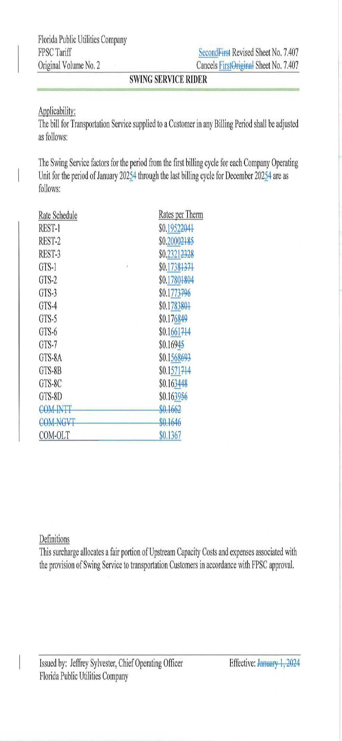

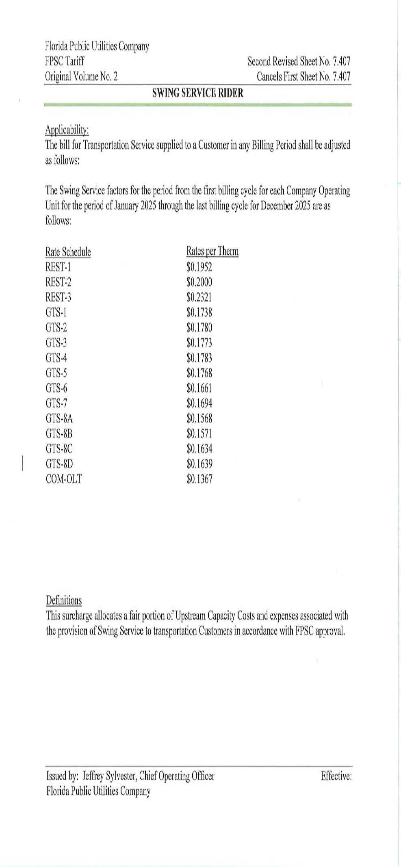

1. The PGA charge is set by the Commission in the annual PGA cost recovery clause proceeding.
2. Order No. PSC-16-0422-TRF-GU, issued October 3, 2016, in Docket No. 160085-GU, *In re: Joint petition for approval of swing service rider, by Florida Public Utilities Company, Florida Public Utilities Company-Indiantown Division, Florida Public Utilities Company-Fort Meade, and Florida Division of Chesapeake Utilities Corporation.*
3. Order No. PSC-2023-0358-TRF-GU, issued November 28, 2023, Docket No. 20230096-GU, *In re: Petition for approval of swing service rider rates for January through December 2024, by Florida Public Utilities Company.*
4. The Commission does not regulate the shippers or their charges for the gas commodity.
5. FPUC’s Responses to our Staff’s First Data Request, No. 6a.
6. FPUC’s Responses to our Staff’s First Data Request, No. 6a.
7. FPUC’s Responses to our Staff’s First Data Request, No. 6b.
8. FPUC’s Responses to our Staff’s First Data Requests, No. 4a.
9. FPUC’s Responses to our Staff’s First Data Requests, No. 4d.
10. *See* direct testimony of witness Stacey K. Laster on behalf of FPUC, filed on August 6, 2024, Document No. 08262-2024, in Docket No. 20240003-GU, Exhibit SKL-1, Schedule E-1, line 8 on page 1, and the direct testimony of Stacey K. Laster, page 3, line 21, through page 4, line 7, included in the petition.