BEFORE THE FLORIDA PUBLIC SERVICE COMMISSION

In re: Joint petition for approval of territorial agreement in Marion County, by City of Ocala and Duke Energy Florida, LLC. | DOCKET NO. 20240110-EU  ORDER NO. PSC-2024-0488-PAA-EU  ISSUED: November 25, 2024

The following Commissioners participated in the disposition of this matter:

MIKE LA ROSA, Chairman
ART GRAHAM
GARY F. CLARK
ANDREW GILES FAY
GABRIELLA PASSIDOMO

NOTICE OF PROPOSED AGENCY ACTION
ORDER APPROVING JOINT PETITION FOR APPROVAL OF TERRITORIAL AGREEMENT

BY THE COMMISSION:

NOTICE is hereby given by the Florida Public Service Commission that the action discussed herein is preliminary in nature and will become final unless a person whose interests are substantially affected files a petition for a formal proceeding, pursuant to Rule 25-22.029, Florida Administrative Code (F.A.C.).

Background
On August 2, 2024, the City of Ocala, Florida d/b/a Ocala Electric Utility (Ocala) and Duke Energy Florida, LLC (DEF), collectively the joint petitioners or utilities, filed a petition seeking our approval of a Territorial Agreement in Marion County, Florida (2024 Territorial Agreement). The 2024 Territorial Agreement provides details on the boundary line changes and also proposes a total of seven customer transfers (one customer from DEF to Ocala, and six customers from Ocala to DEF). The joint petitioners regard these seven customers as extra-territorial customers, since their point of use is in one party’s territory, but they are receiving service from the other party. In its petition, the joint petitioners provided sample customer notifications that were sent to each of the customers who are subject to being transferred. The letters were issued to comply with Rule 25-6.0440(1)(d), F.A.C. The proposed Agreement, maps depicting the new territorial boundaries, and written descriptions are attached hereto as Attachment A, attached hereto.
Since 2009, Ocala and DEF have been parties to a territorial agreement that expired in 2019. We approved that agreement by Order No. PSC-09-0485-CO-EU, dated July 7, 2009. In early 2017, the joint petitioners began negotiations on a new territorial agreement to replace the 2009 Agreement. Although the 2009 Agreement expired, the parties have continued to meet their obligations under it while negotiations towards the new Territorial Agreement were underway.
Both Ocala and DEF acknowledge that their current respective Geographic Information System (GIS) mapping systems offer more precision than prior mapping resources, and at various times, both have inadvertently connected a very small number of customers who are located in the other utility’s territory. As discussed herein, the negotiated 2024 Territorial Agreement includes boundary line changes that acknowledge these inadvertent connections. Other boundary lines changes address mapping discrepancies and split parcels along the territorial boundaries. Through sharing of GIS mapping files, the joint petitioners are currently able to evaluate whether service addresses are located within or outside either utility’s respective service territory, which greatly enhances their ability to prevent future inadvertent connections.
During the review process, our staff issued two data requests to the joint petitioners, for which responses were received August 30, 2024 and September 30, 2024. The proposed 2024 Territorial Agreement establishes the new territorial boundaries reflecting the assets and customer transfers between the joint petitioners. We have jurisdiction over this matter pursuant to Section 366.04, Florida Statutes (F.S.).

Decision

Pursuant to Section 366.04(2)(d), F.S., and Rule 25-6.0440(2), F.A.C., we have jurisdiction to approve territorial agreements between and among rural electric cooperatives, municipal electric utilities, and other electric utilities. Unless we determine that the agreement will cause a detriment to the public interest, the agreement shall be approved.
Compliance with Rule 25-6.0440(2), F.A.C.

Rule 25-6.0440(2), F.A.C., addresses the standards we may consider for approving territorial agreements for electric utilities. The Rule states:

(2) In approving territorial agreements, the Commission may consider:
(a) The reasonableness of the purchase price of any facilities being transferred;
(b) The reasonable likelihood that the agreement, in and of itself, will not cause a decrease in the reliability of electrical service to the existing or future ratepayers of any utility party to the agreement;
(c) The reasonable likelihood that the agreement will eliminate existing or potential uneconomic duplication of facilities; and
(d) Any other factor the Commission finds relevant in reaching a determination that the territorial agreement is in the public interest.

Proposed 2024 Territorial Agreement

Ocala and DEF executed the proposed 2024 Territorial Agreement on August 2, 2024, to replace the 2009 Agreement which expired in July 2019. Upon our approval, the proposed 2024 Territorial Agreement will supersede the 2009 Agreement and all other prior agreements between the joint petitioners in Marion County. Through the proposed 2024 Territorial Agreement, the joint petitioners seek to (1) transfer certain customers to address errors each utility made in connecting and serving customers that were located in the geographic area of the other utility and (2) make minor boundary changes to correct mapping errors and address split parcels, in order to more clearly delineate the respective service areas each utility serves. These combined objectives are expected to aid the utilities in eliminating circumstances that give rise to the uneconomic duplication of service facilities and hazardous situations.

Pursuant to Section 6.0, the proposed 2024 Territorial Agreement will remain in effect for 20 years from date that our order approving the agreement in its entirety is no longer subject to judicial review. Upon the expiration of the initial 20-year term, pursuant to Section 6.0, the agreement shall remain in effect unless either party provides written notice of termination at least 12 months prior to the termination of the Agreement in accordance with the Section 8.2.

Proposed Boundary Changes

The joint petitioners assert that the proposed boundary line changes are minor, and there are two main reasons for them. First, minor changes are needed to implement the transfer of the seven extra-territorial customers and to accommodate the 54 inadvertently-served customers who will not be transferring. Second, other proposed boundary line changes are proposed to address mapping discrepancies (errors) and consolidate parcels that were previously split. Maps depicting the proposed boundary lines are shown in Attachment B, attached hereto.

Regarding the proposed boundary changes to accommodate customer transfers, the joint petitioners contend that the inadvertent connections were the result of human error in interpreting older paper boundary maps, or because one utility or the other did not have facilities at/near the service address at the time service was requested by the customer. The joint petitioners contend that the proposed changes to accommodate customer transfers will accomplish the objectives of avoiding duplication of services and wasteful expenditures, as well as to best protect the public health and safety from potentially hazardous conditions. Other proposed boundary line changes are on vacant land parcels that are unrelated to the seven extra-territorial customers proposed to be transferred.

The joint petitioners are also proposing boundary line adjustments that rectify mapping discrepancies and errors. The utilities propose to do this, in part, by eliminating or greatly reducing the number of split parcels in one or the other utility’s service territory. They contend that split parcels lead to confusion regarding which utility should serve a portion or all of a parcel, whereas, if a negotiated map adjustment eliminated the split and incorporated a whole parcel, such confusion would be averted. In addition, other adjustments are proposed to clarify (or re-draw) parcels where needed, and also to make adjustments that would remove the need for duplicative facilities.

Through their careful review of GIS-based resources, the joint petitioners also determined their existing maps had errors in them. Specifically, these errors were parcels or land areas that were shown on the old and outdated resources as part of one utility’s service territory, and the GIS-based resource indicated the parcels are legally part of another utility’s service territory. The joint petitioners are in agreement as to the nature of the mapping errors and that such errors should be corrected. The utilities also reported that detailed GIS-based mapping that each utility uses, along with written descriptions included in the 2024 Territorial Agreement, will help to avoid similar errors on a going-forward basis.

Inadvertently Served Customers Not Proposed to be Transferred

A total of 54 customers are being inadvertently served, which means their respective point of connection for receiving electrical service is located outside of their utilities’ currently approved service territory. The joint petitioners have forged boundary line changes to avert the need for customer transfers by either utility so that these customers may continue to receive service from their current utility rather than be transferred. DEF currently provides inadvertent service to 41 customer who are not proposed to be transferred to Ocala. These DEF customers are reflected on the current territorial maps as being located in Ocala’s service territory, although proposed map adjustments allow these customers to continue to be served by DEF. Likewise, a total of 13 customers with service addresses in DEF’s territory are currently being served by Ocala. Map adjustments are proposed that will avert the need for implementing transfers. The joint petitioners state that many of the inadvertently served customers are in areas where there were split parcels, and because the proposed boundary line changes are addressing those parcels, these inadvertently served customers are not being transferred because the existing facilities are in place and it makes “operational sense” that they continue to be served by their current utility. Pursuant to Section 1.8 of the Agreement, the joint petitioners clarified that there are no Temporary Service Customers currently being serviced by either party. Temporary Service Customers are defined in the Territorial Agreement as customers who are being temporarily served under the temporary service provisions of the Agreement.

Proposed Seven Customer Transfers

The proposed customer transfers under the 2024 Territorial Agreement are the result of negotiations between the parties, with the intent of avoiding duplication of services and wasteful expenditures, as well as to best protect the public health and safety from potentially hazardous conditions. A total of seven active customer accounts are proposed to be transferred, one from DEF to Ocala and six customer accounts are proposed to be transferred from Ocala to DEF.
DEF to Ocala Customer Transfer (one customer)

The one active DEF customer account that is proposed to be transferred to Ocala, as shown in Exhibit C of the proposed Territorial Agreement, is a residential class customer whose service was established in 2021. At that time, DEF relied upon its then-current mapping resources, which included older paper boundary maps approved by us in 2009 that indicated that the service address was within its franchised service territory. More correct GIS-based mapping resources now indicate that the original connection was in error, and the proposed transfer pursuant to the 2024 Territorial Agreement corrects this.

Ocala to DEF Customer Transfers (six customers)

The six active Ocala customer accounts that are proposed to be transferred to DEF were connected at various times, some dating back to 1995. Exhibit D of the proposed Territorial agreement reflects that three of the customer locations shown are receiving service as commercial class customers and the other three are receiving service as residential class customers. Ocala also stated that the serving utilities relied on mapping sources that were current at the time, and have since been enhanced.

The joint petitioners also share their mapping files with one another as an effort to make sure there is no disagreement on the exact boundaries. Both parties intend to continue using these mapping tools and share data as an ongoing practice to avert errant connections prospectively.

Implementation and Customer Notifications

The joint petitioners state that there will be no customer transfers until we approve the joint petition. Although specific details regarding the transfer of facilities have not been developed yet, the joint petitioners state that upon our approval of the 2024 Territorial Agreement, the customer transfers will be coordinated to take place over a 36-month period.
Pursuant to Rule 25-6.0440(1)(d), F.A.C., DEF notified its one customer of the proposed transfer to Ocala, and Ocala informed its designated 6 customers of their proposed transfer to DEF. The customer notification letters dated March 19, 2024, provided information on the general service rate changes that would be applicable under their proposal. As of August 2024, the residential service rate was $0.09171 per kilowatt hours (kWh) for DEF customers and $0.10126 per kilowatt hours (kWh) for Ocala customers, a difference of about $.00955 per kWh (approximately a 10 percent difference). On a comparative basis, for a typical residential customer using 1,000 kWh per month, a DEF customer would be paying $91.71 per month, and an Ocala customer would be paying $101.26, a difference of $9.55 per month. For a commercial class customer, DEF’s general service rate is $0.07332 per kWh, and the comparable charge for Ocala is $.10310 per kWh (approximately a 34 percent difference).
As of our vote on this matter, we had not received correspondence from customers related to the proposed transfers. The joint petitioners assert they have not received any written correspondence from customers related to the proposed transfers. They also assert that at least 30 days prior to the actual transfer, the affected customers will receive a second notification of the transfer. The joint petitioners assert that no additional charges will be imposed on those customers that will be transferred. We find that DEF and Ocala have met their obligations of providing notification pursuant to Rule 25-6.0440(1)(d), F.A.C., and both commit to doing so again when the specific transfer is eminent.
Standards of Approval

Construction cost estimates or detailed engineering drawings were not presented to us for review. The joint petitioners stated that construction cost estimated or detailed engineering drawings have not been developed yet. Upon approval of the proposed 2024 Territorial Agreement, the parties assert they will address which facilities are to be transferred or purchased, if any, and undertake a valuation of facilities subject to transfer. DEF and Ocala have mutually agreed to use an engineering cost estimation methodology to determine the value of facilities subject to transfer. In our review of the agreement, we analyzed each component of Rule 25-6.0440(2), F.A.C. Regarding paragraph (2)(a), we note that no purchase price was presented for review. As a proxy, we note that the joint petitioners agreed to use an engineering cost estimation methodology to determine the value of facilities when the specific plans and technical drawings for implementing their Territorial Agreement are developed at a later time. This methodology has been used by utility companies in the past, and has been approved by us. Pursuant to Rule 25-6.0440(2)(b), F.A.C., the joint petitioners’ confirmed that the availability and reliability of service to existing or future customers will not be decreased for either petitioner. Additionally, both utilities confirmed that the 2024 Territorial Agreement would help them gain further operational efficiencies and customer service improvements in their respective retail service areas. The joint petitioners stated that the transfer of the one customer from DEF to Ocala would have the greatest operational impact, because the current DEF facilities to serve the customer runs across multiple private properties and heavily wooded areas.

Under the proposed 2024 Territorial Agreement, the joint petitioners have made good faith efforts to minimize existing or potential uneconomic duplication of facilities, as referenced in Rule 25-6.0440(2)(c), F.A.C. Each joint petitioner provided tables and maps indicating the approximate distance between customer locations and primary facilities. The service address for the DEF customer subject to transfer to Ocala is about 200 feet from existing Ocala facilities, and when the transfer is implemented, the joint petitioners assert that about 550 feet of overhead facilities will no longer be needed and can be removed. For the Ocala customers subject to transfer to DEF, the joint petitioners indicate DEF will serve these addresses via overhead and underground service lines. Three of the customer addresses are located about 1,700 feet from existing DEF facilities, and the other 3 are less than 1,000 feet from existing DEF facilities.
Rule 25-6.0440(2)(d), F.A.C., gives us the discretion to address any other relevant concerns that are case-specific. In this case, a disparity of rates (based on a July to August 2024 bill example) exists that would result in certain customers paying more for service. Pursuant to the 2024 Territorial Agreement, the customer transferring from DEF to Ocala would be paying rates that are about 10 percent higher than they are currently. Conversely, the 3 residential customers transferring from Ocala to DEF will be paying rates that are about 10 percent lower than they are currently. Although we are cognizant of the rate impact on customers, we have consistently adhered to the principle set forth in Storey v. Mayo, 217 So. 2d 304, 307-308 (Fla. 1968), and reaffirmed in Lee County Electric Cooperative v. Marks, 501 So. 2d 585 (Fla. 1987), that no person has a right to compel service from a particular utility simply because he believes it to be to his advantage. The Court went on to say in Lee County that “larger policies are at stake than one customer's self-interest, and those policies must be enforced and safeguarded by the Florida Public Service. Commission.” Lee County Electric Cooperative, at 587.
The joint petitioners are optimistic that with modern mapping resources and advancements in GIS technology, instances of inadvertent connection can be greatly reduced or eliminated. Both parties have put in effort to correct certain errors made by both entities over a long period of time. We find that the 2024 Territorial Agreement is reasonable and a product of thoughtful negotiation.

Conclusion

We shall approve the proposed 2024 Territorial Agreement between Ocala and DEF in Marion County, dated August 2, 2024, as consistent with the Standards for Approval pursuant to Rule 25-6.0440(2), F.A.C. The proposed territorial agreement amends the respective boundary between these utilities to more clearly delineate their service territories, while also resolving ongoing matters related to inadvertently served customers. Moreover, approval of the 2024 Territorial Agreement would help the joint petitioners to gain further operational efficiencies and customer service improvements in their respective retail service territories, and to address circumstances giving rise to uneconomic duplication of service facilities and hazardous situations.

Based on the foregoing, it is

ORDERED by the Florida Public Service Commission that the proposed 2024 Territorial Agreement in Marion County, Florida between Ocala Electric Utility and the Duke Energy Florida, LLC, dated August 2, 2024, is hereby approved. It is further

ORDERED that the provisions of this Order, issued as proposed agency action, shall become final and effective upon the issuance of a Consummating Order unless an appropriate petition, in the form provided by Rule 28-106.201, Florida Administrative Code, is received by the Commission Clerk, 2540 Shumard Oak Boulevard, Tallahassee, Florida 32399-0850, by the close of business on the date set forth in the “Notice of Further Proceedings” attached hereto. It is further

ORDERED that if no protest is filed by a person whose substantive interests are affected within 21 days of the issuance of this Order, this docket should be closed upon the issuance of a Consummating Order.

By ORDER of the Florida Public Service Commission this 25th day of November, 2024.

/s/ Adam J. Teitzman
ADAM J. TEITZMAN
Commission Clerk
Florida Public Service Commission
2540 Shumard Oak Boulevard
Tallahassee, Florida 32399
(850) 413-6770
www.floridapsc.com

Copies furnished: A copy of this document is provided to the parties of record at the time of issuance and, if applicable, interested persons.

RPS

NOTICE OF FURTHER PROCEEDINGS OR JUDICIAL REVIEW

The Florida Public Service Commission is required by Section 120.569(1), Florida Statutes, to notify parties of any administrative hearing that is available under Section 120.57, Florida Statutes, as well as the procedures and time limits that apply. This notice should not be construed to mean all requests for an administrative hearing will be granted or result in the relief sought.

Mediation may be available on a case-by-case basis. If mediation is conducted, it does not affect a substantially interested person's right to a hearing.

The action proposed herein is preliminary in nature. Any person whose substantial interests are affected by the action proposed by this order may file a petition for a formal proceeding, in the form provided by Rule 28-106.201, Florida Administrative Code. This petition must be received by the Office of Commission Clerk, 2540 Shumard Oak Boulevard, Tallahassee, Florida 32399-0850, by the close of business on December 16, 2024.

In the absence of such a petition, this order shall become final and effective upon the issuance of a Consummating Order.

Any objection or protest filed in this/these docket(s) before the issuance date of this order is considered abandoned unless it satisfies the foregoing conditions and is renewed within the specified protest period.

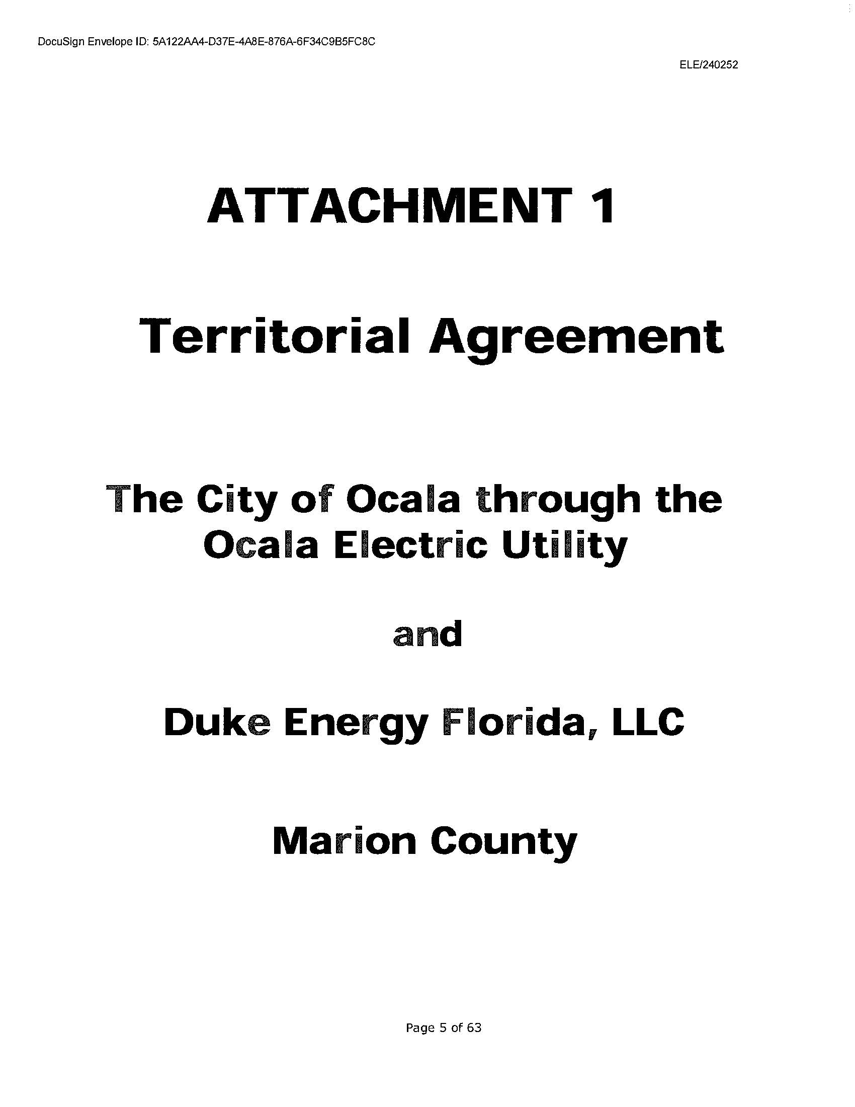

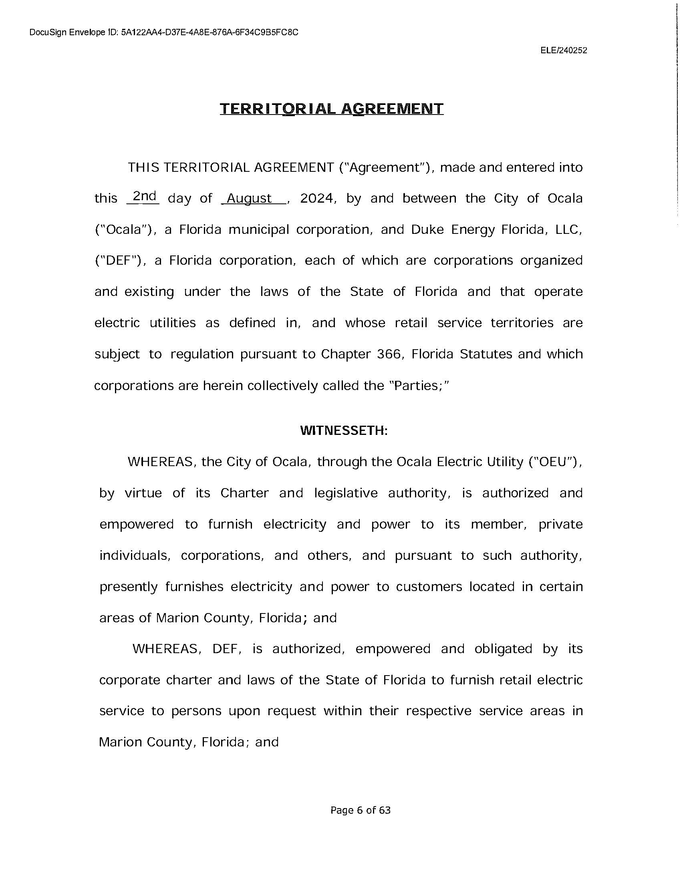

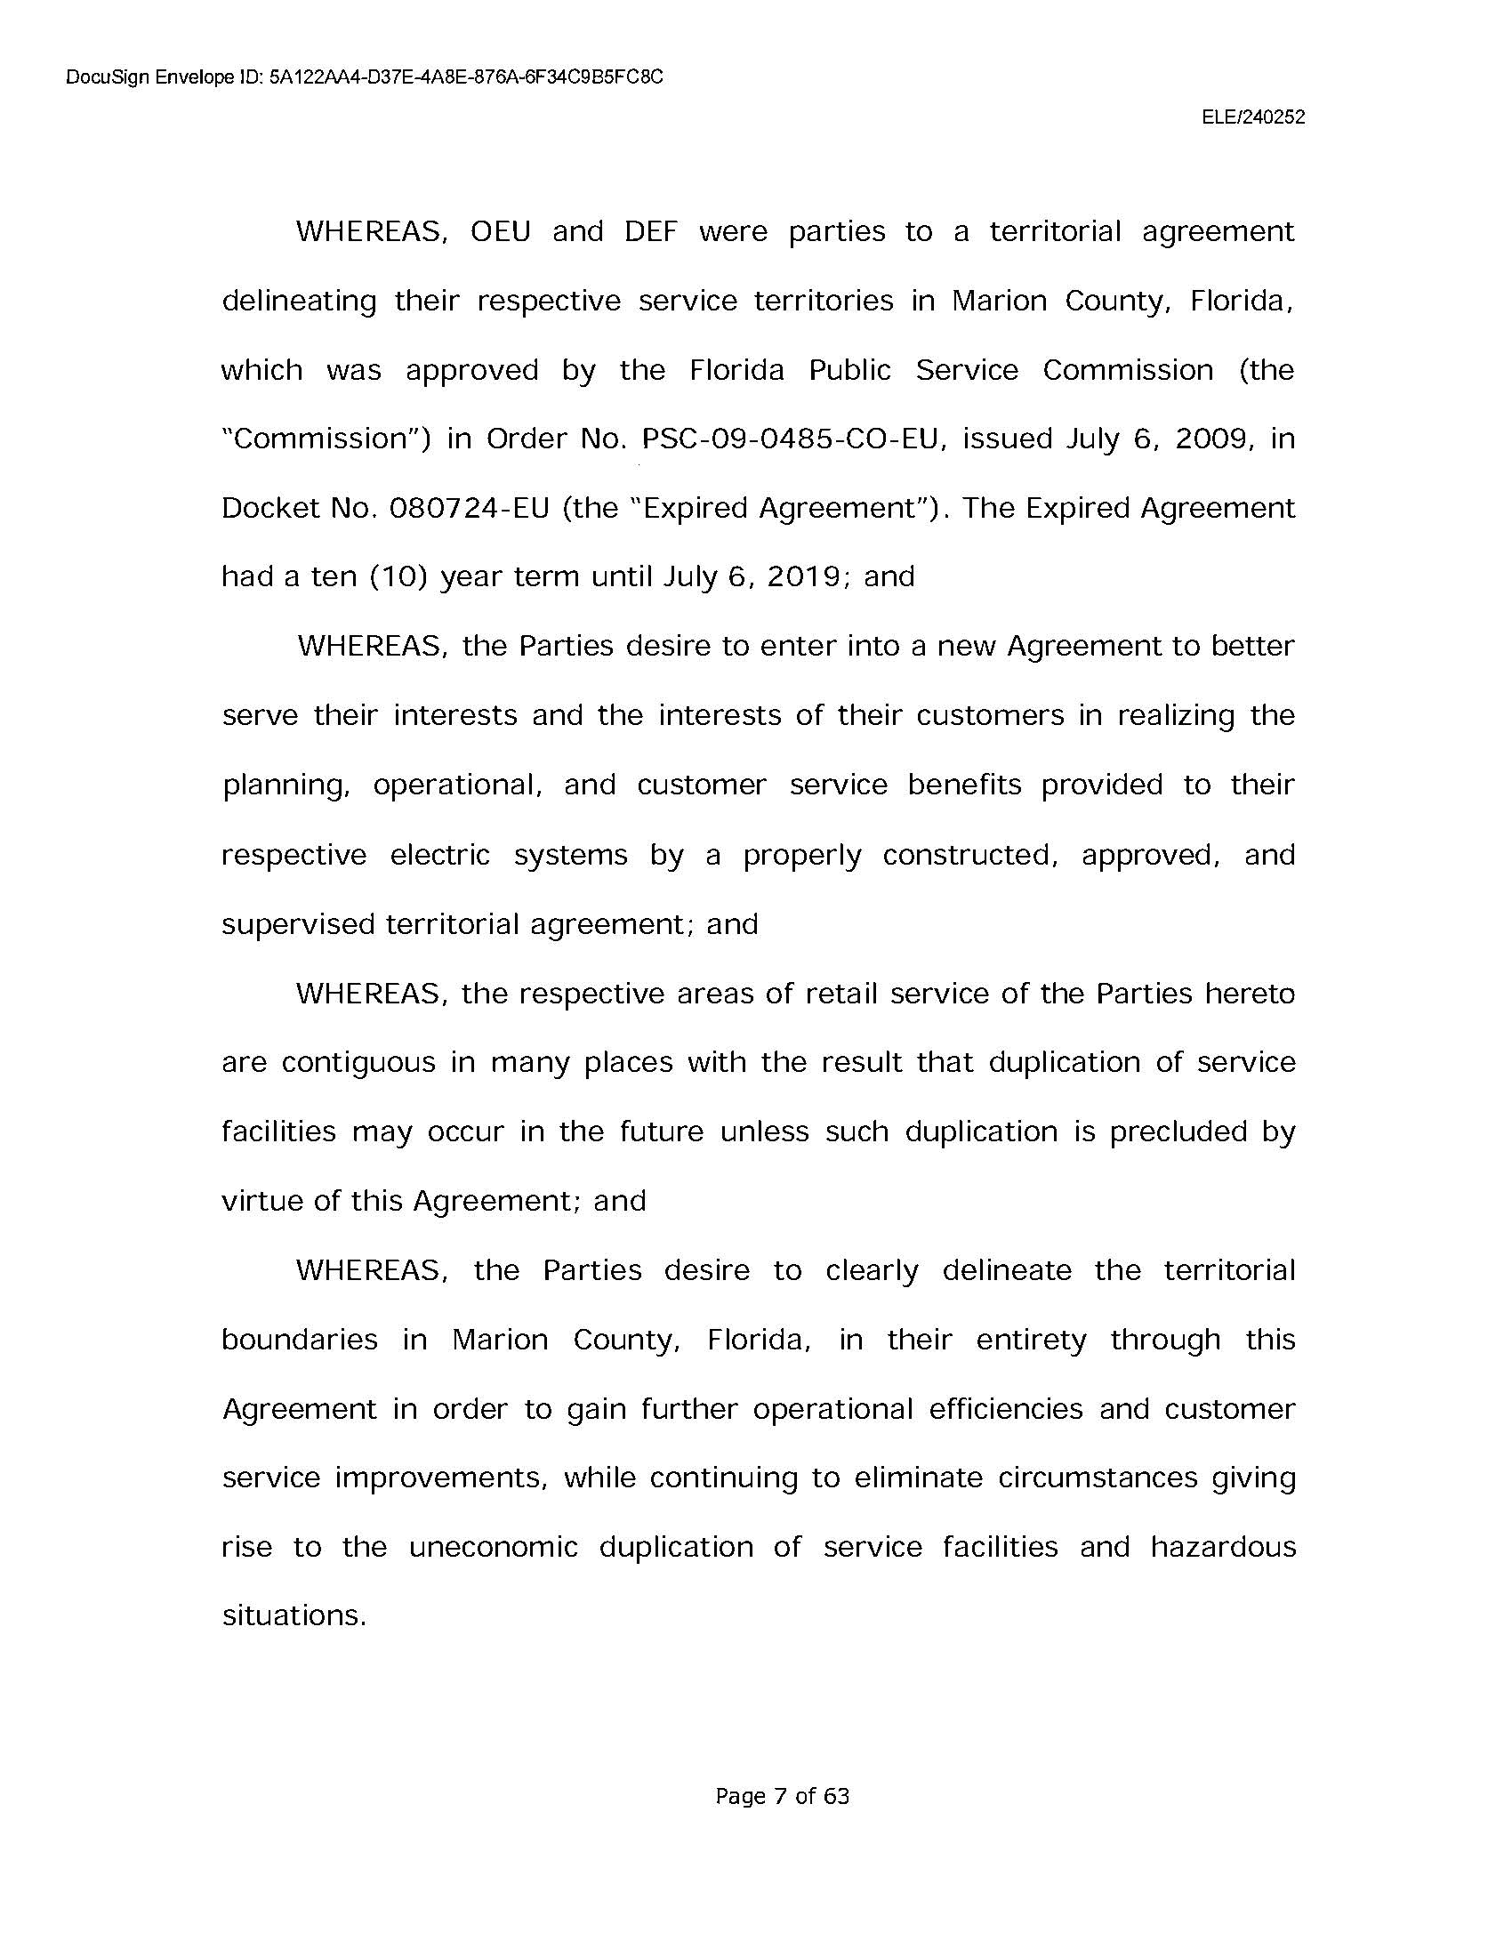

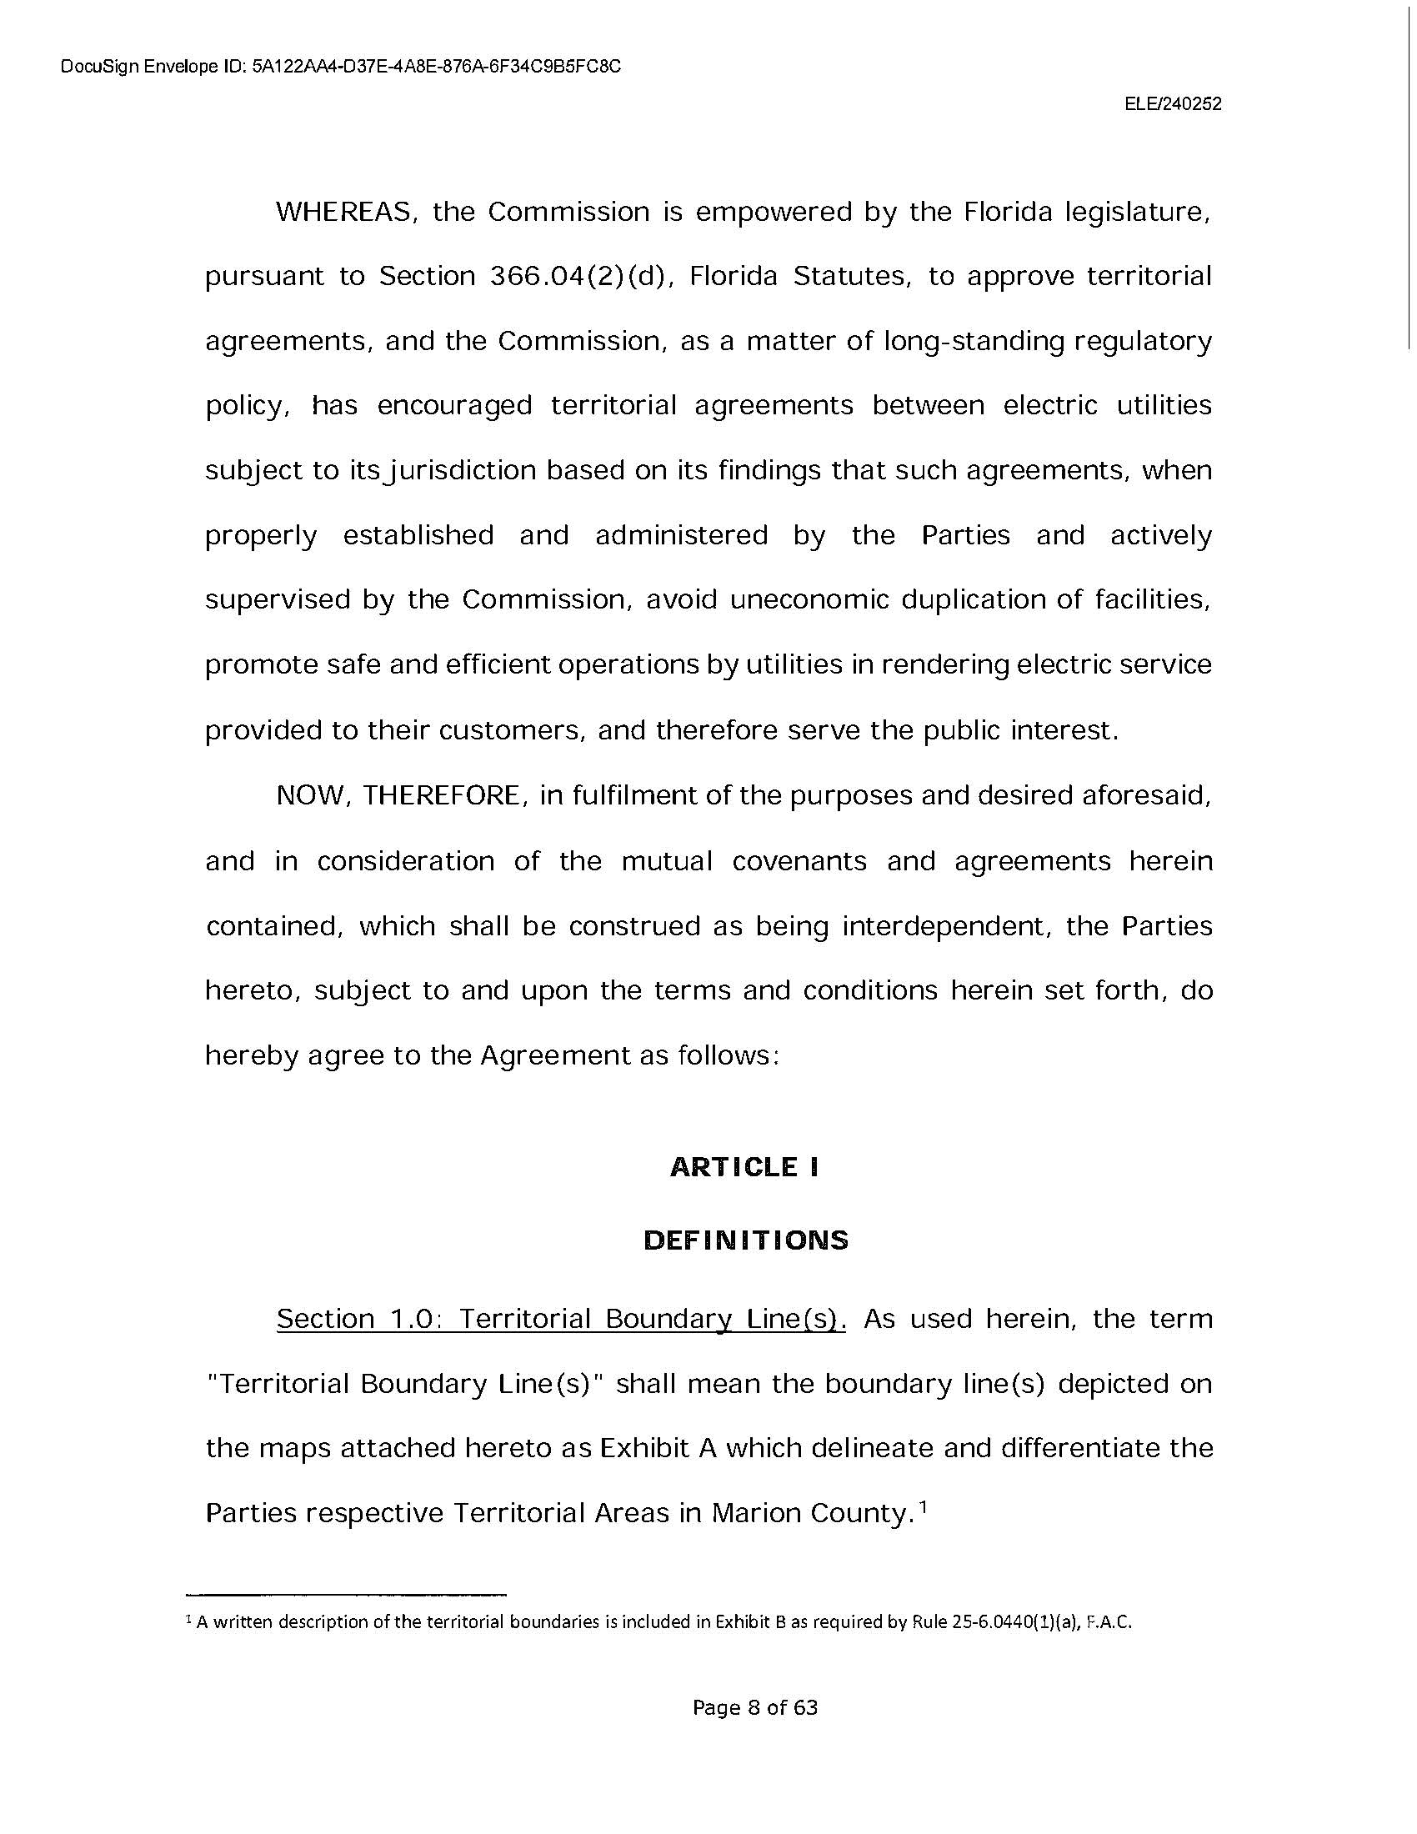

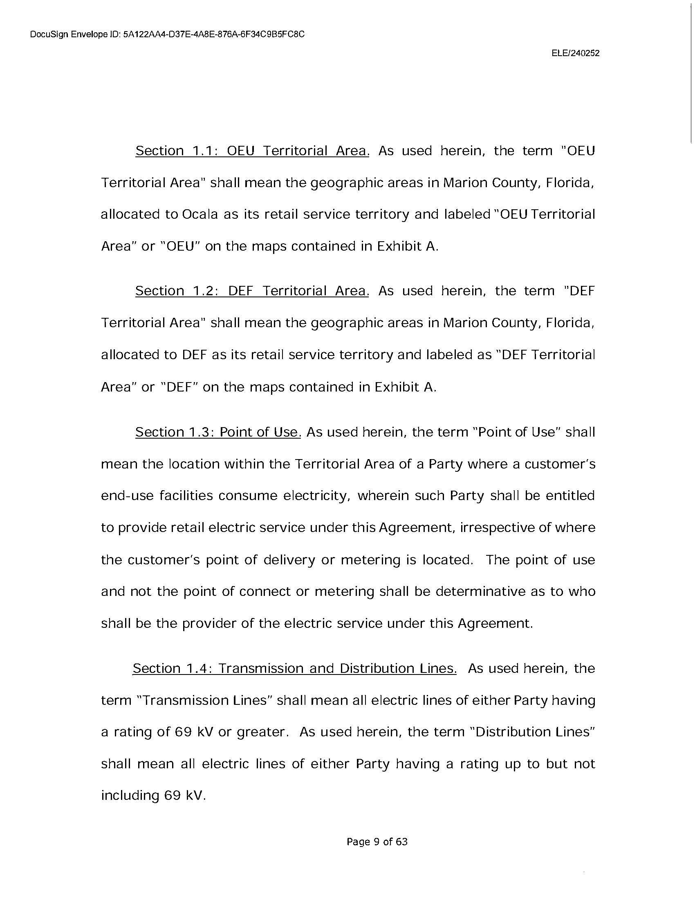

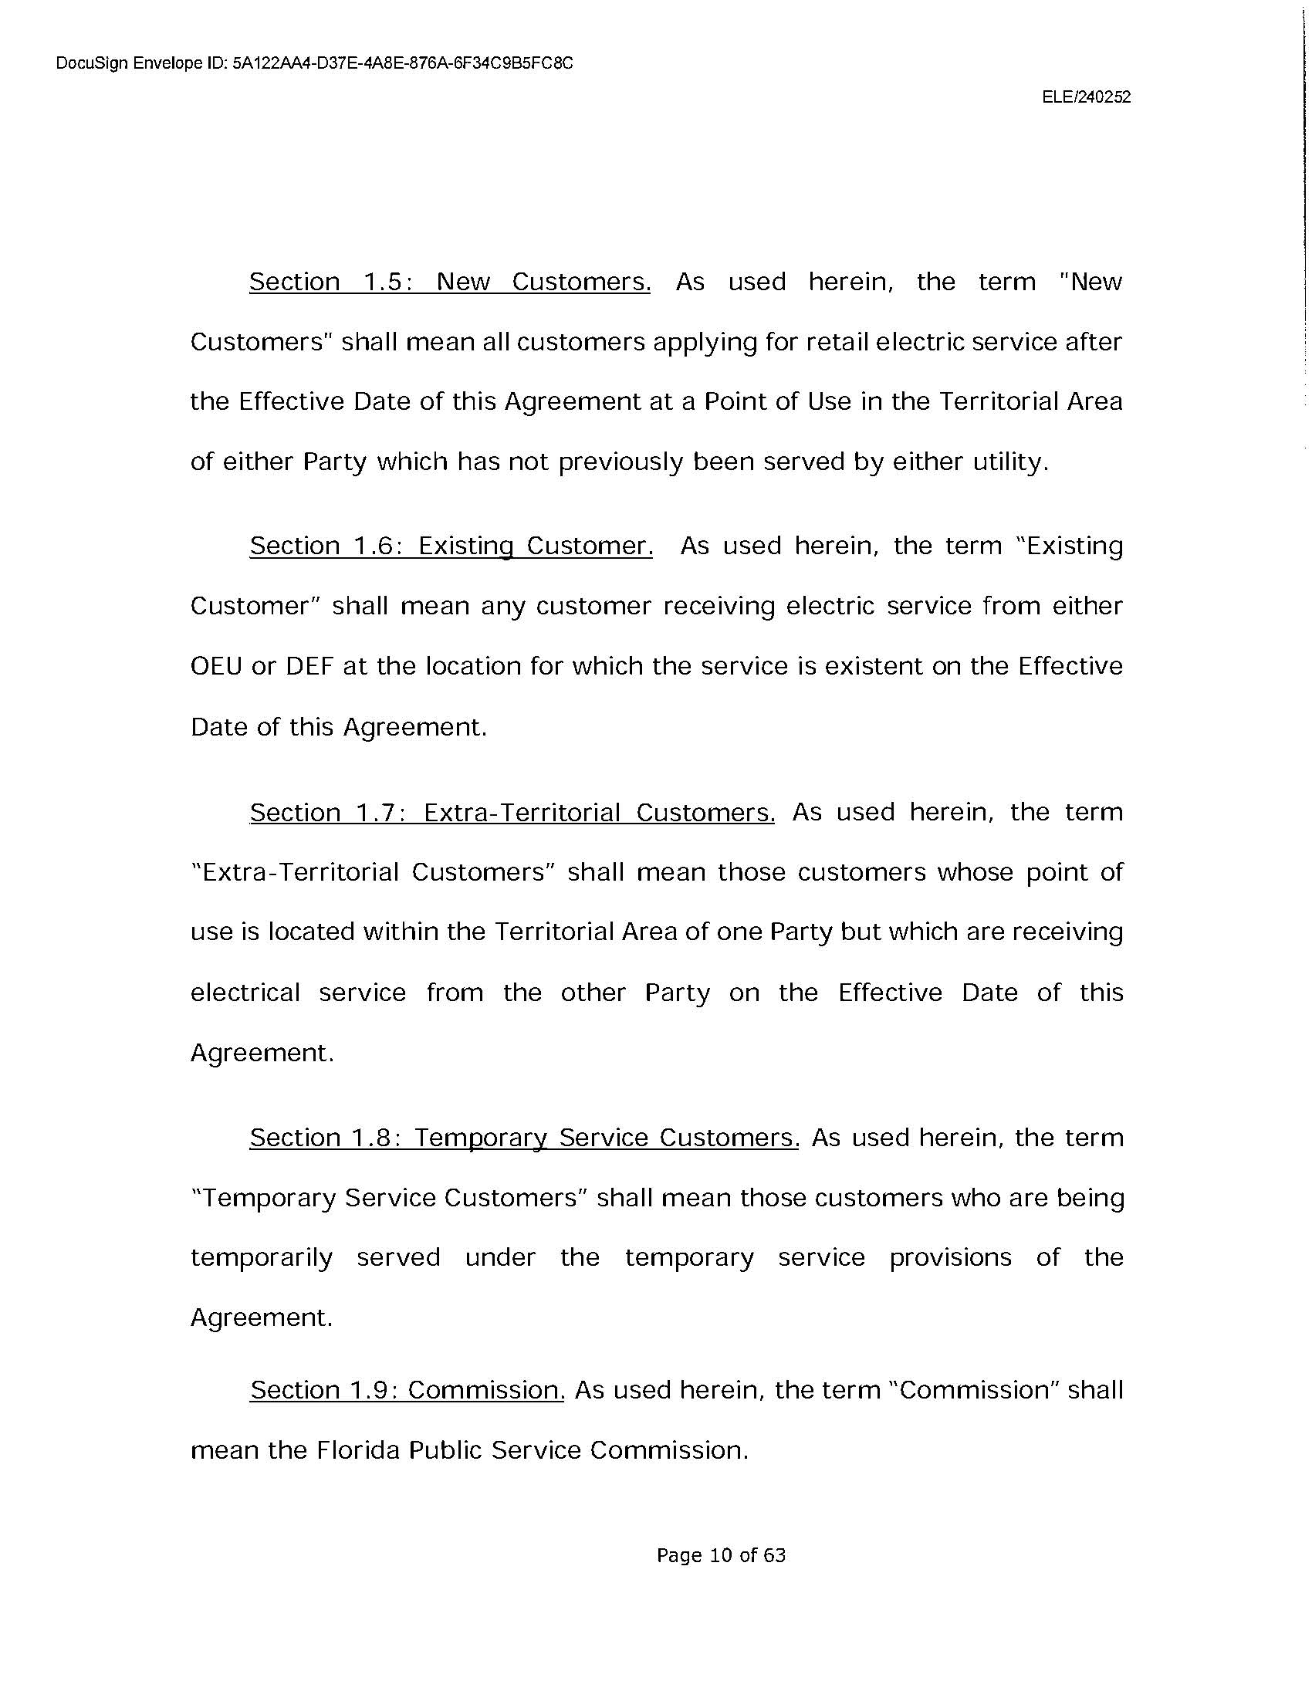

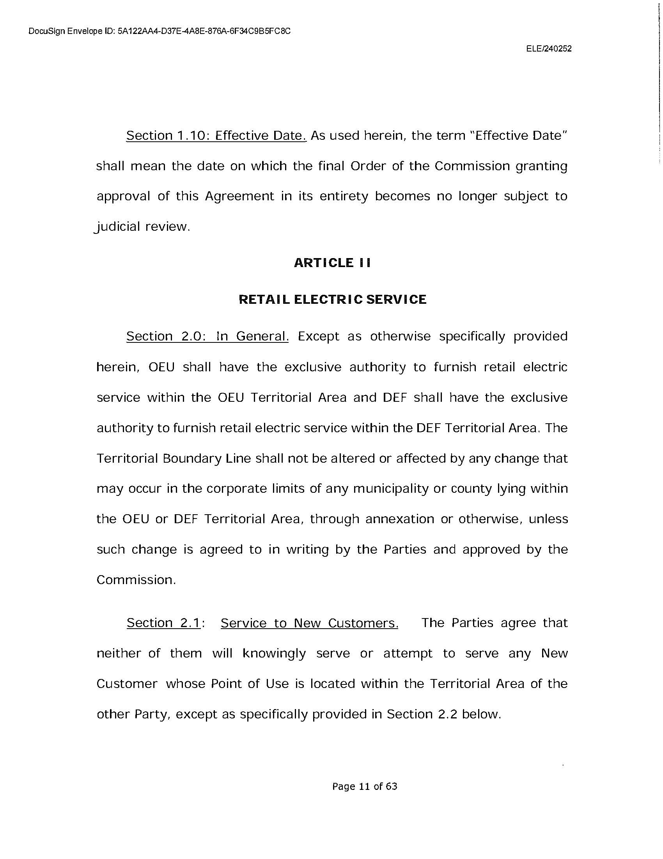

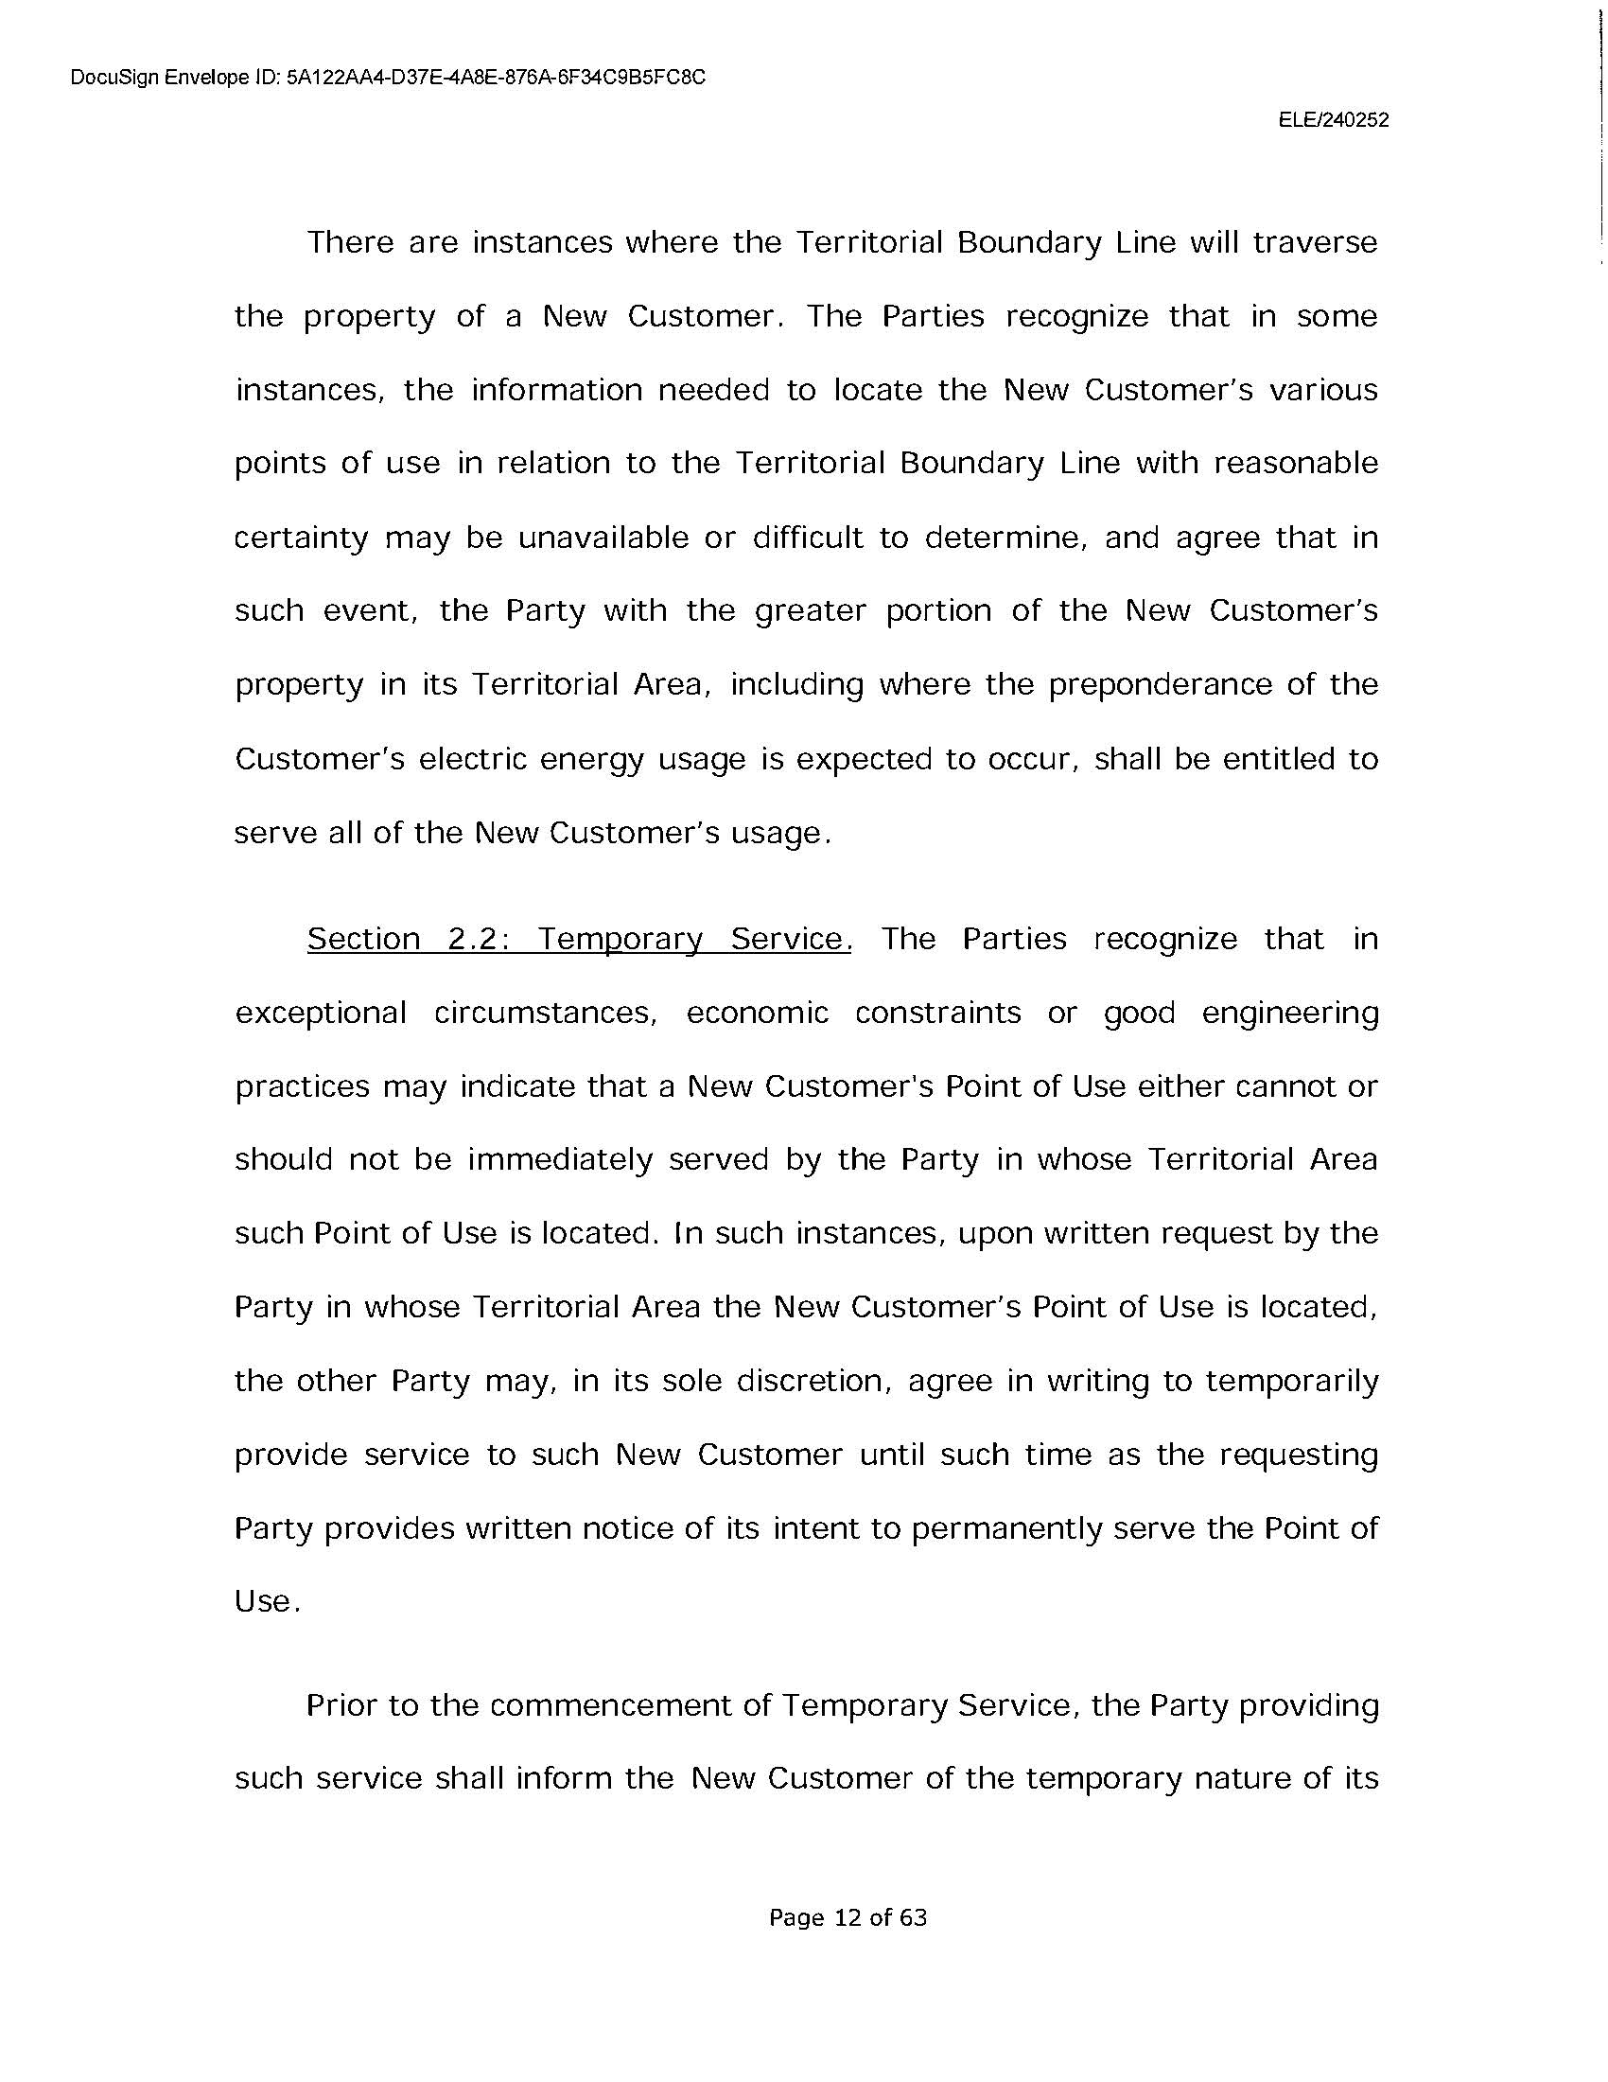

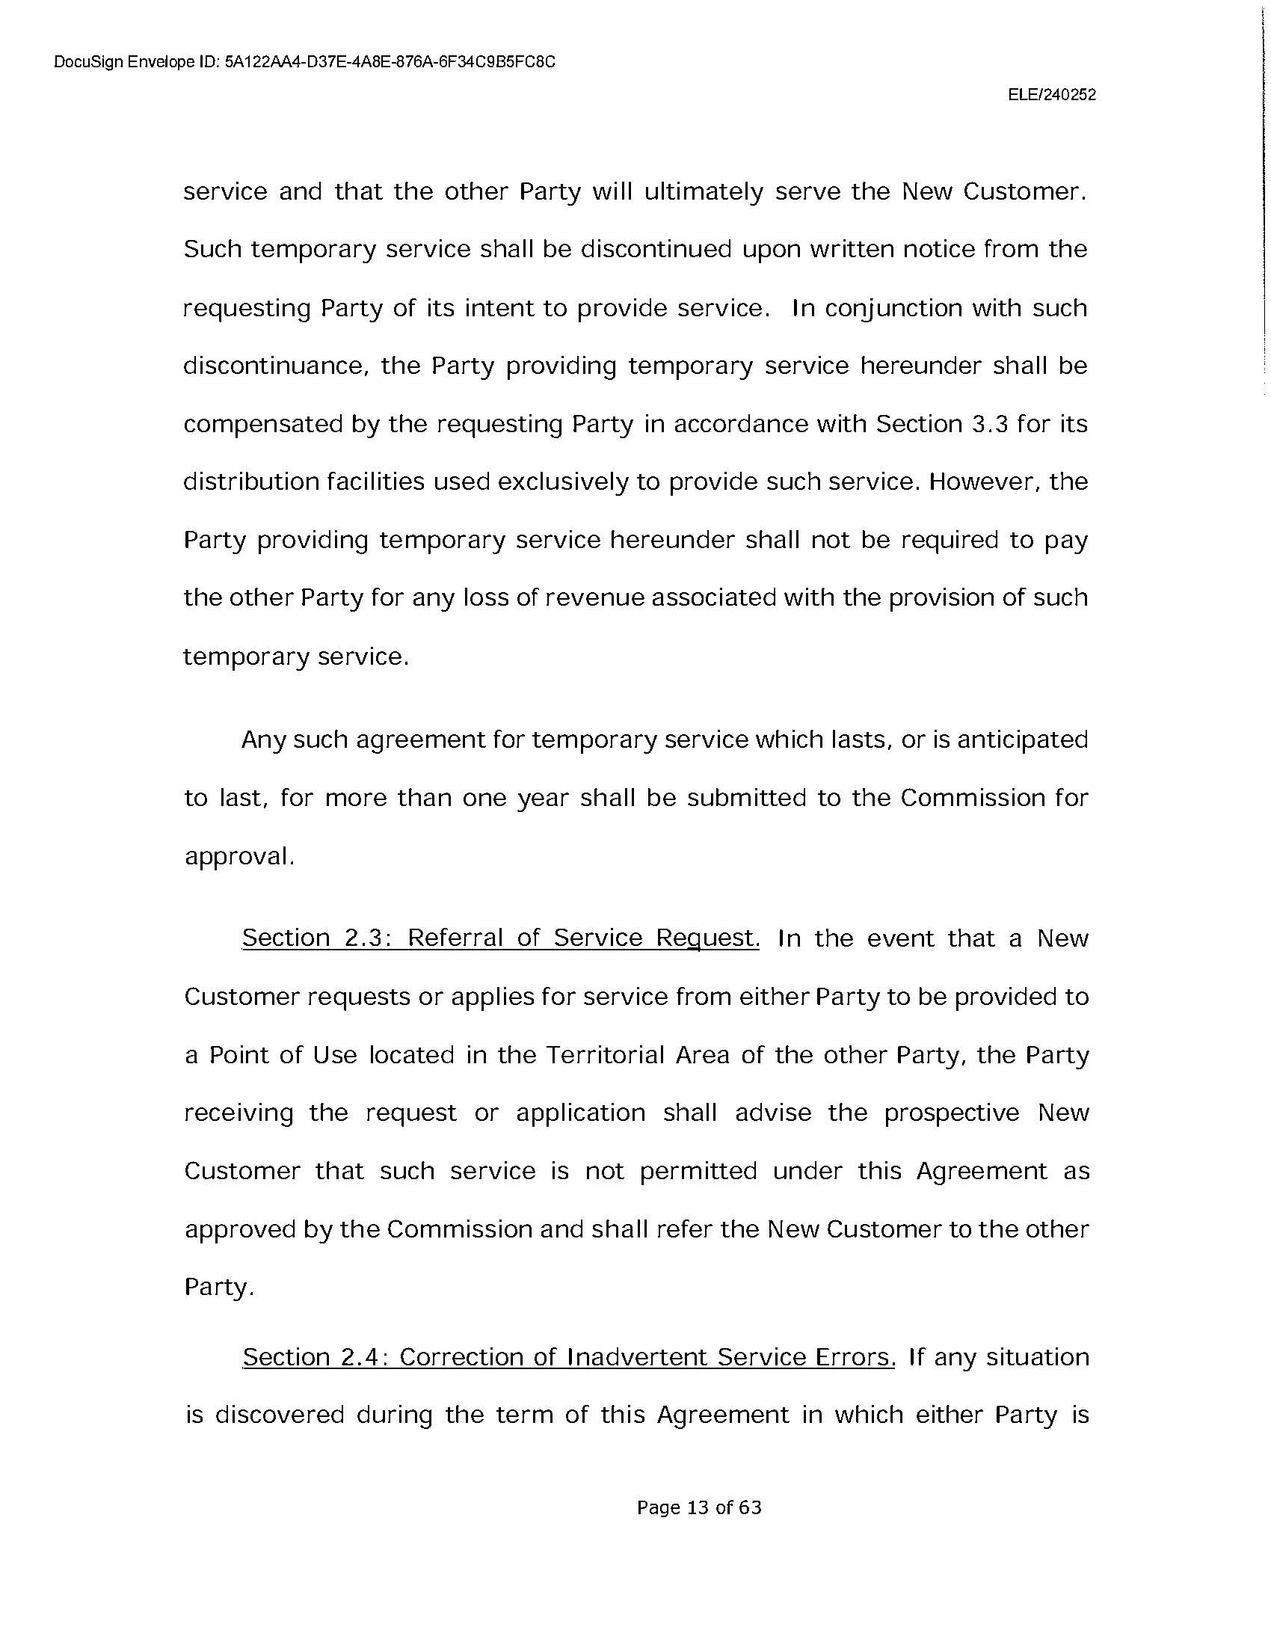

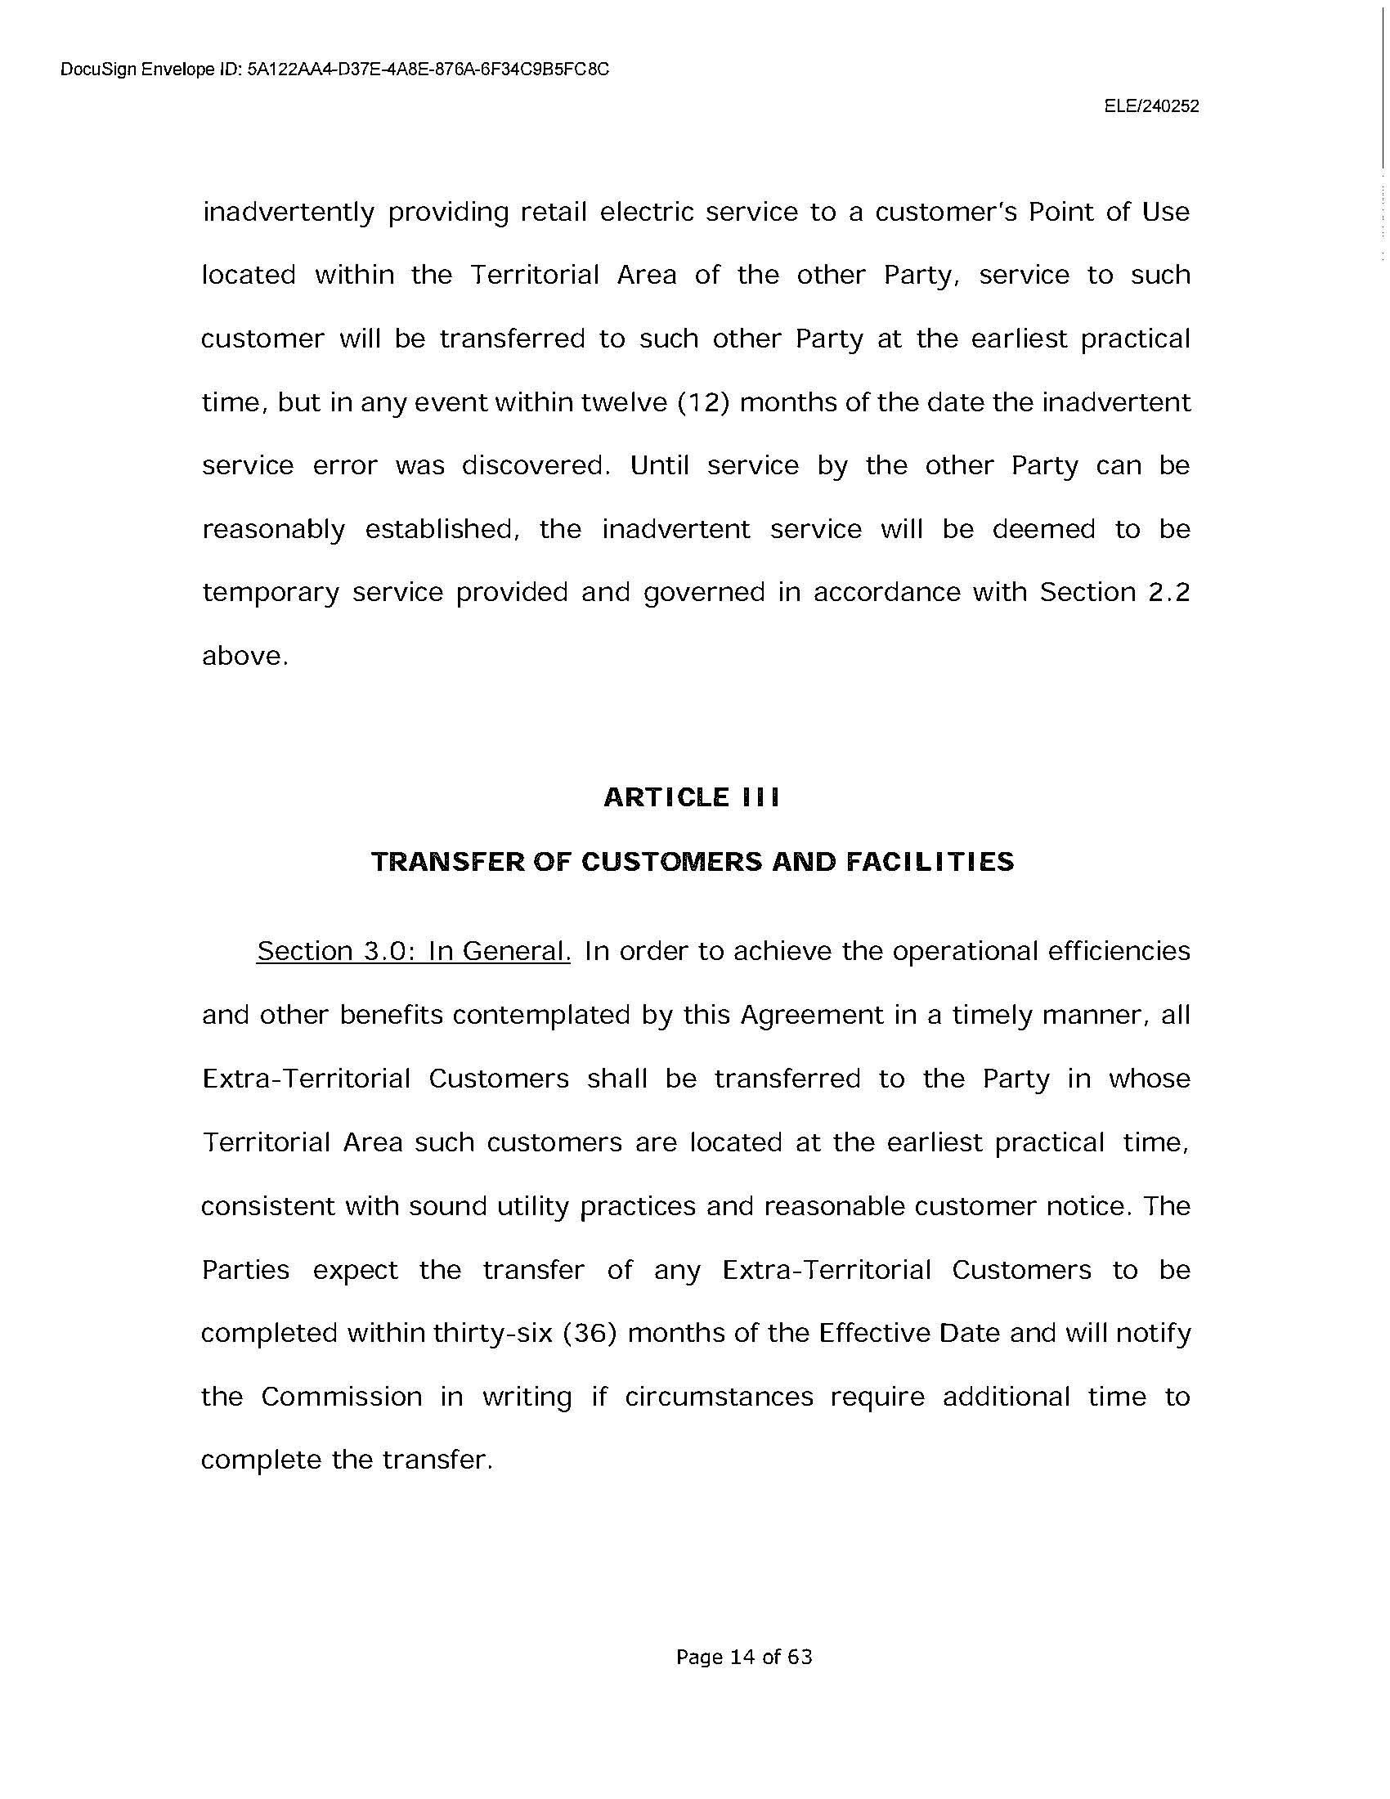

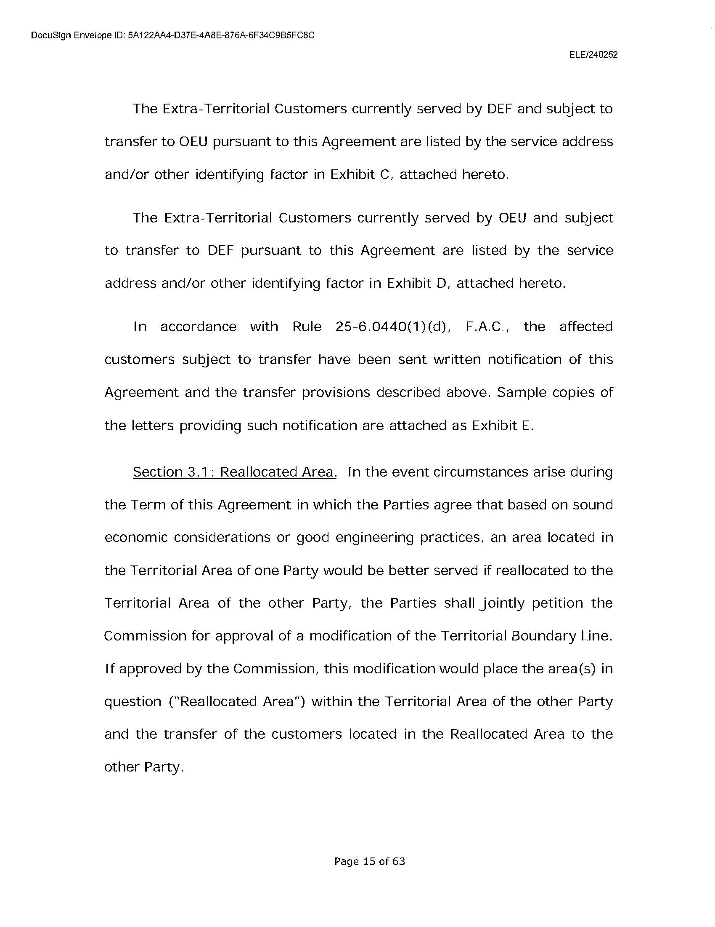

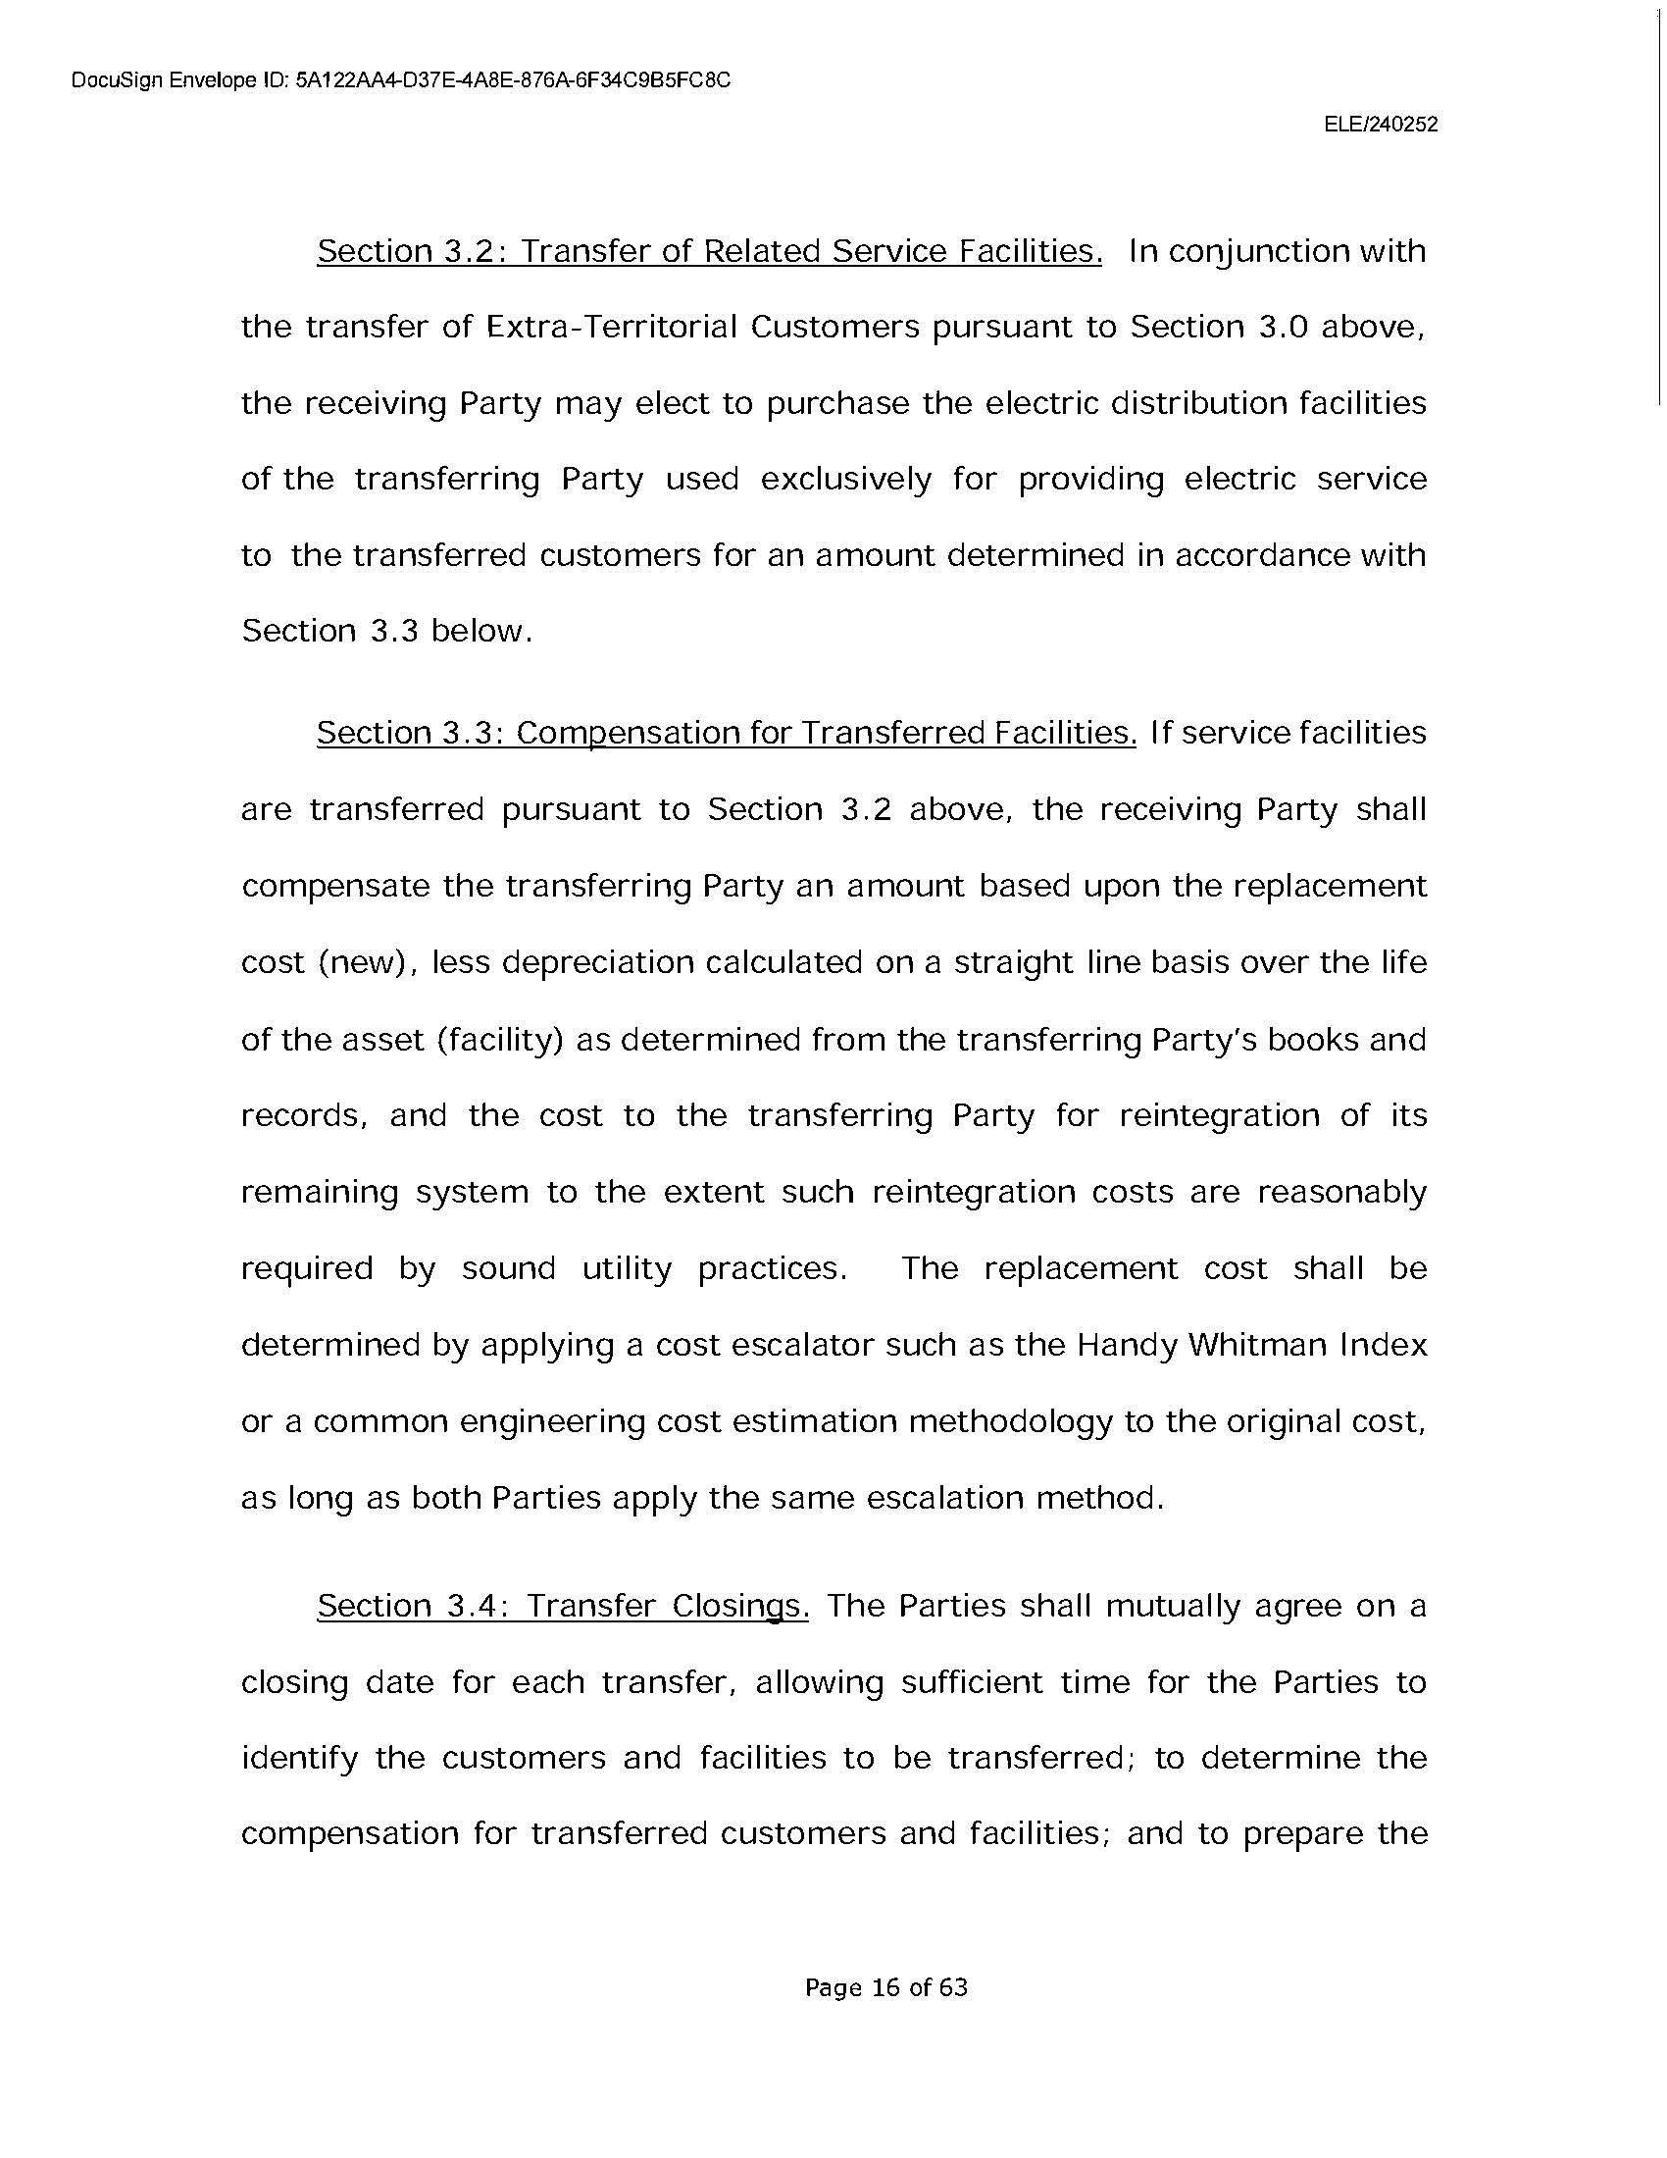

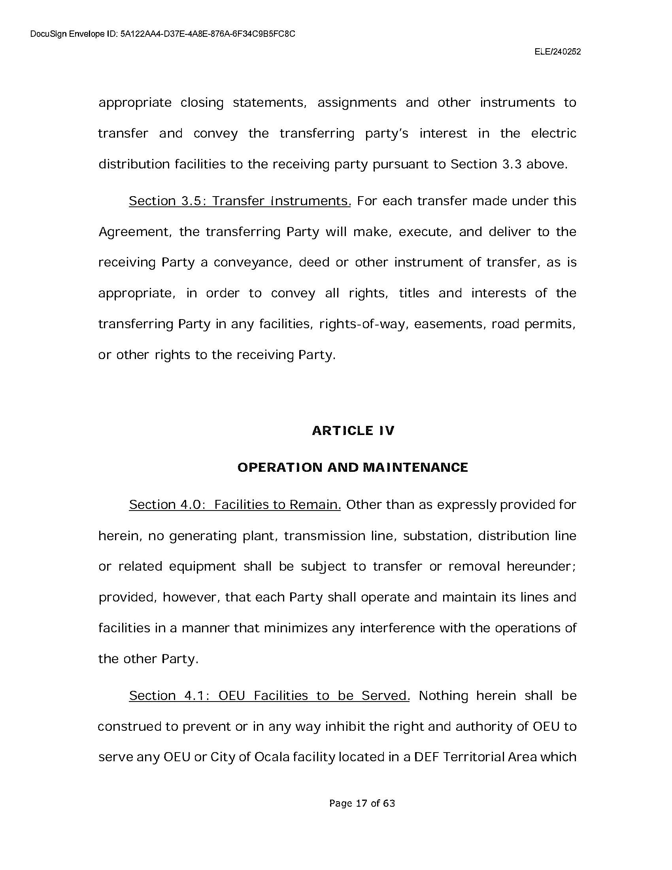

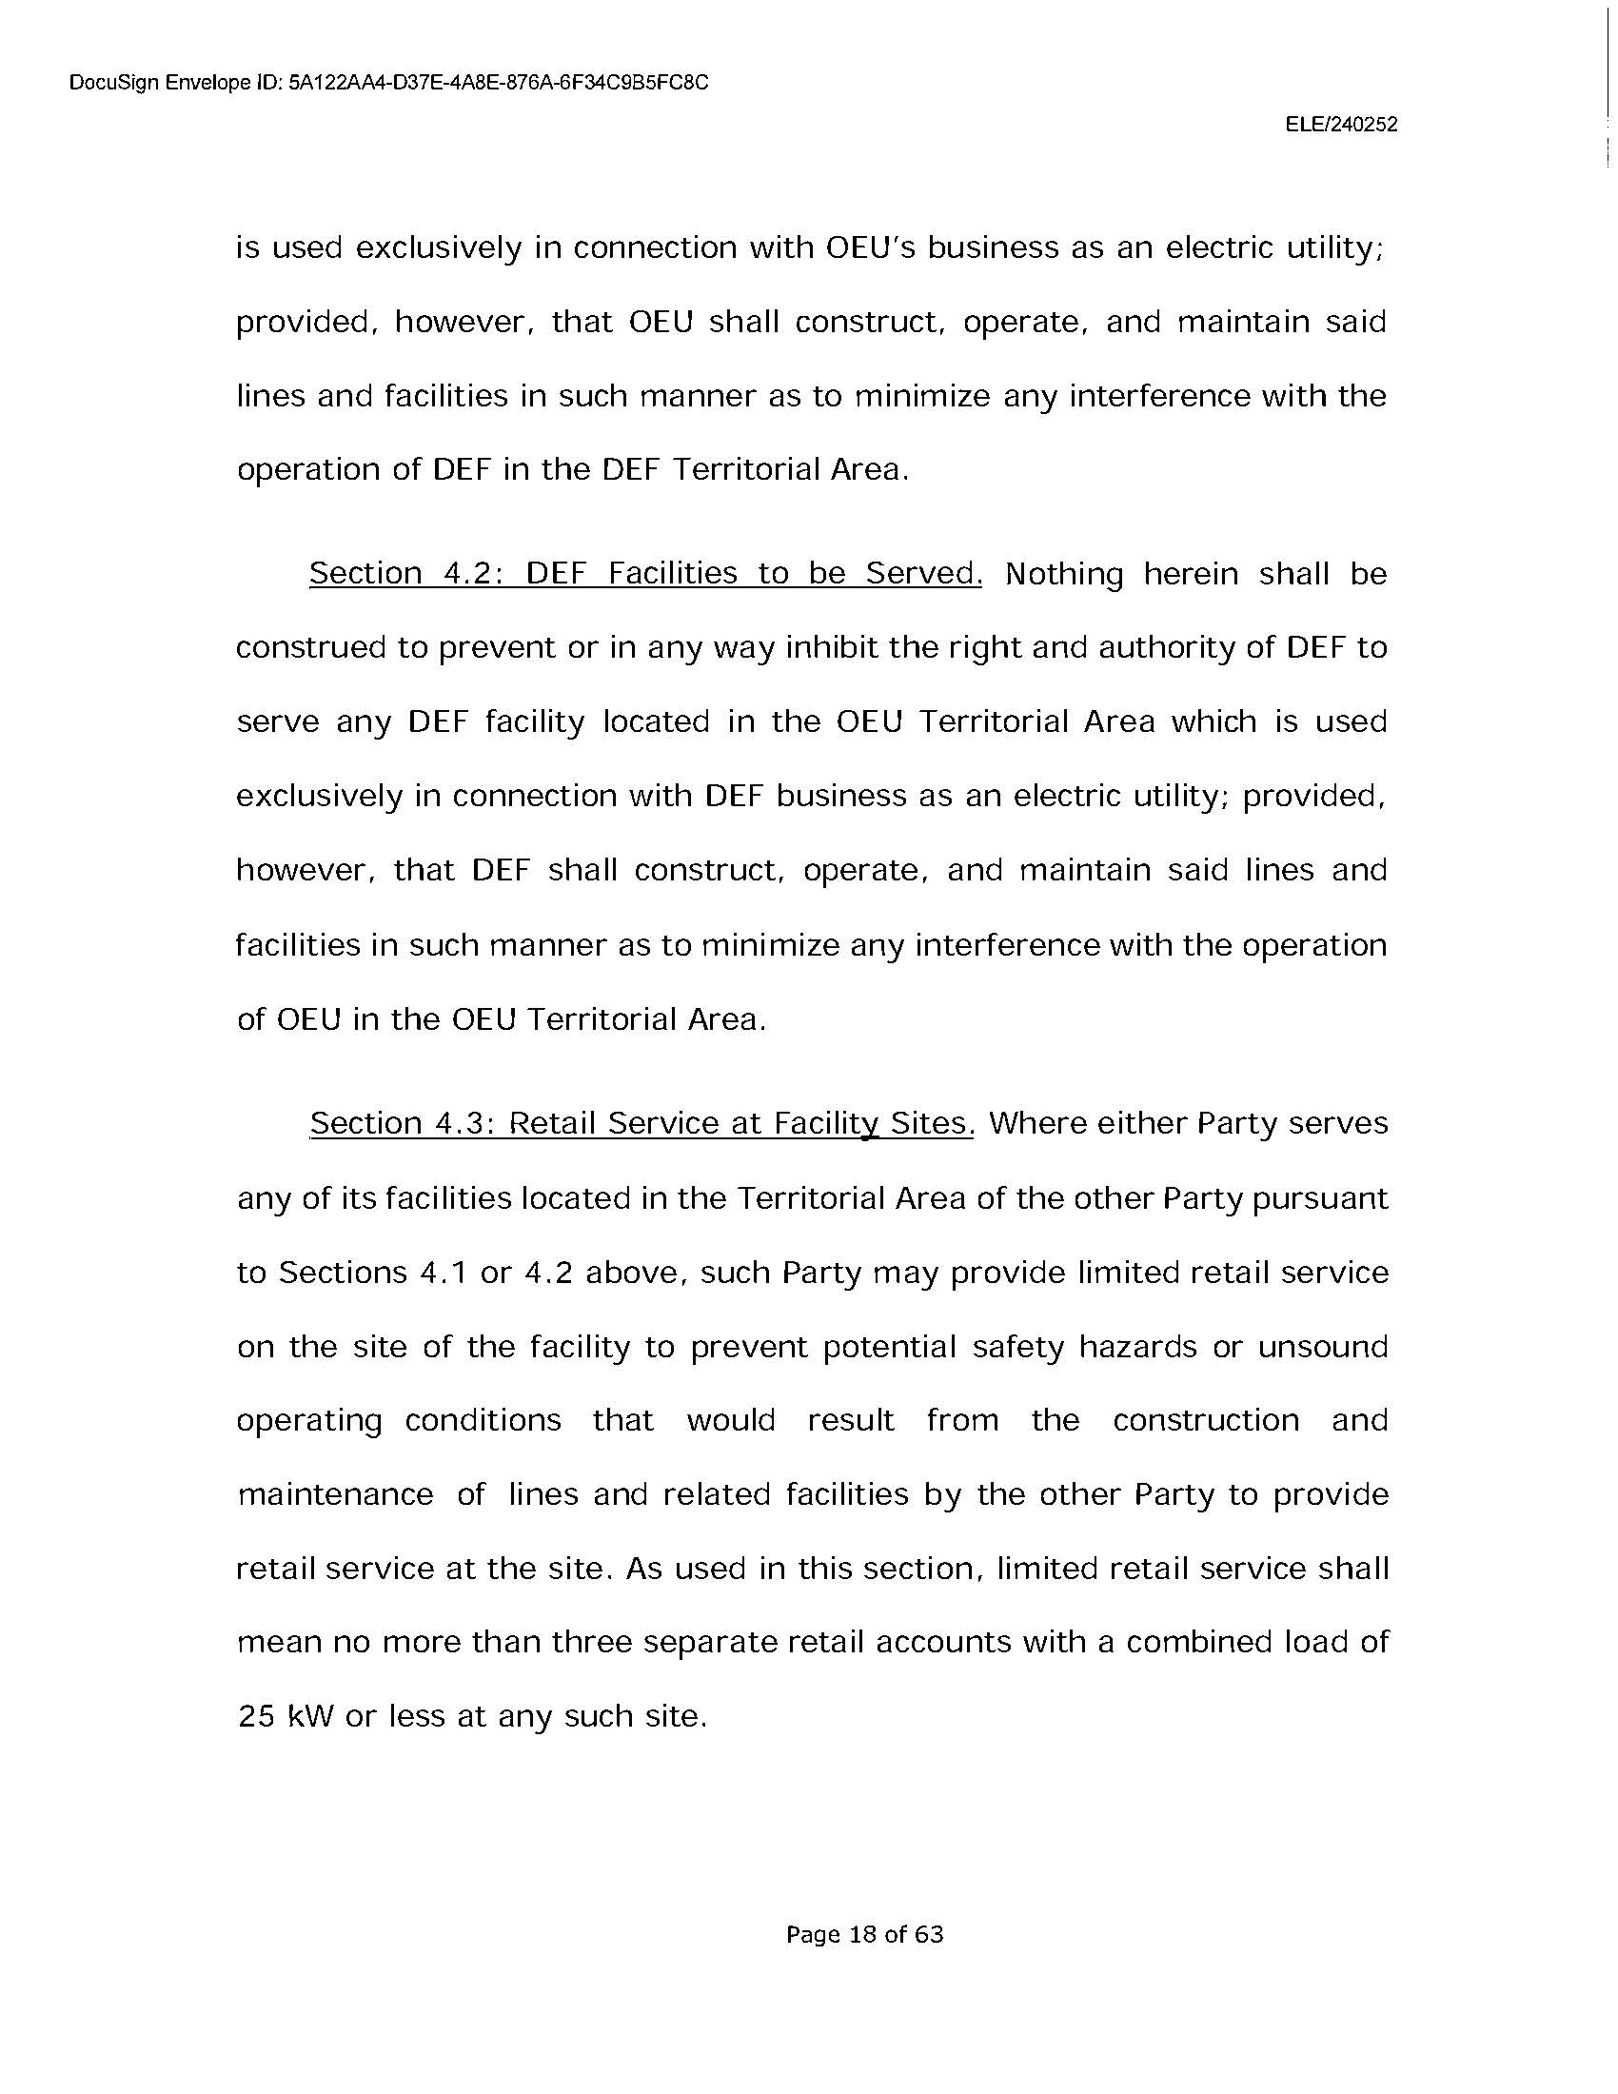

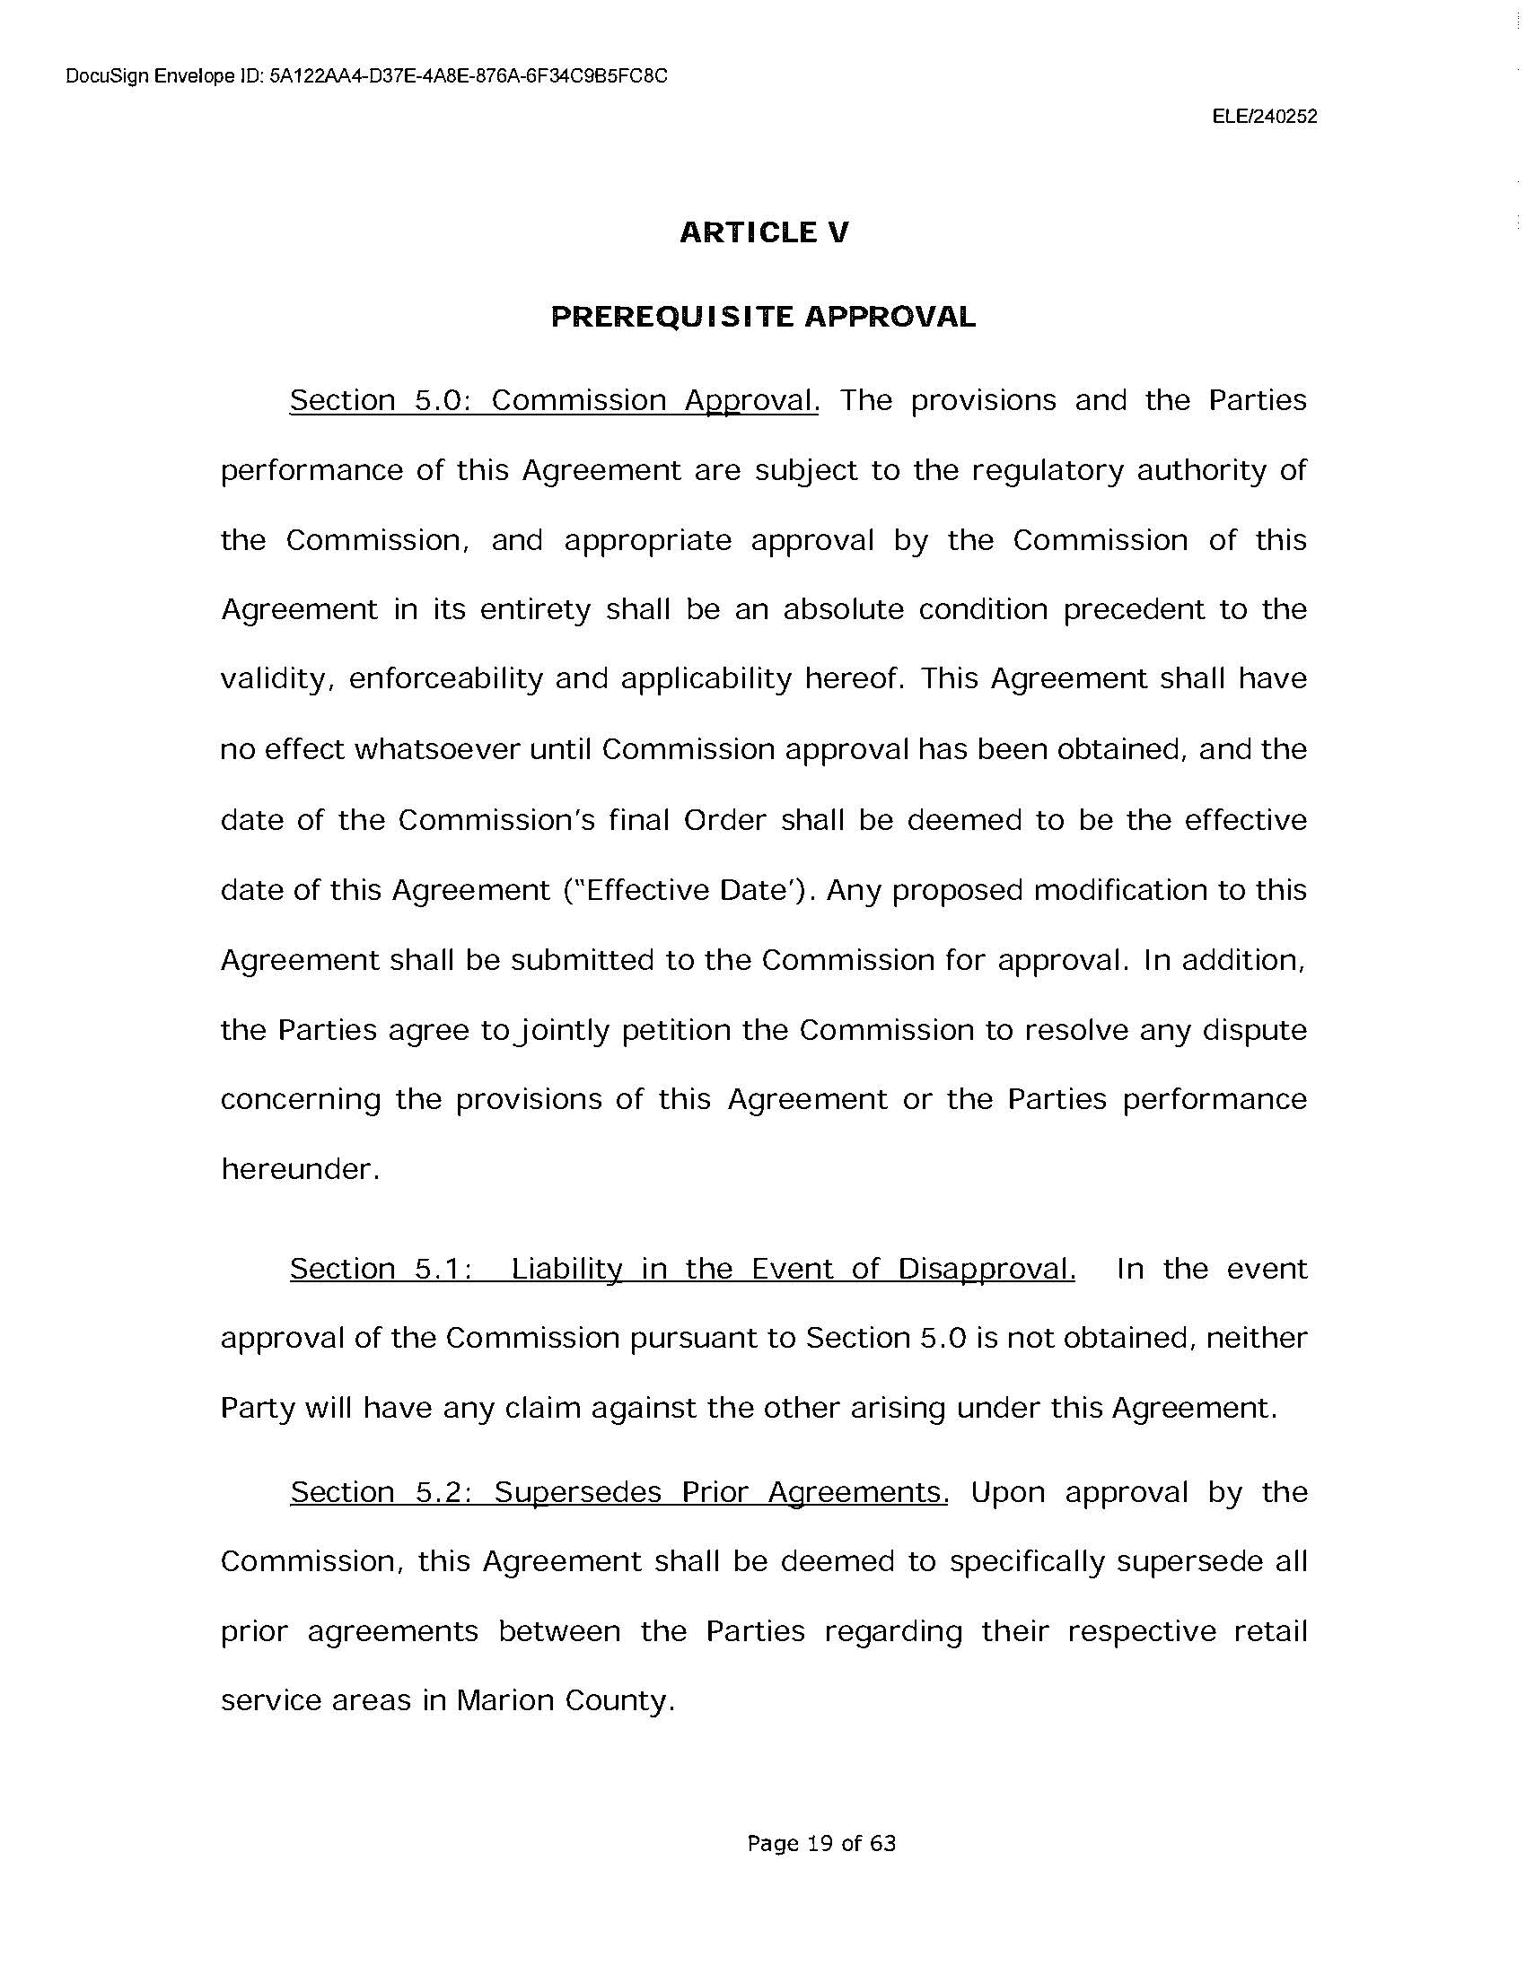

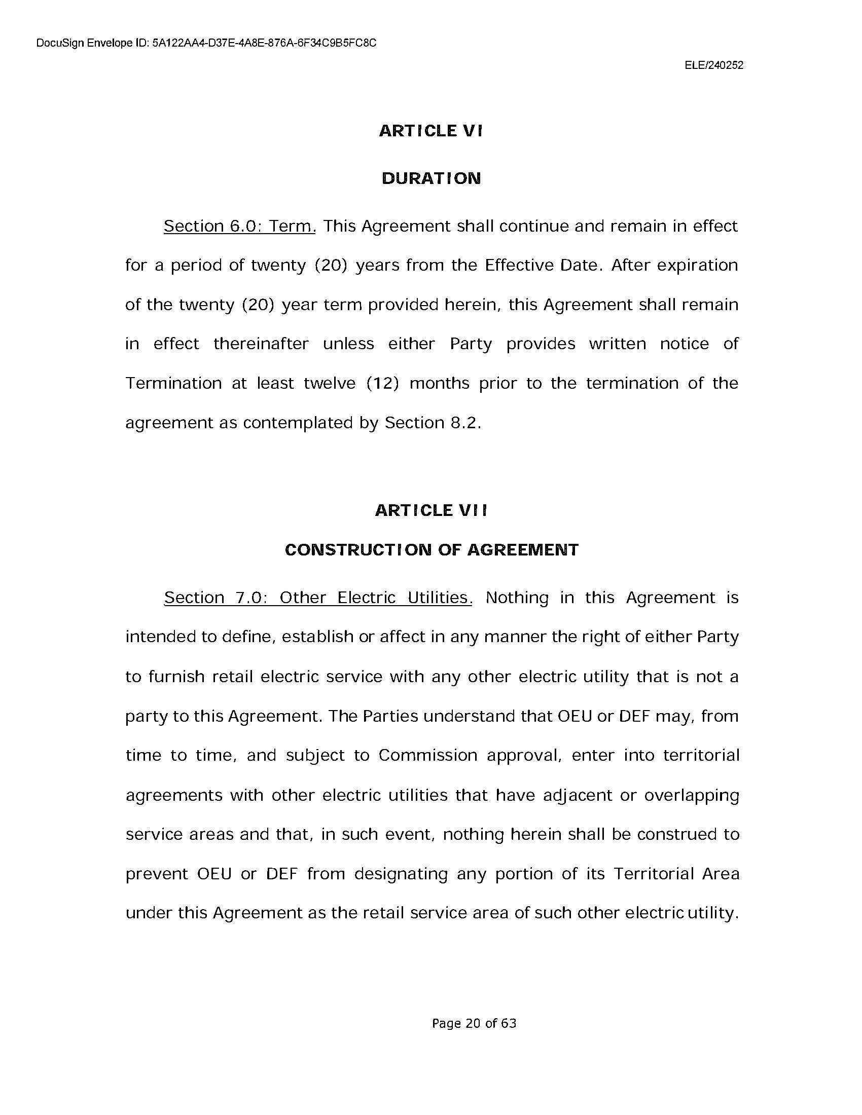

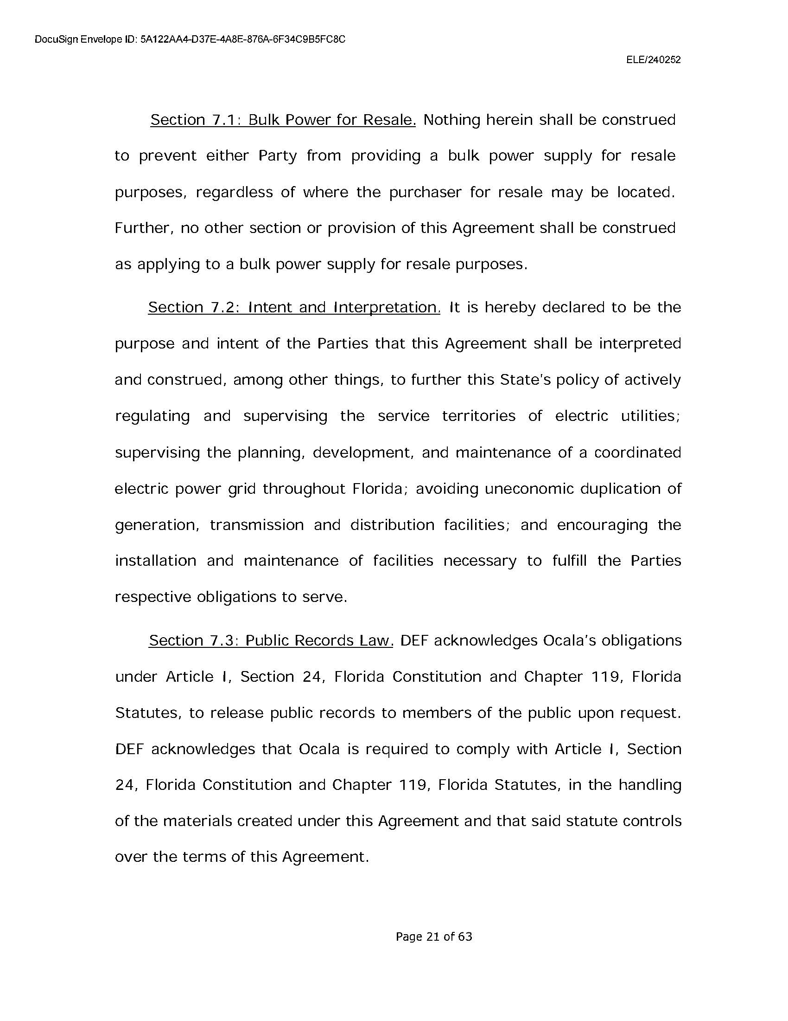

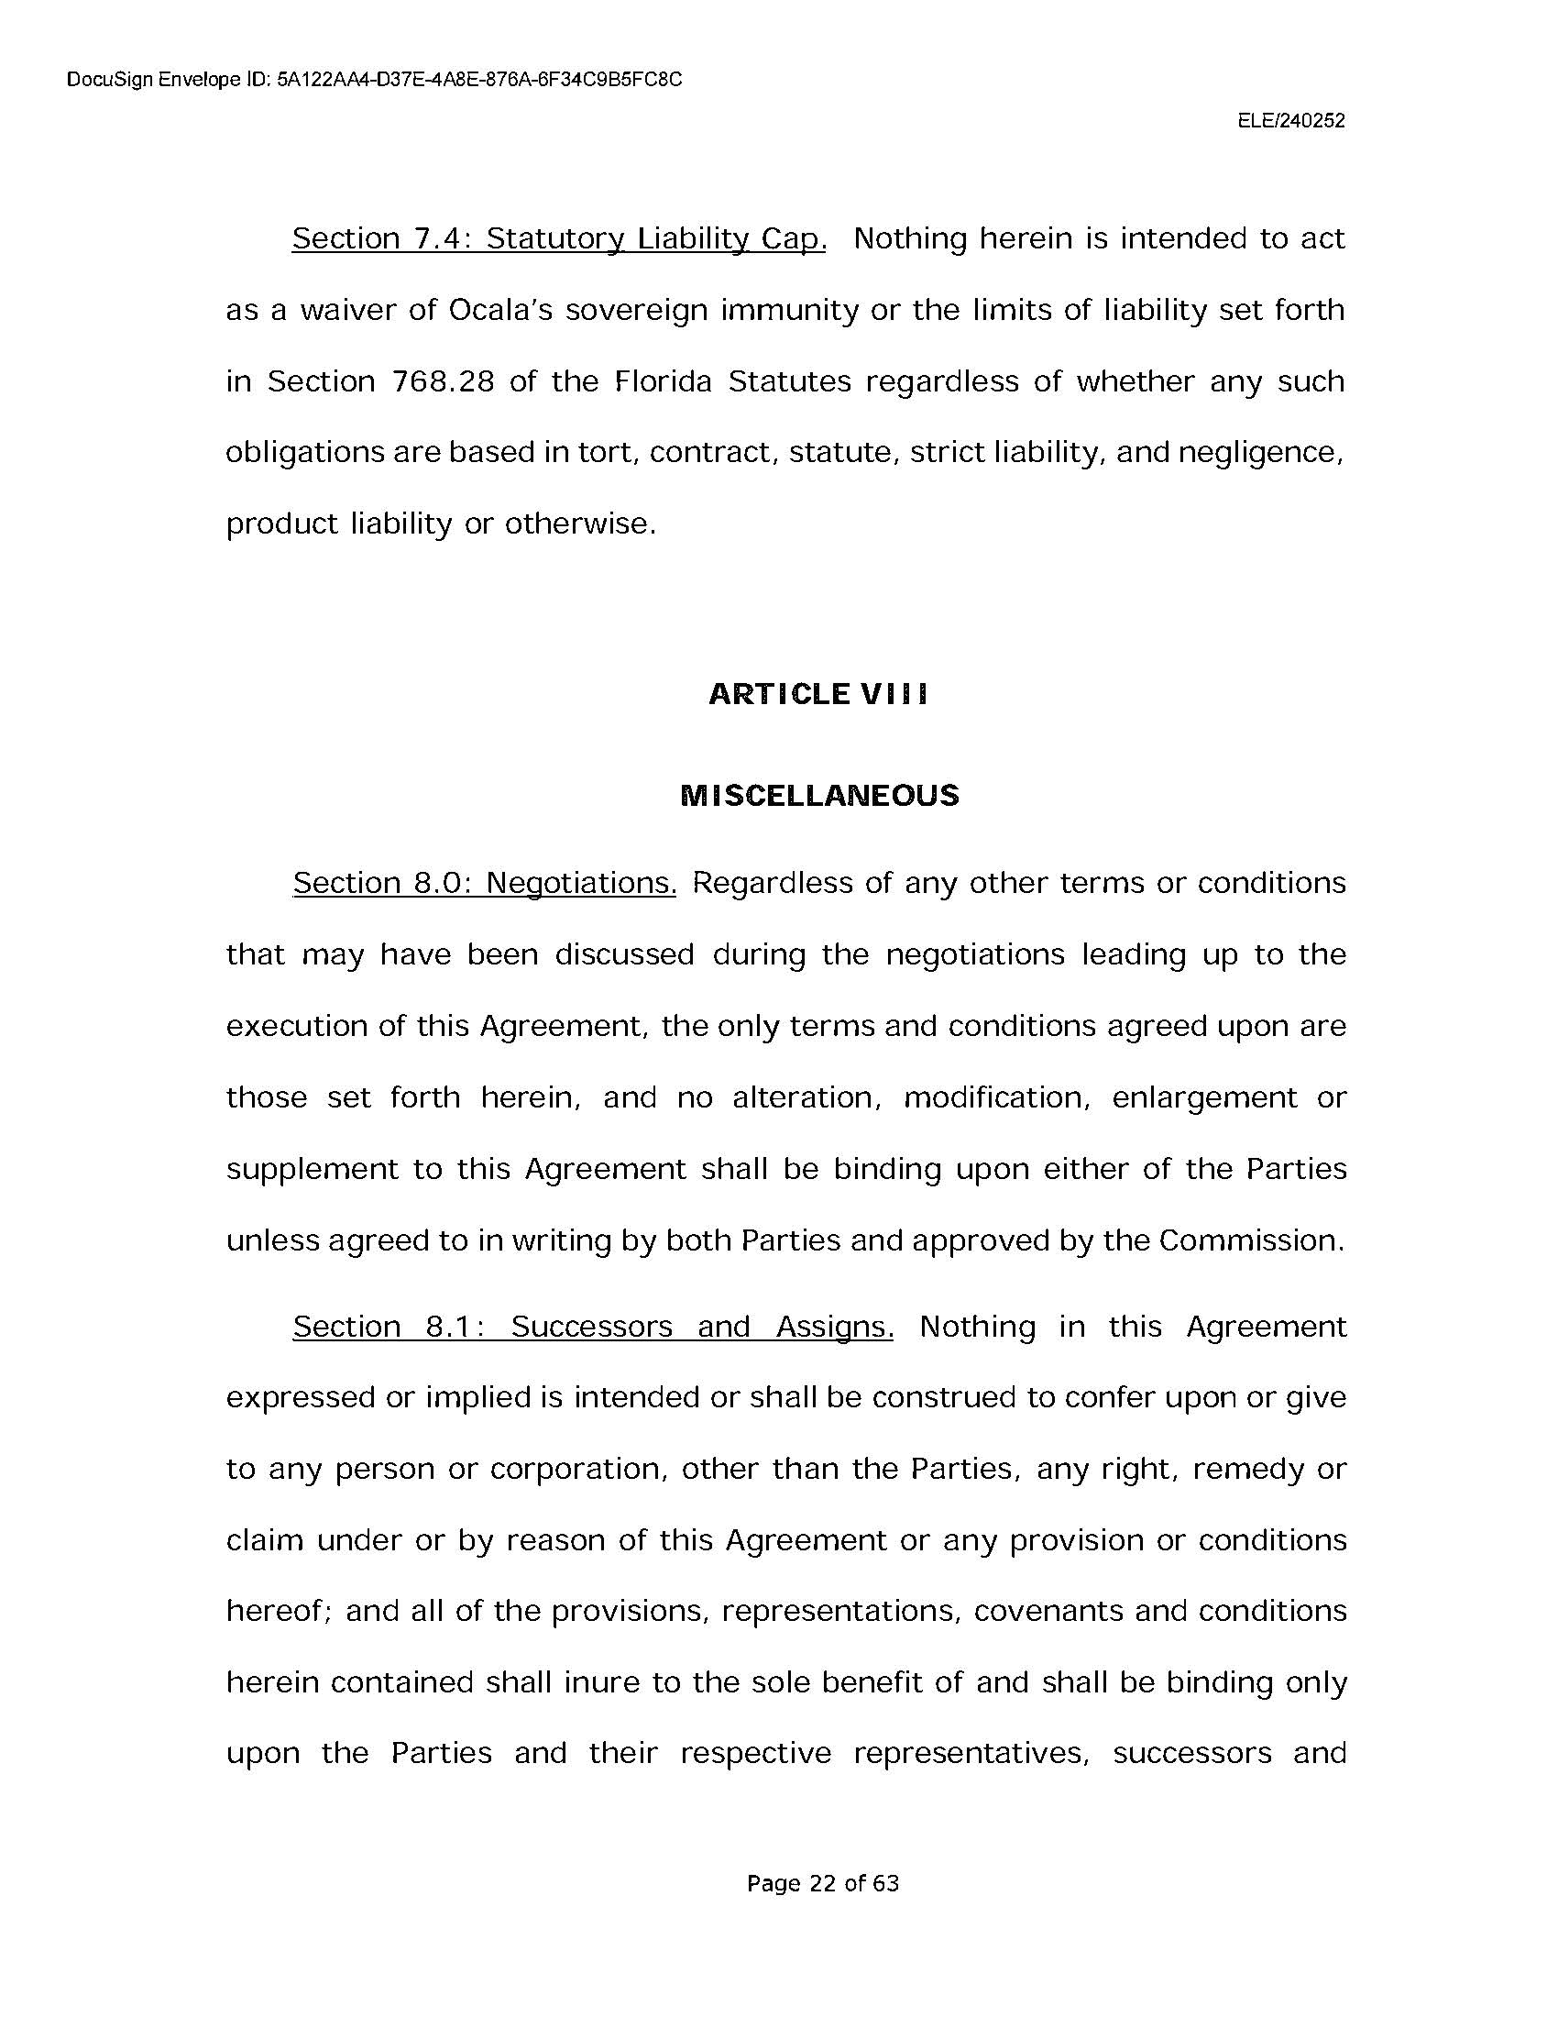

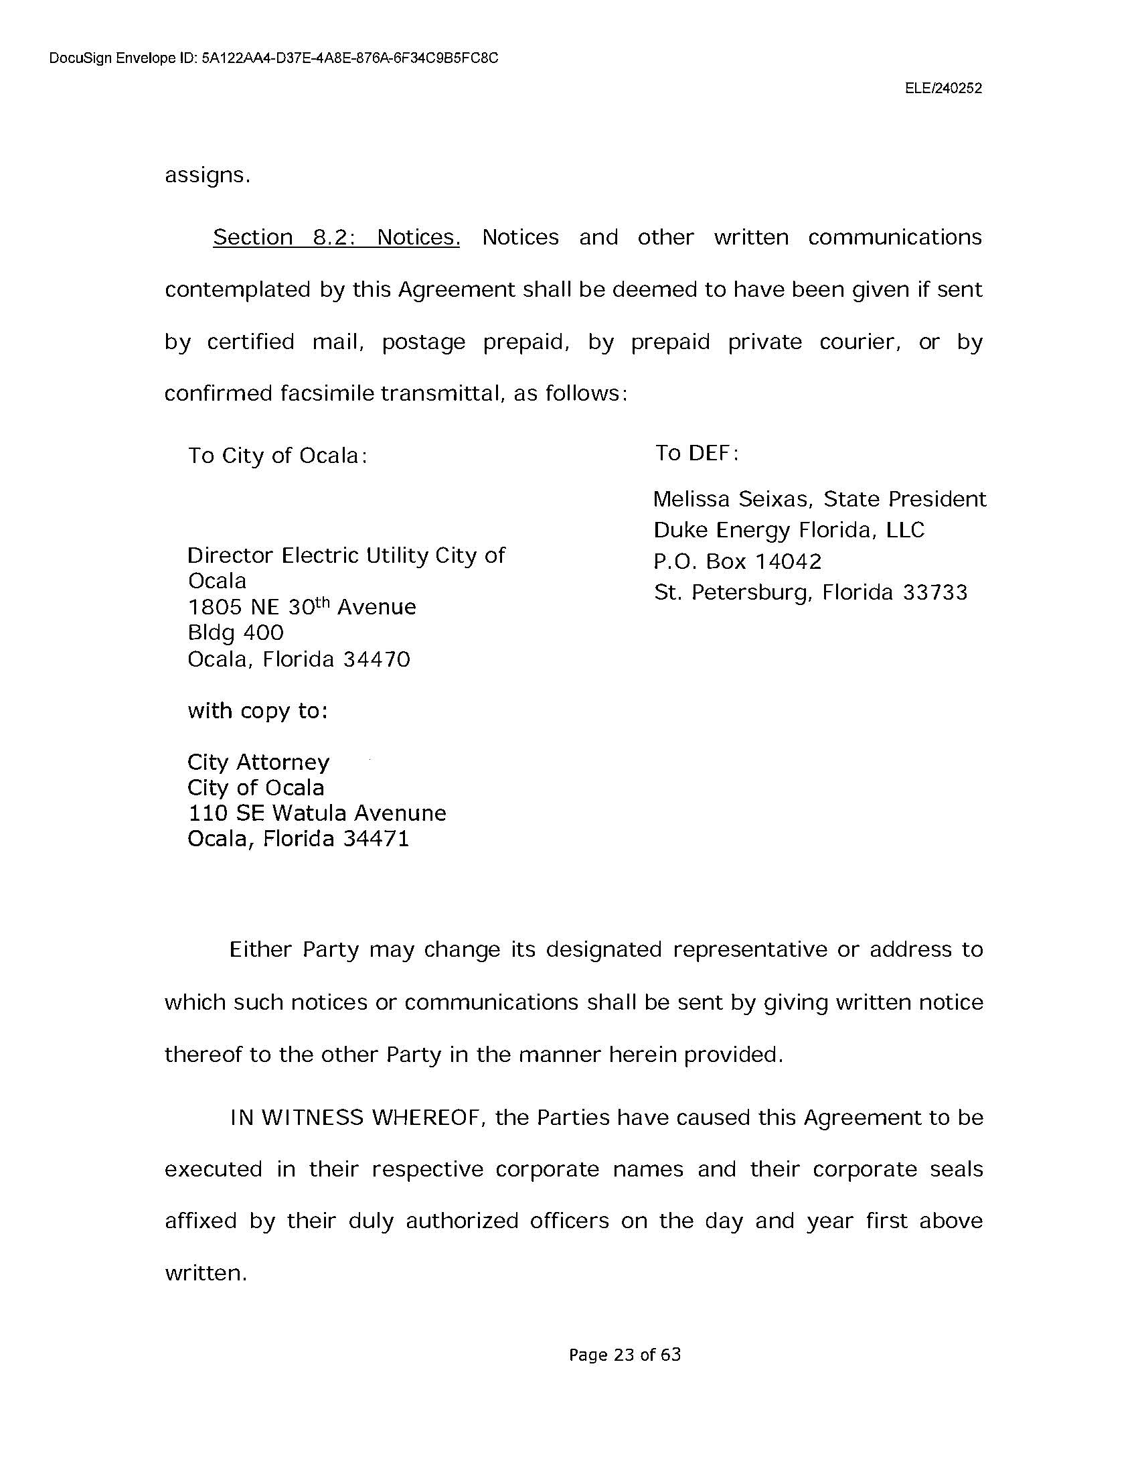

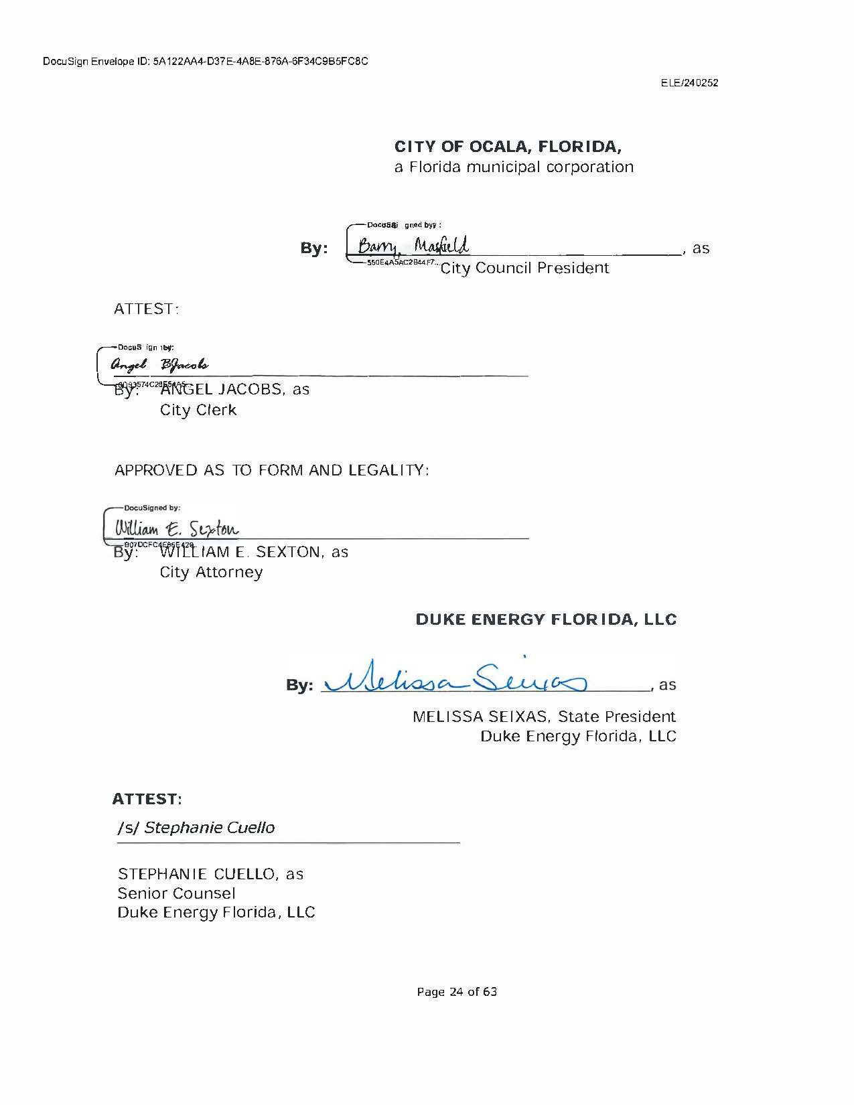

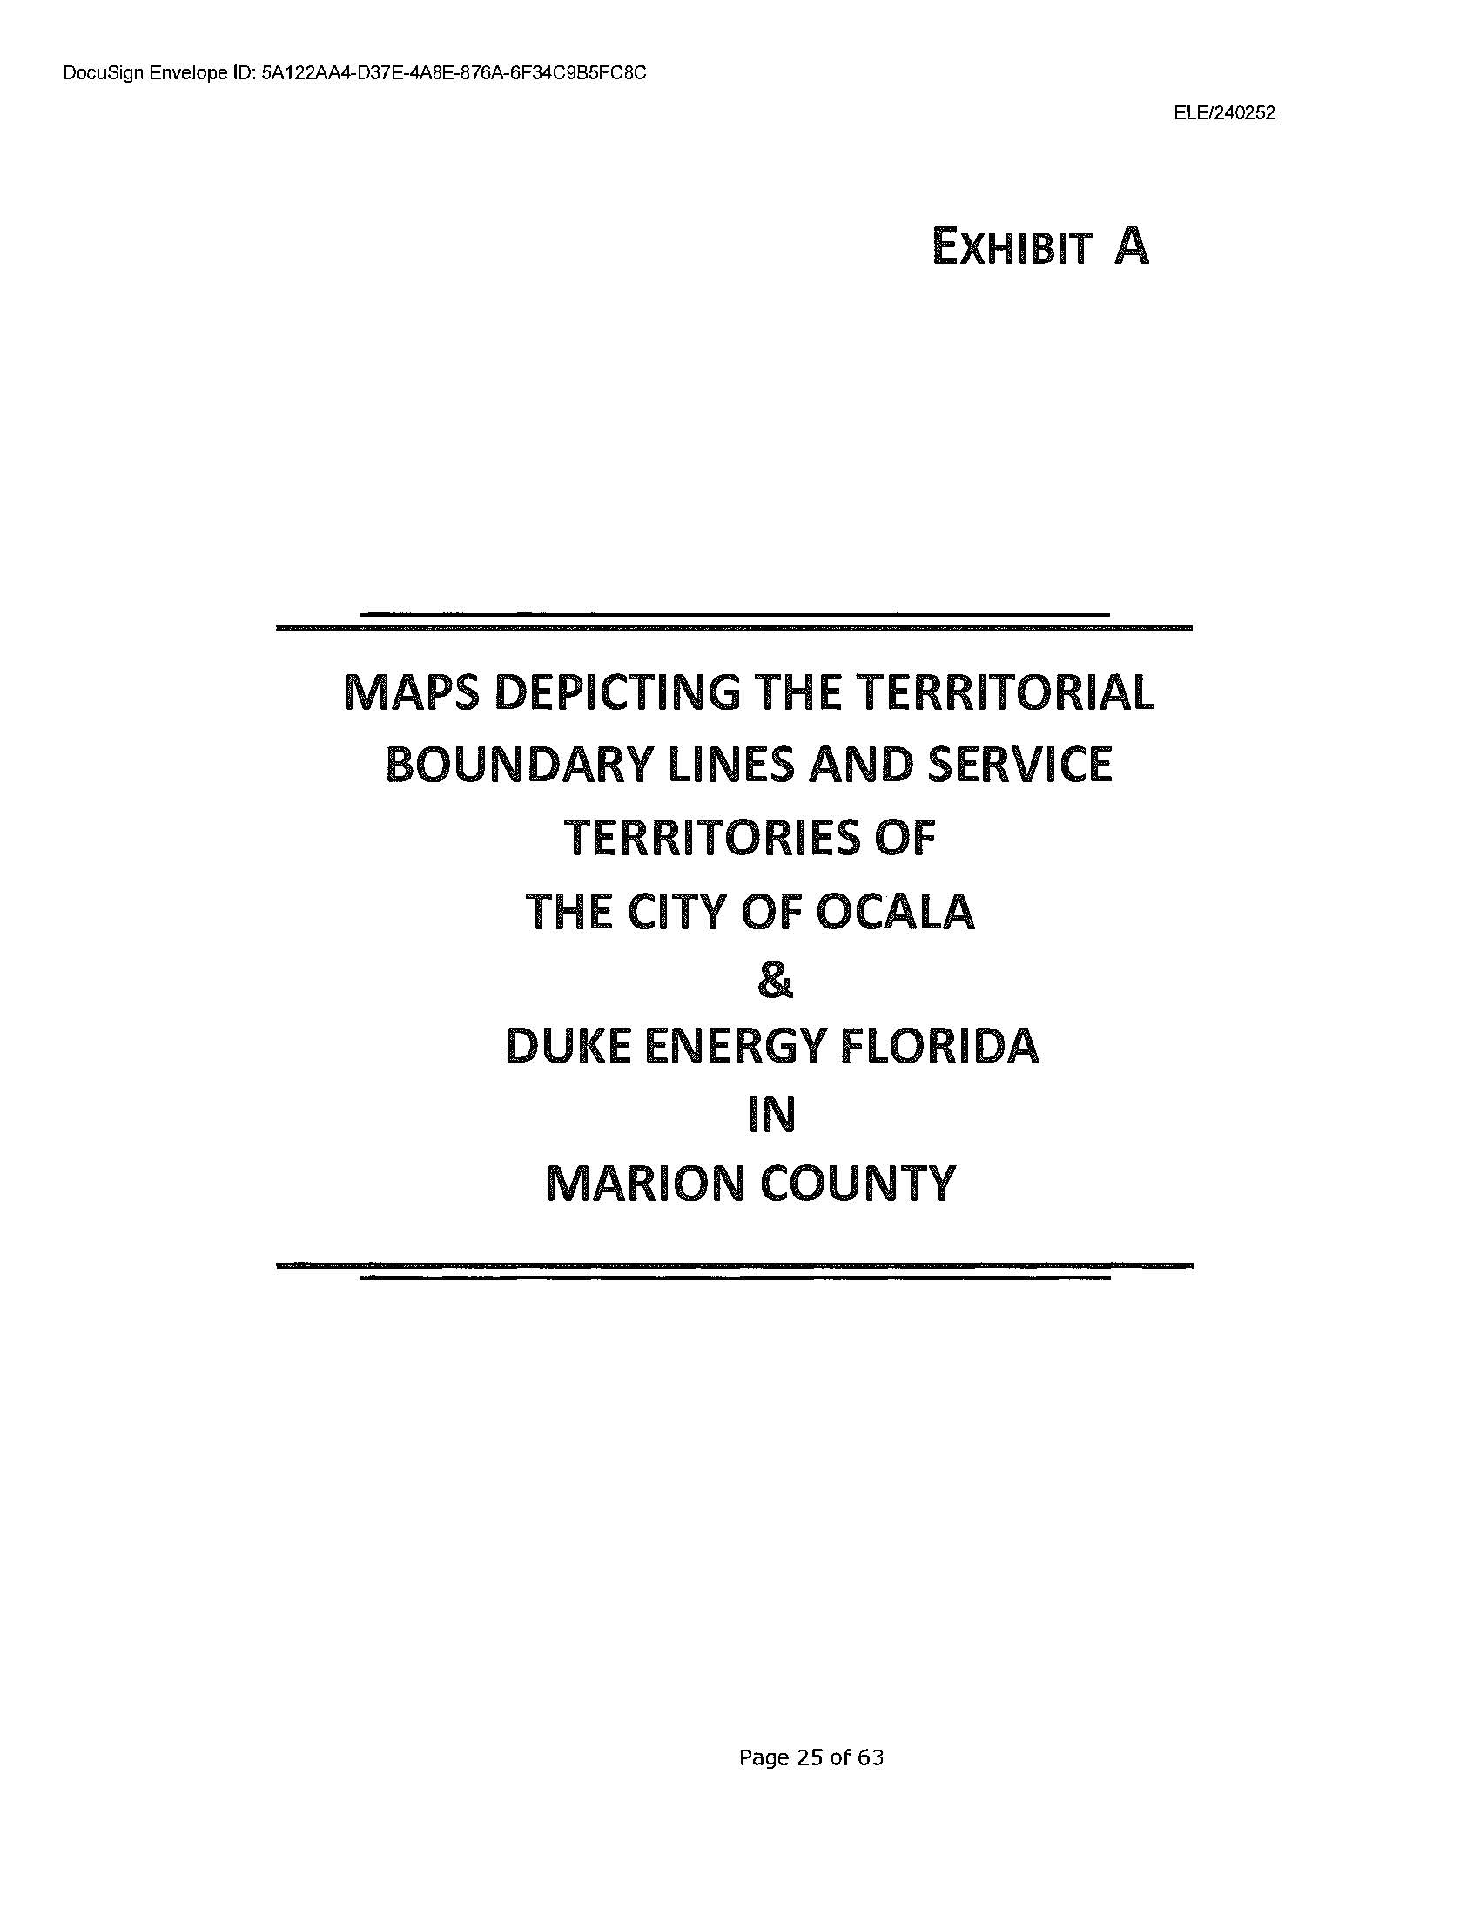

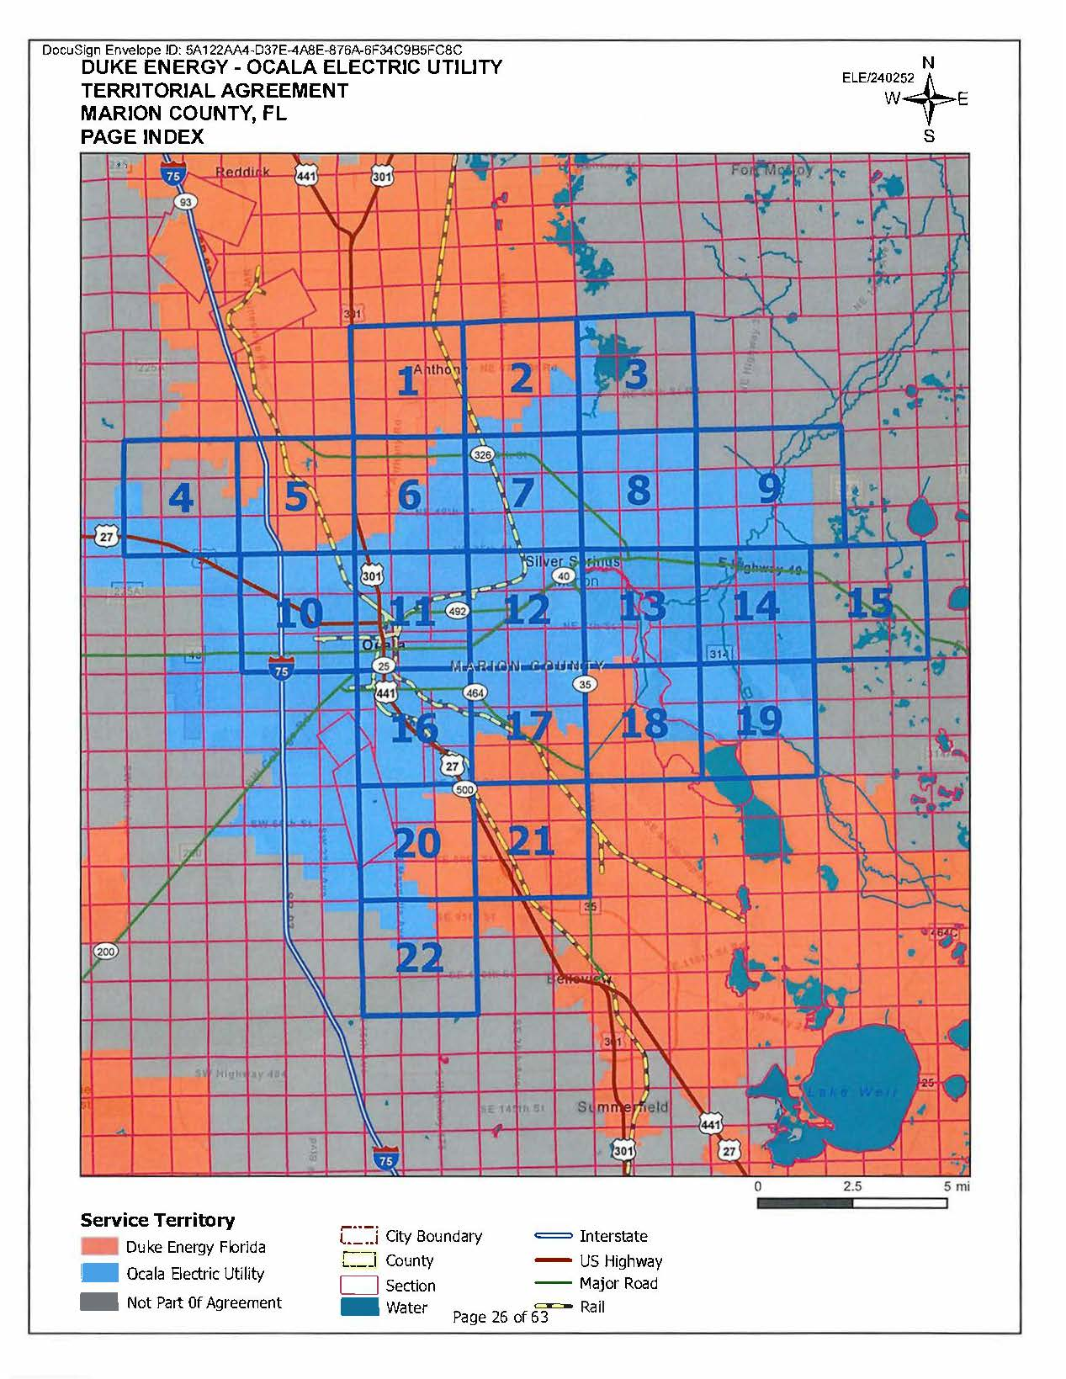

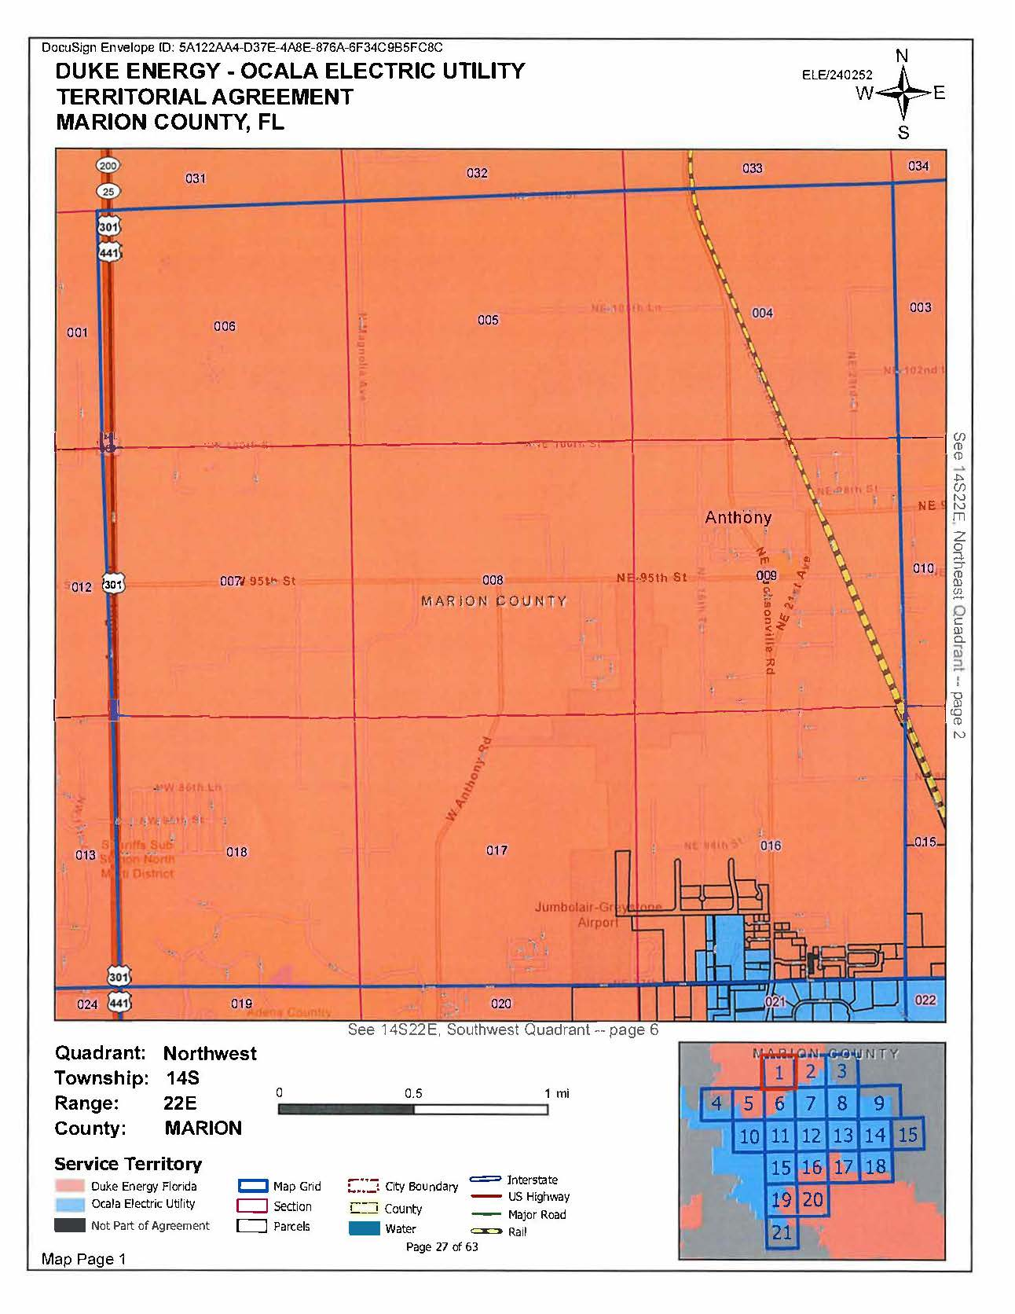

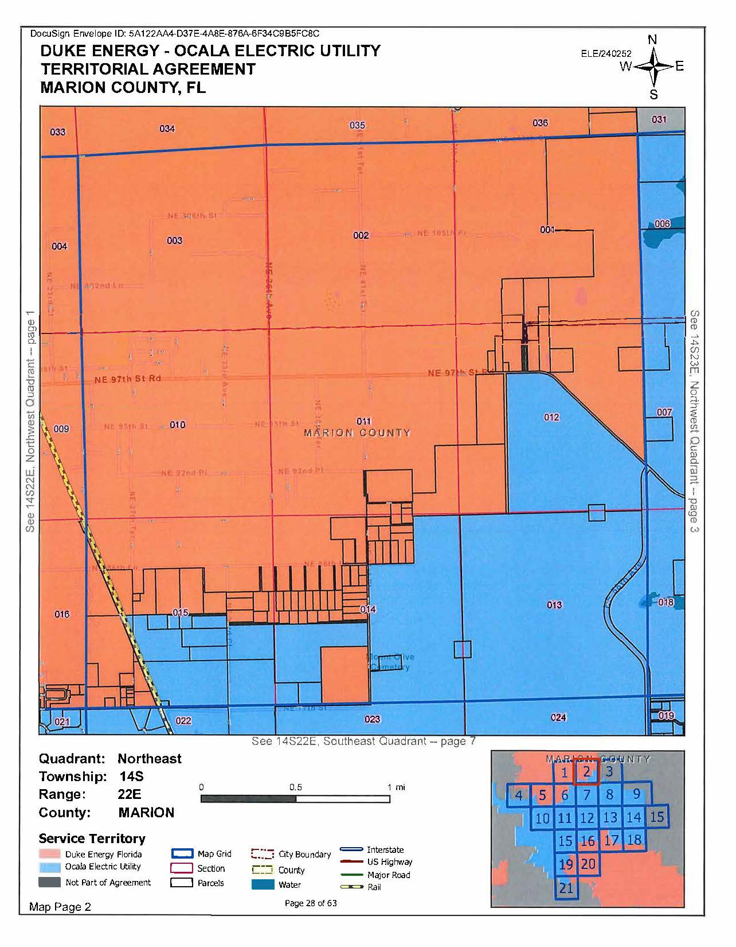

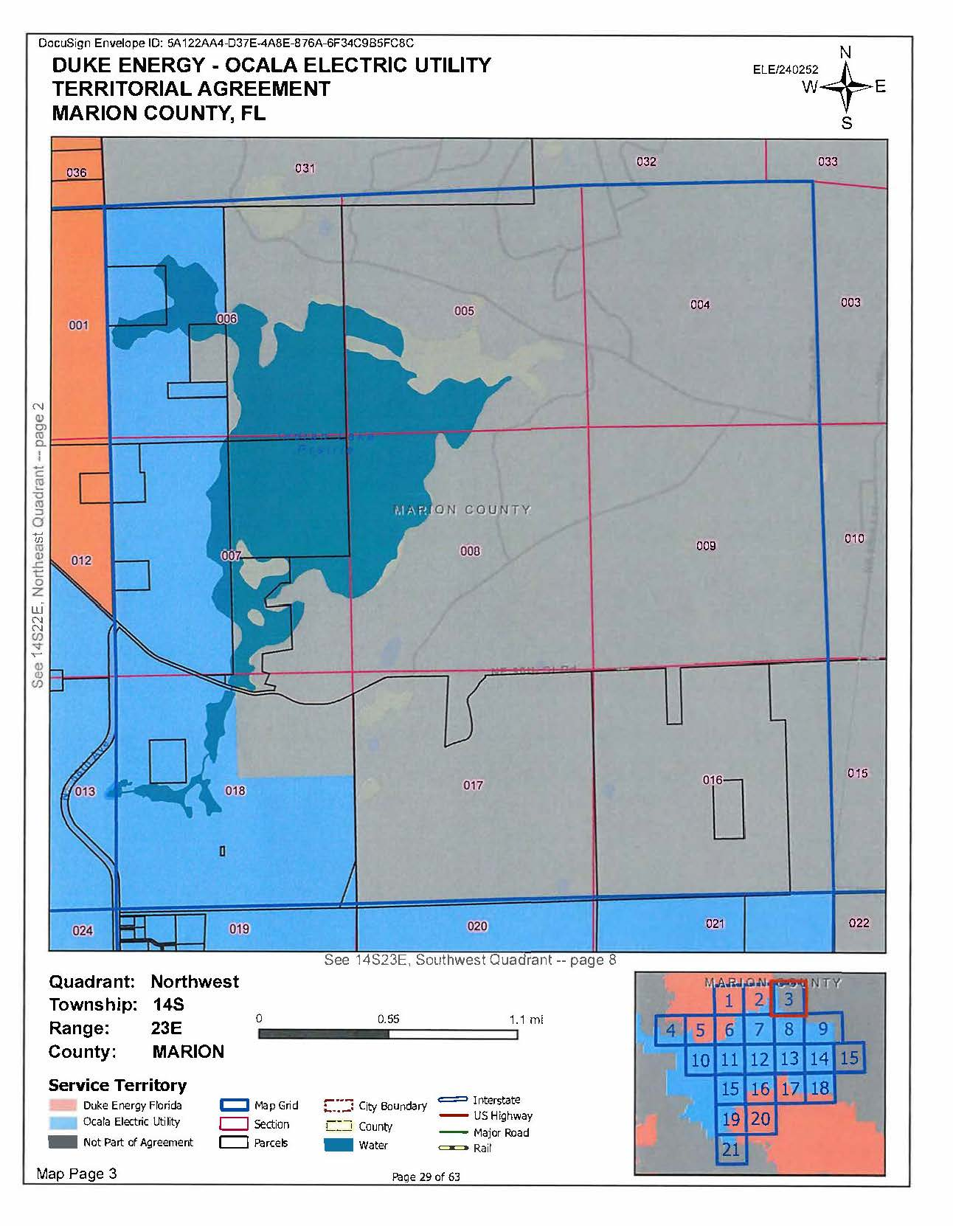

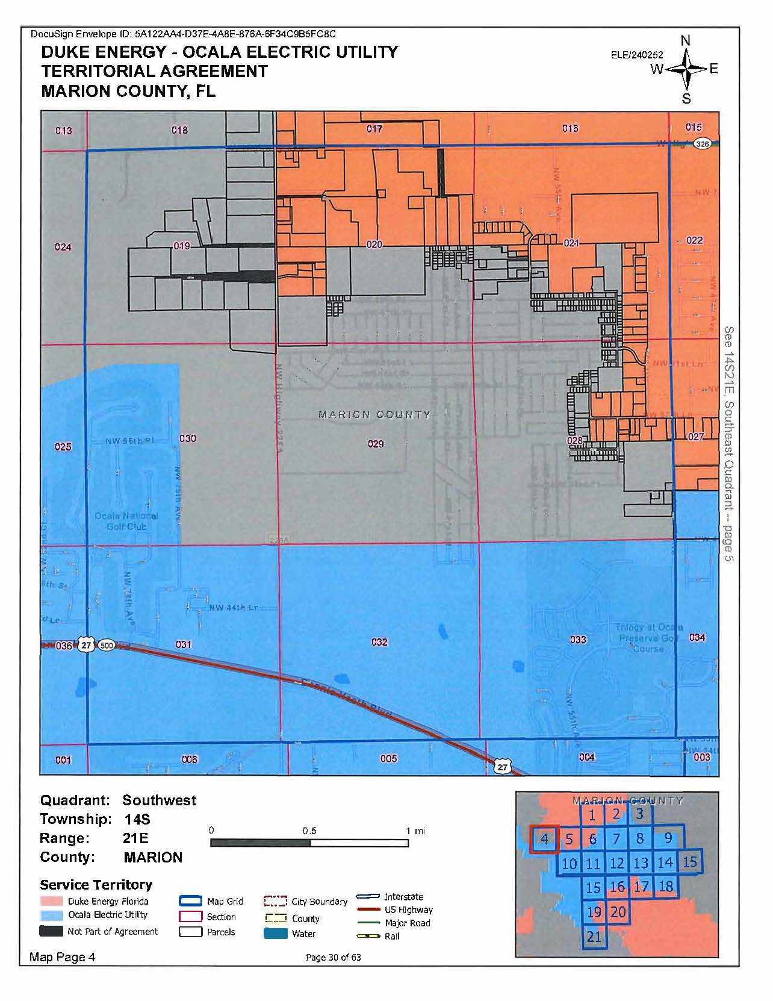

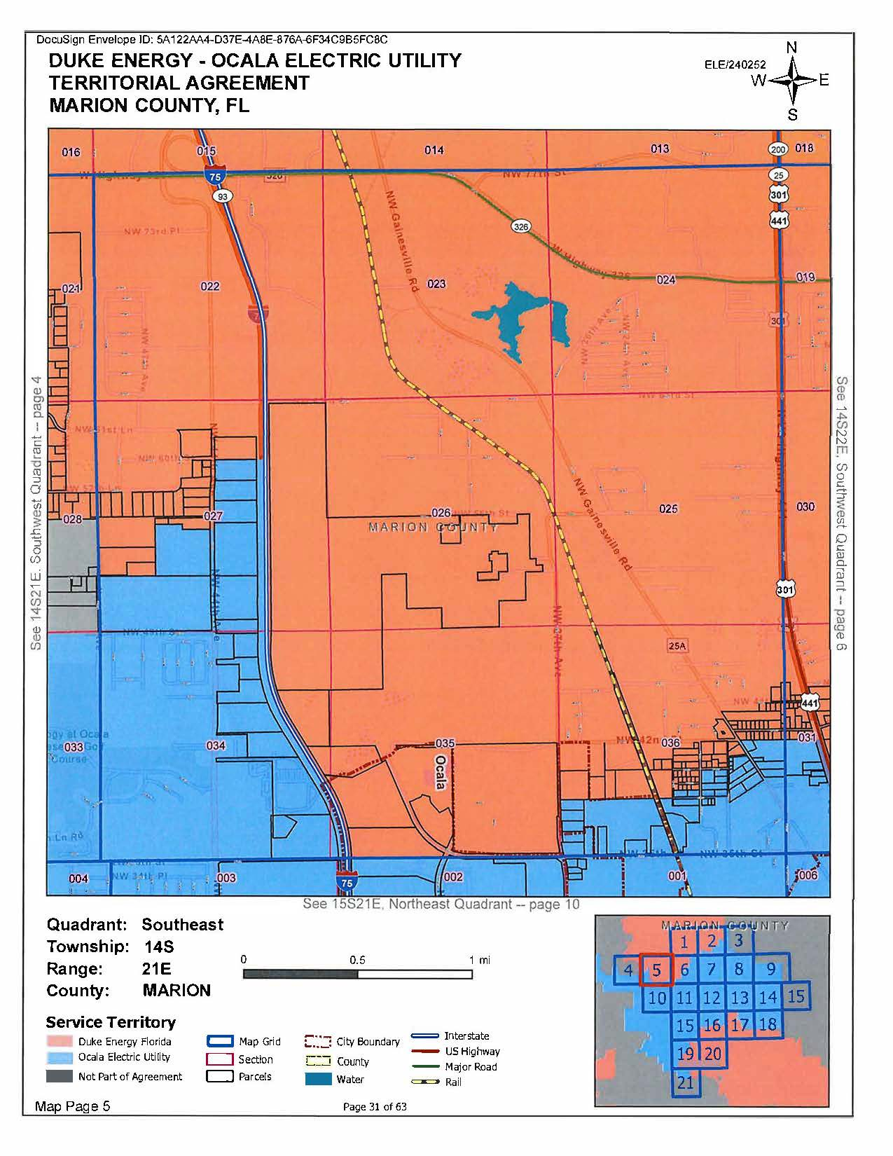

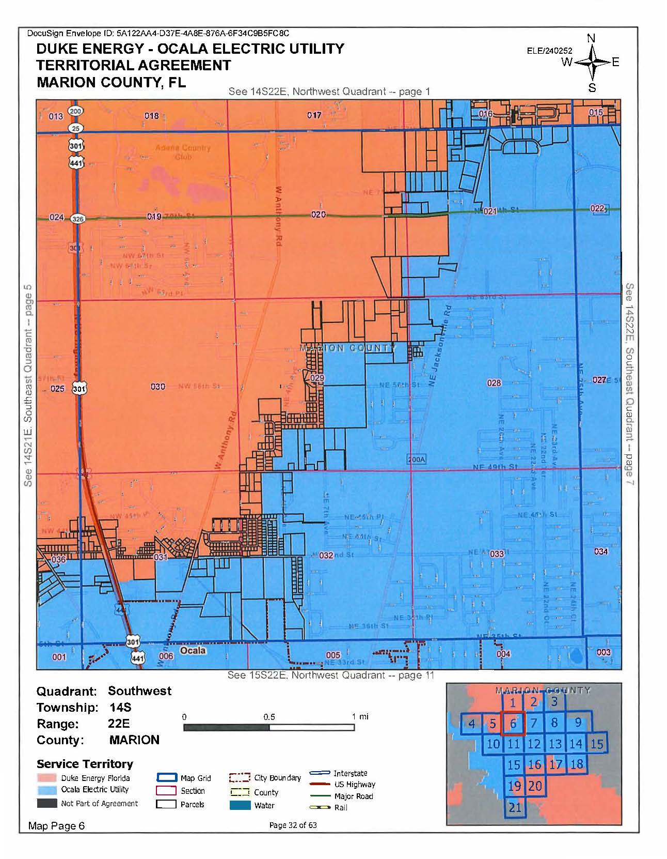

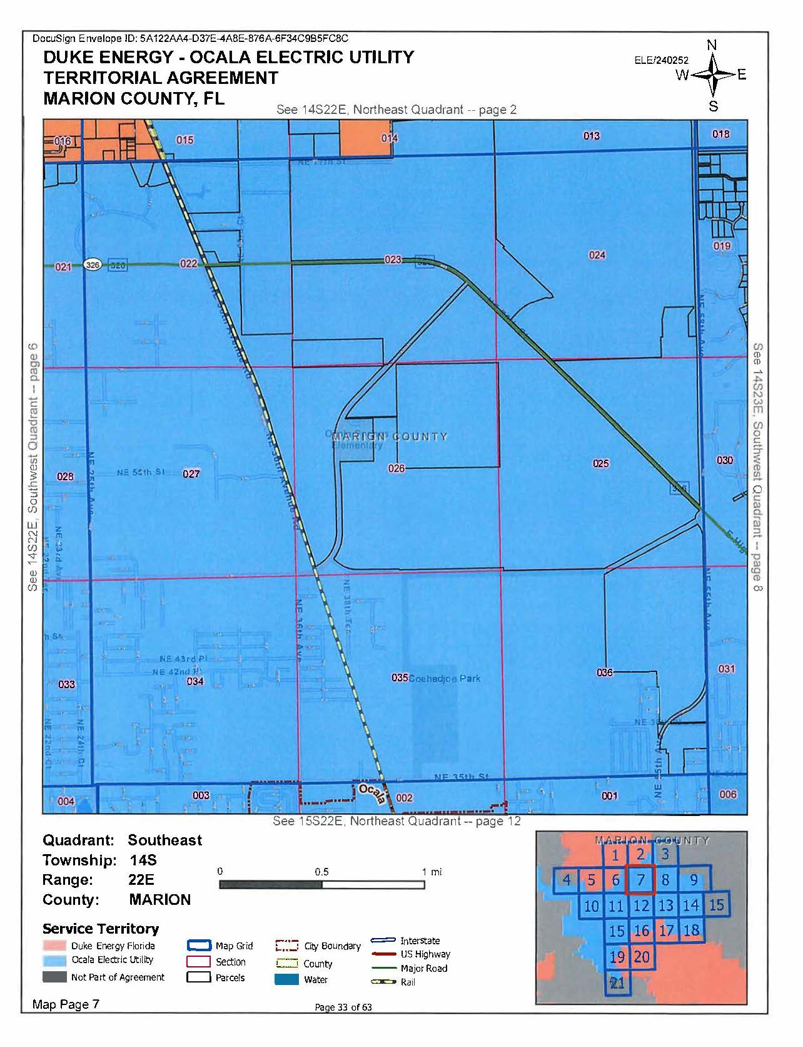

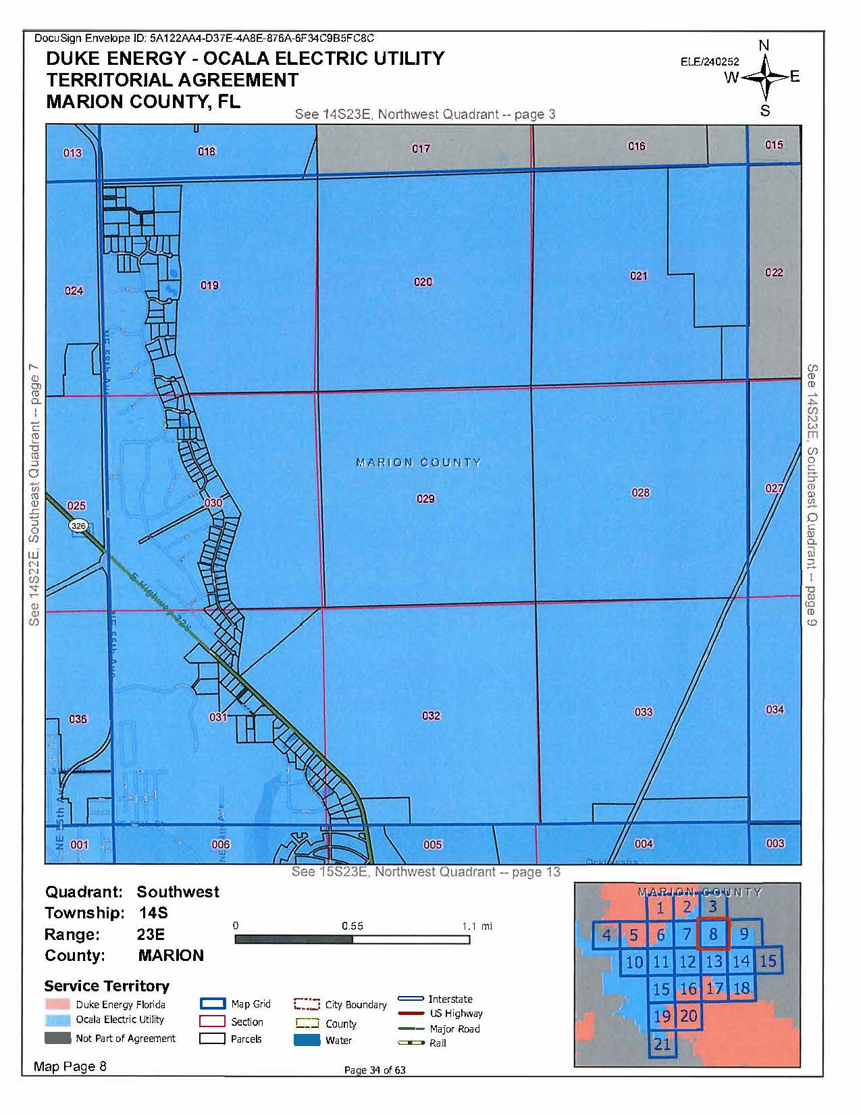

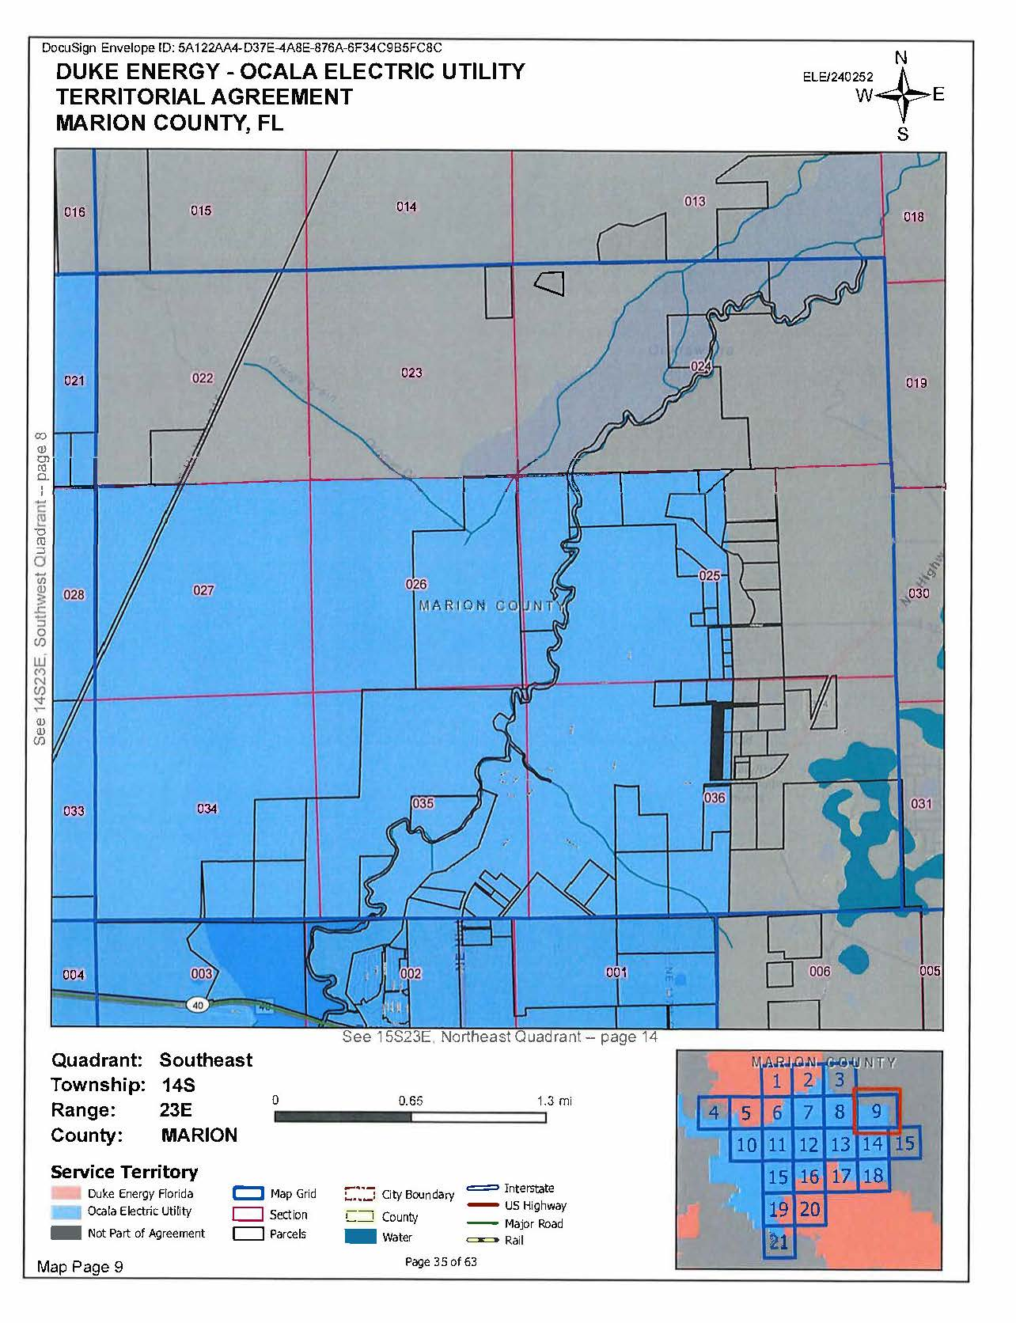

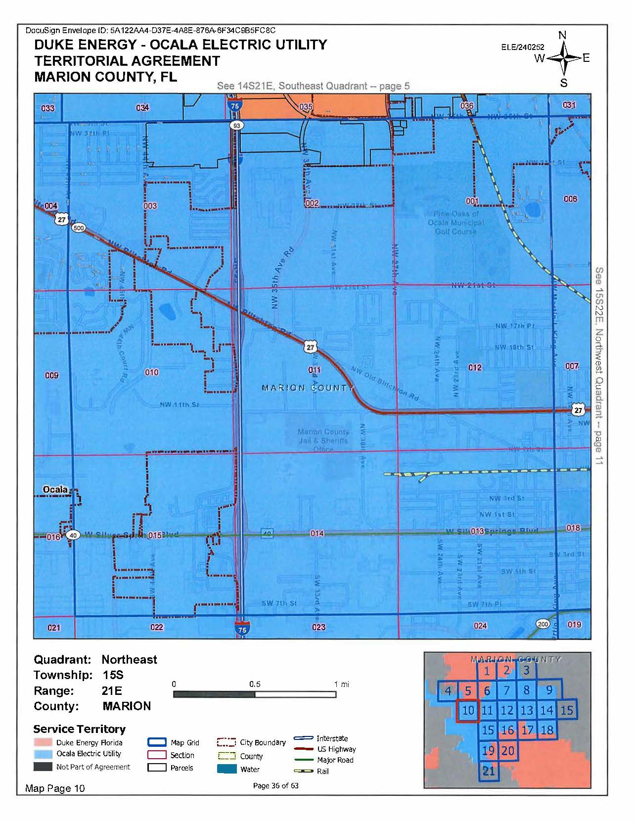

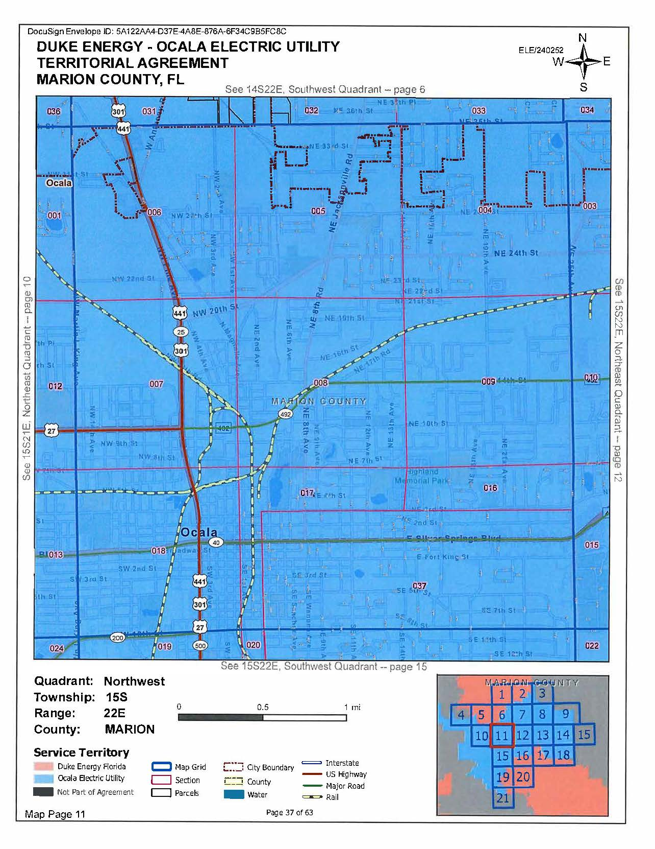

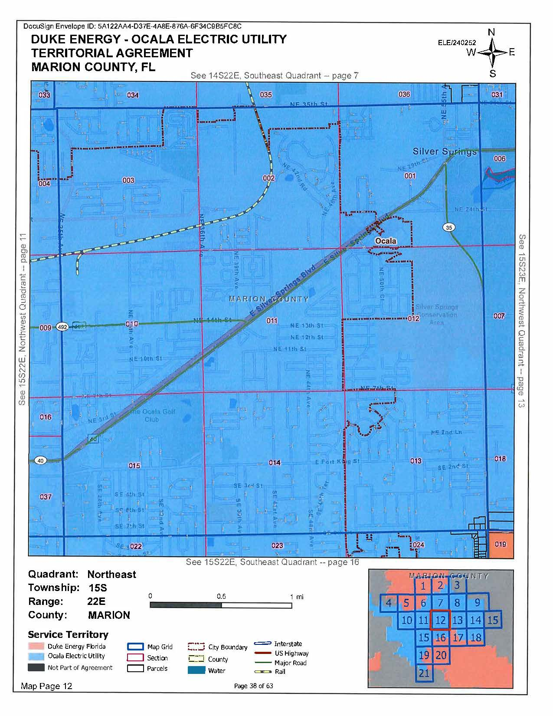

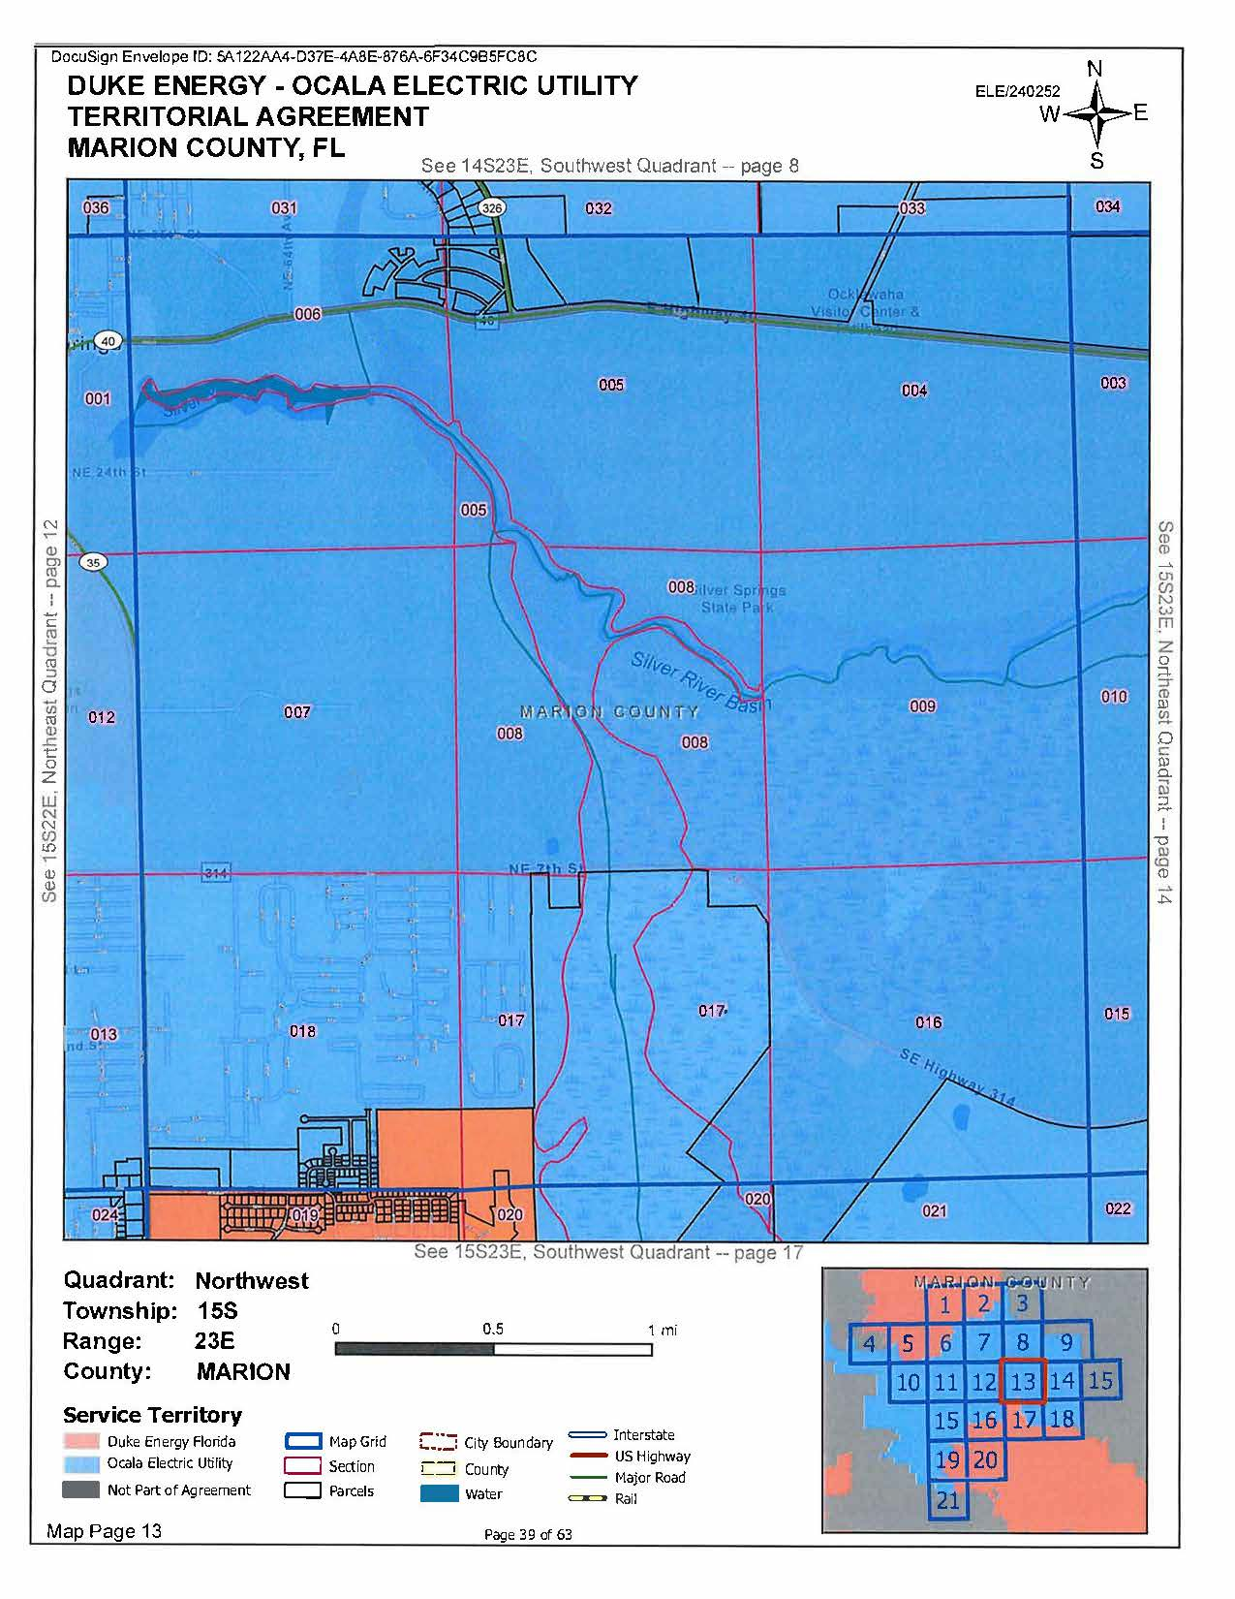

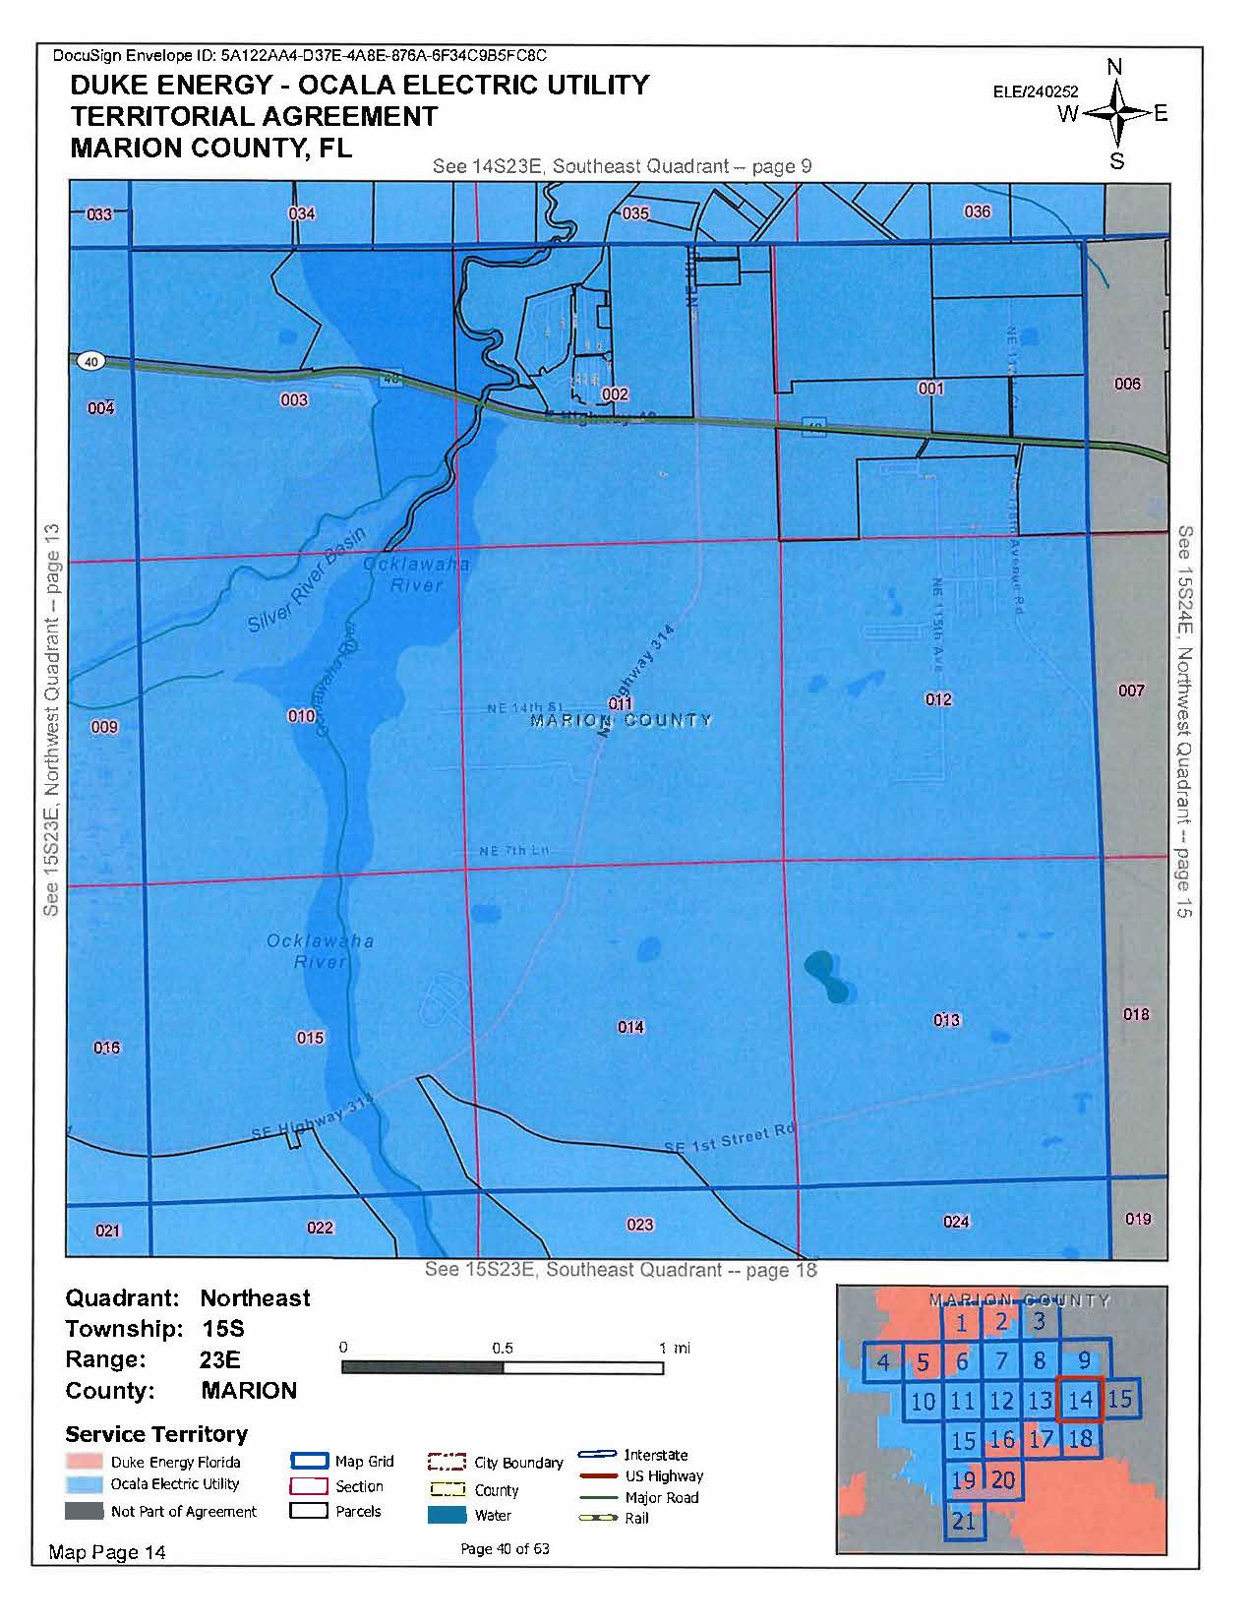

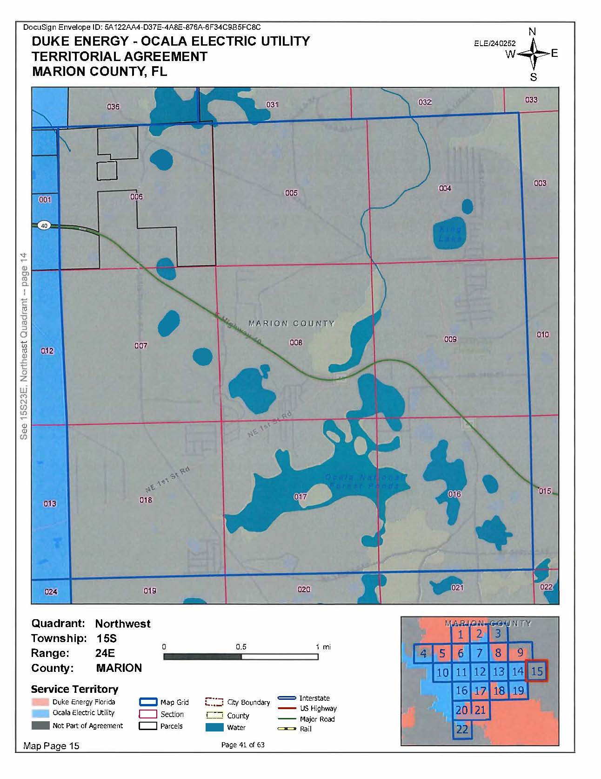

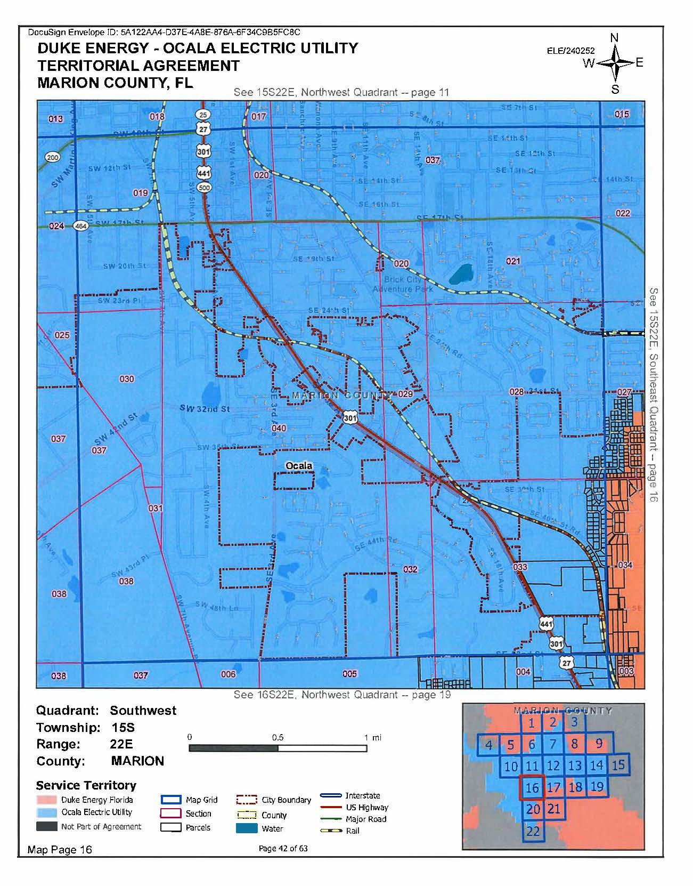

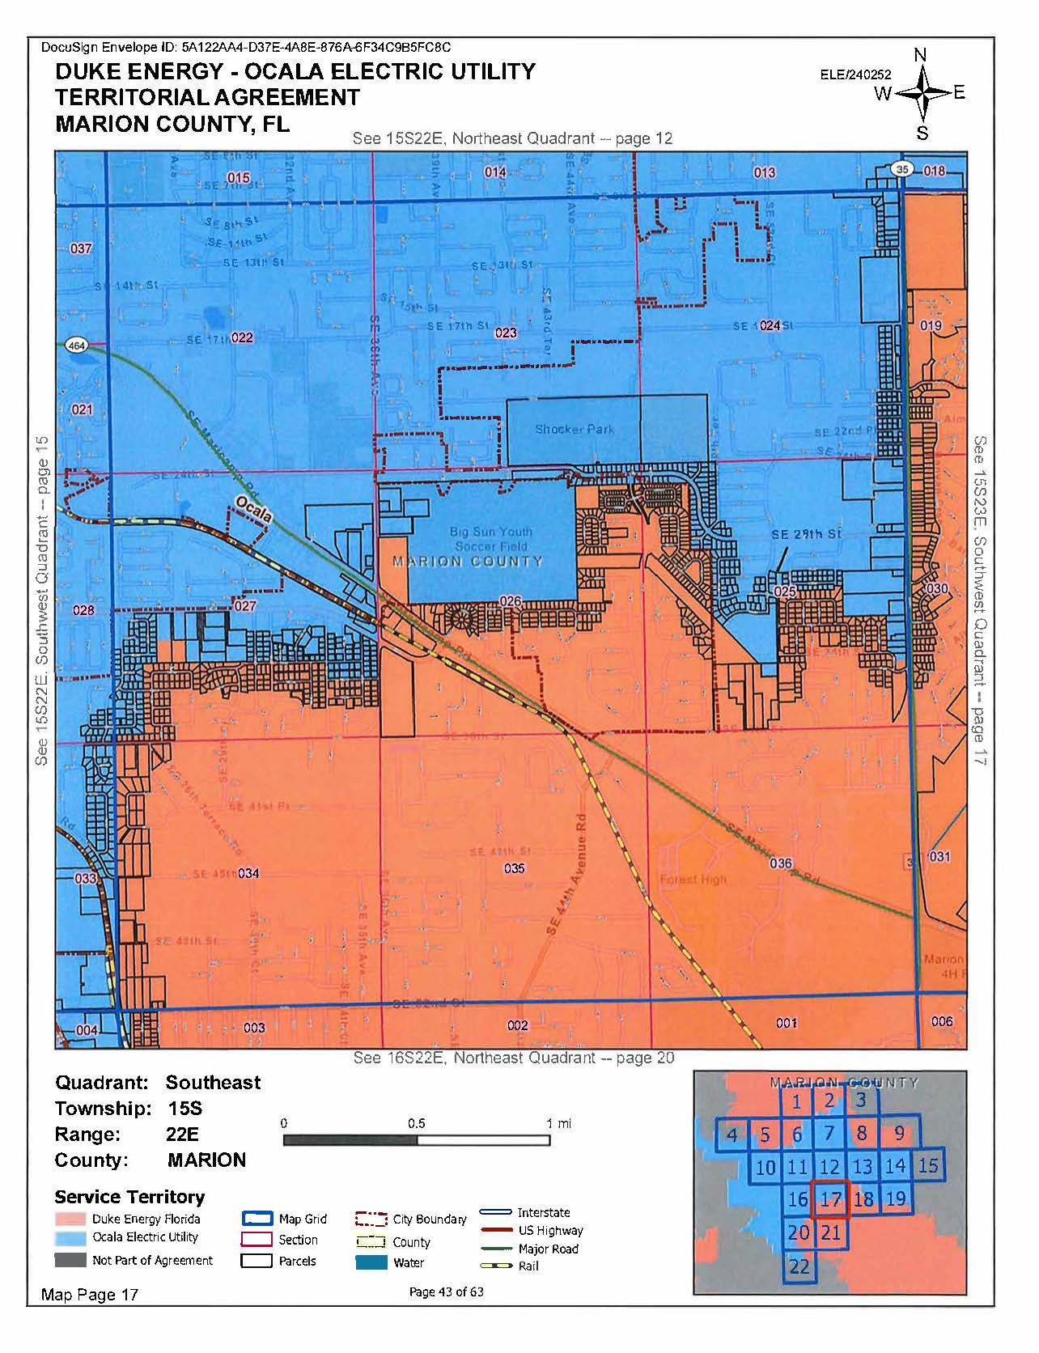

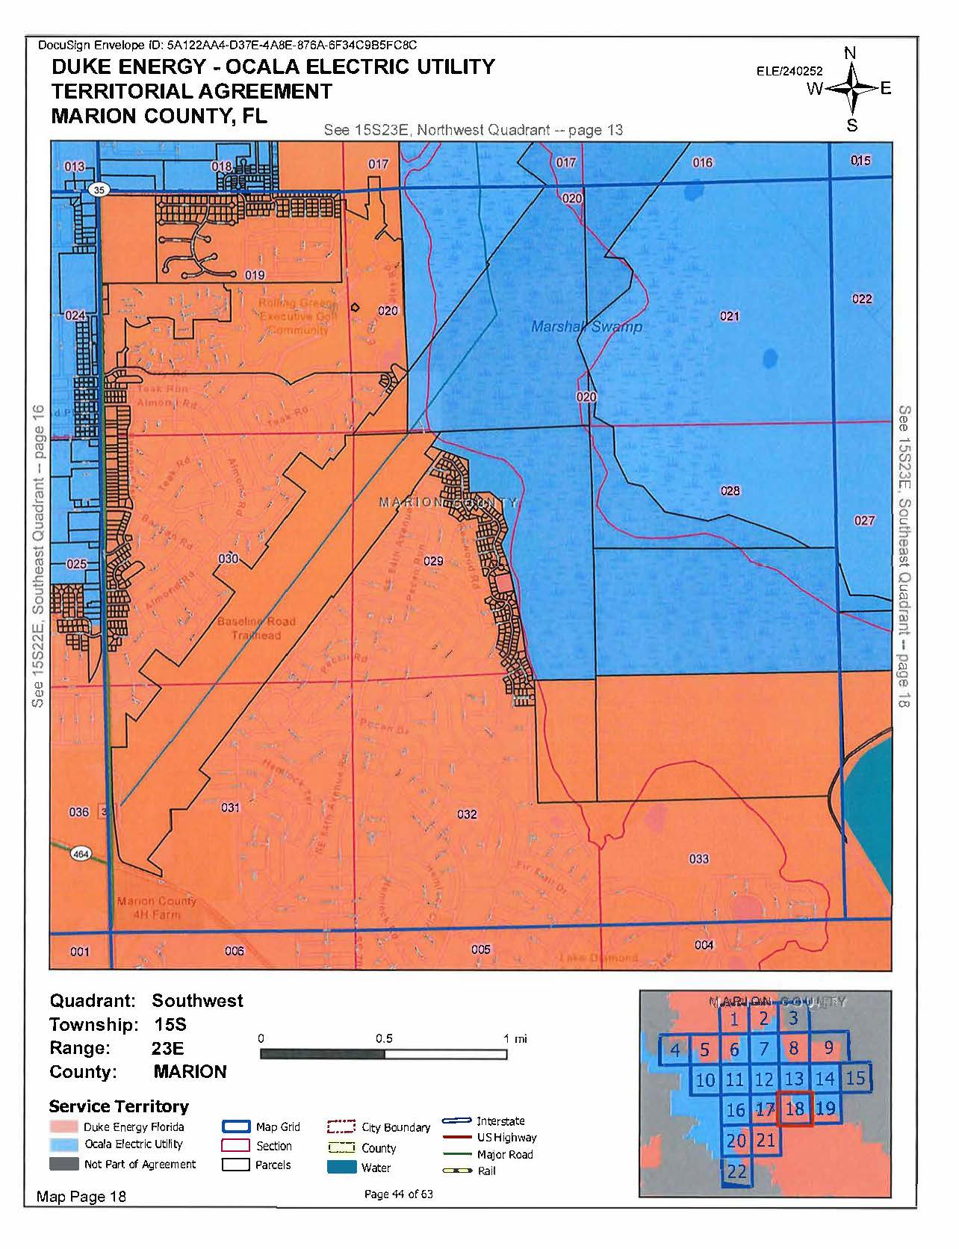

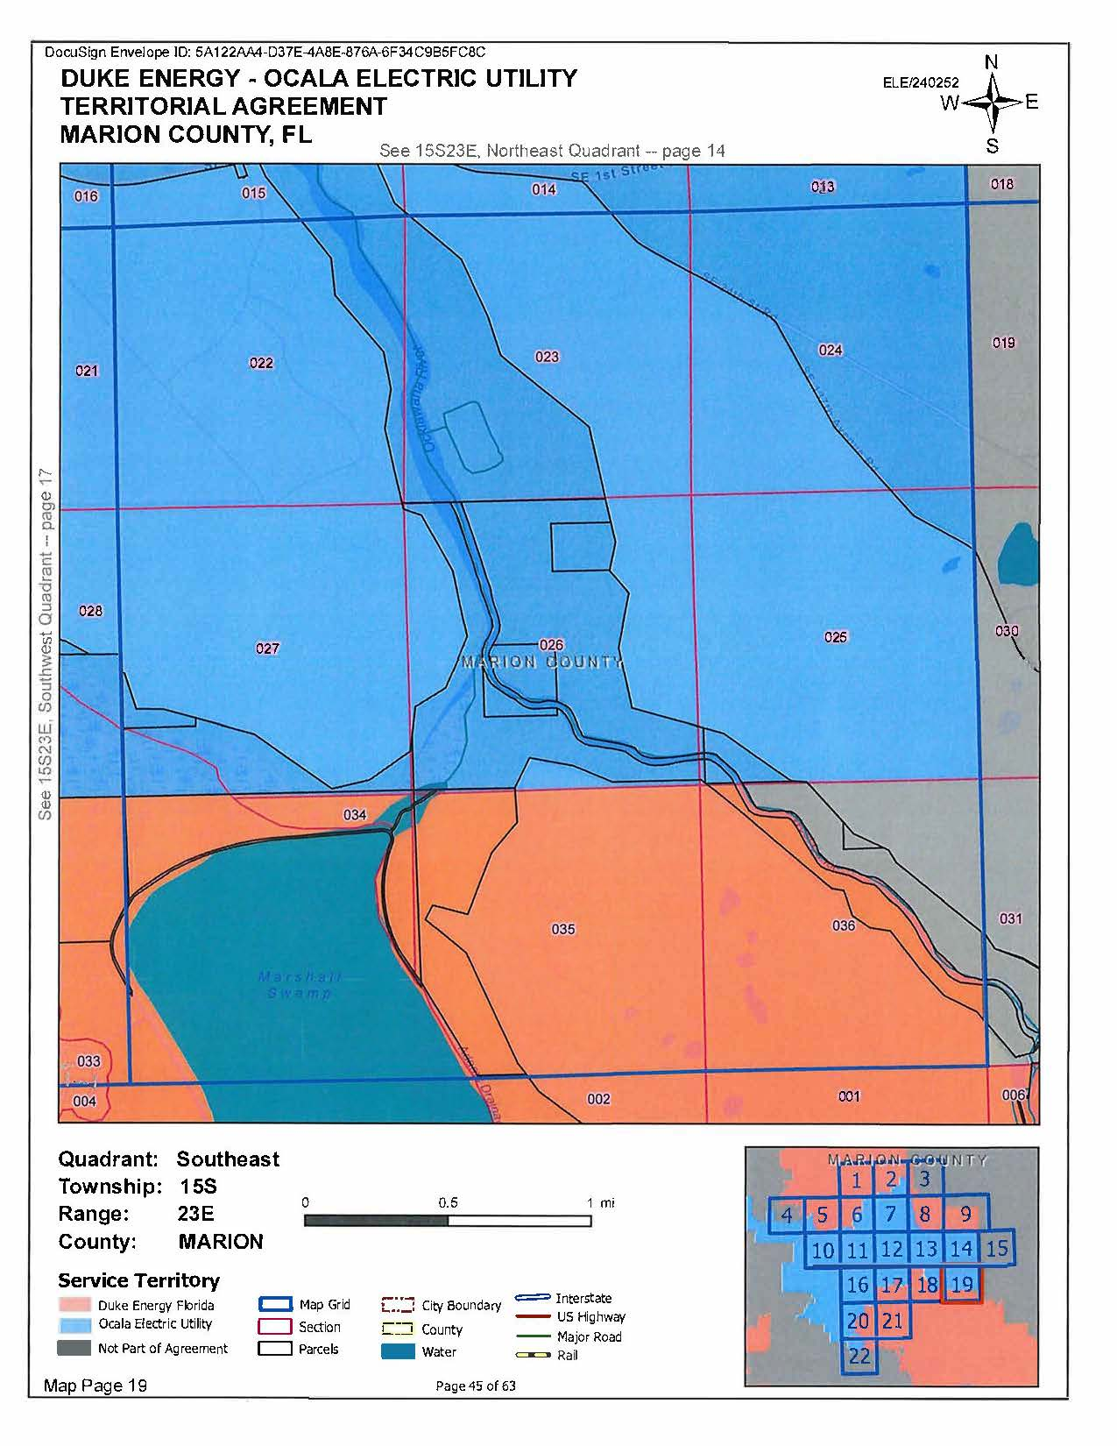

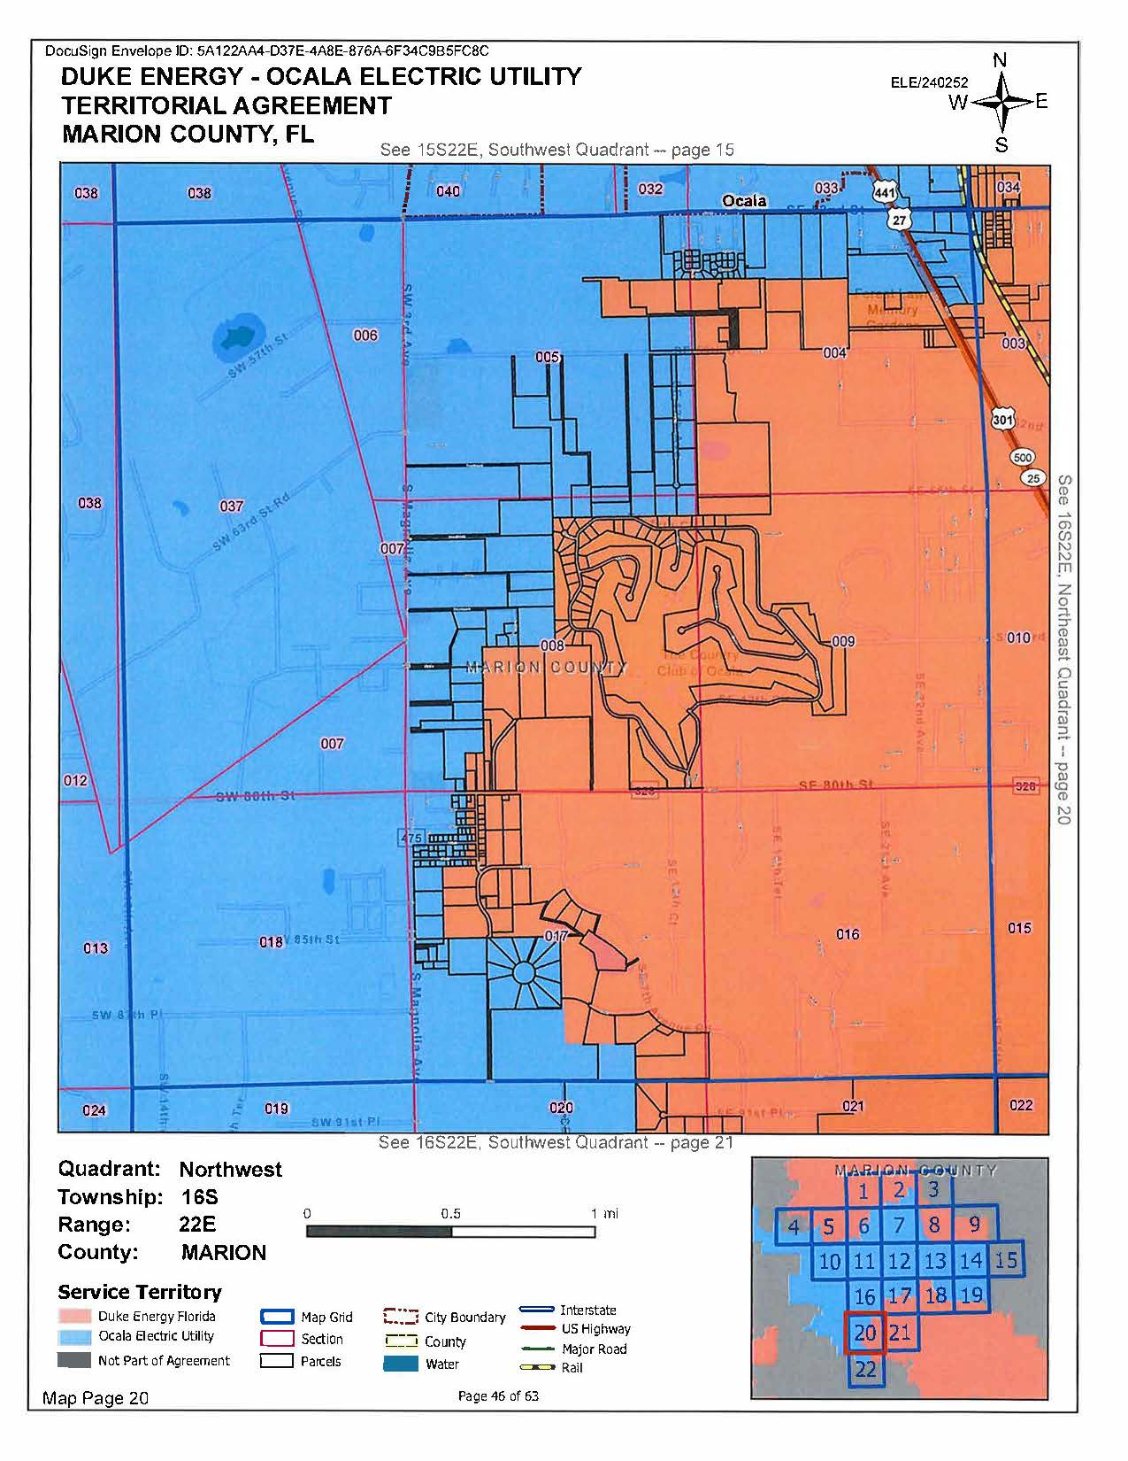

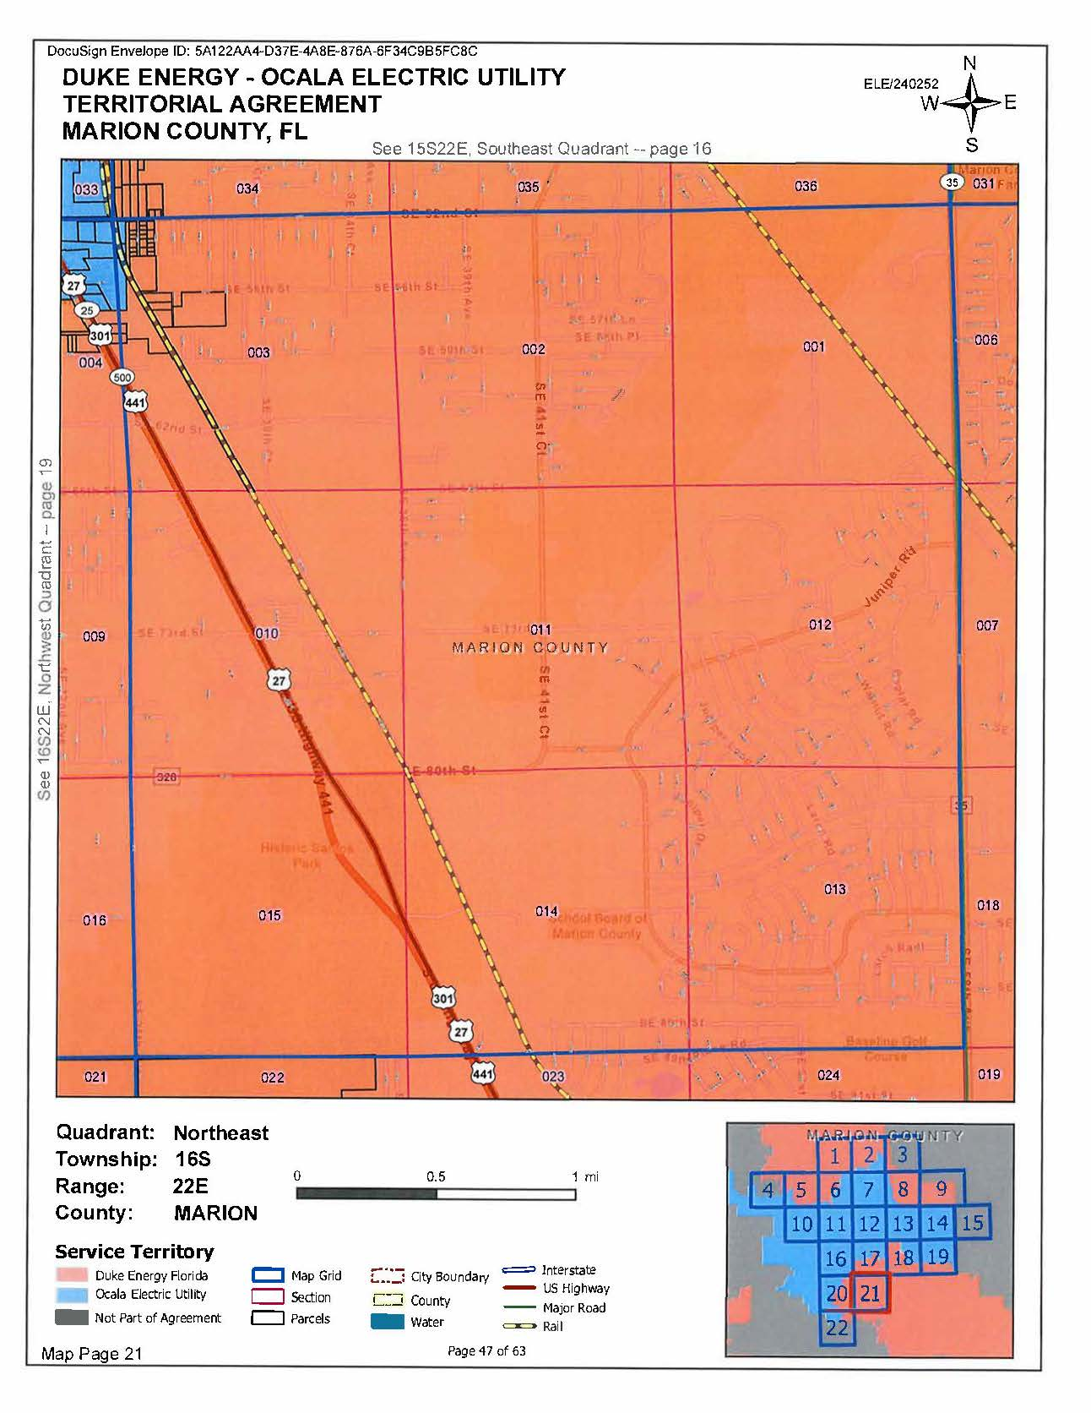

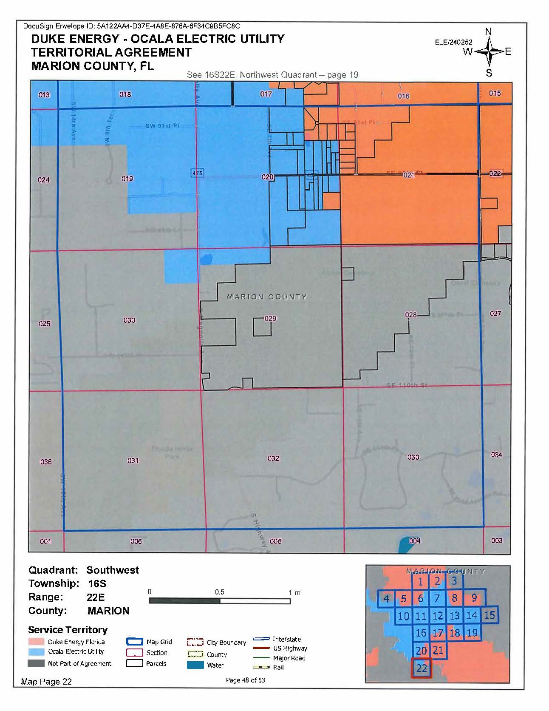

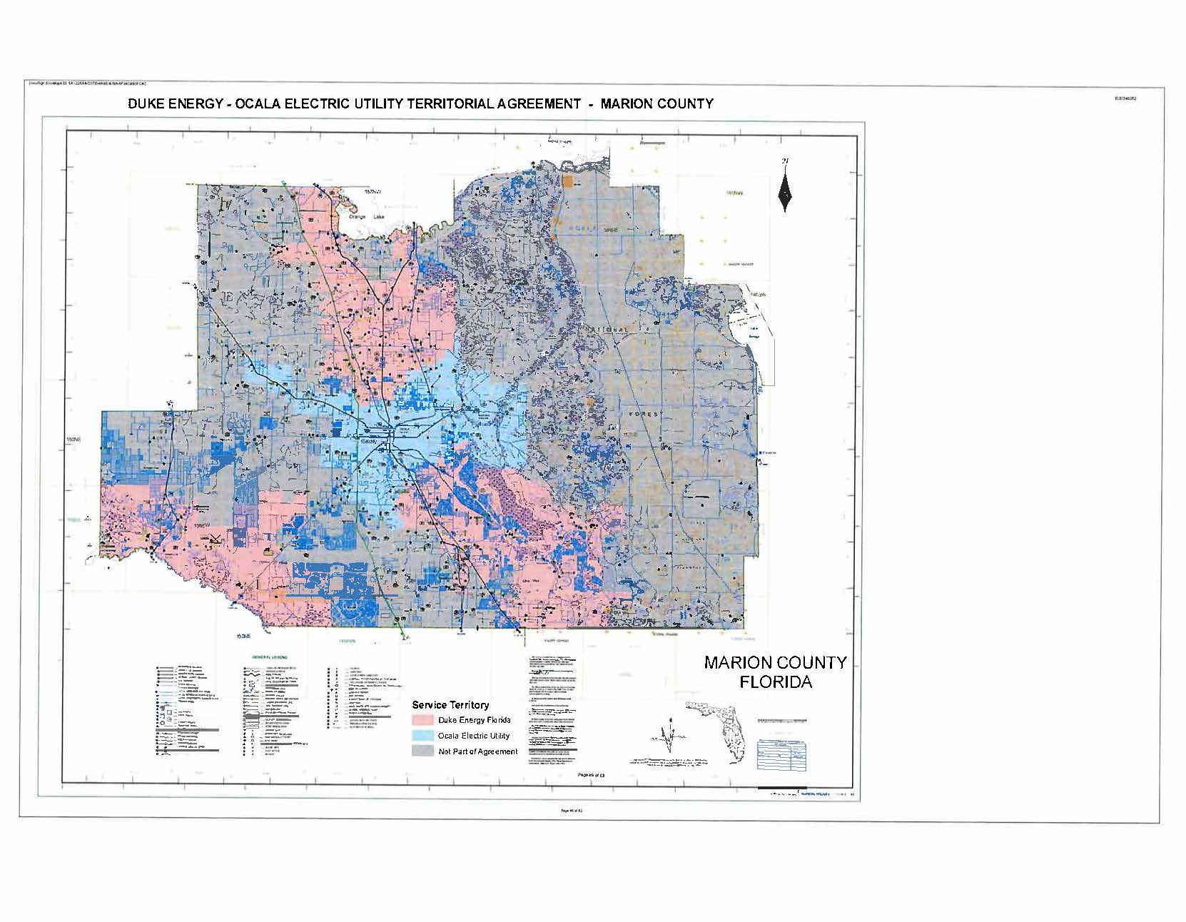

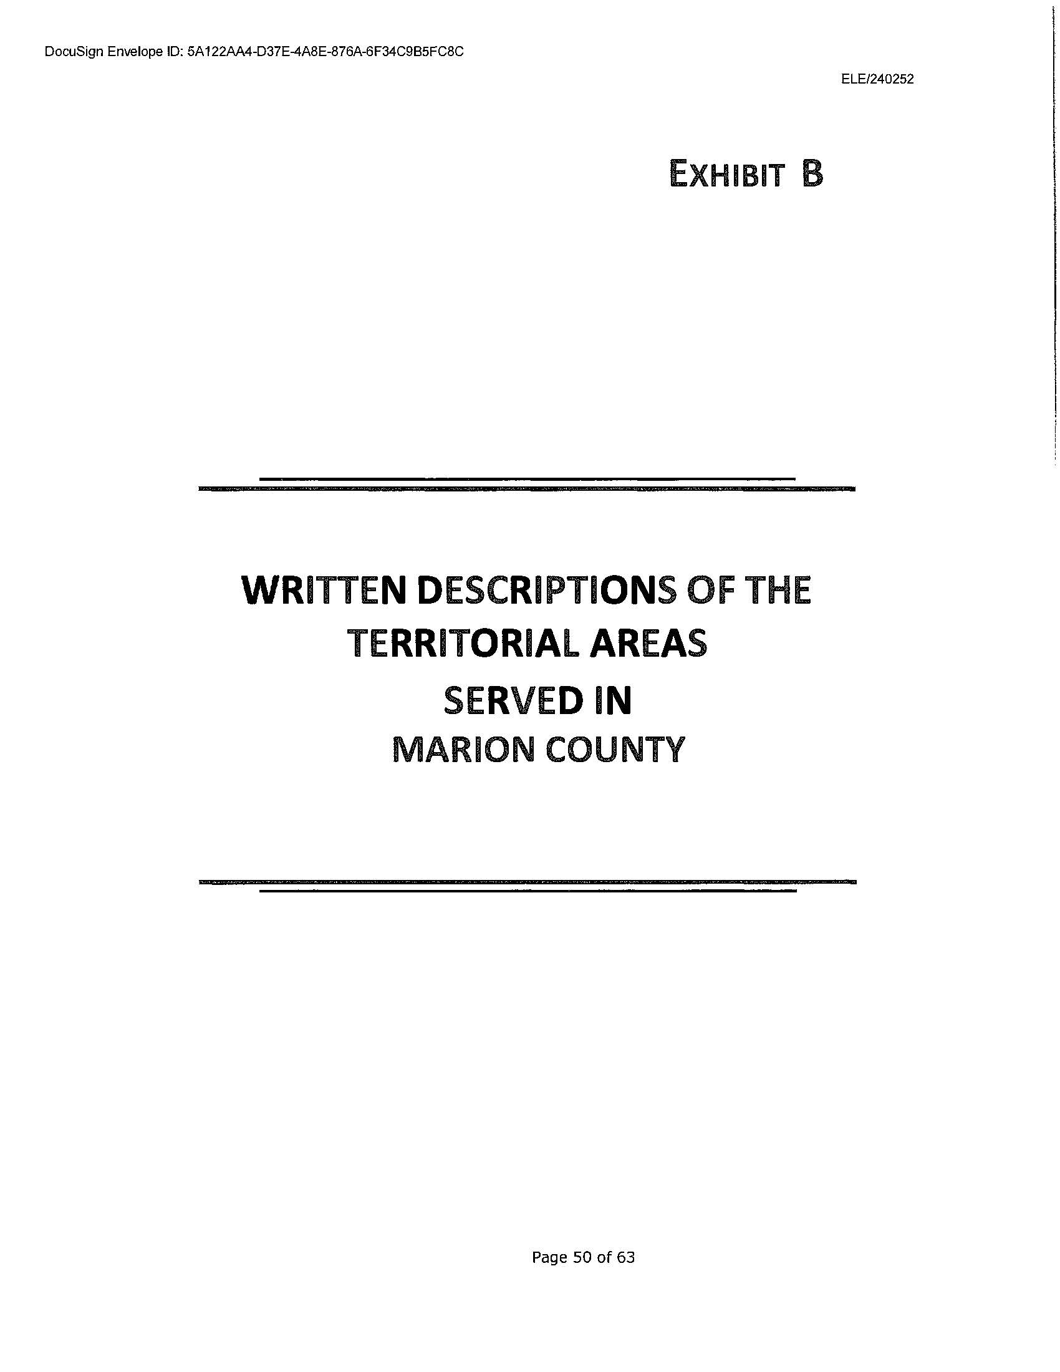

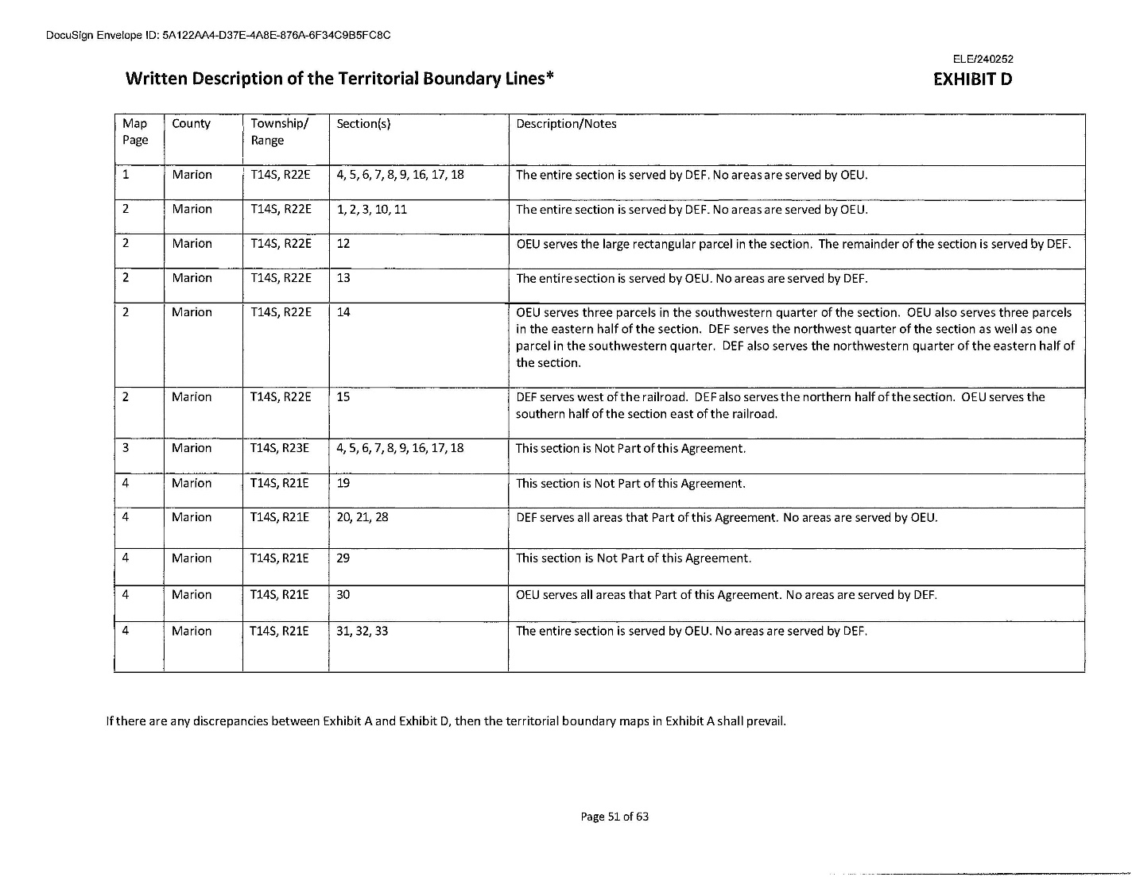

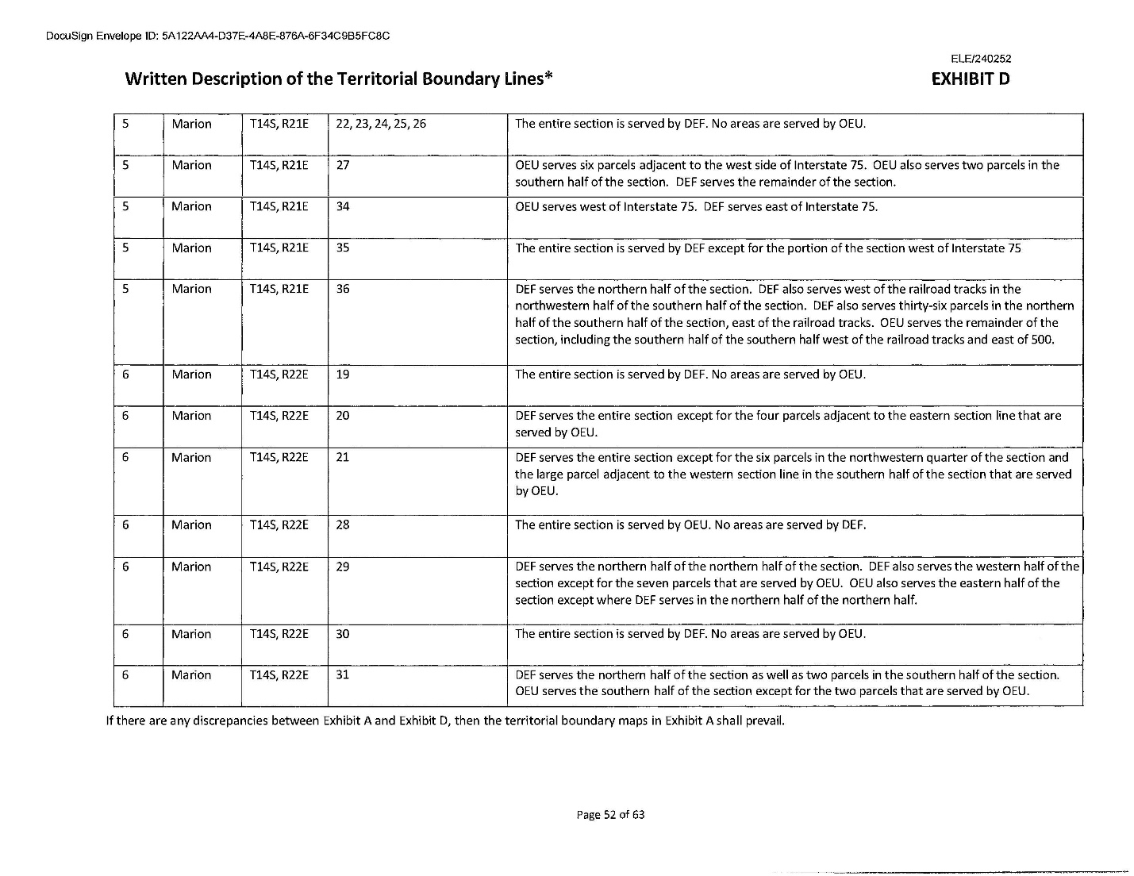

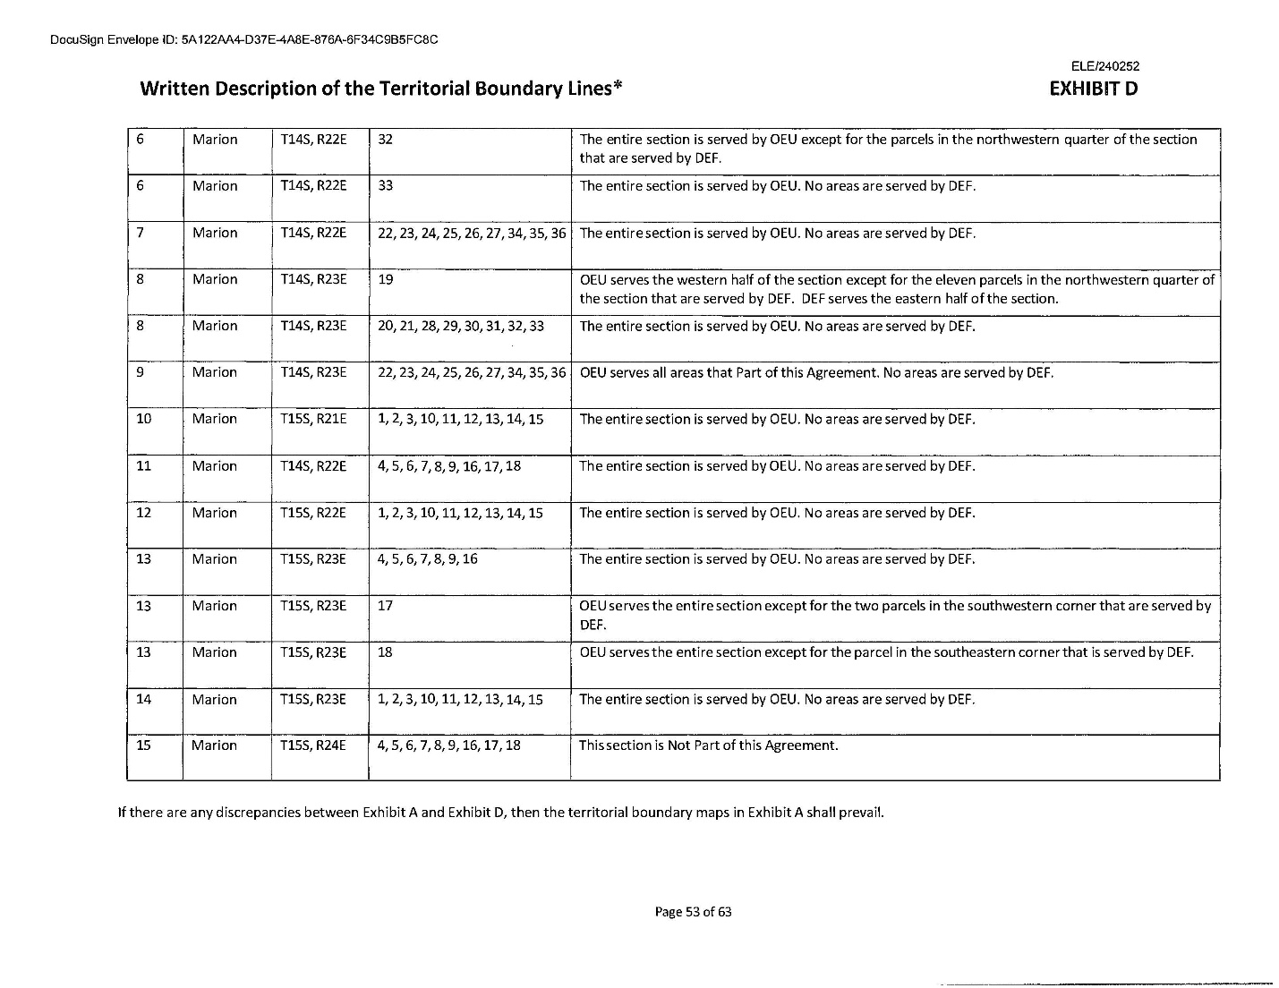

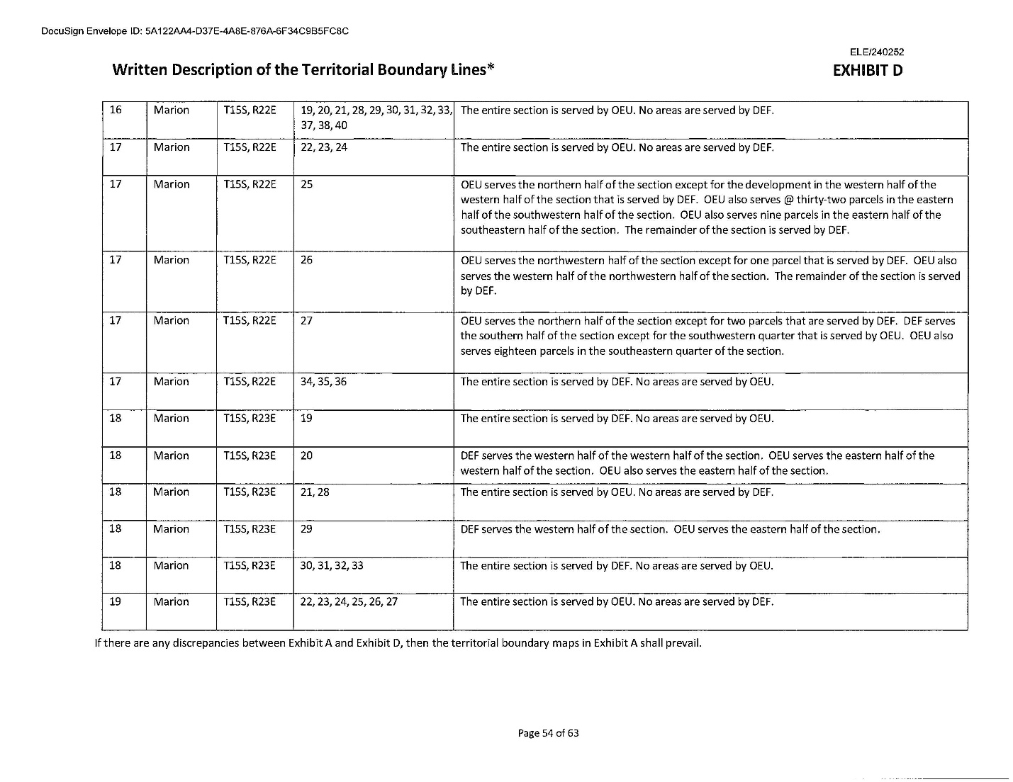

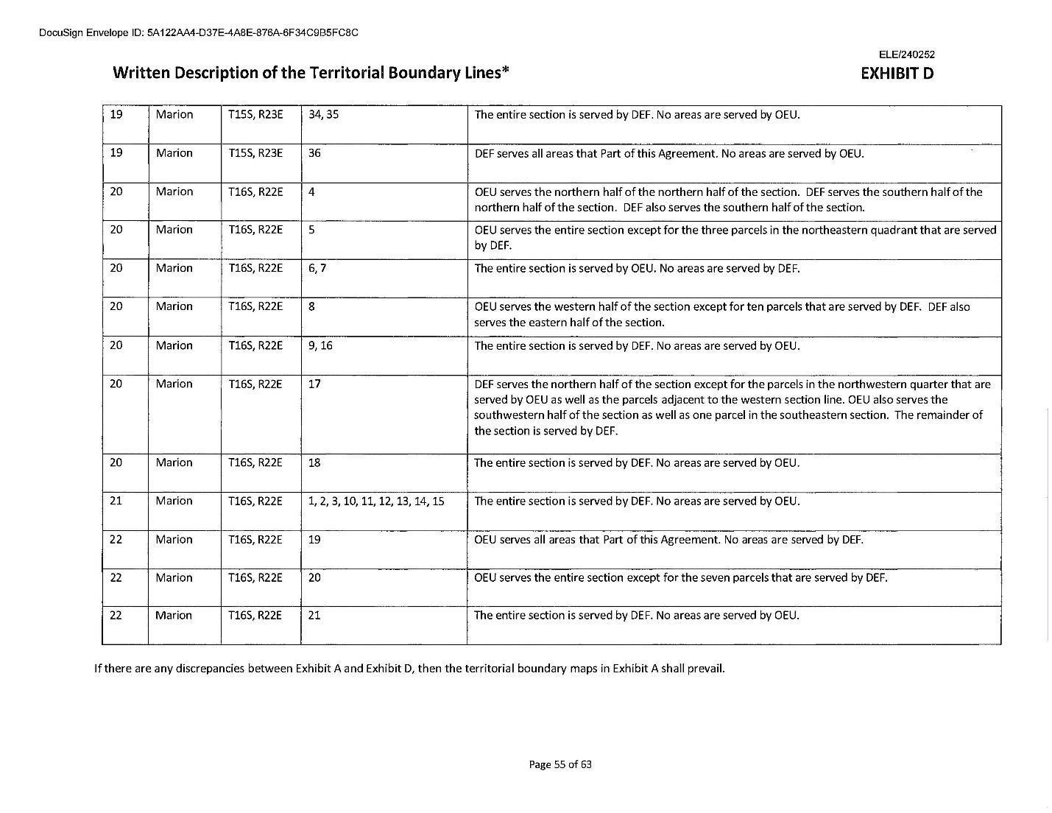

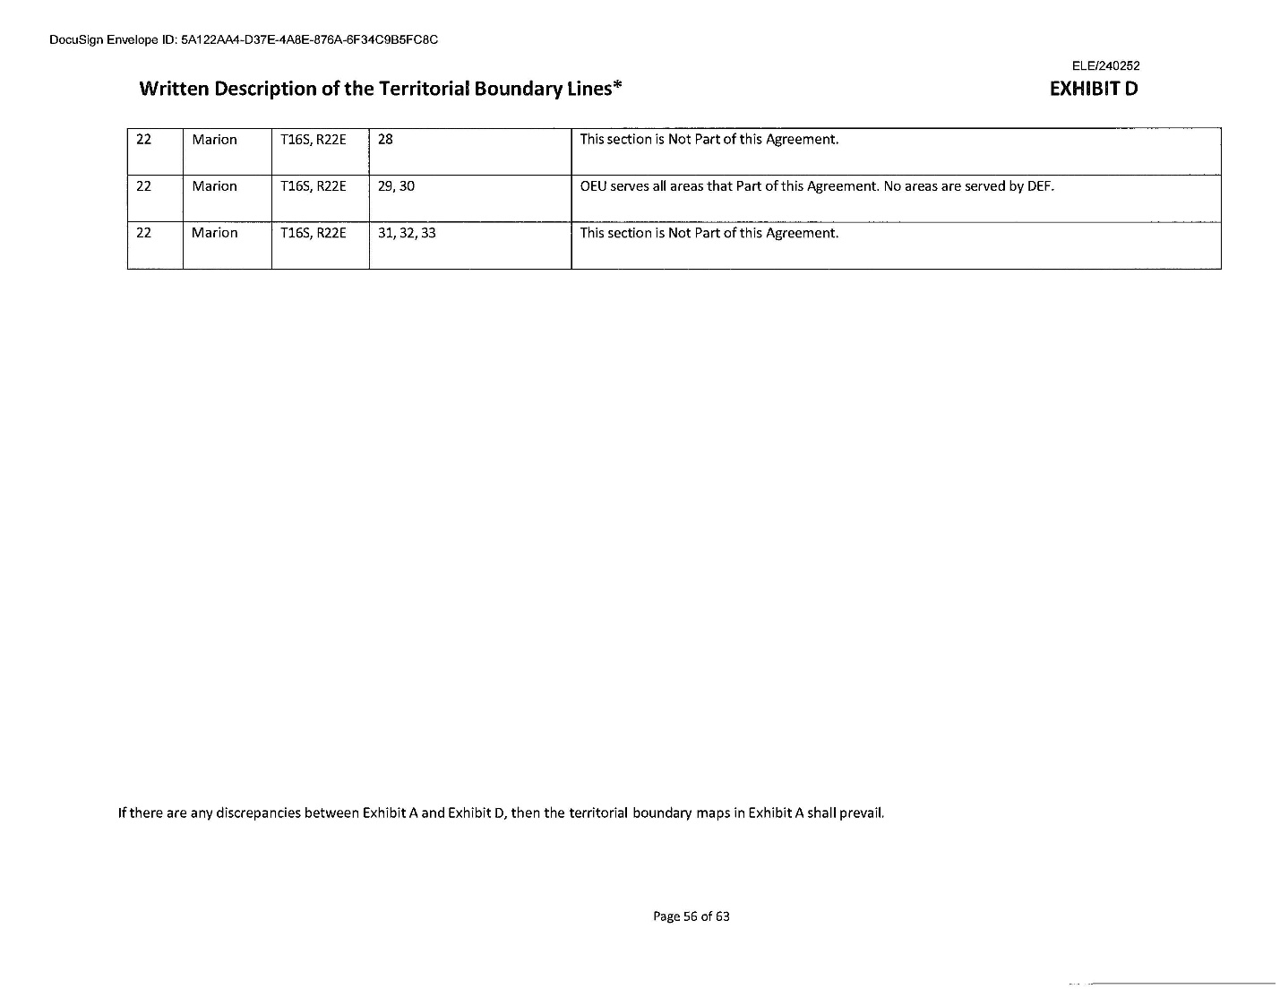

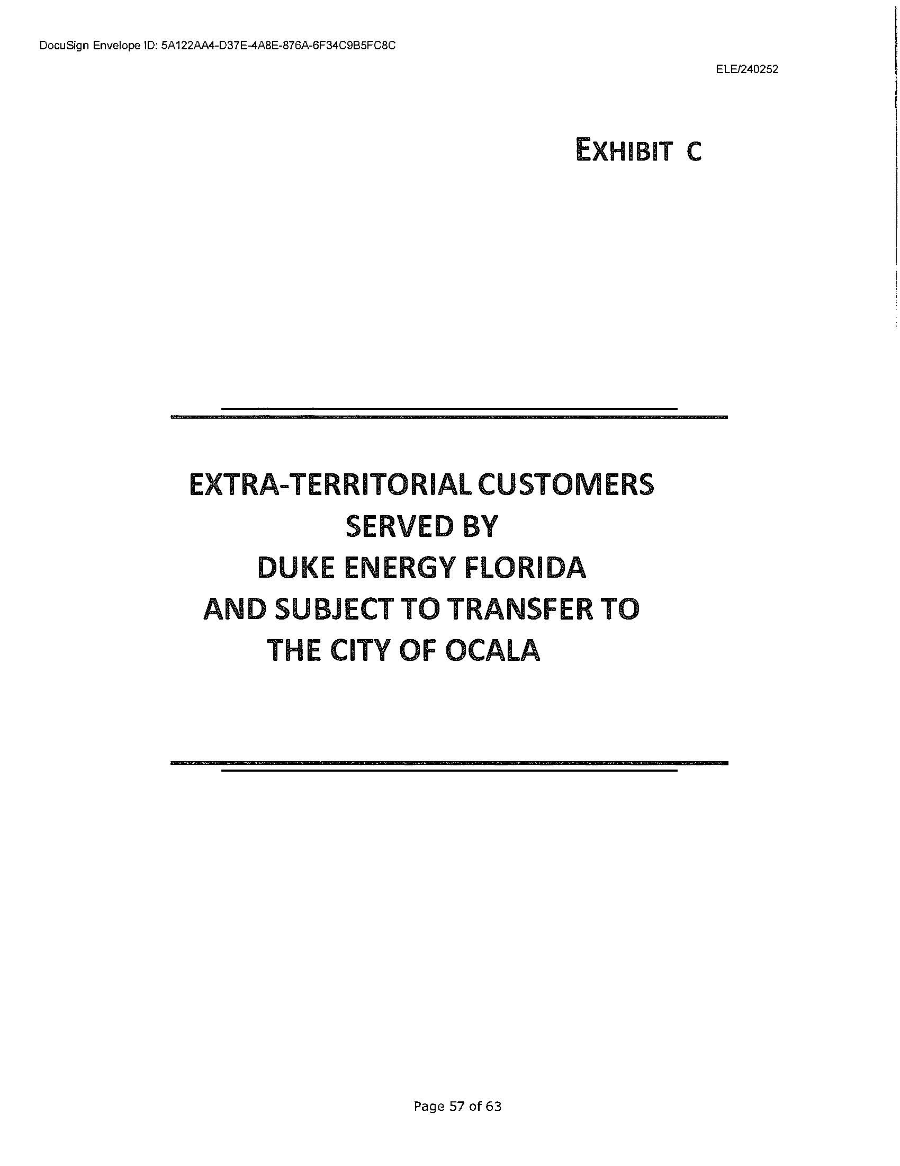

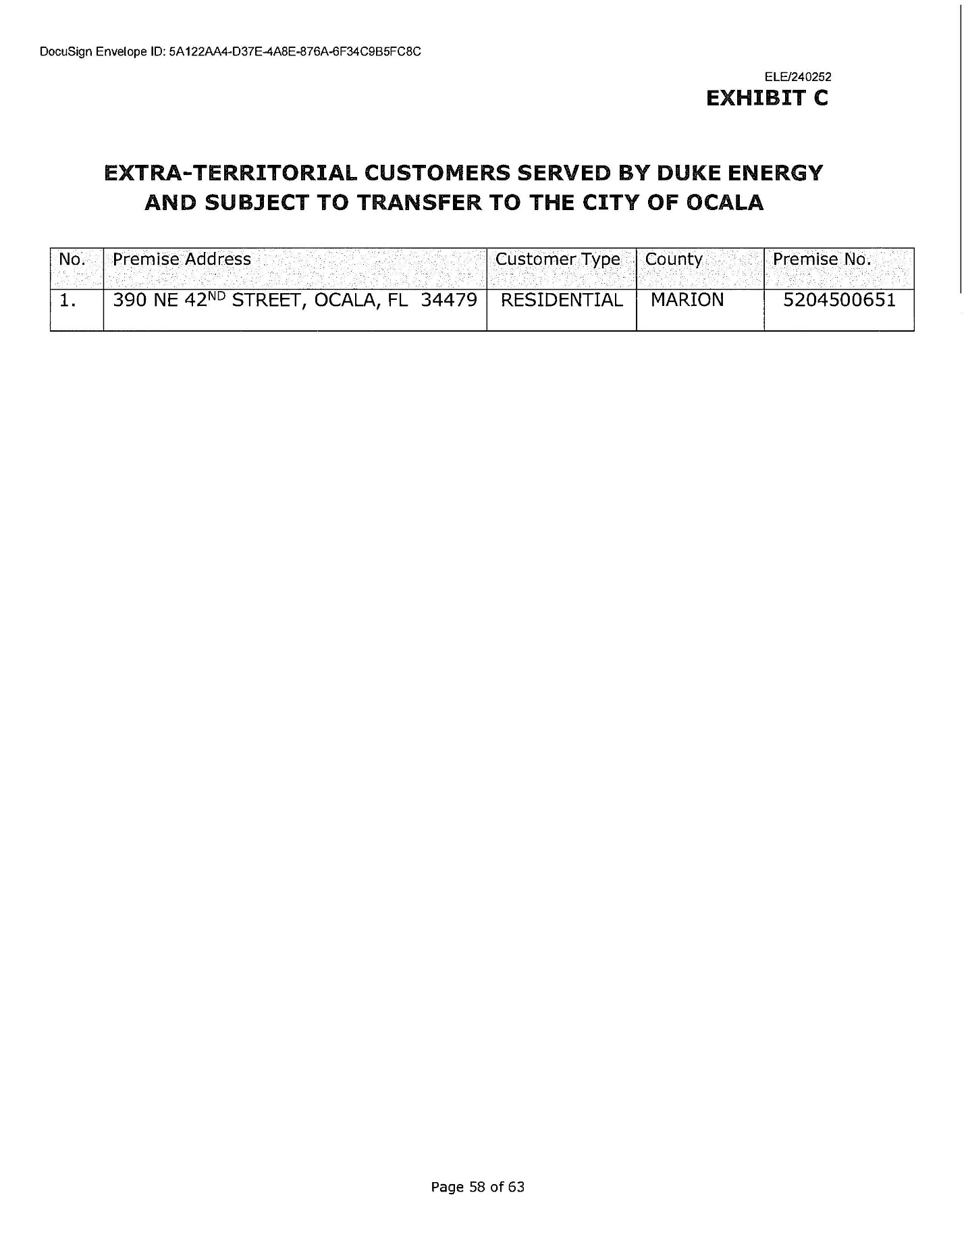

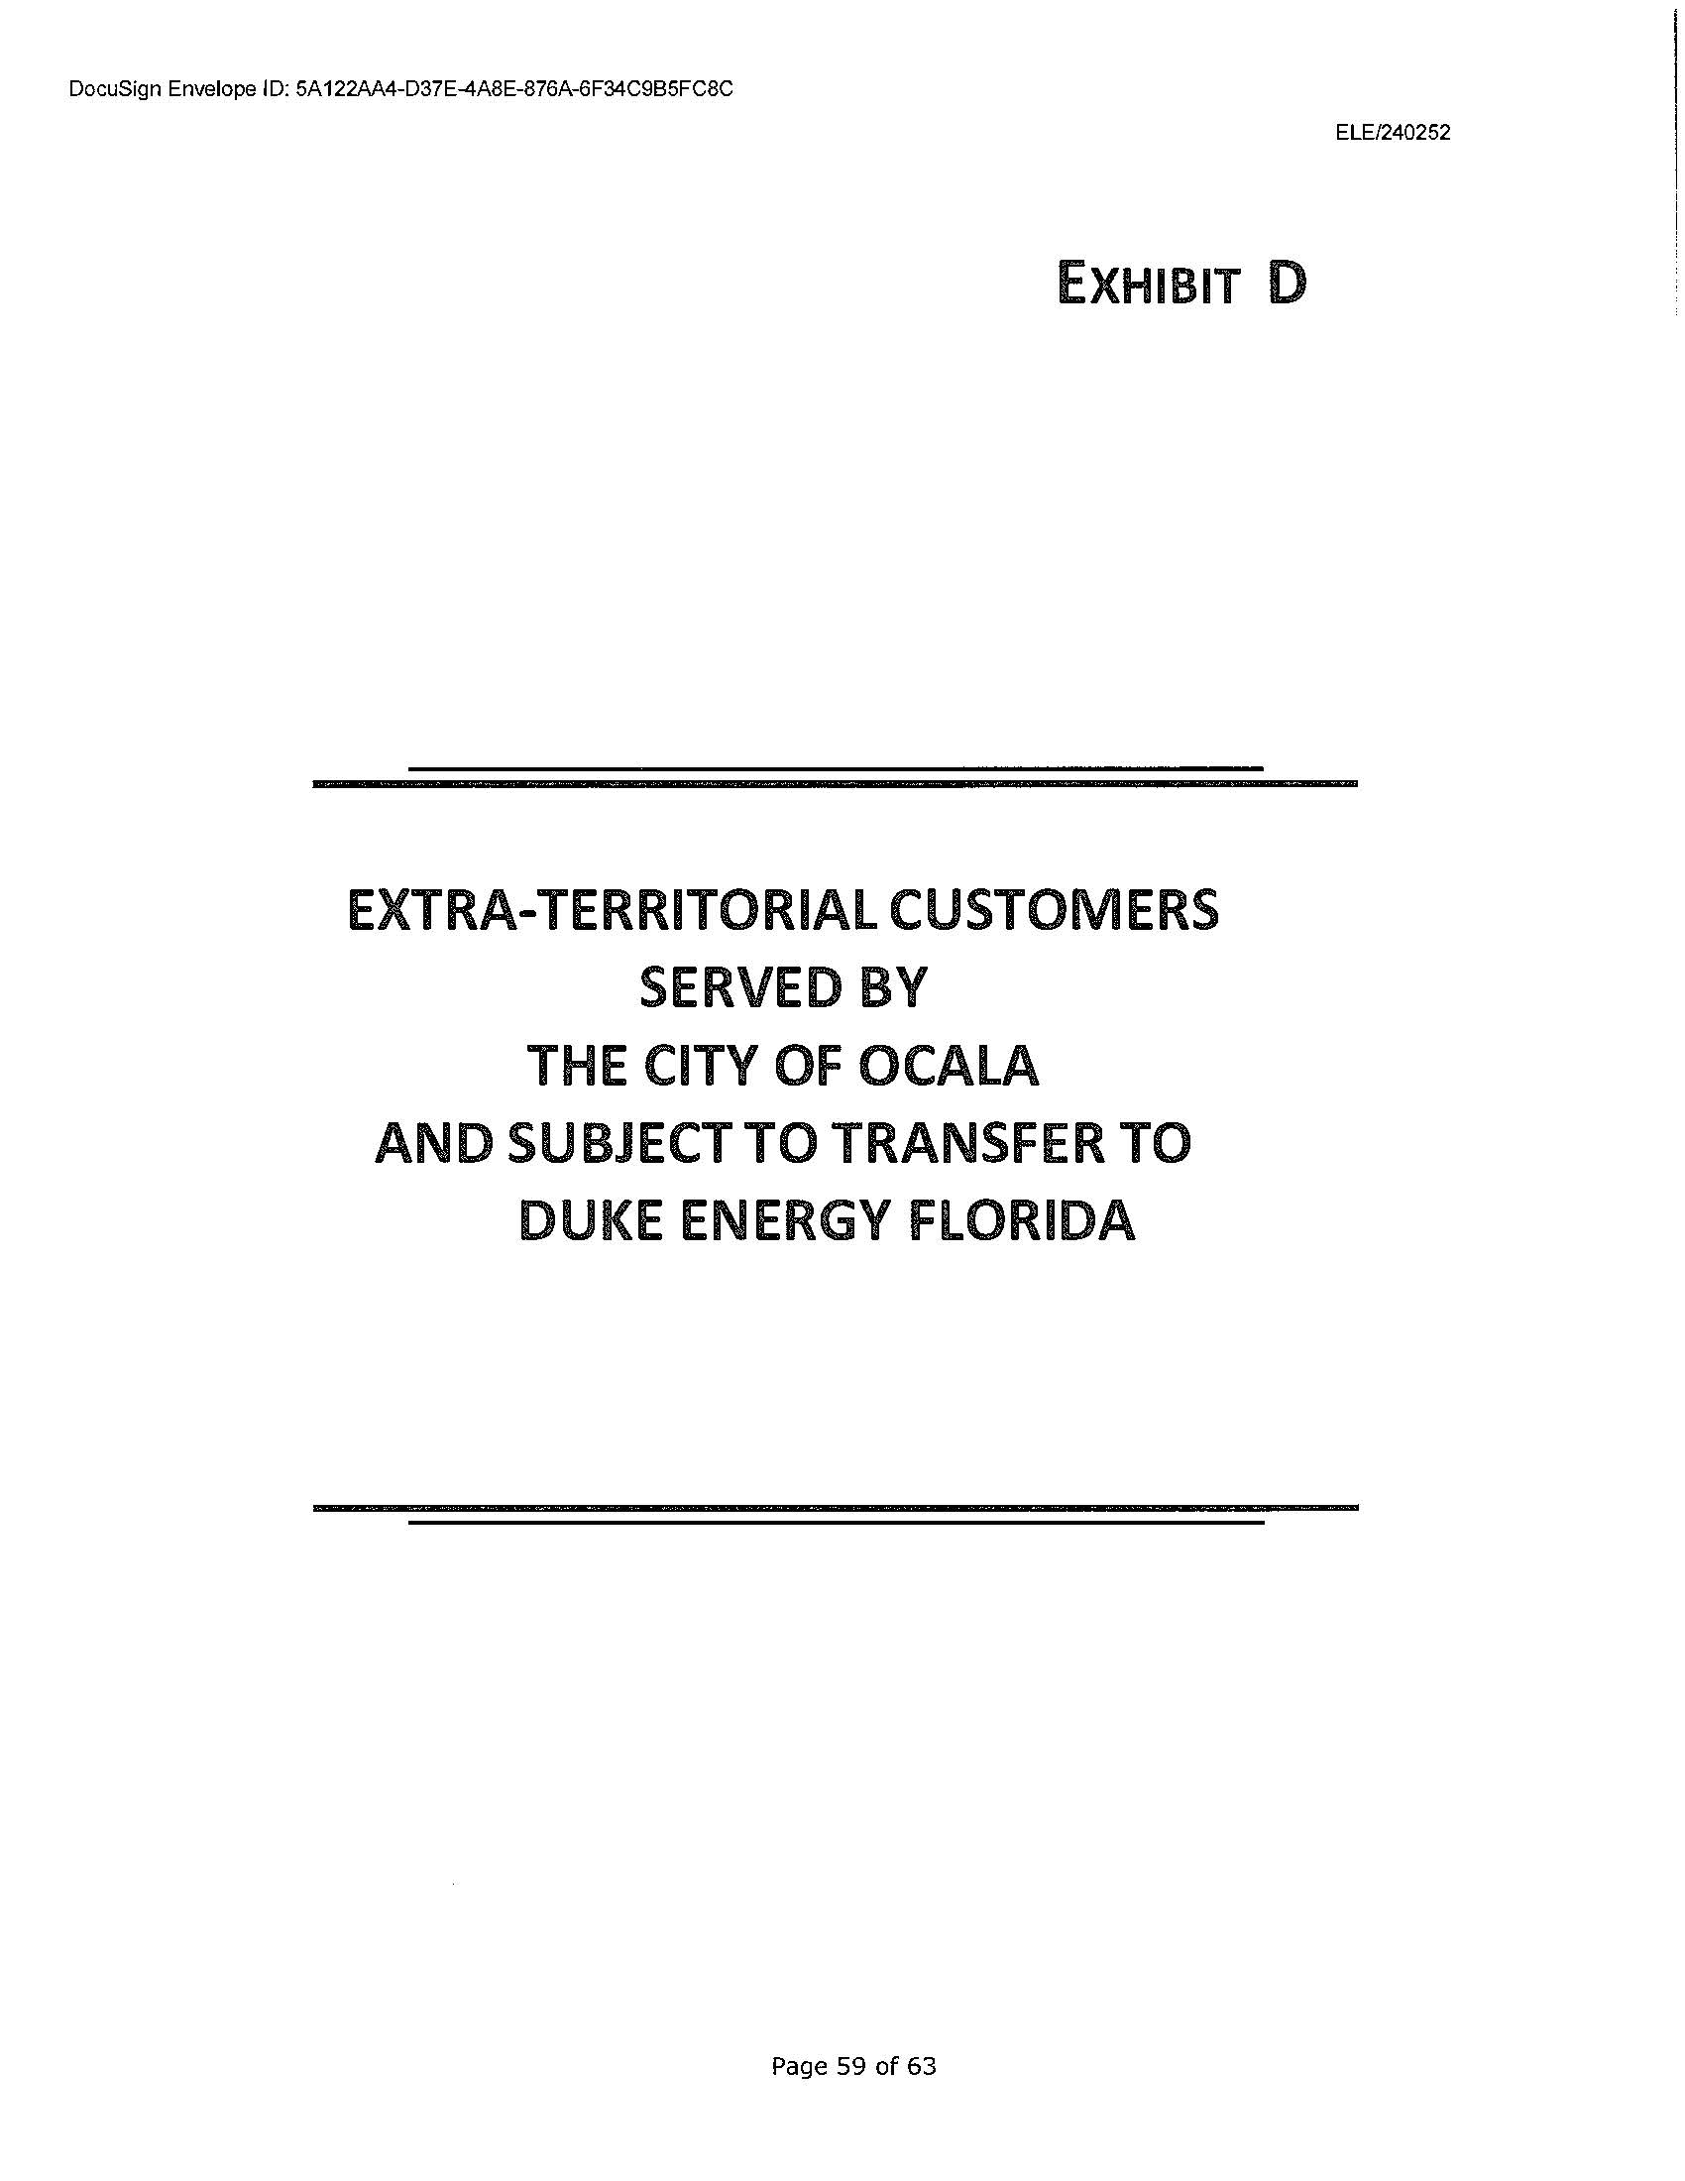

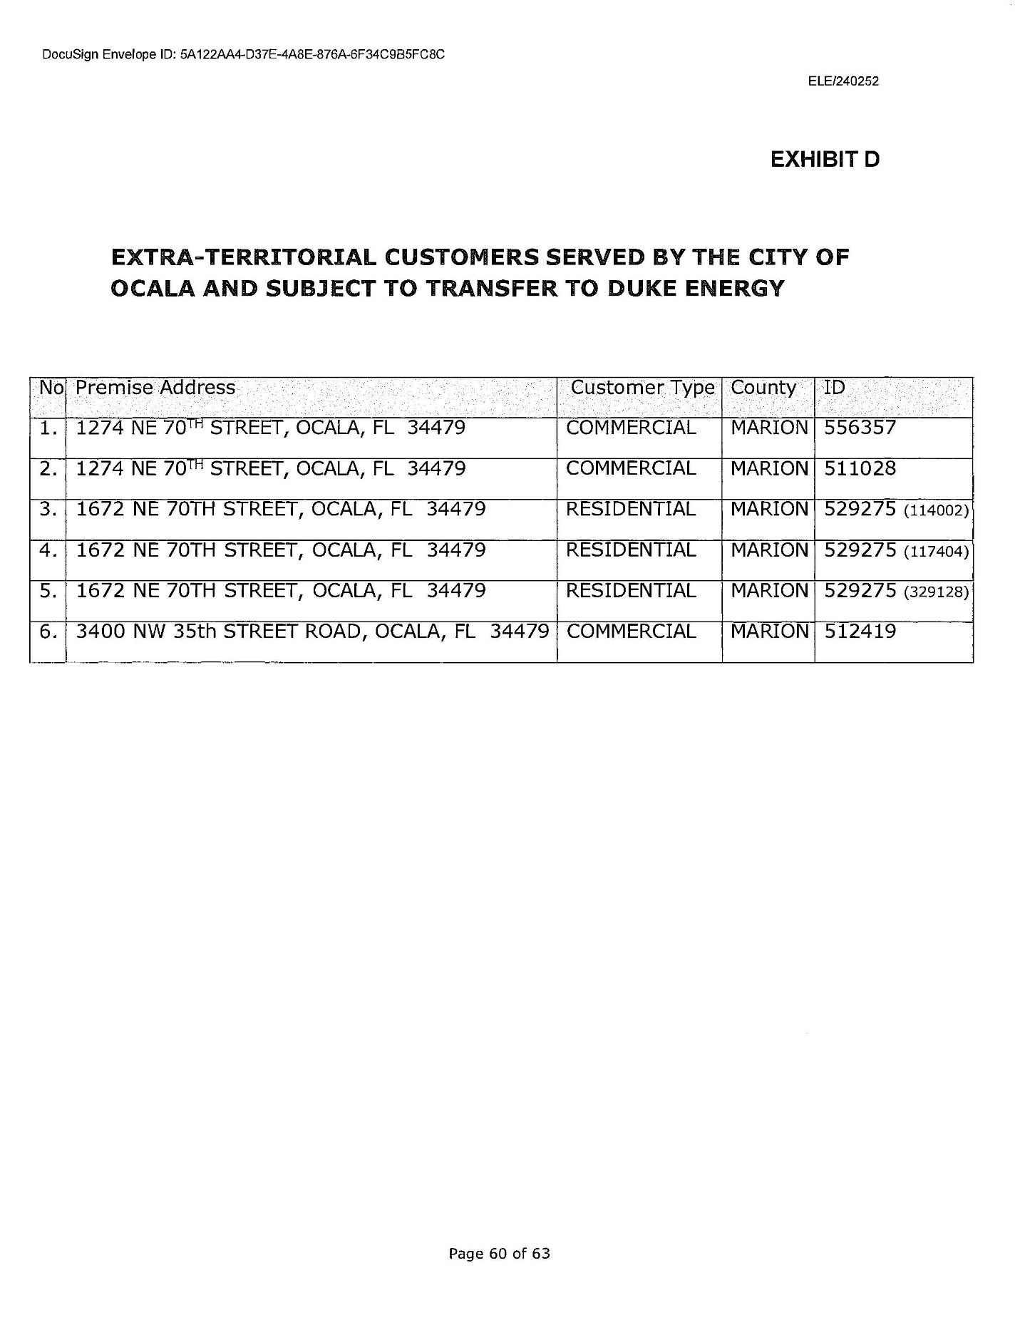

Informational Maps Depicting The Territorial Boundary Line Changes

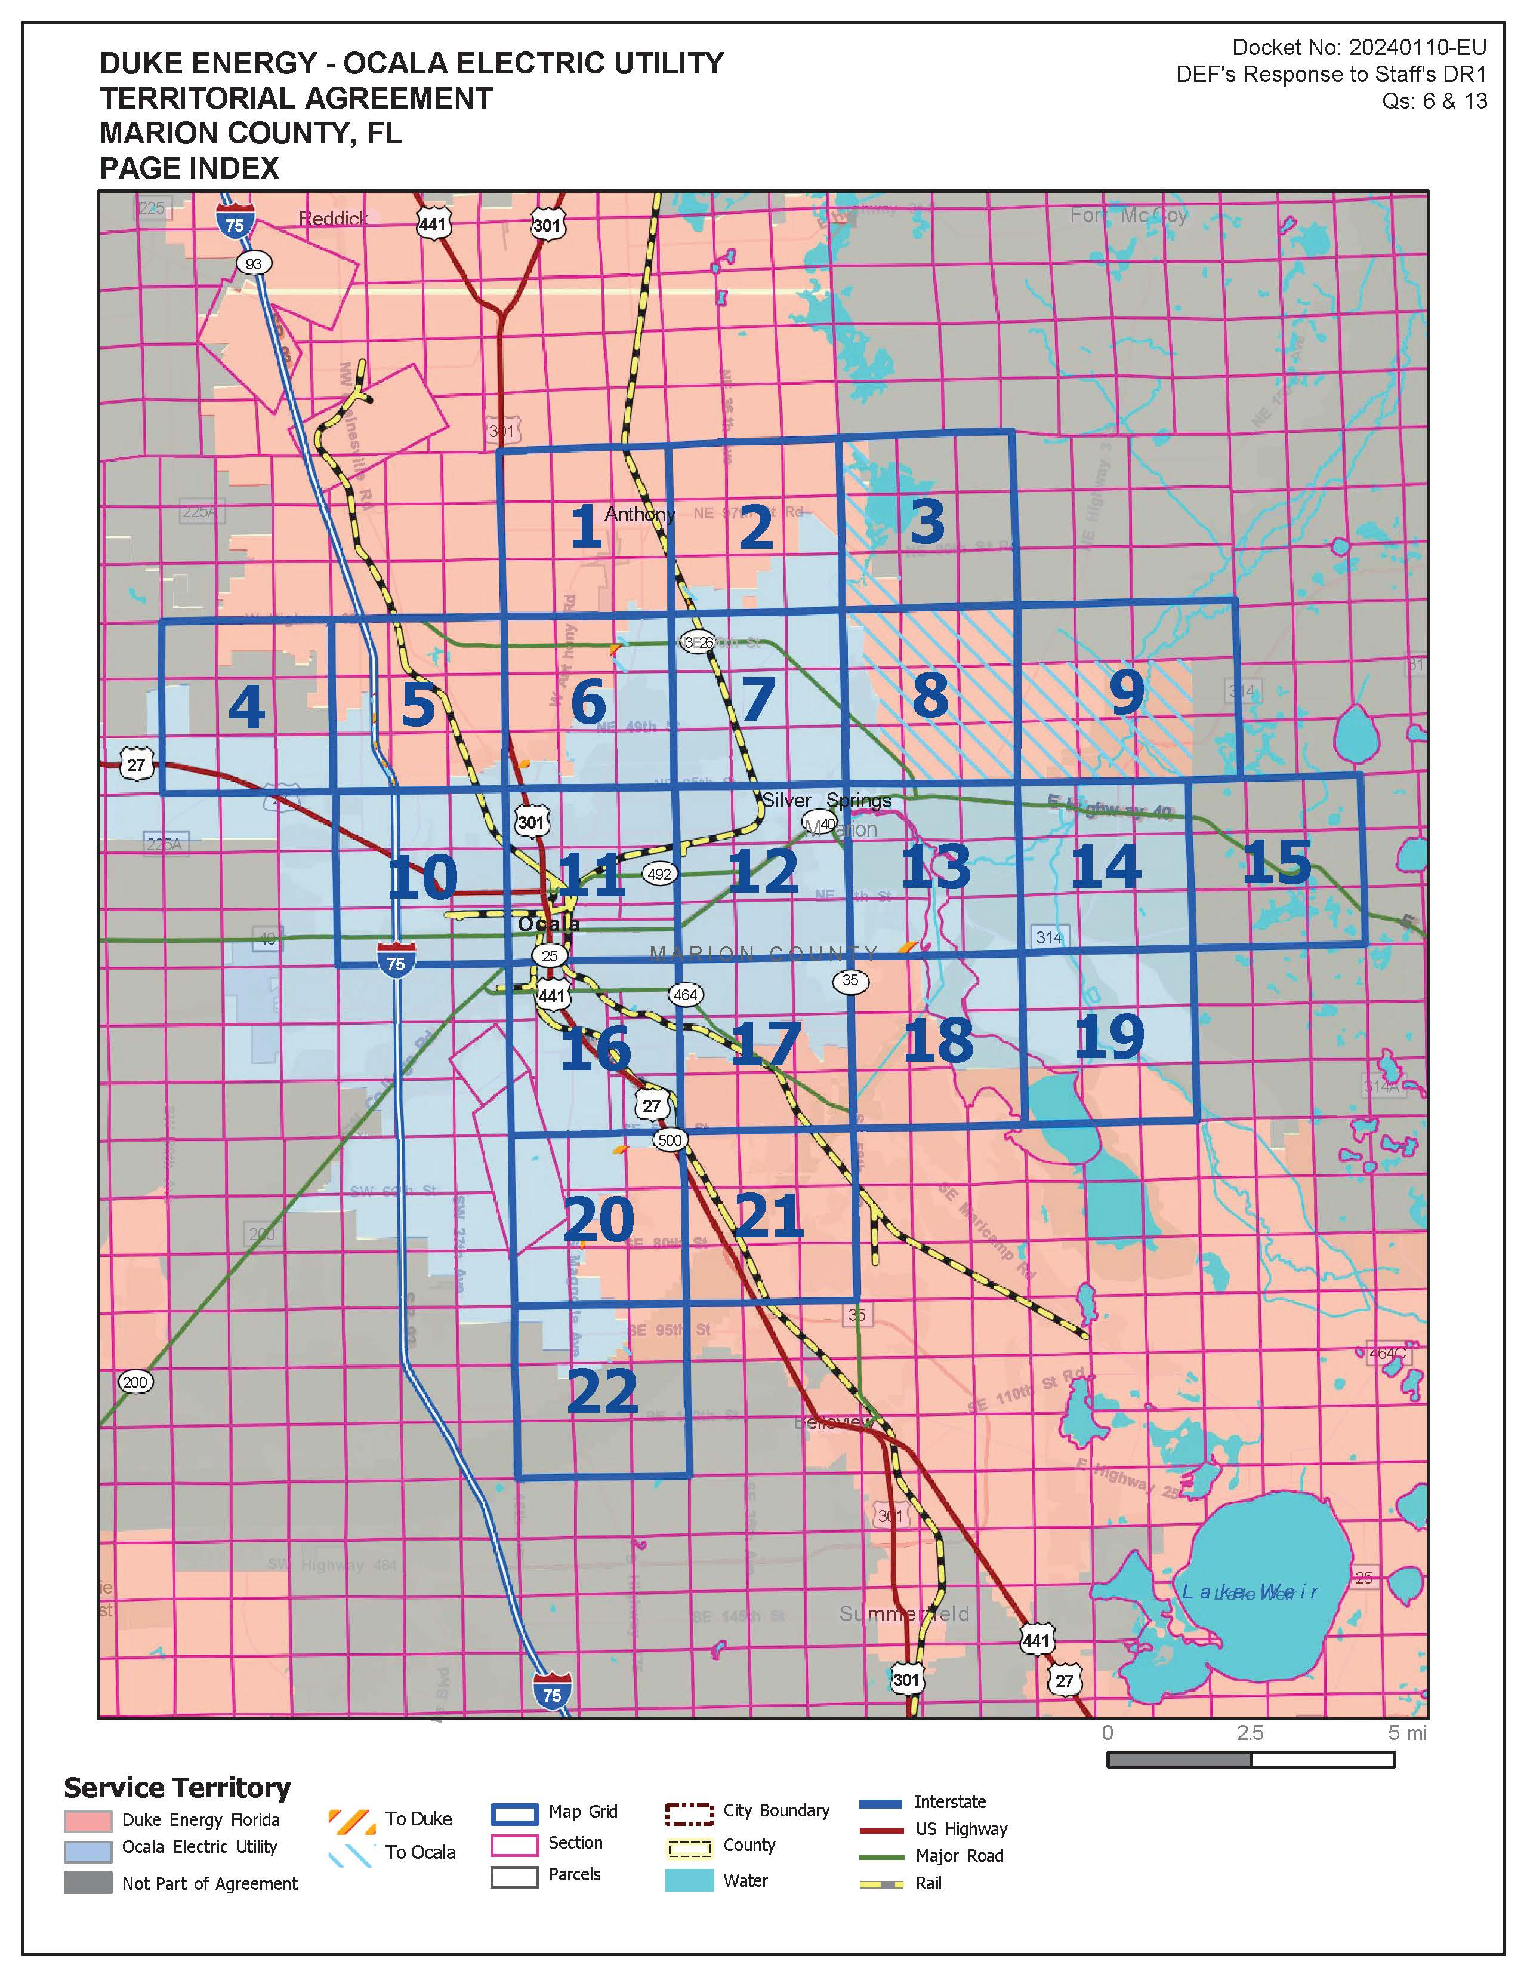

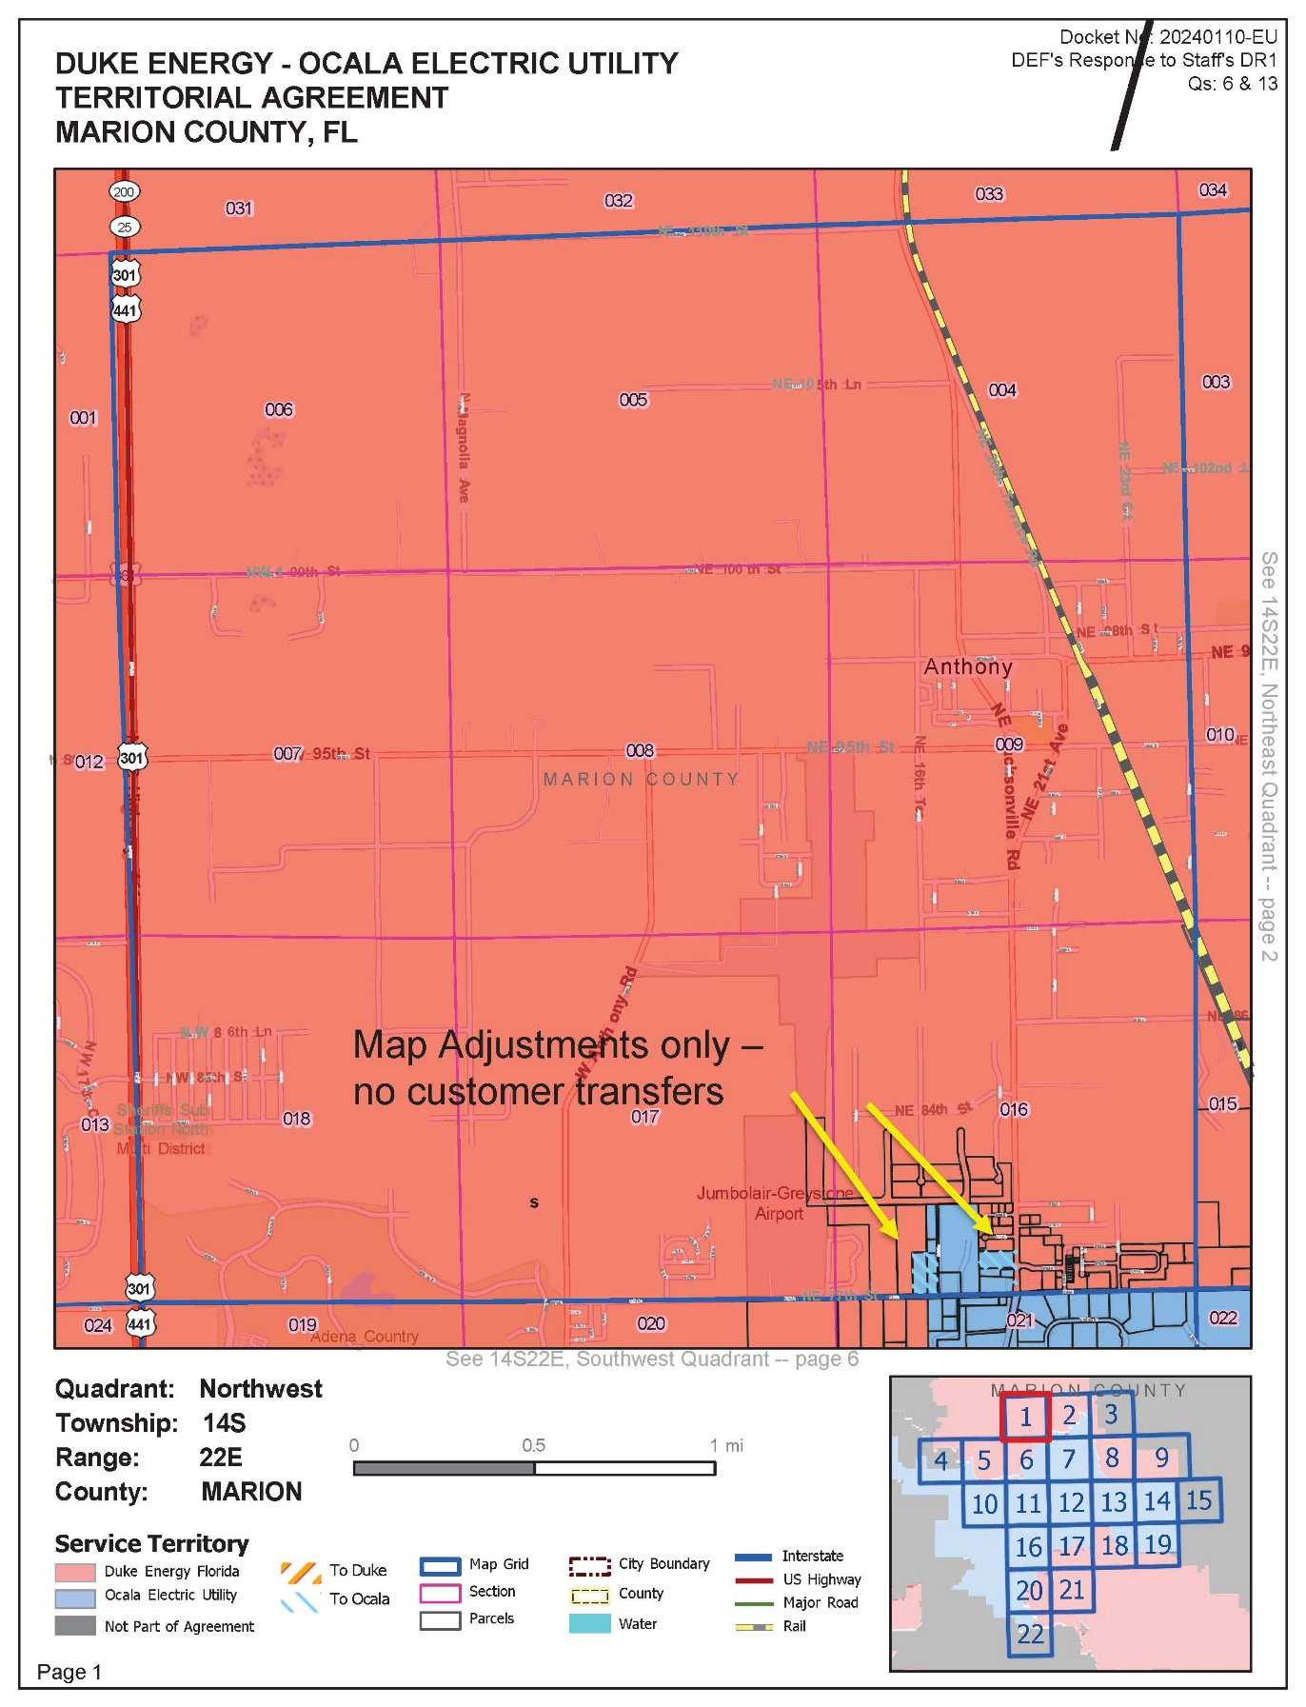

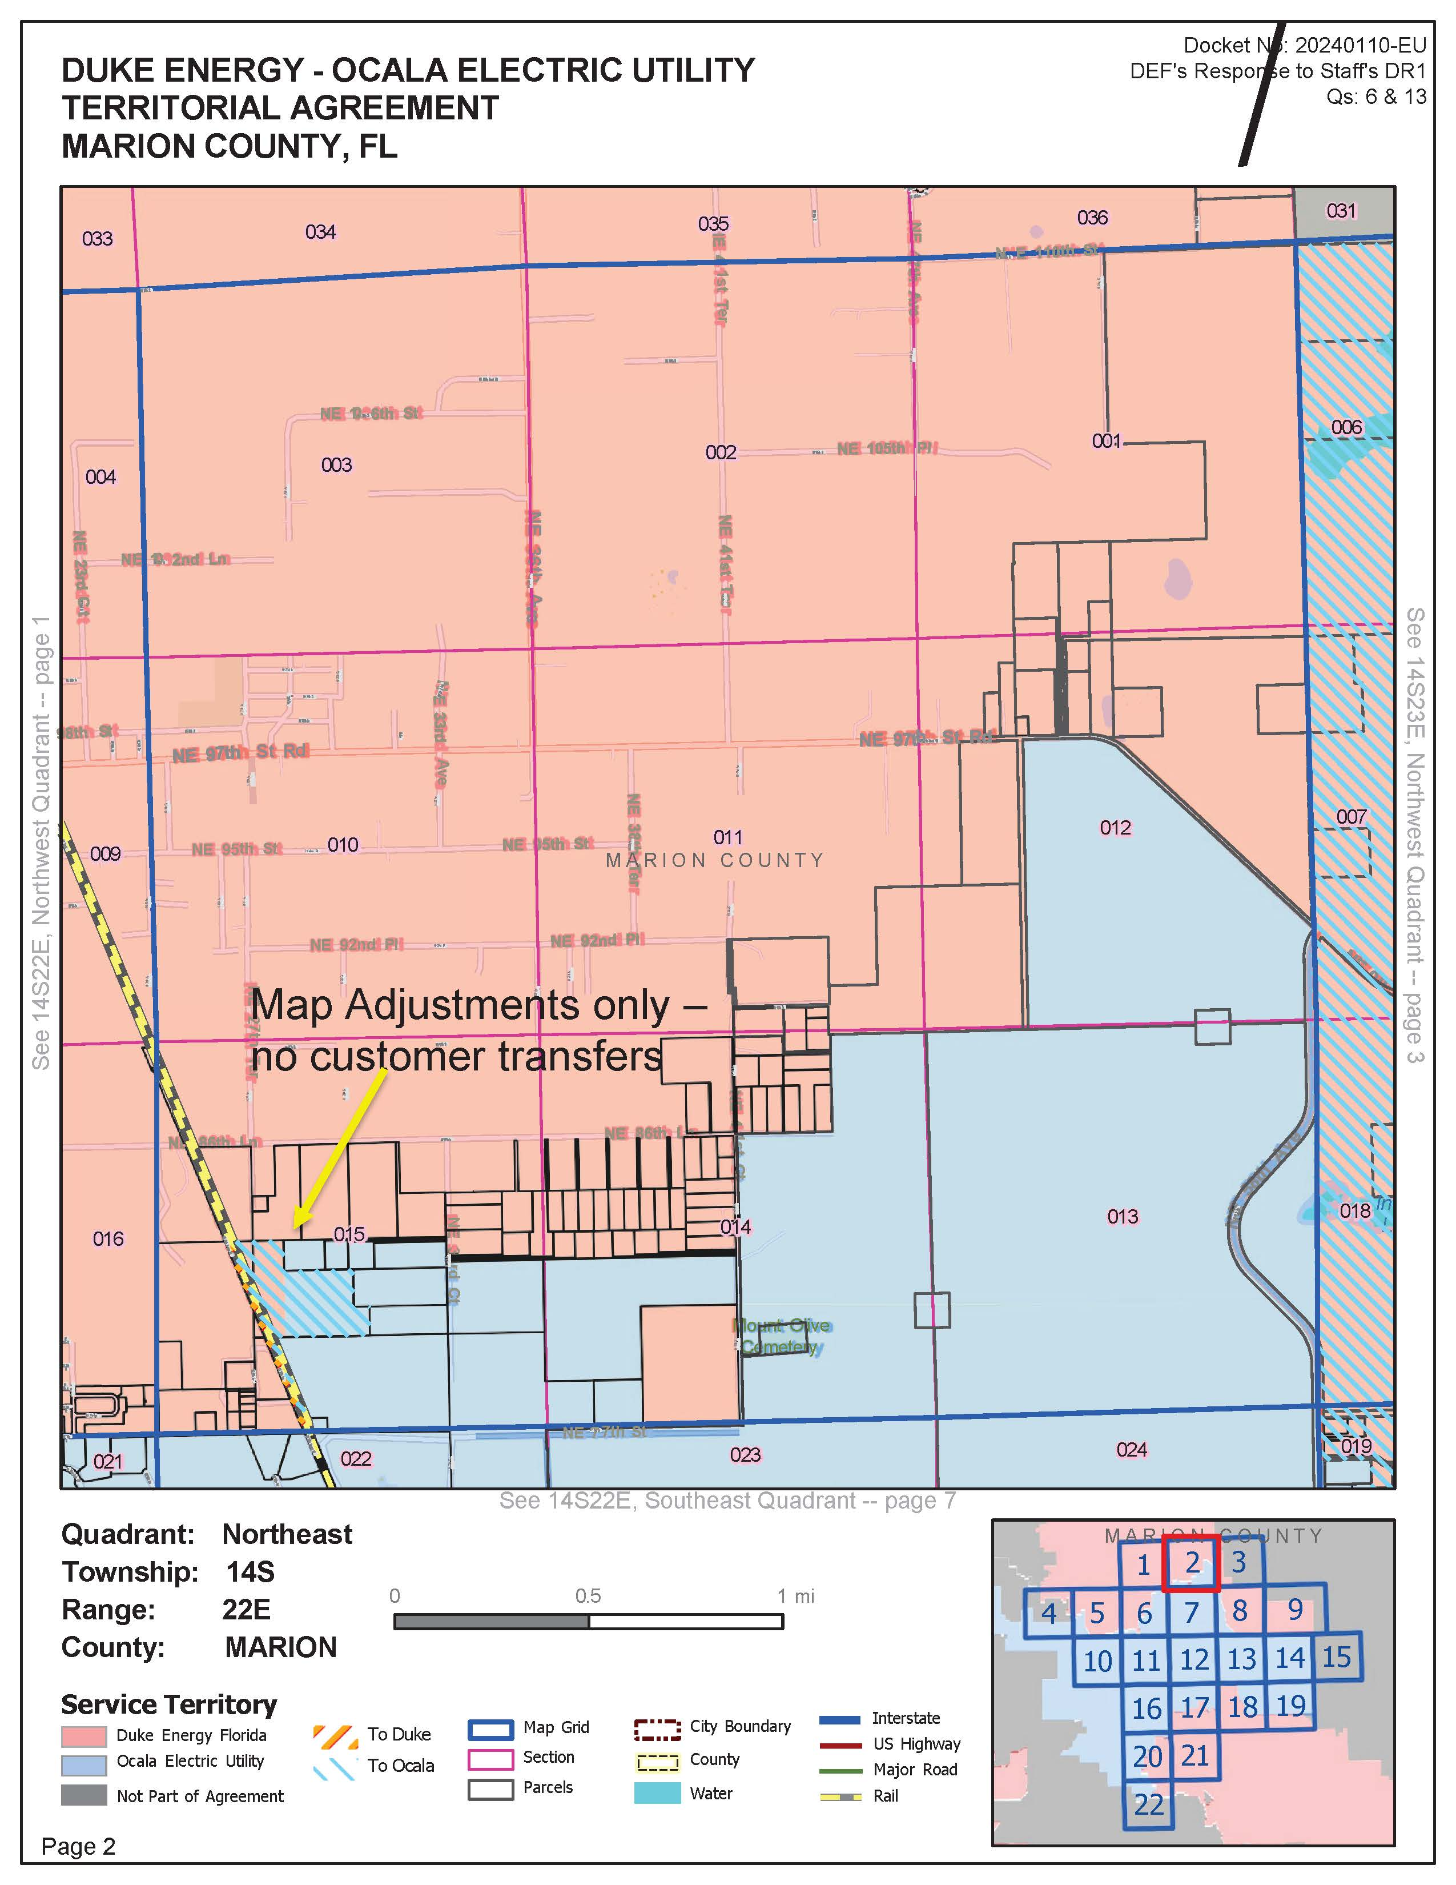

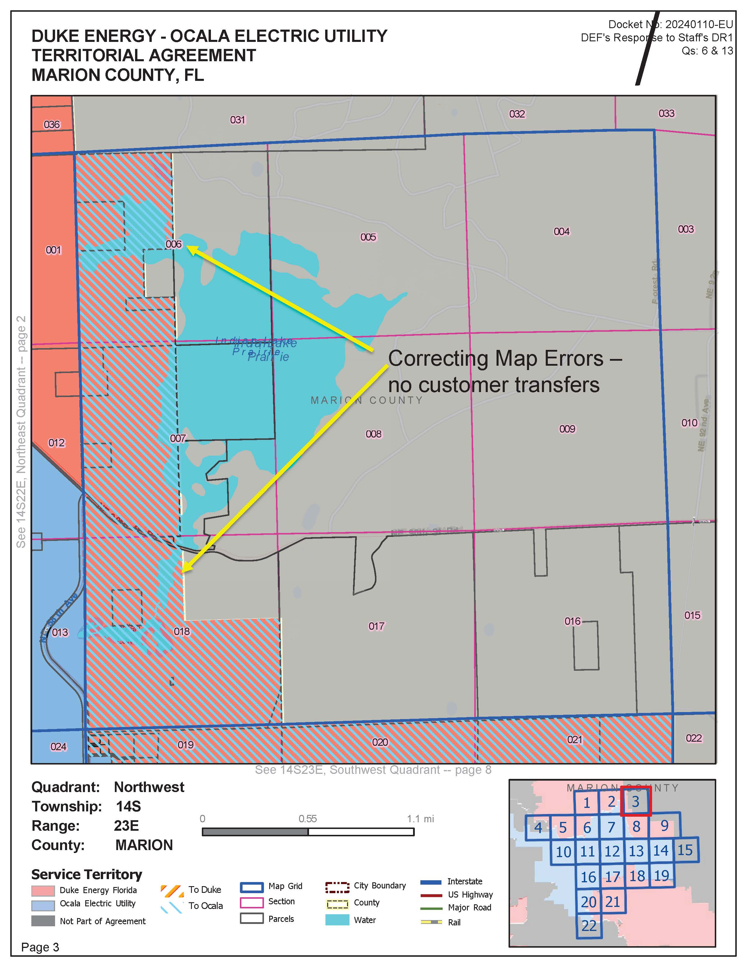

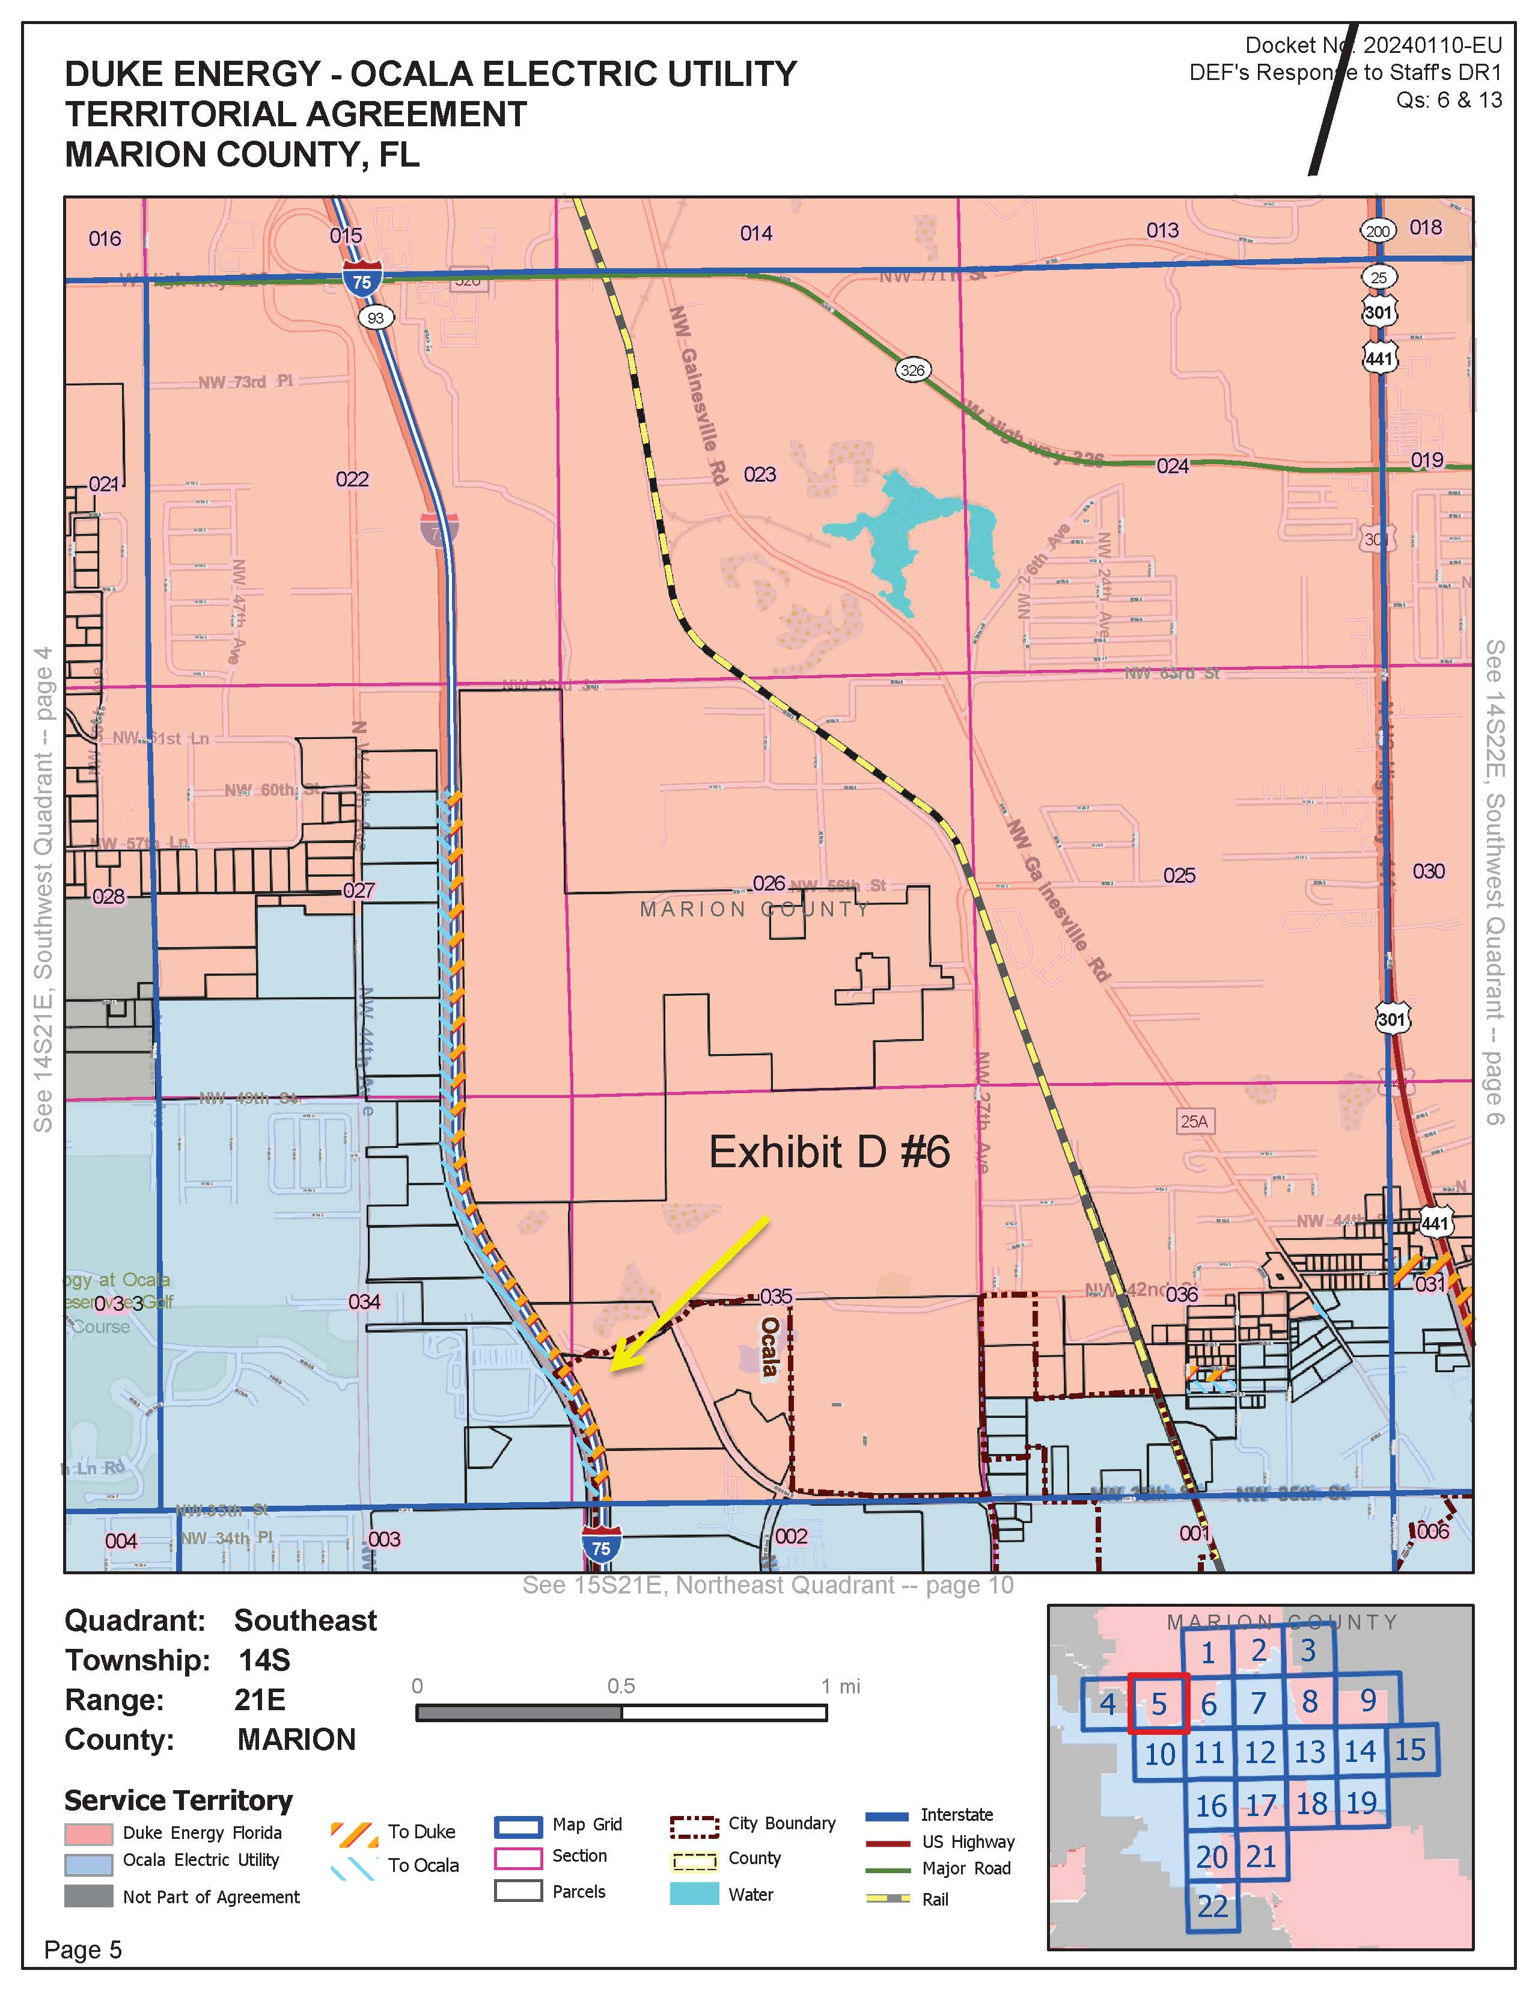

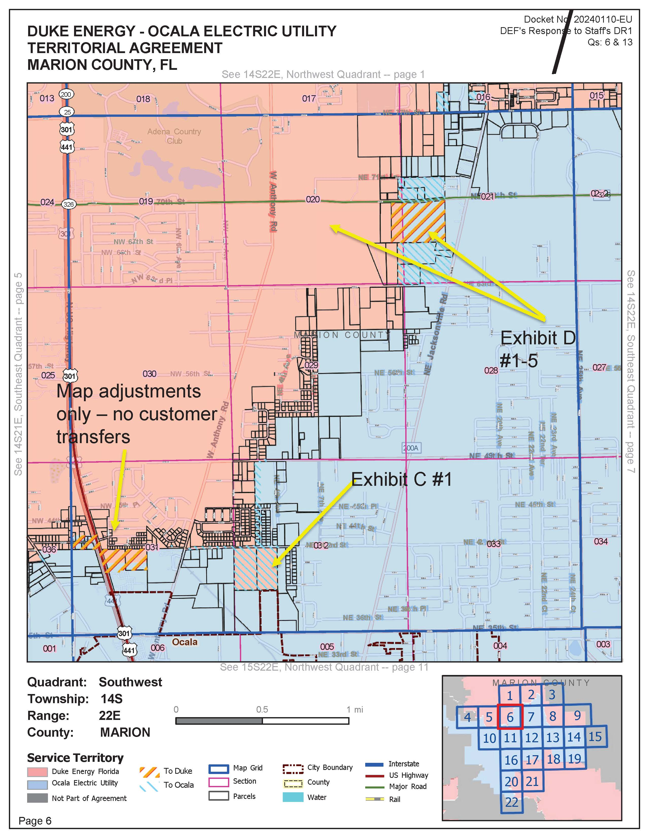

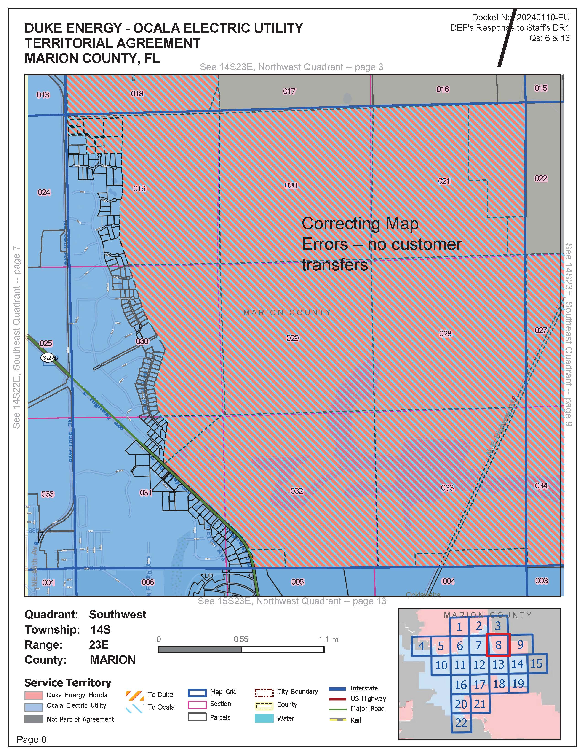

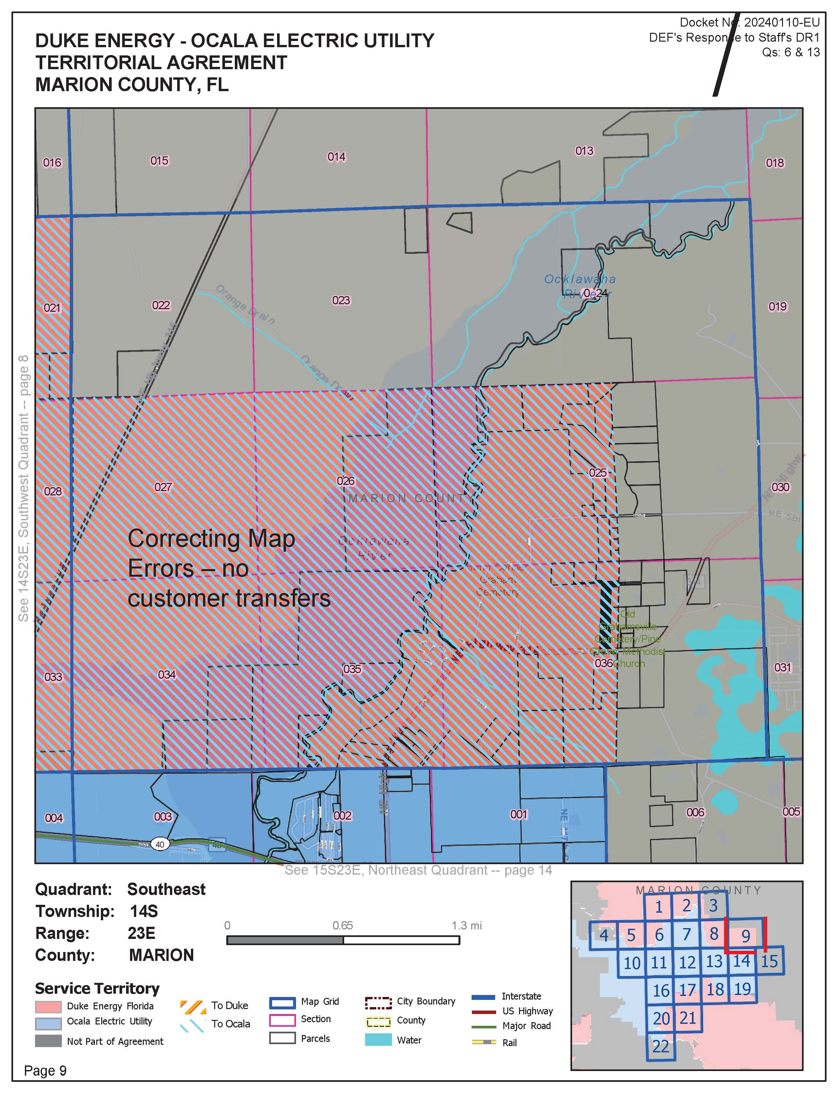

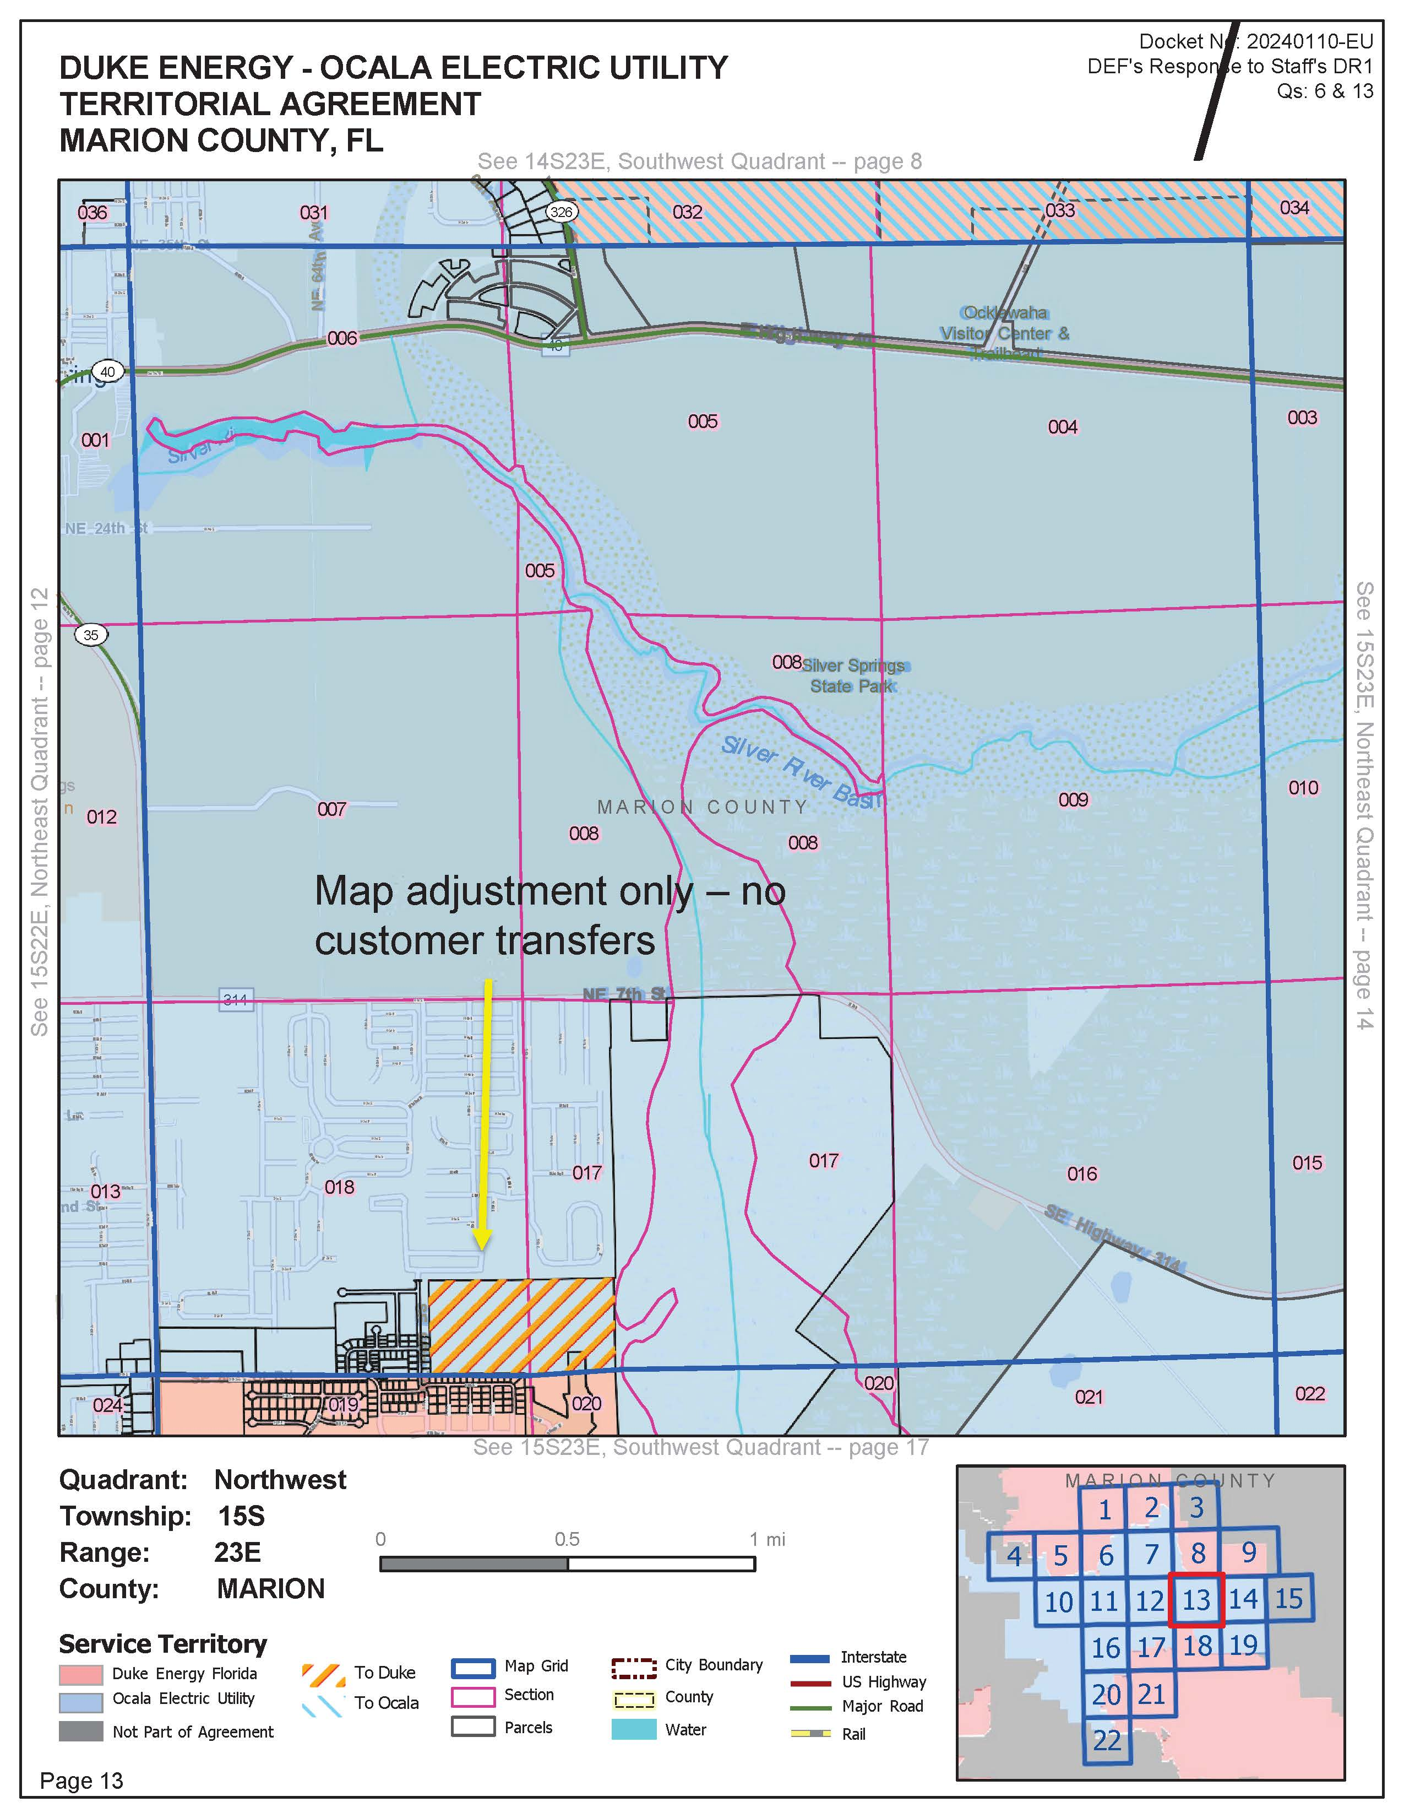

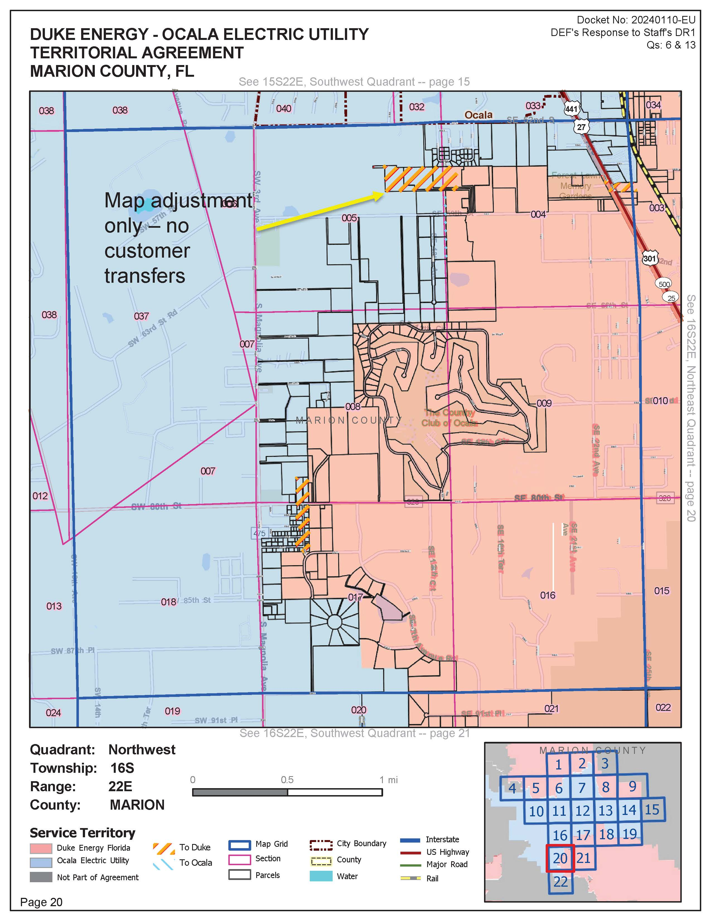

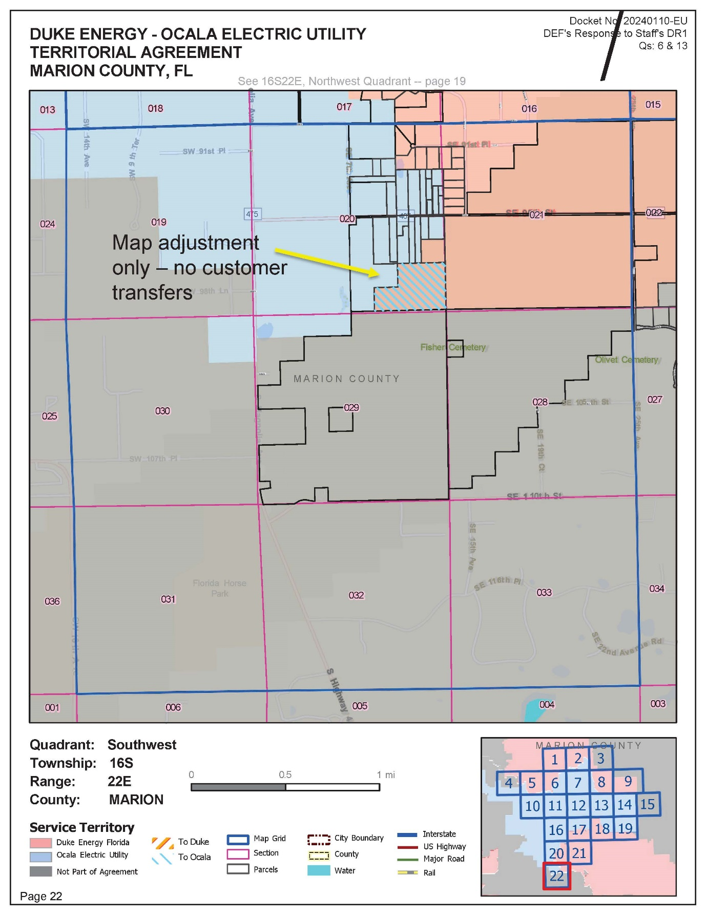

Order No. PSC-09-0485-CO-EU., issued July 6, 2009, in Docket No. 080724-EU, In re: Joint petition for approval of territorial agreement in Marion County by Ocala Electric Utility and Progress Energy Florida, Inc.
Document No. 08767-2024, joint petitioners’ response to our staff’s first data request, No. 2.a.
Utilities Commission of the City of New Smyrna Beach v. Florida Public Service Commission, 469 So. 2d 731 (Fla. 1985).
Document No. 08767-2024, joint petitioners’ response to our staff’s first data request, No. 3.a.
The joint petitioners provided maps in their application in conformity with Rule 25-6.0440(1)(f), F.A.C., that show their proposed boundary lines.
Document No. 08767-2024, joint petitioners’ response to our staff’s first data request, No. 6.
Document No. 08767-2024, joint petitioners’ response to our staff’s first data request, No.13.
Document No. 08767-2024, joint petitioners’ response to our staff’s first data request, No. 5.c.
Docket No. 20240110-EU, In re: Joint petition for approval of territorial agreement in Marion County, by City of Ocala and Duke Energy Florida, LLC.
Document No. 09305-2024, joint petitioners’ response to our staff’s second data request, No. 5.a.
Document No. 09305-2024, joint petitioners’ response to our staff’s second data request, No. 6.a.
Document No. 09305-2024, joint petitioners’ response to our staff’s second data request, No. 6.a.
Document No. 09305-2024, joint petitioners’ response to our staff’s second data request, No. 6.i.
Document No. 09305-2024, joint petitioners’ response to our staff’s second data request, No. 2.
Document No. 09305-2024, joint petitioners’ response to our staff’s second data request, No. 5.a.
Document No. 08767-2024, joint petitioners’ response to our staff’s first data request, No. 7.
Docket No. 20240110-EU, In re: Joint petition for approval of territorial agreement in Marion County, by City of Ocala and Duke Energy Florida, LLC.
Document No. 08767-2024, joint petitioners’ response to our staff’s first data request, No. 5.b.
Order No. PSC-09-0485-CO-EU., issued July 6, 2009, in Docket No. 080724-EU, In re: Joint petition for approval of territorial agreement in Marion County by Ocala Electric Utility and Progress Energy Florida, Inc.
Docket No. 20240110-EU, In re: Joint petition for approval of territorial agreement in Marion County, by City of Ocala and Duke Energy Florida, LLC.
Document No. 08767-2024, joint petitioners’ response to our staff’s first data request, No. 5.a.
Document No. 08767-2024, joint petitioners’ response to our staff’s first data request, No. 5.c and 5.d.
Document No. 08767-2024, joint petitioners’ response to our staff’s first data request, No. 5.d.
Docket No. 20240110-EU, In re: Joint petition for approval of territorial agreement in Marion County, by City of Ocala and Duke Energy Florida, LLC.
Document No. 08767-2024, joint petitioners’ response to our staff’s first data request, No. 10.c and 11.c.
Document No. 08767-2024, joint petitioners’ response to our staff’s first data request, No. 10.c and 11.c.
Docket No. 20240110-EU, In re: Joint petition for approval of territorial agreement in Marion County, by City of Ocala and Duke Energy Florida, LLC
Document No. 08767-2024, joint petitioners’ response to our staff’s first data request, No. 10.c and 11.c.
The joint petitioners have agreed to use a cost escalator, such as the Handy Whitman Index, or common engineering cost estimation methodology. See Docket No. 20240110-EU, In re: Joint petition for approval of territorial agreement in Marion County, by City of Ocala and Duke Energy Florida, LLC
Document No. 08767-2024, joint petitioners’ response to our staff’s first data request, No. 1.c.
Document No. 08767-2024, joint petitioners’ response to our staff’s first data request, No. 3.b.
Document No. 08767-2024, joint petitioners’ response to our staff’s first data request, No. 10.a and 11.a.
Document No. 08767-2024, joint petitioners’ response to our staff’s first data request, No. 10.b.
Document No. 08767-2024, joint petitioners’ response to our staff’s first data request, No. 11.b.
AmeriSteel Corp. v. Clark, 691 So. 2d 473, 480 (Fla. 1997). (“[T]he Commission was fully apprised of AmeriSteel's corporate interest in obtaining lower electricity rates before deciding to approve the JEA–FPL agreement.”)
Document No. 08767-2024, joint petitioners’ response to our staff’s first data request, No. 12.c.
Document No. 08767-2024, joint petitioners’ response to our staff’s first data request, No. 12.c.
See Order No. PSC-96-0755-FOF-EU, issued June 10, 1996, in Docket No. 19950307-EU, In re: Petition to resolve a territorial dispute with Florida Power & Light Company in St. Johns County, by Jacksonville Electric Authority.
Document No. 08767-2024, joint petitioners’ response to our staff’s first data request, No. 5.e and 8.b.

