BEFORE THE FLORIDA PUBLIC SERVICE COMMISSION

|  |  |
| --- | --- |
| In re: Petition for limited proceeding for recovery of incremental storm restoration costs related to Hurricanes Elsa, Eta, Isaias, Ian, Nicole, and Tropical Storm Fred, by Duke Energy Florida, LLC. | DOCKET NO. 20230020-EI |
| In re: Petition for limited proceeding for recovery of incremental storm restoration costs related to Hurricane Idalia, by Duke Energy Florida, LLC. | DOCKET NO. 20230116-EI  ORDER NO. PSC-2025-0204-FOF-EI  ISSUED: June 13, 2025 |

The following Commissioners participated in the disposition of this matter:

MIKE LA ROSA, Chairman

ART GRAHAM

GARY F. CLARK

ANDREW GILES FAY

GABRIELLA PASSIDOMO SMITH

ORDER APPROVING INCREMENTAL STORM COSTS

APPEARANCES:

MATTHEW R. BERNIER, STEPHANIE A. CUELLO, ESQUIRES, 106 East College Avenue, Tallahassee, Florida 32301; and DIANNE M. TRIPLETT, Deputy General Counsel, 299 First Avenue North, St. Petersburg, Florida 33701

On behalf of Duke Energy Florida, LLC (DEF).

WALT TRIERWEILER, Public Counsel, and CHARLES J. REHWINKEL, Deputy Public Counsel, ESQUIRES, Office of Public Counsel, c/o The Florida Legislature, 111 West Madison Street, Suite 812, Tallahassee, Florida 322399-1400

On behalf of Office of Public Counsel (OPC).

SUZANNE BROWNLESS, ESQUIRE, Florida Public Service Commission, 2540 Shumard Oak Boulevard, Tallahassee, Florida 32399-0850

On behalf of the Florida Public Service Commission (Staff).

MARY ANNE HELTON, ESQUIRE, Interim General Counsel, Florida Public Service Commission, 2540 Shumard Oak Boulevard, Tallahassee, Florida 32399-0850

Florida Public Service Commission Interim General Counsel.

BACKGROUND

On October 16, 2023, in Docket No. 20230116-EI, Duke Energy Florida, LLC (DEF) filed a petition seeking authority to implement an interim storm restoration recovery surcharge to recover approximately $91.9 million in incremental storm restoration costs, replenishment of the storm reserve, and interest related to Hurricane Idalia, to begin with the first billing cycle of January 2024 through December 31, 2024, subject to final true-up. At that time, DEF also requested approval to combine the remaining $73.9 million interim incremental storm restoration costs for Hurricanes Elsa, Eta, Isaias, Ian, Nicole, and Tropical Storm Fred, approved in Docket No. 20230020-EI, with Hurricane Idalia costs to recover a total of $166.1 million, over the January through December 31, 2024 time period. Order No. PSC-2023-0375-PCO-EI, issued December 19, 2023, approved the requested combined interim storm cost recovery of $166.1 million over the January through December 31, 2024 time period.

On May 14, 2024, Docket Nos. 20230020-EI and 20230116-EI were consolidated by Order No. PSC-2024-0151-PHO-EI. A hearing was held on May 21, 2024, to establish the final, prudent costs for Hurricanes Elsa, Eta, Isaias, Ian, Nicole, and Tropical Storm Fred. Final storm restoration costs for Hurricanes Elsa, Eta, Isaias, Ian, Nicole, and Tropical Storm Fred in the amount of $431,380,637 plus estimated interest were approved by Order No. PSC-2024-0377-FOF-EI, issued August 27, 2024. The Office of Public Counsel (OPC) was acknowledged as a party in Docket No. 20230116-EI by Order No. 2024-0050-PCO-EI, issued on May 14, 2024. Walmart, Inc. (Walmart) and PCS Phosphate-White Springs (PCS Phosphate) were parties to Docket No. 20230020-EI and became parties to Docket 20230116-EI upon the consolidation of the dockets on May 14, 2024. On May 13, 2025, Walmart filed a letter stating that it did not wish to participate in the May 19 Prehearing or the June 3 hearing resolving issues associated with Hurricane Idalia. That being the case, Walmart has not filed a Prehearing Statement in this proceeding and did not attend the May 19 Prehearing.

On September 23, 2024, DEF filed its petition to determine several issues: (1) to determine the prudent storm cost for Hurricane Idalia; (2) to determine the money actually collected over the April 2023 to December 2024 combined time period in which the storm cost recovery surcharge was in effect; (3) to combine the $431,380,637 costs approved as prudent for Hurricanes Elsa, Eta, Isaias, Ian, Nicole, and Tropical Storm Fred with the costs determined to be prudent for Hurricane Idalia; and (4) to calculate the true-up of collected moneys with the combined prudent storm recovery costs.

We held a final hearing on June 3, 2025, at which 13 exhibits and the prefiled testimony of Witnesses Christopher Menendez, Jimmy New, Todd Fountain and Curt Mouring were admitted into the record. There are eighteen identified issues in this docket which are all the subject of Type 1 Stipulations. Type 1 Stipulations occur when all parties agree on the stated resolution of an issue. We approved the proposed Type 1 Stipulations for all eighteen issues, as stated on Attachment A to this order, at the conclusion of the final hearing.

We have jurisdiction over this matter pursuant to Sections 366.04, 366.05, 377.06, and 366.076, Florida Statutes (F.S.).

DECISION

All proposed Type 1 Stipulations are supported by the record and consistent with controlling law. The positions taken in this case have been agreed to by all parties to the docket who represent both residential and commercial ratepayers. The positions taken in these Type 1 Stipulations are the result of negotiations primarily between OPC and DEF and are part of a multi-year process in which the methodology used to collect and verify storm costs has been reviewed and improved. On May 16, 2025, OPC and DEF filed a Stipulated Confirmations and Commitments document which further details the methods used to collect and evaluate the storm costs for Hurricane Idalia and future commitments by DEF to continue to improve the storm cost accounting methods. (Attachment B). This document confirms that the process methods used in collecting storm cost data in this docket comply with the requirements of Order No. PSC-2019-0232-AS-EI.[1] For these reasons we find that the Type 1 Stipulations are in the public interest and approve them.

As stated in the Type 1 Stipulations, we find that the prudently incurred retail storm cost for Hurricane Idalia is $97,052,694, plus interest to be determined, and the total reasonable and prudent amount of combined retail recoverable storm cost for Hurricanes Elsa, Eta, Isaias, Ian, Nicole and Tropical Storm Fred and for Hurricane Idalia, plus interest to be determined, is $534,739,867. The amount of revenues generated by the storm surcharge is $535,373,165. The over-recovery of approximately $633,298 will be refunded to DEF’s customers through the Fuel Clause docket, Docket 20250001-EI.

Based on the foregoing, it is

ORDERED by the Florida Public Service Commission that Duke Energy Florida, LLC’s petitions for recovery of incremental storm restoration cost for Hurricanes Elsa, Eta, Isaias, Ian, Nicole, Idalia and Tropical Storm Fred are hereby granted as set forth herein. It is further

ORDERED that prudent and reasonable retail storm cost for Hurricane Idalia is $97,052,694, plus interest to be determined, It is further

ORDERED that the combined recoverable storm cost for Hurricanes Elsa, Eta, Isaias, Ian, Nicole and Tropical Storm Fred and for Hurricane Idalia, plus interest to be determined, is $534,739,867. It is further

ORDERED that the Type 1 Stipulations in Attachment A to this order are approved. It is further

ORDERED that these dockets shall remain open until the final calculation of over-recovery is computed and distributed in the Fuel Clause docket, Docket No. 20250001-EI.

By ORDER of the Florida Public Service Commission this 13th day of June, 2025.

|  |  |
| --- | --- |
|  | /s/ Adam J. Teitzman |
|  | ADAM J. TEITZMAN  Commission Clerk |

Florida Public Service Commission

2540 Shumard Oak Boulevard

Tallahassee, Florida 32399

(850) 413‑6770

www.floridapsc.com

Copies furnished: A copy of this document is provided to the parties of record at the time of issuance and, if applicable, interested persons.

SBr

NOTICE OF FURTHER PROCEEDINGS OR JUDICIAL REVIEW

The Florida Public Service Commission is required by Section 120.569(1), Florida Statutes, to notify parties of any administrative hearing or judicial review of Commission orders that is available under Sections 120.57 or 120.68, Florida Statutes, as well as the procedures and time limits that apply. This notice should not be construed to mean all requests for an administrative hearing or judicial review will be granted or result in the relief sought.

Any party adversely affected by the Commission's final action in this matter may request: 1) reconsideration of the decision by filing a motion for reconsideration with the Office of Commission Clerk, 2540 Shumard Oak Boulevard, Tallahassee, Florida 32399-0850, within fifteen (15) days of the issuance of this order in the form prescribed by Rule 25-22.060, Florida Administrative Code; or 2) judicial review by the Florida Supreme Court in the case of an electric, gas or telephone utility or the First District Court of Appeal in the case of a water and/or wastewater utility by filing a notice of appeal with the Office of Commission Clerk, and filing a copy of the notice of appeal and the filing fee with the appropriate court. This filing must be completed within thirty (30) days after the issuance of this order, pursuant to Rule 9.110, Florida Rules of Appellate Procedure. The notice of appeal must be in the form specified in Rule 9.900(a), Florida Rules of Appellate Procedure.

ATTACHMENT A

BEFORE THE FLORIDA PUBLIC SERVICE COMMISSION

|  |  |
| --- | --- |
| In re: Petition for limited proceeding for recovery of incremental storm restoration costs related to Hurricanes Elsa, Eta, Isaias, Ian, Nicole, and Tropical Storm Fred, by Duke Energy Florida, LLC. | DOCKET NO. 20230020-EI |
| In re: Petition for limited proceeding for recovery of incremental storm restoration costs related to Hurricane Idalia, by Duke Energy Florida, LLC. | DOCKET NO. 20230116-EI  ORDER NO.  ISSUED: |

PROPOSED STIPULATIONS

The following issues are proposed as Type 1 Stipulations on all issues in this docket. A Type 1 Stipulation occurs on an issue when all parties agree on the stated resolution of the issue. The proposed stipulations are as follows:

**ISSUE 1:** Should the incremental cost and capitalization approach (ICCA) found in Rule 25-6.0143, F.A.C., be used to determine the reasonable and prudent amounts to be included in restoration costs for Hurricane Idalia?

**Stipulation:** The ICAA approach in Rule 25-6.0143, F.A.C., and the terms of the 2019 Irma Settlement Agreement approved by Order No. PSC-2019-0232-AS-EI should be used to determine the reasonable and prudent amounts included in the restoration costs.

**ISSUE 2:** Have the terms of DEF’s 2021 Settlement Agreement, approved by Order No. PSC-2021-0202A-AS-EI, issued June 28, 2021, been compiled with? If not, why not?

**Stipulation:** Yes.

**ISSUE 3:** What is the reasonable and prudent amount of regular payroll expense to be included in Total Storm Related Restoration Costs for Hurricane Idalia?

**Stipulation:** The reasonable and prudent amount of regular payroll expense is $2,727,108 to be included in the total storm related restoration costs for Hurricane Idalia.

**ISSUE 4:** What is the reasonable and prudent amount of overtime payroll expense to be included in Total Storm Related Restoration Costs for Hurricane Idalia?

**Stipulation:** The reasonable and prudent amount of overtime payroll expense is $6,240,229 to be included in the total storm related restoration costs for Hurricane Idalia.

**ISSUE 5:** What is the reasonable and prudent amount of contactor costs, including vegetation and line clearing, to be included in Total Storm Related Restoration Costs for Hurricane Idalia?

**Stipulation:** The reasonable and prudent amount of contractor costs is $77,261,347 to be included in the total storm related restoration costs for Hurricane Idalia.

**ISSUE 6:** What is the reasonable and prudent amount of vehicle and fuel expense to be included in Total Storm Related Restoration Costs for Hurricane Idalia?

**Stipulation:** The reasonable and prudent amount of vehicle and fuel expense is $1,199,229 to be included in the total storm related restoration costs for Hurricane Idalia.

**ISSUE 7:** What is the reasonable and prudent amount of employee expenses to be included in Total Storm Related Restoration Costs for Hurricane Idalia?

**Stipulation:** The reasonable and prudent amount of employee expenses is $721,666 to be included in the total storm related restoration costs for Hurricane Idalia.

**ISSUE 8:** What is the reasonable and prudent amount of materials and supplies expense to be included in Total Storm Related Restoration Costs for Hurricane Idalia?

**Stipulation:** The reasonable and prudent amount of material and supplies expense is $12,265,808 to be included in the total storm related restoration costs for Hurricane Idalia.

**ISSUE 9:** What is the reasonable and prudent amount of other costs to be included in Total Storm Related Restoration Costs for Hurricane Idalia?

**Stipulation:** The reasonable and prudent amount of other costs is $5,033,852 and $17,592,325 in logistics costs to be included in the total storm related restoration costs for Hurricane Idalia.

**ISSUE 10:** What is the reasonable and prudent total amount of costs to be included in Total Storm Related Restoration Costs for Hurricane Idalia?

**Stipulation:** The reasonable and prudent total amount of costs to be included is $123,041,564 to be included in the total storm related restoration costs for Hurricane Idalia.

**ISSUE 11:** What is the reasonable and prudent amount of storm-related costs that should be capitalized for Hurricane Idalia?

**Stipulation:** The reasonable and prudent amount of storm-related costs that should be capitalized is $18,110,417 for Hurricane Idalia.

**ISSUE 12:** What is the reasonable and prudent amount of storm-related costs that should be ICCA non-incremental O&M adjustments for Hurricane Idalia?

**Stipulation:** The reasonable and prudent amount of storm-related costs that should be ICCA non-incremental O&M adjustments for Hurricane Idalia is $4,510,971.

**ISSUE 13:** What is the reasonable and prudent amount of retail Recoverable Storm Costs for Hurricane Idalia?

**Stipulation:** The reasonable and prudent amount of retail Recoverable Storm Costs for Hurricane Idalia is $97,052,694 plus interest to be determined.

**ISSUE 14:** What is the reasonable and prudent amount of the combined retail Recoverable Storm Costs for Hurricanes Elsa, Eta, Isaias, Ian, Nicole, Tropical Storm Fred and Hurricane Idalia?

**Stipulation:** The reasonable and prudent amount of the combined retail recoverable storm costs for Hurricanes Elsa, Eta, Isaias, Ian, Nicole, and Tropical Storm Fred is $437,687,173 and for Hurricane Idalia is $97,052,694, plus interest to be determined subsequently, for a total of $534,739,867.

**ISSUE 15:** What is the combined amount of Recoverable Storm Costs recovered through the Storm Cost Recovery Surcharge for Hurricanes Elsa, Eta, Isaias, Ian, Nicole, Tropical Storm Fred and Hurricane Idalia?

**Stipulation:** The combined amount of revenues from the storm surcharge is $535,373,165.

**ISSUE 16:** What is the appropriate accounting treatment associated with any storm cost for Hurricane Idalia found to have been imprudently recovered?

**Stipulation:** Imprudently incurred storm costs should not be charged to the storm reserve or recovered through a storm restoration charge on customer bills. No storm restoration costs were imprudently incurred; therefore, no such adjustment is necessary.

**ISSUE 17:** If applicable, how should any under-recovery or over-recovery be handled?

**Stipulation:** DEF will compare the final storm recovery amount approved by the Commission to actual revenues from the storm restoration charge to determine any excess or shortfall. Interest will be applied to this amount at the 30-day commercial paper rate. Thereafter, DEF will collect or refund the excess or shortfall through the fuel clause.

**ISSUE 18:** Should these dockets be closed?

**Stipulation:** No.

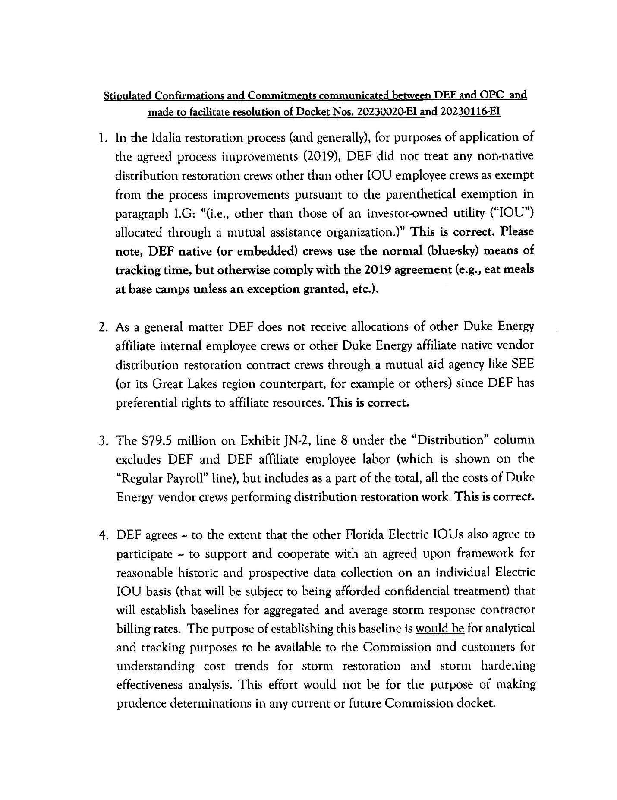

1. Order No. PSC-0232-AS-EI, issued June 13, 2019, in Docket No. 20170272-EI, *In re: Application for limited proceeding for recovery of incremental storm restoration costs related to Hurricanes Irma and Nate, by Duke Energy Florida, LLC.*