BEFORE THE FLORIDA PUBLIC SERVICE COMMISSION

|  |  |
| --- | --- |
| In re: Petition for approval of renewable energy tariff and standard offer contract, by Florida Power & Light Company. | DOCKET NO. 20250056-EQ  ORDER NO. PSC-2025-0208-PAA-EQ  ISSUED: June 17, 2025 |

The following Commissioners participated in the disposition of this matter:

MIKE LA ROSA, Chairman

ART GRAHAM

GARY F. CLARK

ANDREW GILES FAY

GABRIELLA PASSIDOMO SMITH

NOTICE OF PROPOSED AGENCY ACTION

ORDER APPROVING STANDARD OFFER CONTRACT

FOR FLORIDA POWER & LIGHT COMPANY

NOTICE is hereby given by the Florida Public Service Commission that the action discussed herein is preliminary in nature and will become final unless a person whose interests are substantially affected files a petition for a formal proceeding, pursuant to Rule 25-22.029, Florida Administrative Code (F.A.C.).

Background

Section 366.91(3), Florida Statutes (F.S.), requires each investor-owned utility (IOU) to continuously offer to purchase capacity and energy from renewable generating facilities (RF) and small qualifying facilities (QF). Rules 25-17.200 through 25-17.310, Florida Administrative Code (F.A.C.), implement the statute and require each IOU to file with this Commission, by April 1 of each year, a revised standard offer contract based on the next avoidable fossil-fueled generating unit of each technology type identified in the utility’s current Ten-Year Site Plan (TYSP). On April 1, 2025, Florida Power & Light Company (FPL) filed a petition for approval of its renewable energy tariff and amended standard offer contract based on its 2025 TYSP. We have jurisdiction over this matter pursuant to Sections 366.04, 366.041, 366.05, 366.055, 366.06, and 366.91, F.S.

Analysis and Decision

Section 366.91(3), F.S., and Rule 25-17.250, F.A.C., require that an IOU continuously make available a standard offer contract for the purchase of firm capacity and energy from RFs qualifying facilities QFs with design capacities of 100 kilowatts (kW) or less. Pursuant to Rules 25-17.250(1) and (3), F.A.C., the standard offer contract must provide a term of at least 10 years, and the payment terms must be based on the utility’s next avoidable fossil-fueled generating unit identified in its most recent TYSP, or if no avoided unit is identified, its next avoidable planned purchase.

FPL has identified a 469 megawatt (MW) natural gas-fueled combustion turbine (CT) as the next avoidable planned generating unit in its 2025 TYSP. [1] The projected in-service date of the avoided CT is June 1, 2032, with planned construction beginning in 2028. Pursuant to Rule 25-17.250, F.A.C., when this unit is no longer available to be used for the standard offer contract, such as when the utility commences construction, FPL must file a revised standard offer contract based on the next unit of the same generating type, if any. Based on FPL’s 2025 TYSP, there are currently no further avoidable fossil-fueled generating units identified.

Under FPL’s amended standard offer contract, the RF/QF operator commits to certain minimum performance requirements based on the identified avoided unit, such as being operational and delivering an agreed upon amount of capacity by the in-service date of the avoided unit, and thereby becomes eligible for capacity payments in addition to payments received for energy. The standard offer contract may also serve as a starting point for negotiation of contract terms by providing payment information to an RF/QF operator, in a situation where one or both parties desire particular contract terms other than those established in the standard offer.

In order to promote renewable generation, the Commission requires each IOU to offer multiple options for capacity payments, including the options to receive early or levelized payments. If the RF/QF operator elects to receive capacity payments under the normal or levelized contract options, it will receive as-available energy payments only until the in-service date of the avoided unit (in this case June 1, 2032), and thereafter, begin receiving capacity payments in addition to firm energy payments. If either the early or early levelized option is selected, then the operator will begin receiving capacity payments earlier than the in-service date of the avoided unit. However, payments made under the early capacity payment options tend to be lower in the later years of the contract term, because the net present value (NPV) of the total payments must remain equal for all contract payment options.

Table 1 contains FPL’s estimates of the annual payments for each payment option available under the revised standard offer contract to an operator with a 50 MW facility operating at a capacity factor of 94 percent, which is the minimum capacity factor required under the contract to qualify for full capacity payments. Normal and levelized capacity payments begin with the projected in-service date of the avoided unit (June 1, 2032) and continue for 10 years, while early and early levelized capacity payments begin 4 years prior to the in-service date, or 2028, for this example.

Table 1

Estimated Annual Payments to a 50 MW Renewable Facility

(94% Capacity Factor)

|  |  |  |  |  |  |
| --- | --- | --- | --- | --- | --- |
| Year | Energy Payment | Capacity Payment | | | |
| Normal | Levelized | Early | Early Levelized |
| $(000) | $(000) | $(000) | $(000) | $(000) |
| 2026 | 10,835 | - | - | - | - |
| 2027 | 12,603 | - | - | - | - |
| 2028 | 11,936 | - | - | 1,975 | 2,204 |
| 2029 | 17,376 | - | - | 3,427 | 3,778 |
| 2030 | 13,022 | - | - | 3,497 | 3,778 |
| 2031 | 17,324 | - | - | 3,568 | 3,778 |
| 2032 | 18,319 | 3,414 | 3,698 | 3,641 | 3,778 |
| 2033 | 15,670 | 5,922 | 6,339 | 3,716 | 3,778 |
| 2034 | 8,401 | 6,043 | 6,339 | 3,792 | 3,778 |
| 2035 | 19,460 | 6,167 | 6,339 | 3,870 | 3,778 |
| 2036 | 12,195 | 6,293 | 6,339 | 3,949 | 3,778 |
| 2037 | 14,736 | 6,422 | 6,339 | 4,030 | 3,778 |
| 2038 | 9,271 | 6,553 | 6,339 | 4,112 | 3,778 |
| 2039 | 20,305 | 6,687 | 6,339 | 4,196 | 3,778 |
| 2040 | 18,798 | 6,824 | 6,339 | 4,282 | 3,778 |
| 2041 | 18,079 | 6,964 | 6,339 | 4,370 | 3,778 |
| 2042 | 11,247 | 7,107 | 6,339 | 4,459 | 3,778 |
| 2043 | 25,975 | 7,252 | 6,339 | 4,495 | 3,778 |
| 2044 | 27,946 | 7,401 | 6,339 | 4,494 | 3,778 |
| 2045 | 20,354 | 3,173 | 2,703 | 1,371 | 1,715 |
| Total | 323,852 | 86,223 | 84,323 | 67,438 | 69,963 |
| Total (NPV) | 146,420 | 30,779 | 30,779 | 30,779 | 30,779 |

Source: FPL’s Response to Staff’s First Data Request.[2]

FPL’s amended standard offer contract, in type-and-strike format, is included as Attachment A to this Order. The changes made to FPL’s tariff sheets are consistent with the updated avoided unit. Revisions include updates to calendar dates and payment information which reflect the current economic and financial assumptions for the avoided unit.

Conclusion

We find that the provisions of FPL’s renewable energy tariff and amended standard offer contract conform to the requirements of Rules 25-17.200 through 25-17.310, F.A.C. The amended standard offer contract offers multiple payment options so that a developer of renewable generation may select the payment stream best suited to its financial needs.

Based on the foregoing, it is

ORDERED by the Florida Public Service Commission that Florida Power & Light Company’s Petition for Approval of a Renewable Energy Tariff and Standard Offer Contract is GRANTED. The revised renewable energy tariff and amended standard offer contract are approved as set forth herein. It is further

ORDERED that the provisions of this Order, issued as proposed agency action, shall become final and effective upon the issuance of a Consummating Order unless an appropriate petition, in the form provided by Rule 28-106.201, F.A.C., is received by the Commission Clerk, 2540 Shumard Oak Boulevard, Tallahassee, Florida 32399-0850, by the close of business on the date set forth in the “Notice of Further Proceedings or Judicial Review” attached hereto. It is further

ORDERED that this docket shall be closed upon the issuance of a consummating order, unless a person whose substantial interests are affected by the Commission’s decision files a protest within 21 days of the issuance of the Commission’s Proposed Agency Action Order. Potential signatories should be aware that, if a timely protest is filed, FPL’s standard offer contract may subsequently be revised.

By ORDER of the Florida Public Service Commission this 17th day of June, 2025.

|  |  |
| --- | --- |
|  | /s/ Adam J. Teitzman |
|  | ADAM J. TEITZMAN  Commission Clerk |

Florida Public Service Commission

2540 Shumard Oak Boulevard

Tallahassee, Florida 32399

(850) 413‑6770

www.floridapsc.com

Copies furnished: A copy of this document is provided to the parties of record at the time of issuance and, if applicable, interested persons.

JDI

NOTICE OF FURTHER PROCEEDINGS OR JUDICIAL REVIEW

The Florida Public Service Commission is required by Section 120.569(1), Florida Statutes, to notify parties of any administrative hearing that is available under Section 120.57, Florida Statutes, as well as the procedures and time limits that apply. This notice should not be construed to mean all requests for an administrative hearing will be granted or result in the relief sought.

Mediation may be available on a case-by-case basis. If mediation is conducted, it does not affect a substantially interested person's right to a hearing.

The action proposed herein is preliminary in nature. Any person whose substantial interests are affected by the action proposed by this order may file a petition for a formal proceeding, in the form provided by Rule 28-106.201, Florida Administrative Code. This petition must be received by the Office of Commission Clerk, 2540 Shumard Oak Boulevard, Tallahassee, Florida 32399-0850, by the close of business on July 8, 2025.

In the absence of such a petition, this order shall become final and effective upon the issuance of a Consummating Order.

Any objection or protest filed in this/these docket(s) before the issuance date of this order is considered abandoned unless it satisfies the foregoing conditions and is renewed within the specified protest period.

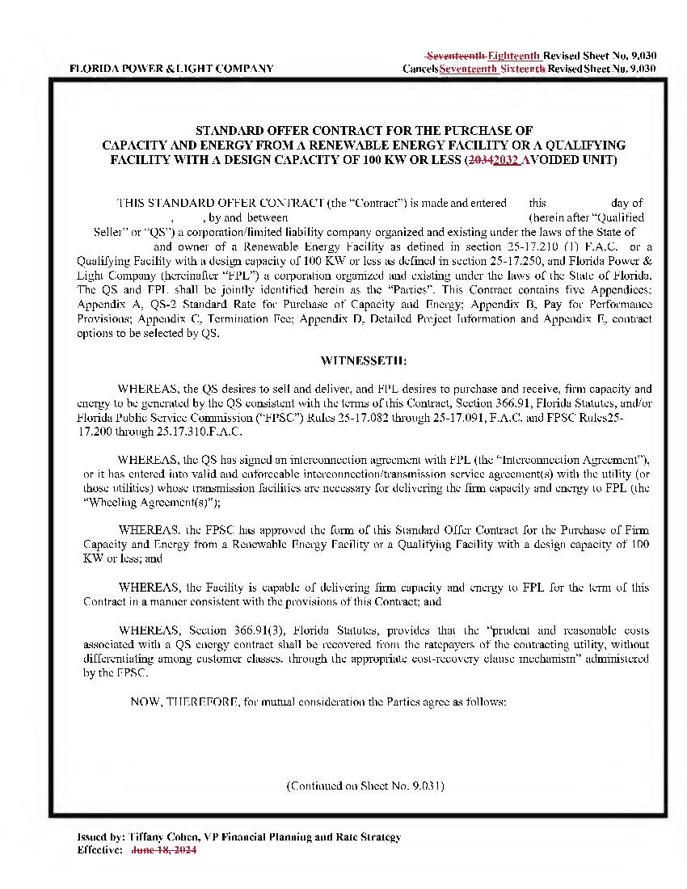

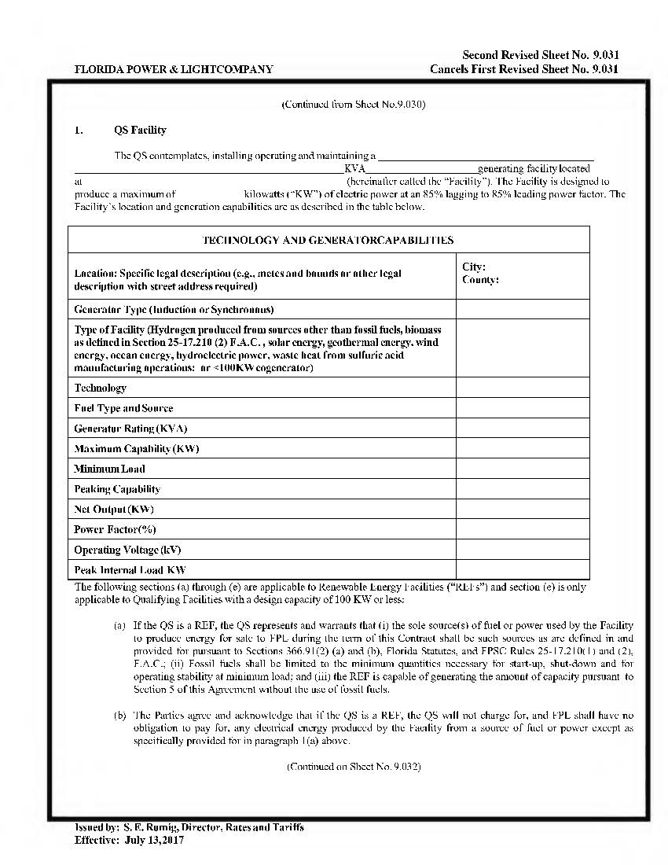

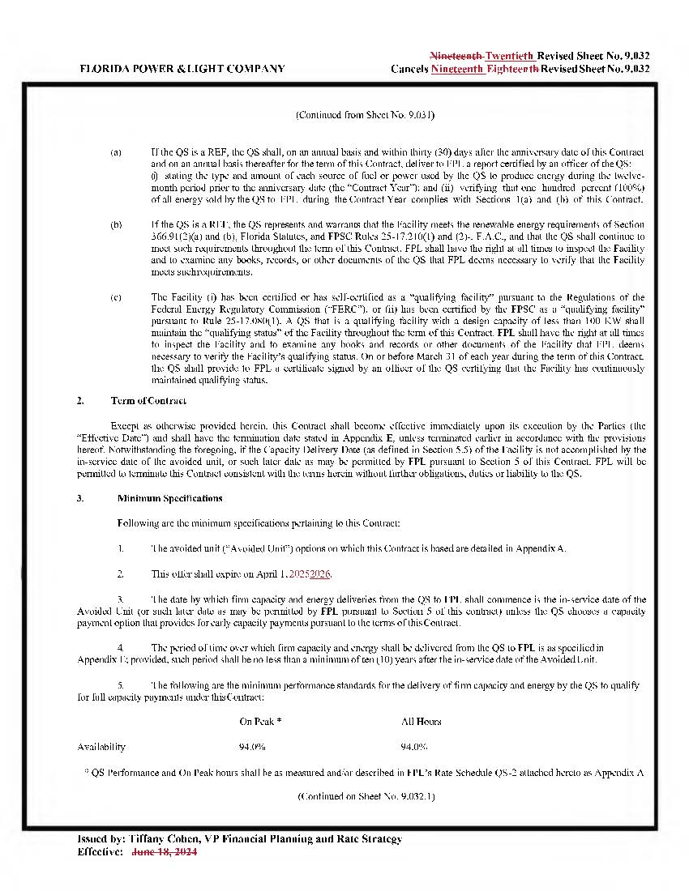

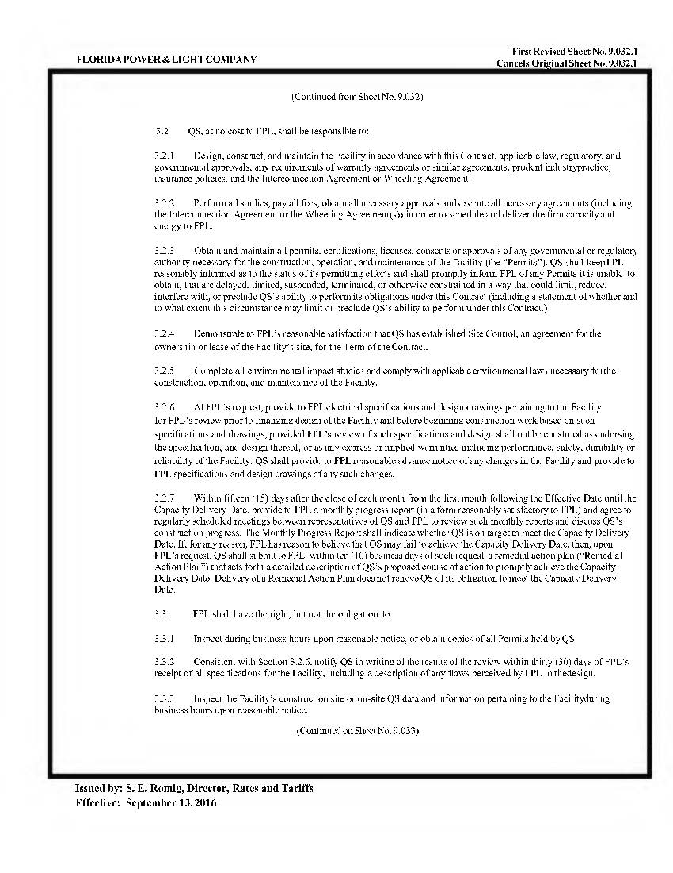

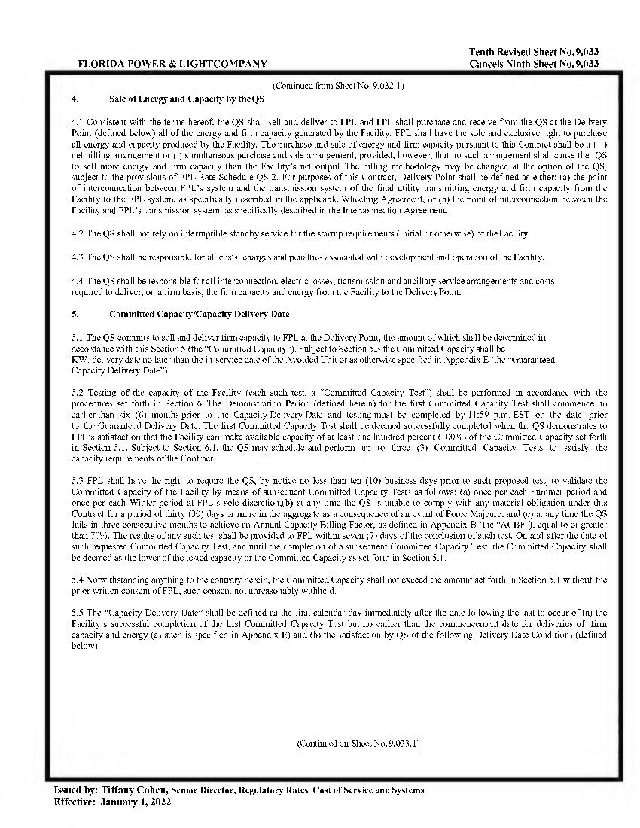

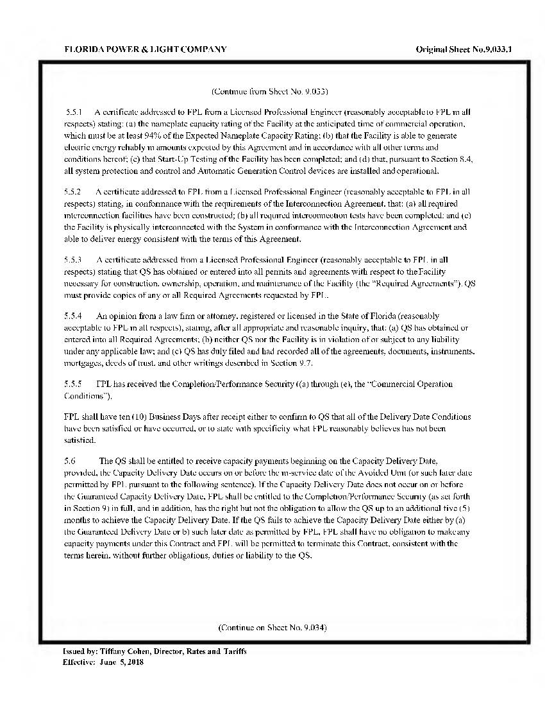

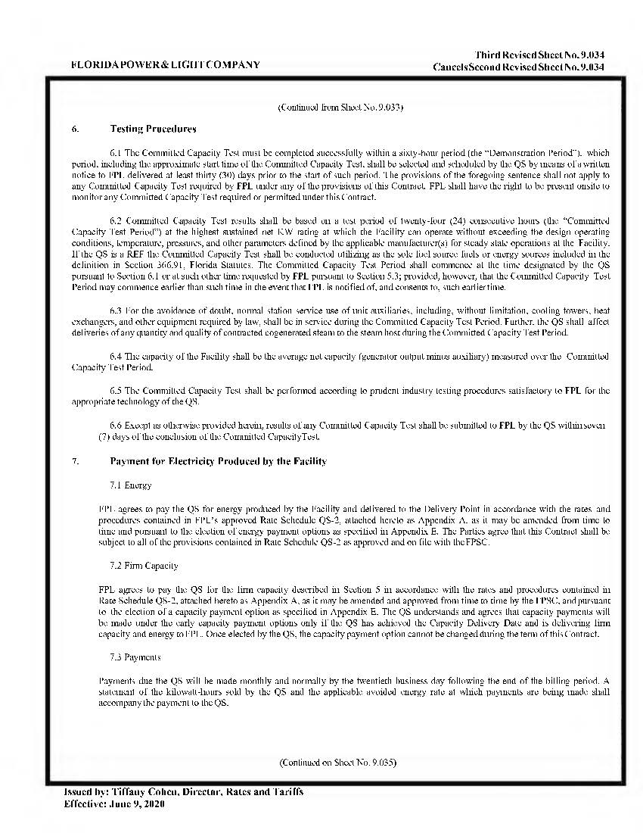

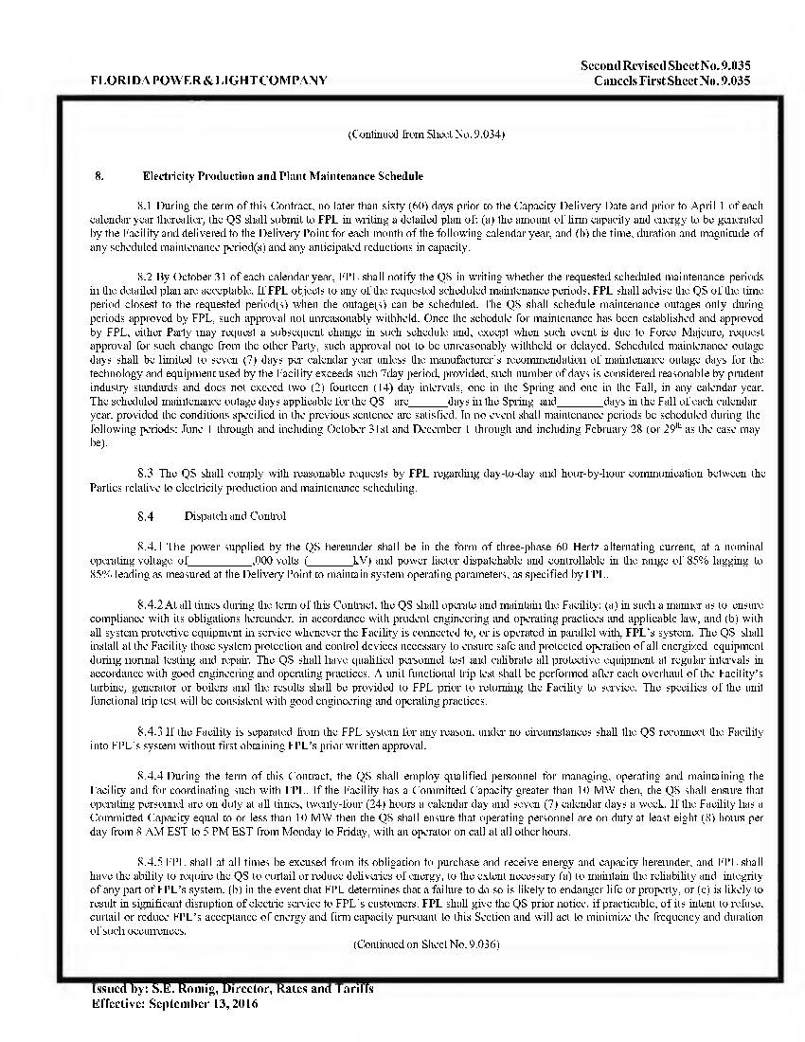

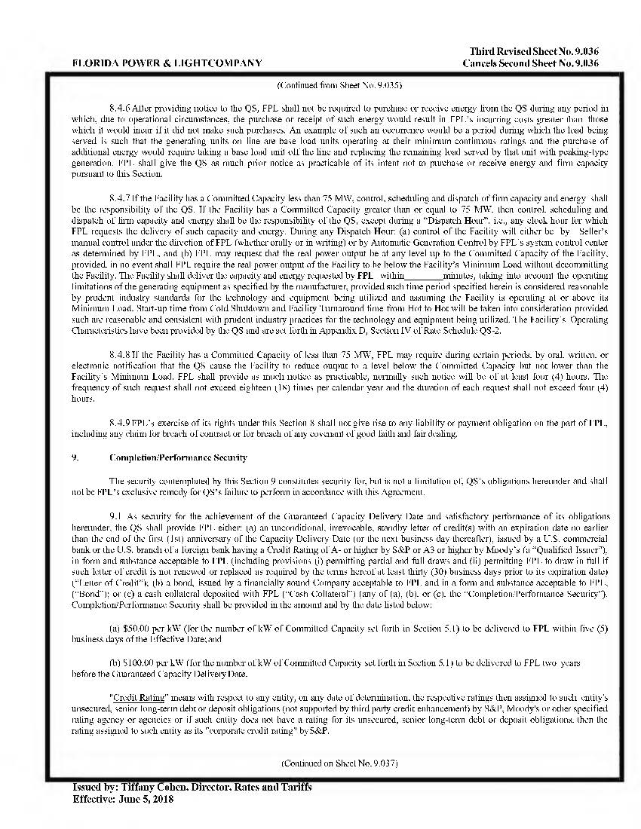

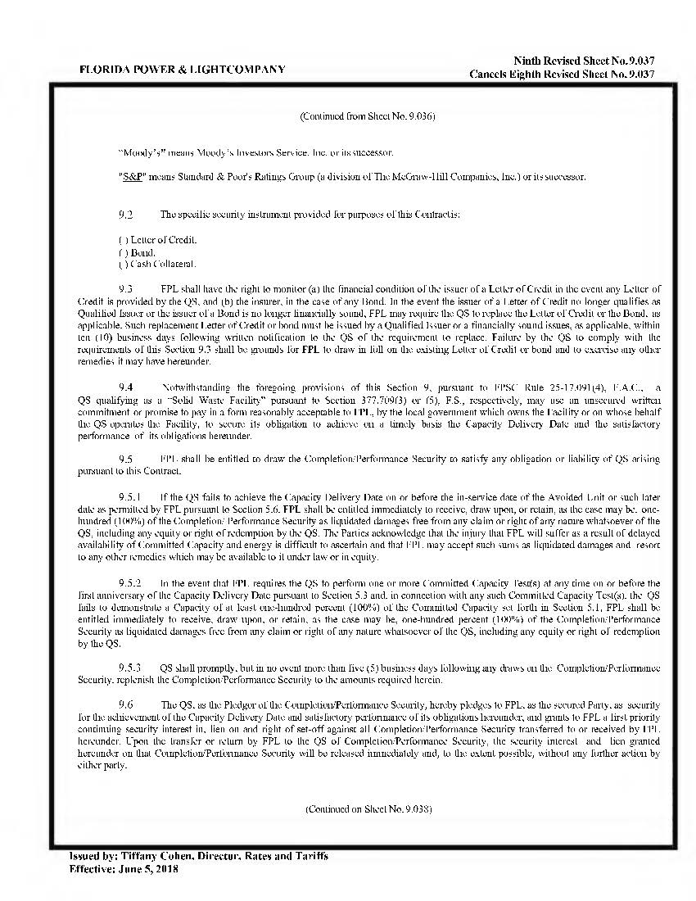

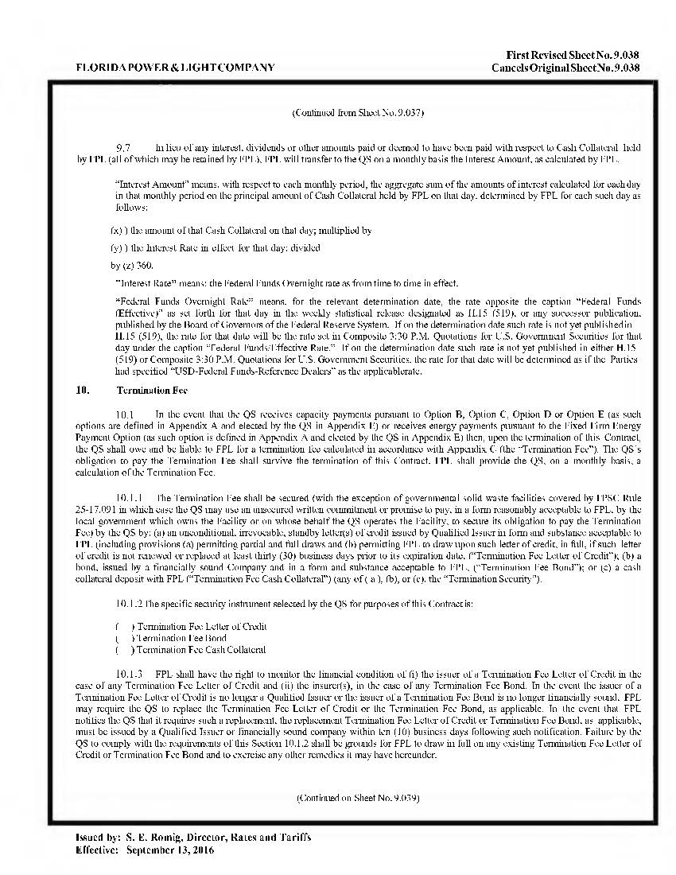

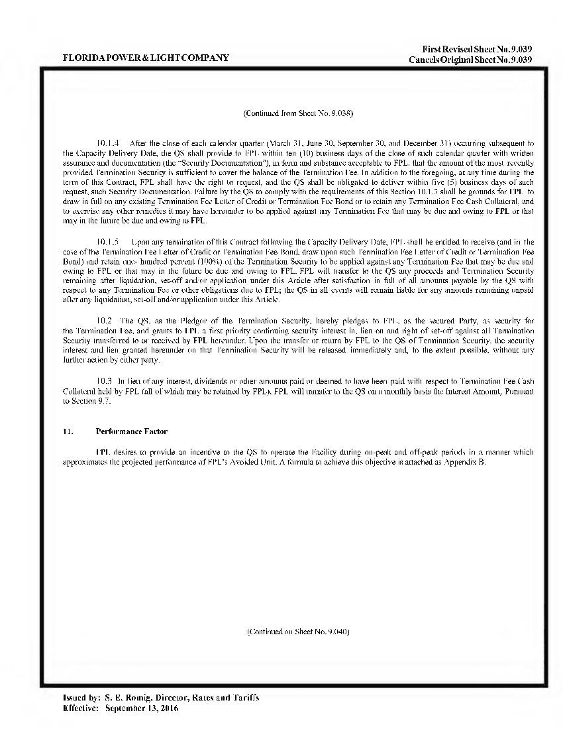

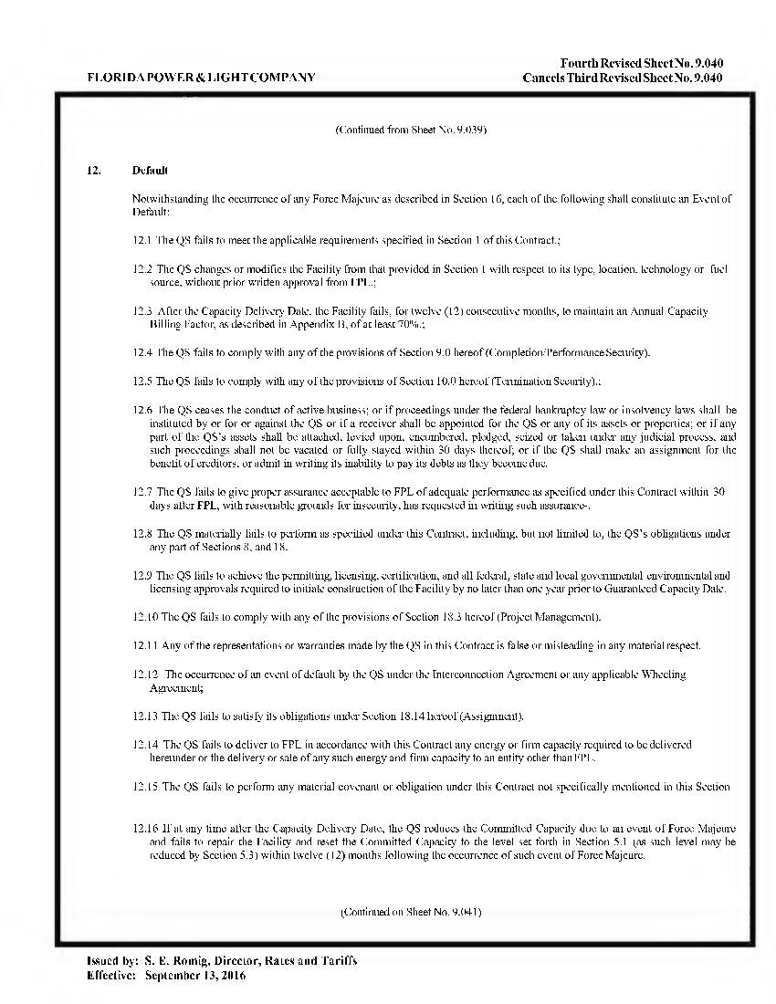

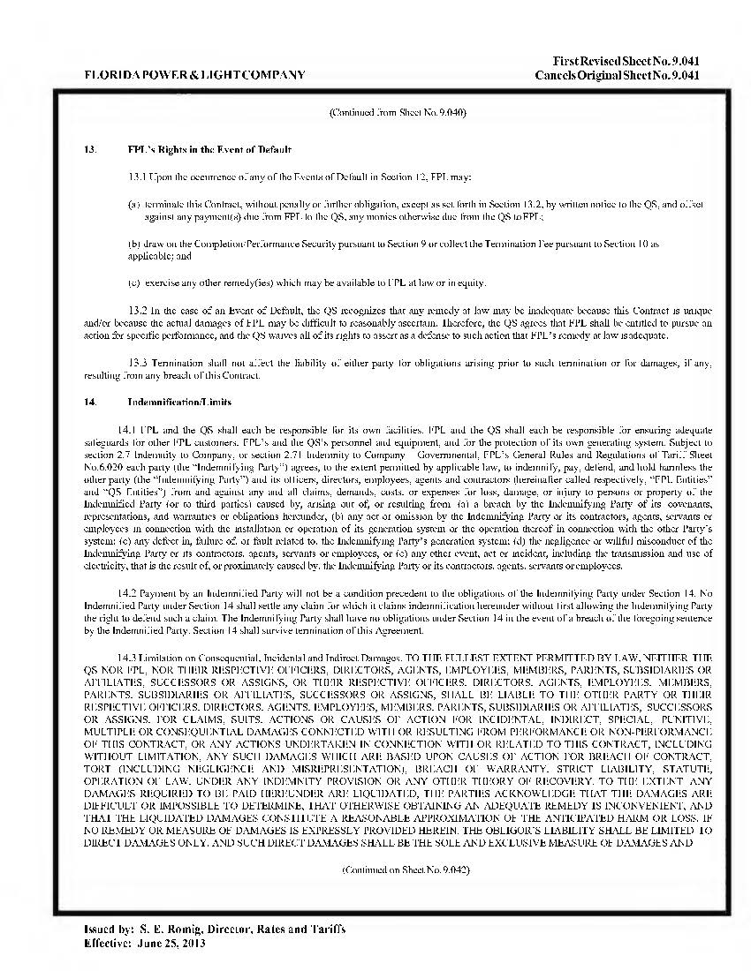

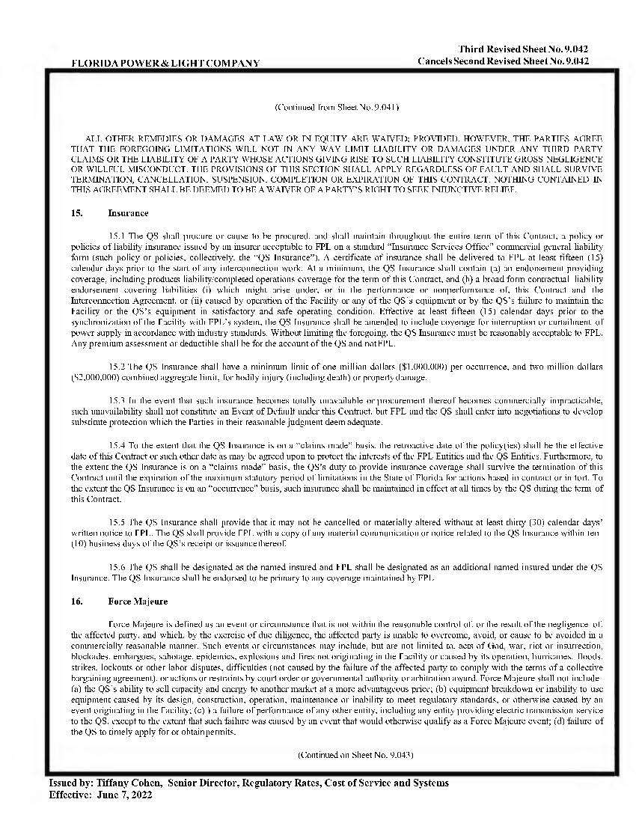

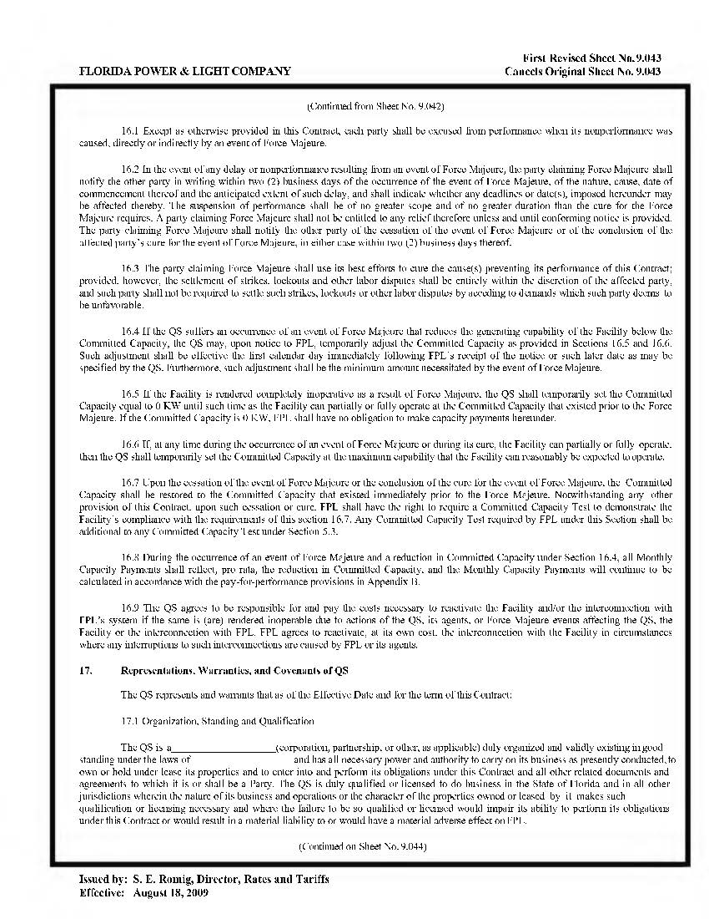

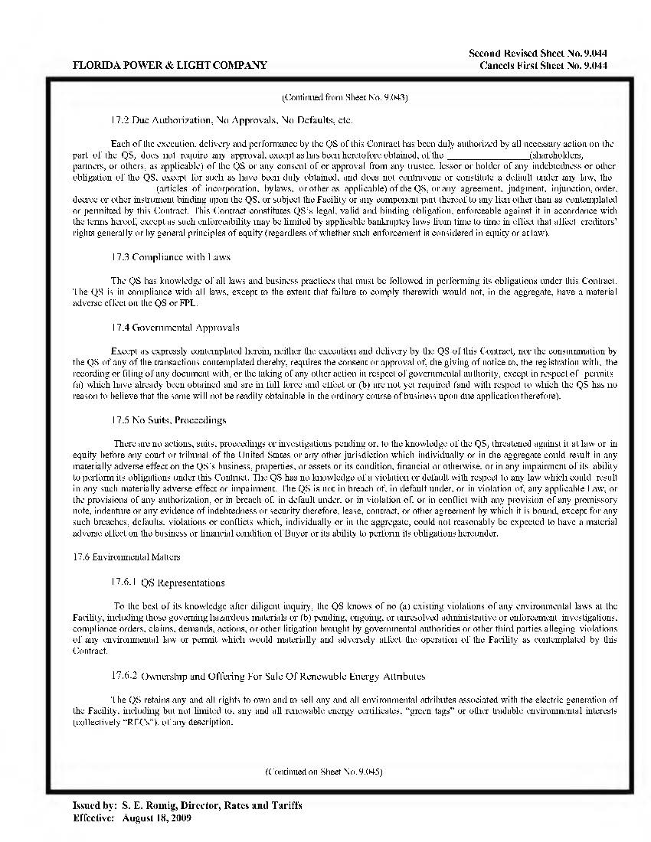

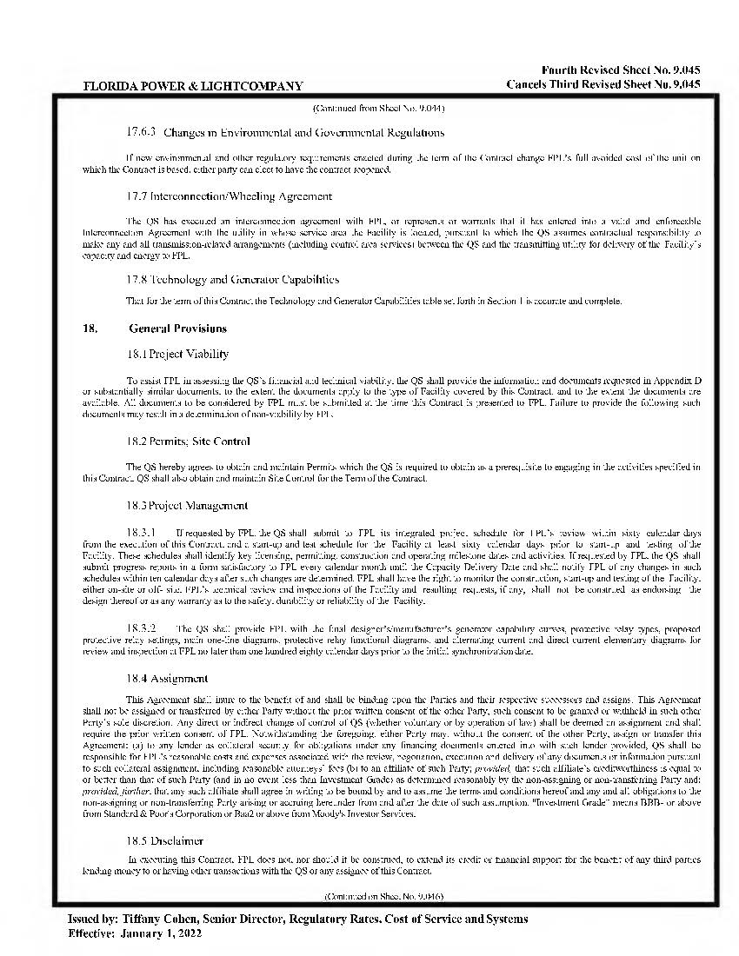

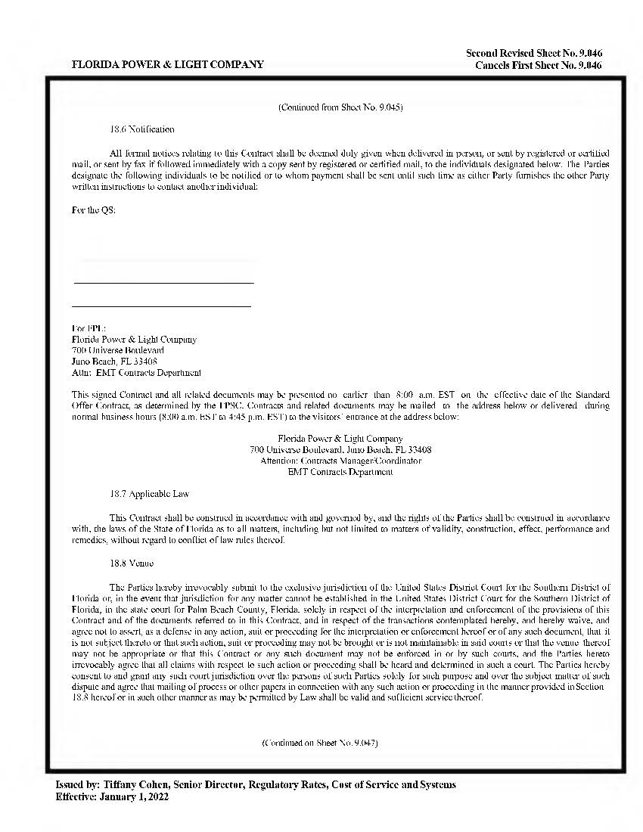

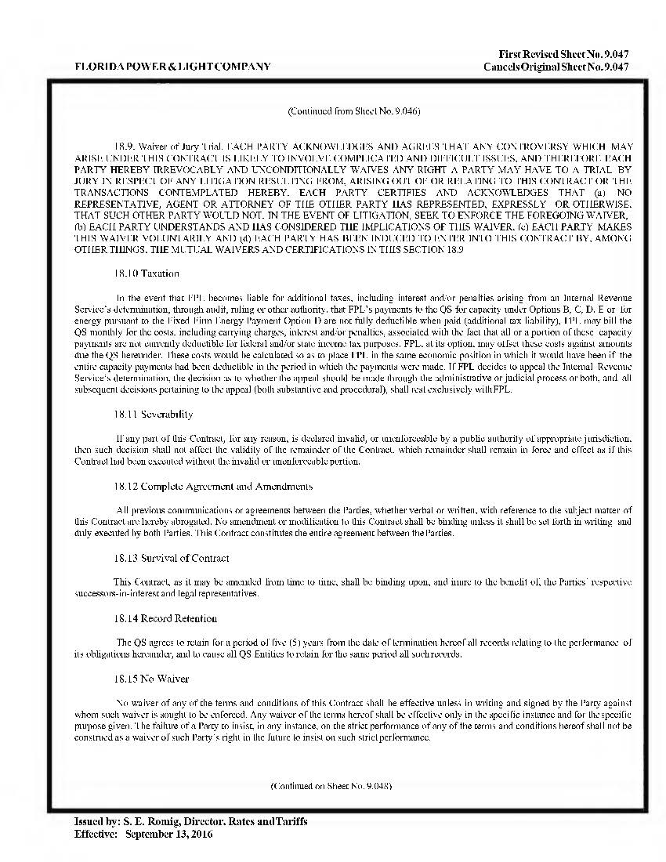

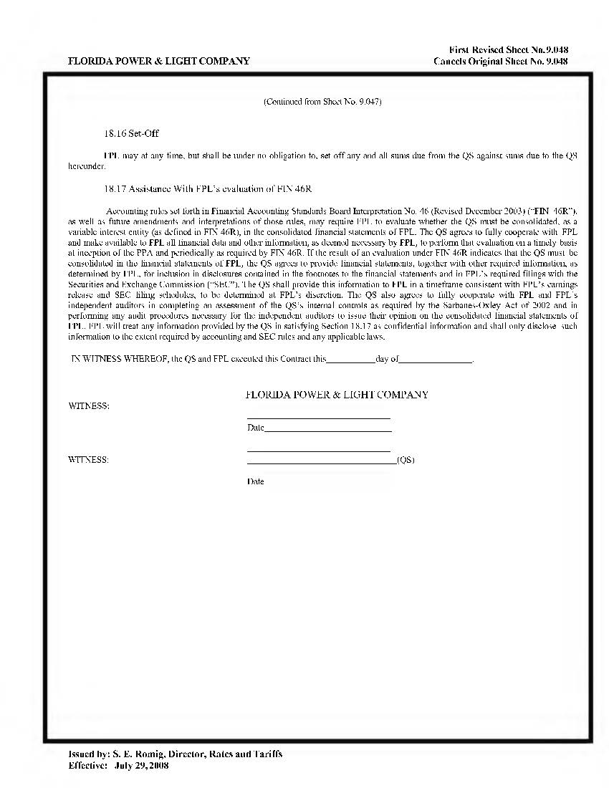

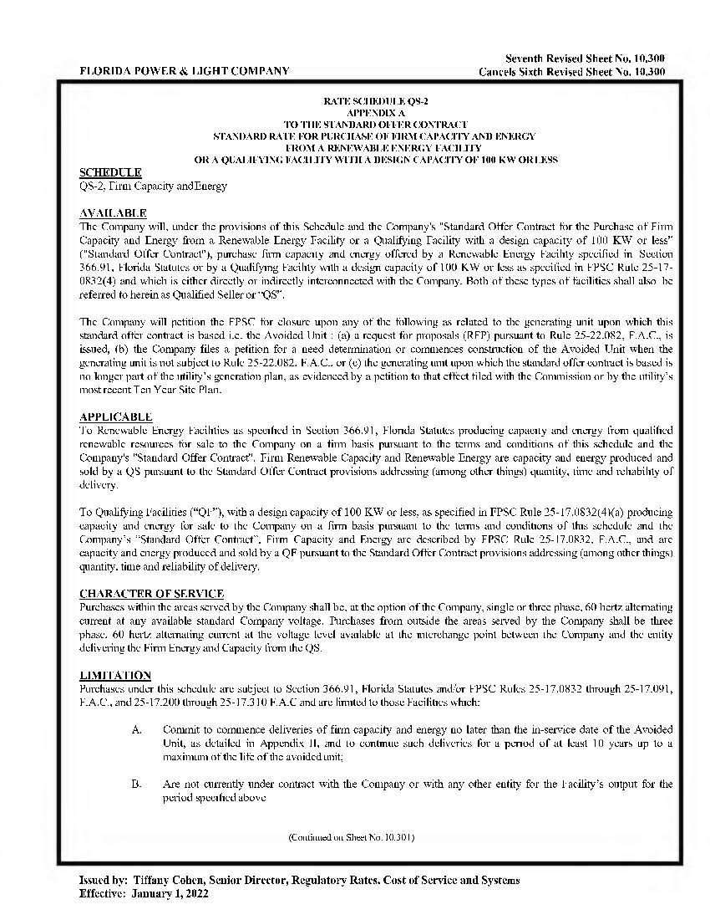

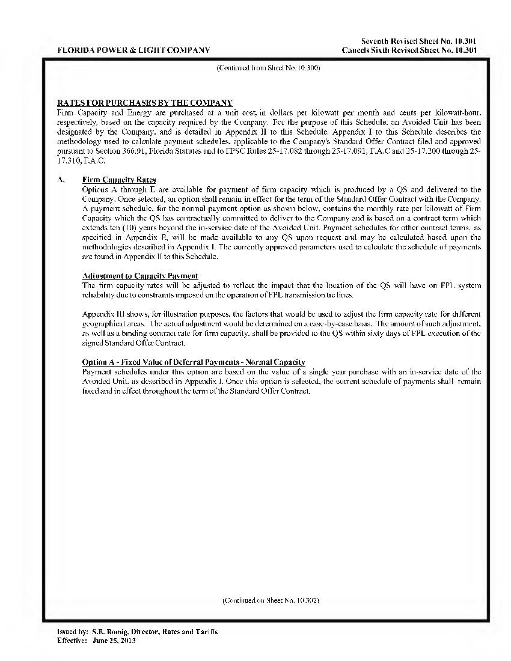

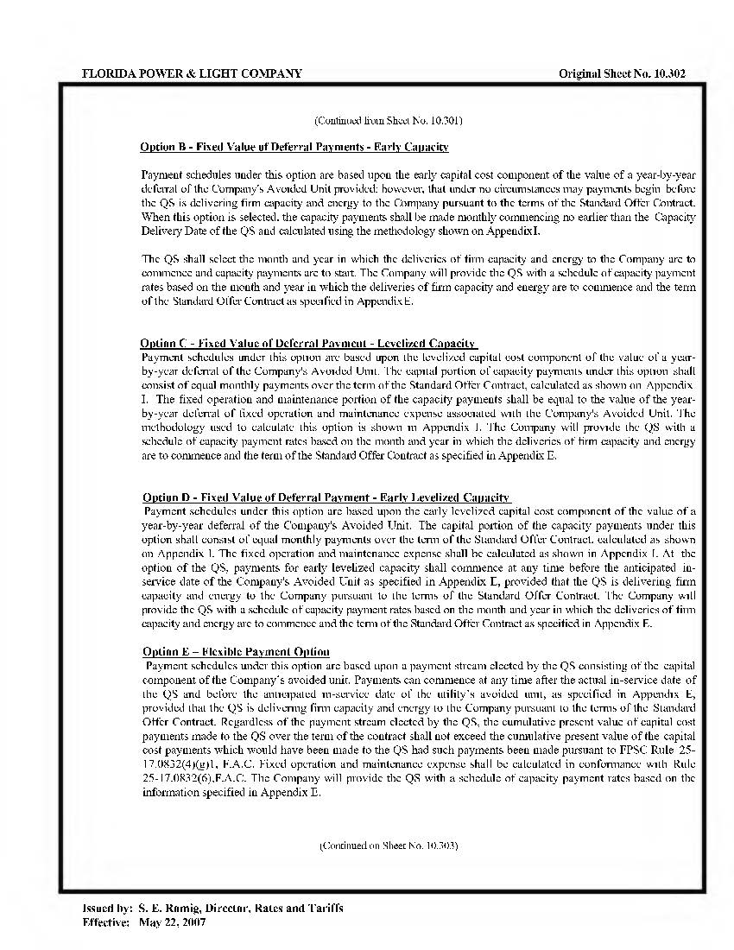

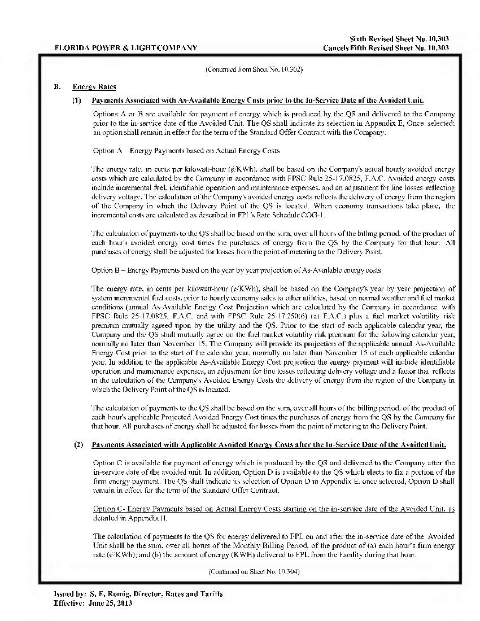

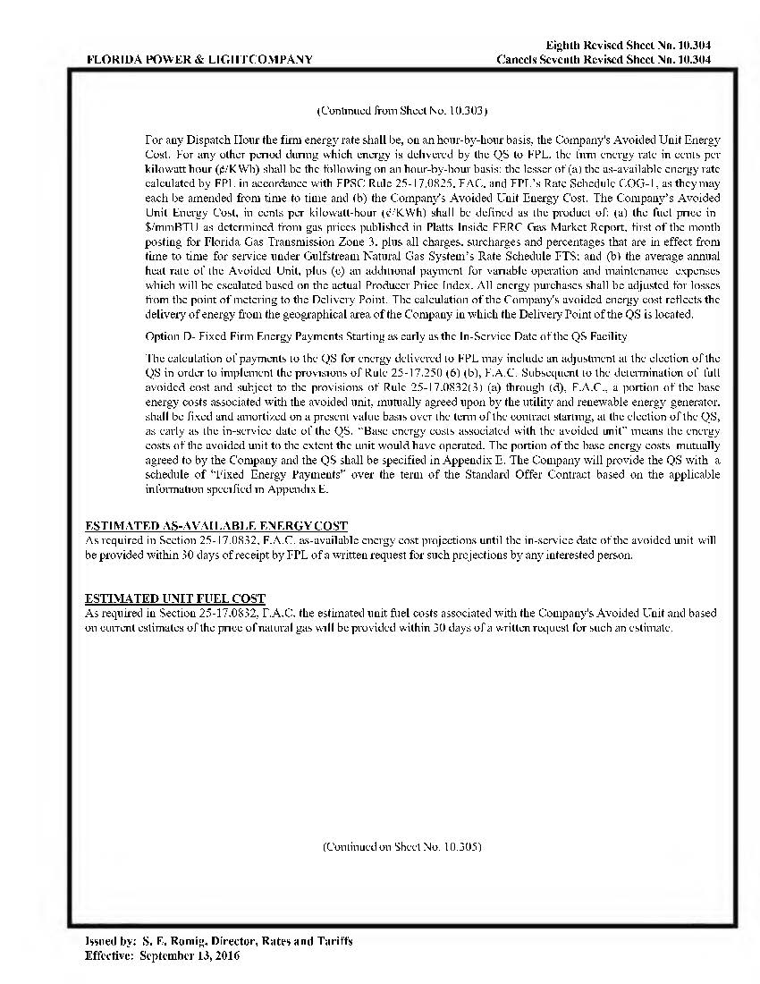

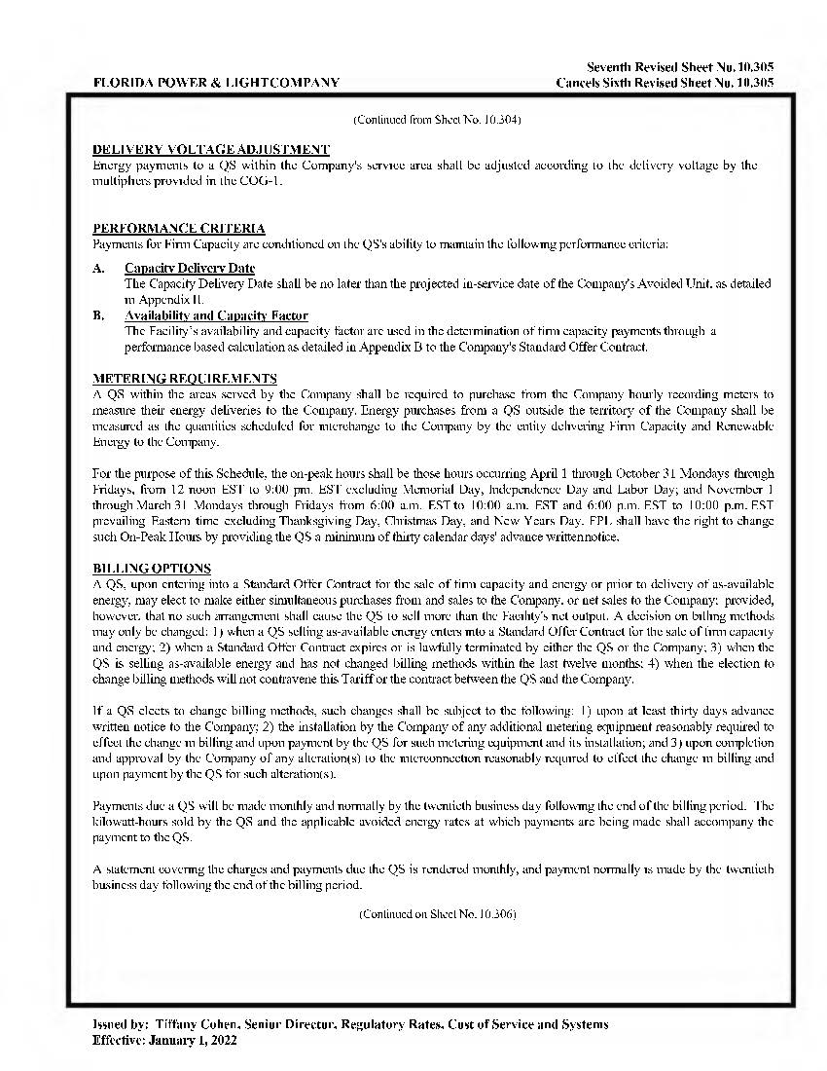

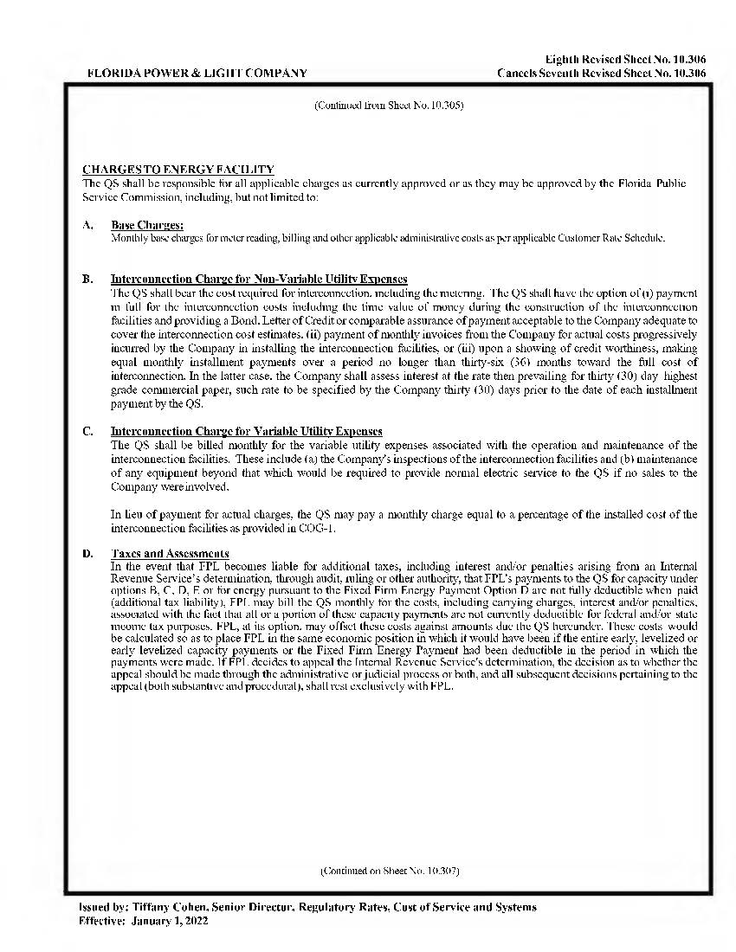

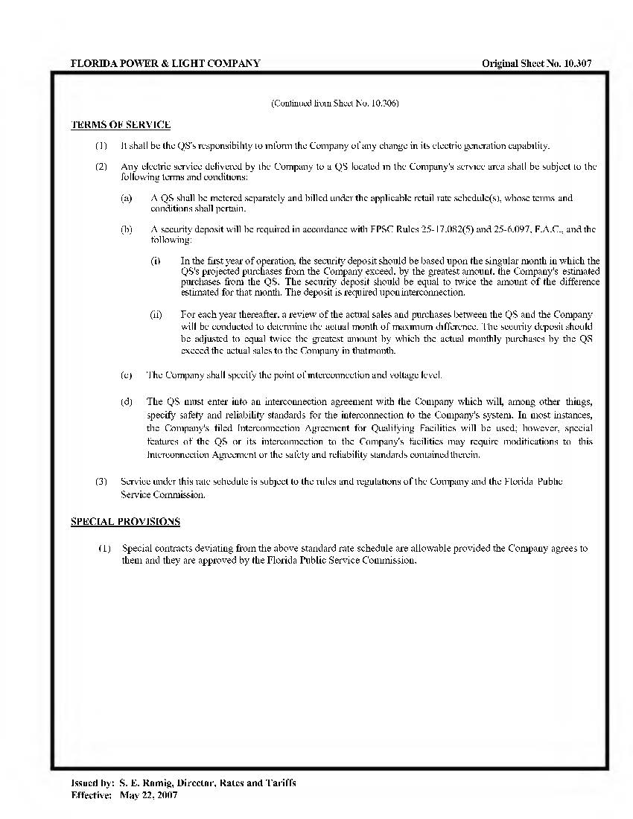

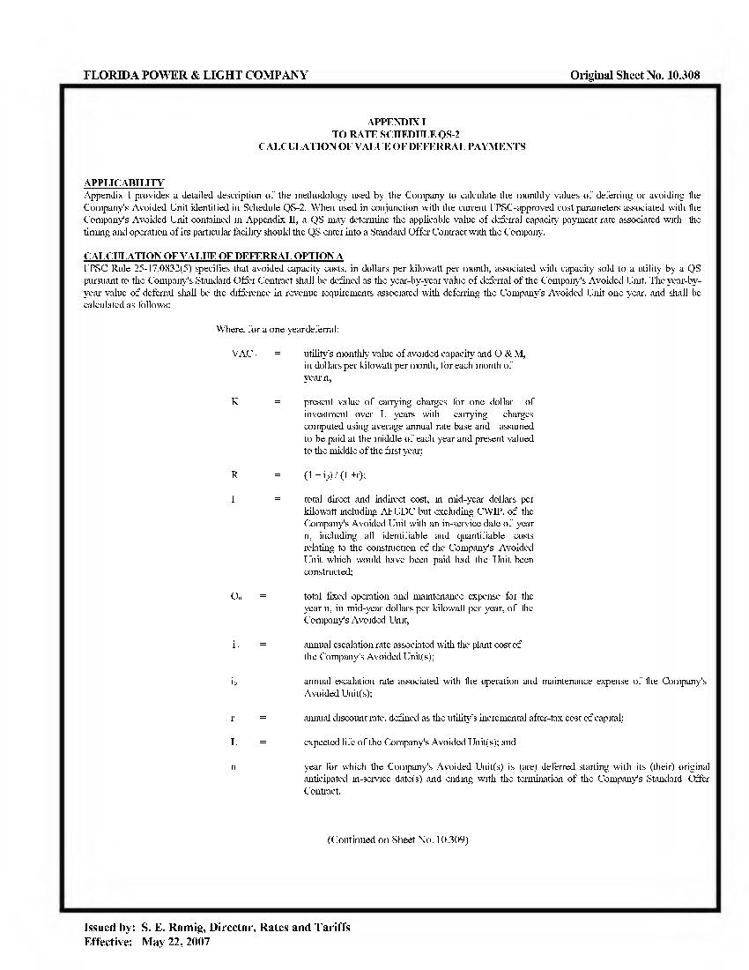

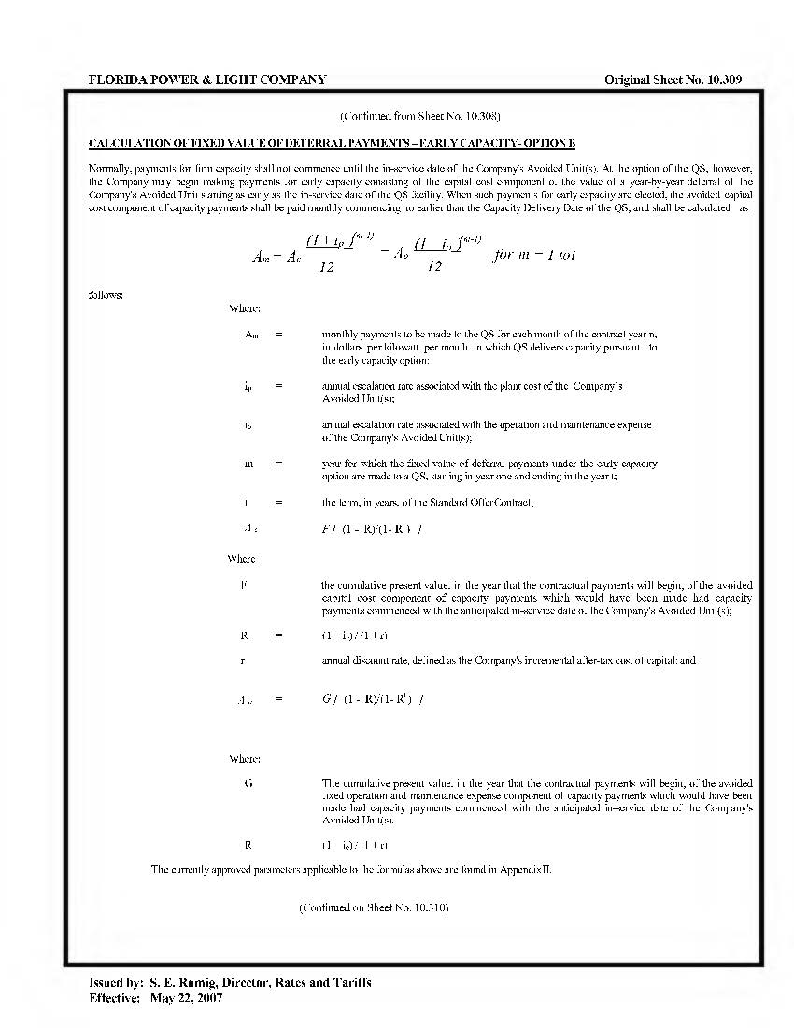

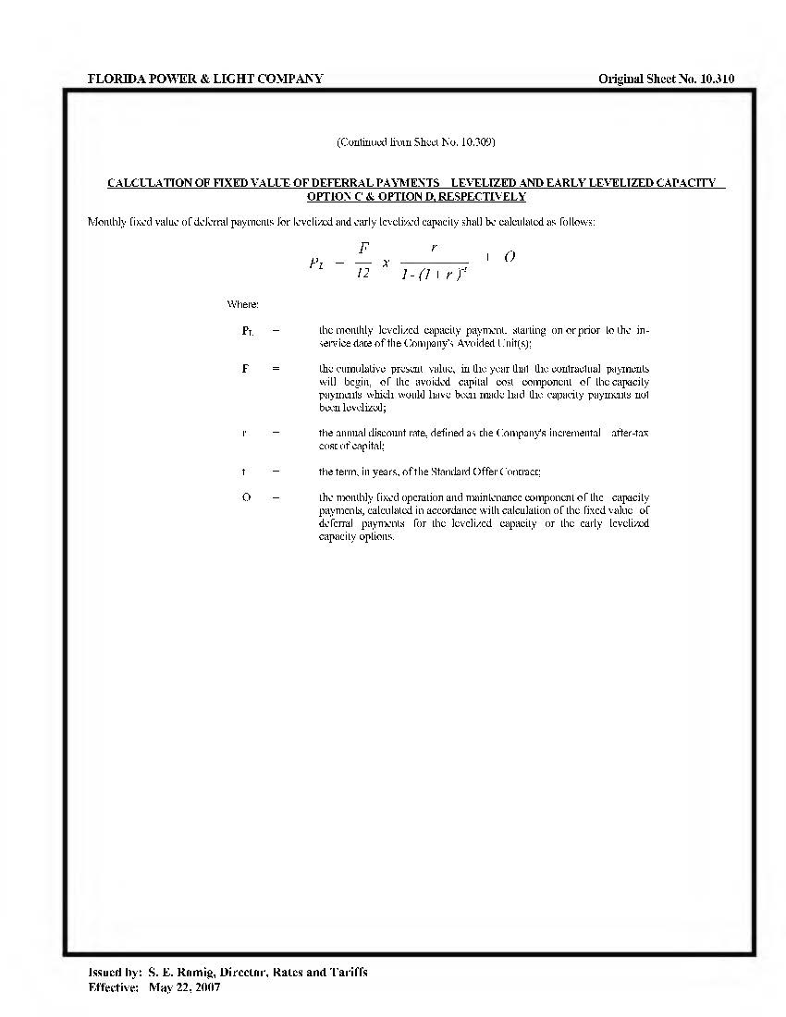

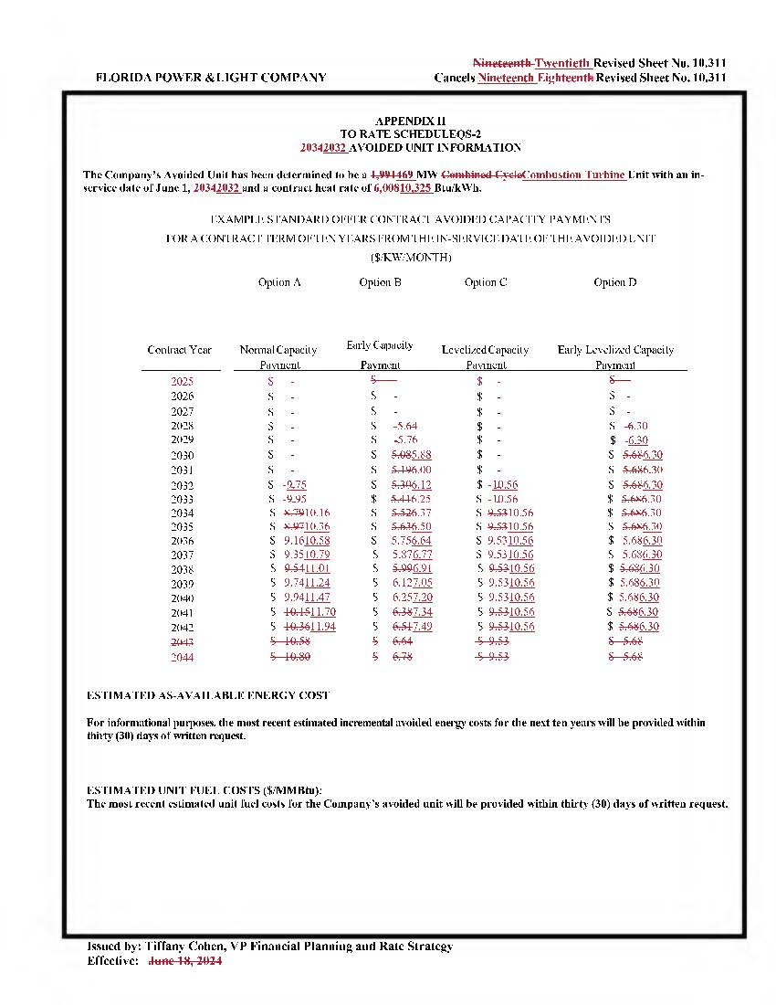

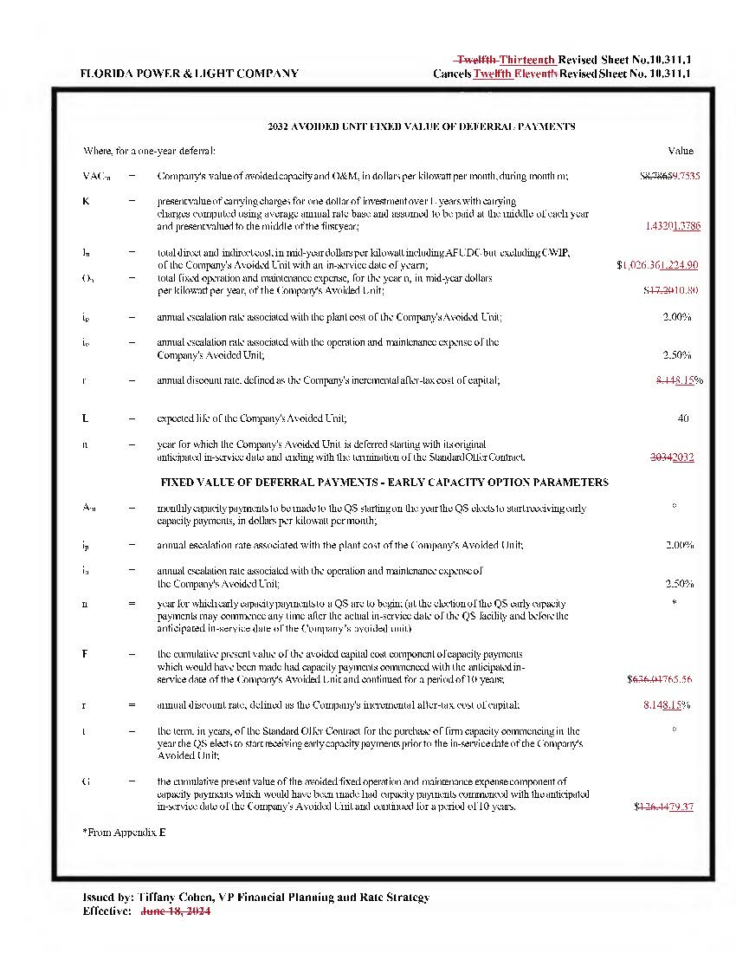

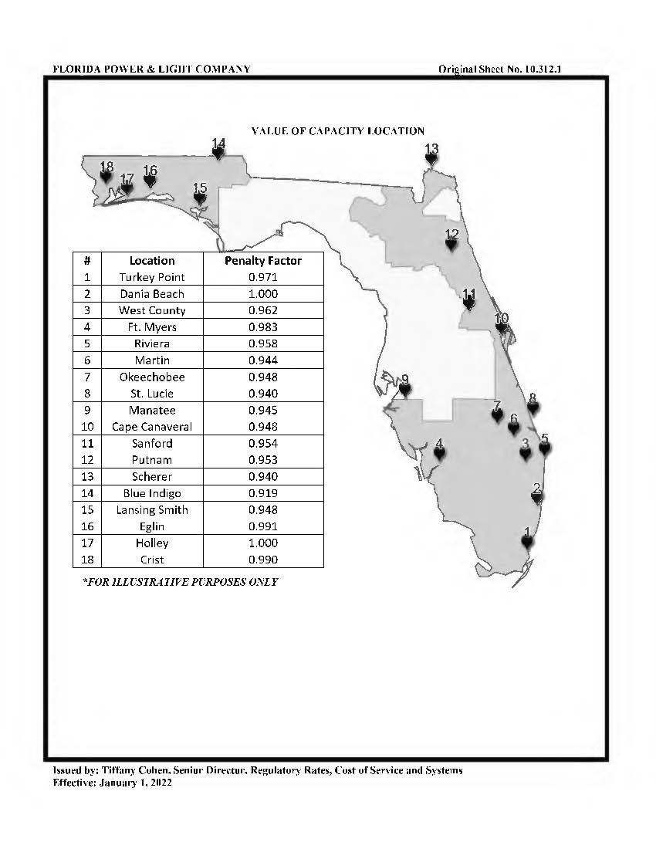

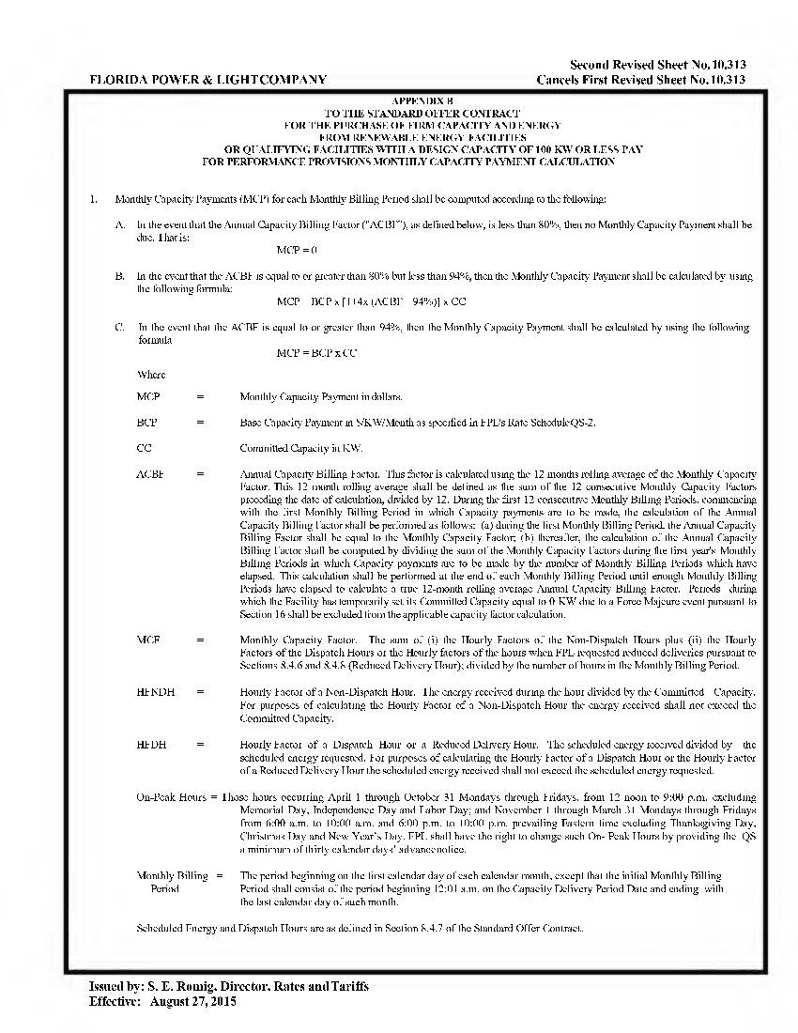

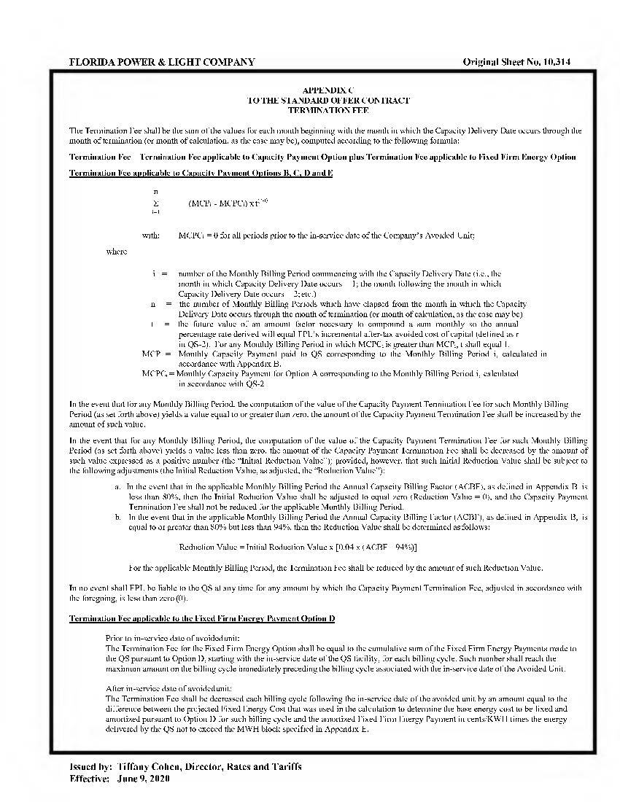

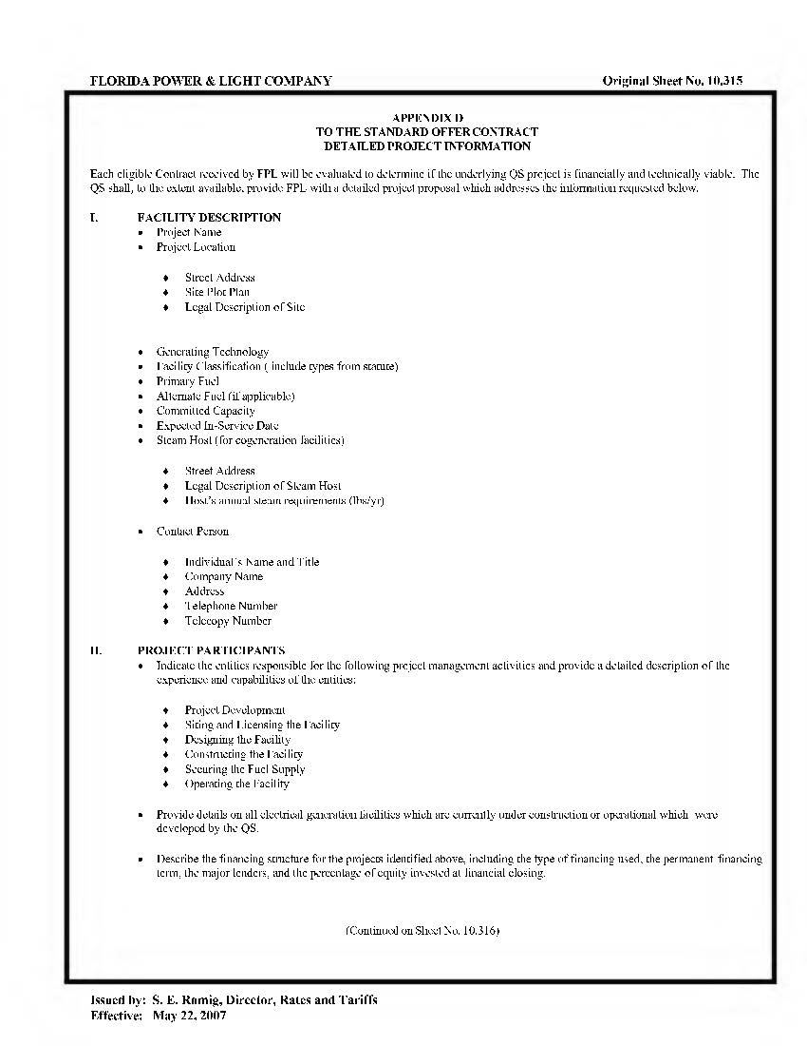

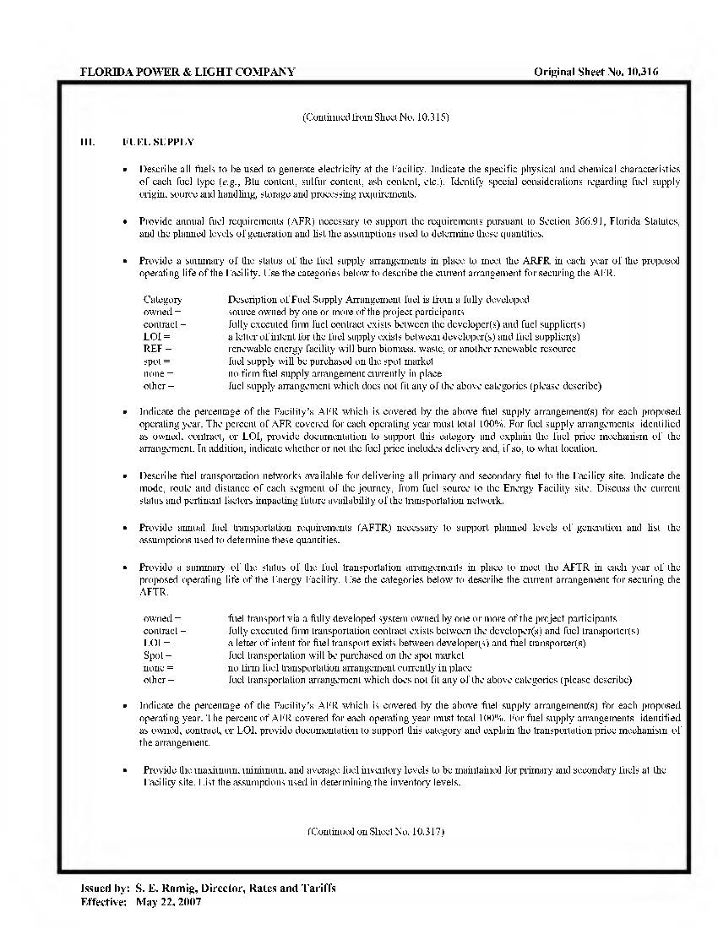

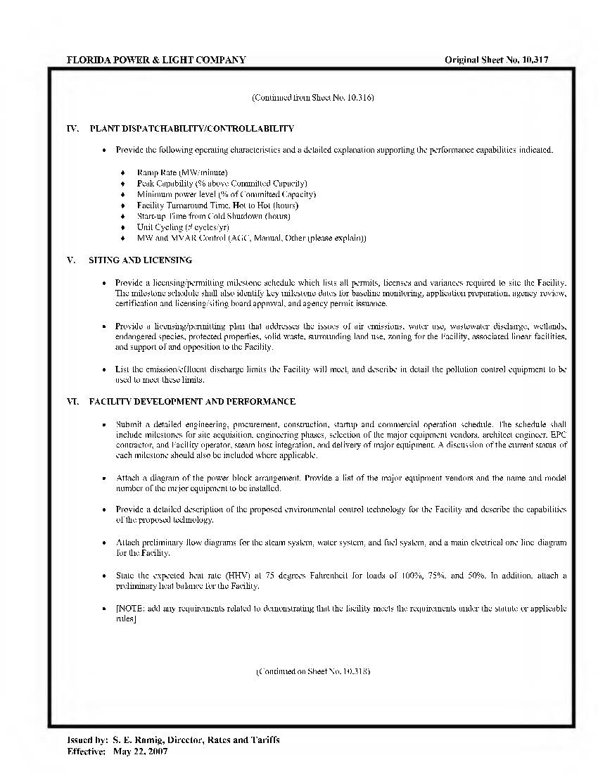

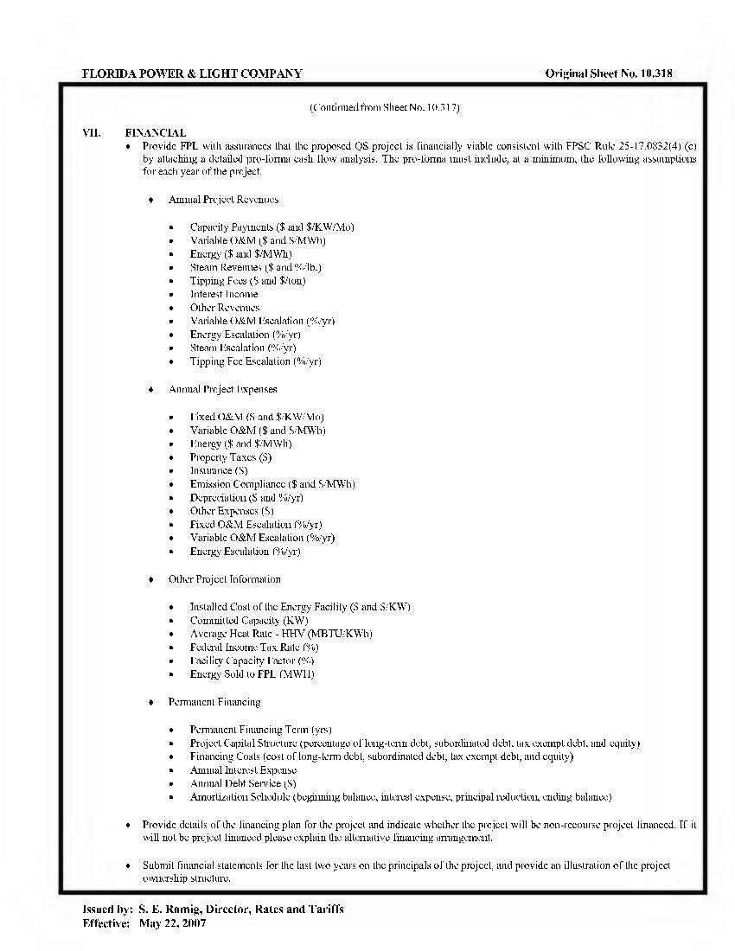

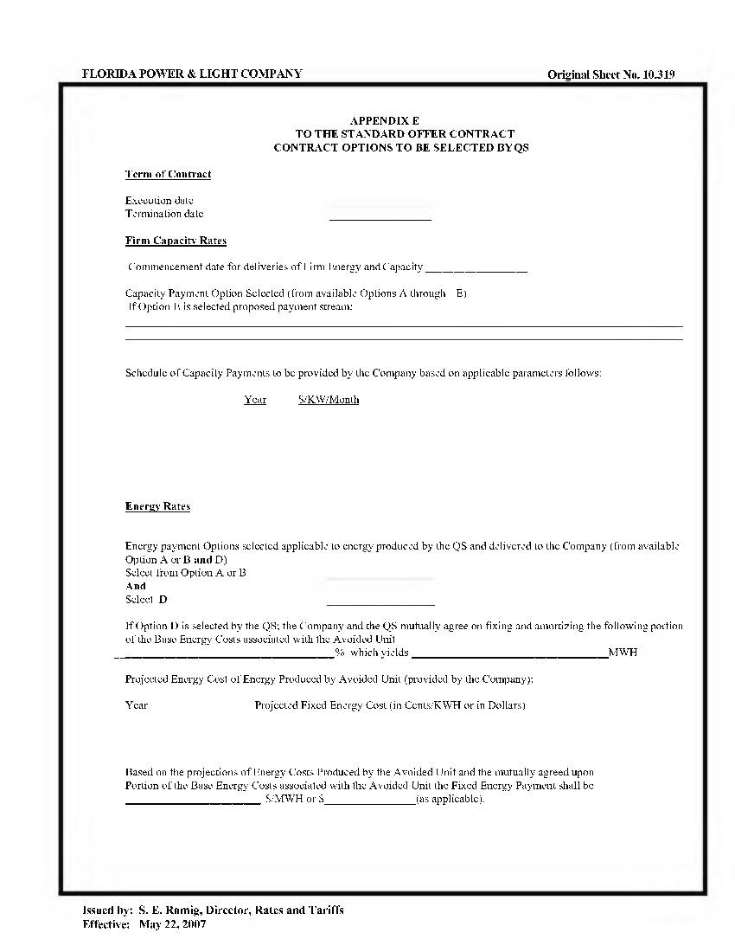

1. We note that the use of FPL’s 2025 TYSP in identifying its next avoidable unit is required by Rule 25-17.250, F.A.C. Approval of FPL’s Standard Offer Contract is not a finding that the 2025 TYSP, or the methodology used to create the plan, is either “suitable” or “unsuitable.” FPL’s 2025 TYSP is scheduled to be before the Commission at its November 18, 2025, Internal Affairs Meeting.
2. Document No. 03208-2025, filed April 28, 2025, in Docket No. 20250056-EQ.