BEFORE THE FLORIDA PUBLIC SERVICE COMMISSION

In re: Petition for approval of purchased power agreement between Tampa Electric Company and Hillsborough County. | DOCKET NO. 20250036-EI  ORDER NO. PSC-2025-0210-PAA-EI  ISSUED: June 17, 2025

The following Commissioners participated in the disposition of this matter:

MIKE LA ROSA, Chairman
ART GRAHAM
GARY F. CLARK
ANDREW GILES FAY
GABRIELLA PASSIDOMO SMITH

NOTICE OF PROPOSED AGENCY ACTION
ORDER APPROVING PURCHASED POWER AGREEMENT

BY THE COMMISSION:

NOTICE is hereby given by the Florida Public Service Commission that the action discussed herein is preliminary in nature and will become final unless a person whose interests are substantially affected files a petition for a formal proceeding, pursuant to Rule 25-22.029, Florida Administrative Code (F.A.C.).

Case Background
On February 28, 2025, Tampa Electric Company (TECO or Company) filed a petition requesting approval of a negotiated purchased power agreement (PPA or Contract) for the purchase of firm capacity and energy with Hillsborough County, Florida (Hillsborough). A copy of the PPA is attached. (Attachment A). The PPA is based on Hillsborough’s Waste-to-Energy Facility (WTE Facility) located in Tampa, Florida, which is an existing 47 megawatt (MW) Qualifying Facility (QF) and is located in TECO’s service territory. Hillsborough is proposing to initially sell 16 MW (with the option to sell up to 35 MW) of firm capacity and energy to TECO for a 10-year period from March 1, 2025, through February 28, 2035. According to the Company, the contract begins the later of March 2025, or when approved by the Commission, with the end date of the agreement remaining unchanged.

We have jurisdiction over this matter pursuant to Sections 366.051, 366.81, and 366.91, Florida Statutes (F.S.).

Decision

Hillsborough proposes to sell 16 MW (with an option to sell up to 35 MW) of firm capacity and energy from its WTE Facility to TECO for ten years, commencing upon approval of the PPA by this Commission through February 28, 2035. The WTE Facility uses municipal solid waste as its primary fuel, a source of renewable energy pursuant to Section 366.91(2)(b), F.S. The price structure in the Contract has no capacity payment, but features an “all-in” $37.00 dollars per megawatt-hour (MWh) energy rate payment with no escalation factor.
Rule 25-17.0832(3), F.A.C., states that in reviewing negotiated firm capacity and energy contracts for the purposes of cost recovery, this Commission shall consider factors relating to the contract that would impact the utility’s customers, including: the need for power by the purchasing utility and/or Florida utilities statewide; the cost-effectiveness of the contract; security provisions for early capacity payment; and, performance guarantees associated with the facility. These factors are evaluated below.
Need for Power
Based on TECO’s 2025 Ten-Year Site Plan (TYSP), the next planned capacity addition that could be avoided is a 247 MW natural gas-fired combustion turbine with an in-service date of January 2031. Therefore, the PPA’s firm capacity of 16 MW would help avoid or defer the construction of future generation capacity for the duration of the PPA. In addition to firm capacity, the PPA would improve the Company’s fuel diversity by increasing the contribution of renewable resources. TECO is forecasted to rely upon natural gas for up to 84.3 percent of its energy during the contract period, according to its 2025 TYSP. Therefore, we find the proposed PPA will enhance TECO’s system reliability and increase its fuel diversity.

Cost-Effectiveness
Rule 25-17.0832(3)(b), F.A.C., states, in part, that we shall consider whether the cumulative present worth of the payments to the QF are no greater than the cumulative present worth of the purchasing utility’s avoided cost of capacity and energy. This cost-effectiveness evaluation is thus based on the differential between TECO’s internal system costs under two scenarios, both with and without the PPA. In response to staff’s data request, TECO provided its cost-effectiveness analysis that estimated the net cumulative benefits of the PPA at $3.1 million on an NPV basis using the base fuel and emission price forecasts based on a March 2025 begin date. As mentioned previously, the effective date of the contract will be the date of our approval, which, if approved in July 2025, would result in a revised estimated net cumulative benefit of approximately $2.9 million. In addition, TECO will receive at no cost any Renewable Energy Credits (RECs) generated by the WTE Facility from its associated energy. In response to our staff’s data request, TECO stated that if it sells any of the RECs it will pass on any revenue to ratepayers. These potential revenues are not included in the economic evaluation of the PPA.

Security Capacity Payment
Rule 25-18.032(3)(c), F.A.C., requires us to consider security factors relating to the contract for early capacity payments. Security guarantees in the contract include provisions to ensure repayment of firm capacity and energy payment in the event that the QF fails to deliver firm capacity and energy in adherence with the terms and conditions of the contract. The Contract is slated to commence in the year 2025, and, based on TECO’s 2025 TYSP, the next avoided unit is scheduled to be in-service in 2031. If the QF defaults during this time, the Contract includes a termination security table for determining compensation due to TECO. We have reviewed the security terms and conditions contained in the negotiated Contract and find them adequate to protect ratepayers.

Performance Guarantees
Rule 25-17.0832(3)(d), F.A.C., requires the us to consider whether the utility’s ratepayers will be protected by the contract’s terms. Performance guarantees included in the contract detail how the QF is to operate and further impose financial penalties or other remedies should the QF fail to adhere to the contract’s terms and conditions. The protections include a lower energy rate if Hillsborough does not provide a monthly energy availability of at least 95 percent during peak months and 90 percent during off-peak months. Also, if the Hillsborough WTE Facility has availability of less than 70 percent for any 6 months in a calendar year during the Contract, this failure will be considered a default, and TECO may recover the cost of obtaining replacement power for the balance of the contract from Hillsborough. We find the performance guarantees contained in the negotiated Contract to be adequate to protect ratepayers.

Other Considerations
Section 5 of the Contract holds TECO responsible for potential transmission studies, if required, as well as for possible upgrades, if needed (although TECO would have the option to terminate the contract in lieu of incurring upgrade costs). However, as stated previously, the QF is within TECO’s service territory and, therefore, TECO is the sole transmission provider. TECO was required to conduct a transmission study in order to secure the related transmission and has no plans for requesting recovery of the transmission study costs from customers. Furthermore, in response to our staff’s data request, TECO stated that no transmission upgrades are required to have power delivered from the facility.

Conclusion
We find that the negotiated PPA improves TECO’s fuel diversity with the addition of renewable energy and is cost-effective based on current forecasts, saving approximately $2.9 million in NPV. Additionally, we find that the Contract has adequate security and performance guarantees to protect ratepayers in the event of a default or non-performance by Hillsborough.

Based on the foregoing, it is

ORDERED by the Florida Public Service Commission that the negotiated purchased power agreement between Tampa Electric Company and Hillsborough County, attached hereto as Attachment A, is hereby approved.

ORDERED that the provisions of this Order, issued as a proposed agency action, shall become final and effective upon the issuance of a Consummating Order unless an appropriate petition, in the form provided by Rule 28-106.201, Florida Administrative Code, is received by the Commission Clerk, 2540 Shumard Oak Boulevard, Tallahassee, Florida 32399-0850, by the close of business on the date set forth in the “Notice of Further Proceedings” attached hereto. It is further

ORDERED that in the event this Order becomes final, this docket shall be closed.

By ORDER of the Florida Public Service Commission this 17th day of June, 2025.

/s/ Adam J. Teitzman
ADAM J. TEITZMAN
Commission Clerk
Florida Public Service Commission
2540 Shumard Oak Boulevard
Tallahassee, Florida 32399
(850) 413-6770
www.floridapsc.com

Copies furnished: A copy of this document is provided to the parties of record at the time of issuance and, if applicable, interested persons.

JLA

NOTICE OF FURTHER PROCEEDINGS OR JUDICIAL REVIEW

The Florida Public Service Commission is required by Section 120.569(1), Florida Statutes, to notify parties of any administrative hearing that is available under Section 120.57, Florida Statutes, as well as the procedures and time limits that apply. This notice should not be construed to mean all requests for an administrative hearing will be granted or result in the relief sought.

Mediation may be available on a case-by-case basis. If mediation is conducted, it does not affect a substantially interested person's right to a hearing.

The action proposed herein is preliminary in nature. Any person whose substantial interests are affected by the action proposed by this order may file a petition for a formal proceeding, in the form provided by Rule 28-106.201, Florida Administrative Code. This petition must be received by the Office of Commission Clerk, 2540 Shumard Oak Boulevard, Tallahassee, Florida 32399-0850, by the close of business on July 8, 2025.

In the absence of such a petition, this order shall become final and effective upon the issuance of a Consummating Order.

Any objection or protest filed in this/these docket(s) before the issuance date of this order is considered abandoned unless it satisfies the foregoing conditions and is renewed within the specified protest period.

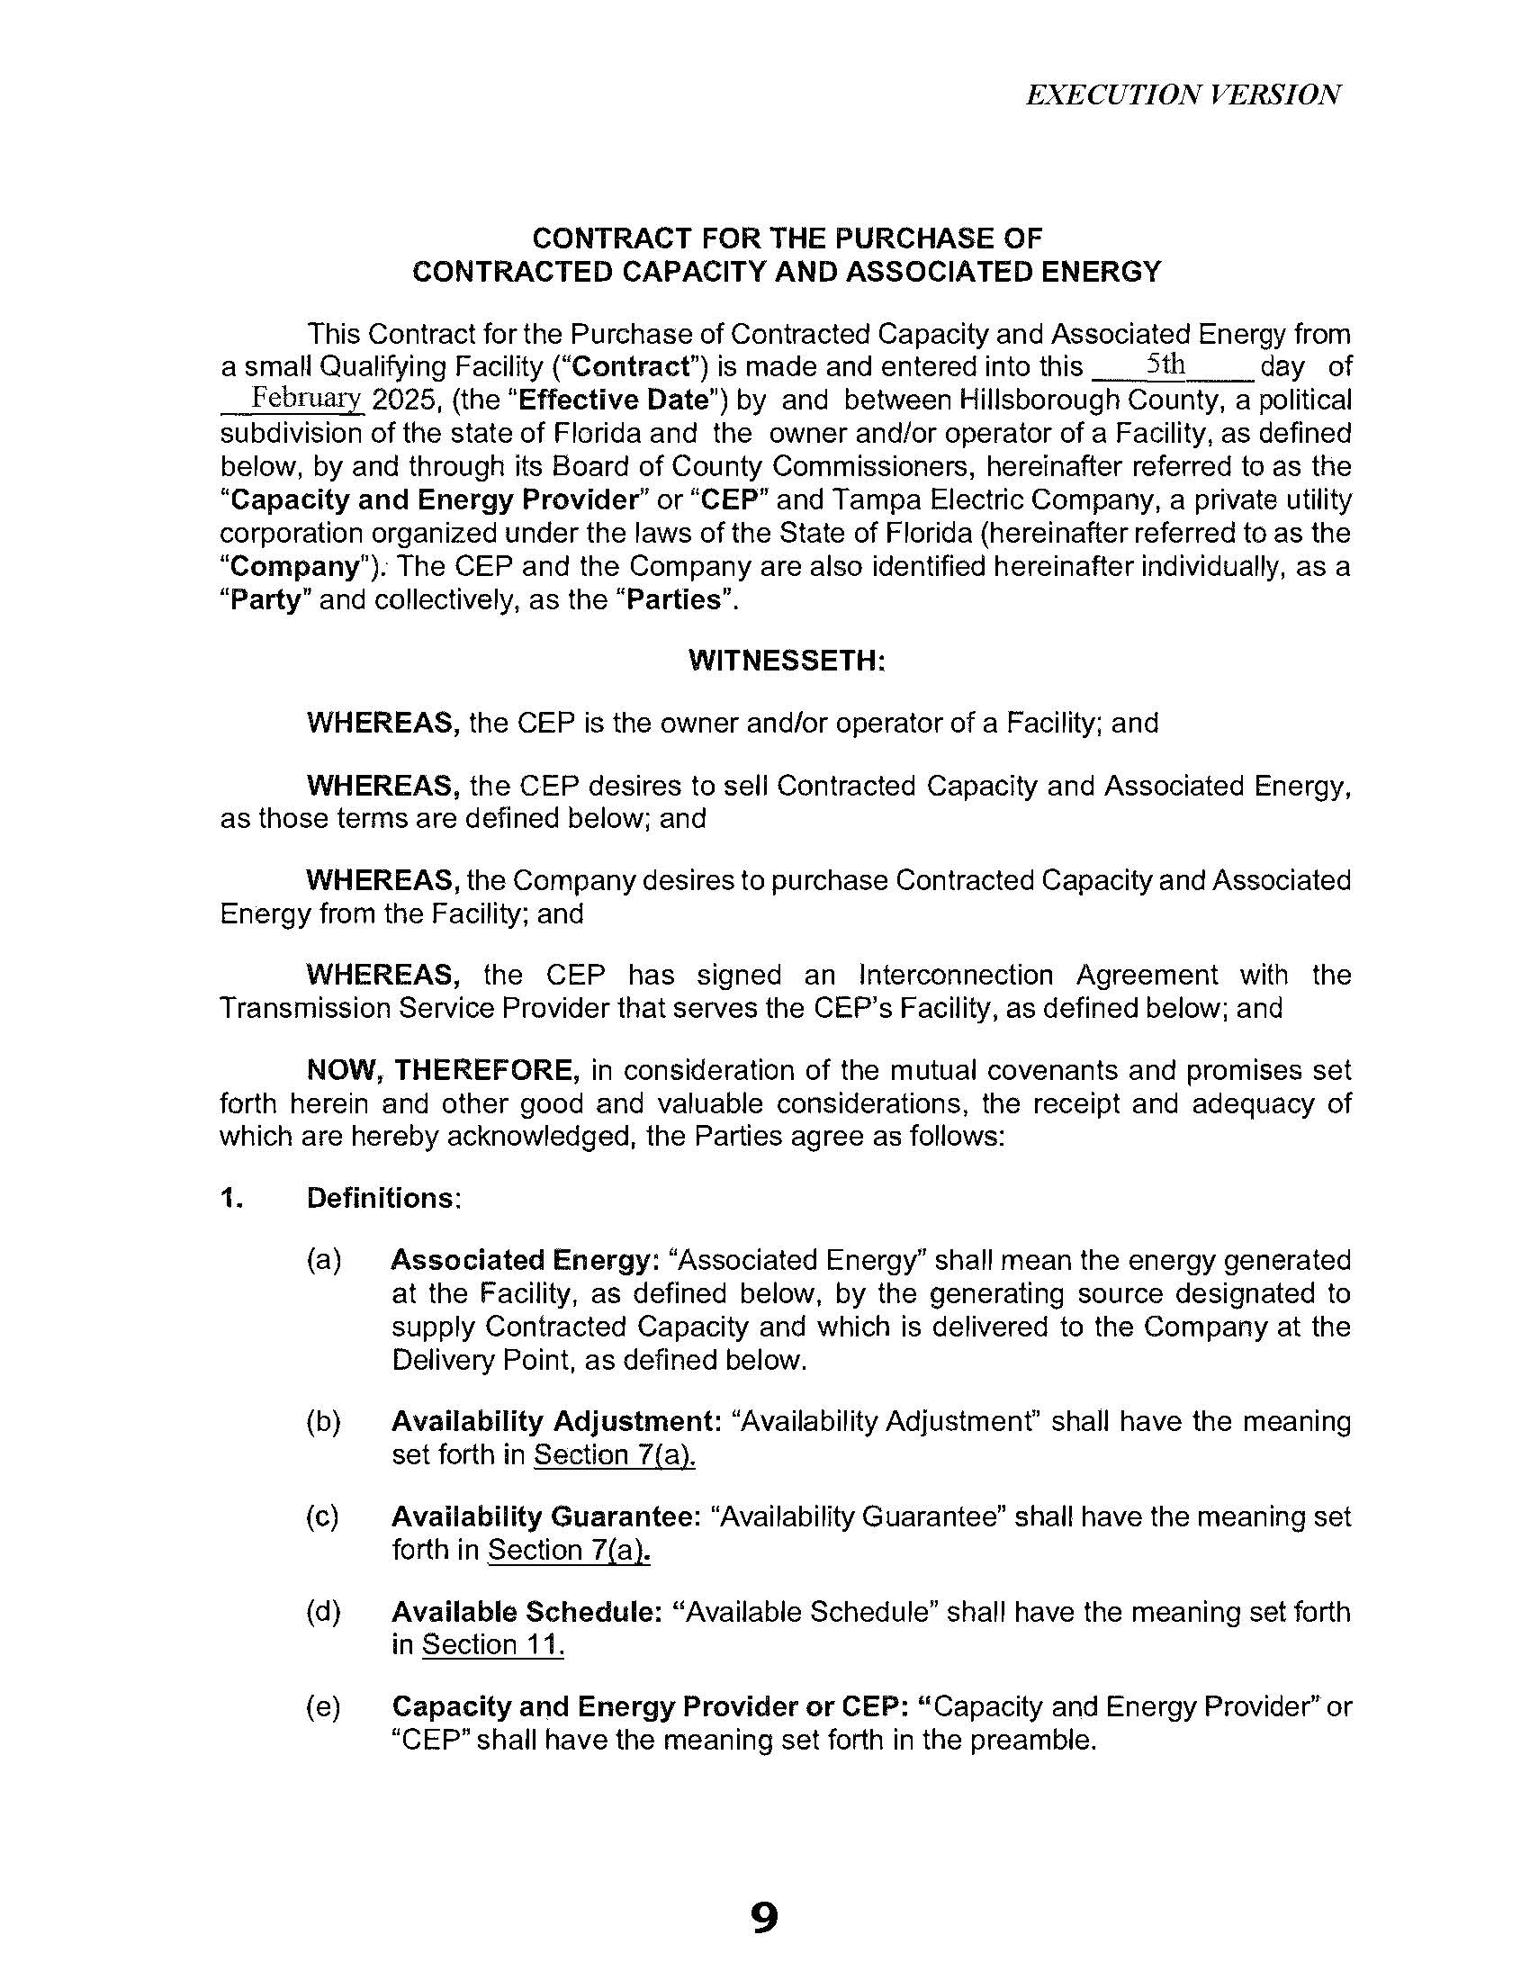

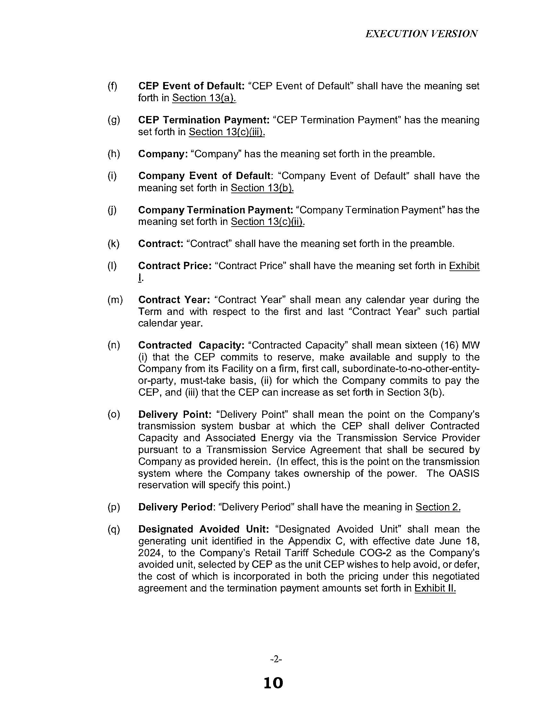

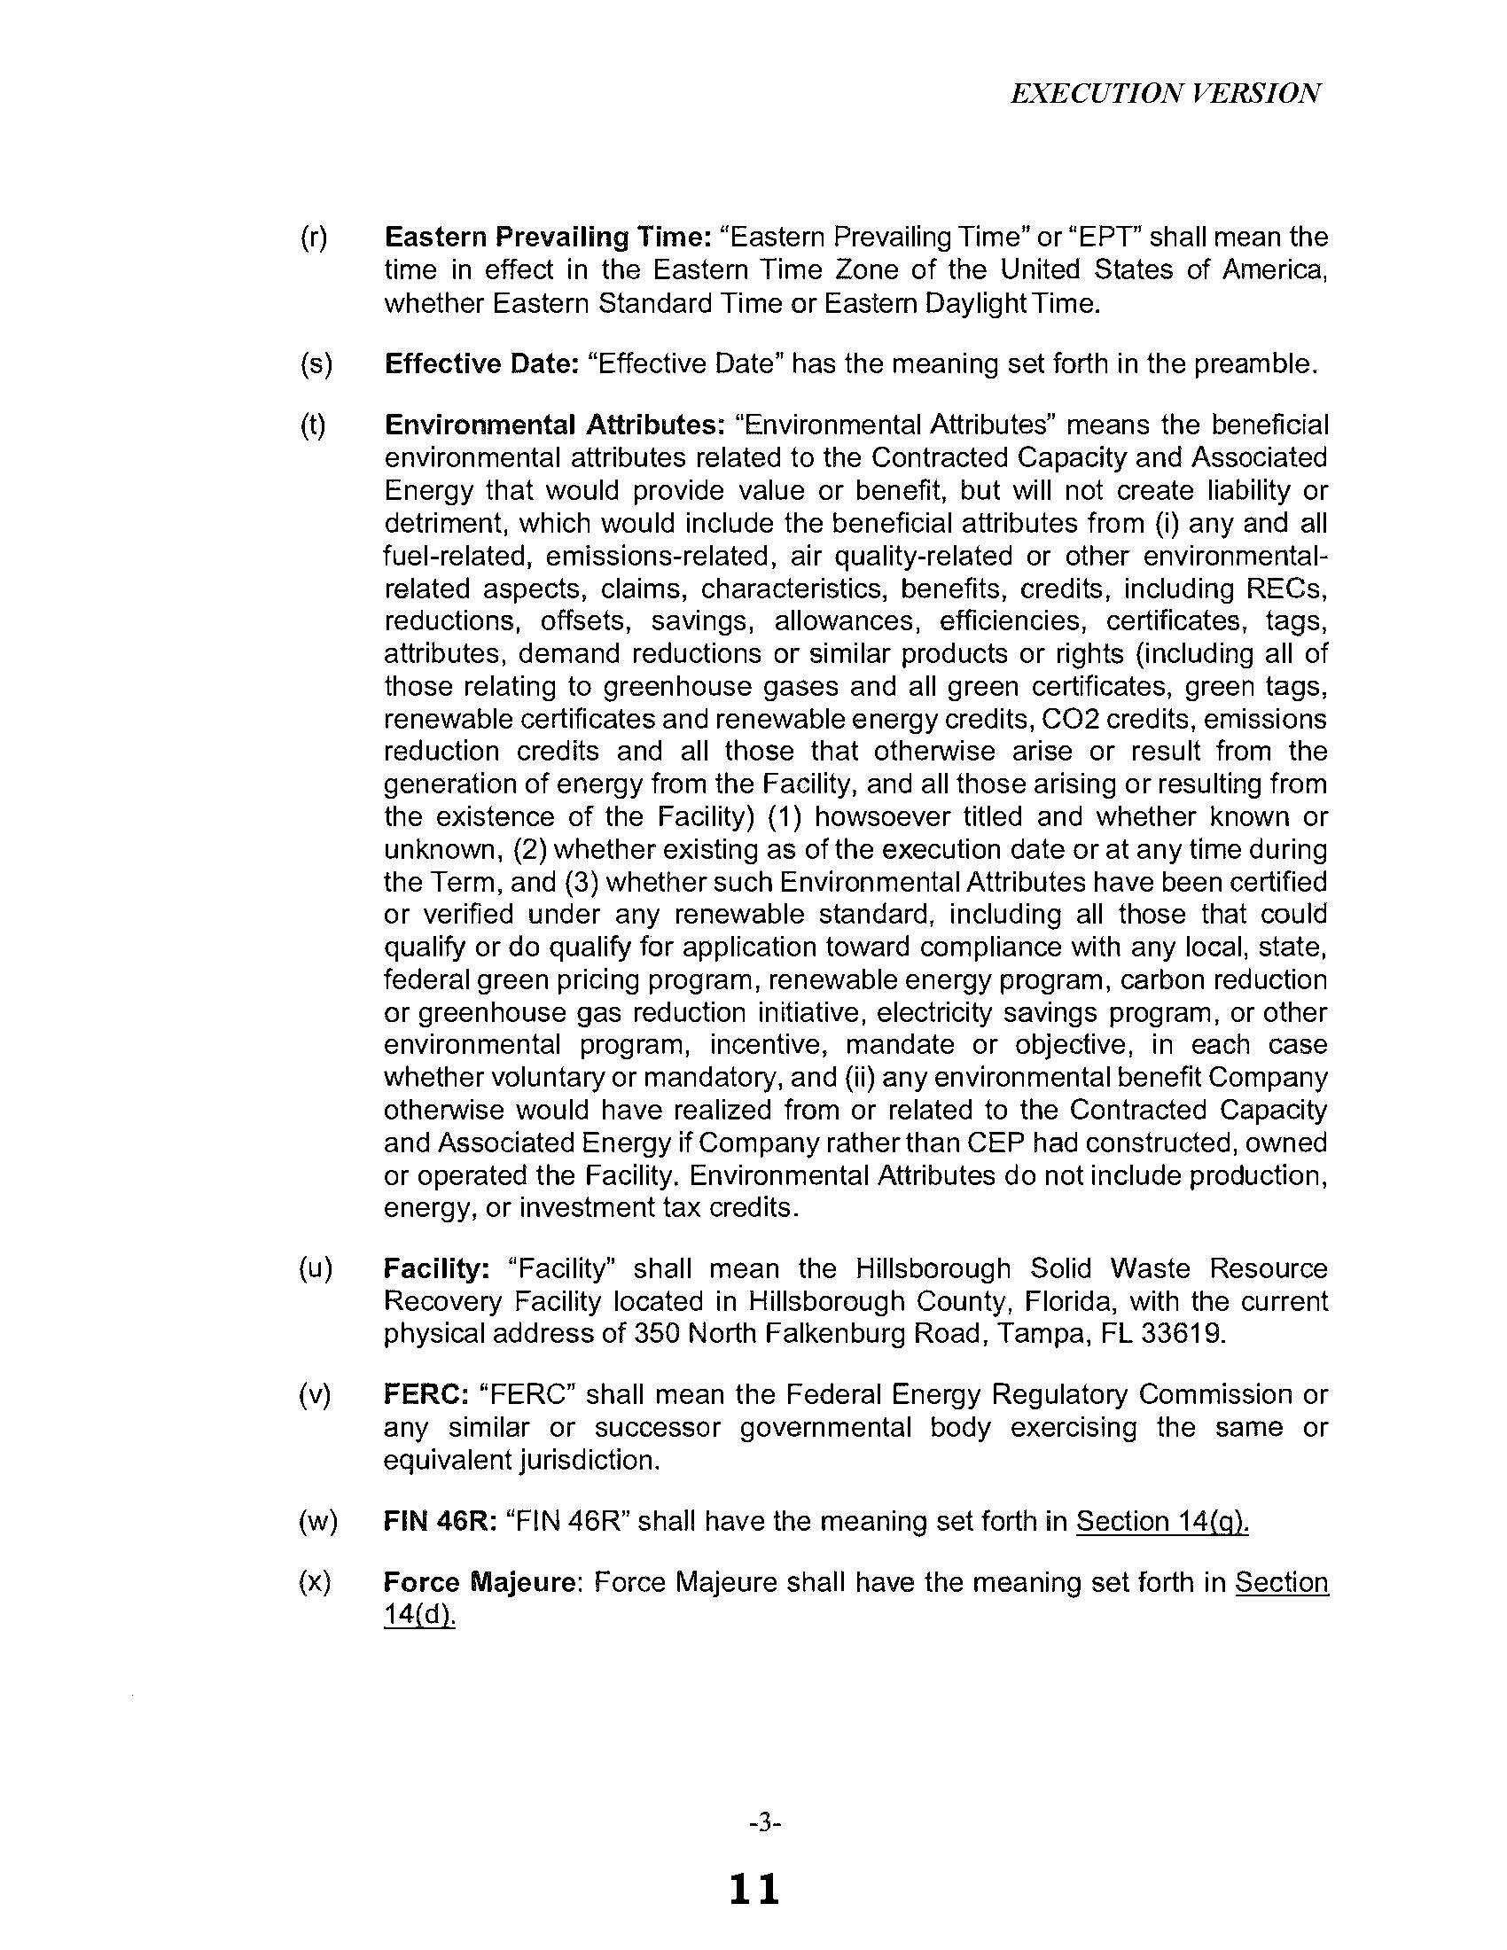
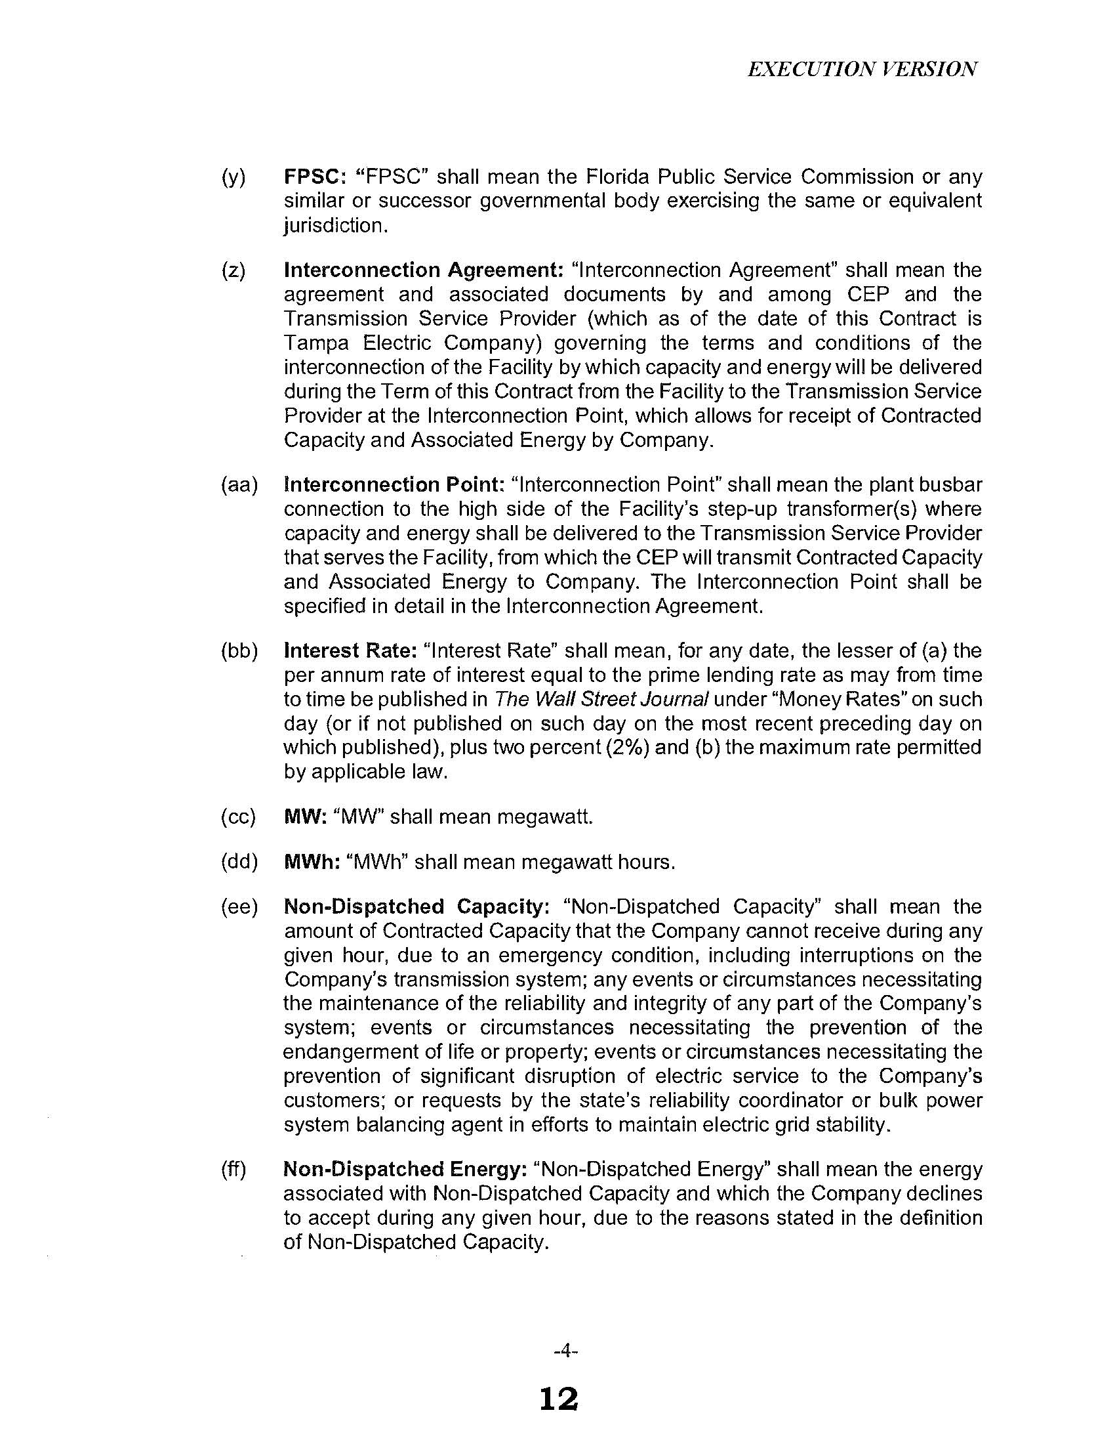

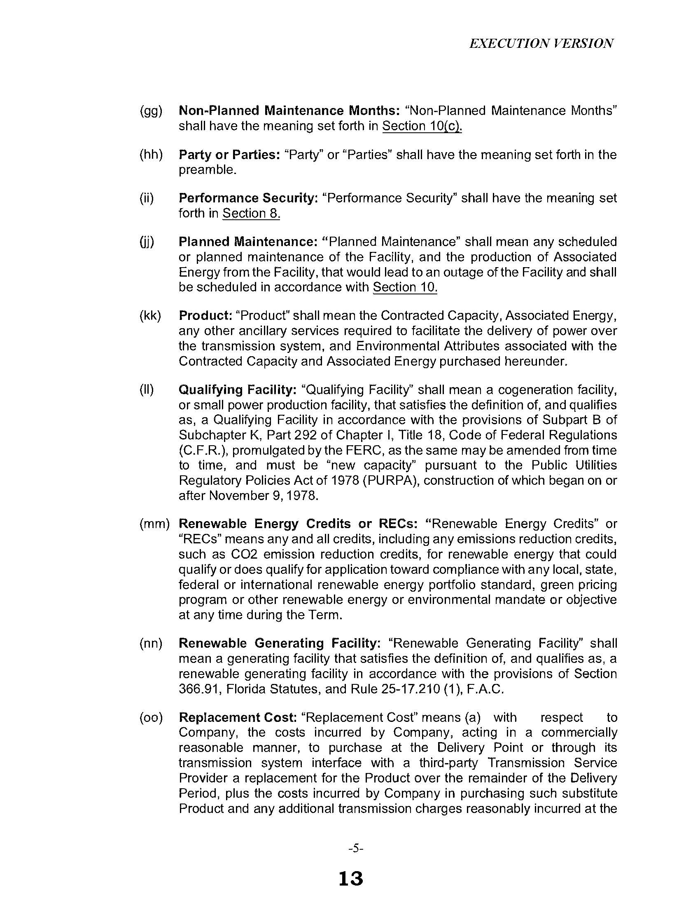

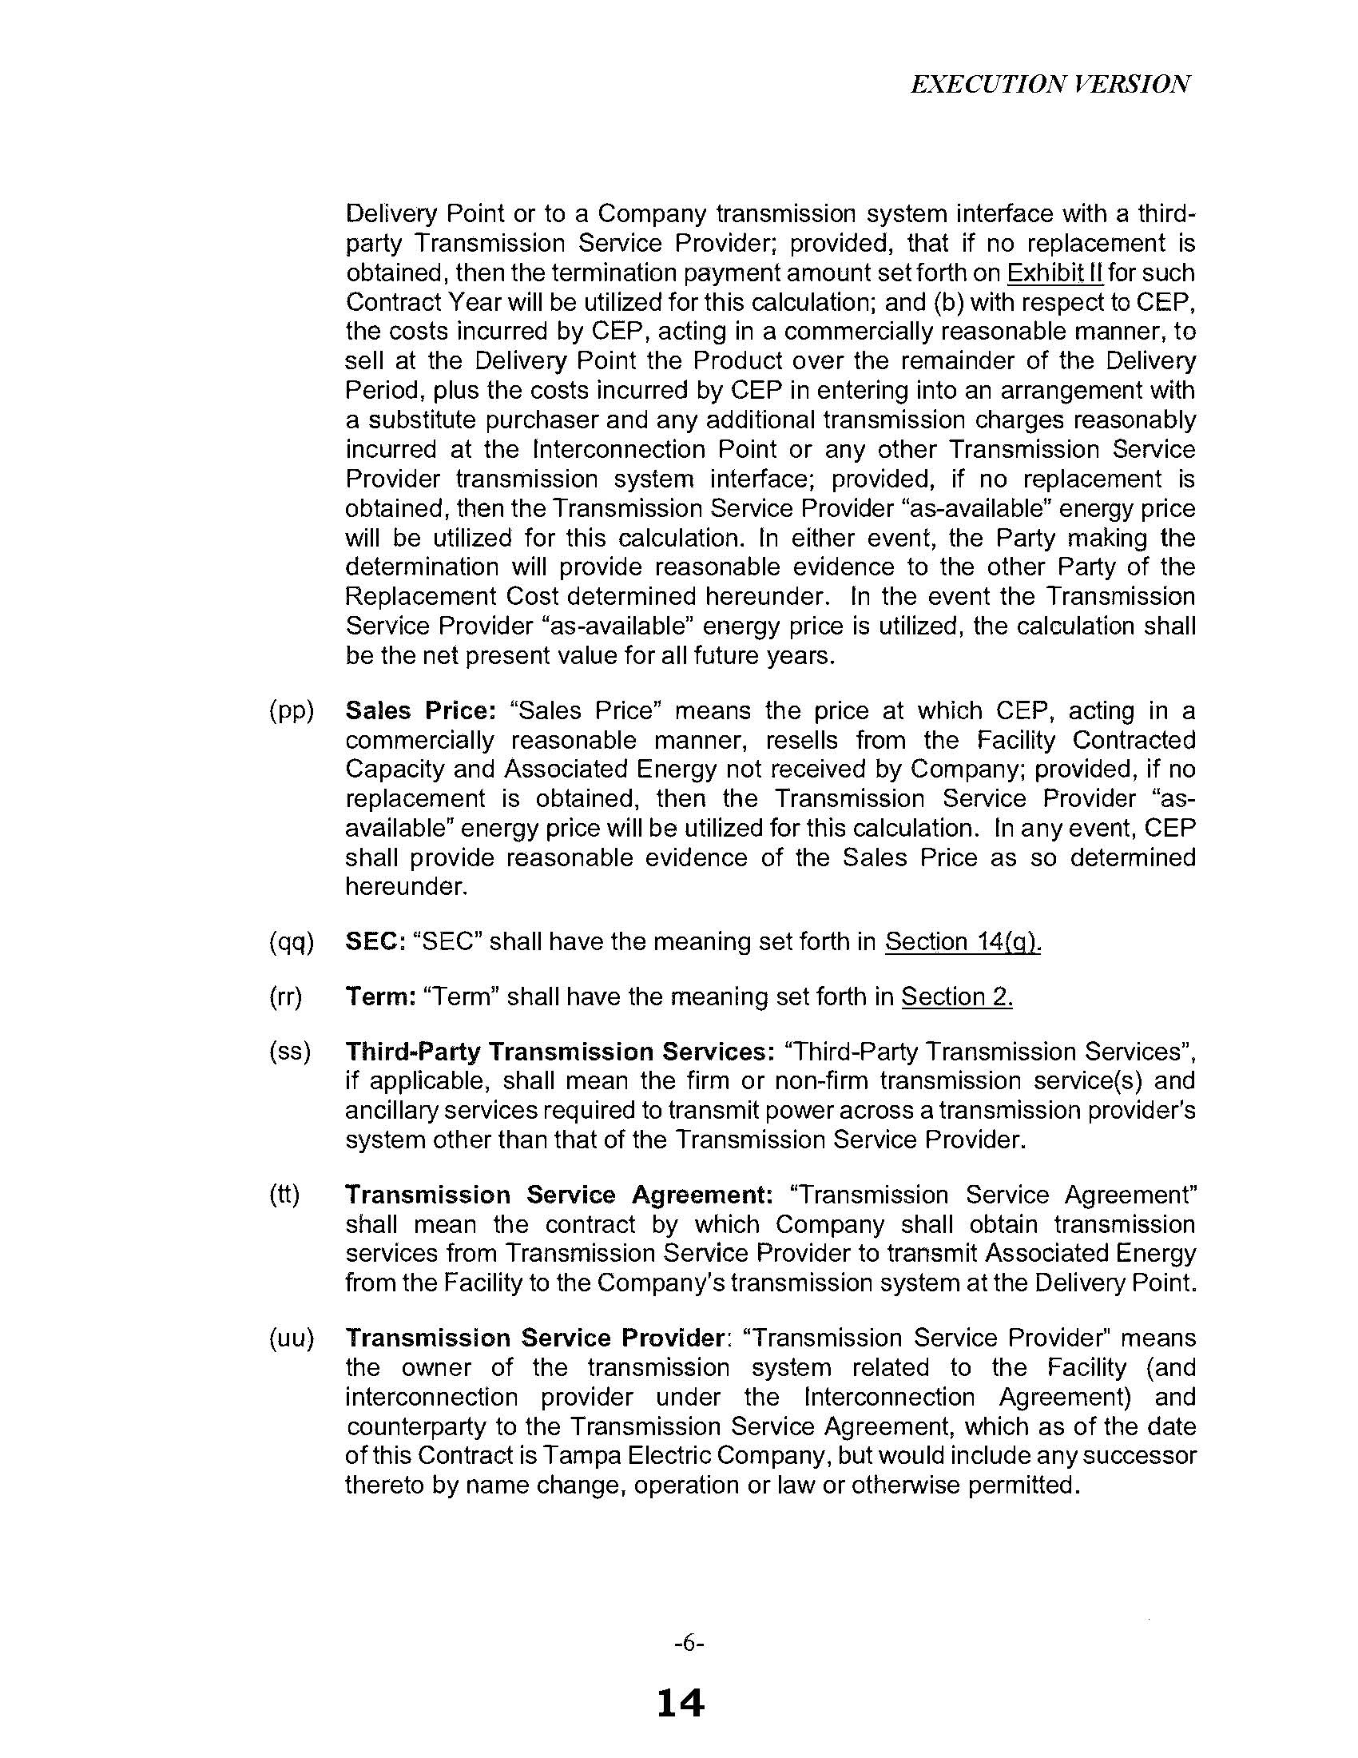

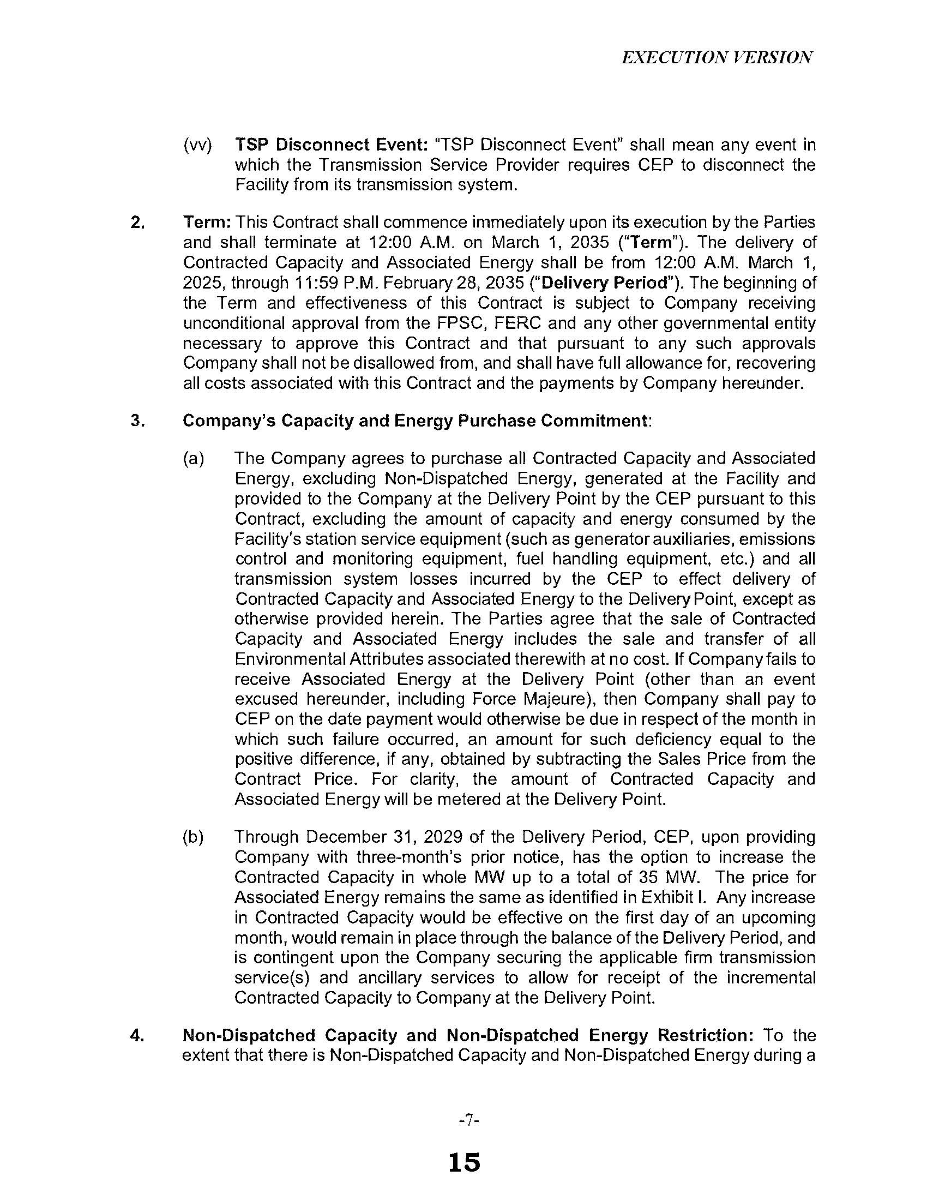

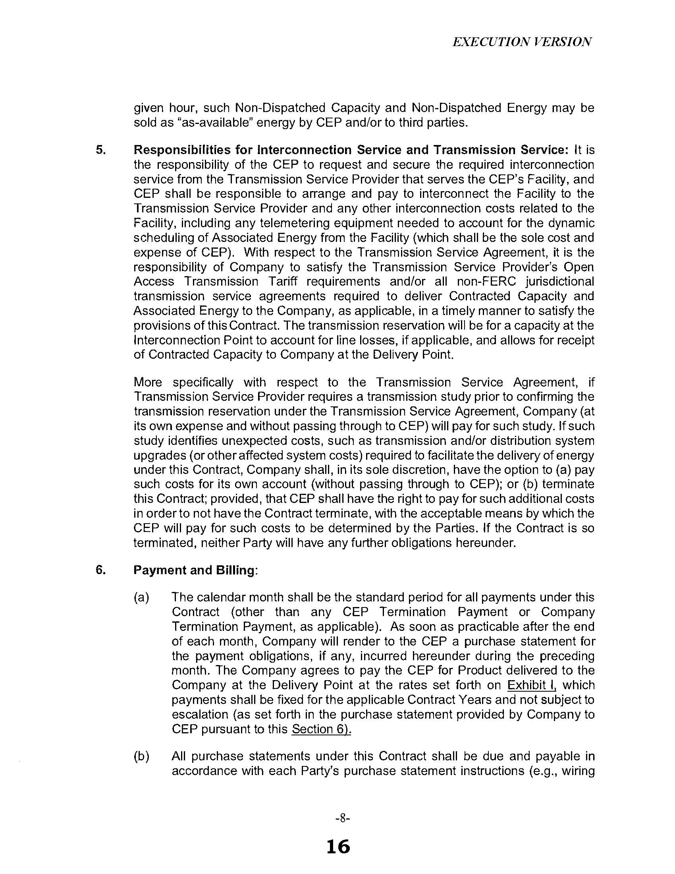

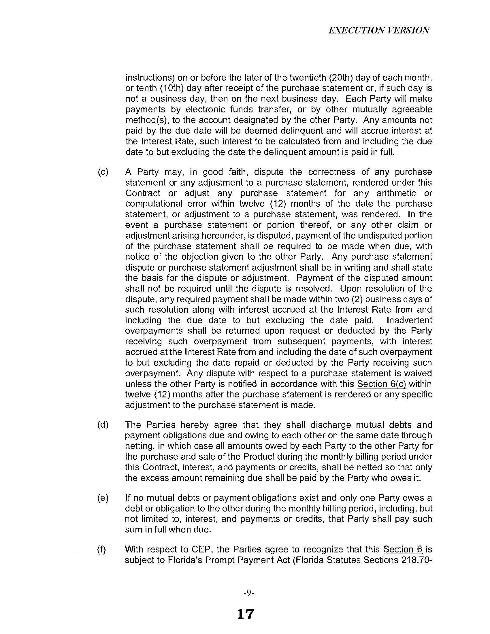

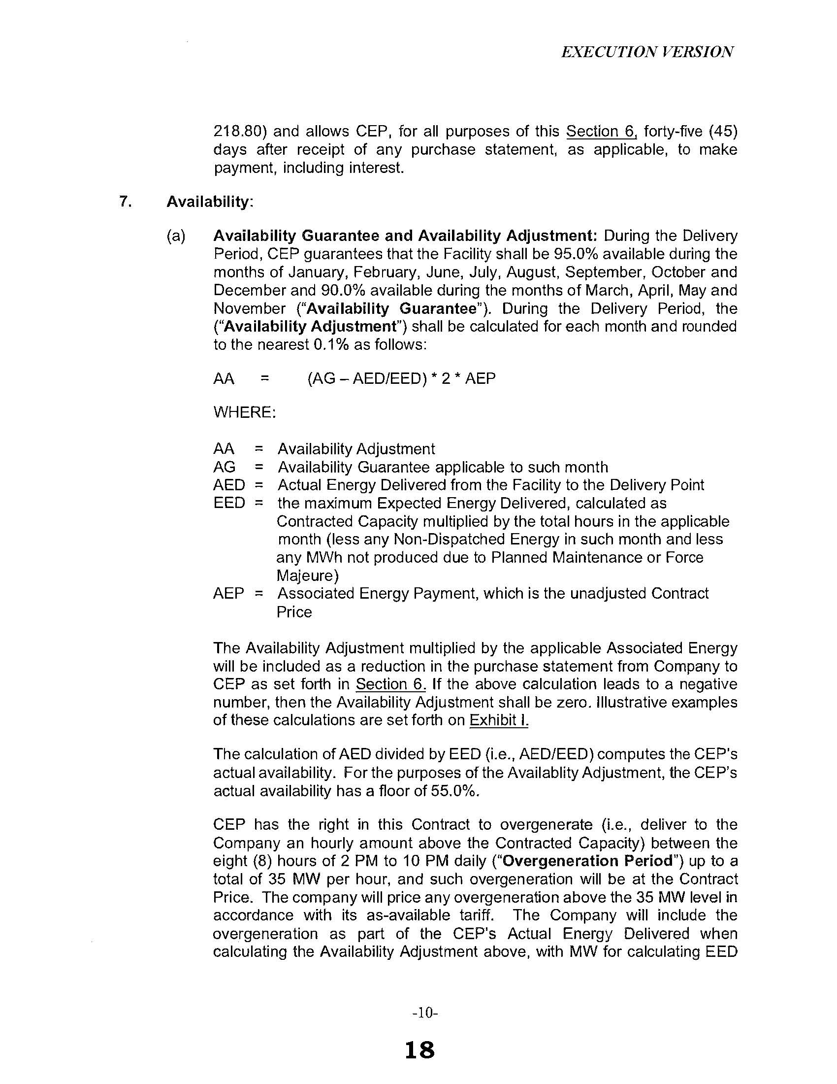

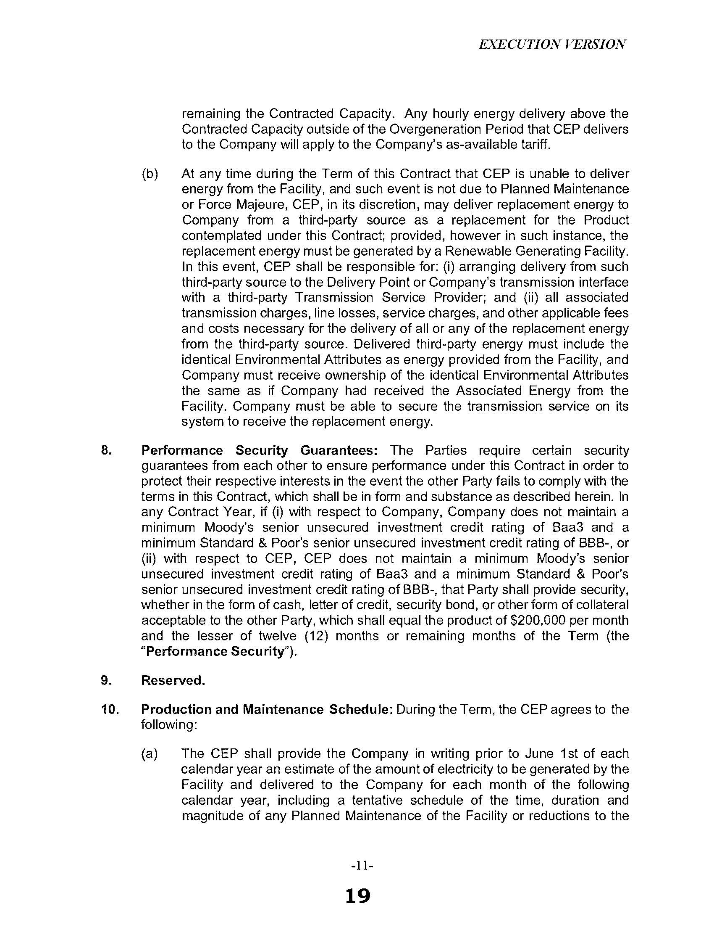

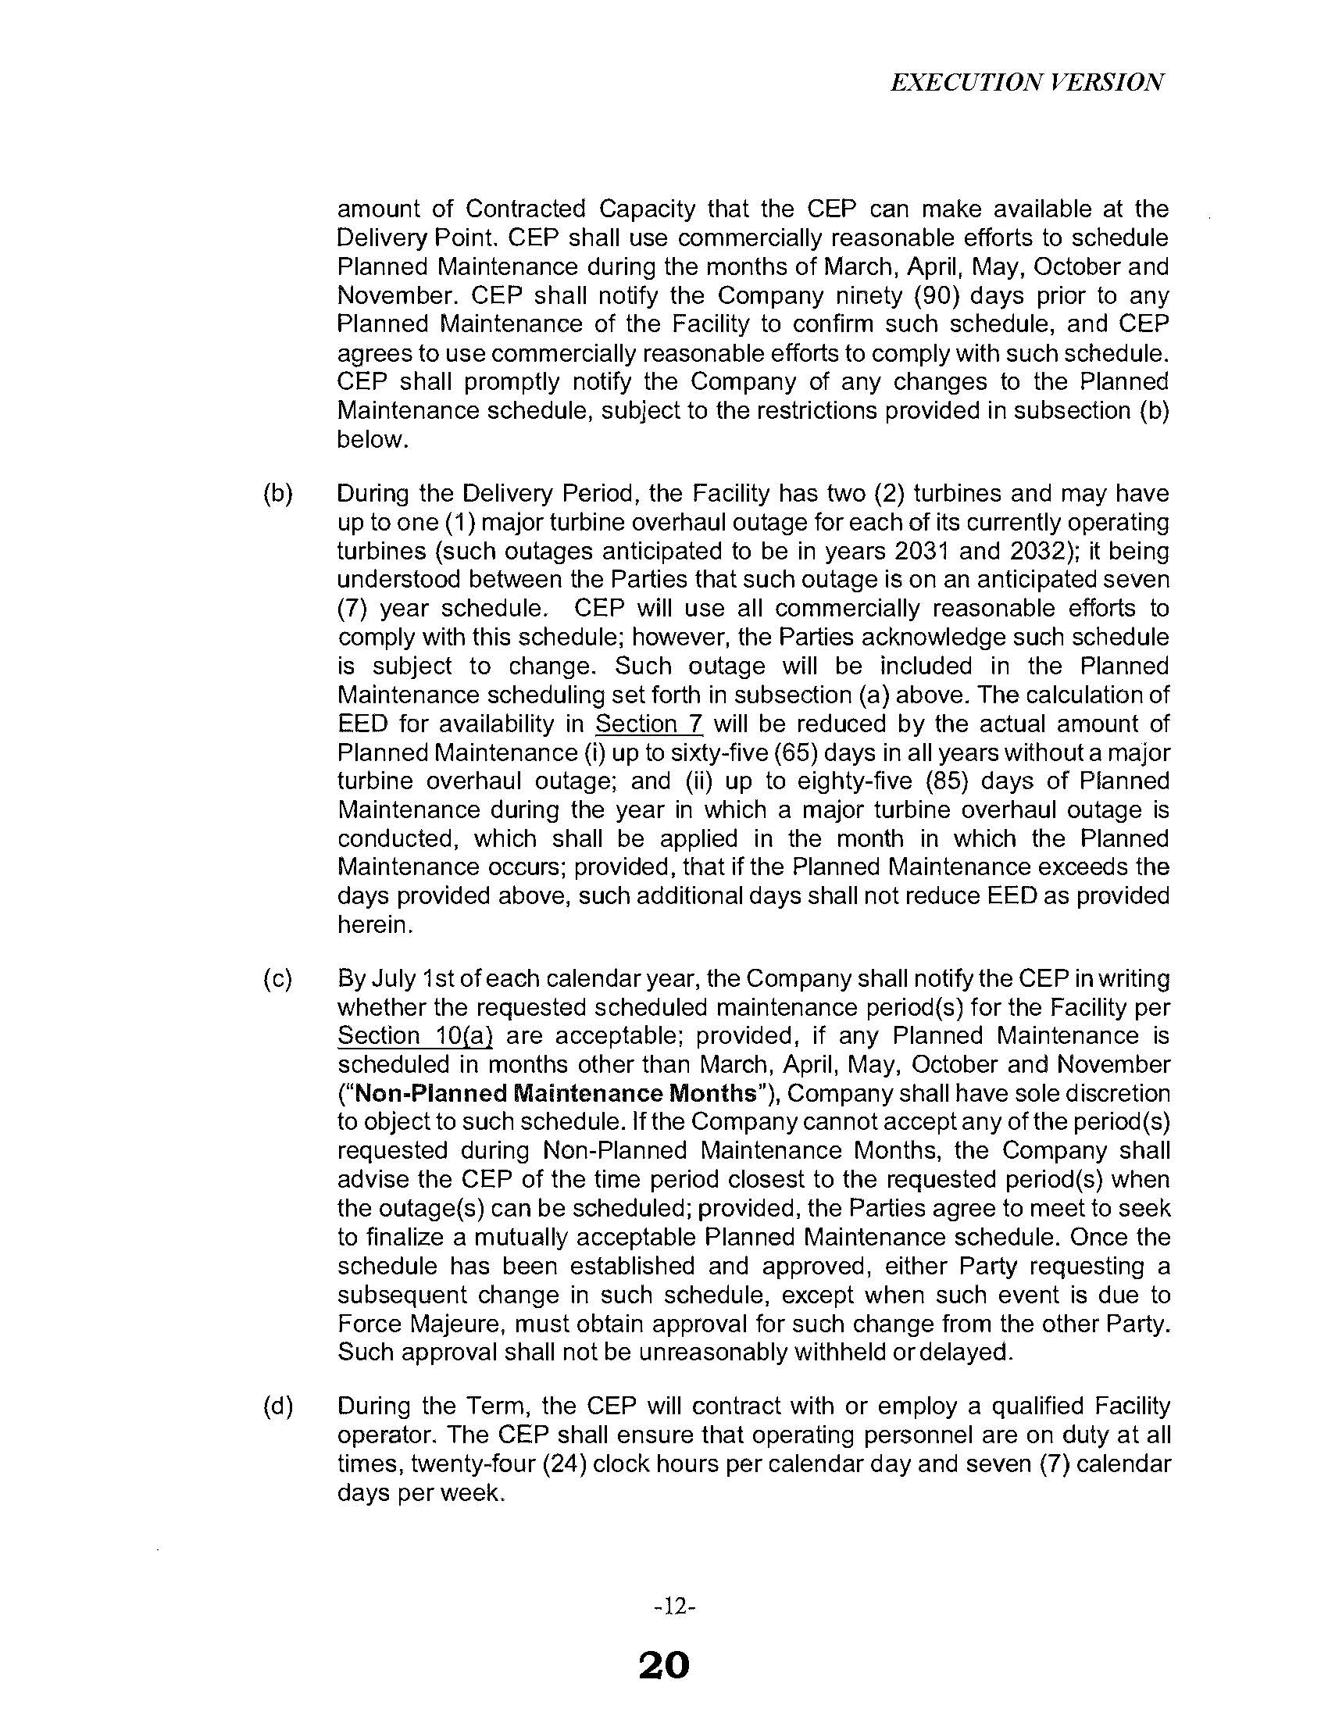

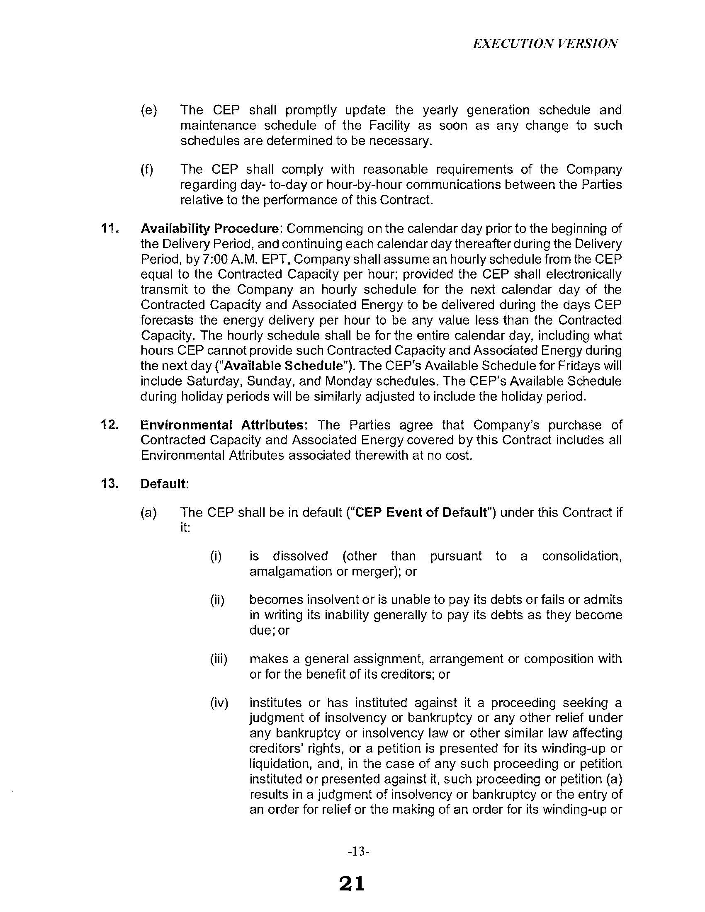

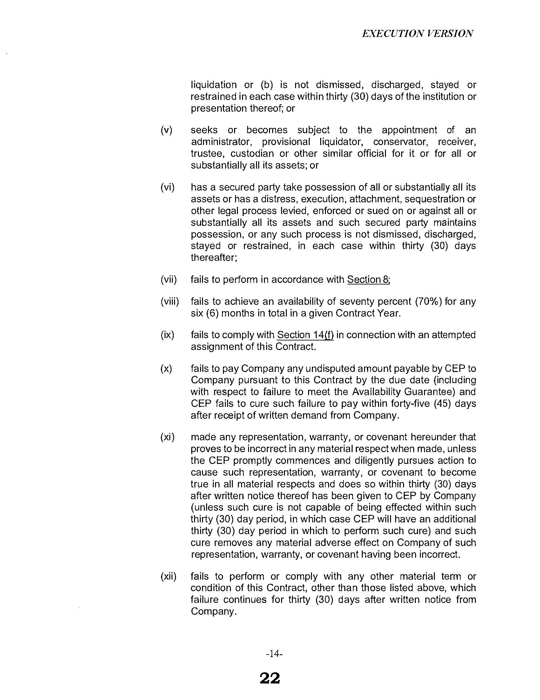

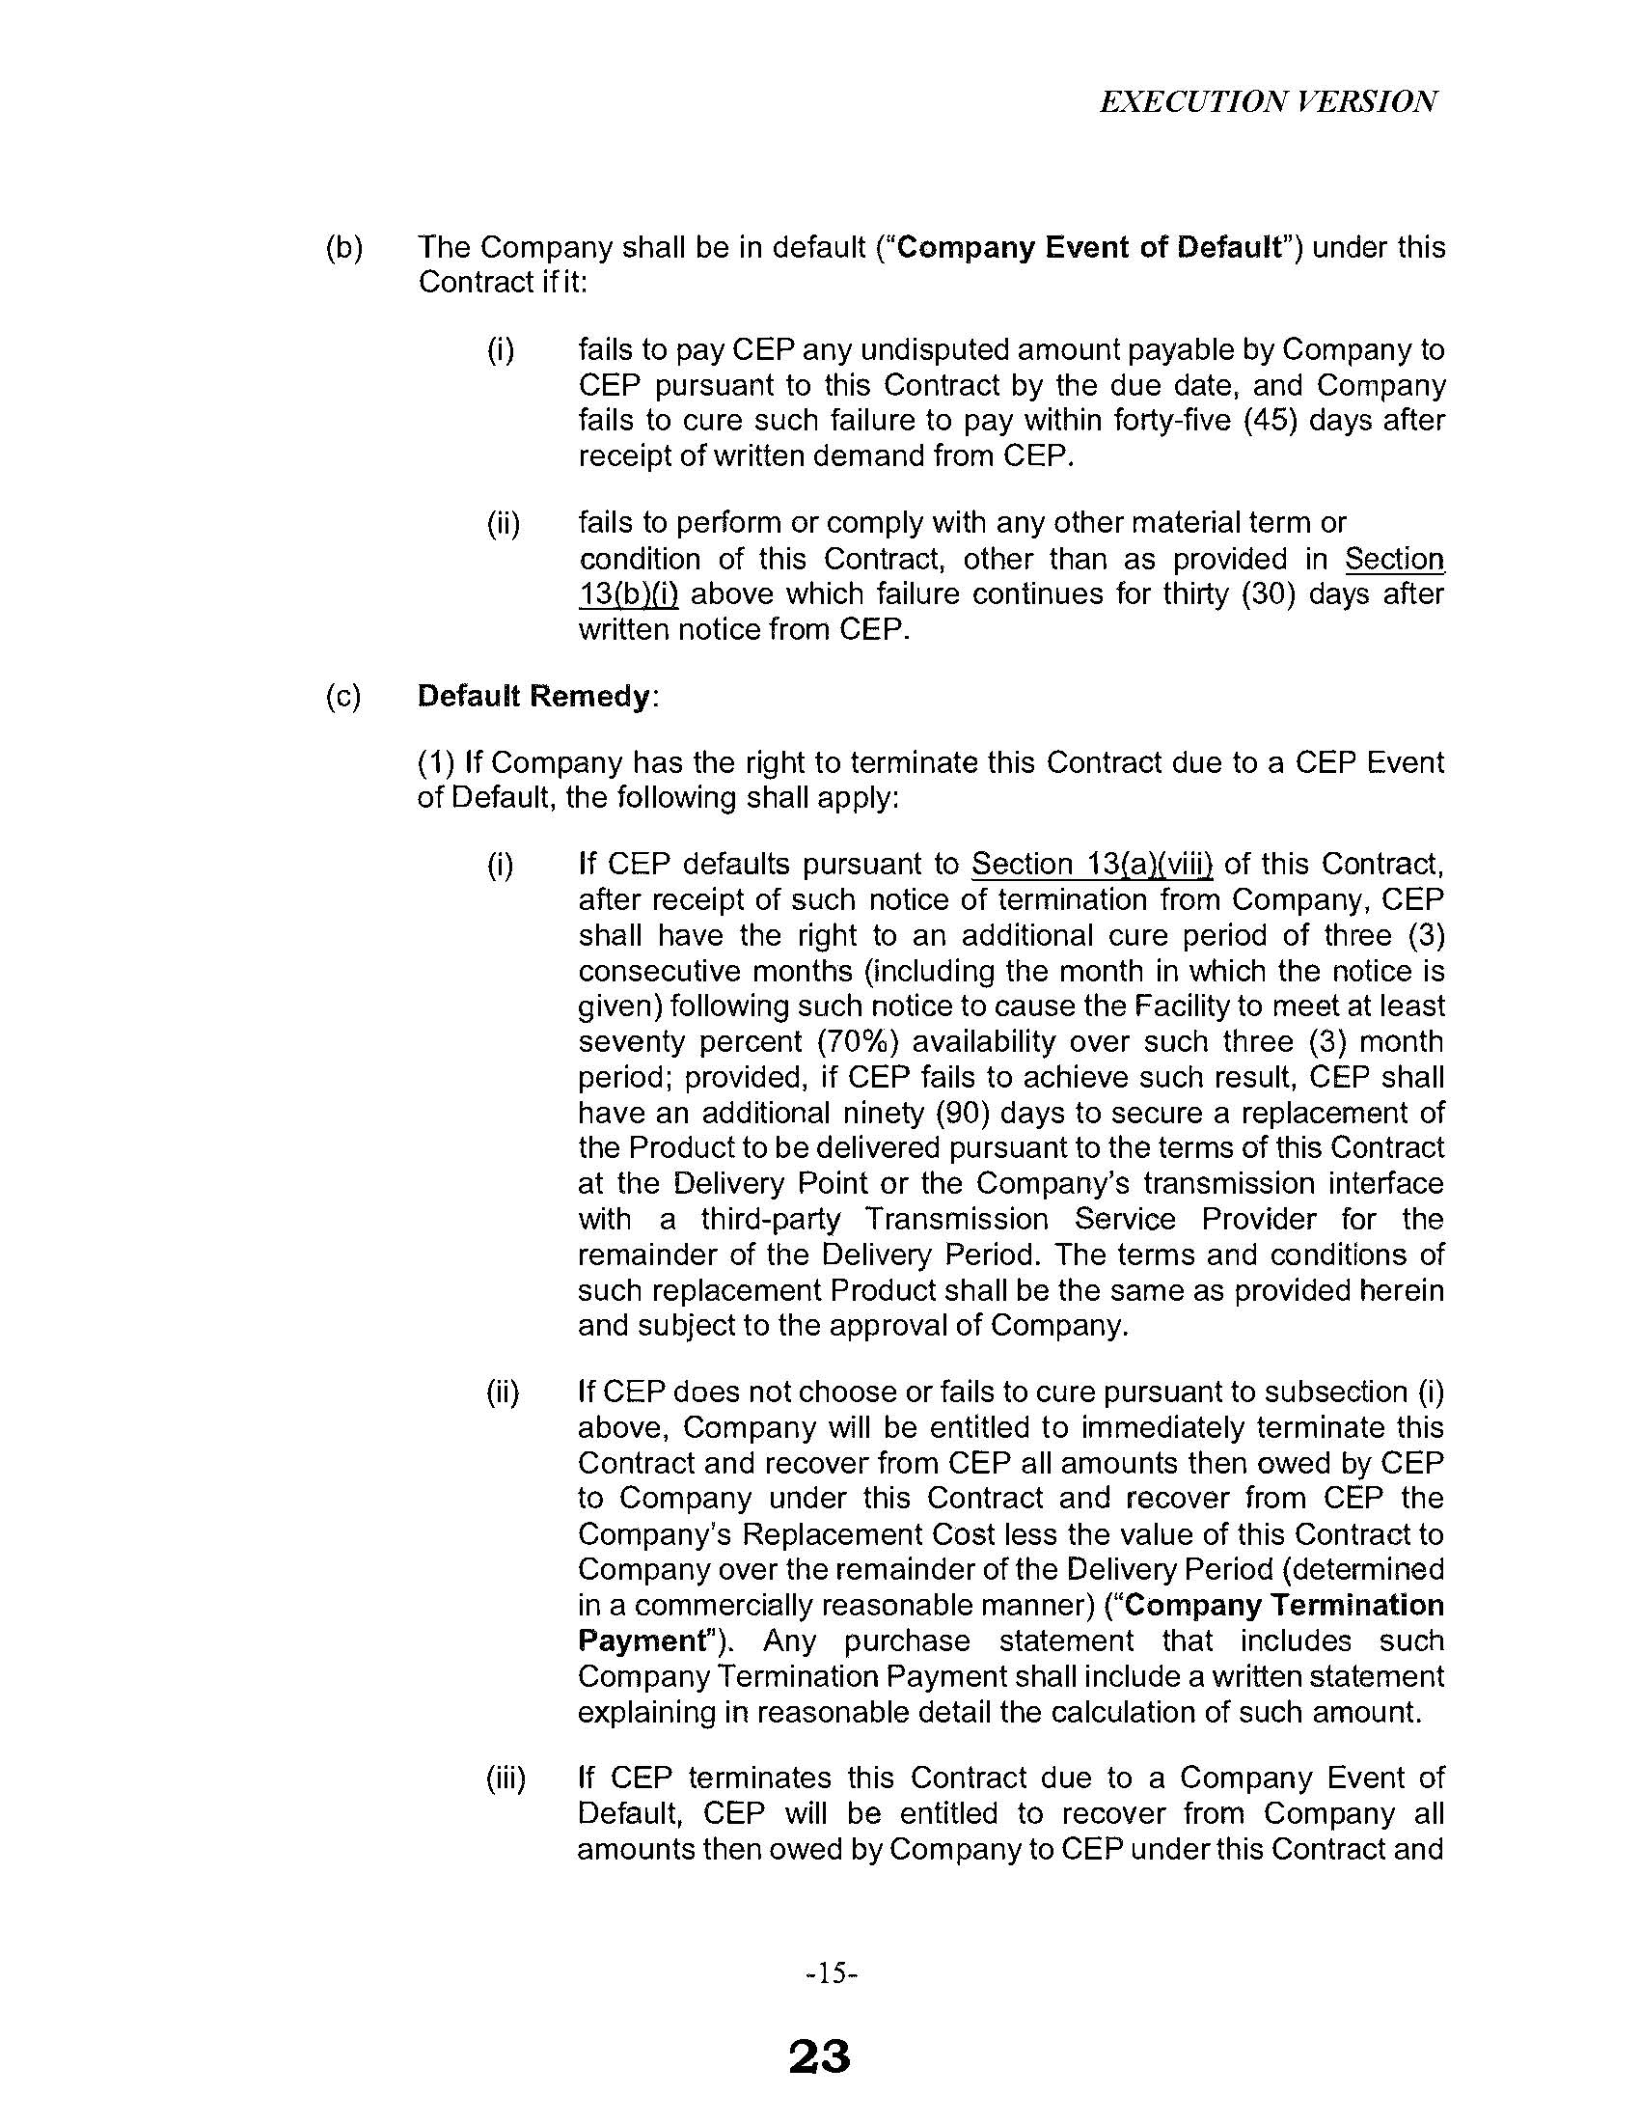

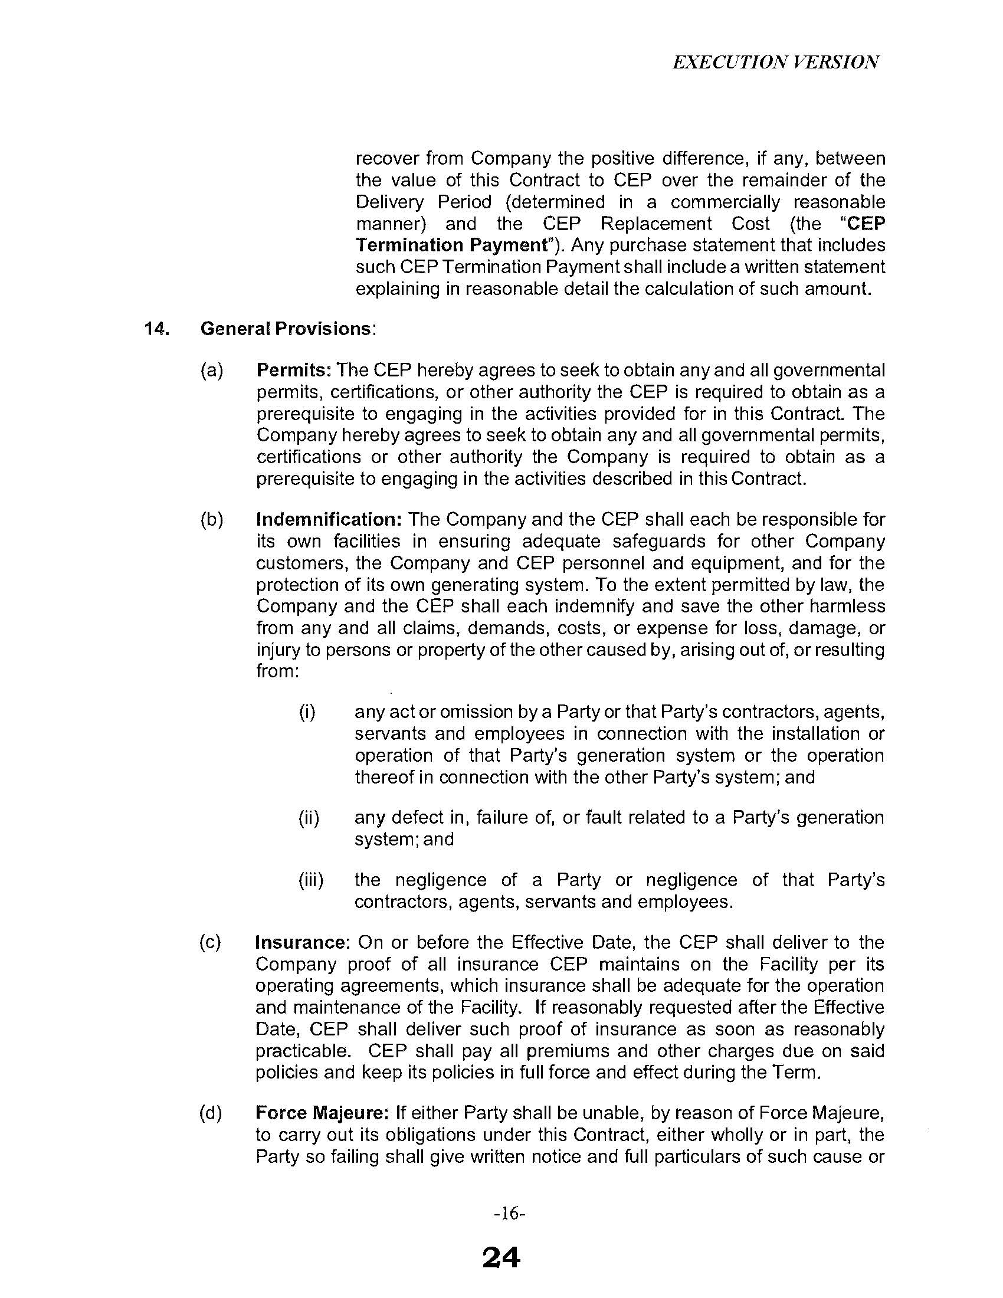

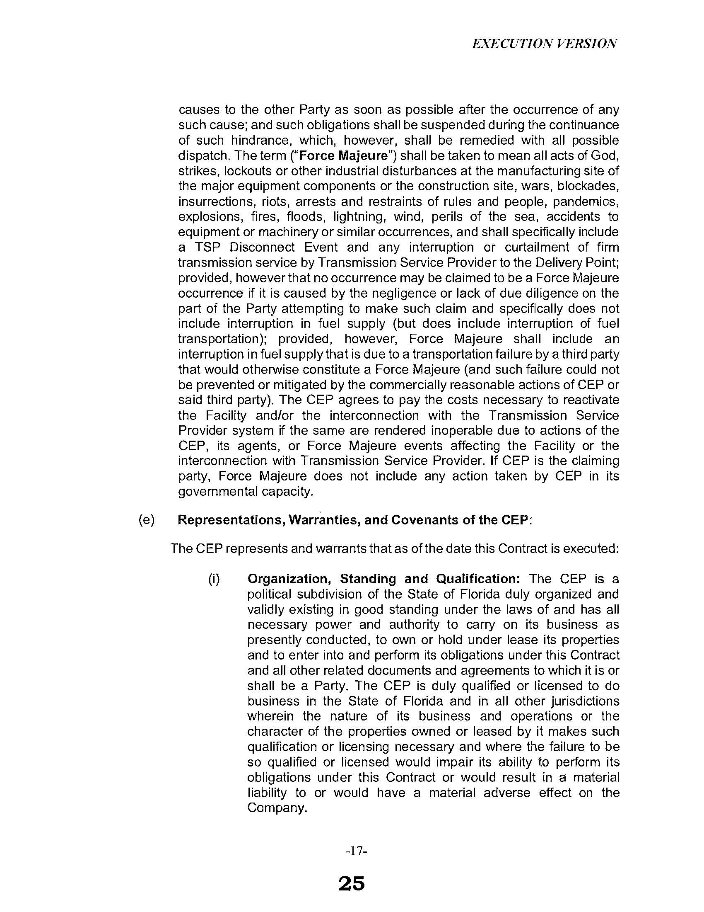

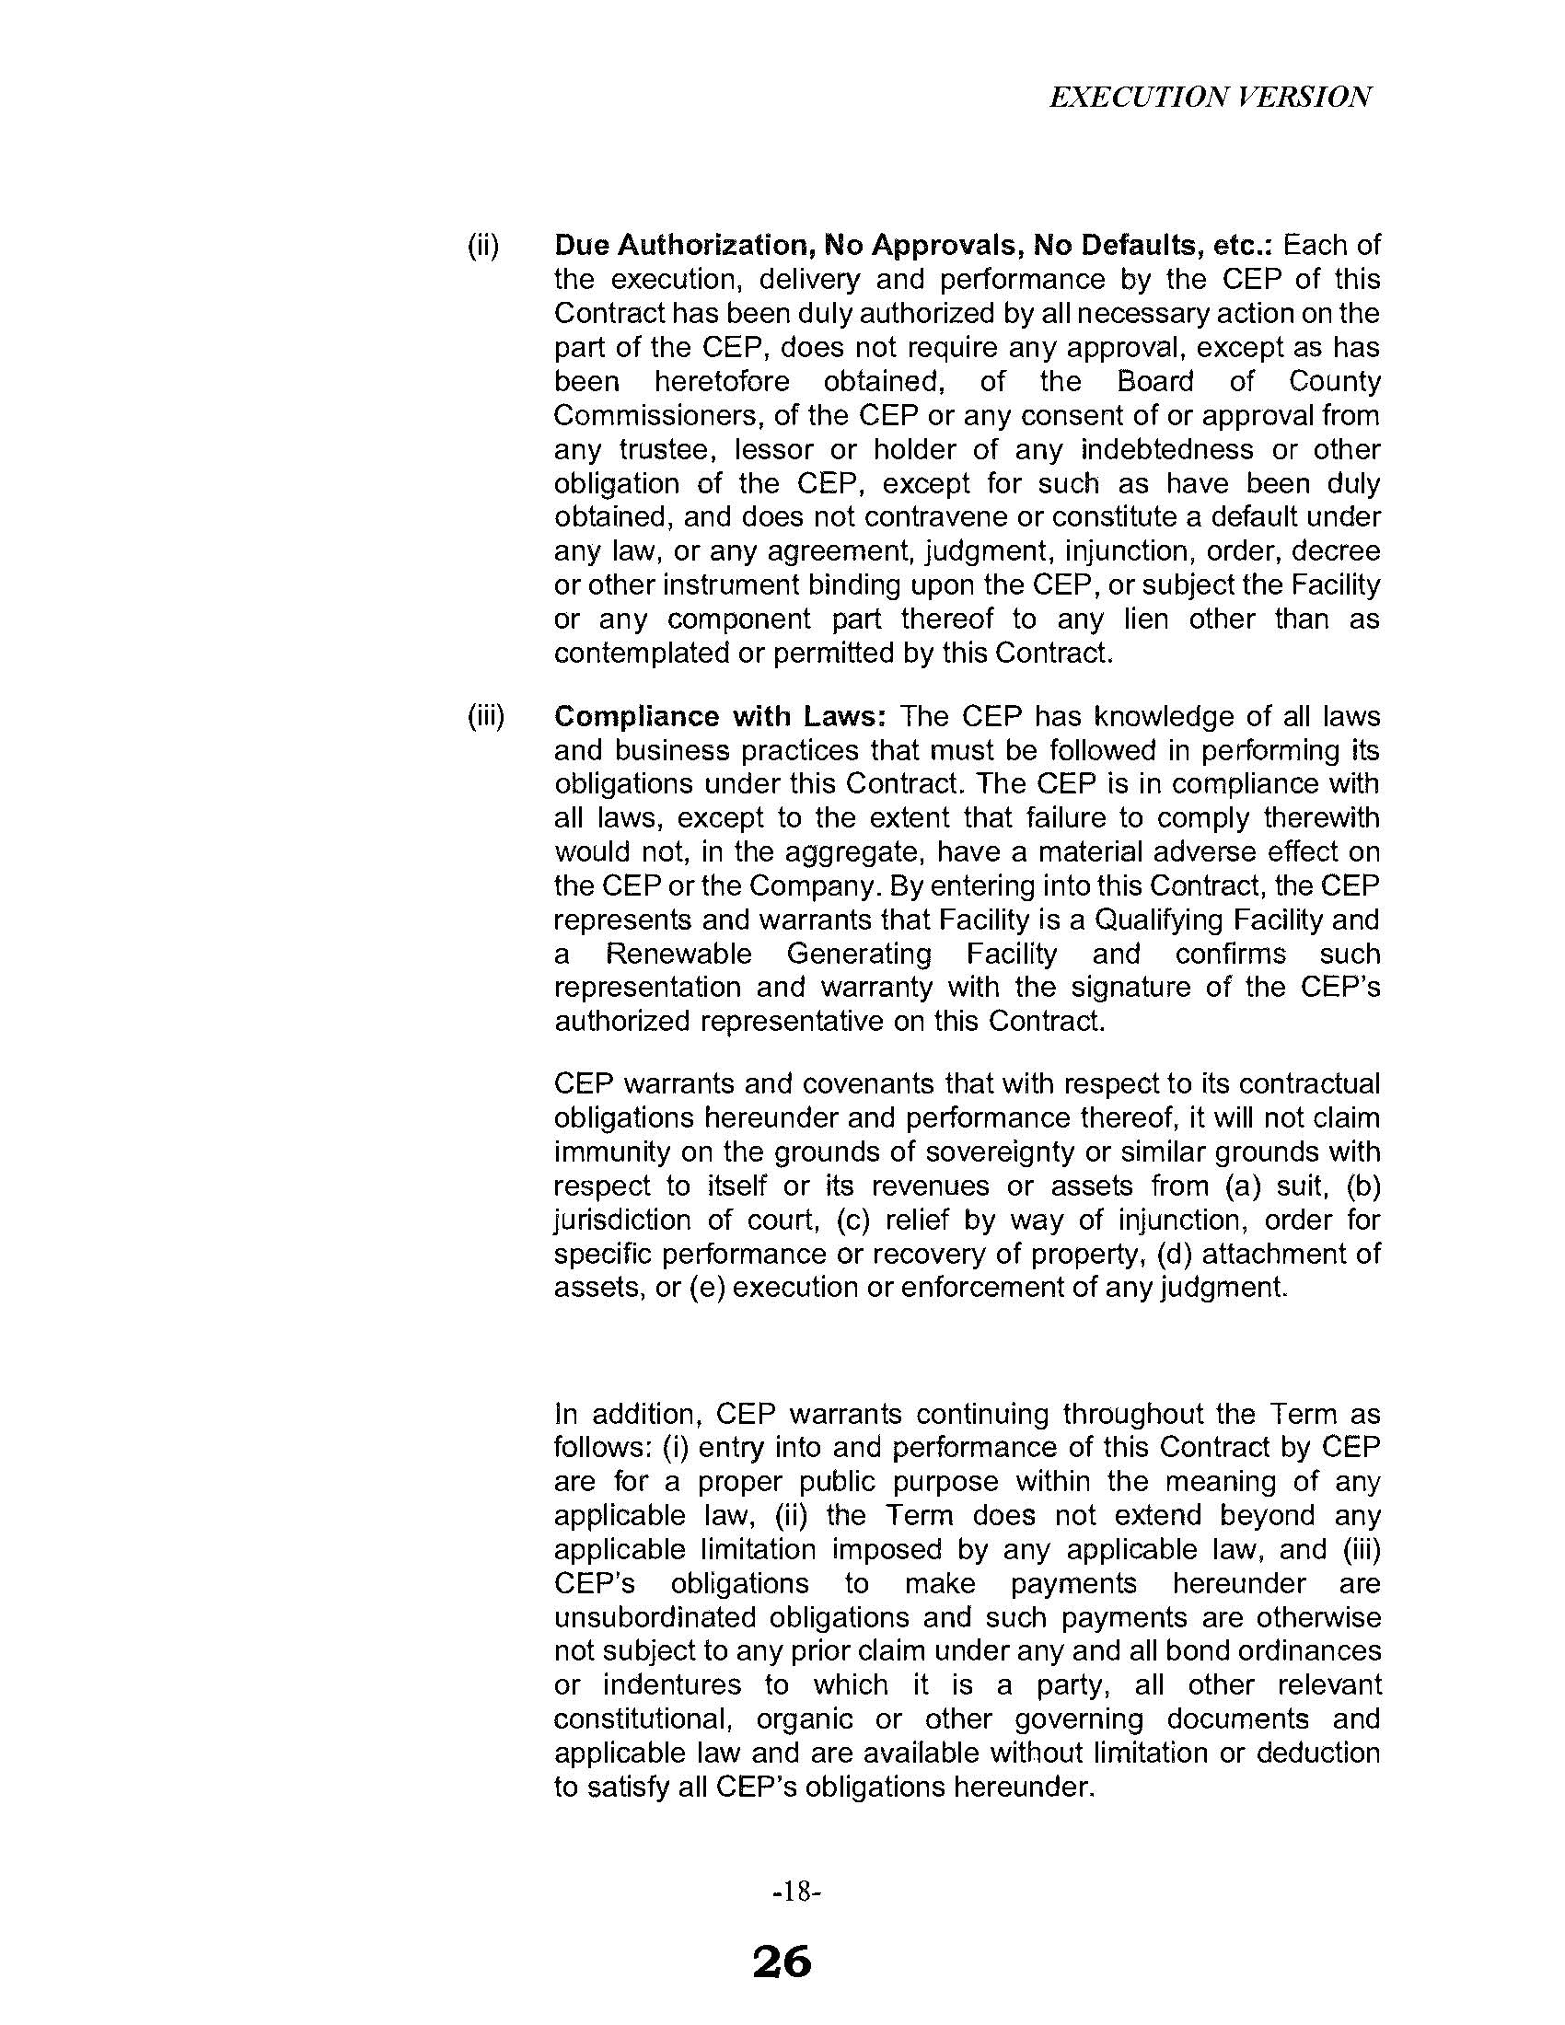

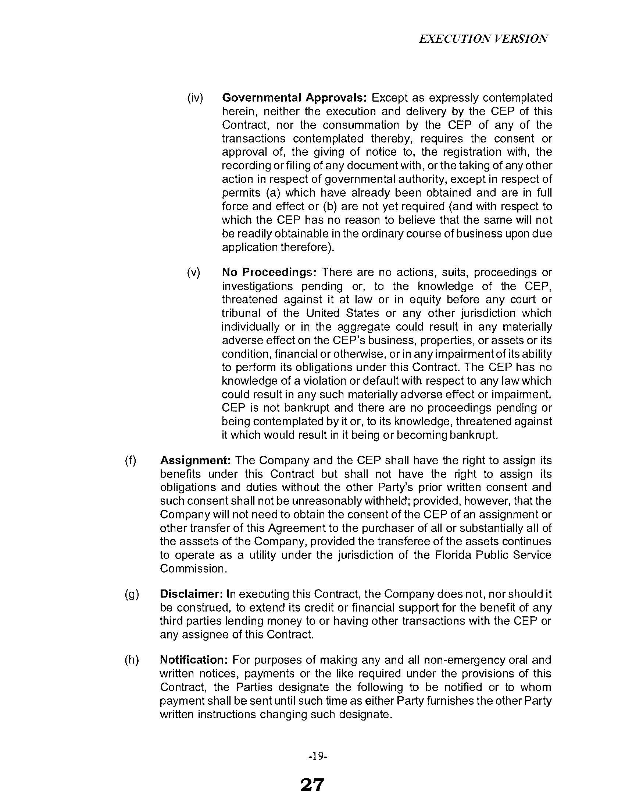

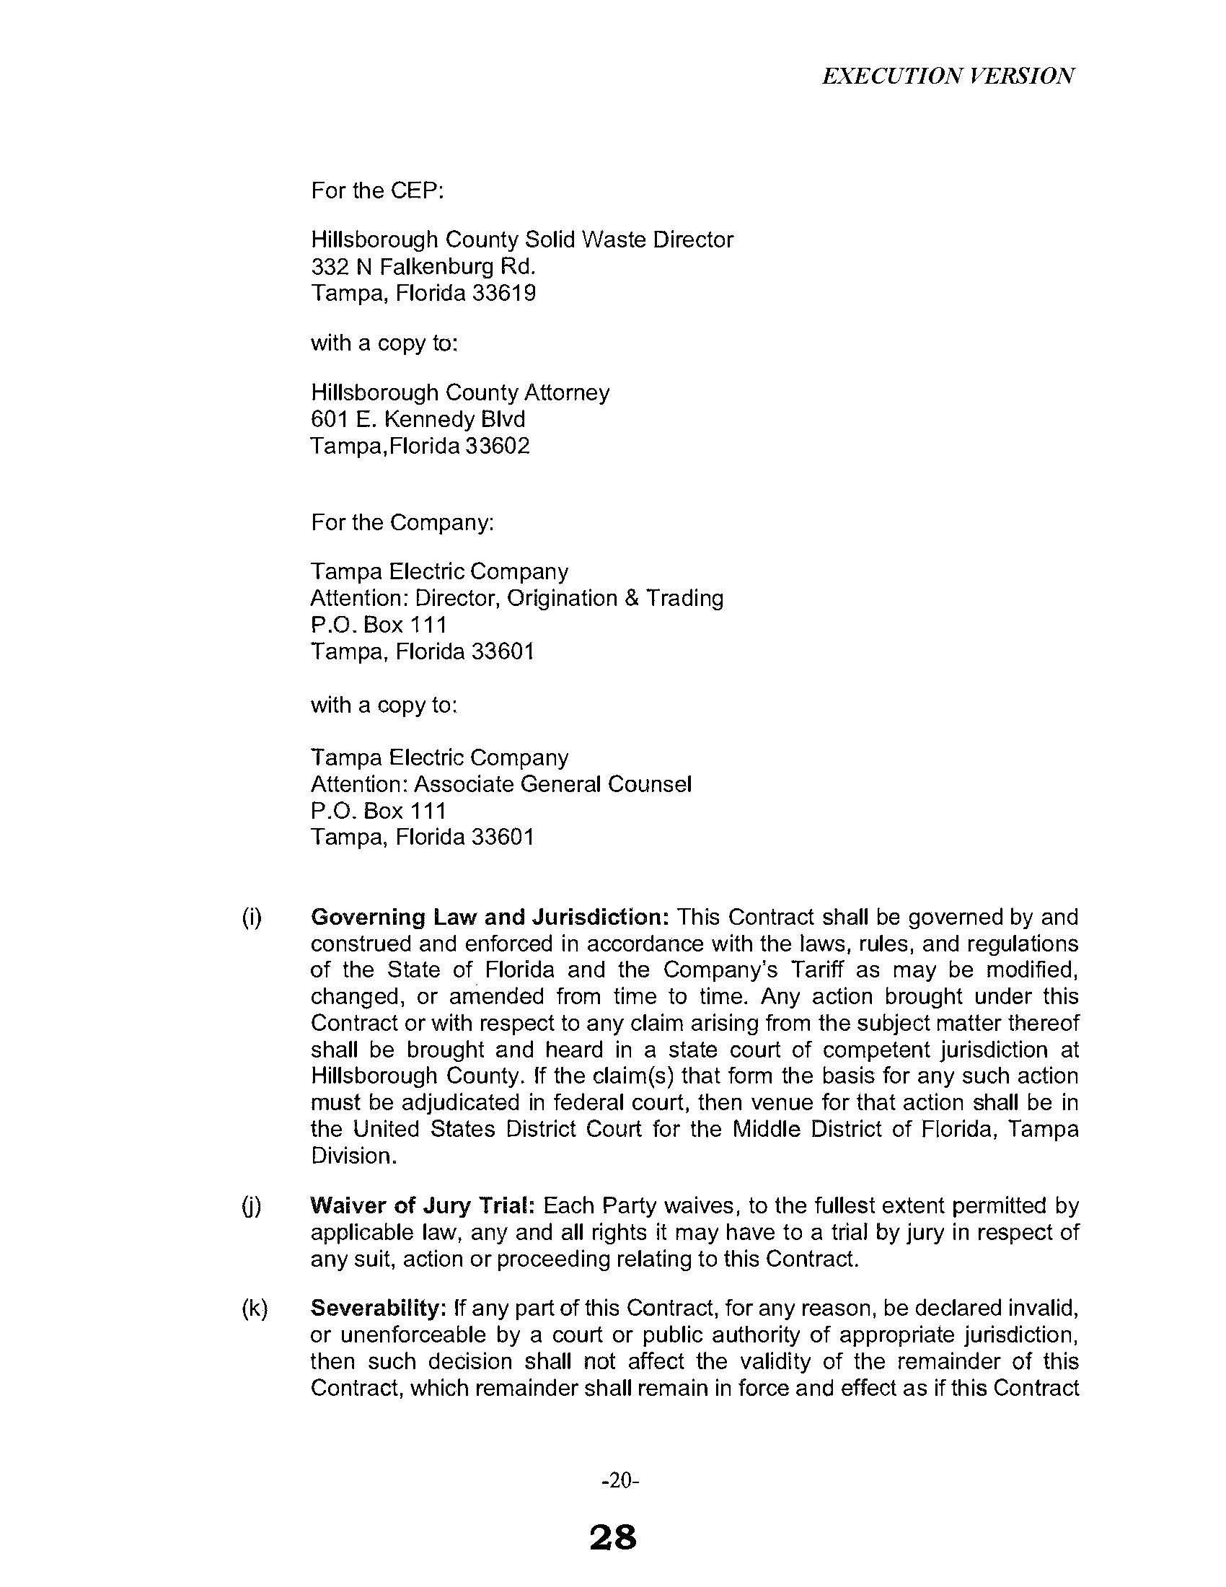

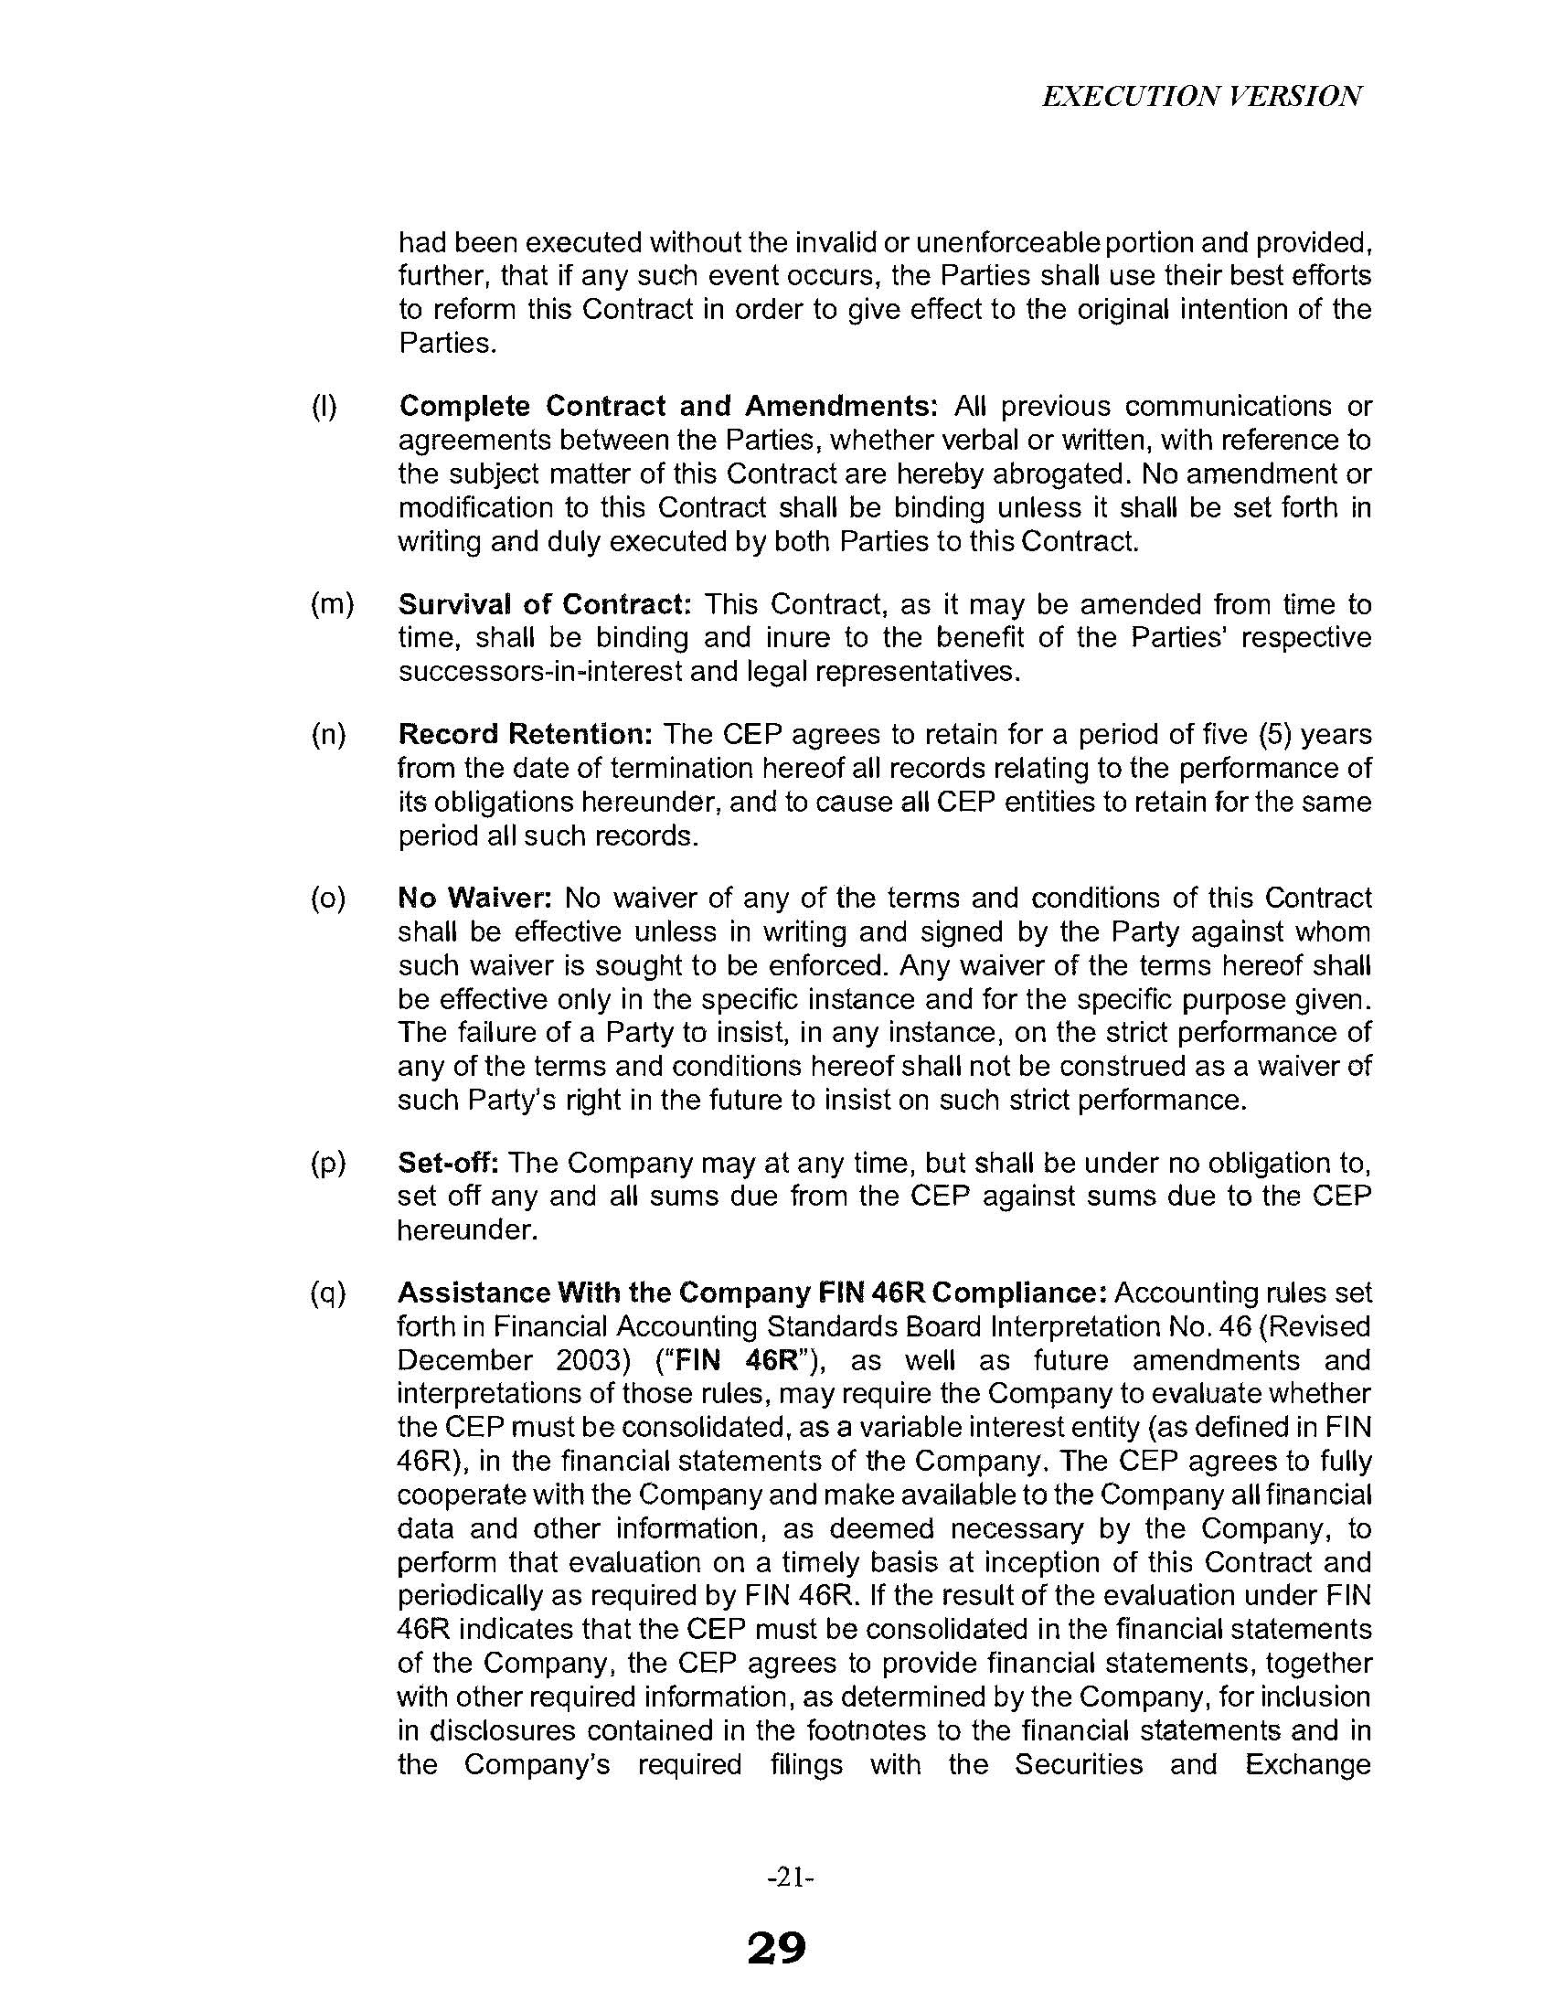

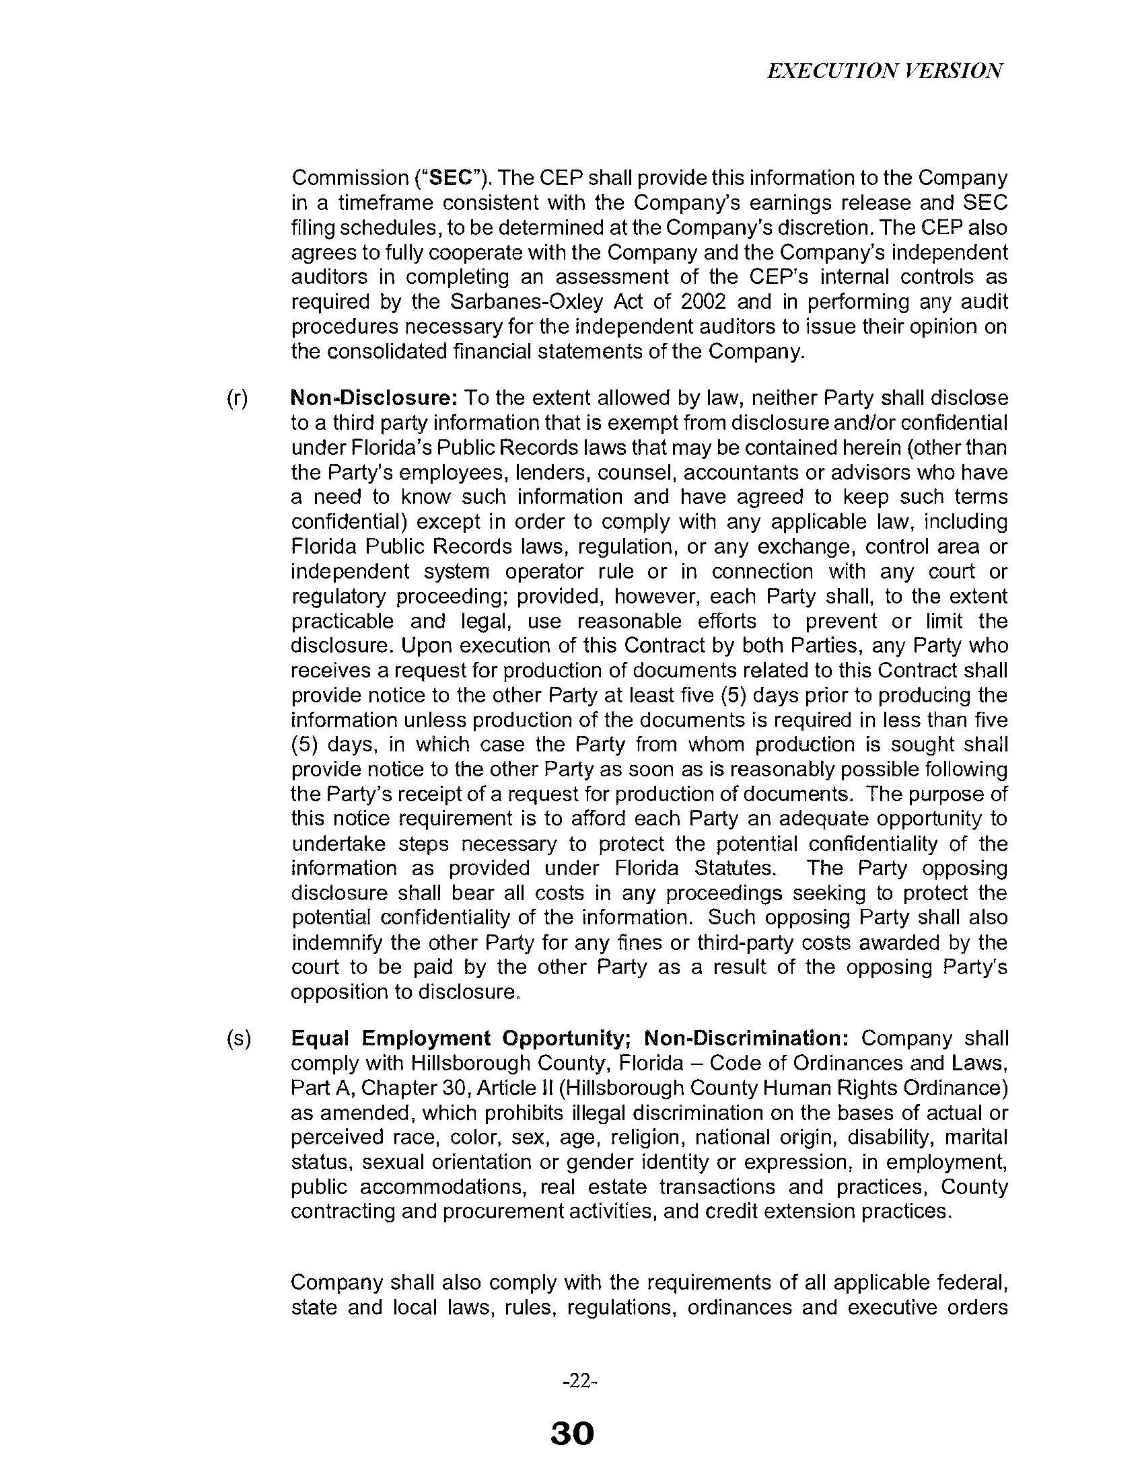

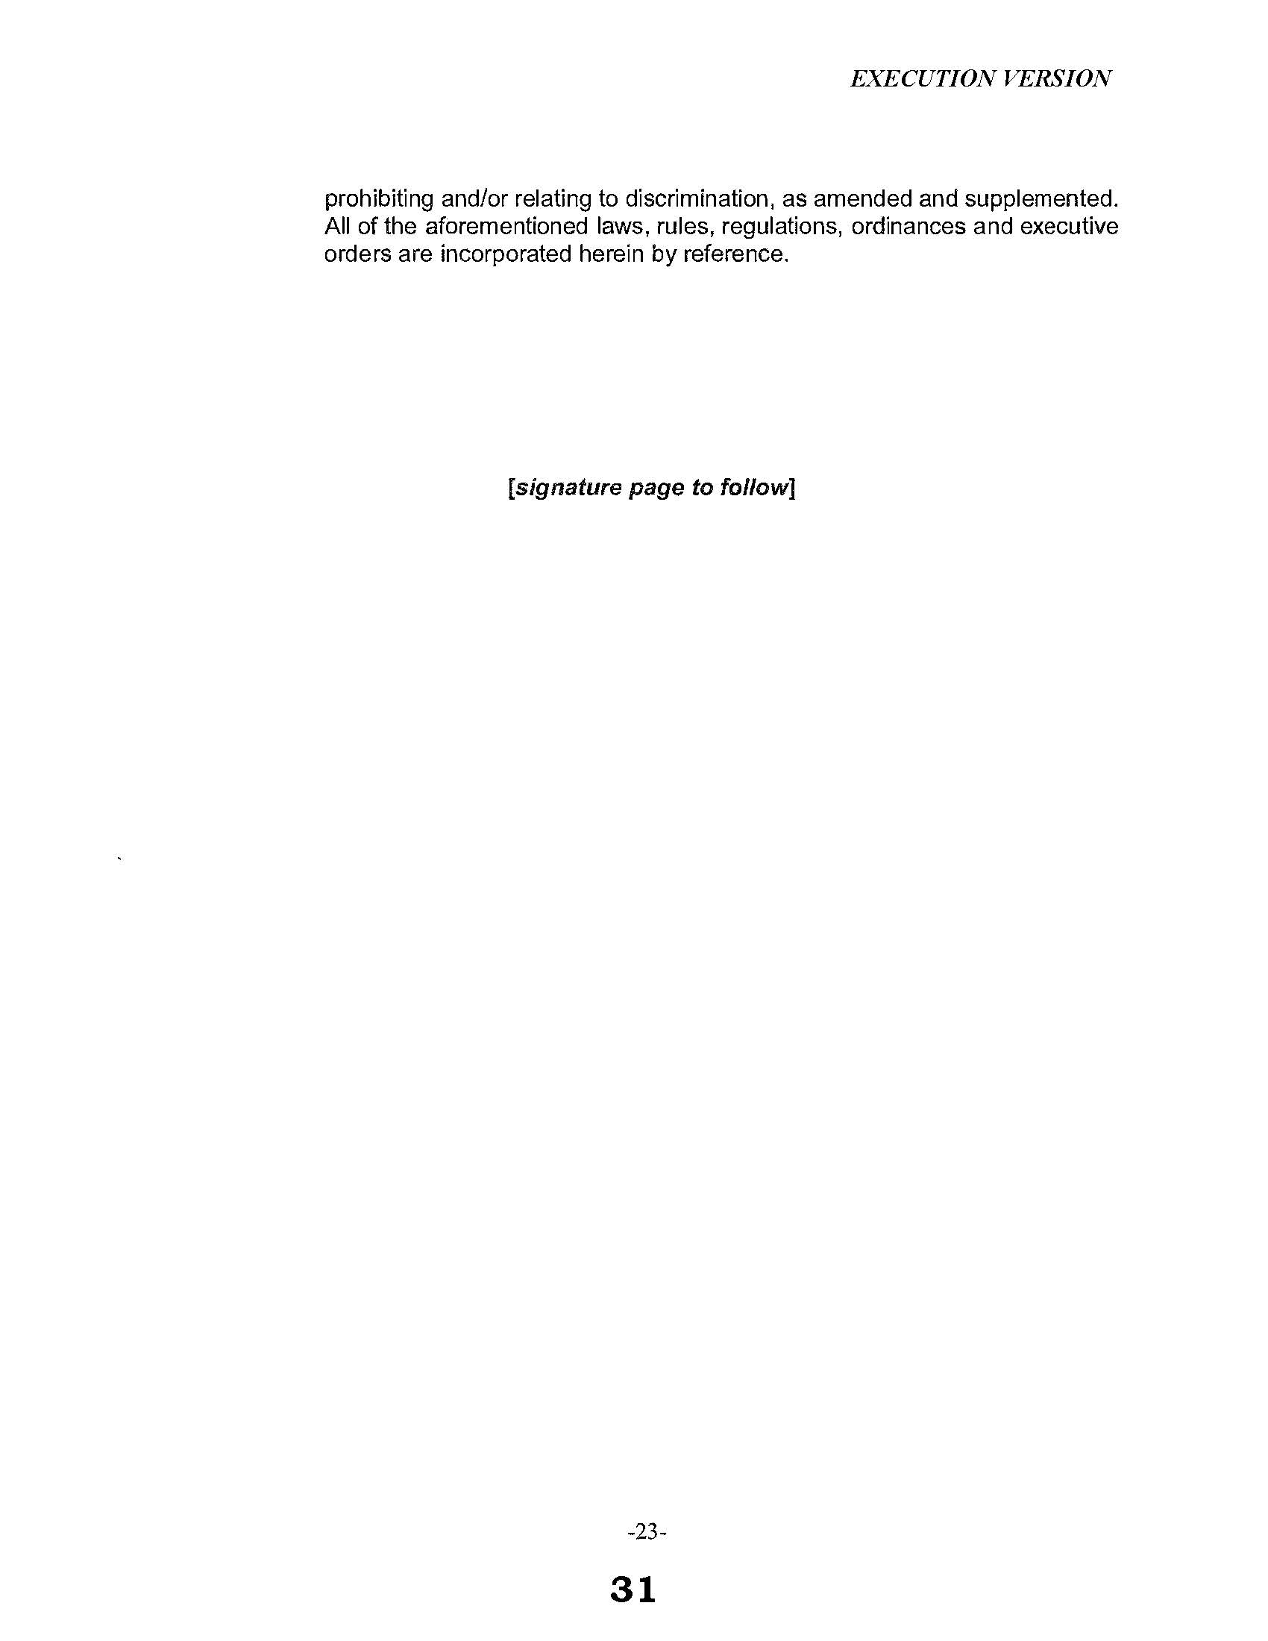

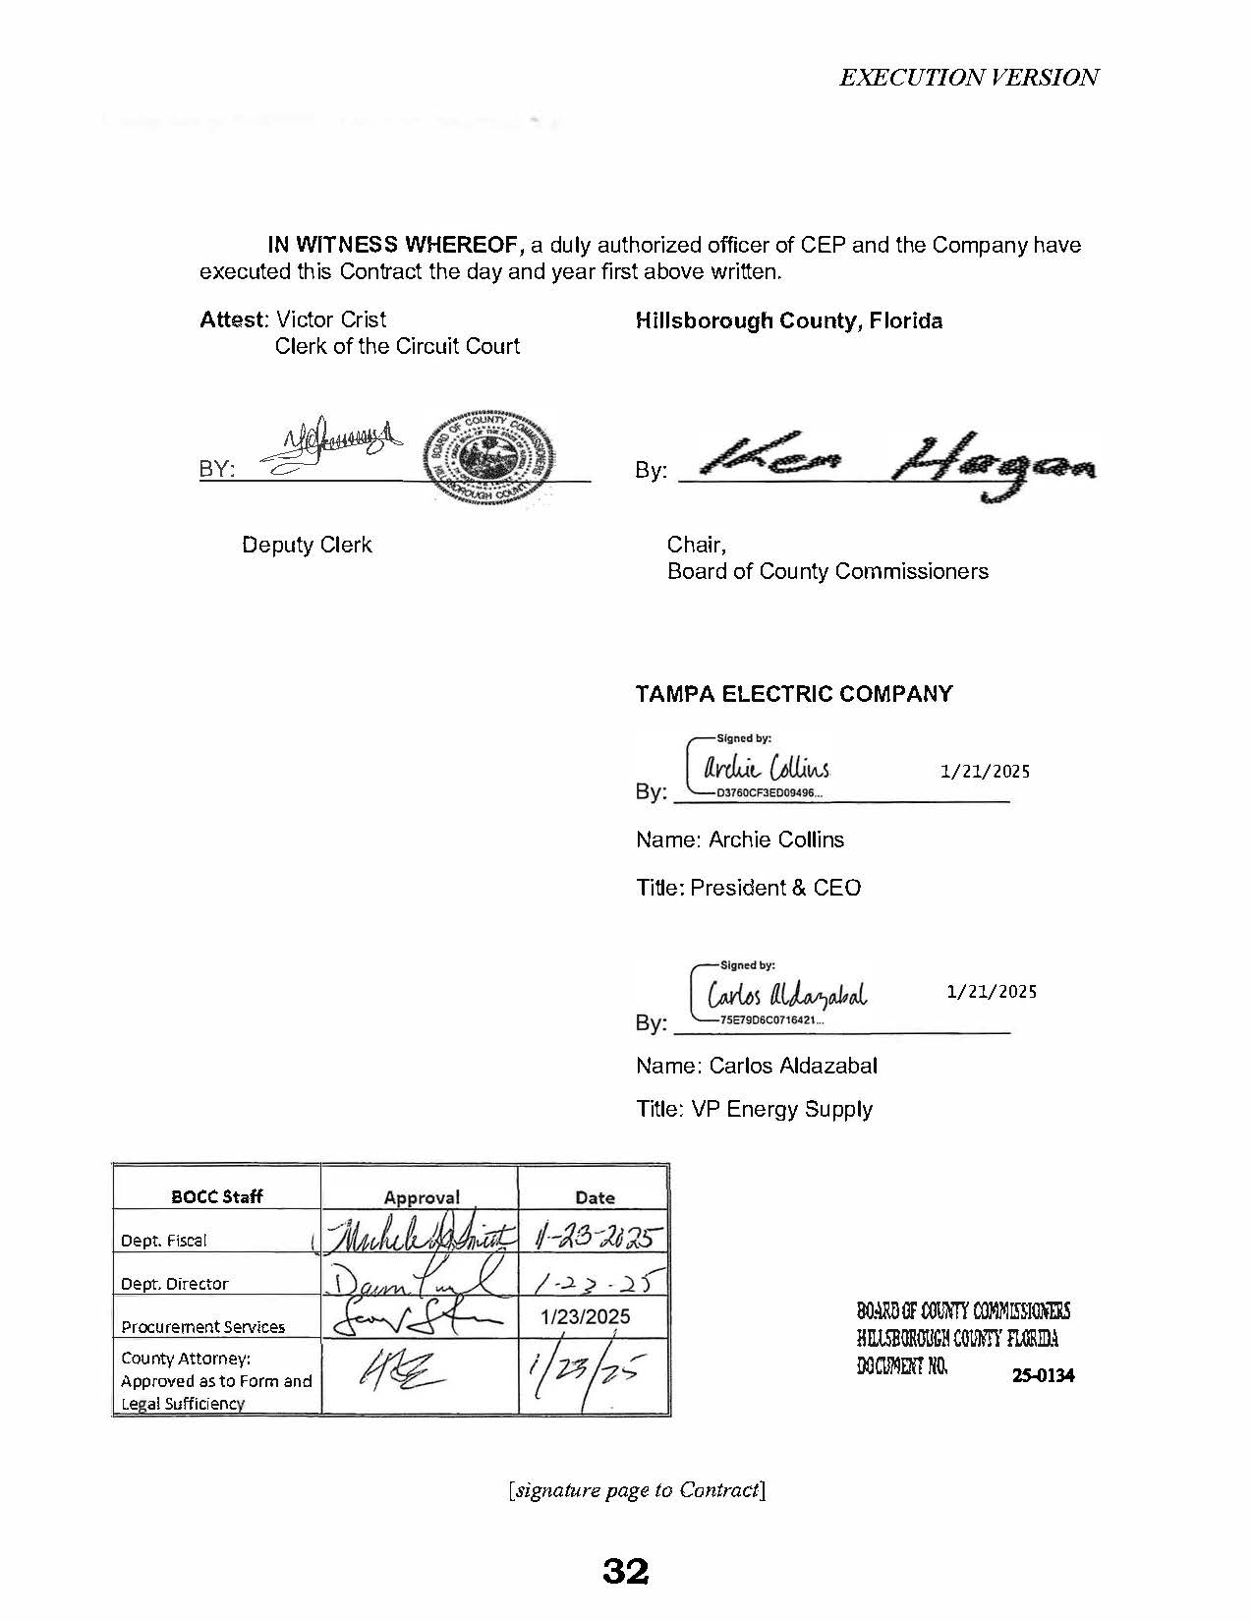

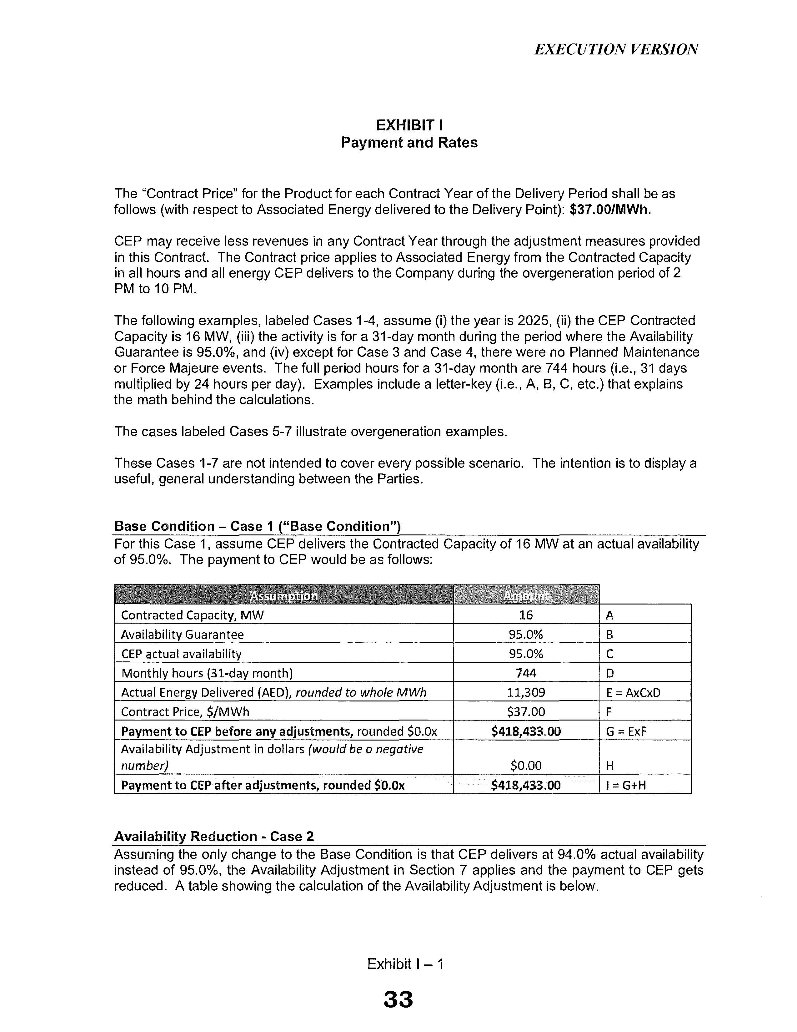

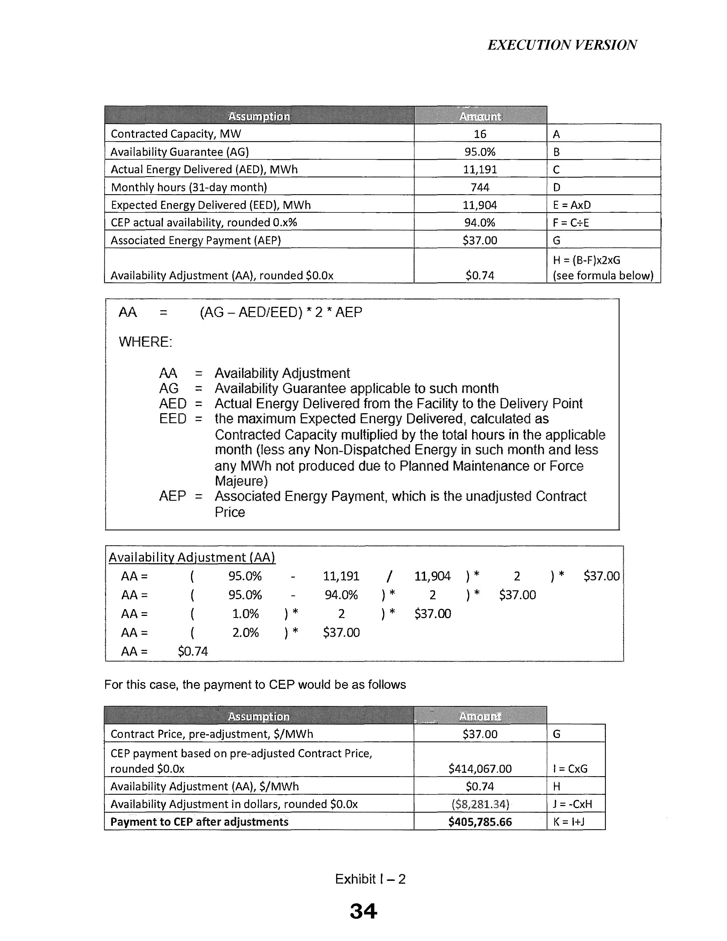

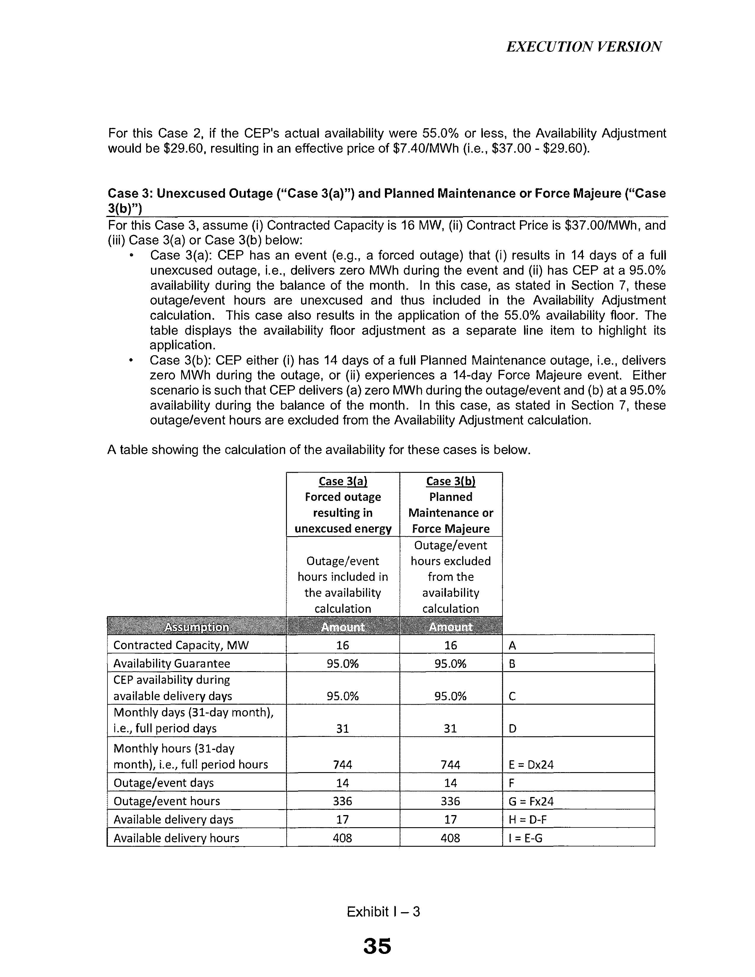

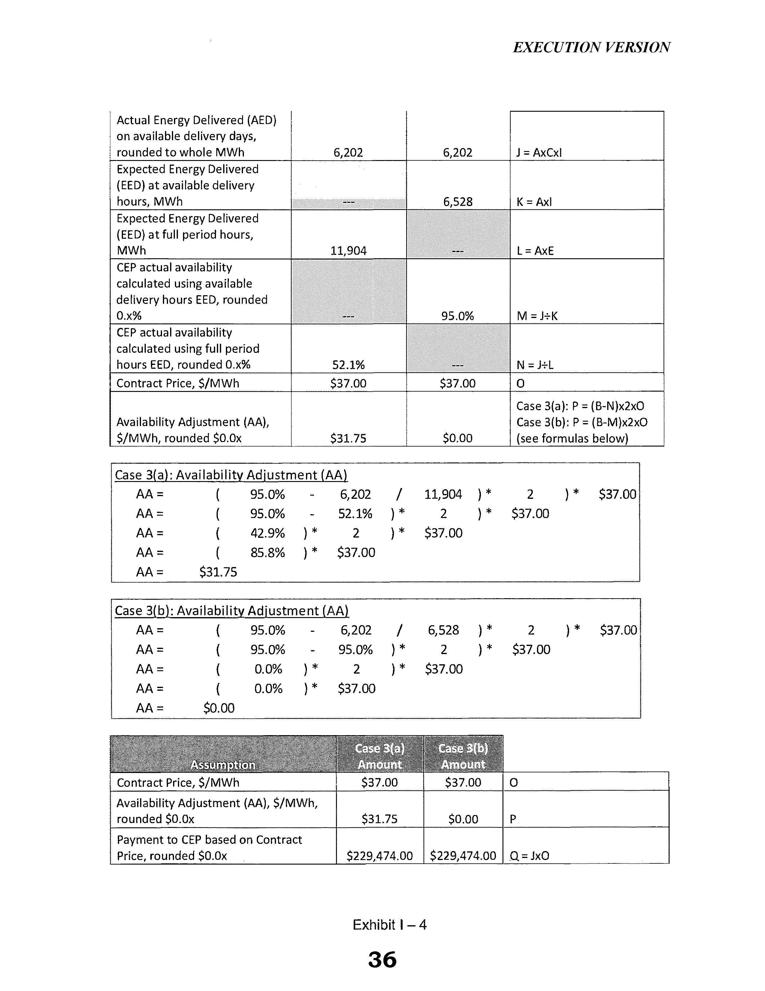

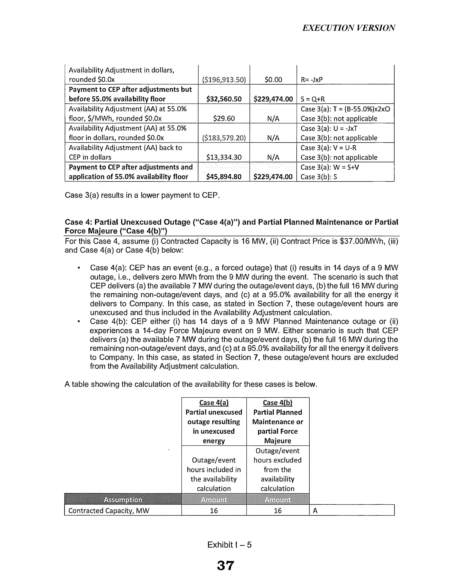

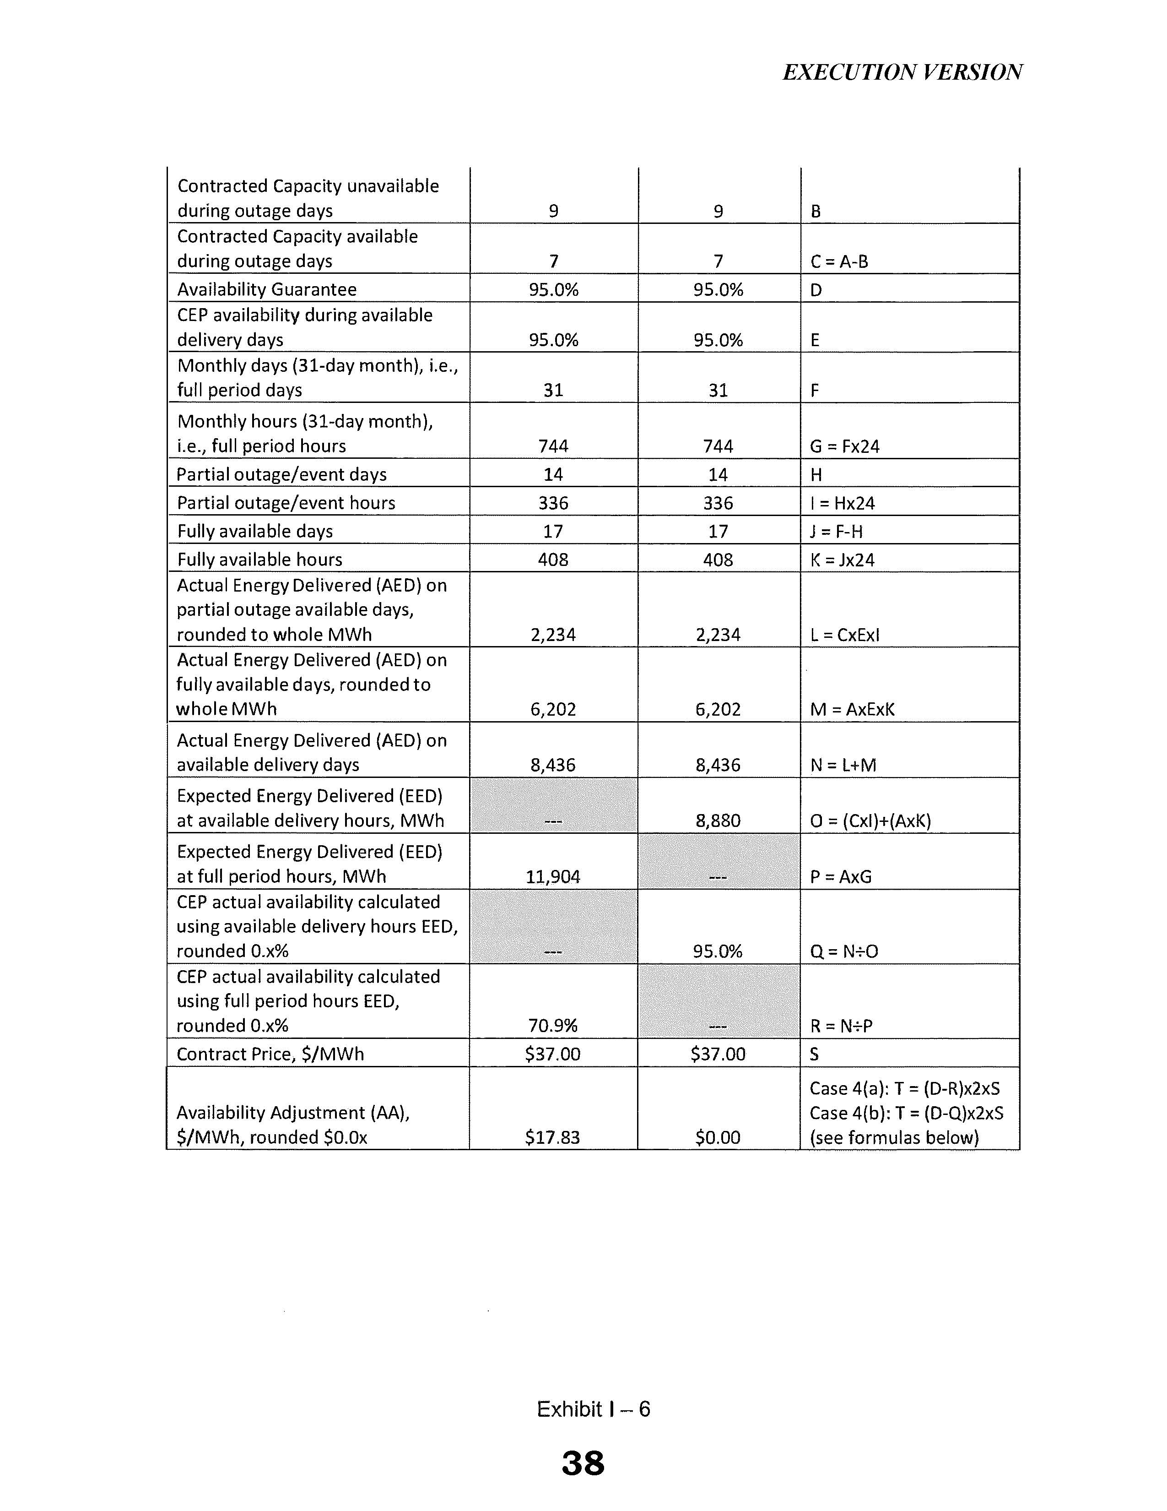

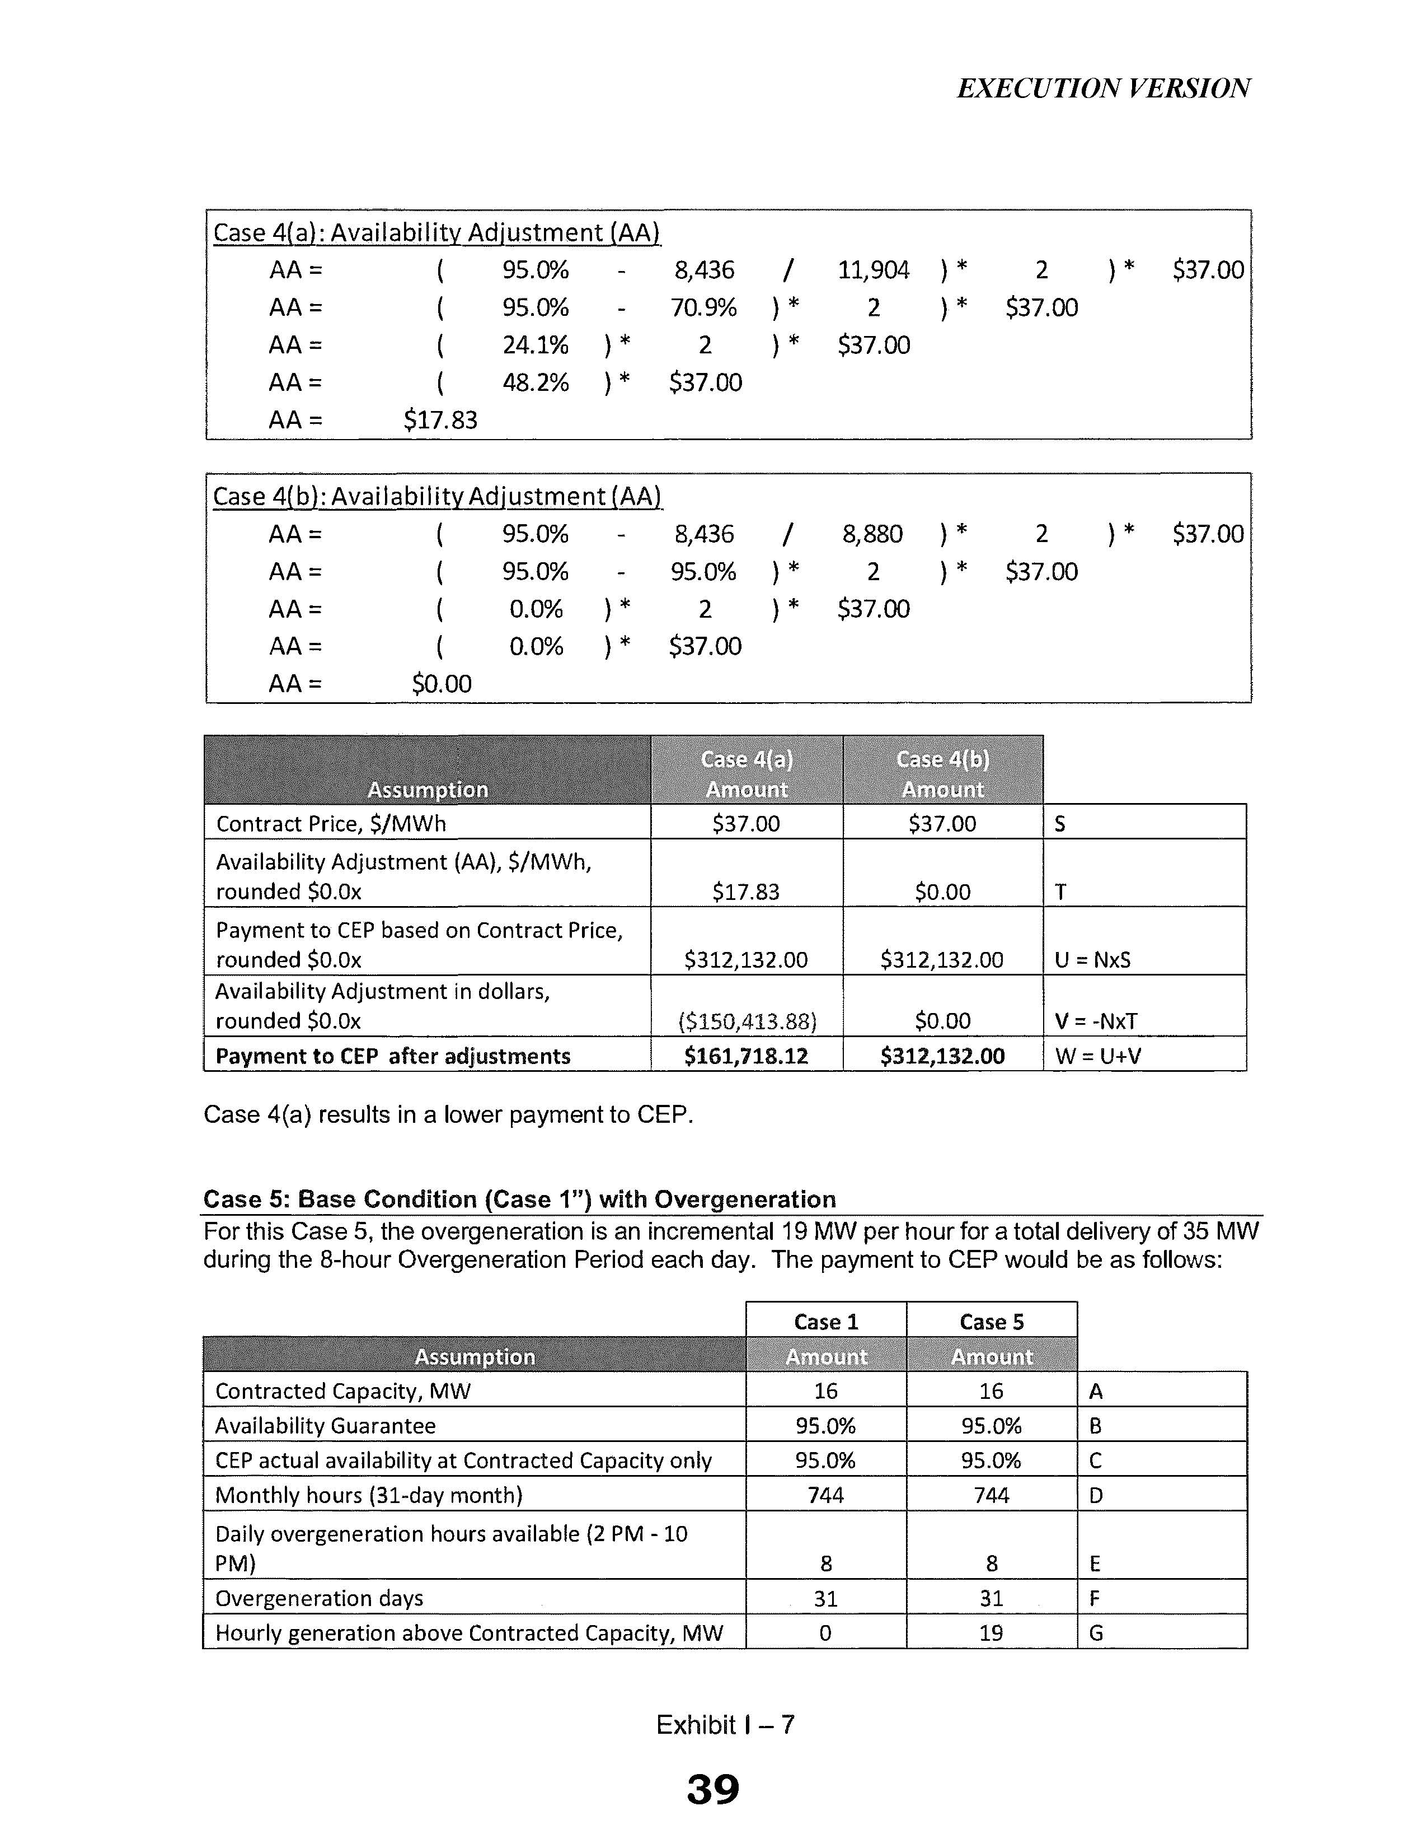

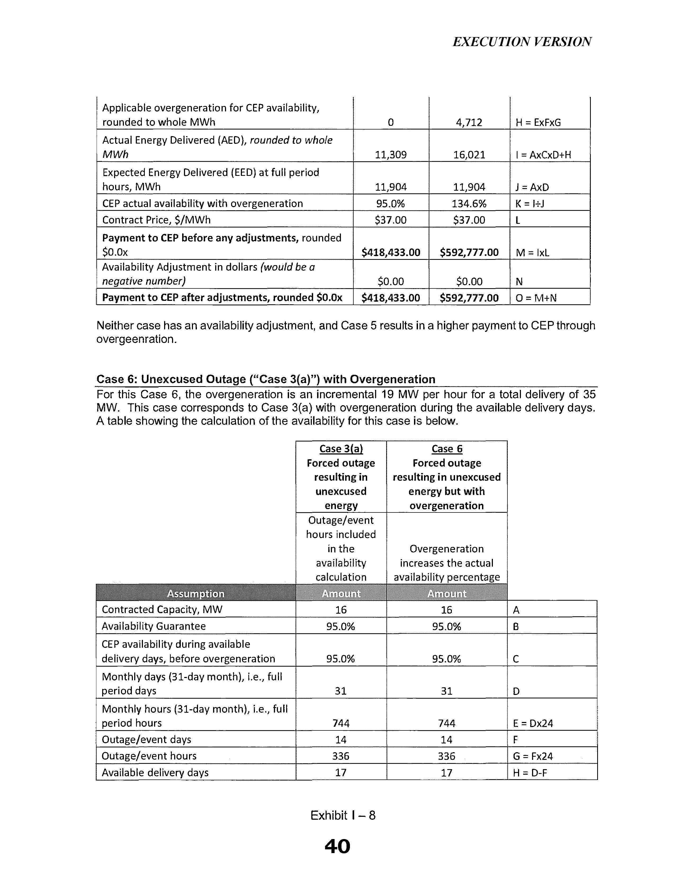

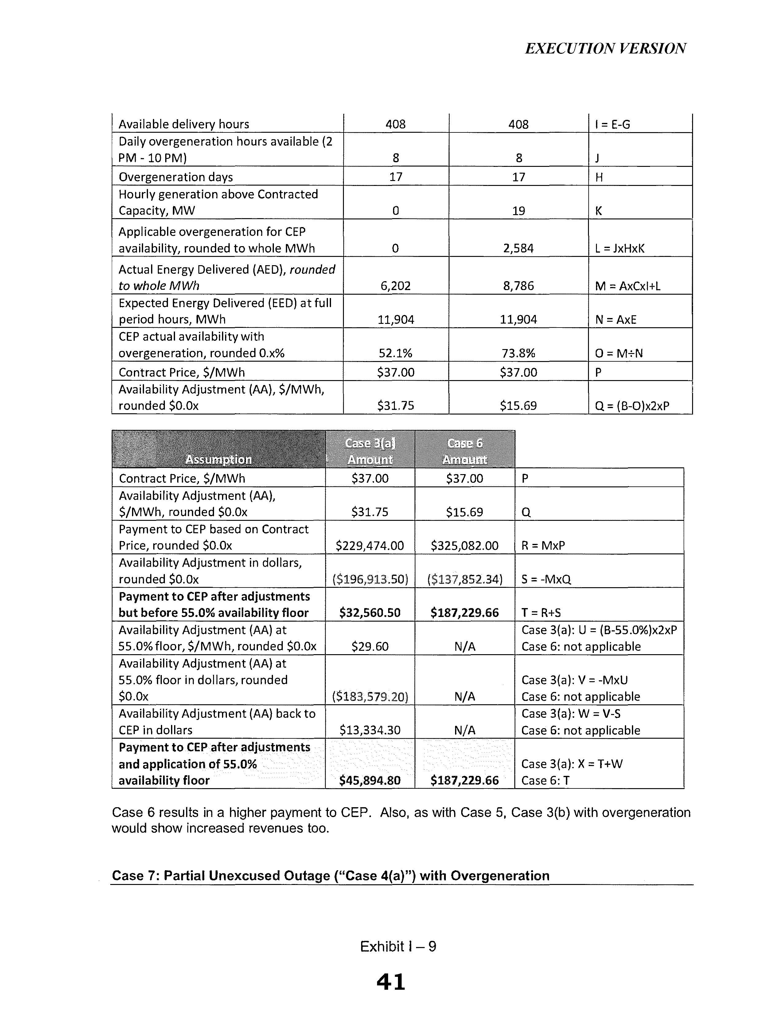

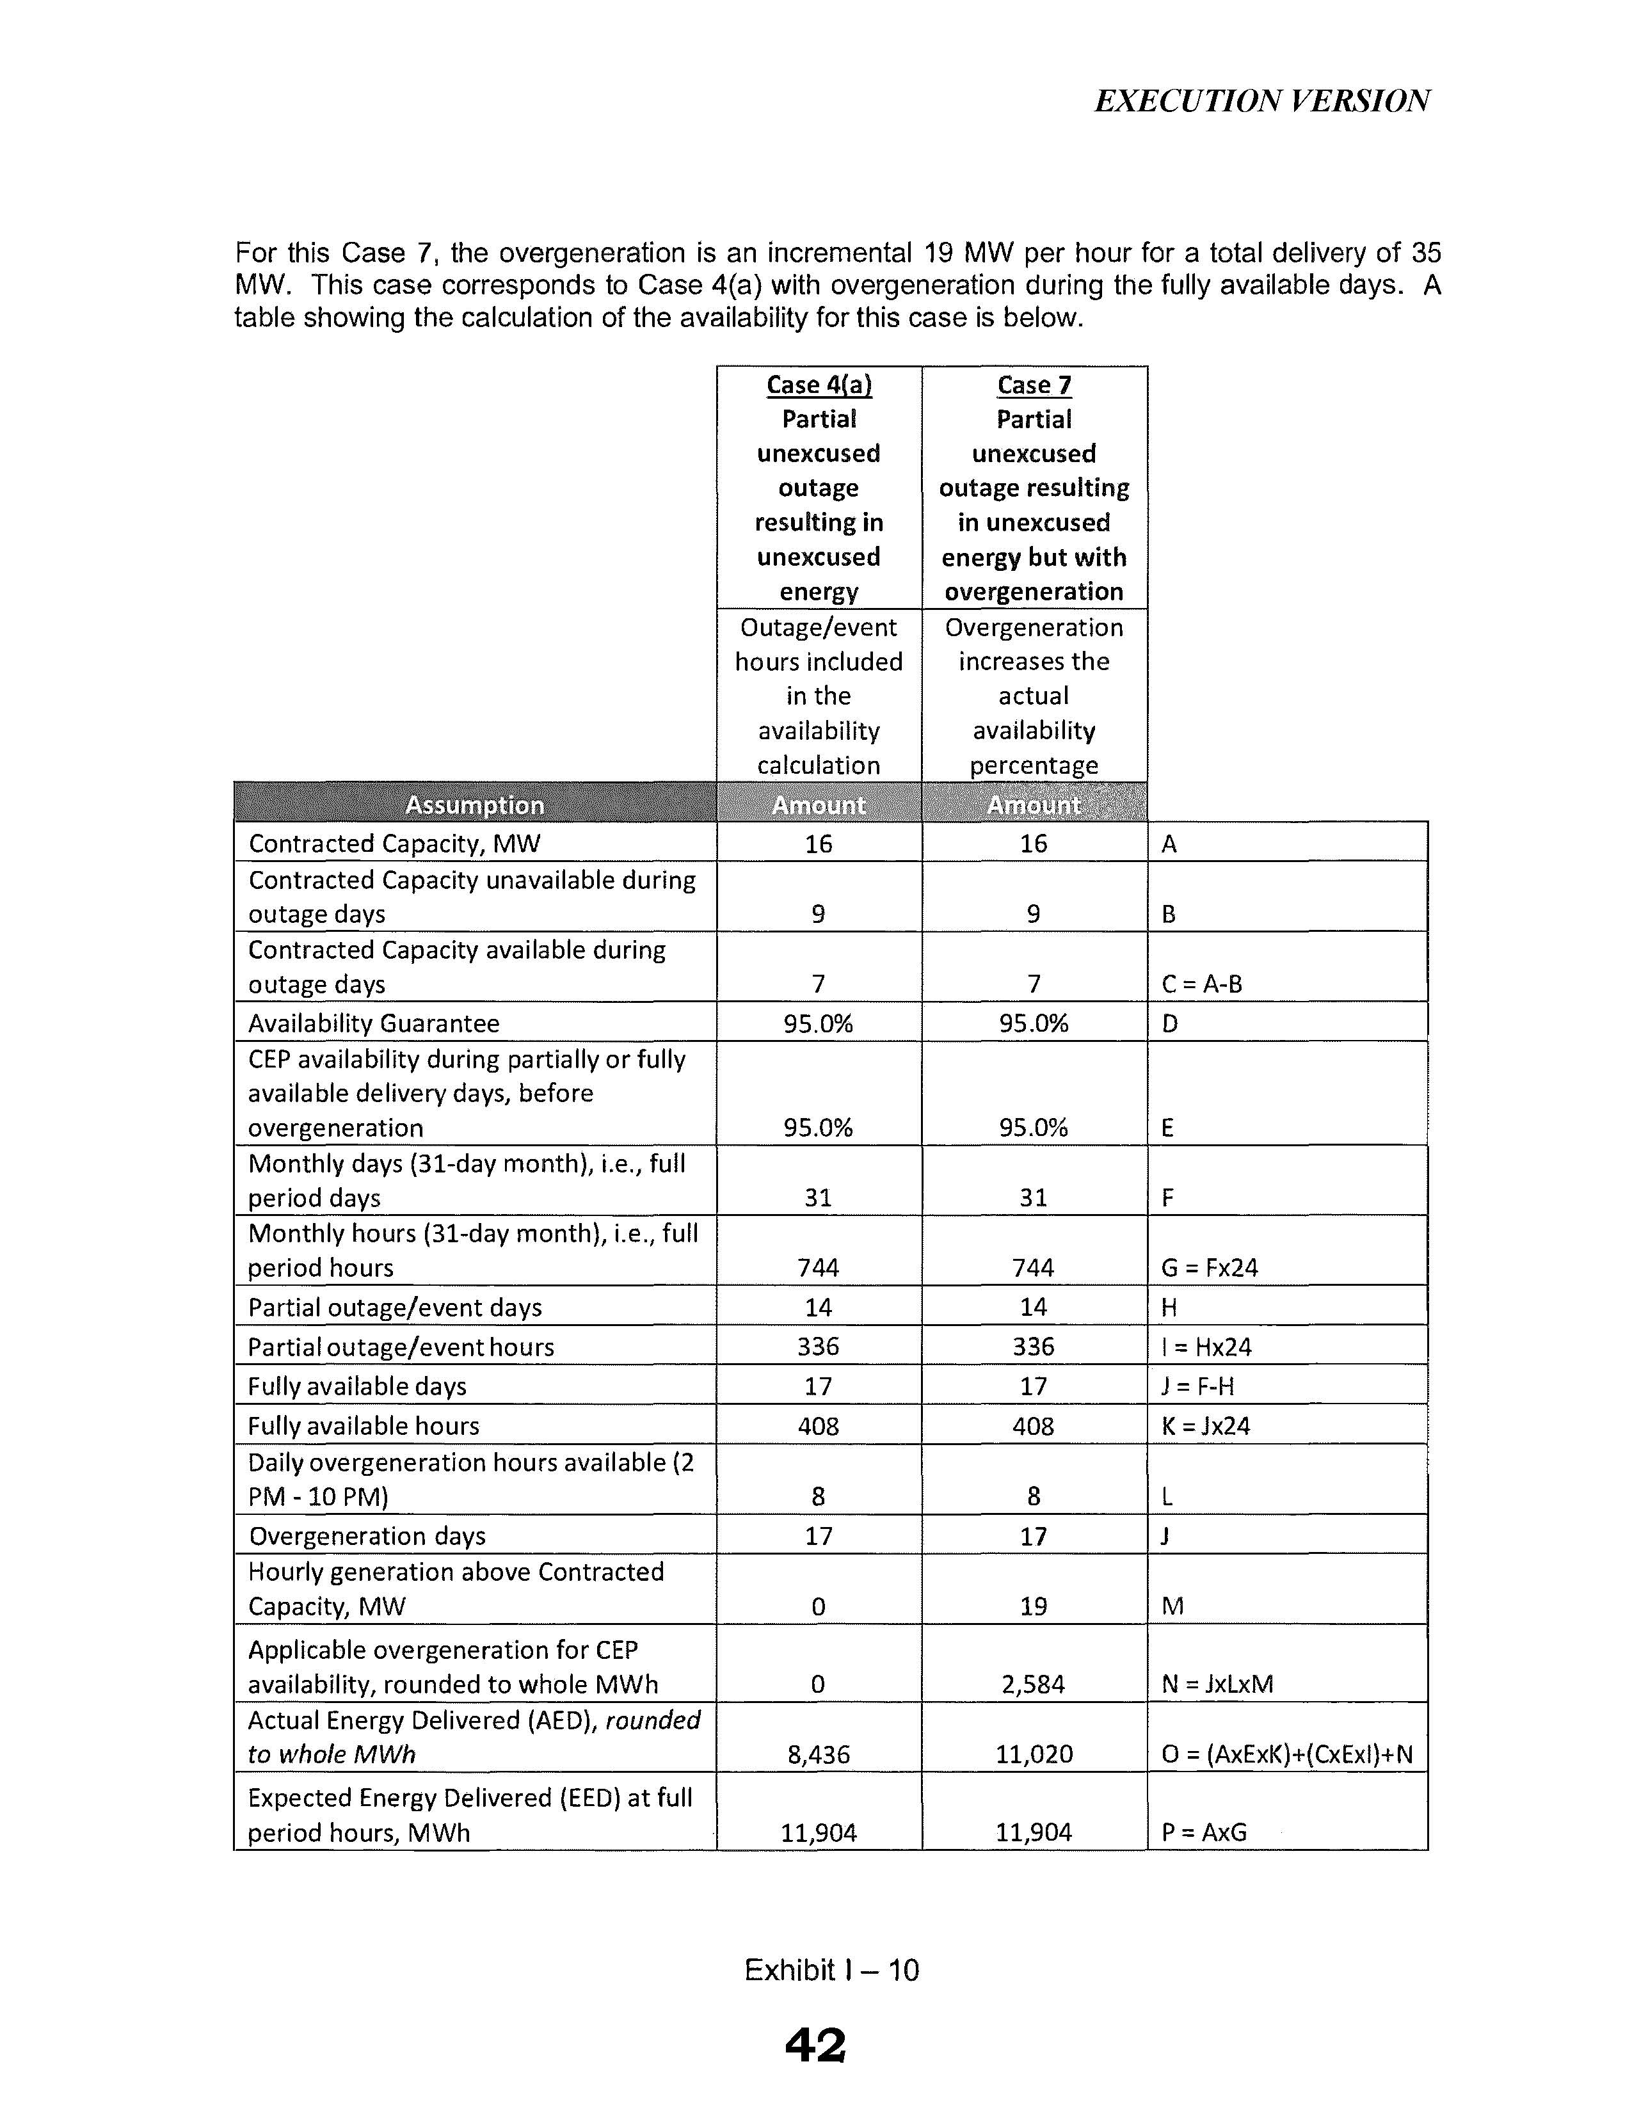

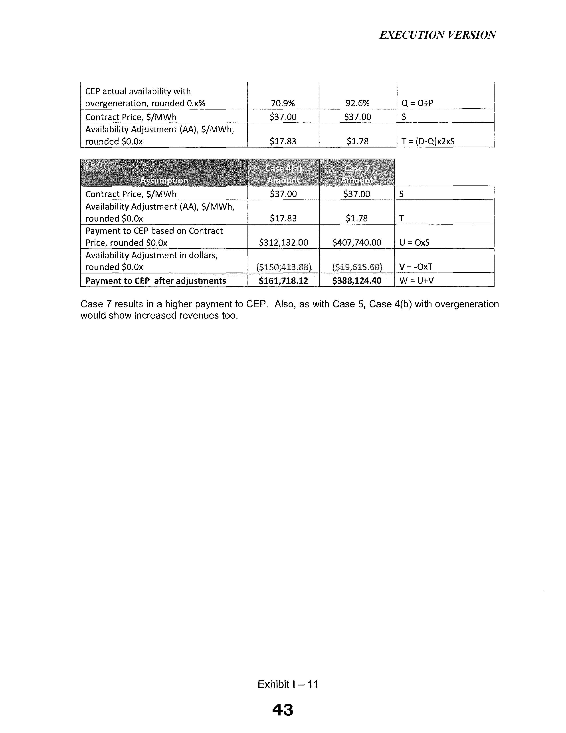

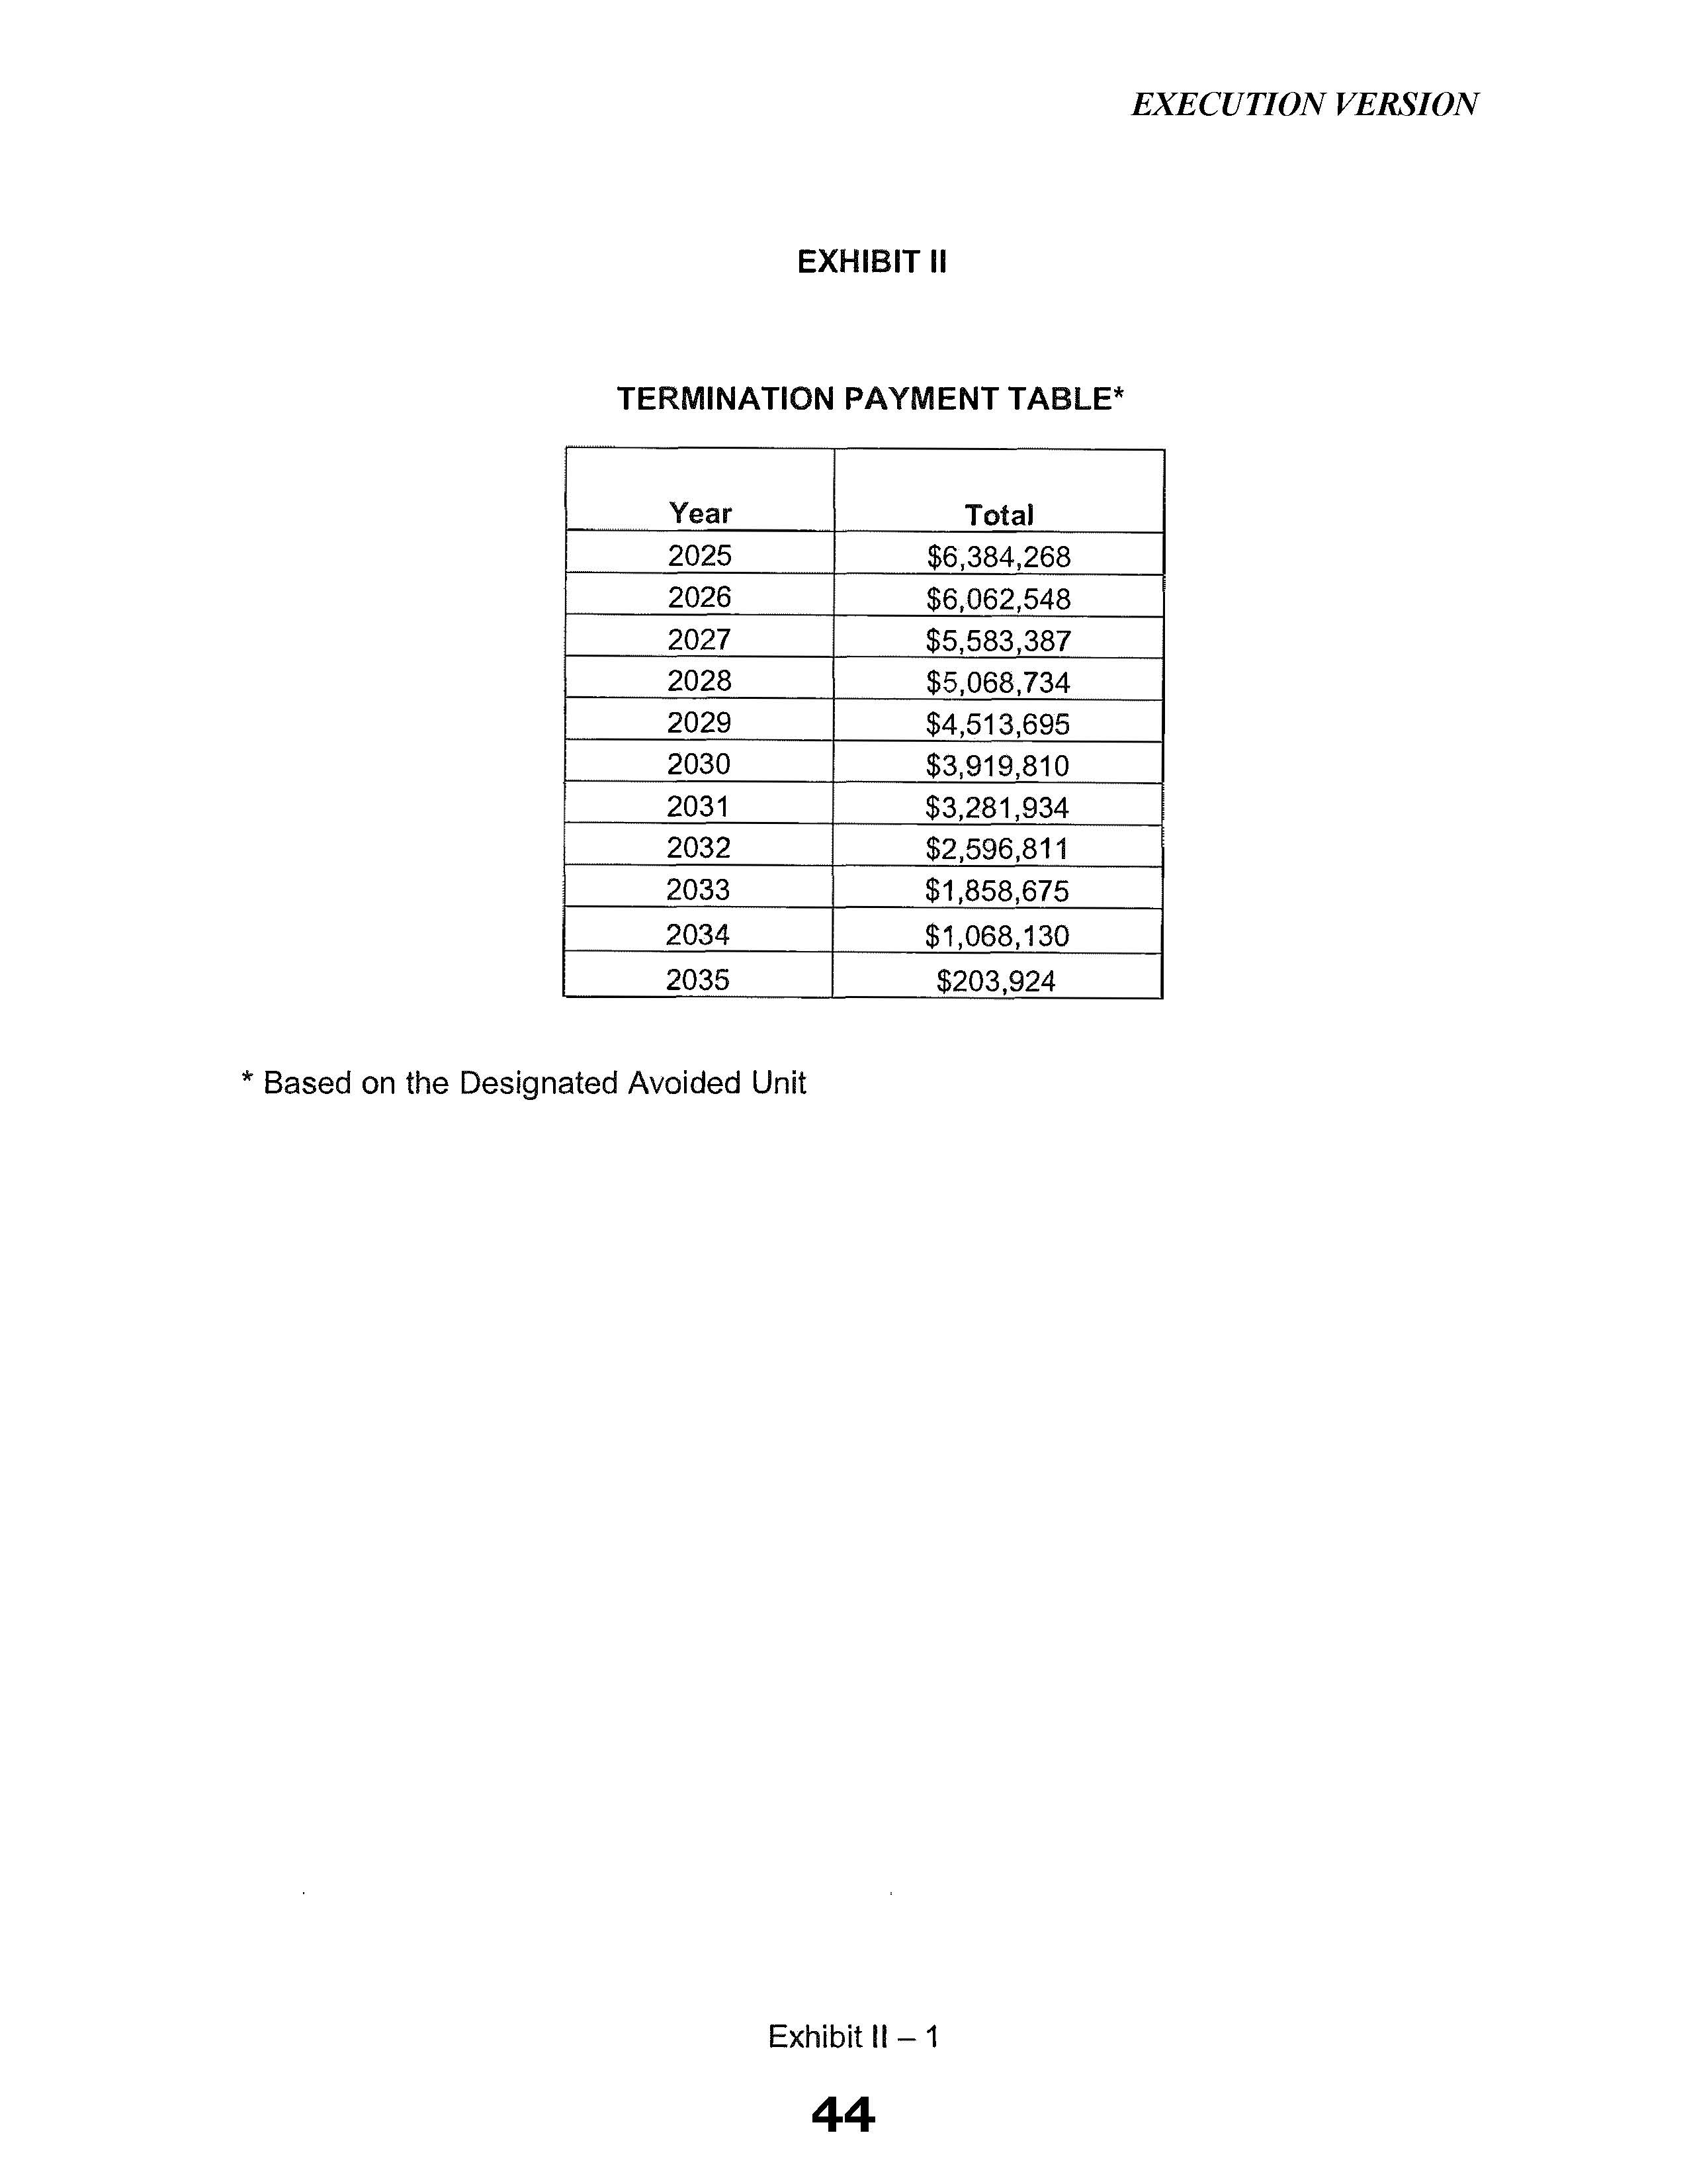

Document No. 02880-2025, filed on April 16, 2025, in Docket No. 20250036-EI, In re: Petition for approval of purchased power agreement between Tampa Electric Company and Hillsborough County.
Id.
Id.

