BEFORE THE FLORIDA PUBLIC SERVICE COMMISSION

|  |  |
| --- | --- |
| In re: Review of 2026-2035 Storm Protection Plan, pursuant to Rule 25-6.030, F.A.C., Florida Public Utilities Company. | DOCKET NO. 20250017-EI  ORDER NO. PSC-2025-0216-FOF-EI  ISSUED: June 19, 2025 |

The following Commissioners participated in the disposition of this matter:

MIKE LA ROSA, Chairman

ART GRAHAM

GARY F. CLARK

ANDREW GILES FAY

GABRIELLA PASSIDOMO SMITH

FINAL ORDER APPROVING WITH MODIFICATIONS

FLORIDA PUBLIC UTILITIES COMPANY’S

STORM PROTECTION PLAN

APPEARANCES:

BETH KEATING, ESQUIRE, Gunster, Yoakley & Stewart, P.A., 215 South Monroe Street, Suite 601, Tallahassee, Florida 32301

On behalf of Florida Public Utilities Company (FPUC).

WALT TRIERWEILER, CHARLES REHWINKEL, PATRICIA A. CHRISTENSEN, MARY A. WESSLING, OCTAVIO SIMOES-PONCE, and AUSTIN A. WATROUS, ESQUIRES, 111 West Madison Street, Room 812, Tallahassee, Florida 32399-1400

On behalf of the Office of Public Counsel (OPC).

CARLOS MARQUEZ and JENNIFER AUGSPURGER, ESQUIRES, Florida Public Service Commission, 2540 Shumard Oak Boulevard, Tallahassee, Florida 32399-0850

On behalf of the Florida Public Service Commission Staff (Staff).

MARY ANNE HELTON, ESQUIRE, Interim General Counsel, Florida Public Service Commission, 2540 Shumard Oak Boulevard, Tallahassee, Florida 32399-0850

Advisor to the Florida Public Service Commission.

BY THE COMMISSION:

Background

Section 366.96(3), Florida Statutes (F.S.), requires each public utility[1] to file a transmission and distribution storm protection plan (SPP) that covers the immediate 10-year planning period, and explains the systematic approach the utility will follow to achieve the objectives of reducing restoration costs and outage times associated with extreme weather events and enhancing reliability. Pursuant to Section 366.96(4)–(6), F.S., at least every three years we are required to determine whether it is in the public interest to approve, approve with modification, or deny each utility’s transmission and distribution SPP filed in accordance with Commission Rule 25-6.030, Florida Administrative Code (F.A.C.). Our decision must be made no later than 180 days from the utility’s filing date.

On January 15, 2025, Florida Public Utilities Company (FPUC or Utility) filed Petition for Approval of Storm Protection Plan. Shortly thereafter, the Office of Public Counsel (OPC), representing the utility customers, intervened in this docket. FPUC’s originally proposed SPP included the following seven programs:

* Overhead Feeder Hardening;
* Overhead Lateral Hardening;
* Overhead Lateral Undergrounding;
* Distribution Pole Inspections and Replacements;
* Transmission System Inspection and Hardening;
* Transmission & Distribution Vegetation Management; and
* Distribution Connectivity and Automation.

All of these programs, except for the Distribution Connectivity and Automation program, are programs that were approved in the prior SPP.[2] On May 15, 2025, FPUC and OPC filed a joint motion for approval of stipulations.[3] Those stipulations are reflected in Attachment A of this Order. A hearing to fully address the petition was held on May 20, 2025.[4] We have jurisdiction over this matter pursuant to Section 366.96, F.S., and Chapter 120, F.S.

Legal Standard

When reviewing each transmission and distribution SPP filed pursuant to Section 366.96, F.S., we must consider the following factors in order to make a public interest determination:

1. The extent to which the plan is expected to reduce restoration costs and outage times associated with extreme weather events and enhance reliability, including whether the plan prioritizes areas of lower reliability performance;
2. The extent to which storm protection of transmission and distribution infrastructure is feasible, reasonable, or practical in certain areas of the utility’s service territory, including, but not limited to, flood zones and rural areas;
3. The estimated costs and benefits to the utility and its customers of making the improvements proposed in the plan; and
4. The estimated annual rate impact resulting from implementation of the plan during the first 3 years addressed in the plan.[5]

Utility storm protection or hardening is an activity that goes above and beyond the basic standard of service to strengthen a utility’s existing infrastructure to withstand the potential for extreme weather. Rule 25-6.030, F.A.C., implements the statute, provides definitions (such as what an SPP is comprised of), and requires the utilities to provide certain information to support their SPPs.

Decision

1. Should the proposed Distribution Connectivity and Automation Program be included in FPUC’s proposed 2026–2035 Storm Protection Plan?

**Stipulation**: A ruling on FPUC’s proposed Distribution Connectivity and Automation Program should be deferred until a subsequent proceeding to address FPUC’s next update to its SPP.

1. Analysis and Conclusion

FPUC and OPC stipulate that we should defer ruling on the newly proposed Distribution Connectivity and Automation program until a subsequent proceeding that addresses FPUC’s next SPP, which is due to be filed in 2028. We accept this stipulation and interpret it to mean FPUC has voluntarily withdrawn its request to include the Distribution Connectivity and Automation program in this year’s proposed SPP. FPUC is not precluded from requesting for that program’s inclusion in a future SPP proceeding. We therefore make no findings on the merits as to the proposed Distribution Connectivity and Automation program.[6]

1. Should the Commission approve, approve with modification, or deny FPUC’s Storm Protection Plan?

**Stipulation**: The Commission should defer a ruling on FPUC’s Distribution Connectivity and Automation Program consistent with the Parties’ Stipulation of Issue 1 but should otherwise approve FPUC’s 2026–2035 SPP subject to the modifications set forth in Attachment 1 to the Stipulations filed by FPUC and OPC on May 15, 2025.

1. Analysis

The agreed upon stipulations are the result of a robust discovery process. The stipulations will result in a modification to the proposed SPP that FPUC filed. As such, what is left for us to analyze in this proceeding are the six remaining programs that comprise the proposed SPP:

* **Overhead Feeder Hardening** – This program will systematically upgrade all 141 miles of overhead feeder backbone lines across 29 feeders to National Electric Safety Code (NESC) 250C extreme wind standards. The backbone of a feeder resembles the major arteries of the distribution circuit that services a particular community. When a fault occurs on a backbone, upwards of 2,500 customers can be immediately impacted.
* **Overhead Lateral Hardening** – This program will systematically upgrade key lateral lines off distribution feeders to withstand extreme wind standards outlined in NESC 250C. A typical overhead lateral can have upwards of 200 to 300 customers.
* **Overhead Lateral Undergrounding** – This program will address the systematic undergrounding in place, or relocation and undergrounding, of the single phase overhead electric facilities, many of which are located in heavily vegetated areas, environmentally sensitive areas, or in areas where upgrading the overhead construction to NESC extreme wind standards is not practical or consistent with industry design standards.
* **Distribution Pole Inspections and Replacements** – This program continues to follow the eight year wood pole inspection program currently in place. Poles are replaced as needed following their cyclical, multi-step inspection. Replacement poles will comply with NESC 250C extreme wind standards.
* **Transmission System Inspection and Hardening** – This program will address the inspection of transmission facilities (six-year cycle) and substation equipment (annual cycle). The inspections ensure that all transmission towers and other transmission line supporting equipment are structurally sound and firmly attached. This program also includes the inspection and full replacement of 69kV wood poles with concrete poles that are compliant with NESC code requirements.
* **Transmission and Distribution Vegetation Management** – This program uses a four-year, cyclical vegetation management plan to identify and perform necessary trimming and address trees found outside the normal trim zone that pose a danger to main feeders. Each circuit will have its own designated cycle and be prioritized based on customer count, critical infrastructure, and vegetation-related customer interruptions.

All six of these programs are continuations of programs we previously approved in FPUC’s last SPP.[7] We are nonetheless charged with evaluating and making a determination that the proposed SPP meets the statutory criteria set forth in Section 366.96, F.S. The evidentiary record before us, comprised of the testimonies of FPUC witness Cutshaw and OPC witness Mara, as well as Exhibit Nos. 1, 9, 22–26, 61–69, and 73, permit our informed review of the proposed SPP consistent with the parties’ stipulations, including with regard to implementation timeframes and costs. As explained in the analysis below, we accept the stipulations in Attachment A because we find they are supported by evidence and lead to a reasonable outcome consistent with the requirements of Section 366.96, F.S., and Rule 25-6.030, F.A.C. Specifically, the testimony and exhibits establish that the six programs are expected to result in reduced restoration costs and outage times, prioritize areas of lower reliability performance, are feasible, reasonable, and practical, have explained costs and benefits, demonstrate rate impact on customers, and are in the public interest.

1. FPUC’s SPP is expected to result in reduced restoration costs and outage times associated with extreme weather events and enhance reliability as well as prioritize areas of lower reliability performance

Section 366.96(4)(a), F.S., states that when reviewing a utility’s transmission and distribution SPP, we shall consider “[t]he extent to which the plan is expected to reduce restoration costs and outage times associated with extreme weather events and enhance reliability.” FPUC presented testimony that its Overhead Feeder Hardening program, Overhead Lateral Hardening program, Overhead Lateral Undergrounding program, Distribution Pole Inspection and Replacements program, and the Transmission System Inspection and Hardening program, would reduce outages and overall restoration times.

FPUC’s service territory contains approximately 141 miles of overhead feeder backbone and 575 miles of overhead lateral lines across 29 feeders. FPUC witness Cutshaw analogizes the backbone of a feeder to the major arteries of a distribution circuit that services a community. When a fault occurs on the backbone of a feeder, upwards of 2,500 FPUC customers can be immediately impacted. Meanwhile, a typical overhead lateral can serve upwards of 200 to 300 customers. To help mitigate damage and outage times caused by storm damage, FPUC witness Cutshaw testified that a key aspect of the SPP includes activities like the hardening of overhead electrical facilities.

Because some overhead electric facilities in FPUC’s service territory are located in heavily vegetated areas, environmentally sensitive areas, or areas where upgrading the overhead construction to NESC extreme wind standards may not be practical or consistent with industry design standards, FPUC witness Cutshaw testified that undergrounding primary and secondary overhead facilities would reduce roadway obstructions and allow restoration crews to quickly restore power to customers. Thus, by strengthening these critical sections of the electric distribution grid to withstand damage during extreme weather conditions, through the Overhead Feeder Hardening program, Overhead Lateral Hardening program, and Overhead Lateral Undergrounding program, outages that may have occurred can be prevented and overall restoration times reduced.

In addition, FPUC presented testimony that the Distribution Pole Inspection and Replacements program and the Transmission System Inspection and Hardening program are also expected to contribute to reduced restoration costs and outage times associated with extreme weather events. For example, by proactively inspecting wood poles through the Distribution Pole Inspection and Replacements program, FPUC can preemptively replace poles that fail inspection criteria with NESC-compliant poles before an area experiences extreme weather conditions. The data demonstrates that hardened structures perform significantly better than non-hardened structures in the face of extreme weather. Because these replacement poles are better able to withstand extreme winds, the likelihood of damage or outage times from storm damage is reduced by comparison. This same rationale and benefit is also applicable to the Transmission System Inspection and Hardening program.

Finally, the Florida Legislature has found that high winds can cause vegetation to “blow into and damage electrical transmission and distribution facilities, resulting in power outages.”[8] “A majority of the power outages that occur during extreme weather conditions in the state are caused by vegetation blown by the wind.”[9] In order to address this problem in its SPP, FPUC offered testimony that the Transmission & Distribution Vegetation Management program, which consists of trimming trees outside the normal trim zone that are located near main feeders, would prevent branches from falling on the electrical system, and thus, would reduce the likelihood of outage events.

Furthermore, FPUC offered testimony on its Risk Resiliency Model to assess system risk and determine project prioritization for its SPP programs based on probability, response, and impact. The model performed an analysis of FPUC’s historical reliability performance, both during extreme and non-extreme weather conditions, using quantitative data from available public sources as well as FPUC-specific data. Model inputs included data such as wind probability, flood/storm surge potential, past performance, accessibility, critical load, and interruption cost estimates. FPUC took into consideration the model’s prioritization portfolio along with other factors, such as external influences and resource availability, when determining the prioritization of its SPP. For example, key programs for FPUC such as the Overhead Lateral Hardening Program and the Overhead Lateral Undergrounding Program focus on prioritizing feeders with the highest risk score and statistically worse performance. Thus, the SPP prioritizes areas of lower reliability based on its use of the Risk Resiliency Model and resulting criteria descriptions for each program. We find this satisfies the prioritization requirement of Section 366.96(4)(a), F.S.

Because there was testimony and evidence from FPUC supporting that the SPP is expected to reduce restoration costs and outage times associated with extreme weather events and enhance reliability, we find that it meets the statutory criteria of Section 366.96(4)(a), F.S. Furthermore, we find that FPUC’s use of the Risk Resiliency Model is expected to result in the prioritization of areas of lower reliability performance for these programs, which meets the statutory directive of Section 366.96(4)(a), F.S.

1. FPUC’s SPP is feasible, reasonable, or practical within the Utility’s service territory

Section 366.96(4)(b), F.S., requires us to consider the extent to which storm protection of transmission and distribution infrastructure is feasible, reasonable, or practical in certain areas of the utility’s service territory, including, but not limited to flood zones and rural areas. FPUC offered evidence from witness Cutshaw who testified regarding the feasibility and practicality of the SPP. Witness Cutshaw testified that although implementation strategies may differ between projects due to geographical or other concerns, all six of FPUC’s SPP programs remain feasible and practical across FPUC’s entire service territory. Witness Cutshaw explained that any project-to-project variations may include combining multiple programs to achieve statutory objectives. In addition, there is evidence before us that the six SPP programs continue to be reasonable at this time for FPUC’s service territory.

Additionally, FPUC offered evidence explaining that it used the Risk Resiliency Model to integrate the analysis of geographic location and population information in order to meet the criteria of Section 366.96(4)(b), F.S. FPUC’s use of the model included data specific to FPUC’s geographic location, customer population, rural areas, and flood zones. This information allowed the Utility to assess the resiliency and risks for each of the unique divisions of its system and develop its comprehensive SPP to address any issues.

Because there was testimony and evidence from FPUC demonstrating that the SPP is feasible, reasonable, and practical in the Utility’s service territory (including in its flood zones and rural areas), we find that the SPP meets the statutory criteria in Section 366.96(4)(b), F.S.

1. The estimated costs and benefits of FPUC’s SPP programs

Section 366.96(4)(c), F.S., requires us to also consider the estimated costs and benefits to the utility and its customers from making the improvements proposed in the SPP. Rule 25-6.030(3)(d)(4.), F.A.C., requires a utility to provide a comparison of the estimated program costs, including capital and operating expenses, and the benefits. Notably, at the planning stage, utilities provide their best estimates of program costs. These costs must be reasonable and supported by the evidence. Estimates of costs and expenses are reviewed and trued-up later in the annual Storm Protection Plan Cost Recovery Clause (SPPCRC) proceeding.

FPUC presented testimony and evidence regarding the myriad of benefits that the proposed SPP will generate. These anticipated benefits include reductions of storm restoration costs, increases in service reliability, and reductions of outage events during both extreme and non-extreme weather conditions. FPUC reviewed its project timelines, work schedules, and inventory, and believes it can still maintain the intended benefits to the public while implementing the stipulated modifications.

For each of the six SPP programs, FPUC provided the estimated capital costs and operating expenses for 2026 through 2028 which are summarized in Table 1 below. The stipulations resulted in reduced program costs for several of the proposed programs.

**Table 1**

**FPUC’s 2026–2028 SPP Program Cost Estimate**

|  |  |  |  |
| --- | --- | --- | --- |
| Program | 2026  (millions) | 2027  (millions) | 2028  (millions) |
| Overhead Feeder Hardening | $5.78 | $5.84* | $5.71 |
| Overhead Lateral Hardening | $6.89 | $7.39 | $6.43 |
| Overhead Lateral Undergrounding | $4.22 | $4.97 | $4.21 |
| Distribution Pole Inspection and Replacements | $0.69 | $0.69 | $0.69 |
| Transmission System Inspection and Hardening | $1.22 | $1.22 | $1.22 |
| Transmission & Distribution Vegetation Management | $2.50 | $2.50 | $2.50 |
| Total | $21.30 | $22.62* | $20.76 |

* Number totals do not add up due to rounding.

FPUC provided adequate descriptions of the benefits that will result from implementing these SPP programs. The Utility also provided estimated program costs, including capital and operating expenses, required by our rule. Because the estimated costs and description of benefits to FPUC customers are supported by the evidence, we find that the SPP meets the statutory criteria in Section 366.96(4)(c), F.S.

1. The estimated annual rate impact resulting from implementation of the FPUC’s SPP for the first three years

Section 366.96(4)(d), F.S., requires us to consider the estimated annual rate impact resulting from implementation of the plan during the first three years addressed in the plan. Notably, these rate impacts are estimates. The estimated annual Storm Protection Plan spending amounts shall not be considered specific targets or hard caps. The actual costs will be trued up in the SPPCRC. That said, the statute requires the utilities to provide their best cost estimates of their SPPs so that we can consider that information.

FPUC originally estimated SPP rate impacts per 1,000 kwh for residential customers of $17.30 in 2026, $21.82 in 2027, and $26.77 in 2028. However, FPUC estimates that the stipulations will reduce the SPP rate impact on customers. To use but one example, FPUC projects a reduction of $2.22 in the SPPCRC factor for customers in 2026. Though the Utility notes that value may be impacted by any true-up. Because FPUC addresses changes to rate impact, we find it meets that statutory criteria.

1. Is FPUC’s SPP in the public interest?

Finally, Section 366.96(5)–(6), F.S., requires us to determine whether it is in the public interest to approve, approve with modification, or deny a proposed SPP within 180 days of filing. In reaching this decision we are guided by the factors in Section 366.96(4), the Florida Legislature’s intent, and Rule 25-6.030, F.A.C.

FPUC and OPC stipulate that a modified SPP is in the public interest and should be approved by us. We agree that the joint proposal leads to a reasonable outcome consistent with the law and supported by evidence. Based on the foregoing analysis and record support that the statutory criteria was met, we find that approving an SPP with the stipulated modifications is in the public interest.

1. Conclusion

Based on the above discussion, we approve the proposed SPP with modifications because it is in the public interest and meets the statutory criteria set forth in Section 366.96, F.S. Therefore, FPUC’s SPP shall be approved with the following modifications: (1) the Distribution Connectivity and Automation program shall be removed because a ruling on that program is deferred to the next SPP proceeding by agreement of the parties and (2) the modifications outlined in Attachment A shall be implemented.

Based on the foregoing, it is

ORDERED by the Florida Public Service Commission that the stipulations, findings, and rulings herein are hereby approved. It is further

ORDERED that Florida Public Utilities Company’s Storm Protection Plan is approved with modifications as set forth herein and described in Attachment A of this Order. It is further

ORDERED that Florida Public Utilities Company shall file a modified Storm Protection Plan reflecting our ordered modifications within thirty (30) days of the issuance of this Order for administrative approval by Commission staff. It is further

ORDERED that this docket shall remain open for Commission staff’s verification that the modified Storm Protection Plan was filed and fully complies with our Order. Once these actions are complete, this docket shall be closed administratively.

By ORDER of the Florida Public Service Commission this 19th day of June, 2025.

|  |  |
| --- | --- |
|  | /s/ Adam J. Teitzman |
|  | ADAM J. TEITZMAN  Commission Clerk |

Florida Public Service Commission

2540 Shumard Oak Boulevard

Tallahassee, Florida 32399

(850) 413‑6770

www.floridapsc.com

Copies furnished: A copy of this document is provided to the parties of record at the time of issuance and, if applicable, interested persons.

CMM

NOTICE OF FURTHER PROCEEDINGS OR JUDICIAL REVIEW

The Florida Public Service Commission is required by Section 120.569(1), Florida Statutes, to notify parties of any administrative hearing or judicial review of Commission orders that is available under Sections 120.57 or 120.68, Florida Statutes, as well as the procedures and time limits that apply. This notice should not be construed to mean all requests for an administrative hearing or judicial review will be granted or result in the relief sought.

Any party adversely affected by the Commission's final action in this matter may request: 1) reconsideration of the decision by filing a motion for reconsideration with the Office of Commission Clerk, 2540 Shumard Oak Boulevard, Tallahassee, Florida 32399-0850, within fifteen (15) days of the issuance of this order in the form prescribed by Rule 25-22.060, Florida Administrative Code; or 2) judicial review by the Florida Supreme Court in the case of an electric, gas or telephone utility or the First District Court of Appeal in the case of a water and/or wastewater utility by filing a notice of appeal with the Office of Commission Clerk, and filing a copy of the notice of appeal and the filing fee with the appropriate court. This filing must be completed within thirty (30) days after the issuance of this order, pursuant to Rule 9.110, Florida Rules of Appellate Procedure. The notice of appeal must be in the form specified in Rule 9.900(a), Florida Rules of Appellate Procedure.

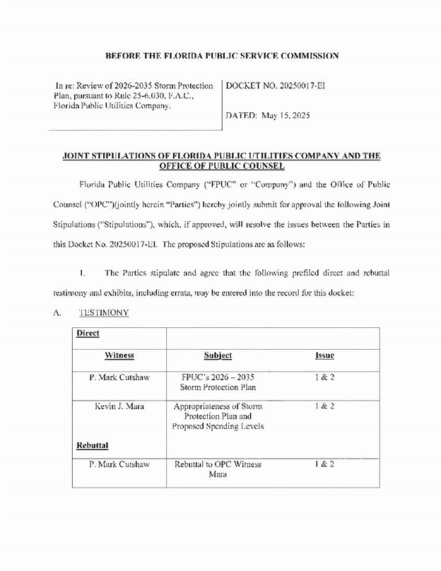

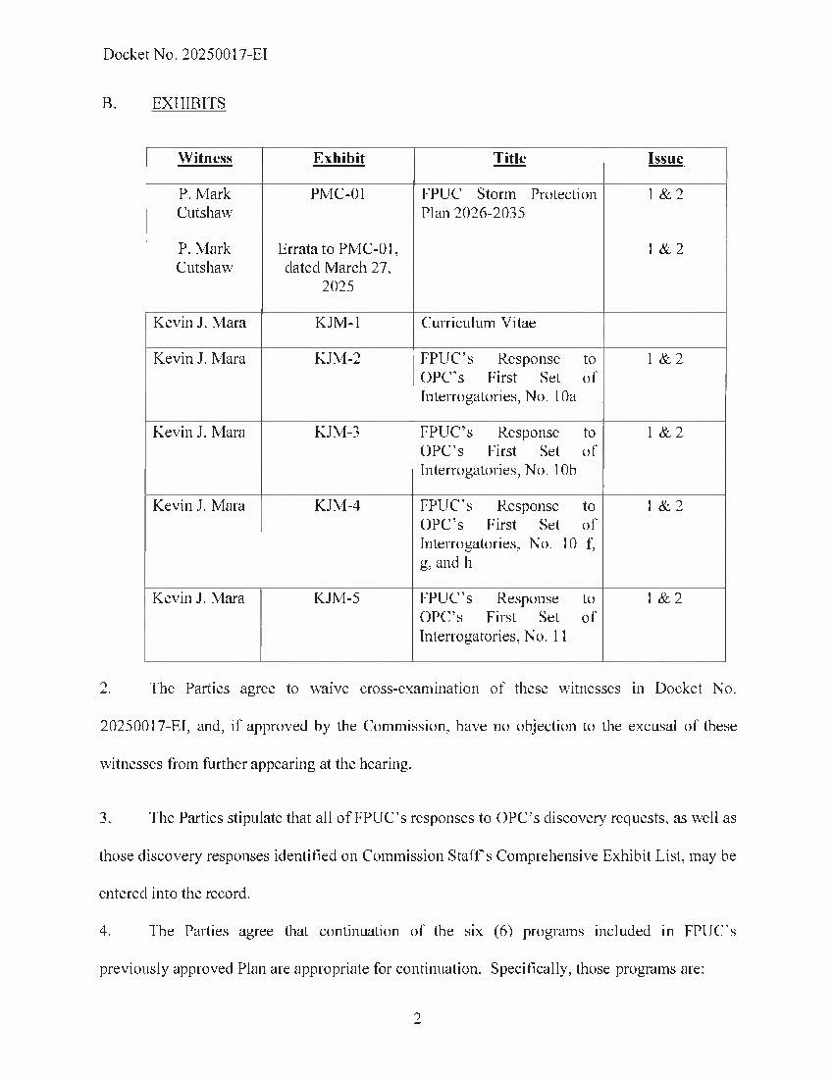

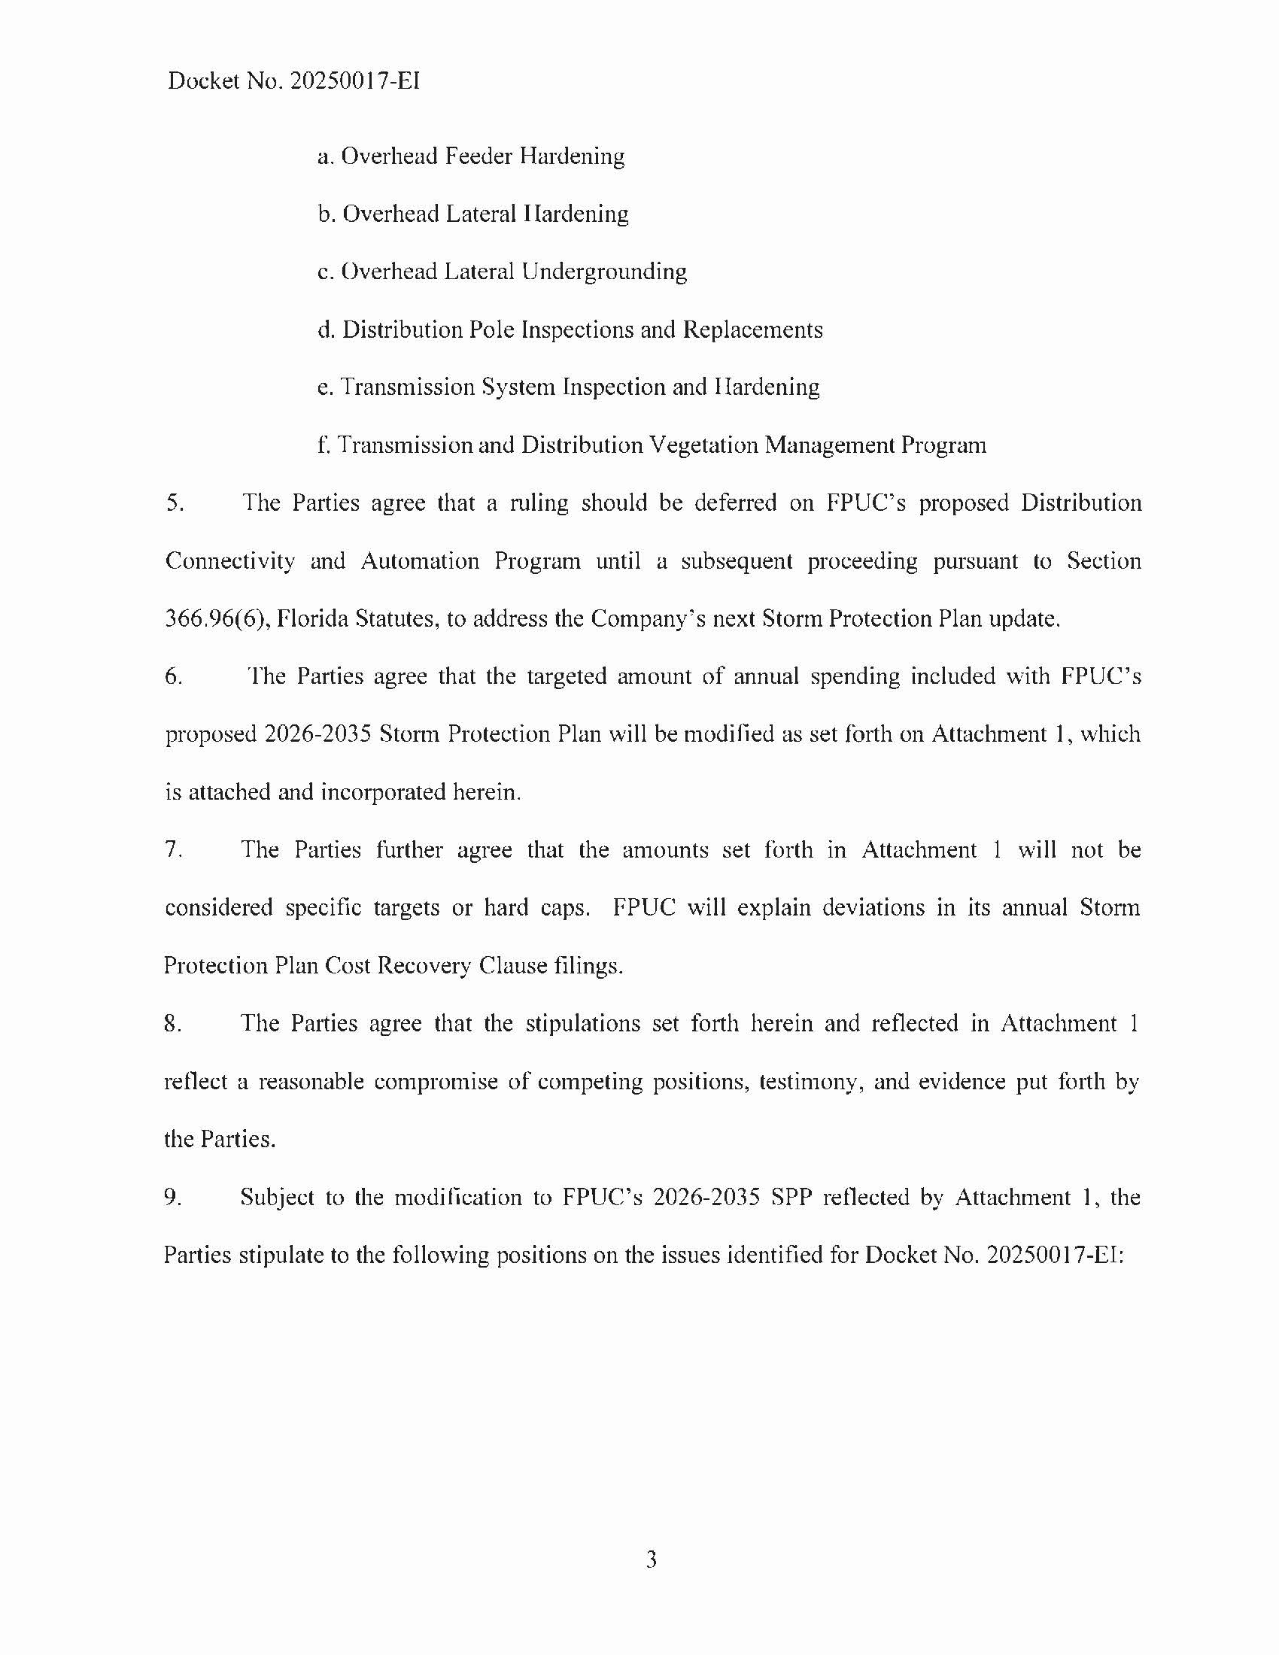

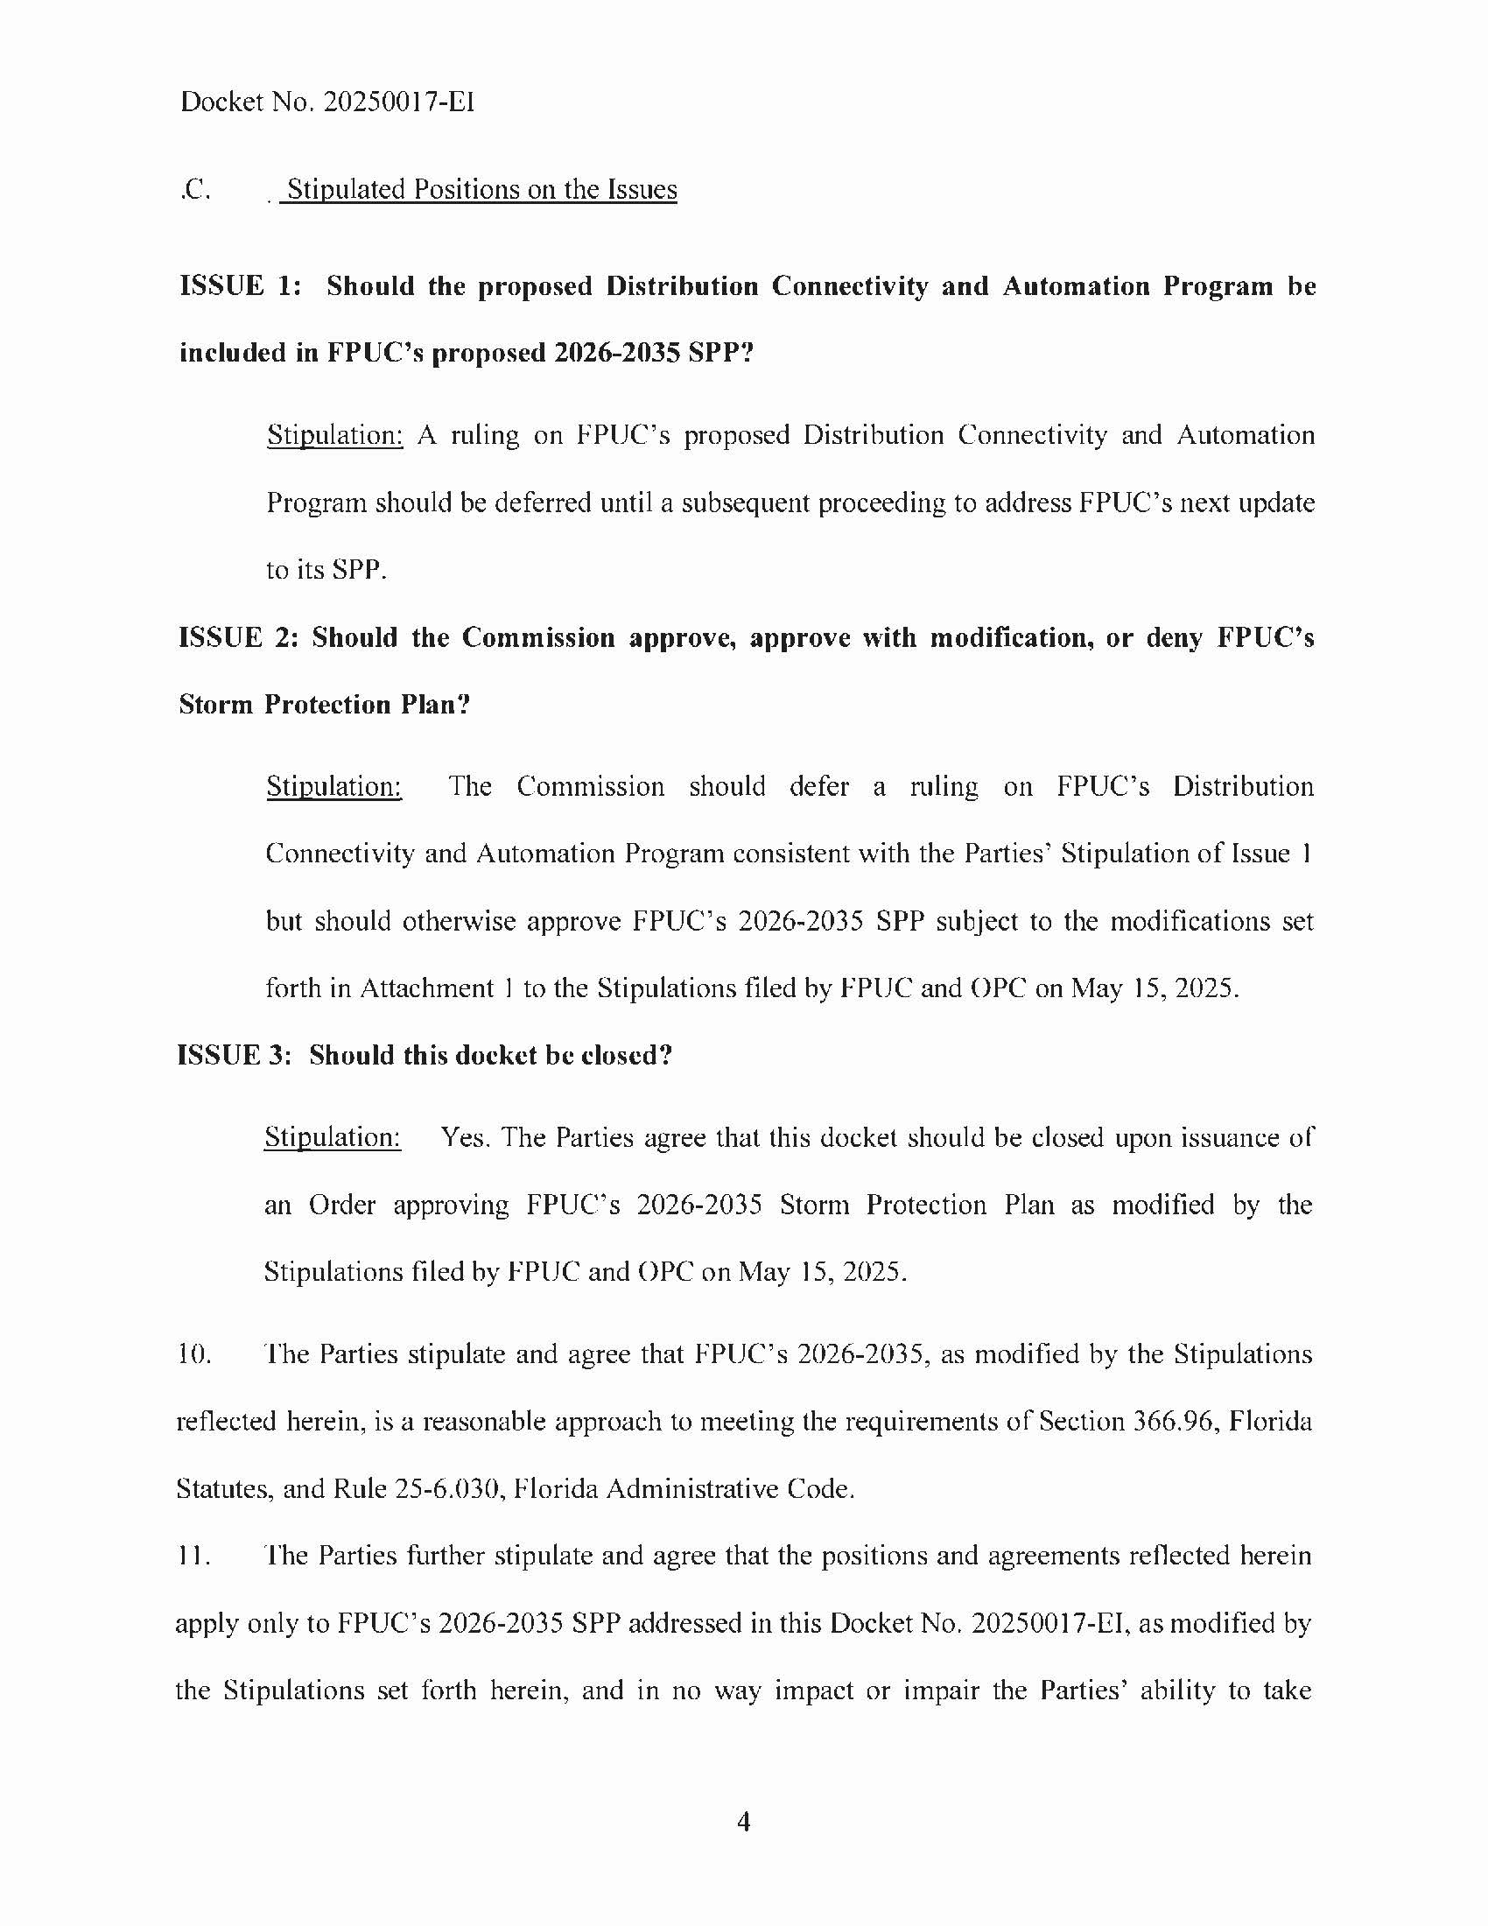

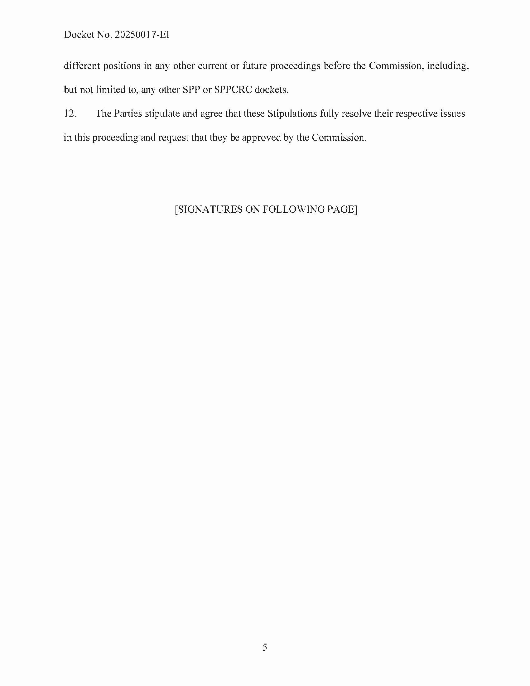

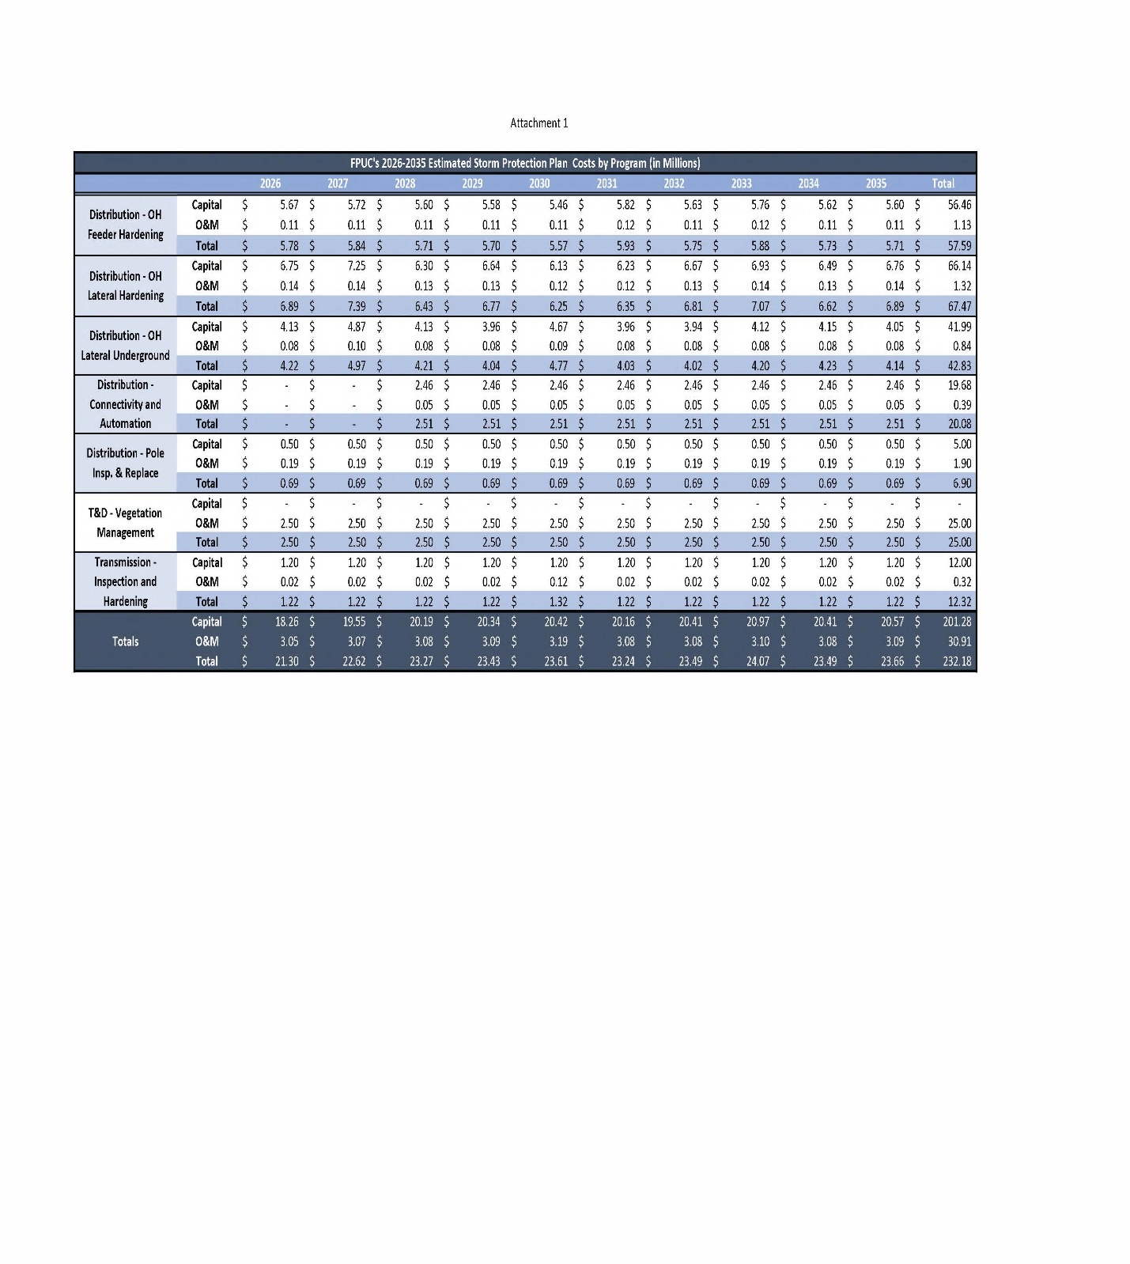

1. In a SPP proceeding, the term “public utility” has the same meaning as set forth in Section 366.02(8), F.S., except that it does not include gas utilities. Section 366.96(2)(a), F.S.
2. *See* Order No. PSC-2022-0387-FOF-EI, issued November 10, 2022, in Docket No. 20220049-EI, *In re: Review of Storm Protection Plan, pursuant to Rule 25-6.030, F.A.C., Florida Public Utilities Company*.
3. Document No. 03642-2025, filed May 15, 2025, in Docket No. 20250017-EI, *Joint Stipulations of FPUC and the OPC*.
4. Docket Nos. 20250014-EI, 20250015-EI, 20250016-EI, and 20250017-EI were consolidated for purpose of the hearing by Order No. PSC-2025-0029-PCO-EI.
5. Section 366.96(4)–(5), F.S.
6. Attachment 1, contained within Attachment A, contains costs for the Distribution Connectivity and Automation program. However, this was a scrivener’s error and FPUC is expected to update this table to remove this program and any associated costs from its updated SPP.
7. Order No. PSC-2022-0387-FOF-EI.
8. Section 366.96(1)(a), F.S.
9. Section 366.96(1)(b), F.S.